Yr Iaith Ar Daith 3 (ECAD6006C)
Task 1- The rationale for choosing the theme and the main aims attached to the activities should be noted. The proposed audience should be noted, and the type of language teaching opportunities that the activities would offer when teaching Welsh as a second language or as a first language (up to 400 words).
During the authors final Professional Teaching Experience (PTE) in a Key stage Two (KS2) classroom, he has experienced a range of Welsh Language activities. He has been able to develop his personal Welsh skills to enhance his ability to teach Welsh as a second language to learners, to develop their skills in their Welsh oracy, reading and writing.
Over the authors PTE his current schools theme for the summer term has been ‘Travel’. Using a theme to engage the pupils has been supported by Donaldson (2015) who suggests that we need to move away from a subject-based curriculum to an areas of learning approach around skills or a theme. Taking into consideration the school theme for the term, the author decided to focus upon the book, ‘Gwyliau yn Sbaen’ by Tudor and Davies (2000). The book includes two main characters, Babs and Benja, who are on holiday in Spain. To enhance the pupil’s Welsh language skills, it uses first person sentence patterns and key vocabulary about travel (See Appendix A for book).
Having spent several weeks in the KS2 class the author observed that the learners experienced a wide range of past tense activities. This was noticed in their Welsh diary’s entries which took place on a weekly basis. Although this task was beneficial to the learners, perhaps too much focus was put upon using the third person. This meant other skills in Welsh such as, skills in first person writing, they were less competent in. Having made these observations, the author decided that for the learners to enhance their first person writing, they should create a book review on ‘Gwyliau yn Sbaen’. Using a book review they could develop their skills by giving their own personal opinions on the book using first person sentence patterns.
Taking into consideration the age and ability of the learners in the class, the author differentiated two tasks. The task was differentiated for the lower and some of the lower middle ability learners, by giving them already set out questions on their task sheet (See Appendix B). This meant that they had to focus upon just the answer rather than coming up with a question for their review. The rest of the class had complete control over their book review, as they were given a blank template where they could use their own questions and answers to complete the task (See Appendix C). All groups were given a wide variety of resources that included, completed book reviews of other books, Welsh sentence starters and Welsh dictionaries to support the child through their learning.

Words: 429

Task 2- Introduce a thematic session and two differentiated activities for a group of children during your PTE period. You will need to film the session and the activities to be analysed by you in Task 3, and you should present it as part of the module's assessment (up to 8 minutes).
https://youtu.be/ar_zU4B5EuE

Task 3- A written reflection on Task 2 (up to 1600 words).
Task 2 has shown a summary of the Welsh lesson that took place in a KS2 environment. The author’s initial feelings prior to the lesson taking place were that the experience could be a success. The author had planned a detailed lesson plan (See Appendix D) that included a range of Assessment for Learning (AFL) strategies that could take place to enhance the learner’s experience. Also, using a variety of resources such as, sentence starters and Welsh dictionaries, could assist the learners in their use of the Welsh language. Using the author’s schools Welsh coordinator to help create the book review template, to make sure the correct sentence patterns were taking place, helped the author feel confident that the lesson could be a success.
After the lesson had taken place, the author tried to list the aspects of the lesson that went well. Barca (2019) suggests, using reading as a stimulus to learning a new language is one of the best strategies to use when teaching. However, Cohen (2017) suggests that the book needs to be engaging for the learner and at their level for them to fully attain the learning of the language. Using the book ‘Gwyliau yn Sbaen’ engaged the pupils and was suitable for their level of learning. Working with a book as a stimulus for a Welsh lesson is something that the learners enjoyed and is a strategy the author would use again to enhance the learning of the Welsh language. The author also believes that the questioning throughout the reading of the book was effective. This was achieved by asking the learners questions such as, ‘what does that sentence/word mean?’ This allowed the learners be engaged and interested with the book throughout the reading.
However, the lesson did have disappointing elements. The author believes that the resources given to the learners on their tables, could have been explained further. Right (2018) suggests that allowing learners to have access to appropriate resources can enhance their learning experience. However, he recommends that learners need to be explained how to use the resources effectively in their learning to enhance their work. Although there were a variety of resources on the learners table the author believes he did not explain them well enough so that the learners could use them effectively. One example of this was an already completed book review of a different book (See Appendix E). Although the resources were there for the learners the author did not explain fully how they could use it to assist their work. They could have used the resource to give them a variety of Welsh sentence starters to their questions. The higher ability could have also used the questions on the resource for their book review to enhance their work further.
During the main body of the lesson, the author used mini-plenaries to use AFL strategies and address any misconceptions within the lesson. Joyce-Gibbons (2017) supports the use of mini-plenaries as opposed to a plenary at the end of the lesson. He suggests that mini-plenaries allow the teacher to use effective AFL strategies throughout the lesson to assess the learning as it is taking place. He also found that they are useful in dealing with misconceptions that may arise within the learning. An example of a mini-plenary is shown in Task 2. The author uses a visualiser to display a student’s work in the class then, as a whole class, we assess the work. Using this AFL strategy is supported by Welsh Assembly Government (2010, p.86) when they state; ‘Using a visualiser gives instant feedback and can model effective formative assessment.’ By assessing the work with the whole class we found that the student was using a variety of first person sentence starters in their work. However, we found that the student kept on using the adjective ‘doniol’, it was then suggested that the learners need to use a variety of Welsh adjectives in their work. Using another AFL strategy, the pupils were told to talk to their partners and come up with a variety of Welsh adjectives, pupils were then invited to share their ideas with the class. This allowed the learners to gather a wide range of words they could use in their book review.
Evaluating the lesson further, the author believes that the task could have been differentiated further for the higher ability learners. Tomlinson (2001) and Levy (2008) suggests that to get the best out of your learners, all tasks need to be differentiated to challenge and engage the pupil in their learning. Although the tasks were appropriate for lower and middle abilities in the class, the author believes that the higher ability could have been challenged further. This was noticed when one higher ability student asked ‘What if I want to write more but I cannot because the box is too small?’ This showed the author that the task should have been differentiated further for the higher ability learners so they could be further engaged and challenged with the activity.
If the author was to teach the lesson again, he would have differentiated it three ways instead of two. He would have achieved this by giving the higher ability learners full control over their book review and removing their blank template. The task would be achieved by showing the learners a wide variety of book review which they could use to gather ideas for what they wanted to include. By allowing them to have full control, they could have decided to write more about the characters in the book and not be limited to the space given in the template. This task would have further improved their skills in reading and writing because they would be looking for questions and sentence starters with a wider variety of book reviews.
When analysing Task 2, it became clear that the authors own pronunciation of words within the Welsh language needs to be developed. Welsh Government (2017) suggests that as teachers we need to act as role models for students in promoting Welsh. The author believes this can be done by pronouncing words correctly and modelling good Welsh oracy skills. Richards and Rodgers (2001, p.24) state that there should be “greater emphasis on accurate grammar and vocabulary from the beginning.” This tells the author that he needs to improve his pronunciation of Welsh language words as it can help the learners in their future learning of Welsh.
To achieve this the author will work with the Welsh coordinator in the school by reading the chosen book, for the class, to them first. The Welsh coordinator can then pick up on any words or pronunciation that need to be addressed before the lesson takes place. The author feels as though he lacks with his pronunciation of the Welsh language because he lives in an area where fluent Welsh speakers are sparse. One way of improving the author’s pronunciation of Welsh is by watching Welsh language television with subtitles. Loing (2010) suggest that using this approach can help learn a new language because you are able to hear the language spoken, acquire new words that you may not use within the classroom and could improve word recognition and grammar. Therefore, to improve the authors own practice he will watch a variety of Welsh language television to listen to improve his pronunciation of Welsh words and phrases. This can then help improve my Welsh lessons for the learners as I will feel more confident when pronouncing words and phrases.
When conduction the next lesson of Welsh. The author realises that there needs to further focus upon the oracy skill within the national curriculum. Although the task for this lesson was mainly focused on reading and writing, the authors believes that it has given the learners the correct skills to now develop their oracy skills. The next lesson would be using the first person sentence patterns like they would in real life situations. This is supported by Donaldson (2015, p.60) who states;
There is a need to build children and young people’s confidence to use the language not only in lessons but also in activities and real-life situations outside the classroom and outside school.
(Donaldson, 2015, p.60)
This could be achieved in the classroom by planning for a lesson using role-play where they would be using first person sentence patterns. This can them give them the confidence to use the skills they have learnt in the classroom outside of school.
In conclusion, the lesson was successful but there are many ways it could have been further improved to enhance the learning. Using a book as a stimulus was good at engaging the learners and building a lesson around. Creating a book review was also an engaging task for the children as it allowed them to learn first person sentence patterns. However, the author needed to explain the other resources further to expand and help the pupils learning. The author was able to show the benefits of using mini-plenaries in addressing misconceptions and modelling good work using the visualiser.
The author also believes the lesson could have been improved by differentiating the tasks further for the higher ability students in the class, to challenge them further. The author also realises that his own use of the Welsh language needs to be improved especially in his pronunciation. For the next Welsh lesson that the author undertakes, he will focus of the points for improvement to make the lesson more successful to benefit the learner’s acquisition of the Welsh language.

Words: 1585

Reference List
Barca, I. (2019). 5 Hacks to Learn Languages by Reading Literature. [online] Fluent in 3 months - Language Hacking and Travel Tips. Available at: https://www.fluentin3months.com/reading/ [Accessed 29 May 2019].

Cohen, A. (2017). If you are learning a foreign language, then you should be READING in it. [Blog] BrainScape. Available at: https://www.brainscape.com/blog/2010/09/reading-foreign-langage/ [Accessed 29 May 2019].

Donaldson, G. (2015) Successful Futures. Crown copyright. Available at: http://gov.wales/docs/dcells/publications/150317-successful-futures-en.pdf

Joyce-Gibbons, A. (2017) Observe, interact and act: teachers’ initiation of mini-plenaries to scaffold small-group collaboration, Technology, Pedagogy and Education, 26:1, 51-68.

Levy, H. M. (2008). Meeting the Needs of All Students through Differentiated Instruction: Helping Every Child Reach and Exceed Standards. Clearing House, 81(4), 161-164.

Loing, A. (2010). Learning a new language through subtitles. BA. Radboud University Nijmegen.

Tomlinson, C.A. (2001). How to differentiate instruction in mixed-ability classrooms. Alexandria, VA. Association for Supervision and Curriculum Development.

Tudor, M. and Davies, N. (2000). Gwyliau Yn Sbaen. Cardiff: ACEN
.
Welsh Assembly Government (2010). How to develop thinking and assessment for learning in the classroom. [online] Cardiff: Crown. Available at: https://learning.gov.wales/docs/learningwales/publications/130429how-to-develop-thinking-en.pdf [Accessed 29 May 2019].

Welsh Government (2017). Welsh in education Action plan 2017–21. Cardiff: Crown.

Appendices

Appendix A

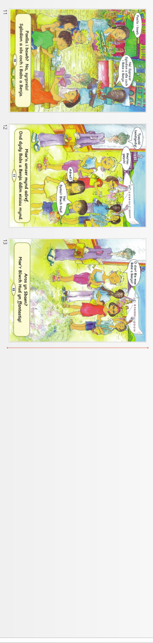
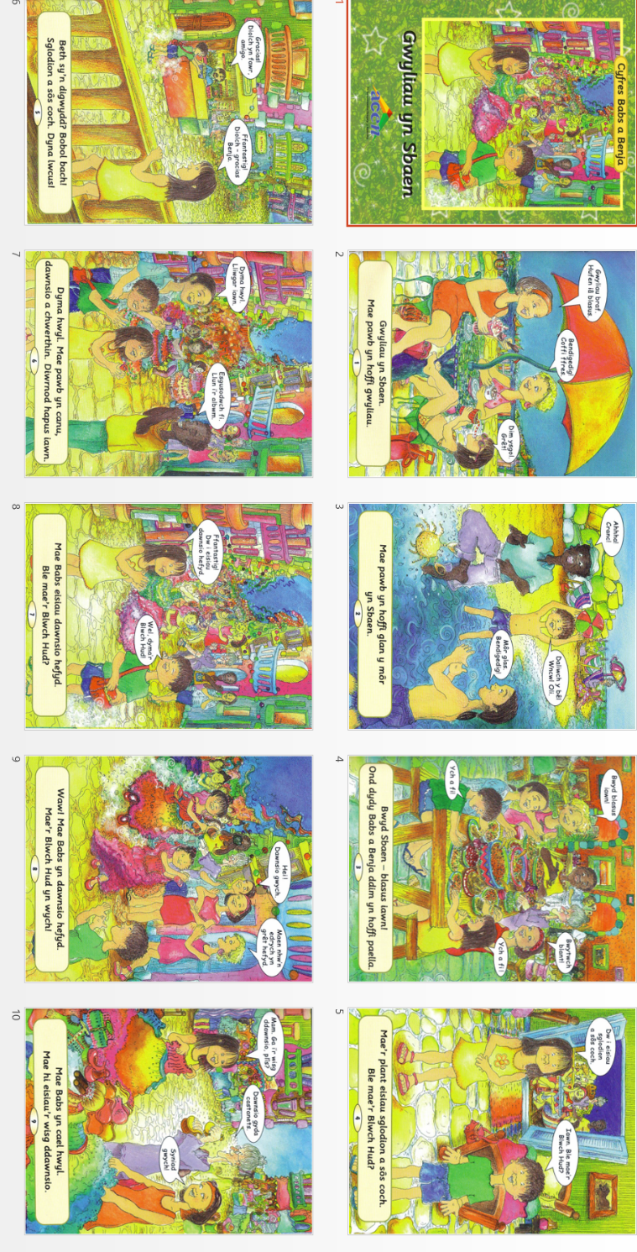

Appendix B

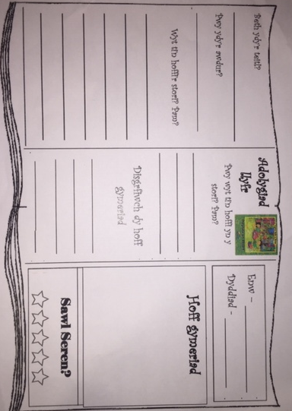

Appendix C

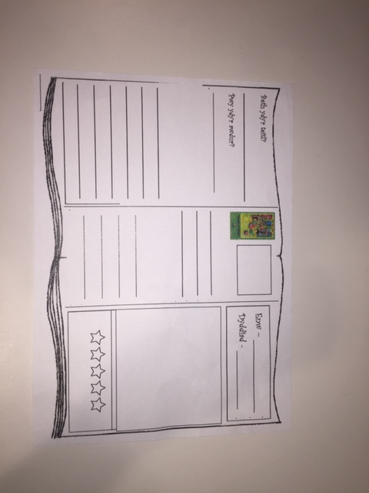

Appendix D

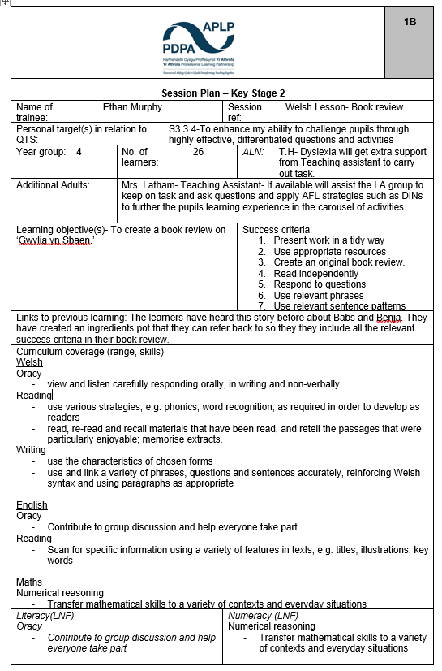

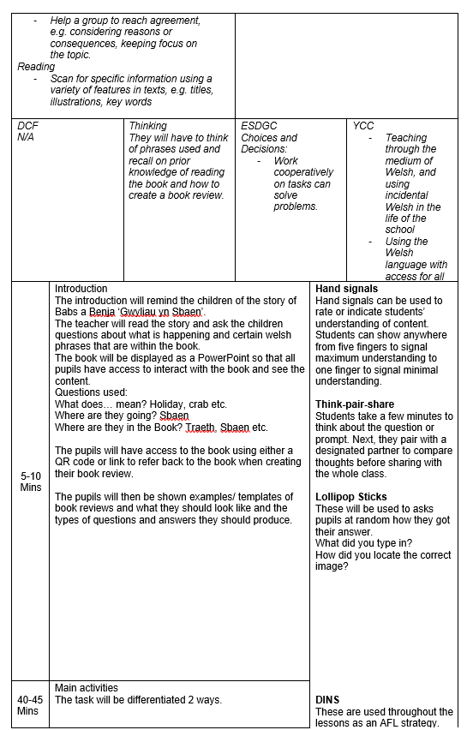
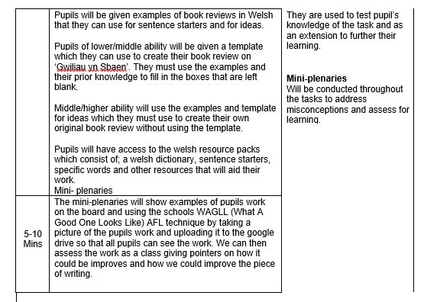

Appendix E



