2007674
Dr Mark Gallagher-Read
BMHP5015_BIRM
E-Portfolio
Changemakers: Building your Personal Brand for Sustainable Employment

Task 1 – Professional Health and social care cv    Profile  Talented and compassionate support worker dedicated to enhancing the lives of her clients through high quality assistance and careful education. Proficient in life, finance, and social skills assisting patients in integrating into society and leading more fulfilling lives. Creative and empathetic worker with over 10 years of experience, building community and developing social skills through incremental therapeutic techniques. Compassionate professional driven to deliver positive outcomes for diverse clint bases. Well organized and resourceful with detail-oriented and conscientious approach. Meticulous in assessment and monitoring to deliver necessary resources for individual needs. Excellent communication and organizational abilities with a pragmatic and flexible mentality. Proven relationship building and planning abilities, self-motivated and can independently solves problems. Prides oneself in helping others.  Contact  PHONE:  01214567757  07448876456  ADDRESS:  Apartment 50 Queen’s College  Chambers,  38 Paradise Street  Birmingham  B1 2AF  EMAIL:  Jaspreetrai422@gmail.com  Hobbies  Reading  Tennis  Ballet  Art  Technology |  | Jaspreet kaur rai  EDUCATION  Harborne Hill School  1998-2002  6 GCSEs  Math – C  English – A  Science – B  RE – A  History – B  French - C  Sandwell College  2004-2006  Level 2 Diploma – Legal Secretary  First Aid ITC  Mathew Bolton College  2006-2007  Level 2 Understanding Working in the Health Sector Certificate  University of Wales Trinity Saint David  2020-2021  Undergraduates Skills for the Workplace Health and Social Care  2021 – present  BSC Health and Social Care level 5  WORK EXPERIENCE  Precious Homes, Birmingham, West Midlands  Day Support Worker  April 2017 – present  Identify service gaps and locate needed resources for individuals including housing, work placement and other support. Collaborate on program operations with Precious Homes, including offering feedback from participants improvement recommendations. Help clients manage and reach individual goals, supporting independent progression and social skills. Analyze overall patient performance and recommend adjustments to care plan goals. Maintain record of daily individual activities, behaviors and pertinent incidents for patient analysis and assessment. Collaborated with external support providers to maintain good care continuity. Transport clients to appointments, shopping venues and entertainment events according to determined schedule. Offered practical daily living advice including, financial planning, living support and legal guidance. Keep clients engaged in social networks and communities for personal health and growth.  Helping Hands Community Care, Birmingham, West Midlands  Visiting Carer  June 2010 – April 2017  Weekly progress reports were created, allowing for appropriate evaluations and changes to care plans. Helped clients with night time routines, such as washing and dressing, in order to maintain healthy sleeping patterns. Service users dietary needs were met by creating meals and snacks based on preferences. Established and maintained positive exercise and social routines based on service user needs. Client medicine was administrated with care and accuracy, with a focus on health and comfort. Client dignity and respect were maintained throughout personal care support. Clients were transported and accompanied to appointments and activities in a safe manner. Assisted clients with daily household tasks including cleaning, laundry, and food preparation. Supported clients in accessing social and leisure activities, developing increased independence and life satisfaction.  Sir Josiah Mason Trust, Birmingham, West Midlands  Housekeeping Assistant  November 2007 – January 2010  Attended numerous staff meetings to maintain detailed understanding of changes to current policies and procedures. Implemented consistently high standards of cleanliness to facilitate excellent client satisfaction. Placed orders for housekeeping supplies and client toiletries to maintain optimal inventory levels. Communicated repair needs to maintenance staff for prompt remedial action. Cleaned and disinfected rooms and communal areas, disposed of rubbish and recycling according to waste management procedures.  Hockley Day Centre, Birmingham, West Midlands  June 2005 – April 2006  Worked as a volunteer four days a week to support adults with learning difficulties. Led a range of group activities for service users including arts and crafts, board games, creative writing gardening to accommodate a safe and positive environment and social interactions. Assisted clients with eating during mealtimes and arranged for outdoor activities to take place safely. Encouraged positive behavior and accompanied experienced staff with transporting clients home. Reported feedback to management when suitable and supported clients with religious needs. Acted as a mentor for service users, providing individualized support and guidance across a range of issues from social development effective decision-making to enhance well-being. Counselled clients through difficult times using approved and compassionate strategies.  SKILLS  Community engagement  Advocacy  Team building  House cleaning  Cooking meals  Medical chart documentation  Communication  Valid Driving License  Life skills development  Care plan development  Activities of daily living  Daily living skills

TASK 2 – COVER LETTER

JASPREET KAUR RAI

Birmingham B1 2AF
07448876456
Jaspreetrai422@gmail.com

13th March 2022

Highbridge Resourcing Ltd

RE: Mental Health Support Worker

Dear Alison Roberson,

I am writing to express my interest in the Mental Health Support Worker position. I am a self-motivated and progress-driven Support Worker with an extensive background in this industry. After reading your job posting for this position, I knew I had the necessary skills and qualifications to immediately bring value to Highbridge Resourcing Ltd. As a candidate who is experienced in the responsibilities associated with this role, I believe that I will perform effectively and go beyond the expectations listed in the job description. I have acquired the skills to help service users accomplish small basic tasks, which helps towards independence that can greatly enhance service users quality of life. In the role of support worker, I strive to create a comfortable and calm atmosphere in which everyone feels valued and a part of the team. Providing care to people suffering from mental illnesses is a wonderful occupation that can be both gratifying and emotionally draining. It requires patience, kindness, and a genuine want to help attitude to be one of the top mental health support workers in this profession and I have what it takes.

While working at my previous and current company as a Day Support Worker, I developed my expertise in treatment planning, life skills development and applying person-centred care. While growing these skills I stood out due to my friendly and compassionate nature. I am currently studying my bachelor’s degree in BSC Health and Social Care with University of Wales Trinity Saint David through which I desire to evolve my knowledge in this sector. My objective is to further apply these abilities as a Mental Health Support Worker, while simultaneously learning new capabilities within the area of Mental Health and Social Care. I am able to deal with difficult situations accordingly and efficiently with a non-judgemental approach and have the ability to develop positive relationships with co-workers and patients.

While I am appreciative for the opportunities offered to me in my previous employment, I am eager to begin a new professional path that will provide me with new challenges to put my abilities to use. I am pleased to be applying for this position with Highbridge Resourcing Ltd as a hardworking and dedicated student with a strong interest in health and social care and look forward to contributing my talents and proficiency in planning toward your team efforts. I thrive in challenging environments, and I am eager to join a company with such clear values and promotes dignity and integrity. My goal is to join a motivated and dedicated team with talented individuals in which I can learn. As Highbridge Resourcing Ltd supply to some of the largest and leading providers of specialist care services in the UK for over fifty years for both children and older adults and with your excellent reputation I would be honoured to apart of your team.

I hope that after reviewing my cv, you can observe my qualifications and potential as a candidate for this position. I would like to go into further detail regarding my how my unique abilities and professional experiences would assist your company. Please contact me to arrange a time and date for a meeting. Please do not hesitate to contact me if you require any further information or references from my previous employers. Thank you for your time and consideration.

Sincerely,

Jaspreet Kaur Rai

TASK 3 – PITCH


(Kiefer, E. 2020)

Ben Marsden, 33, found dead in his cell in HMP Lincoln on 27th January 2022 (theLincolnite, 2022). Liridon Saliuka, 29, found unresponsive in his bed in HMP Belmarsh on 2nd January 2022 (CNNCB, 2022). Saifur Rahman, 39, found the day before his birthday dead in his cell in HMP Birmingham on 23rd January 2022 (Balloo, S. 2020). In fact, not only is the death rate for Covid-19 three times higher in prison than the general population, but suicides in prisons have also rose by almost 30 percent during the pandemic, (UCL, 2021) why is this?
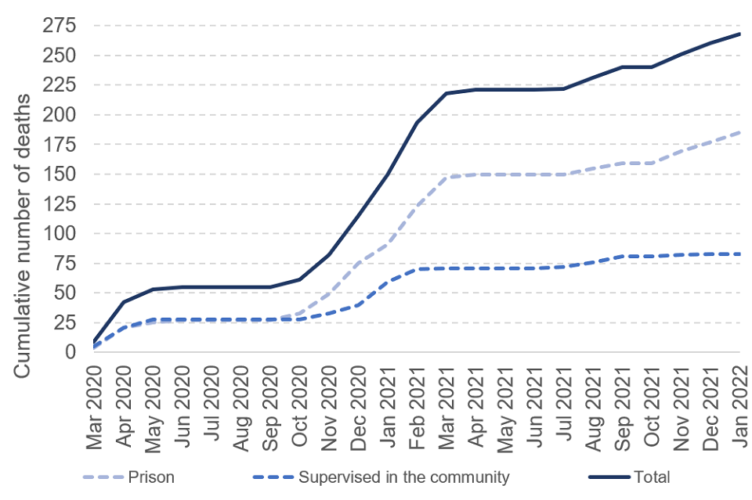
(Gov.uk, 2022)
We secured special permission by the Governors of HMP Dovegate, a category B males prison and HMP Drake Hall a closed category women’s prison, to conduct our research for the documentary ‘Why covid’s extreme regulations are causing mass suicide in prisons’. We have exclusive footage from inside these facilities revealing the new regimes put in place by the home secretary, including intense interviews with several prisoners who reveal the hidden truth about the affects of the new regimes on their mental health. With little focus being given to the affects of the pandemic on prisoners mental health, this documentary succeeds in discovering the causes for the increase of depression and suicide behind the walls. Trials are being put on hold for up to two to three years while prisoners are forced to live in limbo in remand prisons awaiting their fate (Casciani, D. 2021). Prison visits with families and loved ones have been suspended until further notice, home leaves and release to work have also been put on hold causing frustration amongst prisoners. Gym along with other activities have also been suspended and prisoners are forced to remain in their cell for over 23 hours a day, the strain of living in solitude in such conditions are taking a toll on many prisoners. Yes prisons are a form of punishment but to what extent is too far? Many prisoners have worked hard and come a long way to achieve open prison privileges, with the loss of these opportunities prisoners are reaching boiling point and the increase of anxiety and depression is at an all time high (HM Inspectorate of Prisons, 2020). With the suspension of courses long term prisoners are facing longer time in prison due to not being able to progress through the system i.e., categorization. (Insidetime, 2022). So, after 2 years of limited access of exercise, association, rehabilitation, stimulation and contact we see a major rise in suicide rates, in fact in 2020 80 prisoners took their own life in the UK which was recorded at the time for being at an all time high. It has been reported that almost half of women in prisons have attempted to take their life between 2017-2020 and a mental health crisis was established by politicians. With the new lockdown regimes, the number of fatalities has shot up further (Bulman, M. 2020).

In this documentary we take a walk behind the prison walls to discover life in lockdown and how it has affected prisoners mental health and how prison officers are coping with the growing tension behind bars and due to being understaffed there is not enough officers to accommodate any sort of activities. We interview the families and loved ones of prisoners who reveal their feelings about the new regimes and the lack of contact, time away from children is always hard and with no visits it has left mothers and fathers emotional (Colwell, L. 2022). This issue has become a public health concern with more suicides being committed in prison due to the harsh restrictions of Covid. Prisoners reveal the hidden truth of conditions inside that the public are not aware of, they share their thoughts and feelings on not being able to cope with the intense isolation and friends who have since took their own life. We may feel like we know what life in prison is like through tv shows or films, this documentary will shock and enlighten its audience to the real truth of lockdown behind bars.

References

Balloo, S. (2020) Six prisoners die at HMP Birmingham as UK jail death toll reaches record levels, Available at: https://www.birminghammail.co.uk/news/midlands-news/six-prisoners-die-hmp-birmingham-22900728 (Accessed: 13th March 2022

Bulman, M. (2020) Nearly half of female prisoners have attempted suicide, figures reveals, Available at: https://www.independent.co.uk/news/uk/home-news/female-prisoners-suicide-death-rate-mental-health-nearly-half-attempt-figures-reveal-prison-reform-trust-a7724171.html (Accessed: 15th March 2022)

Casciani, D. (2021) Covid and the courts: ‘Grave concerns’ for justice, warn watchdogs, Available at: https://www.bbc.co.uk/news/uk-5571206 (Accessed: 14th March 2022)

CNNBC (2022) ‘Disabled’ prisoner found dead in cell of British prison holding Assange, Available at: https://cnnbc.com/disabled-prisoner-found-dead-in-cell-of-british-prison-holding-assange (Accessed: 13th March 2022)

Colwell, L. (2022) Prisons as a site of care – the health and welfare of older prisoners in UK prisons, Available at: https://blogs.brighton.ac.uk/mentalhealthnursing/2022/03/14/prisons-as-a-site-of-care-the-health-and-welfare-of-older-prisoners-in-uk-prisons/ (Accessed: 15th March 2022)

Gov.uk, (2022) HM Prison and Probation Service Covid-19 Statistics, January 2022 [image] Available at: https://www.gov.uk/government/statistics/hmpps-covid-19-statistics-january-2022/hm-prison-and-probation-service-covid-19-statistics-january-2022 (Accessed: 14th March 2022)

HM Inspectorate of Prisons (2020) Men’s open prisons during Covid-19 – frustration at continued suspension of release to work, Available at: https://www.justiceinspectorates.gov.uk/hmiprisons/media/press-releases/2020/06/mens-open-prisons-during-covid-19-frustration-at-continued-suspension-of-release-to-work/ (Accessed: 15th March 2022)

Insidetime (2022) offending behaviour courses slump due to Covid, Available at: https://insidetime.org/offending-behaviour-courses-slump-due-to-covid/ (Accessed: 15th March 2022)

Kiefer, E. (2020) Coronavirus prison deaths rise in NJ, [image] Available at: https://news.yahoo.com/coronavirusprisondeathsrisenj185250842.html?guccounter=1&guce_referrer=aHR0cHM6Ly93d3cuYmluZy5jb20v&guce_referrer_sig=AQAAAMsT0rtN-cF3NHPtBVY4GY_7Yvx7l9GrsNhQM-CpcsOw8IOEhZoPolZbNZP2ebbTPf06VGP3QUH90OIQMfpQOcdWqCQfXDJMhXEhDtp1TM0rJ6ttpUm9EiPO04FDJXyLLZasf-iCJaGdDRomNItVT5W-HZthEq7UoeElj27HHoT (Accessed: 14th March 2022)

The Lincolnite (2022) Prisoner found dead in Lincoln jail cell, inquest told, Available at: https://thelincolnite.co.uk/2022/01/prisoner-found-dead-in-lincoln-jail-cell-inquest-told/ (Accessed: 13th March 2022)

UCL (2021) Covid-19 death rate among people in prison three times higher than public, Available at: https://www.ucl.ac.uk/news/2021/mar/covid-19-death-rate-among-people-three-times-higher-public (Accessed: 13th March 2022)

