

The Security Implications of 5G router using IOT Devices

by
James Dunhill

Supervisor: Dr Carlene Campbell
Second Marker: Nitheesh Kaliyamurthy

Project submitted as part of the requirements for the award of
BSc (Hons) Computer Networks and Cyber Security

April 2021

Declaration of Originality

I, James Dunhill, declare that I am the sole author of this Project; that I have consulted all references cited; that I have conducted all work of which this is a record, and that the finished work lies within the prescribed word limits.

This work has not previously been accepted as part of any other degree submission.

Signed:

Date: 23/04/2021

FORM OF CONSENT

I James Dunhill hereby consent that my Project, submitted in candidature for the B. Sc. (Hons) Computer Networks degree, if successful, may be made available for inter-library loan or photocopying (subject to the law of copyright), and that the title and abstract may be made available to outside organisations.

Signed:

Date: 23/04/2021

Copyright Acknowledgement

I acknowledge that the copyright of this project report, and any product developed as part of the project, belong to the University of Wales Trinity Saint David, Swansea.

Table of Contents
Abstract 1
Chapter 1 – Project Overview 2
1.1 Introduction 2
1.2 Aim and Objectives 3
1.2.1 Aim 3
1.2.2 Objectives 3
1.3 Structure of The Project 3
Chapter 2 – Research & Review of Literature 5
2.1 Introduction 5
2.2 Cellular Networks 6
2.3.1 Cellular Network Security 7
2.4 Internet of Things 9
2.4.1 Application letter 10
2.4.2 Perception layer 10
2.4.3 Network Layer 10
2.4.4 Threats and vulnerabilities 11
2.5 Slice Isolation on 5G 15
2.6 ARP Poisoning 16
2.7 5G Security Challenges 17
2.8 MITM attack on HTTPS 18
Chapter 3 – Methodology 19
3.1 The Philosophy 19
3.2 The Approaches 19
3.3 The Strategies 19
3.4 The Choices 20
3.5 The Time Horizons 20
3.6 The Techniques & Procedures 20
3.7 Conclusion 20
3.7.1 Hypothesis 20
3.7.2 Hardware 20
3.7.3 Software 21
3.7.4 The Experiment 21
Chapter 4 - Design & Implementation 22
4.1 Introduction 22
4.2 Problem formulation / Design Overview 22
4.3 Design 23
4.4 Software & Tools 23
4.4.1 Kali Linux 23
4.4.2 Metasploit 24
4.4.3 Bettercap 24
4.4.4 Wireshark 24
4.5 Devices & Hardware 25
4.5.1 5G/4G Router 25
4.5.2 Samsung Mobile Device 26
4.5.3 iPhone Device 26
4.6 Implementation 28
4.6.1 Set Up Stages 28
4.6.2 What is Required? 28
4.6.2.1 5G Router 28
4.6.2.2 4G+ Router 28
4.6.2.3 Samsung Phones 29
4.6.2.4 iPhone 29
4.6.2.5 Laptop 29
4.6.2.6 SIM Cards 29
4.6.3 Initial Device and Software Set Up 30
4.6.3.1 4G Router Setup 30
4.6.3.2 5G Router Setup 34
4.6.3.3 Metasploit Setup 37
4.6.3.4 Bettercap Setup 39
4.6.3.5 Wireshark Setup 41
4.6.3.6 Ping & Communication Testing 42
4.7 Experiment Overview 45
4.8 Conclusion 46
Chapter 5 – Testing and Evaluation 47
5.1 Introduction 47
5.2 Evaluation 47
5.2.1 4G Router Results 47
5.2.1.1 MITM Attack 48
5.2.1.2 DOS Attack 51
5.2.2 5G Router Results 59
5.2.2.1 DoS Attack 59
5.2.2.2 MITM Attacks 63
5.3 Overview 68
5.4 Chapter Summary 68
Chapter 6 – Conclusion & Recommendations 69
6.1 Introduction 69
6.2 Summary 69
6.3 Conclusion 70
6.4 Recommendations for Additional Research 71
Chapter 7 – Reflections 72
7.1 Introduction 72
7.2 Aims and Object Refection 72
7.3 Author Learning Reflect 73
7.4 Different Things 74
7.5 Barriers Experienced 74
7.6 Positives 74
7.7 Guidance to the future students 75
7.8 Summary 75
8 References 76
9 Appendices 83
9.1 Appendix 1 – Research Process 83
9.2 Appendix 2 – Block Diagram 84
9.3 Appendix 3 85
9.4 Appendix 4 – Router Diagram 85
9.5 Appendix 5 85
9.6 Appendix 6 - Method 86
9.7 Appendix 7 - Samsung Phone Setup 88
9.8 Appendix 8 – iPhone Setup 89
9.9 Appendix 9 – Kali Linux Setup 91
9.10 Appendix 10 – Gantt Chart 95
9.11 Appendix 11 - Logbook 97

Table of Figures
Figure 1 - The development of Technology over the years 7
Figure 2 - Table of Security for IoT & IT [42] 9
Figure 3 - IoT Classification [42] 10
Figure 4 - Security Threats in IoT Application Domains [45] 13
Figure 5 - Block Diagram Layout Design 22
Figure 6 - Kali Linux Logo [65] 23
Figure 7 - Metasploit Linux [66] 24
Figure 8 - Bettercap Logo [67] 24
Figure 9 - Wireshark Logo [68] 24
Figure 10 - TP-Link 4G+ Router 25
Figure 11 - Samsung Logo [69] 26
Figure 12 - Samsung Phone 26
Figure 13 - Apple Logo [70] 26
Figure 14 - Brand New iPhone 26
Figure 15 - Design diagram for the Implementation section 27
Figure 16 - 4G Router and Sim Card 30
Figure 17 - TP- Link Default Password Setup 30
Figure 18 - Setting up 4G Router Time Zone 31
Figure 19 - Setting Sim Setting 31
Figure 20 - Successful Connection to Sim Card Operator 31
Figure 21 - Verify Setting are Correct 32
Figure 22 - Setup is Completed 32
Figure 23 - Home Screen Showing layout of tools and setting. 33
Figure 24 - Huawei 5G Router 34
Figure 25 - Default Admin Password Setup 34
Figure 26 - Setup SSID Name and Password 35
Figure 27 - Router Log on Page 35
Figure 28 - Router Home Screen displaying device Info 36
Figure 29 - Kali Search Menu 37
Figure 30 - Kali Terminal 37
Figure 31 - Console Setup for Metasploit 37
Figure 32 - Metasploit Menu Running 38
Figure 33 - Installation Command for Bettercap 39
Figure 34 - Installation progressions for Bettercap 40
Figure 35 - Kali Search Menu for Bettercap 40
Figure 36 - Bettercap Running 40
Figure 37 - Installation Command for Wireshark 41
Figure 38 - Installation progressions for Wireshark 41
Figure 39 - Wireshark Running 41
Figure 40 - iPhone Ping Test 42
Figure 41 - Samsung Ping Test 42
Figure 42 - Kali Ping Test 43
Figure 43 - Huawei Ping Test 43
Figure 44 - Nmap Device Discovery 44
Figure 45 - Nmap Device Port Scan 44
Figure 46 - Flow Chart of the Experiment Overview 45
Figure 47 - Testing: MITM Attack using Bettercap by Setting up Parameters. 48
Figure 48 - Testing: iPhone ARP Spoofing 48
Figure 49 - Testing: iPhone ARP Spoofing 2 49
Figure 50 - Testing: Samsung Phone Connecting to the Proxy 49
Figure 51 - Testing: Samsung ARP Spoofing 2 49
Figure 52 - Testing: Suspicious Activity 50
Figure 53 - Testing: Router Home screen 51
Figure 54 - Testing: Wireshark Showing Packets 52
Figure 55 - Testing: Metasploit 53
Figure 56 - Testing: Setting up SYN flood Attack 1 53
Figure 57 - Testing: Running SYN Flood Attack 54
Figure 58 - Testing: Router Discounted from Internet 54
Figure 59 - Testing: Wireshark getting Flooded 55
Figure 60 - Testing: Stopping the Attack 56
Figure 61 - Testing: Rebooted Router 56
Figure 62 - Testing: Changing Target IP 57
Figure 63 - Testing: Running SYN Flood Attack 2 57
Figure 64 - Testing: Showing Router Disconnected from Internet 57
Figure 65 - Testing: Stopping Attack 58
Figure 66 - Testing: 5G Router Connected 59
Figure 67 - Testing: Wireshark Before 5G Attack 60
Figure 68 - Testing: Setting up DOS Attack on 5G 60
Figure 69 - Testing: Running the SYN attack on iPhone 61
Figure 70 - Testing: Cancelling Attack 61
Figure 71 - Testing: Running the SYN attack on Samsung 61
Figure 72 - Testing: Completed Testing of 5G Attack 61
Figure 73 - Testing: Wireshark While 5G Attack is Live. 62
Figure 74 - Testing: 5G Router still Connected 62
Figure 75 - Testing: Probe 5G Network 63
Figure 76 - Testing: iPhone Sniff 64
Figure 77 - Testing: Updated IP Address & Disabled Private Address 64
Figure 78 - Testing: Private Address on iPhone Disabled 64
Figure 79 - Testing: Samsung Showing some IP Address 65
Figure 80 - Testing: Samsung Device Show Security Alert 66
Figure 81 - Testing: Disabling (DSN) On Samsung Device 67
Figure 82 - Research Process for the Project Highlighting the Process. 83
Figure 83 - Onion Diagram [72] 84
Figure 84 – More Detailed Block Design 84
Figure 85 - Router Solutions Diagram 85
Figure 86 - Samsung Home Screen 88
Figure 87 - Samsung Connection Option 88
Figure 88 - Network Mode 88
Figure 89 - Selecting 5G (auto connect) 88
Figure 90 - iPhone Home Screen 89
Figure 91 - iPhone Setting Page 89
Figure 92 - Mobile Data Options 89
Figure 93 - Selecting Voice & Data 90
Figure 94 - Selecting 5G 90
Figure 95 - Kali Install Menu 91
Figure 96 - Kali Time Zone, Keyboard & Language 91
Figure 97 - Kali Setting Hostname 92
Figure 98 - Kali Username 92
Figure 99- Kali Password 92
Figure 100 - Kali Base System Installation 93
Figure 101 - Kali Login Screen 94
Figure 102 - Kali Home Screen 94
Figure 103 - Gant Chart for Task View 95
Figure 104 - Gant Chart Graph View 96

Abstract
This research is aimed to create new knowledge and a better understanding towards a specific area relating to cellular networks security and Internet of Thing (IoT), by attacking and using analysing common threats against a 5G network on IoT devices. This work discusses security threats involving 5G home routers, networks from these new cellular standards have been created for the specifications of 5G, based on this a comparison can be create between 4G and 5G. The availability of certain tools gives the ability to distribute multiple attacks for different IoT devices while recording the data. This work began by analysing different attacks, such as Man in the Middle (MitM), Distributed Denial of Service (DoS), Cross-Site Scripting (XSS), Credential Reuse & Phishing. Several attacks were analysed, throughout the research to determine the best attack to continue forward with in testing. After analysing attack started to investigating Internet of Things (IoT), learning, and understanding about the background that situates with this technology that is emerging. Most IoT devices are manufactured independently and do not follow any ecosystems leaving them open to independent vendors securing them. Furthermore, discussion about IoT and how it operates, gives a backing to understanding how the attacks may affect individual components or sections of IoT devices inside of a network. gives a backing to understanding how the attacks may affect individual components or sections of IoT devices inside of a network.
The overall aim for this paper was to discover and compare the differences between the standards of a 4G network and a 5G network in a home environment, allowing common threats to attack the networks and record the outcome results. Setting out the predictions of this paper allowed for a predicted outcome but from the findings and research it shows that it is not as what was predicted. The focus on this paper was designing a realistic scenario that would be found in a home environment, from this the data that has been collected shows that an attacker would be beneficial to target a 4G home router over a 5G home router. The outcome of this project was able to be achieved from the research giving enough detail and understanding towards the implementation section for the testing to begin.

Chapter 1 – Project Overview

Introduction
Every year a new generation of technology to give better improvements or to give an overall better experience to its last Generation [8], now countries around the world are experiencing the new deployment of 5G networks, with this latest generation of 5G bringing high amounts of speed and low latency [1,8]. This allows for mobile connectivity to be greater than its predecessor, which was 4G. While 5G is growing in demand, the growth of Internet of Things (IoT) has been developing closely to use cellular networks as a way of being able to expand their application usage, giving these devices a new way of expanding their reach to a larger audience [3,4,5,6].
This new generation brings enhanced Internet connectivity and allows for it to accommodate the connection of numerous devices through the Internet of things (IoT) architecture. With this new generation comes significant changes thought proceeds to offer difficulty in trying to connect devices into a network that has inadequate security. The security hindrance comes to light from the restricted protection, ease of access, and a lack of updates on the physical devices.
The growth of IoT becoming more accessible to users, the growth of faster connectivity with new networking technology leads to issues within security [8,11]. Every year there are growing reports that show an exponential increase in exploits and attacks on targeted types of devices, this is down to their simplistic security operation, or even with no security being implemented [1,7]. Create easily accessible ways for hackers to take advantage of these exploits leading to stealing or damaging devices. Creating devices security is overlooked and is only ever being addressed when a problem has been located or notified through data breaches [6,7].
For this project, it is proposing research in new & old security frameworks for IoT devices, by providing A layout that can create a secure network for adding and deploying IoT devices in a home [10,11]. The research will explore different IoT devices that can be easily secure by implementing patches for the most common areas that hackers target on these types of devices. Once a solution is establishing, the goal is to showcase the benefits of having secured IoT devices by comparing a secure device and unsecured device against each other.
For the structuring of this report, there will be a detailed section for the technologies that are going to be researched and used throughout this project, furthermore a section will used to talking about how it was designed. There will be a section on the use of the testbed for analysing and getting feedback and results from the live tests. Around the middle of the report, gaining and analysing the feedback from the live test will have a logged record. For the last section of this report will talk about the summarisation of the feedback with an evaluation and a conclusion detailing how the report went and any additional findings, thus will then lead to the security framework that will be recommended with IoT devices on 5G.

Aim and Objectives

Aim
The aim of this investigation is to investigate various vulnerabilities on IoT devices and perform various attacks on them using a 4G & 5G networks, with the ability to find and identify security flaws.

Objectives
Using these objectives laid out step-by-step should guide and assist this report.
- To Research into different areas of 5G and IoT devices and to gather information about security.
- To investigate different types of vulnerabilities that are commonly found within IoT devices over wireless networks.
- To conduct several experimental attacks on various IoT devices
- To analyse and evaluate the outcome from the attacks.

Structure of The Project
The structure of this project is outlined as follows:
Chapter One is based on background studies of the report; furthermore, containing the aim and objectives that will be outlined through this research, giving a structure that is necessary for a successful outcome.

Chapter Two is based on the literature review and concentrates primarily on background research of this project’s technologies that are going to be used, furthermore looking at additional research papers and books.

Chapter Three contains the methodologies of this project and will be used to give more details towards the objectives of this project, being used as a general discussion for the research design, research methodology and research methods for data collection. This will help to justify the research design in relation to the objectives.

Chapter four is explaining the design and execution that has been selected for the project going through different designs and approaches with justification for the final implementation to be used.

Chapter Five is going to be the testing of the experiments and recording the results.

Chapter six contains the results of the work and will be presented with a critical discussion. This will cover the findings that were found in the testing, it will show the goals achieved. However, talking about further research areas to investigate in addition to uncompleted work due to time constraints.

Chapter Seven is the last chapter talks about many points that have been made across this project and detail reflections on how this project was conducted and the overall progress of the aims and objectives.

Chapter 2 – Research & Review of Literature

Introduction
The security of 5G devices is very important to keep users secure, because any single security flaw in a device could enable an attacker to steal sensitive information, control a device or access a network. The latest research from Cisco shows that the next generation of 5G devices are highly vulnerable to IoT threats [13]. Over the last decade many popular large IoT devices have been compromised to a lack of security of manufacture updates, moreover this can lead to exploits from not getting patched, which can cause the system to stop responding or lead to personal information being stolen [22]. This Project will be exploring this vulnerability that is found in IoT devices using 5G., which can cause the system to stop responding or lead to personal information being stolen [22]. This Project will be exploring this vulnerability that is found in IoT devices using 5G.
As 5G is a new emerging technology that is shifting from its predecessor of LTE to a more powerful millimetre-wave radio signal that allows for higher speed and lower latency to be received by the end device. With this comes to a problem with a lack of security being enabled on new IoT devices being setup [21]. These devices are being added to 5G networks around the world having vulnerability for hackers to take advantage. A large majority of hacks are common vulnerabilities that are found to be listed by OWASP Foundation [23, 24]
Over the years there have been plenty of security frameworks created, and some have been updated to more modern standards and rules. For new technologists, a new framework gets created and applied to them. This is the same for IoT and 5G frameworks have been created and set out for all these and will be updated over time, as everything develops [25]. This investigation is going to explore the vulnerability inside a selection of IoT devices [11, 19]. As to why this investigation is important it will create a project to display the importance and need for basic security in IoT devices in homes.by exploring the vulnerability inside a selection of IoT devices [11, 19]. As to why this investigation is important it will create a project to display the importance and need for basic security in IoT devices in homes. As to why this investigation is important it will create a project to display the importance and need for basic security in IoT devices in homes.

Cellular Networks
Every decade seems to bring a new generation of cellular networks that offer bigger and better improvements than the last generation, these are mostly the Frequency, Bandwidth, Access System and Technology. The first interaction of the standard launched in 1979. Was analogue, and capable of voice only, in addition to supporting a maximum frequency of 30KHz [26]. There were different technologies used to allow 1G to work, around the world different versions were used; the UK adopted Total Access Communication System (TACS) for its infrastructure.
Over the next decade, the development of the next generation was being designed for its launch in the early 1990s. 2G offers more in its ability to send text messages and give a better secured voice communication. Furthermore, changing from analogue to digital allowed access to the internet, although the speeds were considerably slow, offering a connection of 14 kilobits per second. The supporting frequency at maximum was at 200KHz [29]. With this new generation came new technology standards which was the Global System for Mobile Communications (GSM) that most countries adopted instead of having separate independent standards for countries. D-AMPS, IS-95 were technology standards used at the same time, just not common there was another standard CDMA this was more prevalent in country such as USA & Japan.
Another decade passed with development of another generation being ready to launch at the beginning of the 2000s, 3G was created to upgrade for faster data transfer rates. with a new wideband wireless network which allowed it to be more coherence. This offered a new services global roaming, moreover it operated with a range of bandwidth from 15-20MHz used for High-Speed Internet Services [26]. They continued using the same technology from its predecessor GSM, but it was improved with an overall better efficiency. This generation uses an upgrade in the technology by operating on W-CDMA. The spectrum that is used is between 400 MHz and 3 gigahertz that was allocated to 3G. The overall improvements 3G offered was faster communication, being able to receive larger messages, video conferences, streaming services [29].
Around the start of the 2010s came for g the Next Generation, this brought a new technology called LTE which stands for long-term evolution. This technology offered the ability to migrate 3G Technologies over UMTS and CDMA2000. Another technology was being developed called WiMAX, but LTE was instead deployed in favour as LTE is a much more efficient technology than its predecessor as it can reduce the latency of transfer rates, another reason for this was due to cost making more affordable for mass deployment [29]. When 4G launched the averaging speed was around 17 Mbps, after some time enhancements were introduced by bringing out new standards of LTE these were LTE-A and LTE-Pro, this allowed the speed to increase as 3G was reduced and the frequencies bandwidth was given to 4G, these could support speeds up to a maximum of 1GB. Unlike its previous generation it had issues when launching to consumers, 4G technology was expensive hardware to buy, and very battery demanding. 4G was a growing technology with users and needed to have high security, so it was built into the infrastructure [29].
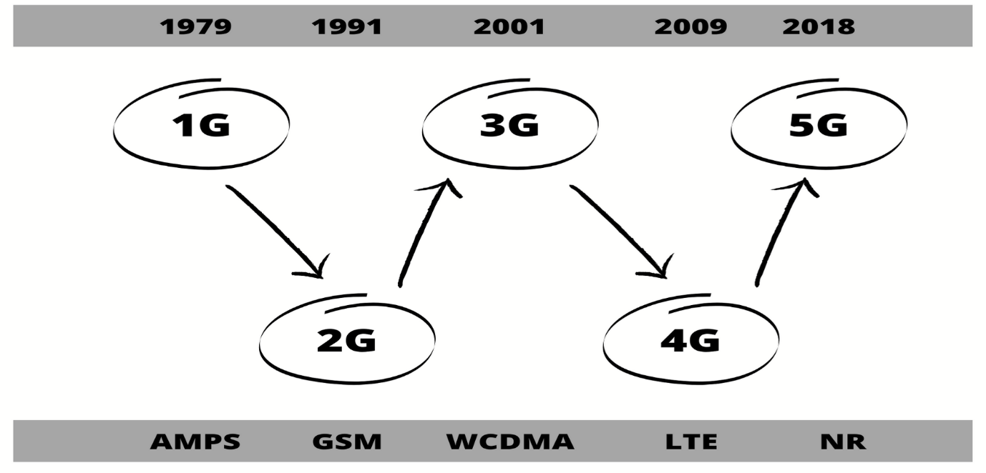
Figure 1 - The development of Technology over the years

5G is currently the latest standard of cellular network technology, compared to the previous generations it is better, more efficient, and more secure. This new technology standard has been able to reach faster speed of over 10Gbps, on average this will give the end user approximately 150Mbps. For this new technology to be used a new standard had to be made, this led to the creation of NR (New Radio), for the 5G network. 3GPP has set this as the standard for the air interface [30].

Cellular Network Security
At the beginning of the development process of 5G it was decided by the standards organisation that 5G would be the first mobile architecture to support specific use cases, meaning it would be allowed to use its own cyber security requirements. This was created to enable IoT applications that are built for massive amounts of data usage in infrastructure to be more secure, for example smart cities will have lots of sensors that will be transmitting data as well as receiving data. It would be crucial to stop hackers accessing this data or hijacking devices to perform denial of service attacks or man-in-the-middle attacks on city sensors [36].
A security solution that 5G designed was the ability for network slicing; this gives the 5G operator the ability to virtualize the network; this allows them to divide a single network connection into multiple virtual connections that can provide different amounts of resources for specific types of data traffic. This new technology is based on existing technology as software defined networking (SDN) and network function virtualisation (NFV) [34]. In combination these two technologies allow for better network flexibility through the ability of partitioning of the network architectures into virtual segments. For 5G, a single physical network can be sliced into multiple virtual networks that can support different radio access networks (RANs) or will be offering different service types running on the RAN. Overall, this will be used primarily to partition the core network up and will be used to implement RAN [35].
Network slicing will maximize the efficiency of 5G networks giving both an optimised utilisation of the infrastructure and allowing the allocation of resources to be distributed evenly. Overall, it will give a greater energy and cost efficiency in comparison to previous generations [35].
This is achieved is by having a set of independent logical network functions that are used to support the requirements of a specific use case. Logical aspect of the network is software-based, from this point the network will be optimised to provide the resources and the network topology for all the specific services that are needed to function correctly. These will be adjusted depending on the requirements each use case requires such as Speed, Connectivity, Coverage, Connectivity. With some exceptional functional components being shared across different network slices depending on use case [36].

Internet of Things
Every year millions of new devices are connected to the internet around the world with a growing estimation of around 22 billion devices connected to the internet as of 2018, this will continue to grow to an estimated 50 billion by 2030 [33]. Multiple regions around the globe are investing billions into IoT infrastructure, these areas are Europe, North America, and China. With these new infrastructures they are creating Smart Cities, Smart Environments, Smart Grids, Smart Metering, Smart Retail, Smart Farming & Agricultural and Smart home Automation [33]. With this global increase of IoT devices it will also bring the number of machine-to-machine (M2M) connections up from 5.6 billion that was estimated in 2016 to an estimated 27 billion in 2024. This increase brings up a major expanding corner of IoT and the market industry will expand with an increase in the digital economy. This is suggested that the global market expected to grow from 2019 at $212 billion to $1.6 trillion by 2025 [33].

With the fast growth of IoT applications comes the issue of security and privacy. IoT devices have a major downside in comparison to cellular networks, Wireless Sensor Network (WSNs) and other technology which are managed and regulated by committees, boards, or associations. IoT does not have its own, therefore there are security challenges that include Authentication Issues, Management Issues, Privacy Issues, and Information Storage. The main issue with IoT devices is there is no framework or ecosystem for new emerging IoT applications to follow which limit the usage and appeal to groups.

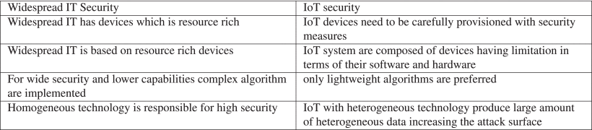
Figure 2 - Table of Security for IoT & IT [42]
IoT is classified into three layers: Application Layer, Perception Layer and Network Protocol; this can all be shown in figure 3.
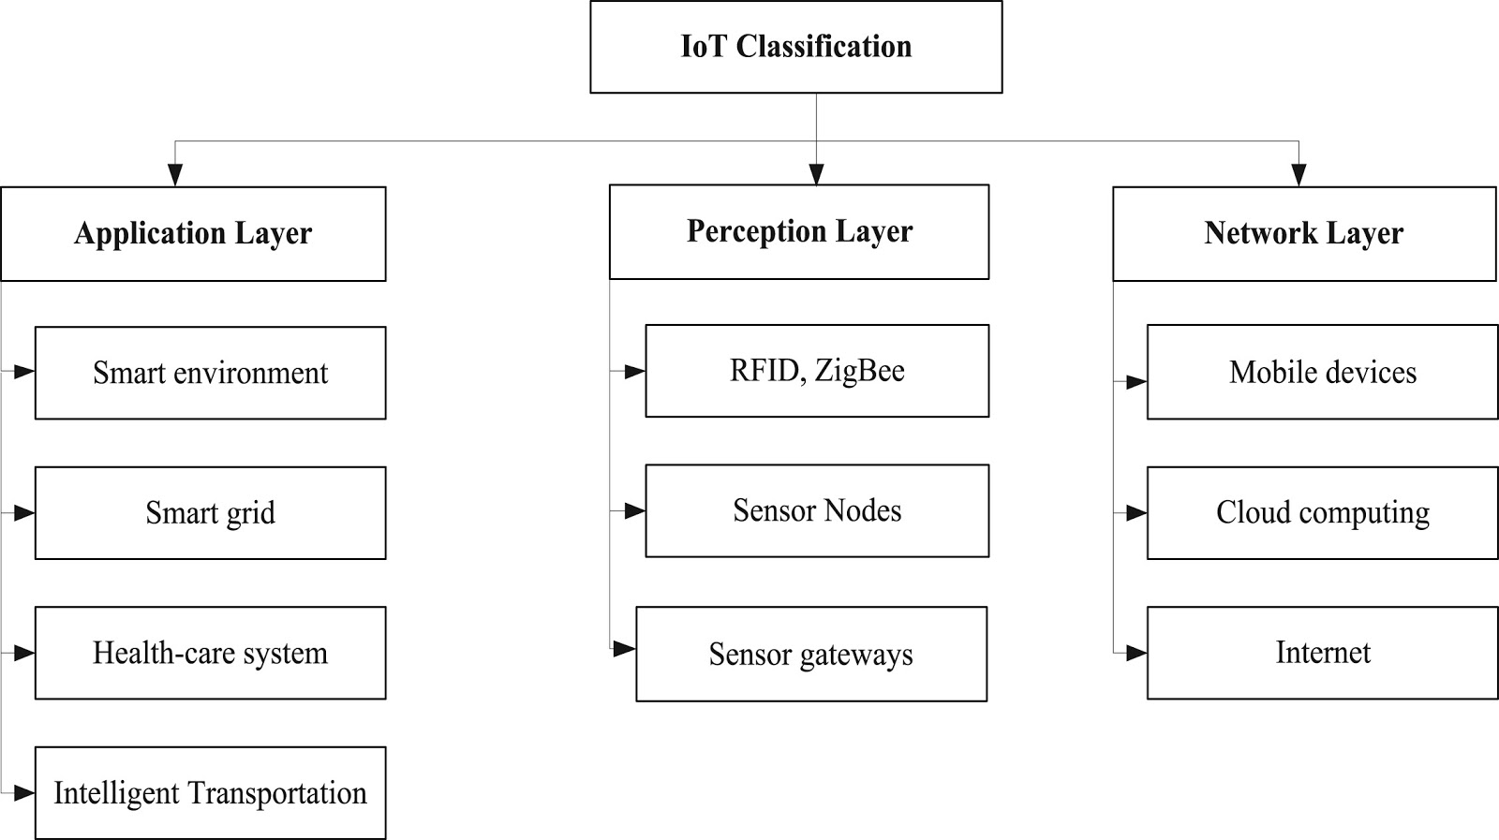
Figure 3 - IoT Classification [42]

Application letter
The application layer is a technology that is commonly used around devices that are constructed with a universal standard built on top of them for manufacturing and production. The situation with IoT is that there is no universal standard on the application layer protocol [41]. With the way that the application layer is structured it can be offered to serve in multiple ways based on the service it is offering, as the application layer is the highest layer and is visible to the end users that are operating these devices. These devices could be used in Smart Cities, Healthcare Systems, Smart Grids and Smart Metres [41]. The most common types of devices that are used are Middleware, M2M2 Communication Protocol, Service Support Platforms & Cloud Computing. With the security, these have issues depending on the industry and the environment that are using the IoT.

Perception layer
A quick understanding of what the perception layer is split up into two main areas for collecting information the first section is named the perception node and this uses sensors and controllers. The other half is called the perception network that interconnects the internal network layers [43]. Perception layer uses a multitude of different types of sensors such as RFID, Sensor Nodes & Sensor Gateways. With the data that is acquired it is controlled at the perception node while the control instructions that is used for sending and controlling the data that is transmitted is sent from the perception network layer [42].

Network Layer
The network layer provides communication, this transmits information securely and delivers prevent access to environments, this is sent to the perception layer, this is the data transmission and the storage awareness the devices that are used would be mobile phones cloud computing and the internet [44].

Threats and vulnerabilities
Threats and vulnerabilities are a constant concern every year with a rapid increase of hackers gaining remote access to IoT devices, installing malicious software or maliciously stealing and leaking data. If a vulnerability is not detected it can be left open and used to exploit entire systems, the damage this can lead to is a serious threat to the whole network security. As manufacturers of IoT devices primarily focus on potential uses that the device can offer, security becomes an afterthought as it can create a hindrance on the device’s practicality. Some of the biggest threats that can affect IoT devices are common attacks that are used in current day systems still [45].

Weak Authentication Mechanisms
Opened occasion mechanisms are in place to allow users to access their accounts via login screens, this method has been around for many years now and has not changed the principal of how it operates, the back end of the security is more encrypted and secure, but they still are hackable [45]. When hackers are trying to gain access to account details the primary method is to start off by using a dictionary attack, hackers would use wordlists to try and gain access to accounts, by using a word list it would act as a password list trying every word until it completed, moving on to a brute-force attack would start of using single letter or digit moving up in length until it succeeds. In most modern-day systems are designed to be more secure with minimum requirements that needed to be met for when setting a password, these are optional decisions that the administrator can choose to enable on the system; Minimum length password, History of password cannot be used, Account can be locked if not used over a set amount of time, Passwords can be expired, Ability for not allowing user IDs to be linked when creating or updating a password [45]. Web services that offer secure logins sometimes give out too much information when incorrect user details have been entered. Incorrect details can result in the database giving back an error that will display information to hackers allowing them to target certain areas to gain access. A type of error that would be returned would be “invalid email” or “incorrect password”, giving too much information out.

Denial of Service Attack
A common threat that would be utilised against IoT devices or potentially using them to create a problem would be a denial-of-service attack. The main intention for this attack is to create disruption for traffic on a targeted device or system by creating slow responses or overwhelming to the point where the system crashes. The most effective versions of this attack use multiple compromised computer systems that individually are sending packets to a destination to flood the incoming data. As the system starts to get overwhelmed with data packets the network will start to slow down as it will be unable to handle the amount of data being processed. The expected result of this is to create traffic jams clogging up the network, preventing regular data from being received at its destination. destination to flood the incoming data. As the system starts to get overwhelmed with data packets the network will start to slow down as it will be unable to handle the amount of data being processed. The expected result of this is to create traffic jams clogging up the network, preventing regular data from being received at its destination.

Malware
Mirai is a malware that can infect network devices that are running on Linux, this will be operated as a bot that can be remotely controlled as a botnet. This is conducted by attacking insecure IoT devices by scanning the internet of open Telnet ports, once found it will then try attacking with default password or password list. On the 19th of September 2016 the first big attack happened on a hosting company in France called OVH. This attack was targeting systems that were hosting game servers by trying to bring them down.

Malicious Attacks
Sybil Attacks are a high threat with IoT devices, this is done by using malicious nodes to impersonate an operational IoT node. Once successfully impersonating the identity of a compromised node, an attack will primarily focus on the network’s performance and try to bring it down or slow by flooding channels with false packets to create delays within the system, leaving it inaccessible to users. It will also be eavesdropping on traffic to listen for additional information, and it can fabricate messages [51].

Physical Security of IoT Nodes
Physical hardware is always vulnerable to being tampered with, therefore it is very important that IoT devices that are unattended must have good built-in security and outside ports need to be locked down. If the outside ports are not locked down an intruder can access this through USB or some other ports that are kept open for maintenance [52]. Depending on the IT device, external methods of entry can also include SD cards that can lead to access directly to the operating system or modifying the operating system. With the lack of physical security hardening this can result in two attacks which are node cloning and side channel attacks [52].
‌
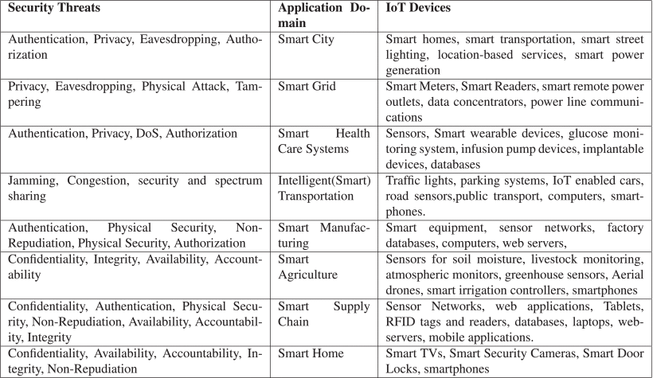
Figure 4 - Security Threats in IoT Application Domains [45]

Node Cloning was stated earlier in the beginning of the section, that there is no ecosystem or standard that IoT devices follow, this leads to a lack of standards that devices use meaning that certain types of sensor nodes are developed without any hardware tampering proof mechanisms [54]. Unattended IoT devices can easily be replicated and accessed by unauthorised users. Having replicated it nodes though individuals can launch several attacks and with the compromised nodes can have access over the network [54].

Side-channel Attacks are oriented around the side channel information about the devices in encryption. The information that is transferred is plain text or cypher text messages. The attacker is using cryptographic operations to obtain this information. the information that is trying to be obtained would be processing time, electromagnetic emissions, and power consumption. Once the information has been obtained it will then be used to reverse engineer the cryptographic system that is by using the device [55].

No Energy Harvesting on IoT nodes are more vulnerable to resource exhaustion attacks, from this there are no mechanisms to harvest the energy of low powered IoT nodes. The problems that this can face are attacks that would jam the communication channels causing extensive and authorised utilisation of resources such as bandwidth memory CPU time and disk space. Furthermore, it will lead to having batteries being drained, subsequently more power from IoT nodes fail to supply services to users. Taking advantage of these exploit vulnerabilities will allow the attacker to drain batteries of devices, create sleep deprivation attacks, dos attacks or node outages [56].

Battery drainage attacks drain batteries on its device is done by flooding the note with many requests that can end up exhausting the batteries [56].

Node outage - The remaining different forms of attacks that could lead to preventing the edge nodes on the system performing their functions these attacks can lead to battery draining, unauthorised access, sleep deprivation etc [54].

Slice Isolation on 5G
A paper titled Towards Secure Slicing: Using Slice Isolation to Mitigate DoS Attacks on 5G Core Network Slices was a study on the next generation of mobile communications being rolled out, allowing for service providers to start implementing and carrying out upgrades to the infrastructure. This researcher aims to provide a study to explore network slicing technology, furthermore an investigation of security concerns that are evolving 5G technology Sattar uses a mathematical model that can supply on-demand slice segregation as well as guarantee end-to-end delay for 5G core network slices.
The study reveals that 5G has security challenges involving IT network slicing technology, showing different technologies that are used showing vulnerabilities and exploits that attack can be taken advantage of, with a main attack being DoS Flood [47].

Other researchers have found different methods or ways of finding a solution. M. A. Javid et al. have worked on 5G artifacts that orients around DOS [48]. Mamolar et al. have used multi-tenant networks to detect DOS in 5G [49]. Furthermore, B. Hussain et al. when down the deep learning path for DOS reduction in 5G [50]. An overall view on different ways that can be used to mitigate DOS attacks.

Reading through the two authors of the papers there do not contradict them self’s in there finding or questions, moreover the questions that are set out are well addressed, giving a detailed depth of understanding to show what they achieved. The two authors give high eminence of following through their research allowing the reader to comprehend their findings. Furthermore, X. Li, et al [58], found their research to show that they considered both the inter-slice and intra-slice isolation, through simulation and testbed, this gave them an evaluation, that verified complete slice isolation mitigates DoS attacks.

In summary, the article provided an extensive and detailed understanding of their simulation and experiment, this study gives a solid conclusion to DoS attacks and how they are operated on 5G networks and the potential to lead to IoT devices. In addition to this the article also outlines the risks that may occur from unprotected 5G networks. The results were shown to use slice isolation to reduce the impact of attacks that were Distributed denial-of-service attacks. With a combination of experiment testbeds and simulations 4 flooding DOS attacks and slice-initiated attacks with an overall result that completed with a slice isolation provides the best mitigation for these attacks. The research led to an interesting point about bandwidth. An average bandwidth that is available to clients was a fraction of the requested bandwidth that happens when there is no isolation. Furthermore, it did lead to an impact of DOS on average available bandwidth but when their solution was enabled it was minimal [47]. In conclusion the research that was found led to slicing isolation provides better and stronger resource isolation but moreover it does reduce the efficiency of the resource utilisation. as for the inter slice isolation this provides better control with the trade-off between security availability and resource utilisation [47].

ARP Poisoning
Reading W. Gao et al., “ARP Poisoning Prevention in Internet of Things,” 2018. Talks about Address Resolution Protocol (ARP) poisoning attack that can affect IoT devices. The author goes on to talk about how ARP is responsible for resolving an IP address that is corresponding into a MAC address. The author continues to mention that ARP attacks still threaten many Internet of things (IoT) and computer systems [60]. At this point the author start to mention about to finding a method to prevent ARP attacks on IoT Devices, discussing the defence method to be used. To achieve this the author creates a small test bed which involves setting a static IP address in the single-chip microcomputer to MAC address on the Ubuntu device, this will then have the router’s static ARP cache table. Furthermore, the ubuntu machine has been turned in to a monitor that is showing the traffic, this was done by enabling IP forwarding function [60]. After this, tools were used to find and detect attacks using software such as Wireshark. Another tool that was used was arptables to intercept malicious ARP packets [60]. Overall, the method the author used was able to intercepts the attacker’s information & then block the attacks packets to a certain level [60].
Other researchers have found different methods or ways of finding a solution in defending from attacks. P. Zhao et al., “P3: Privacy-Preserving Scheme Against Poisoning Attacks in Mobile-Edge Computing”, talks about Privacy-Preserving Scheme with mobile edge computing [61]. Another paper by P. Sinha et al., “Information Security threats and attacks with conceivable counteraction”, mentions W. Geo research in different forms of attacks and how they can affect the end user [62].
The research does a very good job at documenting it experiments, giving it enough detail and understand to follow to recreate. There are diagrams of the framework platform explain the how the ARP attack will work and where it will hit the system. Moreover, the Aim / Object that was created has been answered and giving detailed response to his finding to what there had achieved [60].
In summary, the authors approach to this paper was to prevent ARP poisoning specifically in IoT by using software (arptables). The system can catch information of the attacker, moreover its able to filter or block the attacker. The author goes on to talk about IoT is not mature enough, as the technology is not ready. The overall outcome was found multiply devices are capable for monitoring at the same time, by binding IoT nodes Ip Address to the Ubuntu MAC address in routers static ARP table. Lastly, the author talks about adding shell scripts in future to automate and improve manual areas [60].

5G Security Challenges
Reading A. Dutta and E. Hammad, “5G Security Challenges and Opportunities: A System Approach,” (2020) offers an insight into the security challenges of 5G. The author talks about the 5G redefining current models of end-to-end connectivity by offering more reliability, this includes security to support the new generation of enabled 5G devices.
5G trustworthiness highlights the importance of embedding security capabilities from the very beginning while the 5G architecture is being defined and standardized. Security requirements need to overlay and permeate through the different layers of the 5G systems (physical, network, and application) as well as different parts of an E2E5G architecture within a risk management framework that considers the evolving security threats landscape. 5G presents a typical use-case of wireless communication and computer networking convergence, where 5G fundamental building blocks include components such as Software Defined Networks (SDN), Network Functions Virtualization (NFV) and the edge cloud. This convergence extends many of the security challenges and opportunities applicable to SDN/NFV and cloud to 5G networks. Thus, 5G security needs to consider additional security requirements (compared to previous generations) such as SDN controller security, hypervisor security, orchestrator security, cloud security, edge security, etc. At the same time, 5G networks offer security improvement opportunities that should be considered. Here, 5G architectural flexibility, programmability and complexity can be harnessed to improve resilience and reliability.

MITM attack on HTTPS
Reading an online scholarly Journal by the author G. Drago at al., “Man in the middle attack on HTTPS protocol” [70]. Using a HTTP attack which is also known as a man in the middle attack allows the attacker to impose between the user and the computer it communicates with this allows for it to read and even modify the conversations that are taking place. The author of this begins to open about the dangers and the threats that could be perceived with https protocol attacks in this he lists a range of threats from ecommerce banking and online shopping to where this information can be stolen and then starts to go back into the history of HTTPS and where it came from by using SSL certification [70].
The author goes on to the concept of a man in the middle attack breaking down how the attack works in detail giving an understanding and an explanation behind the components that are needed to be done too successfully. The author goes on to talk about how the attacker exploits the HTTPS server and sends over a certification with a public key to the web browser if this certification is not trusted then this means that the entire communication path is vulnerable to an attack from this the attacker can replace the original certification the authenticates the HTTPS server with a modified version of the certification allowing for the attacker to successfully. Off the certifications have been modified the browser will be offered a warning from this the user will be able to accept the risk or can leave the website, once the user is accepted then I successful attack has begun. The attacker becomes the gateway and can view all the information being transmitted and is able to modify or hijack the session in active [70].
The MITM attack is done and emitted by modifying the Resolution Protocol (ARP) and the Domain Name System (DNS). ARP poisoning is used on regaining the traffic relayed over a switched LAN network using direct IP forwarding. Provided that ARP requests are communicated; the attacker can read & Learn of other hosts. IP addresses [70].
The Journal does not give any practical evidence for any work that has been achieved, a fair amount of research has been made into an example of how an experiment can be conducted. From this, taking the information given, modifying it to fit around this projects testing. This will allow for testing of a man in the middle attack to follow an existing example by these researchers. As shown in the evidence of a practical attack the paper does show possibilities of a web-based attack through HTTPS by exploiting some of the properties of common Lan networks .
In summary this paper does not offer any practical or any evidence for what they are saying but it does offer a vast amount of research and data that could potentially be used for this project and its testing phases as testing this during 4G and 5G or allow for this project to show if amount in the middle attack would work on a 5G network but also taking from what this research has said to being a viable attack.

Chapter 3 – Methodology
The Methodology section discusses the research method and design of the project. The aim of this chapter is to be able to justify any findings towards the research design that is in any form to the objectives of the research. throughout the development of this report the overall design may evolve and change as new understandings and learning develops makeshift be overall design. Referring to the appendices under appendix 1 their flow chart of the process used, it is based on the onion diagram. As well as a diagram of the onion diagram [72].

The Philosophy
There will be numerous assumptions made while embarking on this research, there are three different types of philosophy that most studies follow, this study will be using a positivism approach as it offers a study that is more scientific in its results and findings for testing. For this project, a 5G network will be set up with two or three devices connected and will have a laptop trying to disrupt the connection this will be obtained by ensuring the authenticity of the experiment; this will be compared to a previous generation 4G router. Using professional software that security analysts use will allow the experiment to be conducted. This can then lead to collection of data for analysis of the attack that could be used, in showing how previous attacks are effective on current 5G routers.

The Approaches
The approach for this report would be using an inductive research method, it starts with the aims and objectives achieved during this research, gathering information, and recording it in the literature review will form the groundwork of this report. Using a laptop with Kali Linux will offer a variety of methods to be used and harnessed. In comparison to alternative method as deductive, this starts with an existing theory and not an observation which is best fit for the project.

The Strategies
To achieve the overall aim of the project, a plan of action is required. This plan involves in-depth research into security hacks involving 5G Architecture as well as various number of IoT devices. From this being able to conduct, where they are used, who they affect and why they are used. To gather this information for this approach using certain site will used to attained research data required, Site that will be used are: Science Direct, IEEE Xplore, Research Gate. This will assist in finding different types of DOS attacks and MITM attacks, gathering more information of these will give a depth of details of knowledge to use. Once the research is completed and collected it will offer a rich and detailed backing of information that will aid in analysis is carried out.

The Choices
The choice of this method will be using multi methods as it uses two or more qualitative is observed in the experiment.
The operations of this will be using a laptop on which an attack will be carried out against a 5G network. targeting IoT devices connected to the 5G network will allow analysis of the data on them before and after the attacks. This will identify certain vulnerabilities and sets of data that can be collected. From this a report will be generated detailing the outcomes from the experiment.
After the analysis is completed using the results to identify and review what attacks worked and which ones failed when attacking the IoT devices. Using a checklist to mark off attacks that were successful and unsuccessful will distinguish which attacks to continue with if successful. using the 5G router and altering the settings will give different results and outcomes that may impact the performance or security. This information will be logged, recorded, and analysed in the report.

The Time Horizons
The approach for the time horizon would be using a cross-section data, these are designed to obtain the information on variables in different contexts but is record it at the same time. Over a short period of time the data is collected, to which is then analysed and interpreted. This will allow for the research study to take snapshots of the ongoing situation with the experiment.

The Techniques & Procedures
This is the final layer of the research, this is where primary data would be collected alongside with sources of the project, this will lead to analysing and interpreted into results using, screenshots of the testing, video of whether the study was successful or a failure.

Conclusion

Hypothesis
- Devices that are connected to the 5G router will be disconnected from the router rebooting or shutting down, this while the router is being attack with both attacks.
- The Network will continue to operate with no affect or very small affect overall.

Hardware
The use of hardware for this test requires the use of two 5G enabled devices, one laptop, one 5G enabled router and a 4G enabled router. In combination, these devices will be used for the testing of DOS and MITM attacks. These devices will be logged and recorded with all findings going into a document for analysis.

Software
The software that will be used is Kali Linux, this will be the operating system that will be used to run the Linux applications, these applications are including but not limited to bettercap for the MITM Attack and for the DOS attack using auxiliary modules within Metasploit.

The Experiment
The experiment has a lot of challenges to overcome, to solve the problem by testing of 5G router and a 4G router and initiating the same attacks well show either the same or different results, giving an outcome that will answer the question for this research. With the findings of the research, it will allow for the development of a simple framework for 5G routers based upon the experiment results. As for the consistency of this experiment it is used in controlled environment allowing for alterations to be made whilst the experiment is going to allow for better accuracy and to give better feedback and results for reliability. It could also be changed from attack to defence, allowing the routers to have more security put on them to show the level of security protecting the devices connected.
The experiment using two devices that are connected to a 4G router as well as a laptop running Kali Linux preloaded with software such as Metasploit to initiate attacks on devices connected to the 4G router. The devices would be connected on a 4G SIM that would relay data between the two devices, using very common applications such as web browser versions of social media and video sharing platforms. The laptop will then start to run different attacks that will either try stop the device establishing connection to the network or will try to steal information that is being shared between the browser and the device user, allowing for a man in the middle attack. If the attack is successful and information has been gathered on a 4G device, then the experiment was successful in results prediction. This would then be replicated onto a 5G router with 5G devices using the same attacks and same websites to see if the outcome were the same, if the results are the same then 5G has not improved the security enough on its default settings to be able to prevent these types of attacks. Using two different routers by separate manufacturers, gives a look at updates and hardware for comparison.

The following chapter will start to explore the designing and implementation stages of the project. It will start to discuss how the design process explores the problems that this project is trying to answer. This will also start to dictate on how these problems are going to be answered looking into the tools and software more in detail, by providing explanations and diagrams to illustrate the path that will be used. Going to the design stage in the next chapter will be talking about the design and implementation, using information from the literature review will help layout the testing. This will be used to justify the design and understanding to why this was used for the final iteration.

Chapter 4 - Design & Implementation

Introduction
This chapter of the project is about designing and implementing the experiment, as well as discussing findings and results. The outcome will be comparing the results of the 4/5G routers from the attacks. This chapter has been broken down into multiple sections that break up the design area of the project and the implementation area. The first part of this chapter looks at the design and how it can solve the problem of this project as it starts to breakdown the question by outlining the problems that need to be solved. Furthermore, there will be a diagram illustrating a route to solving the problem by illustrating a block diagram.

Problem formulation / Design Overview
The problem for this project is to find a solution involving common threat to mobile network that inherits the same vulnerabilities. To outline the approach, need to solve the problem for this project, a large amount of research was conducted to find information about mobile networks, Security and IoT device. For the approach to this problem to be found a solution is need for testing different devices and different generations of hardware with the same attacks to give a level of findings towards this project.
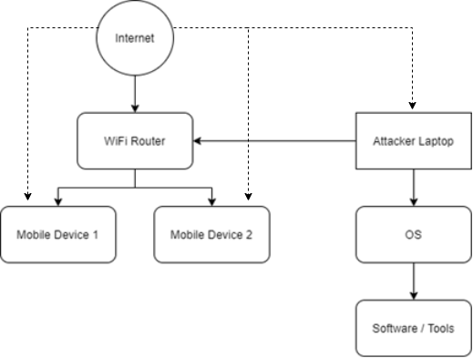
Figure 5 - Block Diagram Layout Design
figure 5 is a block diagram layout to show a basic design for this project. The Wi-Fi router is connected to two mobile devices, these devices are connected to the Wi-Fi router. The attacker laptop creates a traffic to disconnecting user and tries to create a connection to intercept data being transferred. Two mobile devices are connected to the wireless network, these devices will either be disconnected from the network or have data stolen/manipulated. Once the attacker has connected to the router it will then be able to download and retrieve information for software application to complete its attack.
The overview of this project is to establish a security framework that understands and create a simple and easy path for IoT security on emerging networks such as 5G. Refer to the literature review, it is seen thought this technology at the current latest standard still contains flaws with common threats such as distributed denial of service attacked and man in the middle attacks, this research will continue to compare the differences between previous generations.

Design
For the design section it will be focusing on the blueprints of how this is going to be implemented and Furthermore of how it is going to be configured. The devices are connected to the 5G router, whilst the 5G router has an Internet connection to a mobile network. The attacker’s PC will connect over a Wi-Fi connection, then start scanning for devices. Software applications will be loaded and target the router for each for every attack.
The attack in the first case is a denial-of-service attack and the second attack to be used is a Man in the Middle Attack. These two attacks both have a different outcome, A DOS attack works on taking the 5G router down by overloading the system to crash or reboot, removing the devices connection. The MitM attack works on looking at the data being sent in between the devices with the attack being able to record user information.
A brief breakdown of all the components for this project, with a understanding of why it’s being used and what it offers for this experiment. This has been broken down into lists below with subcategories explaining individual parts.

Software & Tools

Kali Linux

Figure 6 - Kali Linux Logo [65]
Kali Linux is a Debian derivative Linux distribution that was primarily designed and created for digital forensics and penetration testing, for these reasons Kali Linux is the operating system that has been chosen to initiate the attacks on the other devices. This operating system allows for the software to be initiated as it is Unix-based and is more efficient than other operating systems such as Windows and Mac OS. The latest build will be used for testing 2020.4. It comes pre-loaded with software that is predominantly targeted towards ethical hacking, it will save time having to download applications or frameworks needed.

Metasploit

Figure 7 - Metasploit Linux [66]
Metasploit is a computer security tool that is used to provide information and assistance in securing vulnerabilities and penetration testing as well as ID signature development. Use this for analysing and searching for vulnerabilities and creating payloads. The current stable release is 6.0.4 and it was released in December of 2020. At the time of this project; this was the most current version of the software. Metasploit will be used to implement a DOS attack against the router.

Bettercap

Figure 8 - Bettercap Logo [67]
Buttercup is a powerful and portable framework that was programmed in Go to offer security researchers an easy all-in-one solution for reconnaissance and attacking Wi-Fi and ethernet networks. At the time of this experiment, the latest version that has been released and will be used is version 2.29. For the testing of this project, this software application will be used to execute a man in the middle attack along with its framework to be able to present a variety of different attacks.

Wireshark

Figure 9 - Wireshark Logo [68]
Wireshark is an open-source packet Analyser tool that is used for network troubleshooting and for analysing. The offers a command-line interface and a GUI interface for the installation on the OS it will be using, a GUI interface will be used for ease of use and guidance. The version that will be used is version 3.4.3. Wireshark will be implemented to track and scan the packets being sent across the devices will be able to pick up the number of packets being sent and to determine what packets have been sent to the devices.

Devices & Hardware

5G/4G Router
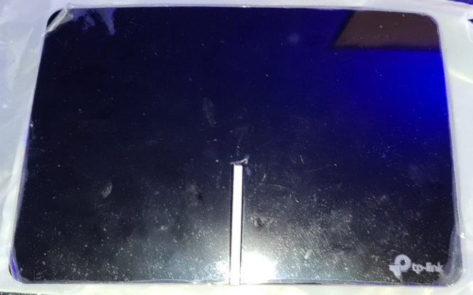
Figure 10 - TP-Link 4G+ Router
The core part of this project is testing the vulnerabilities that can be found within a 5G router and to compare against a 4G router. The 4G router is a TP-Link AC1200 Dual Band Gigabit Router (Archer MR600) equipped with 4G LTE and uses dual band 5GHz + 2.4GHz. There are 2 antennas include for better range of single, 3 LAN ports that support speeds of 1GB and 1 WAN/LAN port with 1GB Support. Furthermore, there is a sim tray slot for a micro sim card. The attack is centred around disrupting or manipulating data on the router depending on which attack is being used.
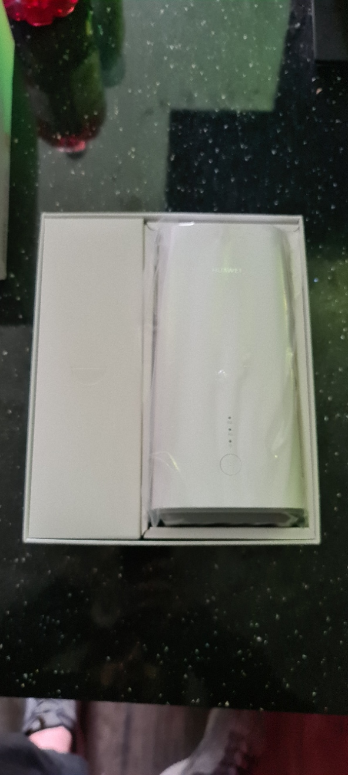
The HUAWEI router is a Huawei 5G CPE Pro is a fully compatible 5G router that works on the latest standards, the router is powered by a Balong 5000 CPU and offers 5G bands for n41/ n77/ n78/ n79. This router does also include 4G capabilities but for testing will be only using 5G, there is also support for dual band frequencies supporting 5 giga Hertz and 2.4 giga Hertz with optional antennas for greater signal boosting but it is not used for this testing, this was due to shorted of time and finding. There are two additional LAN ports on the back, a power supply input, a power button an additional connection for antennas. The same attacks will be applied to this router as two the same for the 4G router. The comparison will be based on the differences between the two different generations of mobile technology hardware.

Samsung Mobile Device
  Figure 11 - Samsung Logo [69] | 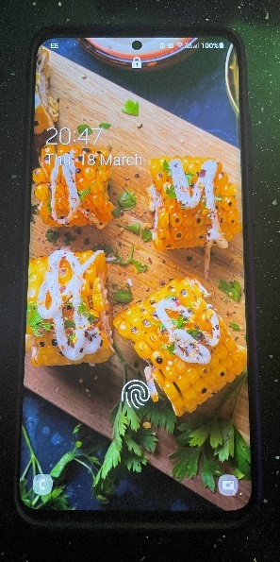  Figure 12 - Samsung Phone
This phone offers a sub-6 GHz chipset and can work on 5G mobile networks. This is also backwards compatible by working with 4G. The phone contains 256gb of storage, 12GB of RAM and running on an Exynos 990 processor. The phone operating system is running android 11 at the current time of this testing. This device will be a prime target towards the attack, leaving its primary goal to be compromised by the falling off the network from a DOS attack or having data being seen or manipulated by the attacker creating a vulnerability for this device.

iPhone Device
  Figure 13 - Apple Logo [70] | 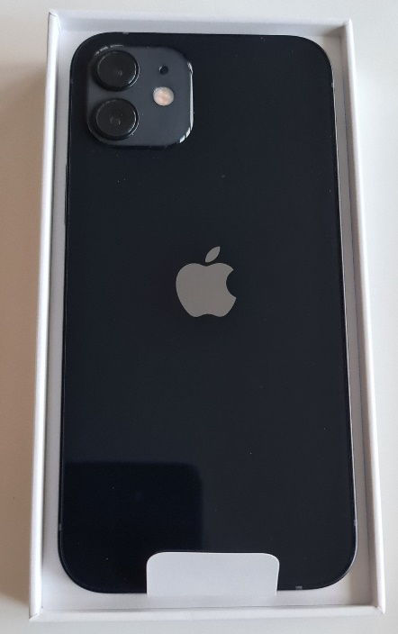  Figure 14 - Brand New iPhone

This device is very similar to the other device mentioned previously it offers a sub 6 gigahertz chipset. This phone contains 64 GB of storage 6 gigabytes of RAM and is running on an A14 bionic processor the operating system being used is iOS 14 at the current time of this testing. The same tests will be applied to this device as well a man-in-the-middle attack and a denial-of-service attack, if either of these attacks are successful, a disruption on the connection between the device and the router or leading to manipulation of data.
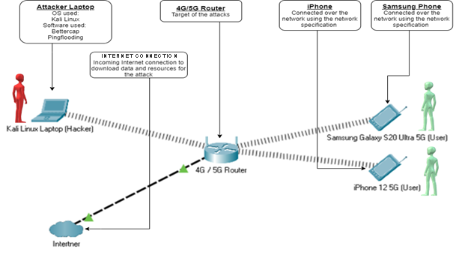
Figure 15 - Design diagram for the Implementation section

The final design that will be used in the live experiment, same devices mentioned in the block diagrams as well as also using Kali Linux.
For the design section it will be focusing on the blueprints of how this is going to be implemented and Furthermore of how it is going to be configured. The mobile devices are connected to the 5G router, whilst the 5G router has a mobile internet connection. The attacker’s PC will connect over a Wi-Fi connection, then start scanning for devices. Software applications will be loaded and target towards the routers for every attack.
Figure 6 is a block diagrams explaining and demonstrating the configuration method of how the test bed will be laid out. This design incorporates two different attacks, as well as a different diagram that show and demonstrate different 4 / 5 G router being used. These attacks will be used on the same configured frequency. Apart from how the targeted devices are connected to the router.

Implementation
The implementation section of this project. Discuss is a step-by-step procedure of how each part of the experiment is laid out and how it is configured to work together in design and structure. Screenshots, pictures & videos of the project being set up and configured, and showing the steps and procedures taken to accomplish the end goal is documented throughout this section. Discussing every part of the design from the cables to the devices being used in detail. This section will discuss everything going through all the experiment.
Please refer to appendix 7 for the setup of the Samsung device and for appendix 8 for the setup of the iPhone.

Set Up Stages
The first section is setting up the individual devices and software that will be required to be used, going through individual items, and setting up the required configuration and the connection specifications that are needed. The next stage will be checking and testing for connection through all devices to prove and assess the devices are able to communicate and talk before testing begins.

What is Required?

5G Router
- Communication Standard: 3GPP Release 15
- Applicable Network: 5G / LTE
- Network Mode: NSA / SA
- 5G Transmission Rate: 1.65Gbps / 250Mbps
- LTE Transmission Rate: 1.6Gbps / 150Mbps
- Wi-Fi: 802.11ac/a/n 2 x 2 & 802.11b/g/n 2 x 2, MIMO
- Wireless Frequency Band: 2.4GHz & 5GHz, dual-band auto-selection
- Processors: Balong 5000 multi-mode chip, GigaHome dual-band Wi-Fi chip
- Network Port: One Wan / Lan GE port, one Lan GE port, one SIM card slot (Nano-SIM)

4G+ Router
- 1 × 10/100/1000 Mbps LAN/WAN Port
- × 10/100/1000 Mbps LAN Ports
- 1 × Micro SIM Card Slot
- 2 × Detachable 4G LTE Antennas
- Wireless Standards: IEEE 802.11a/n/ac 5 GHz, IEEE 802.11b/g/n 2.4 GHz
- Frequency: 2.4 GHz and 5 GHz
- Signal Rate: 300 Mbps at 2.4 GHz, 867 Mbps at 5 GHz
- Wireless Security: 64/128-bit WEP, WPA/WPA2, WPA-PSK/WPA2-PSK encryptions
- Network Type: - 4G: FDD-LTE: B1/B3/B5/B7/B8/B20/B28

Samsung Phones
- Network: GSM / CDMA / HSPA / EVDO / LTE / 5G
- Display: Dynamic AMOLED 2X, 120Hz, HDR10+, 6.9 inches, 1440 x 3200 pixels
- Chipset: Exynos 990 (7 nm+), Octa-core (2x2.73 GHz Mongoose M5)
- Wi-Fi: Wi-Fi 802.11 a/b/g/n/ac/6, dual-band, Wi-Fi Direct, hotspot
- Bluetooth: 5.0, A2DP, LE
- USB: USB Type-C 3.2, USB On-The-Go
- OS: Android 11, One UI 3.1

iPhone
- Network: GSM / CDMA / HSPA / EVDO / LTE / 5G
- Display: Super Retina XDR OLED, HDR10, 6.1 inches, 1170 x 2532 pixels
- Chipset: Apple A14 Bionic (5 nm), Hexa-core (2x3.1 GHz Firestorm)
- GPU: Apple GPU (4-core graphics)
- Memory: 64GB 4GB RAM, NVMe
- Wi-Fi: Wi-Fi 802.11 a/b/g/n/ac/6, dual-band, hotspot
- Bluetooth: 5.0, A2DP, LE
- USB: Lightning, USB 2.0
- OS: iOS 14.4

Laptop
- 10th Gen Intel i7-10875H, 8 Core (2.3GHz/5.1GHz)
- Windows 10 Pro / Kali Lunix Dual Boot
- 17.3” Full HD 300Hz
- NVIDIA GeForce RTX 2070 Super Max-Q
- 512GB PCIe NVMe – Samsung, 500GB PCIe NVMe - WD
- 16GB of Dual-Channel (8GB x2) DDR4 2933MHz
- Intel® Wireless-AX201 (802.11a/b/g/n/ac/ax), Bluetooth 5.1
- 2.5GB Ethernet
- USB 3.2 Gen 2 (USB-A) x 3, USB3.2 Gen 2 (USB-C)
- Thunderbolt 3 (USB-C)

SIM Cards
- 4G Sim Card on Virgin Media
- 5G Sim Card on EE

Initial Device and Software Set Up

4G Router Setup

 |  | Screenshot Images | Explanation of Events
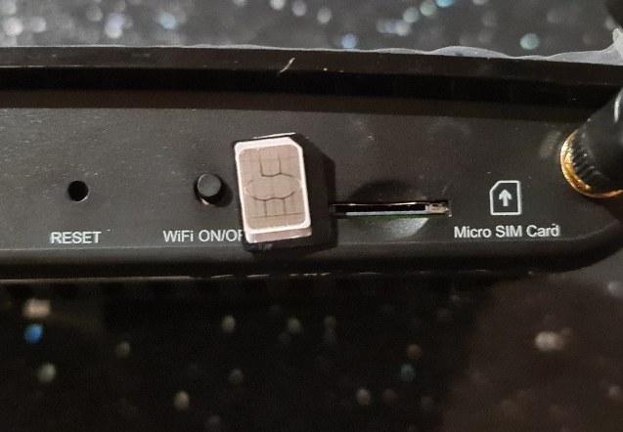  Figure 16 - 4G Router and Sim Card |  |  | ← The first part of setup of the 4G router is inserting the Sim card into the router, this is a micro sim card. This is placed in the top at the end. Then once this is completed turn the router on and proceed to entering the default IP address that is on the back sticker.
 |   Figure 17 - TP- Link Default Password Setup |  | ← The first page of the router asks for a change of the default password for security reasons this is being changed to the same password as Kali Linux just to keep simplicity and consistency throughout this project.

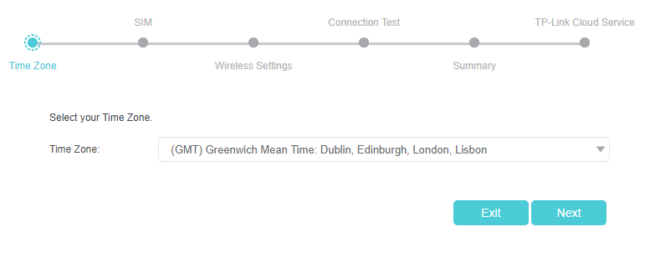  Figure 18 - Setting up 4G Router Time Zone | ← The first part requires the time zone that the route is going to be set in this was set to Greenwich time London.
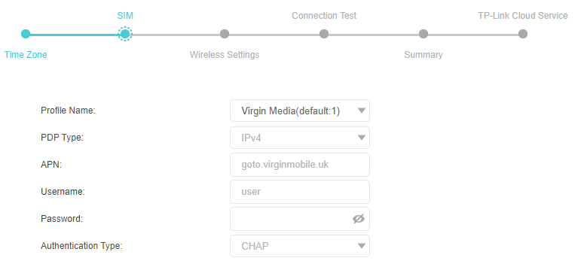  Figure 19 - Setting Sim Setting | ← The next section automatically configures The Sims details that needs to be inserted into the router to connect to the ISP network.
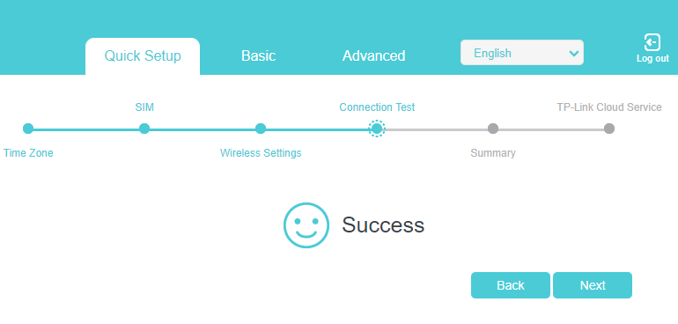  Figure 20 - Successful Connection to Sim Card Operator | ← The next step consists of the router connecting successfully to the ISP and being able to transfer and submit information back and forth.

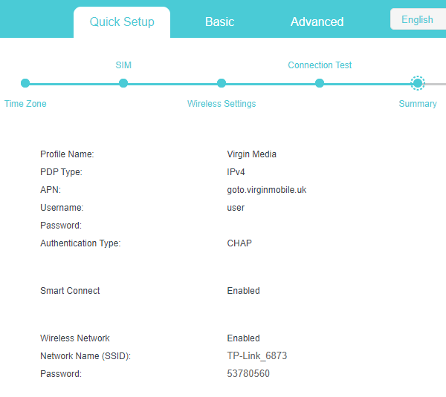  Figure 21 - Verify Setting are Correct | ← After the connection has been connected the router will display information to show how good the signal strength is and to clarify information about the settings are obtained.
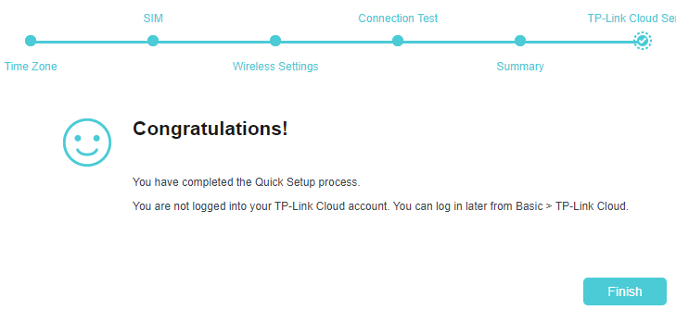  Figure 22 - Setup is Completed | ← After this the router is now fully set up and able to connect to the Internet as well as hub devices connecting to it as well the setup stage is complete.
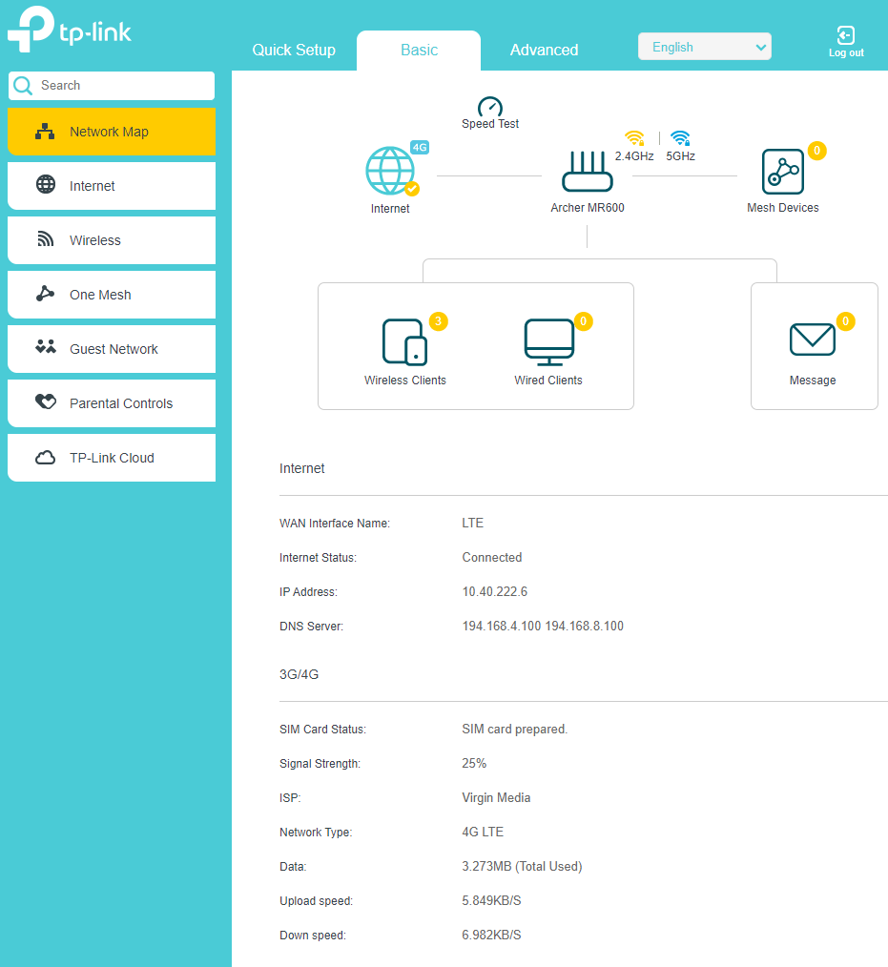
Figure 23 - Home Screen Showing layout of tools and setting.
↑ When the setup is complete, the home screen will present information that will offer details about the connection from the ISP containing IP address, DNS settings, signal strength, data used, type of network is connected (LTE), furthermore, download and upload speed rates.

5G Router Setup

 | Screenshot Images | Explanation of Events
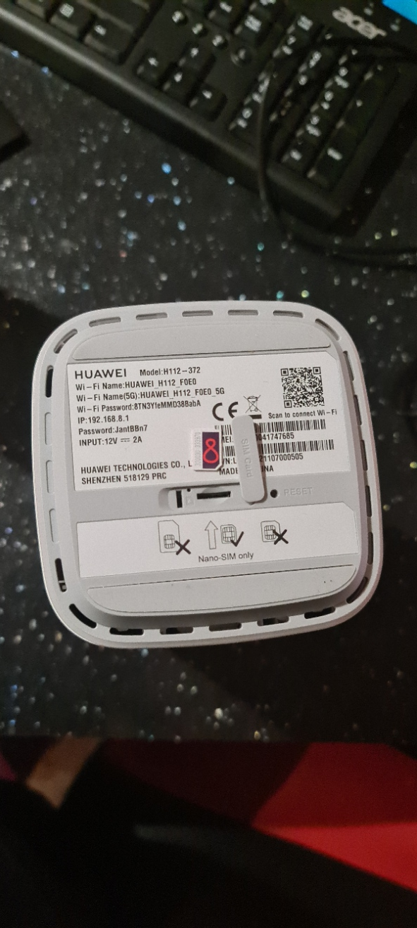  Figure 24 - Huawei 5G Router |  | ← The first part of setup of the 5G router is inserting the Sim card into the router, this is a nano sim card. This is placed in the bottom of the device, under the plastic cover in the centre. Then once this is completed turn the router on and proceed to entering the default IP address that is on the back sticker.
 | 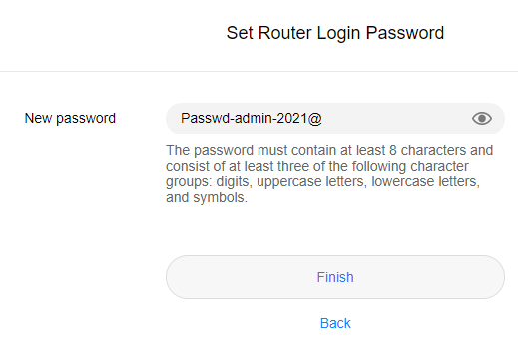  Figure 25 - Default Admin Password Setup | ← Once the router is initiated and booted up, connecting to the router by the default IP address set on the back of the router which is 192.168.1.1 will bring up these menu screen, forcing the user to change the default password.  This was done and furthermore being displayed on the screenshot.

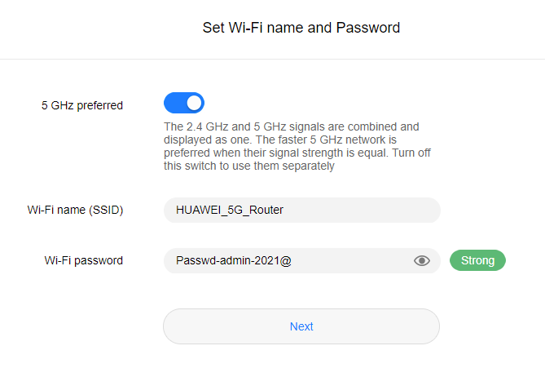  Figure 26 - Setup SSID Name and Password |  | ← After the password has been changed setting up default Wi-Fi name and password for connectivity is next. Leaving the default SSID name in place but changing the Wi-Fi password to a consistent password that is being used throughout this project.
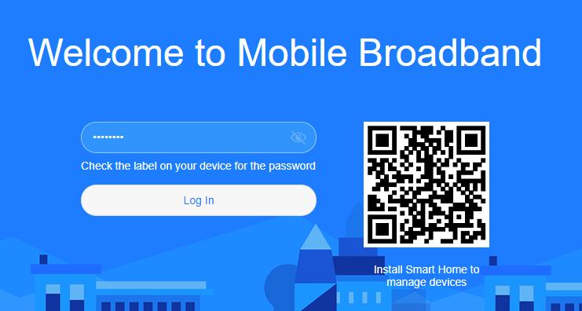  Figure 27 - Router Log on Page | ← Over the previous two steps have been accomplished this will then require the user to log in to the home screen of the router this presents the password for the admin account this password can be found on the back of the router as the default admin password.  This password was changed in the previous section from the default password to enhance the security of the device.
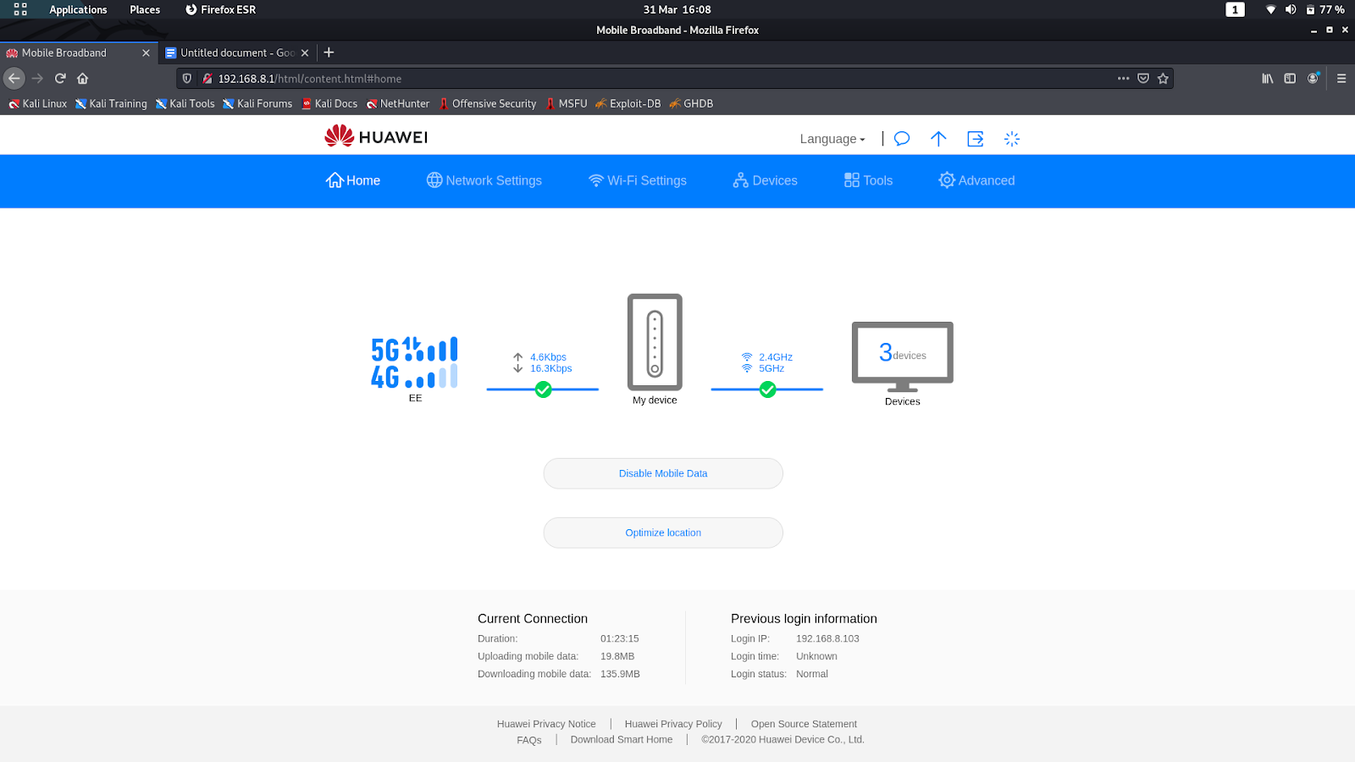  Figure 28 - Router Home Screen displaying device Info | ← Once logged in the user menu there will be information about the system, these items will be showing the status of the 5G connection and the Wi-Fi connection, download and upload speeds.

Metasploit Setup

Screenshot Images | Explanation of Events
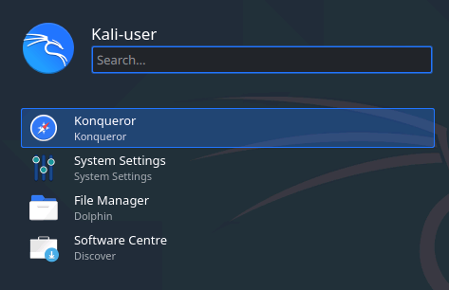  Figure 29 - Kali Search Menu | ← Very much like windows slides in the option in the bottom left-hand corner brings up a menu of applications on a search feature, with this typing in console/ terminal will find the application.
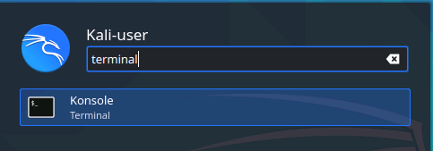  Figure 30 - Kali Terminal | ← Once the application is found select and launch, this will bring up a black box with this inserting the following command.
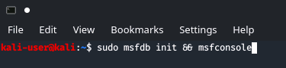  Figure 31 - Console Setup for Metasploit | ← The combat folders in the screenshot of side to this is the command that will initiate the Metasploit console but will also initiate the database that is required to operate Metasploit as it needs to retrieve and submit information to and from the database.

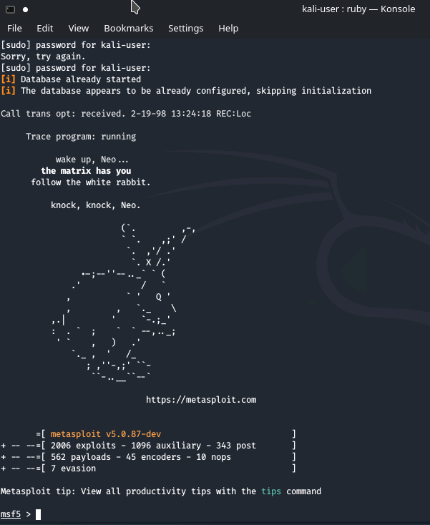  Figure 32 - Metasploit Menu Running | ← Once the system has loaded and set up Metasploit on its comparison database there will be a banner load it up underneath the banner there will be information detailing the version that is running and the total amount of exploits, auxiliary, posts, payloads, encoders, nops and evasions listed within its database.  At this point the user can start running and operating the Metasploit software package.

Bettercap Setup

Screenshot Images | Explanation of Events
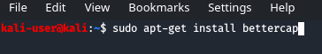  Figure 33 - Installation Command for Bettercap | ← Previously it was shown how to launch the console in the previous Metasploit section, referring to that to launch at the console.  once the console has been loaded setting up an install for software can be done by following the command shown in the screenshot beside.  Addition software will be needed for this project to work as kali come with preload with a large amount of software tool, but the additional tool that are going to be used are not included. Breaking down the command sudo is referred to as “super user do” this is an admin command that allows for users to run programmes with the security privileges.  The next part of the command is apt-get this is a command that searches and handles packages installation and removal of software. The instal is self-explanatory as it initiates the install aspect . The last part is the software that needs to be installed once it cheques for the repository it will start to download and install.

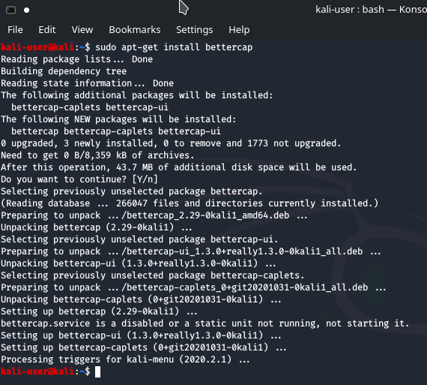  Figure 34 - Installation progressions for Bettercap |  | ← The screenshot on the side has installed all the packages required and necessarily repositories.
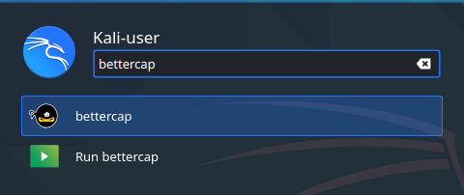  Figure 35 - Kali Search Menu for Bettercap | ← To run bettercap there are two ways of launching this software option one is going back to the search menu by typing in bettercap or the other option is remaining in the console and typing in “sudo bettercap“
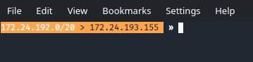  Figure 36 - Bettercap Running | ← Lastly the application is loaded up this will be presented on the main screen. The install was correctly done.

Wireshark Setup

Screenshot Images | Explanation of Events
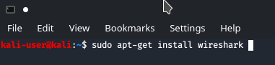  Figure 37 - Installation Command for Wireshark | ← Follow up the steps for better cap will be the same way for Wireshark,  using the command shown in the screenshot aside is how to instal the application. If there are any questions that says yes or no all of them should be asked yes as they are checking for disc space allocation and permission for modifying certain permissions on the system.
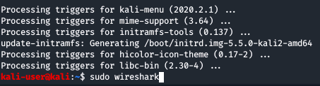  Figure 38 - Installation progressions for Wireshark | ← After the installation period has past and Wireshark is fully installed, then running the command “sudo Wireshark” will launch the application straight into it graphical interface
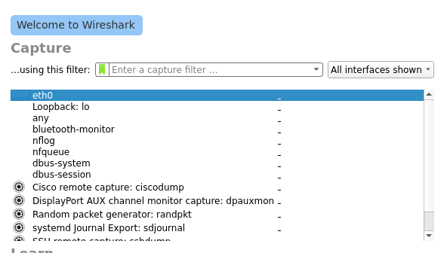  Figure 39 - Wireshark Running | ← Once the graphical interface has loaded up it will present different options for the user to do all that needs to be done is click on the first option with the Ethernet port that is connected or wireless port that signal is being shown on and then start to capture.

Ping & Communication Testing

Screenshot Images | Explanation of Events
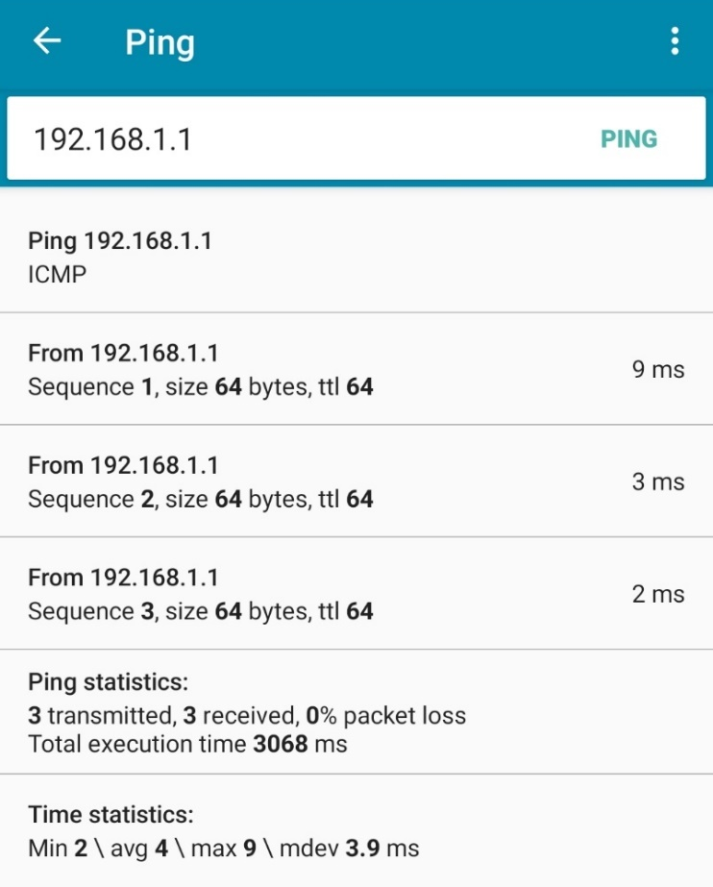  Figure 40 - iPhone Ping Test | ← For the phone to be able to test its connection to the router a third-party app that was called “PingTools” was downloaded to the phone. This enabled the device to ping the router to check to make sure it had connectivity.  Using the IP address for the router which is 192.168.1.1 it will send ICMP packet to test for connection.  The Samsung phone is now able to ping the router.
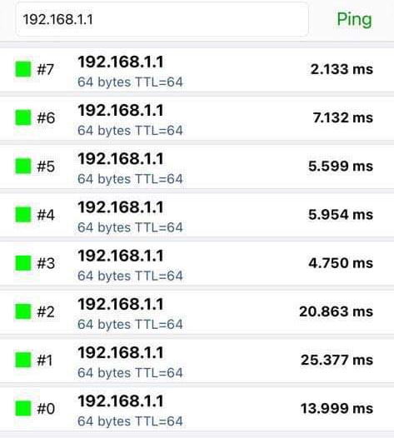  Figure 41 - Samsung Ping Test | ← For the iPhone to be able to test its connection to the router a third-party app that was called “Ping” was downloaded to the phone. This enabled the device to ping the router to check to make sure it had connectivity.  Using the IP address for the router which is 192.168.1.1 it will send ICMP packet to test for connection.  The iPhone is now able to ping the router.

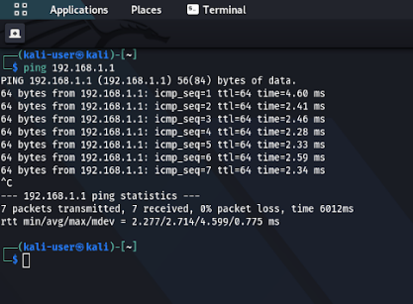  Figure 42 - Kali Ping Test | ← The laptop has been connected to the router and was sending ICMP packets towards the router to test connectivity these were being received add 100% with zero packet loss.  The laptop is fully connected and can continue.
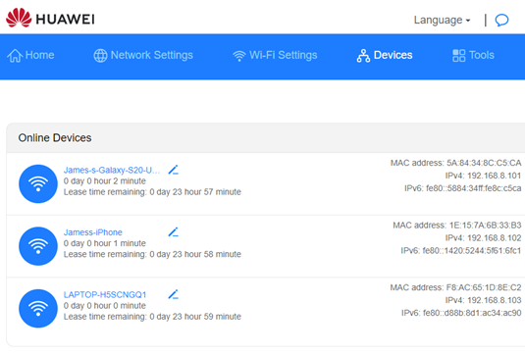  Figure 43 - Huawei Ping Test | ← The Huawei Router is show 3 devices connected directly to it over the Wi-Fi.  These devices are the 2 phones and the laptop.

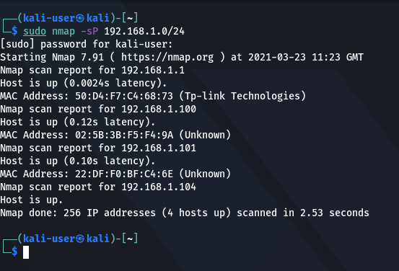  Figure 44 - Nmap Device Discovery | ← Using a very basic command with nmap will be able to detect and find devices that are on the network by relaying their Mac address and the IP address.  The command that has been used is “sudo Nmap -sP 192.168.1.0/24”.
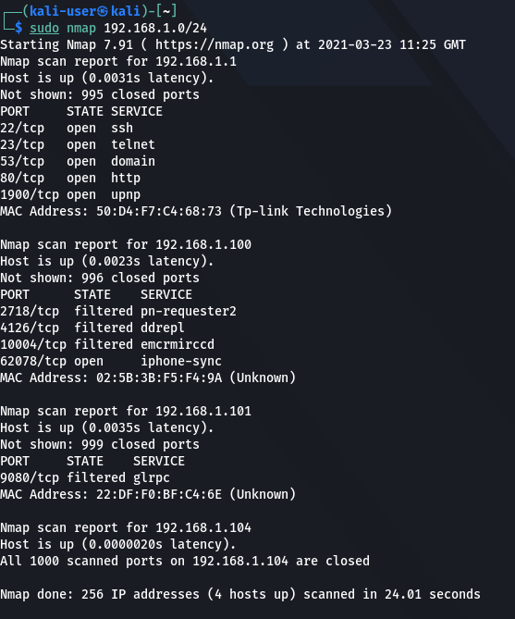  Figure 45 - Nmap Device Port Scan | ← After the first search, some basic information about the devices had been found, doing a deeper search on these items listed to find out if there are any open ports or any information that may be beneficial to later attacks.  ‘sudo nmap 192.168.1.0/24’  This search has given more information about the type of ports and services running on the devices.

Experiment Overview
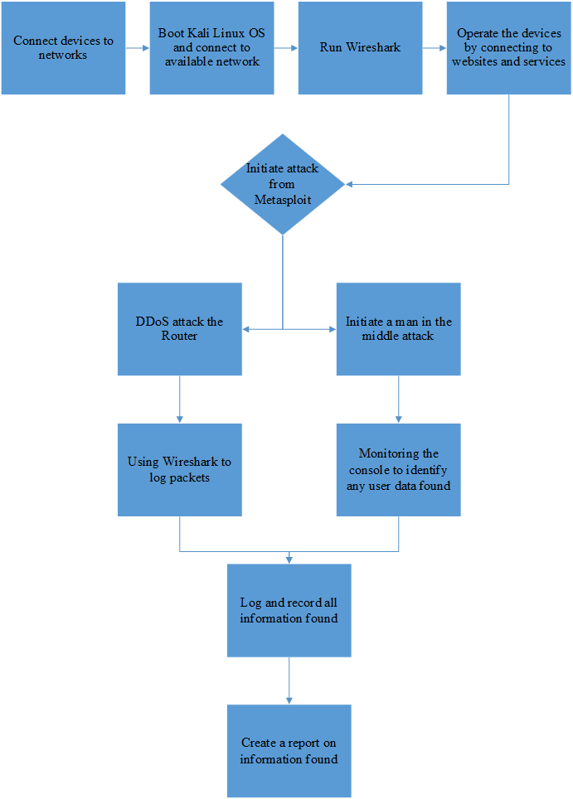
Figure 46 - Flow Chart of the Experiment Overview

Conclusion
To sum up this conclusion, everything that has been cited so far in this section would be the problem formulation and design overview of the project talking about the problem that this project is trying to solve and by giving a design overview of how it will be laid out and solved. A detailed background and understanding of the tools and software that are going to be used and how we are going to be configured Furthermore moving over to looking at the design of the project using block diagrams and flow charts to show how the testing should be followed through.
Moving on to the second section of this chapter is the implementation and going through the required information that is required to set up the testing environment this requires having information laid out about the device requirements and the device settings in configurations. This information is detailed heavily by putting tables and screenshot of each step of the way with detailed instructions. At the end showing connectivity of the devices being able to communicate ready for the testing to begin. A flow chart diagram of the experiment overview is presented to show an understanding of how the project will be carried out. This moves on to the testing and results section of the project, with the testing been completed and results will have been gathered ready for a conclusion to be drawn up for the project.

Chapter 5 – Testing and Evaluation

Introduction
This chapter will discuss the results of the test and will provide an evaluation of the outcome from this testing. Furthermore, it contains a detailed analysis with screenshots of the process used to understand what the research found.

Evaluation

4G Router Results
The testing between the two devices has shown a very different outcome compared to the intended hypothesis that was mentioned earlier in the document. The hypothesis predicted that both networks would be susceptible to man in the middle attacks and distributed denial of service attack. But the testing shows that the 4G router was acceptable to both attacks, where the 5G router was able to mitigate attack from DOS by not even slowing the device down to any level of degree. The MITM attack was only able to retrieve a few IP addresses. These were Google and Twitter, whereas in contrast, the MITM attack did not identify the IP addresses of BBC News or Wikipedia.
What was surprising was that the testing on the 4G router had successful attacks. These were accomplished exceedingly well on the iPhone. As for the Samsung phone, during the MITM attack, the device was able to detect suspicious activity on the TP link router, whilst it was trying to connect to the BBC News website. This resulted in a notification to disconnect from the network. For testing, it was added as an exception to the network just to see if an attack could be permitted after the phone has detected. Moreover, an exception was given to the device, this did allow all HTTP and HTTPS data was being logged and sent directly to the bettercap console. This information can be seen in figure 52 as it shows websites links that the device is trying to access. Unfortunately, it was unable to read what the data was being sent between the website and the device as this remained encrypted by the HTTPS protocol that stopped securing it through the SSL certification. However, this did leave HTTP websites prone to have that information seen and read, this meant that this data could be logged and recorded.

MITM Attack

1.) Bettercap, Setting up arp spoof and http proxy.

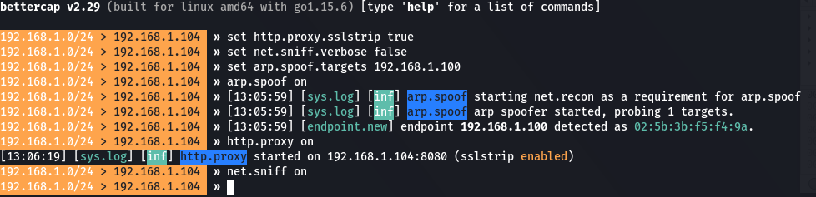
Figure 47 - Testing: MITM Attack using Bettercap by Setting up Parameters.
Setting and configuring bettercap to operate a man in the middle attack. setting these variables up is essential to creating the attack. Using the correct configuration allows for the attack to be more effective.
2.) Getting the iPhone to connect to hacker laptop but entering the IP address into the browser will create a connection that allows the tracking on the iPhone.

(iPhone Images)

3.) iPhone having a man in the middle attack logging all http traffic.

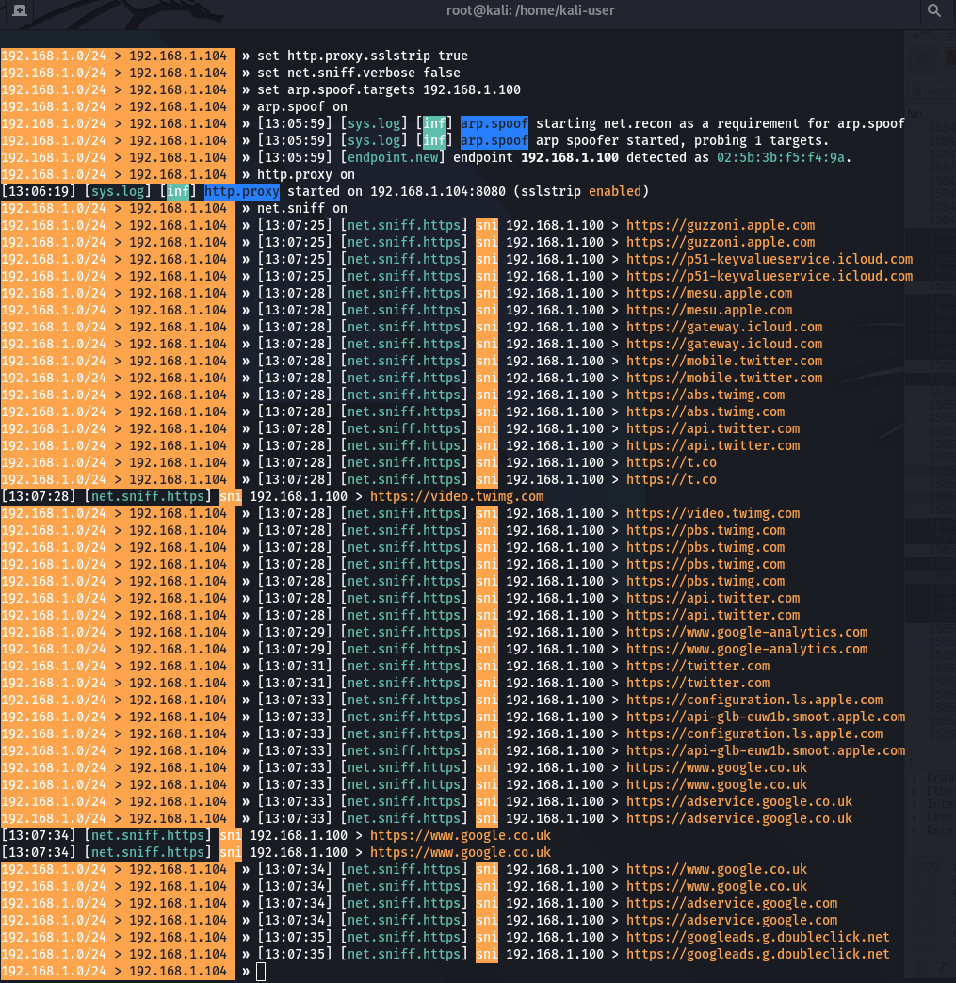
Figure 48 - Testing: iPhone ARP Spoofing
Figure 49 - Testing: iPhone ARP Spoofing 2
All the traffic being collected is HTTP / HTTPS, due to SSL authentication on these websites none of that can been see as it is encrypted. Moreover, the user that is operating the device can be track to what website there are connecting too, this does also work for apps as these send and receive data frequently.
This was then repeated on the Samsung device, the IP address was changed from 192.168.1.100 to 192.168.1.101.

4.) Getting the Samsung phone to connect to hacker laptop the same way the iPhone did by entering the IP address into the browser to create a connection that allows the tracking on the Samsung device.


Figure 50 - Testing: Samsung Phone Connecting to the Proxy
5.) Spoofing all the data that is HTTP / HTTPS from this device
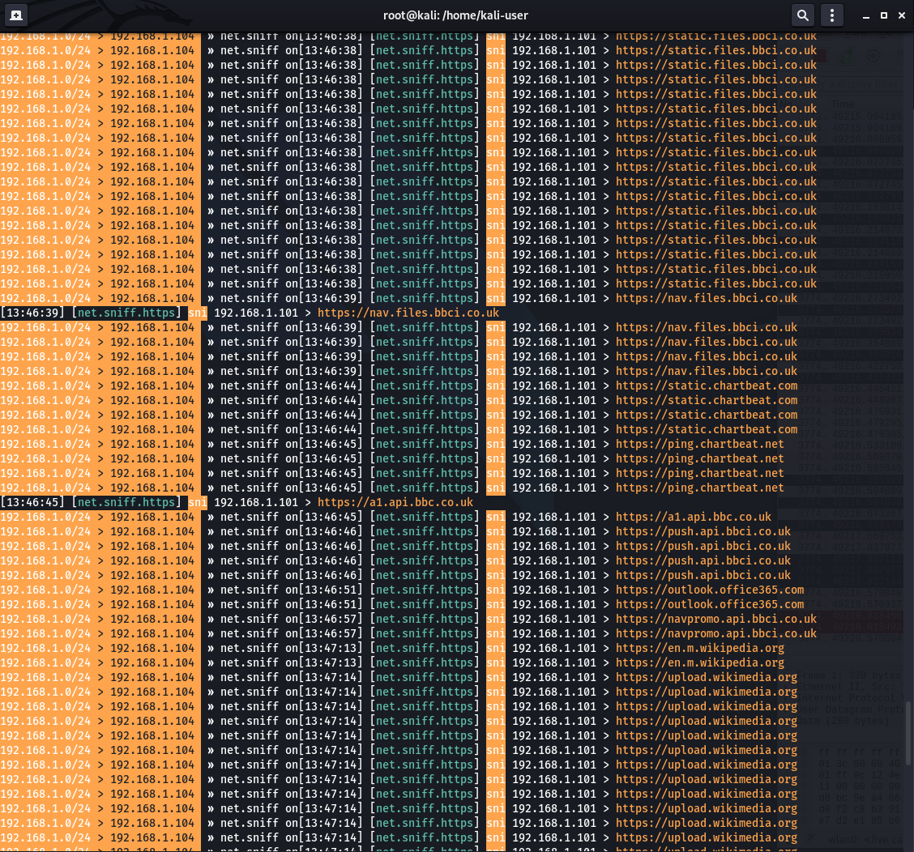
Figure 51 - Testing: Samsung ARP Spoofing 2
6.) While connecting to BBC News, the phone detected suspicious activity on the connection.

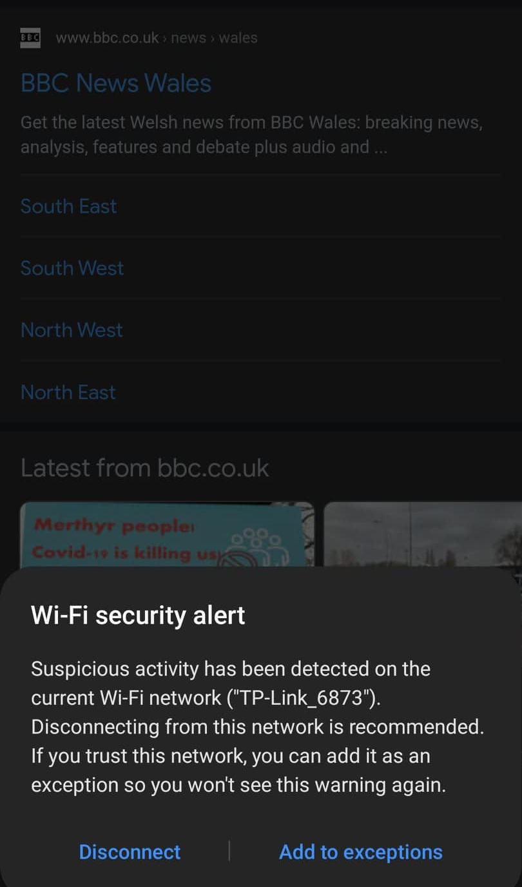
Figure 52 - Testing: Suspicious Activity

DOS Attack
For the testing of a DOS attack, the outcome showed that both devices were rendered unusable and extremely slow, making them inoperable. Whilst the attack was taking place it caused an issue by flooding the ISP sim card so that it disconnected the sim card from the network, making the sim card inactive. A method to overcome this was to limit the number of packets going through the network; this was done by changing the amount that was being sent every minute. Furthermore, changing the attack from a duplex to internal kept all the information within the network. This prevented the sim card from disconnecting, thereby avoiding having to contact the ISP to reactivate the sim. This situation created two problems for any end users as it would slow down the devices or make them unusable while trying to access the internet. Secondly, this could potentially force users to reboot the router to reconnect back onto the sim ISP network or even calling the ISP to reset the sim card status.

1.) Home screen of router, showing connected to 4G network.
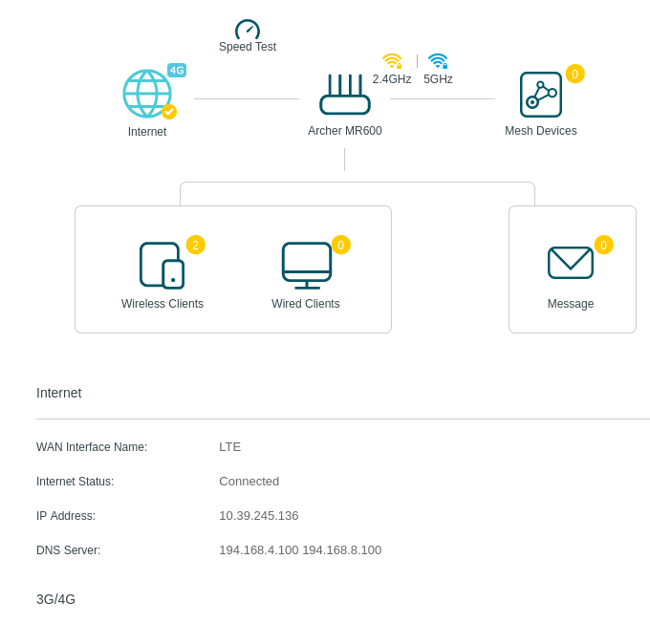
Figure 53 - Testing: Router Home screen
2.) Wireshark showing packets before attack begins.
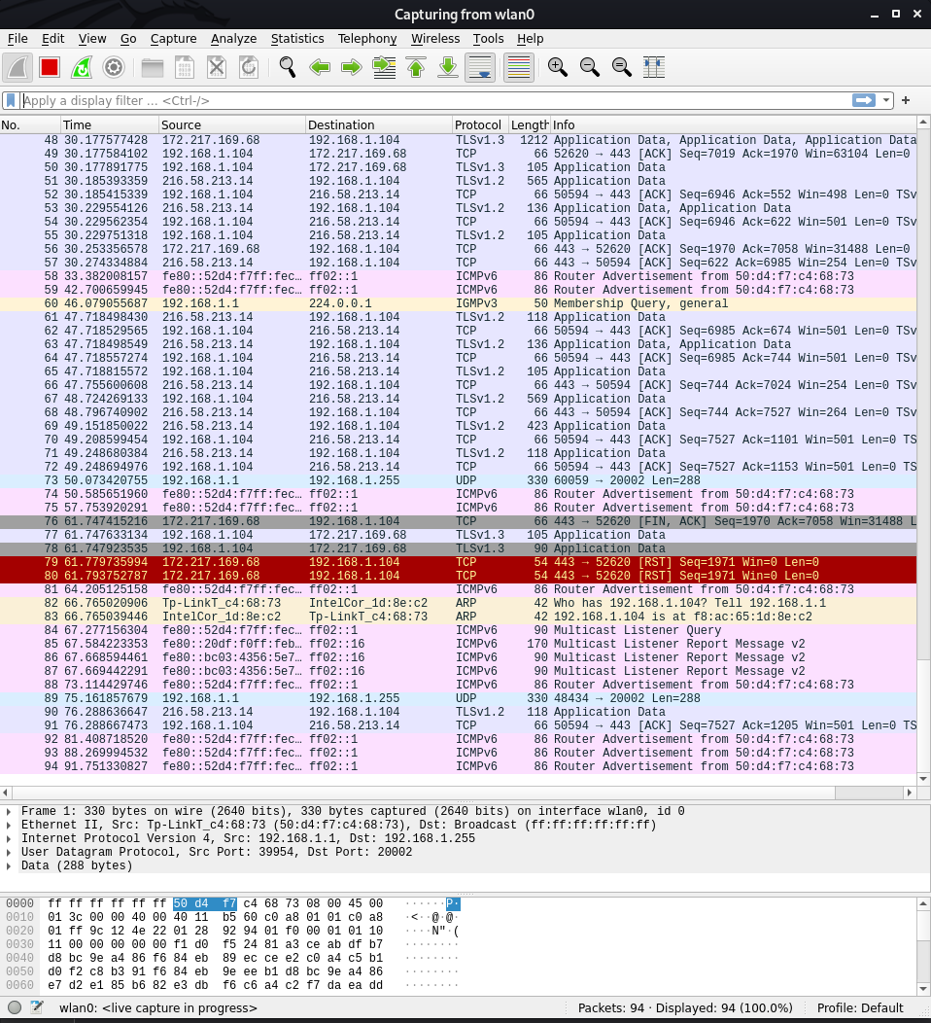
Figure 54 - Testing: Wireshark Showing Packets
3.) Initiating Metasploit & PostgreSQL
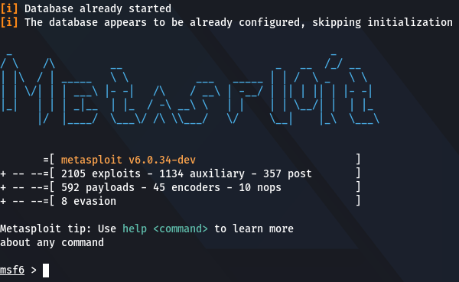
Figure 55 - Testing: Metasploit
4.) Navigating Metasploit to the correct attack location, setting up the IP to the iPhone, furthermore, running the exploit script.
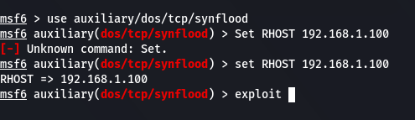
Figure 56 - Testing: Setting up SYN flood Attack 1

5.) Starting the attack, Flooding the IP “192.168.1.100” with SYN packets to overflow the device.
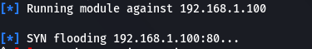
Figure 57 - Testing: Running SYN Flood Attack
6.) Home screen of router, showing disconnected from the Router.

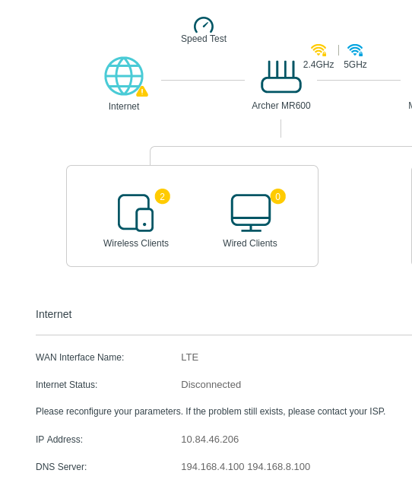
Figure 58 - Testing: Router Discounted from Internet
7.) Capturing all packets being sent showing the flood of packets.
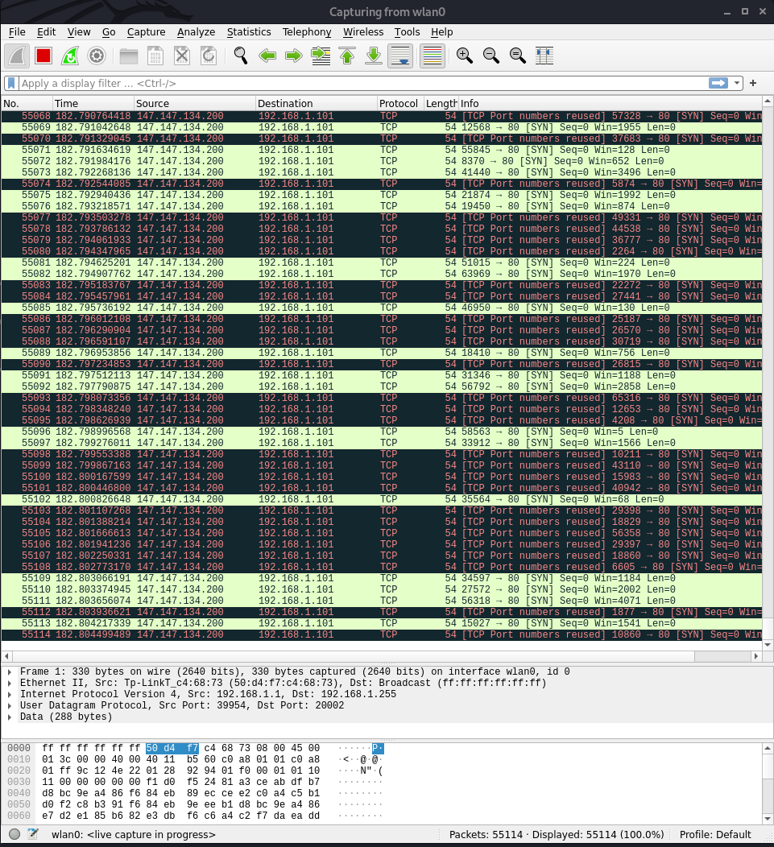
Figure 59 - Testing: Wireshark getting Flooded

8.) Stopping the attack, by doing “ctrl + c”.
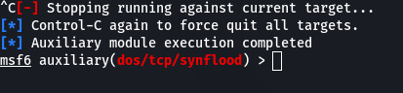
Figure 60 - Testing: Stopping the Attack
Completed the testing on the first devices (iPhone) The second testing will be done on the Samsung phone. The router has been reset to connecting the internet again.
9.) Home screen of router, showing connected to 4G network.
Figure 61 - Testing: Rebooted Router
10.) Changing the IP to the Samsung IP, running the exploit script.
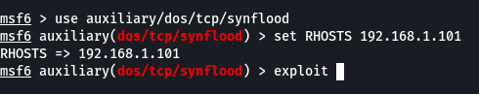
Figure 62 - Testing: Changing Target IP
11.) Running Attack
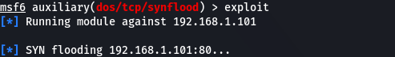
Figure 63 - Testing: Running SYN Flood Attack 2
12.) Home screen of router, showing disconnected from the Router.
Figure 64 - Testing: Showing Router Disconnected from Internet

13.) Stopping the attack, by doing “ctrl + c”.
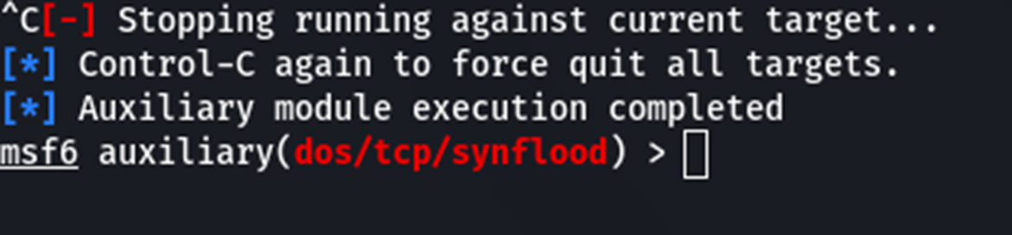
Figure 65 - Testing: Stopping Attack

5G Router Results

DoS Attack
The testing of the 5G router was successful in the man in the middle attack to some level, but the other attack which was DoS; was unsuccessful. During the testing, the denial-of-service attack had no effect on the devices or the network while the packets were flooding, the router was consistent with the output of data as it did not slow or have any hindrances to the users’ requests on the devices. For this testing, different types of data were sent through to test the outcome, the data to which was used was web page data and video data. This led to websites such as BBC News, Wikipedia, Twitter, and YouTube being accessed and used without any hindrances to the user or to the network. Comparing this information to the hypothesis that was set out earlier in the project, it was stated that both networks would be affected by both attacks, but during the testing it was shown that the attacks were not effective on a 5G router.
Previously discussed in the literature review section, talks about ARP attacks from the author W. Gao et al. [60], attempted to prevent these types of attack, while this research tried to compare the differences between the 4G and the 5G routers using this attack. The outcome of the research in comparison shows that 5G technology does not fully prevent it but does offer some support by default. Further research and time would have been able to use different 5G routers, this would lead to testing hardware and software by different manufacturers. The result would be used in a comparison chart to offer different attacks to see if they pass or fail.
Table 10 - Testing: 5G DOS Attack
1.) The Huawei router connected to EE network with 3 devices connected.
Figure 66 - Testing: 5G Router Connected
2.) Running Wireshark Running in the background before any attack begins
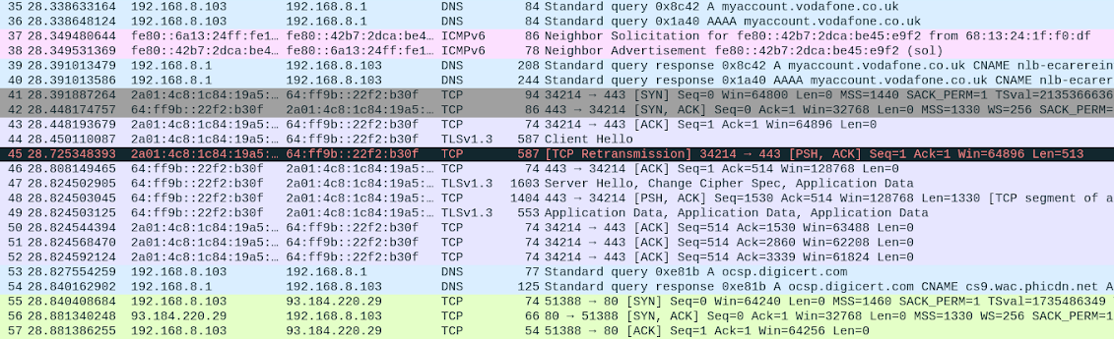
Figure 67 - Testing: Wireshark Before 5G Attack
3.) Prepping SYN attack and selecting the iPhone IP address.

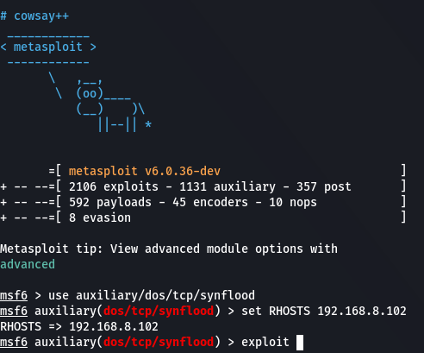
Figure 68 - Testing: Setting up DOS Attack on 5G
4.) Running exploit command

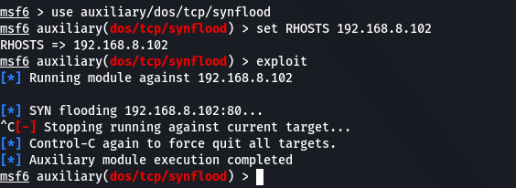
Figure 69 - Testing: Running the SYN attack on iPhone

5.) Cancelling the attack to stop the packets.
Figure 70 - Testing: Cancelling Attack
5.) After running the attack on the iPhone attack swapping the IP address to the Samsung.
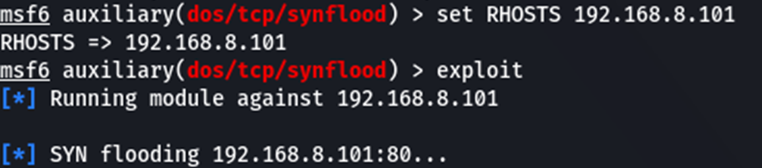
Figure 71 - Testing: Running the SYN attack on Samsung
6.) Cancelling the attack to stop the packets.
Figure 72 - Testing: Completed Testing of 5G Attack

5.) Recorded the packet going through the network.
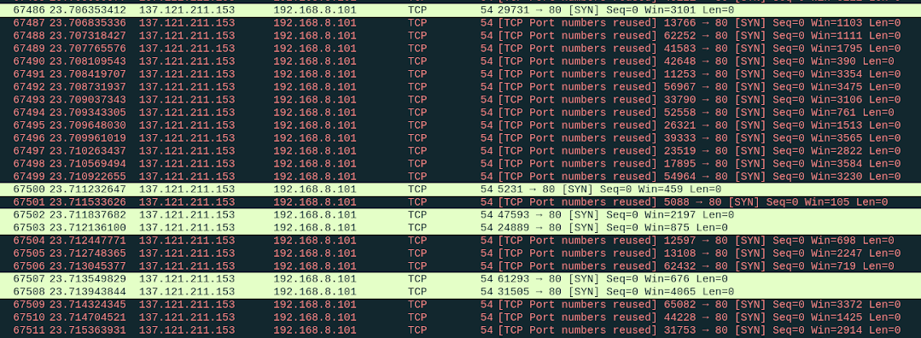
Figure 73 - Testing: Wireshark While 5G Attack is Live.

7.) Device still connected to EE network.
Figure 74 - Testing: 5G Router still Connected

MITM Attacks
As for the MITM attack, this was blocked by both devices’ integral security protection; the iPhone has a built-in feature in IOS 14 called “Private Address” which uses a different MAC address for each Wi-Fi network connected to by the device. This then allows a unique MAC address to be used on every network the device connects to, creating a private Wi-Fi. This also hides a significant amount of data that is being received as websites were not listed when accessed in the browser, this was also the same for apps. So, for the purpose of testing, this feature was disabled, and a new IP address was assigned to the device. After this change was implemented, selected websites would show data while others would not. Furthermore, the Samsung device offered different security protection that immediately prevented any website browsing; this instantly generated a notification that it was an unsecured connection, as it was able to detect suspicious activity. For testing on this device, it was added as an exception to the network, allowing to gather data for the MITM attack. What was surprising is both devices were encountered the same problem, this was certain websites Google and Twitter displayed the IP address but not their domain name. Websites tested included Google, YouTube, BBC news, BBC weather, Twitter, and Wikipedia, from these websites only two websites showed there IP address Google, YouTube but there did not show their domain names, also in comparison to the 4G testing no tracking or any sub domain connection appeared. Moreover, BBC news, BBC weather, Twitter, and Wikipedia did not ever show up in the console where there was nothing to indicate their connection. While in the 4G router this would show the domain and related information like sub-domains and trackers, but for the 5G router it would only list an IP address for selected websites; so, this ended with a lack of detail for this type of attack to be successful.
Table 11- Testing: 5G MITM Attack
1.) Network Probing to find network Devices
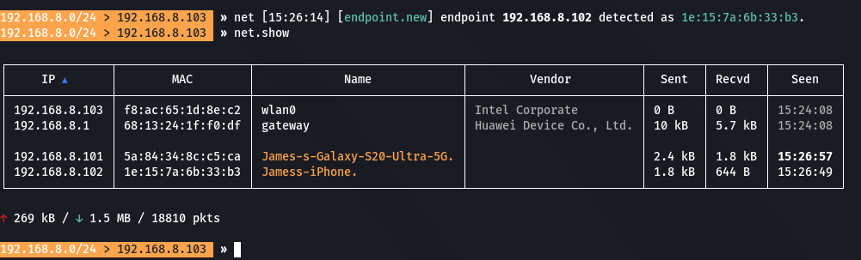
Figure 75 - Testing: Probe 5G Network
2.) Setting up bettercap to sniff iPhone the same way that was done in the 4G attack.
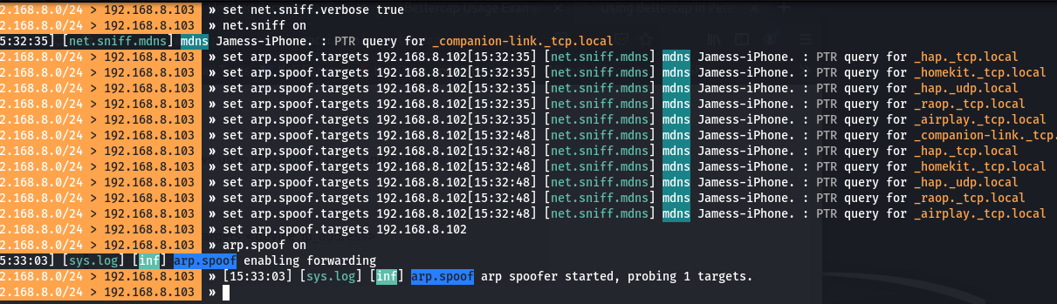
Figure 76 - Testing: iPhone Sniff
3.) Changed IP address on iPhone as it disconnected from the network to disable Private address.
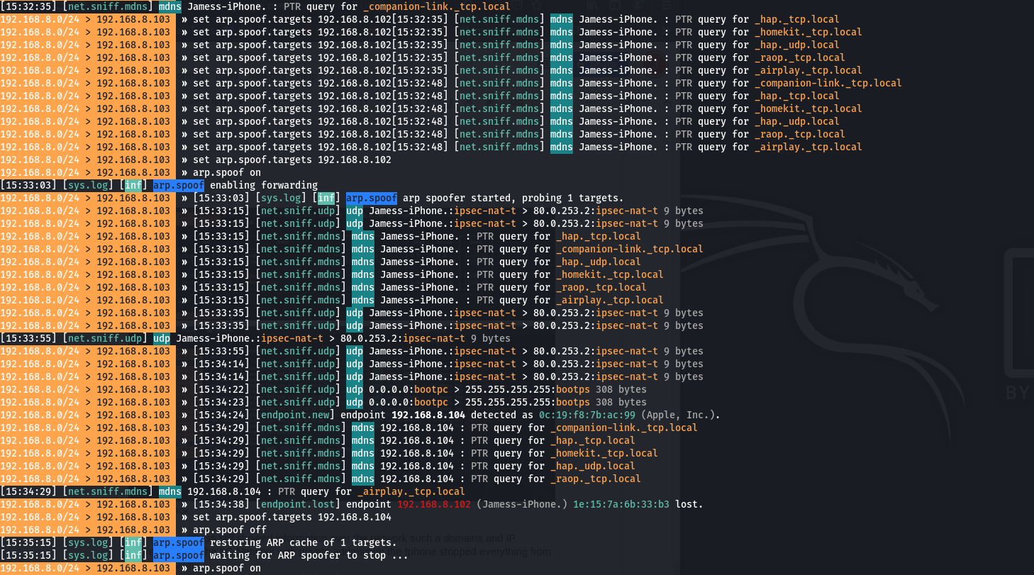
Figure 77 - Testing: Updated IP Address & Disabled Private Address

4.) All data was being encrypted and hidden.
Figure 78 - Testing: Private Address on iPhone Disabled
5.) Changing to the Samsung Device, results show only a few IP address and very few domains were showing.
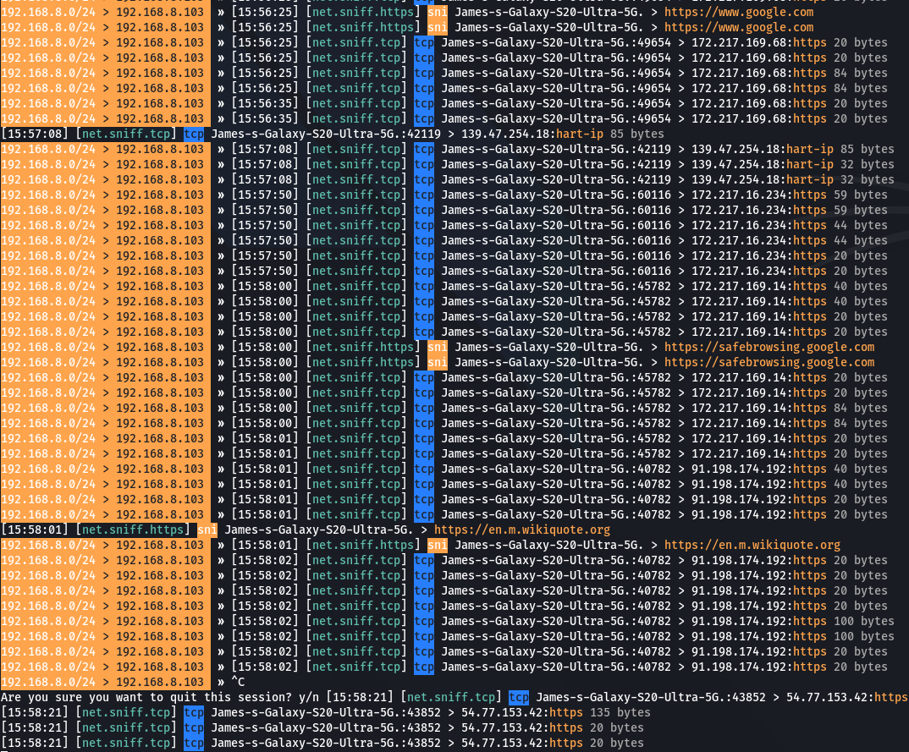
Figure 79 - Testing: Samsung Showing some IP Address
6.) wall connecting to BBC news, a security alert was notified.
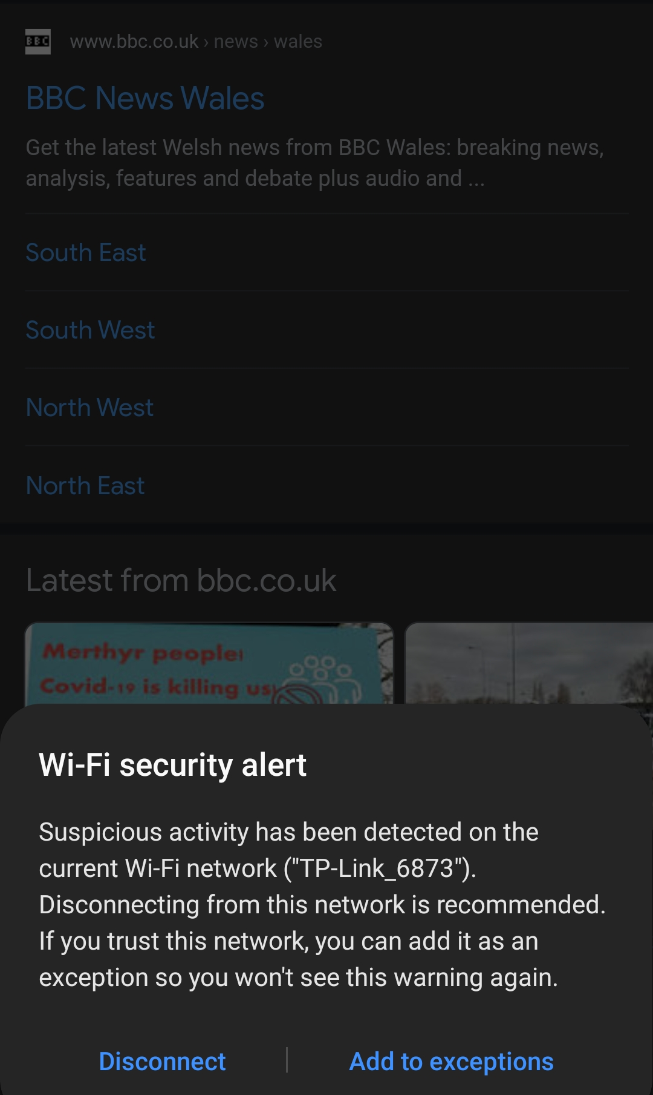
Figure 80 - Testing: Samsung Device Show Security Alert
7.) disabling detect spicious networks for testing purposes.
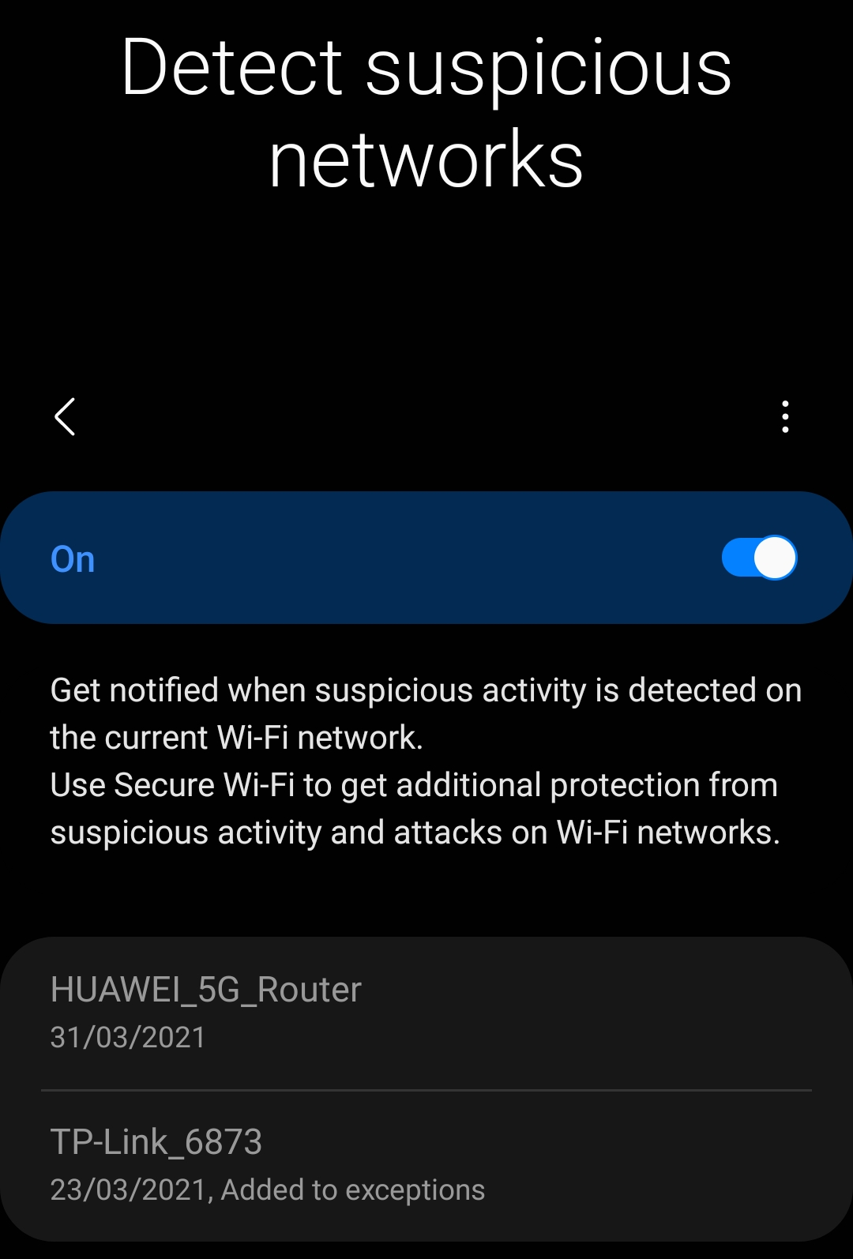
Figure 81 - Testing: Disabling (DSN) On Samsung Device

Overview
From this research and testing has given a very different outcome to what was predicted in the hypothesis in chapter 3, as the prediction was completely inaccurate on the 5G router. Furthermore, looking back at the literature review over G. Drago at al [70], part of his method or performing a MITM attack was used to in this project and the outcome worked with the 4G router but was unsuccessful with the 5G as it has been documented through the previous sections of this chapter. the outcome was surprising as it showed that a generation between the technologies has changed enough to prevent this form of attack to a certain level as it removes a high amount of information being transmitted and only giving a selective amount of IP addresses on certain websites. In addition, researching more into this to try and find a way around or a method in completely removing the ability of tracking individuals IP address.

Chapter Summary
In conclusion, this report has found in its testing that 5G router seem to have a lot more built-in security then 4G routers, as both attacks were unsuccessful to complete their objective in which was to steal information or to shut down the network. Furthermore, the aim was original created at the beginning of this paper has been met as intended, as this investigation was able to use two well-known attack and achieve using them on IoT devices to perform ARP & DoS attack; these attacks were on 5G &4G routers. Then being able to write a detailed log on the attack with screenshot to recreate. After creating recommendation for additional research for solutions and improvements. Then the Objective, these were to research and discover information on security threats and different types of vulnerability in networks and conduct an experiment using this data. After completing each of the section throughout the report and following these objectives it would be said that there have all been meet and accomplished.

Chapter 6 – Conclusion & Recommendations

Introduction
This section of the report will be focusing on summarising the main body of this report and the research that was carried out in the testing. It will also provide additional research recommendations for future projects and work that closely resemble this type of study in the context of attacks.

Summary
In summary, the main study involved researching and conducting experiments on 5G routers that connect to IoT devices and testing common security threats to see if they are improved in the latest cellular network generation. Comparing research data on 5G routers needs to be undertaken with its previous generation by using a 4G router. The expected outcomes that were predicted from this testing was 5G router technology was still as vulnerable as 4G technology in both forms of attack. The DOS attack was meant to remove the devices or the router from any communication or connectivity to the Internet and create a hindrance or an unpleasant experience for the end user where the other attack was to create data log of information to obtain sensitive data about the user’s activity on the network. Throughout the testing, the outcomes were very different from the hypothesis that was set earlier in the research. Above all, what stood out was the unexpected ability of the 5G devices to withstand a dos attack and man in the middle attack as both attacks were rendered unsuccessful from the data that could be retrieved. It was also surprising that both attacks completely worked on the four Gee router perfectly with data being gathered and recorded.
A significant part of this project successful outcome was from the literature review section as it was able to guide and direct the research behind this project; this allowed for the project to be shaped. This section has guided the types of attacks that were used by giving a background and understanding to why they are still commonly used with reporting of these daily. It included research about how IoT systems do not have an ecosystem for security, and therefore it is complex to secure IoT devices as all vendors create their own device security systems, leaving it to the vendor to update the security when they want, unlike Android that is updated by Google and is offered as a system to multiple companies to use. Moreover, 5G is built on a new infrastructure that offers interesting possibilities to how it can operate in IoT as it allows for individually slicing its network virtually creating different sections of its network for different types of devices. This provides much understanding to how prevention to types of attacks such as DoS and MITM attacks can be prevented.
Next, the design and implementation section of the project was a critical and crucial stage as it was heavily affected by the literature review section and by the objectives. The attack the devices on the other side of the connection. Each device used a different operating system to try very out the results so it would not be the same OS being attacked by using an Android and iOS. Once these devices were connected to the router in subject to testing the laptop would be loaded with software used to attack each of these devices one at a time while recording the results of each attack, the software Bettercap used for the MITM offered a full range of tools for exploiting these included items such as proxy, sniffing and spoofing also including DNS spoofing to. The other attack was used by Metasploit, this flooded SYN packets, to overwhelm the devices. The outcome of both attacks on the 4G devices was successful, the DOS attack worked on the 4G router and devices but was ineffective on the 5G router and devices but for the MITM attack this showed a very different outcome from what was discussed in previous chapters. This attack partially worked as it was able to record domain names on the 4G network but was unable to record domain names on the 5G network. Another issue that was found was the devices were able to detect a MITM attack and warn the user of this security vulnerability stopping the users from accessing the network or completely hiding the data.

Conclusion
This research was conducted for understanding security vulnerabilities that are found within IoT device that are connected and operating with 5G networks. The intentions for this project were to attack a 5G network with common security threats to effect IoT devices. The attacks that were used have been detail and documented throughout the research, these are a denial-of-service attack and a man in the middle attack. Targeting the router and the devices connected to these networks to try and gain sensitive information or to completely drop the device from the network. The testing on the 4G network was successful in both attacks as it was able to drop devices off the network and even drop the SIM card from being able to connect to the network. and was also able to see information being transmitted from the device and the router with the man in the middle attack sensitive information was not able to be recorded as this was a failure but was able to collect information about what the user was accessing on websites and track the users where abouts through apps. As for the 5G this presented no effect for the denial-of-service attack this did not affect the device or the router in operation, Furthermore the man in the middle attack was prevented by the devices built in security features detecting suspicious activity on the network recommending disconnecting. Even allowing the devices to bypass the security on the phones, information and data was not able to be gathered as much as the 5G router was preventing information to be permitted and seen stopping tracking of the IP addresses on certain websites and tracking of domain names only showing brief information for certain websites.

To give a brief conclusion of what these chapters have been researching will give a brief and detailed description: chapter one was all about setting up the objectives and the aim for this project, this set up the foundations of what this project would be setting its goals. Moving on to the second chapter this was a detailed and critical section for the research as it was based on the literature review, this set out the structure of what the people was going to research and what problems it was going to try and solve. Researching about 5G network technologies and comparing it to previous generations of how much has changed Furthermore researching the security on IoT devices and how they have been affected over the years as they have been growing more and more into homes and businesses. The research shows that these IoT devices that are created with security do not have a standard security policy to follow meaning that all devices created are independently updated by the manufacturer which is extremely unsecure in a network containing a large amount of IoT devices. Moving into the critical review that analysed and reviewed papers that talked about these types of attacks and security involving IoT devices within 5G.
As for the chapter 3 this was a discussing how the project was going to be flowing and what techniques and methods were going to be used by following the onion method. Moving on to the design and implementation chapter this is what really shaped and took effect of the project, starting with the design part it created a start for how the experiment was going to be formed and shaped. Bike starting off with a problem formulation and working through the different sections by creating block diagrams and flow graphs to give a process overall. Discussing different tools and software that was going to be used in detail as well as listing all the hardware and specifications included. after this part was done moving on into the implementation section which highly detailed the process of installing software on the laptop and showing configuration for the devices to be able to connect to the networks, furthermore, detailing all the process for configuring the routers and devices to connect. after this chapter is completed the testing and evaluation for this project.

Recommendations for Additional Research
Additional research that would be recommended is creating a solely dedicated part for testing the routers, the testing would involve multiple 5G routers and using different attacks that would affect the routers functionality. a more in depth look at the tools that we used and from these features try and gain more information that was unable to be gathered during this project. Another area for additional research would be using 2 SIM cards that are by the same provider for example using two EE Sims 1 being 4G and one being 5G and not one being a subnetwork of the other as this project uses a Virgin SIM for the 4G and an EE SIM for the 5G, both of these systems work on the same network it’s just Virgin controls its section of the network meaning it has different settings and controls than from the EE network. Additional research into the tools used may have led to different outcomes in terms of the man in the middle attack as well as using a different form of denial-of-service attack may have healed it different results.
Additional research into equipment and tools used would be an ideal area for improving this project as given that this project only used 2 phones that were 5G, using other devices such as a microcomputer like a Raspberry Pi but has a 5G SIM card slot. Setting this out would be an ideal type of device used for testing as it does not have security built in serviced from massive companies such as Google or Apple so service patches would be dependent upon the operating system provider and from most of these devices are dependent on user to upgrade and Patch themselves.

Chapter 7 – Reflections
This chapter is to cover the personal reflection of the authors learning experience and the authors own development from conducting this research.

Introduction
The authors enrolment into a networking and Cybersecurity course was motivated by a genuine interest in Networking, Server Administration and Cybersecurity. Given his career ambition of running his own networking and cybersecurity company, further reinforce his understanding within computing was needed. Take part in this course was seen as a rational step to progress professionally. During which this researcher reveal that the programme has been very challenging, it has been a seriously rewarding and pleasurable experience.

Aims and Object Refection
The aim of this research was to start an investigation in to various vulnerability on internet of things and perform various amounts of attacks on them using a 5G router, with this ability to find and identify security flaws. Over the course of the last seven months during the research it was extremely pleasurable experience to try and find the answer to the aim for this entire project. After all the research designing implementation and thoroughly testing the aim was able to be achieved. For this aim to be completed identifying the security flaws within the 5G router was able to be accomplished by attacking the router we’ve two predominantly large attacks that are still very popular in use. these attacks were unsuccessful proving that 5G technology has a lot of security advantages comparison to 4G. Referring to chapter 5 in the denial-of-service attack table for 5G it shows that the attack is unsuccessful in what it was attempting to do the same applies for the man in the middle attack table in chapter 5 both attacks were unsuccessful in comparison to what was predicted earlier on in chapter 3 with the hypothesis.
With great excitement and delight, all the objectives were met and achieved during the brief search of this project. The first objective was to research different areas of 5G and IoT devices and gather information about security flaws, referring to chapter 2 in section 2.2 and 2.2.1 this part of the chapter talks and discusses about generations of cellular networks and the progression towards 5G and its needs and demands as well as also discussing the security implementations within cellular networks as well giving a detailed background to this research. Furthermore investigating the different types of vulnerabilities that are commonly found within IoT devices over a wireless network was researched and discussed in section 2.3 in chapter 2 this section here delves into IoT devices and goes into security vulnerabilities, a common understanding is that manufacturers of IoT devices do not follow a security policy or an ecosystem each device is independently updated by the vendor creating a large problem for networks that support a large amount of IoT devices as this means that the network relies on each vendor to support the security of each device.
Conducting several experimental attacks on various IoT devices and then analysing and evaluating the outcome from the attacks. This part here is done through chapter 5 and 6 to which is during the key segments of these chapters. Please chapters explain and document the detailing of the attacks how they were attempted and finding out the results of each one of them record, this was repeated for every attack and was repeated for a 4G attack and a 5G attack. This information was then gathered and analysed for an evaluation during chapter 6. The same was also said for the IoT devices as things were part of the attack during the testing. Furthermore, the analysing and evaluation was predominantly in chapter 6 as this information here was kept logged a recorded for the outcome, this information led to giving further information about additional research as well as also giving this chapter a reflection on what could have been done better and how it could have been handled if more time were allocated.

Author Learning Reflect
Throughout the project on the research set out, a lot of key areas have been discovered and found interesting with grasp for researching more within 5G networks but more so within the cellular wireless network infrastructure. Another topic that was extremely interesting was the cyber security aspect this area is rich and full of information that is fascinating. the aspect that was gained from learning basic cyber security attacks and what they can potentially do offers an opportunity to continue developing the skills and Furthermore understanding more about the attack and how it is committed to learn how to Patch it and research behind it for possible new exploits. another area that was fascinating too research in was IoT devices as this area contained a wealth of information. after reading papers published by researchers within IoT security a common trend follows that these types of devices are very unsecure, creating a need for further research.
Throughout this project a lot has been uncovered and has made a path clear that the author of this paper wants to follow, it has persuaded unchanged the mindset to persecute further into cyber security research as it is an extremely fascinating topic and contains a wealth of learning as well as an industry that is constantly developing every year faster than of any other industry.
Reflecting on how well the progress of this research went is believed to be very well the answers that were found from the testing were not as perceived to be during the design and implementation, but overall the project went well as it executed everything, all the data and result were able to be analysed to show a degree of how an attack on the 5G was ineffective but also at the same time showing how a man in the middle attack is somewhat effective but not as much as a 4G network in comparison. the learning experience from this alone has been a tremendous amount of pleasure as well as fascinating for further research. overall, this project went well as it met all the goals objectives aims and was able to give her result that was different than what was expected. To discuss things that did not go well would be to mention that obtaining a 5G SIM is not the easiest thing to gain now as well as also not being able to obtain a variety of 5G devices as the cost of the device alone is expensive but also companies have not invested into upgrading current equipment to be using five cheap from 4G as the demand just is not big enough still. Overcoming these problems that were given was done by having to obtain devices that were 5G meaning that two phones that were able to handle a 5G network had to be used instead of using a device such as a laptop, tablet, or car.

Different Things
Even though the project was started at an earlier date, setting up a schedule before work started would have given a layout to follow that would have allowed for work to start one to two weeks earlier instead of setting up all the unnecessary requirements that was digging into the time frame. Another area was the research in chapter 2 as this section required research of finding information Anne should have been organised better by going more in depth in the security element of this project as more research into newer attacks would have also been a benefit as well as they could be more relevant to 5G routers. Lastly another area that could have been tackled differently whether being consulting more with professionals in this field talking to people that would have understood this to form of technology such as 5G but also talking to security professionals to find out what they find more challenging than the attacks I have researched.

Barriers Experienced
There have been a handful of barriers that had to be overcame or had to be diverted around due to my skill level, partly because of my dyslexia I had to overcome writing in academic language for this report and in, so I had to seek guidance for support to finish this document to a standard level deemed good enough for academic. Furthermore, another area that was underdeveloped was my ability to programme in many languages as being able to programme would have brought forward a knew number of ideas that could have been used for this project, because of this I was unable to use tools such as Raspberry pi or Arduino. Lastly an area that was difficult to overcome was trying to find relevant papers to the research I was trying to conduct.

Positives
Receiving weekly meetings and guidance from the supervisor was a very helpful and critical amount of support given to the direction and the completion of this project. without the support of the supervisor what have led to work not being correct and leading to deadlines not being met and potentially missing the overall deadline towards this project. another area was researching into a field that was emerging and it was extremely fun and rewarding by testing this new emerging technology as it will be growing more into the future into consumers’ homes and businesses. Being able to research gnu technology and also to delve deeper into research papers that contain information about other topics that relate very close to security, IoT, devices, 5G and cellular networks in general.

Guidance to the future students
Before starting your project make sure you have the topic that you wish to study as this will save time in your first few weeks of creating a schedule and an idea of what you want to do otherwise it will start to take up time into your project which could be used Feel research stage. Furthermore, making sure that what you research is broad enough to research across multiple areas in case you need to change your project halfway through from developments that may occur as through this project it was unable to continue with the original plan as it was unfeasible to move forward with it due to cost and limitations of the technology being available to use.
When picking your project and your research topic make sure it is something that the individual finds interesting do not use a topic that is boring to the reader as this will create you to lose interest halfway through this project and can cause you to potentially lose marks or even try and change it at the last minute creating massive problems ahead. Moreover, take advice from the project supervisors, the project supervisors know what they are doing and how they can best help the students get the best possible marks for what they are doing. Set up regular meetings with your supervisor and set weekly tasks to give to your supervisor if it means just completing parts of your chapters each week will keep you ahead of the deadline that is set for this project it is super important to get past certain chapters at certain dates otherwise you are going to be stuck with a lot of work just prior to the deadline.

Summary
To summarise the findings of this paper and the experience of this research in total shows that there is always an opportunity to learn new things, experience and gain new, learning never comes to an end it always grows and can expand into new fields. This project has been successful because it was broken down into small achievable units of work with the right amount of resource is given to it and support from different areas allowed for it to be able to achieve its objectives and its aim. For this experience has been gained in project management and has been able to bring a load of skills 2 be used in the working world The ability to understand time constraints costs being able to maximise the workload for the quality of the work and being able to factor this in within deadlines is a massive skill to have when dealing with projects. for this to work staying focused and motivated throughout the project is the ability of factoring those problems and can affect the end result of the project easily and quickly if not here too early on. this has been an absolute wonderful experience and a lot of lessons have been learned and a lot of skills have been gained.

References
[1]
B. DiPietro, “Speed of Tech Change a Threat to Cybersecurity,” Wall Street Journal, Aug. 20, 2018. https://www.wsj.com/articles/speed-of-tech-change-a-threat-to-cybersecurity-1524249888 (accessed Oct. 17, 2020).
[2]
Weblord, “Fact Sheet: U.S.-EU Cyber Cooperation | U.S. Embassy & Consulates in the United Kingdom,” U.S. Embassy & Consulates in the United Kingdom, Mar. 26, 2014. https://uk.usembassy.gov/fact-sheet-u-s-eu-cyber-cooperation/ (accessed Oct. 17, 2020).
[3]
Weblord, “US-United Kingdom Cybersecurity Cooperation,” U.S. Embassy & Consulates in the United Kingdom, Jan. 16, 2015. https://uk.usembassy.gov/fact-sheet-u-s-united-kingdom-cybersecurity-cooperation/ (accessed Oct. 17, 2020).
[4]
M. Moore, “Top Cybersecurity Threats in 2020,” University of San Diego, Sep. 13, 2016. https://onlinedegrees.sandiego.edu/top-cyber-security-threats/ (accessed Oct. 17, 2020).
[5]
K.-K. R. Choo, “The Cyber Threat landscape: Challenges and Future Research Directions,” Computers & Security, vol. 30, no. 8, pp. 719–731, Nov. 2011, doi: 10.1016/j.cose.2011.08.004.
[6]
B. de Matos Patrocinio dos Santos, B. Dzogovic, B. Feng, V. T. Do, N. Jacot, and T. Van Do, “Towards Achieving a Secure Authentication Mechanism for IoT Devices in 5G Networks,” 2019 6th IEEE International Conference on Cyber Security and Cloud Computing (CSCloud)/ 2019 5th IEEE International Conference on Edge Computing and Scalable Cloud (EdgeCom), Jun. 2019, doi: 10.1109/cscloud/edgecom.2019.000-7.
[7]
Zak Doffman, “Cyberattacks on IOT Devices Surge 300% in 2019, ‘Measured in Billions’, Report Claims,” Forbes, Sep. 14, 2019. https://www.forbes.com/sites/zakdoffman/2019/09/14/dangerous-cyberattacks-on-iot-devices-up-300-in-2019-now-rampant-report-claims/#6ed3e9e58926 (2020/10/19)
[8]
E. A. Vogels, “Millennials Stand out for Their Technology use, but Older Generations Also Embrace Digital Life,” Pew Research Center, Sep. 09, 2019. https://www.pewresearch.org/fact-tank/2019/09/09/us-generations-technology-use/ (accessed Oct. 19, 2020).
[9]
R. Solozabal, A. Sanchoyerto, E. Atxutegi, B. Blanco, J. O. Fajardo, and F. Liberal, “Exploitation of Mobile Edge Computing in 5G Distributed Mission-Critical Push-to-Talk Service Deployment,” IEEE Access, vol. 6, no. 2169–3536, pp. 37665–37675, Jun. 2018, doi: 10.1109/access.2018.2849200.
[10]
G. Varshney and H. Gupta, “A security framework for IOT devices against wireless threats,” 2017 2nd International Conference on Telecommunication and Networks (TEL-NET), Aug. 2017, doi: 10.1109/tel-net.2017.8343548.
[11]
B. Jeannotte and A. Tekeoglu, “Artorias: IoT Security Testing Framework,” 2019 26th International Conference on Telecommunications (ICT), Apr. 2019, doi: 10.1109/ict.2019.8798846.
[12]
M. Dooley and T. Rooney, DNS Security Evolution. Wiley-IEEE Press, 2017, pp. 253–256. ‌
[13]
Cisco Public - Whitepaper, M. Geller, and P. Nair, “5G Security Innovation with Cisco,” 2018. Accessed: Oct. 23, 2020. [Online]. Available: https://www.cisco.com/c/dam/en/us/solutions/collateral/service-provider/service-provider-security-solutions/5g-security-innovation-with-cisco-wp.pdf.
[14]
D. Fang, Y. Qian, and R. Q. Hu, “Security for 5G Mobile Wireless Networks,” IEEE Access, vol. 6, pp. 4850–4874, 2018, doi: 10.1109/access.2017.2779146.
[15]
S. Xu, Y. Qian, and R. Q. Hu, “Privacy-Preserving Data Preprocessing for Fog Computing in 5G Network Security,” 2018 IEEE Global Communications Conference (GLOBECOM), Dec. 2018, doi: 10.1109/glocom.2018.8647912.
[16]
Yasir I. A. Al-Yasir, Fundamentals of 5G Mobile Networks. Unknown, 2018.
[17]
Ric Messier, CEH v10 Certified Ethical Hacker Study Guide. Indianapolis, Indiana: John Wiley & Sons, 2019.
[18]
A. Schiffer, “How a Fish Tank Helped Hack a Casino,” Washington Post, Jul. 21, 2017. https://www.washingtonpost.com/news/innovations/wp/2017/07/21/how-a-fish-tank-helped-hack-a-casino/?noredirect=on (accessed Oct. 25, 2020).
[19]
Z. Yan, P. Zhang, and A. V. Vasilakos, “A Security and Trust Framework for Virtualized Networks and software-defined Networking,” Security and Communication Networks, vol. 9, no. 16, pp. 3059–3069, Mar. 2015, doi: 10.1002/sec.1243.
[20]
M. Liyanage, I. Ahmad, A. B. Abro, A. Gurtov, and M. Ylianttila, Eds., A Comprehensive Guide to 5G Security. Chichester, UK: John Wiley & Sons, Ltd, 2018.
[21]
I. Ahmad, J. Suomalainen, and J. Huusko, “5 G ‐Core Network Security,” Wiley 5G Ref, pp. 1–18, Dec. 2019, doi: 10.1002/9781119471509.w5gref151.
[22]
R. Mahmoud, T. Yousuf, F. Aloul, and I. Zualkernan, “Internet of Things (IoT) security: Current status, Challenges and Prospective Measures,” 2015 10th International Conference for Internet Technology and Secured Transactions (ICITST), Dec. 2015, doi: 10.1109/icitst.2015.7412116.
[23]
N. Misra, “OWASP’s Top 10 IoT Vulnerabilities,” Device Authority, Mar. 03, 2019. https://www.deviceauthority.com/blog/owasp-s-top-10-iot-vulnerabilities (accessed Oct. 27, 2020).
[24]
OWASP Foundation, “OWASP Top Ten Web Application Security Risks | OWASP,” Owasp.org, 2020. https://owasp.org/www-project-top-ten/ (accessed Oct. 28, 2020).
[25]
H. Dawson, “The Most Influential Security Frameworks of All Time,” Infosecurity Magazine, Jun. 27, 2019. https://www.infosecurity-magazine.com/opinions/most-influential-frameworks-1-1-1/ (accessed Oct. 28, 2020).
[26]
P. Sharma, “Evolution of Mobile Wireless Communication Networks-1G to 5G as Well as Future Prospective of next Generation Communication Network,” IJCSMC, vol. 2, no. 8, Aug. 2013, Accessed: Nov. 06, 2020. [Online]. Available: http://citeseerx.ist.psu.edu/viewdoc/download?doi=10.1.1.696.7061&rep=rep1&type=pdf.
[27]
S. Li, L. D. Xu, and S. Zhao, “5G Internet of Things: A survey,” Journal of Industrial Information Integration, vol. 10, pp. 1–9, Jun. 2018, doi: 10.1016/j.jii.2018.01.005. Accessed: Nov. 06, 2020
[28]
G. Arfaoui et al., “A Security Architecture for 5G Networks,” IEEE Access, vol. 6, pp. 22466–22479, 2018, doi: 10.1109/access.2018.2827419. Accessed: Nov. 07, 2020.
[29]
M. Lopa and J. Vora, “EVOLUTION OF MOBILE GENERATION TECHNOLOGY: 1G TO 5G AND REVIEW OF UPCOMING WIRELESS TECHNOLOGY 5G,” IJMTER, vol. 2, no. 10, pp. 181–190, 2015, Accessed: Nov. 07, 2020. [Online]. Available: http://www.danspela.com/pdf/p113.pdf.
[30]
Ghayas Adnan, “What Do the Terms 1G, 2G, 3G, 4G and 5G Really mean? - Commsbrief,” Commsbrief, Mar. 03, 2020. https://commsbrief.com/what-do-the-terms-1g-2g-3g-4g-and-5g-really-mean/ (accessed Nov. 09, 2020).
‌ [31]
I. Ahmad, T. Kumar, M. Liyanage, J. Okwuibe, M. Ylianttila, and A. Gurtov, “Overview of 5G Security Challenges and Solutions,” IEEE Communications Standards Magazine, vol. 2, no. 1, pp. 36–43, Mar. 2018, doi: 10.1109/mcomstd.2018.1700063.
[32]
S. Zhang, Y. Wang, and W. Zhou, “Towards secure 5G networks: A Survey,” Computer Networks, vol. 162, p. 106871, Oct. 2019, doi: 10.1016/j.comnet.2019.106871.
[33]
V. Hassija, V. Chamola, V. Saxena, D. Jain, P. Goyal, and B. Sikdar, “A Survey on IoT Security: Application Areas, Security Threats, and Solution Architectures,” IEEE Access, vol. 7, pp. 82721–82743, 2019, doi: 10.1109/access.2019.2924045.

[34]
S. Kavanagh, “What is Network Slicing?,” 5g.co.uk, Oct. 28, 2018. https://5g.co.uk/guides/what-is-network-slicing/ (accessed Nov. 18, 2020).
[35]
X. Foukas, G. Patounas, A. Elmokashfi, and M. K. Marina, “Network Slicing in 5G: Survey and Challenges,” IEEE Communications Magazine, vol. 55, no. 5, pp. 94–100, May 2017, doi: 10.1109/mcom.2017.1600951.
[36]
I. Afolabi, T. Taleb, K. Samdanis, A. Ksentini, and H. Flinck, “Network Slicing and Softwarization: A Survey on Principles, Enabling Technologies, and Solutions,” IEEE Communications Surveys & Tutorials, vol. 20, no. 3, pp. 2429–2453, 2018, doi: 10.1109/comst.2018.2815638.
[37]
J. Deogirikar and A. Vidhate, “Security attacks in IoT: A survey,” 2017 International Conference on I-SMAC (IoT in Social, Mobile, Analytics and Cloud) (I-SMAC), Feb. 2017, doi: 10.1109/i-smac.2017.8058363.
‌[38]
L. Patra and U. Rao, “Internet of Things — Architecture, applications, security and other major challenges - IEEE Conference Publication,” Uwtsd.ac.uk, Oct. 31, 2016. https://ieeexplore-ieee-org.ezproxy.uwtsd.ac.uk/document/7724457/authors#authors (accessed Nov. 18, 2020).‌
[39]
Kagita, Mohan Krishna, N. Thilakarathne, Rajput, Dharmendra Singh, and Lanka, Dr Surekha, “A Detail Study of Security and Privacy issues of Internet of Things,” arXiv.org, 2020. https://arxiv.org/abs/2009.06341 (accessed Nov. 18, 2020).
[40]
Kagita, Mohan Krishna, N. Thilakarathne, Gadekallu, Thippa Reddy, Maddikunta, Praveen Kumar Reddy, and S. Singh, “A Review on Cyber Crimes on the Internet of Things,” arXiv.org, 2020. https://arxiv.org/abs/2009.05708 (accessed Nov. 18, 2020).
[41]
K. Zhao and L. Ge, “A Survey on the Internet of Things Security,” 2013 Ninth International Conference on Computational Intelligence and Security, Dec. 2013, doi: 10.1109/cis.2013.145.
[42]
F. A. Alaba, M. Othman, I. A. T. Hashem, and F. Alotaibi, “Internet of Things security: A survey,” Journal of Network and Computer Applications, vol. 88, pp. 10–28, Jun. 2017, doi: 10.1016/j.jnca.2017.04.002.
[43]
S. K. K, S. Sahoo, A. Mahapatra, A. K. Swain, and K. K. Mahapatra, “Security Enhancements to System on Chip Devices for IoT Perception Layer,” 2017 IEEE International Symposium on Nanoelectronic and Information Systems (iNIS), Dec. 2017, doi: 10.1109/inis.2017.39.
[44]
P. Pongle and G. Chavan, “A survey: Attacks on RPL and 6LoWPAN in IoT,” 2015 International Conference on Pervasive Computing (ICPC), Jan. 2015, doi: 10.1109/pervasive.2015.7087034.
[45]
P. Anand, Y. Singh, A. Selwal, M. Alazab, S. Tanwar, and N. Kumar, “IoT Vulnerability Assessment for Sustainable Computing: Threats, Current Solutions, and Open Challenges,” IEEE Access, vol. 8, pp. 168825–168853, 2020, doi: 10.1109/access.2020.3022842. [
46]
“Denial-of-Service - an overview | ScienceDirect Topics,” Sciencedirect.com, 2012. https://www.sciencedirect.com/topics/computer-science/denial-of-service (accessed Nov. 25, 2020).
[47]
D. Sattar and A. Matrawy, “Towards Secure Slicing: Using Slice Isolation to Mitigate DDoS Attacks on 5G Core Network Slices,” 2019 IEEE Conference on Communications and Network Security (CNS), Jun. 2019, doi: 10.1109/cns.2019.8802852.
[48]
M. A. Javed and S. khan Niazi, “5G Security Artifacts (DoS / DDoS and Authentication),” 2019 International Conference on Communication Technologies (ComTech), Mar. 2019, doi: 10.1109/comtech.2019.8737800.
[49]
A. S. Mamolar, Z. Pervez, Q. Wang, and J. M. Alcaraz-Calero, “Towards the Detection of Mobile DDoS Attacks in 5G Multi-Tenant Networks,” 2019 European Conference on Networks and Communications (EuCNC), Jun. 2019, doi: 10.1109/eucnc.2019.8801975.
[50]
B. Hussain, Q. Du, B. Sun, and Z. Han, “Deep Learning-Based DDoS-Attack Detection for Cyber–Physical System Over 5G Network,” IEEE Transactions on Industrial Informatics, vol. 17, no. 2, pp. 860–870, Feb. 2021, doi: 10.1109/tii.2020.2974520

[51]
J. Wadii, H. Rim, and B. Ridha, “Detecting and preventing Sybil attacks in wireless sensor networks,” 2019 IEEE 19th Mediterranean Microwave Symposium (MMS), Oct. 2019, doi: 10.1109/mms48040.2019.9157321.
[52]
A. Alsadi and S. Mohan, “Improving the Physical Layer Security of the Internet of Things (IoT),” 2018 IEEE International Smart Cities Conference (ISC2), Sep. 2018, doi: 10.1109/isc2.2018.8656930.
[53]
M. Numan et al., “A Systematic Review on Clone Node Detection in Static Wireless Sensor Networks,” IEEE Access, vol. 8, pp. 65450–65461, 2020, doi: 10.1109/access.2020.2983091.
[55]
R. Spreitzer, V. Moonsamy, T. Korak, and S. Mangard, “Systematic Classification of Side-Channel Attacks: A Case Study for Mobile Devices,” IEEE Communications Surveys & Tutorials, vol. 20, no. 1, pp. 465–488, 2018, doi: 10.1109/comst.2017.2779824.
[56]
D. Ma, G. Lan, M. Hassan, W. Hu, and S. K. Das, “Sensing, Computing, and Communications for Energy Harvesting IoTs: A Survey,” IEEE Communications Surveys & Tutorials, vol. 22, no. 2, pp. 1222–1250, 2020, doi: 10.1109/comst.2019.2962526.
[57]
P. Mäkelä, “Computer threats and countermeasures in modern world,” Jan. 2020. Accessed: Dec. 01, 2020. [Online]. Available: https://www.theseus.fi/bitstream/handle/10024/333916/Thesis.pdf?sequence=2.
[58]
X. Li, C. Guo, L. Gupta, and R. Jain, “Efficient and Secure 5G Core Network Slice Provisioning Based on VIKOR Approach,” IEEE Access, vol. 7, pp. 150517–150529, 2019, doi: 10.1109/access.2019.2947454.
[59]
I. H. Abdulqadder, S. Zhou, D. Zou, I. T. Aziz, and S. M. A. Akber, “Multi-layered intrusion detection and prevention in the SDN/NFV enabled cloud of 5G networks using AI-based defense mechanisms,” Computer Networks, vol. 179, p. 107364, Oct. 2020, doi: 10.1016/j.comnet.2020.107364.
[60]
W. Gao et al., “ARP Poisoning Prevention in Internet of Things,” 2018 9th International Conference on Information Technology in Medicine and Education (ITME), Oct. 2018, doi: 10.1109/itme.2018.00166.
[61]
“IEEE Xplore Full-Text PDF”:, Uwtsd.ac.uk, 2018. https://ieeexplore-ieee-org.ezproxy.uwtsd.ac.uk/stamp/stamp.jsp?tp=&arnumber=9004559 (accessed Jan. 20, 2021).
[62]
“IEEE Xplore Full-Text PDF”:, Uwtsd.ac.uk, 2018. https://ieeexplore-ieee-org.ezproxy.uwtsd.ac.uk/stamp/stamp.jsp?tp=&arnumber=8993384&tag=1 (accessed Jan. 20, 2021).
[63]
“IEEE Xplore Full-Text PDF”:, Uwtsd.ac.uk, 2018. https://ieeexplore-ieee-org.ezproxy.uwtsd.ac.uk/stamp/stamp.jsp?tp=&arnumber=8328215 (accessed Jan. 20, 2021).
[64]
A. Dutta and E. Hammad, “5G Security Challenges and Opportunities: A System Approach,” 2020 IEEE 3rd 5G World Forum (5GWF), Sep. 2020, doi: 10.1109/5gwf49715.2020.9221122.
[65]
K. Linux, “Kali Linux | Penetration Testing and Ethical Hacking Linux Distribution,” Kali Linux, Mar. 02, 2021. https://www.kali.org/ (accessed Mar. 08, 2021).
[66]
“Metasploit | Penetration Testing Software, Pen Testing Security | Metasploit,” Metasploit, 2021. https://www.metasploit.com/ (accessed Mar. 08, 2021).
[67]
“bettercap,” Bettercap.org, 2021. https://www.bettercap.org/ (accessed Mar. 08, 2021).
[68]
“Wireshark · Go Deep.,” Wireshark.org, 2017. https://www.wireshark.org/ (accessed Mar. 08, 2021).
[69]
“Samsung UK | Mobile | Home Electronics | Home Appliances | TV,” Samsung uk, Mar. 04, 2021. https://www.samsung.com/uk/#content (accessed Mar. 08, 2021).
[70]
“Apple,” Apple, 2021. https://www.apple.com/ (accessed Mar. 08, 2021).
[71]
G. dragoş, “Man in the Middle Attack on HTTPS Protocol - ProQuest,” Proquest.com, vol. 23, no. 1, pp. 199–201, Jan. 2020, doi: 10.21279/1454-864X-20-.
[72]
unknown, “Figure 1: The research ‘onion’ (Source: Saunders et al., 2007),” ResearchGate, Apr. 2013. https://www.researchgate.net/figure/The-research-onion-Source-Saunders-et-al-2007_fig1_303674706 (accessed Mar. 14, 2021).

Appendices

Appendix 1 – Research Process
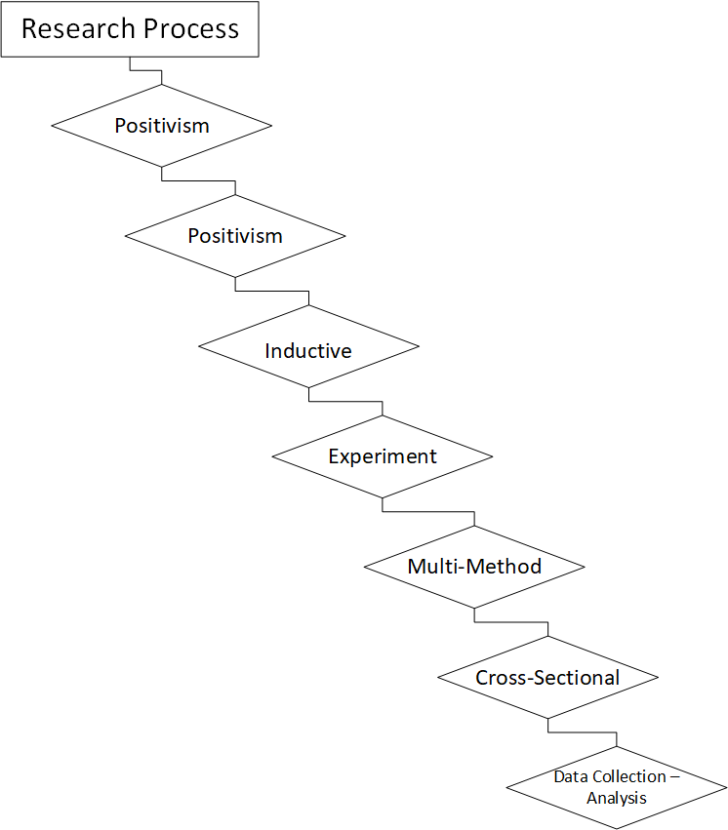
Figure 82 - Research Process for the Project Highlighting the Process.

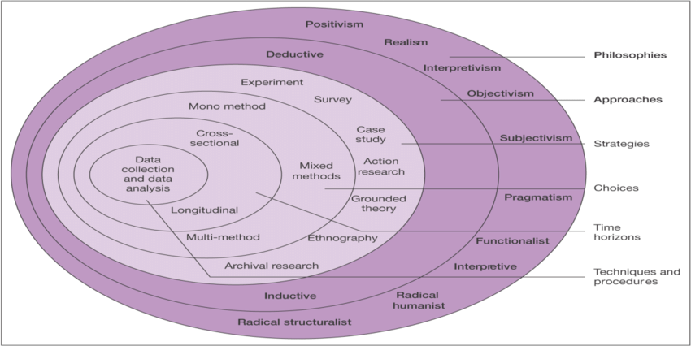
Figure 83 - Onion Diagram [72]

Appendix 2 – Block Diagram
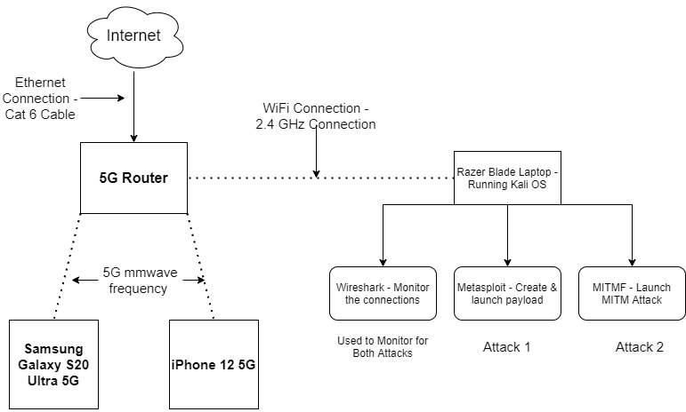
Figure 84 – More Detailed Block Design

Appendix 3
The software and tools that have been used are individually important and specifically desired for certain parts of this experiment to work. Most operating systems that use Linux would work and be acceptable for this kind of experiment as it is mostly just the host for the applications that are being used. To make this experiment operate clean and reliable it has had been chosen to use an operating system that is fit for this kind of style of experiment. Using the Kali Operating System is dedicated to pen testing applications, hardware, or services. This will be perfectly fitting for this king of testing. For the software there will be three applications utilised for the experiment, these are a packet analyse application called Wireshark, this is used to find the packets and track the amount that will be used during the test of the attack. Measuring the number of packets being sent & the amount that fail. The Second application that would be used is Metasploit, this application is one of the best penetration testing tools, this tool would be used to launch an attack for DOS on the routers. Furthermore, the last application is Bettercap this application is used to perform a man in the middle attack, it will be used to obtain the device information such as device history and login details.
For the hardware and tools to be used, it was important to have devices that were 5G enabled and have devices that were backwards compatible with 4G. This led to using two phones that were 5G enabled and contained 4G, these phones are Samsung Galaxy S20 Ultra 5G (sub-6 GHz) & iPhone 12 5G (sub-6 GHz). The equipment that is being used is a laptop that is running Kali Linux, the laptop is a razor blade, and it has an i7 processor with 16 gigabytes of ram Furthermore containing a Wi-Fi card that works with 802.11ac. Furthermore, the additional Wi-Fi antenna that connects via USB to the laptop. The two routers that need to be used are a 5G router and a 4G router, these two routers we used to test the comparison between previous generations.

Appendix 4 – Router Diagram
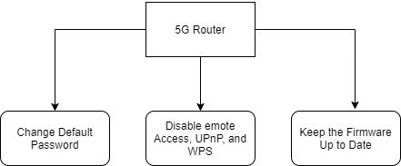
Figure 85 - Router Solutions Diagram

Appendix 5
To give a design overview of how this project experiment will take place, there will be 2 experiments that will follow directly after each other, in figure 6 5G design & figure 7 4G design, there are two block diagrams that show the design of the experiment. the experiments contain two different items but are a 5G router on 4G router in both different block diagrams, everything else in these diagrams stay the same as this will help to create a comparison for the two different technologies at the end to show if 5G technology has improved on its flaws since 4G. Starting off by having a rogue laptop outside of the network connecting over a Wi-Fi connection, having the attacker using the two different attacks (not at the same time) to hack the router. Successfully, the hacker will be able to slow the connection down to be unusable or potentially be able to watch and track user’s activity. At this point the hacker has got the ability to watch and slow down or even disconnect uses from the router, to find a solution for this will require some security input and using a framework for the user to operate.

The design was chosen as it easy to maintain and setup for effective analysing. Comparing this design to other designs found in the literature section, this experiment design has been focused more on the attack to the router and recording the results from the attacks pc and the phone operations.

Appendix 6 - Method
Method
An example of understanding the project ahead will require the use of methods like penetration on the 5G router, Once the penetration is successful it will allow for the laptop loaded with present software tools start scanning for available devices, boss’s devices are found initiating denial of service attacks on devices to drop them out of the network or setting up a man in the middle attack on creating a fake website i.e., Twitter or Facebook collecting logging details.
The reasons why these two types of attacks were selected is because they are predominantly still around after 25 years of being discovered. For these attacks to still be capable of working on the latest standard of network such as 5G brings up questions why has this not been got a solution?
A solution framework design involves primarily teaching end users security information and understanding the devices they are using and what there are working on. For their solution to work, the end users must go through quick and detailed course on basic threats such as malware and phishing links. Referring to Figure 10, a diagram of how a solution would be used. Creating a solution would also involve upgrading the default security on a router. Default security settings on routers are not always the most secure, even when they are coming directly from the factory brand new. This will mean that devices will need to have certain things change, like the default password. Disabling UPnP and remote access as some examples. Referring to figure 11. Shows a solution to configuring default security on a 5 two router.
The attack in the first case is a distributed denial of service attack and the second attack to be used is a Man in the Middle Attack. These two attacks work with the same principle, but both have a different outcome, A DOS attack works on taking the 5G router down by overload the system to crash or reboot, making the signal unable for the end users. The MitM attack works on looking at the data being sent in between the devices with the attack being able to record user information.

Appendix 7 - Samsung Phone Setup

Screenshot Images | Explanation of Events
  Figure 86 - Samsung Home Screen | ← On the home screen of the Samsung phone is a setting button, this can also be located on the home screen or within the option of the notification menu in the top right corner. Once the setting page has loaded it will present a menu of options for the phone settings.
  Figure 87 - Samsung Connection Option | ← In this page, selecting the option “connections” this will open the options for networks. This will be found close to the top of the setting.
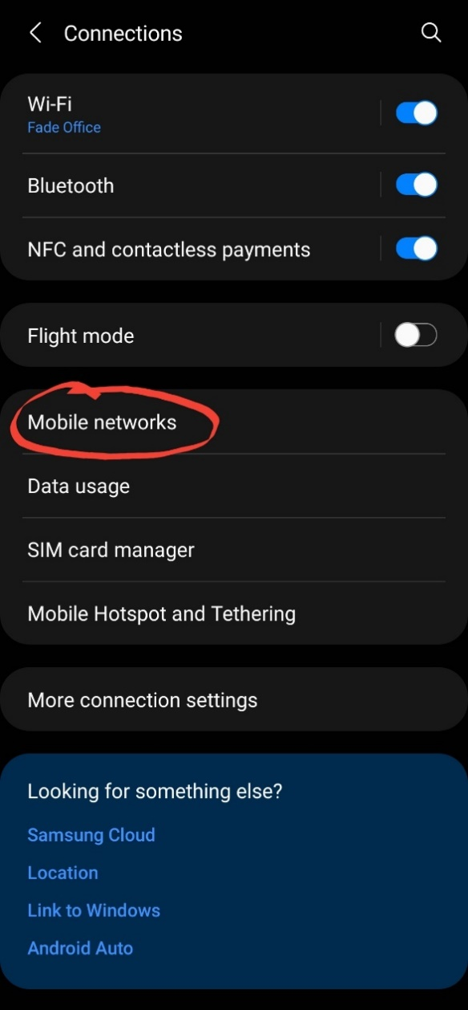  Figure 88 - Network Mode | ← Near the top, selecting the option for the “mobile networks” in these options it will allow for a collection for my in-depth configuration for the network.
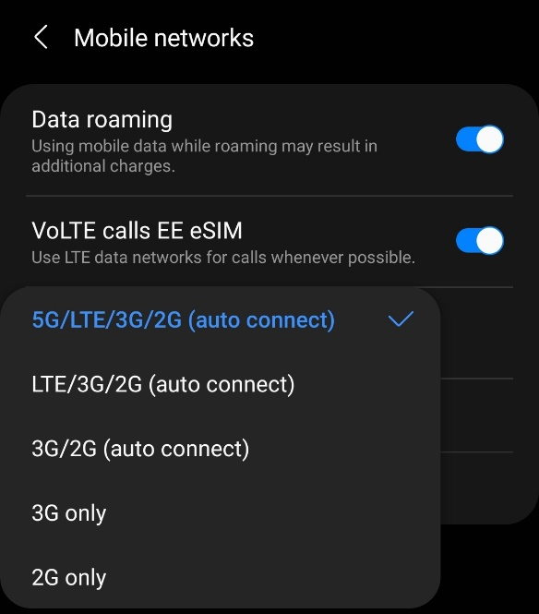  Figure 89 - Selecting 5G (auto connect) | ← The option “Network Mode” is where the user can change to the preferred Network Mode. This was set to 5G, so when a 5G network comes in reach it is about to auto connect to a 5G standard. Once this is done the phone Is setup and ready to connect.

Appendix 8 – iPhone Setup

Screenshot Images | Explanation of Events
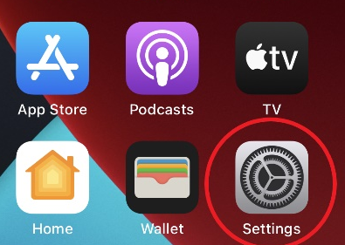  Figure 90 - iPhone Home Screen | ← On the home screen of the iPhone is a setting button, this can also be located on the home screen. Once the setting page has loaded it will present a menu of options for the phone settings.
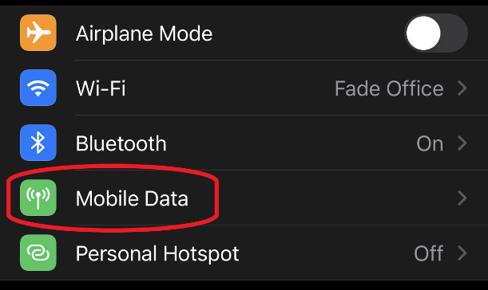  Figure 91 - iPhone Setting Page | ← In this page, selecting the option “Mobile Data” this will open the area for configuring the iPhone sim setting. This will be found close to the top of the setting.
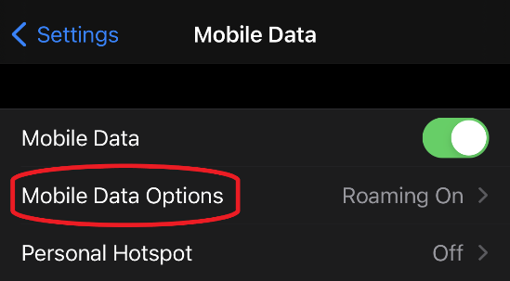  Figure 92 - Mobile Data Options | ← Near the top, selecting the option for the “mobile data options” in these options it will allow for a more in-depth configuration for how the phone will connect to the operator’s network.

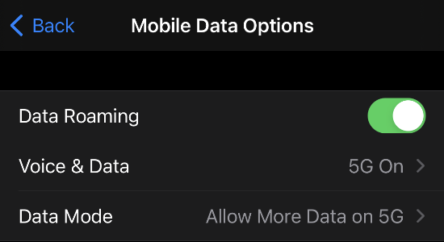  Figure 93 - Selecting Voice & Data | ← The selecting the option “Voice & Data” & “Data Mode” is where the user can change to the preferred Network Mode. (5G, 4G or 3G).
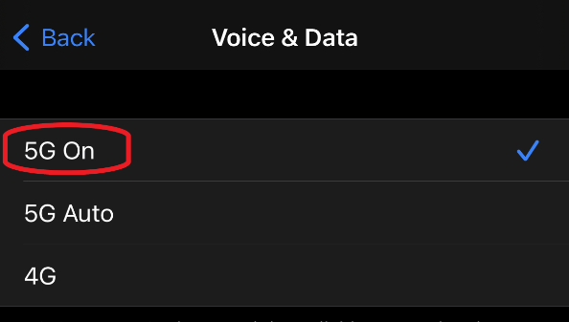  Figure 94 - Selecting 5G | ← This will be set to 5G, so when a 5G network comes in reach it is about to auto connect to a 5G standard. Once this is done the iPhone Is setup and ready to connect.

Appendix 9 – Kali Linux Setup

Screenshot Images | Explanation of Events
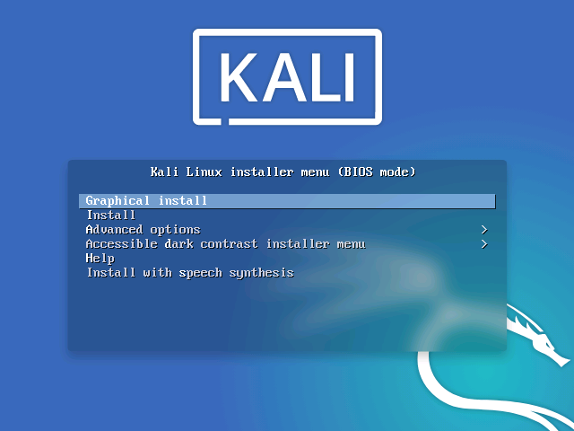  Figure 95 - Kali Install Menu | ← kali installer offers a menu when booting for the first time, choosing the graphical install will allow for a desktop view to be pre-installed with the operating system. Overall, this will make accessing and using the operating system easier and quicker for demonstration purposes.
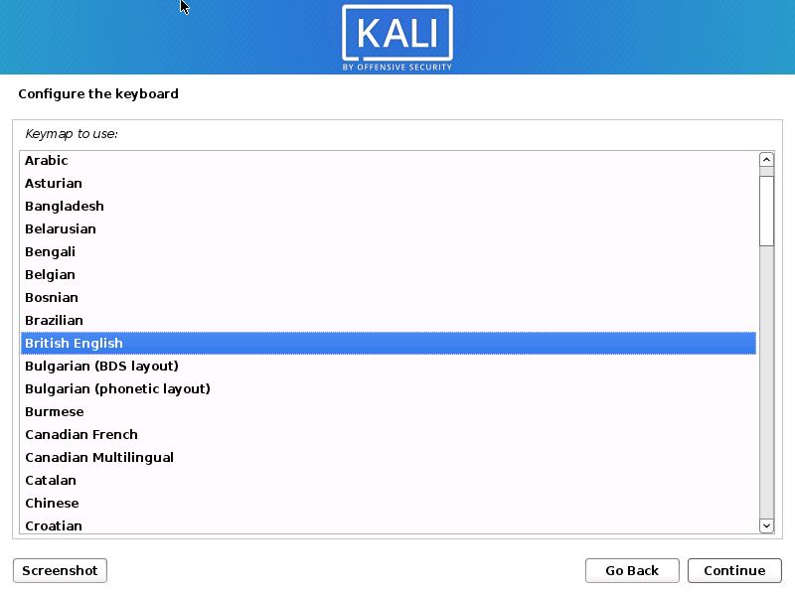  Figure 96 - Kali Time Zone, Keyboard & Language | ← The first step of installing the operating system is setting up the keyboard location and language that the system is going to be using such in this to British English and UK keyboards as the standard as well as being set in London for time zone.

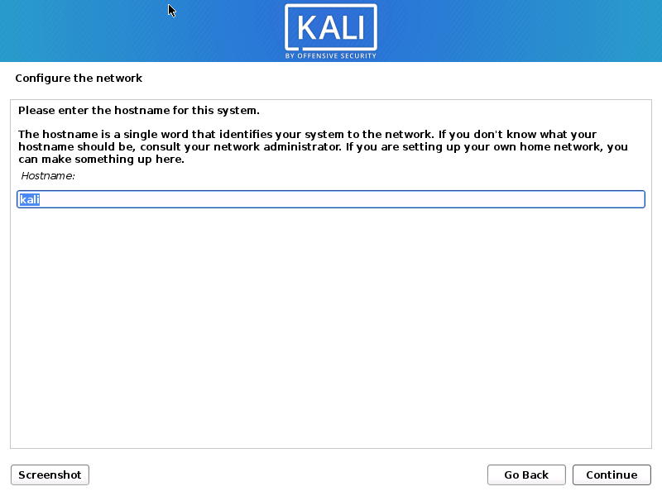  Figure 97 - Kali Setting Hostname | ← The system a host name, this is what is used to identify the system to the network.
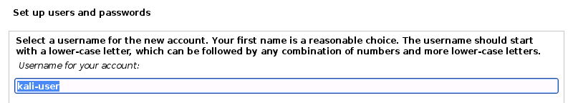  Figure 98 - Kali Username | ← Setting up the username allows for user accounts to be created to log into the system, this user account will be created by default and will have root privileges.
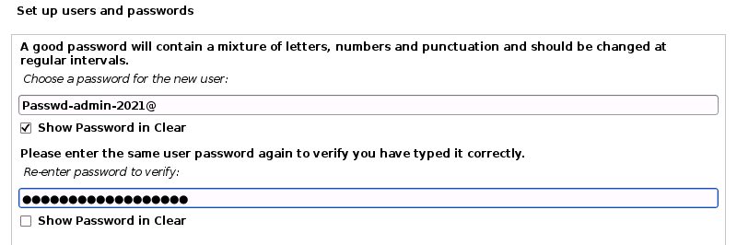  Figure 99- Kali Password | ← The password needs to be created for the account log on this password space set to “Passwd-admin-2021@”.
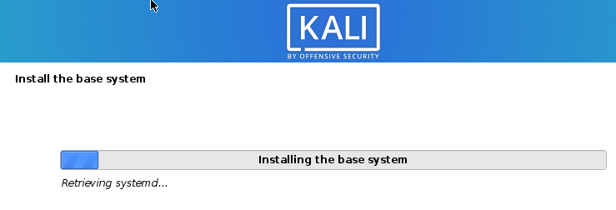  Figure 100 - Kali Base System Installation | ← After the password has been setup the system would then start to partition the disk, this was just set to a basic disc installed with no encryption. The system also asked for a proxy information this was just left blank, and then lastly the software selection where a selection of different desktop environments could be selected or a collection of tools set from minimal, default or large collection. For this option it was chosen to just go with the default software and for the desktop environment going with GNOME.
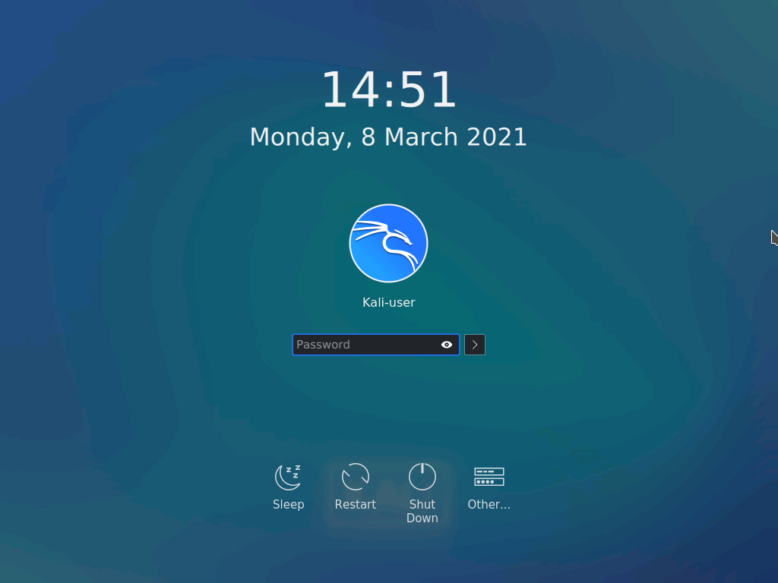  Figure 101 - Kali Login Screen | ← Furthermore, once this section is completed, the system will reboot, and it should bring the lock screen up with password request. Using the password that created in the previous steps “Passwd-admin-2021@” will allow the user to logo on.
  Figure 102 - Kali Home Screen | ← Once the user is log in, this will be the home screen. This desktop environment is played out very much like windows, allow for a smooth transition for user move back and forth.

Appendix 10 – Gantt Chart
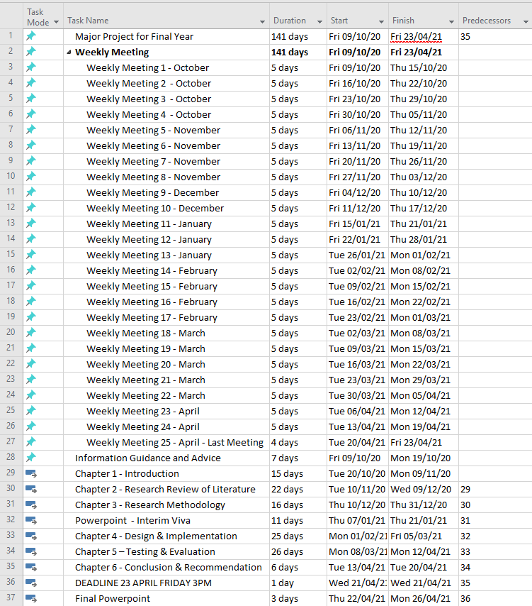
Figure 103 - Gant Chart for Task View

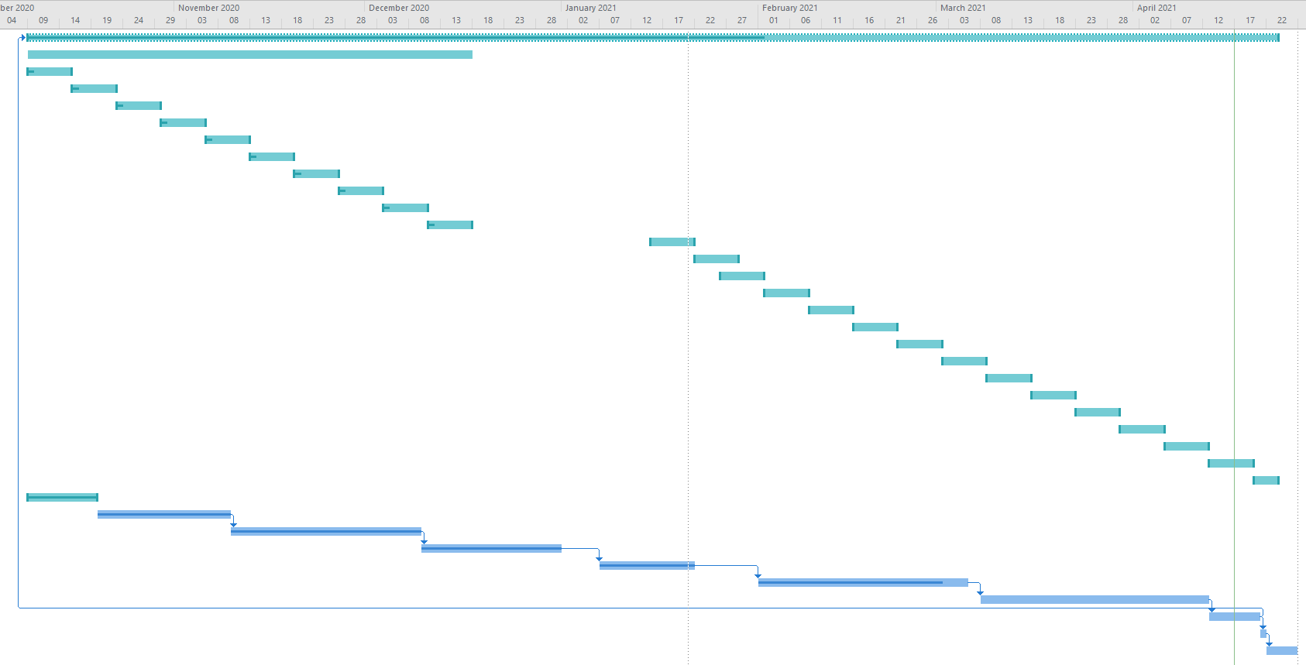
Figure 104 - Gant Chart Graph View

Appendix 11 - Logbook

Date | Logbook Notes
09/10/20 | - First meeting was a discussion about the project and how to go about tweaking and the project to fit within an easy time frame and achievable goals.
16/10/20 | - Guidance and information were given on how to structure the project and go through the first chapters. Starting on chapter one with the introduction and the objectives, aims and structure of the report.  - Researching information on security IoT devices and 5G mostly researching cellular networks for later and saving this information in referencing.
23/10/20 | - Continuing the structure of the report by researching external papers and looking at security frameworks.  - Going through spelling and grammar and tidying up unprofessional University grammar in the paper to make it more professional for publication.
30/10/20 | - Starting on the literature review.  - Gathering resources and research papers.  - finished the introduction.  - start on cellular networks.
06/11/20 | - Finished an overall view of the cellular networks and the security architecture of 5G talking about Network slicing.  - Talks about it and more about the security elements behind it.  - Need to complete and understand more about the security threats.
13/11/20 | - Research survey papers.  - Add more information and research.  - Use more up-to-date information.  - Get the critical review started.
20/11/20 | - Focus on 2 key Ares:  - General knowledge on survey paper  - Related work with technical paper / experiments  - Use Sub heading to keep log about that.  - Constantly keep going back and keep adding for new information in the appropriate area.
27/11/20 | - What is the best way about conducting the experiment?  - I looked at the software MATLAB and it look limited in what I can do.  - Would it be best to focus on attack on IoT devices
04/12/20 | - Keep working on the lecture revive and the related work.  - Aked a question about the authors of two paper and there are good and
11/12/20
15/01/21 | - Preparing Presentation for the Interim Viva Guide
22/01/21 | - Finishing and completing the methodology section on the project
26/01/21 | - Starting the design & implementation  - Use block diagrams to outline the problems to be solved.  - - Outline the approach and how to solve the problem  - - The methods used to solve or experiment  - - Outline the tools being used hardware or software
02/02/21 | - Outline the Approach to the problems that need to be solved.  - How I am going to find the problem – Method – Example Penetration  - Explain the problem after
09/02/21 | - The step by step of the procedures / configuration of implementing the design structure to get it working.  - Take screenshot at ever steps number them and explain. These steps are when you configure the design.  - Discuss ever part of the design / Cables / Router / Devices  - Screenshot the process on the kali OS all the way through.  - Maybe record a video for the experiment  - Show all steps when going though all experiment.
16/02/21 | - No updates
23/02/21 | - No updates
02/03/21 | - The meeting concluded with the supervisor discussing that finishing the chapter for design and implementation was critical to meet deadlines.
09/03/21 | - Testing the 4G Router  - Tested DoS & MitM Attacks  - Recording results
16/03/21 | - Testing the 5G Router  - Having to travel to Swansea to gain access to the 5G network for testing on the router.  - Tested DoS & MitM Attacks  - Recording results
23/03/21 | - Recreated the testing to video recorded the results for evidence.  - Writing up the testing  - Reading addition paper
30/03/21 | - Easter Break - No meeting  - Started creating the conclusion & finished.  - Started chapter 7 reflection
06/04/21 | - Easter Break - No meeting  - Finished the last chapter.  - Added all the reference into the document.  - Finished updating the gant chart.  - Also did a grammar and spelling check
13/04/21 | - Easter Break - No meeting  - Continued to check for grammar and spelling errors.
20/04/21 | - The final Meeting with my supervisor, this meet was to fix any lose ends and tidy up part that did not flow or with not needed for my project. Parts of the project are places within the appendix.

