Student Name: Mihaela Calin  Student ID: 2226828  Module Title: Foreign Languages and Cultural Awareness  Module Code: BMIH5003  Lecturer: Lisa Bassler  Date: 08/02/2024 | 
ASSIGNMENT 1: PORTFOLIO

Component 1: Professional Reflection
A cross-cultural issue was observed when one of the German guests with whom the new trainee receptionist who could not communicate properly interacted. This confusion was clearly visible when I was on duty at my front desk post as working a busy Saturday dinner shift. The guests were in fact an enormous extended family that checked in three rooms attached to each other. The guests could not speak in English very well. As the trainee completed the venture of monitoring the visitors’ booking details and their room selections, he grew agitated and hence could no longer understand the nuances in the guests’ accents and questions.
However, the language barrier became more and more annoying for both the two sides which led to their frustration with each other during check-in process; therefore, I intervened in order to mediate between them. I attempted to refine the acknowledgement of these needs by using gestures and responding questions differently, as well as offering my guests their keycards with a warm but apologetic welcome. Despite the fact that I managed to defuse the situation, I could not help but wonder about how disempowered the family seemed, for effective communication gives visitors a possibility to state needs that affect comfort (Ersoy, 2014). Although it was unintentionally motivated, our service disruption because of cultural and linguistic unfamiliarity did not demonstrate hospitality but rather disrespect.
This was an eye-opening experience that made me realize I have to enhance my skills and cultural background in order to reduce surprising chats from happening. It was discovered by Kalargyrou and Costen, (2017) that hospitality service quality is deteriorated due to the peculiarities of the communication skills and language level of hospitality employees, as individuals find it difficult to adapt their communication tactics or are unfamiliar with foreign languages. The lacking in the cultural awareness evidently becomes more problematic, especially at the reception areas where initial impressions are formed, unintentionally promotes discrimination through ignorance (Manhas and Tukamushaba, 2015).
In a bid to deliver warm and gracious hospitality honours that Courtyard Marriott Exeter is known for, I will be proactive in learning important hospitality phrases in several languages. However, Exeter is known for a large international visitor population. Even verbal basics such as check-in instructions, directions around the city and locals’ recommendations can be beneficial when welcoming a diverse audience. This is also consistent with studies by Lopez-Fernandez and Sanchez-Canizares, (2012) that cross-cultural training is a substantial boost to the skills employees need for serving multicultural customers. Thus, while fluency demands advanced engagement, repeated application of hospitality language apps during my rests can still make me extend attention to any guests (Paparoidamis, Tran and Leonidou, 2019).
I will also not ignore past perplexity or dissatisfaction body language in future to be able to resolve conflicts that may arise immediately. In turn, Reisinger and Dimanche, (2020) notes that cultural literacy needs to be developed by all employees in the tourism industry, for successful interaction with tourists from all corners of the globe. Through observing successful senior receptionists, who can cope with the linguistic difficulties, I am able to develop my own abilities for delivering services in the best possible way. The reward is truly reaped since the value of getting past hurdles to create enriching experience for foreign tourists more than pays off.
References:
Ersoy, A. (2014) “The Role of Cultural Intelligence in Cross-Cultural Leadership Effectiveness: A Qualitative Study in the Hospitality Industry,” Journal of Yasar University, (9).
Kalargyrou, V. and Costen, W. (2017) “Diversity management research in hospitality and tourism: past, present and future,” International Journal of Contemporary Hospitality Management, 29(1), pp. 68–114.
Lopez-Fernandez, M. C. and Sanchez-Canizares, S. M. (2012) “Business social responsibility from an employees’ perspective: The case of hotel companies in Spain,” International Journal of Human Resource Management, 23(2), pp. 318–333.
Manhas, P. S. and Tukamushaba, E. K. (2015) “Understanding service experience and its impact on brand image in hospitality sector,” International Journal of Hospitality & Tourism Systems, 8(1).
Paparoidamis, N. G., Tran, H. T. T. and Leonidou, C. N. (2019) “Building customer loyalty in intercultural service encounters: the role of service employees’ cultural intelligence,” Journal of International Marketing, 27(2), pp. 56–75.
Reisinger, Y. and Dimanche, F. (2020) International tourism. London, England: Routledge.
Component 2: Training Plan

Identified cultural misunderstanding (in a few words) :
A cultural and language misunderstanding was identified as having happened between a group of German family members and a trainee receptionist who was having difficulty communicating properly in English throughout the check-in process. Frustration and a sense of disdain were transmitted to the visitors as a result of the occurrence, which significantly diminished their experience upon arrival. The level of service quality dropped substantially as a result of the staff's lack of cultural understanding and English fluency strategies.
Training plan (Why/What//Who/Where/When):
Why:
Misconceptions about guests’ behavior which take place during the encounters due to cultural and language differences are responsible for the negative service experiences at our hotel. Some frustration and contempt, in general, was conveyed due to a recent event that has occurred within German guests and a receptionist who was unable to communicate the required information throughout the check-in dialogue. This was as a result of the poor quality of service in terms of cultural understanding and fluency in English strategies among the staff (Clarke and Chen, 2007). If we equip our men with knowledge on inter cultural communication skills and also give them a basic knowledge of hospitality words from diverse languages available, they can be able to effectively address our globalized customers.
What/Who:
The cultural sensitivity education will be also part of the training which focuses not only on English-Language fluency and Languages other than English (Lopez-Fernandez and Sanchez-Canizares, 2012). This activity will involve the participation of receptionists, concierges, porters, and front desk managers. Included are all employees that interfere directly with overseas guests who are in front line.
Key Training Content:
1. Cultural awareness basics understanding guest perspectives and avoiding assumptions
2. English clarity tactics like summarizing needs and rephrasing complex questions
3. Basic hospitality phrases in 5 key languages - greetings, check-in vocabulary, amenity terminology
4. Reading body language signals across cultures
5. Etiquette interacting with visitors from Asia, Middle East, Europe, etc.
Where:
Interactive online video modules that enable effective and scalable transmission to all staff members are referred to as eLearning solutions. Retention is strengthened using games and quizzes (Tavitiyaman, Weerakit and Ryan, 2014). The purpose of face-to-face workshops is to provide supplementary in-person experience that promotes peer feedback by role playing possible multicultural visitor scenarios at reception (Tayeb, 2001). On-Floor Reference using condensed tip sheets that contain essential phrases, gestures, and cultural recommendations that employees can refer to while engaging with customers from other countries (Zhu, Baldauf and Fan, 2011).
When is it:
Development: April 2023 - Create customized digital curriculum and in-person materials.
Initial Rollout: May 2023 - All front-line personnel complete online and workshop training composed of two 2-hour sessions.
Refresher: June 2023+ - Quick annual refresher course to reinforce knowledge application.
Through the allocation of resources to continuing cultural and language instruction, our team that interacts directly with customers can give exceptional service to visitors from international corporations. It is possible to enhance pleasant visitor impressions by providing training in front desk skills, specifically in adaptive communication and cultural views.
References:
Clarke, A. and Chen, W. (2007) International Hospitality Management. Oxford, England: Butterworth-Heinemann.
Lopez-Fernandez, M. C. and Sanchez-Canizares, S. M. (2012) “Business social responsibility from an employees’ perspective: The case of hotel companies in Spain,” International Journal of Human Resource Management, 23(2), pp. 318–333.
Tavitiyaman, P., Weerakit, N. and Ryan, B. (2014) “Leadership competencies for hotel general managers: The differences in age, education, and hotel characteristics,” International Journal of Hospitality & Tourism Administration, 15(1), pp. 79–95.
Tayeb, M. (2001) “Conducting research across cultures: Overcoming drawbacks and obstacles,” International Journal of Cross Cultural Management, 1(1), pp. 91–108.
Zhu, Y., Baldauf, R. B. and Fan, D. X. (2011) “Management challenges in China’s hotel industry: The perceptions of expatriate hotel professionals,” Journal of China Tourism Research, 7(4), pp. 415–429.
Component 3: Student Self-Reflection
To critically reflect on my evolving understanding of cultural awareness in hospitality, I will utilize Gibbs' (1988) Reflective Cycle model. This structured approach analyses the event, my response, key takeaways, and future applications.
Description
Initially when learning about hospitality service, I did not consider cultural differences a major factor. My views focused more on skills like customer satisfaction and complaint resolution. However, observing the communication breakdown between our server and Japanese guest deeply highlighted how cultural ignorance can negatively impact visitor experiences (Clarke and Chen, 2021). I lacked understanding of how profoundly language and societal norms influence interactions.
Feelings
Witnessing the cultural disconnect during service made me feel unsettled and concerned for both parties. The guest likely felt confused and potentially disrespected from the language barrier. Meanwhile, our employee seemed stressed and frustrated when he could not understand her accent or translations. I wished I had training to mediate their conversation and make the visitor feel cared for.
Evaluation
Reflecting afterwards, I realized both negative reactions stemmed from cultural and linguistic unfamiliarity. As Swallow and Millo, (2019) explain, hospitality service often suffers when employees cannot bridge cross-cultural gaps. While unintentional, failing to communicate menu options still transmits disrespect rather than hospitality (Cogo, 2016). I should have stepped in to help, using body language, visuals, or translation tools to support mutual understanding.
Analysis
From this incident, I learned language difference alone can inadvertently convey discrimination if employees lack proper diversity training. Researchers emphasize that tourism staff must continually expand cultural knowledge to engage positively with international travelers (Manhas and Tukamushaba, 2015). While complicated, individuals can learn better cross-cultural communication methods through ongoing applied practice and empathy development (Manhas and Tukamushaba, 2015).
Conclusion
Moving forward, I aim to enhance my own language skills and cultural perspectives to minimize awkward or offensive exchanges with guests. I also have greater appreciation for hotels implementing immersive diversity training to expand employee cultural repertoires when serving global clientele. Filling gaps in societal awareness requires institutional commitment along with personal growth.
Action Plan
I will be more proactive offering friendly assistance during service, watching for nonverbal signals of miscommunication. I also plan to study free hospitality language apps during my breaks to build a practical translate phrase vocabulary. To continue improving, I will look for a mentor on staff with strong cross-cultural service expertise that I can shadow. Enhancing my own skills will allow me to better ensure all visitors feel welcomed.
By applying Gibbs’ model, I have mapped my cultural awareness journey from underestimating language challenges to valuing multicultural capacity as central for modern hospitality. Using structured self-reflection, I can trace my perspective shifts and concrete lessons. It reminds me that becoming a truly skilled service professional requires lifelong commitment to understanding people’s diverse needs and backgrounds. This cultural knowledge continues to be a work under construction for me, but it motivates me actively to train myself with the tools and models available. The benefits of the barrier’s transgression, to ensure quality service provision to foreign tourists, justify the workload.
References
Clarke, A. and Chen, W. (2021) International Hospitality Management. 2nd ed. London, England: Routledge.
Cogo, A. (2016) “Strategic use of essentialist representations of linguistic diversity: Tourism and the commodification of language in superdiverse cities,” Applied Linguistics Review, 7(3), pp. 353–376.
Manhas, P. S. and Tukamushaba, E. K. (2015) “Understanding service experience and its impact on brand image in hospitality sector,” International Journal of Hospitality & Tourism Systems, 8(1).
Sizoo, S. et al. (2005) “The effect of intercultural sensitivity on employee performance in cross-cultural service encounters,” Journal of Services Marketing, 19(4), pp. 245–255.
Swallow, D. and Millo, Y. (2019) “Anthropological approaches to international business,” The SAGE Handbook of Cultural Anthropology, 6, pp. 121–143.
Component 4: Training Presentation
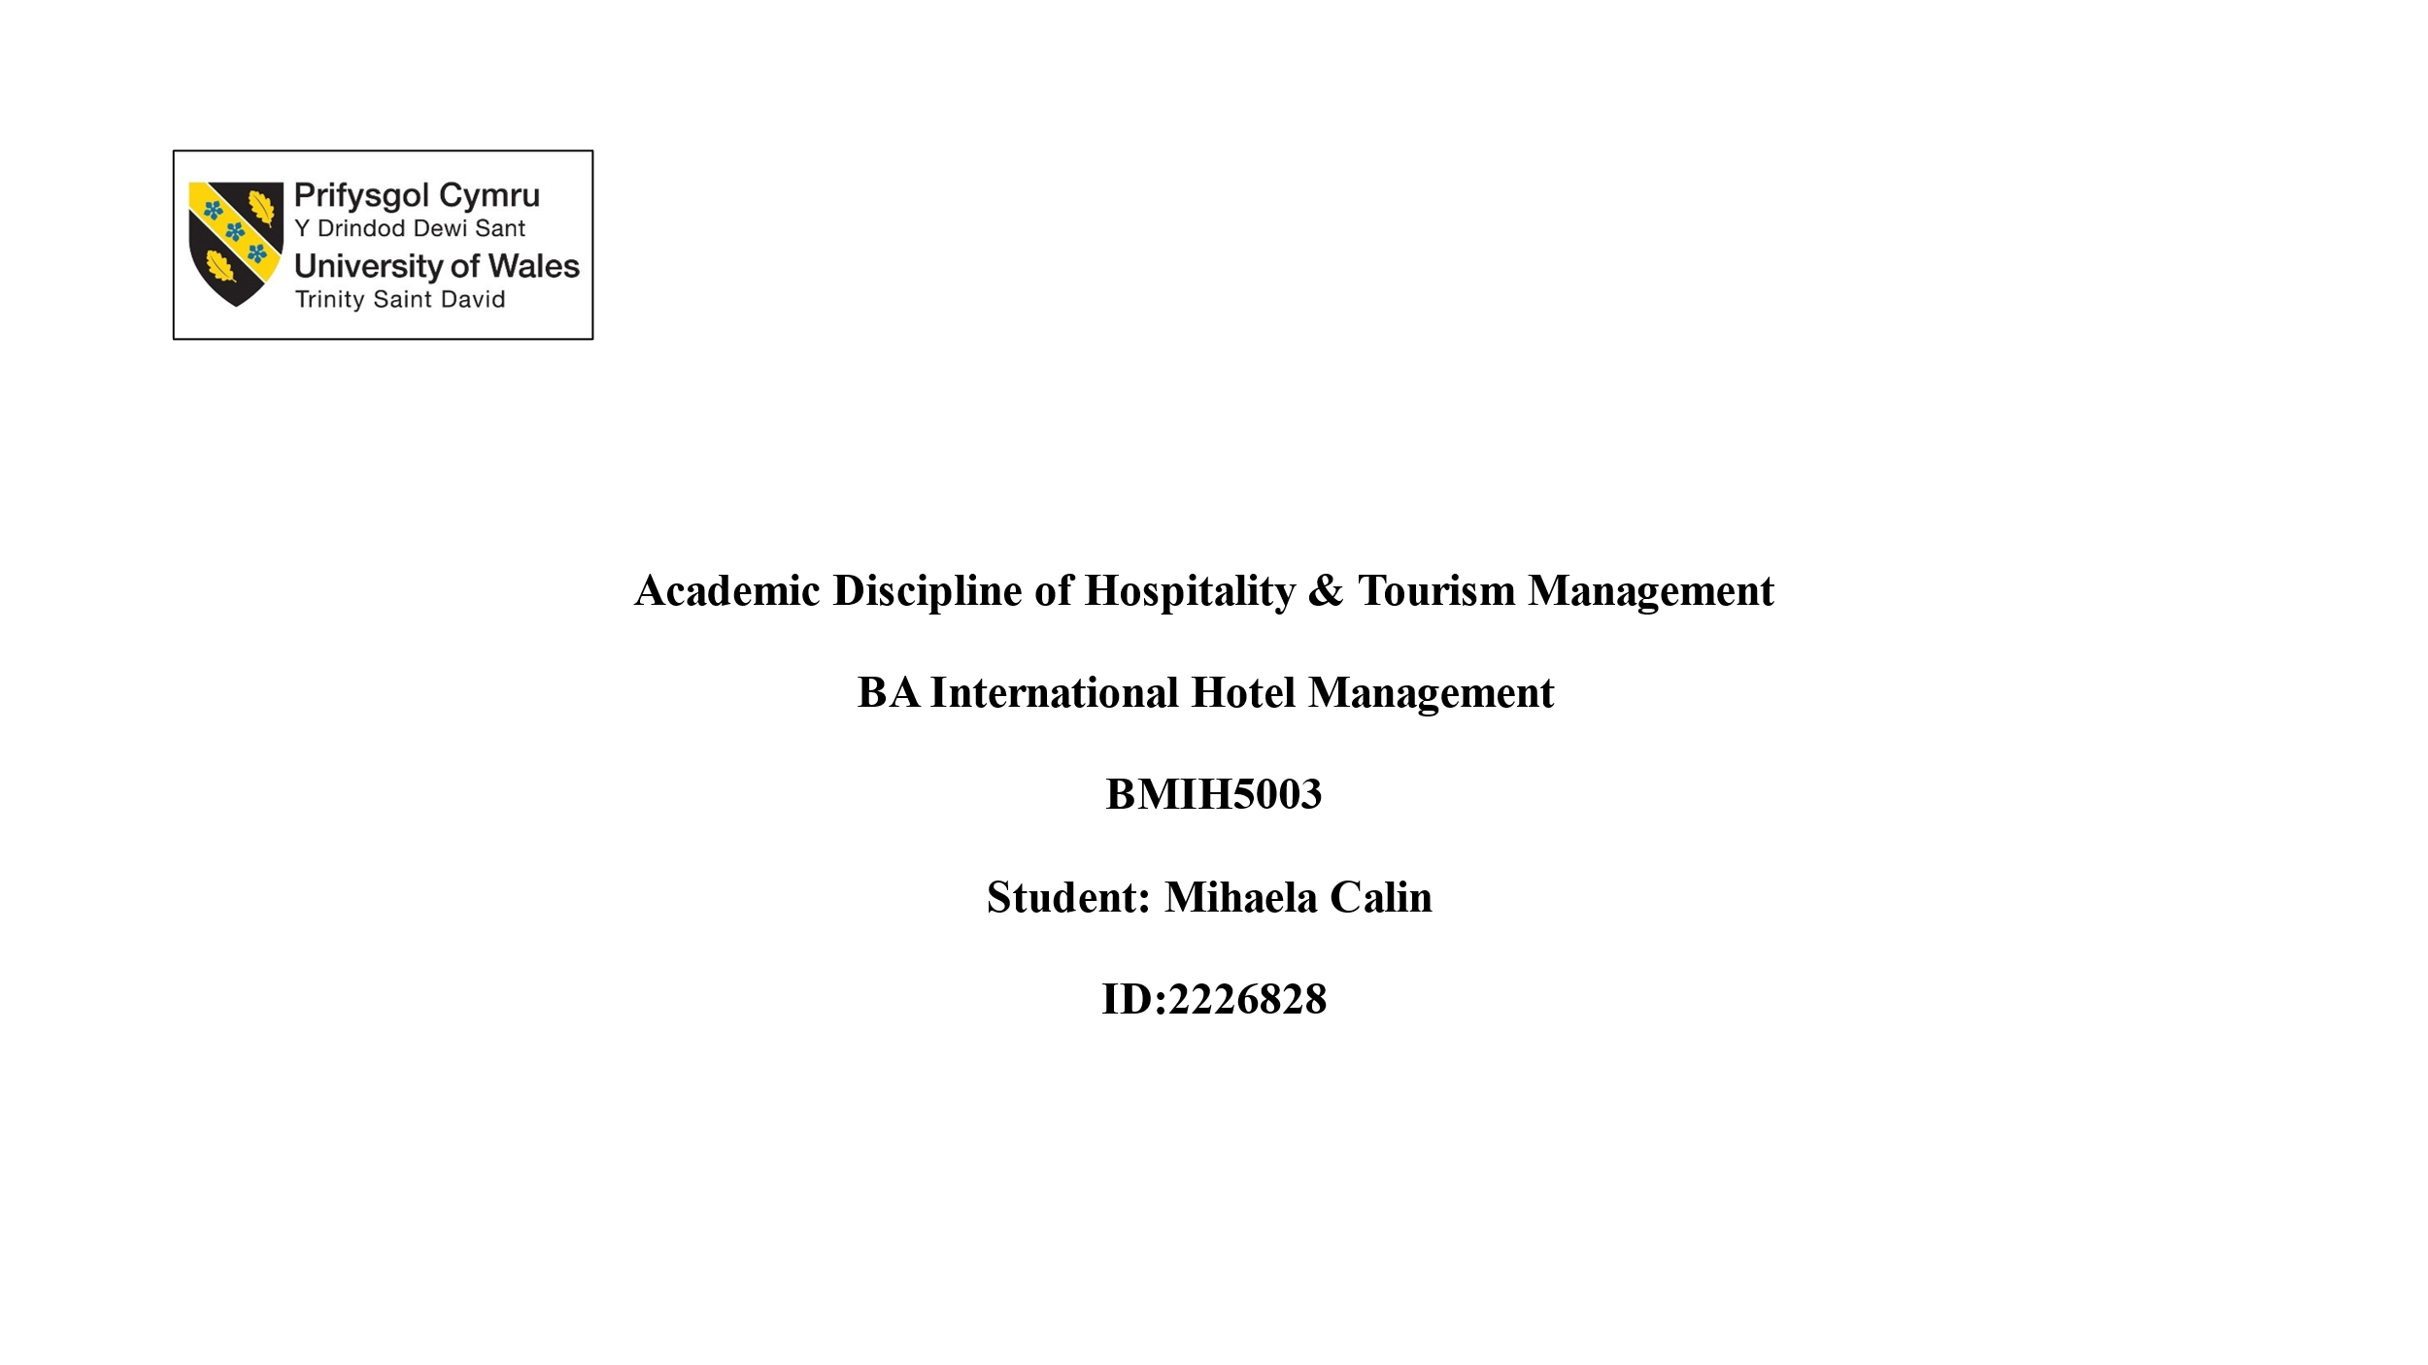
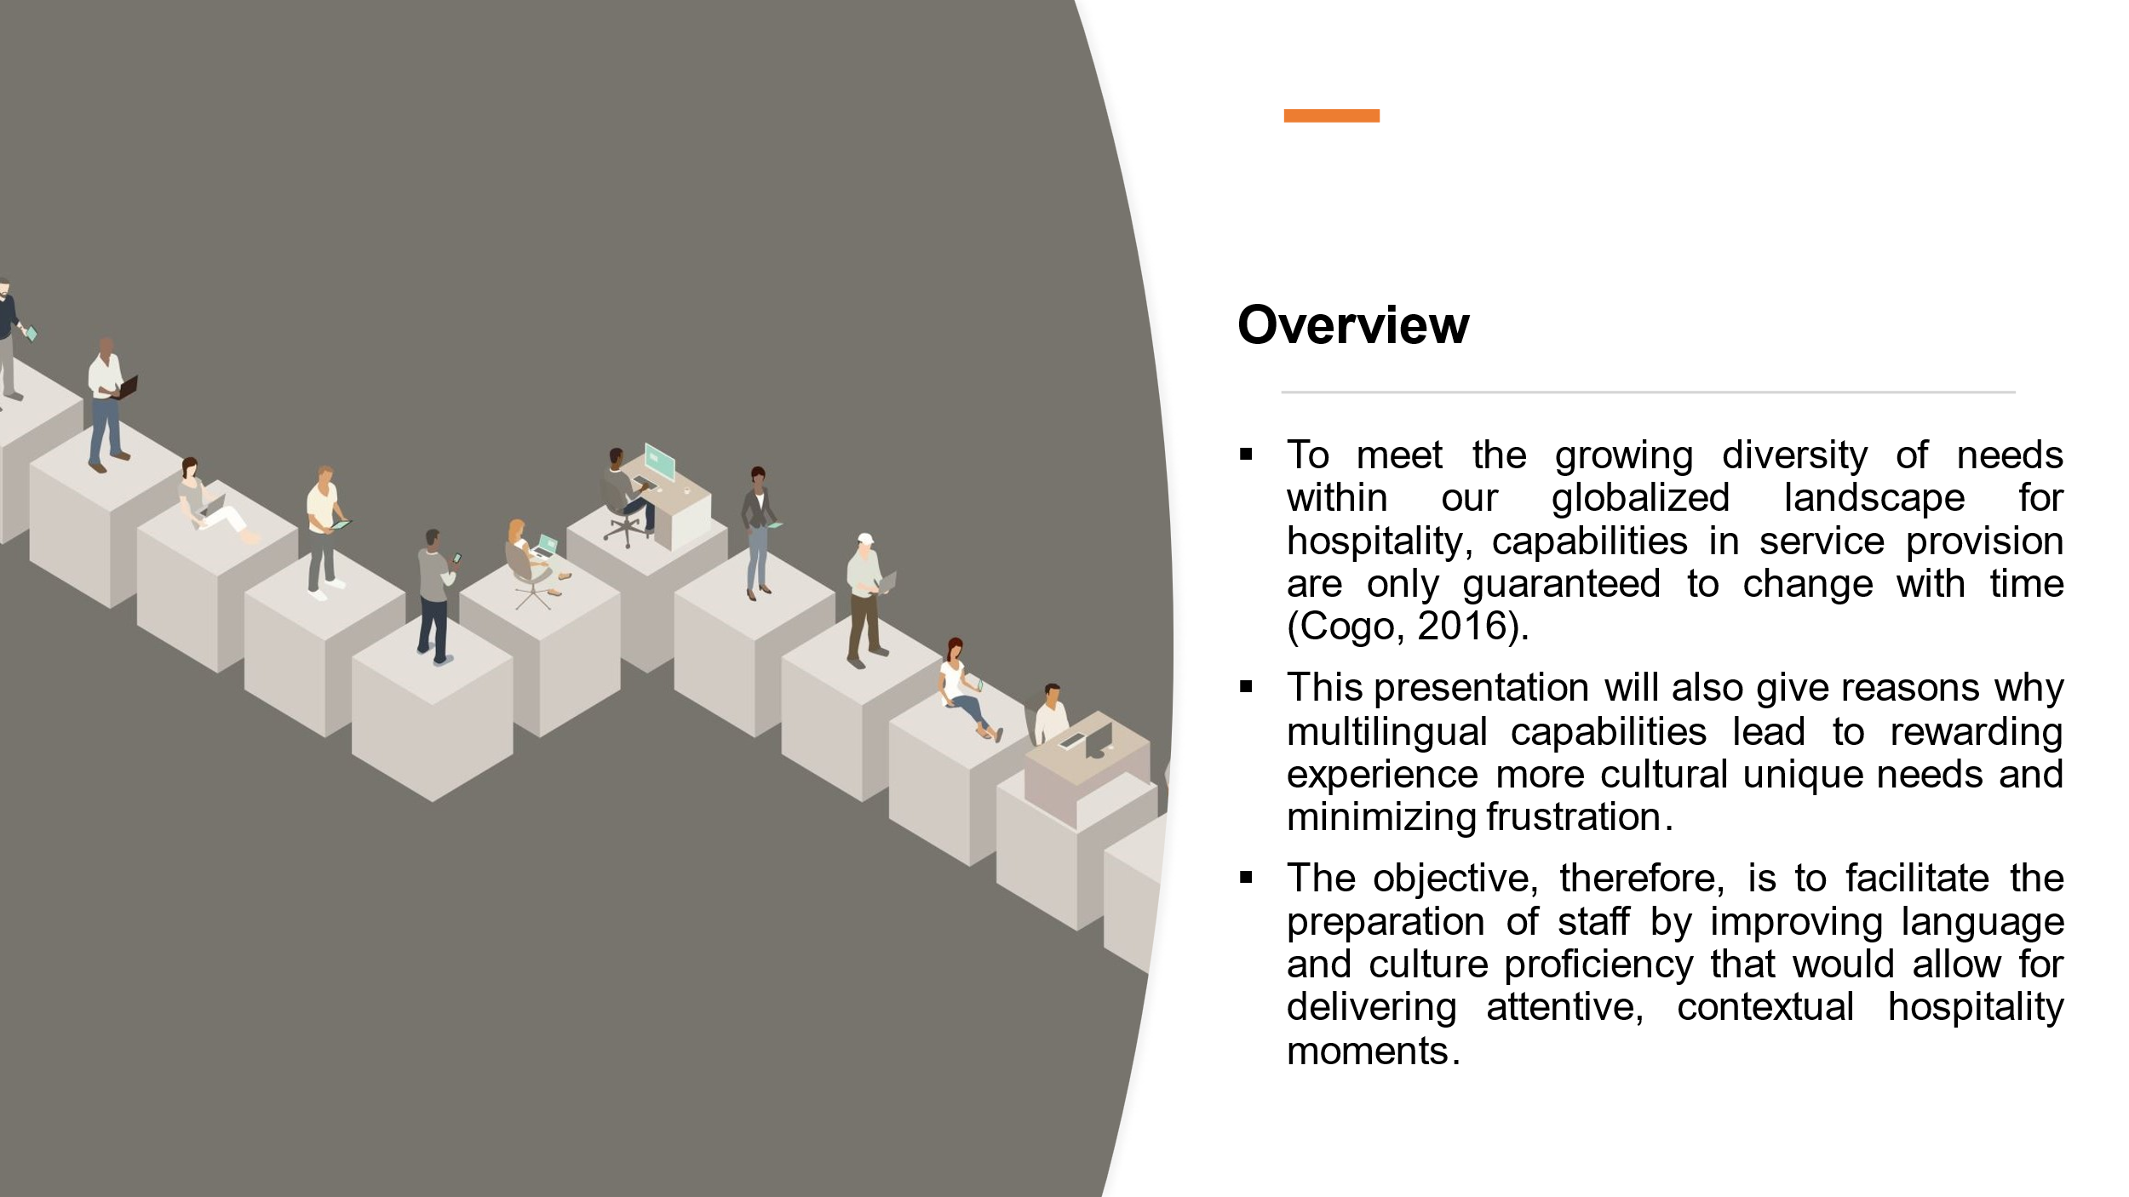

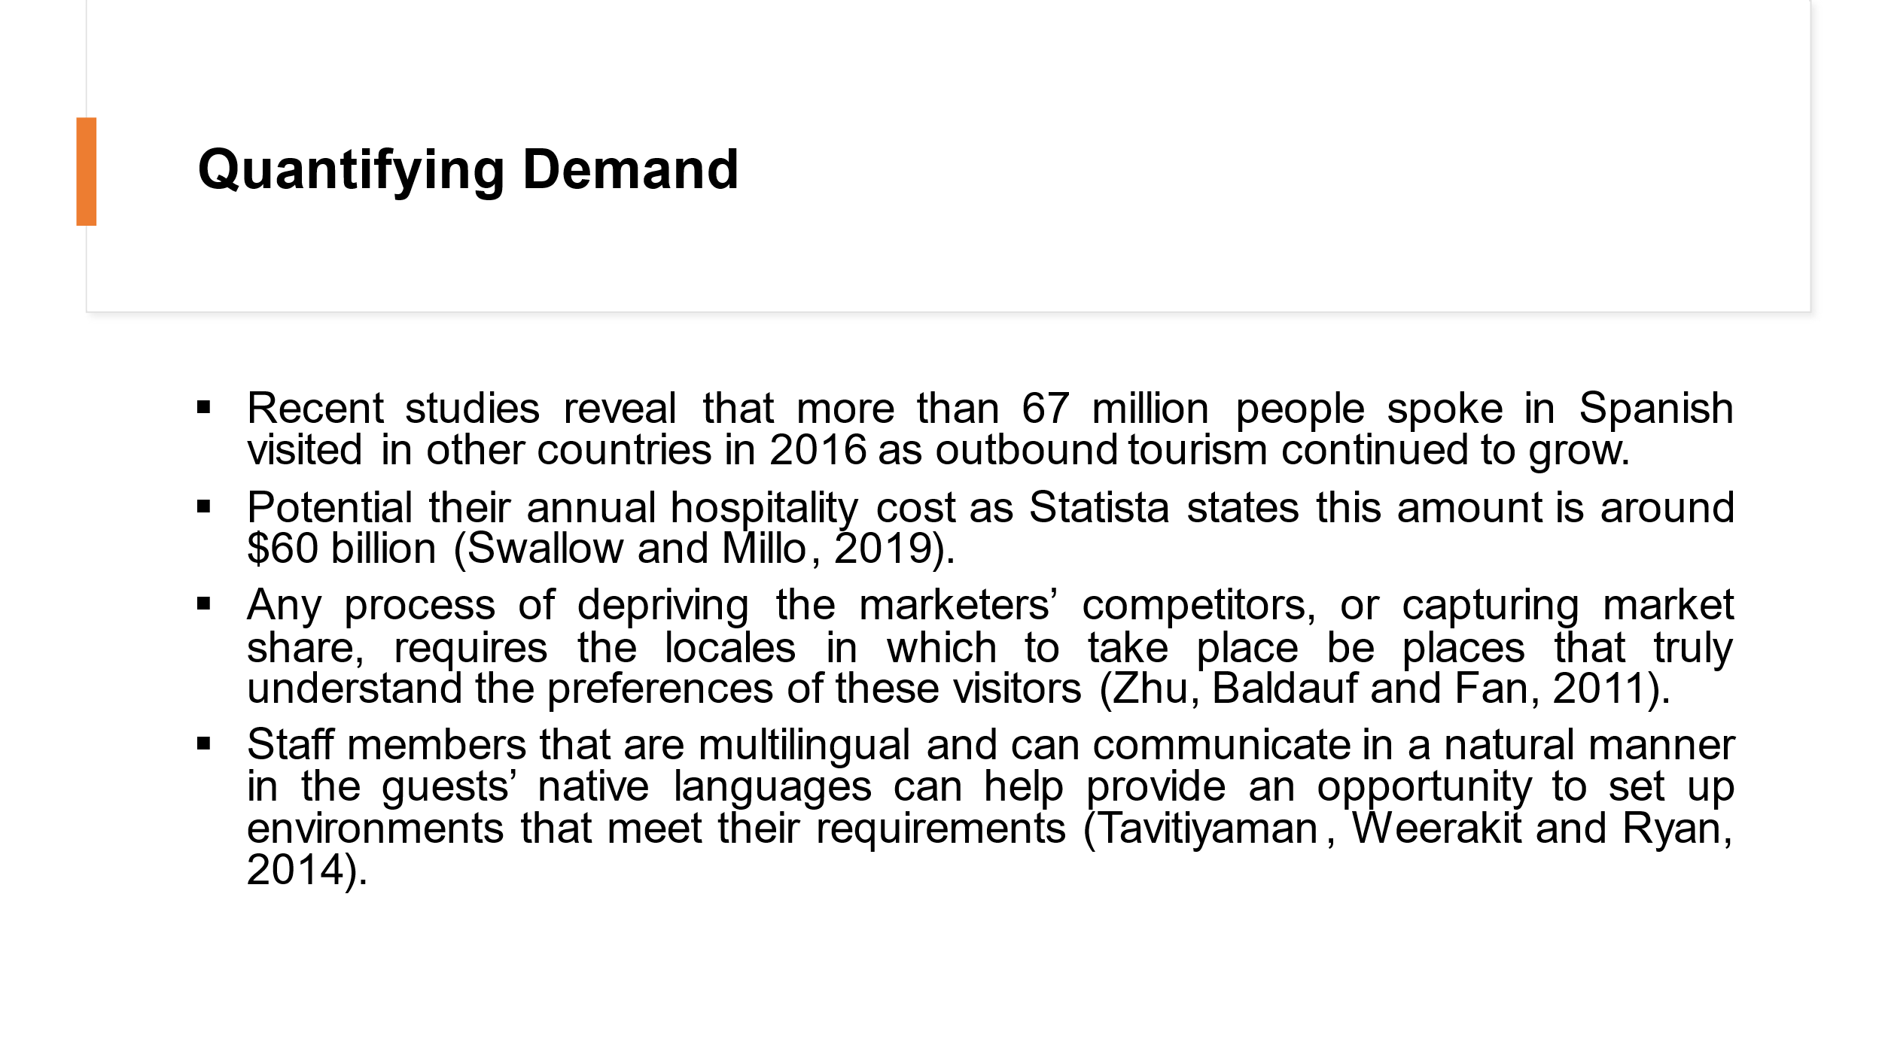
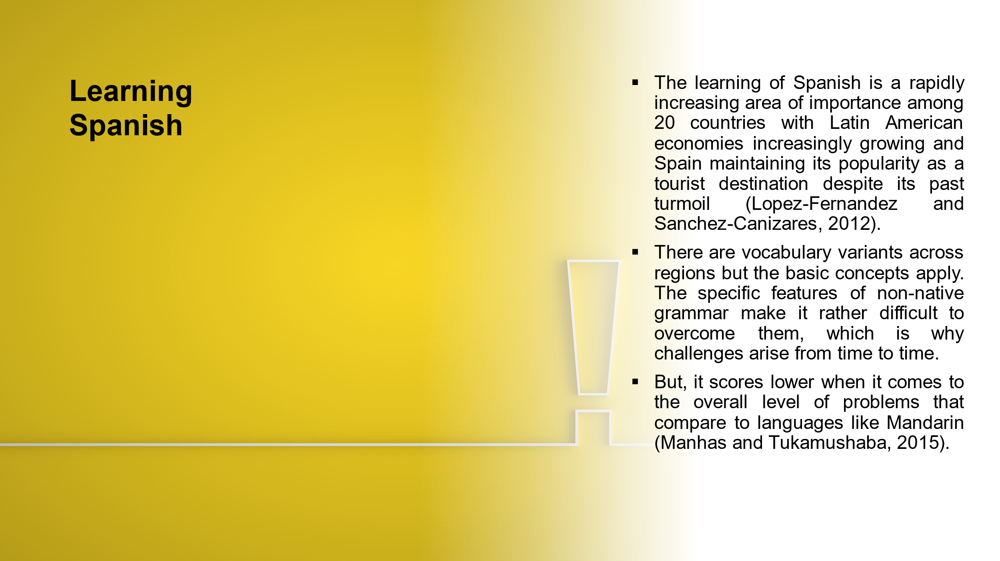

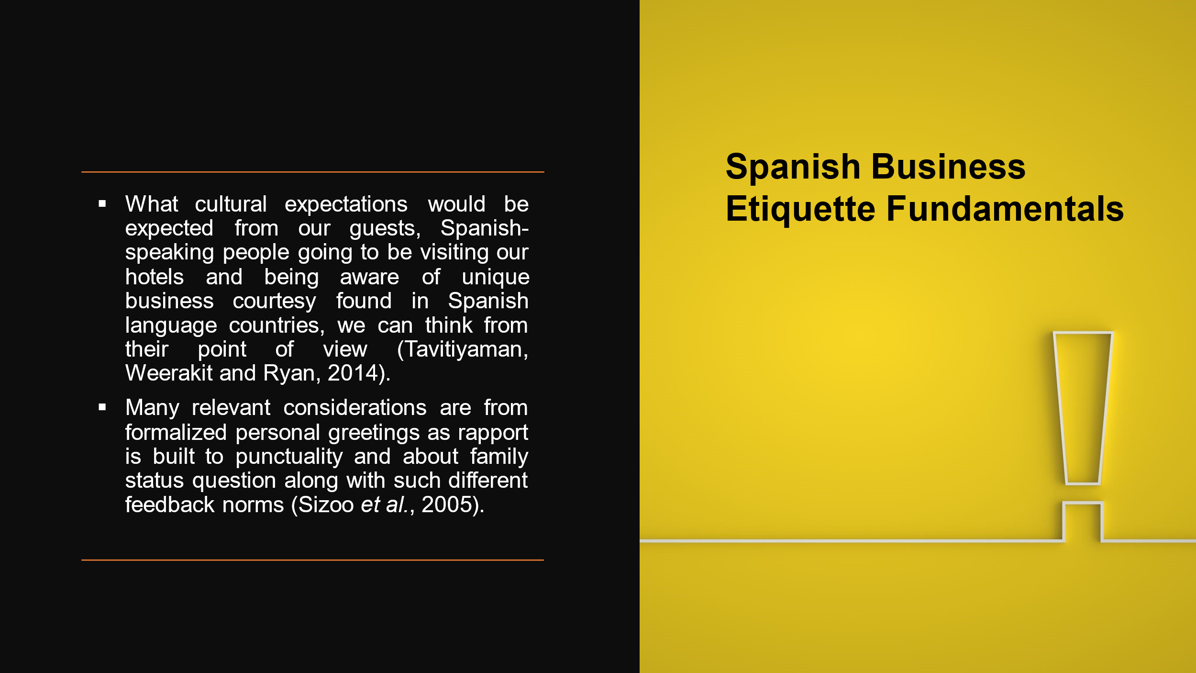

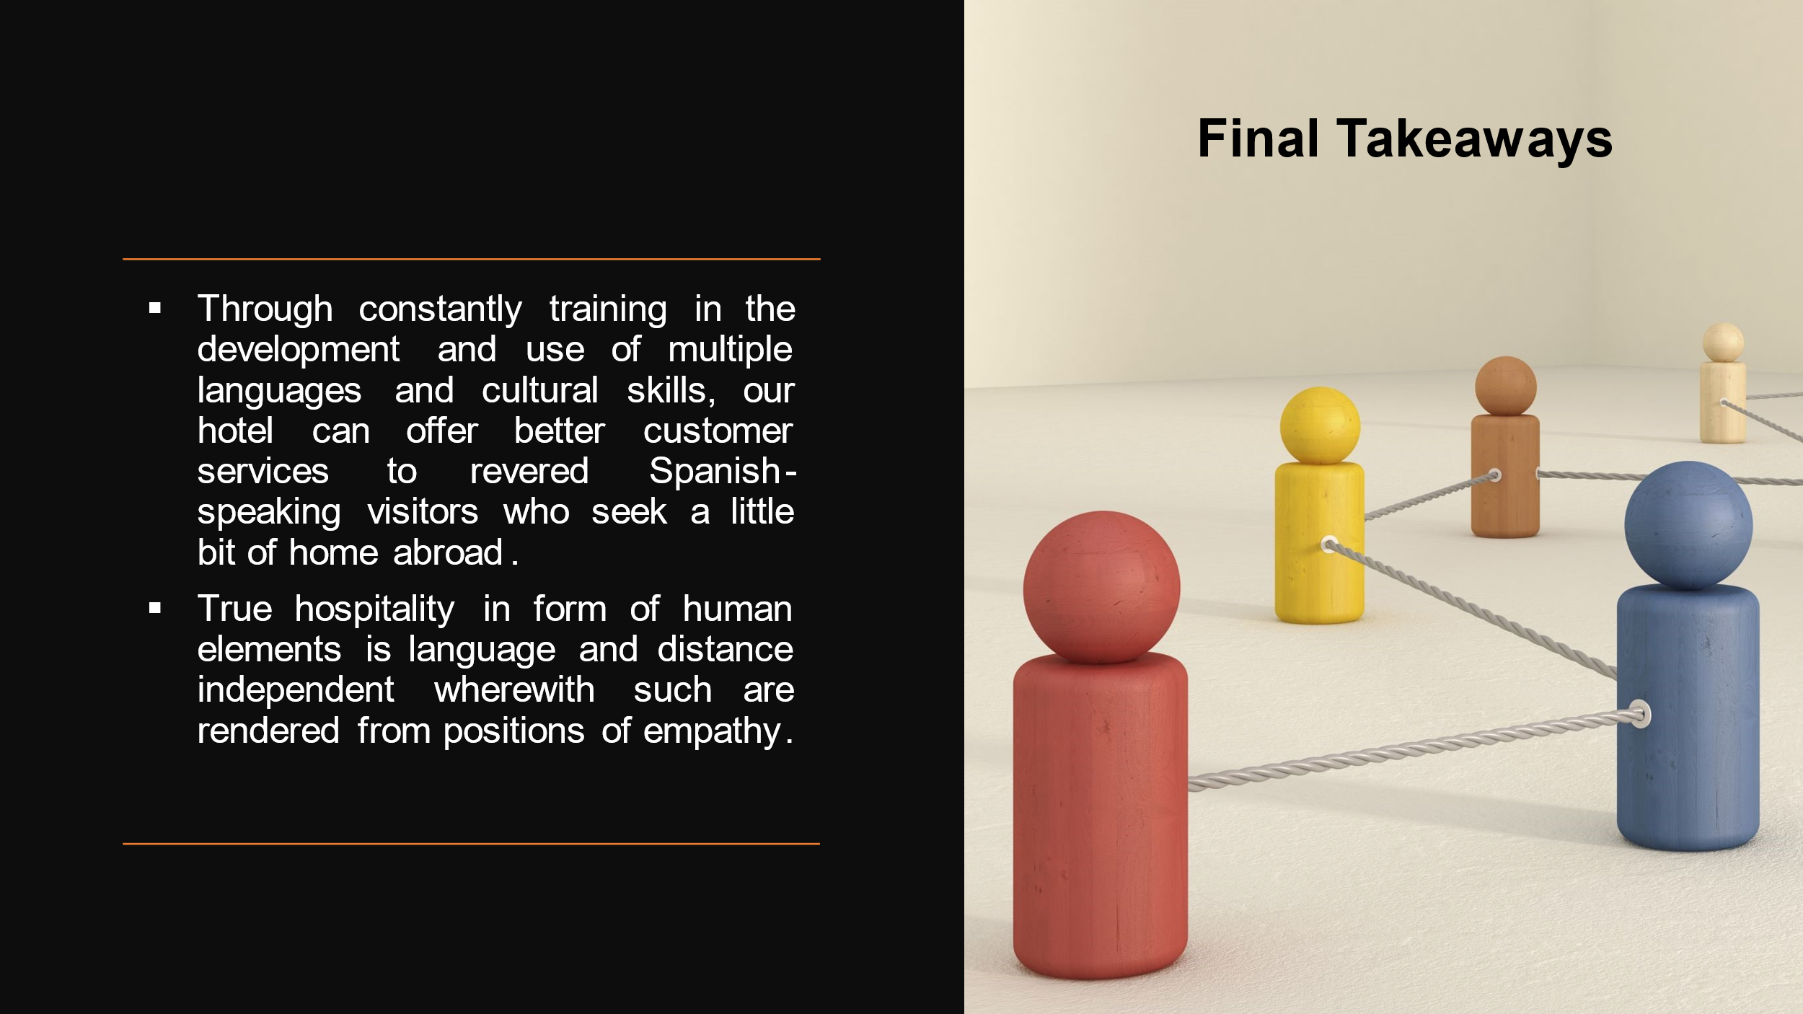

References:
Cogo, A. (2016) “Strategic use of essentialist representations of linguistic diversity: Tourism and the commodification of language in superdiverse cities,” Applied Linguistics Review, 7(3), pp. 353–376.
Lopez-Fernandez, M. C. and Sanchez-Canizares, S. M. (2012) “Business social responsibility from an employees’ perspective: The case of hotel companies in Spain,” International Journal of Human Resource Management, 23(2), pp. 318–333.
Manhas, P. S. and Tukamushaba, E. K. (2015) “Understanding service experience and its impact on brand image in hospitality sector,” International Journal of Hospitality & Tourism Systems, 8(1).
Sizoo, S. et al. (2005) “The effect of intercultural sensitivity on employee performance in cross-cultural service encounters,” Journal of Services Marketing, 19(4), pp. 245–255.
Swallow, D. and Millo, Y. (2019) “Anthropological approaches to international business,” The SAGE Handbook of Cultural Anthropology, 6, pp. 121–143.
Tavitiyaman, P., Weerakit, N. and Ryan, B. (2014) “Leadership competencies for hotel general managers: The differences in age, education, and hotel characteristics,” International Journal of Hospitality & Tourism Administration, 15(1), pp. 79–95.
Zhu, Y., Baldauf, R. B. and Fan, D. X. (2011) “Management challenges in China’s hotel industry: The perceptions of expatriate hotel professionals,” Journal of China Tourism Research, 7(4), pp. 415–429.

