Module title: Marketing Management – Assessment 2
Module code: LCMB7001
Assignment title: Environmental analysis of Walmart
Table of Contents
Introduction 3
PESTLE analysis 3
Porter’s five forces analysis 6
SWOT analysis 8
Role of marketing on organisational operations 9
Recommendations 10
Conclusion 10
Reference List 11

Introduction
Analysing the external influences on a firm is known as business analysis of the environment. This covers a variety of topics, such as the current state of the economy, the technology landscape, and more. By being aware of these factors, a company can develop methods to increase its efficiency in this setting. In this environmental analysis of the business sector and organisational characteristics, the variables that may have either an advantageous or detrimental effect on the firm are studied. Meanwhile, the internal environmental analysis highlights the internal capabilities as well as the downsides of an environment. Walmart Inc. is a national chain of convenience stores, outlet shopping centres, and low-cost department shops with its corporate headquarters located in Bentonville, Arkansas. By the year 2022, Walmart will run 10,586 stores and organisations in 24 different countries under 46 various brand names (walmart.com, 2023). Therefore, this study will conduct an internal and an external analysis of the company and recommendations will be provided based on that.

PESTLE analysis
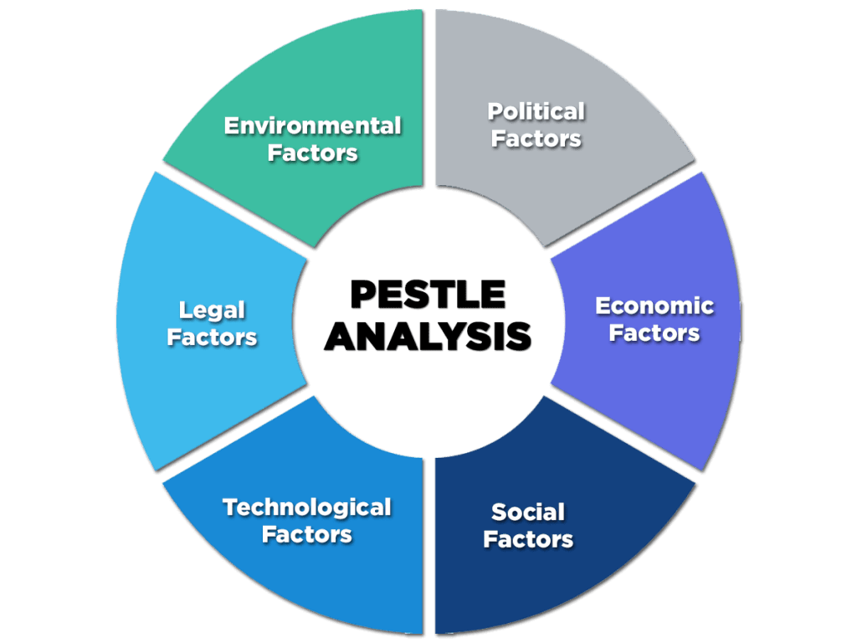
Figure 1: PESTLE analysis
(Source: Pandey et al. 2021)
Political
Political regulations are respected to a high degree since the degree of political stability is high. As a result, businesses like Walmart are not in trouble. Walmart has a significant impact on the politics of states as a result of how it operates (Pandey et al. 2021). To grab the attention of their existing and prospective clients in 2018, they upped the age at which gay rights and firearm licences are legal. Additionally, they encouraged employees to donate to the "Republicans." The business spent $25 million on marketing expenses to grow its presence in the Indian market.
Economic
It is crucial to note that healthy economies of significance are a prerequisite for conducting a study of the economy. A healthy economy makes it easier to launch a profitable firm in these markets. Walmart has an excellent economic foundation and predominantly operates within the United States (Burbach, 2021). It will be easier to launch an effective marketplace in countries that are developing like India because of their economic growth. An economy that is more stable is always desirable for company operations, therefore a reduction in unemployment assures that. Unemployment is declining in some countries, including the United States.
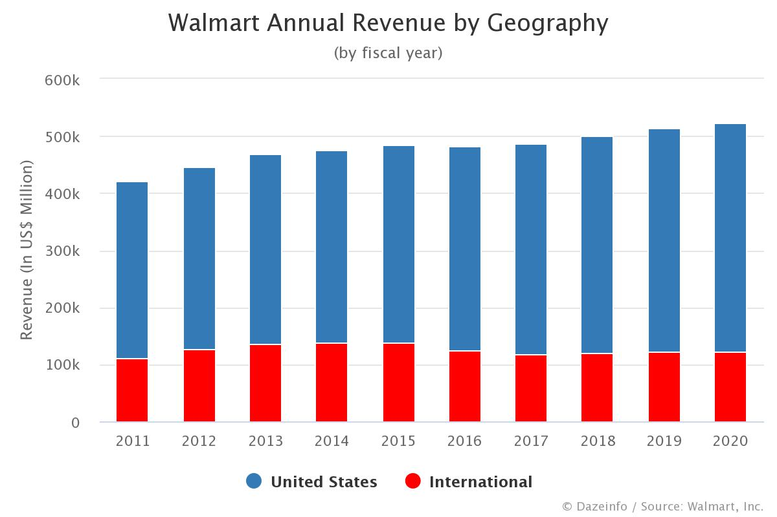
Figure 2: Walmart revenue by region
(Source: Rathore, 2020)
Social
Consumers are the most important factor when it comes to a business. They are typically in the position of regulating the demand and supply confinement, and even a slight shift in how much they want could have a big impact on an organization's profits (Nandonde, 2019). Given the importance of social media movements nowadays, leading a healthy way of life that includes regular exercise, a balanced diet, and other habits is on trend. Walmart ought to stock a greater range of nutritious foods as a result. At the moment, it's in style to respect and value other cultures. a summary of an important external factor that Walmart needs to consider since it has a big impact on the marketplace as a whole (Winata and Ellitan, 2023). An improvement in living conditions is to blame for the shift in consumer demand for various items. The corporation needs to decide that in order to conduct operations properly.
Technological
Using technology to automate repetitive tasks allows businesses to significantly reduce their time and resource requirements. Such tactics are available to Walmart to help it remain competitive. The consumer base has become more microelectronics-friendly due to the rise in smartphone usage, hence, the company needs to adopt a comparable mindset in order to draw in more customers. Walmart's smartphone application technology has been upgraded as of late (Toma, Catana and Gradinaru, 2022). The purchasing procedure for its customers is now more convenient. The vast amounts of data that multinational corporations like Walmart have to manage. Utilising the latest innovations is hence the best line for proceeding in this scenario.
Legal
Every company makes an attempt to comply with the laws that regulate the market it serves. There have to be regulations and rules in place in order to ensure that the food sold by Walmart is safe and nutritious to consume. The welfare of staff members depends on laws addressing matters such as the working environment, minimum wages, security of employment, and other matters (Amiri and Vida, 2023). We need a business structure that is more accountable and transparent. Therefore, it is suggested to improve the tax administration procedures.
Environmental
For a very long time, the people around us have sensed our affluence and aspirations the most. But in order to ensure an improved environment for future generations, companies are now attempting to evolve into more ecologically friendly. Today's fashion is towards environmentally friendly goods. So, protecting the environment has an influence on millions. In order to grow the company, Walmart should likewise include similar products (Onyusheva and Laochockchaikul, 2021). It is no longer a trick for companies to go green. To be blessed with an attractive planet to call home on and conduct business on, though, is what most people do. Walmart should follow their lead and support this effort.

Porter’s five forces analysis
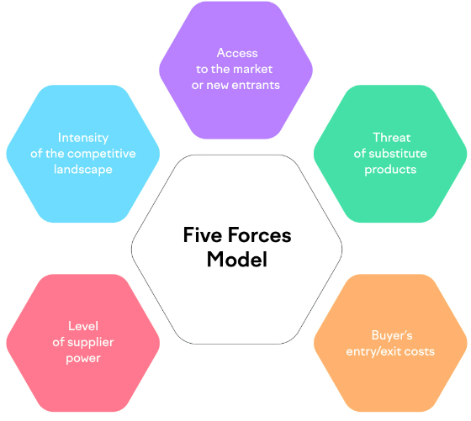
Figure 3: Porter’s five forces
(Source: Liu, Lu and Pei, 2022)
New entrant threat
In the retail sector, Walmart is a behemoth. Because of this, it spends a lot of money on shipping, advertising, and research into the products. A new entity that wants to break into the marketplace needs to put down a large sum of money initially to be able to stand out against already established rivals. Because they sell roughly identical goods, all shops aim to attract the same amount of customers (Liu, Lu and Pei, 2022). It is difficult to stay afloat in the retail sector as a whole overall because of significant retaliation. And on top of all that, Walmart distributes to a lot of consumers and maintains excellent relationships with suppliers. Scale-savings is unquestionably advantageous. Due to its carefully thought-out architecture for transmission and protection, researchers also observe a decrease in sinking expenses. Therefore, the new entrant threat is comparatively low.
Buyer bargaining power
Daily transactions with a large number of small customers allow Walmart to spread the influence of their client's purchasing power. Unlike popular opinion, those customers have a limited to modest amount of influence over the massive retailer. This is due to the difficulty in finding the store's inexpensive costs and accessibility in other places. Therefore, when it pertains to pricing, the business does not experience any pressure from customers (Menghwar and Daood, 2021). While at the exact same time weakening Walmart's purchasing power and enhancing that of its consumers, there is a steady demand for certain novel products that have yet to be in stock. Furthermore, switching costs are minimal because anyone can make transactions at a different retailer. Customer sensitivity to price adjustments is however very strong. Therefore, people typically find that Walmart is the greatest option for meeting their needs. Walmart is too enormous to be concerned about alternatives because of the wide range of products it offers, the low rates it charges, and its prime position (Jin, Xu and Zheng, 2021). Therefore, it is determined that buyers have medium-to-low power of negotiation.
Supplier bargaining power
The items for the network of stores come from a number of sources. Walmart is a client in addition to one of the primary parties to which those firms must supply their products and services. Walmart appears to be an extremely powerful buyer based on its massive purchasing quantities and big customer base. The suppliers that it works with prioritise meeting its requirements in the present and the future. Even the distribution centres are built near to the storefronts just to meet Walmart's needs (Nilufer, 2020). Walmart has a Supplier Diversity Programme in place as part of the company's dedication to CSR. As a consequence of this, it is less dependent on one supply. In the end, Walmart is a significant client that providers have very little influence over.
Substitutional threats
Walmart offers a huge variety of products in all various categories of merchandise, from grocery to appliances for the home. It is unlikely that a particular item would be offered for sale anywhere else compared to at Walmart. Due to its extensive selection, the business doesn't face any substantial competition. Walmart likely offers a product as well as all of its competitors. Given that almost all product variants are readily available on Walmart store shelves, there isn't a big threat from alternatives to consider (Swanson, 2021). As a result, it has no bearing on the test.
Competitive threat
Despite ongoing industry growth, the UK retail industry nevertheless features intense competition. However, when it pertains to Walmart, the food store behemoth has no rivals in the form of little businesses like Sears. Due to its pricing approach and scale-related savings, Walmart enjoys a unique competitive edge that is difficult to discover elsewhere. Tesco, Morrisons, Sainsbury, and Amazon are some important competitors that the company needs to closely monitor (Chang and Hu, 2020). They still don't match Walmart's price strategies or distribution practises. Due to the commercial behemoth, the UK marketplace for retailers is subject to a modest level of rivalry in the industrial sector.
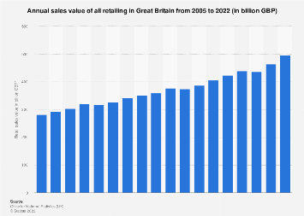
Figure 4: UK retail value of sales
(Source: Sabanoglu, 2023)

SWOT analysis
Strength | Weakness
- With over 11,000 outlets in 27 countries, the brand is well-known and has a strong global presence.  - Because of its size, it has the capacity to take advantage of efficiencies of scale, lowering costs and boosting revenue (Dong, 2023).  - Offerings of a variety of things, such as food, gadgets, clothing, and housewares. | - Low pay and unfavourable conditions of employment have a bad reputation.  - Dependence on a small number of important suppliers, which could cause interruptions in the supply chain.  - Absence in several global marketplaces.
Opportunity | Threat
- Expansion into new markets abroad, particularly in economies that are developing.  - Expansion of its e-commerce infrastructure and technological investments to enhance the client experience (Yuan, Song and Huang, 2021).  - Financial organisations or medical clinics, for example, could offer novel amenities and goods to promote client loyalty. | - Fierce rivalry with other retailers, notably those online.  - Spending by consumer’s volatility and recessions in the economy.  - Increasing legal requirements and probable legal action pertaining to environmental effect, labour practises, and other problems.

Role of marketing on organisational operations
Instead than overcharging for the products, Walmart generates income by lowering prices for consumers and focusing on sales in large quantities. Walmart is well known for its effective price-negotiation strategies, which enable it sustain low costs.
In practically every area, there are a tonne of products available. Among them are foodstuffs, household goods, appliances, furnishings, items for wellness and good health, and enjoyable activities. To cut costs and benefit from economies of scale, they purchase in bulk (Swanson, 2021).
In addition to TV ads, advertisements on billboards, social networking pages, and websites that sell goods online, Walmart employs a variety of other media to market its products.
The majority of the Walmart establishments in the U.S. are positioned in locations with strong business districts.

Recommendations
Organisations can easily respond to unforeseen circumstances whenever they emerge by understanding both their immediate and future implications.
When the corporation was in its expansion stage, it would choose a confrontational defence approach. By selecting superior marketing alternatives, it would engage in direct competition with the rivals. Additionally, it must to produce ads that bash rivals and highlight the superiority of its own items. The business should use flank assault techniques in its offensive moves so that it may target the weak points of its rivals, including Sainsbury, Tesco, and Amazon.
An international expansion strategy should be chosen by the company at this stage of its development. When a market is not yet established, it must promote the products there. Additionally, as it does, the corporation should choose penetration.

Conclusion
Knowing these elements allows an organisation to develop plans to increase its performance in this setting. This environmental analysis of the industry and organisational aspects examines the variables that can have a positive or negative impact on the firm. Walmart is one of the premium organisations in the retail industry and in order to stay competitive, they have to pay close attention to their surroundings. Therefore, this study has taken a closer look at the external and internal environment of Walmart. Based on that, the methods that Walmart can implement have also been highlighted.

Reference List
Amiri, S. and Vida, V., (2023). Analysis of marketing strategic issues at Amazon. SEA-Practical Application of Science, (31), pp.3-13. https://seaopenresearch.eu/Journals/articles/SPAS_31_1.pdf
Burbach, C., (2021). Walmart Strategic Analysis. https://digitalcommons.unl.edu/cgi/viewcontent.cgi?article=1373&context=honorstheses
Chang, Y. and Hu, J., (2020). Analysis on the mode of multinational retail enterprises entering Chinese market—Take Walmart, Carrefour and Metro as examples. Modern Economy, 11(01), p.17. https://www.scirp.org/html/3-7(2023)19_97720.htm
Dong, R., (2023). Wal-Mart's Financial Analysis. Highlights in Business, Economics and Management, 5, pp.312-316. https://drpress.org/ojs/index.php/HBEM/article/view/5097
Jin, Y., Xu, W. and Zheng, N., (2021), September. Analysis of COVID-19’s Investment in Corporate Value. In (2021) International Conference on Financial Management and Economic Transition (FMET (2021)) (pp. 146-152). Atlantis Press. https://www.atlantis-press.com/proceedings/fmet-21/125961029
Liu, Z., Lu, X. and Pei, L., (2022). Analysis on Business model of Chinese Retail Industry in the post-pandemic era: case study of Walmart and Freshippo. Journal of Education, Humanities and Social Sciences, 2, pp.70-77. https://drpress.org/ojs/index.php/EHSS/article/view/765
Menghwar, P.S. and Daood, A., (2021). Creating shared value: A systematic review, synthesis and integrative perspective. International Journal of Management Reviews, 23(4), pp.466-485. https://onlinelibrary.wiley.com/doi/abs/10.1111/ijmr.12252
Nandonde, F.A., (2019). A PESTLE analysis of international retailing in the East African Community. Global Business and Organizational Excellence, 38(4), pp.54-61. https://onlinelibrary.wiley.com/doi/abs/10.1002/joe.21935
Nilufer, N., (2020). Critical assessment on business strategy from aviation to retail industry during COVID-19 Pandemic: A Walmart Case. International Journal of Business Ecosystem & Strategy (2687-2293), 2(2), pp.8-14. https://bussecon.com/ojs/index.php/ijbes/article/view/205
Onyusheva, I.V. and Laochockchaikul, K., (2021). Analyzing foreign market entry strategies: the case of Wal-Mart’s entry into Thailand. Вестник университета Туран, (3), pp.80-87. https://scholar.archive.org/work/2qcph3gfvzbbxkqgikitdsq47u/access/wayback/https://vestnik.turan-edu.kz/jour/article/download/1891/1354
Pandey, R., Dillip, D., Jayant, J., Vashishth, K., Nikhil, N., Qi, T.J., Kee, D.M.H., Mei, T.C., Xin, R.Y.K. and Qhi, L.Y., (2021). Factors Influencing Organization Success: A Case Study of Walmart. International Journal of Tourism and Hospitality in Asia Pasific (IJTHAP), 4(2), pp.112-123. http://www.ejournal.aibpmjournals.com/index.php/IJTHAP/article/view/1059
Rathore, I. (2020) Walmart annual revenue by region: FY 2011 - 2020, Dazeinfo. Available at: https://dazeinfo.com/2020/07/16/walmart-annual-revenue-by-region-graphfarm/ (Accessed: April 24, 2023).
Sabanoglu, T. (2023) Retail sales value in Great Britain 2022, Statista. Available at: https://www.statista.com/statistics/287912/retail-total-annual-sales-value-great-britain/ (Accessed: April 24, 2023).
Save money. live better (no date) Walmart.com. Available at: https://www.walmart.com/ (Accessed: April 24, 2023).
Swanson, L.A., (2021). The role of activity and cost analysis when managing logistics. https://minds.wisconsin.edu/bitstream/handle/1793/80982/Swanson,%20Lauren.pdf?sequence=1
Toma, S.G., Catana, S.A. and Gradinaru, C., (2022). Competitive Business Strategies In Global Retailing: The Case Of Wal-Mart. Annals-Economy Series, 1, pp.106-112. https://www.utgjiu.ro/revista/ec/pdf/(2022)-01/12_Toma.pdf
Winata, M. and Ellitan, L., (2023). The Effectiveness of Technology Development Towards Walmart’s Sustainability Supply Chain Management. J-CEKI: Jurnal Cendekia Ilmiah, 2(2), pp.224-248. https://journal-nusantara.com/index.php/J-CEKI/article/view/1429
Yuan, Y., Song, D. and Huang, Y., (2021), September. The Limitations of Traditional Retail Enterprises’ Self-built Logistics System——A Case Study of Walmart. In (2021) International Conference on Financial Management and Economic Transition (FMET (2021)) (pp. 487-494). Atlantis Press. https://www.atlantis-press.com/proceedings/fmet-21/125961103

