3. Chapter Three: Research Method

3.1 Introduction

The first objective has been achieved in the previous chapter, which elaborates on the importance of corporate social responsibility in the automotive industry.
However, there is a lack of research on the relationship between the automobile industry and corporate social responsibility.

Then, the following chapter will introduce the research method which used in this paper and aims to achieve the second objective: “Through the selection of appropriate research method, to identify the importance of automotive corporate social responsibility to society, as well as explore the point of view of the importance of environmental responsibility of relevant enterprise.”

The research onion developed by Saunders et al. (2016) can make this investigation process achieve the second objective logically. In addition, effectiveness, reliability, limitations and other issues will also be fully considered.

3.2 Research Onion

Research is usually regarded as a systematic process, and researchers strengthen cognition by studying the nature of phenomena. (Collis & Hussey, 2013; Saunders et al., 2009).

Figure 3.1: The Research Onion (Saunders et al., 2016)
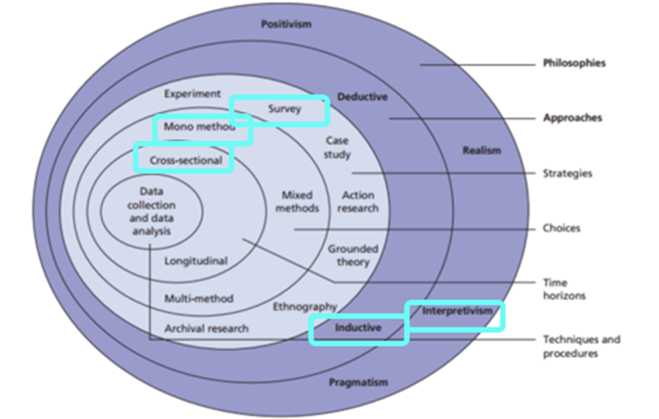
Collis and Hussey (2013) and Saunders et al. (2009) pointed out that exploratory research can help researchers establish an understanding of the problems that need to be further explore due to the lack of previous research, and provide more valuable support for further investigation and analysis.

Descriptive research is a research method in basic research, which aims to accurately describe a topic or a phenomenon under study. (Collis & Hussey, 2013; Saunders et al., 2009).
Gliner and George state that the scientific research paradigm is a way of research or the process and implementation method of thinking. It is not a methodology, but a philosophy that provides a research process. (Gliner and George, 2016)

3.2.1 Philosophy

Research philosophy mainly explores the source, nature and development of knowledge. In short, it is an idea of how effectively the data of a phenomenon should be collected, analyzed and used in an appropriate way. (Bajpai, 2011)

In essence, this part can be seen as expounding in the paper that research philosophy involves awareness and elaboration of researchers' beliefs and hypotheses. （Saunders, Lewis & Thornhill, 2012)

The choice of specific research ideas will also be affected by some practical significance factors.
For example, there are important philosophical differences between research that pays attention to facts and figures and qualitative research. (Johnson & Clark, 2006) This research uses positivist because the objectives of this paper are to identify and analyze these objective elements and causes, and it based on a large amount of quantitative data support. Positivists prefer to collect objective data that can be observed and look for regularity and causality in the collected data to create systematic generalizations. (Saunders, Lewi, & Thornhill, 2009)

3.2.2 Approach

Deductive approach means that one or more hypotheses are put forward on the basis of existing theories, and then formulates the research approach to test it (Silverman, 2013). For research projects, the researchers focus on whether the observed phenomena are in line with expectations, and this method is the most suitable to guide this research. (Wiles et al., 2011).
Therefore, deductive methods may be considered particularly suitable for positivist approach, as the process is to make assumptions first and then statistically test the expected results to reach an acceptable level (Snieder&Larner, 2009)

3.2.3 Strategy

The method of collecting data and analyzing the process depends on the specific situation. (Bryman, 2012). This research will use surveys approach to investigate and analyze the actual situation of corporate social responsibility of automobile enterprise at home and abroad, not only make a qualitative analysis of it, but also provide a great number of relevant quantitative indicators to specify the specific content of automobile corporate social responsibility, which can greatly improve the authenticity of this research. Surveys benefit quantitative research through obtaining vast amounts of data on attitudes and perceptions of a phenomenon (Glasgow, 2005). At this stage, the overall reliability and validity of mature survey programs will contribute significantly to the findings. (Saunders et al., 2007)

3.2.4 Choice

Due to mono-method research is often weak in providing comprehensive solutions to social problems, (Ojebode, and Oyedele, 2018) so this research adopts the mixed-methods, there are quantitative and qualitative method. The mixed-methods requires the use of two or more methods. This research method which usually refers to the combination of qualitative and quantitative methods to make it more widely applicable. (Bryman, 2012). Positivist prefer quantitative indicators such as social surveys and official statistics because these methods are reliable and representative. (ReviseSociology, 2020) Quantitative method is through the collection of numerical data, used for statistical analysis, finally to explain the phenomenon or its nature. (Sukamolson, 2007). Qualitative research includes the collection and analysis of non-digital data, such as texts, to facilitate researchers to understand concepts and form opinions. (Pritha, 2020)
The positivist paradigm is regarded as a philosophical theory, and knowledge is analyzed and learned through real data, and these quantified results can be observed, measured and explained by logical analysis (positivist paradigm, 2018).

3.2.5 Time Horizon

The time horizon refers to a time frame that contains an approximate time frame for the completion of a project plan. (Saunders et al., 2007). The cross-sectional time horizon refers to the time horizon that has been determined, and researchers must collect data at a particular point in time. (Flick, 2011). Which is the most suitable for this research. This method is suitable for the study of investigating specific phenomena. The longitudinal time for data collection refers to the repeated collection of data over a period of time, which is used to study an important factor (Goddard&Melville,2004) that changes over time.

3.2.6 Techniques for Data Collection, Processes and Analysis

3.2.6.1 Data Collection

The second research is data collected by others for their own purposes. It can be opinion polls, interviews, and so on. All types of data that researchers may use directly for specific research purposes, which are collected and collated by others (Steffani, 2018)
With regard to the research on the evaluation of corporate social responsibility, researchers generally use content analysis method, result observation method and index method in the research. This study will make an objective and systematic analysis of the contents of the document to determine the actual situation of the observed object and make an objective evaluation.(Roca and Searcy, 2012) In addition, because the index method is subject to the selection criteria of data providers in the selection of corporate samples, only part of the research objects may be covered in the database, therefore, this study will draw lessons from the main methods used by the following scholars to study the effectiveness of corporate social responsibility to collect, analyze and compare secondary data from the online database. Secondary data types are highly available. (Oxford reference, 2021)

3.2.6.2 Pilot Study

In order to help researcher better decide how best to conduct a large-scale research project, they will conduct preliminary small-scale study which is called a pilot study. (Ashley, 2019)
Researchers can identify or further refine research problems through pilot research, combine analysis to find out the best way to solve the problem, and make a comprehensive systematic assessment of the time cost and resources needed to complete a larger version of the survey.

3.2.6.3 Analysis

These second-hand data will be analyzed using the social science statistics package (SPSS).
This paper will combine normative research and case empirical analysis. On the one hand, this paper makes a descriptive analysis of a series of research results of automobile corporate social responsibility at home and abroad, and compares the current situation of corporate social responsibility of China's Shanghai Automobile Group Co., Ltd., and makes a further specific analysis of its situation. through the empirical analysis of the above cases, establish a corresponding and matching social responsibility system. (Carroll, 2000)

3.3 Sample

Because there are too many enterprises in the whole automobile industry to carry out research, the researchers chose one of the companies as a sample. This sample can well represent the current situation of the wider industry, so as to ensure the reliability and validity of the research results. (Collis & Hussey, 2013).

3.4 Reliability and Validity

Reliability is defined as the degree to which research results remain consistent over time. (Joppe, 2000) It can refer to the extent to which questionnaires, tests, observations, or other research procedures produce the same results in repeated trials.
Wainer and Braun (1998) described the validity in quantitative studies as "construct validity". It is the initial concept or assumption used to determine what data to collect and how to collect it.

3.5 Limitations

The identification of the influencing factors of the strategic transformation of automobile corporate social responsibility may not be comprehensive enough. (James and Judy, 2004) This study studies the driving factors and implementation basis of social responsibility in many automobile enterprises, but the identification of the driving factors is still based on the review of relevant theories, and combined with the analysis of relevant practice, it is concluded that due to the limitations of objective conditions such as COVID-19, the researchers did not carry out manager interviews or questionnaires, and the identification of driving factors may not be perfect. And there is no in-depth analysis of the importance of different drivers.

Another limitation comes from the social aspect. Because the information and content involved in the topic in this survey is very sensitive, participants will give moral answers through various trade-offs, rather than the real situation. (Andersen & Mayerl, 2019).
Therefore, researchers will select anonymous companies from multiple databases to reduce the extent to which the data is affected by other factors as much as possible.

3.6 Ethical Considerations

Ethical consideration is a major factor in the research. While ensuring that the purpose of the research is achieved, researchers transmit real information and knowledge, truth and prevent the emergence of erroneous ideas. (Priya, 2016)
The principles of ethical considerations can be concluded in the following aspects, promote authentic, original and true knowledge by avoiding error, to promote values of collaborative work and increase public accountability. (Resnik, 2011); (Smith, 2003)

This study was conducted in accordance with the ethical standards of UWTSD and approved by the research supervisor and coordinator through the ethical approval form (see Appendix 3).

3.7 Conclusion

This chapter has been successfully achieved the second objective of this research:

“Through the selection of appropriate research method, to identify the importance of automotive corporate social responsibility to society, as well as explore the point of view of the importance of environmental responsibility of relevant enterprise.”

This chapter determines the research methods applicable to this study. The researchers chose a positivist quantitative method to prove that the study was reasonable by collecting second-hand data and then taking samples from automobile companies. The next chapter will do in-depth analysis and research on the collected data.

Smith, D. (2003). Five principles for research ethics. Monitor on Psychology, 34(1), p.56. Available at: http://www.apa.org/monitor/jan03/principles.aspx [Accessed February 25, 2021].

Resnik, D. (2011). What is Ethics in Research & Why is it Important? National Institute of Environmental health sciences.

Priya, C. (2016) Importance Of Ethical Considerations In A Research. [online] Available at: https://www.projectguru.in/importance-ethical-considerations-research/ [Accessed 25 February 2021]

James H. and Judy Murnan. (2004) “Research Limitations and the Necessity of Reporting Them.” American Journal of Health Education 35: 66-67.

Andersen, H. and Mayerl, J. (2019) Responding to Socially Desirable and Undesirable Topics: Different Types of Response Behaviour?. Methods, data, analyses: a journal for quantitative methods and survey methodology (mda), 13(1), pp.7-35.

Collis, J. and Hussey, R. (2013) Business research: A practical guide for undergraduate and postgraduate students. England: Palgrave Macmillan Higher Education.

Carroll, Archie B, Buchholtz. (2000) Business and Society: Ethics and Stakeholder Management, Cincinati, South-Western Collage Publishing:135-139.

Ashley, C. (2019). Pilot Study In Research. [online] Available at: https://www.thoughtco.com/pilot-study-3026449 [Accessed 24 February 2021].

Roca, L. C., & Searcy, C. (2012) An Analysis of Indicators Disclosed in Corporate Sustainability Reports. Journal of Cleaner Production, 20, 103-118. http://dx.doi.org/10.1016/j.jclepro.2011.08.002
Oxford Reference. (2021) secondary research. [online] Available at: <https://www.oxfordreference.com/view/10.1093/oi/authority.20110803100451291> [Accessed 24 February 2021].

Steffani, C. (2018). The Advantages And Disadvantages Of Secondary Research. [online] Available at: https://bizfluent.com/info-8205583-advantages-disadvantages-secondary-research.html [Accessed 24 February 2021].

Flick, U. (2011). Introducing research methodology: A beginner’s guide to doing a research project. London: Sage.

Goddard, W. & Melville, S. (2004) Research Methodology: An Introduction, (2nd ed.) Oxford: Blackwell Publishing.

Glasgow, P, (2005) Fundamentals of Survey Research Methodology: MITRE. Washington C3 Centre, Virginia, USA.

Pritha, B. (2020) An Introduction To Qualitative Research. [online] Available at: https://www.scribbr.com/methodology/qualitative-research/ [Accessed 24 February 2021].

Wainer, H., & Braun, H. I. (1988). Test validity. Hilldale, NJ: Lawrence Earlbaum Associates.
Joppe, M. (2000) The Research Process. [online] Available at: http://www.ryerson.ca/~mjoppe/rp.htm [Accessed 24 February 2021].

Bryman, A. (2012) Social research methods (5th ed.). Oxford: Oxford University Press.

ReviseSociology. (2021) Positivism and Interpretivism in Social Research. [online] Available at: <https://revisesociology.com/2015/05/18/positivism-interpretivism-sociology/> [Accessed 24 February 2021].

Saunders, M., Lewis, P., & Thornhill, A (2007) Research Methods for Business Students. (6th ed.) London: Pearson.

Snieder R. & Larner, K. (2009) The Art of Being a Scientist: A Guide for Graduate Students and their Mentors, Cambridge: Cambridge University

Ojebode, A., Ojebuyi, B., Oladapo, O. and Oyedele, O. (2018) Mono-Method Research Approach and Scholar–Policy Disengagement in Nigerian Communication Research. The Palgrave Handbook of Media and Communication Research in Africa, pp.369-383.

Silverman, D. (2013) Doing Qualitative Research: A practical handbook. London: Sage.

Wiles, R., Crow, G., & Pain, H. (2011) Innovation in qualitative research methods: a narrative review. Qualitative Research, 11(5),

Johnson, P. and Clark, M. (2006) Business and management research methodologies. London: SAGE.

Saunders, M., Lewis, P. & Thornhill, A. (2012) “Research Methods for Business Students” 6th edition, Pearson Education Limited

Bajpai, N. (2011) “Business Research Methods” Pearson Education India

Saunders, M., Lewis, P., & Thornhill, A. (2009) Research methods for business students (5th ed., pp. 1–617). England: Pearson.

GLINER, J., (2016) RESEARCH METHODS IN APPLIED SETTINGS: An Integrated Approach to Design and Analysis, 2nd. USA: ROUTLEDGE.

