Michele CHIARELLO
Student id: 1805745
module tutor: terry walcott

ACCC5003
NETWORK OPERATING SYSTEMS AND SECURITY
assignment 1 - observational tasks
April 18, 2020
Contents
TABLE OF FIGURES 2
INTRODUCTION 3
WORKSHEET 1 3
Task A: 3
Task B: 4
Task C: 4
Task D: 6
WORKSHEET 2 6
Task 1: 6
Task 2: 7
WORKSHEET 3 7
Task A: 7
Task B: 7
Task C: 8
Task D: 8
WORKSHEET 4 8
Task Q1: 9
Task Q2: 9
Task Q3: 9
WORKSHEET 5 10
Task Q1: 10
Task Q2: 10
Task Q3: 10
Task Q4: 10
REFERENCES 11

TABLE OF FIGURES

Figure 1. AD Forest, trees etc 4
Figure 2. Domain Controller 5
Figure 3. DHCP explanation 9
Figure 4.FQDN 10
Figure 5. DNS Zones 11

INTRODUCTION

The following document has been redacted with the aim to show and explain the different steps undertaken to accomplish the required tasks during the development of the Practical Laboratory Work.

WORKSHEET 1

Task A:

A Hypervisor is a software that runs above the physical host. It allows running multiple Operating Systems on the same machine, bringing cost advantages to companies, reducing the investment on physical hardware.
There are two main types of Hypervisors and they can be defined as:
- Type 1 or BM (Bare Metal Hypervisor)
- Type 2 or Hosted
Type 2 HV, is a virtualization software that is mostly used for end-user virtualization. This means that, unlike Type 1 HV, does not run directly on the physical machine, but is a software that relies on an operating system.
In the design used to build the network infrastructure of the current assignment, the author made use of the Virtual Box virtualization software.
The following points represents the advantages it brought for the development of the network:
- Possibility to run multiple OSs on the same machine
- Possibility to virtually interface hosts for the test of the AD design
- Possibility to recover the data if the host goes down
The following point instead, represent the weaknesses of this kind of system:
- Low performances

Task B:

When talking of AD, is possible to find always references to:
- Forests
- Trees
- Parent and Child domains
The diagram below aims to explain the meaning of the listed terms.

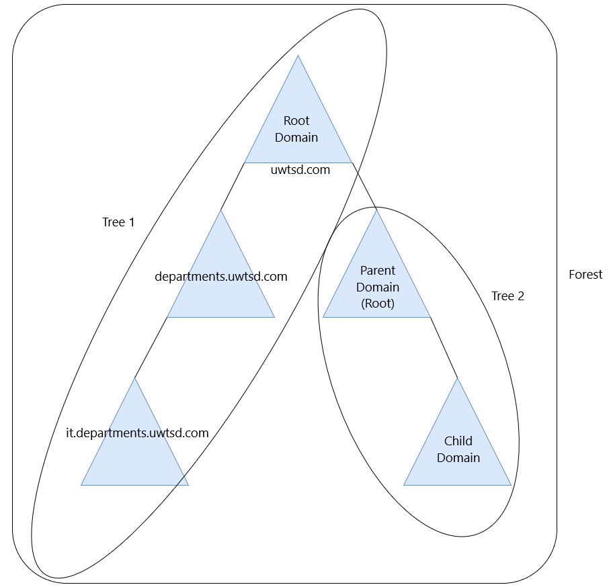
Figure 1. AD Forest, trees etc

Task C:

Domain Controller is what control Active Directory. DC is, for definition, a server that that has AD Domain Services installed. It stores all the policies and information of user accounts and network resources.
All the information is stored in the Schema, a database the DC uses to give privileges and control access to the resources.
The main responsibility of this type of server is to handle authentication requests across the domain and distribute resources among the different groups of users.
AD is a tool used to manage users, groups, group policies, computers, printers and, generally, all the network resources.
Groups are containers for any kind of object the AD can manage. Objects and groups are stored in folders defined by the name Organizational Units or OUs.
Wanting to represent the functionalities that a DC have, is possible to imagine this kind of diagram:
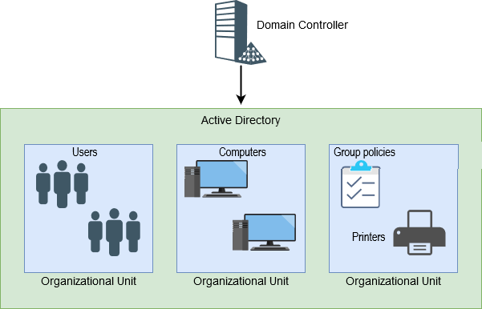
Figure 2. Domain Controller

Task D:

To avoid a situation in which a DC could become unavailable, because of an HW fault or a network error etc, would be advisable to replicate it. This to make the infrastructure fault-tolerant.
In a design that involves more than one DC, there is always one Primary and one Secondary DC, where the data of the first is replicated.
If the first goes down, the clients switch automatically to the second, avoiding disruptions.

WORKSHEET 2

Task 1:

Passwords are one of the most important aspects when talking of security and every AD implementation should provide policies to handle as better as possible the possibility that the access to one of the systems within the domain could be compromised.
It is possible to define some major characteristic that a password used to keep secure a device should respect:
- Complexity
- Expiration date
Complexity means that a password should not contain parts related to the account username, it should include special characters and should contain upper/lower-case character and numbers.
Also, a password should have a minimum length of 8 characters. This to protect the users against brute force attacks.
Regarding the expiration date, it is possible to state that, a password should be changed on a regular time interval and should be different from the previous ones.

Task 2:

Groups in AD are objects that allow managing multiple users by adding them to the same container (Group) and setting up policies without the need to assign them permissions one by one.
The advantages they bring are:
- Time saves
- Security
- Fast policies rollout

WORKSHEET 3

Task A:

Microsoft Windows systems use two different types of permissions to give access to files and folders to users.
These are:
- Share Permissions
- NTFS Permissions
According to J. Melnick(2018), the main differences between the two, even though that both serve the same role which is to prevent unauthorised access, are that NTFS Permissions are applied to both local and network users regardless of where they are accessing from.
Share Permissions instead are only applied to users that access through the network.

Task B:

Microsoft Operating Systems support different types of file systems.
The most common are:
- FAT32
- exFAT
- NTFS
FAT32 is an old type of file system, used since the early versions of the OS. It cannot handle files over 4GB and is slow, compared to NTFS. It is commonly used in small drives because the bigger is the partition it must handle the worst are the performances.
Also, it does not feature security features, like permissions, that are available for NTFS.
NTFS (NT File System) is a modern type of file system that overcomes to the limitations of the previous ones. It offers journaling that allows to recover if there is an error, shadow copies and so on.

Task C:

The use of groups in AD domain, allows to manage a high number of users, computers, resources without the need to assign permissions one by one.

Task D:

Group Policies are helpful tools for the administration of the domain because they permit to handle permissions based on the resource type, assigning permission just once.
Organizational Unit instead, are folders that allow to group various AD objects, simplifying the management tasks, with the help of the above-mentioned GPs.

WORKSHEET 4

Task Q1:

DHCP service is helpful in a network infrastructure because, once defined the parameters for the IP addresses assignment, allows to handle the hosts automatically, without the intervention of the Administrator.

Task Q2:

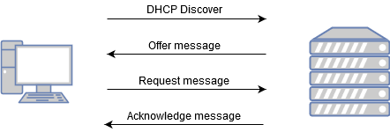
Figure 3. DHCP explanation
The above diagram tries to explain the 4 stages that the DHCP process involves.
Starting from the top, it is possible to see that the Client start to broadcast a Discover Packet that aims to find any possible DHCP Server in the network.
If a server successfully receives the message, it sends an Offer Message to the client to acknowledge the Client that is ready to assign an IP.
The Client replies with a Request Message and the Server sends to the Client an Acknowledgement Message that contains the IP addressing data.

Task Q3:

When using a DHCP service could be possible that an unauthorised client could act as MitM (Man in the Middle) to get an IP.
A compromised server could divert the network traffic poisoning the DNS.

WORKSHEET 5

Task Q1:

A Recursive Query is a request that passes from a DNS Server to another to find a certain IP address.
An Iterative Query, instead, is a request that is sent to a DNS Server that is directly involved in the lookup of the interested IP.

Task Q2:

Root Hints are queries related data stored in DNS Servers cache, to improve response speed to the Clients that is looking for a certain IP.
When a request is sent to a Non-Authoritative Server, or rather, a Server that does not contain a copy of the records interesting the requested zone, this is forwarded to other servers in the DNS hierarchy to find the needed IP.

Task Q3:

- Server1.subcontA.nwtraders.msft
- The picture below illustrates how the Domain Name System breaks up this FQDN in to host and Domain namespace

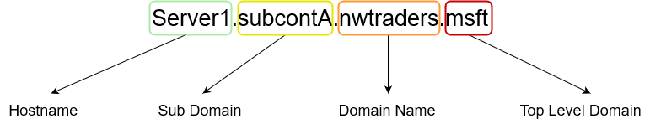
Figure 4.FQDN

Task Q4:

DNS makes use of zones that allow a more specific control on its components such as Domain Name Space, Name Servers and Resolvers.
Zones are organizational areas of a domain space that can be extended to subdomains to split and delegate the control to different managers.
A zone can more subdomain and multiple zones can be managed by the same server.
The picture below, represent what these are.
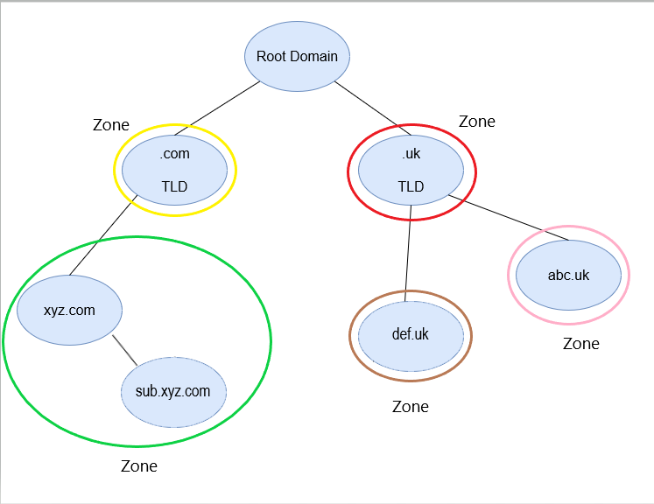
Figure 5. DNS Zones

REFERENCES
DNSStuff. (2019, December 16). Active Directory Forest and Domain Guide 2020 + Best Tools. Retrieved from dnsstuff.com: https://www.dnsstuff.com/active-directory-forest
Indiana University. (2018, 01 18). ARCHIVED: In Windows, what file system should I use? Retrieved from kb.iu.edu: https://kb.iu.edu/d/aexw
Melnick, J. (2018, 05 3). Differences Between Share and NTFS Permissions. Retrieved from netwrix.com: https://blog.netwrix.com/2018/05/03/differences-between-share-and-ntfs-permissions/

