UNIVERSITY OF NARNIA
WEB DEVELOPMENT - BCs Cloud Computing – term 3

Lecturer – Suneth Fernando

Ralitsa Nikolova
1806089

Table of Contents
INTRODUCTION 2
THE DATABASE 2
PHP FRAMEWORKS 3
CakePHP 3
Symfony 3
Laravel 4
CodeIgniter 4
THE WEBSITE 4
Pages that can be accessed by any user 4
Pages that can be accessed only after logging in 5
Admin page 5
TESTING 6
Test Case 1 – Access to a user page without logging in 6
Test Case 2 – Logging in with the wrong credentials 6
Test case 3 – Grading students 7
Test case 4 – Student enrolment field format 7
Test case 5 – Enrolling a student with a duplicate email 8
EVALUATION 9
References 10
APPEDNDIX 1 – WEBSITE PREVIEW 11
APPENDIX 2 – TESTING 20

INTRODUCTION
This paper is concerned with the development of a student management website for the University of Narnia. It contains all the basic functionalities needed by a student to enrol into the university, get relevant information about its courses and their corresponding modules. A multiuser login which will help the students to check their ongoing progress with exams and grades. There is also an admin side which will allow changes and updates on sensitive information accessible only for an administrator. Also, a lecturer dashboard is created where, the lecturer can update the student’s grades. The website is created using HTML client-side programming language and PHP server-side programming language. It uses MySQL database management system and Apache web server to host it.

THE DATABASE
According to the assignment requirements, database is created using PHPMyAdmin. It is a software application with a user-friendly interface which is designed to handle a MySQL database over the web (PHPMyAdmin, 2020). The database design is developed on the foundation of the following ER Diagram:
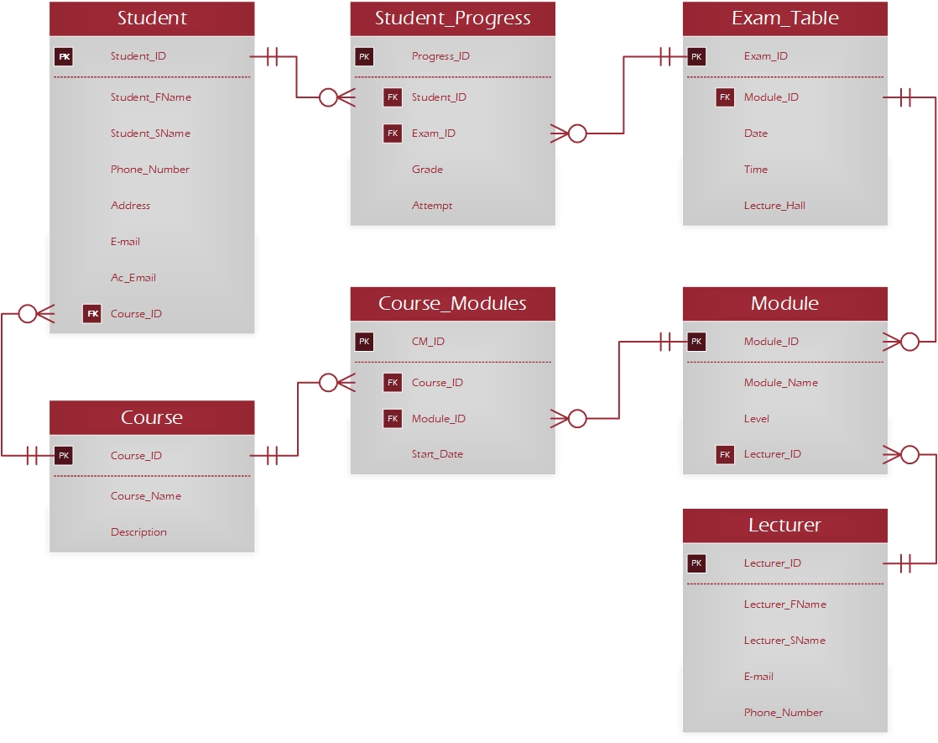
It is reduced to third normalised form and obeys the following rules:
- A student can enrol in one course only.
- One course has many modules.
- One module can be a part of many courses.
- Student receives grades on each module.
- Each student can attempt different exams on the same module (up to 3 times).
- Each module is taught by only one lecturer.
- One lecturer can teach many modules.
In addition, two separate tables are created, to hold the login information for the users with different levels of access, and the administrator information.
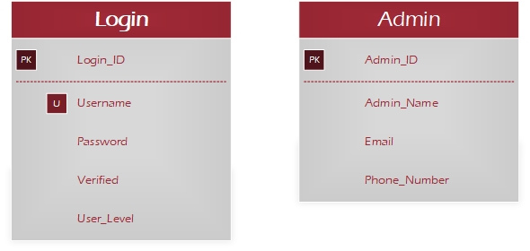

PHP FRAMEWORKS
PHP is a highly popular open-source scripting language used in most of today’s websites because it is flexible and easy to use (Njenga, 2020). But as with every other programming language, coding with PHP may become repetitive and monotonous. Also, given that most web applications have similar structures and functionalities these days, there is a way of extracting the common architecture and making it into a template, ready to be used by developers of many levels of experience (JotForm Inc., 2020). This is where a framework comes in. It is a way of streamlining the coding process, thus making it easier and faster to build. It also allows the developer to create a more complex structure in a more stable manner and in a smaller timeframe.
There are many options available when it comes to PHP frameworks. One can even develop their own framework. It also depends on the configuration the developer is using and weather the framework is compatible with it. The following are some of the most popular choices and their advantages (+) and disadvantages (-) (Reigns, 2020):

CakePHP
- Focused on rapid developing.
- Elegant and simple to use and install, easy to learn (requires only a web server and a copy of the framework).
- Modern framework (supports PHP 5.5+)
- Many security features – SQL injection prevention, scripting prevention, CSRF and XSS.
- Built in Authentication, Validation, Caching, Database Access.
- Good for commercial applications.
- Not useful for RESTful APIs used in cloud computing.

Symfony
- High performance
- Can be used for enterprise-level projects.
- Stable and highly flexible (allows importing of external libraries).
- Easy for installation.
- Suitable for advanced developers.
- Slower performance.
- Does not support MVC.

Laravel
- Suitable for both simple and more complex enterprise applications.
- Fast performance.
- Supports MVC architecture.
- Strong security features.
- Does not work on shared hosting plans.

CodeIgniter
- Suitable for beginner developers
- Easy to use, fast performance, lightweight.
- Compatible with shared hosting.
- Supports MVC architecture.
- Not very reliable from a security point of view.
The current assignment is completed without using a framework.
For the deployment and maintenance of a website there is also a need of a web server and a database management system. Generally speaking, the web server’s main purpose is to store the website’s files and transmit the data via internet to clients who request access to it (WebHostingGeeks, 2010). For the purpose of this assignment the role of a web server will be held by the local computer it is created on (the host). This is possible by installing a web server software, in this case – Apache.
Another piece of software needed for the correct work of a web site is the database management system. In this case, MySQL is used. A web database is where all the relevant data for the web site is stored, organised and able to be accessed through the website via a web browser (Muslihat, 2018).
Keeping all this in mind, there are software applications that can provide all the tools needed for hosting a website in one place. For the completion of this assignment, XAMPP is used. It is an easy and quick way to install all mentioned elements, in order to access the created web site on the local machine (Apache Friends, 2020).

THE WEBSITE
The University of Narnia website consists of two main types of web pages.

Pages that can be accessed by any user
There are several pages containing information accessible to any user. In other words, it is not needed to be enrolled or logged in, in order to see this information. These pages are the Home page(Figure 1), the Contacts page (Figure 2) and the Course Details page (Figure 3). The last is a page containing a search module, where the user can select one of the university’s courses from a drop-down menu and review its details and modules it holds (Figure 4).
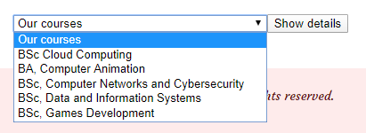
The data is extracted from the database.
The website has the option for enrolment for students and lecturers. Both modules are identical. After filling the enrolment form and submitting it, the users gets a message on the screen containing information about their credentials. The process behind this action is as follows:
- The form is submitted.
- The Student/Lecturer table in the database is populated with the data from the form.
- The Login table in the database is populated, where the username is generated by extracting the user’s ID (Student_ID from the Student table or Lecturer_ID form the Lecturer table) and adding a prefix to it: “S” for students and “L” for lecturers. The user’s password contains eight characters and is randomly generated by shuffling letters and numbers. A user level is assigned depending on the user that is enrolling: level ‘student’ or level ‘lecturer’.
- The user gets the following message on the screen:
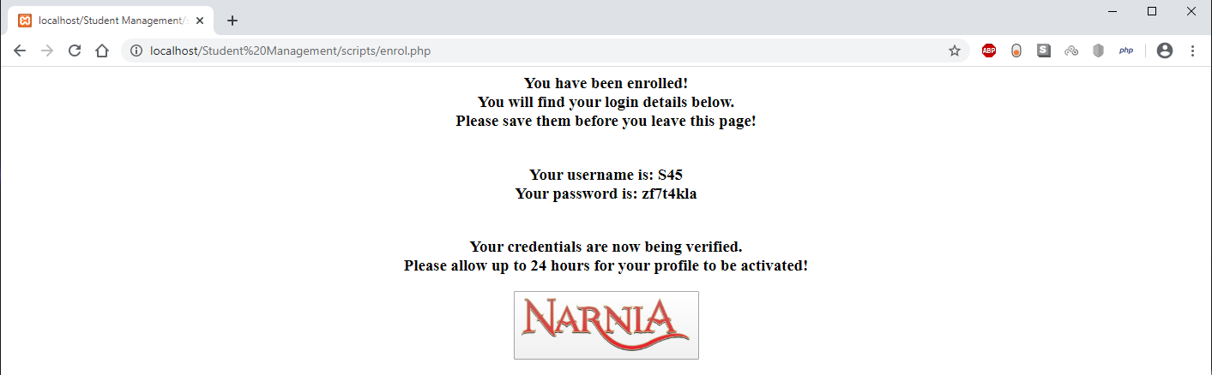
- The next step is related to the administration panel. Before the user can log in their account, a physical validation process needs to be completed, after which the admin activates the user’s account by changing the ‘Verified’ field in the Login table form ‘0’ to ‘1’. If the verification is not complete the user is not allowed to log in and gets a message on the screen:
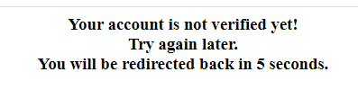

Pages that can be accessed only after logging in
After a successful verification has been made, the users can log in to their accounts and each user is directed to their corresponding pages – Student page and Lecturer page.
The student page contains a subpage with the personal details of the student, where he can edit his details, like phone number and address. He can also see what course he has enrolled into and check his grades by selecting the module from a drop-down menu containing the modules only for his course (Figure 9). On another subpage he can see an exam table for any of the modules in his course (Figure 10).
Respectively, the lecturers page contains two subpages. One holds personal details, including a list with the modules that the specific lecturer teaches. Also, the lecturer can check the upcoming exams for his modules by selecting the module from a drop-down menu (Figure 11). On the other subpage there is another drop-down list of the exams for his modules. By selecting one of them, he can see all the students that took this exam and grade them (Figure 12). As a future improvement a section can be added, where the lecturer would be able to enrol students for the exams and keep track of their number of attempts.

Admin page
The administrator page is created to handle sensitive information and to create, read, update and delete data from the database. The username is created in a similar matter as the rest, only the prefix here is “A”. After login the user is directed to the Admin page where he immediately sees a list with all the users that have enrolled to the university and have not been verified yet. There are also several subpages for managing different categories of data as follows:
- Students (Figure 14) – search a student by the ID, edit his details or delete a student (the adding of a student is done through the enrolment page).
- Courses (Figure 15) – search a course by its ID and update its details. Also, there is a form for creating a new course and assigning modules to that course.
- Modules (Figure 16) – search a module by its ID and update its details. Also, there is a form for creating a new module.
- Lecturers (Figure 17) – search a lecturer by the ID, edit his details and deleting a lecturer (the adding of a lecturer is done through the enrolment page).

TESTING
For the website to work properly and for implementing some security features, different validations are created throughout the execution of some processes. The following tests were conducted to assure that the validations work as expected:

Test Case 1 – Access to a user page without logging in
Action taken – From the home page - typing the destination path in the address bar of the browser without logging in first.
Input
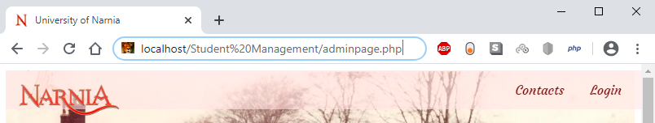
Output
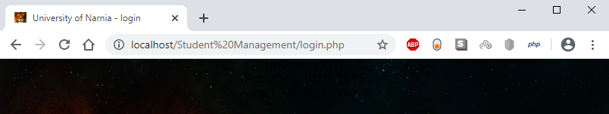
Result - The user is immediately redirected to the login page, thus restricting the access to the admin page. The same restrictions are enforced for the student and lecturer pages as well. (Figure 18)
PASS

Test Case 2 – Logging in with the wrong credentials
Action taken – Trying to login with the admin’s username but with the wrong password.
Input
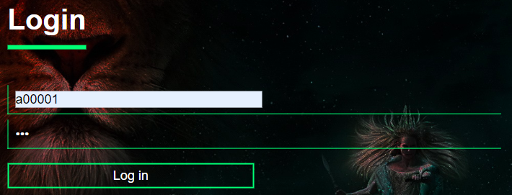
Output
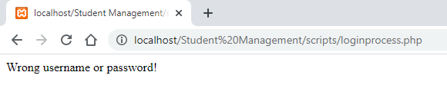
PASS
Result – the user gets a message on the screen. (Figure 19)

Test case 3 – Grading students
Action taken – after logging in with a lecturer’s credentials, a student is graded with a negative mark or a mark greater than 100.
Input and output
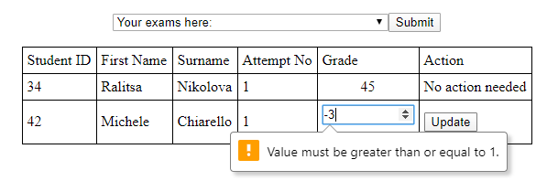
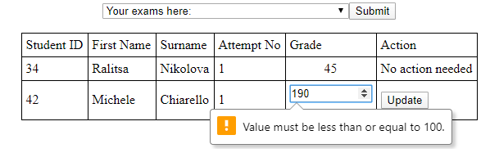
PASS
Result – the user is not allowed to enter a number less than 1 and greater than 100. (Figure 20)

Test case 4 – Student enrolment field format
Action taken – student trying to enrol by entering the wrong format for the phone number.
Input and output
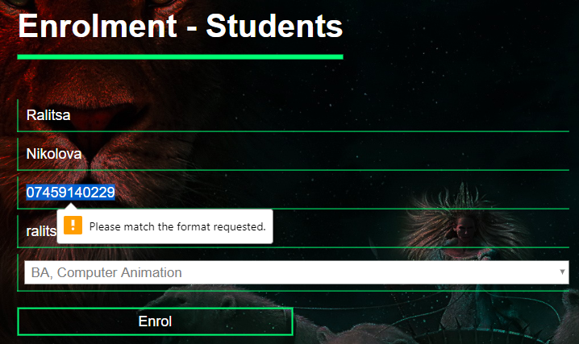
Result – The student is not allowed to enrol. (Figure 21)
PASS

Test case 5 – Enrolling a student with a duplicate email
Action taken – trying to enrol a student to a course using an email that already exists in the database.
Input
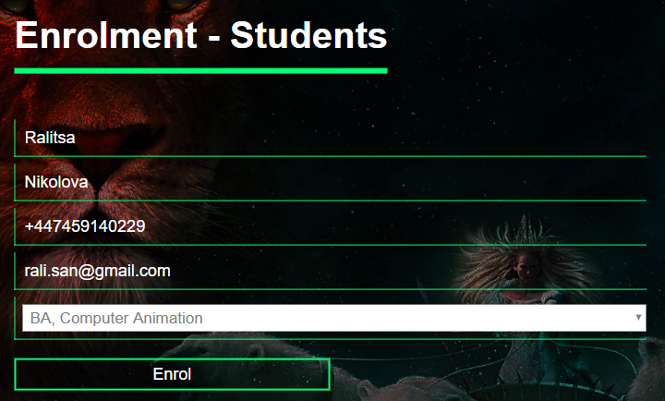
Output
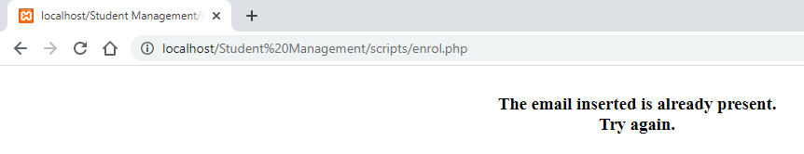
Result – the user gets a message and gets redirected to the enrolment page again. The insertion into the database is not executed. (Figure 22, Figure 23)
PASS
More tested validations are presented in Appendix 2.

EVALUATION
Many advantages can be recognised in the website of the University of Narnia. Some of them are the multiple validations which keep the user’s data safe. Also, the simplicity of the website makes it user friendly.
On the other hand, this assignment can be developed into a fully functioning project by improving its functionalities and adding features, such as:
- Improving the admin dashboard by adding CRUD operations for the rest of the tables in the database.
- Improving the lecturer dashboard by adding different search functionalities and a section for them to be able to enrol a student for an exam.
- Improving the security of the website by implementing the Apache configuration file ‘.htaccess’ for URL redirects.
- Implementing a messaging service for direct contact with the administrator.

References
Apache Friends. (2020). What is XAMPP? Retrieved January 15, 2020, from Apache Friends: https://www.apachefriends.org/index.html
JotForm Inc. (2020). Discussing PHP Framework. Retrieved January 15, 2020, from JotForm: https://www.jotform.com/blog/discussing-php-frameworks/
Muslihat, D. (2018, January 30). Everything You Need to Know About Web Databases. Retrieved January 15, 2020, from Zenkit: https://zenkit.com/en/blog/everything-you-need-to-know-about-web-databases/
Njenga, A. (2020). 10 Popular PHP frameworks in 2020. Retrieved January 15, 2020, from Raygun: https://raygun.com/blog/top-php-frameworks/
PHPMyAdmin. (2020). Bringing MySQL to the web. Retrieved January 15, 2020, from PHPMyAdmin: https://www.phpmyadmin.net/
Reigns, S. (2020). 11 Best PHP Frameworks for Modern Web Developers in 2020. Retrieved January 15, 2020, from CodersEye.
WebHostingGeeks. (2010, August 23). What Are Web Servers and Why Are They Needed? Retrieved January 15, 2020, from WebHostingGeeks: https://webhostinggeeks.com/blog/what-are-web-servers-and-why-are-they-needed/

APPEDNDIX 1 – WEBSITE PREVIEW
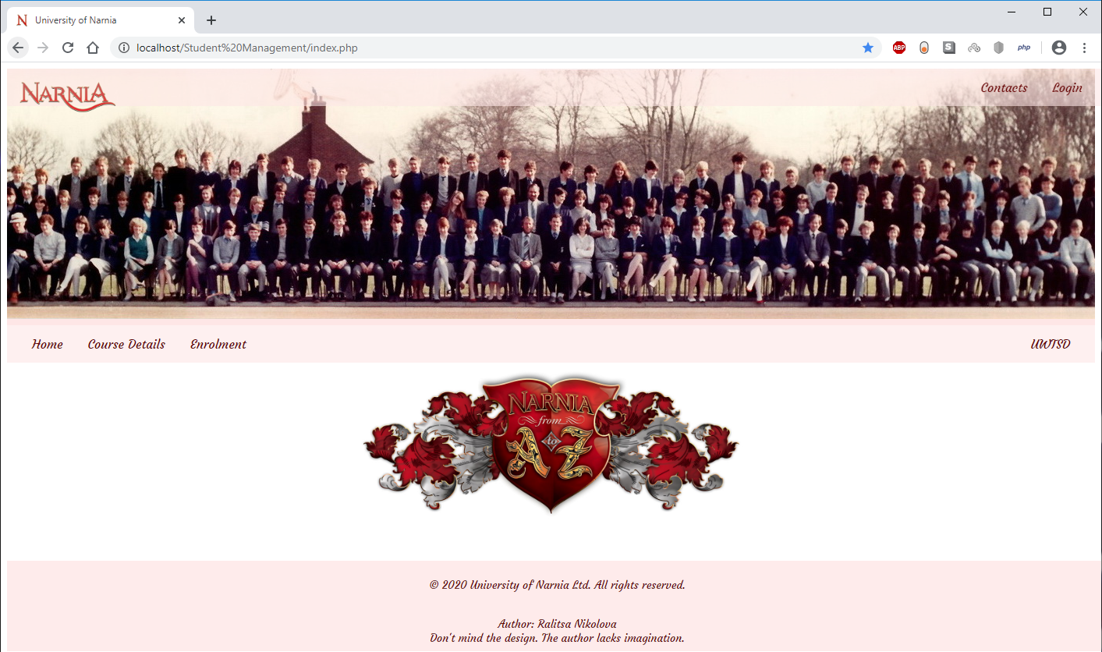
Figure 1. Home page
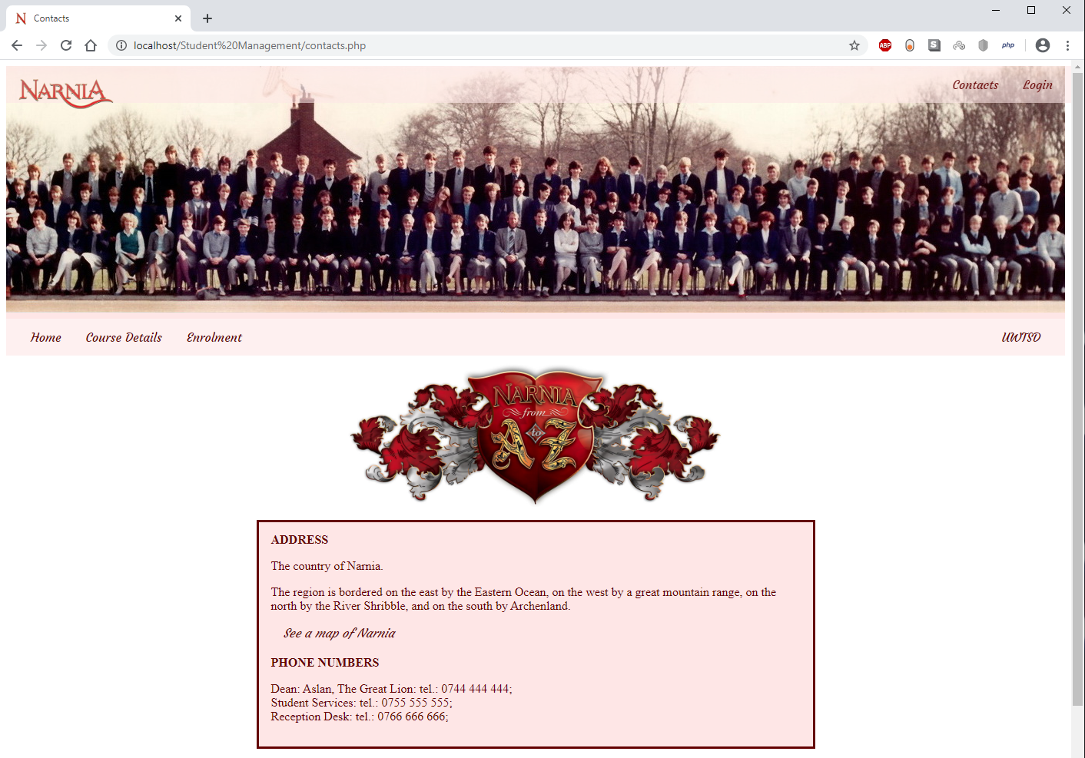
Figure 2. Contacts page
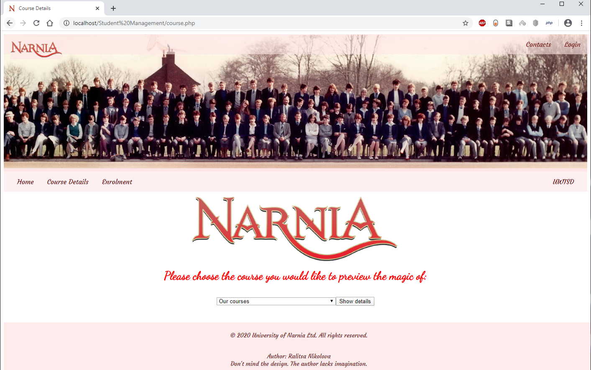
Figure 3. Course Details page
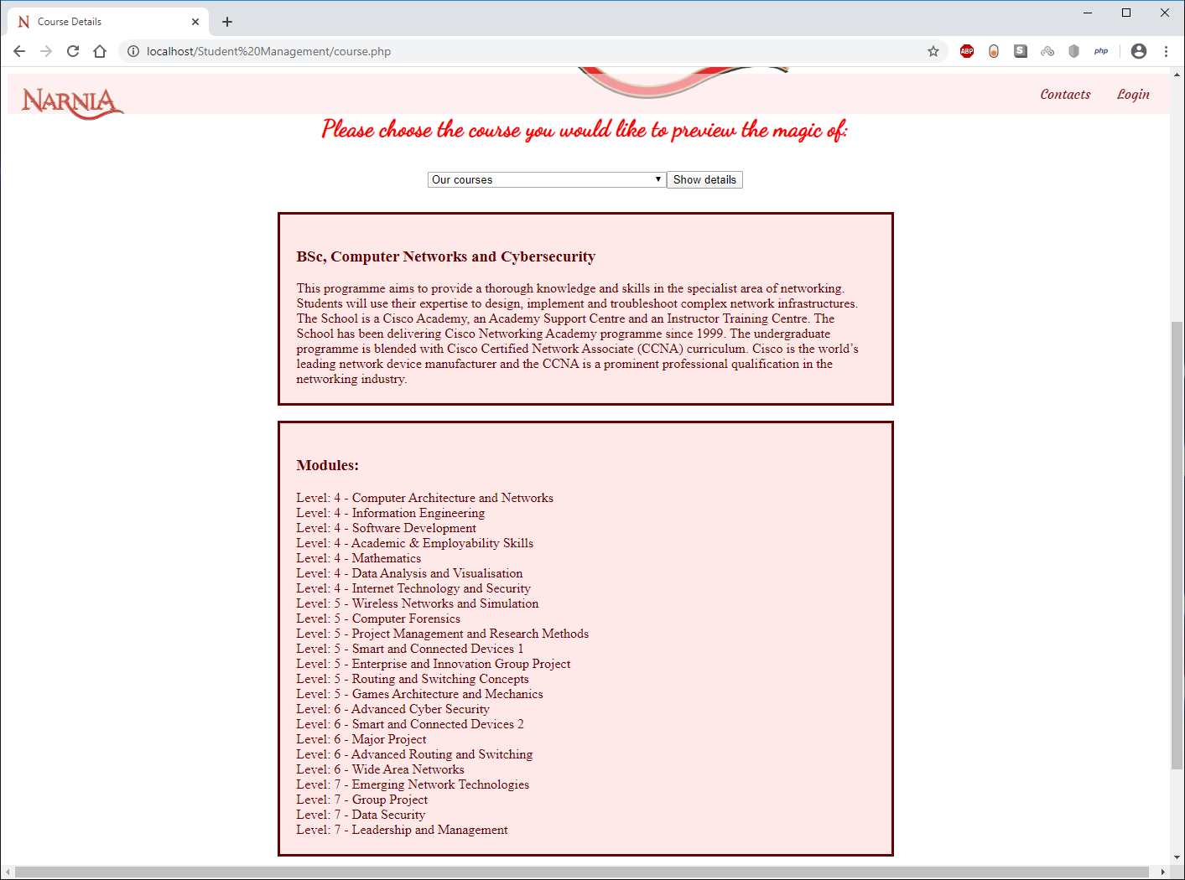
Figure 4. Course Details - after selecting a course
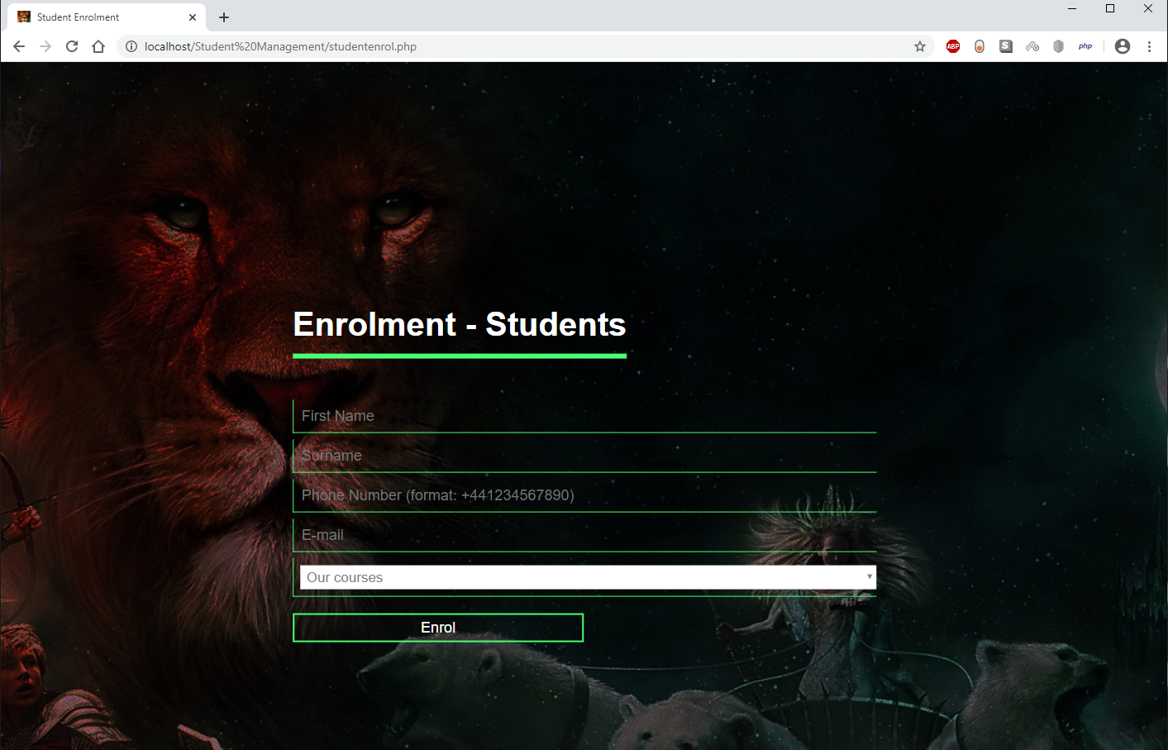
Figure 5. Student enrolment page
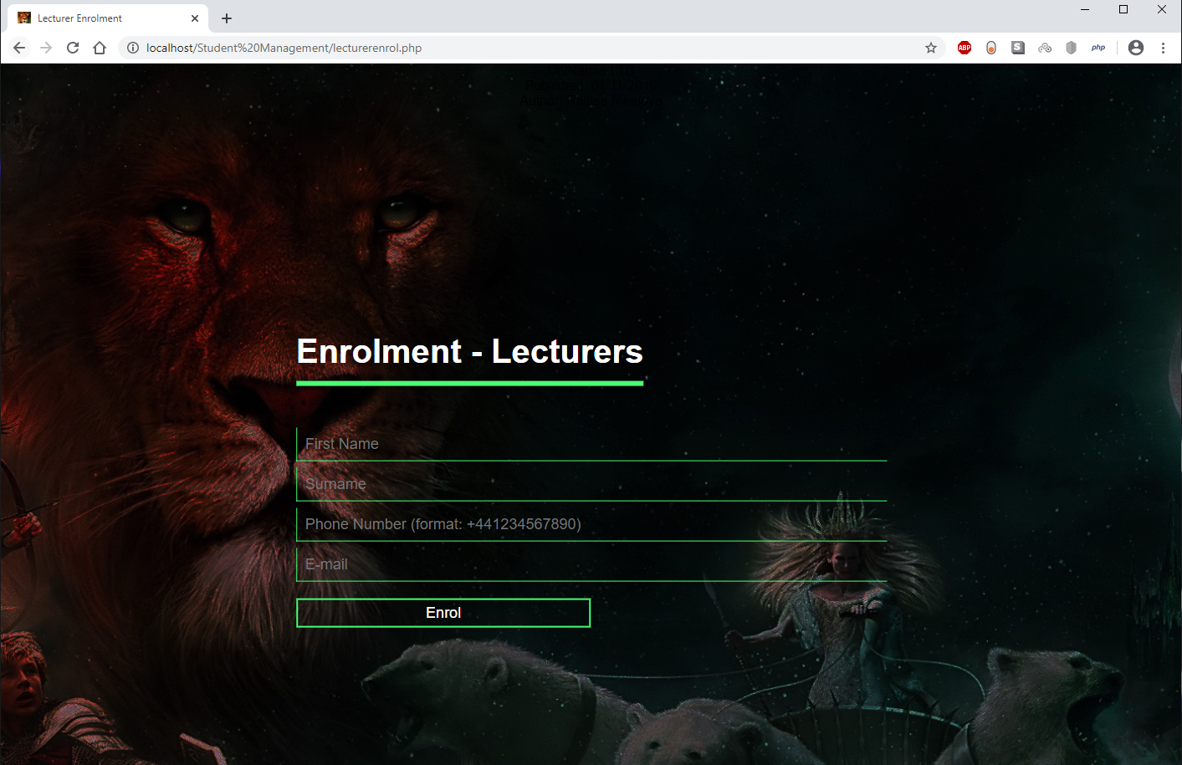
Figure 6. Lecturer enrolment page
Figure 7. Credentials shown after an enrolment is done
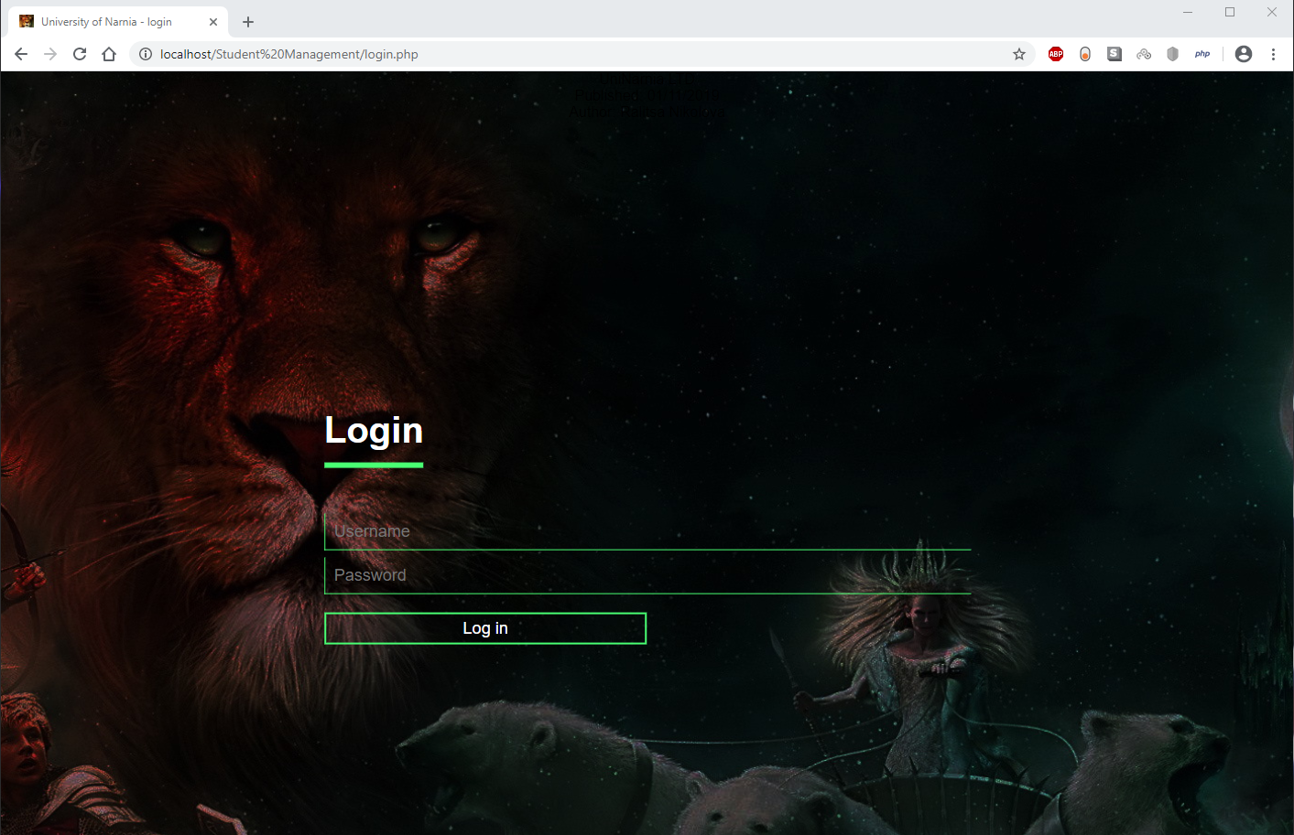
Figure 8. Login page
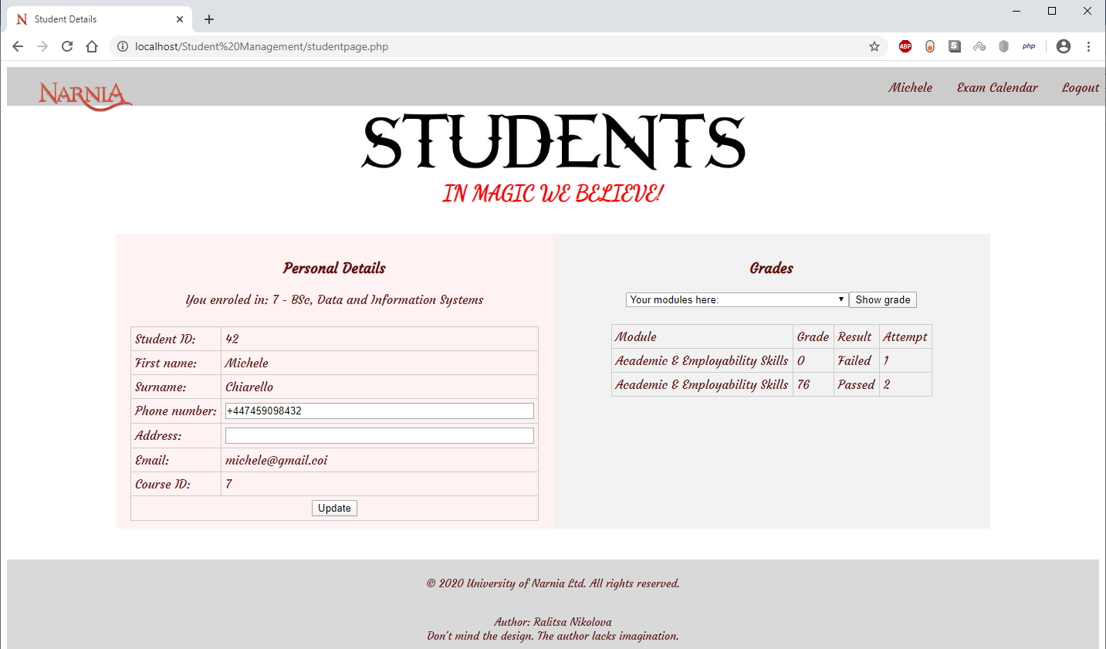
Figure 9. Students page - personal profile
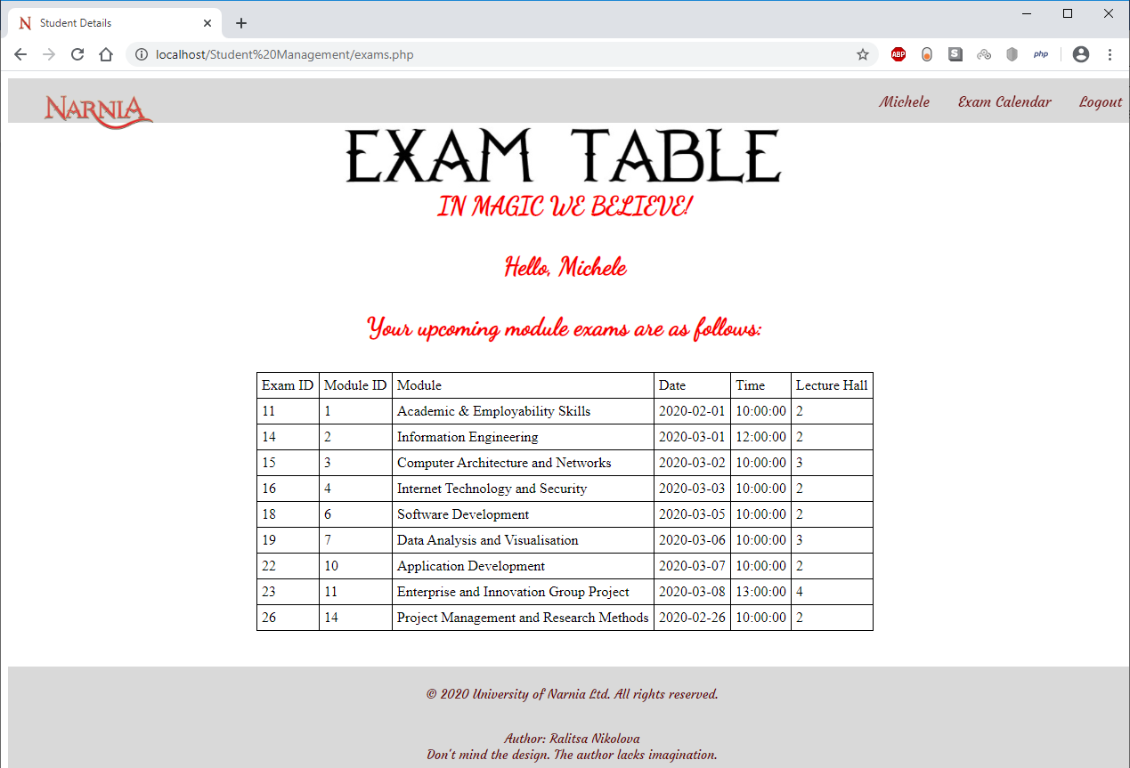
Figure 10. Students page - exam table
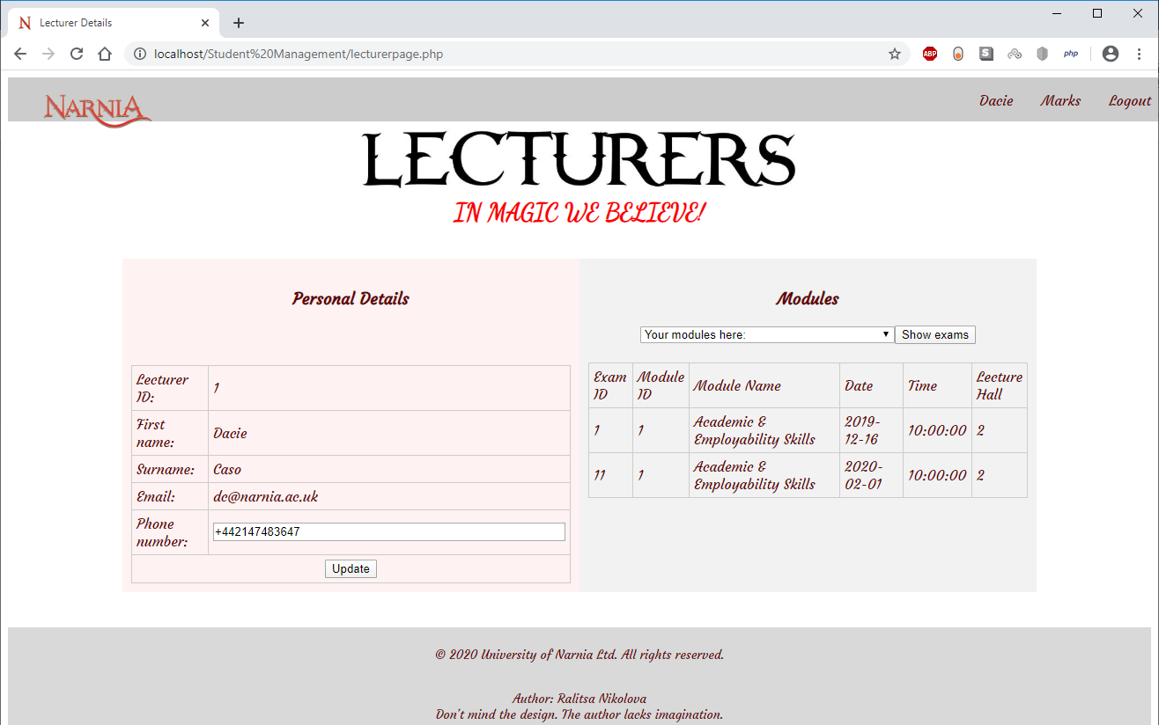
Figure 11. Lecturers page - personal profile
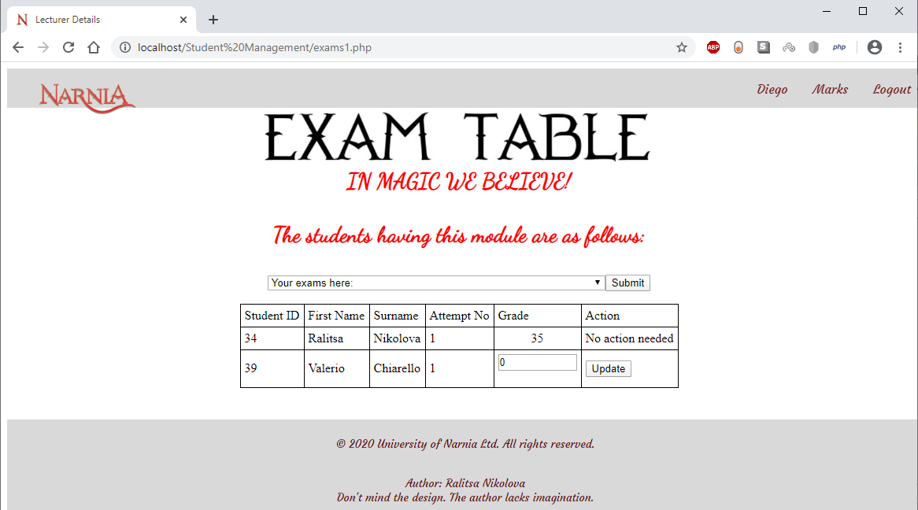
Figure 12. Lecturers page - list of students that attended a specific exam
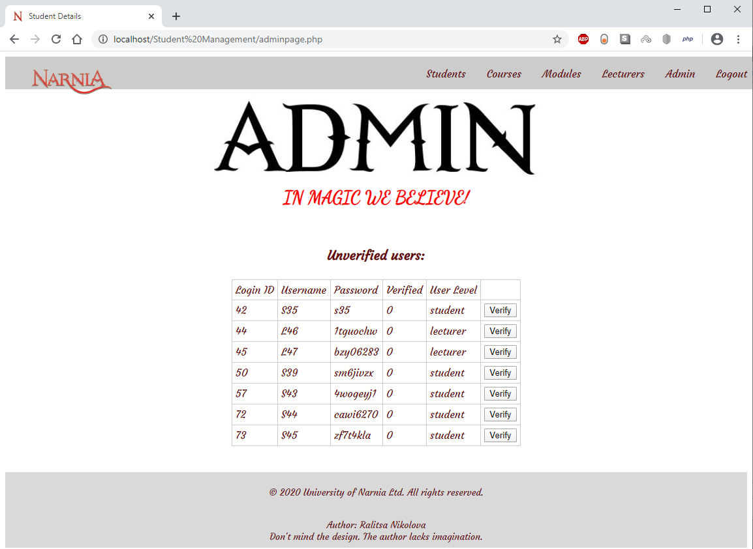
Figure 13. Admin page
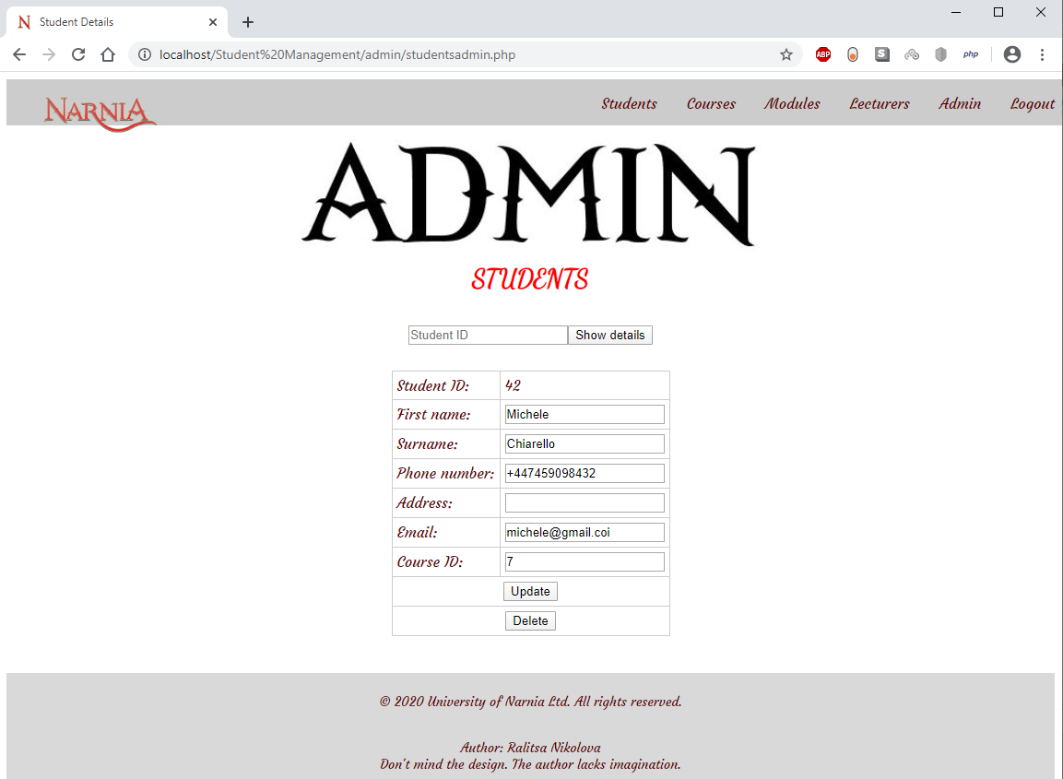
Figure 14. Admin page - managing students
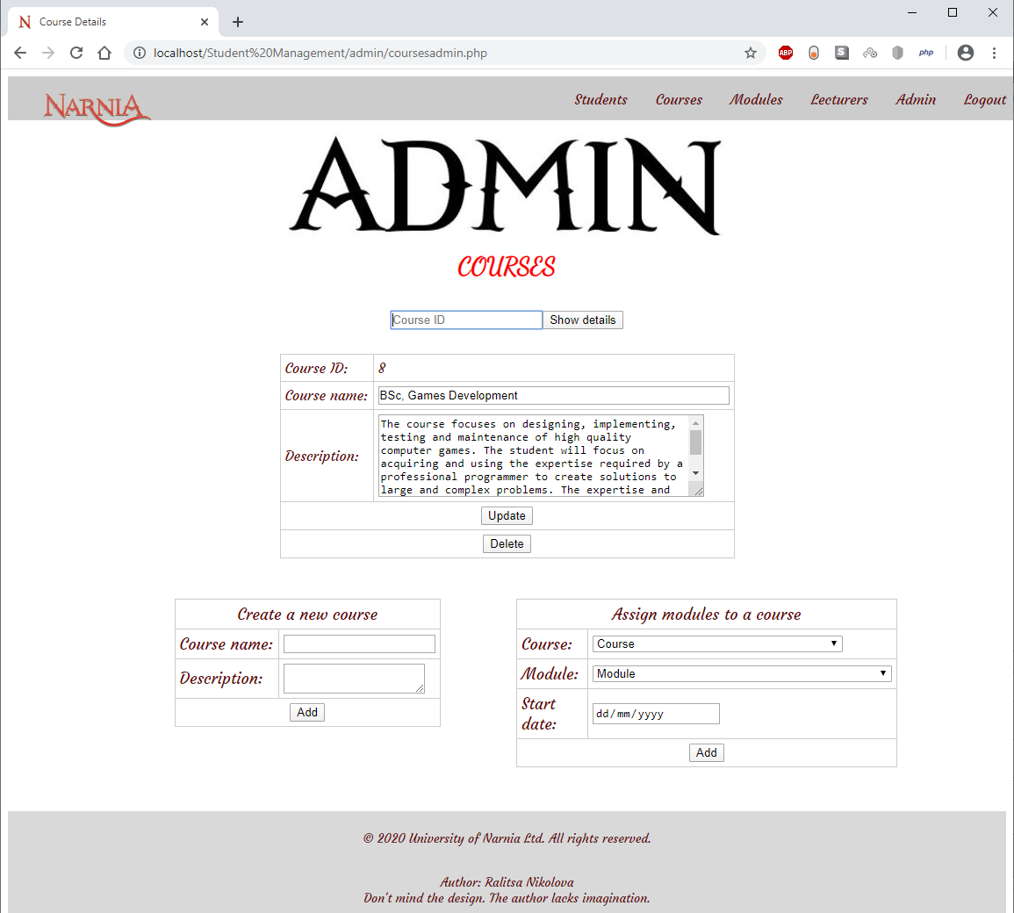
Figure 15. Admin page - managing courses
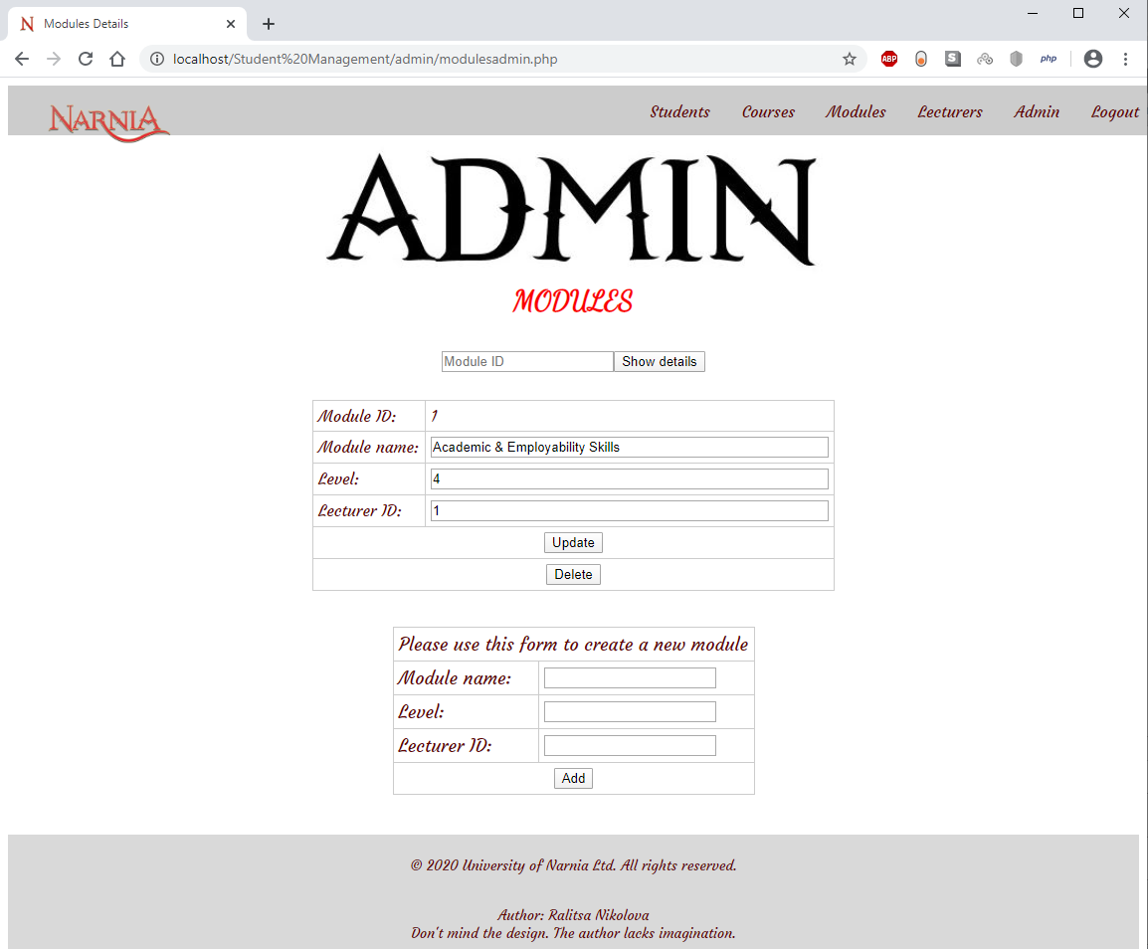
Figure 16.Admin page - managing modules
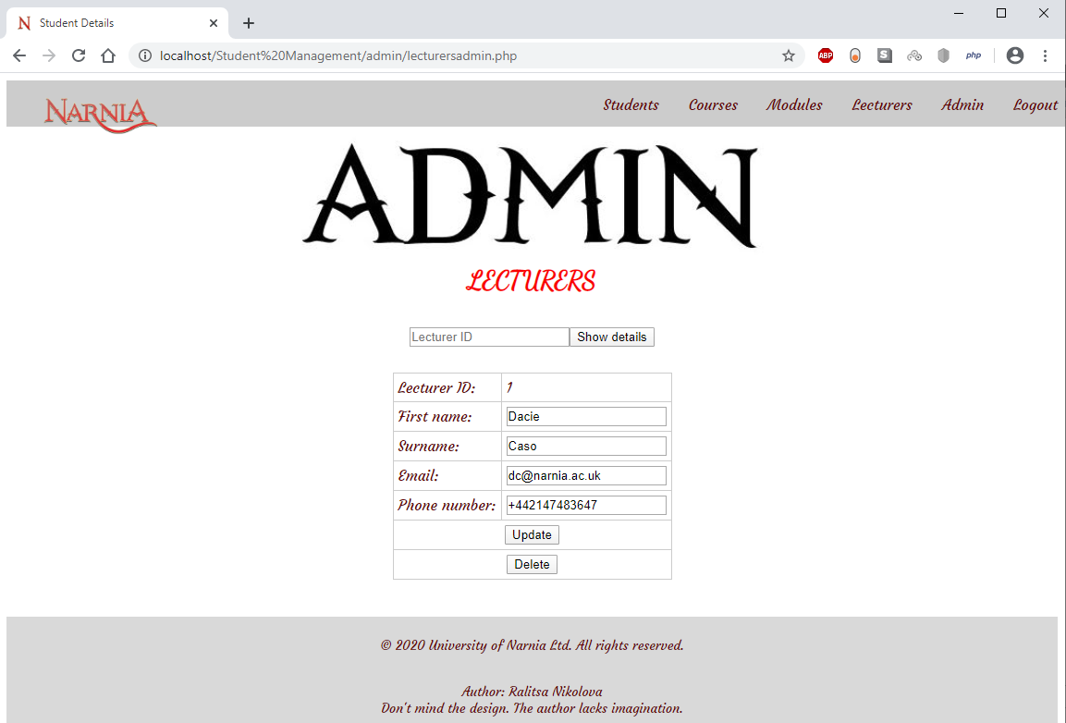
Figure 17. Admin page - managing lecturers

APPENDIX 2 – TESTING
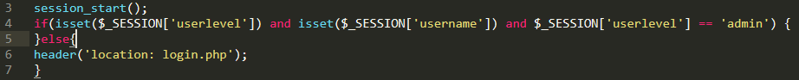
Figure 18. Validation code - Test case 1
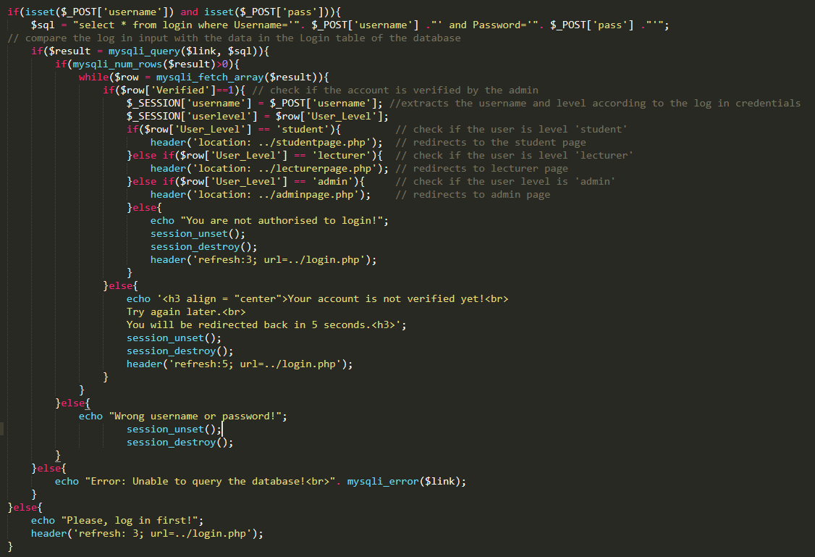
Figure 19. Validation code - Test case 2
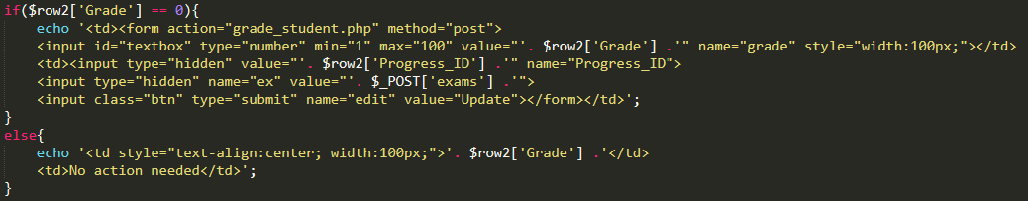
Figure 20. Validation code - Test case 3
Figure 21. Validation code - Test case 4
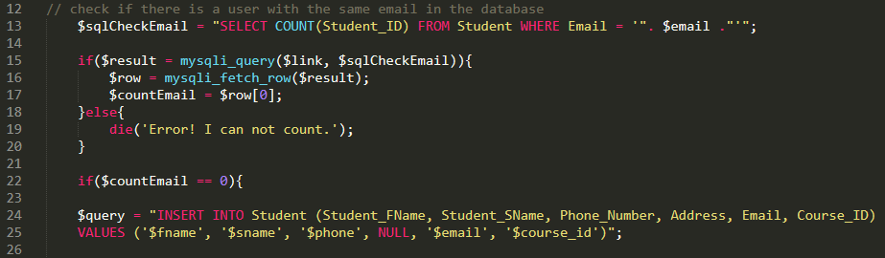
Figure 22. Validation code - Test case 5
Figure 23. Validation code - Test case 5 – result
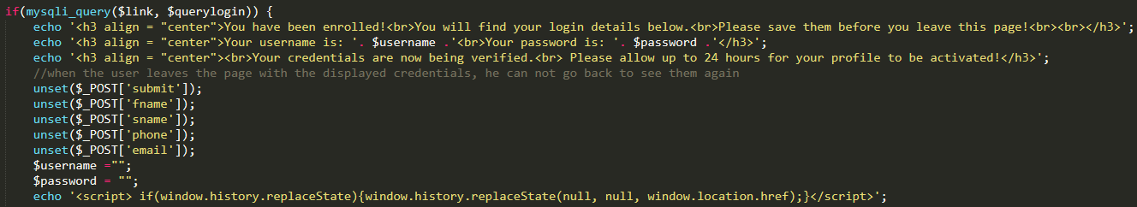
Figure 24. Test case 6 - Clearing the user's credentials

