Student Name: Nizar Kasamali Charania
Student ID: 2132189
Module: LCMB7006
International Marketing
Lecturer: Tushara Balendran

APPLE

Table of Contents
Introduction................................................................................................................................3
Background.................................................................................................................................3
Macro-Environmental Analysis of Apple in USA and UK.............................................................3
Micro-Environmental Analysis of Apple for USA and UK............................................................7
Porter five forces of Model of Apple Company for USA and UK................................................10
SWOT Analysis of Apple Company for USA and UK....................................................................13
Relation to STP of Apple in UK and USA.....................................................................................15
Marketing Mix for USA and UK...................................................................................................17
Market Entry Strategy of Apple Incorporation...........................................................................19
Apple directional development Strategy....................................................................................24
Ansoff Matrix analysis of apple for USA and UK........................................................................24
BCG Matrix analysis of apple for USA and UK............................................................................27
Product Life cycle model of apple..............................................................................................28
Product Life cycle strategies of apple for USA and UK...............................................................29
Defence strategies for Pioneers in the Growth stage of the PLC for USA and UK.....................30
Attack strategies for Followers in the Growth stage of the PLC for USA and UK......................31
Strategies in the Maturity stage of the PLC for USA and UK......................................................31
Recommendation.......................................................................................................................32
Conclusion..................................................................................................................................34
References..................................................................................................................................35

Introduction:
The term "global marketing" encompasses more than just international sales technique for developing and advertising a product or service on a global scale. Most of the company’s potential customers are international marketers. Competing successfully in today's global economy necessitates mastering new skills. Experts in marketing have the potential to take a firm to new heights if they execute their jobs properly. Marketing on a worldwide scale is essential for businesses whose wares may be bought and used anywhere in the world. Consumables like food, telephones, and automobiles are in high demand all around the world(Apple, 2018).
Background:
Steve Jobs and Steve Wozniak, both of whom dropped out of college, founded Apple Computers, Inc. on April 1, 1976. Jobs and Wozniak wanted to make computers small enough to carry and use anywhere. Simply put, they wanted a computer that was user-friendly(Newman, 2014).

Macro-Environmental Analysis of Apple in USA and UK:
- Political Factors:
- Apple is only one of several large U.S. technology companies with substantial cash on hand. It had $34.7 billion in the bank as of the end of the second quarter of 2015. This has led to proposals for higher corporate taxation in countries like the United States, where income inequality is a major political issue(Liébana-Cabanillas et al., 2020).
- The United Kingdom's political system is unique among modern democracies. The policies of this reliable democracy have had deep and far-reaching influences on Britain's economy. Apple has found success in a number of countries thanks to its ability to operate under the local legal and cultural framework. With this newfound knowledge, you can appreciate why the United Kingdom is the world's preeminent political superpower (Rayie, 2021).
To find alternatives to low-cost manufacturing, Apple may have to invest heavily. This has the potential to drive up the price of Apple products.
- Economic Factors:
- Apple's competitive edge is being eroded by the growing cost of living in the United States.
- Incentives were offered by having the Bank of England ensure the safety of the country's banking system on a local level. So, it looks like Apple has a fair shot at being a financially stable company (Consejería de Educación. Junta de Castilla y León, 2020).
- Falling middle-class incomes in certain industrialised countries, such as the United States, may be reducing the size of the potential market for Apple's and other high-end consumer goods in those countries(Hsu et al., 2022).
- Social Factors:
- Consumers in mature markets like the United States have strong brand loyalty to Apple because of the memories and experiences they have had with the company's products over the years.
- The average lifespan in the United Kingdom is far higher than everywhere else on the planet. They consider a life of opulence a necessary part of their superiority complex. Due to their high income, they can afford nothing but the best.
- Company provide the Apple Inc. logo as an example of a brand sign. Because of their illustrious reputation, buyers have the utmost confidence in the quality of their product.
- Technological Factors:
- Both Google and Samsung have proven they can successfully copy Apple's products. Despite Apple Pay's dominance in the mobile payments market, Android Pay only took Google a little over a year to build. This means that many of Apple's most well-known products are no longer unique(Jay and Dave, 2018).
- Only so many new Apple consumer products can be introduced each year. Only a small portion of the population will be interested in its new offerings like Apple TV.
- In UK, Apple has profited substantially from technological developments and these developments will be utilised in the development of new Apple goods (Kerin and Hartley, 2019).
- Legal Factors:
- By launching Apple Pay in the United States, Apple is now competing in the highly regulated financial services industry. Because of this, it could be subject to even stricter rules and a closer look by the government.
- Adding financial services might increase Apple's vulnerability to legal action.
- Apple often includes a complimentary one-year limited warranty with its products. This safety net is on top of the consumer safeguards already in place in the UK for you. The AppleCare Protection Plan and AppleCare+ are optional paid upgrades that provide a variety of additional services and support for Apple products(Chen, Liu and Gong, 2022).
- Environmental Factors:
- The United States' poor system for recycling old electronics is Apple's biggest environmental issue. Disposal costs for electronic waste can add up, especially if the device in question uses expensive lithium-ion cells. Apple may be forced to pay for the disposal of such devices due to environmental concerns(Ruyter, Isobel Keeling and Ngo, 2018).
- Apple has been accused by some British environmentalists of contributing to the worldwide destruction of natural areas. The mining procedures used in mobile phone production are damaging to ecosystems. The same goes for recycling when inadequate facilities necessitate the use of dangerous chemicals. As a result, fewer people are buying new iPhones, and more people are hanging on to their old ones. However, by the year 2030, Apple promises that no Apple product will contribute to the emission of any greenhouse gases (Thomas, 2020).
- Cultural Factors:
Hofstede's cultural model is a useful tool for comparing the cultural characteristics of two distinct civilizations. This research may assist Apple's U.S. and U.K. management in determining the best expansion possibilities by providing information on cultural values, customs, and laws.
Multinational corporations must have a complete understanding of the cultural norms and standards of conduct in a variety of nations in order to engage with international organisations and clients.
Apple's culture conforms to the conventions of the country where its headquarters are located. By knowing these cultural norms and attitudes, the company can successfully analyse its competition and make solid business decisions in both the U.S. and the U.K.
To encourage its employees to improve their performance, the organisation may also strengthen its understanding of the cultural values of its employees and create a more conducive work environment.
By creating a company culture that aligns with the personal beliefs of its employees, a firm may drastically minimise employee turnover and boost intrinsic motivation.
In addition to analysing economic growth, the study findings may be used to discover nations with similar cultural values and customs. By analysing these qualities, managers may determine if cultural norms and levels of acceptability are comparable across nations.
Therefore, it will be easy for Apple to expand into the United States and the United Kingdom, whose economies are similar to Apple's.
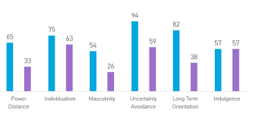
Fig.1: Hofstede Insights, 2021 analysis
Source: https://www.essaypandas.com/essay/Apple-12610-Hofstede-Cultural-Model

Micro-Environmental Analysis of Apple for USA and UK:
The Company: Apple's 2022 revenues are predicted to reach $365.82 billion, strengthening its financial situation (Apple Press). In 2022, the corporation was expected to generate 99.8 billion USD. The global success of the iPhone 6 and iOS 8 has boosted the company's reputation and finances. Apple often offers clients the latest technology, as these examples show. Apple caters to its customers with a wide range of computers and devices. Apple makes Macs, iPods, iPads, iPhones, iTunes, Apple Watches, and the Apple Store. Apple's ingenuity keeps its products ahead of the pack(Hoang Tien and Nguyen Hoang Tien, 2019).
For the fiscal year ended September 25, 2021, Apple Retail UK, the company's retail branch in the UK, reported pre-tax earnings of £38.2 million on sales of £971.5 million. Over the prior year, it increased by 29% (Hoang Tien and Nguyen Hoang Tien, 2019).
- Human Resource/ Employees:
Apple understands the significance of effective human resource management in the success of any business. When it comes to doing their jobs, Apple employees have a firm grasp on what is expected of them and the training to back it up. Those in charge are always kind to their staff. The goal of a company's management team is to improve both customer happiness and the bottom line through the efforts of their staff. Apple also encourages its employees to continuously develop their skills and knowledge in the workplace.
The type of multidimensional, self-motivated, and competent employee Apple seeks to hire in the United Kingdom is consistent with the company's HR practices. According to Apple's non-egalitarian policies, the corporation has A-players filling 95% of its most crucial positions. Apple recognises the importance of full-time work execution; thus, the corporation has created a comprehensive and tailored perk package for its corporate representatives in the UK, including self-awareness training.
- Suppliers:
Apple has a lot of clout in negotiations due to the number of U.S. suppliers it works with. China, India, and South Africa are just a few of the many countries from which the corporation sources its supplies. Apple believes that it can give its suppliers an advantage by funding and facilitating training and development programmes. The strength of a company's ties with its suppliers determines how well it can manage its supply chain and gain an advantage in the market. Apple has established a strict code of conduct for suppliers to follow.
Suppliers in the UK benefit from easy access to a sizable client base due to the country's concentration of PC assembly plants. Pricing disparities between PC devices produced by different vendors might disrupt the market equilibrium. Apple has poured a lot of money into trying to revitalise the UK PC industry.
- Customers:
Apple's corporate office in USA insist that the business always delivers on its promises of providing customers with products that are of the highest quality, have the most advanced technology, work flawlessly, and cost less than competitors' offerings. In a survey conducted by J.D. Power, Apple was found to have the greatest customer satisfaction rating by far, with 85 percent of customers reporting complete satisfaction (GSM Arena). Apple's success may be attributed to the meticulous planning that went into every aspect of the company, from the procurement of raw materials and human labour through the final stages of production and distribution(Thomas, 2020).
Apple's target market in the UK consists of young adults. These buyers are looking for cutting-edge features and superior build quality in their next smartphone. Adults who are comfortable with modern technology are another target demographic.
- Competitors:
Apple has stiff competition on the market. Apple's key competitors in the US are Samsung, Microsoft, Amazon, and Google. In addition to Apple, Motorola, HP, HCL, and Blackberry are all formidable competitors in the smartphone market. In poorer countries, Apple goods are considered luxury goods due to their high price tags, while Samsung has a more extensive product line at more affordable costs(Thomas, 2020).
In the United Kingdom, Apple's main competitor, Samsung, has been quite aggressive. Samsung, like Apple, has heavily invested in research and development, and this has paid off by providing the corporation with a dominant share of the UK smartphone market. Emerging Chinese electronics manufacturers, including Huawei, Infinix, and Tecno, are strengthening their foothold in the UK.
- Public:
In the United States, this group includes the populace at large, the press, the government, and the banking system. Since it abides by all rules and regulations, Apple enjoys a solid standing with the government. It's possible that Apple will receive a range of reactions in the media due to the constant stream of product complaints. On the other hand, Apple devotees are devoted and proud to flaunt their products.
Apple needs PC users in the UK to have any kind of political or economic clout. The purchasing power of a company's clients is closely tied to the company's short-term and long-term success. Apple may have identified its target demographic among the UK's most tech-savvy early adopters. The iPad, iPhone, and other iTunes devices have gained nearly cult status among British teenagers and young people.
Porter five forces of Model of Apple Company for USA and UK:

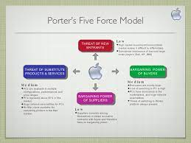
Fig.2: Apple's porter five forces of model
Source: https://peachyessay.com/sample-essay/apple-incorporated/
- Industry Competition:
Apple's rivalry with other IT behemoths is fierce in the USA. Apple's main competitors are the PC hardware manufacturers HP and Samsung. All of these companies, Apple included, spend a lot of money on research, development, and marketing. As a result, the risks for those who choose to work in this field are substantial. Due to the high levels of competitiveness and minimal entry barriers, this industry offers consumers a unique and engaging product. Customers don't have to shell out a lot of cash to make the switch from an Apple iPad to an Amazon Kindle or another tablet computer. Apple is able to stay ahead of the curve and dominate the market because of its commitment to ongoing innovation and the production of new products.
There is a lot of competition for Apple in the UK tech sector from companies like Samsung, Google Inc., and Amazon.com. Since they employ similar methods of product development, advertising, and innovation, these companies provide a serious challenge to Apple. There are so many alternatives to Apple that customers may have an easy time switching. Apps that do well on Android usually make the jump to iOS (Apple). This category includes cloud-based services optimised for mobile devices, such as Apple's iCloud and Google's Google Drive (Thomas, 2020).

- Bargaining Power of Buyers:
The low switching cost I described above is a major issue that Apple must take into account in the United States to increase the bargaining power of its customers. Additional research within this group should focus on the influence purchasers have both as individuals and as a group. Because the loss of a single customer would not have a material effect on Apple's bottom line, the corporation is in a poor position to bargain with individual consumers. However, customers as a group have considerable negotiating power in the market, and the threat of mass customer defections to competitor is significant. Apple spends much on R&D to keep producing ground-breaking devices like Apple Pay and the Apple Watch and to foster intense brand loyalty among its clientele in order to compete with this tough rival.
Leaving Apple for a direct competitor is not going to have much of an influence on Apple's market share, but it will have a significant impact on the market share of the rival. This is a major factor to think about because of the ease with which customers may obtain information (Hoang Tien and Nguyen Hoang Tien, 2019).
- Threat of New Entrants:
Apple is unlikely to lose significant market share in the United States to a new entrant. Large initial investments and sustained brand promotion activities are necessary to establish a presence in this industry. Start-ups looking to break into the PC or smartphone sectors will need a sizable capital reserve dedicated solely to R&D and manufacturing costs before they can begin selling their wares and making a profit. A new entrant would have to compete with Apple and the other industry giants. The market is already crowded with giants like Apple, Google, and Amazon, making it tough to stand out.
Due to Apple's well-known brand, large market dominance, and the high cost of developing an organisation to compete with Apple, new entrants, especially in the UK, will encounter substantial competition and challenges. However, firms such as Google and Amazon are so large and well-funded that, despite their relatively late entry, they can compete head-on with Apple, making the risk of new entrants to Apple relatively low (Yamoah and Acquaye, 2019).
- Bargaining Power of Suppliers:
Apple's U.S. suppliers face little to no competition. Apple's massive size and constant demand have weakened the bargaining position of its suppliers. Apple uses a wide range of suppliers for its materials and components. Competition is fierce in the markets where its suppliers, like those that produce computer CPUs, operate. There isn't a significant enough difference in price between Apple's current supplier and a potential new one for Apple to make this a top priority. Many of the companies that supply Apple with components also see the company as a strategic partner, so they are understandably hesitant to lose that business. Thus, Apple's negotiating position is improved while that of its suppliers is weakened. Suppliers of Apple's and its main rivals' component parts are of little importance in terms of bargaining leverage.
The United Kingdom-based component manufacturers Apple works with are naturally wary of losing such a significant customer to a competitor, giving Apple an advantage in any contract discussions. This makes it quite evident that Apple's component and part suppliers have little sway over Apple's long-term strategy and limited bargaining power with the corporation. This means Apple's agreements with its suppliers are smooth sailing.
- Threat of Buyers Opting for Substitute Products:
The iPhone is a popular high-end product, but there are others to consider. Using an Apple device in the US may mean sacrificing your cell phone in favour of a landline. Due to the restricted functionality of most alternatives, such as a landline telephone, the competitive pressure on Apple is typically minimal.
The danger of alternative products, as defined by Porter's Five Forces study, is a factor that Apple must consider. Due to their limited resources, potential UK competitors to Apple pose little threat. Despite the iPhone 12's many benefits over professional-grade digital single-lens reflex cameras, some people still prefer them. There is currently no other technology that can fully substitute for mobile phones.

SWOT Analysis of Apple Company for USA and UK:
- Strength:
- Innovative Products, Unique Designs:
Apple is said to be releasing a new version of its popular Air-Pods headphones with some user-requested improvements and a lower price in 2021(Hsu et al., 2022).
- Introduction of new services:
With the advent of new digital streaming and payment technologies, especially in the United States, Apple has been able to effectively establish its own systems. Apple will soon release and improve a number of new services, including Apple Arcade, Apple TV+, Apple Music, Apple Card, and iTunes(Li, 2021).
- Brand Identity:
Apple has a large customer base in the United Kingdom due in part to the company's well-known brand. The aesthetics of its products are striking; they are sophisticated yet understated; they are one-of-a-kind and innovative.
- Weaknesses:
- Limited Distribution Network:
Apple Inc. has a small distribution network in the United States, with only a few locations established in different areas, due to the company's goal to sell its goods independently. Compared to other smartphone companies, it is rare to be able to buy an Apple device from any store.
- Price Point:
Many Americans are put off by Apple's comparatively exorbitant prices. The enormous profit margin of the product has prevented it from breaking through to the mainstream audience of smartphone owners. A growing number of people, especially in the United States, are choosing to spend more money on name brands like Samsung(Li, 2021).
- Highly dependent on iPhone and iPad:
The UK is a massive market for iOS devices and a major contributor to Apple's bottom line. In 2020, Apple will make $365 billion, or 52% of its entire income. In 2020, Apple broke records with sales of 194 million iPhones, 71 million iPads, and 20 million Mac and MacBook computers (Li, 2021).
- Opportunities:
- Brand Loyalty:
In the United States, Apple has seen record sales thanks to the premium brand's relationship with hipness, refinement, and individuality.
The word travels fast when it comes to Apple product announcements and presentations, especially in the USA. Furthermore, Apple's iPhone boasts a remarkable 92% client retention rate. Their full potential in terms of market share has yet to be revealed.
- Technology:
In order to capitalise on the expanding U.S. wearables industry, Apple may look to develop new products beyond the Apple Watch and Air Pods.
- Green technology:
Apple has not yet introduced any products made entirely from sustainable materials. The process used to make it in the United Kingdom is not completely green and sustainable just yet.
- Smart wearable technological products:
The United Kingdom is one of the nations that have recognised the world-changing potential of smart wearable technologies. By 2022, this industry might be valued at £27 billion, as predicted by Forbes (Li, 2021). Thus, Apple now has a solid foundation upon which to build its wearable business, one that can be leveraged beyond simply the Apple Watch and Air Pods.
- Threats:
- Market Capture by Competitors:
These changes have made it easier for new players to enter the U.S. and UK smartphone industry. It is expected that Android-based smartphones will make up 74.13 percent of the market, while iOS based smartphones will make up only 24.79 percent.
- Coronavirus Outbreak and Global Tensions:
Many multinational corporations have built their supply chains and manufacturing facilities in the United States. Until April of 2020, the virus outbreak may wipe out as much as 20% of Apple's annual revenues. The predicted range for revenue was $63–67 billion; the actual number of $57 billion is a fall of 15-20 percent. Similarly, the Corona virus epidemic damaged Apple's supply chain, leading the firm to predict flat sales for 2020(Li, 2021).
Apple relies significantly on the United Kingdom for manufacturing and shipping its products. Apple's annual revenue in the UK is close to $1.5 billion. We may expect the coronavirus to continue to be an issue in the future, which will have a negative effect on sales.

Relation to STP of Apple in UK and USA:
- Segmentation:
Apple's creative product development strategy segments its user base by US and UK customer needs. Businesses categorise customers by demographics, shopping inclinations, and personality types (Apple Segmentation, Targeting, and Positioning, 2022). Apple's demographic segmentation helps firms offer a wide choice of products for different customers. Mac for work, iPad for leisure Apples are healthier than oranges. Its encrypted connection and specialised programmes make it one of the safest web access methods.
Apple has expanded its retail presence across the United Kingdom and United States to meet the needs of a wide variety of customers. Apple has also created online retail hubs. Direct sales of Apple products and services to customers are enabled through these virtual stores. Apple's growing online and offline visibility has led to a larger market presence and customer base.
- Targeting:
Apple primarily markets to affluent Americans and united kingdoms in their twenties to forties who are interested in receiving perks and who have strong emotional ties to the company. They sell high-end, cutting-edge products, and that's what they specialise in. Spending more on Apple products benefits those who care about technology, functionality, and aesthetics. Apple customers are willing to pay a premium for the brand because of its superior build, features, and performance.
Apple's strategies for locating and contacting its target audience in the UK and USA are incredibly original. The company has honed in on the most lucrative part of the market. The process culminated with picking the best subset that had been established beforehand. Apple has primarily designed its products for this age group.
- Positioning:
Apple's dedication to technological innovation has been a major factor in the company's sustained success in the U.S. and UK market throughout the years. The new iPhones from Apple will have better performance and design (Apple Segmentation, Targeting, and Positioning, 2022). As the most valuable company in the world, Apple has long since cemented its reputation as a premium manufacturer.
Apple's strong position in the USA and UK market has enabled the corporation to cater to the needs and preferences of a select clientele by providing them with a range of premium products and services. The worldwide company's advertising and product offerings are tailored to the needs of shoppers in that niche. It appears that the percentage of people who find Apple products appealing is highest in the United Kingdom and United States both.

Marketing Mix for USA and UK:
- Product:
For a long time now, Apple has prioritised U.S. production over anything else when it comes to the design and construction of its products. Wozniak believes Jobs told him, "This is how you get fantastic stuff to people," in reference to Apple's commercial practises and ethical position. Apple was busy revolutionising the way people interacted with computers by introducing icons and the mouse, while its competitors were making "boring" products.
Apple's product ads in the UK emphasise the company's advantages over competitors. Television and print commercials for new products run throughout their availability (Li, 2021). The advertisements either employ a black background with white text and a white logo or a white background to accentuate the sleek black of their products (iPhone, iPad, etc.).
- Price:
Typically, Apple's prices are higher than those of its competitors. On September 16, 2022, Apple debuted the iPhone 14 Pro Max in USA, which was met with mixed reactions from the industry due to its high price tag. "We never had the desire to promote a low-cost phone," Apple CEO Tim Cook said in response to the criticism.
Following the launch of products in the United Kingdom, the corporation reduced its pricing. It skims and charges more.
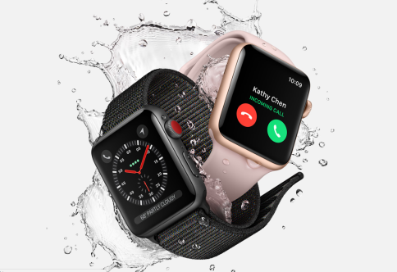
Fig.3: Apple Watch Series 3 from $329 (Apple (United Kingdom), 2018)
Source: https://www.apple.com/uk/newsroom/2017/09/apple-watch-series-3-features-built-in-cellular-and-more/
- Place:
Many countries currently have Apple Stores, and that number is expected to grow. These stores help promote Apple's emotional branding because they give customers a comfortable environment in which to fully immerse themselves in the brand's products and tenets.
Apple also has relationships with other companies, including retail outlets like Curry’s PC World and John Lewis and telecommunications firms like EE, Virgin, BT, and others. Apple may be well-known online, but it is far from unique. For instance, Apple's online shop is both fashionable and easy to navigate, and it offers an extensive selection of products in a wide variety of categories and with a wide variety of attributes (such as colour, storage capacity, etc.) and optional extras.
Apple lets UK businesses control this marketing mix element. Apple sells through its stores, the App Store, authorised retailers, telecom carriers, fulfilment services, and corporate resellers.
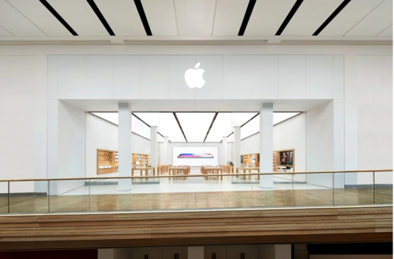
Fig.4: Apple Store, Meadowhall Shopping Centre (Apple, 2018)
Source: https://www.apple.com/uk/retail/meadowhall/

Market Entry Strategy of Apple Incorporation:
USA:
In USA Apple Inc. favours entering new markets through licencing, exports, and imports. Apple Inc. employs licencing because it is superior to other methods of market entry, such as joint ventures and strategic partnerships. Take into account the following for more clarification:
- Low Risk:
When compared to other methods of entering the market (such as a joint venture, a strategic alliance, etc.), the risk involved with a licence is very low.
- Low Regulations:
Similarly, a business encounters fewer regulatory barrier when it enters the market via licencing rather than some of the other entry modes.
- High Returns:
When compared to alternative methods of entering international markets, the corporation may see significant profits through the licencing route. The same is true for imported and exported entry modes, both of which are put to use by Apple Inc.
UK:
Apple's market entry strategy includes a steady stream of updates to the iPhone line in order to keep up with demand from customers in the UK. Apple's online music store remains the first of its type, even though it has been updated to work with the iPhone 6. The iPhone 6 is available in the United Kingdom at three different price points: premium, regular, and ordinary. Those who qualify for these deals will receive further price reductions on their desired products.
- Promotion:
One part of Apple's marketing approach is holding free events and workshops within its stores. These high-profile Apple CEO keynotes have developed into promotional events in their own right, and true Apple fans would be remiss to miss them. Carmine Gallo, an expert speaker who teaches at Harvard, said that Steve Jobs' keynote speech about the iPhone in 2007 was the best speech ever given.
Apples are promoted in the UK through branding, advertising, public relations, corporate identity, social media engagement, and sales.
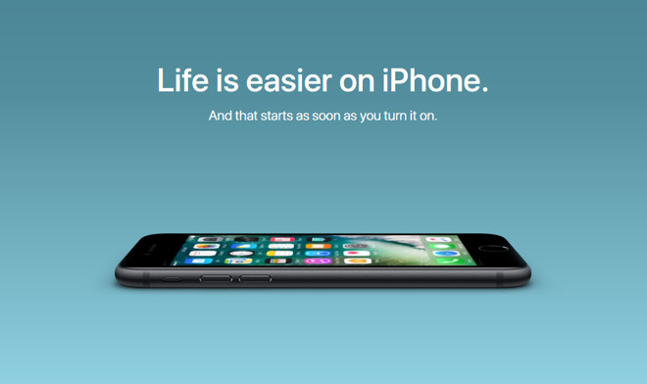
Fig.5: iPhone Print Ad
Source: https://marbossdigitalmarketing.wordpress.com/2018/10/23/apples-marketing-mix/
- People:
Customers who have had a great experience with Apple products in the United States are more inclined to recommend the company to their friends and family. The abundance of internet discussion around Apple amounts to free promotion for the company.
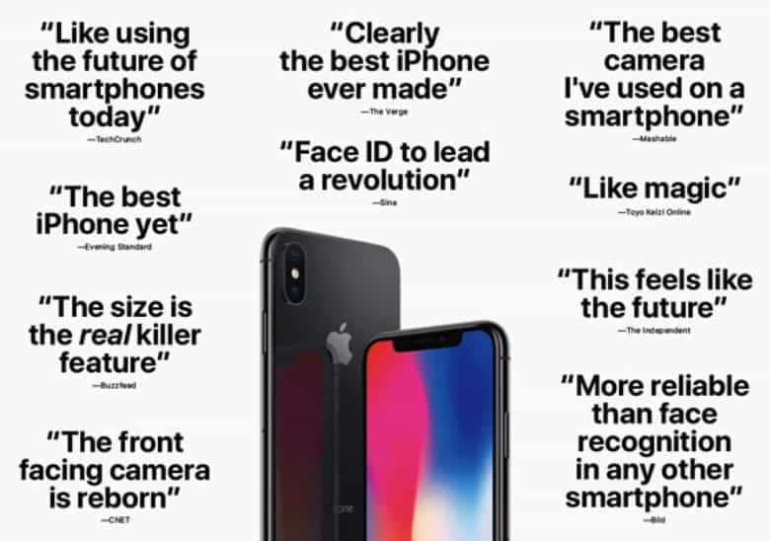
Fig.6: Apple's advertising campaign is built in part on the back of satisfied consumers' comments. Cult of Mac is the image's source (2017).
Source: https://marbossdigitalmarketing.wordpress.com/2018/10/23/apples-marketing-mix/
The Apple Care Protection Plan expands customers' service coverage and provides convenient, centralised access to Apple-certified technicians in the United Kingdom.

Fig.7: Apple Support (Apple, 2018)
Source: https://medium.com/macoclock/my-beef-with-apple-support-b89843dd17c4
- Process:
Apple's customer service in the US is accessible via a variety of mediums. Customers who need service for their Apple products can choose to receive a phone call, start a conversation, or go to an Apple Retail Store.
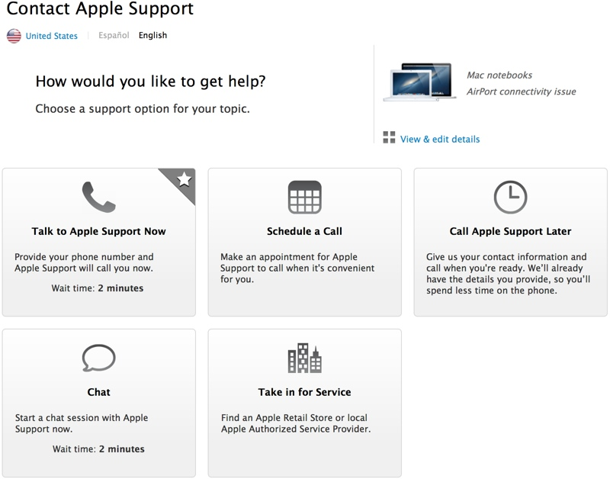
Fig.8: The image is a screenshot from Apple's website, which allows users to select their preferred method of contacting Apple's experts. This image (2018) was created using Mac Rumours.
Source: https://marbossdigitalmarketing.wordpress.com/2018/10/23/apples-marketing-mix/
Customers in the United Kingdom have access to Apple's expert and free technical support staff at any of the company's retail locations or online(Shailza, 2020). All of Apple's hardware is supported here.
- Physical Evidence:
Apple stores are typically found in the heart of major shopping districts in the United States. Those interested in seeing this principle in action can visit the Apple Store on Destiny USA Drive in Syracuse, New York 13204, United States. While the decor of each Apple Store is unique, they all share a commitment to simple, understated furnishings that put the focus on the store's contents. The inside looks like it was taken right out of a museum that shows off the latest scientific and technological developments(Li, 2021).
Apple has capitalised on the synergy between all of these elements to become the leading luxury brand in the UK. Apple's stores are designed to be welcoming and uncluttered so that customers can focus on their purchases and learn more about the company's products (Lee, Lee and Jung, 2020).
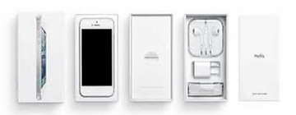
Fig.9: iPhone packaging. Sweadbrandgroup.com (2017)
Source: https://www.mammesardenelmondo.com/post/apple-s-extended-marketing-mix

Apple directional development Strategy:
Taking into account Apple's strengths, limitations, opportunities, and threats, it is clear that the company have a sound strategic direction. Despite the recent setback imposed by the death of the company's founder and CEO, Steve Jobs, certain organisational aspects remain in place to ensure the company's future growth and profitability. Ipad and iPod sales are important corporate strengths and a solid source of innovation at this time. Innovative tactics and the Apple brand are the company's driving forces. These traits will likely serve as the foundation for Apple's future market expansion strategy. In this environment, the company must utilise leverage to keep its competitive edge. As a consequence of the sales of Apple's Macintosh, iPod, and iTunes technologies, the firm enjoys access to several new demographics. In order to promote innovative software design and a market-leading brand, the company must integrate client access as permitted by this software. Apple's capacity to continue innovating products after the passing of CEO Steve Jobs will be tested in the coming years, but the business's immense market dominance and brand awareness give it sufficient potential to maintain its decade-long success.

Ansoff Matrix analysis of apple for USA and UK:
Businesses that want to increase their profits by "tapping into" new markets or producing novel goods and services might use the Ansoff model to do so.
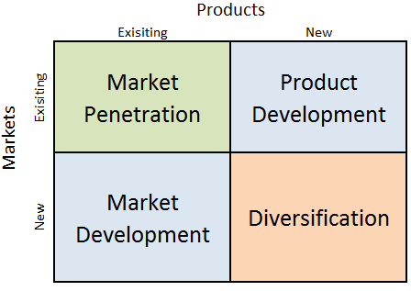
Fig.12: Apple Ansoff Matrix
Source: https://research-methodology.net/apple-ansoff-matrix-2/

Apple employs four distinct growth methods within the context of the Ansoff Matrix:
- Market Penetration:
In order to "penetrate" a market, one must actively sell into it. In the United States, Apple has 272 physical stores.
Apple sells its UK-based products through this technique. Apple sells in a number of countries. Apple or authorised retailers sell the products. Third-party Apple resellers sell them too. increase market share. The company also sells its products online. To increase market share, the corporation cuts prices and gives discounts after launch. Software upgrades and other accessories attract and keep clients. To expand, the company partners with Verizon and AT&T. It sponsors UK events and exhibits its products. Thus, the corporation can boost sales in existing markets.
- Product Development:
Furthermore, the multinational technology company regularly launches updated versions of their already excellent products and services. From $0.78 billion in 2007 to an expected $90.15 billion in 2022, the company has put more money into R&D to create new products.
Apple leads UK product development. New cell phones, tablets, and PCs let them enter new markets. The iPhone 14 Pro Max is current. Apple has several product revisions for different tech levels. Technology makes people want new stuff. New Apple goods can attract new and returning customers. Products will debut in the UK and Europe. Apple executives create products that help consumers understand new technology.
- Market Development:
Expanding into new consumer niches is an integral part of developing the US market. Insights into Apple's expansion the fastest-growing economies in the world are in Asia, and the largest IT firm in the world is aiming for them. The multinational technology firm targets new markets by appealing to their values and customs. In 2020, Apple will see more than 45 percent of its revenue come from the Americas.
Apple opens direct sales stores in new UK markets. In 1980, Apple established its first foreign manufacturing facility in the United Kingdom. It now has outlets in 24 countries. The company develops unique distribution techniques for each market to fulfil consumer needs. It has entered growing markets inside and outside the UK. Apple sells more because its products quickly saturate markets.
- Diversification:
Apple's US business approach has briefly diversified. Apple's non-iPhone projects haven't always succeeded. Some video streaming businesses have responded slowly to the outbreak. Apple is expected to diversify soon as the global iPhone market becomes saturated.
Apple Watch, Apple Card, and Apple Pay were released in the UK simultaneously. These cutting-edge products have enabled the company to access new consumer markets. The riskiest and slowest approach to launching a new product Apple hopes this will boost both. Apple can diversify because of its high-risk tolerance and cash flow.

BCG Matrix analysis of apple for USA and UK:
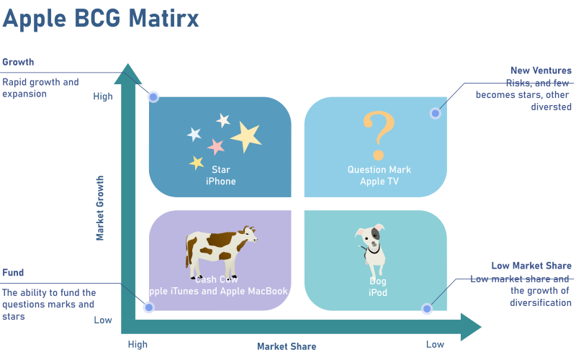
Fig.13: Apple BCG Matrix
Source: https://www.edrawmax.com/article/apple-bcg-matrix-analysis.html
- Question Mark:
Apple's Smart TVs may represent a potential gap in the company's BCG matrix in the USA. It has the potential to become a bestseller if Apple addresses ecosystem issues. The second product with some uncertainty is the ever-expanding smartphone industry.
Apple TV does well commercially in the UK, but it is not maximising its potential. Apple must fix ecosystem flaws before dominating TV. Apple TV is rumoured to be as successful as the iPod, iPhone, and iPad.
- Stars:
The Apple BCG market in the United States sets new records in sales with each new iPhone model. A lot of people want to get their hands on an iPhone because of how innovative it is. The iPhones devoted customer base has helped it become the market leader in the rapidly expanding smartphone industry.
Apple's UK iPhones are stars. Apple breaks sales records with each iPhone launch.
- Cash Cows:
Apple's US BCG matrix tops two products that are all iMacs, MacBook’s, and iTunes. These inventions helped the corporation expand revenue and market share. Apple devotees only buy Apple products.
iTunes, MacBook’s, and iMacs are Apple's UK cash cows. Apple's cash cows are iTunes, MacBook’s, and iMacs.
- Poor Dogs:
Apple companying dogs in the United States are a high-growth, low-market-share product. Since these items are money losers for the company, they do not receive any funding. According to the BCG matrix, Apple's iPods are losers due to weak demand and fierce competition.
Despite being touted as the next big thing, Apple's iPods ultimately failed to break through in the United Kingdom due to a combination of fierce competition and weak consumer demand.

Product Life cycle model of apple:
USA:
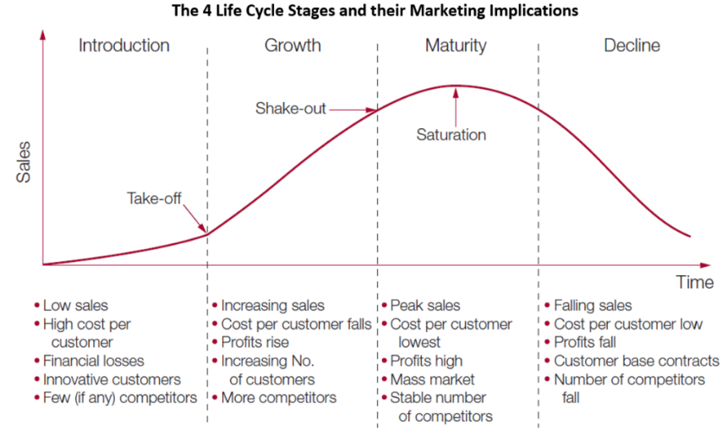
Fig.14: Apple product life cycle model in USA
Source: https://marketing-insider.eu/characteristics-of-the-product-life-cycle-stages/
UK:
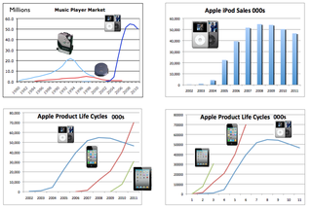
Fig.15: Apple product life cycle model in UK
Source: https://jkaonline.typepad.com/jkaonline/2011/04/apple-case-study-from-the-ipod-to-the-ipad-product-life-cycles-and-growth-potential.html

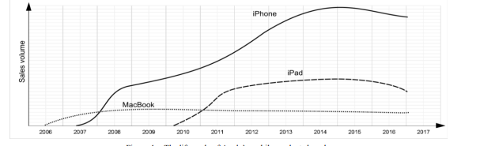
Fig.16: Apple's Mobile Product Brands Over Time(Ewa et al., 2017)
Source: https://www.researchgate.net/figure/The-life-cycle-of-Apples-mobile-products-brands_fig2_319199871

Product Life cycle strategies of apple for USA and UK:
- Introduction Strategies:
- Develop its distinct brand identity.
- Find the best people to help spread the word about their product's launch.
- To charge a price that is not terribly inflated.
- Growth Strategies:
- Increasing their market share by developing and releasing novel product features and supporting services
- getting into new niches of the market.
- Increase the segmentation of markets.
- Should increase their distribution channels in UK.
- Maturity Strategies:
- To shift one's market strategy so as to steal market share from rivals.
- For the purpose of enhancing and introducing new features to their products.
- Establishing a price for all products and setting it apart from competitors in the market
- Decline Strategies:
- They need to cut back on the money they're spending on product promotion.
- Find a different application for the item.
- To withdraw the service or product after it has reached its full potential.

Defence strategies for Pioneers in the Growth stage of the PLC for USA and UK:
- Fortress or position defence strategy:
Although its competitors have increased the amount of RAM in their smartphones, Apple has shown no interest in doing the same for iOS devices in USA and UK. Tech pros would greatly benefit from this quality assurance.
- Flanker strategy:
In USA and UK, to cover the gap of premium prices and incompatibility with other OS, apple normally manufactures high quality and unique features-based products. Also company also introduces discounted rates for their products.
- Confrontation strategy:
In the European countries, if Apple's rivals launch new items, Apple will quickly follow suit by releasing its own version of a similar product.
- Market expansion strategy:
In USA and UK, Apple is deciding to increase the further new number of stores outsides the cities to facilitate the travellers.

Attack strategies for Followers in the Growth stage of the PLC for USA and UK:
- Frontal Attack strategy:
In European countries, Apple, Dell and Samsung have been at frontal attack with each other for the past many decades.
- Leapfrog strategy:
App-store and classy camera in apple products are extra-ordinary which makes them unique and different in USA and UK against their competitors.
- Flank Attack:
Apple's ecosystem gives it unmatched market resilience against their competitors in USA. And that’s how it attacks on its competitors weak spots.
In the UK, Apple has highlighted its innovation and user privacy, emphasising the iPhone's customer satisfaction, ease of use, and performance. Apple has ignored the interim report and refused to consider ecosystem changes.
- Encirclement strategy:
Apple has launched multiple product variants with varied prices in the US and UK markets to outsell competitors.

Strategies in the Maturity stage of the PLC for USA and UK:
- Increased Penetration Strategy:
In the United States, Apple has 272 physical stores(Khan, Alam and Alam, 2015). Apple will also expand its market in the future to increase its marketing. As well as They are also thinking to increase its ecommerce market strength.
Apple or authorised resellers sell UK products. Unauthorized Apple dealers sell it. expand market share. The company sells online. After launching the product, the corporation offers discounts to acquire market share. Free software updates and other products help retain and acquire customers. The company grew by partnering with Verizon and AT&T. It hosts UK events. Thus, it can boost revenue in its current markets.
- Extended User Strategy:
In the USA and many other countries, Apple employs "product shortages" to convince shoppers that popular models will soon be unavailable and that they must act quickly to purchase one(Shailza, 2020). The buyer is made to feel rushed into buying the product.
Apple's marketing strategy in the United Kingdom centres on their USP (UVP)(Lan, 2021). Apple has always been unafraid to charge what it believes its products are worth. Apple is also participating by delivering price cuts without compromising on quality.
- Global Market Expansion Strategy:
The core of Apple Inc.'s differentiation strategy is the development of new goods and services that help deliver outstanding value to customers. creating a strong consumer base and boosting the business's visibility overseas (Rayie, 2021).

Recommendation
TOWS matrix for USA and UK:
The matrix demonstrates that Apple's financial success is a source of strength; hence, the threat of increased employment expenditures is minimized. It is typical for Apple to leverage their strong financial position to pay higher labour expenditures, thereby decreasing their vulnerability to product recalls, since they may anticipate a higher-quality workforce if they spend more. We would examine the weaknesses to threats section first, as both are detrimental to the business, followed by the weaknesses to opportunities section, the strengths to threats section, and finally the strengths to opportunities section, as the company faces the least amount of risk from its strengths and opportunities. Apple Investors provided much of the data for this TOWS analysis. A TOWS study provides an accurate image of an organisation if the first four components have valid data. Mintel and other databases provide this data, but the company's website is preferable. In addition, it is required to evaluate the monthly reports of businesses, etc.
USA:
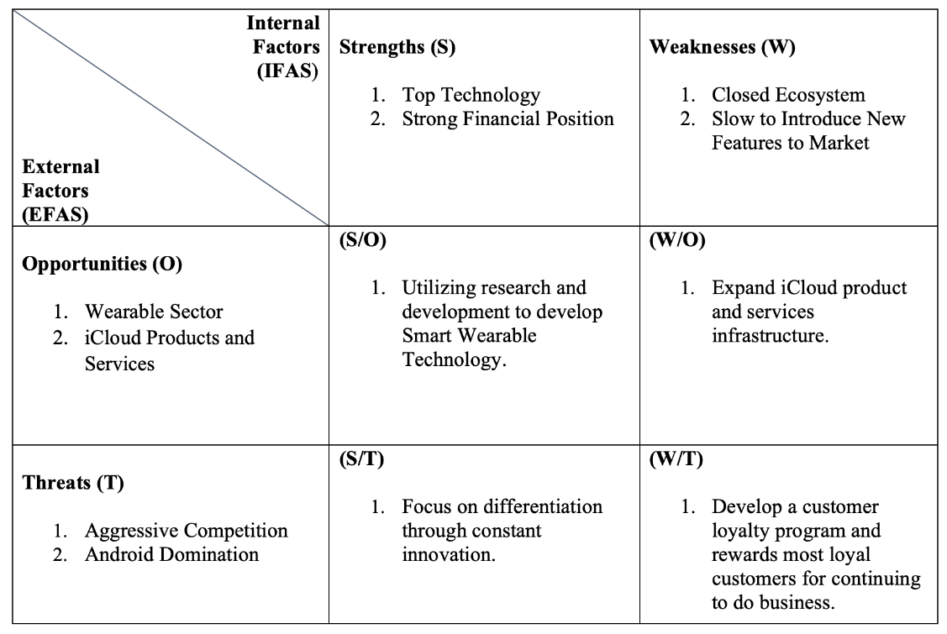
Fig.10: TOW analysis table of apple for USA
Source: https://www.linkedin.com/pulse/apple-tows-matrix-jimmy-alan/
UK:
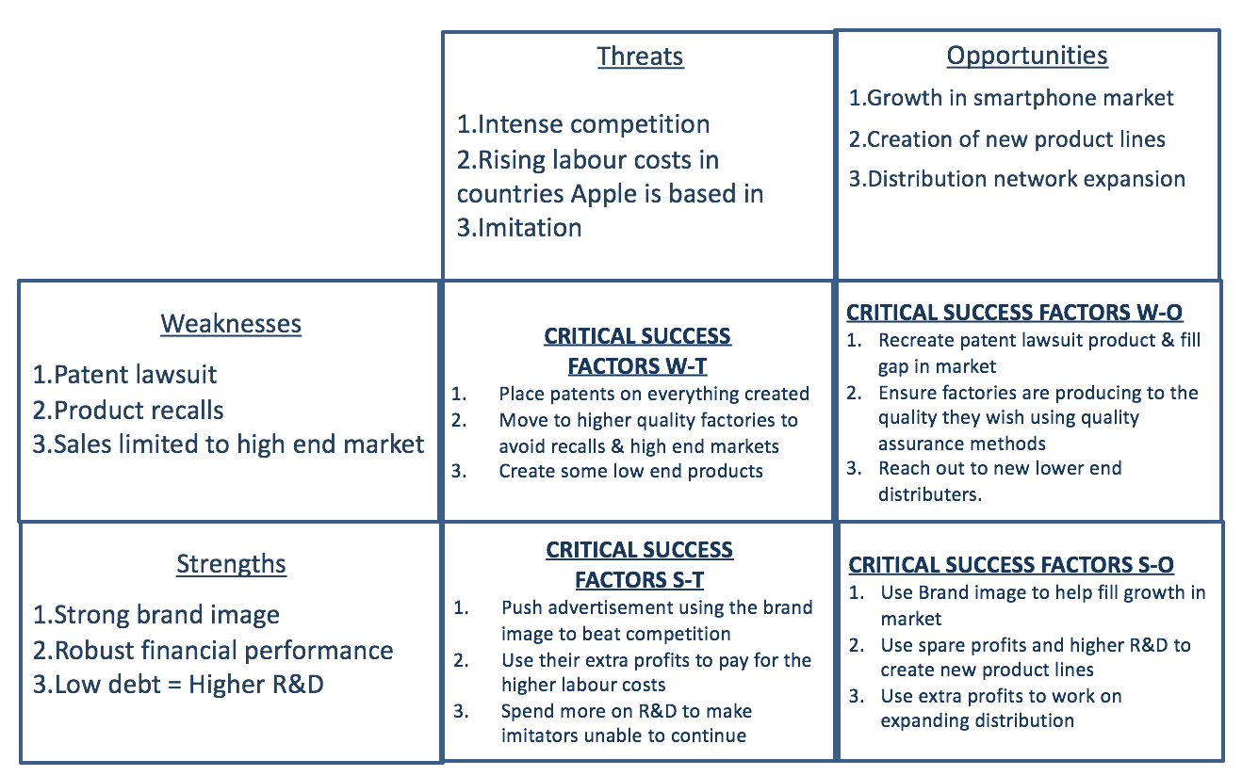
Fig.11: TOWS analysis table of apple for UK
Source: https://componentaindividualblogreport.wordpress.com/2017/05/24/second-blog-entry/

Conclusion:
Apple's advantages are twofold. Apple's devotion to technological innovation allows it to stay ahead of the competition and prepare for the next round. Apple can innovate and acquire market share faster than its competitors. Apple will fail if it can't maintain its competitive advantage. Apple's example shows how experience marketing must comprehend the minds of today's experience-economy consumerisation and prepare for the next round. Apple can innovate and acquire market share faster than its competitors. Apple will fail if it can't maintain its competitive advantage. Apple's example shows how experience marketing must comprehend the minds of today's experience-economy consumers. Apple, on the other hand, knows what its customers want to point to and has a sales method that makes it more money than any other company.

References:
1. Apple, L.M. (2018) ‘Digital Printing Technology in University Experiential Learning Classes’, Journal of Textile Science & Fashion Technology, 1(3), pp. 4–5. Available at: https://doi.org/10.33552/jtsft.2018.01.000515.
2. Chen, X., Liu, Y. And Gong, H. (2022) ‘Apple Inc. Strategic Marketing Analysis and Evaluation’, Proceedings of the 2021 3rd International Conference on Economic Management and Cultural Industry (ICEMCI 2021), 203(Icemci), pp. 3053–3061. Available at: https://doi.org/10.2991/assehr.k.211209.499.
3. Consejería de Educación. Junta de Castilla y León (2020) ‘済無No Title No Title No Title’, Protocolo de prevención y organización del regreso a la actividad lectiva en los centros educativos de Castilla y León para el curso escolar 2020/2021, pp. 1–19.
4. Ewa, W.-J. Et al. (2017) ‘Apple Products: A Discussion of the Product Life Cycle’, 31(Msmi), pp. 159–164. Available at: https://doi.org/10.2991/msmi-17.2017.36.
5. Hoang Tien, N. And Nguyen Hoang Tien, C. (2019) ‘International distribution policy comparative analysis between samsung and apple Change management View project International distribution policy comparative analysis between samsung and apple’, International Journal of Research in Marketing Management and Sales, 1(2). Available at: https://www.researchgate.net/publication/338719419.
6. Hsu, T.H. et al. (2022) ‘The Application of an Innovative Marketing Strategy MADM Model-SIVA-Need: A Case Study of Apple Company’, International Journal of Electronic Commerce Studies, 13(1), pp. 33–68. Available at: https://doi.org/10.7903/ijecs.1972.
7. Jay, A. And Dave, G. (2018) ‘A CASE STUDY ON MARKETING STRATEGY: APPLE i-Phone’, International Journal of Research and Analytical Reviews, 5(4), pp. 106–114. Available at: www.ijrar.org.
8. Kerin, R. And Hartley, S. (2019) ‘Marketing , 14e Chapter by Chapter Changes’.
9. Khan, U.A., Alam, M.N. and Alam, S. (2015) ‘A Critical Analysis of Internal and External Environment of Apple Inc’, International Journal of Economics, Commerce and Management, III(6), pp. 955–967.
10. Lan, B. (2021) ‘Analysis of Apple’s Marketing Strategy’, 543(Icssed), pp. 128–132.
11. Lee, J., Lee, S.-J. And Jung, K. (2020) ‘Balanced SWOT: Revisiting SWOT Analysis through Failure Management and Success Management’, SSRN Electronic Journal [Preprint]. Available at: https://doi.org/10.2139/ssrn.3612519.
12. Li, Y. (2021) ‘Apple Inc. Analysis and Forecast Evaluation’, Proceedings of Business and Economic Studies, 4(4), pp. 71–78. Available at: https://doi.org/10.26689/pbes.v4i4.2389.
13. Liébana-Cabanillas, F. Et al. (2020) ‘Mobile payment adoption in the age of digital transformation: The case of apple pay’, Sustainability (Switzerland), 12(13), pp. 1–15. Available at: https://doi.org/10.3390/su12135443.
14. Newman, N. (2014) ‘Apple ibeacon technology briefing’, Journal of Direct, Data and Digital Marketing Practice, 15(3), pp. 222–225. Available at: https://doi.org/10.1057/dddmp.2014.7.
15. Rayie, T. (2021) ‘Improving the Quality of Processed Apple Products Through the Home Industry Food Permit (PIRT) to Encourage Marketing Development in Batu District, Batu City’, Business and Management Research, 193(Bistic), pp. 138–142.
16. Ruyter, K. De, Isobel Keeling, D. And Ngo, L.V. (2018) ‘When nothing is what it seems: A digital marketing research agenda’, Australasian Marketing Journal, 26(3), pp. 199–202. Available at: https://doi.org/10.1016/j.ausmj.2018.07.003.
17. Shailza, S. (2020) ‘Prospects of Custard Apple Value Chain Development in Rajasthan’, Economic Affairs, 65(2), pp. 117–123. Available at: https://doi.org/10.46852/0424-2513.2.2020.11.
18. Thomas, B. (2020) ‘A Study on Gender Equality With Reference to Labour Force Participation: A Study Undertaken In Selected Villages of Anand District’, (April), p. 234. Available at: https://www.researchgate.net/publication/350687355.
19. Yamoah, F.A. and Acquaye, A. (2019) ‘Unravelling the attitude-behaviour gap paradox for sustainable food consumption: Insight from the UK apple market’, Journal of Cleaner Production, 217, pp. 172–184. Available at: https://doi.org/10.1016/j.jclepro.2019.01.094.

