Can FEA replace physical testing?
Advanced Stress Analysis & FEA (M6X00420)
University of Wales Trinity Saint David, School of Engineering
BEng Motorcycle Engineering (4 Year Course)
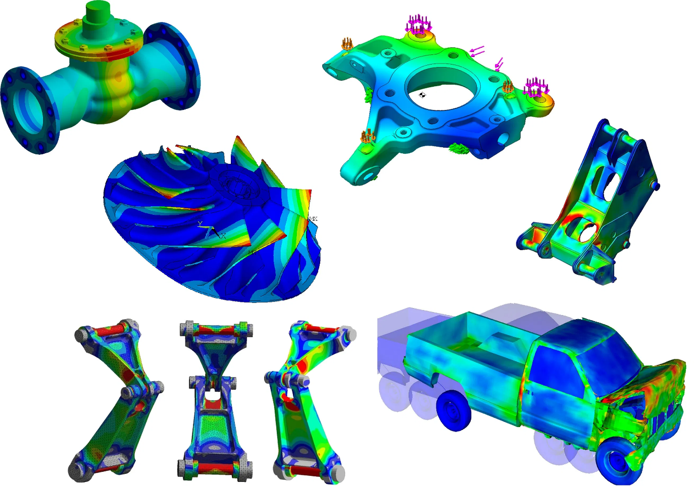
Table of Contents
1 Introduction to Finite Element Method II
1 “Why do companies typically carry out FE analysis alongside physical testing?” II
2 How can a physical test be correlated to an FE model?” 1
2.1 How do you correlate? 1
2.2 A Case Study 3
3 “Can (or should) FE analysis ever replace physical testing?” 4
4 References 5

Figure 1: The NASA “Space Shuttle” was developed and manufactured using a combination of physical testing methods and NASAs own FEM package "NASTRAN" (National Aeronautics and Space Administration, 2008) II
Figure 2: An example of a typical processing loop for FEM, BEM, FDM etc (Test Tooling Solutions Group, 2020) 1
Figure 3: Example of FEM alongside physical testing in tensile tests of ductile sheet metal samples (Chong, Daxin, & Ning, 2016) 3
Figure 4: Example of physical tests alongside FEM for prediction of failure in bone structures (Miura, et al., 2017) 4

Introduction to Finite Element Method
The Finite Element Method of analysis is the scrutinization of material/component behaviour under loading through the application of simple mathematical relationships to an intricate structure of divisions of a component, known as a “mesh”. The individual divisions are known as “elements”, these elements can be 1st, 2nd or 3rd dimensional and can be split into various “orders” by way of the placement of manipulation points along their edges (known as “nodes”) to increase accuracy of mathematical approximation of component/material behaviour.
This is carried out by utilising matrix algebra to apply these relationships across the elemental structure of this “mesh”. This mathematical model is known as a “stiffness matrix” (particularly in mechanical loading) and defines the properties of the component that will subjected to the loading cases defined by the user. This matrix has to be defined in terms of a local or global coordinate structure to provide easily interpretable results for the user and this is carried through a transformation matrix to transform the loading and change seen in either local or global system into the most readily interpretable system.
Through these matrices a set of boundary conditions and loading cases are applied mathematically to predict behaviour at each of these elements and through extensive computational calculation a picture is developed of the behaviour of the component in that specified case. This can then be scrutinised in different ways to provide information of how the component or material would react in the case specified.

“Why do companies typically carry out FE analysis alongside physical testing?”
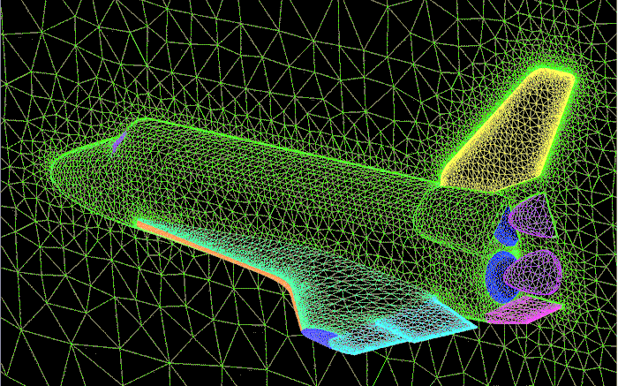
Figure 1: The NASA “Space Shuttle” was developed and manufactured using a combination of physical testing methods and NASAs own FEM package "NASTRAN" (National Aeronautics and Space Administration, 2008)
Some primary reasons for using Finite Element Method alongside physical testing in modern engineering industries are as follows (PES Performance, 2020):
Prior design evaluation before costly prototypes and physical tests need to be constructed. Multiples of a specific design architecture can be created with small differences to determine the best “start-point” for physical testing.

Reduction in the number of physical tests required as multiple scenarios can be carried out virtually to determine most pertinent physical testing required. Results from initial physical testing can be applied to an FE model to refine the physical test in a virtual sense and then once a more accurately defined problem has been established the testing can return to the physical for final testing to reduce the overall number of physical tests.
Greater degree of safety and design-for-purpose can be obtained with correct FE/Physical Test method. If FE method is used correctly (correlation/validation) alongside physical testing it can provide a much more “user friendly” method of analysis with very visual results to highlight areas of note that may not be able to be easily identified during physical testing. For instance, secondary potential failure areas where a destructive physical test may only highlight the “worst” failure, running FE alongside will highlight “all” potential failure areas.
Another reason to carryout an FE study alongside a physical test is the ease of modification to the style of testing undertaken, once an initial test has been undertaken the study can be modified extremely easily to accommodate a different loading case or a small change in the parts geometry whereas a real world test may take hours or even days to alter the part or testing procedure to garner the same analysis.
Also, the current trend of assimilation of FEA solvers into CAD/CAE software means that a complex FE tests can be readily carried out alongside a simplified physical test. This can be done when elaborating on the physical test may prove uneconomical or complex, in essence to alleviate the limiting factors of the physical testing by virtually providing more complex scenarios.
Additionally, to a lesser extent, the following is true of carrying out Finite Element Method analysis alongside physical testing:
The possibility for better material selection and optimisation as multiple material/material grade options can be explored to narrow down choices before physical manufacture for testing. There can be a reduction in the overall cost of the design cycle through reduced prototyping and testing costs when compared to a more traditional “non-FE” design cycle. And there is the possibility for providing alternate testing scenarios where a physical test would difficult or not economically viable to carry out.

How can a physical test be correlated to an FE model?”

How do you correlate?
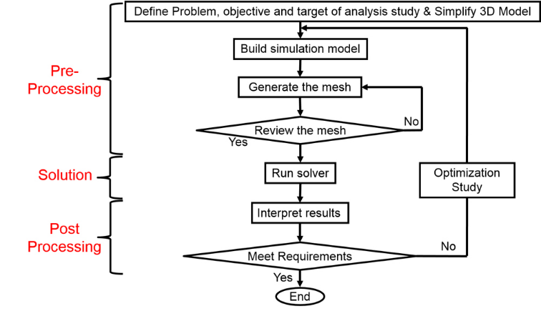
Figure 2: An example of a typical processing loop for FEM, BEM, FDM etc (Test Tooling Solutions Group, 2020)
There are a multitude of considerations for correlating an FE model with a physical test. These considerations form a negative feedback loop that aims to converge the FE results with the physical test results through means of logical scrutiny of incorrect method and output results until the virtual work is within a margin of the real-world results (Lake, 2020) (Dassault Systemes, 2018-2020).
The first and most obvious method is using normal engineering common-sense questions to properly define the problem and work out limitations, boundary conditions, loading scenarios and such to their closest possible numerical parameters to mimic the real-world test (de Weck & Kim, 2004):
- Are the loads of the correct magnitude, type (Thermal loading, Mechanical Loading, Fatigue cases etc) and applied in the correct planes and directions?
- Is the material correct for the test, does it match the real-world material, are any heat treatments or property modifiers accurately represented?
- Are any connections and jointing methods accurately represented, bolted connections, bonded connections, welds etc?
- In the case of thermal or pressure testing are the ambient conditions correct to those seen in the physical test (humidity and ambient airflow for convective analysis or barometric pressure for pressure vessel testing)?
The second set of questions is the more refined FE-specific criteria that must be considered:
- Is the mesh representative of the real-world test? Have local refinements been applied at areas of interest?
- Has the geometry and mesh been optimised for FE study, have sliver faces and erroneous or unimportant geometry conditions been eliminated?
- Is the order of the elements being used the most pertinent to the results that are trying to be correlated?
- Are the type of elements correct for the study being undertaken? Triangular/tetrahedral elements, square/cuboid elements etc?
- Are there enough degrees of freedom to accurately describe the scenario under scrutiny?
- Have areas been simplified when they shouldn’t, should the “coarseness” of the mesh be reduced despite the increase in computation/solve time?
Once these questions have been answered and the simulation has been run the results must then be scrutinised to determine the issues causing inaccuracies and differences between the physical and virtual results.
- Is the maximum reported value seen at a fixture of infinite stiffness (the end of a bar under static loading fixed to a wall for instance), could a margin of elements around this point be disregarded to more accurately portray the real-world scenario?
- Is the correct type of stress being scrutinised? Von Mises, Guest-Tresca etc? Are the stresses overall general stresses or stresses normal to an axis or direction? Are the normal stresses to the correct axis in the correct coordinate system?
- In a multiple case study are the correct cases being compared or is a later case the greatest stress and therefor most comparable to the real-world experiment?
An important consideration at this point in the correlation is, “how accurate does this need to be to real life?”, obviously all engineers strive for the greatest accuracy possibly but if the correlation displays a very fine margin of error across multiple cases/datapoints is it really economical and reasonable to strive for the extra 0.001% or is it a reasonable enough assumption to use the information as a useful model going forward?
And a final and overarching question that should always be asked, is FEM the correct method of solve? Would, for instance, boundary element, finite difference or finite volume be a better method of solution for the particular problem defined in the physical test?

A Case Study
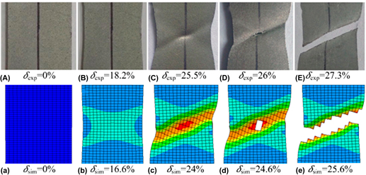
Figure 3: Example of FEM alongside physical testing in tensile tests of ductile sheet metal samples (Chong, Daxin, & Ning, 2016)
As can be seen above, FEM and physical testing can show very promising correlated results when properly developed and validated (Chong, Daxin, & Ning, 2016).
In the case above there are several methods of correlation that can be observed visually. The initial visual “tells” of failure can be identified in both the physical reality and virtual reality, “necking” and an “X” shaped deformation pattern beginning to develop in cases “B,b” and “C,c”, then further in cases “D,d” and “E,e” initial crack propagation can be observed in the centre of the test piece and finally component failure can be observed across the same fracture growth pathway as predicted by the FE analysis. Despite the correlation shown above several issues can be noted.
Firstly, it can be observed that the percentage deformation seen in the physical and the virtual tests differ by approximately 1% per “timestep” of tensile test. Secondly, the deformation and failure appear to be much exaggerated in the FE model than in the physical test piece.
In the case of the second point here there is the possibility that, at case “d” due to the two-dimensional nature of scrutinising the results (commonly referred to as a “Cut”, “Section” or “Cut Plot”) the FE analysis is highlighting a greater internal fracture that cannot be seen entirely at the surface in the image of the physical case “D”, an internal fracture “pocket” if you will.
The more likely reason for this disparity between physical and virtual is the mesh size used for the FE analysis. As can be observed the initial fracture seen in the “d” case is the size of approximately 4 of the elements seen around it, from this it can be concluded that the reason for the fracture being so large is that this particular solver deletes the entire element when the stress exceeds the materials failure point and the stress drops to zero, therefore with a smaller element size this large failure visualisation could be more realistically portrayed by using a smaller element size.
For this particular case as the study is relatively small this piece it could be feasible to increase the mesh resolution as a whole but a better practice for the sake of expediency to reduce computing time either local meshing condition could be applied to the suspected site of failure, or, a more automated approach would be to define a function/command to refine the mesh when a certain level of stress of deformation is seen in an element, an automatic mesh refinement.

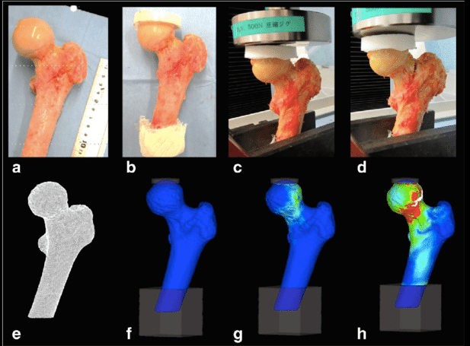
“Can (or should) FE analysis ever replace physical testing?”

Figure 4: Example of physical tests alongside FEM for prediction of failure in bone structures (Miura, et al., 2017)
In the authors opinion, “No, Finite Element Method shouldn’t fully replace physical testing in its entirety, that being said it can definitely be more widely utilised.” The reasoning for this is as follows:
Firstly, there is no realistic method at current to accurately predict every possible anomalous result discovered in a physical test, for instance a reasonably accurate FE test could be performed for a material that has previously undergone a weathering or damage scenario but every permutation and combination of these scenarios cannot be simulated without a degree of work that would prove nonsensical. A greater deal of these scenarios can be recreated in a physical sense than a virtual (albeit still not being able to cover all bases). Perhaps with the current advent of Artificial Intelligence and exponential increase in computing capability FE methods can take the fore in this “random-real-world-scenario” testing (Javdi, Mehravar, Faramarzi, & Ahangar-Asr, 2009) (Blanco, 1990).
Secondly, an extremely important point is that FE simulations are computational solvers meaning regardless of your inputs they will apply their commands and logic to the absolute, meaning if you apply incorrect inputs and parameters it will supply output parameters based on those inputs, the commonly used phrase is “Garbage In equals Garbage Out”. Whilst this is true for physical testing also, it can be much easier to see problems/incorrect method in a physical experiment than a complex FE simulation (Enterfea, 2020) (Lake, 2020).
Another key consideration with FEM is that even at its best it is still a mathematical approximation and while, with a great enough degree of refinement and a high enough resolution of calculation, it can be extremely accurate it is up to the user to define the accuracy of the study (Ghionea, 2007). For instance, to be able to accommodate cavitation seen in a badly designed casting process the areas of porosity must first be defined with in the FE model either by designing a further study to mimic the fluid behaviour of the casting pour causing cavitation and translating those results into the FE model or by manually designating areas of porosity found in the part after the casting process. As is obvious, this can be lengthy, complex, and expensive process. A destructive physical test of a component can be much easier to design to highlight this type of issue as the part can then be sectioned to view the internal geometry rather easily. Again, potentially with increased use of AI and greater computing power this will bring FE further to the fore in this regard but at current this style of investigation is reserved the pinnacle of engineering establishments.

References
Blanco, A. G. (1990). Towards Intelligent Finite Element Analysis. Urbana: University of Illinois at Urbana-Champaign/ United States Department of Defence.
Chong, L., Daxin, E., & Ning, Y. (2016). Analysis on fracture initiation and fracture angle in ductile sheet metal under uniaxial tension by experiments and finite element simulations. Journal of Materials Research, 3991-3999.
Dassault Systemes. (2018-2020). Solidworks Simulation Add-In Walkthroughs and Tutorials. Technical Help Guides and walkthroughs attached to Solidworks 2017,2018,2019. Velizy-Villacoublay, Ile-de-France, France: Dassault Systemes.
de Weck, O., & Kim, I. Y. (2004). Engineering Design and Rapid Prototyping: Finite Element Method. Cambridge Mass.: Massachusetts Institute of Technology.
Enterfea. (2020). How Accurate is Finite Element Analysis? Retrieved from Enterfea.com: https://enterfea.com/how-accurate-is-finite-element-analysis/
Ghionea, I. (2007, October 9). Design World: Using FEA to study a mechanical part. Retrieved from Design World Online: https://www.designworldonline.com/using-fea-to-study-a-mechanical-part/
Javdi, A. A., Mehravar, M., Faramarzi, A., & Ahangar-Asr, A. (2009). An Artificial Intelligence Based Finite Element Method. ISAST Transactions on Computers and Intelligent Systems, 1-7.
Lake, K. (2020, January). Lectures on Creating a CAE FE Model. (O. L. Lord, Interviewer)
Miura, M. &., Wako, Y., Suzuki, T., Hagiwara, S., Orita, S., Inage, K., . . . Ohtori, S. (2017). Prediction of fracture load and stiffness of the proximal femur by CT-based specimen specific finite element analysis: Cadaveric validation study. BMC Muscoskeletal Disorders.
National Aeronautics and Space Administration. (2008, October 23). Dryden Flight Research Centre: X-Press Archives. Retrieved from NASA.gov: https://www.nasa.gov/centers/dryden/news/X-Press/stories/2008/10_08_technology.html
PES Performance. (2020, April 20). Analysis, Simulation, Testing Services. Retrieved from Finite Element Analysis: What are the benefits of FEA?: https://www.pes-performance.com/analysis-simulation-testing-services/finite-element-analysis/
Test Tooling Solutions Group. (2020). Test Tooling Solutions: Applying FEA Simulation for Test Interface Unit. Retrieved from Test Tooling Solutions Group.com: https://tts-grp.com/v4/index.php?option=com_k2&view=item&id=478:applying-fea-simulation-for-test-interface-unit&Itemid=529

