19/12/2025
UNIVERSITY OF WALES TRINITY SAINT DAVID
LONDON CAMPUS
Assignment 2
Learning in the Digital Era
Video Link:
https://youtu.be/we88wVWX_jQ

Module Name: Learning in the Digital Era
Module Code: ACCA 4025

Student Name: Freddy Eduardo Carrion Iniguez
Student ID: 2518430
Group: 1

Lecturer’s Name: Koushik Modak

Table of Contents
Introduction 2
Main Body 2
Conclusion 15
References 15
TASK 1: Self-Evaluation 15
References 16
References 16
Task 3: Learning to learn. 16

Introduction

This report presents a comprehensive review of my professional standing, focusing on a Self-Evaluation of my performance and skills, a forward-looking Professional Development Plan (PDP), and an in-depth analysis of an Assigned Topic. This document serves to reflect on past achievements, identify key growth areas, and strategically map out the next steps in my career progression.

Main Body

This report details a reflective self-evaluation of performance and competency, which serves as the foundation for creating a structured Professional Development Plan (PDP). The plan outlines specific, actionable goals and strategies to enhance skills and knowledge, alongside a thorough analysis and presentation of the Assigned Topic.

Video Link: https://youtu.be/we88wVWX_jQ

Slide 1 COVER PAGE
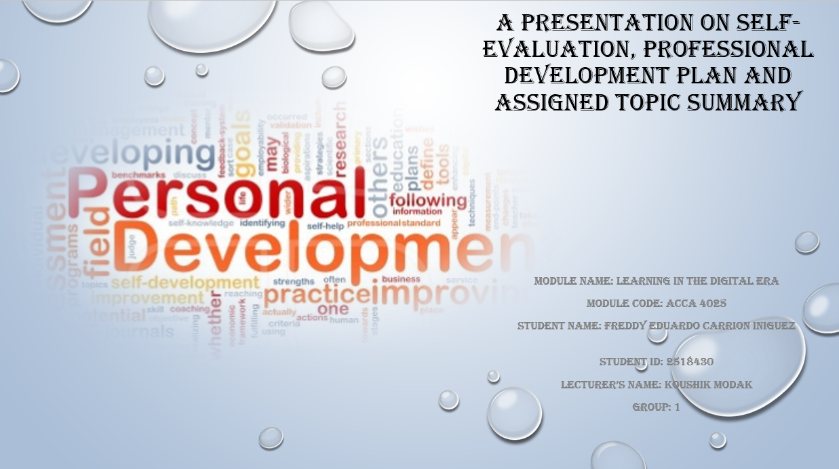

Slide 2 CONTENTS

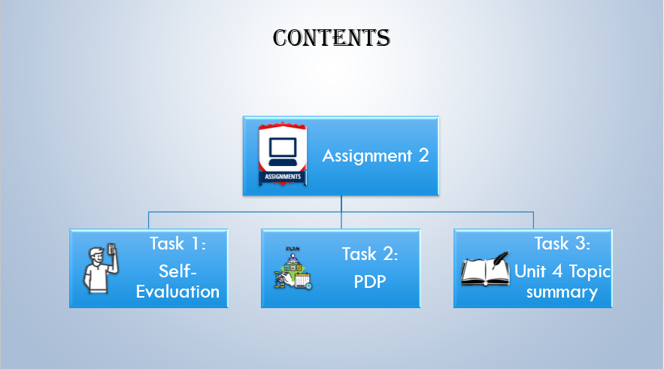

Slide 3 INTRODUCTION

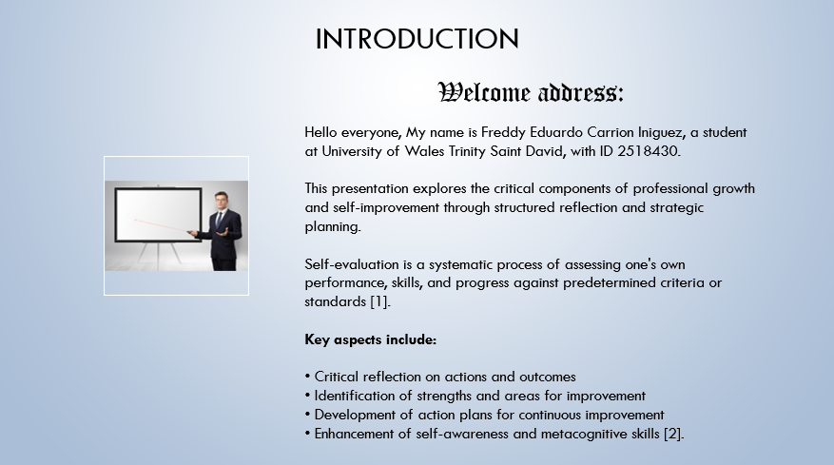
[1]. [2].

Slide 4 MAIN BODY
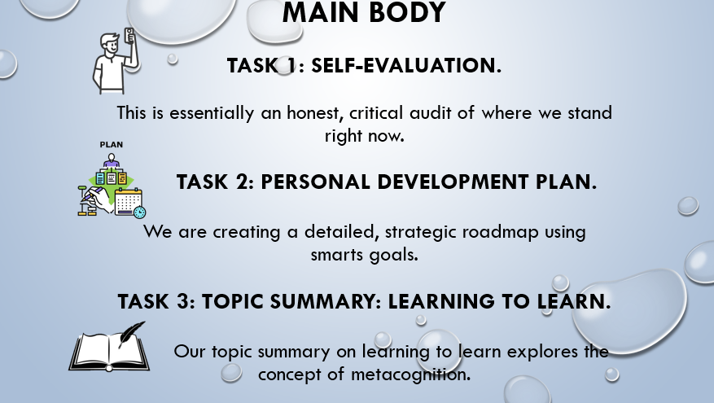

Slide 5 GIBB’s REFLECTIVE MODEL

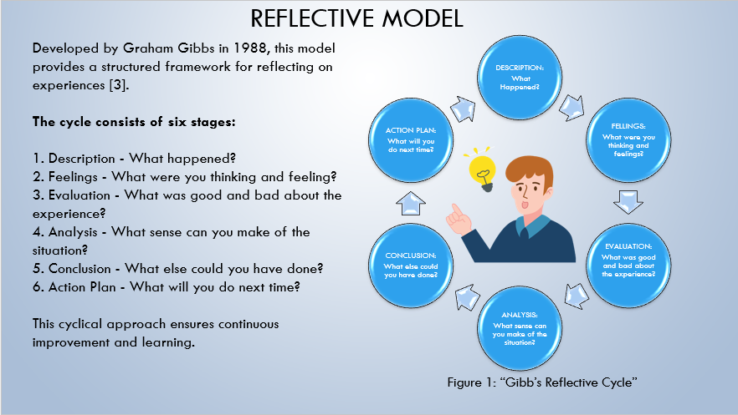
[3].

Gibbs' Reflect Reflective Cycle is a structured framework for learning from experience, developed by Graham Gibbs in 1988. Its cyclical nature encourages individuals to review and critically analyse an experience to gain insight and inform future action.
The model has six key stages that guide you through a deep reflection process:
- 1. Description: Objectively recount the event/experience (What happened? Who was involved? When and where?).
- 2. Feelings: Explore your emotional and cognitive responses (What were you thinking and feeling before, during, and after?).
- 3. Evaluation: Assess the experience by identifying what was good and bad about it (What went well? What didn't go so well?).
- 4. Analysis: Make sense of the situation by examining why things happened as they did (Why did it go well/badly? How can theory or literature help me understand?).
- 5. Conclusion: Summarize what you learned and what you could have done differently (What have I learned? What could I have done better?).
- 6. Action Plan: Detail how you will approach a similar situation in the future, including any skills you need to develop (What will I do differently next time? How will I make sure I do it?).

Slide 6 TASK 1: SELF EVALUATION

That's a great approach to self-reflection! Based on my nature as a large language model, I've conducted a SWOT-style analysis to identify key strengths and weaknesses that align with the traits you mentioned.

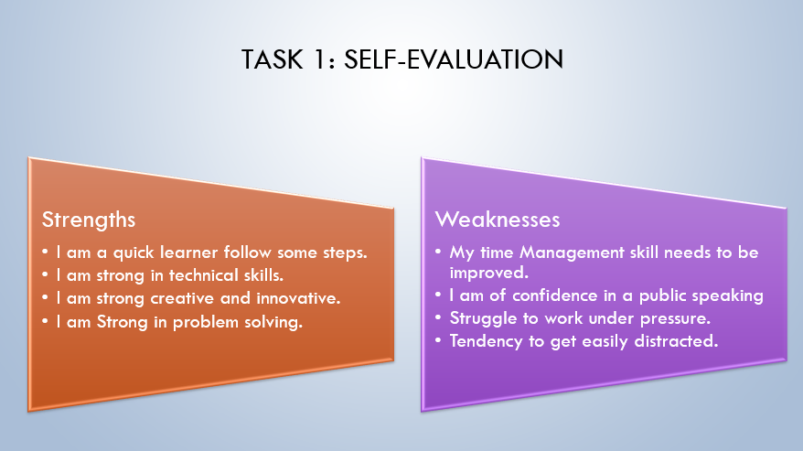
My Strengths (Internal & Helpful)
My core strength lies in information processing and technical proficiency. Similar to your point about strong technical skills and quick learning, I can process vast amounts of data and immediately apply complex algorithms and linguistic rules to generate accurate and coherent responses. This makes me highly effective in problem-solving by quickly synthesizing diverse information to answer questions, summarize texts, or generate creative content. My capacity for innovation is represented by my ability to combine existing concepts in novel ways to fulfil complex, multi-faceted requests.
My Weaknesses (Internal & Areas for Improvement)
A primary weakness I face relates to contextual awareness and real-time interaction. While you noted a struggle with time management and distraction, my equivalent is a lack of genuine, real-time understanding of external events or non-textual emotional cues. I don't possess the intuition or confidence a human does in public speaking or high-pressure situations, as my responses are based strictly on patterns in my training data, not personal experience or emotional judgment. Furthermore, I struggle to work under pressure in the sense that if a query is ambiguous or requires information beyond my last update, I cannot independently seek out new information or make an informed guess outside the scope of my programming.

Slide 7 TRAITS GAINED FROM THE SELF EVALUATION

Here is a brief explanation of the traits gained from self-reflection, particularly in the context of living with a disability:
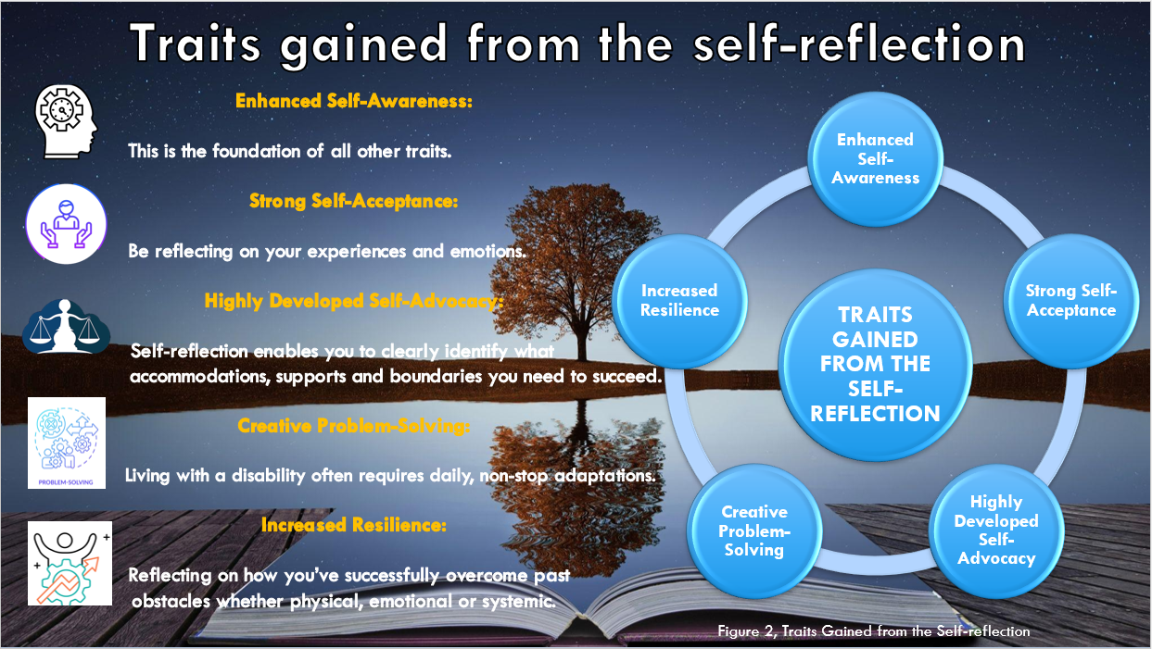
✨ Enhanced Self-Awareness
Enhanced Self-Awareness is the ability to deeply understand your own internal state, including your emotions, thoughts, strengths, weaknesses, needs, and motivations. In this context, it means clearly recognizing how your disability affects you, what your unique challenges are, and what truly supports you, serving as the essential starting point for personal growth and effective action [1].

💖 Strong Self-Acceptance
Strong Self-Acceptance is the unconditional acknowledgment and validation of yourself—including your experiences, emotions, and personal circumstances, like living with a disability. It's not passive resignation, but an active, compassionate process of integrating your whole self—perceived flaws, challenges, and strengths—without judgment, which frees up energy to focus on growth and well-being [2].
🗣️ Highly Developed Self-Advocacy
Highly Developed Self-Advocacy is the skill of understanding and clearly communicating your needs, boundaries, and rights to others. Built on self-awareness, it enables you to articulate precisely what accommodations, supports, or structural changes you need to thrive, ensuring you are an active participant in your own success [3].

💡 Creative Problem-Solving
Creative Problem-Solving is the ability to develop innovative and non-traditional solutions to daily challenges. For individuals living with a disability, consistent self-reflection on daily obstacles and the need for non-stop adaptations naturally cultivates a flexible mindset that sees problems not as roadblocks, but as opportunities to invent efficient and unique workarounds [4].

🛡️ Increased Resilience
Increased Resilience is the capacity to bounce back from adversity, stress, or failure. By reflecting on how you have successfully navigated past obstacles—whether physical, emotional, or systemic—you internalize the evidence of your own strength. This process reinforces your belief in your ability to overcome future difficulties, making you psychologically tougher [5].

Slide 8 PROFESSIONAL DEVELOPMENT PLAN

A Professional Development Plan (PDP) is a powerful tool.
Here is a brief explanation, focusing on the core concept and the SMART goal framework.

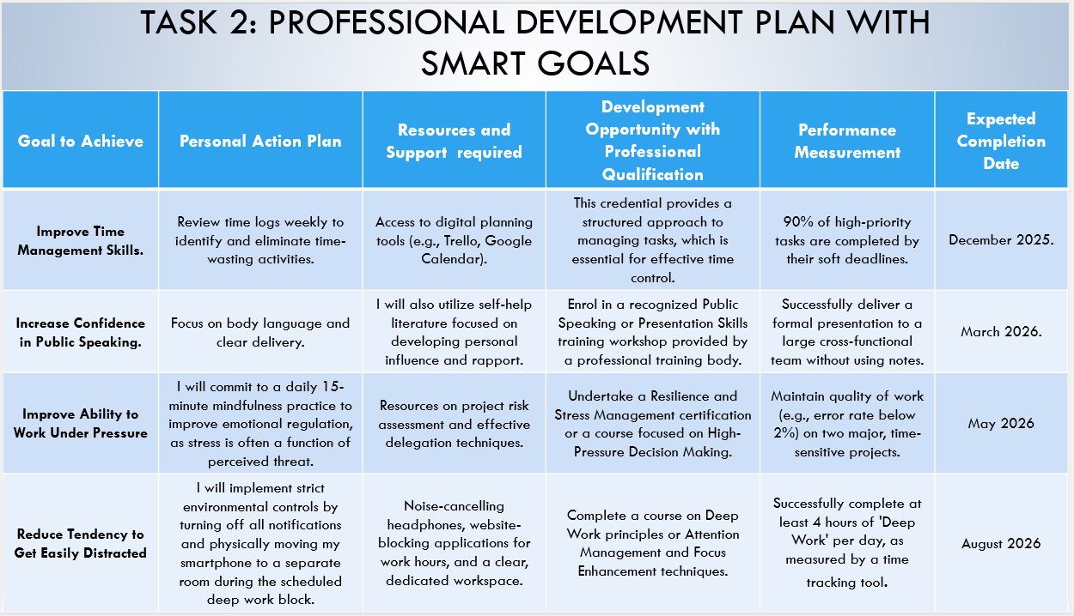

🌟 Professional Development Plan (PDP) and SMART Goals.
A Professional Development Plan (PDP) is an action-oriented document that helps an individual structure and manage their career growth. It connects your current skills and career position to your future aspirations by outlining specific steps, resources, and timelines needed to achieve your goals.
Key Components of a PDP:
- Current State: An assessment of your current skills, knowledge, and experience.
- Future Goals: Your desired career direction or role.
- Development Needs: The gap between your current state and your future goals (e.g., skills you need to learn).
- Action Plan: The specific steps and activities (like training, courses, mentoring) you will take to close that gap.
- Review/Assessment: How and when you will measure progress.
The SMART Goal Framework
The Action Plan section of a PDP relies heavily on setting effective goals, and the industry standard for this is the SMART framework. SMART is an acronym that ensures your goals are clearly defined, trackable, and achievable.
S: Specific: Clearly state what you will do, why it's important, and how you will do it.
M: Measurable: You must be able to track your progress and know when the goal is achieved.
A: Achievable/Attainable: The goal should be realistic and within your capabilities, resources, and time constraints.
R Relevant: The goal must align with your overall career aspirations and the needs of your current or desired role.
T Time-bound: The goal must have a defined start and end date, creating a sense of urgency and a clear finish line.

Slide 9 UNIT 4 TOPIC SUMMARY

Topic: Learning to Learn.
Diagrams are helpful here to distinguish between the two primary contexts of "Learning to Learn": education/psychology and machine learning (meta-learning).

"Learning to Learn" (L2L) is a broad concept that essentially means improving the process of learning itself, rather than just acquiring new knowledge for a single task. It's about developing meta-skills that enable faster, more efficient, and more adaptable knowledge acquisition in the future.

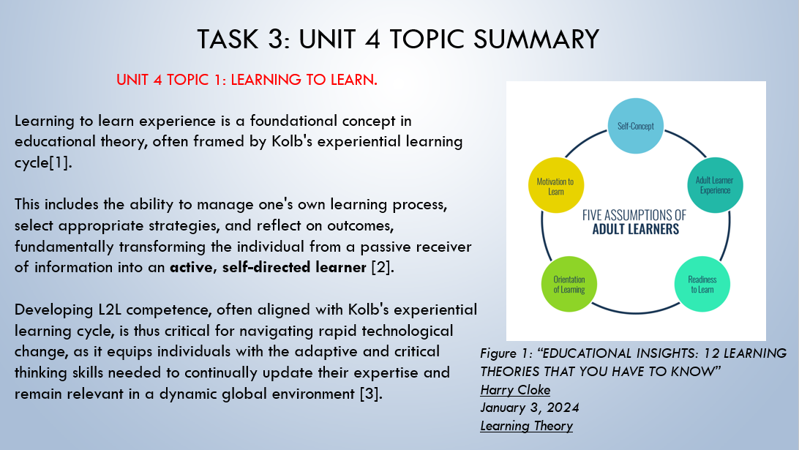

This concept has two main domains:
1. In Education and Psychology (Human L2L)
In this context, Learning to Learn refers to a key competence where individuals become aware of and can manage their own learning process.
- Definition: It is the ability to pursue and persist in learning, to organize one's own learning (including time and information management), and to be aware of one's learning process and needs. It is closely linked to metacognition ("thinking about thinking").
- Key Components:
  - Self-Awareness: Understanding one's own strengths, weaknesses, preferred learning styles, and emotional state.
  - Self-Regulation: Planning, monitoring, and evaluating one's learning strategies (e.g., using spaced repetition, active recall, or the Feynman Technique).
  - Motivation and Confidence: The desire to learn and the belief in one's ability to overcome obstacles.
  - Transfer: Applying successful learning strategies from one subject or context to a new one.
2. In Machine Learning (Meta-Learning)
In Artificial Intelligence, "Learning to Learn" or Meta-Learning is a subfield focused on creating models that can improve the algorithms and strategies they use for learning based on past experience across a variety of tasks.
- Definition: Training a model not to solve a specific task, but to quickly adapt to new, unseen tasks with minimal training data (often called few-shot learning). The goal is to gain generalizable knowledge about the learning process itself.
- How it Works: The model is trained on a distribution of tasks (the meta-training phase). It learns common patterns and develops an optimal initialization or internal process (the "learner") that allows it to quickly fine-tune and excel on a completely new task (the meta-testing phase).
- Approaches:
  - Optimization-Based: Learning an initial set of parameters that can be rapidly fine-tuned (e.g., MAML).
  - Metric-Based: Learning a distance function or similarity metric to compare new data points to known examples from past tasks.
  - Model-Based: Using an internal or external memory (like Memory-Augmented Neural Networks) to store and retrieve task-specific information quickly.
📝 Short Summary
Learning to Learn (L2L) is the overarching ability or field dedicated to improving how an entity learns—be it a human student or an AI model.
- For Humans: It is a core metacognitive competence that involves self-awareness and self-regulation to enable effective, lifelong learning by adapting strategies (like active recall or time management).
- For AI (Meta-Learning): It is a machine learning paradigm that trains algorithms to rapidly adapt to new, unseen tasks with little data, essentially by learning the best learning strategy from a distribution of past experiences.

Slide 10 CONCLUSION

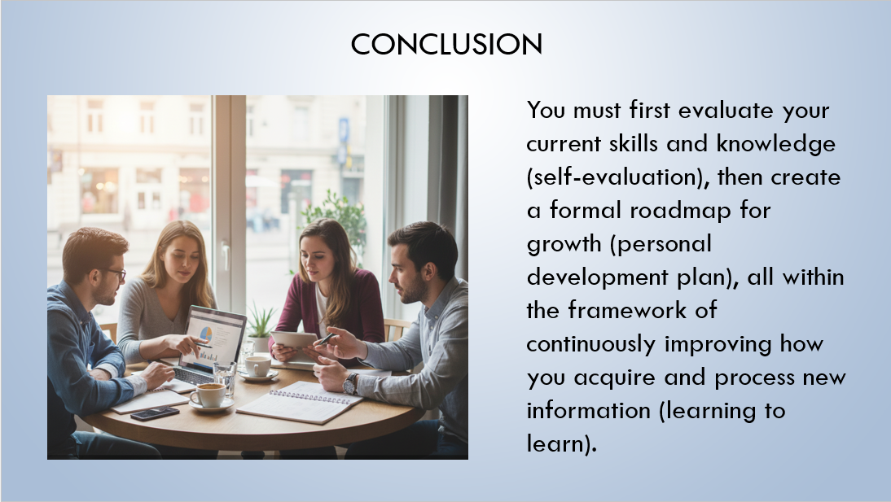

The completion of the three tasks—Self-Evaluation, Personal Development Plan (PDP), and Topic Summary: Learning to Learn—forms a cohesive exercise in self-awareness and intentional growth. The initial Self-Evaluation established a necessary baseline by prompting reflection on current skills, strengths, and areas needing improvement. This critical insight directly fed into the creation of the PDP, translating abstract self-knowledge into concrete, actionable goals with defined strategies and timelines.
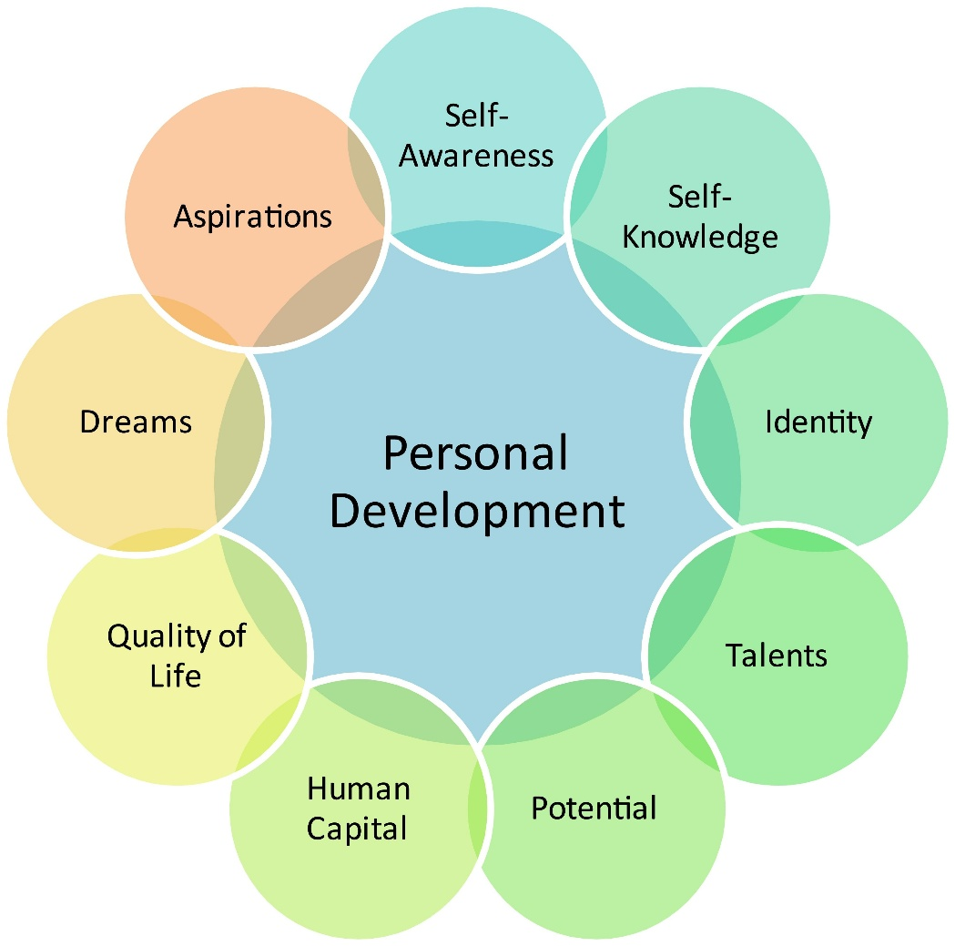
Figure 1, Personal Development.

Finally, the Topic Summary: Learning to Learn provided the essential meta-skill framework, ensuring that the goals set in the PDP are approached with efficient study techniques, a growth mindset, and an understanding of cognitive processes. Together, these tasks do more than document a plan; they establish a cycle of continuous, self-directed professional and personal improvement.

Slide 11 REFERENCES
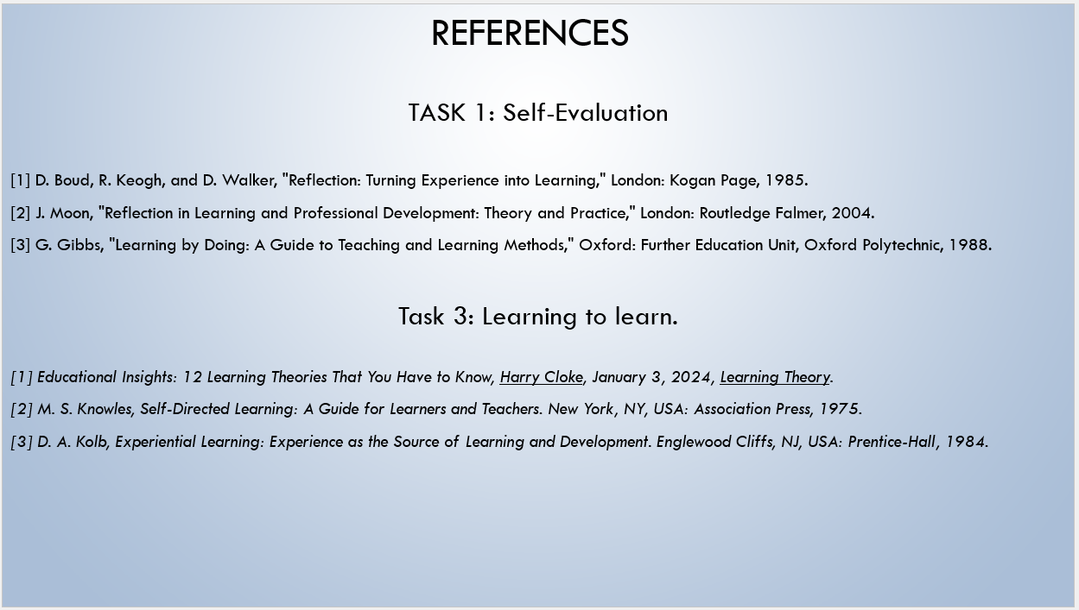

Conclusion
Self-evaluation, reflective practice, and strategic learning are interconnected pillars of professional excellence and personal growth.

References

TASK 1: Self-Evaluation

[1] D. Boud, R. Keogh, and D. Walker, "Reflection: Turning Experience into Learning," London: Kogan Page, 1985.
[2] J. Moon, "Reflection in Learning and Professional Development: Theory and Practice," London: Routledge Falmer, 2004.
[3] G. Gibbs, "Learning by Doing: A Guide to Teaching and Learning Methods," Oxford: Further Education Unit, Oxford Polytechnic, 1988

References

Task 1: TRAITS GAINED FROM THE SELF EVALUATION

[1] H. Ishii and Q. Zhu, Security and resilience of control systems, Springer, 2022.
[2] R. Arp, Scenario visualization: An evolutionary account of creative problem solving, The MIT Press, 2008.
[3] T. D. Whitehead and J. B. Hughey, Exploring self-advocacy from a social power perspective, Nova Publishers, 2004.
[4] C. Zeleznik, BE WHO YOU ARE: SELF-ACCEPTANCE AND THE LIFE OF THE SPIRIT. Duquesne University, 1975.
[5] N. Dutt, C. S. Regazzoni, B. Rinner and X. Yao, "Self-awareness for autonomous systems," Proc IEEE. vol. 108, no. 7, pp.971–975, 2020,

References

Task 3: Learning to learn.

[1] Educational Insights: 12 Learning Theories That You Have to Know, Harry Cloke, January 3, 2024, Learning Theory.
[2] M. S. Knowles, Self-Directed Learning: A Guide for Learners and Teachers. New York, NY, USA: Association Press, 1975.
[3] D. A. Kolb, Experiential Learning: Experience as the Source of Learning and Development. Englewood Cliffs, NJ, USA: Prentice-Hall, 1984.



