Alice Percy (2318126)
2318126@student.uwtsd.ac.uk
ACDC5009
Lecturer: Stalin Jacobs
Design and analysis of electromagnetic systems
Electromagnetic Radiation

Contents
Abstract 3
1 3
1.1 Abstract 3
1.2 Introduction 3
1.3 Methodology 4
1.3.1 Rectangular Waveguide Model with PEC filled with Vacuum 4
1.3.2 Rectangular Waveguide Model with PEC filled with Teflon 11
1.3.3 Halfwave Dipole Antenna 13
1.4 Results 23
1.4.1 Rectangular Waveguide Model with PEC filled with Vacuum Plots and Calculations 23
Port field Display 23
1.4.2 Rectangular Waveguide Model with PEC filled with Teflon Plots and Calculations 27
1.4.3 Halfwave Dipole Antenna Plots and Calculations 30
1.5 Discussion 33
1.5.1 Rectangular Waveguide Model with PEC filled with Vacuum 33
1.5.2 Rectangular Waveguide Model with PEC filled with Teflon 33
1.5.3 Halfwave Dipole Antenna 33
1.6 Conclusion 33
References 33
2 Radar Report 34
2.1 Introduction 34
2.2 Literature Review 34
2.3 Discussion 34
2.4 Conclusion 35
2.5 References 35

Figure 1 Screenshot of Ansys: Insert a HFSS design 4
Figure 2 Screenshot of Ansys: Set Model Units 5
Figure 3 Screenshot of Ansys: Solution Type Settings 5
Figure 4 Screenshot of Ansys: Box Dimensions Settings 6
Figure 5 Screenshot of Ansys: Name and Material: Rectangular Waveguide with Vacuum 6
Figure 6 Screenshot of Ansys: Assigning PEC Boundary 7
Figure 7 Screenshot of Ansys: Assigning PEC Boundary Identified 7
Figure 8 Screenshot of Ansys: Creating Excitation Ports 8
Figure 9 Screenshot of Ansys: Wave Port Modes 8
Figure 10 Screenshot of Ansys: Wave Port- Port Processing 9
Figure 11 Screenshot of Ansys: Driven Solution Setup 9
Figure 12 Screenshot of Ansys: Edit Frequency Sweep 10
Figure 13 Screenshot of Ansys: Validation check 10
Figure 14 Screenshot of Ansys: Analyse All 11
Figure 15 Screenshot from Ansys: Dimension (Teflon) 12
Figure 16 Screenshot from Ansys: Teflon Properties selection 12
Figure 17 Screenshot from Ansys: Dipole HFSS 13
Figure 18 Screenshot from Ansys: Dipole Unit selection 13
Figure 19 Screenshot from Ansys: Dipole solution type selection 14
Figure 20 Screenshot from Ansys: Draw cylinder 14
Figure 21 Screenshot from Ansys Dipole Properties Selection 15
Figure 22 Screenshot from Ansys: Dipole Dimensions Simulated 15
Figure 23 Screenshot from Ansys: Modeler Properties Name, Material, Transparency 16
Figure 24 Screenshot from Ansys: Dipole Gap Properties values 16
Figure 25 Screenshot from Ansys: Dipole Gap Name, Material, Transparency 17
Figure 26 Screenshot from Ansys: Subtracting the gap from the Dipole 17
Figure 27 Screenshot from Ansys: Assigning the plane of the excitation 18
Figure 28 Screenshot from Ansys: Dipole Port creation 18
Figure 29 Screenshot from Ansys: Dipole Lumped Port Impedance declaration 19
Figure 30 Screenshot from Ansys: Dipole Lumped Port Mode 19
Figure 31 Screenshot from Ansys: Dipole create open region 20
Figure 32 Screenshot from Ansys: Open region created, large cuboid containing cylinder 20
Figure 33 Screenshot from Ansys: Dipole radiating excitation/ lumped port surface 21
Figure 34 Screenshot from Ansys: Dipole driven solution setup 21
Figure 35 Screenshot from Ansys: Dipole Edit Frequency Sweep 22
Figure 36 Screenshot from Ansys: Dipole Validation Check 22
Figure 37 Screenshot from Ansys: Dipole Analysis Stage 23
Figure 38 Port 1 Mode 1 (Vacuum) 24
Figure 39 Port 2 Mode 1 (Vacuum) 24
Figure 40 Port 1 Mode 2 (Vacuum) 24
Figure 41 Port 2 Mode 2 (Vacuum) 24
Figure 42 Port 1 Mode 3 (Vacuum) 24
Figure 43 Port 2 Mode 3 (Vacuum) 24
Figure 44 Epsilon Plot for Vacuum Waveguide 27
Figure 45 Port 1 Mode 1 (Teflon) 27
Figure 46 Port 2 Mode 1 (Teflon) 27
Figure 47 Port 1 Mode 2 (Teflon) 28
Figure 48 Port 2 Mode 2 (Teflon) 28
Figure 49 Port 1 Mode 3 (Teflon) 28
Figure 50 Port 2 Mode 3 (Teflon) 28
Figure 51 Epsilon Plot for Teflon Waveguide 30
Figure 52 Ideal S Parameter Plot 31
Figure 53 Unexpected S-plot returned 31
Figure 54 Lecture Slides, Anatomy of Dipole Radiation Pattern [2] 32
Figure 55 Predicted Radiation Plot 32
Figure 56 Unexpected Radiation Plot 32

Table 1 Port Field Display Rectangular Waveguide (Vacuum) 24
Table 2 Magnitude and Vectors (Vacuum) 26
Table 3 Port Field Display Rectangular Waveguide (Teflon) 28
Table 4 Magnitude and Vectors (Teflon) 29

Abstract
The assignment is split into two parts. Part 1 comprises of Task 1 (A and B), and Task 2. Task 1 focuses on designing a rectangular waveguide model with Perfect Electric Conductor (PEC) either filled with (A) vacuum, or (B) with Teflon, simulating and recording the process for both variations. Task 2 focuses on the design of a Halfwave Dipole Antenna, using PEC and placing the design within a rectangular radiating surface. These tasks are then summarized as a report.
Part 2 of the assignment comprises of Task 3, examining radar technology and its applications for tracking and detecting aircraft, considering possible challenges and the impact of these systems.

1

1.1 Abstract
This Task records the process and output of three simulations. The first and second simulation (1A and 1B) were conducted to examine how microwaves propagate through rectangular waveguides containing an interior vacuum or interior Teflon. The results revealed that the waveguide containing a PEC filled with Teflon had a lower cut-off frequency and more readily supported higher level TE modes. The second task, that focuses on the Halfwave Dipole Antenna, was a good demonstration for designing RF antennas.
Another aspect of the simulation was the revelation that the theoretical calculations confirmed that the simulations accurately reflected the expected physical behavior.

1.2 Introduction
Antennas operate by converting electric current into electromagnetic (EM) waves and vice versa, enabling the transmission and reception of radio and microwave signals. Depending on their design, antennas can function as transmitters, receivers, or both. Their structure is influenced by factors such as operating frequency, polarization, directionality, physical configuration, and intended application.
A rectangular waveguide, widely used for guiding EM waves, consists of a hollow metallic tube with a rectangular cross-section. In simulations, its interior is modelled as a Perfect Electric Conductor (PEC) and filled with either vacuum or Teflon, depending on the scenario (Task 1A vs Task 1B). Waveguide ports are applied as boundary conditions to define how energy enters and exits the structure. These ports will be monitored in Tasks 1A and 1B to capture field distributions at Port 1 and Port 2. A frequency sweep will also be performed to assess waveguide behaviour across a range of frequencies, with the results compared to theoretical predictions.
The simulated dipole antenna comprises a straight conductive wire split into two equal halves, extending in opposite directions from a central feed point—the optimal location for power input due to its low impedance. Designed as a half-wave dipole, its total length corresponds to half the operating wavelength. The antenna is constructed using PEC material and excited through a 50-ohm lumped port, placed within a rectangular radiating surface to evaluate its radiation pattern and performance. The formulas used throughout this report were taken from the university formula sheet for the module, recorded in the references.

1.3 Methodology
This section provides a detailed description of the simulation methods for the models used.
The dimensions of the normalized waveguide, ‘a’ and ‘b’ are based on the author’s student number 2318126. The calculations are as followed.
$a= first two numbers of the student ID$
$b=$ $\frac{3rd and 4th number of the student ID}{2}$ (rounded to the nearest integer)
This means, throughout Task 1a and Task 1b the Width (a) is calculated as 23mm, and the Height (b) is calculated as 9mm, whilst the Length as listed in the task description remains as 50mm.
For Task 2 the intended electromagnetic waves wavelength (λ) is to be calculated using the first three digits from the author’s student ID, in this case λ = 231mm. Relative permeability is 1 and the relative permittivity is 2.1.

1.3.1 Rectangular Waveguide Model with PEC filled with Vacuum
Begin a new project using Ansys Electronic Student Software, and insert a HFSS design (Figure 1).
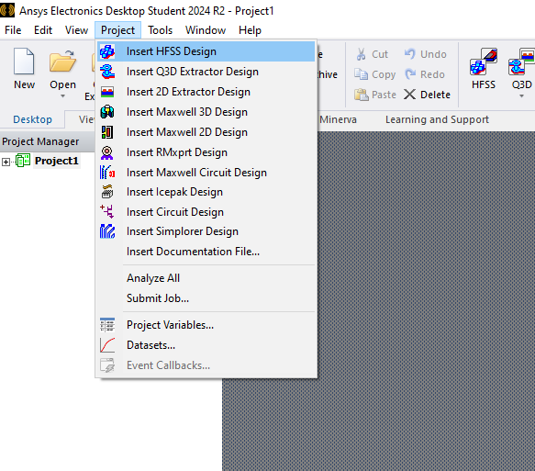
Figure 1 Screenshot of Ansys: Insert a HFSS design
Then make sure that the units for the modal are set to millimeters (mm) (Figure 2).
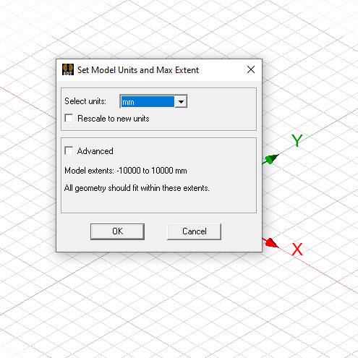
Figure 2 Screenshot of Ansys: Set Model Units
Select the solution type of the HFSS and make sure the solutions type is set to HFSS and the option as Modal.
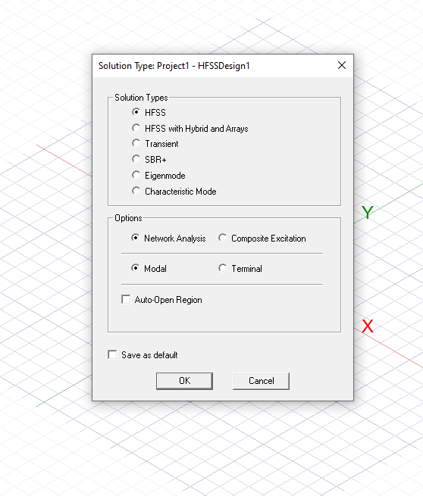
Figure 3 Screenshot of Ansys: Solution Type Settings
The next stage is to draw a cuboid of any dimension, once this is executed from the project manager select the CreateBox listing, this produces a properties dialogue box, from this point the X-axis (Width), Y-axis (Height), and Z-axis (Length) measurements may be altered. As stated in the introduction for both Task 1A and 1B these measurements are: Width = 23mm, Height = 9mm, and Length 50mm. This is depicted in the figure below.
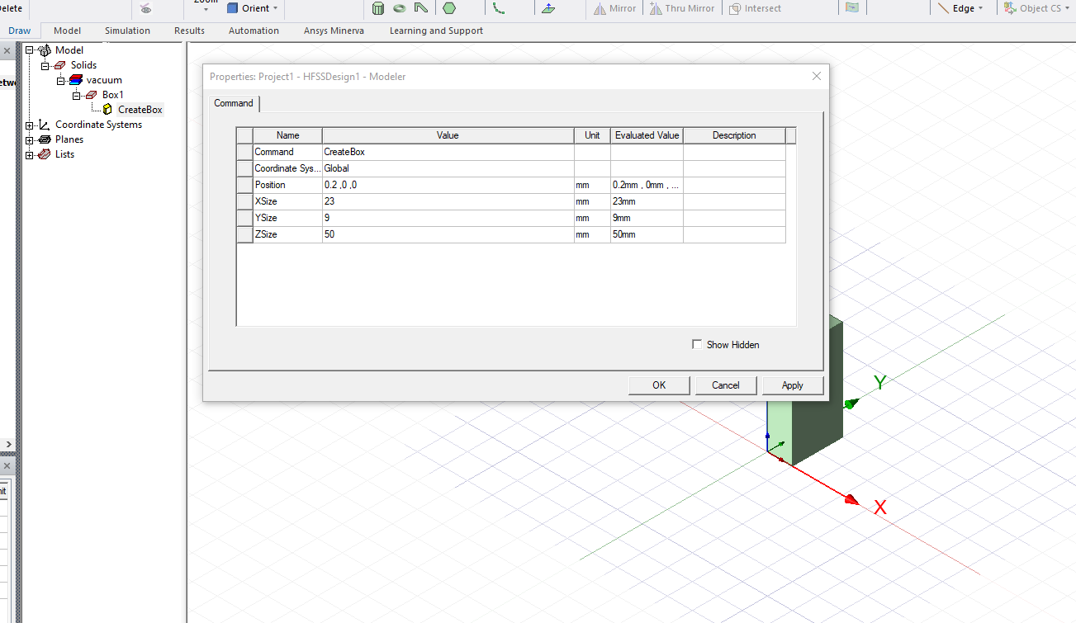
Figure 4 Screenshot of Ansys: Box Dimensions Settings

The next stage of the process is where the methodology for Task 1A and Task 1B deviate. In this section we will focus on the methodology for a Rectangular Waveguide Modal with Perfect Electric Conductor (PEC) walls filled with vacuum. Section 1.3.2 will continue the methodology for a Rectangular Waveguide Modal with Perfect Electric Conductor (PEC) walls filled with Teflon.
From the Model settings beside the project manager it is now time to select Box1, this section allows the author to select the name of the Model, keeping good practice with scientific method, and also provides the opportunity to determine the material that fills the walls of the PEC. In this case the material is set to ‘vacuum’. The transparency of the object is also adjusted to 0.8, which assists with the modelling process.
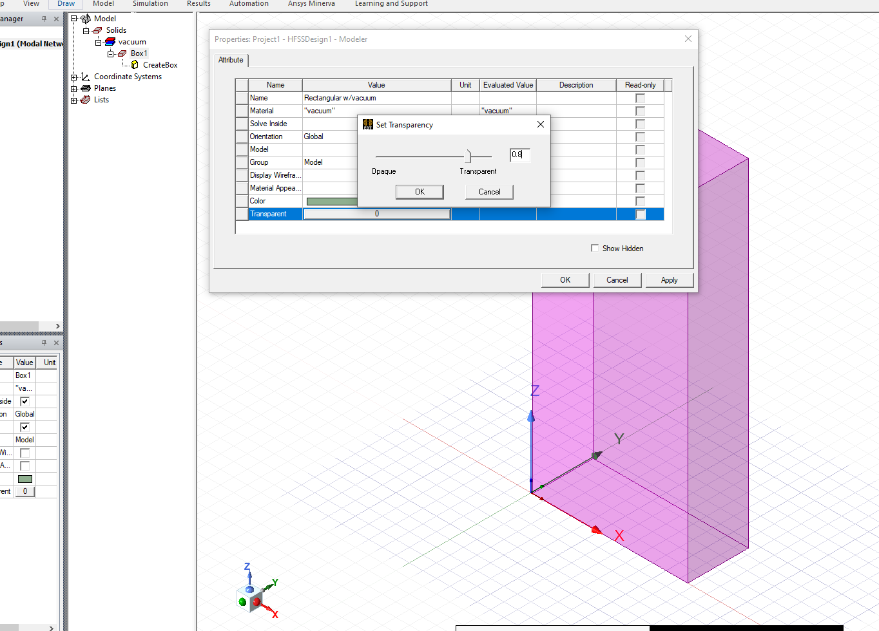
Figure 5 Screenshot of Ansys: Name and Material: Rectangular Waveguide with Vacuum
In order to choose the PEC for the rectangle’s walls the four sides of the rectangle must be selected and then the ‘Assigned Boundary’ must be set to ‘Perfect E’. The Perfect Electric Region can then be verified by selecting the Boundaries option from the project manager, where the four sides will then appear patterned.
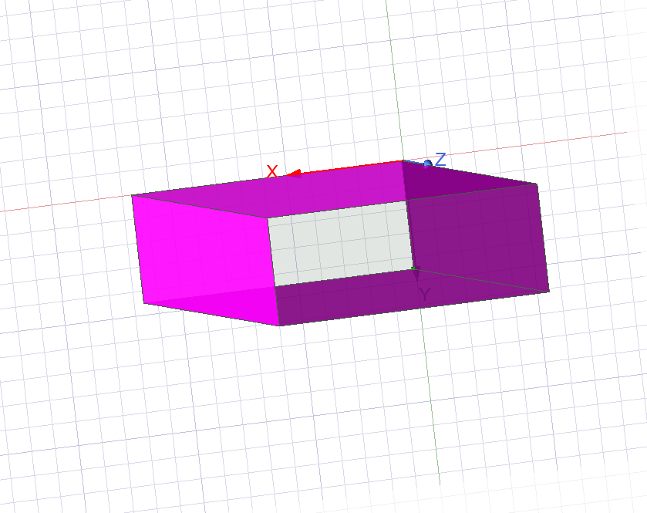
Figure 6 Screenshot of Ansys: Assigning PEC Boundary
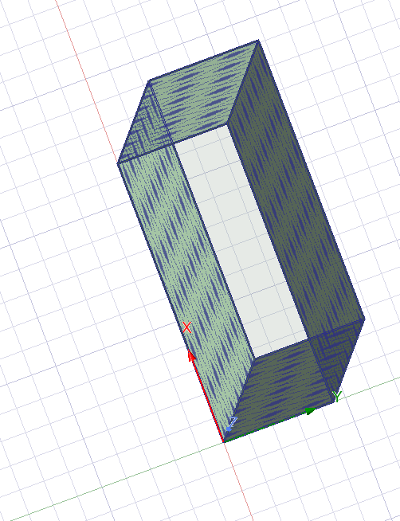
Figure 7 Screenshot of Ansys: Assigning PEC Boundary Identified
To create an Excitation at the ports (two openings of the waveguide) the two remaining faces of the cuboid will both be made wave ports. In order to do this first select one of the faces, then ‘Assign Excitation’, select ‘Port’ and then select ‘Modal Wave Port’.
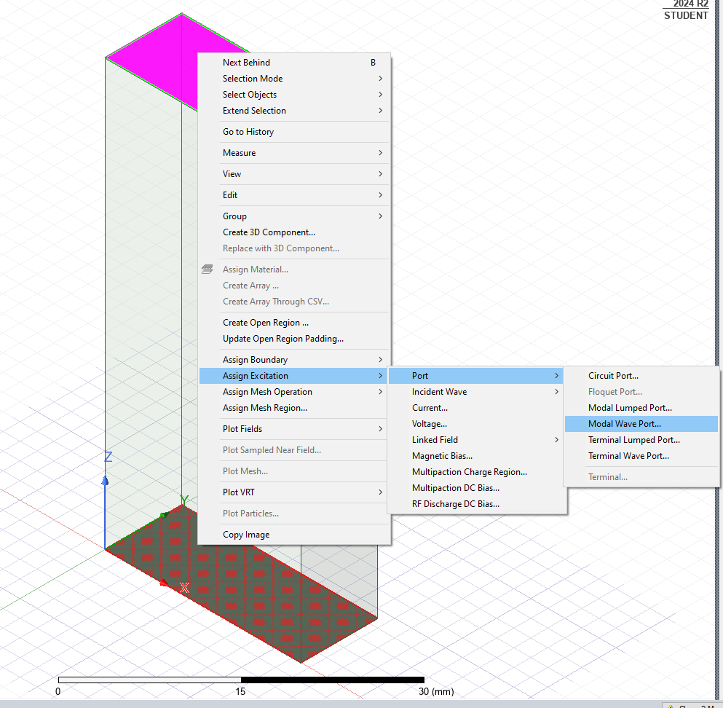
Figure 8 Screenshot of Ansys: Creating Excitation Ports
A wave port general dialogue box will then appear and 3 modes are implemented, once confirmed the port processing window will appear and the fill port impedance should be set to 50 ohms. The sides set as excitations can then be verified by clicking on the excitations option in the project manager, where the relevant face will become patterned when selected.
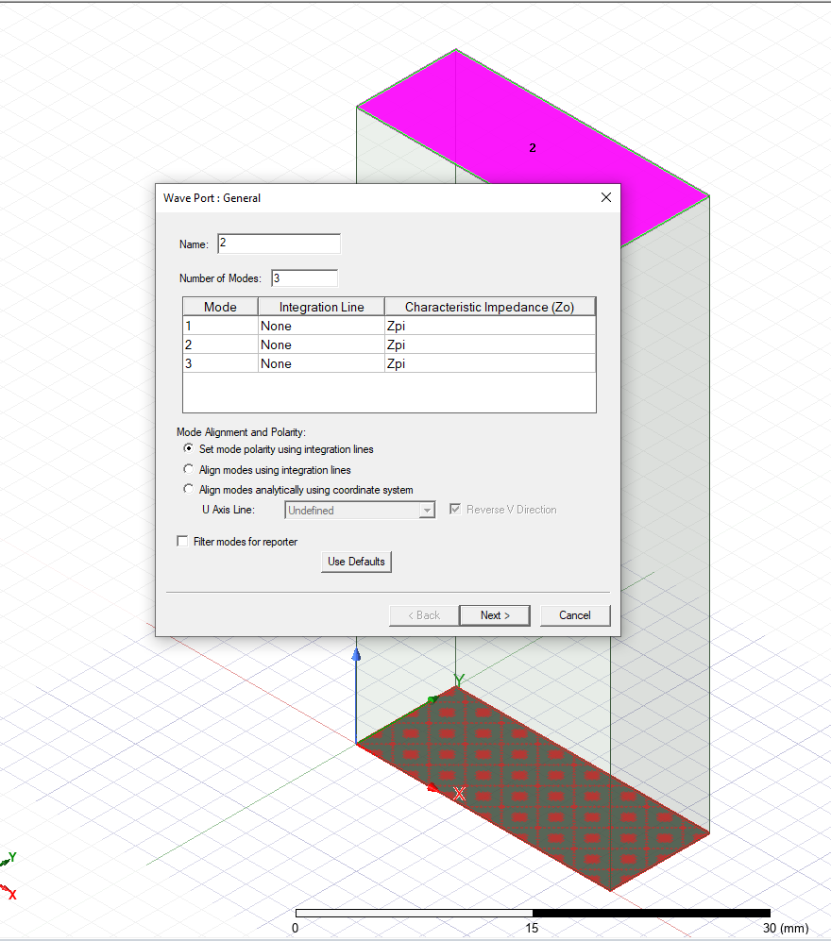
Figure 9 Screenshot of Ansys: Wave Port Modes
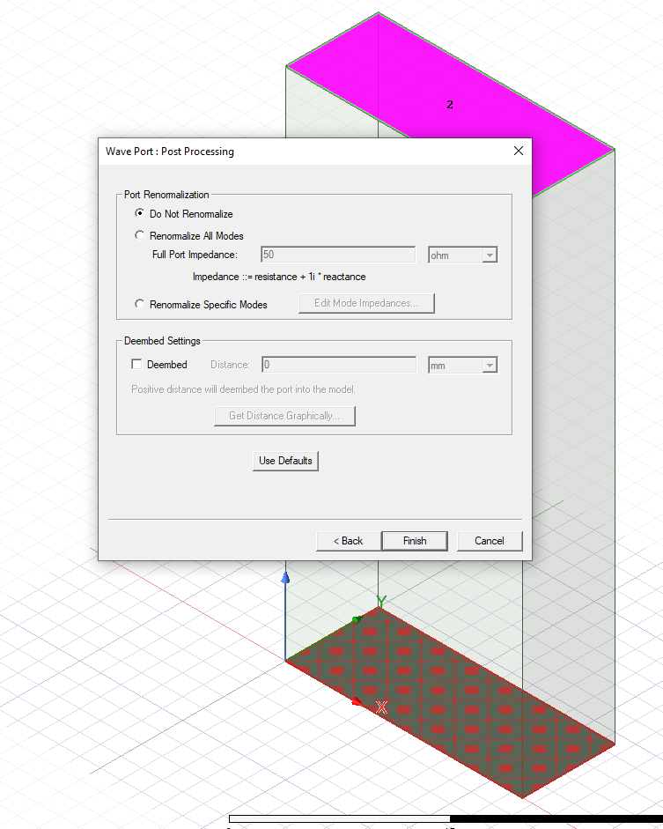
Figure 10 Screenshot of Ansys: Wave Port- Port Processing
Once the port processing has finished, it is time to input the Solution set up, inputting advanced options. A Driven Solution Setup window will open and in this case the Frequency is set to 5GHz and the maximum number of passes is set as 99.

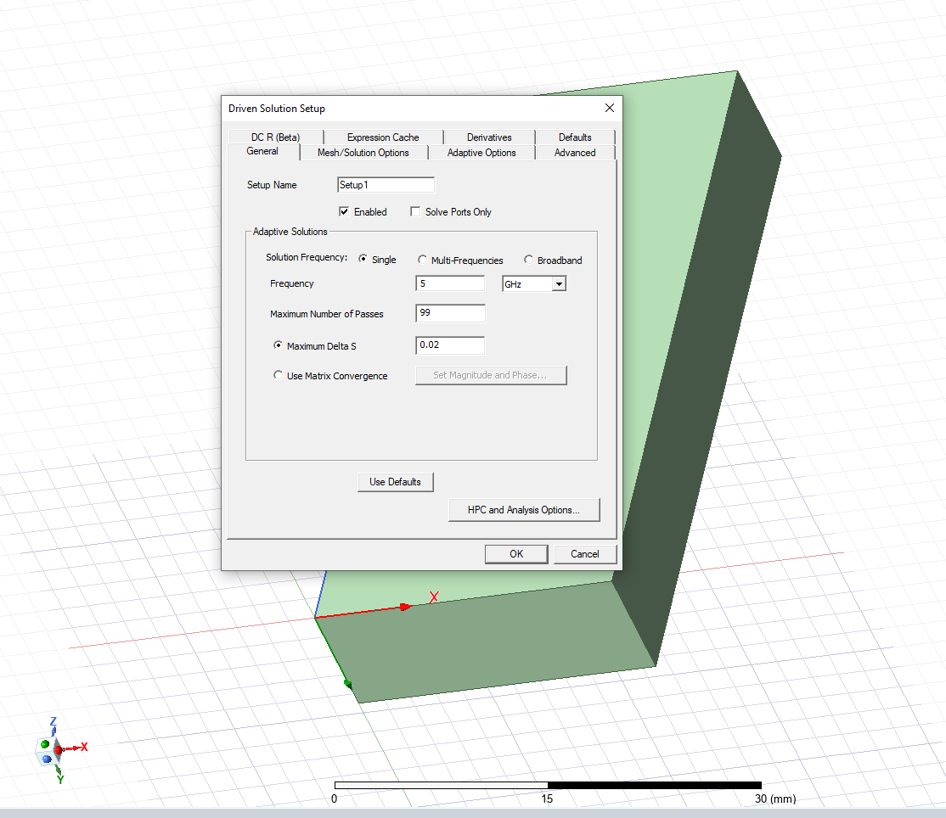
Figure 11 Screenshot of Ansys: Driven Solution Setup
Once this data has been accepted, it is possible to edit the frequency sweep, the sweep type is interpolating, the start frequency is set to 2GHz and the end frequency is set to 30GHz, saving the fields. The generated plot will be according to this frequency range.
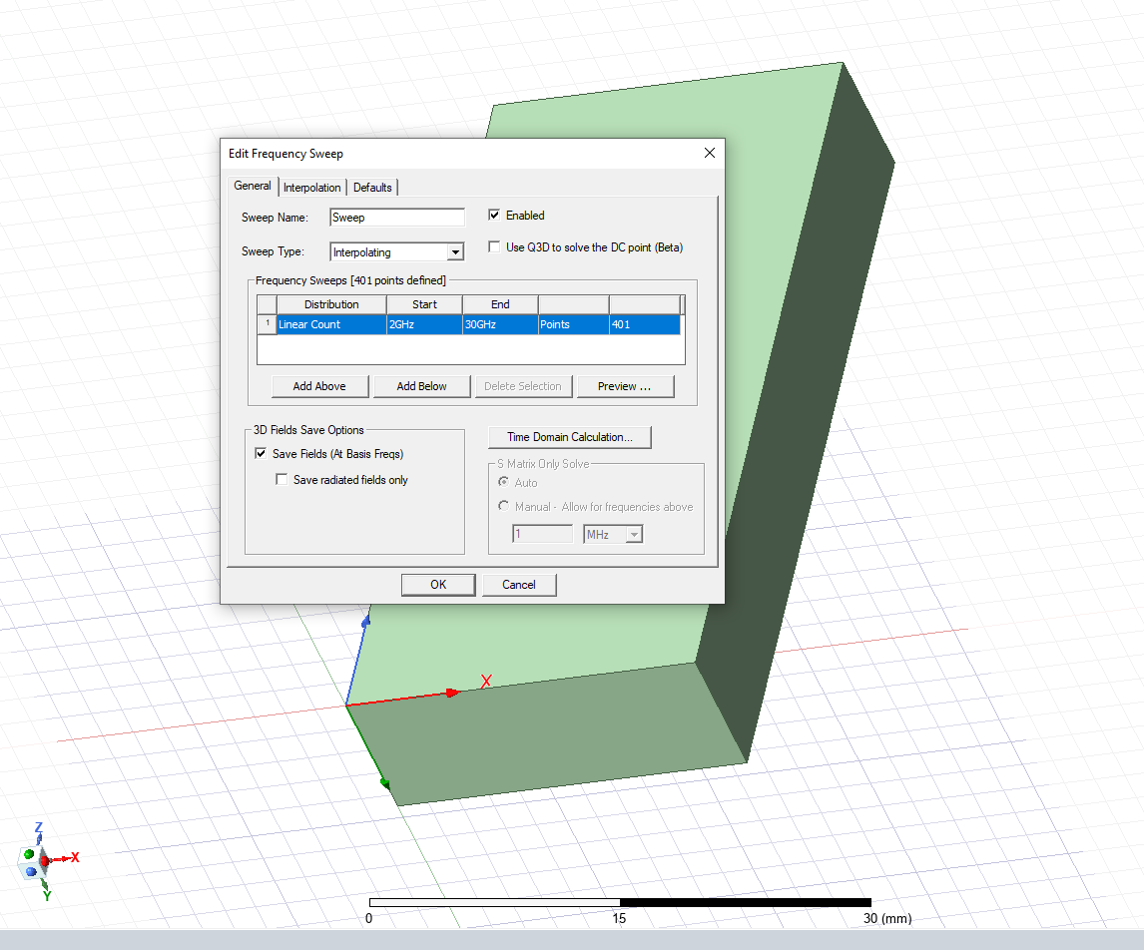
Figure 12 Screenshot of Ansys: Edit Frequency Sweep
Once the above steps have been completed, it is time to begin the simulation, this requires a validation check, and then for the settings and model to be analysed, as demonstrated by Figure 13 and Figure 14.
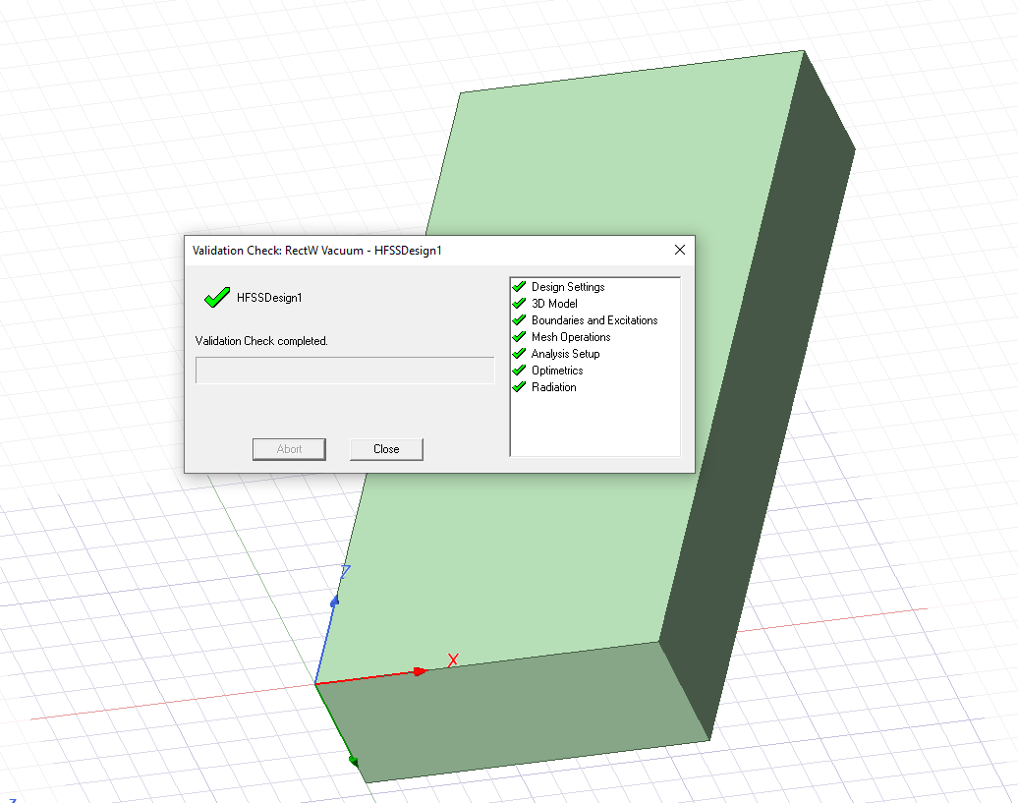
Figure 13 Screenshot of Ansys: Validation check
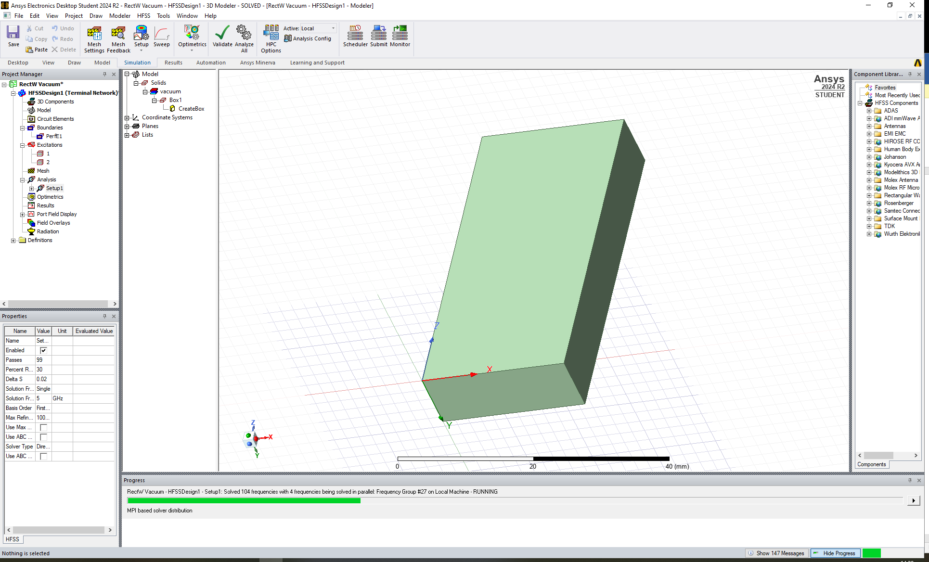
Figure 14 Screenshot of Ansys: Analyse All

1.3.2 Rectangular Waveguide Model with PEC filled with Teflon
Figure 1 to figure 4 are the same process in setting up the Rectangular Waveguide Model, so to review the first stages of this antenna’s implementation of this software please refer to the methodology recorded in these stages in section 1.3.1. Once these stages have been reviewed, the methodology continues to record how to build the relevant waveguide model with PEC filled with Teflon.
The measurements for the X, Y, and Z axis remained the same results from the calculations taken for Task 1A, as demonstrated in figure

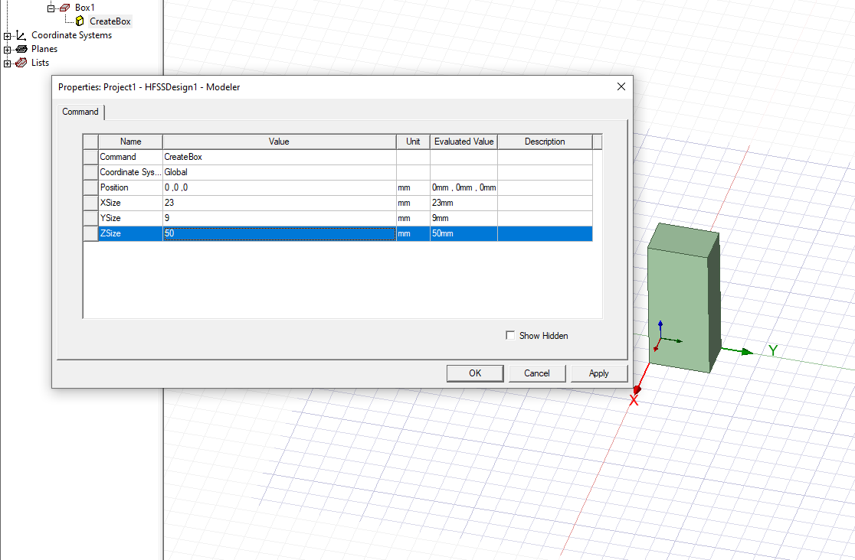
Figure 15 Screenshot from Ansys: Dimension (Teflon)
From the Model settings beside the project manager it is now time to select Box1, this section allows the author to select the name of the Model, keeping good practice with scientific method, and also provides the opportunity to determine the material that fills the walls of the PEC. In this case the material is set to ‘Teflon’. The transparency of the object is also adjusted to 0.8, which assists with the modelling process.
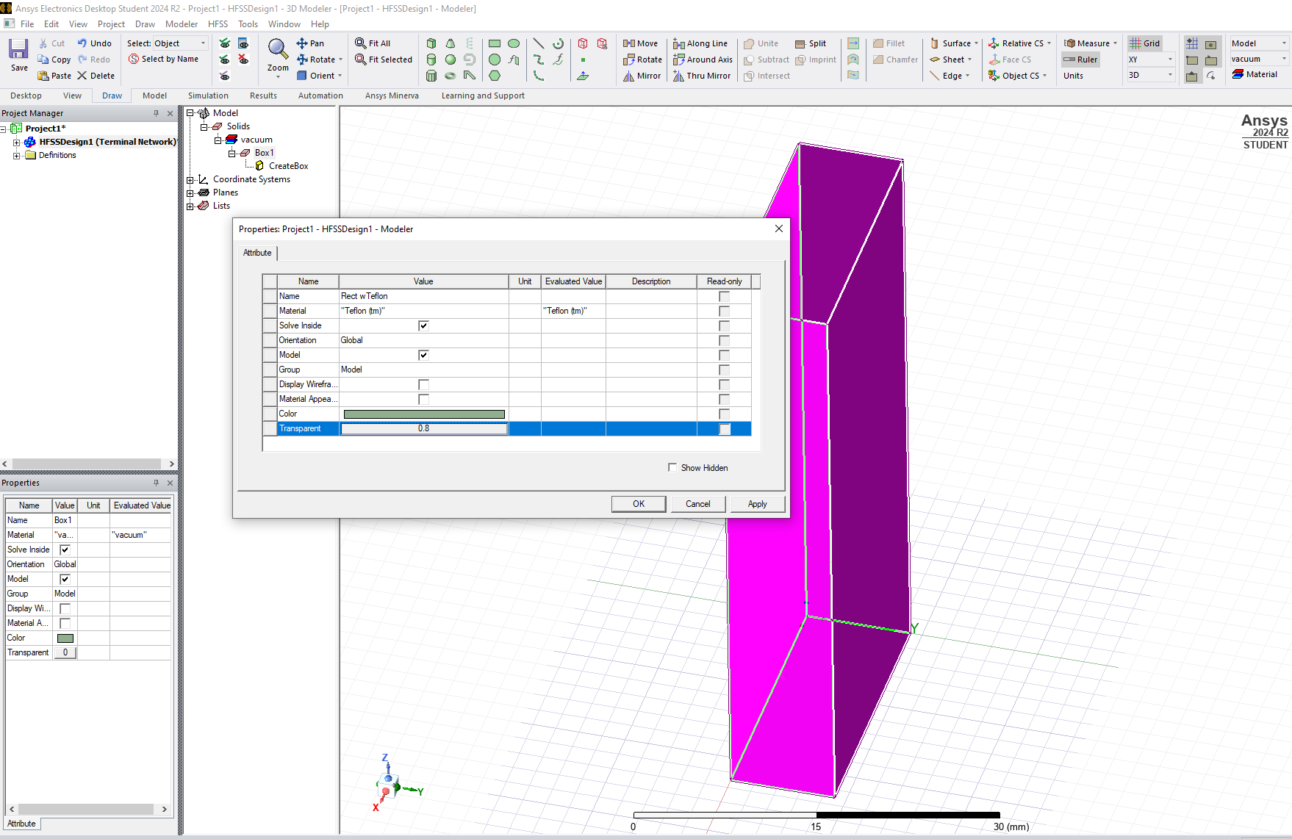
Figure 16 Screenshot from Ansys: Teflon Properties selection
From this point the instructions provided in 1.3.1 Figure 6 onwards fulfill the methodology for the simulation, and they may be followed for further instruction.

1.3.3 Halfwave Dipole Antenna
Begin a new project using Ansys Electronic Student Software, and insert a HFSS design. (Figure 16). Then make sure that the units for the modal are set to millimeters (mm) (Figure 17). Select the HFSS Solution Type and assign I HFSS and Modal (Figure 18). It is now time to select cylinder and draw what will be the dipole of the antenna (Figure 19).
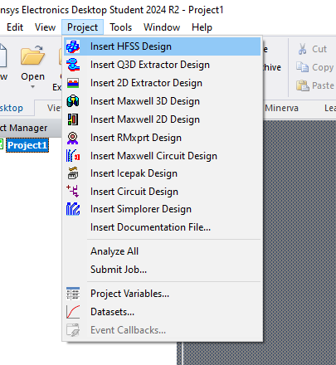
Figure 17 Screenshot from Ansys: Dipole HFSS
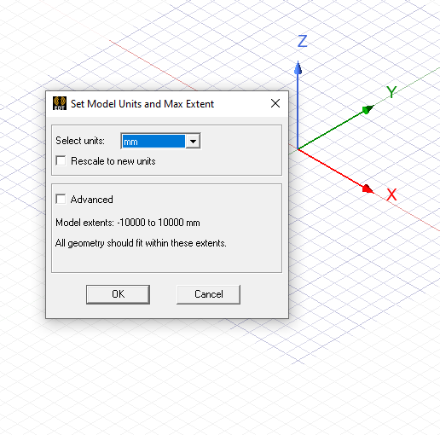
Figure 18 Screenshot from Ansys: Dipole Unit selection
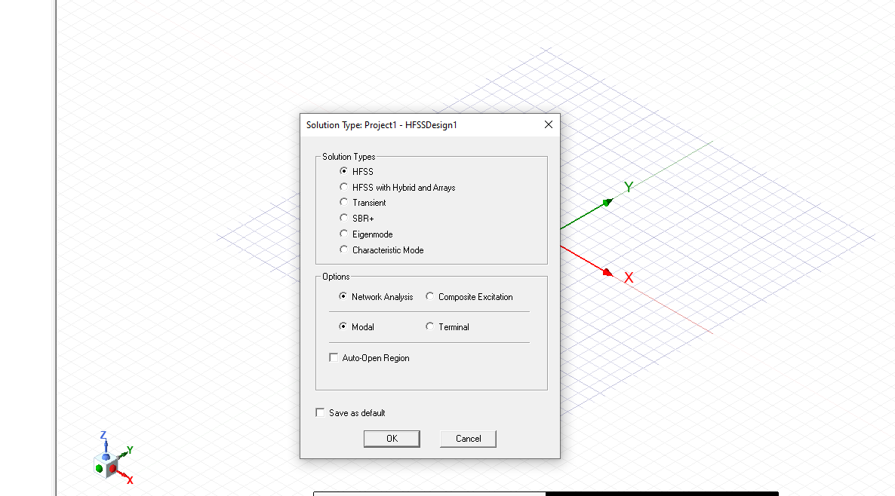
Figure 19 Screenshot from Ansys: Dipole solution type selection
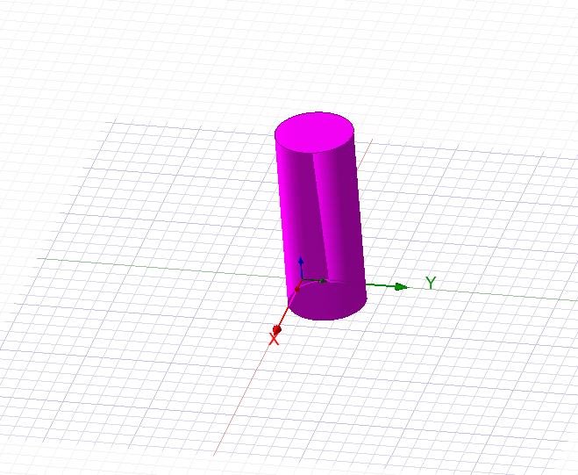
Figure 20 Screenshot from Ansys: Draw cylinder
Once the cylinder has been created the properties of the object can be altered (Figure 20). The waveguide dimensions were specified in the properties menu. To centre the dipole its position was shifted along the Z-axis by half the total height. Since an antenna length directly determines its resonant frequency, the height parameter had to be selected with care. According to the assignment brief, the wavelength would be 231mm, based on the first three digits of the author’s student number. For a half-wavelength dipole, this value was divided by two yielding a required height of 115.5mm.

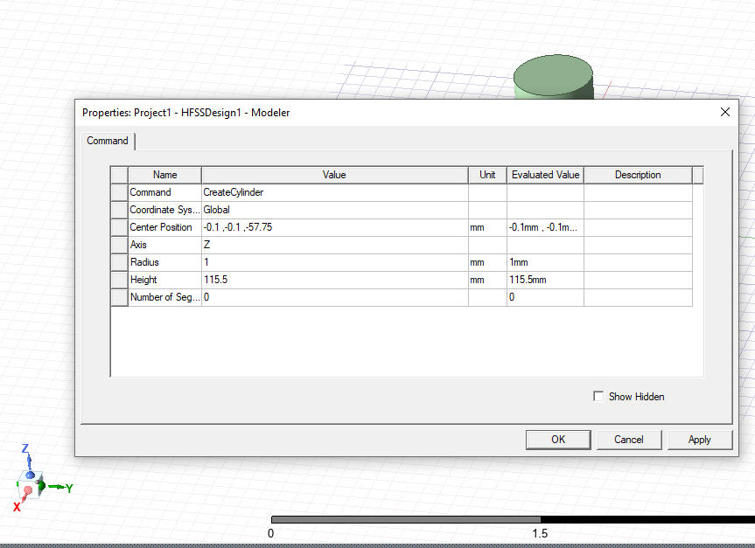
Figure 21 Screenshot from Ansys Dipole Properties Selection
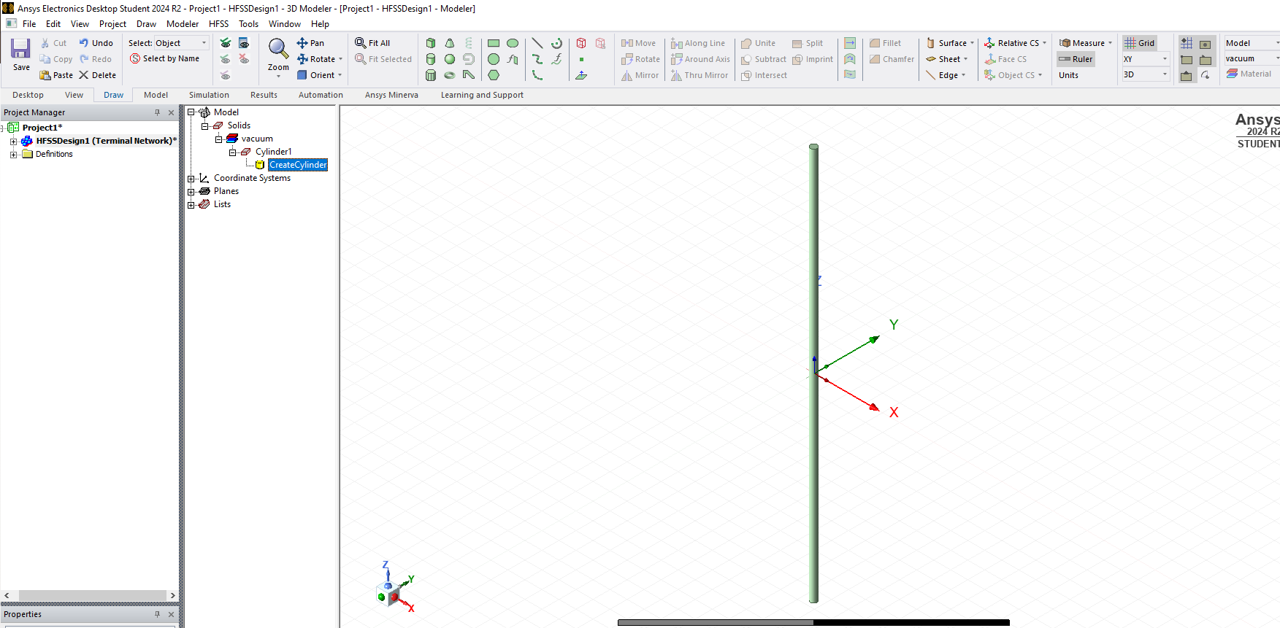
Figure 22 Screenshot from Ansys: Dipole Dimensions Simulated

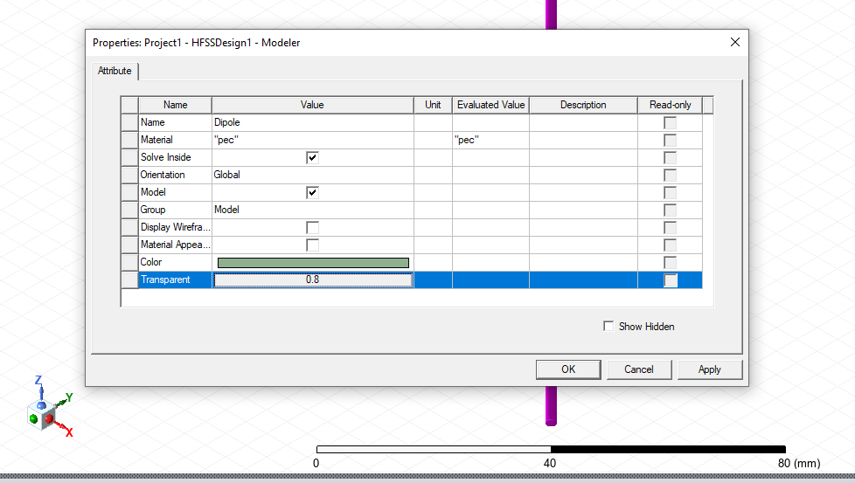
Figure 23 Screenshot from Ansys: Modeler Properties Name, Material, Transparency
The assignment stipulates the dipole antenna should be modelled as a Perfect Electrical conductor, meaning it exhibits no capacitive, inductive or resistive behaviours. To accurately simulate a dipole antenna, a small gap must separate the two elements allowing for the placement of a wave port. Since the dipole is centred at the origin of the coordinate space, this gap can be created by inserting a small cylinder of equal radius at the centre. As the assignment hasn’t defined the size of the gap the author has chosen a value of 1mm (Figure 23).
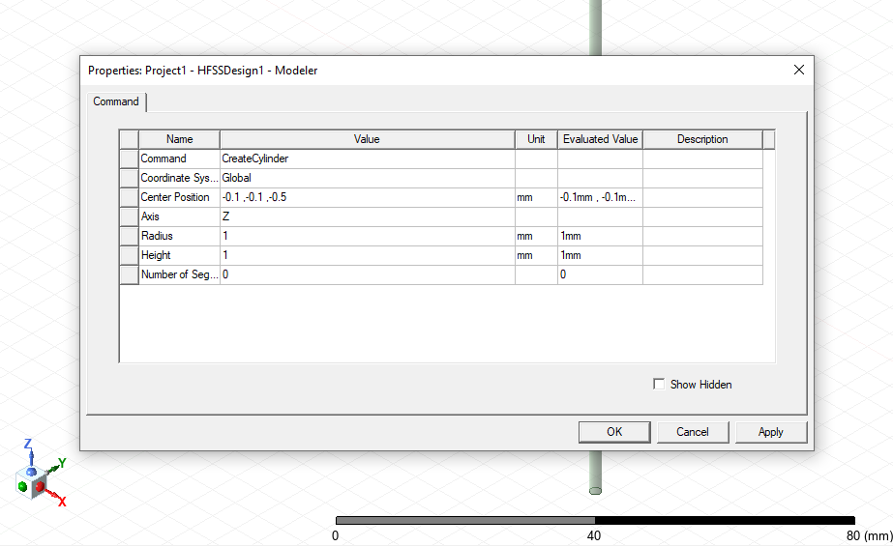
Figure 24 Screenshot from Ansys: Dipole Gap Properties values
It is not possible to edit the name of the object by opening the properties dialogue box of Cylinder1, the name may be changed to Dipole, to reflect the kind of antenna, and the material may be changed to PEC, alongside the opacity being altered to 0.8,
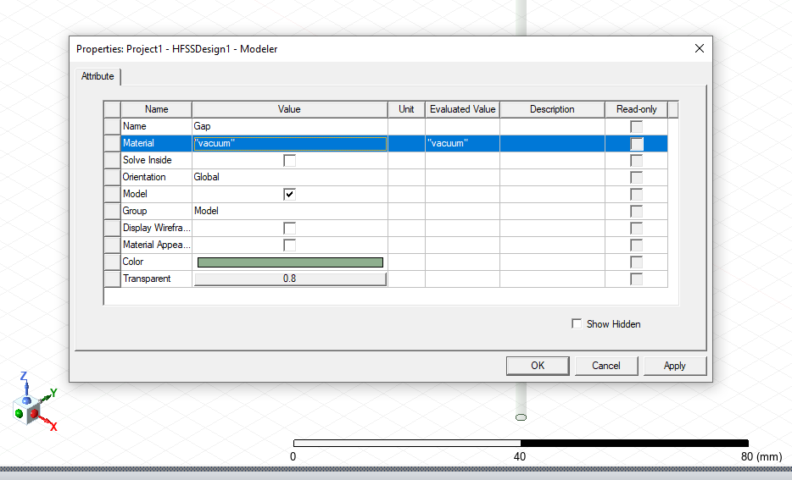
Figure 25 Screenshot from Ansys: Dipole Gap Name, Material, Transparency
It is now time to duplicate the cylinder so that the ‘gap’ may be created. By copying the current Dipole, and repeating the previous steps, however in this case the center position would be the editing the properties of the object renaming it to Gap, and the material to vacuum.
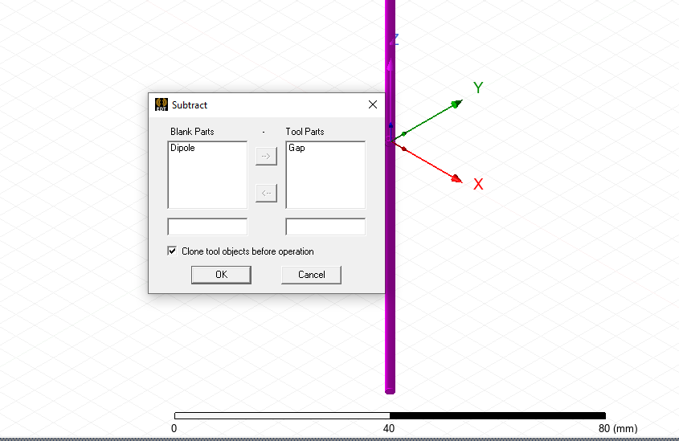
Figure 26 Screenshot from Ansys: Subtracting the gap from the Dipole
Select the YZ plane as the lumped port should be parallel to the Z axis (Figure 26).
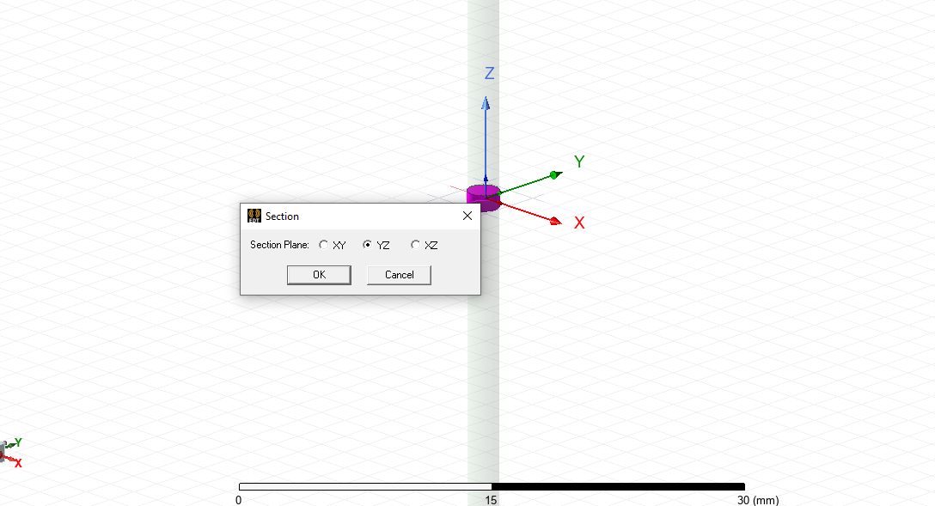
Figure 27 Screenshot from Ansys: Assigning the plane of the excitation

Select the rectangular plane that has been created, and assign it as a lumped port via the excitations. (Figure 27).

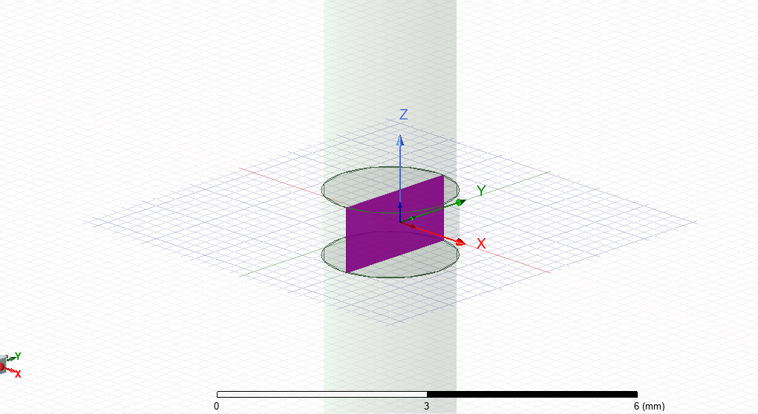
Figure 28 Screenshot from Ansys: Dipole Port creation
The lumped port dialogue box allows for the full port impedance to be set to 50 ohms (Figure 28).
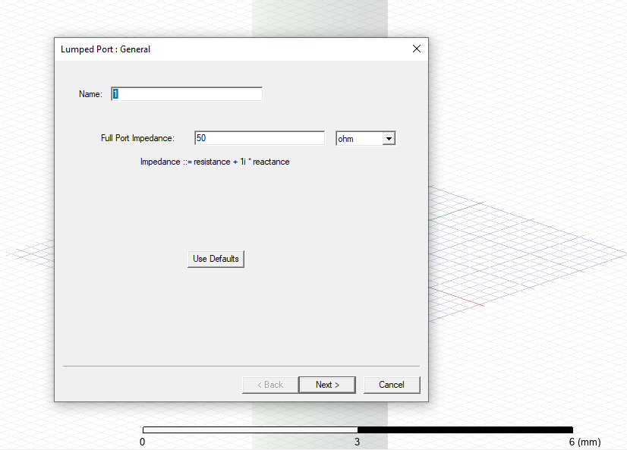
Figure 29 Screenshot from Ansys: Dipole Lumped Port Impedance declaration
The number of modes may be set to the default one and the integration line may be selected to newline rather than default (Figure 29).
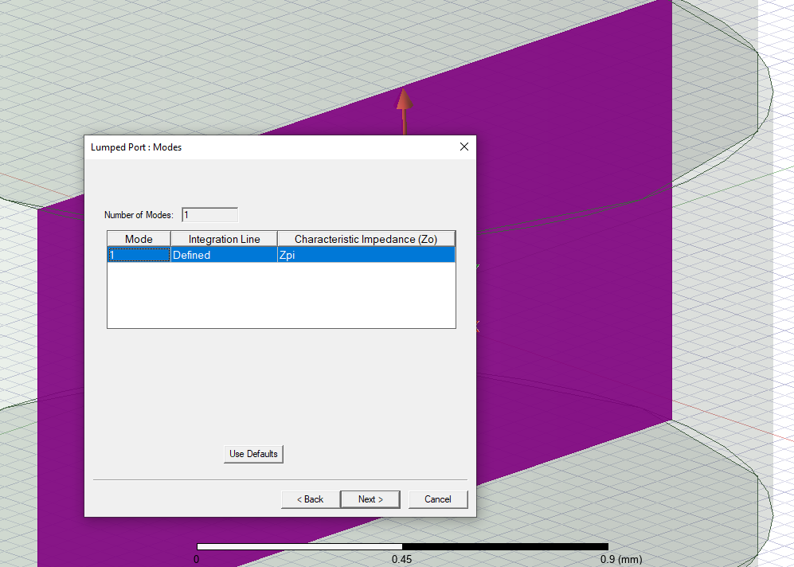
Figure 30 Screenshot from Ansys: Dipole Lumped Port Mode
A line now must be drawn from the bottom of the rectangular sheet to the top of it, then defined. An open region must then be created, in order to set an operating frequency, in this case defaulted to 1GHz, and the boundary set to PML.

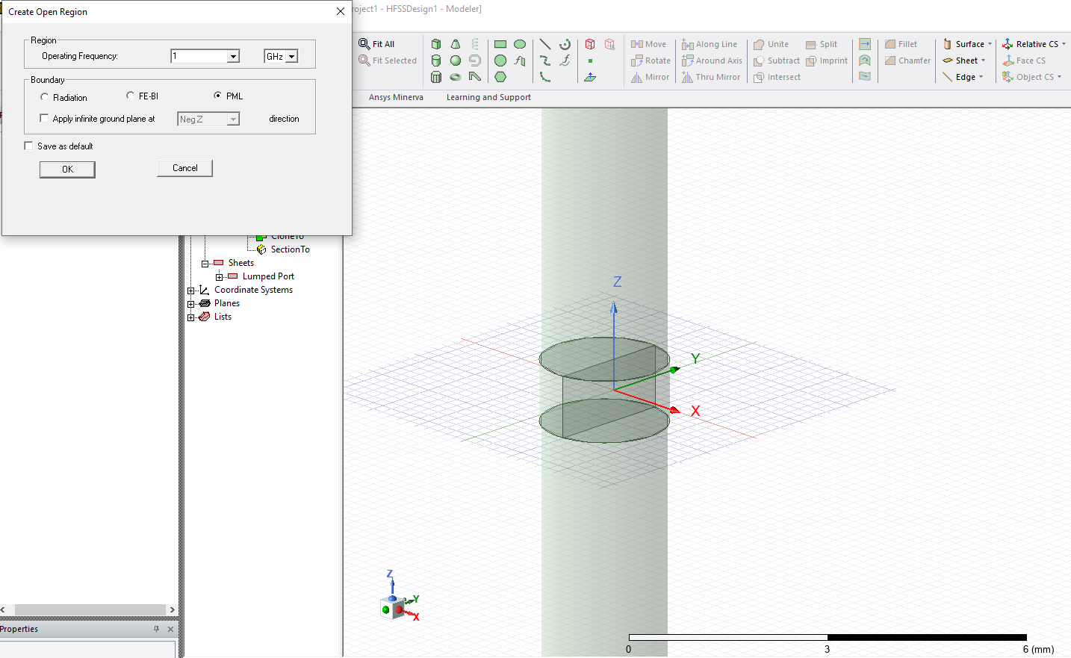
Figure 31 Screenshot from Ansys: Dipole create open region
This creates an open rectangular region with the antenna radiated within the open space, as seen in Figure 31.
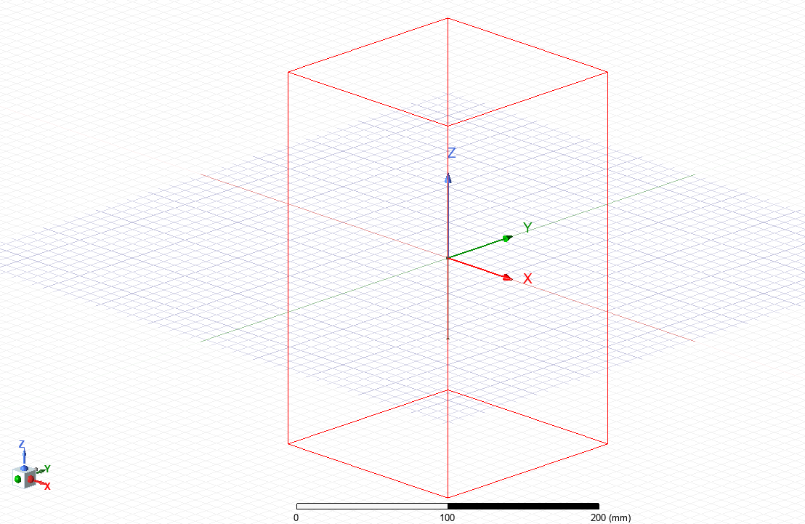
Figure 32 Screenshot from Ansys: Open region created, large cuboid containing cylinder
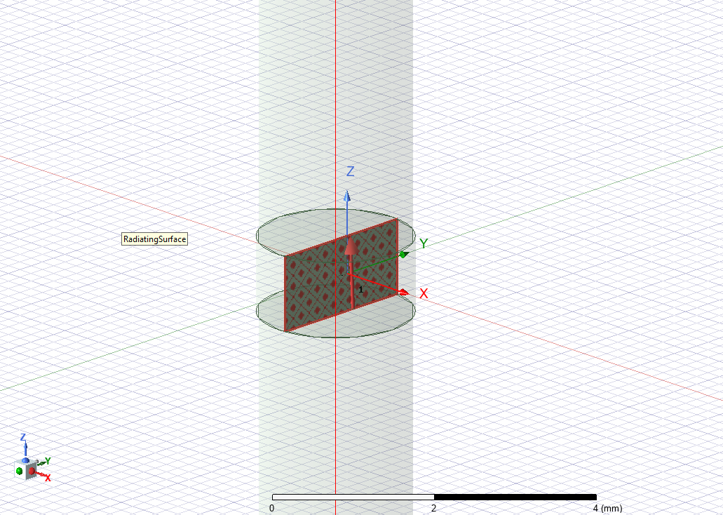
Figure 33 Screenshot from Ansys: Dipole radiating excitation/ lumped port surface
The solution setup must then be defined, here the frequency, which must be close to the operating frequency, and the maximum number of passes may be set.
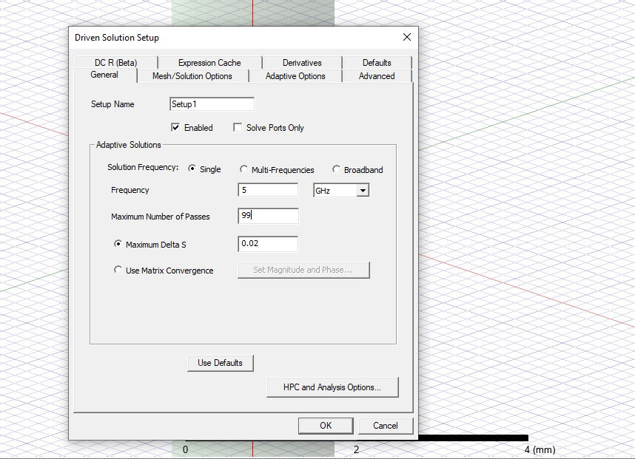
Figure 34 Screenshot from Ansys: Dipole driven solution setup
The frequency sweep boundaries can now be selected. The plot will be formed from the values selected, the operating frequency must fall within the range.
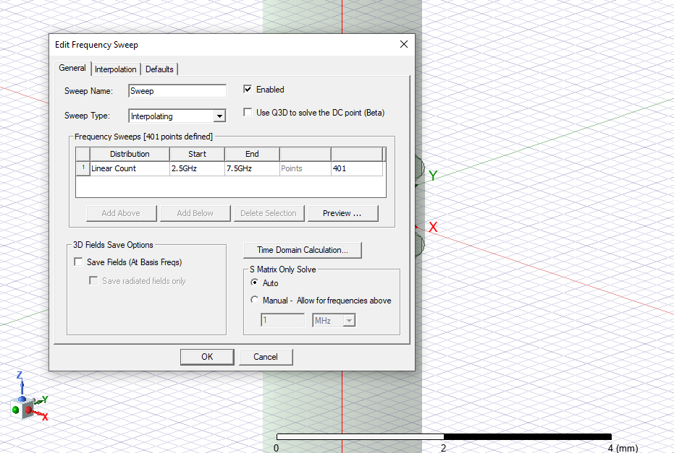
Figure 35 Screenshot from Ansys: Dipole Edit Frequency Sweep
The build can then be validated and analysed as seen in figure 35 and Figure 36.
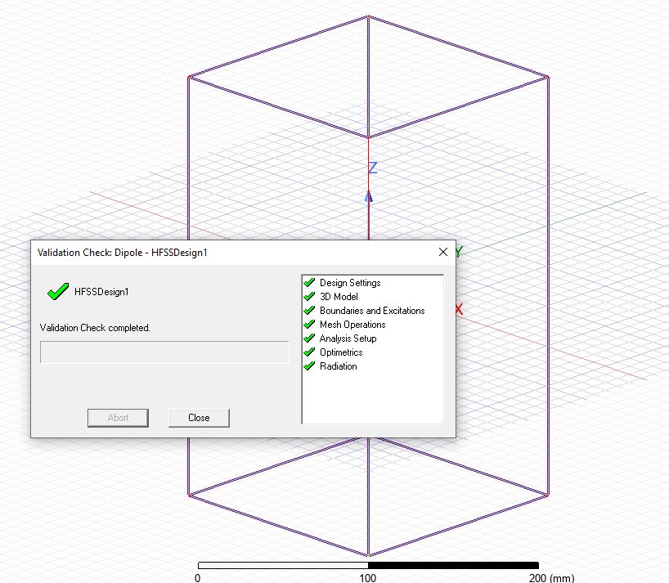
Figure 36 Screenshot from Ansys: Dipole Validation Check
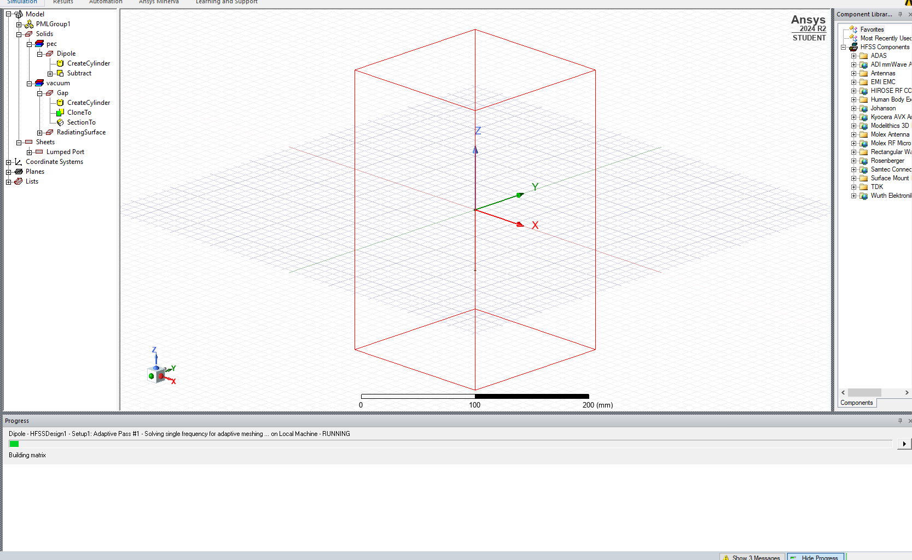
Figure 37 Screenshot from Ansys: Dipole Analysis Stage

1.4 Results
This section records the plots and calculations for each simulation method. This includes: the Port Field Display, the Magnitude and Vectors of Electrical and Magnetic Fields, and graphs calculating cutoff frequencies, for Task 1A and Task 1B.
Mode indices are used to classify the different types of electromagnetic wave propagation within waveguides. In this context, m and n denote the mode indices, specifically, m (the azimuthal mode number) indicates the number of half-wavelength variations in the azimuthal or width (x-direction), while, (the radial mode number) corresponds to the number of half-wavelength variations in the transverse or height direction (y-direction) of a rectangular waveguide. [1]

1.4.1 Rectangular Waveguide Model with PEC filled with Vacuum Plots and Calculations

Port field Display
Mode | Port 1 | Port 2
Mode 1 | 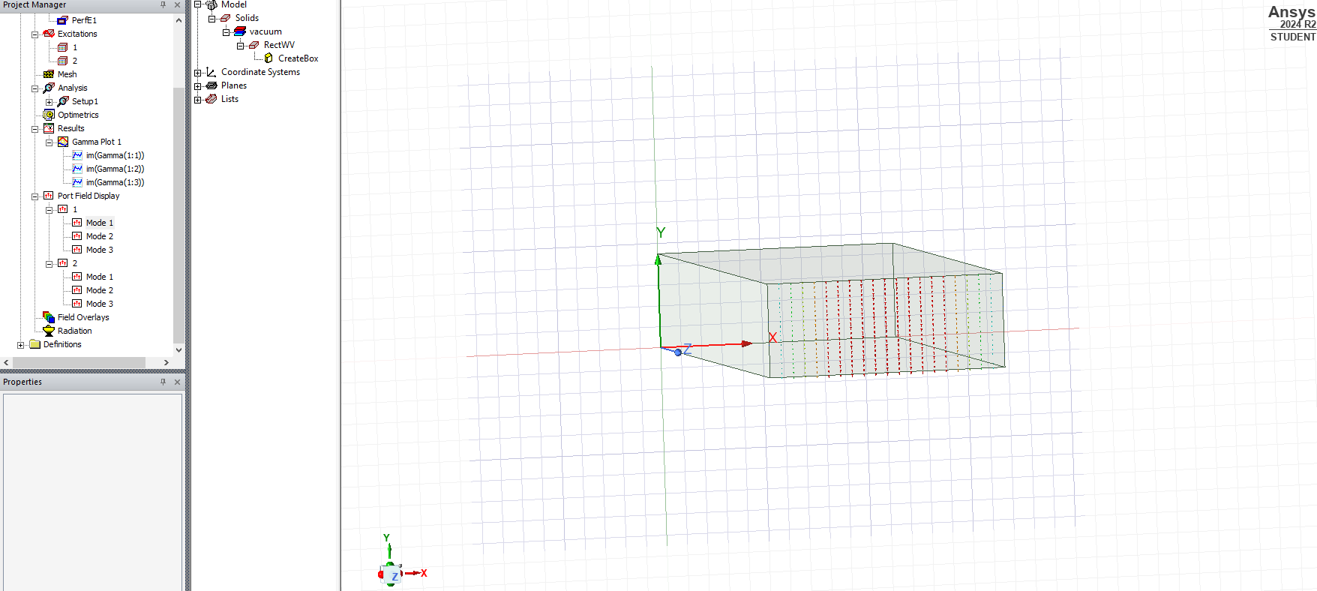  Figure 38 Port 1 Mode 1 (Vacuum) | 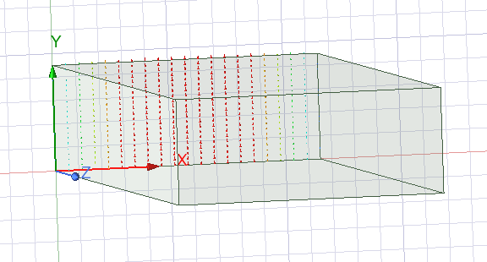  Figure 39 Port 2 Mode 1 (Vacuum)
Mode 2 | Figure 40 Port 1 Mode 2 (Vacuum) | 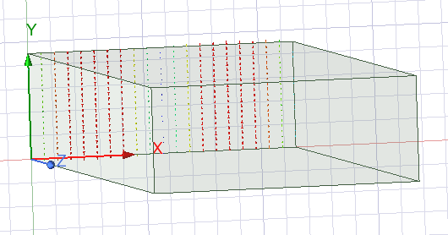  Figure 41 Port 2 Mode 2 (Vacuum)
Mode 3 | 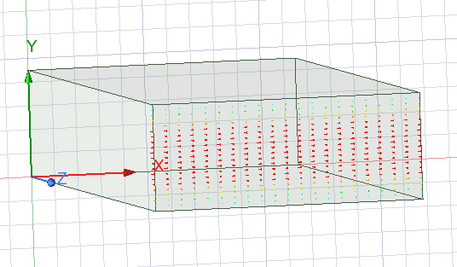  Figure 42 Port 1 Mode 3 (Vacuum) | 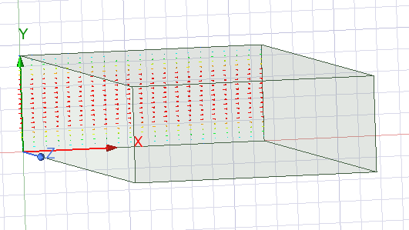  Figure 43 Port 2 Mode 3 (Vacuum)
Table 1 Port Field Display Rectangular Waveguide (Vacuum)

Magnitude and Vectors of Electric and Magnetic fields (Vacuum)
Port and Mode | E Field | H Field
Port 1 M1 | 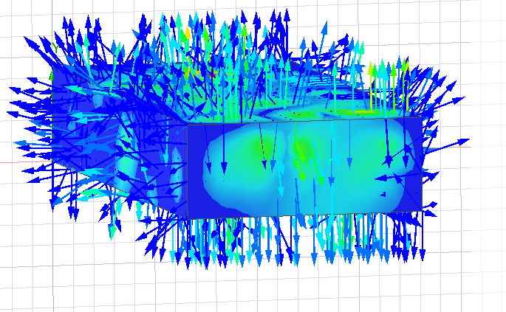 | 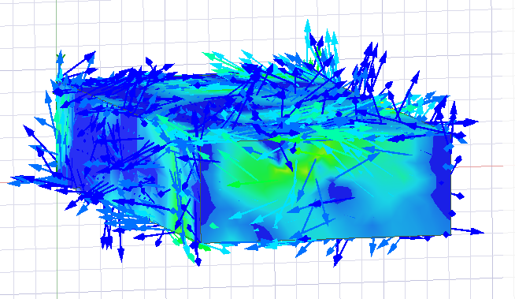
M2 | 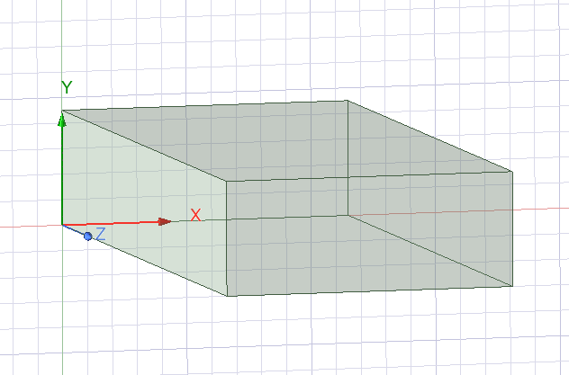 | 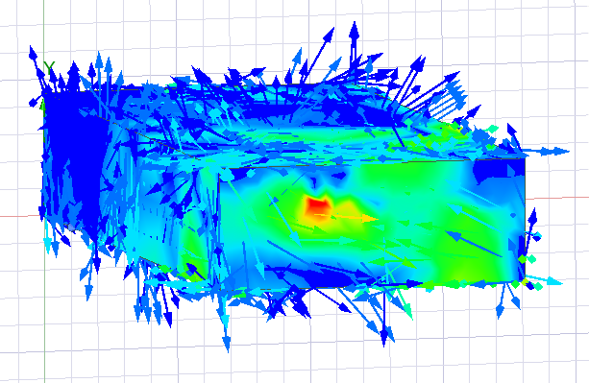
M3 | 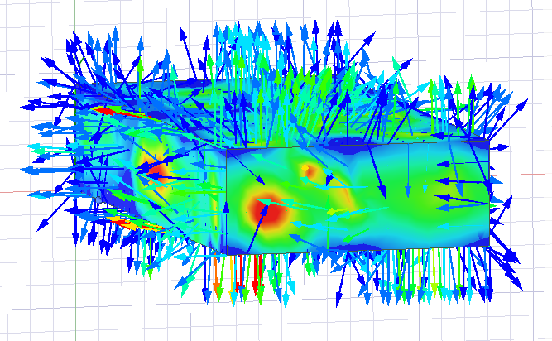 | 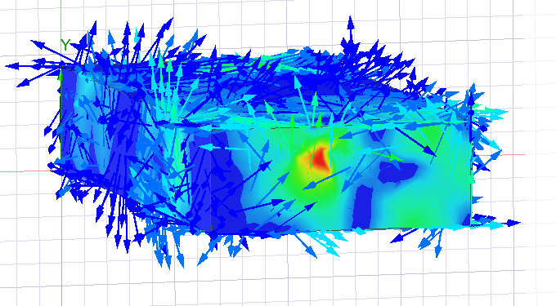
Port 2 M1 |  | 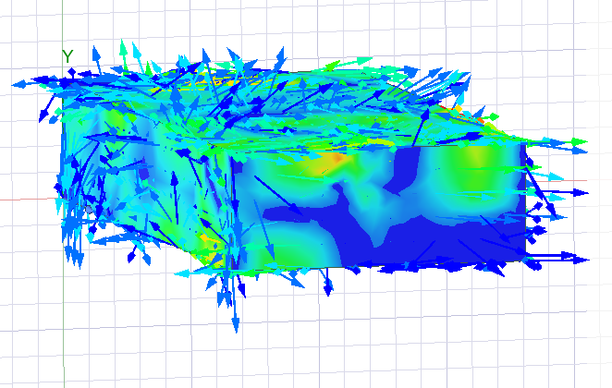
Port 2 M2 | 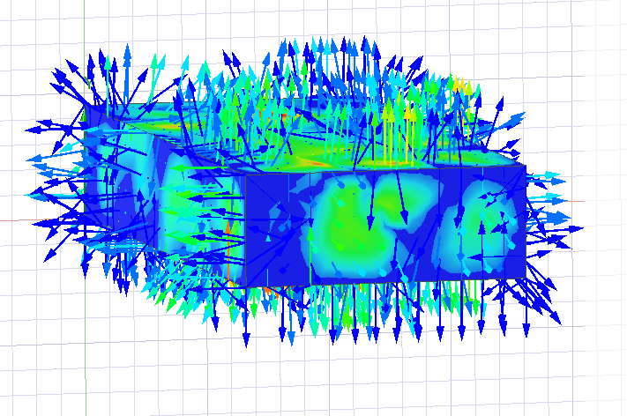
Port 2 M3 |  | 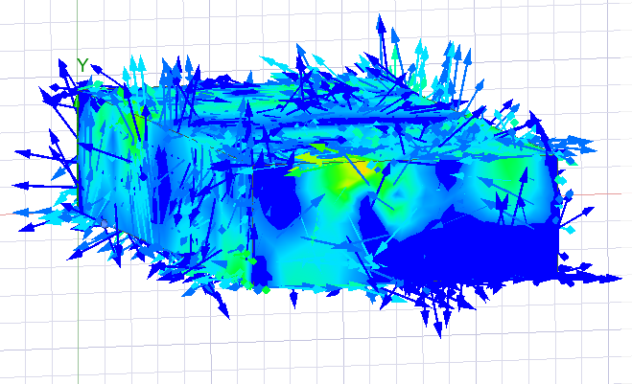
Table 2 Magnitude and Vectors (Vacuum)

Theoretical cut-off frequencies in a vacuum rectangular waveguide
$$fc= \frac{c}{2} × \sqrt{{\left(\frac{m}{a}\right)}^{2}+{\left(\frac{n}{b}\right)}^{2}}$$
$$c=299792458 \frac{m}{s}(speed of light in a vacuum)$$
Mode 1 | Mode 2 | Mode 3
$$fc= \frac{c}{2} × \sqrt{{\left(\frac{1}{23}\right)}^{2}+{\left(\frac{0}{9}\right)}^{2}}$$ | $$fc= \frac{c}{2} × \sqrt{{\left(\frac{2}{23}\right)}^{2}+{\left(\frac{0}{9}\right)}^{2}}$$ | $$fc= \frac{c}{2} × \sqrt{{\left(\frac{3}{23}\right)}^{2}+{\left(\frac{0}{9}\right)}^{2}}$$
= 6.5122403 | = 13.0344546957 | =19.551682.0435

Simulated Cut-off Frequencies in a vacuum rectangular waveguide
Name | X [GHz] | Y
M1 | 6.4800 | 0.0000
M2 | 12.9900 | 0.0000
M3 | 16.6300 | 0.0000

Rectangular Waveguide Model with PEC filled with Vacuum Graph
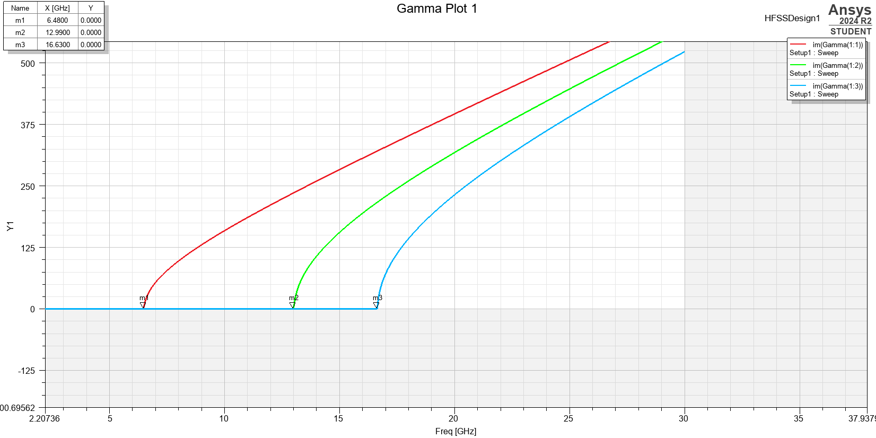
Figure 44 Epsilon Plot for Vacuum Waveguide
The simulation plot shows the permittivity for the three modes within the waveguide (vacuum). At the points the graph lines intersect with Y=0, the modes do not propagate indicating cut-off conditions.

1.4.2 Rectangular Waveguide Model with PEC filled with Teflon Plots and Calculations

Port Field Display
Mode | Port 1 | Port 2
Mode 1 | 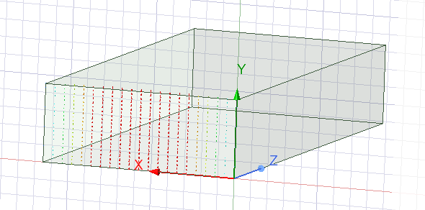  Figure 45 Port 1 Mode 1 (Teflon) | 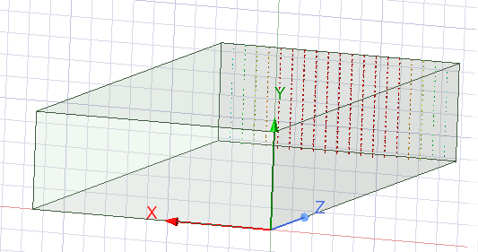  Figure 46 Port 2 Mode 1 (Teflon)
Mode 2 | 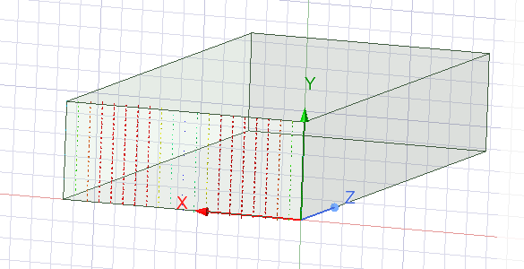  Figure 47 Port 1 Mode 2 (Teflon) | 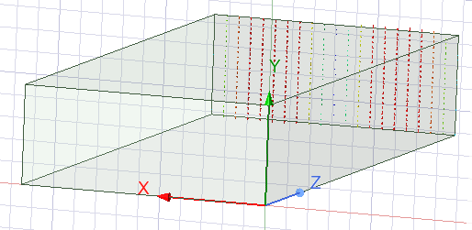  Figure 48 Port 2 Mode 2 (Teflon)
Mode 3 | 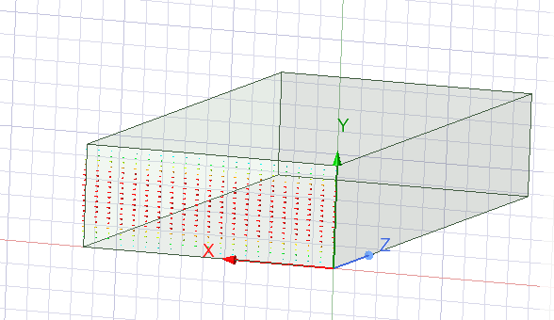  Figure 49 Port 1 Mode 3 (Teflon) | 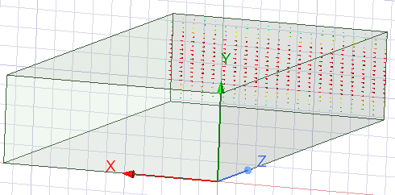  Figure 50 Port 2 Mode 3 (Teflon)
Table 3 Port Field Display Rectangular Waveguide (Teflon)

Magnitude and Vectors of Electric and Magnetic fields (Teflon)
Mode | E Field | H Field
M1 | 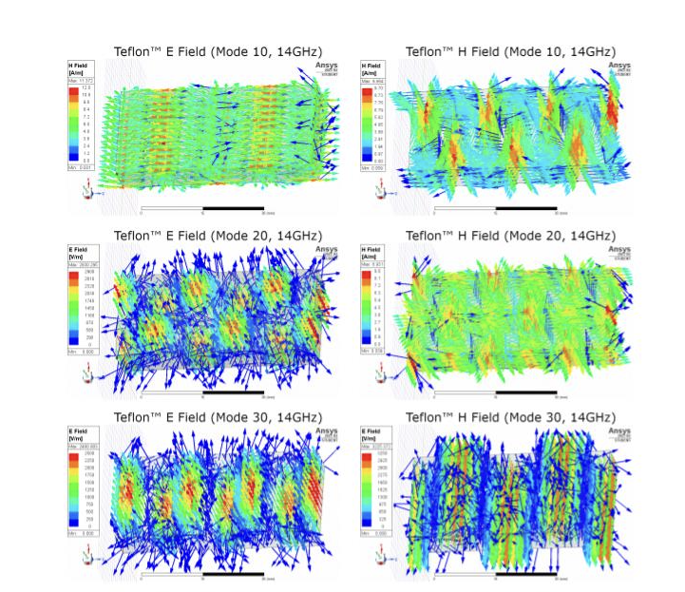
M2
M3
Table 4 Magnitude and Vectors (Teflon)

Cut-off Frequency for modes of non-vacuum rectangular waveguide
$$fc= \frac{c}{2π√μϵ}\sqrt{{\left(\frac{m}{a}\right)}^{2}+{\left(\frac{n}{b}\right)}^{2}}$$
$$c=299792458 \frac{m}{s}(speed of light in a vacuum)$$
$$μ=2.1(Relative Permittivity)$$
$$ϵ=1 (Relative Permiability)$$
Mode 1 | Mode 2 | Mode 3
$$fc= \frac{c}{2π\sqrt{2.1∙1}}\sqrt{{\left(\frac{1}{23}\right)}^{2}+{\left(\frac{0}{9}\right)}^{2}}$$ | $$fc= \frac{c}{2π√2.1∙1}\sqrt{{\left(\frac{2}{23}\right)}^{2}+{\left(\frac{0}{9}\right)}^{2}}$$ | $$fc= \frac{c}{2π√2.1∙1}\sqrt{{\left(\frac{3}{23}\right)}^{2}+{\left(\frac{0}{9}\right)}^{2}}$$
= 14.3153955049 | = 28.6307910097 | = 42.9261865146

Simulated Cut-off Frequencies in a Teflon rectangular waveguide
Name | X [GHz] | Y
M1 | 4.4500 | 0.0284
M2 | 8.9300 | 0.1674
M3 | 11.4500 | 0.9910

Rectangular Waveguide Model with PEC filled with Teflon Graph
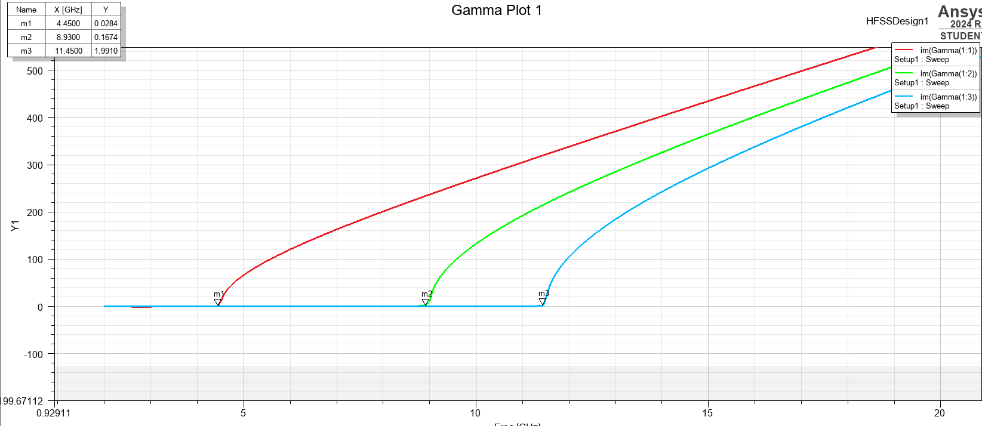
Figure 51 Epsilon Plot for Teflon Waveguide

1.4.3 Halfwave Dipole Antenna Plots and Calculations

Calculate the length of the halfwave dipole antenna using theoretical formula
$$f= \frac{c}{\frac{λ}{2}}×{10}^{-9}$$
$$f= \frac{c}{\frac{231}{2}}×{10}^{-9}$$
$$f= \frac{c}{115.5}×{10}^{-9}$$
$$f=2.595GHz$$

S-parameter plot, identifying the operating frequency
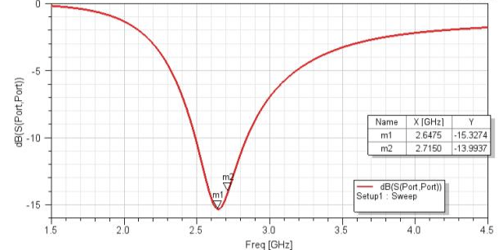
Figure 52 Ideal S Parameter Plot
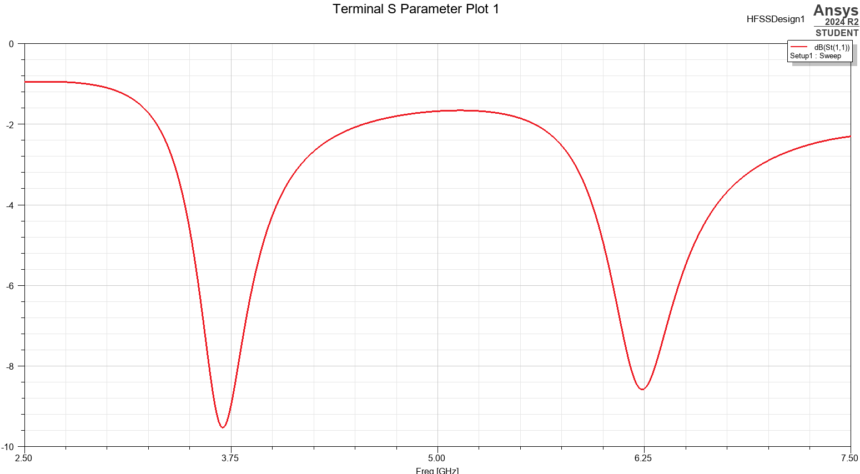
Figure 53 Unexpected S-plot returned

Radiation Pattern of the antenna
Radiation patterns are graphical representations of the distribution of radiated or received electromagnetic energy as a function of direction. It provides a visual of how an antenna distributes its radiated power in different directions and helps in understand their performance. The radiation pattern of this halfwave dipole is omnidirectional in the H-plane. [2]
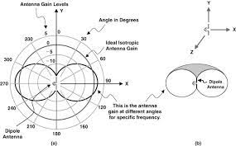
Figure 54 Lecture Slides, Anatomy of Dipole Radiation Pattern [2]

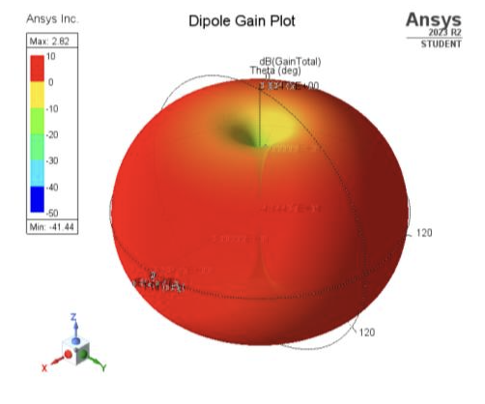
Figure 55 Predicted Radiation Plot
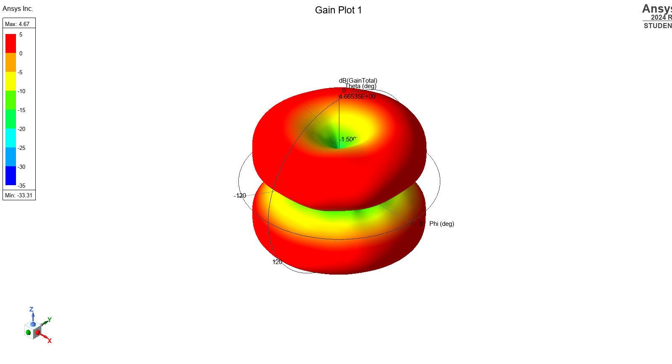
Figure 56 Unexpected Radiation Plot

1.5 Discussion
Each waveguide model is analyzed below, focusing on the limitations and impact of the model. The mode entries across both ports were recorded for both the vacuum and Teflon waveguide simulations. Across the ports the pattern that was shown appeared to remain the same, however the direction of the vector was mirrored.

1.5.1 Rectangular Waveguide Model with PEC filled with Vacuum
This waveguide was relatively simple to simulate and correlated most with the theoretical results of the formulas. When observing the ports, the pattern that was shown appeared to remain the same, however the route of the vector was mirrored. The predicted frequency cutoffs were within a reasonable margin of the simulated results, for all three modes.

1.5.2 Rectangular Waveguide Model with PEC filled with Teflon
For the Teflon cut-off frequency calculations, they are similar to the vacuum calculations except they include the permittivity and permeability variables. The theoretical calculations are completely off from the simulated calculations from the graph, after multiple simulations and calculations these remain uncorrelated. The simulated results did seem to indicate that in comparison to the vacuum the change in cavity lowered the value of the cut-off frequency for all three modes. This can surely be assigned to the increased values of permeability and permittivity.

1.5.3 Halfwave Dipole Antenna
The calculated resonant frequency of the dipole antenna does not align with the simulation results. An extreme discrepancy exists between the theoretical calculation and the simulation, whilst a slight discrepancy could be related to real world vs simulated conditions, in this case there is a larger problem. The 3D gain plot reveals a double donut patter rather than the expected toroidal radiation pattern, meaning that the expected omnidirectional dipole is not reflected. It is clear that the simulation and calculations need further development and guidance.

1.6 Conclusion
It is clear that whilst the ideal outcome may be theorized and contemplated it is not always necessarily produced by the author. The rectangular waveguides were fairly successful beside the theoretical calculations of the Teflon version. Task 2 clearly needs further examination.

References
[1] University PowerPoint, Waveguide cut-off Frequency Stalin Jacobs (Moodle)
[2] University PowerPoint, Lecture 10 – Antennas Stalin Jacobs (Moodle)
Equations were taken from the university formula sheet.
Uwtsd.ac.uk, 2025. EMR Formula Sheet 2025 (Moodle)

2 Radar Report

2.1 Introduction
This report explores the function of radars, and their utility detecting and tracking. Radar is short for ‘Radio Detection And Ranging’, it uses radio waves to measure the distance and velocity of objects. A typical radar system includes a transmitter that emits radio signals and a receiver that detects the energy reflected back from targets. [1] A drone and UAV (Unmanned Aerial Vehicles) are discussed in conjunction with one another. There are typically used in scenarios where an unmanned vehicle and remote control of an object is preferred. They are viewed as precise and unobtrusive. [2] This report will examine the challenges and broader societal impacts of deploying such systems, and will propose improvements or solutions that could enhance the effectiveness for drone detection.

2.2 Literature Review
Certain radars fail to detect Drone or unmanned aerial vehicles. Drones are becoming more compact, advanced and accessible to consumers, and in some ways, this makes them a potential risk.
Robin Radar Systems identifies three major shortcomings regarding standard radar systems: some Drone are too small to be captured by them, as the radar systems are detecting via short pulses of radio waves to identify objects, for this reason the smaller drones can sometimes escape identification, as that are not large enough to bounce the radio wave back to the antenna seeking them. The second shortcoming is that some radar systems register the drones as birds, as whilst they may be able to identify the object they are not able to identify what the object necessarily is. This means that time can be wasted and confusion caused to those trying to identify object and prioritizes items identified. The third item identified as a major shortcoming is that radar systems are not necessarily good at tracking multiple fast moving small targets. As drones are remotely controlled they can behave vary their speed and behave evasively in various conditions making them complex to detect. They are also able to be deployed in large groups, that could still evade detection as the radar cannot track that many small objects. [3]
CRFS also identifies elements of Drone detection, distinguishing between what may be perceived as myth and what may be reality. They identify that whilst radar can detect drones, they are not a perfect solution as they require a ‘direct line of sight’ for the objects they are observing. This is easier with aircraft that are larger objects, however when it comes to drones and UAVs they are operated at extremely low altitudes and can be obscured by trees or buildings, taking advantage of their smaller size. Despite this it may still be possible to detect these drones as RF signals can pass through or around these objects. [4]

2.3 Discussion
Both of the sources identified in the literature review, Robin Radar Systems and CRFS seem to agree that drones are effective at obscuring themselves from detection, however they are not foolproof. The ability to be in some cases undetectable is beneficial because
The relatively accessible nature of drones means that they are a great tool that can be used throughout society for a variety of operations, including within daily life. They are an impressive piece of technology that should be further developed. They can be used to effectively and cheaply perform mountain rescue scoping, they are used in emergency services, science and exploration, agriculture, animal conservation and can be ran using green energy. This means that the societal impact of the drone is dependent on who is utilizing the technology. The utility is broad and the negative impact of their misuse must be mitigated alongside their positive impact. [5] An improvement that may be possible for those concerned with the availability of drones may be to register larger powered drones to owners.

2.4 Conclusion
It is clear that whilst radar is an extremely effective and necessary technology, when it comes to drones and unmanned vehicles there is a large margin for improvement, and there is active work to improve the technology to overcome the challenges reflected discussed in section 2.3.

2.5 References
[1]
NOAA, “How radar works,” www.noaa.gov, Sep. 27, 2023. https://www.noaa.gov/jetstream/doppler/how-radar-works (accessed Apr. 25, 2025).
[2]
“Drones: What are they and how do they work?,” BBC News, Jan. 31, 2012. Accessed: Apr. 26, 2025. [Online]. Available: https://www.bbc.co.uk/news/world-south-asia-10713898
[3]
R. R. Systems, “Why Traditional Radar Isn’t Effective at Tracking Drones,” www.robinradar.com. https://www.robinradar.com/why-traditional-radar-isnt-effective-at-tracking-drones (accessed Apr. 27, 2025).
[4]
“Drone Detection: Myths and Reality | CRFS,” Crfs.com, 2024. https://www.crfs.com/blog/drone-detection-myths-and-reality (accessed Apr. 28, 2025).
[5] H. Green, “What are The Positive Uses of Drones,” Drone Safe Register News and Blog, Oct. 14, 2016. https://dronesaferegister.org.uk/blog/amazing-drone-uav-uses [Accessed April 26]
‌

