Student name: Dragos Marian Piron
Lecturer name: Charles Oham
Module: Community Engagement
Module code: LCBB4011

Short History of Hawkinge.
Hawkinge is a village in the southeast of England near Folkestone in Kent. Its history spans across centuries – there are records of the village dating to the 11th century – it was listed as “Hacinge” in the Domesday Book, meaning “people of Heah.” The village’s name is believed to derive from an Old English personal name, “Heah,” and the suffix “ing,” which means “of the people of,” so it is likely it was a settlement for the folk of Heah. Medieval to Early Modern. For most of the medieval period and afterwards, Hawkinge was a small agricultural settlement. St. Michael’s Church, parts of that are from the 13 th century, is one of the oldest buildings in the village. World War II and Hawkinge Airfield. However, it took on an elevated historical significance in the 20 th century, especially the World War II. The Hawkinge Airfield, officially RAF Hawkinge, was the nearest operational airstrip to mainland Europe and played an important role during the Battle of Britain. Even though it was heavily affected by bombings during the War, it is remembered for the brave pilots and its strategic location. The Kent Battle of Britain museum is now located in the village. Post-War Development. After the war, the airfield closed, and Hawkinge changed from a rural village to a more residential area. After World War II, more and more people were moving into the area that required more infrastructures and accommodations. These developments increased significantly since the 1990s, encouraged by increasing interest in the village as a Folkestone and Channel Tunnel suburb. Modern Hawkinge. Today, Hawkinge is a lively residential community with a mix of new and old houses, schools, retail enterprises, and other local amenities. The building boom has been in full swing for the past few decades as people move to the village due to its proximity to Folkestone and the area’s natural landscapes.

Hawkinge — The Churchill School
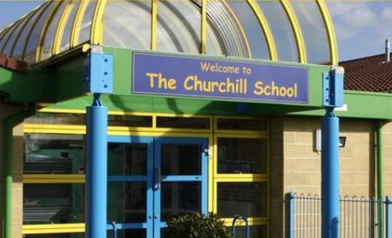
Overview:
The Churchill School (primary school in the village of Hawkinge, near Folkestone, Kent) The school caters for children from Reception to Year 6 (ages 4 -11) and was set up specifically in response to the growing local community. Sharing the name with Britain's World War II Prime Minister, Sir Winston Churchill (who lived nearby), it is representative of the area's war association and its proximity to Kent Battle of Britain Museum. And a part played in battle traffic through that area during The Battle Of Britain itself.

History and Development:
Established in September 2002, the Churchill School catered for growing numbers of young families moving into expanding Hawkinge. It was constructed as part of the response to rapid residential development and population growth in the village at the end of the 20th century through into the early 21st. Particularly with an emphasis on developing love of learning, character development and community service, perfect for a modern classroom.

Facilities and Curriculum:
The Churchill School provides a combination of modern facilities curated to cater for an all around educational experience. These facilities include:
Classrooms: Welcoming spacious classrooms with interactive whiteboards and other classroom technologies.
Library: A fully resourced library that also promotes literacy and love of reading among pupils
Outside Areas: Playgrounds & Sports Fields; Garden concedes (inhabited areas) to advance physical action and outside learning.
Specialized Rooms: Music, Art and science laboratories and Information Technology Room
The curriculum at The Churchill School is based on the National Curriculum for England and consists of a broad and balanced compulsory core including English, Mathematics, Science in addition to foundation subjects covering History, Geography as well Art & Design Music Physical Education Computing. This school has a strong focus on personal development, social skills and values within the community.
Community Engagement:
Based in Hawkinge, The Churchill School aims to forge links with the local community. It works closely with local organizations, such as the Kent Battle of Britain Museum and regional charities to provide students a sense of community and help them learn about their area’s history — including why it is important. The school also promotes parental involvement through events, workshops and opportunities for volunteering.
Values and Ethos:
Compassion, honesty teamwork and trust are the main values of our school – together these make up respect responsibility resilience kindness. It intend to provide a safe, nurturing and challenging environment for every child enabling them the opportunity of reaching their full potential. The school motto — "Learn Together, Achieve Together" - demonstrates its commitment to collaborative learning and individual accomplishment.

Recognition and Achievements:
The school has been commended by the education watchdog (Ofsted - Office for Standards in Education, Children's Services and Skills), particularly its quality of education as well as leadership & management. Celebrated for its inclusiveness and student wellness consultation, as well academic success at the school.

Overview:
It follows the primary school, one of many nationwide including in Hawkinge such is its difficulty with parking space and management. The main reasons for the increased need for roadside parking are that we have seen an increase in students accessing our school which, as a growing residential area has led to more parents/staff/visitors requiring access to enter ground.
Key Issues with Parking:
Limited On-Site Parking:
It has only a few spaces on site to park. Primarily for staff, and not with many or no spots left over for parents/visitors mostly at busy times like drop-off/pick-up time.
Congestion During Peak Hours:
Huge traffic builds in the mornings dropping children off and collections at The Churchill School by around Haven Drive road surrounding it. Parents must park on streets nearby, creating a traffic bottleneck that disturbs the peace of quieter residential areas as frustrated drivers navigate through these neighbourhoods in search for open space to drop their children off or pick them up.ca.
Safety Concerns:
Students and his guide are also asked to walk, while lack of parking lots adequate pavements nearby danger as students lead home. Kids going back and forth to school could pass parked cars or busy roads, making accident a greater risk.
Impact on Local Residents:
Parents were parking in front of their homes and blocking driveways, said neighbours who live near the school. This has at times created tensions between residents and the school community.
Inadequate Drop-Off Zones:
There is a small drop-off zone at the school, which does not have enough space for the number of cars arriving in the morning. Which can, in turn (or stop), causes vehicles to pile up down the main road adding further congestion and delays.

Environmental Concerns:
The amount of cars that are passing by and sitting in traffic is harmful for the environment, such as air pollution or noise pollution this should not happen everywhere but especially about a school where children often times arrive.
Potential Solutions:
Staggered Start and Finish Times
Introducing staggered start and finish times for various year groups would alleviate the worst of the congestion outside school, with fewer parking space required at any one time.
Promoting Walking, Cycling And Carpooling:
Encourage initiatives that promote walking, cycling and carpooling to reduce the number of cars arriving at school. This could also be backed up by campaigns such as walking buses where children walk to school in supervised groups or there may need incentives.
Extra parking sections:
This could involve working with local businesses or community centres to use their car parks during peak times, as well negotiating land in the vicinity of the school from other authorities and/or partners.
Improved Traffic Management:
Work with local road authorities to enable better traffic around the school. These may involve the introduction of road closures, one-way systems or extra pedestrian crossings to make it safer and reduce congestion.
Drop-Off and Pick-Up Zones:
Reconfigure the current drop-off and pick-up zones to maximize their effectiveness, width/length or ongoing “stop-and-drop” where parents do not leave vehicle.

COMMUNICATING WITH PARENTS AND THE COMMUNITY:
Keeping residents in the loop with updates on considerate parking and alternative transport options via parent emails can do wonders to reduce tensions, improve relationships.

School Travel Plan:
Prepare a whole school travel plan in collaboration with the local authority and community. This might include a specific approach to solving parking issues, improving sustainable travel, and making the roads around the school safer.

Discussion with the local community:
Interviewer: Hello, thank you for agreeing to have a chat with me today about the parking situation at The Churchill School who are based in Hawkinge.
Interviewer: Tell me what the parking situation is like at drop-off and pick-up near the The Churchill School?
E: It’s pretty bad. I live just down the road and every morning and afternoon it seems like we are in traffic. Parents parked on pavements and corners which are dangerous for anyone walking to school, especially children. I've even witnessed cars almost getting stuck in the mayhem.
Interviewer: What do you think would make this situation any better?
E: More parking restrictions and enforced correctly. Maybe the school could have a drop-off zone that is farther away from campus to spread traffic out.
Interviewer: Mr. D. do you have any views on the parking issues around The Churchill School?
D: Honestly, it’s a mess. I have lived here for 25 years, and it has never been this bad. So many people out there on the street that some days it is hard to get in and out of my own driveway! Also, don't even think about inviting guests around in those moods!
Interviewer: What, in your opinion is a solution to this problem?
D: School needs to coordinate with the council for some off site parking perhaps a field or car park close by. And they ought to promote car-pooling or walking more assiduously.
Interviewer: Can you tell us what is it like parking The Churchill School?
L: That is really frustrating! Some of the parents have never considered it. They park when and where there is space, even if that means blocking in another vehicle or making it difficult for other vehicles to manoeuvre. The council has had to cope with this several times and I have complained about such occurrences already.
Interviewer: School or community could help to solve these problems…
L: They could also have many more volunteers or crossing guards because people don't know how to maintain the flow of traffic! And a bit more awareness campaigns to remind moms and dads park responsibly would be ideal
Interviewer: Tell us a bit what the parking situation is like with students at this school?
A: It's a hell during school time. This can be seen when members of the public park on grass verges causing deterioration. Not only is this inconvenient, it can also be harmful to the local environment.
Interviewer: What should be different?
A: More parking spaces may help, but I suppose managing traffic better and having a drop off point away from residence will ultimately be the right way forward.
Interviewer: What has parking around The Churchill School been like for you?
R: I get that parents have to park, but this is ridiculous. The road is always blocked off and it feels like we are living next to a car park. My concern is the amount of cars everywhere and how safe kids are with so many vehicles around.
Interviewer: Any suggestions how to improve it?
R: They could bring in park-and-walk where parents just take their children the last part of the way. More engagement from the school to come up with solutions tied in closely with community input would help.
Discussion with the school administration and local council: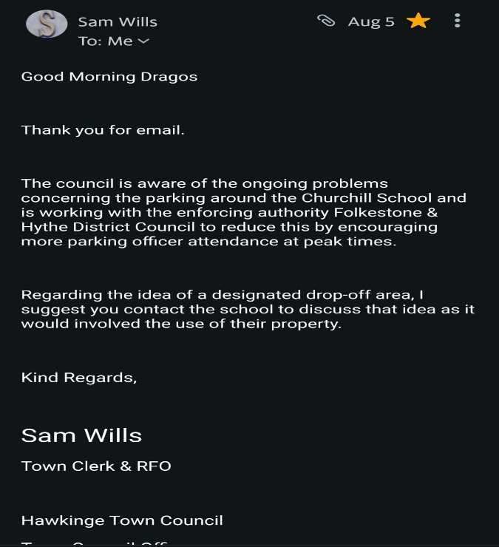 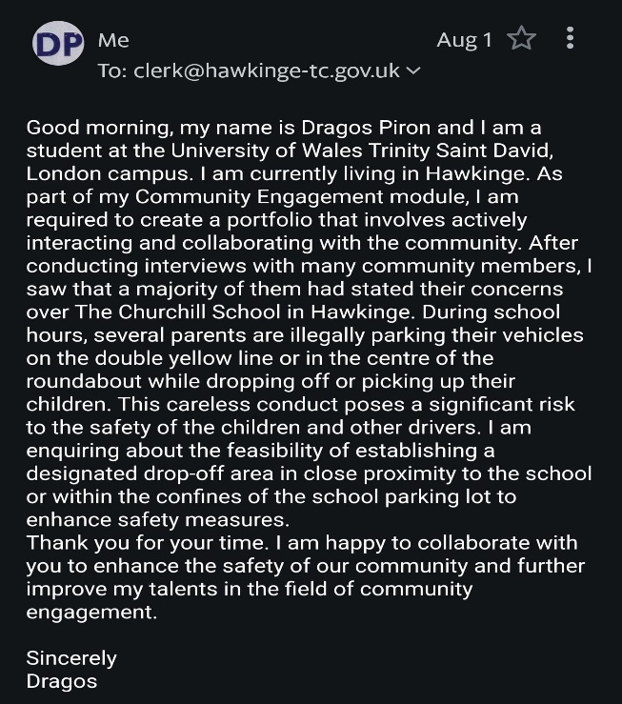

Good morning, my name is Dragos Piron and I am a student at the University of Wales Trinity Saint David, London campus. I am currently living in Hawkinge. As part of my Community Engagement module, I am required to create a portfolio that involves actively interacting and collaborating with the community. After conducting interviews with many community members, I saw that a majority of them had stated their concerns over The Churchill School in Hawkinge. During school hours, several parents are illegally parking their vehicles on the double yellow line or in the centre of the roundabout while dropping off or picking up their children. This careless conduct poses a significant risk to the safety of the children and other drivers. I am enquiring about the feasibility of establishing a designated drop-off area in close proximity to the school or within the confines of the school parking lot to enhance safety measures.
Thank you for your time. I am happy to collaborate with you to enhance the safety of our community and further improve my talents in the field of community engagement.

Sincerely Dragos

Good Morning Dragos

Thank you for email.

The council is aware of the ongoing problems concerning the parking around the Churchill School and is working with the enforcing authority Folkestone & Hythe District Council to reduce this by encouraging more parking officer attendance at peak times.

Regarding the idea of a designated drop-off area, I suggest you contact the school to discuss that idea as it would involved the use of their property.

Kind Regards,

Sam Wills
Town Clerk & RFO

Hawkinge Town Council
Town Council Offices
Hawkinge Community Centre
Heron Forstal Avenue
Hawkinge CT18 7FP

The Churchill school administration:

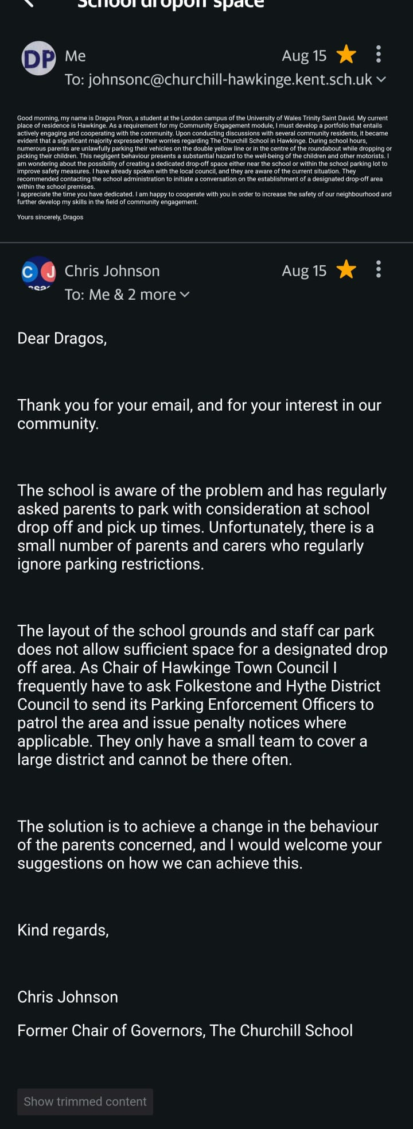
Good morning, my name is Dragos Piron, a student at the London campus of the University of Wales Trinity Saint David. My current place of residence is Hawkinge. As a requirement for my Community Engagement module, I must develop a portfolio that entails actively engaging and cooperating with the community. Upon conducting discussions with several community residents, it became evident that a significant majority expressed their worries regarding The Churchill School in Hawkinge. During school hours, numerous parents are unlawfully parking their vehicles on the double yellow line or in the centre of the roundabout while dropping or picking their children. This negligent behaviour presents a substantial hazard to the well-being of the children and other motorists. I am wondering about the possibility of creating a dedicated drop-off space either near the school or within the school parking lot to improve safety measures. I have already spoken with the local council, and they are aware of the current situation. They recommended contacting the school administration to initiate a conversation on the establishment of a designated drop-off area within the school premises.
I appreciate the time you have dedicated. I am happy to cooperate with you in order to increase the safety of our neighbourhood and further develop my skills in the field of community engagement.
Yours sincerely, Dragos

Dear Dragos,

Thank you for your email, and for your interest in our community.

The school is aware of the problem and has regularly asked parents to park with consideration at school drop off and pick up times. Unfortunately, there is a small number of parents and carers who regularly ignore parking restrictions.

The layout of the school grounds and staff car park does not allow sufficient space for a designated drop off area. As Chair of Hawkinge Town Council I frequently have to ask Folkestone and Hythe District Council to send its Parking Enforcement Officers to patrol the area and issue penalty notices where applicable. They only have a small team to cover a large district and cannot be there often.

The solution is to achieve a change in the behaviour of the parents concerned, and I would welcome your suggestions on how we can achieve this.

Kind regards,

Chris Johnson
Former Chair of Governors, The Churchill School

Conclusion :
Proposed Solution to Resolving the Parking Issue at The Churchill School, Hawkinge:
Based on the engagements made with both the Hawkinge Town Council and The Churchill School administration, the following is the proposed solution to the challenge of parking unsafely by parents during school times. The proposed solution is structured as below:
Immediate action: Awareness and enforcement:
Increase enforcement: Partner with Folkestone & Hythe District Council for more frequent and random parking enforcement patrols during peak hours to reduce illegal parking.
Community awareness campaign: Begin with an awareness campaign that includes a distribution of leaflets, posters with key messages, social media pages and platforms, and “ Parking Pledge “ that parents can sign—suggesting some concerns for possible statements in the pledge.
Short-term mitigation: Walking routes and sectioned off drop-off zones
Walking routes serve as a “walking bus”: Facilitate safe walking routes with “bus stops” where children can be dropped off and walk with appointed guardians, especially volunteers, to school to prevent accidents on roads.
Carpooling or alternative transport incentives : Promote carpooling, cycling, walking by giving parents incentives such as discounts and providing a carpool matching platform to connect parents.
Long-term solution: Infrastructure changes and cultural alteration.
Rethink school grounds: Consider the possibility of creating a small drop-FF zone on the school’s premises or nearby.
We got additional support from Lidl Hawkinge, which has agreed to allow parents to use its parking lot during peak school hours. The Lidl parking area serves as a well-placed substitute for parents and a direct solution to congestion near the school.
Main components of the updated community partnership strategy are:
Community Awareness Campaign: The offer of the Lidl is promoted to parents through flyers, school newsletters, and social media
Community Parking Collaboration: The direct traffic to the Lidl parking during the peak hours through Lidl-Branded Signs, mentioning the initiative in all materials related to Hawkinge council, and inscribing the new pedestrian route from Lidl to school.
Regular Feedback Loop: regular checks on Lidl parking usage and its reception by parents and local teams.
Development of Community Surveys: including information regarding the Lidl offer.
Change Concerning Partnerships with Local Businesses: Lidl’s assistance and partnership would be used to attract other representatives of local business to introduce similar offers and support awareness campaigns

Introducing programming to change behaviour: Develop programs to educate parents and children about how to park properly.
Feedback and improvements:
Platforms to get a pulse on the community: Regular meetings such as quarterly meetings, or an online forum to host discussions.
Periodic interviews with the community: Conduct periodical interviews to gauge what drivers and the community think.
Collaborative cultural approach
Partnering with local government: engage local authorities in a working group to explore funding sources.
Engaging local businesses: seek partnerships with local business to provide safe r routes, support, and promote awareness.

References:

- Brooks, Robin J. Kent Airfields in the Second World War. Countryside Books, 1993.
- Hawkinge. British History Online. Available at: British History Online
- Hawkinge. Domesday Book Online. Available at: Domesday Book Online
- Kent Battle of Britain Museum Trust. "History of the Hawkinge Aerodrome." Available at: Kent Battle of Britain Museum
- Longmate, Norman. The Bombers: The RAF Offensive Against Germany, 1939–1945. Hutchinson, 1983.
- Orbell, John. British Airfields of World War II: Then and Now. After the Battle, 1993.

