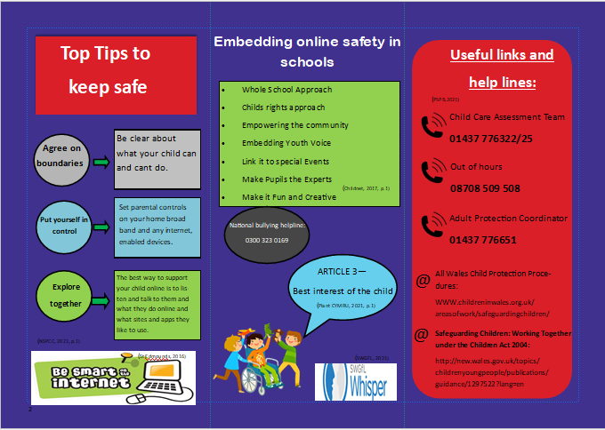
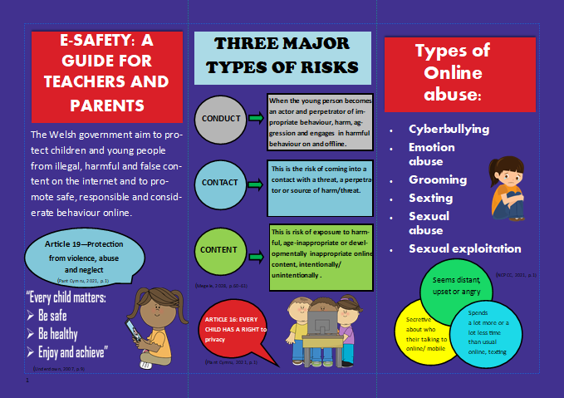

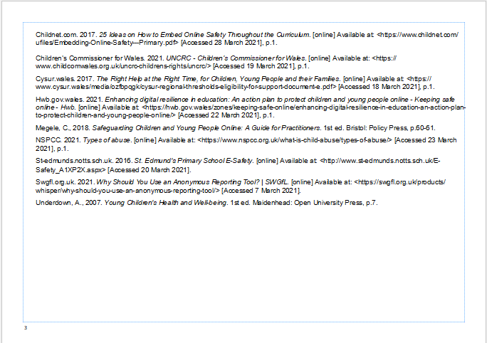

Keeping our Children Safe
The following essay will include a critical perspective relating to policies and legislation that keeps pupils safe in an educational setting. Whilst further addressing the critical role practitioners play in promoting the welfare of children. A particular focus on the contribution to theoretical approaches such as, “Bronfenbrenner’s 1979 ecological model of human development” Bronfenbrenner (1979, quoted in Underdown, 2007, p.10), which conceptualizes children’s “development within their environmental context” (Underdown, 2007, p.10). The layers that “define Bronfenbrenner’s theory are sometimes likened to Russian dolls, where smaller dolls are placed within much bigger ones” Linden (2005, quoted in Gray and Macblain, 2012, p.98). An example of these layers includes the Mesosystem, which relates to the structure of networks among “immediate environments, such as, a child’s home and school” (Gray and Macblain, 2012, p.99). Thus, these exchanges within the systems can either act as “barriers or facilitators” (McAuley and Rose, 2010, p.140).
Furthermore, the “United Nations Conventions on the Rights of the Child” (Plant Cymru, 2021, p.1) is another theoretical approach which offers a normative concept of children’s rights and a framework for understanding children’s wellbeing and will also be referred to throughout this essay. “Developing children’s understanding of their rights” (Welsh Government, 2020, p.10) is considered a vital preventative strategy to “safeguard the welfare of children and young people” (Ibid). Furthermore, to accompany this essay an e-safety leaflet has been produced, informing parents and practitioners about the risks associated with the internet. Whilst further providing practical advice and information.
From an historical perspective the “practice of child abuse goes back to the roots of human history” (Bilston, 2019, p.1). Whilst it is only in the last hundred years that it has been accepted as a “distinct phenomenon” (Ibid) in which children have the right to be safeguarded from. An example of this can be seen in what is the most influential “advocacy tool for children’s rights” (Gillet-Swan and Coppock, 2016, p.7). The “United Nations convention on the Rights of the Child (UNCRC) 1989” sets out 52 articles which are “organised into three categories including, provision, protection and participation” (Lyle, 2013, p.213). Thus, creating an “international framework for the protection and promotion of human rights and fundamental freedoms” (Gillet-Swan and Coppock, 2016, p.7). Having said this, unlike the “Human Rights Act 1998” (Collins and Foley, 2008, p.240), which is “directly enforceable throughout the UK courts” (Ibid). The UNCRC has not been “incorporated into domestic legislation” (CYPCS, 2020, p.5) within the UK despite it being a recommendation of the “UN Committee on the Rights of the Child (committee)” (CYPCS, 2020, p.5). Wales has, however, “become the first Government in the UK to enshrine the UNCRC in domestic law” (Welsh Government, 2020, p.10) through “The Rights of the Children and Young Persons (Wales) Measure 2011” (Ibid). Wales has further introduced policies, such as “The Social Services and Well-being (Wales) Act 2014 and the Well-being of Future Generations Wales Act 2015” (Holland, 2017, p.4). All of which contribute towards a “children’s rights approach” (Ibid) and plays a fundamental role in the safeguarding and protection of children.
Furthermore, the “United Nations on the Convention of the Rights of the Child (UNCRC) 1989” (Plant Cymru, 2021, p.1) “enshrines a broad range of rights and principles” (Collins and Foley, 2008, p.182), which governments must have due regard when applying “policy and practice legislation regarding child safeguarding within the UK” (Linden and Webb, 2016, p.5).“Local authorities also have overarching responsibility for safeguarding and promoting welfare of all children in their area” (Linden and Webb, 2016, p.1). In addition to this, they must follow several legislative requirements, as set out in the “1989 and 2004 Children’s Acts” (Ibid).
Written under Conservative rule and implemented in October 1991 (Walker, 2008). “The Child Act 1989” (Walker, 2008, p.30) was a ground-breaking and innovative piece of legislation” (Collings and Foley, 2008, p.230) which intended to amalgamate a vast array of previous regulation. The motivation for change was influenced when a scandal emerged from Cleveland, which found just over 500 children being referred to social services for allegations of sexual abuse, almost doubling from the previous year (Walker, 2008). The cause appeared to be the result of “two consultant paediatricians at a Middlesbrough hospital” (Walker, 2008, p.29) diagnosing the sexual abuse of children on untested medical diagnosis. This resulted in social workers removing many children from their homes in what was named as “place of safety orders” (Ibid) often in unexpected raids in which children were “literally taken from their beds and placed into care” (Ibid). Linking with “article 12 and 9 of the (UNCRC) 1989” (Plant Cymru, 2021, p,1). An inquiry headed by “Elizabeth Butler- Sloth” (Walker, 2008, p.29) found the social workers “had not paid sufficient attention to what the children were saying to them” (Walker, 2008, p.32) and the human rights of both child and parent were overlooked (Walker, 2008). Thus, the philosophy is reflected in the main ideas that “drive The Children Act 1989” (Walker, 2008, p.30), which can “coincidently be configured with the letter P” (Ibid), including the paramountcy of the child, parental responsibilities, protection, and planning which addresses the notion that “multi-agency or even single agency work should be effectively and clearly planned” (Ibid).
Linking with the UNCRC, the “three Ps - protection, participation and provision” (Collins and Foley, 2008, p.240) was considered a key feature in “The Child Act 1989” (Walker, 2008, p.30). Although sadly in 2000 this was not the case for Victoria Climbe. Thus, after her death, an investigation led by “Lord Laming” (Walker, 2008, p.154) found a number of agencies that had been “involved with the family” (Ibid) had failed to protect Victoria. “The tragedy pointed to a complete breakdown in the multi-agency approach to child protection” (Batty, 2003, p.1). Thus, linking with “Bronfenbrenner’s ecology model 1979”, the microsystems within Victoria’s environment, acted as barriers as opposed to facilitators. Additionally, linking with “article 12 of the UNCRC” (Plant Cymru, 2001, p.1) the report emphasised the “importance of listening to children” (Ibid), whilst it also acknowledged that “children in need of protection could rarely be differentiated from those with a broader range of needs” (Collins and Foley, 2008, p.183). Furthermore, early intervention can avoid the “situation deteriorating to the point where children suffer significant harm” Statham and Biehal (2005, quoted in Collins and Foley 2008, p.183).
Following on from the inquiry “the government published green paper Every Child Matters” (Walker, 2008, p.154), which was then followed by “Every Child Matters: The Next Steps and passed The Child Act 2004” DfES (2004, quoted in Walker, 2008, p.154). The ethos of “Every Child Matters programme are the five outcomes” (Walker, 2008, p.8), which the government considers to be the “five desirable outcomes for all children” (Walker, 2008, p.155). Furthermore, linking with “article 12 of the UNCRC” (Plant Cymru, 2021, p.1) these outcomes were formulated in discussion with children (Walker, 2008). However, no specific details were given to the number of children who took part (Walker, 2008). “The five outcomes” include, “Be healthy, stay safe enjoy and achieve, make a positive contribution and achieve economic well-being” (Walker, 2008, p.156). Whilst, “Wales has seven core outcomes” (Ibid), including “a flying starting in life, access to play” (Ibid) and linking with the “UNCRC article 24” (Plant Cymru, 2021, p.1), enjoy the best possible health, including freedom from abuse, victimization and exploitation” (Ibid). These outcomes further link to “Bronfenbrenner ecology model 1979” Bronfenbrenner (1979, quoted in Underdown, 2007, p.10), which considers all the child’s environment, thus, acting as a facilitator. An example of this can be seen in “area two of the five outcomes” (Walker, 2008, p.158), which stresses the importance of “early intervention and effective protection” (Ibid). Hence, developing “improved information sharing, a multi-professional team based around schools and child’s centres” (Ibid). Whilst also promoting “a Common Assessment Framework” (Ibid).
“The Right Help at the Right Time” (CYSUR, 2017, p.1) is an example of how this framework can provide the necessary guidance to practitioners when deciding what support is needed for children and families. Additionally, linking with “Bronfenbrenner ecology model” Bronfenbrenner (1979, quoted in Underdown, 2007, p.10) a holistic assessment, based around the “child’s developmental needs, basic care, and environmental factors” (CYSUR, 2017, p.6) should be considered when deciding what support is needed. For instance, “enhanced support” (Ibid) may include an intervention such as Flying Start. Although this intervention is classed as “progressive universalism” (Welsh Government, 2017, p.10), in which all “flying start families should receive additional intervention beyond those offered universally through the HCWP” (Ibid). Thus, enhanced intervention may include support such as “parent support programmes and speech and language interventions” (Ibid), whilst intensive support is much more likely to include “a multi-agency approach including home visits and safeguarding and child protection” (Ibid).
The “term child protection” (Walker, 2008, p.68) was considered the norm among practitioners up until 2003. Then, the governments “Every Child Matters programme” changed the approach towards the protection of children and adopted a much wider perspective, hence, the term “safeguarding children and promoting their welfare” (Ibid). Additionally, linking with “Article 19 of the UNCRC” (Plant Cymru, 2021, p.1), “the Welsh Government’s Keeping Learners Safe Guidance 2021” (Welsh Government, 2021, p.1) states that the “safe-guarding is preventing and protecting children from abuse, neglect or other kinds of harm and educating those around them to recognise the signs and dangers” (Ibid). Thus, practitioners should for instance take measures “to prevent impairment of children’s health” (Welsh Government, 2021, p.6), whilst also “taking action to enable children to achieve the best outcomes” (Ibid), which further links with “Article 6 of the UNCRC” (Plant Cymru, 2021, p.1).
From a personal perspective, School A acknowledges the role it contributes to safeguarding through “adhering to the Wales Safeguarding Procedures and Section 175 of the Education Act 2002” (School A, 2020, p.2). Furthermore, linking with the “UNCRC three P’s” (Collins and Foley, 2008, p.240) the schools policy consists of three key strategies including provision “to pupils who may have been abused, procedures for identifying and reporting alleged abuse” (Ibid), and “prevention through teaching and pastoral support is also offered to pupils” (Ibid). Additionally, linking with “Bronfenbrenner’s ecology model” Bronfenbrenner (1979, quoted in Underdown, 2007, p.10) a multi-agency approach is an essential component to safeguarding, in which all agencies must collaborate to “promote safe practice and challenge poor and unsafe practice” (Ibid). Furthermore, it also prevents “unsuitable people from working with children and young people” (Ibid). Since 2012, the “Disclosure and Barring Service” (Hall, n d, p.62) forms an integral part of a schools safeguarding policies, as it allows employers to gain vital information on the employee’s history. Prior to this, “in 2011 there were 4.1 million applications of which 20,000 were found to be unsuitable to work with children” (Ibid) which is an example of the important role the DBS plays in protecting and safeguarding children in a school setting.
In regards to the leaflet to accompany this essay, the use of digital technology over recent years has increased dramatically and although this can provide children “unlimited opportunities to learn, to explore and to engage with others” Longfield (2018, quoted in Megele, 2018, p.7), it can also “be exploited by those with malicious intent, targeting vulnerable groups and individuals in our society” (Ibid) . Having said this, to put the possible dangers at the “forefront of learning would be as inappropriate as it would be ineffective” (Livingstone, 2019, p.1). Thus, while it is imperative to address the risks that the internet may pose, “a balance must be struck when it comes to online safety which acknowledges the many positives” (Ibid).
The (Welsh Government, 2020, p.1) state, to “support our children and young people, digital resilient is fundamental”. Resilience captures the ability to “develop knowledge, skills and strategies in order for children and young people to” (Ibid), “reduce risk of harm and mitigate the impact of online risks” (Megele, 2008, p.53), reach out for advice if needed, the ability to use critical thinking skills to recognise distortion of truth and flourish from the “opportunities the internet offers” (Welsh Government, 2020, p.1).
Resilience can be particularly effective against the effects that cyberbullying may have on a pupil. Defined “an aggressive act or behaviour that is carried out using electronic means” (Megele, 2008, p.163), research suggests cyberbullying affects over “764,000” (ONS, 2020, p.1) children and young people throughout the UK. Whilst, the frequency of cyberbullying was “significantly higher for those children with a long-term illness or disability” (Ibid). Furthermore, Cyberbullying can often leave a child with feelings of “anger, shame, guilt and self-blame” (Megele, 2008, p.11) which can then lead to “depression, emotional and mental health problems” (Ibid). This links with “Bronfenbrenner’s ecology model” Bronfenbrenner (1979, quoted in Underdown, 2007, p.10) in which the child’s environment within systems can act as a barrier as opposed to a facilitator. It is of vital importance that school staff “pay attention to behavioural and emotional changes” (Megele, 2018, p.171) as this may be an indicator that a child is experiencing the effects of cyberbullying. For instance, a child may display signs such as, “low self-confidence, and low self-esteem” (Ibid), there attendance at school may have fallen and linking with “Article 26 of the UNCRC” (Plant Cymru, 2021, p.1), the pupil’s academic achievements may fall. Along with spotting the signs, practitioners need to be aware of the correct protocol to follow regarding any concerns they may have. For instance, disclosures must be recorded straight away and given to the designated person in charge of managing safeguarding in schools – this for instance may be the head teacher or child protection officer (School A, 2020). In addition to this it is of vital importance that staff know the correct way to respond to a child if an allegation is made. Linking with “Article 12 of the UNCRC” (Plant Cymru, 2021, p.1) staff need to listen to what the child is saying without any judgement or bias. Whilst, although reassuring the pupil, the member of staff must not “promise confidentiality as they have a duty to pass on the pupil’s information” (Ibid). This links with “The Child Act 1989” (Underdown, 2008, p.30). Thus, the child must be aware of this. It is imperative that children give their own account of the incident, although “open ended questions, such as what happened? Or where did it happen?” (School A, 2020, p.6).
Schools play an integral part in keeping our children safe and although there are many positive aspects that children can enjoy there are also many risks. “A whole school approach to online safety helps ensure staff, governors, volunteers and parents” (NSPCC, 2021, p.1) teach children to become digitally resilient and “teach children about e-safety” (Ibid). Furthermore, schools should adopt positive environments in which children can openly talk about there experiences on-line. Whilst further expressing any concerns they may have. Although schools play a fundamental role in the safety of children, each and every one of us in Wales has a responsibility for keeping children and young people safe (Davies, 2017, p.1).

Appendices
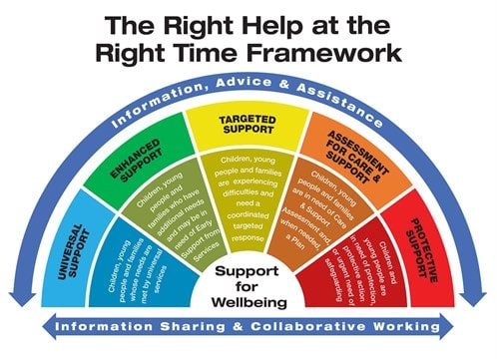

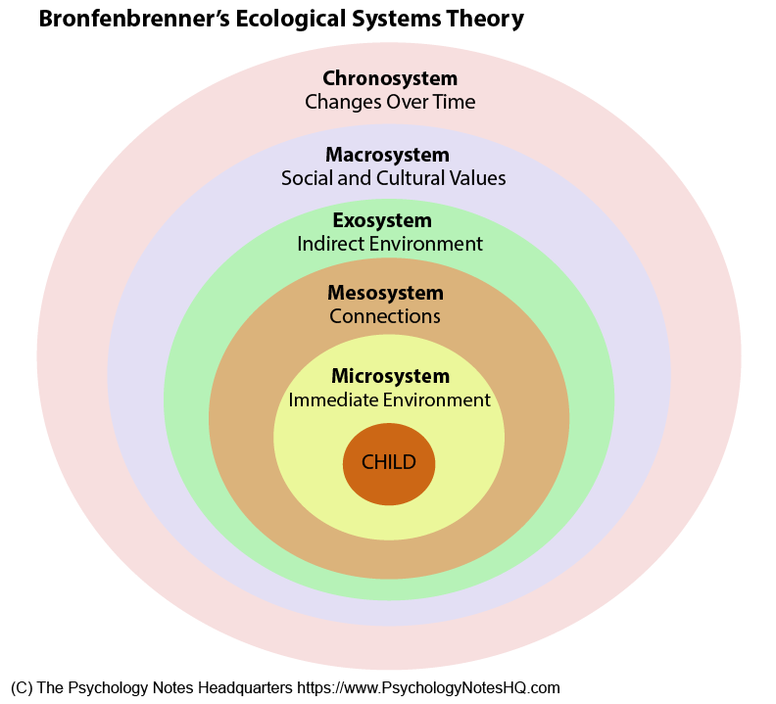

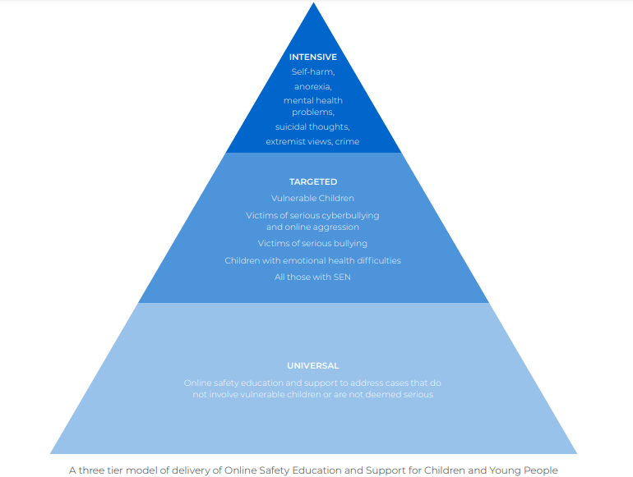

Reference list
Batty, D., 2003. Victoria Climbe Inquiry. The Guardian, [online] Available at: <https://www.theguardian.com/society/2003/jan/30/1> [Accessed 22 March 2021], p.1.
Bentley, H., Fellowes, A., Glenister, S., Mussen, N., Ruschen, H., Slater, B., Turnbull, M., Vine, T., Wilson, P. and Hayes, S., 2020. How safe are our children 2020 [online] Scotland: NSPCC. Available at: <https://learning.nspcc.org.uk/media/2287/how-safe-are-our-children-2020.pdf> [Accessed 31 January 2021], p.1-30.
Bilston, B., 2019. A history of child protection. [online] Open Learn. Available at: <https://www.open.edu/openlearn/body-mind/childhood-youth/working-young-people/history-child-protection> [Accessed 15 February 2021], p.1.
Children’s Commissioner for Wales. 2021. UNCRC - Children’s Commissioner for Wales. [online] Available at: <https://www.childcomwales.org.uk/uncrc-childrens-rights/uncrc/> [Accessed 19 March 2021], p.1.
Childcomwales.org.uk. 2017. The Right Way A Children's Rights Approach in Wales. [online] Available at: <https://www.childcomwales.org.uk/wp-content/uploads/2017/04/The-Right-Way.pdf> [Accessed 1 March 2021], p.1.

Child Net. 2018. Digital resilience. [online] Available at: <https://www.childnet.com/resources/digital-resilience> [Accessed 13 March 2021], p.1.

Collins, J. and Foley, P., 2008. Promoting children's wellbeing. 1st ed. Bristol: Policy Press, p.178-240.

Cypcs.org.uk. 2020. Report of the Children's Commissioners of the United Kingdom of Great Britain and Northern Ireland to the United Nations Committee on the Rights of the Child. [online] Available at: <https://cypcs.org.uk/wpcypcs/wp-content/uploads/2020/12/crc-report-2020.pdf> [Accessed 28 February 2021], p.3-31.
Cysur.wales. 2017. The Right Help at the Right Time, for Children, Young People and their Families. [online] Available at: <https://www.cysur.wales/media/ozfbpqgk/cysur-regional-thresholds-eligibility-for-support-document-e.pdf> [Accessed 18 March 2021], p.1-17.
Dickinson, R., 2021. Reflecting on the Children Acts of 1989 and 2004. [online] Themj.co.uk. Available at: <https://www.themj.co.uk/Reflecting-on-the-Children-Acts-of-1989-and-2004/216219#> [Accessed 22 March 2021], p.1.
Dorey, E., 2016. The Children’s Charter: A Turning Point in the History of Childhood. [online] History of Childhood and Youth. Available at: <https://ellendorey.wordpress.com/2016/11/16/the-childrens-charter-a-turning-point-in-the-history-of-childhood/> [Accessed 17 February 2021], p.1.
Falch-Eriksen, A. and Backe-Hansen, E., 2018. Human Rights in Child Protection: Implications for Professional Practice and Policy. 1st ed. [eBook] Oslo: Palgrave Macmillan. Available at: <https://link.springer.com/book/10.1007/978-3-319-94800-3> [Accessed 1 March 2021], p.3-60.
Firmin, C., 2020. Contextual Safeguarding and Child Protection: Rewriting the Rules. 1st ed. Oxon: Routledge, p.3-50.
Gillet-Swan, J. and Coppock, V., 2016. Children's Rights, Educational Research and the UNCRC Past, Present and Future. 1st ed. Oxford: Symposium, p.7.
GOV.WALES. 2017. “Safeguarding is everyone’s responsibility” – Huw Irranca-Davies | GOV.WALES. [online] Available at: <https://gov.wales/safeguarding-everyones-responsibility-huw-irranca-davies> [Accessed 28 March 2021], p.1.
Gray, C. and MacBlain, S., 2012. Learning theories in childhood. 1st ed. London: Sage, p.98-99.
Hall, A., n.d. Keeping Children Safe in Education. [online] Safeguardinginschools.co.uk. Available at: <https://www.safeguardinginschools.co.uk/wp-content/uploads/2014/09/Serious-Issues-in-Safeguarding-Andrew-Hall-Every-Child-Matters-Journal.pdf> [Accessed 28 March 2021], p.62.
Holland, S., 2021. A Report of the Welsh Government's exercise of its functions by the Children's Commissioner for Wales. [online] Children's Commissioner for Wales. Available at: <https://www.childcomwales.org.uk/wp-content/uploads/2021/02/ReviewofWG_FINAL_ENG.pdf> [Accessed 8 March 2021], p.4.
Hwb.gov.wales. 2020. Enhancing digital resilience in education: An action plan to protect children and young people online - Keeping safe online - Hwb. [online] Available at: <https://hwb.gov.wales/zones/keeping-safe-online/enhancing-digital-resilience-in-education-an-action-plan-to-protect-children-and-young-people-online/> [Accessed 27 March 2021], p.1.
Katz, A. and Assam, A., 2018. Vulnerable Children in a Digital world. [online] Available at: <https://www.internetmatters.org/wp-content/uploads/2019/04/Internet-Matters-Report-Vulnerable-Children-in-a-Digital-World.pdf> [Accessed 17 March 2021], p.2-22.
Lindon, J. and Webb, J., 2016. Safeguarding and Child Protection 5th Edition. 5th ed. London: Hodder Education, p.5.
Livingstone, S., 2019. The online safety education challenge for schools. [online] Parenting for a Digital Future. Available at: <https://blogs.lse.ac.uk/parenting4digitalfuture/2019/01/30/the-online-safety-education-challenge-for-schools/> [Accessed 27 March 2021], p.1.
Lyle, S., 2014. Embracing the UNCRC in Wales (UK): policy, pedagogy, and prejudices. Educational Studies, [online] 40(2), pp.215-232. Available at: <https://doi-org.ezproxy.uwtsd.ac.uk/10.1080/03055698.2013.870880> [Accessed 17 February 2019], p.215-232.

McAuley, C. and Rose, W., 2010. Child Well-Being. 1st ed. London: Jessica Kingsley, p.10-140.

Megele, C., 2018. Safeguarding Children and Young People Online: A Guide for Practitioners. 1st ed. Bristol: Policy Press, p.3-163.
Ons.gov.uk. 2020. Online bullying in England and Wales - Office for National Statistics. [online] Available at: <https://www.ons.gov.uk/peoplepopulationandcommunity/crimeandjustice/bulletins/onlinebullyinginenglandandwales/yearendingmarch2020> [Accessed 28 March 2021], p.1.
NSPCC Learning. 2021. E-safety for schools | NSPCC Learning. [online] Available at: <https://learning.nspcc.org.uk/research-resources/schools/e-safety-for-schools> [Accessed 28 March 2021], p.1.

Pembrokedockcommunityschool.co.uk. 2020. Pupil Safeguarding | Pembroke Dock Community School. [online] Available at: <https://www.pembrokedockcommunityschool.co.uk/pupil-safeguarding/> [Accessed 28 March 2021], p.1-13.
Smahel, D., Machackova, H., Mascheroni, G., Dedkova, L., Staksrud, E., Olafsson, K., Livingstone, S. and Hasebrink, U., 2020. EU Kids Online 2020. [online] Available at: <https://www.lse.ac.uk/media-and-communications/assets/documents/research/eu-kids-online/reports/EU-Kids-Online-2020-10Feb2020.pdf> [Accessed 14 March 2021], p.2-50.
Shotton, G. and Burton, S., 2019. Emotional Wellbeing: An Introductory Handbook for Schools. 2nd ed. Oxon: Routledge, p.1-60.
Starmans, B., 2018. Society for the Prevention of Cruelty to Children. [online] The Social Historian. Available at: <https://www.thesocialhistorian.com/suffer-the-children/> [Accessed 15 February 2021], p.1.
The Psychology Notes Headquarters. 2021. What is Bronfenbrenner's Ecological Systems Theory? - The Psychology Notes Headquarters. [online] Available at: <https://www.psychologynoteshq.com/bronfenbrenner-ecological-theory/> [Accessed 18 March 2021].
The Welsh Government, 2017. Flying Start Health Programme Guidance. Cardiff: Crownp. p.2-14.
The Welsh Government, 2020. Keeping Learners Safe; The role of local authorities, governing bodies, and proprietors of independent schools under the Education Act 2002. Cardiff: Crown, p.10.
Underdown, A., 2007. Young Children's Health and Well-being. 1st ed. Maidenhead: Open University Press, p.10-30.
Walker, G., 2008. Working together for children. 1st ed. London: Continuum, p.30-154.

