SERVICE IMPROVEMENT REPORT
A Critical Analysis of Quality and Patient-Safety Failures at Mid Staffordshire NHS Foundation Trust and a Proposed Quality Improvement Strategy
Module: LCHS7006 – Service Improvement
MSc Level 7
University of Wales Trinity Saint David (UWTSD)
Student Name:- Rizwana (2521764)

Contents
1. Introduction and Contextual Background
2. Critical Analysis and Evidence Base
3. Root-Cause Analysis
3.1Fishbone Analysis
3.2 Five Why
3.3 Donabedian Model
3.4 SWOT Analysis
4. Proposed Quality Improvement Strategy
4.1 PDSA
4.2 Lean
4.3 Six Sigma
5. Implementation Plan
6. Measurement and Evaluation
7. Critical Evaluation and Sustainability
8. Conclusion
9. References

Abbreviations
Abbreviation | Full Term
BBC | British Broadcasting Corporation
BMJ | British Medical Journal
CQC | Care Quality Commission
DHSC | Department of Health and Social Care
IOM | Institute of Medicine
JAMA | Journal of the American Medical Association
Lean | Lean Healthcare / Lean methodology
NHS | National Health Service
PDCA | Plan-Do-Check-Act
PDSA | Plan-Do-Study-Act
PESTLE | Political, Economic, Social, Technological, Legal, Environmental
PSIRF | Patient Safety Incident Response Framework
QI | Quality Improvement
RCA | Root-Cause Analysis
RCPCH | Royal College of Paediatrics and Child Health
Six Sigma | Six Sigma Quality Improvement Methodology
SWOT | Strengths, Weaknesses, Opportunities, Threats
WHO | World Health Organization

1. Introduction and Contextual Background
Quality improvement (QI) is a central component of safe healthcare because high-quality services must continuously identify variation, learn from failures and redesign systems. The Institute of Medicine (2001) conceptualises quality through safety, effectiveness, patient-centredness, timeliness, efficiency and equity. This multidimensional definition is important because a service may perform well against financial or activity indicators while still providing unacceptable patient care. Donabedian (1988) similarly proposes that quality can be understood through structure, process and outcome, linking organisational resources and conditions with the way care is delivered and the results experienced by patients.
The Mid Staffordshire NHS Foundation Trust case is a powerful illustration of what can occur when these dimensions become disconnected. The Healthcare Commission's 2009 investigation identified serious concerns about care at Stafford Hospital and prompted further investigation. The subsequent Francis inquiries demonstrated that the problems were not adequately explained by isolated clinical errors. Rather, they involved interacting weaknesses in leadership, staffing, governance, organisational culture, complaints handling, patient voice and external scrutiny (Healthcare Commission, 2009; Francis, 2010; Francis, 2013). The final Public Inquiry made 290 recommendations, demonstrating the scale and systemic nature of the findings. The Government's later response addressed the recommendations through measures intended to strengthen openness, staffing transparency, complaints learning and patient safety (Department of Health, 2013).
This report critically analyses Mid Staffordshire as a systems-level quality and patient-safety failure and proposes a 12-month improvement strategy. The analysis deliberately distinguishes warning signals from causal claims. It uses Fishbone and Five Whys to explore contributory factors, Donabedian to connect structure, process and outcome, and SWOT to assess implementation conditions. PDSA, Lean and Six Sigma are then integrated into a practical improvement programme. The strategy is evaluated through outcome, process and balancing measures, with contemporary NHS patient-safety principles informing sustainability.

2. Critical Analysis and Evidence Base
Mortality indicators were an important warning signal in the Mid Staffordshire case, but a Level 7 analysis should avoid interpreting an elevated mortality ratio as a direct count of deaths caused by poor care. Mortality statistics are screening signals that require investigation and triangulation. Their interpretation should be combined with patient accounts, complaints, staffing information, clinical evidence and regulatory findings. This distinction is essential because correlation does not establish causation and because hospital mortality is influenced by case mix, comorbidity and other factors. The significance of the Mid Staffordshire evidence therefore rests on convergence across multiple sources rather than on one numerical indicator.
The Francis Inquiry provides that wider evidence base. It documented unacceptable experiences of care and deficiencies in organisational systems, demonstrating that the issue was not simply technical performance. A key governance lesson is that organisations require multiple sources of safety intelligence and must act when different indicators point towards deterioration. A dashboard that only reports mortality, waiting times or financial performance may create false reassurance. Effective governance should integrate clinical outcomes, staffing, patient experience, complaints, incident learning and qualitative staff intelligence.
Workforce capacity was a major concern. Francis (2013) identified problems associated with staffing and the delivery of fundamental care. Wider evidence supports the importance of adequate nurse staffing, although associations should not be simplistically transferred from one setting to another. Aiken et al. (2014) found associations between nurse staffing, nurse education and hospital mortality across European hospitals. The critical implication is that staffing is a system variable interacting with acuity, skill mix, supervision, workload, leadership and escalation processes. Consequently, the proposed intervention does not rely on a staffing number alone; it combines safe staffing oversight with escalation and monitoring of staff wellbeing.
Organisational culture provides a further explanatory layer. Francis (2013) described an environment in which concerns were not sufficiently challenged and poor standards could become normalised. Edmondson's (1999) concept of psychological safety is relevant because staff need to feel able to speak up, question decisions and report risk. However, psychological safety should not be treated as a standalone solution. Culture is shaped by leadership behaviour, organisational structures, workload, incentives and the way concerns are responded to (Mannion and Davies, 2018). A safety culture intervention must therefore be supported by visible leadership action and credible escalation routes.
Leadership and governance are particularly important because organisational priorities determine what receives attention. The Francis Inquiry showed how the pursuit of organisational objectives could become disconnected from the fundamental requirement to provide safe, compassionate care (Francis, 2013). Financial stewardship is legitimate and necessary in the NHS, but it becomes unsafe when cost control is treated as an end in itself rather than balanced with quality and patient safety. Boards should therefore examine quality, workforce, patient experience and financial indicators together and explicitly test whether efficiency initiatives create unintended safety consequences.
Patient voice is another critical dimension. Complaints and patient stories are potential sources of safety intelligence, not merely reputational threats. If complaints are minimised or handled defensively, the organisation loses an important opportunity to detect harm and learn. Importantly, a reduction in complaint numbers does not necessarily demonstrate improvement; it may reflect barriers to reporting. The proposed strategy therefore focuses on complaint themes, timeliness of responses, evidence of learning and direct patient involvement rather than complaint volume alone.
External regulation also matters. The case illustrates the risk of fragmented assurance when different bodies hold pieces of information but no organisation creates a sufficiently coherent picture of risk. The Government response after Francis sought to improve transparency and surveillance, including greater visibility of staffing and complaints learning. The contemporary PSIRF approach similarly emphasises system-based learning, proportionate responses and involvement of patients, families and staff (NHS England, 2022). These developments reinforce the argument that patient safety requires an integrated learning system rather than isolated investigations.

3. Root-Cause Analysis
Root-cause analysis should be used carefully in complex healthcare because there may be multiple interacting contributors rather than one final cause. Reason (2000) argues for understanding how system conditions create opportunities for error. The following tools are therefore used as complementary lenses rather than as proof of a single causal pathway.

3.1 Fishbone Analysis
The Fishbone framework organizes interacting contributors rather than identifying a single cause. It is useful for multidisciplinary discussion because it makes the relationship between workforce, leadership, culture, governance, processes, patient voice and regulation visible.
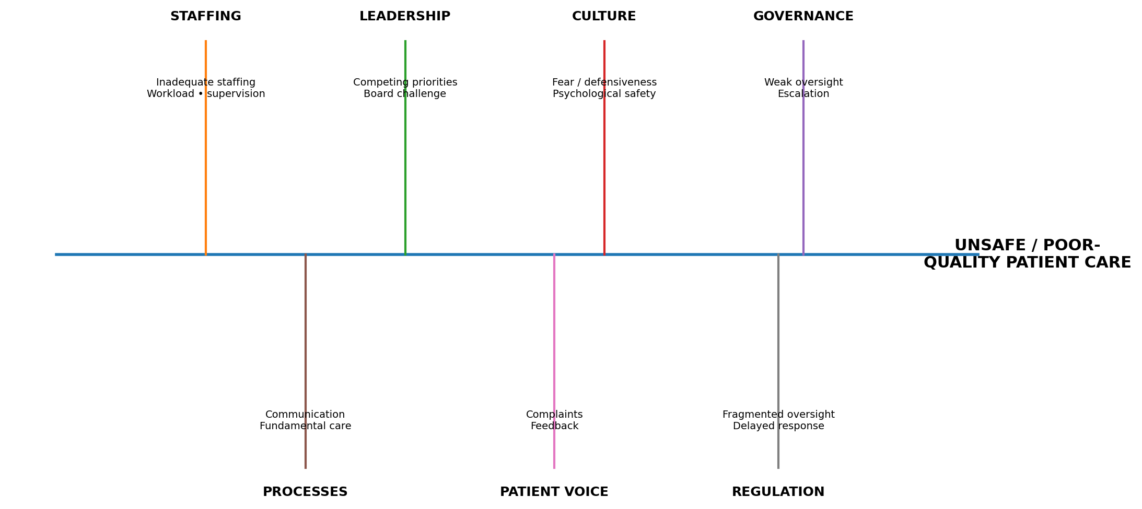
Figure 1. Fishbone analysis of contributing factors to unsafe and poor-quality patient care. Source: Author's own construction informed by Francis (2013), Reason (2000) and Mannion and Davies (2018).
The main limitation is that a Fishbone diagram can make a complex adaptive system appear linear. The factors shown should therefore be treated as interacting contributors. For example, inadequate staffing can increase workload, reduce supervision, weaken communication and contribute to burnout, while a defensive culture may simultaneously reduce escalation.

3.2 Five Whys
Stage | Analysis
Problem | Unsafe and inadequate patient care
Why 1 | Staffing, supervision and escalation were insufficiently reliable
Why 2 | Care processes were not consistently supported by adequate systems and resources
Why 3 | Operational, financial and organisational priorities competed with quality priorities
Why 4 | Governance and leadership did not sufficiently identify and challenge deteriorating care
Why 5 | Weak learning culture, staff voice, patient feedback and external assurance allowed problems to persist
Figure 2. Five Whys analysis. Source: Author's own analysis informed by Francis (2013) and Reason (2000).
Five Whys is limited by its tendency to imply a single causal chain. In healthcare, multiple causes often operate simultaneously. The tool is therefore used here as a structured questioning method, not as evidence that one factor was the ultimate cause.

3.3 Donabedian Model
Donabedian's model links organizational conditions to care processes and patient outcomes. It provides a useful bridge between root-cause analysis and the proposed improvement strategy.
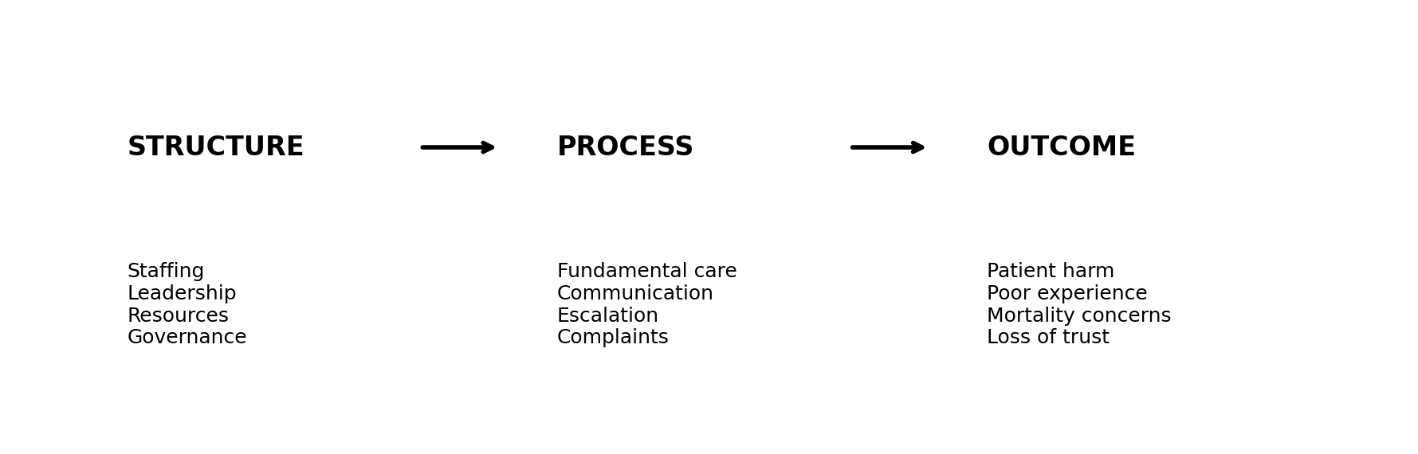
Figure 3. Application of Donabedian's structure-process-outcome model. Source: Adapted from Donabedian (1988).
Structure includes staffing, leadership, governance and resources; process includes fundamental care, communication, monitoring and escalation; outcomes include patient harm, experience and trust. The model is valuable but does not fully explain culture, power or regulatory fragmentation, so it is complemented by the other frameworks.

3.4 SWOT Analysis
STRENGTHS | WEAKNESSES
- Evidence-based QI methods  Clear measurement framework  Patient and staff engagement  Iterative testing | - Staff time and capacity  Potential resistance  Data-quality limitations  Resource requirements
- PSIRF learning approach  Digital governance dashboard  Stronger patient voice  Improved staff escalation | - Workforce shortages  Financial pressures  Change fatigue  Competing organizational priorities
Figure 4. SWOT analysis of the proposed QI strategy. Source: Author's own analysis.

4. Proposed Quality Improvement Strategy
The overall aim is to improve the reliability of fundamental patient care and safety escalation over 12 months through stronger staffing oversight, multidisciplinary safety huddles, patient and staff voice, transparent governance and systematic learning. The strategy intentionally combines several QI methods because the Mid Staffordshire problem was multifactorial. A single dashboard, staffing intervention or training programme would be unlikely to address the interacting causes.
PDSA is used as the core improvement engine because it permits small-scale testing before wider implementation. Taylor et al. (2014) found widespread use of PDSA in healthcare but also highlighted weaknesses in reporting and application. This means each cycle should have a defined change, prediction, measurement plan and documented learning. The first cycle would pilot structured safety huddles on selected acute wards, followed by review of staffing risks, incidents, patient concerns and staff feedback.
Lean principles can support process redesign by identifying unnecessary steps, delays, duplication and communication waste. In this case, Lean could be applied to handover, escalation and documentation pathways. However, Lean must not be equated with simple cost reduction. If staffing is reduced or essential clinical activity is removed in the name of efficiency, the intervention could reproduce the very conditions associated with poor care. Lean should instead focus on removing process waste while protecting the resources required for safe care.
Six Sigma complements Lean by focusing on variation and process reliability. A DMAIC structure could define inconsistent early-warning-score escalation as a quality problem, measure baseline compliance, analyse causes of variation, improve the process through standardisation and PDSA, and control performance through routine monitoring. This approach creates a measurable pathway from identifying variation to sustaining improvement. Its limitation is that statistical control cannot compensate for poor leadership or unsafe staffing, so it must remain embedded within wider organizational change.

4.1 PDSA
PDSA should be implemented through small tests of change. The first cycle could test a standardised multidisciplinary safety huddle on one or two wards, measuring attendance, escalation actions, staff perceptions and safety indicators. The second cycle could adapt the intervention based on learning before wider implementation.
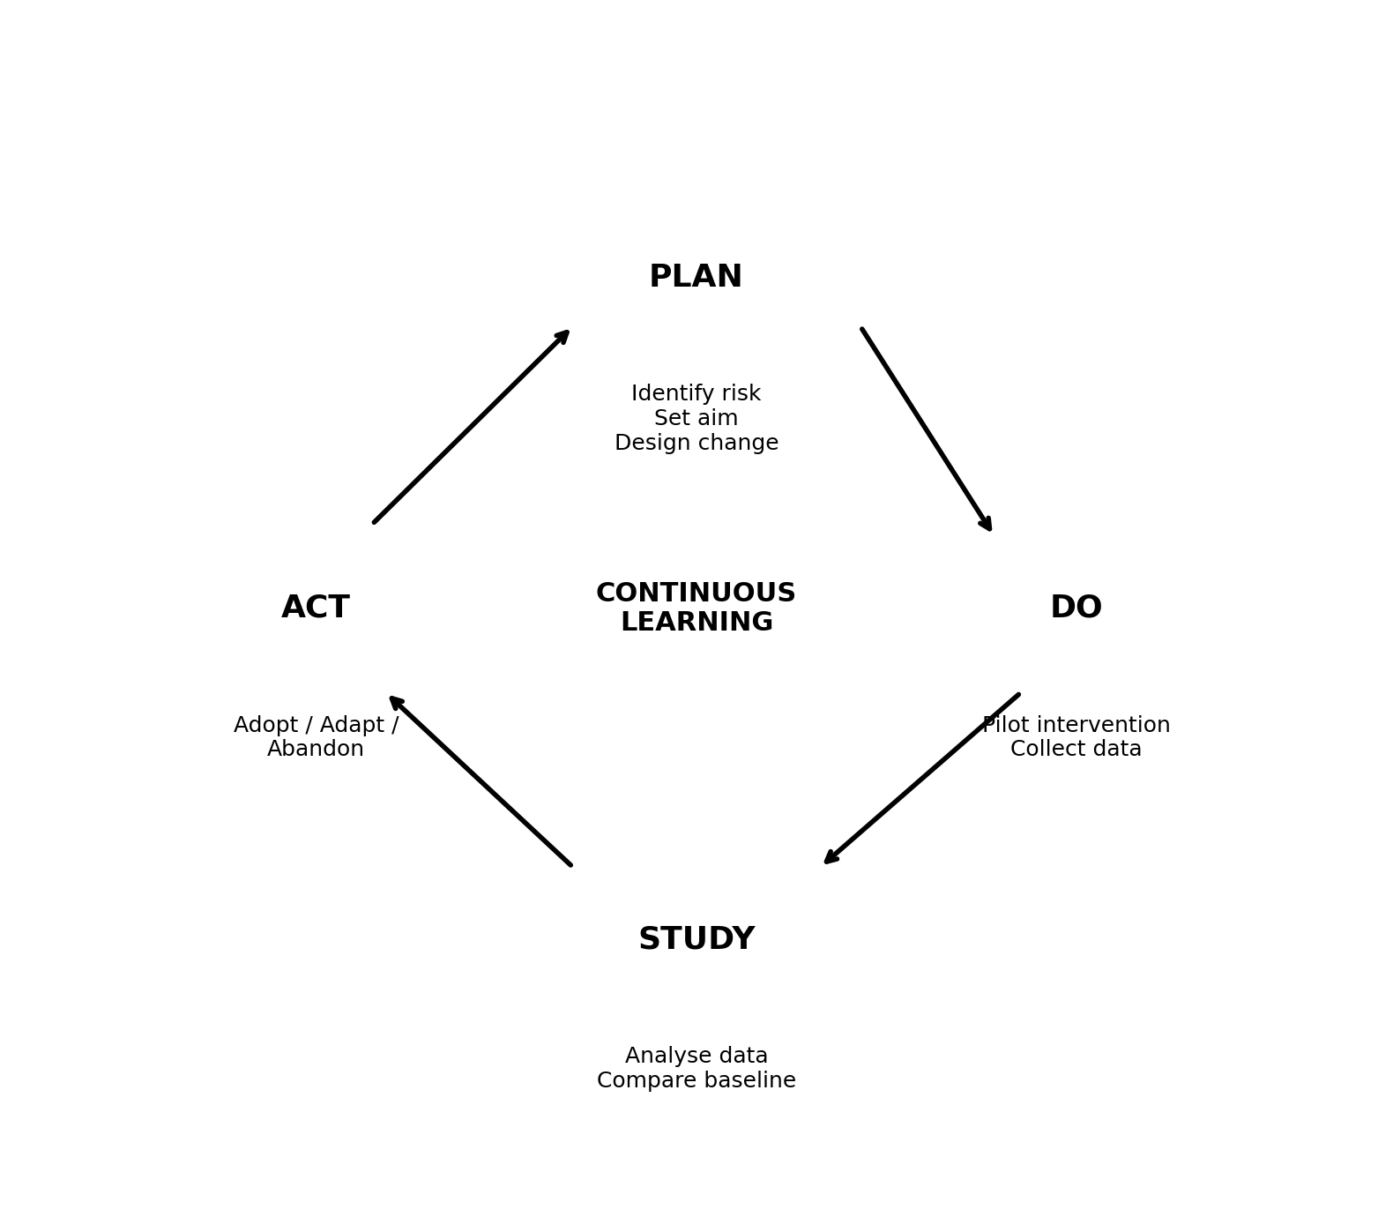
Figure 5. PDSA cycle for patient-safety improvement. Source: Adapted from Taylor et al. (2014).

5. Implementation Plan
Implementation should proceed in phases so that the organisation does not introduce multiple changes simultaneously without learning. Months 1–3 focus on baseline measurement and a small PDSA pilot. Months 4–6 expand governance infrastructure and Duty of Candour training. Months 7–9 apply Lean to priority pathways, and months 10–12 consolidate successful changes and use Six Sigma-style process control. Senior clinical leadership, ward managers, quality teams, patient representatives and frontline staff should share responsibility for implementation.
A governance dashboard should be reviewed at ward, divisional and board level. Escalation rules should specify what happens when safe staffing, early-warning-score compliance or patient-safety indicators fall below agreed thresholds. The dashboard should not replace clinical judgement. Instead, it should support timely conversations and escalation. Patient and staff feedback should be reviewed alongside quantitative data so that improvement is assessed for both measurable outcomes and lived experience.

5. Implementation Plan
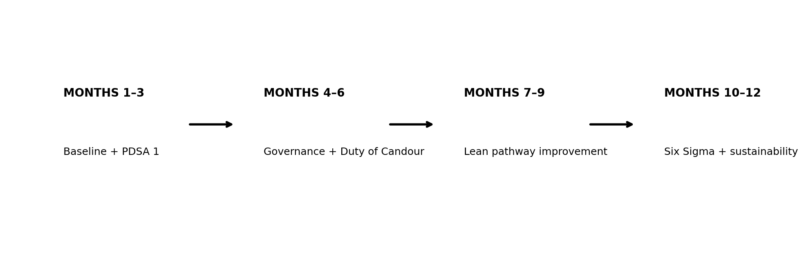
Figure 6. Proposed 12-month implementation pathway. Source: Author's own construction.
Phase | Timing | Main intervention | Key outputs
1 | Months 1–3 | Baseline audit + PDSA 1 | Baseline data; safety-huddle pilot; staff/patient feedback
2 | Months 4–6 | Governance dashboard + Duty of Candour training | Escalation thresholds; board reporting; training
3 | Months 7–9 | Lean pathway improvement | Reduced duplication/delay; standardised handover/escalation
4 | Months 10–12 | Six Sigma + sustainability | Variation analysis; standardisation; final evaluation

6. Measurement and Evaluation
Evaluation should include outcome, process and balancing measures. Outcome measures assess whether patient safety and experience improve; process measures test whether the intervention is being delivered as intended; and balancing measures identify unintended consequences. This combination reduces the risk that a project is declared successful merely because documentation compliance increases.
Suggested outcomes include hospital-acquired pressure ulcers, falls, patient experience and complaint themes. Process measures include the proportion of shifts meeting locally agreed safe-staffing thresholds, compliance with safety huddles and early-warning escalation, and completion of safety training. Balancing measures include staff sickness, burnout, workload and agency expenditure. Targets should be finalised after baseline measurement rather than imposed without local context. A target such as 95% compliance can be used as a proposed benchmark for process reliability, but it should be justified against baseline performance and clinical risk.
Run charts or statistical process control methods could be used to monitor change over time rather than comparing only pre- and post-intervention averages. This is important because healthcare performance fluctuates naturally. Qualitative data from staff and patients should be triangulated with numerical indicators. If a numerical measure improves while staff report increased workload or patients report poorer communication, the intervention should be adapted rather than declared successful.

6. Measurement and Evaluation
Type | Metric | Proposed benchmark | Purpose
Outcome | Falls | Reduction from baseline over 12 months | Patient safety
Outcome | Hospital-acquired pressure ulcers | Reduction from baseline | Fundamental care
Outcome | Patient experience | Improvement from baseline | Patient-centredness
Outcome | Complaint themes | Evidence of learning and improved response | Patient voice
Process | Safe staffing threshold compliance | ≥95% proposed benchmark | Workforce reliability
Process | Early-warning escalation compliance | ≥95% proposed benchmark | Timely response
Process | Safety-huddle completion | ≥95% proposed benchmark | Team communication
Process | Safety training completion | ≥95% proposed benchmark | Capability
Balancing | Staff sickness/burnout | No deterioration | Avoid workload harm
Balancing | Agency expenditure | Monitor | Avoid unintended financial impact
Balancing | Staff workload | Monitor | Avoid burden displacement
Figure 7. Proposed outcome, process and balancing measures. Source: Author's own construction.
The proposed 95% process benchmarks are improvement targets, not historical Mid Staffordshire results. They should be confirmed after baseline measurement and local clinical risk assessment.

7. Critical Evaluation and Sustainability
The major Level 7 challenge is sustainability. QI tools do not independently guarantee long-term safety. A checklist, roster or dashboard can exist while poor culture persists. The Francis case demonstrates why technical controls must be supported by leadership, staffing, psychological safety and mechanisms for patient involvement. The organisation must therefore make safety a standing board priority and demonstrate that concerns lead to action.
PSIRF provides a useful contemporary framework because it aims to support learning and improvement through system-based approaches, proportionate responses and compassionate involvement of those affected by incidents (NHS England, 2022). NHS England states that PSIRF integrates patient and family engagement, system-based learning, proportionate responses and supportive oversight. It also links incident response with clinical governance and complaints management. This is highly relevant to the lessons of Mid Staffordshire because safety learning must cross organisational boundaries rather than remain within individual investigations.
A further sustainability risk is compliance culture. If staff believe that dashboards are primarily used for performance management, they may prioritise recording compliance rather than raising concerns. This could recreate the defensive behaviours that contributed to poor learning. Leaders should therefore communicate that data are used to identify risk and improve systems, while accountability remains appropriate when there is deliberate misconduct. Psychological safety must coexist with clear professional standards.
Finally, improvement should be treated as a continuous process. After each PDSA cycle, leaders should review whether the intervention worked, for whom, under what conditions and with what unintended consequences. Successful changes should be standardised, but standardisation should not prevent local adaptation. Sustainability requires ongoing measurement, staff engagement, patient involvement, leadership visibility and periodic review of whether the intervention continues to improve outcomes.

8. Conclusion
Mid Staffordshire demonstrates that major patient-safety failures can emerge from the interaction of workforce pressures, governance weakness, organisational culture, leadership priorities, inadequate patient voice and fragmented oversight. The case cannot be reduced to individual error or one deficient process. A systems perspective is therefore necessary.
The proposed 12-month strategy combines Fishbone, Five Whys, Donabedian and SWOT for analysis and PDSA, Lean and Six Sigma for improvement. Outcome, process and balancing measures provide a balanced evaluation framework. The strategy is deliberately designed around learning rather than compliance alone and incorporates contemporary PSIRF principles concerning system-based learning and engagement with patients, families and staff.
The central lesson is that patient safety must remain an explicit organisational priority. Sustainable quality improvement depends on listening to patients and staff, identifying warning signals early, responding transparently to concerns, ensuring adequate capacity and continually testing whether changes improve care. In this respect, the legacy of Mid Staffordshire is not simply a historical warning but a continuing quality-governance challenge for healthcare organisations.

9. References
- Aiken, L.H., Sloane, D.M., Bruyneel, L., Van den Heede, K., Griffiths, P., Busse, R., Diomidous, M., Kinnunen, J., Kózka, M., Lesaffre, E., McHugh, M.D., Moreno-Casbas, M.T., Rafferty, A.M., Schwendimann, R., Scott, P.A., Tishelman, C., van Achterberg, T. and Sermeus, W. (2014) ‘Nurse staffing and education and hospital mortality in nine European countries: a retrospective observational study’, The Lancet, 383(9931), pp. 1824–1830. [Source]
- Ayanian, J.Z. and Markel, H. (2016) ‘Donabedian's lasting framework for health care quality’, New England Journal of Medicine, 375(3), pp. 205–207. [Source]
- Berwick, D. (2013) A Promise to Learn – A Commitment to Act: Improving the Safety of Patients in England. London: Department of Health. [Source]
- Care Quality Commission (2009) Progress report on Mid Staffordshire NHS Foundation Trust. London: CQC. [Source]
- Care Quality Commission (2018) Opening the door to change: NHS safety culture. London: CQC. [Source]
- Deming, W.E. (1986) Out of the Crisis. Cambridge, MA: MIT Press. [Source]
- Department of Health (2013) Patients First and Foremost: The Initial Government Response to the Report of the Mid Staffordshire NHS Foundation Trust Public Inquiry. London: The Stationery Office. [Source]
- Department of Health and Social Care (2013) Hard Truths: The Journey to Putting Patients First. London: The Stationery Office. [Source]
- Department of Health and Social Care (2023) The NHS Constitution for England. London: DHSC. [Source]
- Dixon-Woods, M., McNicol, S. and Martin, G. (2012) Ten Challenges in Improving Quality in Healthcare. London: The Health Foundation. [Source]
- Donabedian, A. (1988) ‘The quality of care: How can it be assessed?’, JAMA, 260(12), pp. 1743–1748. [Source]
- Edmondson, A. (1999) ‘Psychological safety and learning behavior in work teams’, Administrative Science Quarterly, 44(2), pp. 350–383. [Source]
- Francis, R. (2010) Independent Inquiry into Care Provided by Mid Staffordshire NHS Foundation Trust January 2005–March 2009. London: The Stationery Office. [Source]
- Francis, R. (2013) Report of the Mid Staffordshire NHS Foundation Trust Public Inquiry. London: The Stationery Office. [Source]
- Glasgow, J.M., Scott-Caziewell, J.R. and Kaboli, P.J. (2010) ‘Guiding inpatient quality improvement: a systematic review of Lean and Six Sigma’, Joint Commission Journal on Quality and Patient Safety, 36(12), pp. 533–540. [Source]
- Health Foundation (2013) Quality Improvement Made Simple. London: The Health Foundation. [Source]
- Helms, M.M. and Nixon, J. (2010) ‘Exploring SWOT analysis – where are we now?’, Journal of Strategy and Management, 3(3), pp. 215–251. [Source]
- Institute of Medicine (1999) To Err Is Human: Building a Safer Health System. Washington, DC: National Academy Press. [Source]
- Institute of Medicine (2001) Crossing the Quality Chasm: A New Health System for the 21st Century. Washington, DC: National Academies Press. [Source]
- Keogh, B. (2013) Review into the Quality of Care and Treatment Provided by 14 Hospital Trusts in England. London: NHS. [Source]
- Kirkup, B. (2015) The Report of the Morecambe Bay Investigation. London: The Stationery Office. [Source]
- Langley, G.J., Moen, R., Nolan, K.M., Nolan, T.W., Norman, C.L. and Provost, L.P. (2009) The Improvement Guide. 2nd edn. San Francisco: Jossey-Bass. [Source]
- Mannion, R. and Davies, H.T.O. (2008) ‘Effective quality improvement: part 1 – culture and behaviour’, Quality and Safety in Health Care, 17(1), pp. 70–74. [Source]
- Mannion, R. and Davies, H.T.O. (2018) ‘Understanding organisational culture for healthcare quality improvement’, BMJ, 363, p. k4907. [Source]
- NHS England (2019) The NHS Patient Safety Strategy: Safer Culture, Safer Systems, Safer Patients. London: NHS England. [Source]
- NHS England (2022) Patient Safety Incident Response Framework. London: NHS England. [Source]
- NHS England (2024) Patient safety incident response standards. London: NHS England. [Source]
- Rathi, R., Vakharia, A. and Shadab, M. (2022) ‘Lean six sigma in the healthcare sector: A systematic literature review’, Materials Today: Proceedings, 50, pp. 773–781. [Source]
- Reason, J. (2000) ‘Human error: models and management’, BMJ, 320(7237), pp. 768–770. [Source]
- Schein, E.H. (2010) Organizational Culture and Leadership. 4th edn. San Francisco: Jossey-Bass. [Source]
- Sunder, M.V. and Antony, J. (2018) ‘A systematic review of Six Sigma in healthcare’, International Journal of Quality & Reliability Management, 35(5), pp. 1075–1092. [Source]
- Taylor, M.J., McNicholas, C., Nicolay, C., Darzi, A., Bell, D. and Reed, J.E. (2014) ‘Systematic review of the application of the plan-do-study-act method to improve quality in healthcare’, BMJ Quality & Safety, 23(4), pp. 290–298. [Source]
- Toussaint, J.S. and Berry, L.L. (2013) ‘The promise of Lean in health care’, Mayo Clinic Proceedings, 88(1), pp. 74–82. [Source]
- Vincent, C. (2010) Patient Safety. 2nd edn. Chichester: Wiley-Blackwell. [Source]
- Wachter, R.M. (2010) ‘Patient safety at ten: unmistakable progress, troubling gaps’, Health Affairs, 29(1), pp. 165–173. [Source]
- West, M., Dawson, J., Admasachew, L. and Topakas, A. (2011) NHS Staff Management and Health Service Quality. London: Department of Health. [Source]
- World Health Organization (2021) Global Patient Safety Action Plan 2021–2030. Geneva: WHO. [Source]

