3/25/2022
Rowanne El-Nader – 2110041.
University of wales trinity saint david.
The Decline of the High Street.
Report.

Contents
Introduction: 1
Main Findings: 2
Nature: 2
Scope: 2
Impact: 2
S.W.O.T Analysis: 3
PESTLE Analysis: 4
Conclusion: 5
Recommendations: 6
Planning, Monitoring and Reviewing the Solutions: 7
Appendices: 8
Reference List: 9

Introduction:

The purpose of this report is to provide an assessment and recommend a solution on the current problem faced by the High Street at the moment, Establishing the Nature, Scope and Impact of the current problem and by using tools such as SWOT analysis, Conversion strategies, PESTLE Analysis and Decision making matrix. Once the tools have been undertaken the business will be able to bring together the information that has been suggested and come to a conclusion on how to resolve the issue.

Main Findings:

Nature:

Over the past 7 years, high streets, retail parks and shopping centres have declined by 10% due to less footfall (Nazir, 2019). There are many factors that have contributed to this, such as squeezed income, online shopping, change of taste, rising overheads, too many shops, and too much debt (Thomas, 2018).

Scope:

Online shopping has made life a little easier for people, With a click of a button customers can find the item they desired and have the item delivered the next day which is very convenient for people who work full time. Online shopping regularly has discounts on throughout the year which attracts more customers every day.
It’s like a domino effect, Distributors, Delivery companies, Retailers, Staff, Communities and Customers have suffered due to a high volume of customer choosing to shop online.

Impact:

It’s like a domino effect, When clients are choosing to continue to shop online, Retailers will now no longer want or need to buy many stock from the distributes, Due to that the distributes now no longer need the workforce to assist with the pick and packing of the stock, With much less stock going into shops, Deliveries could be much which can cause workforce cuts. That results in many sectors having no alternative but to reduce jobs as workforce are now no longer wanted because of the shortage of footfall.

To establish the nature, scope and impact on the decline of the high street, a Fishbone diagram or also known as the Ishikawa Diagram referenced to Kaoru Ishikawa who created this tool during the 1960’s . This tool is used to identify the root cause of the problem, what’s the problem, who it’s effected and how its effected (Lewis, 2020).

S.W.O.T Analysis:

SWOT analysis is a method that can be used to recognise the strengths, weaknesses, opportunities, and threats of a person and it can also be used for an organisation. SWOT Analysis was developed in the 1960’s by Albert Humphrey.
A SWOT analysis is a planning tool which is used to understand major factors such as strengths, weaknesses, opportunities, and threats involved in a project or in an organisation (CIPD.co.uk,2021).
Below is a SWOT Analysis on the scope of the decline of the high street which is online shopping;
- Strengths: Product selection, Delivery options and Return policies.
- Weaknesses: Finance, shipment prices , payment methods by clients and refunds.
- Opportunities: Influencers, improvement in technology and social media.
- Threats: Competition, crash in technology, change of legalisation.
Once a SWOT analysis has been completed opportunities will be spotted to give the business a boost in the right direction, Identify weaknesses before they threaten the profitability of the business and locate the threats in order to reduce or even offset them (Smith, n.d).

A conversion strategy that will work would be a strength to take advantage of an opportunity, for example;
- Product selection – Influencers; By reaching out to influencers, online shopping will be more exposed due to the influencers having a big social media platform, working closely with them would attract more customers to shop online and to shop for the specific brand, The brand would also be able to work closely with the influencer and promote in store events.

PESTLE Analysis:

PESTLE analysis was created by Francis Aguilar in the 1960’s, Aguilar an American scholar was an expert in strategic planning. The tool can create a large amount of data which sometimes can be overwhelming, Due to this keeping a PESTLE analysis short so that there’s a better chance of completing a careful analysis which will be more important to the business. A PESTLE analysis is a simple tool that helps businesses succeed because it allows business owners to gain an understanding of the wider market in which they are in (Reding, 2021).
Having a greater understanding of your business in general, can help you to apply your PESTLE analysis.

A PESTEL analysis is an abbreviation for a tool used to identify the external forces facing an organisation, It stand for Political, Economic, Social, Technological, Environmental and Legal.
In an organisation, before any kind of strategy or tactical plan can be applied, it is important to carry out a full situational analysis. It is recommended that an analysis should be repeated every six months to identify any changes in the macro-environment. When Organisations successfully monitor and respond to changes in the macro-environment, They will have a competitive advantage over others (blog.oxfordcollegeofmarketing.com, n.d).

A PESTLE Analysis has been undertaken and has been attached in the appendices section of this report.
The PESTLE Analysis shows the political analysis could be Brexit which has lead to a dip in currency and new trade restrictions, Covid19 has also had an impact due to lockdowns and working from home, The economical analysis is also Brexit and recently Covid19, they have led to a major decline in currency and a rise in tax, household bills and groceries. The social analysis are caused by change in trends, customers adapting to shopping online due to Covid19 and local lockdowns and customers have become unsociable.
Technology has become very important as it has majorly developed in the past few years and more recently since Covid19, Customers have had no choice but to shop online, There is more of a social media presence and companies pay for advertisement on the platforms, The Legal analysis is important as laws will differ in every trading country and if the business employs staff from abroad, they will need to have visas or work permits which is a legal requirement and finally the environmental analysis are things such as sustainable packaging and delivery (cipd.co.uk, 2021).

Conclusion:

With the high street continuing to decline and online shopping booming, Business have no choice but to adapt to the new way of retail shopping. By investigating the scope of the problem and by using tools such as SWOT analysis that can help determine strengths, weaknesses, opportunities and threats of the business followed by conversion strategies help turn a negative into a positive.
A PESTLE analysis will then help owners identify the current issues that affect the political, economic, social, technological, environmental and Legal aspect of their business.
By completing all the above businesses are able to establish the problem and understand what needs to change to continue to succussed in such turbulent times.
Once the problem is identified, A decision making matrix can be used to make the right decisions and point the business in the right direction.
Unless businesses take the time to understand the needs of the business and how they could grow it, the business will have no choice but to start cutting cost, cutting staff or close completely.

Recommendations:

Many businesses have the same path to succussed and most importantly increase sales and reduce expenses to improve profitability. According to (Waters,2019) Here are recommendations for the high street;
- Increase sale opportunities.
- Improve customer service.
- Add new products and lines.
- Buy from vendors with great value.
- Increase marketing.
- Lower expenses.
- Attend trade shows.
- Invest in new technology.
- Staff training.
- Reduce shrinkage by using security.

There are many recommendations that business can take on to help the business grow, Using tools such as SWOT analysis, Conversion strategies and a PESTLE analysis will help establish the problems which is a start but how to make the decision to go in the right direction? That is when can a Decision Making Matrix can be carried out. Once the problem has been identified, A decision making matrix will help create solutions and help point the business in the right decision.
A decision making matrix assesses and highlights a list of options that can help a business make the right decision (Asq.org, n.d).
Using one of the recommendations suggested such as Increasing sale opportunities, the decision making matrix will help pin point the best solution to implement it.

Planning, Monitoring and Reviewing the Solutions:

It’s important for a business to be organised as it helps the day run smoothly,
Having a business social media page would increase sale opportunities and will help promote the business nationally, Reaching out and working with influencers has been a popular choice for other businesses and has worked with increasing sales.
Recommendations on who to work with and which social media platform to use can be made by using the decision making matrix, once all recommendations have been given by team members the decision can be made rationally and based on the need of the business.
Routine planning and monitoring can help highlight any issues that could be in a business before they escalate. Some businesses choose to plan and monitor daily, weekly, monthly or yearly. Monitoring a certain issue and comparing data collected over time should help point out what has caused any issues or where they began. This can then be used to provide a fix or come up with ways to improve (whistl.co.uk, 2020).

Appendices:

Strengths  Product selection.  Delivery options.  Return policies. | Weaknesses  Finance.  Shipment prices.  Payment made by clients.  Refunds.
Opportunities  Influencers.  Improvement in technology.  Social media. | Threats  Competition.  Crash in technology.  Change of legalisation.

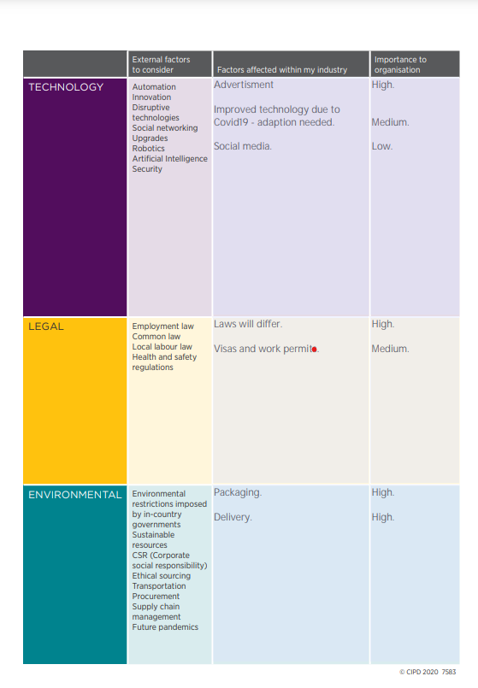
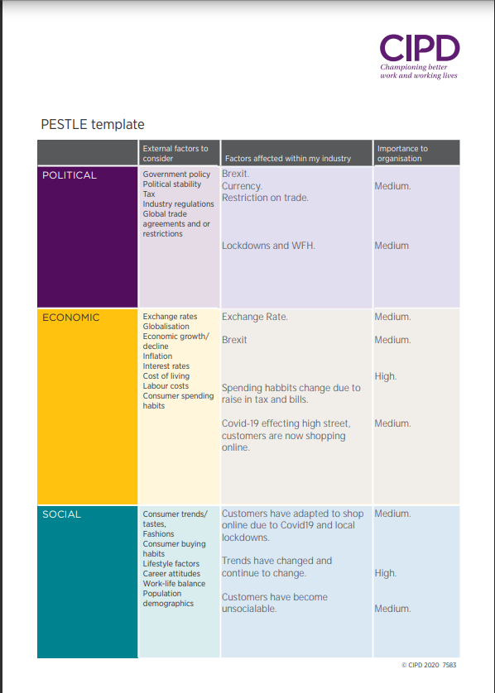
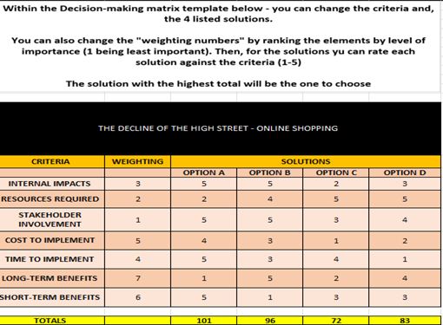

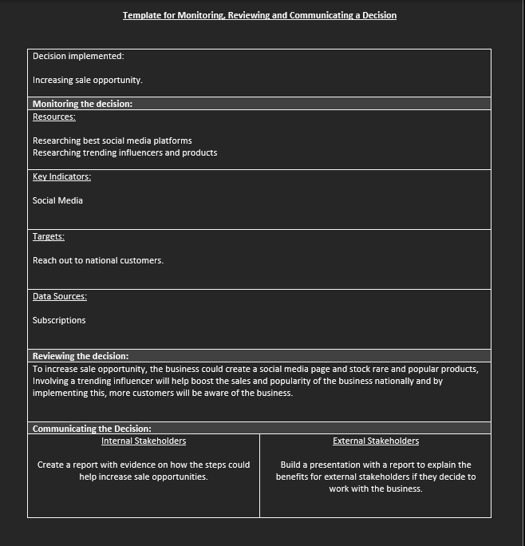

Reference List:

Asq.org. n.d. What is a Decision Matrix? Pugh, Problem, or Selection Grid | ASQ. [online] Available at: <https://asq.org/quality-resources/decision-matrix> [Accessed 24 March 2022].
Cipd.co.uk. 2021. SWOT Analysis | Factsheets | CIPD. [online] Available at: <https://www.cipd.co.uk/knowledge/strategy/organisational-development/swot-analysis-factsheet#gref> [Accessed 22 March 2022].
Lewis, S., 2020. What is a Fishbone Diagram (Ishikawa Cause and Effect Diagram)?. [online] WhatIs.com. Available at: <https://whatis.techtarget.com/definition/fishbone-diagram> [Accessed 27 January 2022].
Oxford College of Marketing Blog. 2022. What is a PESTEL analysis?. [online] Available at: <https://blog.oxfordcollegeofmarketing.com/2016/06/30/pestel-analysis/> [Accessed 22 March 2022].
Smith, S., n.d. [SWOT for e-commerce] Analyze your online business. [online] Doofinder. Available at: <https://www.doofinder.com/en/blog/swot-for-e-commerce> [Accessed 22 March 2022].
Thomas, D., 2018. Six reasons behind the High Street crisis. [online] BBC News. Available at: <https://www.bbc.co.uk/news/business-43240996> [Accessed 27 January 2022].
Waters, S., 2019. Easy Recommendations for Retailers to Increase Profit. [online] The Balance Small Business. Available at: <https://www.thebalancesmb.com/ways-to-better-your-business-2890540> [Accessed 24 March 2022].
Whistl. 2020. The Importance of Business Monitoring and Reporting. [online] Available at: <https://www.whistl.co.uk/news/the-importance-of-business-monitoring-and-reporting> [Accessed 24 March 2022].
Reding, M., 2021. What is a PESTLE analysis?. [online] CPD Online College. Available at: <https://cpdonline.co.uk/knowledge-base/business/pestle-analysis/#:~:text=The%20PESTLE%20analysis%20was%20invented,PESTLE%20tool%20was%20first%20identified.> [Accessed 24 March 2022].
Cipd.co.uk. 2021. PESTLE for retail industry as at November 2021. [online] Available at: <https://www.cipd.co.uk/Images/PESTLE-example-for-retail-industry-2021_tcm18-27108.pdf> [Accessed 24 March 2022].

