
Developing an MS Access Database for Coastal Tourism Management
[Document subtitle]
Luke Davies (2315714) |  | Introduction to Web and Database Concepts

Contents
Section A – Question 1 2
Section A – Question 2 3
Section A – Question 3 4
Section A – Question 4 6
Section A – Question 5 7
Section A – Question 6A 16
Section A – Question 6B 17
Section A – Question 7A 18
Section A – Question 7B 19
Section A – Question 8A 20
Section A – Question 8B 21
Section B – Question 9 22
Section B – Question 10 23
References 24

Section A – Question 1

One type of user is an end-user' - this would be the persons who are viewing specific sets of the data facilitated by the DBMS, also known as the external schema.

- Tourists – their role would be to book accommodation or events via the data sets provided through use of the DBMS. They would be responsible for inputting their tourism requirements, making bookings from the data provided, and making payment.

- Businesses or individuals offering a service – their role would be to provide their services information (e.g. events/accommodation for booking) to the company for customers to arrange a booking. They would be responsible for, as an example, supplying details of available events and availability.

- Employees of CTM not involved in database creation – this would include all employees who wish to view sets of data within CTM for specific reasons. For example, the sales department may access the database to input a new sales invoice into the system, and they may be responsible for following up on quotations provided to tourists who have enquired with CTM regarding its events or accommodation.

Another type of user could be those within CTM which have helped create or maintain the database and DBMS itself. These users work to implement the database concepts (e.g. the conceptual scheme) and they physically realize the database in terms of how it is stored (the physical schema). These are sophisticated users of the CTMS if they use the system as an end-user. These would be:

- The logical database designer – this person's role is as a data administrator is to help create the logical schema of the database including defining the relationships between entities and attributes. Their responsibility would include ensuring the data is stored in compliance with specific business rules – for example, that an address must be provided for a tourist registering with CTM.

- Application developers – their role is to link the DBMS to the end user by ensuring they can view the information required. They would be responsible for ensuring the data is provided in clear sets for the user depending on their data-viewing requirements.

- Physical database designer – this user's role is to create the internal schema of the database, or how it is physically stored. Their responsibilities would include ensuring the database is stored in a secure location and ensuring backups are available.

Section A – Question 2

Departments within CTM which will require access to the CTMS are as follows:

- Marketing department – this department would require the CTMS to provide details of local businesses with events or accommodation for booking, and they would then be responsible for using this information to publicize these to tourists either online or in local media.

- HR department – this department would need the CTMS to include employee information, including role, salary, and details of absences. They may also need to add new employee information into the system. The department would be responsible for, using this data, carrying out tasks such as managing employee absences or registering new staff members with CTM.

- Finance department – this department may need to obtain financial data from the CTMS including payments made over specific periods, reviewing prices of accommodation or events, or may need details of suppliers to the company to make payment. This department would be responsible for, for example, financial forecasting using the data in the CTMS or keeping records of payments made to suppliers.

- Business procurement department – this department may focus on securing new business relationships such as advertising the company to accommodation/events owners to secure new business. They may need the CTMS to confirm that there is a shortage of availability of events or accommodation in a specific area, for example that accommodations in a certain area are always fully booked during a period of the year. Using this information, the procurement department can then canvas for new business with the knowledge gained from the data provided.

- Management – managers at CTM may be responsible for managing employee performance, for example sales generated in the marketing department or new businesses canvassed in the procurement department. The CTMS would need to provide a set of data to managers confirming an individual employees performance over a set period, for example.

Section A – Question 3

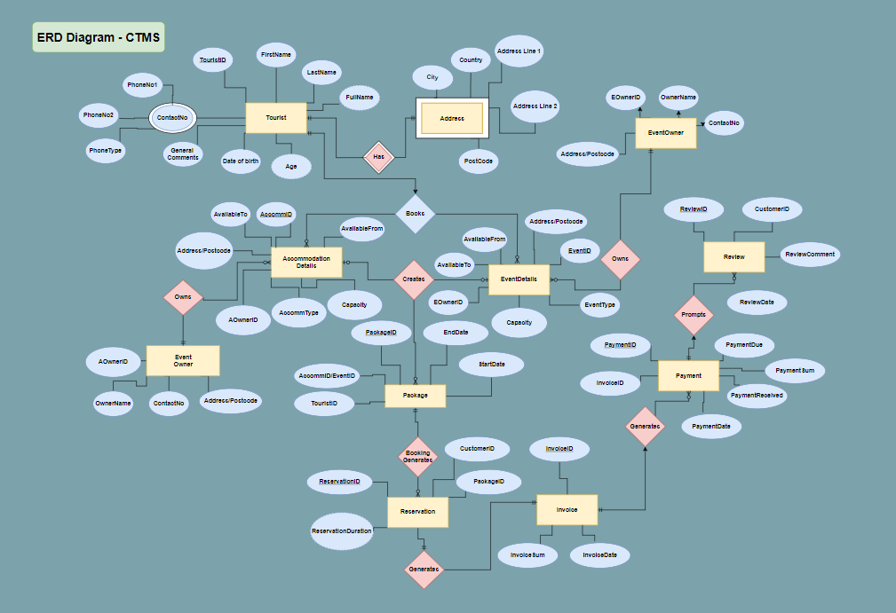

If unable to view above, full diagram viewable at:
https://viewer.diagrams.net/?tags=%7B%7D&highlight=0000ff&edit=_blank&layers=1&nav=1&title=ERD2315714.drawio#Uhttps%3A%2F%2Fdrive.google.com%2Fuc%3Fid%3D1pmVdfi5UxwBb14SikbzMdryseIRAaDjC%26export%3Ddownload
Explanation – entities and attributes
- Tourists – Details stored to enable Coastal Getaways to liaise with their customers throughout their interactions with the company. For example, the attributes are recorded to confirm bookings with tourists, adding these details to invoices, or for contacting with future package offers.
- Accommodation/Event Details – Required to provide tourists with details needed to book and attend packages offered by the company. For example, the attributes listed allow a tourists/employees to filter the database by capacity, preferred location or type of property/event according to individual tourist requirements and provide a bespoke package.
- Accommodation/Event Owner – Details stored to allow Coastal Getaways to contact owners in the event of any tourist reported issues or reviews to provide feedback, and to generate reports on which owner owns or relates to which items offered in a package for various reasons, e.g. which companies worked with most frequently or which have common issues identified in tourist reviews.
- Package – Stored to maintain a record of packages offered or created by tourists, from which Coastal Management can complete data analysis to better understand the popularity of certain packages and potentially suggest these to new tourists enquiring with the company.
- Reservation – stored to maintain record of events and accommodation reservations, allowing availability of events and accommodation to be updated in the database.
- Invoice – Stored to record invoice details once a package is booked. Attributes such as invoice sum and the invoice ID can be compared with attributes in the Payments table to identify unpaid invoices.
- Payment – Records payments received for booked packages from tourists. Attributes allow for understanding of sums generated for packages and records if these are paid or unpaid.
- Review – included to record Tourist feedback following payment and attendance at a package. The attributes listed allow Coastal Management to record both good and bad feedback to improve the offered packages for tourists.
- I have not listed employees/branches in my ERD however I am aware that these would also be included in the database. My ERD is focused on the customer experience aspect of the company.

Section A – Question 4

Entity: Tourists
Attributes: TouristID (PK), FirstName, LastName, FullName, DOB, Address1, Address2, Postcode, City, Country, PhoneNo1, PhoneNo2, PhoneType, Email
Entity: Accommodation
Attributes: AccommID (PK), AOwnerID (FK), Address1, Address2, Postcode, City, Capacity, AccommodationType, AvailableFrom, AvailableTo, CostPerNight
Entity: Events
Atttributes: EventID (PK), EOwnerID (FK), EventName, Address1, Address2, Postcode, City, EventType, Capacity, AvailableFrom, AvailableTo, EventCostPerPerson
Entity: Accommodation Owner
Attributes: AOwnerID (PK), CompanyName, Address1, Address2, Postcode, City, ContactNo
Entity: Event Owner
Attributes: EOwnerID (PK), CompanyName, Address1, Address2, Postcode, City, ContactNo
Entity: Package
Attributes: EventID (CK), AccommID (CK), StartDate, EndDate,
Entity: Reservation
Attributes: ReservationID (PK), CustomerID (FK), PackageName, StartDate, EndDate, PackageDescription
Entity: Invoice
Attributes: InvoiceID (PK), ReservationID (FK), InvoiceDate, PaymentDue
Entity: Payments
Attributes: PaymentID (PK), InvoiceID (FK), ReservationID (FK), AmountDue, AmountPaid, PaymentType, PaymentDate
Entity: TouristReviews
Attributes: ReviewID (PK), TouristID (FK) PackageID (FK), ReservationID (FK) AccommRating, EventRating, GeneralComments, PackageRating (derived from accommodation and event ratings), ReviewDate

Section A – Question 5

Please review the MS Access file entitled CTMS_2315714.accdb uploaded separately to view full table contents.
Screenshots are provided below of tables in Data Sheet and Design view:
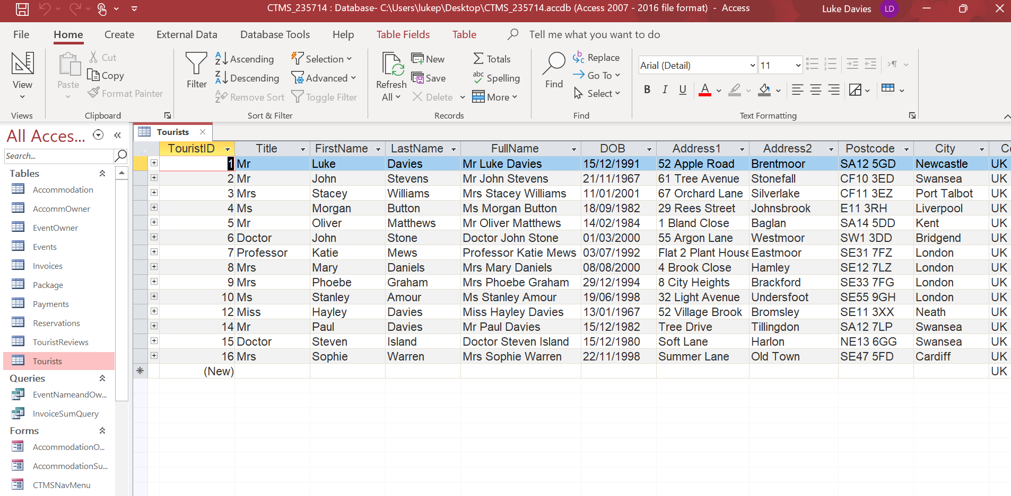
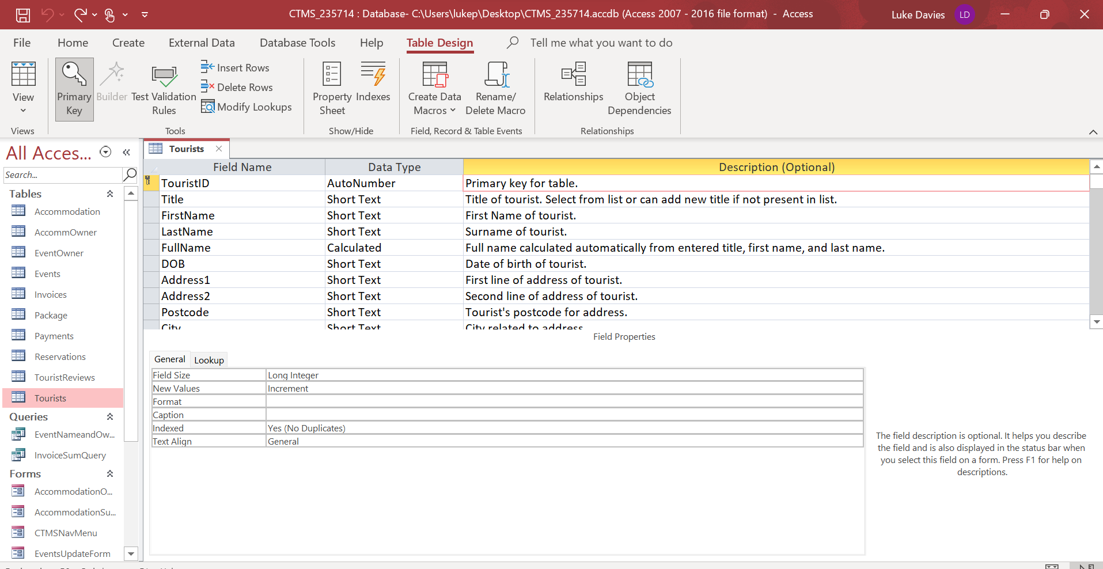

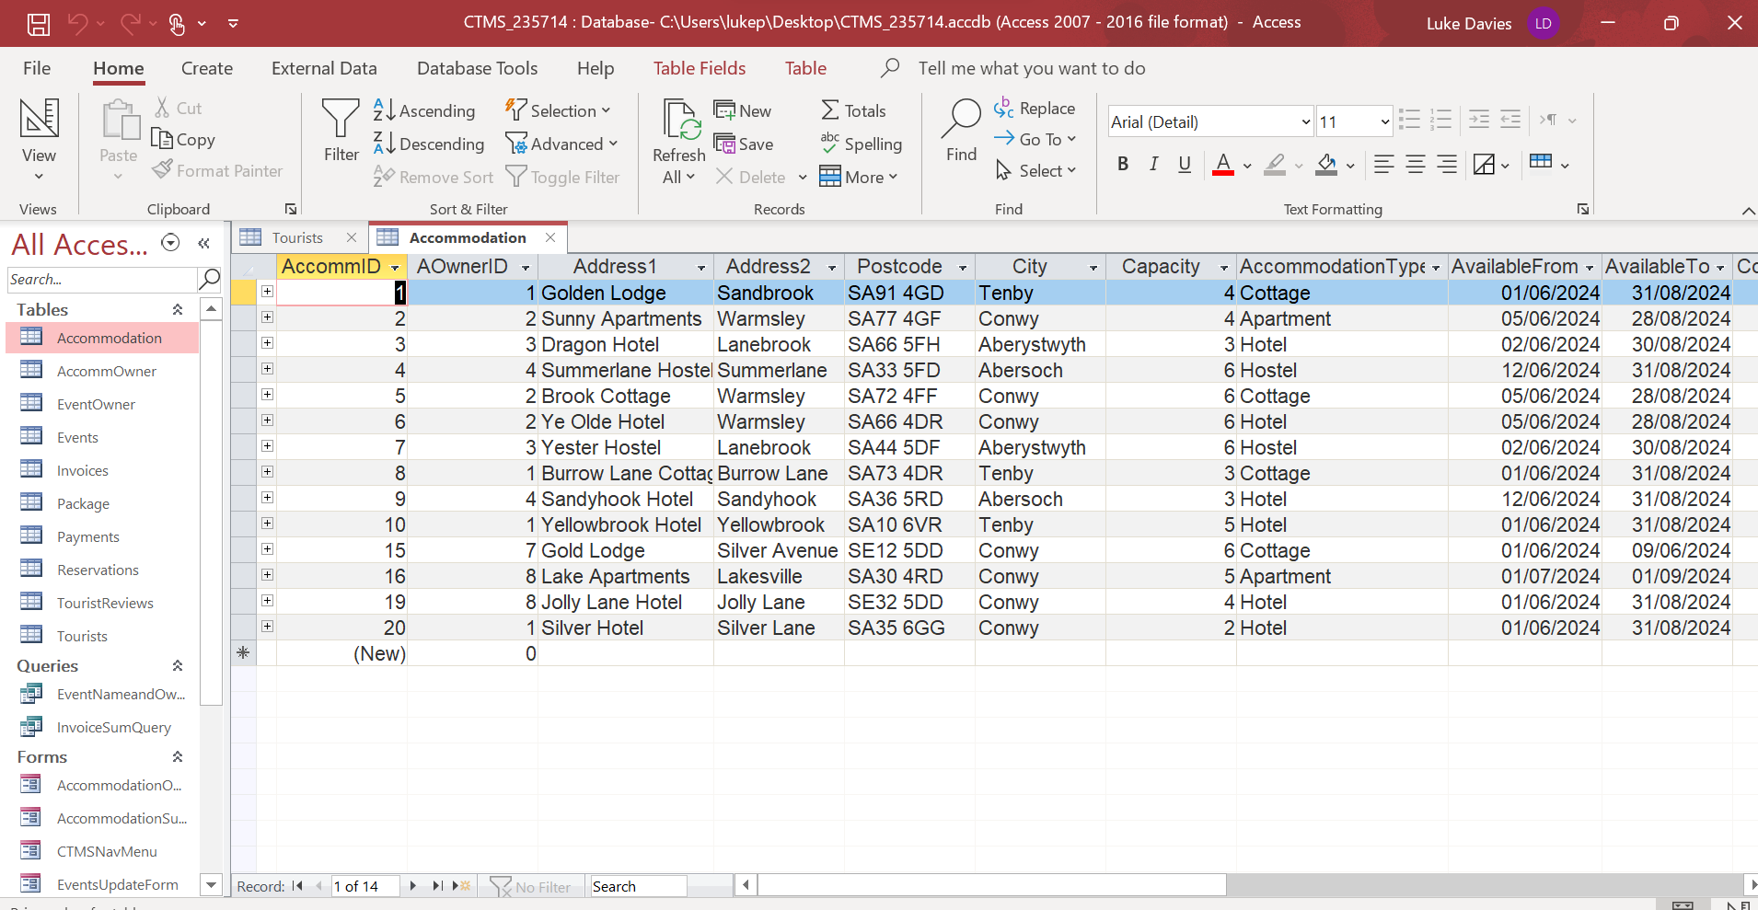

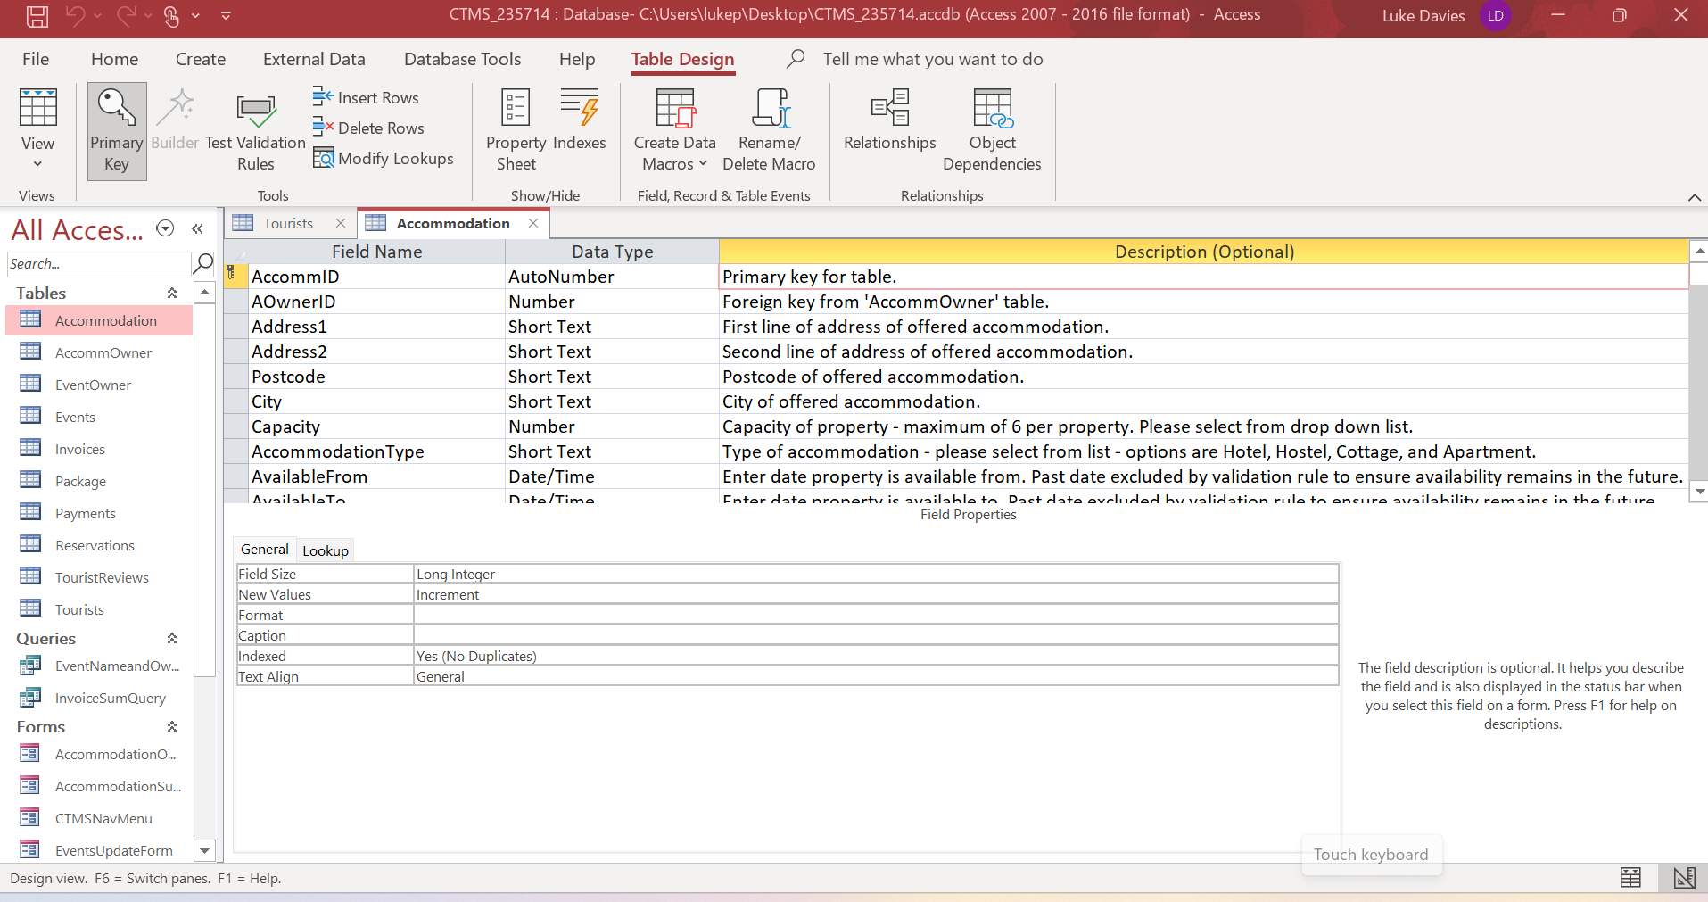

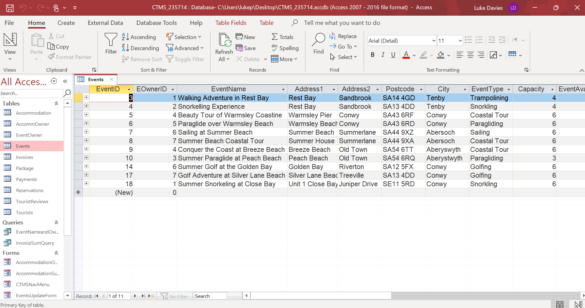

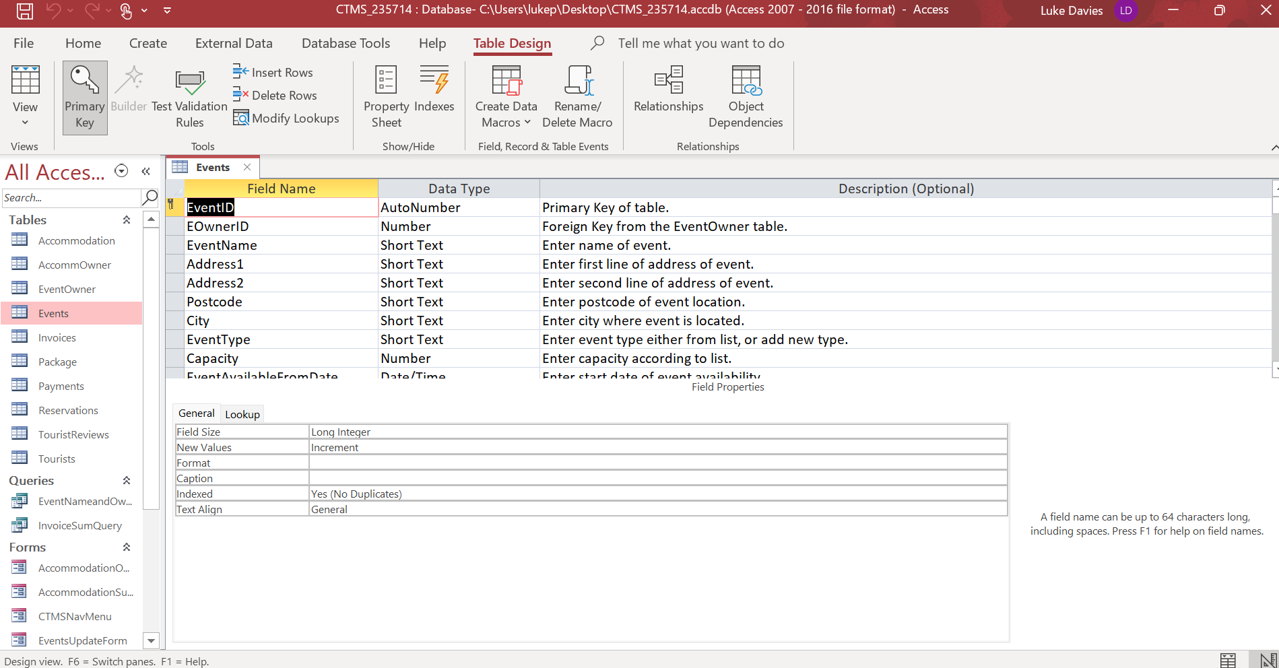

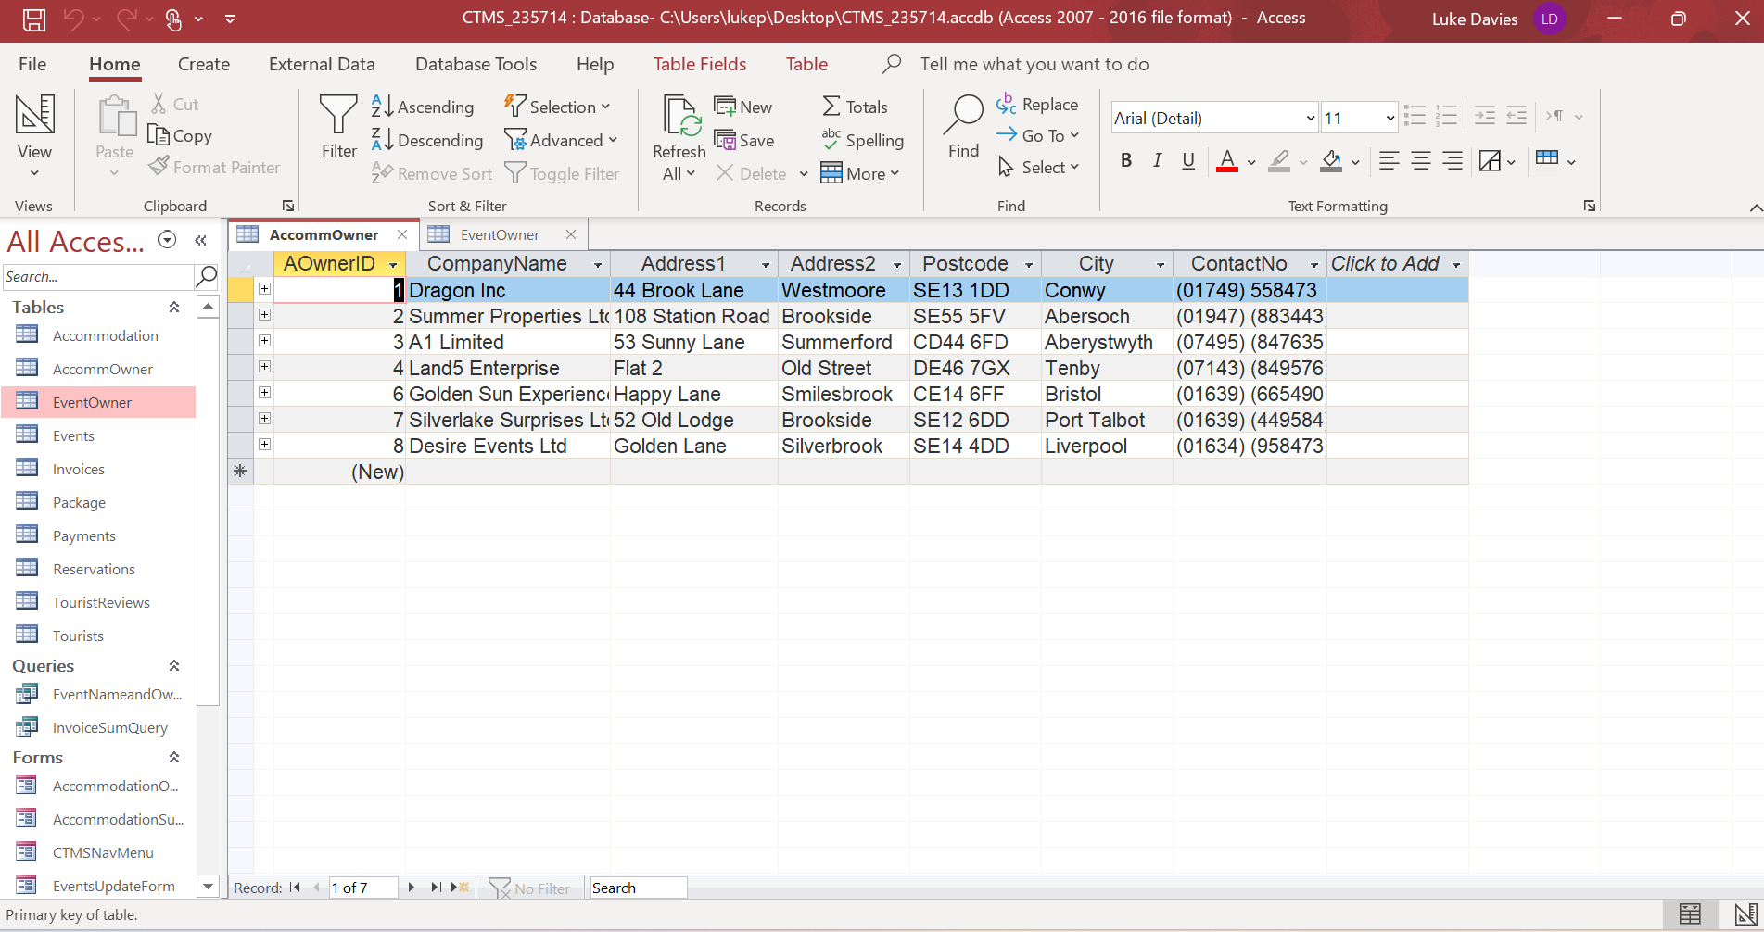

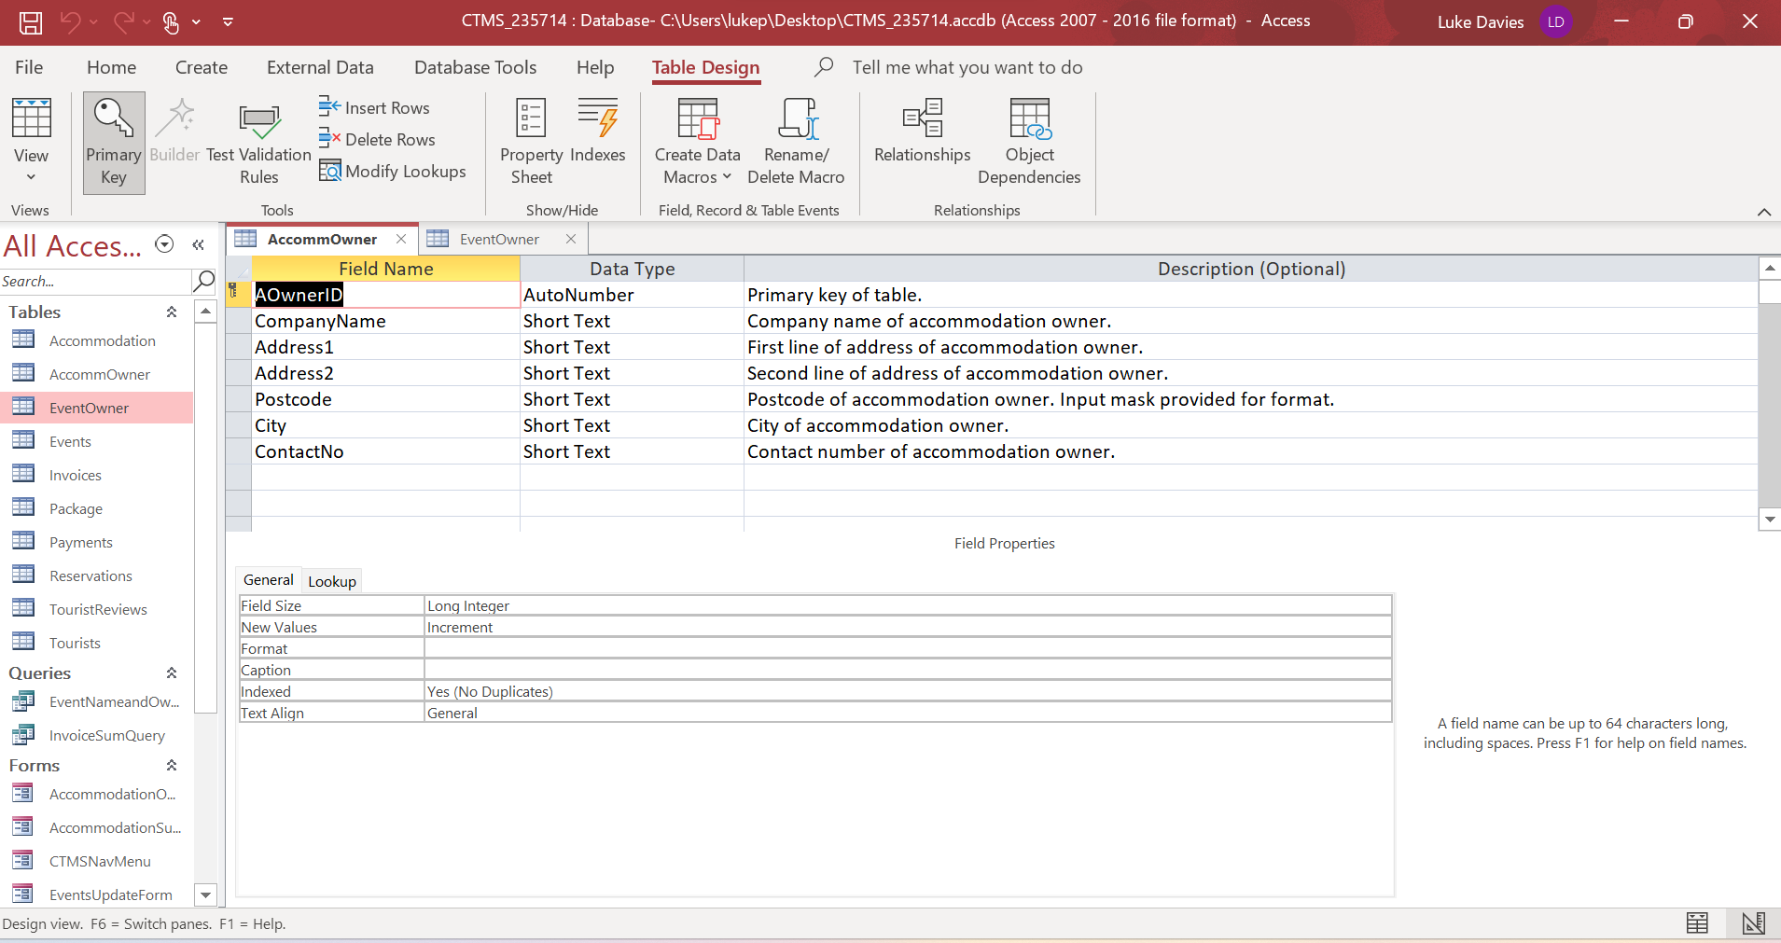

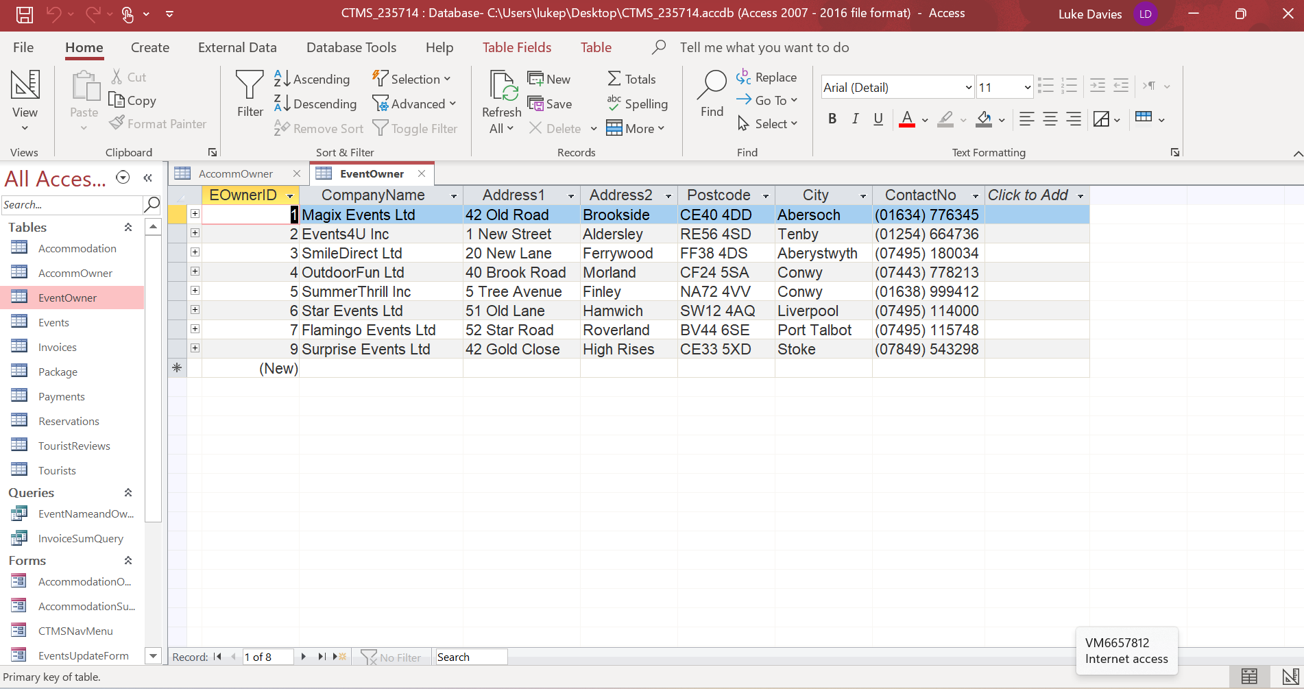

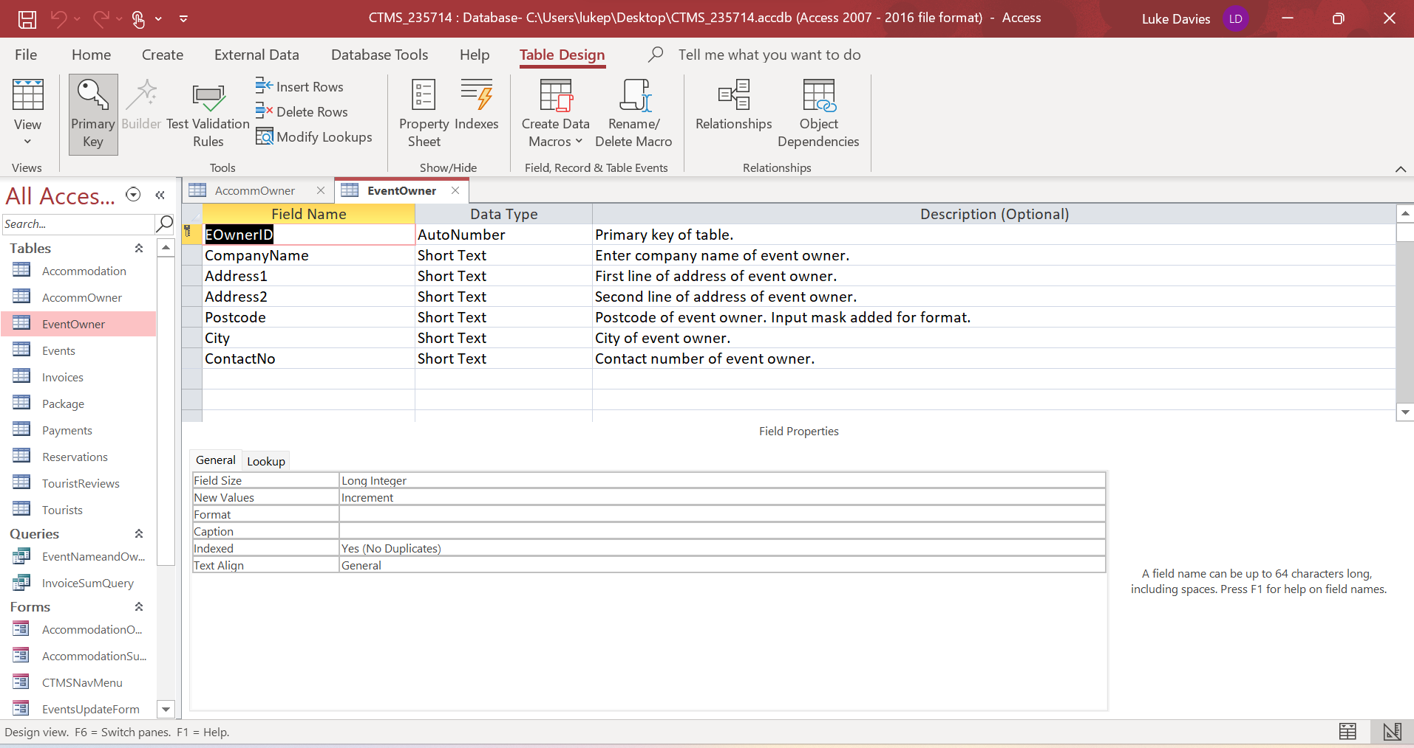

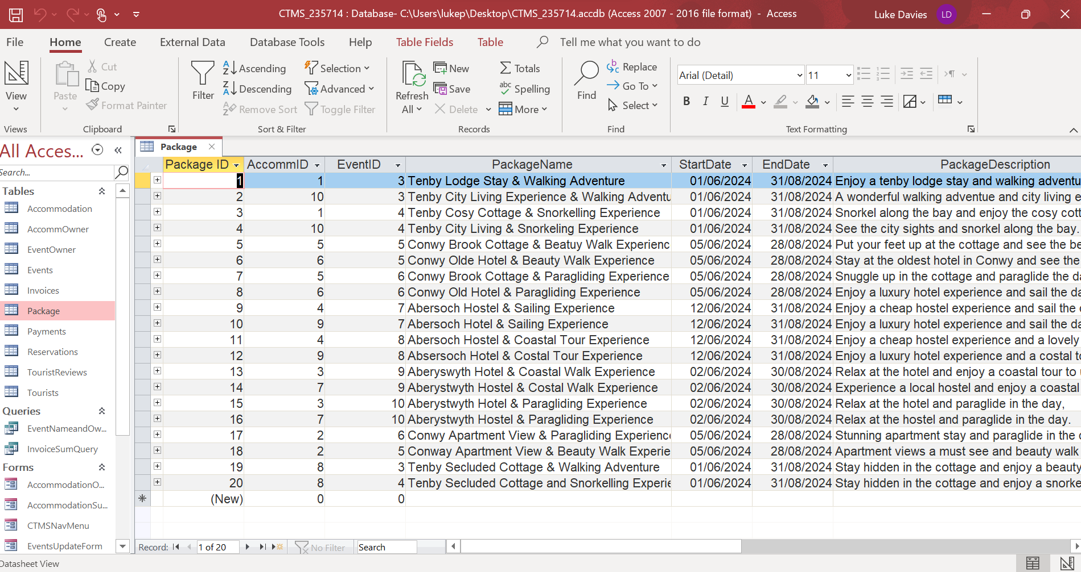

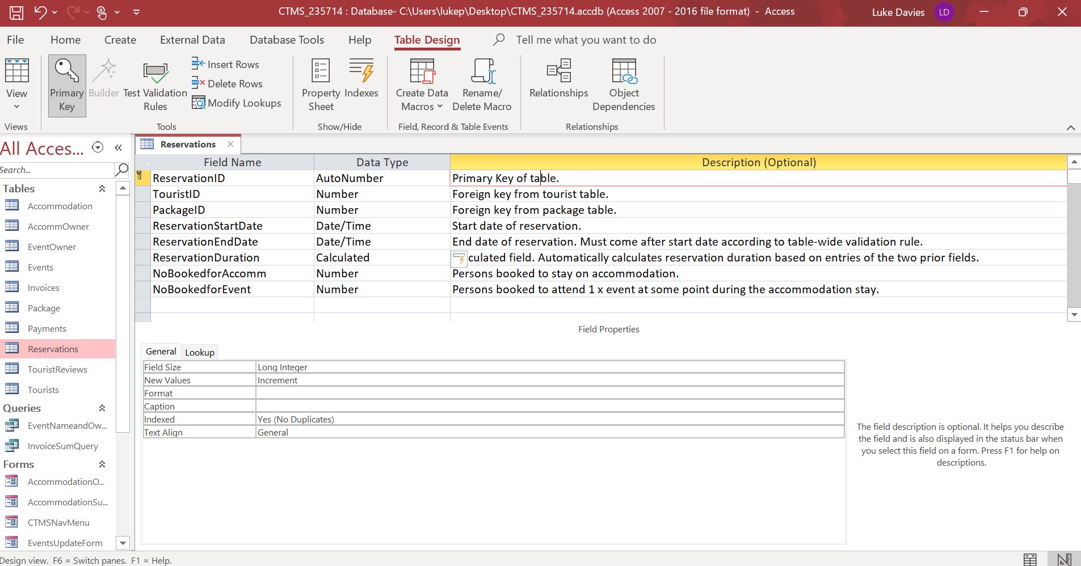

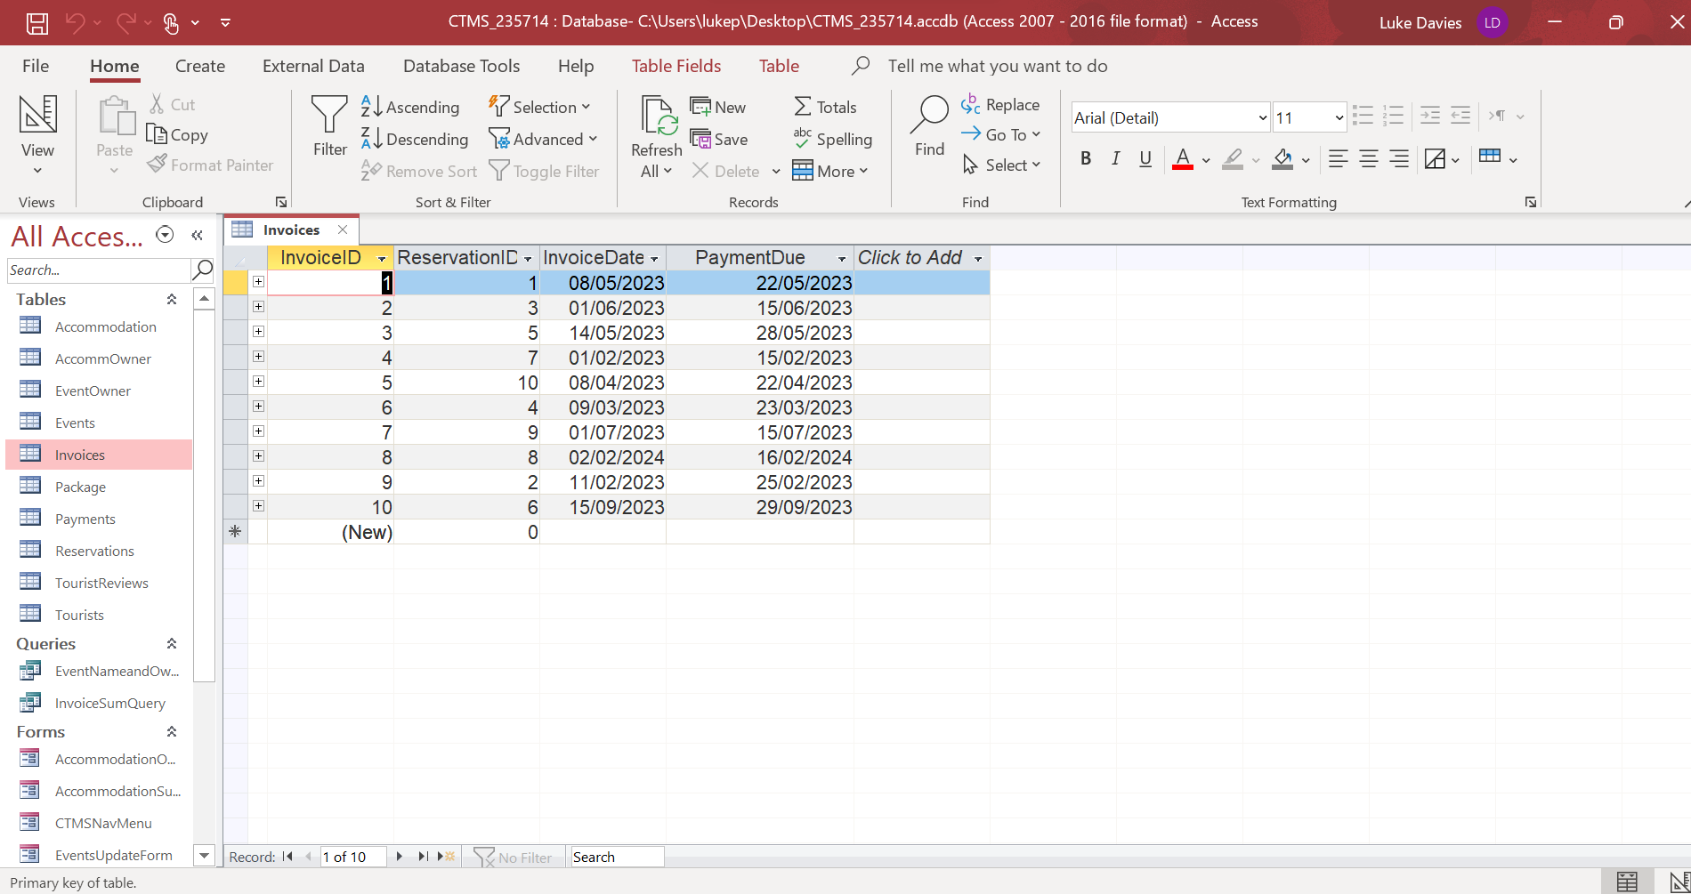

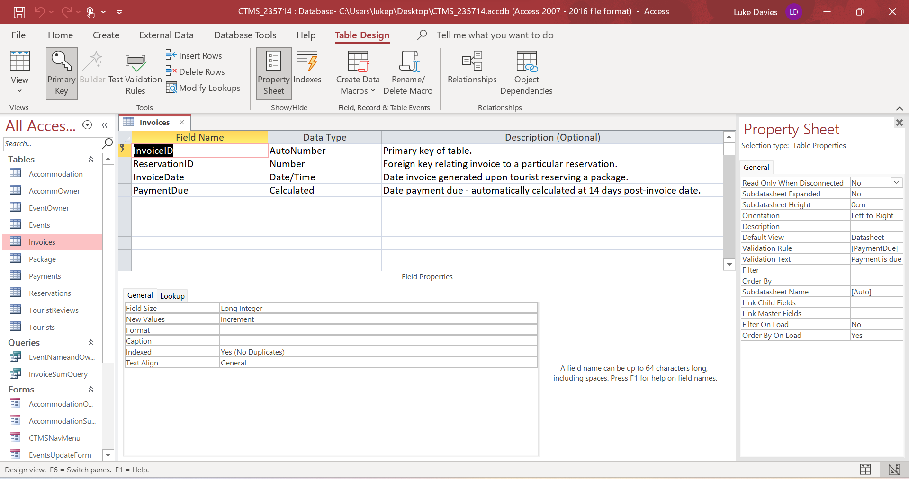

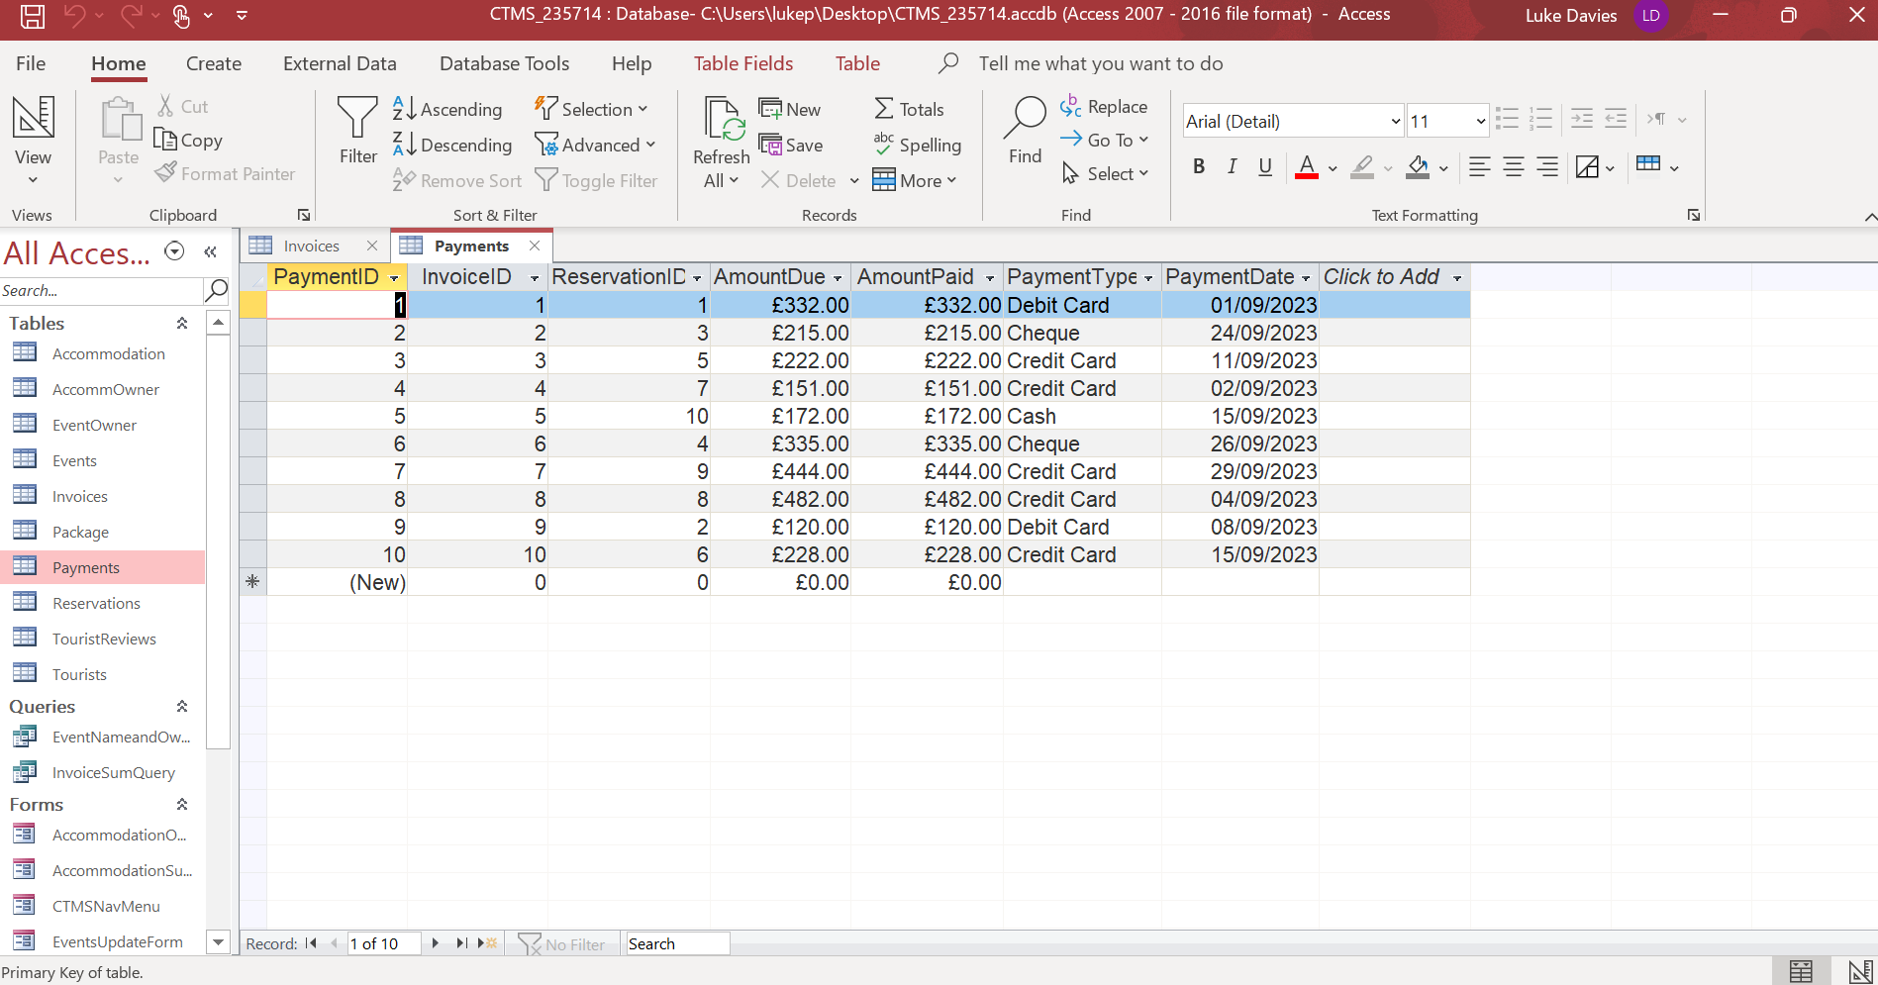

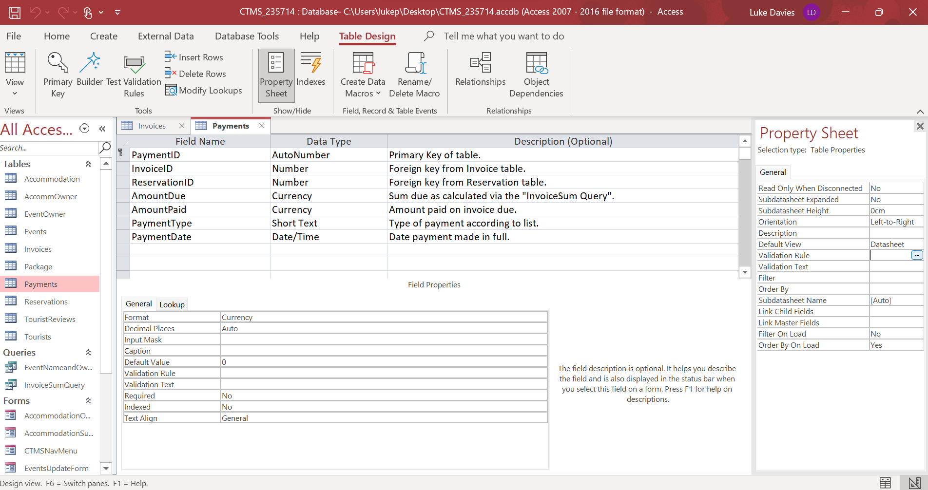

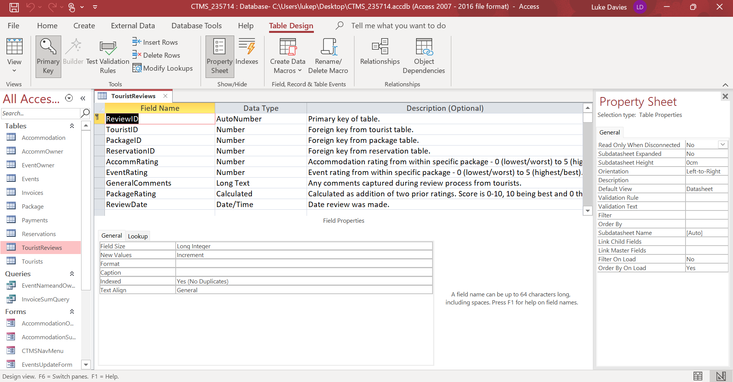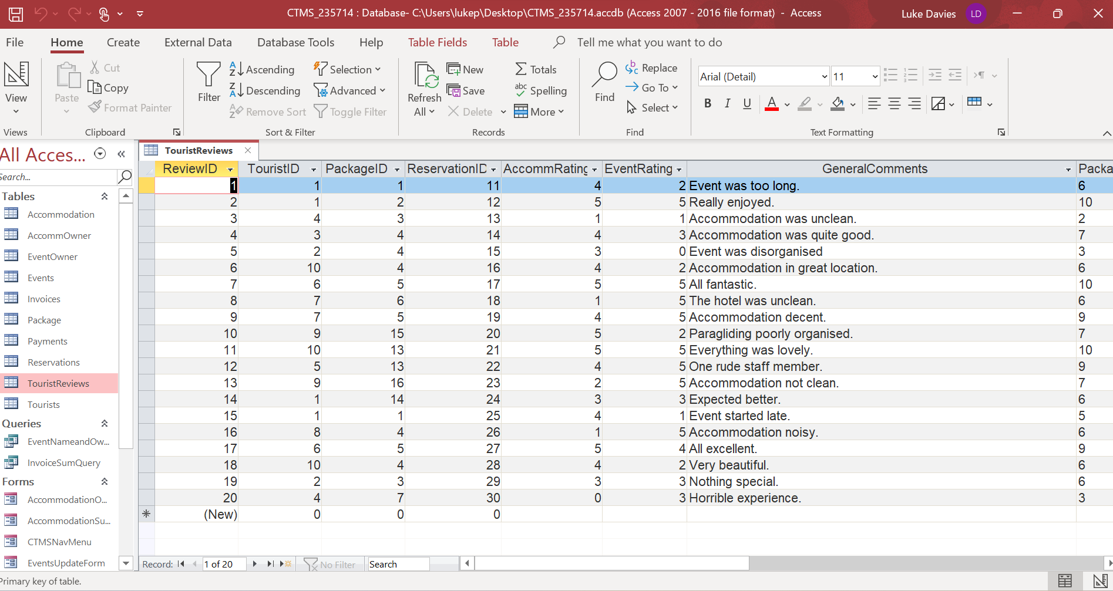

Section A – Question 6A

See report titled “Payments Report – July Sept 23” within file CTMS_2315714.accdb.
The “AmountPaid” column within the Payments table used to create this Report has been calculated and inputted from a Query (See “InvoiceSumQuery”).
Screenshot of Revenue Report
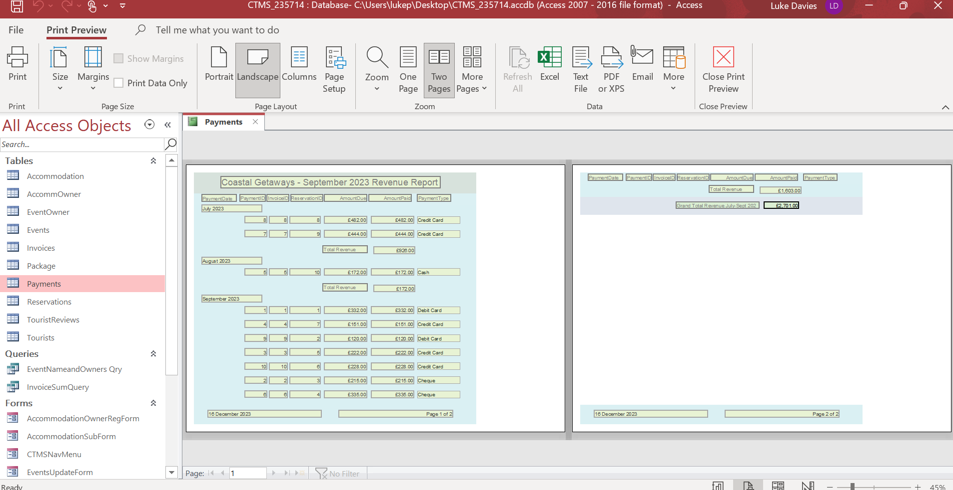

Section A – Question 6B

See report titled “TouristReviewReport” within file CTMS_2315714.accdb.
The report is organised by Package and review scoring is displayed based on a calculated score of 0-5 for accommodation and events, creating an overall package score. Comments are displayed for individual feedback and conditional formatting of lower scores provides a visual aid for areas of improvement.
Screenshot – Report
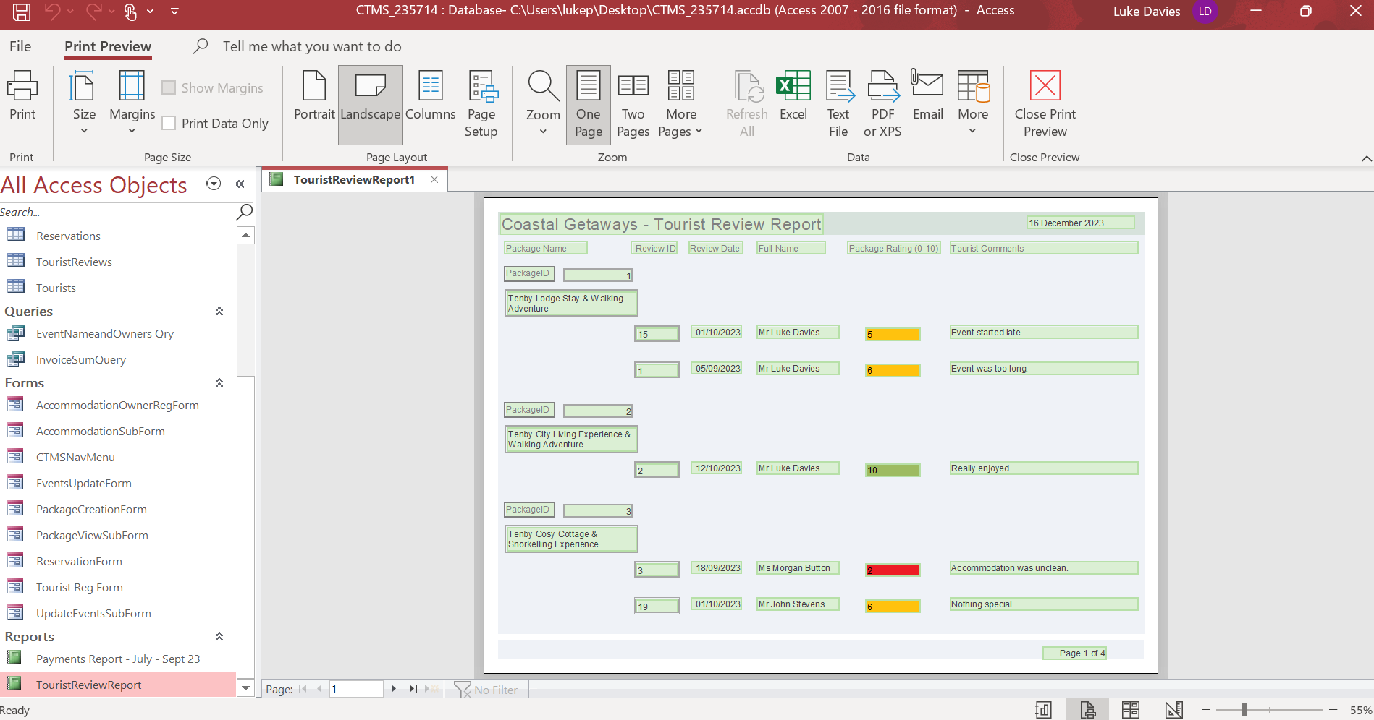

Section A – Question 7A
See form entitled “ReservationForm” within database file. I have included several controls/validation rules to provide an easier reservation process:
- Users may select a title/phone type using a dropdown list.
- Postcode, date of birth and phone numbers are added according to an input mask.
- Assuming our customers are UK based, ‘Country’ defaults to UK.
- The reservation end date must be a date after the reservation start date. Validation text appears if incorrect dates are inputted.
- The persons booked for accommodation/event must not exceed the maximum capacity of either (6). If a number is inputted above 6, validation text appears.
- Package information is displayed on the form but has been locked so it cannot be edited by tourists.
Form Screenshot
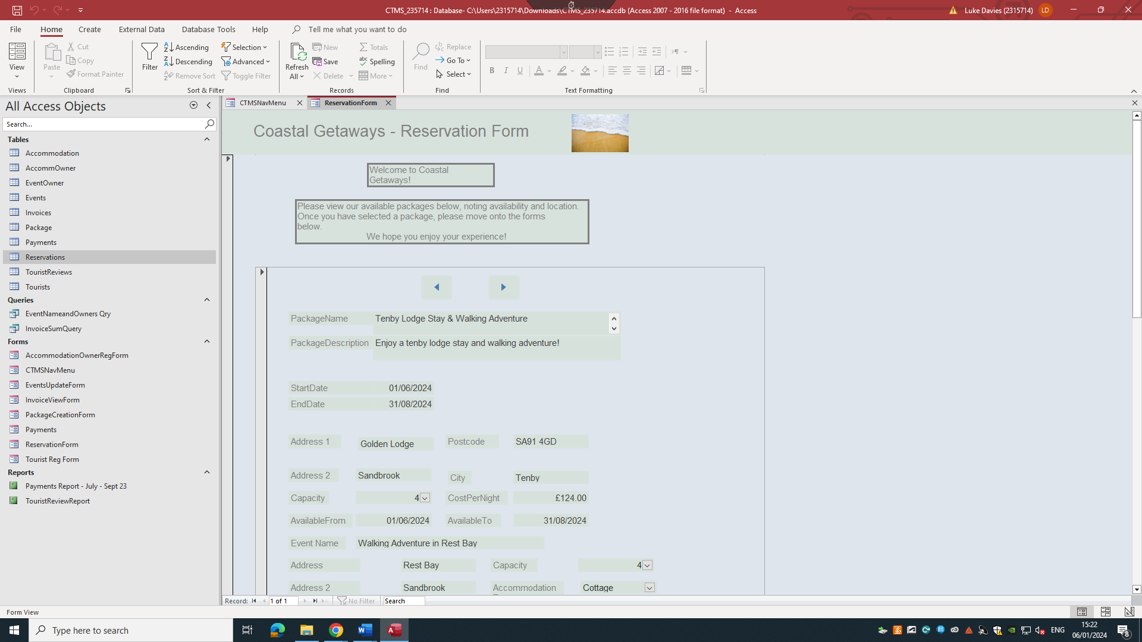

Section A – Question 7B

Please see form entitled ‘EventsUpdateForm’ within the database file.
Screenshot of form
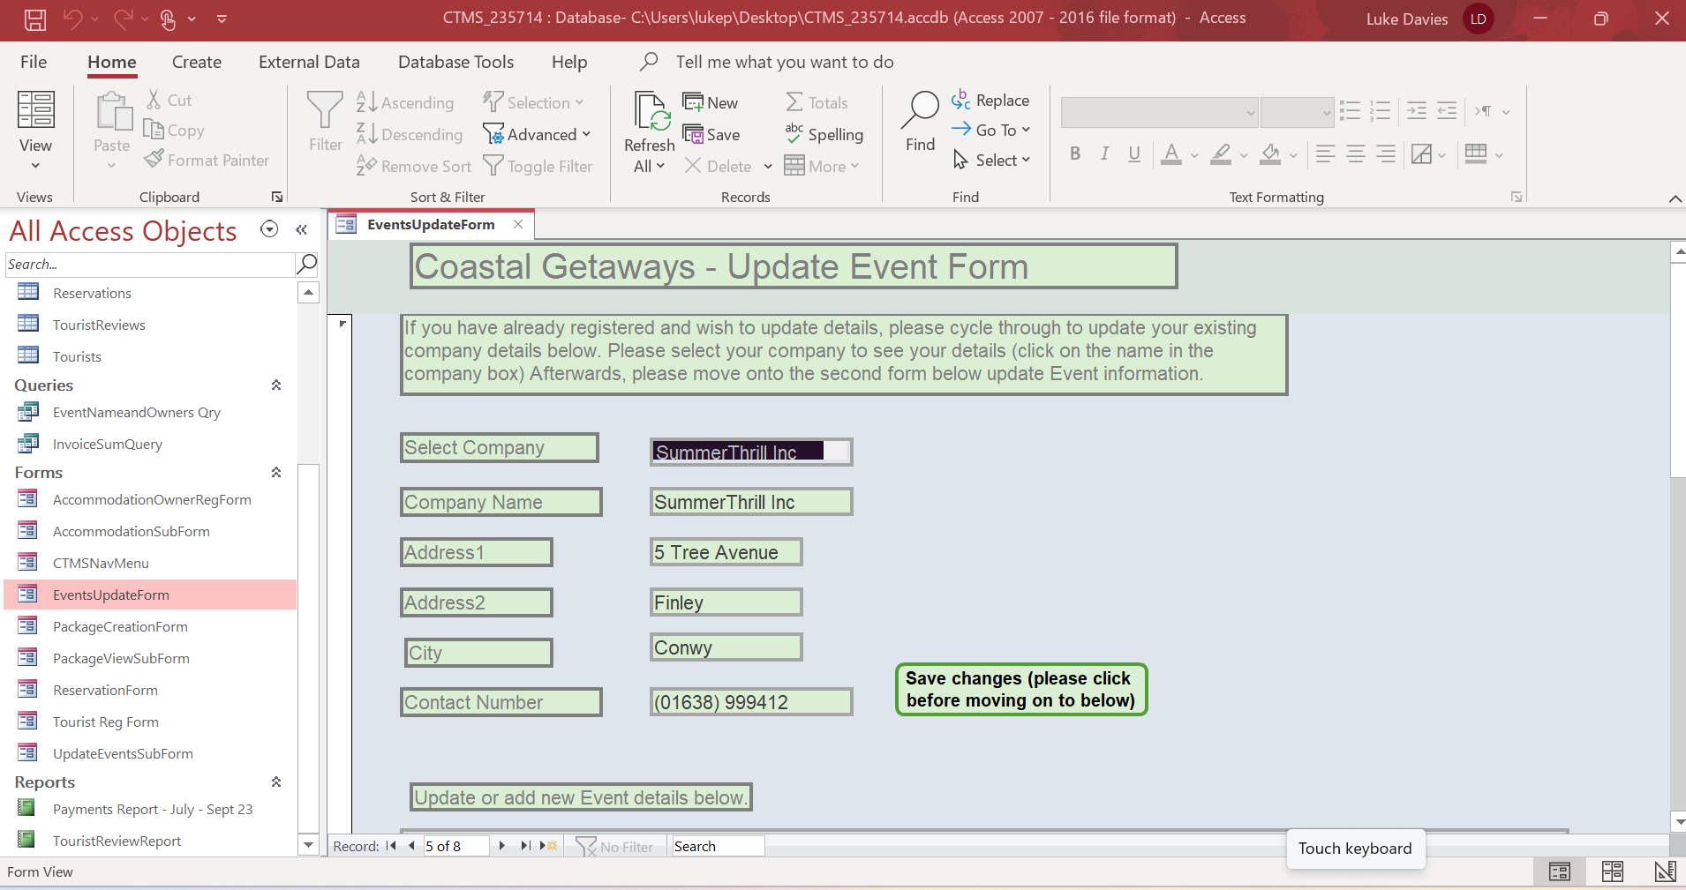

Section A – Question 8A

See form entitled ‘CTMS NavMenu’. Form has 9 buttons taking the required user to various forms to input/amend database information.

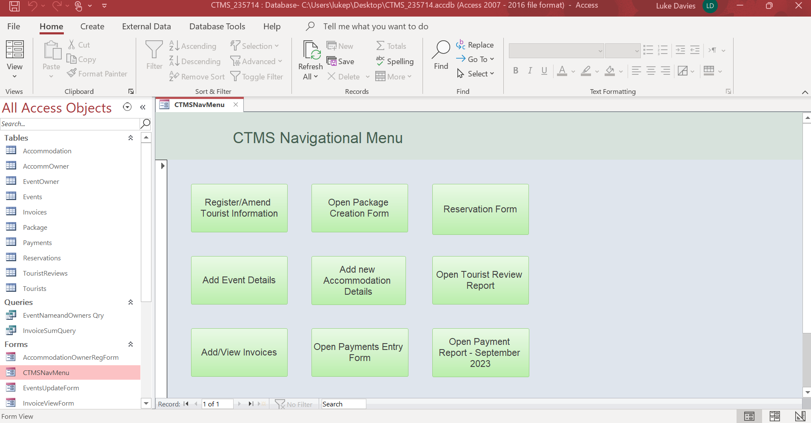

Section A – Question 8B

When opening the database, the form ‘CTMSNavMenu’ automatically appears.

Section B – Question 9

To realise the corporate aim of Coastal Getaways (namely, providing coastal getaway packages to tourists) an MS access database has several efficiency improvements which may not be present in the data storage methods used by the company prior to its implementation.

One of the main benefits for the company with a well-designed database will be the avoidance of data duplication. For example, and to take an analogy of the ‘loan problem’ identified by Eckstein and Schultz [1] which describes the issue with data duplication in a single table, the company may presently record several versions of the same data (for example, it could record tourist details multiple times when a package is booked). A properly designed database would allow for each set of data (e.g. tourist addresses) to be stored in one table in the database rather than recorded in multiple places, therefore reducing issues such as update, insertion, and deletion anomalies via the independence of data in its own table.

Another benefit would be a decrease in administration and increase in efficiency of business insights across the company. Relational database systems are designed to, as Dilling writes, “manage vast amounts of data” [2]. With a database being utilised for data input, there would no longer be a requirement for employees to trawl through vast amounts of data to gain business insights as they would in a file or spreadsheet system – for example, SQL queries could generate useful datasets quickly for the company such as the most popular tourist destinations, or the least positively reviewed accommodations.

The company will also benefit from an increased security of its data. IBM’s database security article [3] and a similar article from LinkedIn [4] and Microsoft [5] outline how database access can be limited, or the database can be suitably encrypted, to ensure the data is not subject to loss and or cyber theft which “can have serious consequences for... reputation, compliance and liability” [4]. The company will naturally run more effectively in the absence of any data breaches resulting from poor security, which could be costly given, for example, GDPR breach fines within the EU can be as high as 20 million euros [6].

Section B – Question 10

Benefits

One benefit of the transition would be, as Abiud writes [7], that manual records “cannot be accessed simultaneously by multiple users”. The manual system used by the company to date, if either paper or file based, would not allow for the separation of data from its point of storage, and so if one person in the company was using or viewing a paper or electronic file, another may not be able to view the same data at the same time. In contrast, a DBMS can allow the sharing of data amongst departments in the company by allowing specific users to view particular subsets of data from the central relational database, which the CTMS pulls the data from.

A further benefit of a computerised database, managed by a DBMS, is that the integrity of the data can be effectively managed. Doorn [8] discusses how constraints in the database “keep the database in an accurate state”. For example, validation rules can be inputted into the DBMS (such as ‘input masks’ for telephone numbers) to ensure the data inputted in a format required by the company and to prevent data entry errors.

Another benefit of a DBMS is the ability to cross reference and retrieve data using SQL. The company may presently need to sift through and compare data manually for analysis purposes – for example, reviewing paper reviews from tourists and tallying up the number of positive/negative reviews for a particular package – whereas through SQL, users can, as described by Hernandez [9], “view information in an almost unlimited under of ways”. Through use primary and foreign keys, SQL queries can link together data from different related tables and display a subset of data according to user requirements.

Challenges

Connolly and Begg describe several drawbacks of using a relational database and DBMS [10] stemming from the expensive of purchase, speed of performance (although as Hernandez [9] writes, speed has improved with technology advances) and the cost of staff training on a new database system. To overcome these challenges, the DBMS selected by the company must be suitable for the companies' individual purposes and ensure staff are appropriately trained on the new company systems.

References

[1] J. Eckstein and B. R. Schultz, Introductory relational database design for business, with Microsoft Access. Hoboken, New Jersey: Wiley, 2018, page 46.
[2] T. J. Dilling, “Artificial Intelligence Research: The Utility and Design of a Relational Database System (RDBS),” Advances in Radiation Oncology, vol. 5, no. 6, Jul. 2020, doi: https://doi.org/10.1016/j.adro.2020.06.027.
[3] IBM, “Database Security: An Essential Guide | IBM,” www.ibm.com, 2023. https://www.ibm.com/topics/database-security [Accessed January 2, 2024]
‌[4] “What are the benefits of encrypting your database to improve data security?,” www.linkedin.com. https://www.linkedin.com/advice/0/what-benefits-encrypting-your-database-improve-data (accessed Jan. 02, 2024).

[5] “Database Security Best Practices and Solutions | Microsoft Azure,” azure.microsoft.com. https://azure.microsoft.com/en-us/resources/cloud-computing-dictionary/what-is-database-security#:~:text=secure%20a%20database%20%3E- (accessed January 2nd 2024)

‌[6] B. Wolford, “What are the GDPR Fines?,” GDPR.eu, Jul. 11, 2018. https://gdpr.eu/fines/ (accessed January 2nd 2024)
‌[7] C. G. Abiud et al, "FishNET: An automated relational database for zebrafish colony management," PLoS Biology, vol. 17, (6), 2019. Available: https://www.proquest.com/scholarly-journals/fishnet-automated-relational-database-zebrafish/docview/2258795792/se-2. DOI: https://doi.org/10.1371/journal.pbio.3000343.
[8] J. H. Doorn, J. H. Doorn, and L. C. Rivero, Database integrity challenges and solutions. Hershey, Pa: IGI Global, 2002. doi: 10.4018/978-1-93070-838-9, page 9.

[9] Hernandez, M. J. (Michael J. (2021). Database design for mere mortals : a hands-on guide to relational database design (Fourth edition.). Addison-Wesley.
[10] T. M. Connolly and C. E. Begg, Database Systems : a practical approach to design, implementation, and management, Sixth, Global edition. Boston: Pearson, 2015, page 80-81.

