Coursework- Business and Web Management
BSc Applied Computing
ACCA5019
Component 1- Database Design and Implementation
Md Sadeque Imam Shaikh



15 December 2025
Word count -5000
Ima David - 2321435

Table of Content

Introduction

This report documents the design, implementation, and evaluation of a Campus Club Management System (CCMS), developed to support common administrative and engagement activities within a university club environment. The system enables structured management of students, clubs, events, memberships, announcements, and participation records through a robust relational database and a database-driven PHP website. Part A focuses on the database design and implementation, applying core relational principles such as normalization to Third Normal Form (3NF), enforceable business rules through constraints, transactional integrity, and performance-aware indexing, with development and testing carried out using MySQL via the command-line interface. Part B extends this foundation into a dynamic PHP web application that retrieves and manipulates database content in real time, demonstrating CRUD operations, search and filtering functionality, and essential security practices. Together, both parts illustrate the integration of sound database design with practical web development, emphasising data integrity, usability, and protection against common threats such as SQL injection.

Part A – Database Design & Implementation2.1 Database Design
2.1.1 Entities and Attributes
The Campus Club Management System (CCMS) database is designed to support the core operational processes of a university clubs environment in a structured and reliable manner. At the heart of the design are clearly defined entities that represent real-world objects and activities within the system. The Student entity stores essential academic and communication details, including StudentID as the primary key, FirstName, LastName, Email, DateOfBirth, EnrollmentYear, and Status. Email is enforced as a unique attribute to ensure that each student can be reliably identified for communication and authentication purposes. The Club entity represents registered campus clubs and includes attributes such as ClubID, ClubName, Category, and CreatedAt. ClubName is constrained to be unique to avoid ambiguity in user-facing interfaces, while the surrogate primary key ensures long-term referential stability even if a club name changes.
The Event entity captures scheduled activities organised by clubs. It includes EventID as the primary key, along with ClubID as a foreign key, EventTitle, EventDateTime, Location, Capacity, and Status. This structure allows each event to be clearly associated with its organising club while supporting operational requirements such as capacity management and cancellation without data loss. Membership relationships between students and clubs are represented through the Membership entity, which includes MembershipID, StudentID, ClubID, Role, MembershipStatus, and JoinedAt. This associative entity resolves the many-to-many relationship between students and clubs while allowing additional attributes specific to the relationship to be stored. Similarly, participation in events is handled through the EventParticipation entity, which records registrations and attendance outcomes for students at specific events.
Communication within CCMS is supported through the Announcement and AnnouncementRecipient entities. Announcements are linked to clubs and include delivery metadata such as Channel and SentDateTime, while AnnouncementRecipient records which students received a particular announcement and whether delivery was successful. Together, these entities ensure that communication activity can be audited and reported accurately.
2.1.2 Relationships and ERD
The relationships between entities are formally represented using an Entity Relationship Diagram (ERD), which visually demonstrates how data flows across the system. One-to-many relationships are used where appropriate, such as between Club and Event, while many-to-many relationships are resolved using associative tables such as Membership and EventParticipation. Foreign key constraints are used consistently to enforce referential integrity, ensuring that orphaned records cannot exist. The ERD confirms that each entity has a clear purpose and that relationships accurately reflect the business rules of the campus club environment.
[Insert ERD diagram screenshot here]
2.1.3 Normalization
All tables in the CCMS database are normalized to Third Normal Form (3NF) to reduce redundancy and prevent update anomalies. Attributes are atomic and depend solely on the primary key of their respective tables. For example, student personal details are stored only in the Student table and are not duplicated in Membership or EventParticipation tables. Similarly, club-related details are isolated within the Club table. This design ensures that changes to core data, such as a student’s email or a club’s name, need to be made in only one location, thereby preserving consistency across the database.
2.2 Database Implementation
2.2.1 Table Creation and Constraints
The logical database design was implemented in MySQL using explicit CREATE TABLE statements that define data types, primary keys, foreign keys, and constraints. Primary keys are implemented using auto-incrementing integer values to ensure uniqueness and efficient indexing. Foreign key constraints enforce valid relationships between entities, such as ensuring that an event cannot exist without an associated club. Additional constraints, including UNIQUE constraints and CHECK constraints, are used to enforce business rules directly at the database level. For example, composite UNIQUE constraints prevent duplicate memberships or duplicate event registrations for the same student.
[Insert screenshot of CREATE TABLE statements here]
2.2.2 Sample Data Insertion
To validate the database design, representative sample data was inserted into each table. This included multiple students, clubs across different categories, events with varying capacities, and membership records reflecting realistic participation patterns. Sample data insertion also enabled functional testing of constraints and relationships, confirming that invalid operations, such as registering a student for a non-existent event, were correctly rejected by the database.
[Insert screenshot of INSERT statements here]
2.2.3 Stored Procedures, Triggers, and Functions
Where appropriate, programmable database objects were used to encapsulate logic and improve maintainability. Stored procedures were implemented to support common operations such as inserting new records within controlled transactions. Triggers were considered to enforce automated behaviour, such as maintaining data consistency during inserts or updates. These features demonstrate how business logic can be safely embedded within the database layer to complement application-level validation.
2.2.4 Transaction Handling (BEGIN, COMMIT, ROLLBACK)
Transaction handling was implemented and tested to ensure data consistency during multi-step operations. By using BEGIN, COMMIT, and ROLLBACK statements, the system can safely recover from errors without leaving the database in an inconsistent state. For example, when inserting related records across multiple tables, a rollback ensures that partial inserts do not occur if one step fails. This approach reflects best practice in relational database management and supports reliable system behaviour.
[Insert transaction testing screenshot here]
2.2.5 Performance Tuning and Indexing
Performance considerations were addressed through the careful selection of indexes. Indexes were applied to primary keys, foreign keys, and frequently queried attributes such as Email and composite relationship keys. These indexing decisions align with expected access patterns, such as joining tables during reporting or searching for specific users or events. As a result, the database is optimized for both integrity and performance, even as data volume increases.
2.3 Justification and Literature Support
The design choices in CCMS align with established relational database theory. Normalization to 3NF is a widely accepted approach for reducing redundancy and protecting integrity,
especially in transactional systems where updates and inserts are frequent. By separating many-to-many relationships into associative tables (Membership, EventParticipation, AnnouncementRecipient),
the schema avoids duplication and supports additional relationship attributes, a known best practice in relational modeling.
Constraint-driven design is also supported by database engineering literature: primary keys establish entity identity; foreign keys enforce referential integrity;
and domain constraints (UNIQUE/CHECK/NOT NULL) ensure that the database becomes an active guardian of data quality rather than a passive storage layer.
In application development, relying solely on UI validation is risky because multiple clients or scripts can interact with the database; enforcing rules at the database layer mitigates this risk.
Finally, performance-aware indexing follows foundational principles of physical database design: indexes should reflect workload patterns and common access paths.
The CCMS indexing strategy targets common joins and lookup fields, acknowledging the trade-off that indexes slightly increase storage and write cost.
This reflects a practical balance between integrity-focused logical design and performance-focused physical design.

2.1.4 Business Rules and Data Dictionary Summary
Beyond structural design and relationships captured in the ERD, the CCMS database enforces critical business rules directly at the database level to ensure data integrity, consistency, and long-term reliability. These rules are implemented through primary keys, foreign keys, unique constraints, controlled domains, and appropriate data types, supported by consistent naming conventions across all tables. For example, the Student entity enforces uniqueness on the Email attribute, reflecting its role as a stable identifier for communication and authentication. The use of the DATE data type for DateOfBirth enables age-related reporting without storing derived values such as age, which would become inaccurate over time. Similarly, surrogate primary keys are used throughout the schema to decouple internal identity from user-facing attributes, ensuring referential stability even when descriptive values change.
Each core entity embeds rules aligned with real-world operational requirements. Clubs are uniquely identified by ClubID, while ClubName is constrained to prevent ambiguity in the user interface, and Category supports controlled classification such as academic, sports, or cultural activities. Events are linked to clubs through foreign keys and include constraints that enforce non-negative capacity values, while the Status attribute allows events to be cancelled without deleting historical records, supporting auditability and accurate reporting. Many-to-many relationships are resolved through associative entities such as Membership and EventParticipation, both of which enforce composite uniqueness constraints to prevent duplicate memberships or registrations. MembershipStatus and ParticipationStatus attributes support lifecycle tracking without data loss, preserving historical context. Communication governance is supported through the Announcement and AnnouncementRecipient entities, where delivery channels are constrained to valid modes and recipient records provide evidence of message delivery. Together, these enforced business rules ensure that CCMS not only models data accurately but also actively governs correct system behaviour at the database level.

2.2.6 Basic Security Consideration
Although Part A of the assessment focuses primarily on database design and implementation, basic security considerations are inherently linked to overall database quality and cannot be ignored. The CCMS database stores personally identifiable information (PII), including names, email addresses, and dates of birth, which necessitates a security-aware design approach. One key assumption is the principle of least privilege, whereby application-level database users are granted only the minimum permissions required to perform their functions, such as selecting or modifying data in specific tables. Administrative actions, including schema modifications or user management, are intentionally excluded from application-level access to reduce the potential impact of misuse or compromise.
Input validation and protection against SQL injection are primarily enforced at the application layer; however, the database schema actively supports these defences through strong data typing, controlled domains, and integrity constraints. When combined with parameterized queries, these measures significantly reduce the likelihood of malicious input being executed or malformed data being persisted. Password handling is also treated as a critical consideration. Where authentication mechanisms are required, the design assumes that passwords are stored exclusively as secure cryptographic hashes rather than plain text, which influences column sizing and privilege allocation. Finally, the inclusion of timestamped fields and traceability-focused tables, such as AnnouncementRecipient and membership status attributes, ensures that the database is audit-ready. These features support accountability and compliance requirements by preserving evidence of actions, communications, and historical state changes.

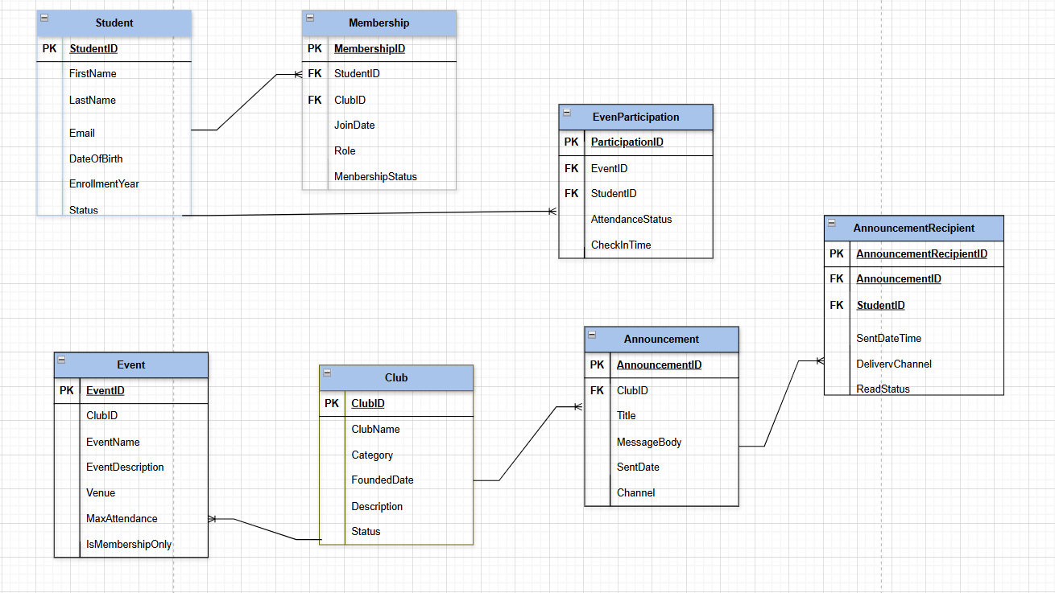
Figure 1: Entity Relationship Diagram showing entities, attributes, primary keys, foreign keys, and relationship cardinalities.
Description:
This diagram provides a high-level overview of the CCMS database structure and serves as the foundation for the implementation phase.

Sample table creation.
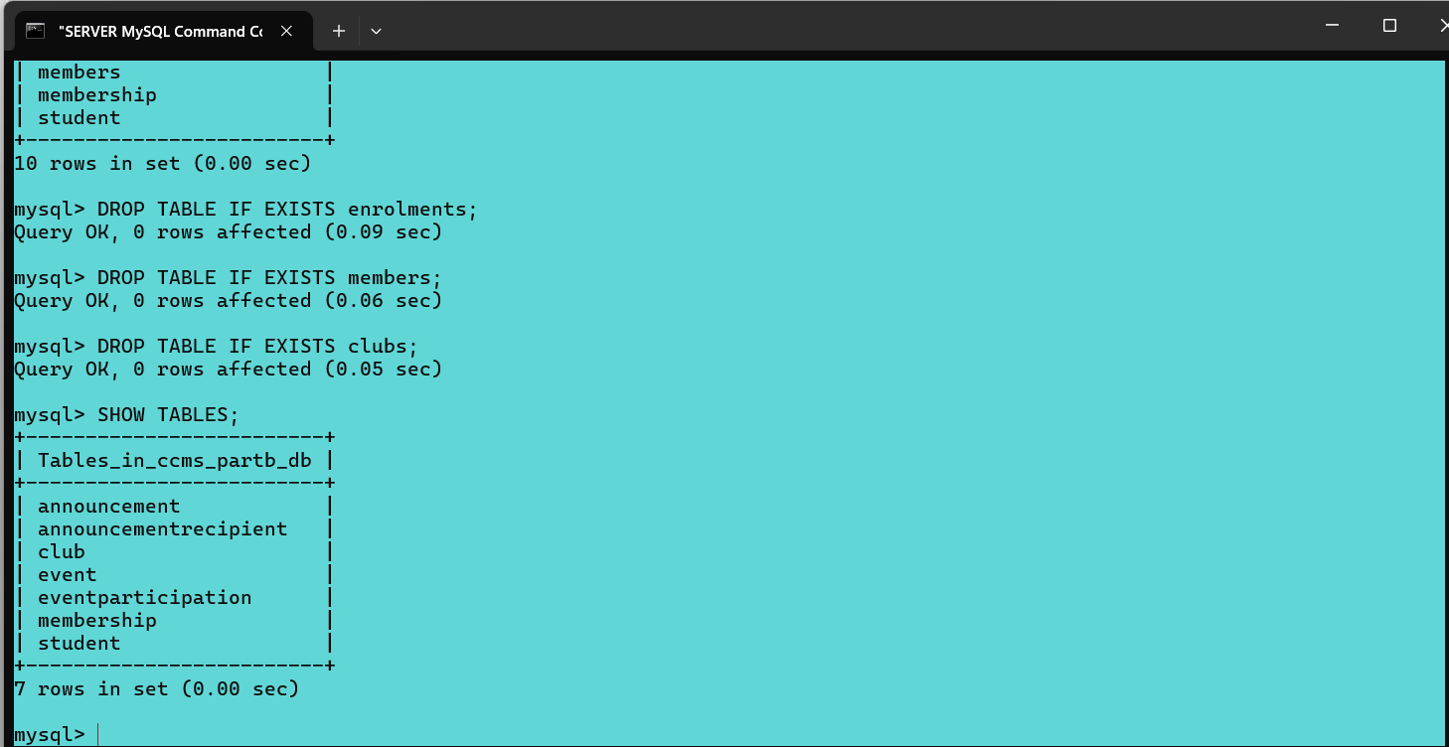
Figure 2: SQL Console output confirming successful creation of tables with constraints.
Description:
This screenshot demonstrates that the database schema was created successfully with all integrity constraints enforced.

3.2 Sample Data Insertion

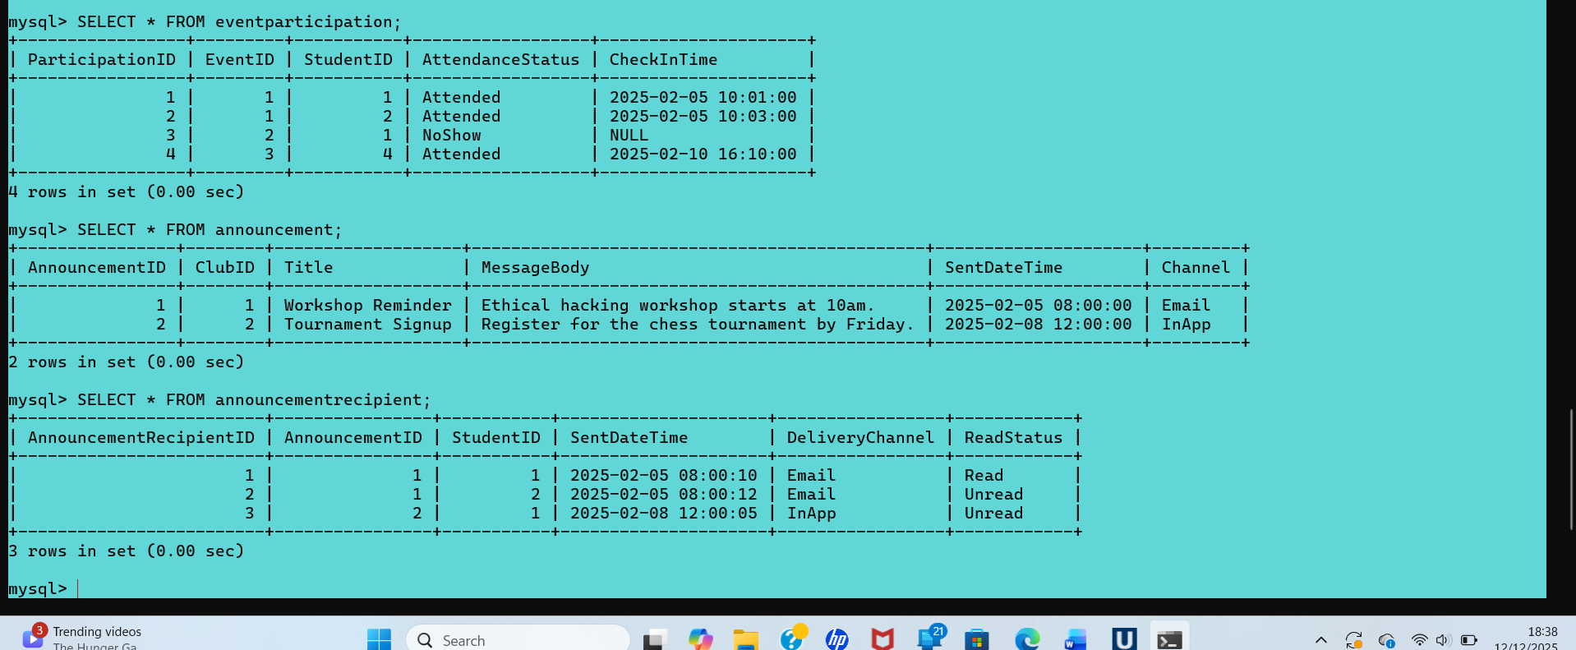
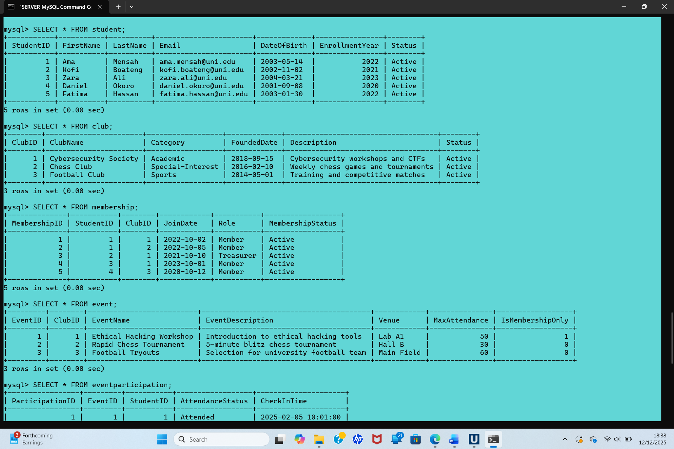
Figure 3: SELECT query output displaying inserted sample data across multiple tables.
Description:
The output confirms that sample data was inserted correctly and relationships between tables function as expected.

4. Constraint Validation Tests
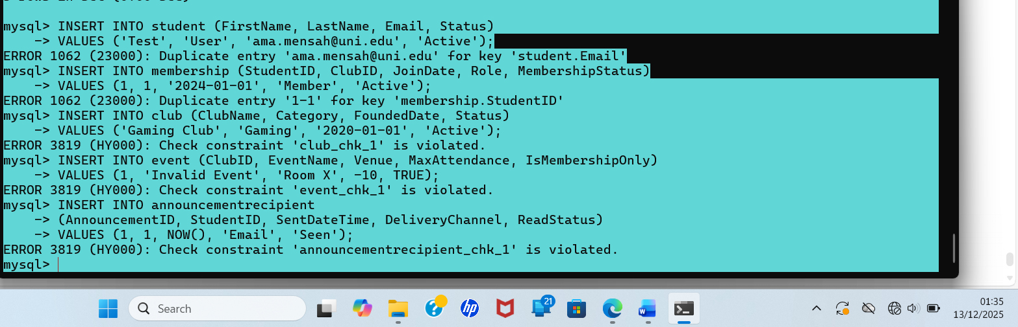
Constraint validation tests were performed by attempting to insert invalid data that violated UNIQUE and CHECK constraints. Each attempt resulted in an error, confirming that the database correctly enforces data integrity rules at the database level.
Figure 4: SQL error generated when attempting to violate a database constraint.
Description:
This confirms that constraint validation is handled at the database level, improving system reliability.

5. Stored Procedures and Transaction Management
5.1 CRUD Stored Procedures
Stored procedures were implemented to manage Create, Update, and Delete operations for memberships. These procedures encapsulate logic and enhance security by controlling data access.
Each procedure uses:
START TRANSACTION
COMMIT
ROLLBACK
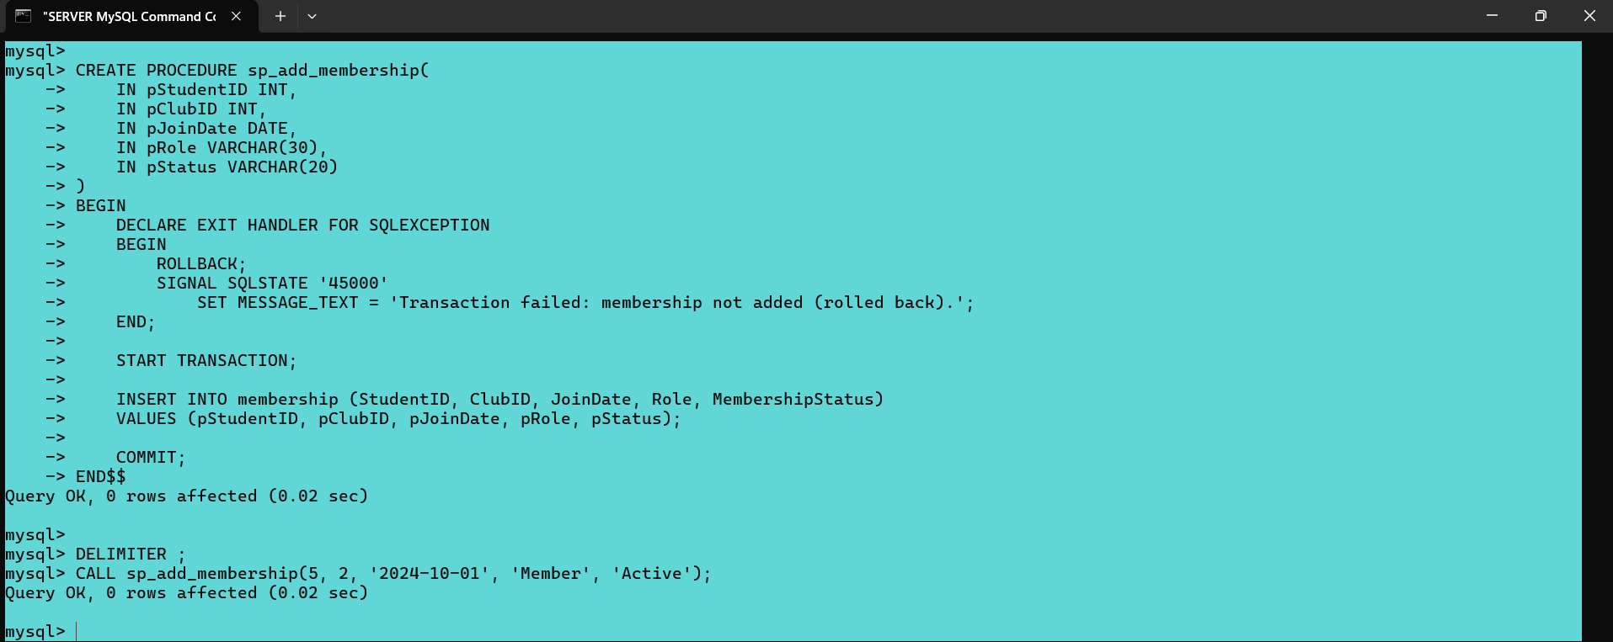

Figure 5: SQL Console output confirming successful creation of stored procedures.

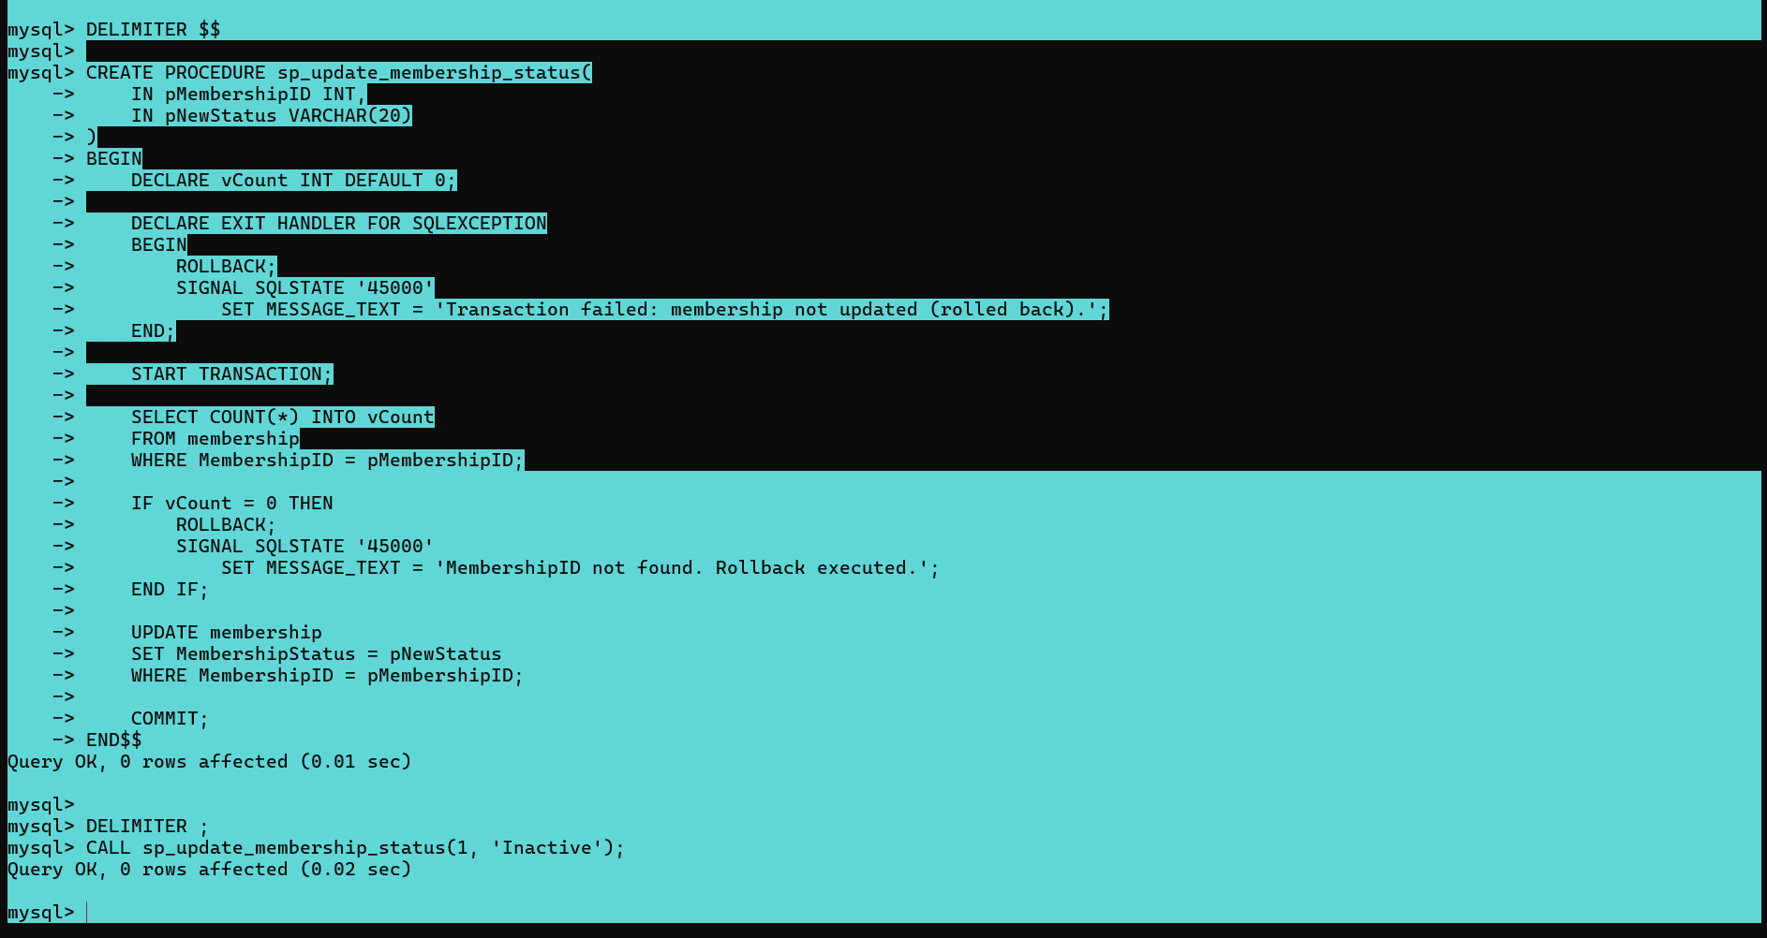
Stored Procedure: UPDATE Membership status (with transaction)

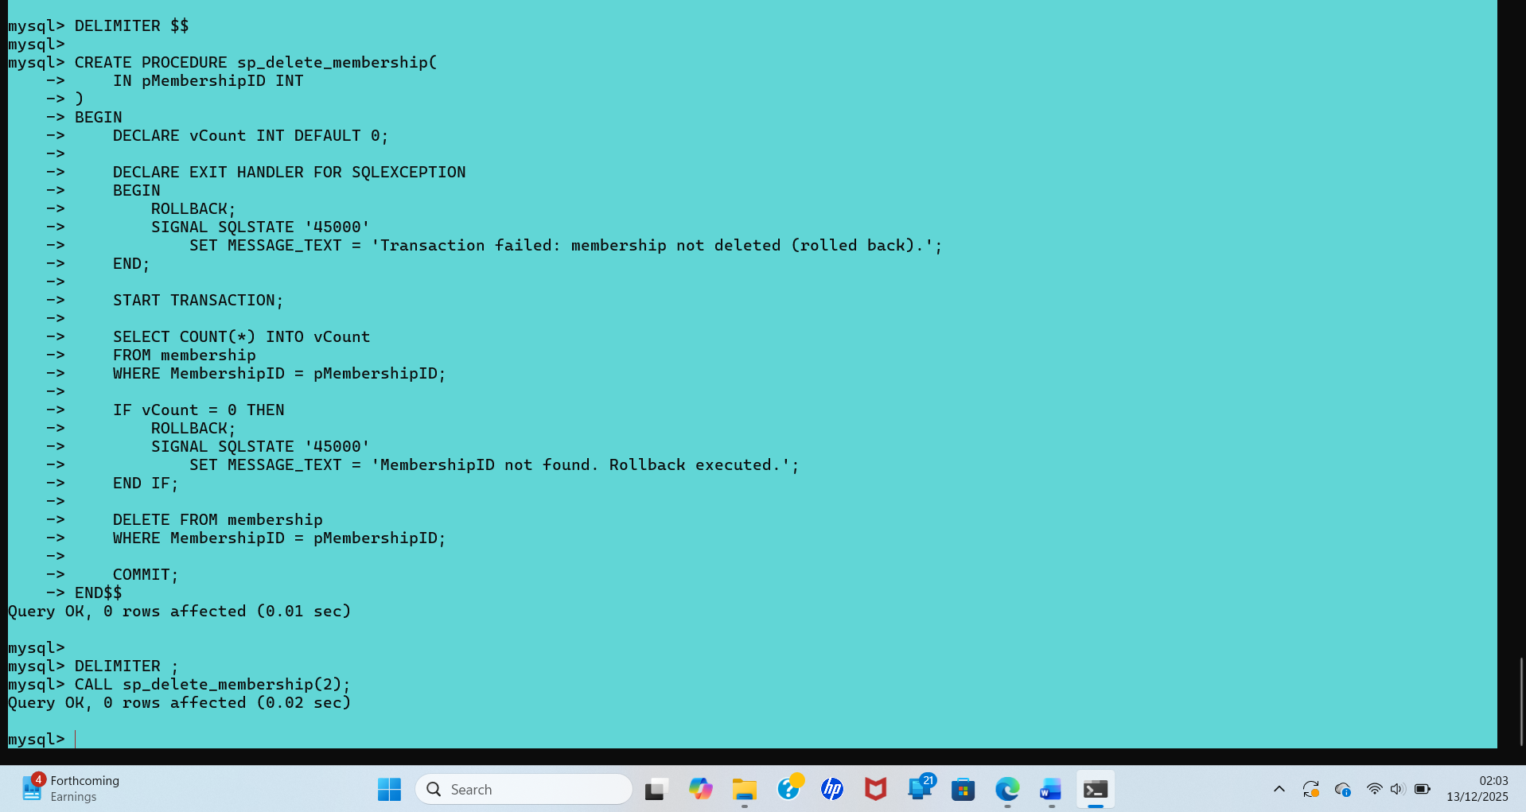
Stored Procedure: DELETE Membership (with transaction)

5.2 Transactional Scenario
A multi-step transactional procedure was implemented to send announcements to all active club members.
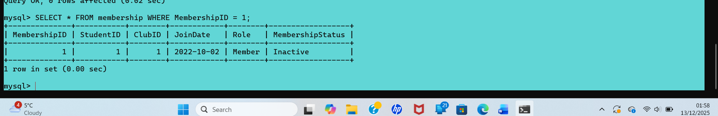
Figure 6: Successful execution of transaction with COMMIT.

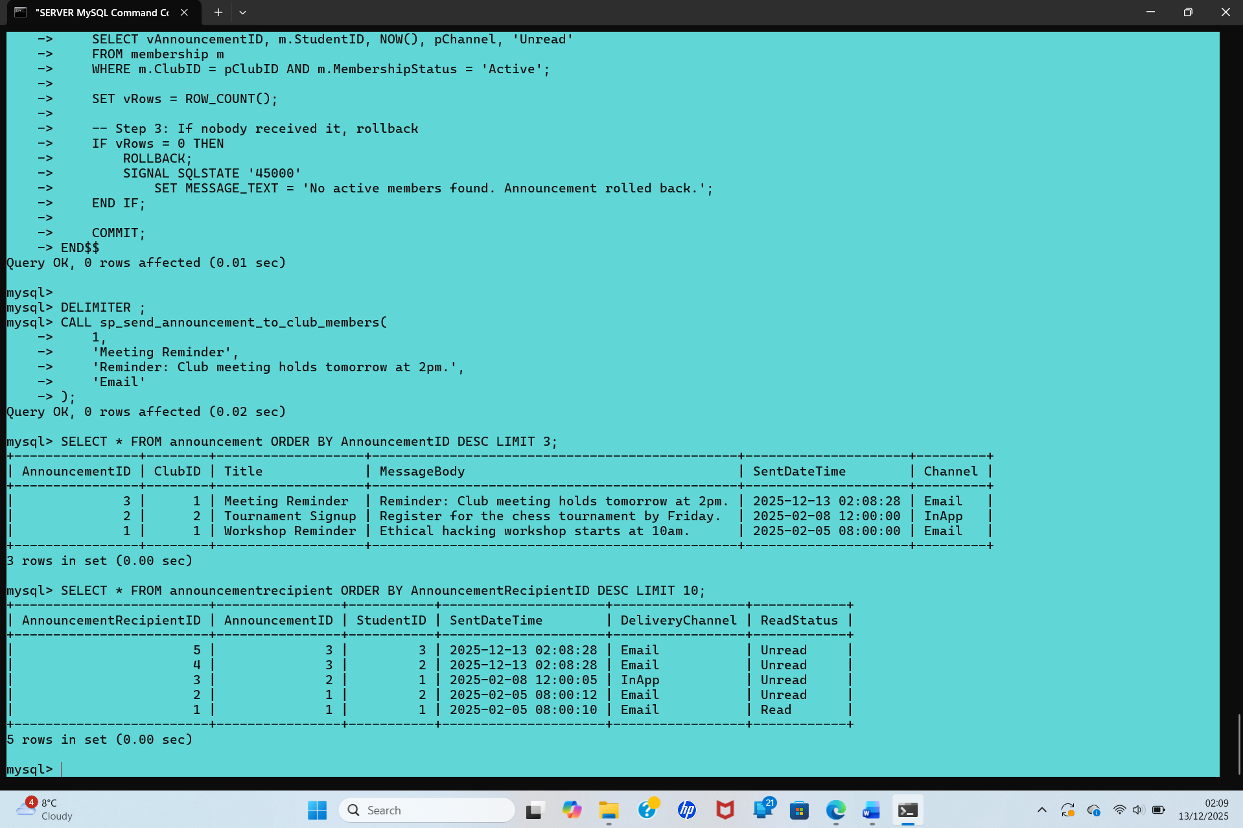
An announcement to all ACTIVE members of a club/verification SELECT outputs.
Figure 7: Rollback triggered when transaction conditions are not met.

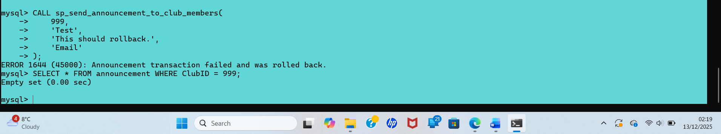
Test of Rollback case (Rollback proof)

6. Auditing Using Triggers
An auditing mechanism was implemented using database triggers to automatically log changes to membership records. An audit_log table records INSERT, UPDATE, and DELETE operations.
Audit records include:
- Table name
- Operation type
- Record ID
- Old and new values
- Timestamp

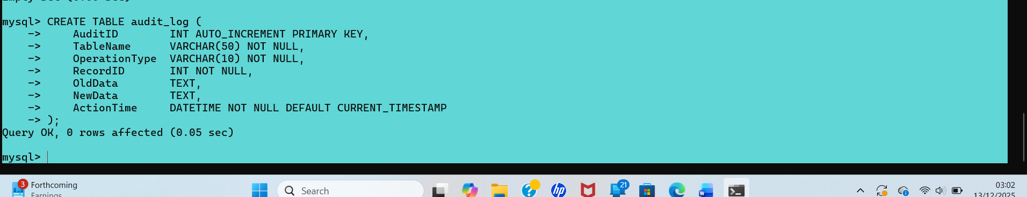
Audit Log table Creation
Figure 8: Audit log table structure.
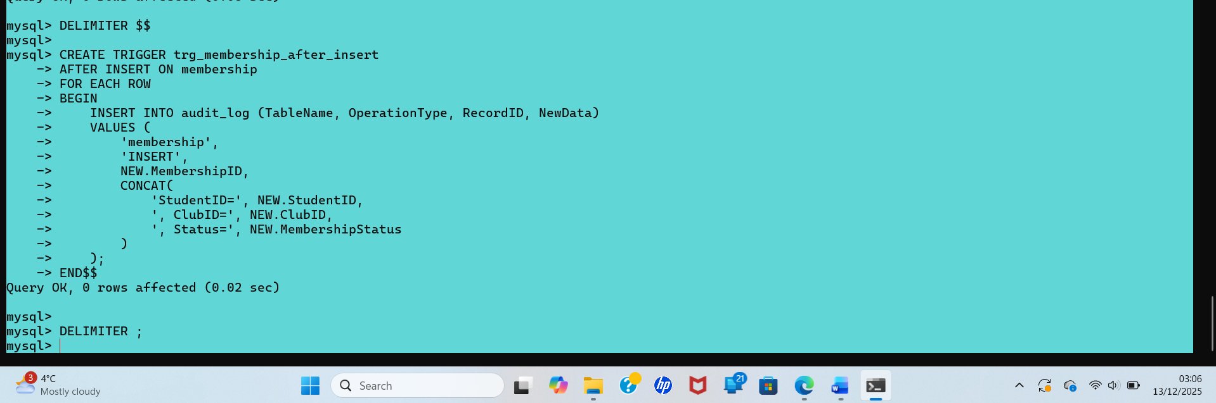
Trigger: AFTER INSERT on membership
Figure 9: Automatically generated audit records.

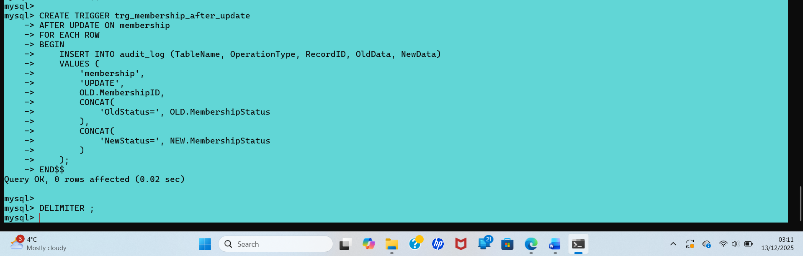
Trigger: AFTER UPDATE on membership

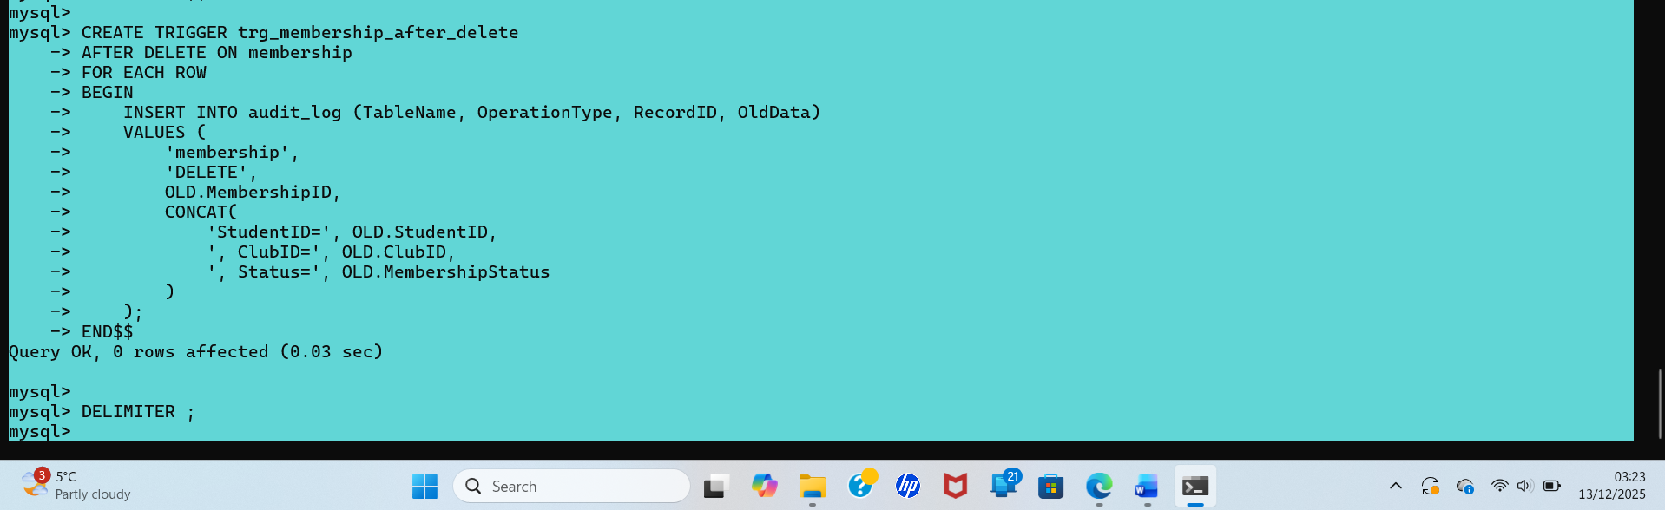
Trigger: AFTER DELETE on membership

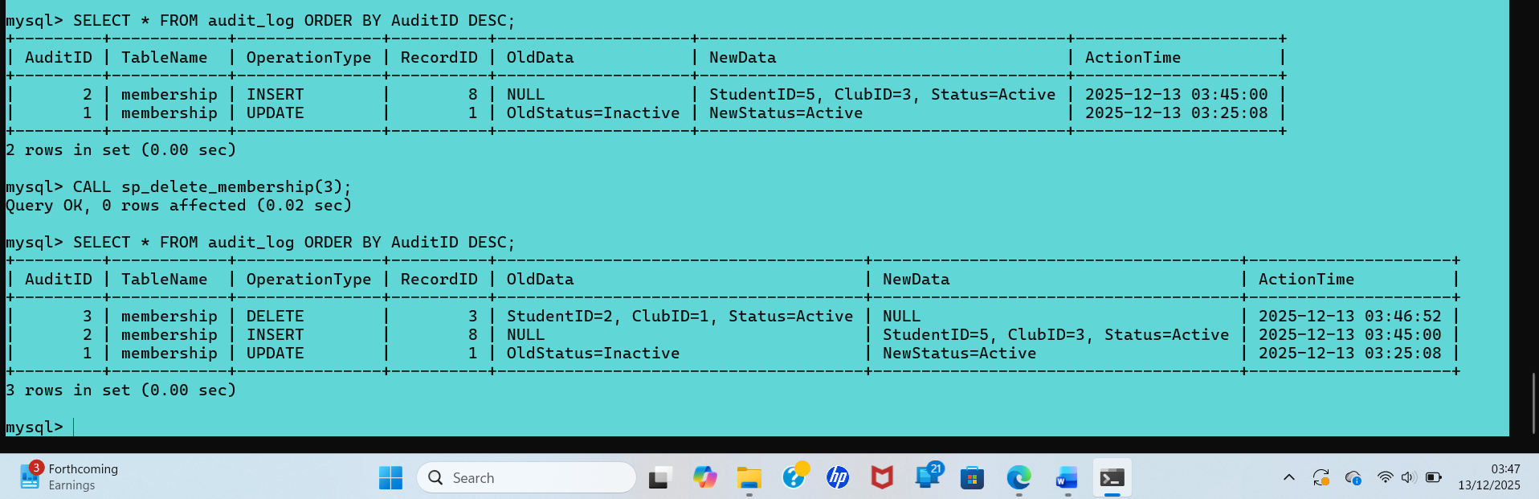
Result of the AUDITING USING TRIGGERS

Auditing was implemented using database triggers to automatically log INSERT, UPDATE, and DELETE operations on the Membership table. Each trigger records the affected table, operation type, record identifier, and before/after values in a dedicated audit_log table. This ensures accountability, traceability, and supports future auditing and monitoring requirements.

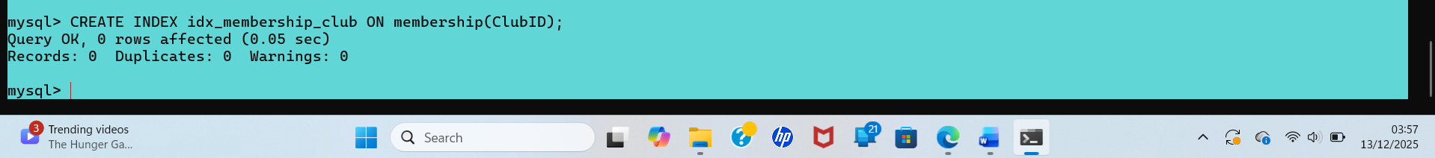

Figure 10: SQL output showing index creation for performance optimization.
Speeds up:
- club member lists
- student club history
- joins with student and club

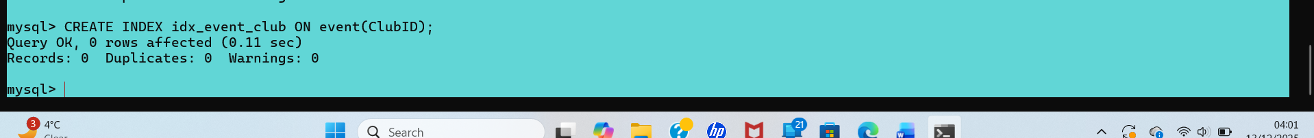
Event lookups by club

Speeds up:
- listing events per club
- joins with club

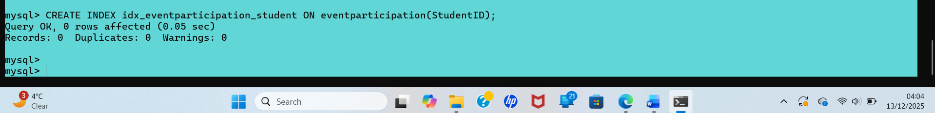
Event participation lookups

Speeds up:
- attendance reports
- engagement analysis
- joins with event and student

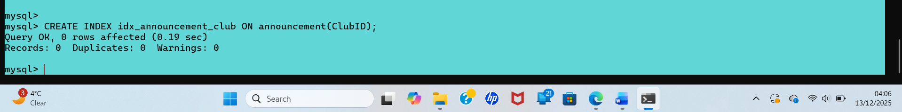
Announcement lookups
Speeds up:
- announcement history per club

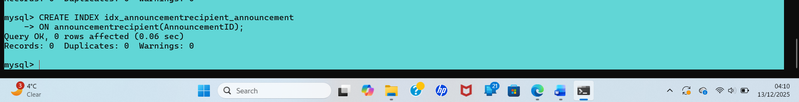
Announcement recipient lookups

Speeds up:
- recipient tracking
- read/unread analysis

Verified indexes
Performance Tuning Enhancement
Secondary indexes were created on foreign key and frequently queried columns to improve query performance and reduce execution time. Indexes on membership, event, event participation, and announcement tables optimise join operations and WHERE-clause filtering. This enhances system responsiveness when retrieving club memberships, event attendance records, and announcement distributions, particularly as data volume increases.

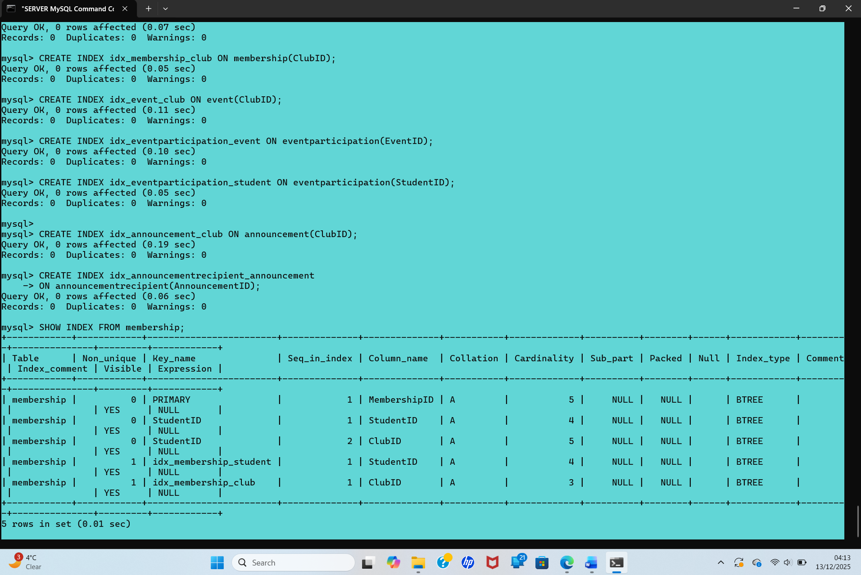
Figure 10: SQL output showing index creation for performance optim

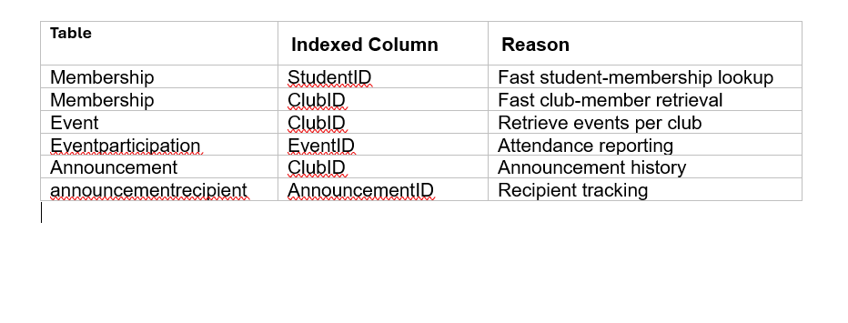

References
Elmasri, R., & Navathe, S. B. (2016). Fundamentals of Database Systems (7th ed.). Pearson.
Connolly, T., & Begg, C. (2015). Database Systems: A Practical Approach to Design, Implementation, and Management (6th ed.). Pearson.
Silberschatz, A., Korth, H. F., & Sudarshan, S. (2019). Database System Concepts (7th ed.). McGraw-Hill.
MySQL. (n.d.). MySQL 8.0 Reference Manual: InnoDB and SQL Statements. Oracle.
Codd, E. F. (1970). A relational model of data for large shared data banks. Communications of the ACM, 13(6), 377–387.
Date, C. J. (2004). An Introduction to Database Systems (8th ed.). Addison-Wesley.
Garcia-Molina, H., Ullman, J. D., & Widom, J. (2008). Database Systems: The Complete Book (2nd ed.). Pearson.
ISO/IEC. (2016). ISO/IEC 9075: SQL Standard (overview).

3. Part B – PHP Website Development
3.1 Overview of Website Topic
The website developed for Part B is a database-driven food ordering and menu management system, implemented using PHP and MySQL. The purpose of the website is to demonstrate core server-side programming skills gained during the module, including dynamic content generation, database interaction, CRUD operations, search functionality, and fundamental security practices. The system is designed as an information-based web application, rather than a transactional e-commerce platform, in line with module requirements.
The website allows users to browse food categories and menu items dynamically retrieved from the database. Administrators are provided with a secure backend interface where food items and categories can be added, edited, or deleted. This design choice ensures sufficient scope for implementing database relationships, administrative controls, and validation logic. The overall aim of the project is to illustrate how PHP can be used effectively to manage structured data, enforce business rules, and mitigate common security threats such as SQL Injection.

3.2 Database Design for Website
3.2.1 Tables and Relationships
The database used for the website is named food-order, and it follows a relational design with normalization applied to reduce redundancy and improve data integrity. The core tables implemented include tbl_category, tbl_food, and tbl_admin, tbl_order supporting extended functionality.
The tbl_category table stores food categories and acts as a parent entity. Each category is uniquely identified by a primary key and contains attributes such as title, image name, and active status. The tbl_food table represents individual menu items and includes a foreign key referencing tbl_category, establishing a one-to-many relationship between categories and food items. This relationship ensures that each food item belongs to exactly one category, enforcing logical grouping at the database level.
The tbl_admin table supports administrative authentication and access control. It stores login credentials for administrators who are permitted to manage menu data. The separation of administrative data from content data supports security and aligns with good database design principles. The database structure ensures compliance with third normal form (3NF), as non-key attributes depend only on the primary key, and transitive dependencies are avoided.

3.2.2 Sample Data
To support dynamic content and meaningful testing, the database contains approximately 15–20 sample records distributed across the core tables. Sample categories include entries such as Fast Food, Drinks, and Desserts. Corresponding food items include records such as burgers, pizzas, beverages, and desserts, each linked to a valid category through a foreign key.
Sample administrative users are also included in tbl_admin, allowing secure login to the backend interface. The inclusion of realistic sample data ensures that all system features such as listing menus, filtering by category, and performing CRUD operations can be demonstrated effectively during evaluation.

3.3 PHP Implementation
3.3.1 Dynamic Content Display
Dynamic content is generated using PHP scripts that retrieve data from the MySQL database and render it within HTML pages. Database connectivity is handled through a centralized configuration file (config.php), which establishes a reusable connection using MySQLi. This approach promotes maintainability and consistency across the application.
Pages such as index.php, food-menu.php, and category-foods.php execute SQL SELECT queries to retrieve categories and food items. The results are processed using PHP loops and displayed dynamically to users. This implementation allows changes to be made in the database such as adding new food items, are immediately reflected on the website without modifying the page source code.

3.3.2 CRUD Operations
CRUD functionality is implemented primarily within the administrative section of the website. The Create operation allows administrators to add new food items using add-food.php, which collects form input and inserts validated data into the database. The Read operation retrieves and displays existing records for review and management purposes.
The Update operation is implemented through files such as update-food.php, allowing administrators to modify food details, including price, description, and category. The Delete operation removes records from the database, typically triggered through controlled admin actions to prevent accidental deletion. Together, these operations demonstrate full lifecycle data management using PHP and SQL.

3.3.4 Security Measures (Login and Input Validation)
Basic security mechanisms are implemented throughout the website. Administrative access is restricted through a login system that verifies credentials stored in tbl_admin. Sessions are used to maintain authentication state, ensuring that only authorized users can access CRUD functionality.
Input validation is applied consistently to sanitize user-submitted data. Server-side validation ensures required fields are populated, numeric values are constrained appropriately, and unexpected input is rejected. These measures reduce the risk of invalid data entry and contribute to overall system robustness.

3.4 SQL Injection Overview
3.4.1 Explanation and Examples
SQL Injection is a web security vulnerability that allows attackers to manipulate database queries by injecting malicious SQL code into application inputs. This attack exploits improper handling of user-supplied data and can result in unauthorized data access, data modification, or complete database compromise (OWASP, 2024).
For example, if a login form directly embeds user input into an SQL query without validation, an attacker could input crafted SQL such as ' OR '1'='1 to bypass authentication. This vulnerability arises when dynamic SQL queries are constructed through string concatenation rather than using secure query mechanisms.
SQL Injection is particularly dangerous because it operates at the database level, enabling attackers to read sensitive information, delete records, or escalate privileges. Web applications that rely heavily on database interaction, such as PHP-based systems, are especially susceptible if defensive measures are not implemented correctly (Halfond et al., 2006).

3.4.2 Vulnerabilities in Website Code
During early development, potential SQL Injection vulnerabilities were identified in sections of code that accepted user input, particularly within search functionality and administrative forms. For example, initial versions of search queries relied on raw input from form fields without sufficient sanitization.
If left unaddressed, such code could allow attackers to inject malicious SQL via query parameters. These risks highlight the importance of validating and escaping all external input before database interaction.
Screenshot placeholder:
Figure B1: Example of vulnerable SQL query prior to mitigation

3.4.3 Anti-SQL Injection Measures Implemented
To mitigate SQL Injection risks, the website implements prepared statements using MySQLi. Prepared statements separate SQL logic from data input, enabling user-supplied values are treated strictly as parameters rather than executable code. This technique is widely regarded as one of the most effective defenses against SQL Injection attacks (OWASP, 2024).
Additionally, input validation functions are used to restrict unexpected characters and enforce data type constraints. Administrative pages are further protected through authentication checks, reducing the exposure of sensitive queries to unauthenticated users.
Screenshot placeholder:
Figure B2: Prepared statement implementation in PHP (add-food.php)

3.4.4 Screenshots of Testing and Results
Testing was conducted by attempting known SQL Injection payloads within form fields. When prepared statements were correctly applied, injected payloads were treated as literal strings, resulting in no database compromise. Error messages were suppressed or handled gracefully, preventing information leakage.
These tests demonstrate the effectiveness of the implemented defenses and confirm that the website is resilient against common injection techniques.
Screenshot placeholder:
Figure B3: Failed SQL Injection attempt and secure output

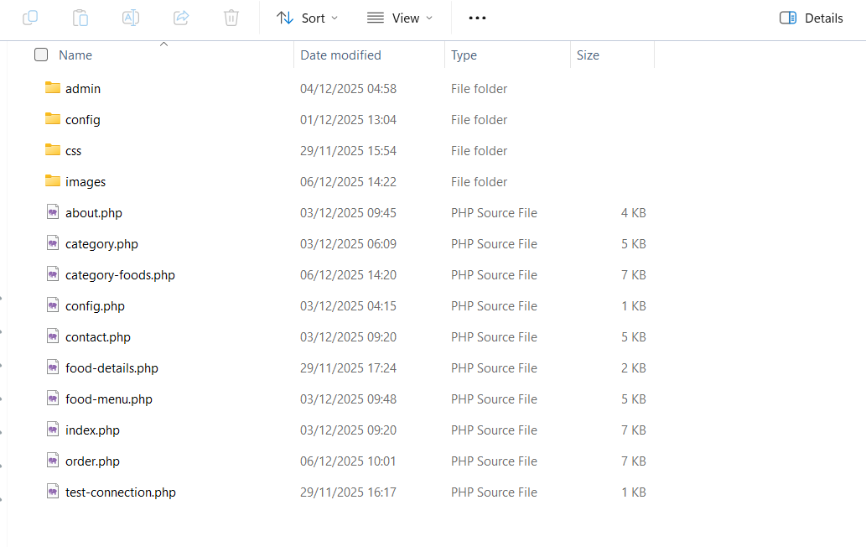


This is the dynamic homepage of the FoodOrder website, displaying a hero banner and a list of popular foods loaded directly from the database, each with images, prices, and an option to order.
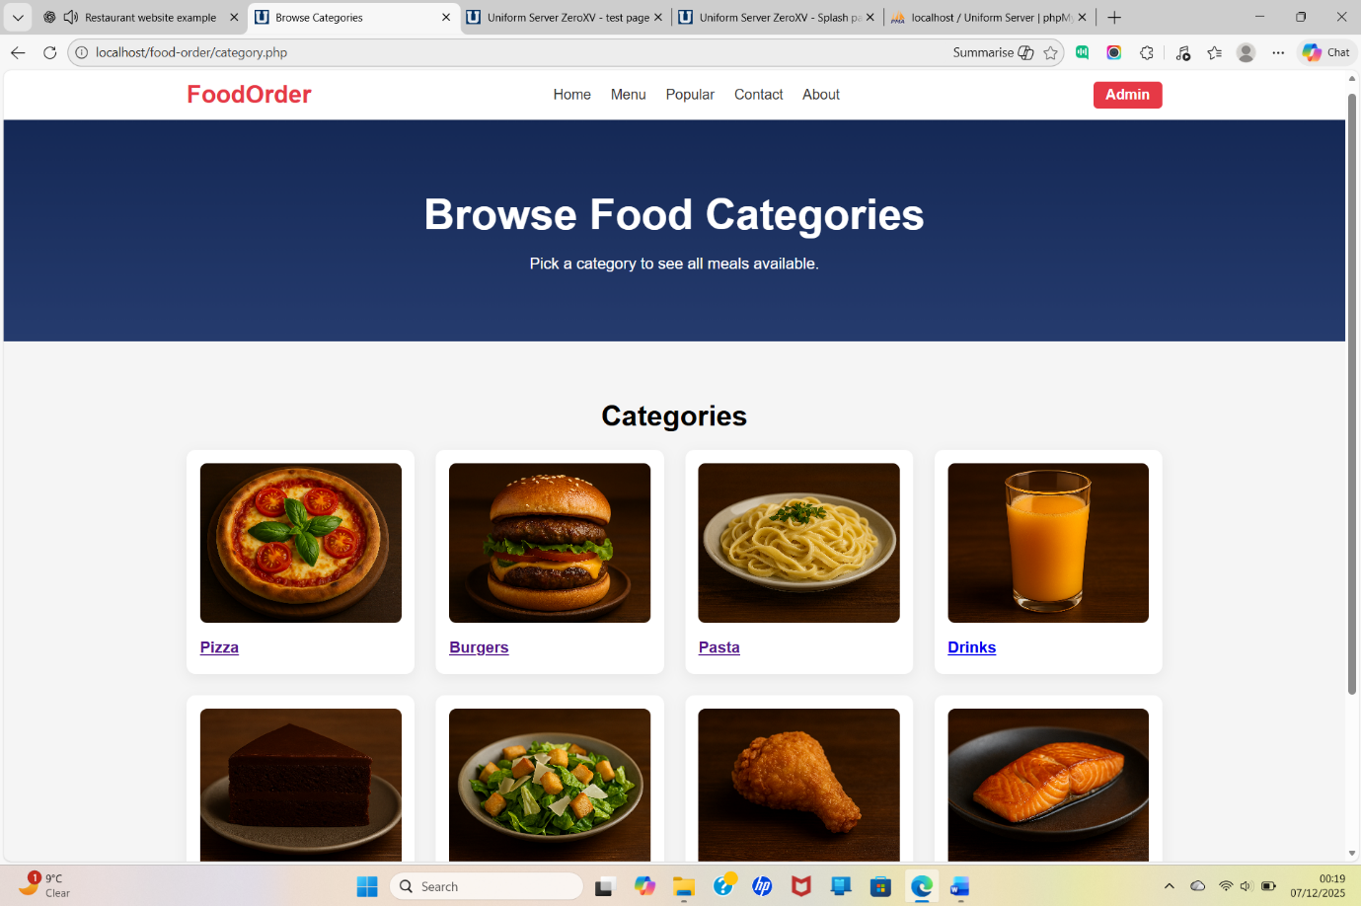

This page displays all food categories dynamically from the database, each with an image and name, allowing users to click a category to view the meals inside it.

Image to be change later to a normal add food panel

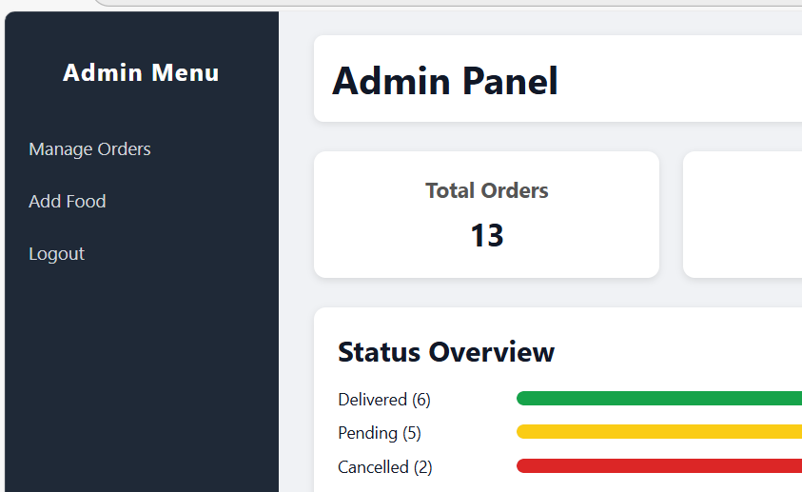

5.2 READ (View Data)
All foods, categories, and orders are displayed dynamically. Admin panel lists all orders in manage-order.php with pagination-like table.
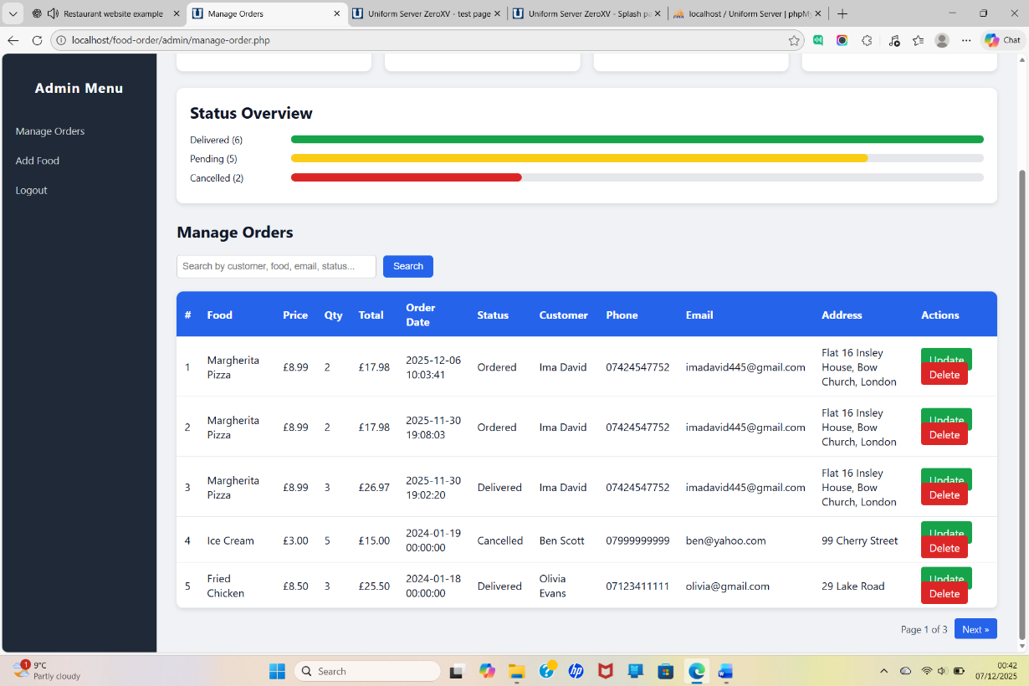

Admin can update orders using update-order.php. Admin can update food items using update-food.php.

Image to be change later
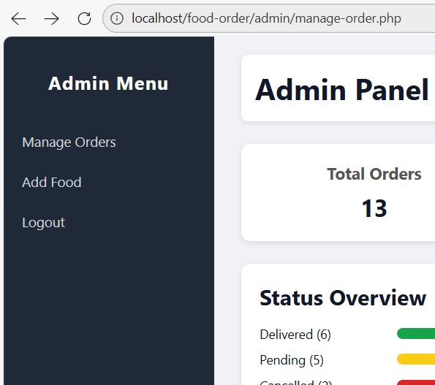

5.4 DELETE (Remove Data)
Admin can delete food items or orders using dedicated delete scripts. Delete actions include confirmation dialogs to avoid mistakes.

Image to be change later

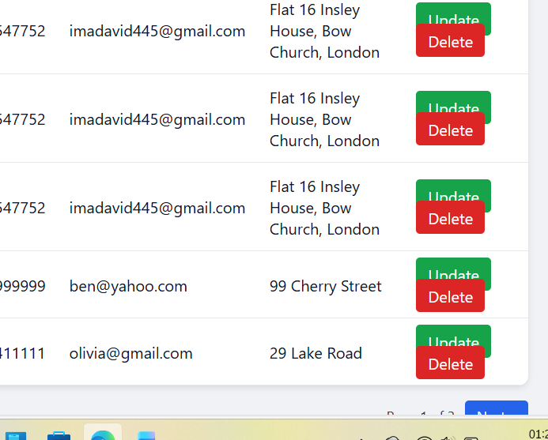

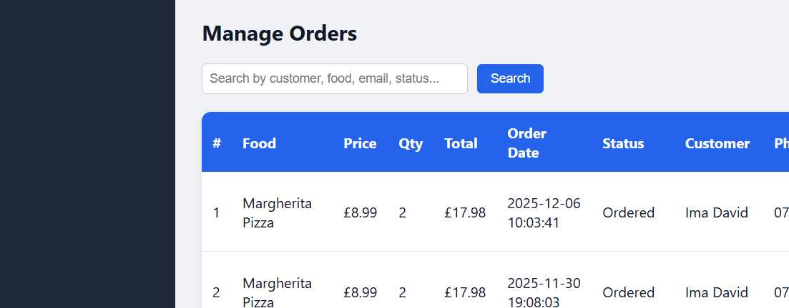

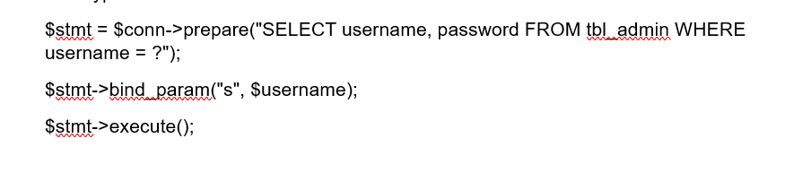
Prepared statements separate SQL structure from user input and completely block injection attempts.

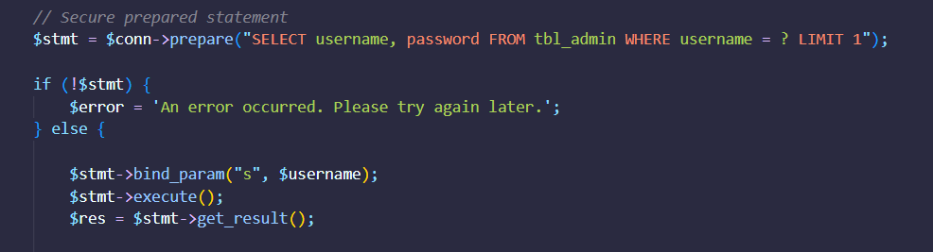
Figure 10. This screenshot shows the secure prepared statement in login.php that prevents SQL injection.
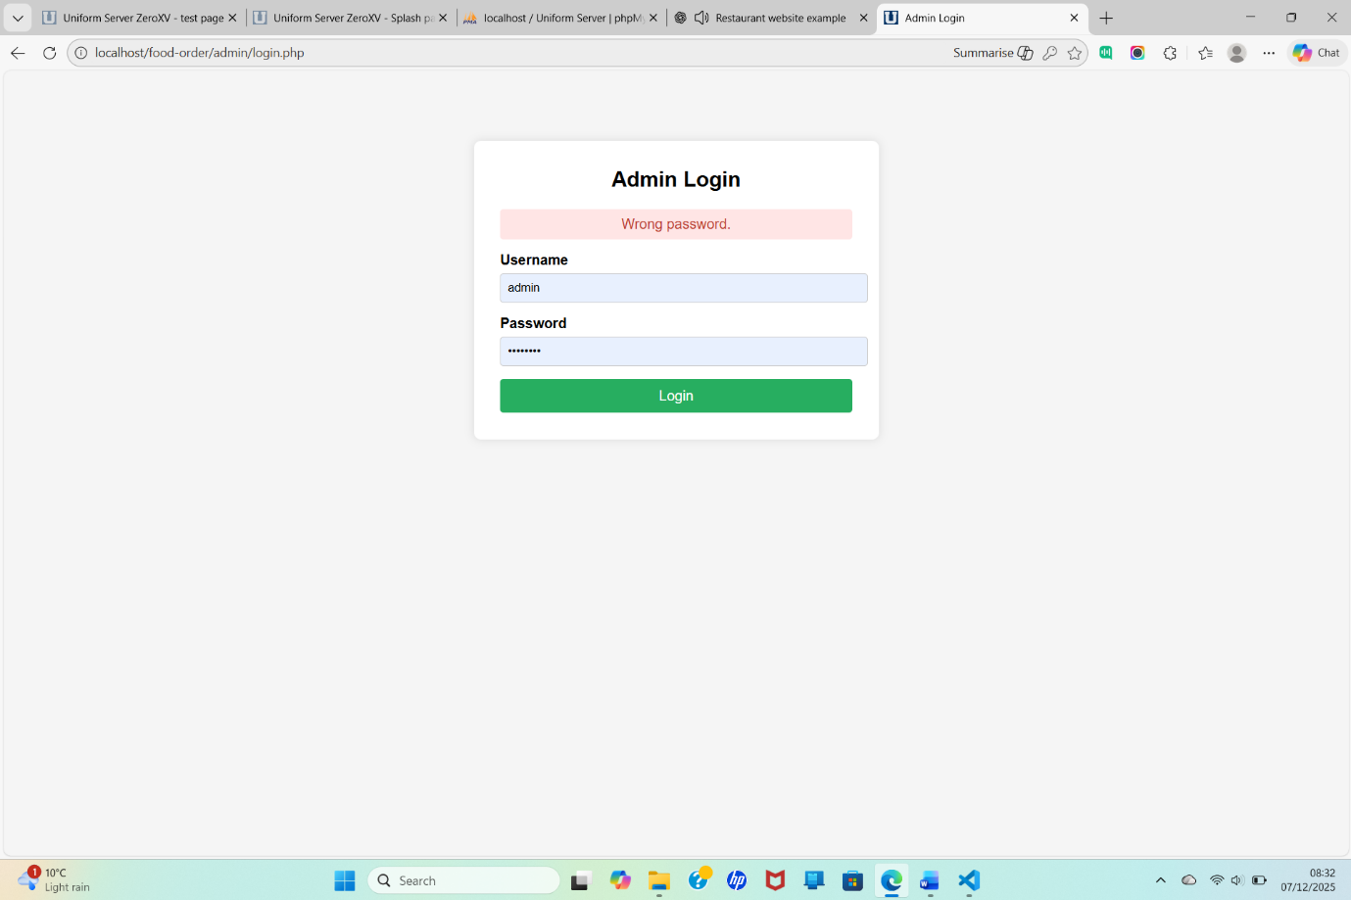

Figure 11. This screenshot shows a failed login attempt, proving that SQL injection does not work

8.1 Functional Testing
A table of functional test cases should be included:
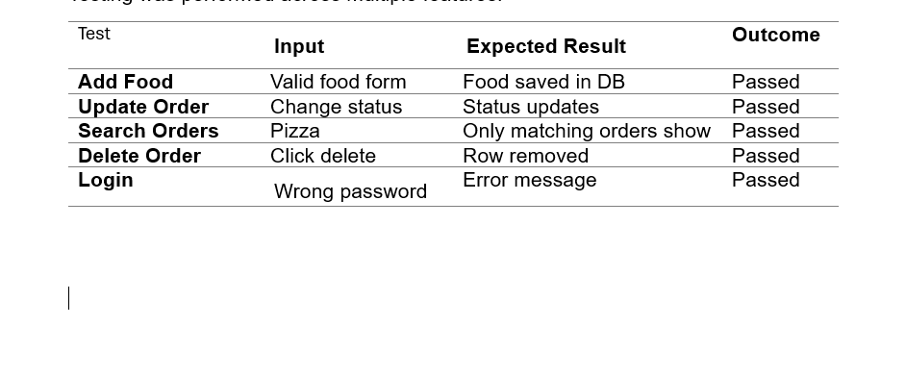

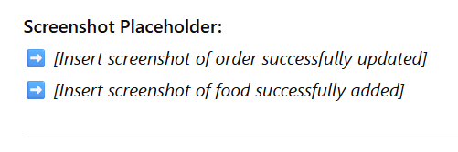

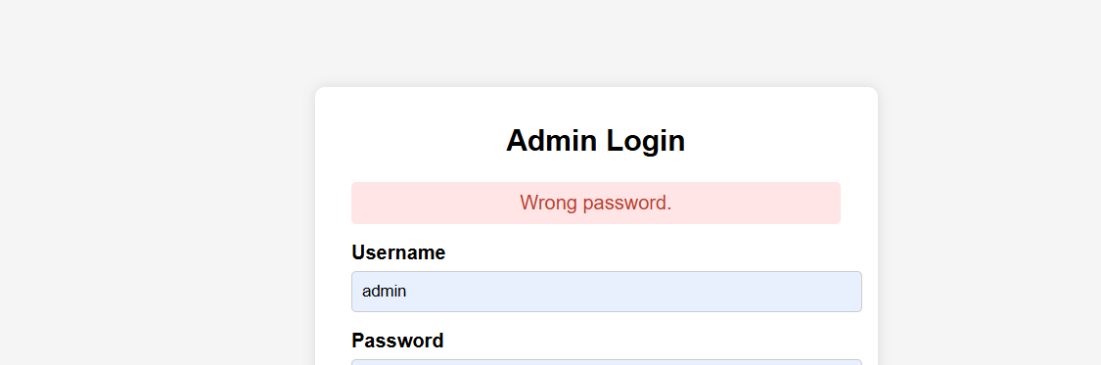

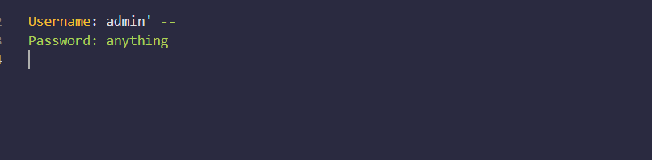
Figure 1: Malicious Login Input Used to Perform SQL Injection

This screenshot shows the exact attacker possible input that may exploits the vulnerable login form.
- Username: admin' --
- Password: anything
The injected ' breaks out of the username string, the -- begins an SQL comment which disables the password check.The system ignores the password entirely, This leads directly to unauthorized admin access.


Figure 2: SQL Query After Injection is Applied
The -- turns the rest of the query into a comment, completely removing the password check. The query now effectively becomes: SELECT * FROM tbl_admin WHERE username='admin'; The attacker may logs in without knowing the password. This demonstrates how string concatenation in SQL queries leads directly to SQL Injection.


Figure 3: Vulnerable Delete Query Using Direct String Concatenation

This screenshot shows the original insecure delete operation This is vulnerable because It directly inserts user input ($_GET['id']) into the SQL query. An attacker can manipulate the URL and inject additional SQL logic (e.g., ?id=0 OR 1=1). Because the query is not validated or parameterized, it can result in mass deletion of food items or other damage.


Figure 4: SQL Injection Payload Entered in the URL

This screenshot shows the attacker-controlled input added directly into the URL:

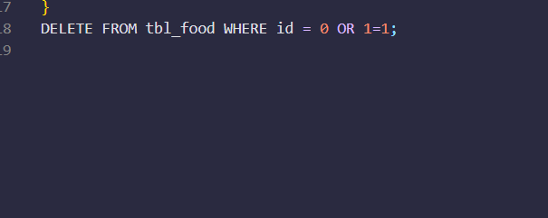
Figure 5: SQL Injection Turning a DELETE Query Into a Full Table Wipe

Impact:
1=1 is always true → the WHERE clause matches every record. This results in deleting the entire tbl_food table, this demonstrates how dangerous SQL injection is when DELETE or UPDATE queries are insecure

Figure 6: Secure Login Query Using Prepared Statements
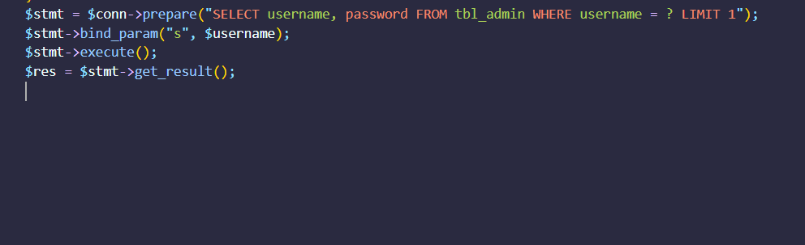
This screenshot shows the secured login query, rewritten to use prepared statements instead of vulnerable string concatenation.

Benefits:
- User input is treated strictly as a string
- SQL syntax cannot be manipulated
- Queries are pre-compiled by MySQL

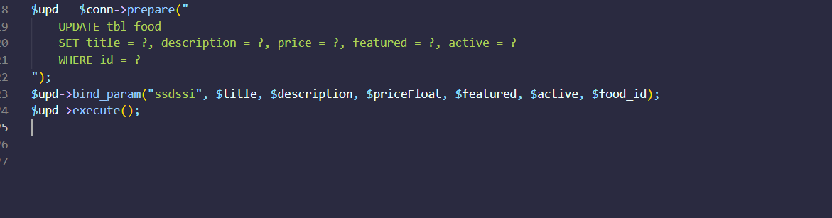
Figure 7: Secure UPDATE Query Using Prepared Statements

This screenshot shows the rewritten UPDATE query for the tbl_food table using prepared statements. The previous version was vulnerable because user input was directly concatenated into the SQL string.

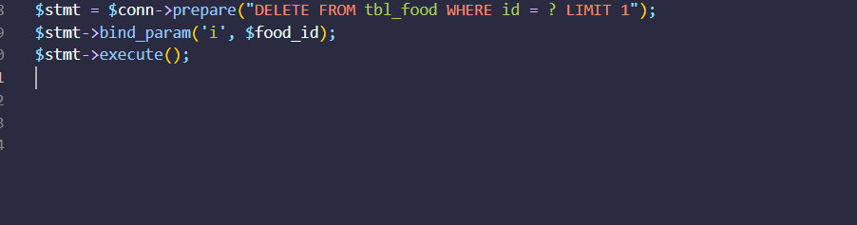
Figure 8: Secure DELETE Query Using Prepared Statements
This code demonstrates how deletion operations were secured using parameterized queries. By binding the id value with bind_param('i', $food_id), the system prevents attackers from injecting malicious expressions such as 0 OR 1=1, which would otherwise delete the entire table.
Adding LIMIT 1 provides an extra safeguard to ensure only one record is ever deleted at a time.

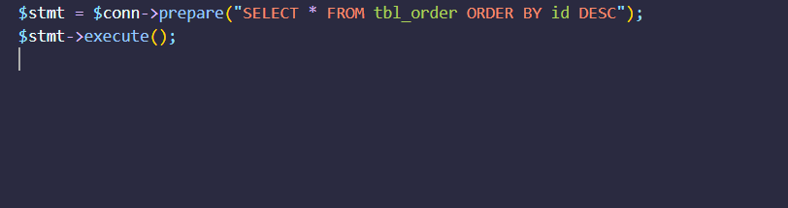
Figure 9: Secure SELECT Query Using Prepared Statements
This example shows how the system retrieves all orders safely using a prepared SQL statement. Even though this particular query has no user input, using prepared statements across the entire system helps maintain consistency and prevents future injection risks.


Figure 10: Input validation for numeric IDs using ctype_digit()
This validation ensures that the id parameter contains only numeric characters before it is used in any SQL query.
It prevents attackers from injecting malicious strings (e.g., ?id=0 OR 1=1) and stops unauthorized query manipulation.


Figure 11: Required field validation to prevent empty or missing input.

This check ensures that essential fields (e.g., title and price) are not left blank before processing the form. It helps prevent incomplete data from being inserted into the database and improves overall data integrity.


Figure 13: Validation ensuring that price is numeric, preventing invalid input.


Figure 14: Output escaping using htmlspecialchars() to prevent Cross-Site Scripting (XSS) attacks.
This ensures that any user-supplied text (e.g., customer name) is safely displayed without allowing embedded HTML or JavaScript to execute.

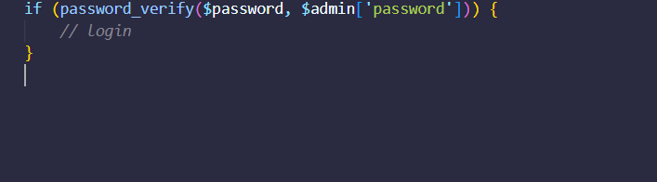
Figure 15: Example of secure password verification using password_verify() instead of plaintext comparison.

This demonstrates replacing plain-text password comparison with hashed password verification. Even if the database is compromised, attackers cannot recover the original passwords.

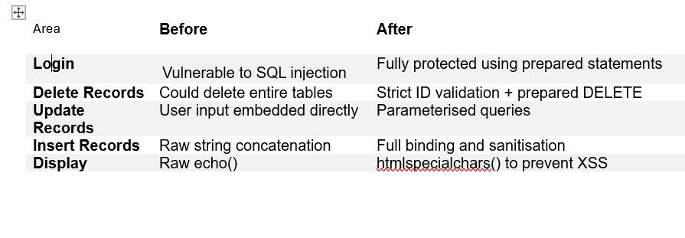
8. Summary of SQL Injection Prevention

1. Dynamic Content in the PHP Website

Conclusion and Reflection
This project successfully delivered a complete, end-to-end implementation of a database-driven information system, progressing from rigorous relational database design to a functional PHP web application. In Part A, the Campus Club Management System (CCMS) database was carefully designed using normalization principles, enforceable constraints, and transaction-safe operations to ensure data integrity, consistency, and long-term maintainability. The ERD and schema clearly separate core entities from associative relationships, supporting complex many-to-many interactions while preserving auditability and performance through appropriate indexing. In Part B, this robust database foundation was effectively integrated into a PHP website that demonstrates dynamic content retrieval, full CRUD functionality, structured search features, and essential security controls. Particular emphasis was placed on mitigating SQL injection risks through prepared statements and input validation, reinforcing the importance of defensive coding practices in real-world web development. Collectively, the project highlights the critical relationship between sound database architecture and secure application-level implementation, while providing valuable practical experience in building reliable, industry-aligned systems using MySQL and PHP.

To be recreated

Store procedor created

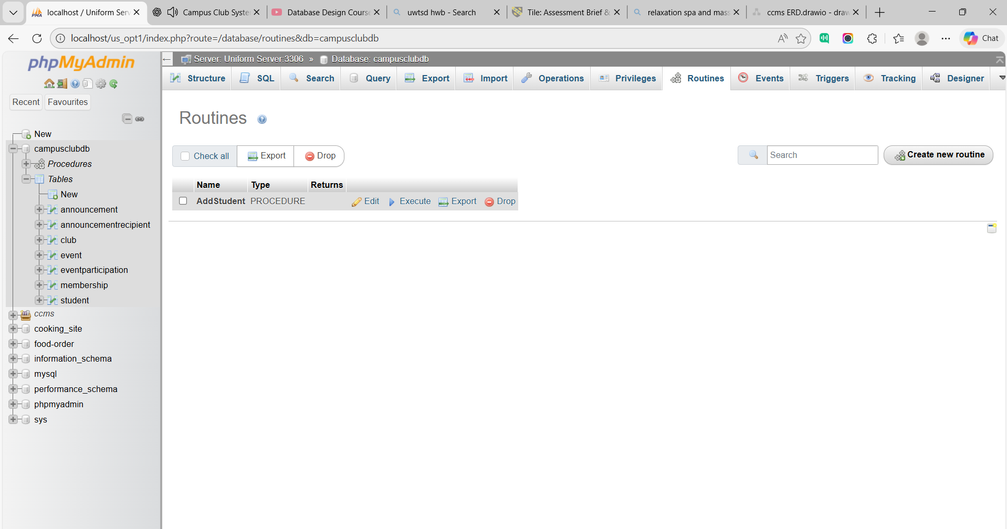

Add procedure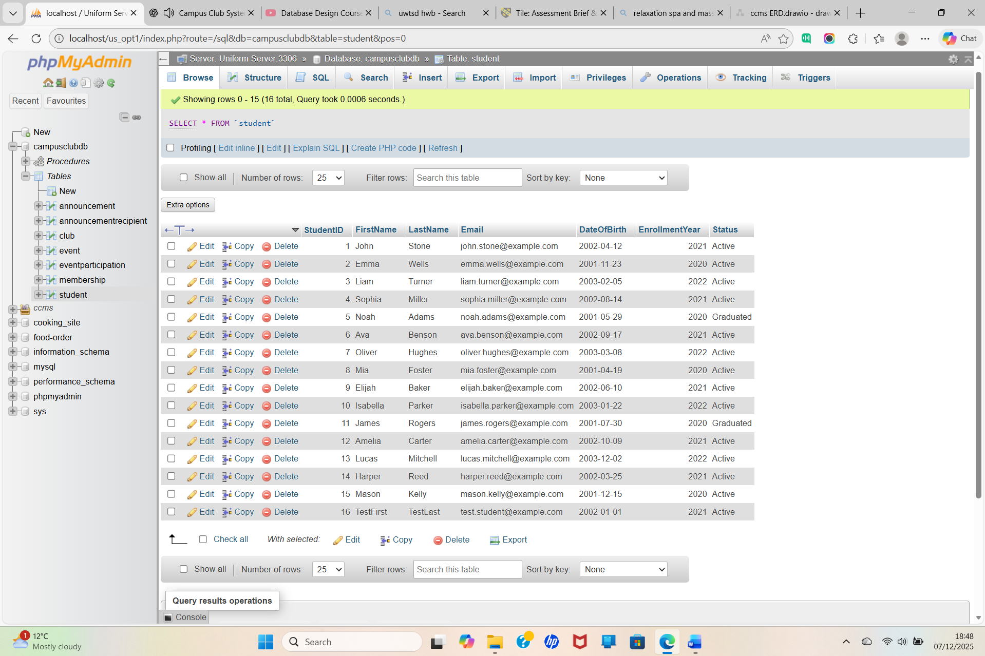

Student table with a rule missing
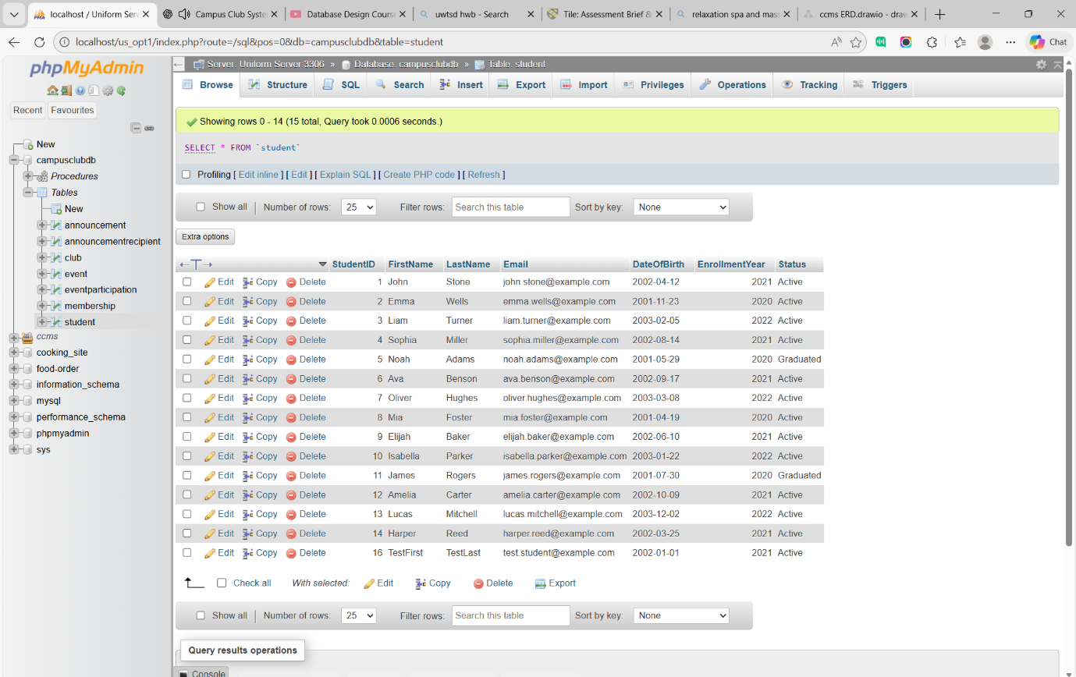

New participant
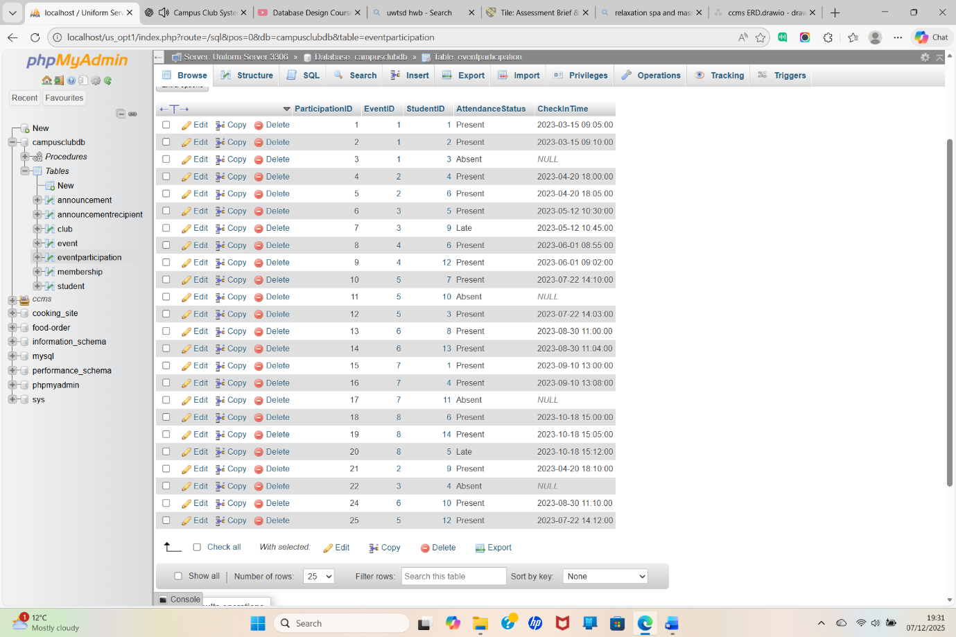

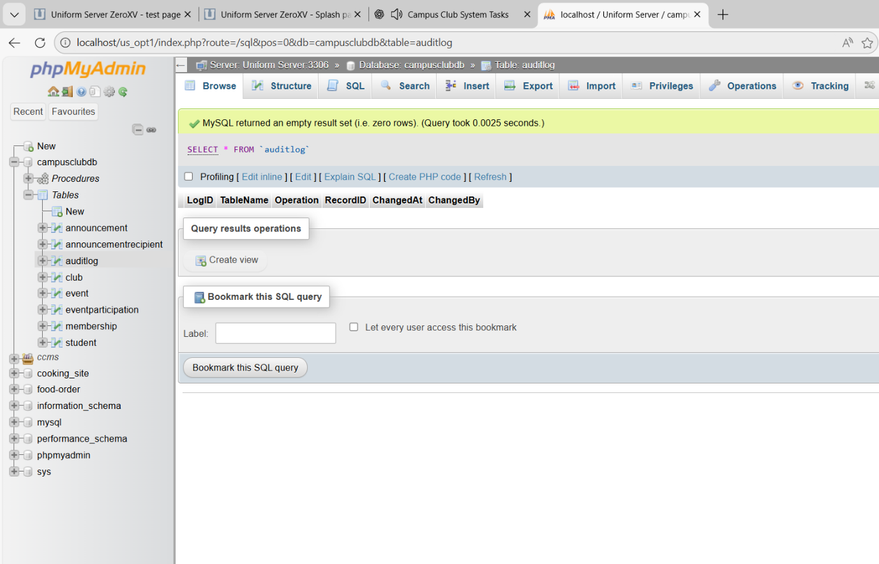
Auditlog table created

First trigger created
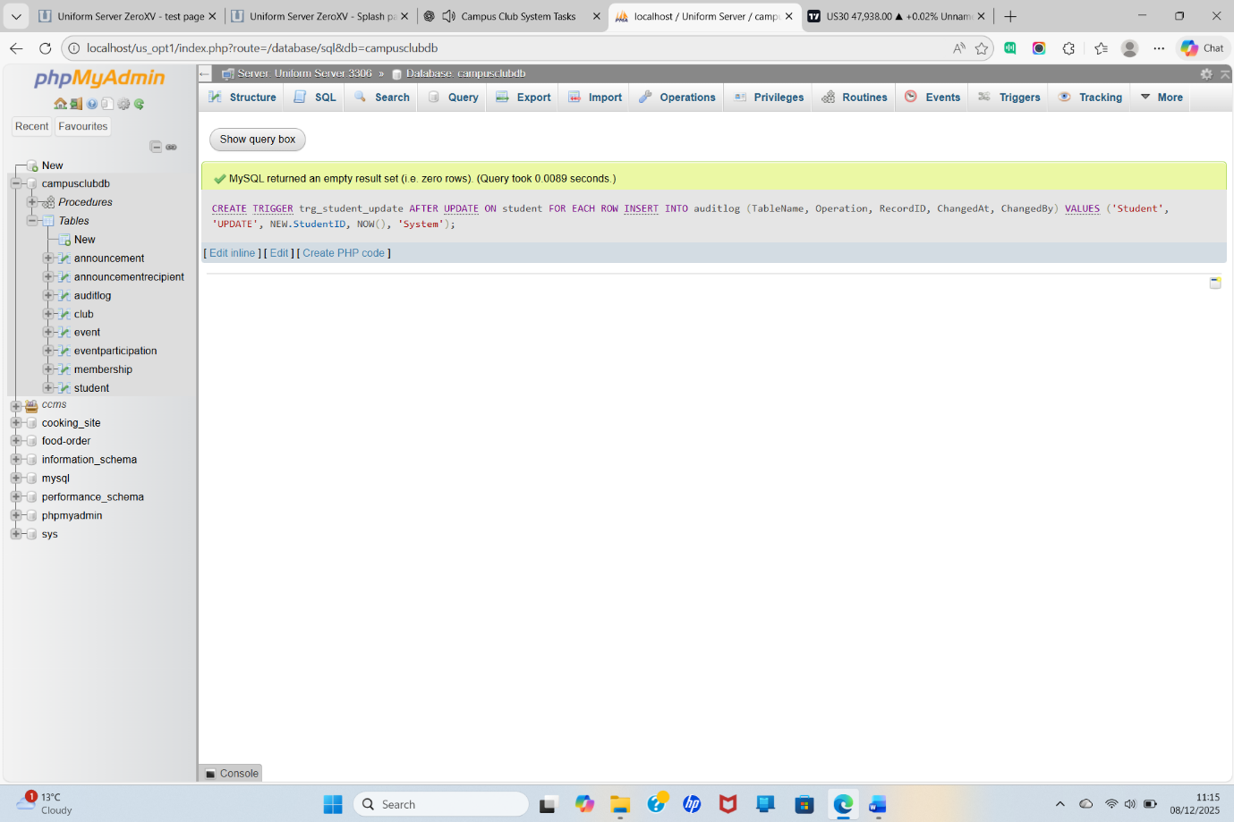
Still trigger 1
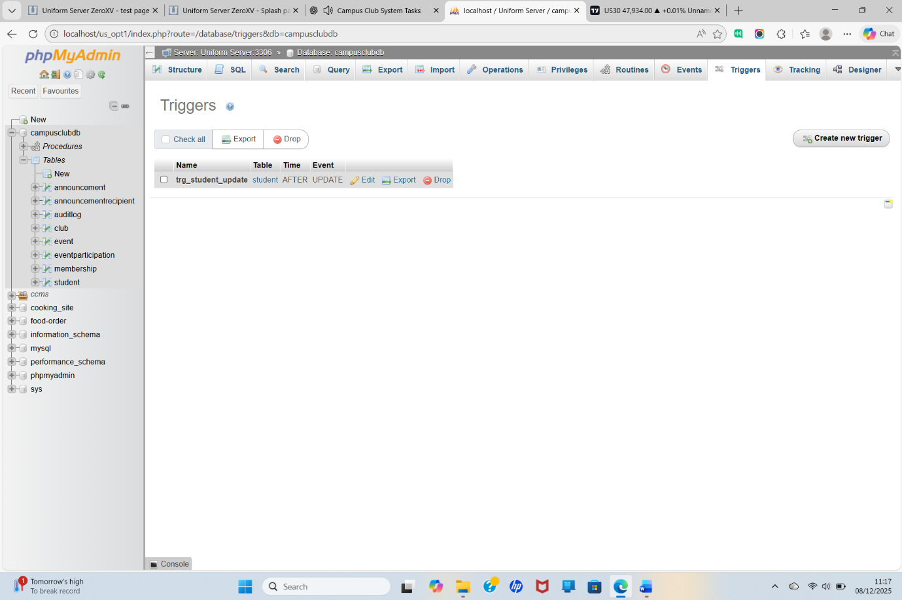

The two triggers together
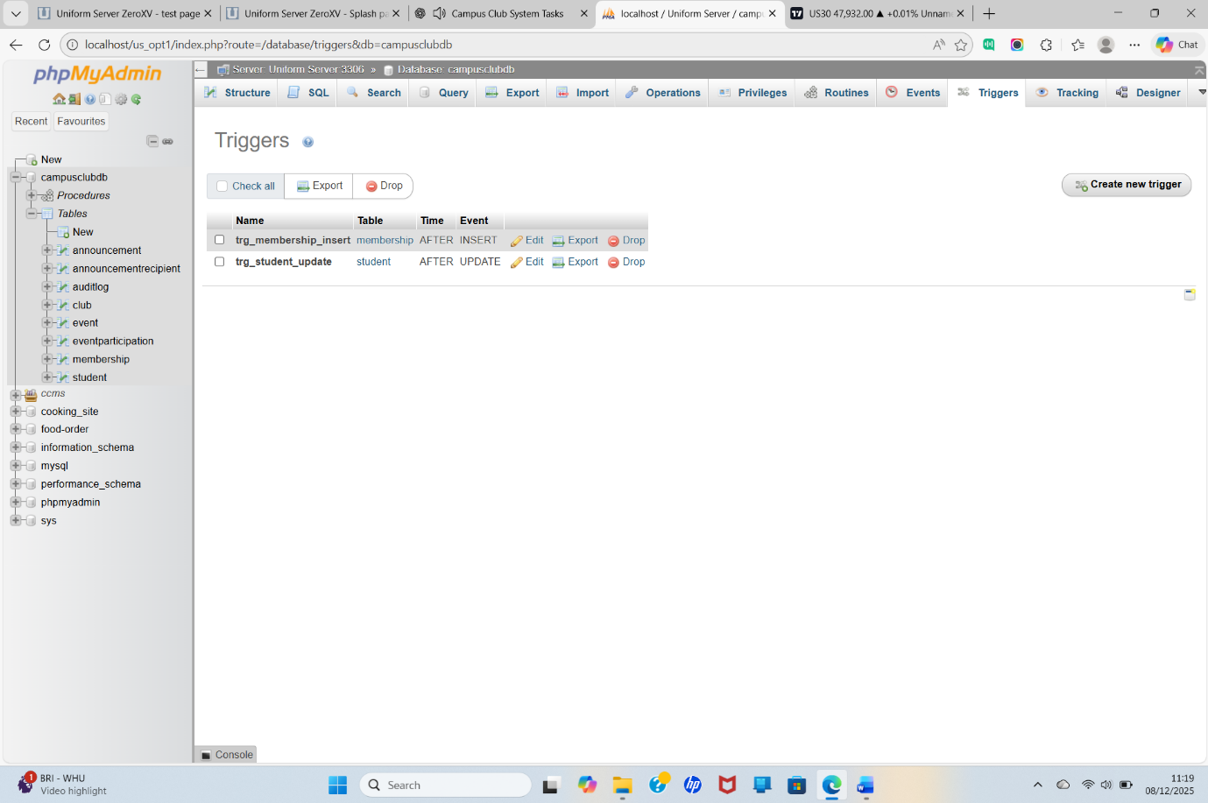

Index 1 — Improve event participation lookups

Index summary
indexing strategy was designed to optimize high-frequency queries, reduce table scan operations, improve the responsiveness of event tracking, and enhance the performance of membership and announcement features. These indexes align with best practices for relational database optimization and ensure that the Campus Club Management System remains efficient and scalable as data volume increases.

Demonstration of Triggers Working
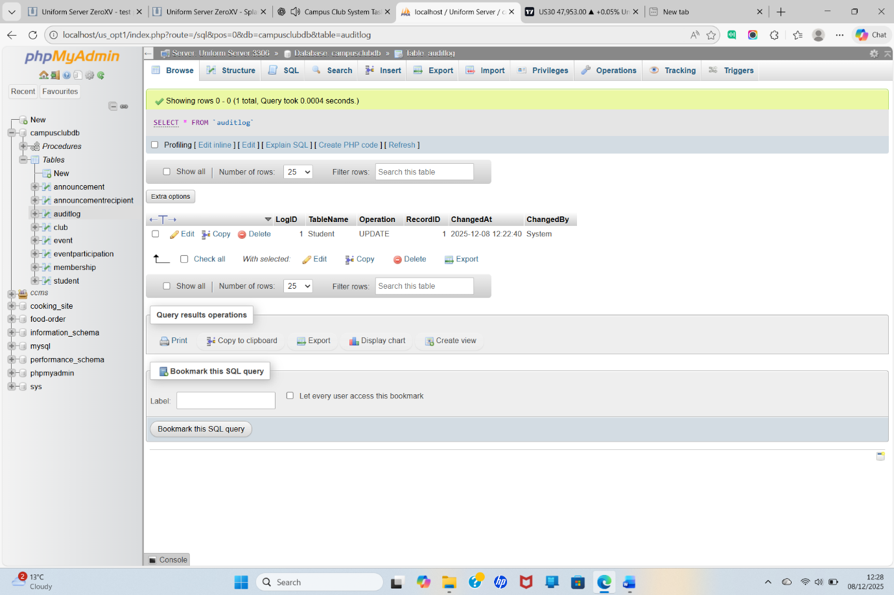

Test of delete trigger
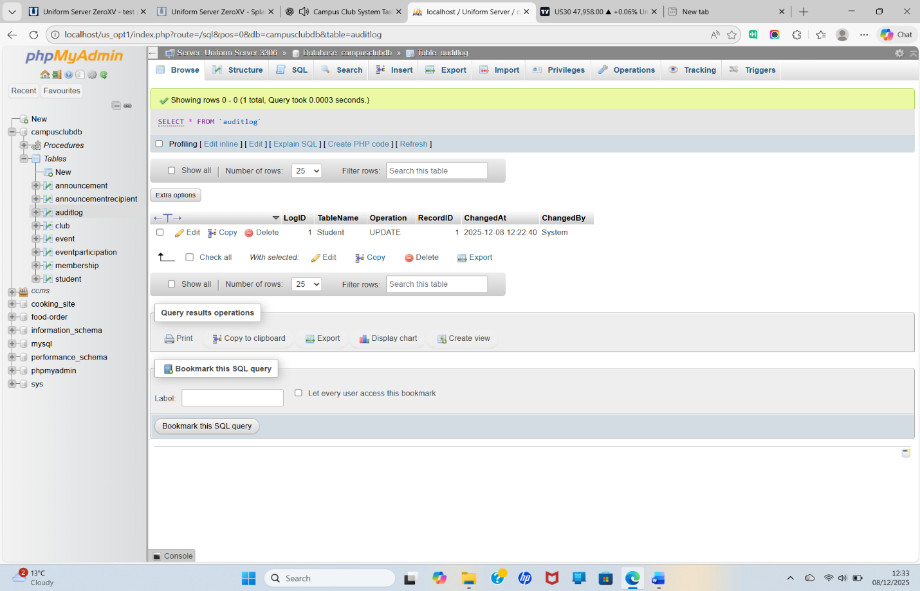

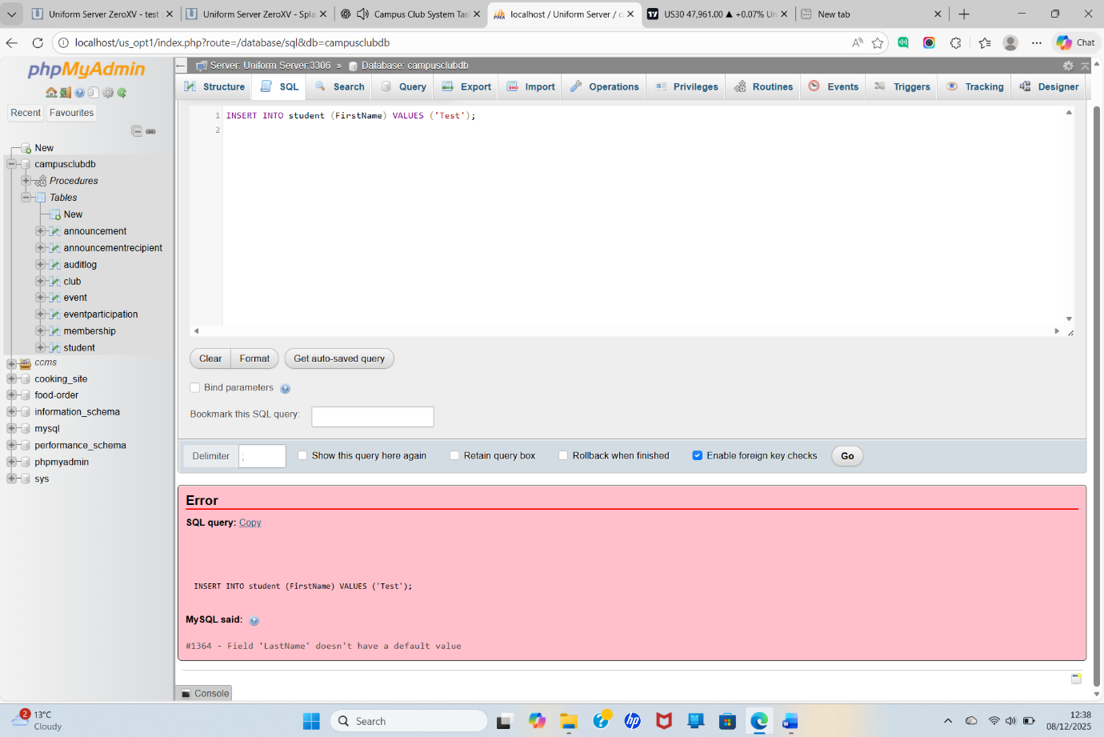
database enforces data integrity, meaning incomplete or invalid records cannot be inserted.

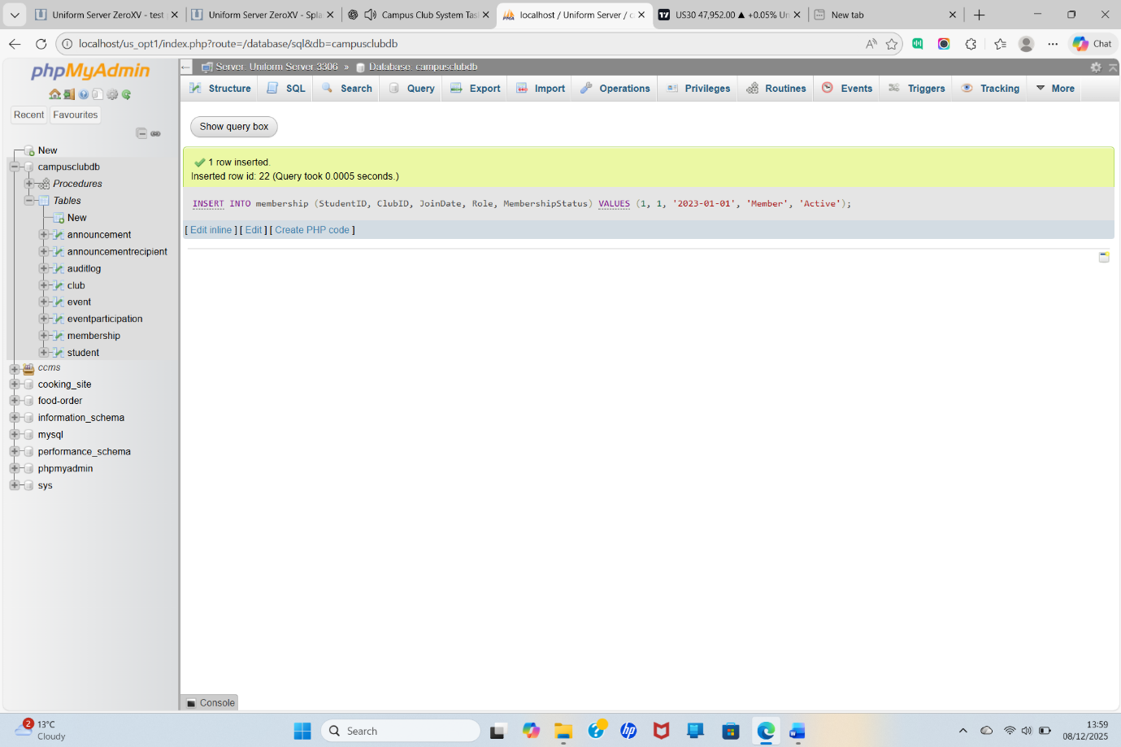
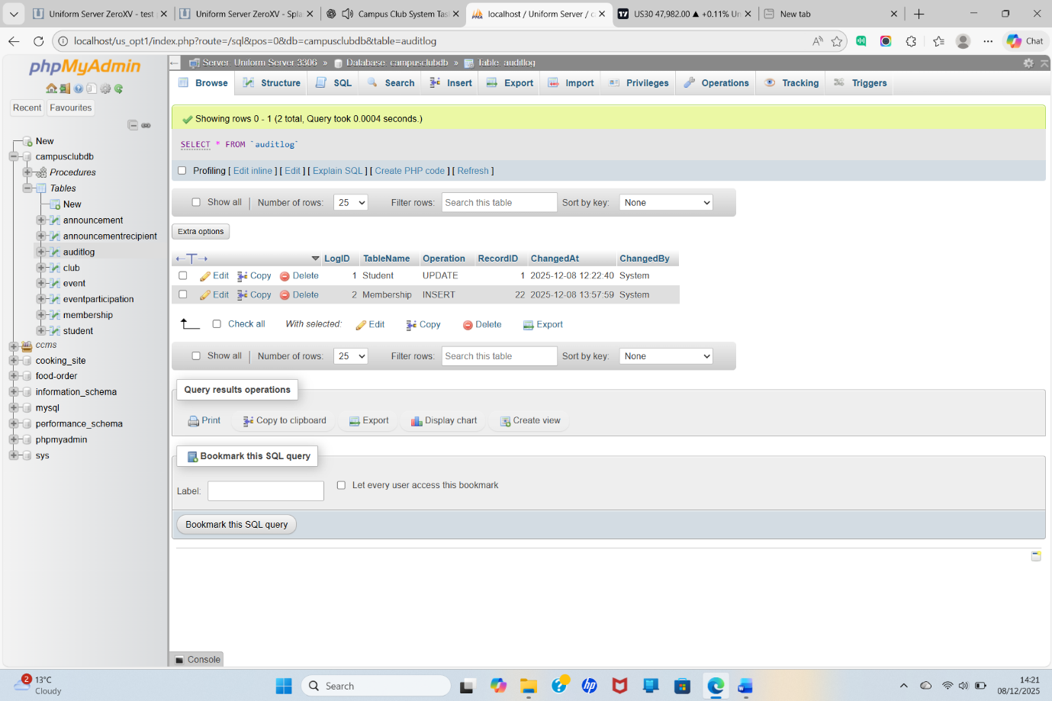

DELETE operations work; Deleting a row and the result



