Cockpit and Driver Controls - Jon

The cockpit of a Formula Student car is a critical component that impacts the driver's safety and performance around a track. The cockpit seats the driver of the car, and it is vital that it provides a comfortable and ergonomic seating position, good visibility, and easy access to controls (FSAE, 2022). Additionally, the cockpit protects the driver from impact using components such as crash structures on the rear, front and side that are designed with impact absorbing materials. Also, there is fire safety procedures in place such as a plumbed in fire extinguisher and a firewall. Throughout this project, it has been vital that research on previous Formula Student cockpits has been carried out. Throughout this review, the aim is to provide a comprehensive overview of the current state of knowledge on cockpit design for Formula Student.

1 Gear Shifter
The first component that was looked at was the shifter. The chosen shifter had been used previously by a team from the trinity college of engineering and research in Pune, Maharashtra, India. The shifter they used was a clutch less quick button shifter. However, for the car, it has been decided that paddles instead of buttons would be used. There were three potential systems that could have been used, electric, pneumatic, or hydraulic. However, with the aid of research, it was found that both pneumatic and hydraulic systems add great weight to the vehicle. Additionally, it was found that the fluids in a hydraulic system could catch on fire, limiting the safety of the system (Dabhade et al., 2020). The choice of system was electronic. This was due to factors such as its low cost, low weight, its reliability, and speed of function compared to the other two and the great comfort it provides for the driver (Dabhade et al., 2020). The methodology stated that the only time a clutch will be used is for the shift from neutral to first. From first to second, the upshift paddle will be used, and a signal will be sent to the MCU which will open the open and closed relays. These relays are placed in the circuits of the fuel injector and spark plug and when they are open, the power of both components is cut. The engine will then temporarily slow down as the shifting takes place and as there is no power or spark, the driver will not have to remove their foot off the accelerator (Dabhade et al., 2020). Further research was conducted to look at the reasons of choosing an electronic paddle shifter over a manual stick gear shifter. It was found that the difference in shift actuation speed between using a manual and paddle shifter was significant. While the average driver can actuate a shift within 500 milliseconds to 1 second, a paddle shifter can perform the same task but in a quarter of that time. The position of the paddles is on each side of the steering wheel, making the actuation an easy and safe task. The driver will use the paddle on the right to perform an upshift, and the left paddle to perform a downshift. This system was found most suitable for the car because of many reasons. The main one being the fact that it has a lot more benefits driving with a paddle shifter than a manual. It vastly increases the speed of actuation as mentioned above, and it also gives the driver more control over the car as it is possible to perfect a cornering shift with the paddles on the wheel.

2 Safety measures
It is vital that all relevant precautions are considered to ensure the driver's safety due to the high speeds and hazardous conditions on the racetrack. From the materials used in construction to the placement of controls, every aspect of the cockpit must be carefully considered and designed with safety in mind. Safety measures inside a cockpit include fire safety such as fire extinguishers and firewalls, drivers' protection such as harnesses, and crash protection such as side, front and rear impact structures. It was found in the regulations that there must be two dry/chemical extinguishers that are plumbed in and have a minimum firefighting agency capacity of 0.9kg. The fire extinguisher will be mounted in a fixed position within the cockpit, close to the driver's seat for easy access. It is connected to the car's electrical system and triggered by a switch on the dashboard or steering wheel. When triggered, it will release the firefighting agents to suppress the fire in the affected area.
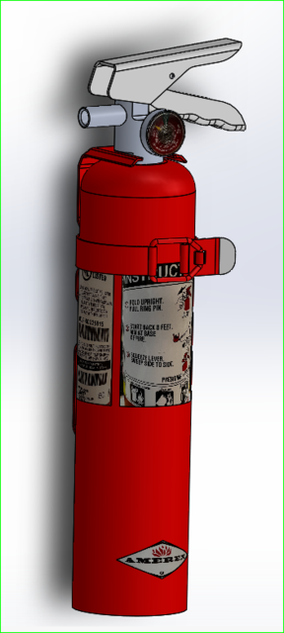
Figure 1 – 1kg Fire extinguisher

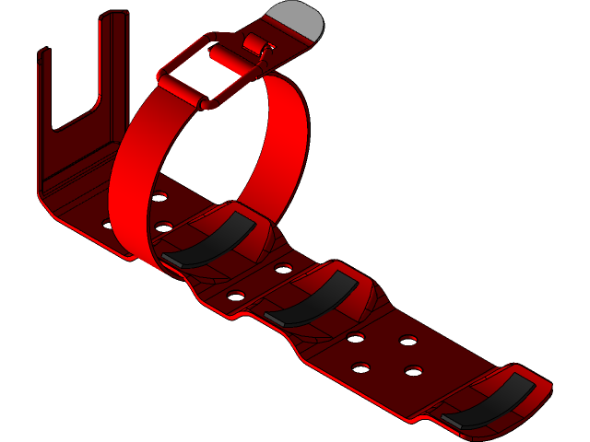
Figure 2 – Extinguisher mount

This is the design for the fire extinguisher and mount. This extinguisher will be bolted near the seat in an area that is easily accessible for the driver.

The other fire safety aspect is the firewall. The firewall must be created from a hard, fire-resistant material such as aluminium or carbon fibre. Particularly, along the sides and the floor of the cockpit must be entirely watertight and impenetrable. This can be accomplished by building the firewall in a single piece that is at least 2mm thick, which will make it sturdy enough to survive any impacts or vibrations that may happen during the race (FSAE, 2022). Wiring, cable, and other pass-throughs are allowed if they are sealed with grommets to stop liquids from passing through (FSAE, 2022). Any line of sight between the driver compartment and should be blocked by the firewall. The firewall must cover any portion of the tallest driver below a plane that is 100 mm above the bottom of the helmet to guarantee that the driver is given the maximum amount of protection (FSAE, 2022). Moreover, many panels may be utilised to create the firewall, but they must overlap by a minimum of 5mm and be joined together by seals to prevent fluids from passing through (FSAE, 2022). Generally, a firewall for the vehicle should be manufactured from a fire-resistant material, designed to be as rigid as
possible. The chosen material for the firewall was aluminium as it is more beneficial to the personal requirements of the car, especially the cost effectiveness.
The regulations stated that the harness must be attached using one 8mm metric grade 8.8 bolt and steel backing plates with minimum thickness of 2mm. The edges of the test fixture supporting the sample must be a minimum of 125 mm from load application point (FSAE, 2022). The width of shoulder harness test sample must not be any wider than the shoulder harness panel height. Harness loads must be tested with the worst case for the range of the angles specified for the driver's harness (FSAE, 2022). Using these regulations, it was found that a Schroth's Harness was most suitable. This harness weighs 2kg and the strap lengths are as follows; 850mm for the shoulder strap, 700mm for the lap strap and 780mm for the crotch strap (Raceparts, n.d).

There must be a crash structure for the rear, side, and front that comply with the regulations. These structures must be able to absorb a minimum of 4000J of impact energy, this is equivalent to a low-speed collision between two vehicles, or a moderate speed collision between a car and an object. Typically, in the automotive industry tests are run on energy absorption values in the range of 1000-4000J of energy. In sports such as cycling, helmets are required to have tests run to ensure that they can withstand energy in the range of hundreds to several thousand joules. The front and rear structures must be able to distribute the impact forces evenly across the vehicle and must be located with certain distance limits from the front and rear ends (FSAE, 2022). The front structure must be made from composite materials such as aluminium or steel. Static load tests must be undertaken for the front and rear structures (FSAE, 2022). It was found that an aluminium honeycomb was the best option for the front. It was previously used, and it can withstand 7350J of energy (UBC Formula SAE, 2022). The structure is hexagon patterned made from thin foil that shows strong absorption characteristics and great strength. It absorbs energy by collapsing at its base and folding in on itself, resulting in a small amount of energy being stored as it folds. As the load is applied it does not spring back to its original shape (UBC formula SAE, n.d). For the rear structure, a foam filled tube will be used. The choice of foam material was expanded polystyrene as it is cheap, lightweight, has good absorption characteristics and is easily shaped to fit the dimension regulations. The outside material is aluminium due to its strength, corrosion resistance, low weight and can be easily reconstructed to the right shape. The side structure is an aluminium sandwich panel with two aluminium skins with an aluminium honeycomb in between. The panel is mounted to the side of the frame with brackets designed to withstand impact forces and prevent the panel from separating from the frame.
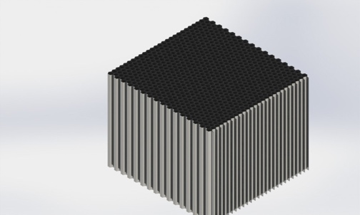
Figure 3- Front impact structure

3 Pedal Box
The pedal box used in the car was found online on a website that sells specific formula student components. We have chosen this pedal box as we feel it is the most suitable for our parameters, due to its lightweight, and limited maintenance. The pedal box chosen was a hydraulic clutch kit that cost £329.75 (RacingPedalBoxes, n.d).
A hydraulic clutch pedal box system works by using the fluid pressure to engage and disengage the clutch. This system has a master cylinder on the clutch pedal and a slave cylinder near it. When the clutch pedal is depressed, the master cylinder applies pressure to the fluid, which then moves the slave cylinder, causing the clutch to disengage. There was a choice of cylinder for the master cylinder, and it was between OEM and Willwood. It was found that the one that carries the best characteristics for racing is the Willwood cylinder.
Below is a table of the advantages and disadvantages of this box:

Table 1 - Advantages and disadvantages of the chosen pedal box
Advantages | Disadvantages
Soft pedal and long sturdiness | Pipes will rot
Versatile as it can be placed in anyplace | The correct fluid must be used
It is reliable | There is a risk of cylinder overflow
The pedal height can be automatically adjusted | Always must be compelled to check clutch fluid level
The cables are self-lubricated wherever the cables must be compelled to be greased from time to time. | Quite expensive
A soft pedal means that there is more comfort for the driver due to the pressure on the pedal being minimalised. The sturdiness characteristic means there is limited maintenance. Due to exposure to moisture, corrosive substances, and chemicals. Over time, this will cause the pipes to rot. The correct fluid must be used due to decreased performance if the wrong fluid is used. This can also lead to a cylinder overflow. To ensure this is measured, the team must be compelled to check the clutch fluid level which adds to the maintenance of the car.

The pedal ratio of this box is 5:1. The throttle pedal has an adjustable wire mechanism, with the pedal rotation angle and the wire stroke being adjustable. The brake pedal has a balance bar with a diameter of 7/16” - 20 to provide maximum stiffness. Each pedal has an anti-slip surface, and the box weighs 3.25kg (RacingPedalBoxes, n.d).

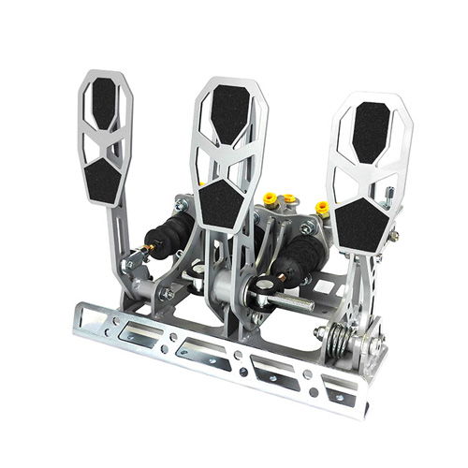

Figure ‎3- Hydraulic clutch pedql box (RacingPedalBoxes, n.d)

4 Steering
The regulations state that any system using cables or belts is prohibited. To overcome this, it was found that the most suitable system would be a mechanical steering rack. This system consists of a steering rack and pinion set, a steering column, a steering shaft, and an adjustable steering ratio. This system was chosen as maintenance can easily be performed, it is easy to adjust, and it is good for competitiveness. The regulations state that:
- The system must have positive steering stops that prevent the steering linkages from locking. These stops must be placed on the rack to prevent tyres and rims from encountering any other parts. The actuation of the steering wheel when standstill must also be possible.
- The steering system free play is limited to 7 degrees measured at the wheel.
- The wheel must be attached to the column with a quick disconnect, driver must be able to operate this while in the normal sitting position with gloves on.
- The wheel must be no more than 250mm rearward through the front hoop. This distance is measured horizontally, on the vehicle centreline, from rear surface of the front hoop to the forward most surface of the steering wheel with steering in any position.
- The rack must be mechanically attached to the chassis.
- Vehicles must have a wheelbase of at least 1525mm.
- The smaller track of the vehicle must be no less than 75 percent of the larger track.
- The track and centre of gravity of the vehicle must combine to provide adequate rollover stability (FSAE Rules, 2022).

The chosen rack was one found on the formula seven website. This website has been used throughout the project for other components, and it states that the chosen rack is suitable for the most demanding lightweight race cars (Formula Seven, n.d). To attach this rack, there were several steps to account for. The rack had to be positioned in line with the front wheels center line. Then using the appropriate brackets, the rack was attached to the chassis. The steering column was attached using suitable couplers. The rack chosen had a size of 450mm, with a weight of 940g. This rack has a travel distance from lock-to-lock of 72mm (Formula seven, n.d). This rack had options of any additional parts and it was decided that a hall effect sensor and steel spline couplers would be purchased with the rack.
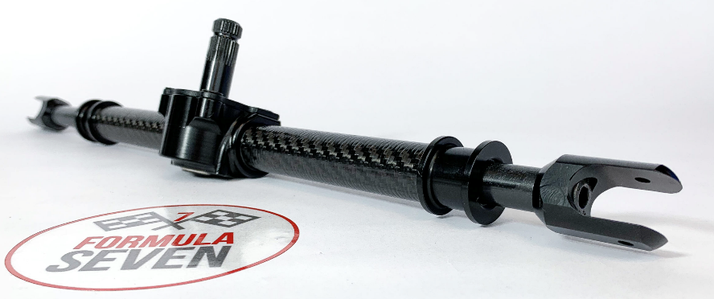
Figure 4- Steering rack (FomulaSeven, n.d)

It was essential that a steering wheel that was small, lightweight, and easy to control was found for this system. The sparco 383 wheel was chosen as it holds great characteristics that match the required parameters. This wheel has a diameter of 330mm meaning it is small (DemonTweeks, n.d). It has a flat-bottomed design which gives the driver an effortless way in and out of the cockpit. The wheel has a six-bolt mounting so it can be attached to the column using a quick release mechanism. The quick release system contains a hub attached to the column, and a mating adapter that is attached to the steering wheel. To detach the steering wheel, the driver must depress a lever which disengages the locking mechanism and allows the wheel to be lifted off the hub. To ensure that this system accommodates the shift system, additional components were required. These were mounting brackets to secure the shift paddles, as well as wiring and connectors to the interface with the vehicle's electronics.
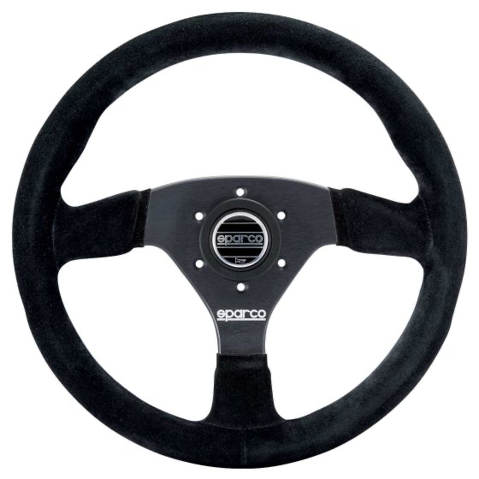
Figure 5 - Sparco383 wheel (DemonTweeks, n.d)

5 Ergonomics design
During this project, it was instrumental that the drivers' comfort and safety was heavily considered to increase the performance. Alongside the safety measures, the ergonomic design of the cockpit impacts the drivers' performance. Using background research, a design from Aligarh Muslim University was found. This design was for the 95th percentile male, and they found it to be the best fit for maximum comfort for the average male driver.
The rules stated that the driver must be:
- A minimum of 50.8mm from the straight line drawn from the top of the main hoop to the top of the front hoop.
- A minimum of 50.8mm from the straight line drawn from the top of the main hoop to the lower end of the main hoop bracing extend rearwards.
- The bottom 200mm circle will be placed on the seat bottom that the distance between the centre of the circle and the rearmost of the pedals is no less than 915mm (FSAE, 2022).

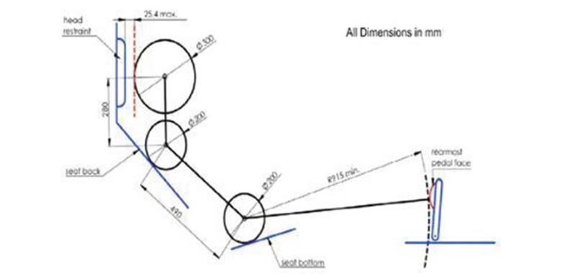
Figure 6- FSAE 95th percentile male template (Ahmad et al., 2021)
It was concluded that the distance between the neck point and the topmost point of the head is a straight line parallel to the vertical member (Ahmad et al., 2021). In the work performed by this team they listed dimensions such as the back-seat angle and the thigh angle, however some dimensions were made constant such as the pedal height (Ahmad et al., 2021). They performed an analysis of two seat angles of 55 and 70 degrees to find out what was most comfortable, and this was performed on subjects of different weight and height. Below is the data obtained by this team on the tests carried out:

Table 2 - Cockpit dimensions data from subjects (Ahmad et al., 2021)
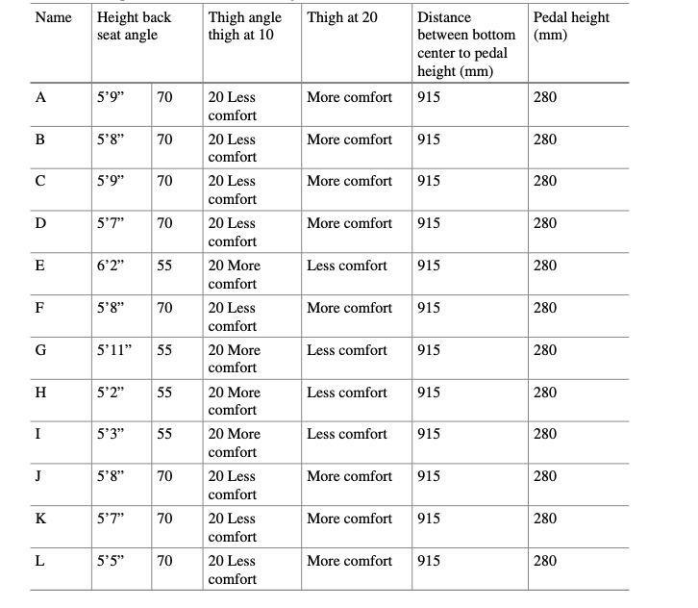
After carrying out these tests, the team was able to establish a maximum comfortable position for driving, and the best seat thigh angle which facilitates the knee according to the operation of the pedals (Ahmad et al., 2021).

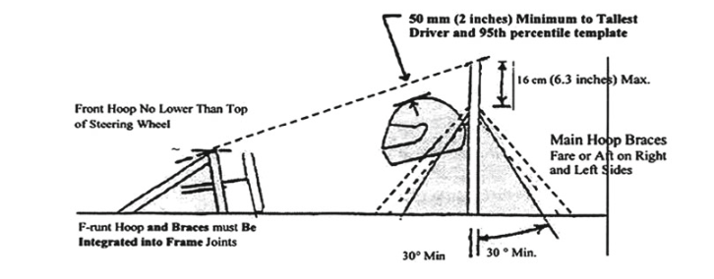
Figure 7- Demonstration of the rules of FSAE (Ahmad et al., 2021)
The design for the apparatus was made from wood and steel rods. It was found that this is the most suitable as:
- Wooden apparatus is cost-effective.
- It is customizable. Wood can be easily cut to fit the dimension requirements.
- Comfortable. It has good shock absorbing properties, that help to reduce discomfort and fatigue.
- Sustainable. Using wooden apparatus can help to reduce the environmental impact of the design process.

The team designed an apparatus that followed the guidelines of the FSAE rules. The length was fixed to 915mm (Ahmad et al., 2021). For the testing, the seat back angle, thigh angle, dash height and pedal assembly were adjustable for the subjects' preferences. The design used was the same materials as this team and using the results found by that team, it made more sense to use similar dimensions. However, there are differences such as the steering wheel being different, using a different pedal box kit, and a different shifter system etc. The design that was used for the vehicle had a fixed steering wheel position, however, this wheel has a quick release system so it can easily be removed and put back on.
This is how the apparatus looked:

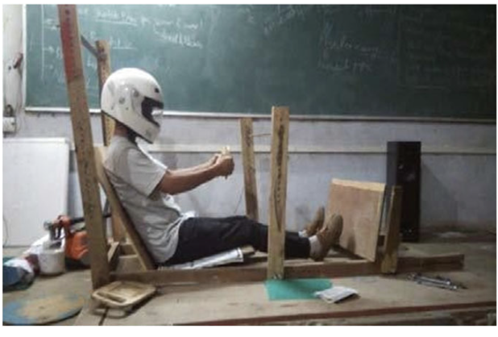
Figure 8- Ergonomic apparatus cockpit (Ahmad et al., 2021)

6 Fuel Tank
The fuel tank stores the fuel required for the engine. The size for the fuel tank for our project will be 7 litres which allows for some extra room. The weight ratio is around 1kg/L. The track length is approximately 5.89km long so, to work out the fuel consumption rate the equation – capacity/range = 7/5.891 = 1.19L/km. The size of this component needed to be competitive with other teams as having extra unnecessary capacity could be costly. This tank will be made from carbon fibre due to its lightweight and strength characteristics. To fit the space efficiently this component will be cylindrical and will fit within the car’s chassis. It is also crucial to consider the safety of this component – it must be able to withstand impact in the event of a crash. However, it must also not leak, and this can be ensured by making sure all connections to the pump are secure, and a robust fuel line. The design of the fuel tank also includes internal baffles that help control spill in the case of high-speed cornering. The design is shown below, and it shows the most compatible tank for the car. The fuel tank will be placed low and central within the chassis to lower the cars centre of gravity which improves performance.
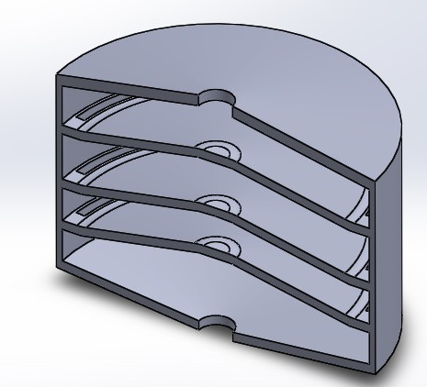
Figure 9- Fuel tank

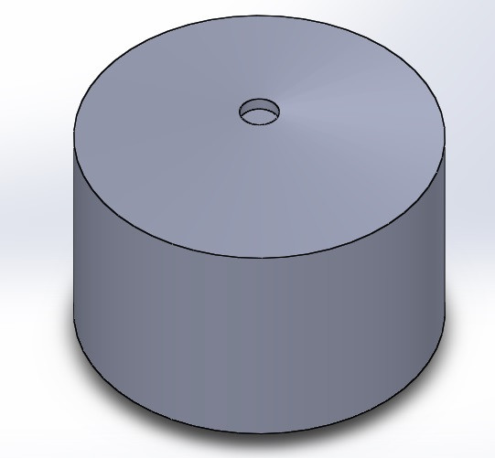
Figure 10- Fuel tank

7 Reference list
Raceparts.com(n.d) Schroth formula student harness
Available at: https://race.parts/catalogue/content.aspx?node_id=628f78e6-498a-409f-b9e0-a5a800fc79ea
Accessed(23rd march 2023)

Ameya Dabhade et al.,(2020) Research on clutchless gear shifter
‌Available at:346966084_Research_on_Clutchless_Quick_Gear_Shifter_for_Formula_Student_Vehicle
Accessed(22nd march 2023)

Racingpedalboxes.com(n.d) Hydraulic clutch pedal box kit
Available at: https://racingpedalboxes.com/shop/pedal-boxes/pedalbox-kit-car-hydraulic-clutch/#clutch-master-cylinder
Accessed(24th march 2023)

Formula-seven.com(n.d.) Formula SAE pro steering rack
Available at: http://www.formula-seven.com/shop-products/steering-racks-w-rotative-sensor/
Accessed(24th march 2023)

Demontweeks.com(n.d) Sparco 383 steering wheel
Available at:http://www.formula-seven.com/shop-products/steering-racks-w-rotative-sensor/
Accessed(26th march 2023)

Ahmad et al., (2021) Cockpit design of a formula student race car: An ergonomics design
Available at: https://www.researchgate.net/publication/350319123_Cockpit_Design_of_a_Formula_Student_Race_Car_An_Ergonomics_Study
Accessed (26th march 2023)

