Front cover
Bachelor of Arts in Applied Business
LEVEL 5 Module Name: Enterprise Development and Commercial Innovation BMBS5000
Email: C.Wilkin@UWTSD.ac.uk
Student name: Tracey Campbell
2508869 Submission date: 12th October 2026

AI Acknowledgement
I have not used any Ai content

Contents
Front cover 1
AI Acknowledgement 2
Mind mapping 4
Value proposition canvass 6
Business model canvass 7
Opportunity Screening 8
Hello fresh subscriptions report. Googletrends.com (2026). 9
Cheap Restaurant reports UK. Googletrends.com (2026). 10
My persona 11
Perceived value to the consumer 11
Demand and revenue diagram 11
Reference list 12
References continued: 13

Mind mapping
https://mm.tt/map/4080797784?t=CvvlAAyWe2

Value proposition canvass
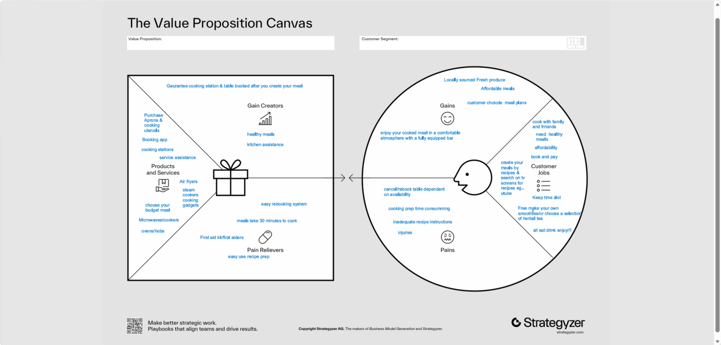

Business model canvass
https://canva.link/uqu590p2k02buk9

Opportunity Screening

Criterion | Question | Score 1-5 | What assumptions lead to this score?
Problem severity | How important is the problem? | 5 | limited affordable restaurants uk, google trends.com
Customer frequency | How often does it occur? | 5 | daily
Willingness to pay | Is there evidence customers might pay? | 5 | Evidence meal kit subscriptions
Market potential | How many potential customers exist? | 5 | 59% who enjoy cooking from scratch Soininen, K. (2024).
Feasibility | Can the problem realistically be solved? | 5 | yes, by attracting them to purchase meals & offering cooking classes
Competitiveness | How many competitors exist? | 5 | Meal kit subscriptions restaurants

Hello fresh subscriptions report. Googletrends.com (2026).
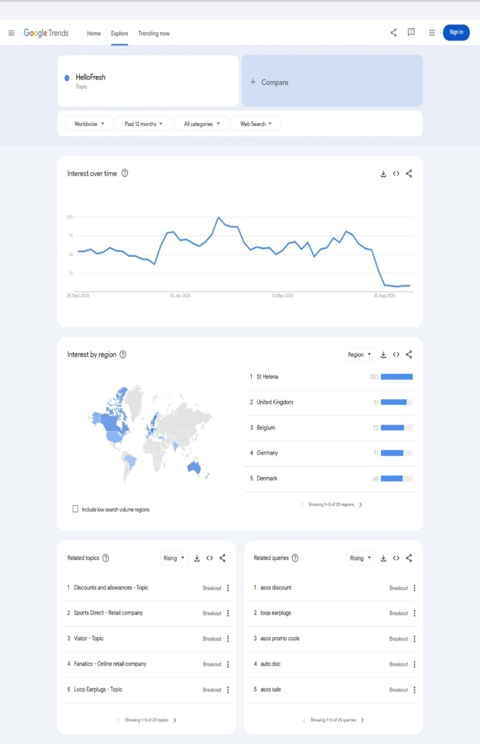

Cheap Restaurant reports UK. Googletrends.com (2026).

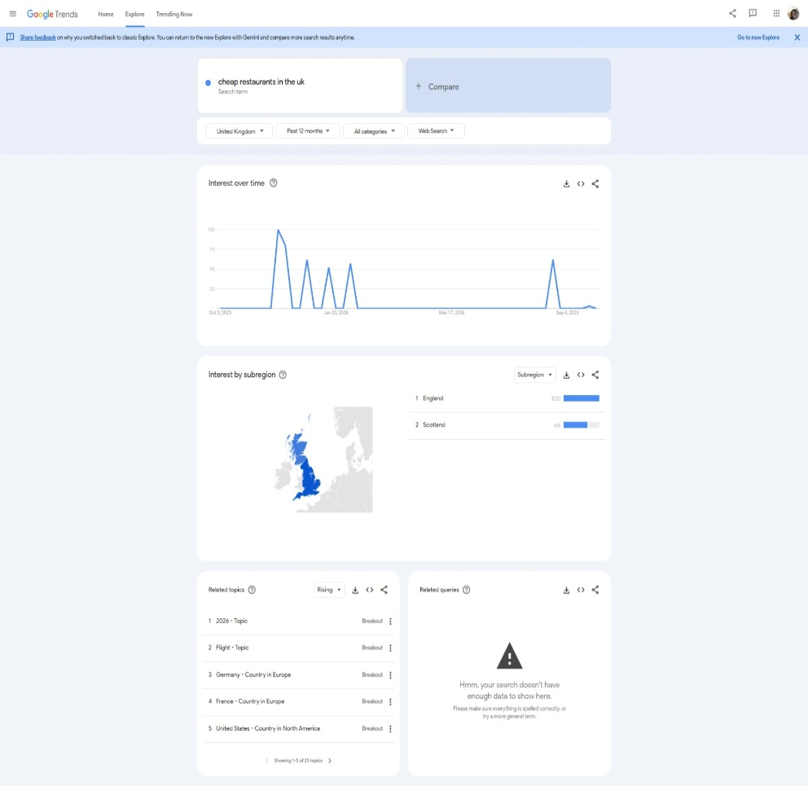

My persona
https://www.hubspot.com/make-my-persona?share=true#/share/-P3Bc2KNhas3NlyGwYQq

Perceived value to the consumer
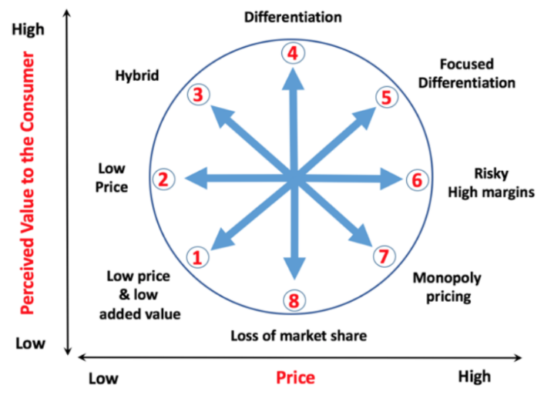
Make & Eat Restaurant is a low-price number 2 as it matches with a daily meal kit from Gusto who charge £12. (Meal kit costings in Mind map).

Demand and revenue diagram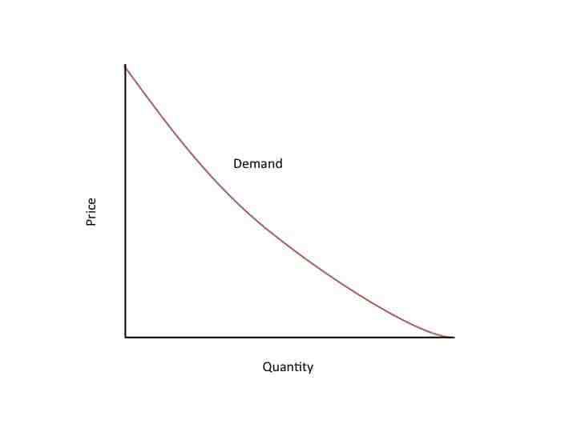
Single persons 4x £7.50=£30
Based on two families basic 2x £12=£24
Cooking class 10x £15=£150

Reference list
- Accio (2026) Meal kit industry trends. Available at: https://www.accio.com/buisness/prepared_food_industry_trends (Accessed 2nd October 2026.

- Allcock, S. (2026). Uk restaurant industry statistics 2026: Market size consumer spending, and estate churn https://www.foodfuture.org.uk/news/uk-restaurant-industry-statistics-2026 (Accessed 4th October 2026).

- Analysis & Strategic Management.’ VOL. 36 (4), 797–812. https://doi.org/10.1080/09537325.2022.2060072 798. (Accessed 23rd September 2026).

- Antonio, J.L., Schmidt, A L., and Kanbach, D.K. (2023). ‘Enacting disruption: How entrepreneurial ventures innovate value propositions to increase the attractiveness of their technologies. International journal of entrepreneurial behaviour & research.’ Vol. 30 (4), doi:10.1108/IJEBR-07-2023-0688. 888-890 (Accessed 24th September 2026).

- Aray, Y.N., Brouard, F., Christodoulou, I. and Christofi, M. (2026). ‘Balancing profit and purpose: Differences in business model components of social and traditional enterprises. The International Journal of Entrepreneurship and Innovation,’ vol. 27 (3), doi:10.1177/14657503261464393. 393-395. (Accessed 24th September 2026).

- Best family restaurants in the Uk (2026 dinning guide). (2026). https://foodfuture.org.uk/news/uk-restaurants-industry-statics-2026. (Accessed 28th September 2026).

- Blake, H. (2026). United Kingdom Food Subscription Market Size & Outlook, 2026-2034. Available at: https://www.deepmarketinsights.com/vista/insights/food-subscription market (Accessed 30 Sept. 2026).

- Bühring., J. (2022). ‘Pinduoduo: Hybrid value propositions. The Business & Management Collection,’ (9), 1007242. doi:10.69645/zzpw8590. (Accessed 25th September 2026).

- Combs, J.G., Gruber, M. and Zahra, S.A. (2024). ‘Four approaches to new venture creation: Taking stock and moving forward. Journal of Management, vol. 50 (8). 3105–3109. doi:10.1177/01492063241264226. (Accessed 26th September 2026).

References continued:

- Costa, L., Reginaldo, M L., and Diogo J H. (2023). ‘Using the OKR method and fuzzy logic to determine the level of sustainability in restaurants Sustainability,’ vol.15 (7). doi:10.3390/su15076065. 1-10. (Accessed 26th September).

11. Debucquet, G., Dugué, M. and Cardinal, M. (2023). ‘Choice for sustainable meals at staff restaurants: Influence of at-home food habits and food triggers. British Food Journal.’ Vol 125 (9), 3468–3488. doi:10.1108/bfj-12-2022-1101. (Accessed 26th September).
12. Dinev, K. (2022). IBISWorld - Industry Market Research, Reports, and Statistics How meal kit firms are feeding UK demand. www.ibisworld.com. Available at: How Meal Kit Firms are Feeding UK Demand (Accessed 27 Sept. 2026).
13. Dobiecka, D.P., Markiewicz-Żukowska, R., and Socha, K. (2025). ‘New dietary trends—Meal kit delivery services as a source of nutrients: A scoping review. Nutrients,’ vol. 17(7), 1–13. doi:10.3390/nu17071154. (Accessed 27 Sept. 2026).
14. Fraser, K., L, P., Laws, R., C, K. and Spence, A.C. (2023). ‘Meal kit subscription services and opportunities to improve family vegetable consumption. Health Promotion International,’ Vol. 38 (6), doi:10.1093/heapro/daad155. 3–4. (Accessed
27 Sept. 2026).
15. https://www.googletrends.com (Accessed 7th September 2026).
16. https://www.gusto.co.uk (Accessed 7th September 2026).
17. https://www.hellofresh.co.uk (Accessed 7th September 2026).
18. Ikechukwu K, O, Umezuruike L, O, and Okolie, J.A. (2024). ‘Machine learning application in horticulture and prospects for predicting fresh produce losses and waste: A review. Plants,’ vol.13 (9). Doi:10.3390/plants13091200. (Accessed 6th October 2026).
19. Lee, J. and Lee, G. (2025). ‘Revisiting crowded restaurants in the post-pandemic era: Exploring the social drivers of emotion and behavioural intentions for sustainable dining culture. Sustainability,’ Vol. 17 (18), 8400. doi:10.3390/su17188400. (Accessed 4th October 2026). 17.
20. Lin, P.M.C., Au, W.C.W. and Xia, S.J. (2026). ‘From classroom to kitchen: Promoting plant-based eating through experiential teaching. Journal of Hospitality, Leisure, Sport & Tourism Education,’100610. Doi: 10.1016/j.jhlste.2026.100610. 39. (Accessed 27 Sept. 2026).
21. McDonald, M. and Oliver, G. (2022). ‘Six actionable steps to preparing financially quantified value propositions. Journal of Creating Value,’ vol 8 (1) 113–130. doi:10.1177/23949643221091667. (Accessed 27 Sept. 2026).
22. Mele, C., Bernardo, I. D, and Skålén, P. (2026). ‘Joining schools of thought on value propositions: A review and research agenda. Journal of Business Research,’ 2 116481. Doi: 10.1016/j.jbusres.2026.116481. 218. (Accessed 27 Sept. 2026).
23. Mind meister. https://www.mindmeister.com/app/map/408079778 (Accessed 7th September 2026).
24. Muhammad S, A. Muhammad Z, R. and Mohammad A K (2022). ‘Blue Ocean 4.0 for sustainability – harnessing Blue Ocean Strategy through Industry 4.0. Technology Analysis & Strategic Management.’ VOL. 36 (4), 797–812. https://doi.org/10.1080/09537325.2022.2060072 798. (Accessed 23rd September 2026).
25. My persona. https://www.hubspot.com/make-my-persona?share=true#/share/-P3Bc2KNhas3NlyGwYQq (Accessed 21st September 2026).
26. Reepu (2022). Blue ocean strategy: A critical examination. AAYAM: AKGIM Journal of Management, suppl. Special Issue on Emerging Business and Economic Challenges, vol.12 (2). Available at: https://www.proquest.com/scholarly-journals/blue-ocean-strategy-critical-examination/docview/2780449762/se-2?accountid=130472 .8-10. (Accessed 8 Oct. 2026).
27. Restaurant industry statics 2026: Market size, consumer spending, and estate churn. (2026), https://foodfuture.org.uk/news/uk-retaurants-industry-statics-2026. (Accessed 3rd September 2026).
28. Shepherd, D.A. and Patzelt, H. (2021). Entrepreneurial strategy. Springer Nature, 57–58.
https://www.simplycook.com (Accessed 7th September 2026).
29. Soininen, K. Attitudes towards cooking in the home-uk-2024. https://clientsmintel.com/downloads/brochure/attitudes-towards-cooking-in-the-home-uk-2024. (Accessed 4th October 2026).
30. Yeboaa O, Y, A., Bashiru J, A. and Novak, P. (2022). ‘A strategic framework for developing sustainable value propositions. Problems and Perspectives in Management,’ vol. 20 (4), 407–421. doi:10.21511/ Vol.20 (4) 407–421 (Accessed 27th September 2026).

