Student Name: Anita Ajmani
Student No. 1817900
Lecturer Name: Mr. Christopher Wilkin
Module No. BMMB7012
Module Name: Marketing Management
Word Count: 3195

Table Of Contents

Table of Contents
Introduction 3
Marketing Strategy 3
Situational Analysis 4
The 5 Cs of Marketing 4
Swot Analysis 5
The STEEPLE Analysis of Hilton Hotels 7
Marketing Mix 9
Market Segmentation of Hilton Hotel 11
Digital Marketing at Hilton Hotels 13
Conclusion 16
Recommendations 17
Appendix 1 22
Appendix 2 23
Appendix 3 24
Appendix 4 25
References 26

Introduction
The organisation chosen is Hilton Hotels. This report will conduct a situational analysis and it will use the 5 C’s, SWOT, and Steeple analysis to find out the problems which are that Hilton does not consider the ethical considerations and CSR effectively and it is not expanding much in international markets. Marketing mix, Market Segmentation and Digital and social media tools will also be used find out the problems of Hilton which are that negative tweets and comments are posted on social media which affects the reputation and profitably of Hilton hotels and they do not target a wider spectrum of customers. This report will produce a conclusion by addressing the weaknesses of Hiton hotel’s marketing strategy. This report will recommend the 5 C’s, SWOT analysis, Marketing Mix, Digital and social media tools and market segmentation tools to improve the marketing strategy of Hilton hotels and this report will also provide the limitations regarding using these tools.
In 1919, Conrad Hilton first bought his hotel in Cisco, Texas, and his son Barron Hilton over the last three decades has been the president and CEO of Hilton Hotels Corporations. It is one of the most thriving organisations in the hospitality industry. Currently, Hilton Inc. is formed of 117 brands, with more than 5,900 properties in 114 countries globally and most of their achievement is due to the effective leadership of Barron (Foundation, 2023). Christopher J. Nassetta joined the organisation in 2007 and presently he is the CEO of Hilton Hotels (Hilton, 2023).

Marketing Strategy
According to AMA, marketing is a procedure of designing and implementing the formulation, promotion, pricing and dispensation of thoughts, services, and goods, to generate connections that assure organisational and individual’s goals (American Marketing Association, 2023).

Situational Analysis

The 5 Cs of Marketing

Company
Hilton is more than the hotels and creates revenue from other avenues, like, gaming and entertainment, and thereby benefitting from its diversity, although it does not ensure success. The problem of Hilton is the lack of expansion in global market, the recession in the global economy and significant terrorist attacks (Solitario, 2023).
Customers
Hilton focuses on high income social class families, and they need to focus on broadening their customers and target more customers. According to Crimson Hexagon, Hilton receives the most negative sentiment on social media, with 17% of tweets being negative (Amey, 2015). Hilton has also posted pictures of their customers from their personal Instagram account without asking their permission for their marketing promotions (Reddit, 2023).
Competitors
The competitors of Hilton are Marriot, Holiday Inn, and Hyatt. Due to the high competition between them Hilton is facing reduced profitably and they all are competing for the same set of customers and price point. As a result, Hilton has to raise more money in order to hold off competition (Whyte, 2023)
Collaboration
Hilton collaborates with Government, business allies and other funders and providers in the community they serve. Hilton foundations is an important partner in the connecting business initiative, and it addresses the demand for more effective engagement of the private sector as an equal partner, both locally and worldwide, with the international community and governments (Foundation, 2023). Hilton has also participated in Substantiable Development Goals which is a framework for worldwide development which will try to end poverty, and fight inequality (Foundation, 2023).
Climate
Hilton is lessening emissions from its franchised and managed hotels in accordance with the Paris Climate Agreement and counteracts 100% of its corporate emission from rental cars and air travel (Pole, 2023). However, The tourism-watchdog Tourism Concern had concerns with Hilton about CSR and have been using Hilton hotels as an example to prove its case, whatever CSR policies are published unless they are not fully applied within the company, they are pointless (News, 2006).

Swot Analysis

Strengths  Efficient customer retention schemes.  Effective Leadership of Christopher Nassetta.  Brand recognition and high level of property portfolio (Samoszuk, 2022).  Guest loyalty program, such as Hilton Honors (Mortimer, 2016). | Weaknesses  High degree of debts.  Flexibility is lacking due to its huge size (Dudvoskiy, 2016).  Greatly dependent on the U.S. market.  Fragile customer review (Bakhora, 2022).
Opportunities  Expanding further in International Market.  Expanding into Green travel market (Samoszuk, 2022).  More social media engagement (Bakhora, 2016). | Threats  Unfavourable changes in Macroeconomic climate.  Ethics-related problems (Dudvoskiy, 2016).  Indecision in franchising.  Lack of staff (Bakhora, 2022).  Competitors such as, Hyatt, Marriott, and Holiday Inn (Comparably, 2023).

As seen above Hilton Hotels strengths are their brand image and big property portfolio and good customer retention plans. Hilton has become successful under effective the leadership of Christopher Naseetta. However, they need to focus on their weaknesses which are huge debts, lack of flexibility and too much dependence on U.S. markets. They need to take advantage of their opportunity to expand in international markets, so they are not too dependent on U.S. markets. They also need to focus on their competitors about pricing and targeting the same customers. As Hilton is a big company there can be less staff which affects the service of Hilton Hotel. Hiton has been embroiled with several discrimination lawsuits by several Black people alleging they were taken aside about their appearance at hotels where they were customers (Oliver & Woodyard, 2023).

The STEEPLE Analysis of Hilton Hotels
Socio-cultural
As Hilton Hotels operates worldwide, they foster overall growth. (Hilton 2023). However, Hilton is facing several lawsuits alleging accusing them of being discriminatory towards Black people.
Technological
Hilton sometimes does not follow the GDPR regulations and post pictures of their customers with their consent in their marketing promotions. There are also concerns regarding too much information overload which can be accessed through digital platforms by the user that it can be formidable for them (Jobber, 2007).
Economic
The economic factor of different countries affects the business of Hilton differently. Due to the current global recession Hilton is seeing reduced profit.
Environmental
Hilton announced in 2018 that it will nip its ecological imprint by half and double its social footprint investment by 2030 (Chhabra, 2019). Hilton has a big impact on environment due to the nature of its processes, especially in areas such as water usage, energy consumption and waste generation (Quora, 2023).
Political
Hilton Hotels operates globally; therefore, they expose themselves to various types of political system and political environment risks. Due to the Russian invasion of Ukraine, Hilton decided to close its corporate office which was located in Moscow and additional expansions of hotels has also been stopped (Diller, 2022).
Legal
Hilton has a worldwide code of conduct which all the staff must follow, and they respect the diverse communities where Hilton Hotels operates in different countries (Conduct, 2023). Hilton had been banned via an injunction by Starwood hotels which prevented Hilton from introducing any lifestyle hotels for two years as Starwood had claimed that members of Hilton’s senior management team had taken their private proposals and put it into their lifestyle’s brand (Johnson, 2010).
Ethical
Tourism Watchdog Tourism Concern implicated Hilton Hotels on 25th July of deceiving local neighbourhoods and surroundings destruction, against its allegation to be green and clean (Simpson, 2006).
They need to focus on their ethical standard as they have been accused of greenwashing and ensure that they do not exterminate local habitat. Hilton needs to consider the political factors of each country for e.g., Brexit in UK and Russian and Ukraine war. However, the limitations of STEEPLE analysis are the risk of acquiring too much data may lead to ‘paralysis by analysis’ and in order to be effective, the procedure needs to be repeated often (CIPD, 2023).

Marketing Mix
The Marketing mixes are the set of measure which are used by an organisation for advancing their product or brand in the market and McCarthy (1960) introduced the 4Ps of Marketing which are, price, product, place, and promotion (Darnton, 2022).
Place
Hilton uses Hilton Elevate which lets them manage their property’s Expedia Travel Ads, within the Koddi platform, incorporating, performance, engagement, spend and ad copy (Taylor, 2020). Hilton also uses Bookin.com where customers can book their rooms online (Booking.com 2023). Appendix 4 shows the portfolio of property of Hilton Hotels globally which is quite large (Similarweb, 2023).
Price
The hotel’s dedicated team makes decisions on the pricing and despite fears of recession, a softening economy and high inflation, Hilton and its competitors are not reducing its prices which will have a negative effect on the business of Hilton (Thomas, 2022).
Promotion
Hilton’s promotions on social media faces scrutiny as they post pictures of their customers without asking permission and results in negative comments. Hilton has also faced problems with influencers as they want free stay, food, and free invites to events in order to write positive reviews. However. Hilton cannot all the time provide these facilities and the influencers get upset and write negative reviews which negatively affects the business of Hilton (Schlappig, 2018).
Product
Hilton does not appear in the top five brands ranked by review sites scores according to research shown to Marketing Week, for e.g., Hilton in the UK market, conventionally gets an aura effect, where people identify a brand to be powerful than it genuinely is (Chahal, 2012).
People
The problem is the lack of staff at Hilton, and it affects the efficient running of the hotel. Less employees means that there is more pressure on the employees to take on more tasks which affects the service and productivity of the employees. Their work-life balance suffers and as result they get stressed and ill (Hilton Worldwide, 2023)

Market Segmentation of Hilton Hotel
Hilton’s marketing segmentation can be divided into four groups, and these are:
Geographical Segmentation
Hilton hotels are built on prominent locations with regards to their targeted customers, for e.g., Hilton Hotels in London are found in popular locations such as Kensington, Park lane (Toolkit, 2022). Appendix 1 shows Hilton’s portfolio of hotels across worldwide and the global rank is 1,121 and category rank is 1 (Similarweb, 2023).
Demographic Segmentation
Hilton targets high income and social class families and senior and middle-aged professionals (Hotel, 2013). Appendix 2 shows the market share across audiences by using Similar Web and the audience is 51.13% for females and 48.87% for males in gender distribution. Appendix 3 shows 25-34 years old are the biggest group of visitors (Similarweb, 2023). Hilton’s problem is that they do not focus on young people with good income.
Psychographic Segmentation
The prices of Hilton’s services and products are high, and they target customers with a psychological make-up of customers who are in high social class, income and wants to show their status (Grabler, et al. n.d.). The problem with Hilton is that they do not target young customers who have high income.
Behavioural Segmentation
Hilton does not target a broad spectrum of customers and with changing times they need to focus on young people, and they do not sometimes change according to customer’s buying behaviour.

Digital Marketing at Hilton Hotels
Digital marketing has greatly changed, and it has been more than 25 years since Sir Tim Berners developed the World Wide Web (Silk, 2015).
Hilton uses Facebook, Twitter, LinkedIn, Instagram, and YouTube to promote their hotels. However, Hilton gets the most negative tweets and comments on social media out of all hotel chains. The negative comment on Facebook and Instagram can be seen below:
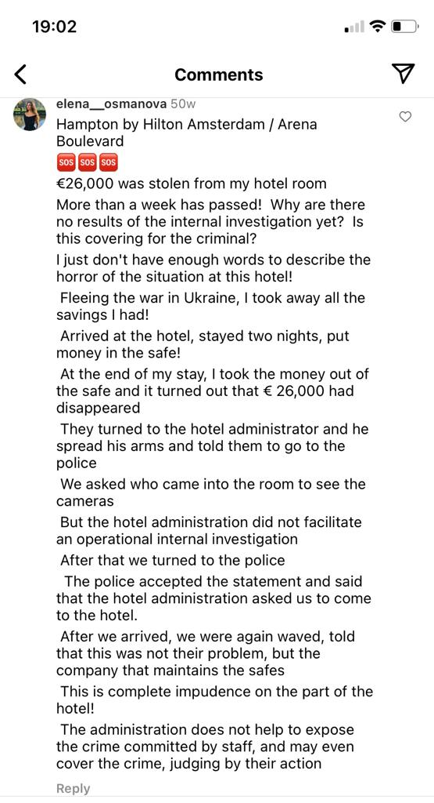
(Osmanova, 2022)
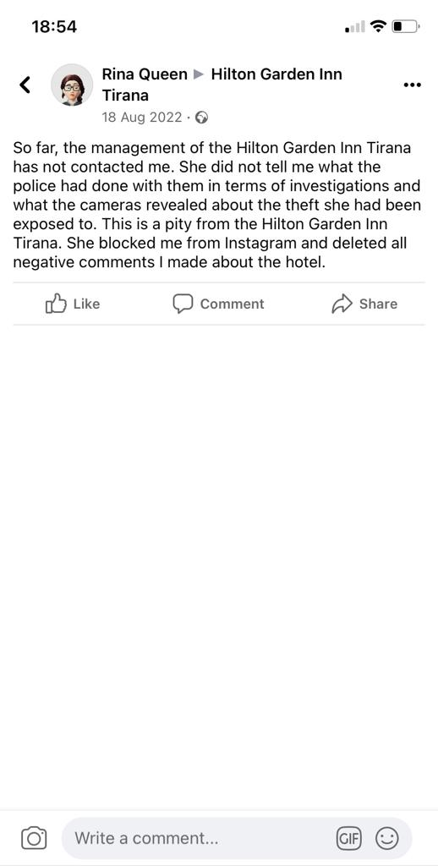

(Queen, 2022).

The Data Protection Act in 2018 was implemented to control as to how your personal information is used by businesses, companies, or the government (GOV.UK, 2023). However, Hilton has broken these rules by uploading personal pictures of their customers which they clicked on their stay at Hilton hotel from their personal Instagram accounts on Hilton’s marketing promotional digital platforms without asking their permission (Mconk, 2022).

Conclusion
The 5 C’s was conducted and it was found that many customers post negative tweets and comment on social media. Hilton needs to expand more in international market, and they face fierce competition from Marriot, Holiday Inn, and Hyatt and due to global recession, they are also facing further challenges. Hilton has faced concern from Tourism-watchdog about not following through their CSR policies.
SWOT analysis was conducted, and it was found that it needs to focus on its high debts and bring it down. Hilton Hotels have not currently expanded their hotels more in international market and their finance for funding in research and development is less. The competition is tough for Hilton with their rival hotels.
STEEPLE analysis was conducted, and it was found that Hiton faces problems in upholding their ethical standards and greenwashing claims. Hilton faces problems with negative comments being posted on social media. Hilton does not respond quickly to the problems of their customers, and they need to fix this problem of responding to their customers immediately if they have any problems.
Marketing mix framework was applied, the problem is that the cost of living has gone up over the last year and Hilton is not reducing its prices. Hilton has faced problems with several influencers as they want free stay and food to write positive blogs and reviews. If Hilton does not offer them freebies, then the influencers write negative blogs and review which has negative impact on the business of Hilton. Although, the rooms and services of Hilton is good, however, in UK it needs to change its brand image as it is not strong as people perceive it to be.
Hilton faces issues as they have less staff which affects the quality of service and productivity of their employees as they find it too stressful doing their jobs and are unable to maintain work-life balance.
Marketing Segmentation was also used, and it was found while using Similarweb Hilton’s global rank was 1,121, therefore, Hilton needs to focus on its global market. Hilton just focuses on high income social class families and senior to middle-aged people and this their problem. Hilton does not target a broad spectrum of customers.
Although Hilton uses Digital and social media quite effectively, however, there have been some concerns that they do not follow on the Data Privacy Laws and post pictures of their customers without their permission.

Recommendations
The recommendations will be that Hilton Hotels need to use digital media and social media, such as Facebook, Twitter, Instagram, YouTube, and LinkedIn to market their brand. However, they need to follow the Data Privacy Law so that they do not get entangled in lawsuits and loss of reputation. They should stop posting private pictures of their customers without their consent for marketing promotions. They should also respond immediately if negative comments and reviews are being posted on social media and deal with these customers in person rather than online. They should ask them as to how they can improve their experience in future and resolve their conflict quickly and should try to resolve their complaints before they leave negative feedback on social media (Dandby, 2023).
They should communicate with their staff and find out as to why the negative comments were posted and take appropriate steps accordingly (Wojcek, 2017). Hilton should keep their websites and social media updated by posting current photos and promotional events of their hotels.
There are various advantages of using social digital media as it is very convenient in terms of retrieving information and services 24/7 and throughout the year, from wherever they are at the time. Customers can gain a good grasp of services and goods by examining multimedia content and digital platforms (Jobber, 2007).
However, with this marketing research tools there are limitations as people feel that they are getting too many emails, surveys, and telephone calls regarding market research questions, and they feel that their privacy is being compromised (Jobbar, 2004). Another drawback is that many consumers globally do not have access to social media and the aged population do not like using social media as they like to use traditional methods (Fahy & Jobber, 2019).
The 5 C’s is also recommended, and Hilton should expand more internationally, especially in the Asian market so they can generate more income, and this can be done by using this framework to find out about their competitors and customers in the specified country where they want to open their hotels. Hilton should set their algorithms in twitter in a way which will enable them to flag any negative tweets earlier giving them time to respond accordingly (Vaughan, 2022). In future, they should build hotels with solar panels and have more windows so natural light can come through and as a result less electricity is used. They should also install flushes in toilets which does not use much water.
SWOT analysis is recommended as Hilton Hotels should know their competitors and compare the prices which their competitors charge, such as Marriott, Hyatt and Holiday Inn for their rooms and food and beverages and then price their rooms, food, and beverages accordingly and try to be one step ahead of them. This analysis will also help Hilton in expanding their business internationally as they are too dependent on U.S. markets. If they expand more in international market the reliance on U.S. will be less and they will be more profitable. Hilton needs to focus on their ethical considerations, and they need to provide training and workshops to their staff for equality, diversity, and inclusion and this should be done during their induction so that they know how to treat their guests fairly (Aspire, 2023).
There are some limitations of using this framework as it lacks detailed structure and, important elements are missing, and the speed of change makes it progressively difficult to understand developments that may affect the company in future (CIPD, 2023).
Marketing Mix framework is also recommended as due to global recession things have changed globally. Hilton should set their prices according to the marketing conditions of specific countries in which they operate and their competitor prices as well. They will also be able to monitor their online presence and understand buying cycles which will help them to determine which channels are more efficient for each stage of their cycle for e.g., some customers may be open for direct selling on any given time whereas others may only book hotels during certain seasons, such as Christmas time (Staah, 2022).
The staff should act in accordance with the code of conduct of Hilton hotels (Hilton Worldwide, 2023). Hilton should recruit more staff by using the Applicant Tracker (TAM) hospitality applicant tracking system and it offers cloud convenience and attracts applicants to its customizable careers pages and has other excellent features, such as, screening applicants, selecting applicants, hiring, and onboarding applicants and is fairly easy to use. (Manager, 2023). The price varies according to the size of organisation and can range from free to $100,000 and again it varies on the company’s recruitment budget (Mccann, 2023). They should also provide trainings so staff are updated, and it will help them getting promotions which will result in staff retention.
The limitations of using marketing mix are that they do not improve campaign performance on their own and many brands grapple in interpreting this framework into an actual marketing plan with calls to activities, targets, campaign measures and other factors (Clair, 2017). As market is always developing the marketers have to be flexible regarding changes in customers behaviour (Evolution, 2018).
Marketing segmentation framework is also recommended as Hilton can attract different customers by targeting them according to their geographic, demographic, psychographic and behavioural segmentation. Hilton needs to broaden it spectrum and target young customers with high income and this can be achieved by marketing their hotels on TikTok which is a craze amongst young people. If Hiton Hotels follows on these recommendations it will become more profitable.
However, there are limitations of using this framework as it needs to be applied in an established way and the cost is not taken into matter when pursuing a section (Bhasin, 2018). The other drawback is that bigger inventory has to be sustained by both the distributors and manufacturers and when aspects of a market section change, investment which was made may become pointless (Chand, 2023). Overall, the benefits outweigh the limitations.

Appendix 1
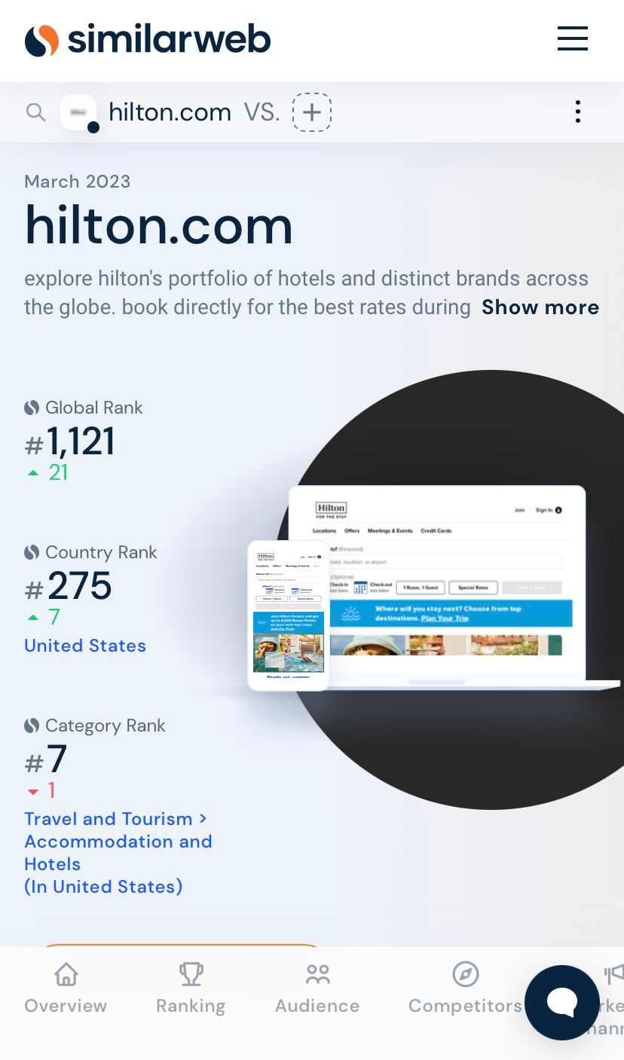

Appendix 2
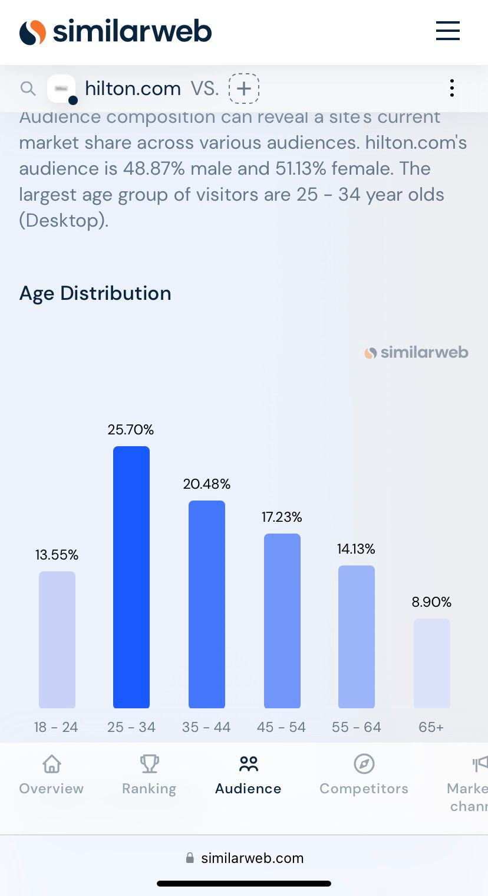

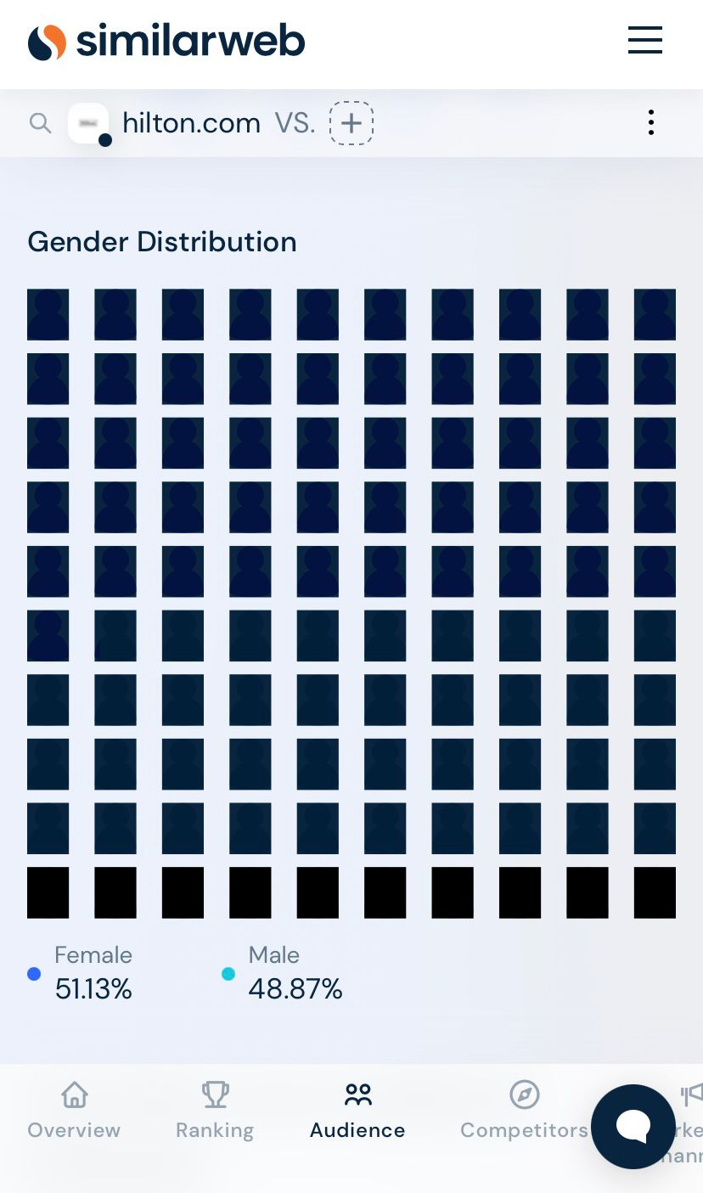
Appendix 3

Appendix 4
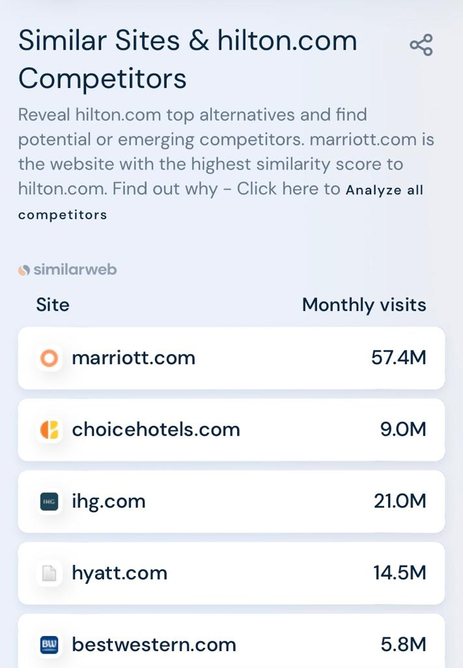

References
American Marketing Association. (2023) Marketing Strategy. Available at: https://www.ama.org [Accessed 2nd May 2023).
Amey, K. (2015) Histon is the hotel Twitter users hate the most, according to new study that analyses posts for negative language. [Online]
Available at: htttps://www.dailymail.co.uk
[Accessed 3rd May 2023].
Aspir. (2023) Above and beyond training. [Online]
Available at: https://www.aspire-leadership.co.uk
[Accessed 3rd May 2023].
Bannon, D. P. n.d. Marketing Segmentation and Political Marketing. [Online]
Available at: htttps://www.researchgate.net
[Accessed 16th April 2023].
Bhasin, H. (2018) Limitations of segmentation. [Online]
Available at: https://www.marketing91.com
[Accessed 3rd May 2023].
Bhasin, H. (2019) Marketing Mix of Hitlon Hotel and Resorts - Hilton Hotel and Resorts Marketing Mix. [Online]
Available at: https://www.marketing91.com
[Accessed 16th April 2023].
Booking.com. (2023) The World's best Hilton Hotels. [Online] Available at: https://www.booking .com [Accessed 3rd May 2023]
Chaffery, D. (2010) Smart Insights Introducing Race: A practical framework to improve your digital marketing. [Online]
Available at: https://www.smartinsights.com/digital-marketin-strategy/race-a-practical-framework-to-improve-your-digital-marketing
[Accessed 17th April 2023].
Chahal, M. (2012) Hotels fail to get a grip on reality. [Online]
Available at: https://www.marketingweek.com
[Accessed 3rd May 2023].
Chand, S., (2023) Advantages and Disadvantages of Market Segmentation.. [Online]
[Accessed https://www.yourarticlelibrary.com May 2023].
Chhabra, E. (2019) How Hilton is cutting its environmental footprint by half. [Online]
Available at: https://www.forbes.com
[Accessed 29th April 2023].
CIPD. (2023) Advantages and Disadvatages of using SWOT analysis. [Online]
Available at: https://www.cipd.org
[Accessed 30th April 2023].
CIPD. (2023) The advantages and disadvantages of PESTEL Analysis. [Online]
Available at: httyps://www.cipd.org
[Accessed 30th April 2023].
Clair, S. (2017) The benefits and limitations of Marketing Mix Models. [Online]
Available at: https://www.measurementmojo.com
[Accessed 16th April 2023].
Comparably. (2023) Hilton Competitors. [Online]
Available at: https://www.comparably.com
[Accessed 30th April 2023].
Conduct, H. C. O. (2023) Our Purpose Platform. [Online]
Available at: https://www.ir.hilton.com
[Accessed 30th April 2023].
Dandby. (2023) 5 Ways hotels can avoid negative guest review online. [Online]
Available at: https:/www.microfridge.com
[Accessed 19th April 2023].
Diller, M. 2022. Hotel brands are pausing development in Russia, but they aren'st pulling out completely.. [Online]
Available at: https://www.washingtonpost.com/travel/03/15/hotels-russia-marriot-hilton-ihg/
[Accessed May 2023 2023].
Dudovskiy, J. 2016. Hilton Hotels Marketing Mix - 7Ps of Marketing. [Online]
Available at: htttps://www.research-methodolgy.net
[Accessed 16th April 2023].
Dudovskiy, J. 2016. Hilton Hotels Segmentation, Targeting and Positioning. [Online]
Available at: https://www.research-methodology.net
[Accessed 16th April 2023].
Dudvoskiy, J., 2016. Hilton Swot Anaslysis. [Online]
Available at: https://www.research-methodology.net
[Accessed 29th April April 2023].
Evolution, M. 2018. Pros and Cons of Marketing Mix Modelling: Advantages and Disadvantages of Marketing Evolution. [Online]
Available at: https://www,marketingevolution.com
[Accessed 16th April 2023].
Fahy, D. J. &. J. 2019. Foudations of Marketing. 6th ed. London: McGraw-Hill Education.
Foundation, H. (2023) Collaboration. [Online]
Available at: htttps://www.hiltonfoundation.org
[Accessed 3rd May 2023].
Foundation, T. C. N. H. (2023) Biography. [Online]
Available at: htttps://www.hiltonfoundation.org
[Accessed 16th April 2023].
GOV.UK. (2023) Data Protection. [Online]
Available at: https://www.gov.uk
[Accessed 19th April 2023].
Grabler, H. et al. n.d. Psycographic segmntation and its application in the hospitality industry. [Online]
Available at: https://www.researchgate.net
[Accessed 2023 April 2023].
Hilton. (2020) Human Rights. [Online]
Available at: https://www.cr.hilton.com
[Accessed 30th April 2023].
Hilton. (2023) Board of Directors. [Online]
Available at: https://www.ir.hilton.com
[Accessed 16th April 2023].
Hilton. (2023) Social Impact. [Online]
Available at: https:www.esg.hilton.com
[Accessed 29th April 2023].
Hotels, P. T. N. 2013. Segmentation and targeting of Hilton Hotels. [Online]
Available at: https://www.uweteamextreme.wordpress.com
[Accessed 30th April 2023].
Jobbar, D.2004. Principles and Practice of Marketing. 4th ed. Berkshire: McGraw Hill Education.
Jobber, D. 2007. Priciples and Practice of Marketing. 5th ed. Berkshire: McGraw Hill Education.
Johnson, B. (2010) Hilton banned from developing lifestyle hotels for two years. [Online]
Available at: htttps://www.marketingweek.com
[Accessed 3rd May 2023].
London, I. (2015) Hilton Hotel draws most negative tweets. [Online]
Available at: https://www. business-standard.com
[Accessed 19th April 2023].
Ltd., K. M., 2020. Hotel companies named among world's most ethical companies 2020. [Online]
Available at: https://www.hoteliermagazine.com
[Accessed 30th April 2023].
Manager, T. A., 2023. Hospitality Recruitment. [Online]
Available at: https://www.tamrecruiting.com
[Accessed 3rd May 2023].
Mccann, A., 2023. ATS pricing: How much does an applicant system cost?. [Online]
Available at: https://www.resources.workable.com
[Accessed 3rd May 2023].
Mconk, 2022. Hilton HOtek tooks photos off my personal IG and is using them for marketing promotions. [Online]
Available at: https://www.reddit.com
[Accessed 19th April 2023].
Mortimer, N., 2016. Inside Hilton's plan to stay ashead of the tech curve, and the competition. [Online]
Available at: https://www.thedrum.com
[Accessed 17th Aprl 2023].
News, B. T., 2006. Hilton Slated over clean and green image. [Online]
Available at: https://www.breakingtravelnew.com
[Accessed 3rd May 2023].
Niklas Eriksson, e. a., 2016. The Data Driven Decison Race in eRetailing. [Online]
Available at: https://www.researchgate.net
[Accessed 19th April 2023].
Oliver, C. W. a. D. (2023) Do you belong here?': Lawsuits allege Hilton, other hotels discriminated against Black guests.. [Online]
Available at: https://www.eu.usatoday.com
[Accessed 3rd May 2023].
Osmanova, E., 2022. Hampton by Hilton Amsterdam/Arena Boulevard. [Online]
Available at: https://www.instagram.com
[Accessed 3rd May 2023].
Pole, S., 2023. Hilton-Using corporate climate action as aforce for good. [Online]
Available at: htttps://www.southpole.com
[Accessed 3rd May 2023].
Prasad, C., 2022. Market Segementation Adevantages and Disadvantages. [Online]
Available at: https://www.jooksms.com
[Accessed 16th April 2023].
Quora. (2023) What is the environmental impact of Hilton Worldwide's operations. [Online] Available at: https://www.quora.com [Accessed 3rd May 2023]
Queen, R. 2022. Hilton Hotel. [Online]
Available at: https://www.facebook.com
[Accessed 3rd May 2023].
Rakhmatova Bakhora, e. a., 2022. Performance of Hilton: How Hilton tackles the epidemic Covid-19 diesease. Thematics journal of business management, 5(1), pp. 2277-3002.
Samoszuk, S., 2022. Hotel Management Case Study: SWOT Analysis of Hilton Hotels. [Online]
Available at: https://www.study.com
[Accessed 30th April April 2023].
Schlappig, B. (2018) Hotel calls out "Influencer" for asking for free stay, bans all bloggers. [Online]
Available at: https://www.onemileatatime.com
[Accessed 3rd May 2023].
Silk, A., 2015. Sir Tim Berners-Lee: The marketing impact of artificial intelligence. [Online]
Available at: https://www.campaignlive.com
[Accessed 3rd May 2023].
Similarweb, 2023. Hilton.com. [Online]
Available at: https://www.similarweb.com
[Accessed 30th April 2023].
Simpson, D., 2006. War of words on Hilton 'greenwash' claims bring spotlight on tourism ethics. [Online]
Available at: https://www.cabi.org
[Accessed 2023 April 2023].
Solitario, F. T., 2023. Hilton Hotel Case Study One Situational Analysis. [Online]
Available at: https://www.scribd.com
[Accessed 3rd May 2023].
Staah. (2022) 7PS of Hotel Marketing. [Online]
Available at: htttps://www.blog.staah.com
[Accessed 19th April 2023].
Toolkit, L. (2022) Hilton Hotels in Central London. [Online] Available at: https://www.londontoolkit.com [Accessed 3rd May 2023]
Thomas, I. (2022) Why Marriot, Hilton aqnd Hyatt say hotel prices are only going up. [Online]
Available at: htttps://www.cnbc.com
[Accessed 30th April 2023].
Vaughan, P., 2022. How to deal with negative comments on Social Media. [Online]
Available at: https://www.blog.hubspot.com
[Accessed 3rd May 2023].
West, A. S. &. D. C., 2001. Direct and Interactive Market. 1st ed. New York: Oxford University Press.
Whyte, P., 2023. 2022. [Online]
Available at: htttps://hospitalityinvestor.com
[Accessed 3rd May 2023].
Wojcek, A., 2017. Twitter Analytics: How to access and understand twitter stats. [Online]
[Accessed https://www.travelmediagroup.com April 2023].

