DS2: Business Digital Artifact

Student ID- 2438385

Word Count- 600-800 Words

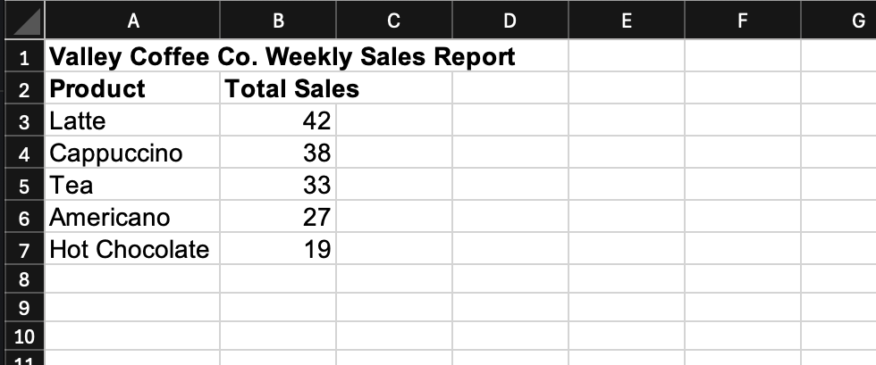
Conclusion:
Latte was the highest-selling product with 42 sales, while Hot Chocolate was the lowest-selling product with 19 sales. This shows that Latte was the most popular drink during the week, whereas Hot Chocolate had the lowest demand.

DS2 Reflection Log – Valley Coffee Co.
I selected Microsoft Excel for this task because the scenario required working with numerical sales data. Excel is commonly used in business contexts to organise information, perform calculations, and present data clearly. I determined it was the most appropriate tool, as it enabled me to transform raw sales figures into meaningful insights that the café owner could easily interpret.
I also considered using Word or PowerPoint, but I decided against them. Word is better suited for written reports, and PowerPoint is mainly used for presentations. Since this task required analysing numbers and identifying the highest- and lowest-selling products, Excel was more appropriate because it allows for easy calculation and comparison of data. Using Excel also made it easier to create a chart, which is useful in a business context because it allows patterns and differences in sales to be seen quickly.
The information I used came directly from the email provided by Mr Habib, the owner of Valley Coffee Co. The email contained sales data for five products: Latte, Cappuccino, Americano, Tea, and Hot Chocolate. The data showed how many of each product were sold each day over seven days. I entered all of this information into an Excel spreadsheet to organise it clearly. After inputting the data, I calculated the total number of sales for each product across the entire week. This allowed me to compare the overall performance of each product rather than just daily figures. From these totals, I was able to identify patterns in customer preferences. Latte had the highest total sales, while Hot Chocolate had the lowest. This information helped answer the main question in the scenario, which was to identify the best-selling and least-selling products.
When I first started the task, I entered the raw data into Excel exactly as it appeared in the email, including daily sales for each product. However, I realised that this format was not the clearest way to answer the question, as it made it difficult to quickly see overall performance. To improve this, I created a separate summary table that only showed the total weekly sales for each product. This made the data easier to read and allowed for direct comparison between products. After creating the table, I also added a column chart. This visual representation helped make the differences in sales much clearer. Instead of reading numbers, the café owner can now quickly see which products performed better than others. I also made changes to the formatting of the spreadsheet. I added headings, adjusted column sizes, and ensured the data was neatly aligned. These changes improved the overall presentation and made the spreadsheet more professional.
I improved my work in several ways throughout the process. First, I checked all calculations to ensure that the totals for each product were accurate. This was important because any mistakes in the data could lead to incorrect conclusions about product performance. I also reviewed the layout of the spreadsheet and made adjustments to improve clarity. For example, I separated the raw data from the summary table so that the key information was easier to find. This helped make the report more user-friendly. Another improvement I made was adding a column chart. This significantly improved the presentation of the data because it allowed for quick visual comparison between products. The chart clearly highlighted that Latte was the highest-selling product and Hot Chocolate was the lowest-selling product. Finally, I reviewed my work as a whole and made small formatting adjustments to improve readability, including clearer headings and consistent spacing throughout the spreadsheet. Overall, these improvements made the final artefact more effective and suitable for a business owner who needs quick and clear insights.

References
Microsoft Support. Excel Help and Learning.
UWTSD Bitesize. Digital Skills Resources.

