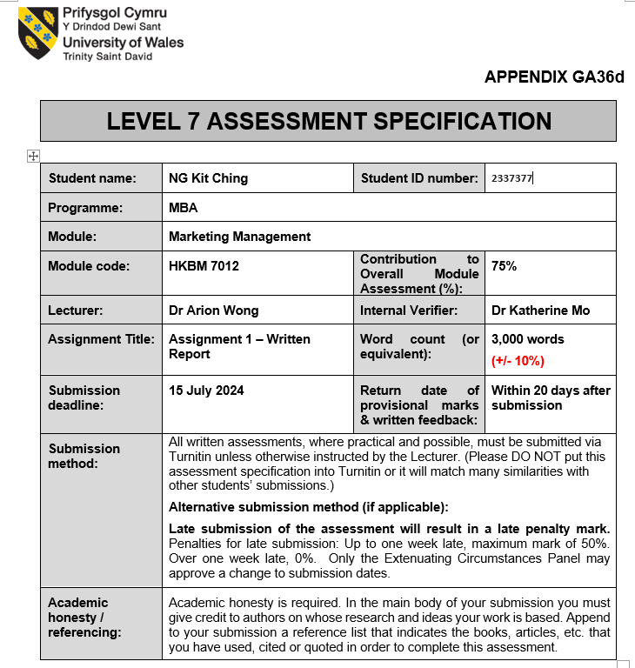
1
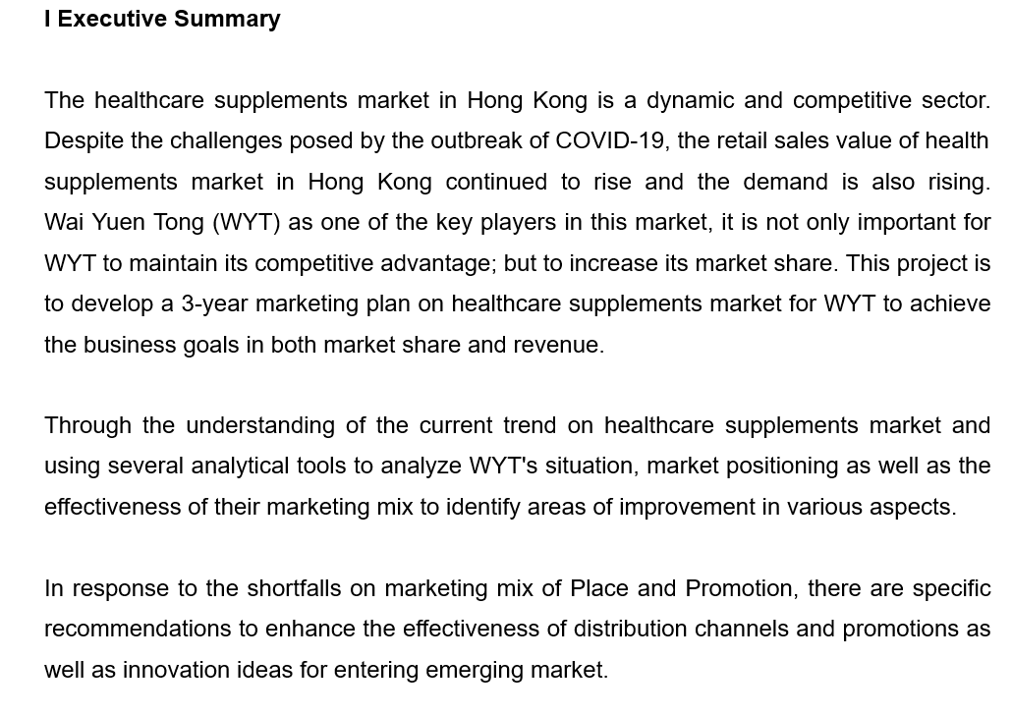

2

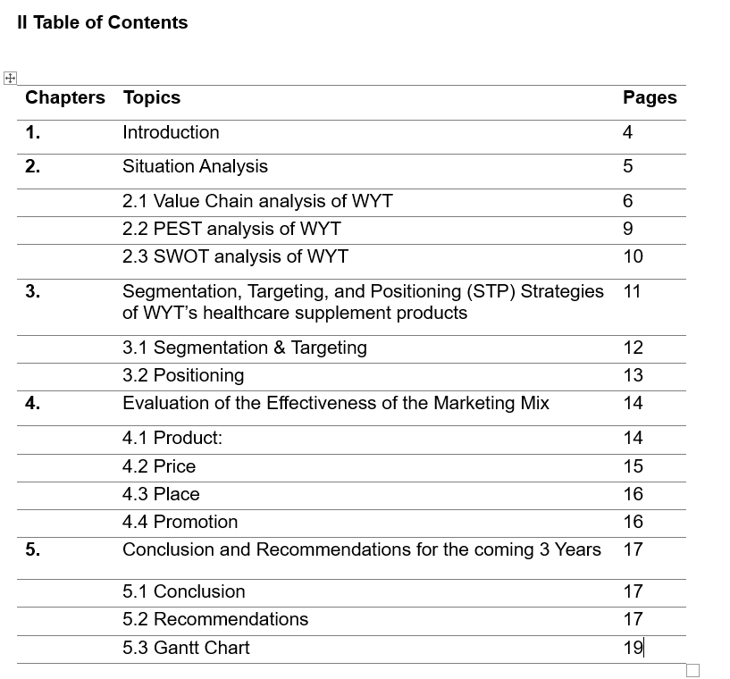

3

1. Introduction

Wai Yuen Tong (WYT) is a renowned traditional Chinese Medicine (TCM) manufacturer with 125 years of history, found by a government official Li Changhou and several likeminded friends in 1897 (www.wyteshop.com, n.d.).

Started their footprint in Hong Kong in 1930. Relocated the head quarter from Guangzhou to Hong Kong in 1952 and is now a listing company (stock code 897) in Hong Kong. WYT carrying the philosophy of “Preparing Medicine with Dedication, Growing Strong with Reputation” since its establishment in 1897.

Currently, WYT operates more than 100 stores (including franchised stores) in Hong Kong, Macau and China, specializes in manufacturing and retailing of top-quality traditional Chinese medicine and healthcare supplements, Western pharmaceutical products and personal care products under the brands Madame Pearl's and Pearl’s. WYT also providing one-stop registered Chinese medicine doctor services at over 75 retail outlets.

In terms of product offerings, WYT categories their products by Product Functions (www.wyteshop.com, n.d.):
- Men Formula
- Women Formula (Relieve Monthly Discomfort, Postnatal Care)
- Disease Prevention (i.e. healthcare supplements for Digestive and Intestinal Health, Immunity Booster, Hypertension, High Cholesterol, Respiratory, Eye Care, Heart and Cardiovascular)
- Stress and Fatigue
- Relieves Muscular & Bone Aches
- Hair Care
- Pet Health Care

4
Considering the current market trend in Hong Kong in the post-COVID era that the demand on health supplements continues to rise due to Hong Kong’s ageing population and rising health consciousness among the public (Hong Kong Health Food Association, 2019). This report will focus on the 3-year marketing plan for Disease Prevention products (healthcare supplements) of WYT.

2. Situation Analysis

It is always important to conduct a situation analysis before coming up the marketing plan. Through the situation analysis to identify the internal and external factors related to market trends, customer preference and competitive landscapes that directly affected the overall performance of the company. Situation analysis is a stage of strategic planning and there are several analytical tools for the analysis (Brex, 2023).

Value Chain analysis uses for analyzing the company’s internal environment. It is a process for a company to disaggregates the activities and processes involved in the creation of a product or delivering a service. By determining the costs and value of these activities to identify ways for better improvement (Tarver, 2021).

PEST analysis uses for analyzing the company’s external environment. It is a measurement tool to analyze the changes in business environment so that a better decision in business direction, marketing strategies as well as product development and research can be made (Kenton, 2024b).

SWOT analysis is a basic process to evaluate a company’s strengths, weaknesses, opportunities, and threats and most importantly to gain a complete understanding on their current market position and overall performance (Kenton, 2024a)

5
2.1 Value Chain analysis of WYT:
According to the Michael Porter's framework for value chain analysis (Harvard Business School, 2019), we will separate the company activities into two broad categories, i.e. Primary Activities and Secondary (or Support) Activities to obtain an overview of the internal environment (strength, weakness) that influence WYT’s business performance.

Primary Activities
Inbound Logistics: WYT produce the healthcare supplement products by its Good Manufacturing Practice (“GMP”) factory which the construction and production operations are in accordance with the standard of “The Pharmaceutical Inspection Co-operation Scheme” (“PIC/S”), a stringent manufacturing practice regulation with worldwide recognition. GMP factory become the competitive advantage of WYT and allows WYT to leverage its brand strength with “100% Made in Hong Kong” (Wai Yuen Tong Medicine Holdings Limited, 2023).

Operations: WYT has over a hundred stores (including 22 franchised stores) in Hong Kong, Macau and China (Wai Yuen Tong Medicine Holdings Limited, 2023).

Outbound Logistics: Most of the retail stores of WYT also served as one-stop integrated Chinese medicine clinics, with more than 80 Chinese medicine practitioners in Hong Kong. Besides offline retail, WYT also operates an online retail shop (www.wyteshop.com) (Wai Yuen Tong Medicine Holdings Limited, 2023).

6
Marketing and Sales: WYT always focuses on media and print advertising (traditional marketing) as major parts of its marketing strategy. This includes television commercials, print advertisement on newspapers, banner advertisement on buses (App.goo.gl, 2018) (asn9999zealot, 2006) (位元堂 Wai Yuen Tong, 2015)
(位元堂 Wai Yuen Tong, 2023).

Products and Services: WYT offers a wide range of top-quality of traditional Chinese medicine products and healthcare supplements including the newly launched pet healthcare supplements. According to Ipsos’ market survey on consumers of Chinese healthcare supplements conducted in April 2023, among different Chinese medicine brands, WYT is recognized as the brand providing best Chinese medicine quality. The three hero products of WYT, including the most well-known “Angong Niuhuang Wan, the most classic “Young Yum Pill”, also known as “Young Sheng Pill”, were awarded the Lingnan Traditional Chinese Medicine Cultural Heritage of Guangdong Province in 2009, and “Hou Tsao Powder”, ranked first in sales for 9 consecutive years in Hong Kong, making it a preferred choice of healthcare supplements for many consumers (Wai Yuen Tong Medicine Holdings Limited, 2023).

In terms of services, their specialized retail outlets provide customers with one-stop TCM services, blazing a new trail in TCM healthcare. As a gesture of contributing back to the community, WYT organizes TCM seminars and free TCM consultations with various organizations (www.wyteshop.com, n.d.).

7
Secondary Activities
Infrastructure: Board of Directors responsible for overall strategic planning, business development, sales and marketing, channel sales, retail operation and raw materials sourcing of the company. Board committees oversee areas of audit, remuneration and nomination. They also have a company secretary to handle legal related matters (www.wyth.net, 2024). The average age of main board members is 65 (webb-site.com, n.d.).

Human Resources Management: Mother company (Wang On Group) has a career page on company website for job seekers to submit application. They offer various training and learning programs to over 1,200 staff. Most of the programs are lead by the experienced management team (Digital (www.miracels.com.hk), n.d.).

Technology Development: Good Manufacturing Practice factory (“GMP”) with solar panels for reducing carbon emissions to further strengthen the leading position in product quality and achieve a win- win situation for the environment and economy. Partnership with the Hong Kong Productivity Council for development of an intelligent automatic packaging system enhances the stability of the packaging and reduce the waste of materials (Wai Yuen Tong Medicine Holdings Limited, 2023).

Margin: As a result of the dedicated efforts and initiatives described above, for the year of 2023 WYT enjoys an approximately 23.9% revenue growth (total revenue increased to HK$635 million) from the segment of Chinese pharmaceutical and healthcare supplements when compared with the previous year (Wai Yuen Tong Medicine Holdings Limited, 2023).

8
2.2 PEST analysis of WYT:
PEST (Political, Economic, Socio-cultural, Technological) analysis uses for identifying the external environment (opportunities, threats) of WYT (KESHO, 2015).

Political: Currently, there is no legislation or standards in Hong Kong to govern the provision of information pertaining to relevant safety and efficacy of healthcare supplements. However, with the deepening of the reform of the medical system and the promulgation of several industrial policies and laws in medical fee control, drug control, traditional Chinese medicine certification, etc., significant effects may be brought to the future development of the healthcare supplements and pharmaceutical industries (nutraingredients-asia.com, 2024).

Economic: Adverse fluctuations in retail rental and exchange rates still pose various challenges to the retail industry (Wai Yuen Tong Medicine Holdings Ltd, 2023)

Socio-cultural: Hong Kong's ageing population and tourism recovery are the key drivers of increasing on the demand of healthcare supplements (Wai Yuen Tong Medicine Holdings Ltd, 2023). On the other hand, considering the consumer purchasing behavior shifting from offline to online, e-commerce platforms become more popular and efficient in expanding market reach and consumer accessibility (Statista, n.d.).

Technological: Using Artificial Intelligence (AI) technology to improve the formulation and experiment process of new products is being exploited in the pharmaceutical industry which the production process will become much faster and less expensive (Thomas, 2022).

9
2.3 SWOT analysis of WYT:
- Strengths:
- A leading player in the market of Chinese pharmaceutical and healthcare supplement products. Their product quality and work ethics are highly praised by customers as supported by industry-related customer surveys and awards.

- Strong corporate brand image of “100% made in Hong Kong” sustained by the production line of Good Manufacturing Practice (“GMP”) factory.

- Century-old high brand equity and prestigious brand image enable WYT to charge higher prices than other players in the market (Appendix I).

- The mature franchise model helps WYT reduce the cost of opening new retail stores and accelerate the efficiency of market penetration (www.wyteshop.com, n.d.).

- Weaknesses:
- WYT has always been well-known for their traditional industries and products, it may not be able to quickly seize emerging markets.

- Oversupplied product selection may result in large and obsolete inventories, which may incur a high wastage ratio and causing additional rental costs.

- The average age of senior management team is relatively high (65), management style might be bit conservative. They might need to taking long time for decision of new strategies or investments. Due to the rapidly changing market conditions, there will be a chance that the best time to launch a product or invest will be missed.
10
- Opportunities:
- Rosy outlook on the increasing demand of healthcare supplements due to ageing population and tourism recovery in Hong Kong

- With the development of technology, the efficiency of research and development and production process of new product has been improved, more opportunities for WYT from market diversification strategy.

- Treats:
- There are risks and uncertainties in the healthcare supplements market as there is no legislation or standards in Hong Kong to govern the provision of information pertaining to relevant safety and efficacy of healthcare supplements currently.

- If WYT is unable to pass on the impact of adverse fluctuations in retail rental and exchange rates to customers, it may have an adverse impact on its cash flows and profits.

- Over-reliance on traditional marketing method will weaken WYT's competitiveness in the e-commerce platform considering customers' buying behavior shifting from offline to online.

3. Segmentation, Targeting, and Positioning (STP) Strategies of WYT’s healthcare supplement products

Segmentation, targeting and positioning (STP) is a strategic marketing technique and a necessary guide for a company to understand how effective of their business and marketing plan to compete in the market and the key factors for building a success business model (Vyas, 2016).

11
3.1 Segmentation & Targeting
For segmentation, there are two important approaches to segment a market which are descriptive variables and behavioral variables. Descriptive variables focus on geographic, demographic, and psychographic variables. Whereas, benefits-sought, occasions, user status, and usage rate variables are behavioral approach (Kotler and Keller, 2016).

Targeting is a method of selecting the right market segments by balancing the company's capabilities and resources with the needs of different market segments. Organizations can choose either undifferentiated (mass) marketing or differentiated marketing as targeting strategies (Kotler and Keller, 2016).

Undifferentiated or mass marketing is a strategy that companies choose to employ when market segmentation is not useful and does not result in meaningful and inherently distinct market segments. The strategy here is to focus on common characteristics rather than differences (FutureLearn, n.d.).

Differentiated or segmented marketing is deployed when a company selects one or several market segments that offer it the best opportunities. Each segment has special offers designed specifically for buyers in that market. Establishing a stronger position in a market segment typically leads to higher sales, more repeat purchases, and greater customer satisfaction. All of these are more costly than undifferentiated marketing because each segment requires a different product mix, which reduces the opportunity for economies of scale. Promotion costs also increase (FutureLearn, n.d.).

12

WYT always focuses on an undifferentiated marketing strategy while offering healthcare supplement products as according to the product descriptions which including function, ingredients, dosage and precautions of their popular healthcare supplement products available in the market, most of them are suitable for both children and adults as well as male and female customers (Appendix II).

3.2 Positioning
Positioning refers to building a positive brand image in consumers’ minds by designing and marketing a particular product to fulfil the targeted market's desired requirements. It is all about communicating the benefits of the product and differentiating the work from that of competitors (Kotler and Keller, 2016).

According to Wai Yuen Tong Medicine Holdings Limited (2023) the statement in the Annual Report 2023 of WYT, among different Chinese medicine brands, Wai Yuen Tong is recognized as the brand providing best Chinese medicine quality. Comparing selling price of healthcare supplements of WYT with key market players (Appendix I), WYT is enjoying premier price level than other key players in the market. WYT is the market leader in product quality and price of healthcare supplements market.

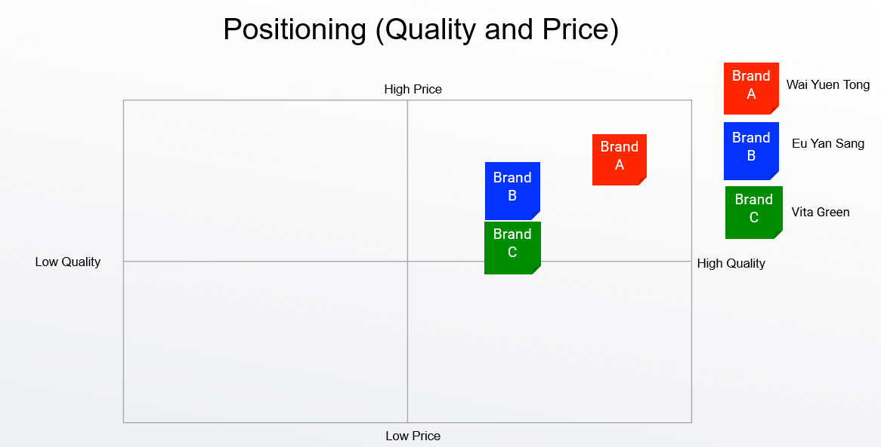
13
4. Evaluation of the Effectiveness of the Marketing Mix

An essential factor for developing a comprehensive, effective marketing plan is to consider a marketing mix that refers to the Product or Service, Price, Place and Promotion (4 Ps). It integrates key marketing strategies that create brand awareness, build customer loyalty, and drive product sales (Kenton, 2024a).

4.1 Product:
Product represents an item designed to satisfy customer needs and wants. One of the important factors of evaluating the effectiveness in marketing a product is to identify the product differentiation with the competing products in the market. (Kenton, 2024a).

WYT adopts the strategy of differentiating itself from competitors in the market by providing highest quality products and focuses on highlighting their own Good Manufacturing Practice (“GMP”) factory that both construction and production operations are in accordance with the standard of “The Pharmaceutical Inspection Co-operation Scheme” (“PIC/S”). GMP factory become the competitive advantage of WYT and allows WYT to leverage its brand strength with “100% Made in Hong Kong”.

14
Customer surveys and sales data can prove that WYT has achieved an effective result in its product strategy. In terms of surveys, according to Ipsos’ market survey on consumers of Chinese healthcare supplement products conducted in April 2023, WYT is recognized as the brand providing best Chinese medicine quality among the other market players in Hong Kong. In terms of sales data, one of their popular healthcare products, Hou Tsao Powder ranked first in sales for 9 consecutive years in Hong Kong. Last but not the least, WYT recorded the total revenue of Chinese Pharmaceutical and Healthcare Supplement Segment increased to approximately HK$635 million in 2023, represented an approximately 23.9% growth compared with the year before (Wai Yuen Tong Medicine Holdings Limited, 2023).

4.2 Price:
Price is the amount that consumers will be willing to pay for a product. Factors to decide the price including cost, demand, competitors’ pricing of similar products as well as the products’ real and perceived value. To stay competitive, sometimes discount offering also a part of pricing strategy. Pricing strategy is the second most important element in the marketing mix as it related to the product demand and profitability (Kenton, 2024a).

The pricing strategy of WTY for healthcare supplement products is positioned as premium reflecting the high standard in both ingredients and production (Appendix I).

WYT has established in Hong Kong for years and with century-old high brand equity, considering the rising demand of healthcare supplements market, keep receiving well supported and recognized by the customers as well as the growing revenue on healthcare supplement products are enough to prove that premium pricing strategy is a wise business decision for WYT.

15
4.3 Place:
Place refers to distribution channels. Specifically, where the products are available for the consumers to purchase, or where the customers to discover the products (Novak, 2023).

Distribution channels of WYT including own online platform (WYT eShop), 77 self-operated and franchised retail stores in Hong Kong, and selected third-party e-commerce platforms, e.g. HKTVmall, Ztore etc.

Compared with other key players in the market, such as Eu Yang Sang and Vita Green, WYT has the largest number of retail stores in Hong Kong, however, its sales network is less comprehensive than Eu Yang Sang and Vita Green. WYT mainly relies on their retail stores as the key sales channel, while the competitors not only have retail stores, but also operate consignment counters in health and beauty product chain stores and department store, e.g. Mannings, Watsons and Wing On etc.

4.4 Promotion
Promotion is how to promote a product and strategies use to convert prospects into buyers. Marketers to achieve sales goals by deploying promotional strategies, such as advertising, public relations, social media marketing, content marketing, direct marketing as well as discounts and special offers (Novak, 2023).

In terms of promotions, WYT has always been focusing on the traditional marketing method. Although they could achieve profit growth on the healthcare supplement products under this promotional method, however, it cannot be considered a successful and effective strategy in response to the current market trend of the digital world. To improve the effectiveness of their strategies and increase market share, WYT must strengthen its online awareness and presence.

16
5. Conclusion and Recommendations for the coming 3 Years

5.1 Conclusion:
Based on the above analysis, it is concluded that the healthcare supplements market is a promising and worthy area for WYT to continuing invest of resources and development. The current marketing strategies on Product and Price are appropriate and effective. However, compared with other market players and current market trends, there is still a lot of room for improvement on marketing strategies on Place and Promotion.

5.2 Recommendations:
Considering the above findings, it is recommended that WYT should strengthen their marketing strategies on Place and Promotion. The following specific recommendations for the coming 3 years are provided:

- In response to mass market approach, WYT should expand their presence in residential areas by:
- Increasing the no. of franchised retail stores from currently 23 to 40.
- Establishing 30 consignment counters in department stores and supermarkets.

- Open 5 “Pet Café” to increase awareness of Pet Healthcare Supplements, community engagement as well as exploring emerging market.

- Drive more tariff to WYT eshop and increase number of loyalty members by establishing WYT Mobile App and extend tactical offers.

- Strengthen online awareness and presence (i.e. generate more likes, shares and comments) on social media platforms. According to the characteristics of individual social platforms, optimize company contents and promotions on the platforms should be made:
17
- Instagram is famous for its story highlights to promote business. WYT can follow this direction to design interesting and attractive stories to showcase their products and seasonal promotions and use Product Tags to increase sales volume. Product Tags on Instagram is a feature that allows users to purchase products directly on Instagram without leaving the platform.
- Facebook is good at text promotion. WYT can put more copywriting-related promotions and activities on Facebook.
- WYT can also increase interaction with their consumers and visibility by posting short videos on YouTube.
- Establish WYT account in China based platforms, such as Xiaohongshu and TikTok.

- Organize regular public relations events (e.g. healthcare supplements seminars by industry professionals, product launch events, media tasting etc) to increase the visibility and image, building positive relationships with partners and consumers.

- Provide free online health and healthcare supplements consultation services to Hong Kong residents who have immigrated overseas, thereby exploring overseas markets.

By implementing these recommendations, WYT’s marketing strategies will become more comprehensive and effective, thereby increasing the market share as well as solidifying WYT's position in the healthcare supplements market.

18
5.3 Gantt Chart
The following Gantt Chart including project details and timeline of the above-mentioned recommendations.

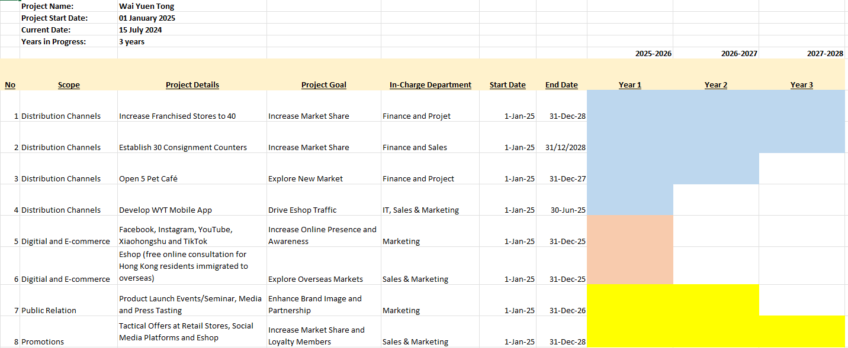

19

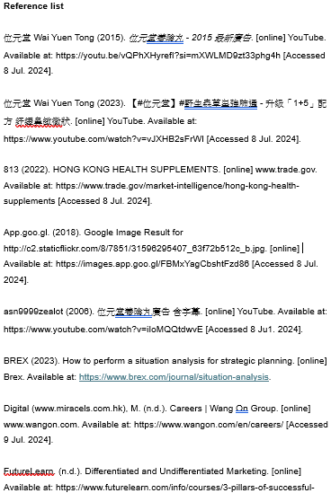

20

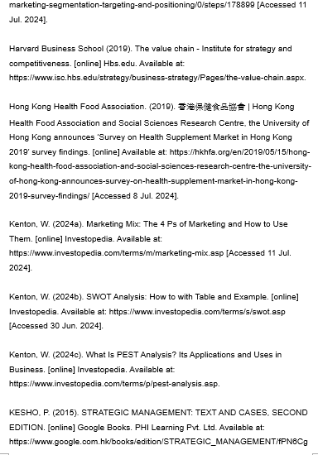

21

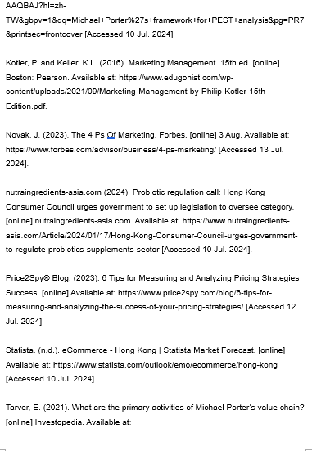

22

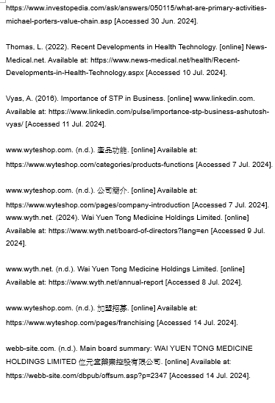
23

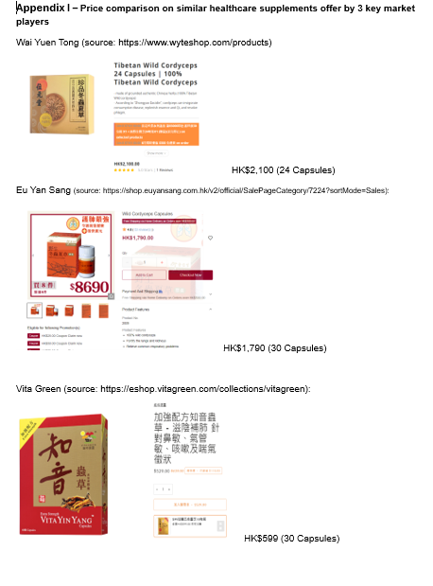
24

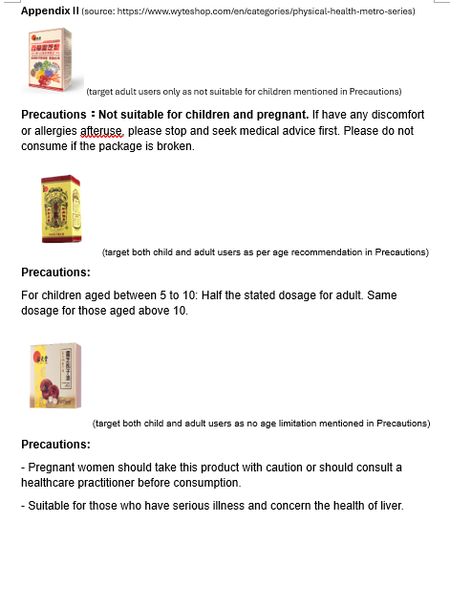

25

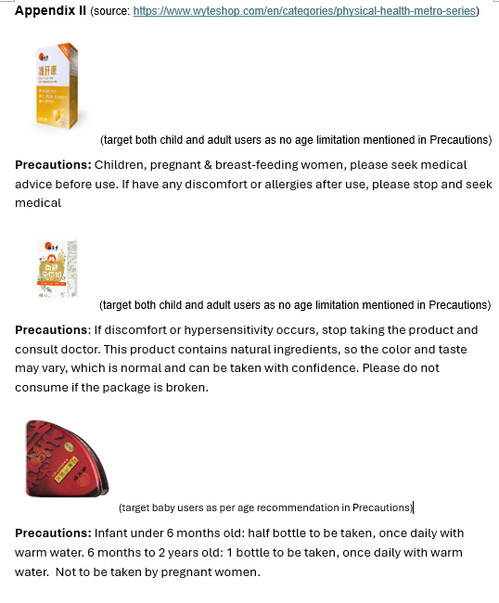

26

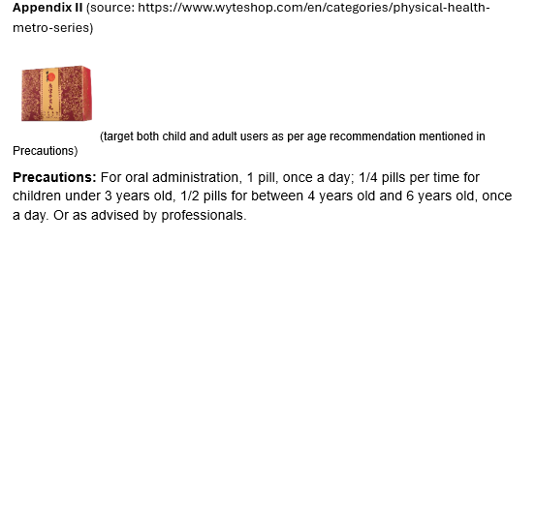

27

