
University of Wales Trinity St David
Changemakers: Creativity and Value Creation
Changemakers: Creativity and Value Creation
Assignment 2: Project Management &Innovation

- Student name: Nigist Eshetu
- Programme: BSC Applied Computing
- Module: ACCA5033
- Lecturer: Dr Fahad Ahmed

Table of Contents
Introduction 1
Task 1: Project Management 1
Project Management & Planning 1
Project scope 1
Proposed solution 1
Required Technologies and Resources 1
Project Timeline and Schedule 1
Constraints 1
Development method 1
Project Design 1
Requirements Specification 1
Wireframes 1
Flowchart 1
Entity Relationship Diagram (ERD) 1
Network & Security Architecture 1
Network structure diagram 1
Network security architecture/diagram 1
Task 2: Enterprise & Innovation 1
Task 3: Project reflection 1
Risks and Challenges and Their Mitigation 1
Conclusion 1
References 1

Introduction
The widespread use of single-use plastic bottles poses health concerns due to the chemical leaching of certain polymers, such as bisphenol A (BPA) and phthalates. Despite strong scientific evidence pointing to these risks, consumers lack a quick and practical way to assess the safety of bottles in their daily lives. This project offers an accessible, user-friendly mobile app that assesses the safety of plastic bottles based on material composition and standard resin identification codes (RICs). The SafeBottle app, internally called Container Check, will offer camera-based optical character recognition (OCR) scanning to detect resin codes on labels, as well as manual RIC entry. It will provide a risk assessment along with advice on safe use, exposure, and reuse.

Task 1: Project Management

Project Management & Planning

Project scope
The goal of this project is to design and develop an intuitive mobile app that will enable consumers to assess the safety of plastic bottles in everyday use. The app will focus on identifying plastics using standard Resin Identification Codes (RICs) and provide clear, evidence-based guidance on potential health risks associated with chemical leaching.
The project includes the development of key features such as camera-based optical character recognition (OCR) for scanning resin codes, manual RIC code entry options, and a color-coded risk assessment system.[1]

Proposed solution
The SafeBottle app (codename: Container Check) is a dual-data entry system designed to assess the safety and suitability of plastic containers.
Users can manually select the resin code (e.g., PET, HDPE) or bottle type or use a camera/scanner to read the resin symbol or bottle barcode.
Both data are fed into a risk assessment system, which provides a comprehensive assessment,
including:
- Safety Index
- Health Impact
- Usage Instructions (e.g., is it safe to reuse?)
Required Technologies and Resources
- Mobile development /platform IOS/Android, user friendly
- API/backend cloud infrastructure
- Database SQL/Mongo Database for storing material safety data
- Data acquisition /peer reviewed scientific literature and regulatory datasets
- Personnel /project manager, Full-Stack Developer, Mobile Developer, Data Specialist, UI/UX Designer[2]

Project Timeline and Schedule
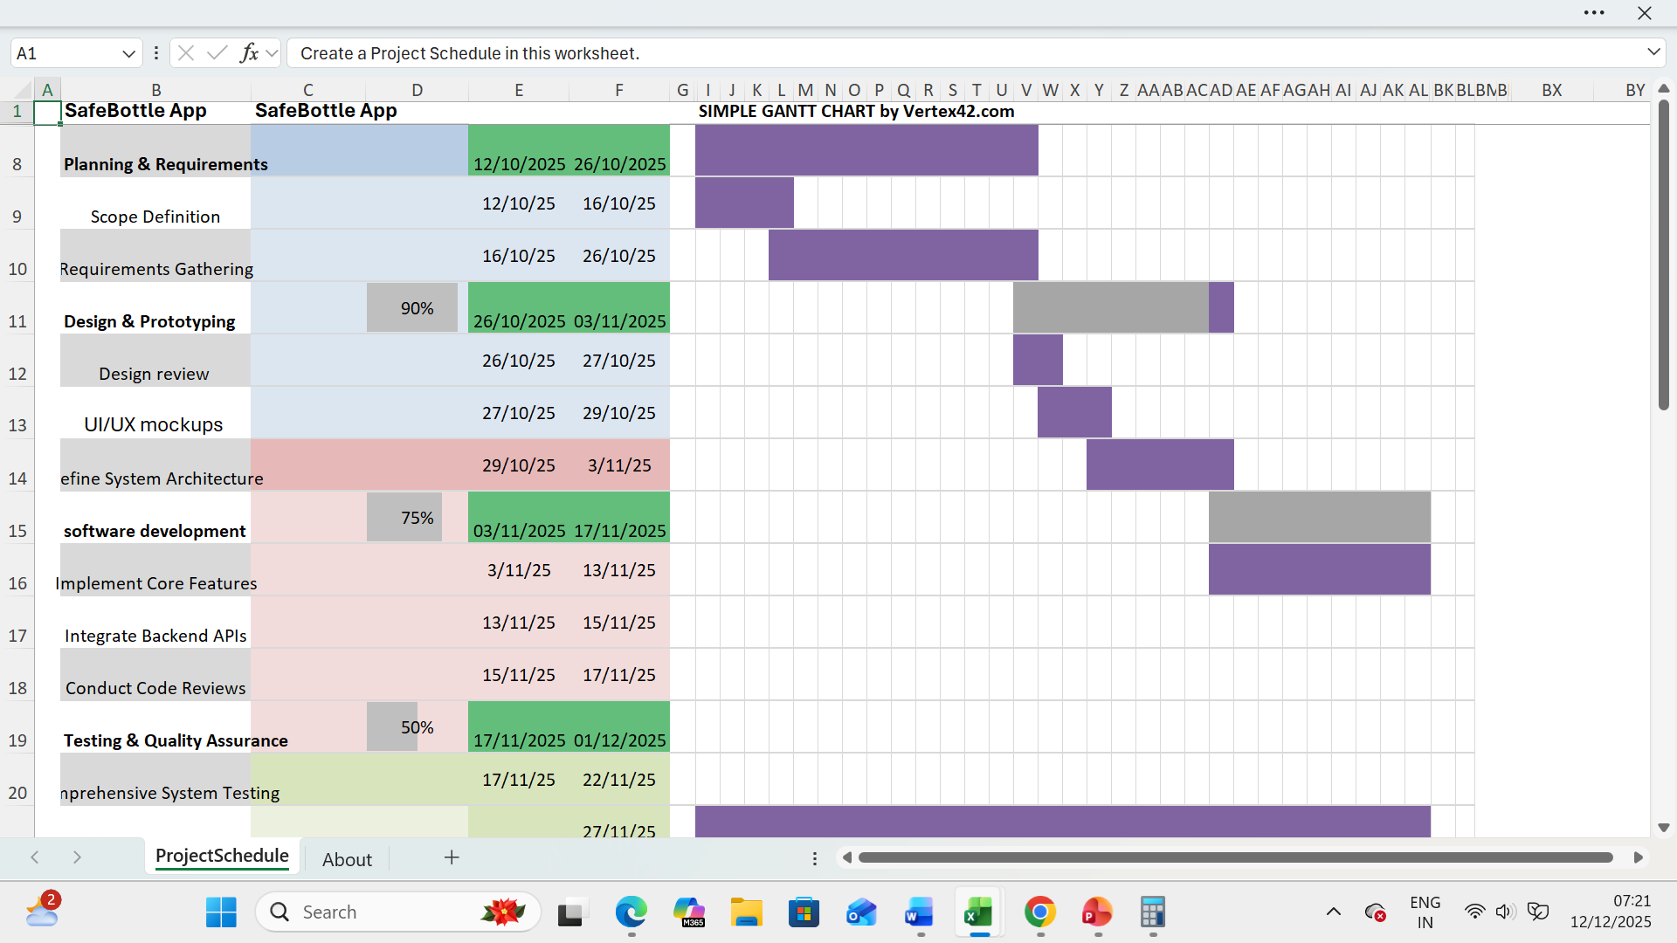

Constraints
The SafeBottle App project is subject to several constraints that influence its planning and implementation. A fixed two-month development timeline requires a strong focus on delivering a Minimum Viable Product (MVP), with advanced features such as machine-learning-based material recognition postponed to Version 2.0.
- Legal and ethical considerations prevent the app from offering medical diagnoses, and all information must be based on credible scientific sources and accompanied by appropriate disclaimers.
- Scope limitations restrict Version 1.0 to plastic beverage bottles and their Resin Identification Codes.
- Technical challenges include possible OCR inaccuracies, making reliable manual input essential.
- Resource constraints, including a part-time Data Specialist (50%), may slow database integration.

Development method
I used Agile development methodology, specifically employing a Scrum-based approach. Agile facilitates iterative and incremental development,
- enabling the project to be delivered in discrete, manageable phases within the defined timeframe. Tasks will be organised into short sprints, each with specific objectives and deliverables, including features such as OCR scanning, manual RIC input and risk assessment functionality. Regular sprint reviews and comprehensive testing will allow for the early identification of issues, ensuring that the application remains user-centred, reliable, and functional. Furthermore,
- Agile provides the flexibility to accommodate evolving requirements and shifting priorities, making it an effective framework for delivering a Minimum Viable Product (MVP) while supporting continuous improvement and the integration of future enhancements. [3]

Project Design

Requirements Specification
Functional Requirements
- The app shall allow users to input a plastic bottle’s resin code manually.
- The app shall allow users to scan a resin symbol or barcode using the device camera
- The app shall identify the plastic type using standardized resin classification (1–7).
- The app shall display a safety rating (Safe / Caution / Avoid).
- The app shall provide health and environmental guidance for each plastic type.
- The app shall function offline once the database is installed.[4][5]

Non-Functional Requirements
- Interface must be readable and usable by non-technical users
- High-contrast UI and scalable text
- Results displayed within 2 seconds
- No personal data stored or transmitted
Android and iOS support

Wireframes
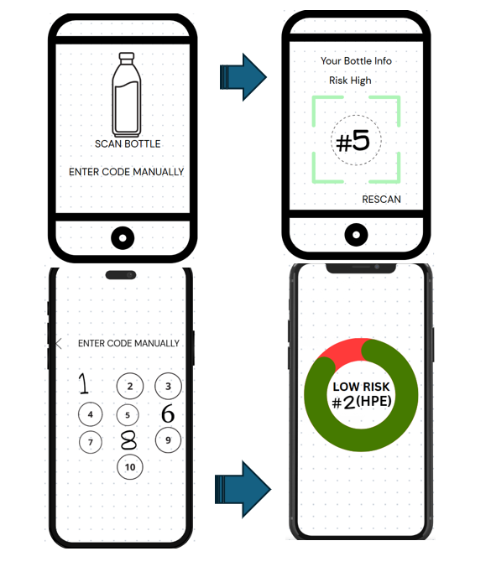

Flowchart
This flowchart confirms the system logic is simple, linear, and user-friendly, reducing cognitive load.

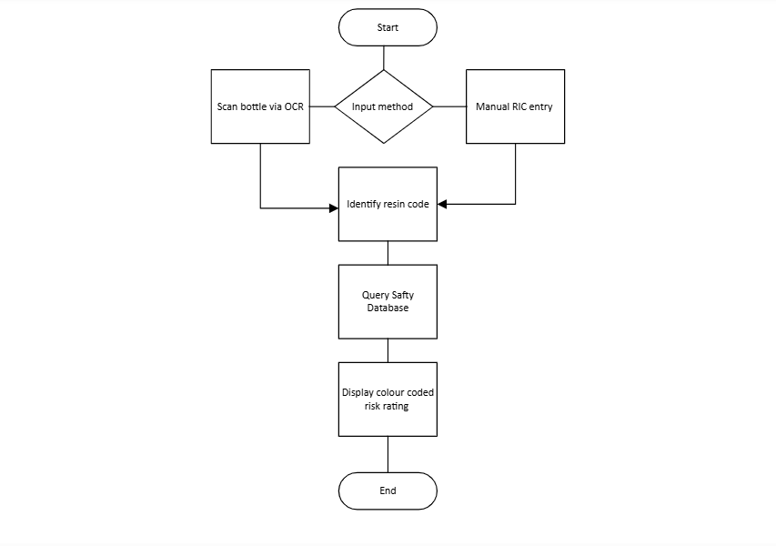

Entity Relationship Diagram (ERD)
As the following ERD shows the Entity relationship is one to many because one plastic can have many scans result and can associate with multiple chemical hazards.
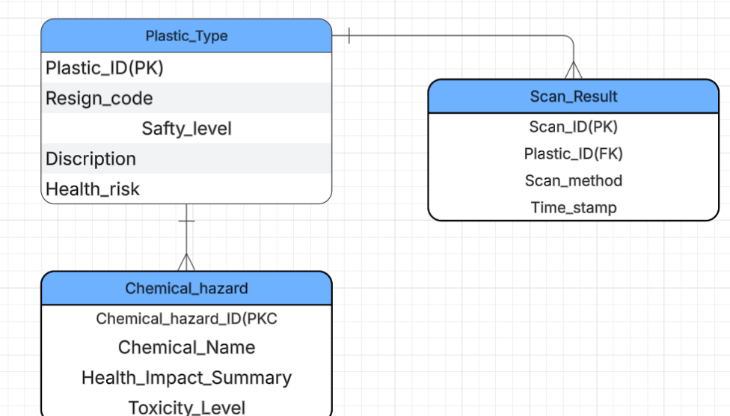

Network & Security Architecture
Architecture Description
- App operates locally on device
- Plastic safety database stored offline
- No user authentication required
- No personal data collected
- Optional updates via secure HTTPS connection
This architecture ensures privacy, low risk, and compliance with ethical data
practices.

Network structure diagram
Mobile client (SafeBottle app)
Mobile Client
Secure communication channel certificate pinning
client-side data signing
Backend infrastructure
Database storage
Bottle validation service
API Gateway
IP filtering
Request validation
Web application Firewall
(WAP)
b

Secret management
Client integrity check

Network security architecture/diagram
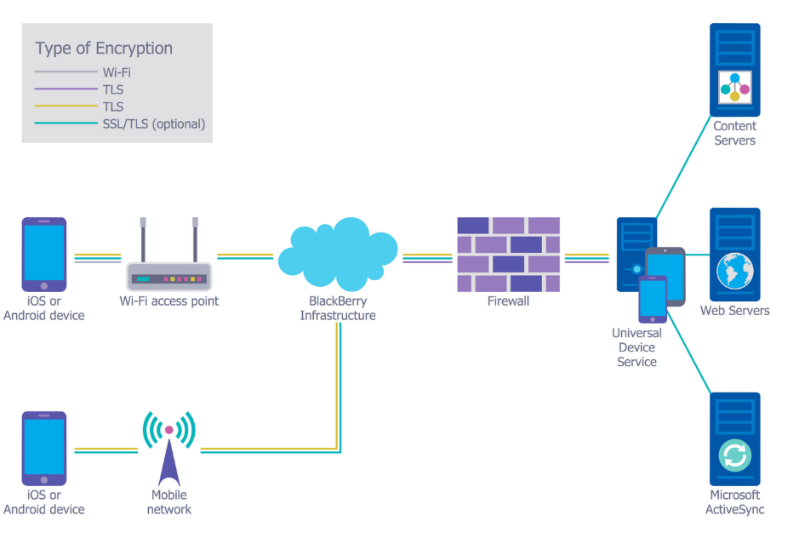

Task 2: Enterprise & Innovation
PEST Analysis key consideration
Social (S): Increasing consumer health awareness and demand for supply chain transparency drive app adoption. These trends also enable the development of premium features, including personalized safety alerts, notifications of product recalls, and tailored guidance, enhancing user engagement and trust.
SWOT Analysis Key Considerations
Strengths: SafeBottle benefits from a proprietary scanning and validation algorithm that enables fast and reliable authentication of bottled products. This technological compliance edge creates a strong intellectual property position and a competitive advantage within the market.
Weaknesses: The app’s performance depends significantly on partnerships with food and bottle manufacturers to access essential data and implement tag placement. This reliance introduces potential vendor-related risks and may affect the app’s scalability and operational flexibility.
Opportunities: There is potential to expand into a B2B model by providing audit data and insights to restaurants, distributors, and other stakeholders. This approach could generate additional revenue streams and strengthen the app’s market presence.
Threats: Any food safety incident involving a verified partner product could severely undermine user trust and damage the app’s reputation.
Legal & Ethical Considerations: Due to its focus on safety, SafeBottle faces legal liability if a bottle labelled as safe is later compromised. Clear disclaimers on scan reliability are essential. Ethically, the app must maintain algorithmic transparency and adopt data minimization practices, collecting only necessary user information to ensure privacy and trustworthiness.
Logo
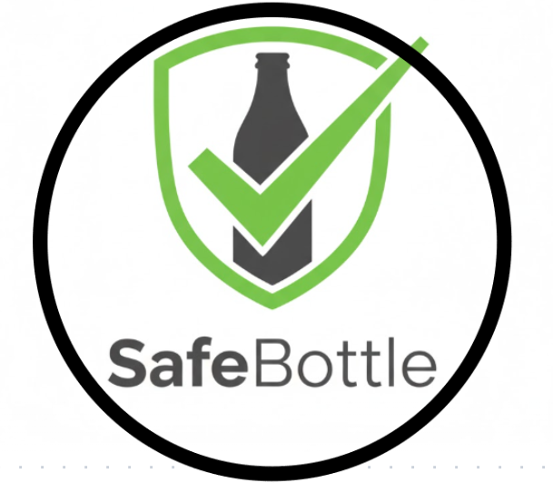

Business Type & Funding
SafeBottle would be established as a Private Limited Company, enabling it to hold contracts, own intellectual property such as app code and trademarks, and protect founders from personal liability. Potential funding sources include government and industry grants focused on food safety and supply chain innovation, non-dilutive funds that do not require equity, and angel investors with relevant industry experience. Adherence to corporate governance, data protection regulations, intellectual property registration, and tax compliance is essential to ensure secure, ethical, and sustainable operations within the technology and consumer sectors.
Concepts
The SafeBottle App will be developed using Agile and Development approaches, supporting iterative development, collaborative teamwork, and ongoing improvement. By applying User-centred Design (UCD) principles, the app is designed to meet both stakeholder expectations and end-user needs. Its secure-by-design architecture ensures compliance with data protection laws, including GDPR and CCPA, while enabling scalability, reliability, and optimal performance. Continuous adherence to regulatory requirements and industry safety standards throughout development ensures the app remains trusted, credible, and effective.
Methods
Agile development method: Features are developed in fixed-length sprints with prioritized backlogs, daily stand-ups, and sprint reviews, delivering incremental value while allowing flexibility.
Continuous Integration/Continuous Deployment (CI/CD): Automated pipelines Streamline building, testing, and deployment, minimising errors and speeding up release cycles.
Prototyping & MVP Development: Key functionalities, including bottle scanning and safety alerts, are tested early to gather user feedback and refine the app prior to full-scale launch.
Practices
- Code Reviews & Pair Programming: Improve code quality while facilitating knowledge transfer among team members.
- Automated Testing: Conduct unit, integration, and security tests to ensure reliability and consistent performance.
- Documentation & Version Control: Maintain comprehensive records to support compliance, maintainability, and future development.
- Change Management: Apply structured procedures to minimize risks during updates.
- Monitoring & Feedback Loops: Continuously track system performance and user behaviour to guide iterative enhancements.
Tools
Essential tools comprise Git/GitHub for version control, Jira/Trello for project management, Docker/Kubernetes for containerization and orchestration, Jenkins/GitHub Actions for CI/CD, and Prometheus/Grafana for monitoring system performance and health.
Maintenance & Evolution
Ongoing maintenance includes regular bug fixes, security updates, and feature improvements. Continuous monitoring ensures system reliability and scalability, while iterative development, guided by user feedback, technological advancements, and regulatory changes, enables SafeBottle to stay innovative, secure, and competitive within a large organisational context.

Task 3: Project reflection
- This project strengthened my technical and professional skills, including software development, system architecture, CI/CD, and cloud integration. I enhanced project management through Agile Scrum, sprint planning, and backlog prioritization, while improving problem-solving, teamwork, and communication. It provided hands-on experience addressing ethical, regulatory, and data privacy considerations.
- The SafeBottle App enhances public health and consumer safety by providing real-time authentication of bottled products, reducing risks from contamination or counterfeits. Using AI, IoT, and mobile scanning, it empowers informed choices, raises product safety awareness, encourages high manufacturing standards, and drives responsible digital innovation in the food and beverage sector.
- Doing this project also enabled me to develop technical, ethical, and professional skills that benefit society more broadly. Skills in software development, system design, project management, and data privacy compliance equip me to create secure, reliable, and user-focused solutions. Understanding ethical and regulatory requirements ensures that technology is deployed responsibly.

Risks and Challenges and Their Mitigation
The SafeBottle App could encounter several risks and challenges that may affect its overall success:
1. Data Privacy and Security: Managing sensitive user information, including personal details and purchase histories, could lead to data breaches or non-compliance with regulations such as GDPR and CCPA. Mitigation: Employ strong encryption, anonymization, and secure storage practices, collect only essential data, and perform regular security audits and penetration testing.
2. Regulatory and Legal Compliance: Failure to comply with food safety, consumer protection, or digital laws could result in fines or legal action. Mitigation: Keep updated with relevant regulations, integrate compliance checks during development, consult legal experts, and include clear disclaimers regarding scan reliability and liability.
3. Technical Failures: Issues such as system crashes, inaccurate scanning, or integration problems could reduce user confidence. Mitigation: Conduct automated and manual testing, use CI/CD pipelines for controlled deployments, implement error handling, and monitor systems continuously.
4. Dependence on Partners: Relying on manufacturers for tagged bottles may delay rollouts or limit data availability. Mitigation: Build multiple partnerships, establish formal agreements, and create fallback mechanisms to maintain app functionality.
5. Reputation Risk: A safety incident involving a verified bottle could harm the app’s credibility. Mitigation: Ensure algorithm transparency, implement rapid incident response plans, and communicate openly with users during issues.
6. User Adoption Challenges: Low adoption could result from lack of awareness or trust. Mitigation: Run marketing campaigns, educate users, offer incentives, and gather feedback for continuous improvement.
By addressing these risks proactively, SafeBottle can operate securely, reliably, and maintain public trust while promoting consumer safety.

Conclusion
This project provided a comprehensive framework for applying project management, enterprise, and innovation principles in a real-world context. Developing the SafeBottle App allowed me to define a clear project scope, plan resources, and use technologies such as mobile scanning, AI, cloud integration, and CI/CD pipelines. Tools like Gantt charts, wireframes, flowcharts, and security diagrams supported structured planning and visualization, ensuring alignment with technical requirements and regulatory compliance. Conducting PEST and SWOT analyses informed strategic decision-making and ethical considerations. Overall, the project enhanced my technical, professional, and ethical skills while demonstrating how technology can deliver secure, reliable, and socially valuable solutions.

References
[1] K. Schwalbe, Introduction to project management, Course Technology Cengage Learning Boston, 2009.
[2] A. Rivero-Rodriguez, P. Pileggi and O. A. Nykänen, "Mobile context-aware systems: technologies, resources and applications," vol. 10, no. 2, pp. 25–32, 2016,
[3] S. Al-Saqqa, S. Sawalha and H. AbdelNabi, "Agile software development: Methodologies and trends", vol. 14, no. 11, 2020,
[4] P. Verschuren, H. Doorewaard and M. J. Mellion, Designing a research project, Eleven International Publishing, The Hague, 2010.
[5] P. Girard and V. Robin, "Analysis of collaboration for project design management," Comput.Ind., vol. 57, no. 8-9, pp. 817–826, 2006,

