

Module Title: Dissertation Module Code: LCMB7020

Course: MASTER OF BUSINESS ADMINISTRATION IN MARKETING

Dissertation Topic: The Impact of Influencer Marketing on Consumer Purchase Behavior in the UK Luxury Sneaker Industry.

Lecturer:
Dr. Jaya Gopalkrishnan

Master’s Degrees by Examination and Dissertation

Declaration Form.

- This work has not previously been accepted in substance for any degree and is not being concurrently submitted in candidature for any degree. Signed : Yogesh Sain
Date : 09/02/2024

- This dissertation is being submitted in partial fulfillment of the requirements for the degree of Master in Business Administration. Signed : Yogesh Sain
Date : 09/02/2024

- This dissertation is the result of my own independent work/investigation, except where otherwise stated.
Other sources are acknowledged by footnotes giving explicit references. A bibliography is appended.
Signed candidate : Yogesh Sain Date: 09/02/2024
- I hereby give consent for my dissertation, if accepted, to be available for photocopying, inter- library loan, and for deposit in the University’s digital repository
Signed (candidate) : Yogesh Sain Date : 09/02/2024

Supervisor’s Declaration.
I am satisfied that this work is the result of the student’s own efforts. Signed : Dr. Jaya Gopalkrishnan
Date: 13/02/2024

University of Wales: Trinity Saint David E-Thesis Deposit Agreement

Details of the Work
I would like to deposit the following item in the digital repository maintained by the University, and/or in any other repository authorized for use by the University:

Title: The Impact of Influencer Marketing on Consumer Purchase Behavior in the UK Luxury Sneaker Industry.

This item is a product of my own research endeavors and is covered by the agreement below in which the item is referred to as “the Work”. It is identical in content to that deposited in the Learning Resources Centre, subject to point 4 below.

I agree that the University of Wales: Trinity Saint David may electronically store, copy or translate the Work to any approved medium or format for the purpose of future preservation and accessibility. The University is not under any obligation to reproduce or display the Work in the same formats or resolutions in which it was originally deposited.
UW: TSD Digital Repository
I understand that work deposited in the digital repository will be accessible to a wide variety of people and institutions, including automated agents and search engines via the World Wide Web.
I understand that once the Work is deposited, the item and its metadata may be incorporated into public access catalogues or services, such as national databases of electronic theses.

I agree as follows:
- That I am the author or have the authority of the author/s to make this agreement and do hereby give the University of Wales: Trinity Saint David the right to make available the Work in the way described above.
- That the electronic copy of the Work deposited in the digital repository and covered by this agreement, is identical in content to the paper copy of the Work.
- That I have exercised reasonable care to ensure that the Work is original, and to the best of my knowledge, does not breach any laws including those relating to defamation, libel and copyright.
- That I have, in instances where the intellectual property of other authors or copyright holders is included in the Work, gained explicit permission for the inclusion of that material in the Work, and in the electronic form of the Work as accessed through the open access digital repository, or that I have identified and removed that material for which adequate permission has not been obtained and which will be inaccessible via the digital repository
- That University of Wales: Trinity Saint David does not hold any obligation to take legal action on behalf of the Depositor, or other rights holders, in the event of a breach of intellectual property rights, or any other right, in the material deposited.
- That I undertake to indemnify the University of Wales: Trinity Saint David against all actions, suits, proceedings, claims, demands and costs occasioned by the University in consequence of any breach of this agreement

Signature: Yogesh Sain Date: 09/02/2024

Abstract

This study investigates the complex correlation between influencer marketing and consumer behaviour in the context of high-end sneaker brands. The study utilises a mixed-methods approach, employing a quantitative survey distributed to a purposefully chosen community of luxury Sneaker consumers. The online examine survey examines the influence of influencers on consumer preferences and buying decisions, specifically exploring factors such as the trustworthiness of influencers and its relationship with the intention to make a purchase.

The quantitative data obtained from the structured questionnaire will be analysed using statistical methods, utilising software such as SPSS. The study includes a comprehensive examination of significant discoveries in connection with existing literature, providing insights into the theoretical and practical consequences for luxury sneaker businesses.

Although the methodology does not include in-depth interviews due to unique limitations, the research guarantees a thorough review by analysing quantitative data. The findings enhance scholarly and industrial understanding by providing recommendations for future study avenues. This research, based on ethical considerations and a rigorous methodology, illuminates the dynamic relationship between influencers and customer behaviour. It offers useful insights for marketing tactics in the luxury sneaker sector.

Acknowledgement

I like to convey my deepest appreciation to my supervisor Dr Jaya Gopalkrishnan for guiding and providing feedback throughout this study.

I am indebted to my colleagues and friends who supported me and assist me in gathering prerequisites for my study. Finally, I am grateful to my family for helping me complete my education and supporting me throughout the journey.

Your Signature: Yogesh Sain Date: 09/02/2024

Table of Contents

Chapter 1: Introduction 10
  - Context and Justification 11
  - Research Aims & Objectives 12
  - Significance of the Study 13
Chapter 2: Literature Review 15
  - Analyzing Influencer Marketing 16
  - Impact of Influencers on the Sneaker Industry 17
  - Consumer Behaviour and Purchase-Decision Making Models 19
  - Examining conceptual Framework in Influencer Marketing 23
  - Prior Research and Unexplored Areas 24
Chapter 3: Research Methodology 26
  - Introduction 26
  - Research Onion 26
  - Research Philosophy 27
  - Research Approach 27
  - Research Design 27
  - Research Strategy 27
  - Data Collection Method 27
  - Data Analysis 27
  - Population and Sampling 27
  - Linking Objectives with Methodology 28
  - Research Limitations 28
  - Research Ethics 28
  - Conclusion 28
Chapter 4: Analysis and Discussion 29
  - Evaluation of Survey Feedback 29
  - SPSS Descriptive Statistics and Analysis 51
  - Correlation and Its Analysis 79
  - ANOVA, Regression & Coefficients Statistics and Analysis 81
  - Conclusion 85
  - Analysis and Evaluation of Results 87
  - Key Findings in Reference to Existing Literature 88
  - Theoretical Implications of the Research 89
  - Practical Implications for Luxury Sneaker Brands 90
Chapter 5: Conclusion 91
  - Introduction 91
  - Final Analysis and Suggestions 92
  - Contributions to Knowledge 93
  - Suggestions for Future Research 94
Chapter 6: References 97
Survey Questioner 101

Introduction
The swift advancement of information technology, together with the changes in societal habits resulting from government and organisational restrictions imposed to mitigate the transmission of Covid-19, jointly contribute to the triumph of electronic trade. Netflix has emerged as the predominant medium for filmmakers to exhibit their work, replacing traditional cinemas. Social media supplants television stations as the predominant source of entertainment for the general public. Instead of superstars, social media influencers have emerged as the prominent figures who possess the ability to modify their followers' conduct and impact their purchase choices.
The advent of modern social media and social networking sites (SNSs) has had a significant influence on the manner in which individuals get information and news. According to a recent online examine survey conducted by the Pew Research Centre (Gottfried and Shearer, 2016), there has been a consistent increase in the proportion of Americans who heavily depend on social media for news in the previous five years.
Individuals are currently subjected to a multitude of advertisements on a daily basis, with the vast majority emanating from social networking platforms (Ganguly 2015). Certain demographic segments, particularly millennials and younger cohorts, have formed a consistent dependence on social media (Gottfried and Shearer 2016). As a result, their inclination to gather data from social media and other clients is higher than ever before. According to recent data from Twitter and Annalect, around 40% of online examine surveyed Twitter users have made a purchase in response to a post by an influencer (Karp 2016).

As stated by Ki and Kim (2019), a social media influencer (SMI) is a person who has the capacity to exert influence on others using social media platforms. As a result of the significant impact of SMIs, an increasing number of brands are seeking out SMIs to provide sponsored content, such as product placements or brand endorsements. Audrezet et al. (2020) term this practice as influencer marketing.
Influencer marketing combines elements of both traditional and contemporary marketing strategies. This reinvents the notion of celebrity endorsement as a contemporary marketing campaign centred around content. The key differentiating factor between influencer marketing and other marketing methods lies in the fact that the outcomes of influencer marketing campaigns are achieved via collaborative efforts between brands and influencers. Feeley (2020) said that the global value of influencer marketing in 2018 was USD 4.6 billion. From 2019 to 2025, the growth rate is projected to exceed 25% annually. Aligning social media influencers (SMIs) with their target audiences enhances their effectiveness in product placement and recommendation compared to conventional celebrities. A prevalent mistake often observed in traditional media is their inability to differentiate between celebrities and online influencers.

Although SMIs enjoy significant popularity on social media platforms, their recognition in the offline realm may not be as widespread as that of celebrities. Furthermore, a significant portion of influencers have cultivated a robust connection with their followers, who are fervent and enthusiastic advocates of the social media influencers. Consequently, if influencers do not publicly support a specific brand, their followers will discontinue their association with the brand.

Influencer marketing can be seen as a strategy to avoid being perceived as a "product pusher" by customers, who generally have a preference for personal material rather than corporate websites (Agrawal, 2016). The practice of ad blocking is significantly disrupting the entire marketing environment. Ad blocking behaviours pose a significant threat to the survival of firms that depend on advertising

revenue. Therefore, it is imperative for organisations to utilise influencer marketing in order to guarantee that intended advertising messages effectively reach the desired target clients without being obstructed.

With the growing use of ad blockers, there is a notable transition from conventional media to social networking platforms like Facebook, Instagram, and TikTok. Retailers should customise their social media strategies based on the online and offline behaviours of their customers. This study aims to examine the mechanism via which social media influencers impact the loyalty of their followers and subsequently influence their purchase behaviours, in light of the growing significance of influencer marketing.

Context and Justification
Social media is a computer-based tool that facilitates interpersonal communication. It has transformed into a platform that is accessible to anyone with an internet connection. Due to the internet's exponential expansion and the significant time devoted to social media, marketers are being encouraged to explore advertising strategies that take use of these emerging mass media communication platforms. Based on the latest figures, over 50% of the global population, which amounts to 3.6 billion individuals, utilize social media (Freberg et al., 2011). Marketers may opt to focus their efforts on a certain demographic on social media because of the audience's accuracy and specificity. Enterprises may utilize social media platforms to initiate cost-effective marketing efforts.

The phrase "social media influencer" is widely employed in the field of marketing. The significance of influencer marketing on social media is swiftly increasing as a technique for acquiring customers. This approach allows marketers to directly engage with customers, reinforce their message, and enhance brand recognition.

Marketers are closely monitoring and actively engaging with social media influencers due to their business acumen and extensive reach. Brands hold the belief that by engaging with influencers, they can optimise their investment in social media. The emergence of social media has transformed the strategies firms employ to promote themselves, with influencers assuming a prominent position.Brands are increasingly utilising social media influencers as a marketing tactic (Dean, 2019). Many entrepreneurs have observed the increasing impact of influencers. Social media influencers are increasingly acquiring popularity and impact in the corporate sector. They have demonstrated efficacy in promoting products. The organization's tagline is "Developing authentic relationships," and it engages in partnerships with influential and proficient storytellers on social media with a collective net worth surpassing millions of dollars, these individuals are highly regarded by corporations as great marketing assets.

Influencers gain popularity on social media platforms due to their engaging content and their endorsements of various products and companies. They possess a dedicated cohort of enthusiasts and adherents who value their viewpoint. In networks like Facebook (Meta), Instagram, and Twitter, influencers are perceived as genuine and have a substantial and devoted audience. Social media influencers utilise various social media platforms to actively endorse and enhance the visibility and desirability of new items or a company's brand, whether through direct or indirect means.

As a result of intensified rivalry, social media influencers are in high demand. Nevertheless, with the increasing level of competition, businesses and organisations are facing challenges in accurately recognising authentic influencers who possess a substantial number of followers. An influencer effectively disseminated current knowledge and influenced the attitudes and behaviours of consumers, thereby endorsing a product that the consumer admired and motivating them to make a purchase.

According to Talavera (2015), influencer-generated branded content is perceived as having a greater sense of authenticity, genuineness, and direct connection with potential consumers compared to
brand-generated marketing. The surge in popularity of influencer marketing has grown rapidly. According to a recent survey, in 2018, 39 percent of marketers intended to increase their spending for influencer marketing, while 19 percent expected to allocate more than $100,000 per campaign (Bevilacqua and Del Giudice 2018). Although numerous studies have examined the impact of celebrity endorsers on advertising, such as the research conducted by Amos, Holmes, and Strutton in 2008, this existing body of literature fails to consider the unique characteristics of social media influencers, also known as "celebrity" content creators. Furthermore, despite recent studies on influencer advertising (e.g. De Veirman, Cauberghe, and Hudders 2017; Djafarova and Rushworth 2017; Evans et al. 2017; Johansen and Guldvik 2017), none of these studies have focused on the underlying mechanisms that contribute to the effectiveness of influencer marketing. In both academic and industrial settings, influencer marketing is becoming increasingly popular. The influence of social media influencers on customer behaviour has not been well examined. Hence, the study is being undertaken to address an existing research lacuna.

Research Aims & Objectives

The study has defined precise research aims and objectives to comprehensively investigate the complex dynamics of influencer marketing within the luxury sneaker industry in the UK.

- Analyse Consumer Patterns and Behaviors: - Objective: The main objective is to examine the impact of influencer marketing on customer buying patterns within the luxury sneaker sector in the United Kingdom.

  - Aim: This entails a thorough examination of shifting patterns in customer preferences and behaviours, with the Aim of comprehending the variables that drive informed decision-making enabled by influencers.

- Investigate the Emergence of Influencer Marketing: - Objective: Another primary Aim is to comprehend the essential elements that contribute to the prevalence of influencer marketing in the luxury sneaker industry in the UK.

  - Aim: This entails evaluating the changing trends in how people consume media, particularly the growing dependence on social media platforms for finding inspiration for products.

- Comprehend the Influence of Influencers on Decision-Making: - Objective: This study aims to elucidate the intricate impact of influencers on the decision-making processes of consumers while purchasing luxury trainers.

  - Aim:This purpose entails doing a thorough examination of the methods by which influencers establish trust and relatability. The Aim is to get insight into the psychological variables that drive consumers to adopt the preferences of influencers.

- Analyse the correlation between influencers and brands: - Objective: The research seeks to examine the symbiotic relationship between influencers and high-end sneaker producers.
  - Aim: This entails examining the strategies, collaborations, and storytelling techniques utilised by influencers and brands to establish a cohesive and engaging brand image.
- Offer Practical Advice for Marketers: - Objective: Ultimately, the study seeks to provide actionable guidance for companies and marketers working in the ever-changing realm of luxury sneaker marketing.
  - Aim: This entails providing valuable perspectives to improve the comprehension of the complex interplay between influencers, consumers, and luxury sneaker enterprises.

By breaking the research aims and objectives into different paragraphs, the study intends to completely analyse the intricate dynamics of influencer marketing in the UK luxury sneaker sector, thereby offering valuable insights to the existing body of information.

Significance of the Study

The marketing industry has witnessed a gradual shift from celebrity endorsements to recommendations from social media influencers. One might easily envision a scenario where a celebrity collaborates with a firm to promote a product, even if the promotion takes the form of a series of 10-minute films rather than a 30-second television advertisement. In contrast to celebrities, influencers might be encountered in various locations. The reason for their influence lies in their substantial online and social media following. An individual who can have a significant impact on others' opinions and behaviours can be considered an influencer. This can be a sneaker photographer who shares their work on Instagram, a knowledgeable cybersecurity blogger who posts on Twitter, or a highly regarded marketing manager who engages with professionals on LinkedIn.

Hence, it is imperative for scholars and industry experts to gain a more comprehensive comprehension of social media influencer marketing.

Social media influencers (SMIs) possess the ability to reach a substantial audience. Due to their credibility, which is established through their authenticity and wide audience, social media influencers (SMIs) have the ability to persuade their followers to purchase the products they endorse. Additionally, they can also inspire their followers to engage in word-of-mouth marketing by sharing news or videos featuring their favourite SMIs on social media platforms. To cultivate a strong bond with their followers, individuals can establish a robust connection by showcasing their everyday activities and expressing their viewpoints on contemporary matters. This will further strengthen the impartial perception of "people like me" (Allsop et. al., 2007). The enhancement of customer loyalty would subsequently impact the customers' intention to purchase the goods and/or services promoted by the small and medium-sized

enterprises (SMIs).
Influencer marketing refers to the collaboration between a brand and an online influencer to promote and advertise the brand's products or services. SMI marketing is increasing, and many brands are beginning to rely more on SMIs to promote brands. Yet, there is a dearth of studies that have examined how SMIs play a role in affecting consumers' engagement with endorsed brands.

Certain influencer marketing collaborations focus on intangible outcomes, where firms collaborate with influencers to enhance brand awareness. PewDiePie, a prominent figure on YouTube, serves as an early illustration of influencer marketing. He collaborated with the creators of a horror film that takes place in the French Catacombs beneath Paris, and produced a collection of movies in which he confronted various obstacles within the Catacombs. The video proved to be highly suitable for PewDiePie's extensive subscriber base of 27 million, garnering almost twice the number of views compared to the film's trailer. The rapid progression of marketing underscores the necessity for us to examine the mechanism by which social media influencers will impact client loyalty and the act of imitating choices.

Literature Review

The luxury sneaker industry in the UK is constantly changing, and influencer marketing has become a crucial part of modern marketing strategies. Influencers have a significant impact on consumer preferences and choices, especially when it comes to aspirational products. There is a growing body of research highlighting the importance of authenticity in influencer marketing, emphasizing the necessity for clear communication to build trust and connect with audiences looking for genuine connections.
Furthermore, the psychological phenomenon of parasocial interaction has been identified as a key factor, highlighting the strong relationships influencers build with their audiences, which greatly influence consumer decisions in the luxury sneaker industry.

The term "influencer" is a relatively new addition to the marketing language and does not have a clear definition. Brown and Hayes (2008) state that influencer marketing involves external individuals who have an impact on consumers' purchasing decisions. This type of marketing focuses on individuals who have a large and engaged audience on digital platforms and effectively convey a brand's message to a specific demographic (Smart Insights, 2017). Research shows that influencers are more successful than other internet sources in gaining consumer trust, causing a change in consumer behavior, with many using ad blockers to actively avoid traditional online advertisements like pop-ups and banners.

In the digital world, individuals who have gained influence on online platforms have become reliable and authoritative figures (Freberg et al., 2011). Influencers are used to facilitate interactive communication between brands and their online audience on platforms like Facebook, YouTube, and Instagram, with the goal of influencing followers to support specific businesses (Markethub, 2016). Furthermore, in the luxury sneaker industry, influencers are more successful in connecting with consumers than traditional celebrities because they can deeply resonate with specific target audiences, leading to a more committed and dedicated customer base.

The literature also highlights the strategic importance of influencer marketing in increasing brand recognition and expanding reach. With their large online following, influencers provide luxury sneaker businesses with a dynamic platform to showcase their products in visually appealing and
lifestyle-oriented settings. This not only improves brand visibility but also helps create narratives that align seamlessly with the aspirational nature of luxury sneakers.

In spite of the benefits, the literature also reveals ongoing problems encountered by luxury sneaker companies in influencer marketing. Obstacles include finding suitable influencers, evaluating the effectiveness of campaigns, and maintaining authenticity in an era saturated with sponsored content. However, the research consistently emphasizes the crucial role of influencers in shaping customer intentions and decisions in the luxury sneaker industry. The increasing dependence on influencers as a trusted source of advice and validation among consumers underscores their strong influence, especially when it comes to luxury sneaker purchases. This phenomenon highlights the psychological and emotional factors that drive consumers' decision-making processes.
In conclusion, the examination of literature not only helps us understand the intricate workings of influencer marketing but also shows its substantial impact on customer behavior in the UK luxury sneaker market. The various factors such as authenticity, parasocial interaction, advantages over traditional celebrities, and brand challenges all contribute to a deep understanding of the subtle relationship between

influencers and consumer choices. This enhances the conversation on marketing strategies in the ever-evolving luxury sneaker industry.

Analyzing Influencer Marketing
An influencer is an individual, collective, or entity that holds the ability to impact the choices made by a specific audience on a digital platform due to their acclaim, reliability, expertise, status, or connection with said viewers. Through the accessibility and rapid dissemination offered by the internet, certain contributors acquire a substantial following and cultivate a devoted fanbase, thereby transitioning into social media influencers (Influence L., 2020).
According to the Association of National Advertisers (2018), influencer marketing has become increasingly important as a crucial aspect of digital marketing strategies for companies. This is because consumers are increasingly relying on peer-to-peer interaction. Influencer marketing is often seen as essential for improving engagement with brands online (Newberry 2018). Bloggers and social media influencers play a role in generating word of mouth about a brand, product, or service through their posts, videos, and messages. Sponsored blogging is one way to utilize the networks and influence of influencers to reach their followers. There have been both successful and unsuccessful examples of this, such as Nokia's campaign promoting camera phones in Finland and the unsuccessful "Raging Cow" campaign by Dr. Pepper (Corcoran et al. 2006). Influencer marketing incorporates aspects of paid and earned media, distinguishing it from the traditional marketing strategy that primarily focuses on paid and owned media (Hewett et al. 2016). The impact of influencers on individuals' cognitive, emotional, and behavioral attitudes towards a company is particularly significant, given the growing importance of earned media.
Hughes et al. (2019) emphasize that influencer marketing differs from both word-of-mouth (WOM) and conventional advertising as influencers combine paid and earned media components. In terms of motivation enhancement, conventional advertising may have diverse objectives such as building brand equity, whereas influencers may prioritize increasing the loyalty of their followers. Message design and implementation also vary, with the responsibility falling on the company in traditional advertising, while influencers have the freedom to create their own posts and messages, aligning them with their own personalities and public image. Influencer marketing is a marketing strategy that capitalizes on the influence of prominent individuals or opinion leaders to augment brand recognition and/or purchase intent among consumers (e.g., Brown and Hayes 2008; Scott 2015). The inherent qualities possessed by influencers significantly attract firms and marketers, who may opt for less costly influencer collaborations as compared to engaging well-known celebrity endorsers (Hall 2015).

Moreover, the majority of social media influencers have already established themselves by focusing on specific areas of expertise. As a result, customers are more likely to trust and accept the opinions of influencers when they engage with brands that align with their personal areas of expertise (Hall 2016). A recent study on social media trends found that 94 percent of marketers who have used influencer marketing initiatives have found them to be advantageous (Ahmad 2018). According to the same study, the return on investment (ROI) for influencer marketing was eleven times higher than that of traditional advertising. The dominance of mass communication channels such as television, radio, and newspapers as primary sources of information for consumers has been replaced by social media channels and virtual communities. Customers now frequently use these channels to exchange information and build relationships (Hair, Clarke, and Shapiro 2010). Social media influencers utilize these same channels, providing unique value to both consumers and advertisers. Freberg et al. (2011) defined social media influencers as individuals who influence audience attitudes through blogs, tweets, and other social media platforms. Another term used to describe them is "endorsers," who are individuals with public recognition

and fame that leverage their status to promote consumer goods (McCracken 1989). In contrast to traditional endorsers who are usually celebrities or public figures who gained their fame through traditional media, social media influencers are usually ordinary individuals who have gained popularity through viral content creation on social media (Garcia 2017).

In the UK luxury sneaker industry, influencer marketing is a vital force that impacts consumer behavior and brand interaction. This section aims to deeply analyze influencer marketing to fully comprehend its intricate mechanisms, various techniques, and substantial influence on consumer behavior in the luxury sneaker industry.
Influencer marketing employs various methods to effectively endorse high-end Sneakers and influence consumer behavior. These methods include creating genuine and relatable content to establish trust and forge a connection with the audience, building engaged communities that foster brand interaction, and promoting luxury Sneakers as essential elements of an aspirational lifestyle. Influencers also utilize tactics such as unboxing videos and product demonstrations to showcase the design, quality, and desirability of the Sneakers, as well as provide thorough evaluations and personalized recommendations for the audience's purchasing decisions.- Exclusive Collaborations and Partnerships:Collaborating with high-end sneaker brands allows influencers to jointly develop unique goods or limited editions, leveraging their credibility and wide audience to enhance desirability and consumer involvement.

In the luxury sneaker sector, influencer marketing has a complex impact on customer behavior. This includes influencing purchase intent and decision-making, shaping perceptions and aspirations of the brand, and enhancing follower engagement and conversions. An in-depth examination of influencer marketing in the UK's luxury sneaker industry reveals valuable insights into its complex mechanisms and significant influence on consumer behavior. This study aims to unravel the complexities of influencer marketing and provide useful insights into the changing dynamics of consumer-brand connection in the luxury sneaker industry.

Impact of Influencers on the Sneaker Industry

The influence of sneaker influencers goes beyond traditional product endorsements and brand partnerships. They have revolutionized the sneaker industry with their presence and deeply influence it. To understand their influence in the high-end sneaker market, it is important to examine their various contributions. This section explores how influencers impact sneaker consumption habits, increase brand visibility and interaction, influence industry trends and aesthetics, and foster brand authenticity and relevance.

In terms of sneaker consumption, influencers have a significant impact on transforming consumer desires and views on luxury products. High-end sneakers have become essential elements of a desirable lifestyle. Influencers create a connection with their audience by

presenting carefully selected information and inspiring stories. This not only shapes their sneaker choices but also their perception of the desired lifestyle. Influencers also play a role in making luxury sneakers more accessible to a wider audience by presenting a variety of choices and trends.

Influencers also have a strong influence on increasing brand visibility and interaction. They expand the reach of sneaker companies and luxury sneaker labels by leveraging their extensive reach and dedicated followers. They also foster authentic customer involvement by initiating exchanges and discussions centered on high-end sneakers. This strengthens the bond between brands and consumers.

Influencers play a significant role in setting industry trends and aesthetics. They popularize trends and establish high-end sneakers as essential items. Their advocacy for a wide range of aesthetics and styles enhances the recognition and endorsement of luxury sneakers as stylish commodities. This collective impact affects consumer behavior and their choices for luxury sneakers.

Influencers' effectiveness in the luxury sneaker market relies heavily on their authenticity. They excel at presenting sneaker brands through content that is genuine and resonates with their audience. This not only fosters trust and credibility among consumers, but also allows influencers to navigate market trends and align luxury sneaker brands with evolving preferences and lifestyles. Their awareness of trends ensures a long-lasting impression and boosts the appeal of high-end sneaker labels.
In summary, the influence of influencers on the sneaker industry, especially the luxury sneaker market, is crucial to understand. Their impact spans across sneaker consumption patterns, brand visibility and interaction, industry trends and aesthetics, and brand authenticity and relevance. Influencers shape sneaker trends and consumer behavior and their insights are essential in understanding the changing dynamics of the sneaker market.

Consumer Behavior and Purchase Decision-Making Models

The analysis of consumer decision-making models has been a prominent area of study in the fields of marketing and consumer behavior for a considerable duration. These models offer useful insights into the cognitive processes and psychological aspects that impact customers' decision-making and purchasing behaviors.

The Information Processing Model is a well-researched and highly regarded framework for consumer decision-making. It is recognised as one of the first and most influential models in this area of study. The model, derived from cognitive psychology, proposes that consumers engage in a methodical
decision-making process consisting of several stages: problem identification, information retrieval, alternative evaluation, purchase determination, and post-purchase assessment (Bettman, 1970; Engel, Blackwell, & Miniard, 1990).
During the problem recognition stage, individuals become aware of a requirement or issue that need a solution, hence commencing the decision-making process. Consequently, people proactively search for information to assess several choices, considering aspects including price, product excellence, and brand standing. Upon completing a comprehensive examination of the various options, consumers finalise their purchase decision and subsequently do a post-buy evaluation to gauge their degree of satisfaction with the selected product or service.

The following figure illustrates the model:
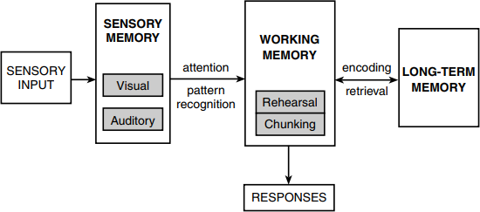
Source:
https://fredjmr.wordpress.com/2020/08/30/what-is-the-information-processing-theory-thebasics-of-cognitivism/

The consumer decision-making process model expands on the information processing model by including other components such as external influences and situational considerations. According to Hoyer & MacInnis (2008), this theoretical paradigm proposes that consumer decision-making is not exclusively guided by logical and methodical information processing, but is also impacted by emotional factors, past experiences, and the social environment. Based on this theoretical perspective, it can be deduced that the process by which consumers make decisions is influenced by a combination of internal psychological elements, such as attitudes, beliefs, and motivations, as well as external influences that include social, cultural, and situational characteristics.

Consumers' brand choices and purchasing behaviours are highly influenced by social variables such as family connections, reference groups, and the influence of social media. Likewise, cultural elements,

including culture and subculture, have a significant impact on moulding customers' brand preferences and impressions of products. Furthermore, consumers' choices are impacted by situational variables such as time limitations and physical environment, which impact convenience and availability.

The consumer decision-making process model recognises the complex interaction of several aspects that impact consumer behaviour, with a focus on comprehending consumers' cognitive and emotional reactions to marketing stimuli (Panwar et al., 2019). Marketers can utilise this notion to create focused and customised marketing tactics that effectively connect with consumers' emotions, correspond with their convictions, and cater to their distinct requirements and preferences.

The subsequent illustration epitomises an optimal model for consumer decision-making process:
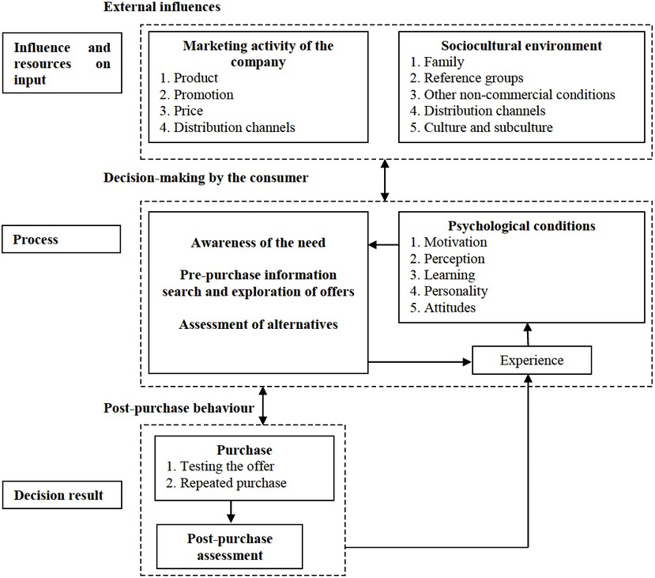

Source:
https://www.researchgate.net/figure/Model-of-the-consumer-decision-makingprocess_fig2_321080708

Essential Theoretical Concepts in Consumer Behaviour Research

The Theory of Planned Behavior (TPB), pioneered by Ajzen (1991), stands as a significant theoretical framework within the realm of consumer behavior. The subsequent illustration depicts the model:
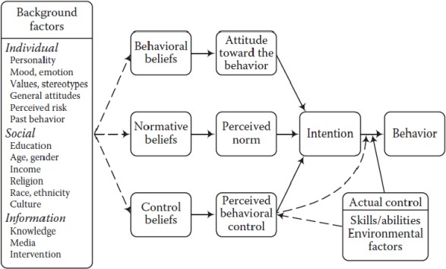

Source: https://www.linkedin.com/pulse/theory-planned-behaviour-considering-drives-proximitydynamics-sehgal/

The Theory of Planned Behaviour (TPB), formulated by Ajzen (1991), asserts that behavioural intentions are shaped by three primary constructs: attitudes towards the behaviour, subjective standards, and perceived behavioural control. Consumer attitudes are a reflection of individuals' thorough assessment of participating in a particular behaviour. Subjective norms refer to the perceived societal impact that encourages individuals to engage in a certain behaviour, while perceived behavioural control relates to individuals' confidence in their capacity to do the behaviour.

The TPB has been widely used in marketing research to understand and forecast client purchase intentions and behaviours. Various studies have used the Theory of Planned Behaviour (TPB) to examine customers' inclinations to embrace new products, engage in environmentally-friendly actions, and partake in online shopping (Armitage & Conner, 2001; Bamberg & Moser, 2007; George, 2004).
The Technology Acceptance Model (TAM), introduced by Davis (1987), is a notable theoretical framework that focuses on analysing customers' attitudes and behaviours when it comes to embracing and adopting new technologies and goods. According to the Technology Acceptance Model (TAM), the main aspects that affect customer attitudes towards adopting a technology or product are how valuable they think it to be and how easy they perceive it to use. Perceived usefulness pertains to customers' evaluations on the degree to which a specific technology or product will improve their performance or productivity, whereas perceived ease of use encompasses consumers' assessments of the level of effort needed to use

the technology or product.
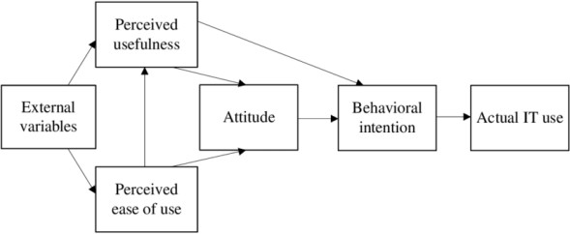
Source: (Davis, 1987)

The TAM has been widely employed in scholarly research pertaining to electronic commerce, mobile applications, and diverse technical innovations. Prior studies have utilised the Technology Acceptance Model (TAM) to investigate the determinants that affect consumers' adoption and utilisation of different digital services, including mobile banking, online shopping platforms, and social media applications (Widanengsih, 2021; Ha & Stoel, 2009; Al-Qaysi, Mohamad-Nordin & Al-Emran, 2020).
The Self-Concept Theory is highly relevant as a framework in consumer behaviour research. The importance of self-concept, which pertains to individuals' ideas of themselves, is highlighted due to its influence on their purchasing decisions. Consumers frequently make a deliberate effort to find products and brands that match their self-concept, allowing them to showcase their identity to others (Sirgy, 1985).
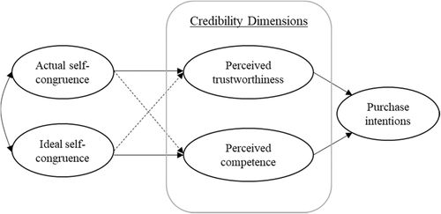

Source: https://onlinelibrary.wiley.com/doi/full/10.1002/mar.21439

The Self-Concept Theory is a core concept in consumer behaviour research, highlighting the importance of individuals' self-perceptions and how they impact their purchasing choices. Consumers often exhibit a tendency to deliberately search for products and brands that match their self-concept, allowing them to communicate their identity to external observers (Sirgy, 1985). This inclination may be evident when buyers select high-end goods to convey their social standing or when they choose

environmentally-friendly products to showcase their ecological awareness. Comprehending the
self-perception of customers and its correlation with brand recognition can assist marketers in developing focused advertising and branding tactics that successfully connect with their intended audience (Sirgy, 1982).

Examining Conceptual Frameworks in Influencer Marketing:
The model elucidates the influence of the credibility factor of social media superstars on the formation of attitudes and client purchase intentions. This study incorporates three distinct independent variables, namely competence, trustworthiness, and attractiveness. The dependent variables examined are purchase intention and customer sentiment towards companies.
These three independent variables are associated with the dimensions of source credibility or influencer credibility. Considering the fact that previous research has only utilised two dimensions of source credibility, this study incorporates three degrees of credibility as proposed by Munnuka, Uusitalo, and Toivonen (2016). Previous literature has not adequately explored the mechanism by which the content of influencers and characteristics of social media celebrity's legitimacy impact purchase intention and customers' attitude towards companies. Thus, our study addresses this void in the existing body of knowledge.

This research holds practical significance as it aims to assist practitioners and marketing managers in engaging social media influencers in their marketing initiatives to allure customers. Moreover, this research study employs the images of social media influencers in the fashion sector, so enhancing the significance of this research. Bandura's theory of social learning has found applications in diverse fields such as marketing, communication, and influence. This theory provides a theoretical foundation for developing ideas about socialising agents that can predict a client's consumption behaviour (Chen, Wang, and Hung, 2015). According to this concept, when an individual interacts with socialising agents, either directly or indirectly, they are driven and exhibit positive behaviour (Chen, Wang, and Hung, 2015). Past academics have employed this concept to demonstrate the influence of various socialising agents, such as celebrities, influencers, family, and friends, on consumer behaviour. The hypothesis formulated for this research study examines the influence of celebrities on social media on customer behaviour, in accordance with the aforementioned considerations.

This concept serves as a contextual basis for the formation of celebrity perception, and it greatly impacts the attitudes and decision-making of the audience. The study would benefit from utilising social learning theory, since it emphasises credibility, which is founded on values and effectively raises awareness among consumers by involving internet celebrities. This approach influences the decision-making process over whether or not to purchase the product. Therefore, Bandura's social learning theory is highly valid in explaining the proposed model and conceptualization.
Furthermore, the notion of reasoned acts is equally applicable to this research investigation. Based on our extensive research and analysis of the literature, we have determined that there is a sufficient amount of material on this topic. However, there is a scarcity of relevant literature specifically focused on social commerce. The Theory of Reasoned Action (TRA) developed by Ajzen and Fishbein has gained acceptance due to its ability to give a framework for analysing the psychological dynamics between customers' intents, behaviours, and attitudes. An individual's beliefs influence their attitudes, which in turn guide their behaviour and eventually determine their intention to undertake specific acts (Ajzen and Fishbein, 1980).

Hence, this study incorporates the Theory of Reasoned Action (TRA) as a significant framework to

expound on the perception of consumers' trust and buy intention in relation to their behaviour. In TRA, it is postulated that an individual's perception invariably leads to behaviours that are determined by their attitudes. This research study considers the believability factor as an individual perception that influences and governs behaviours.

Social commerce allows consumers to access personal information, profiles, reviews, suggestions, and ratings of other consumers on social networking sites (SNS). As a result, the characteristics of social commerce can impact consumer trust and behaviour. This research aims to comprehend the characteristics of s-commerce that impact perceptions, the legitimacy of social media influencers, customer behaviours towards companies, and customers' intents to make purchases. Prior research has asserted that these elements have an impact on consumer purchasing intentions and attitudes towards online business
(e-commerce). Moreover, prior research assessed diverse facets and attributes of s-commerce. Kim (2011) stated that the attributes of social commerce, such as the reputation of social media influencers and market share, have an impact on consumers' intents to make a purchase. Hence, this idea is equally applicable in bolstering the research model.
While the Social Comparison Theory can be partially used, it is mostly more appropriate for comparing two civilizations. The social comparison theory, introduced by Festinger (1954), posits that individuals tend to compare themselves to others in the absence of clear benchmarks (Festinger, 1954). This theory asserts that the credibility of social media is reinforced when multiple organisations provide the same product. In such cases, consumers are more likely to purchase the product with a favourable reputation. To make this decision, consumers tend to engage in a comparison process and rely on word-of-mouth recommendations.
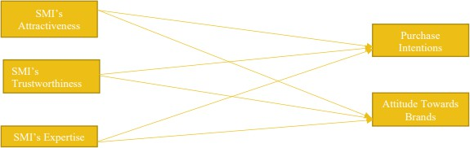

Conceptual Framework

Prior Research and Unexplored Areas
Previous studies reveal significant deficiencies in the current understanding of the impact of influencer marketing on customer behavior in the United Kingdom. There is a lack of comprehensive research on specific metrics that are relevant to UK audiences. While previous research has examined general metrics like likes, comments, and shares as indicators of effectiveness, there is a shortage of research on indicators that specifically appeal to UK audiences. Customizing metrics to align with the interests and behaviors of UK consumers is crucial for accurately evaluating the impact of influencer efforts in this unique market.

There is a limited examination of trust dynamics and adherence to transparency. Although the importance of trust in influencer marketing is acknowledged, there is a lack of comprehensive investigation into how

trust is established within the UK context. Understanding how influencers in the UK build and maintain trust with their audience is vital for marketers seeking to build genuine connections. Additionally, research into compliance with disclosure regulations and the level of transparency in influencer-brand collaborations in the UK is essential.

There is a limited understanding of the impact of micro-influencers on the UK luxury sneaker market. While micro-influencers are growing in popularity globally, there is a lack of research specifically examining their impact on niche industries such as the luxury sneaker market in the UK. Analyzing the influence of micro-influencers on customer behavior in this specific context is crucial for marketers targeting UK audiences with an interest in high-end footwear.

There is a lack of precision regarding the dynamic social media environment in the United Kingdom. The fast-changing social media landscape, including the convergence of influencer marketing and
e-commerce, requires more specific research within the UK context. Current research lacks precision in understanding the implications of these advancements for influencer marketing techniques in the UK. Brands aiming to leverage the latest trends in their campaigns must understand how these trends manifest in the UK market.

This study aims to address these gaps by conducting a targeted analysis of the influence of influencer marketing on consumer decision-making in the UK. The study will analyze customized metrics for UK audiences, examine trust dynamics and transparency, explore the impact of micro-influencers in the luxury sneaker market, and examine the evolving social media patterns in the UK. The expected benefits of this study include offering precise metrics for measuring campaign success, providing insights into trust formation and compliance, understanding the impact of micro-influencers, and providing practical insights on evolving social media trends in the UK market.

Research Methodology

Introduction
The research technique is a crucial stage that establishes the basis of a study, converting unprocessed data into a full body of knowledge. This section will examine the various components of the Research Onion, including research philosophy, methodology, design, strategy, data collection methods, analysis, population, sampling, and the ethical issues that impact the research.

Research Onion
The Research Onion, created by Saunders, Lewis, and Thornhill (2023), offers a systematic framework for comprehending the various levels of research design and methodology. The researcher is led through increasingly profound levels, similar to removing layers of an onion, in order to reach the essence of the study. Every layer corresponds to a distinct phase in the research process, guaranteeing that judgements are in accordance with the study's aims and purpose.

The Research Onion is utilised as the foundational framework for the research design in this dissertation, guaranteeing that it is in line with the study's aims, questions, and purpose.
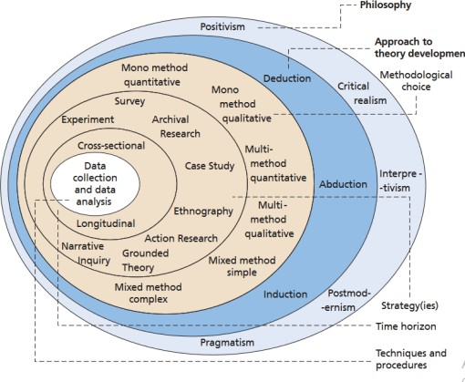

Source: Saunders, Lewis and Thornhill (2023)

Research Philosophy
The research philosophy sets out core beliefs that guide the research process. This dissertation employs a pragmatic research philosophy that integrates both positivist and interpretivist methodologies.
Pragmatism encompasses the use of structured surveys to gather numerical data and the examination of interpretive elements to comprehend real-world experiences.

Research Approach
The selected research methodology is inductive, with the objective of deriving Assumptions or generalizations from the collected data. This methodology is appropriate for comprehending viewpoints, sentiments, and actions associated with the influence of marketing influencers on customer conduct within the luxury sneaker sector in the United Kingdom.

Research Design
A mixed method research design is utilised to comprehensively examine the particular context of influencer marketing's impact on consumer behaviour, particularly among university students.

Research Strategy
The study plan employs a cross-sectional methodology, which involves collecting data at a specific point in time to obtain a picture of participants' current perspectives and behaviours. This technique is in line with the dynamic nature of influencer marketing.

Data Collection Method
A hybrid research design is utilised, integrating both quantitative and qualitative methodologies. The study employs a survey administered using Google Forms, incorporating multiple-choice, closed-ended, and open-ended questions to evaluate views, preferences, and degrees of engagement.

Data Analysis
SPSS is a software programme that is utilised for doing correlation and descriptive analyses. It is particularly useful for examining relationships between variables and gaining a comprehensive grasp of the dataset.

Population and Sampling
The population consists of individuals from the UK who purchase luxury Sneakers, and purposive sampling is used to choose participants who have direct exposure to influencer marketing in the luxury sneaker sector.

Linking Objective with Methodology
The research technique is closely connected to the study objectives, guaranteeing a systematic and intentional approach throughout the research process.

Research Limitation
The study has limitations such as its exclusive emphasis on the UK, which means that any generalisations made to other countries should be approached with caution. Additionally, the study only provides a snapshot of the influencer marketing scene at a single period in time.

Research Ethics
Guaranteed the ethical nature of the research by acquiring informed consent, protecting the confidentiality and anonymity of participants, and conforming to moral principles. This encompasses obtaining explicit permission while ensuring the preservation of confidentiality and the preservation of participant anonymity for the entirety of the study. Adhering to ethical standards is of utmost importance, underscoring the significance of transparency, honesty, and respect for participants' rights. By simplifying and clarifying the research procedures, trust is fostered and the integrity of ethical principles is maintained.

Conclusion
Conclusively, the research methodology utilises a strong framework, incorporating the Research Onion, pragmatic philosophy, inductive technique, mixed method design, and mixed-methods strategy to examine the influence of influencer marketing on customer behaviour regarding luxury Sneakers in the UK. The study's credibility is enhanced by taking into account ethical considerations and acknowledging its limits.

Analysis and Discussion

Evaluation of Survey Feedback
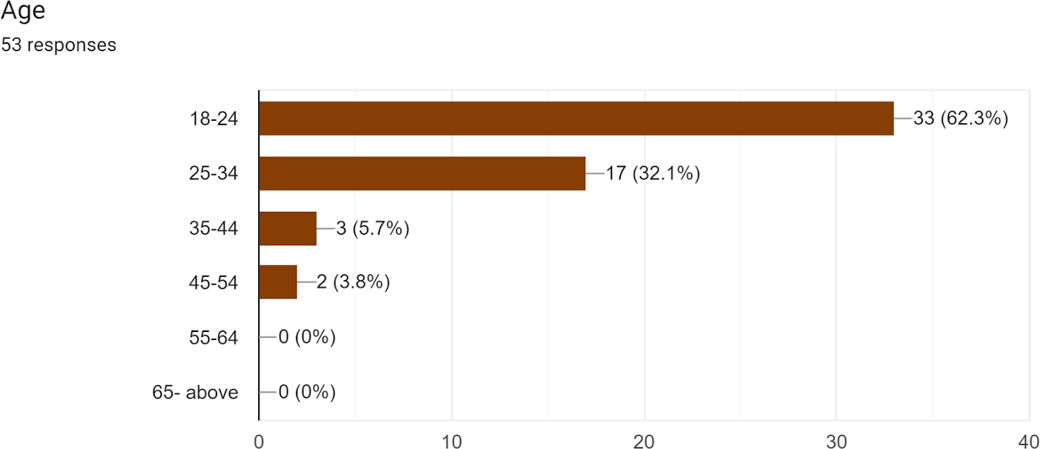

Age Distribution: According to the survey findings, a significant proportion of participants fall within the 18-24 age bracket, indicating that the primary age group influenced by celebrities and social media personalities in terms of luxury sneakers is predominantly young.

Implications:

- Youth-Focused Marketing Strategies: Given the significant representation of the 18-24 age group, luxury sneaker businesses should tailor their marketing strategies to resonate with the preferences and lifestyles of this young demographic. Collaborations with influencers and social media campaigns can be particularly powerful in reaching this age group.

- Celebrity and Influencer Alignment: Recognizing the strong influence of celebrities and social media personalities on the 18-24 age group, brands should carefully select influencers and celebrities who share the tastes and preferences of this demographic. The authenticity of influencer partnerships can enhance brand credibility.

- Trendsetting Opportunities: As the 18-24 age group is often seen as trendsetters, businesses can utilize influencer marketing to establish and amplify trends within this demographic. Aligning with influencers who have a deep understanding of youth culture can position a brand as innovative and in touch with current trends.
- In order to effectively market to the 18-24 age group in the luxury sneaker market, it is crucial for brands to focus on utilizing digital platforms that are popular among this demographic, such as Instagram and TikTok. By prioritizing these platforms, brands can increase their reach and engagement through influencer marketing strategies.

- Building connections with the 18-24 age group through influencer marketing can have a long-term impact on brand loyalty. By establishing relationships early on, brands have the potential to create a loyal customer base who will continue to engage with and support the brand over time.

In conclusion, the age distribution findings highlight the importance of understanding and catering to the unique preferences of the 18-24 age group in the luxury sneaker market. By developing influencer marketing strategies that align with the specific characteristics and aspirations of this demographic, brands can effectively promote their brand and engage with customers.
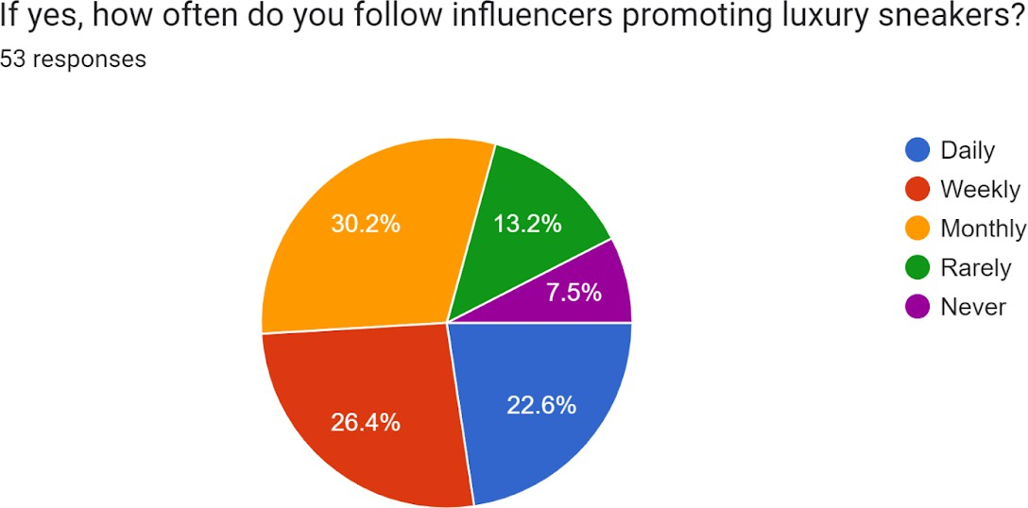

- Frequency of Followers: - Daily Followers: - These respondents are expected to possess a significant interest in influencers, demonstrating a substantial level of involvement with social media platforms.
  - Weekly Followers: - This group has regular interest in influencers but may not consume influencer content as enthusiastically as the daily followers.
  - Monthly Followers: - Monthly followers exhibit lower levels of engagement with influencers, potentially suggesting a more casual interest in influencer content.
  - Minimal/Infrequent Adherents: - This demographic is unlikely to be significantly swayed by social media influencers when making luxury sneaker acquisitions.

Implications:

- Targeted Content Frequency:
  - For luxury sneaker brands, tailoring daily influencer content could have a significant impact on daily followers, who are actively engaged. However, weekly followers should also be considered as a substantial audience and brands should maintain a consistent presence without overwhelming them. Monthly followers have lower engagement, so occasional influencer partnerships may be effective, but creating compelling content is key. Minimal/Infrequent adherents show minimal interest and may require alternative marketing strategies.

- Content Customization:

  - Customizing messaging based on varying levels of interest is important. In-depth content may be appreciated by daily followers, while monthly followers may prefer concise and impactful messages for maintaining interest. Promotional timing should also align with follower frequency, with daily and weekly followers responding to timely and frequent promotions, and monthly followers requiring more strategic and occasional incentives.

- Diversified Marketing Channels:
  - For minimal/infrequent adherents, diversifying marketing efforts beyond influencer collaborations is crucial. Exploring other channels such as traditional advertising or partnerships might be more effective.

- Engagement Metrics:
  - Regularly monitoring engagement metrics based on follower frequency can provide insights into the effectiveness of influencer collaborations. Strategies should be adjusted based on these metrics to ensure optimized engagement.

- Building Trust:
  - Gradually building trust with followers is important, regardless of their frequency. Consistency in messaging and genuine collaborations can contribute to a positive brand perception.

Understanding follower frequency segmentation allows luxury sneaker brands to optimize their influencer marketing strategies. Tailoring content and engagement approaches based on follower habits can help brands reach and impact different audience segments effectively.
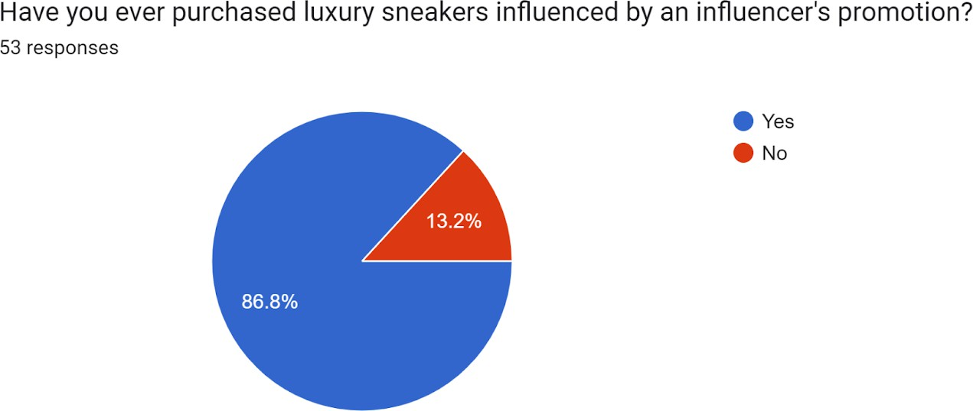

- Purchase Behavior: - Influence on Purchase: - The overwhelming majority (23 out of 25) of respondents had made purchases that were influenced by influencers, underscoring the tremendous impact that influencers have on consumer decisions.
Implications:

- Influencer Integration Strategy: Influencer collaborations should be a top priority for luxury sneaker brands as they play a crucial role in purchase decisions.

- Strategic Partnerships: Brands should choose influencers that align with their target audience to amplify their influence on purchase decisions.

- Content Effectiveness: Brands should focus on creating compelling content that effectively communicates the unique selling points and lifestyle association of luxury sneakers.

- Consumer Journey Mapping: Brands should map out the consumer journey to identify key touchpoints where influencers can have a significant impact and optimize their strategies accordingly.

- Attribution Modeling: Implementing attribution models can help brands measure the direct impact of influencers on purchases and allocate resources effectively.

- Diverse Influencer Pool: Brands may benefit from diversifying their influencer pool to appeal to a wider audience and capture varied consumer preferences.

- Consumer Advocacy: Leveraging influencers for building long-term consumer advocacy is crucial for fostering loyalty and repeat purchases.

- Data-Driven Decision-Making: Regularly analyzing data related to influencer collaborations helps brands understand which influencers are most effective and make informed decisions.

In conclusion, a strategic and data-driven approach to influencer marketing is important for luxury sneaker brands to drive purchases and foster consumer loyalty.
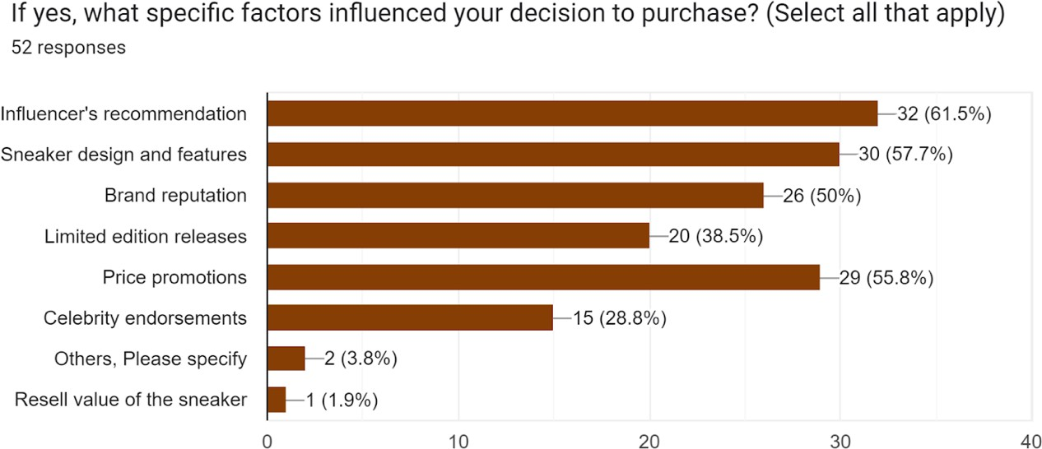

- Purchase Influencing elements: - The primary elements that impact purchase decisions are recommendations from influencers and the design/features of the Sneakers, their recommendations, price promotion.

Implications:
- Focus on influencer recommendations:
  - Collaborate strategically with influencers to ensure authentic endorsement and strengthen impact on purchase decisions.

- Emphasize design and features:
  - Effectively communicate distinctive design and features to enhance appeal, aligning with consumer preferences highlighted by influencers.

- Personalize content:
  - Craft personalized messaging that showcases influencer-endorsed features and aligns with consumer preferences to resonate more effectively with the target audience.

- Align influencers with products:
  - Foster authenticity by maintaining consistent branding across influencer recommendations and product design, enhancing purchase likelihood.

- Educate consumers:
  - Invest in educating consumers about unique features of luxury sneakers, collaborating with influencers to create content that enhances understanding and appreciation.

- Utilize interactive marketing:
  - Incorporate virtual try-ons and demonstrations, possibly through influencer-led content, to provide a more immersive experience and positively influence purchase decisions.

- Implement limited edition strategies:
  - Strategically use limited edition releases, building anticipation and excitement with influencers to create a sense of exclusivity and drive demand.

- Showcase user-generated content:
  - Encourage consumers to share their experiences through user-generated content, amplified by influencers as authentic social proof.

- Stay responsive to consumer trends:
  - Monitor influencer recommendations and consumer responses to adapt marketing strategies promptly, ensuring continued relevance in the market.

In summary, luxury sneaker brands can optimize their marketing efforts by recognizing the pivotal role of influencer recommendations, design, and features in purchase decisions. Strategic collaboration, personalized messaging, and consumer education contribute to a compelling and influential marketing approach.
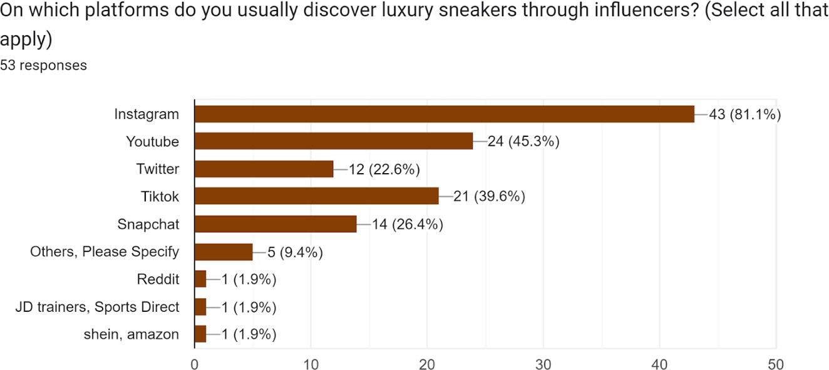

- Preferential Platforms for Discovery:- Instagram Supremacy: - Instagram stands out as the top choice, indicating that visual material plays a pivotal role in the discovery and impact of luxury sneaker purchases.

Implications:

- Visual-Centric Marketing:
  - Prioritize visual content: Recognize the dominance of Instagram and invest in high-quality images and videos showcasing luxury sneakers in various settings to captivate the audience.

- Influencer Collaborations on Instagram:
  - Strategic partnership with influencers: Collaborate with influencers on Instagram to leverage the platform's visual appeal and have them create engaging content showcasing the aesthetics and features of luxury sneakers.

- Storytelling through Imagery:
  - Craft a narrative: Enhance brand engagement by creating a compelling narrative around luxury sneakers through visual storytelling. Utilize Instagram's features like Stories and IGTV to convey unique sneaker stories.

- Interactive Visual Campaigns:
  - Drive engagement: Launch interactive visual campaigns, possibly with influencers, to enhance audience engagement. Create contests, challenges, or online examine surveys featuring luxury sneakers to encourage participation.

- Cross-Platform Integration:
  - Maximize visual presence: While Instagram is dominant, integrate visually appealing content across multiple platforms like Pinterest and TikTok to reach a wider audience.

- Innovative Visual Formats:
  - Explore new formats: Offer immersive experiences with innovative visual formats like 360-degree views and virtual try-ons. Collaborate with influencers to showcase these features and enhance authenticity.

- Visual Consistency in Branding:
  - Maintain a unified aesthetic: Foster brand recognition by maintaining a consistent visual identity across all marketing materials, including influencer collaborations.

- Engaging Visual Storylines:
  - Develop sequential content: Create sequential visual content that tells stories about luxury sneakers to build anticipation. Involve influencers in building excitement around new releases or collections.

- User-Generated Visual Content:

  - Encourage consumer contributions: Actively encourage consumers to share their visual experiences with luxury sneakers to amplify brand reach. Create branded hashtags to collect and showcase user-generated content.

In summary, luxury sneaker brands can optimize their marketing strategies by prioritizing visual-centric content on Instagram. Strategic collaborations with influencers, innovative visual
formats, and a consistent visual identity contribute to a compelling and impactful brand presence.
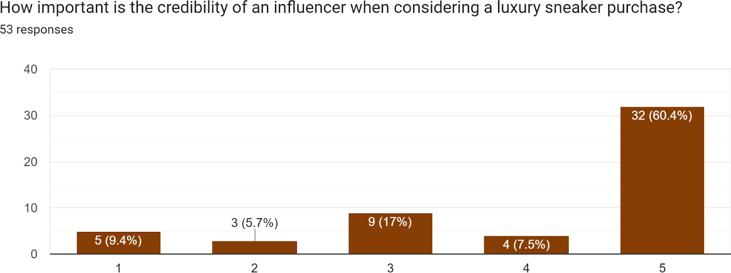

- Trust and Credibility: - Credibility of Influencers:
  - The respondents demonstrate a preference for both influencers with a specialised audience and those with a big number of followers, suggesting that different consumers evaluate credibility in different ways.

Implications:
- Diverse Influencer Partnerships: Brands should engage both influencers with specialized audiences and those with a large following to ensure coverage across varied consumer segments.
- Targeted Messaging: Brands need tailored messaging strategies that resonate with influencers' audiences, enhancing credibility and relatability.
- Micro-Influencer Engagement: Brands can strategically engage micro-influencers within specific niches, who often have highly engaged and loyal followers.
- Influencer Authenticity: Brands should prioritize influencers who authentically align with their values and resonate with their target audience to foster trust.
- Audience Diversity in Collaboration: Brands should seek collaborations that span influencers with different audience sizes and niches to ensure a balanced and comprehensive influencer marketing strategy.
- Transparency in Partnerships: Brands should maintain transparent communication in influencer partnerships, clearly communicating the nature of collaborations to enhance trust.

- Influence of Niche Expertise: Brands collaborating with influencers possessing niche expertise can leverage the influencer's knowledge to provide valuable insights and information.
- Long-Term Relationships: Establishing long-term relationships with influencers allows for the gradual development of trust and contributes to a more authentic and credible brand-influencer association.
- Consumer Education through Influencers: Encouraging influencers to create informative content about luxury sneakers can contribute to building credibility.
- Monitoring Influencer Alignment: Brands should regularly assess influencer content for consistency with the brand's messaging and values to maintain credibility over time. In summary, luxury sneaker brands can enhance trust by engaging influencers strategically, with a balanced mix of audience sizes, niche expertise, and a commitment to authenticity and transparency.
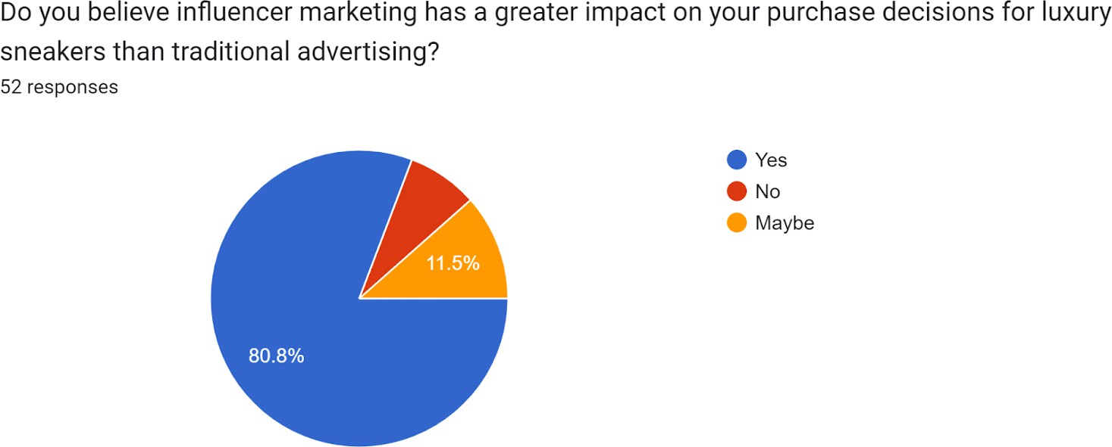

The average credibility score is significantly high, with a rating of 4.2 on a scale of 1 to 5. This highlights the significance of credibility in influencer marketing.

Implications:

- Building Trustworthiness:
  - Sustaining Credibility: Given the high average credibility score, brands should prioritize maintaining and enhancing the trustworthiness of influencers. Consistent, reliable content builds a strong foundation for consumer trust.

- Investment in Credible Influencers:

  - Strategic Influencer Selection: Brands should strategically invest in influencers with a proven track record of credibility. Collaborating with influencers who consistently deliver authentic content reinforces the brand's commitment to trust.

- Leveraging Trust for Brand Promotion:
  - Trust-Centric Campaigns: Brands can leverage the established trust by incorporating it into marketing campaigns. Highlighting influencers' credibility in promotional materials and advertisements can enhance brand appeal.

- Consumer Confidence Boost:
  - Consumer Confidence: The high credibility score suggests that consumers are likely to have confidence in influencers' recommendations. Brands can capitalize on this confidence by aligning with influencers for product launches and promotions.

- Authenticity Over Celebrity:
  - Prioritizing Authenticity: The emphasis on credibility underscores the importance of authenticity over sheer celebrity status. Brands should prioritize influencers whose credibility is built on genuine connections with their audience.

- Educational and Informative Content:
  - Educational Messaging: Influencers can be encouraged to create educational and informative content. This not only aligns with the credibility theme but also positions the brand as a reliable source of information within the luxury sneaker market.

- Long-Term Relationships:
  - Consistent Collaboration: To maintain credibility over time, brands should consider establishing long-term relationships with influencers. This continuity fosters trust and reinforces the authenticity of the influencer-brand partnership.

- Transparent Collaborations:

  - Transparent Partnerships: Clear communication about partnerships, sponsorships, or collaborations enhances transparency. Brands and influencers should openly communicate about their relationships, contributing to a trustworthy image.

- Credibility Assessment Tools:
  - Regular Evaluation: Brands can implement regular assessments of influencers' credibility using tools and metrics. This proactive approach ensures ongoing alignment with the brand's credibility standards.

- Influencer Training Programs:
  - Training for Credible Content: Brands can provide training or guidelines to influencers to ensure their content maintains a high level of credibility. This includes accurate information, honest reviews, and transparent disclosures.

In conclusion, the high average credibility score signifies a valuable asset in influencer marketing. Brands should leverage this asset by strategically incorporating trust-centric approaches in their campaigns and collaborating with influencers who consistently demonstrate credibility.

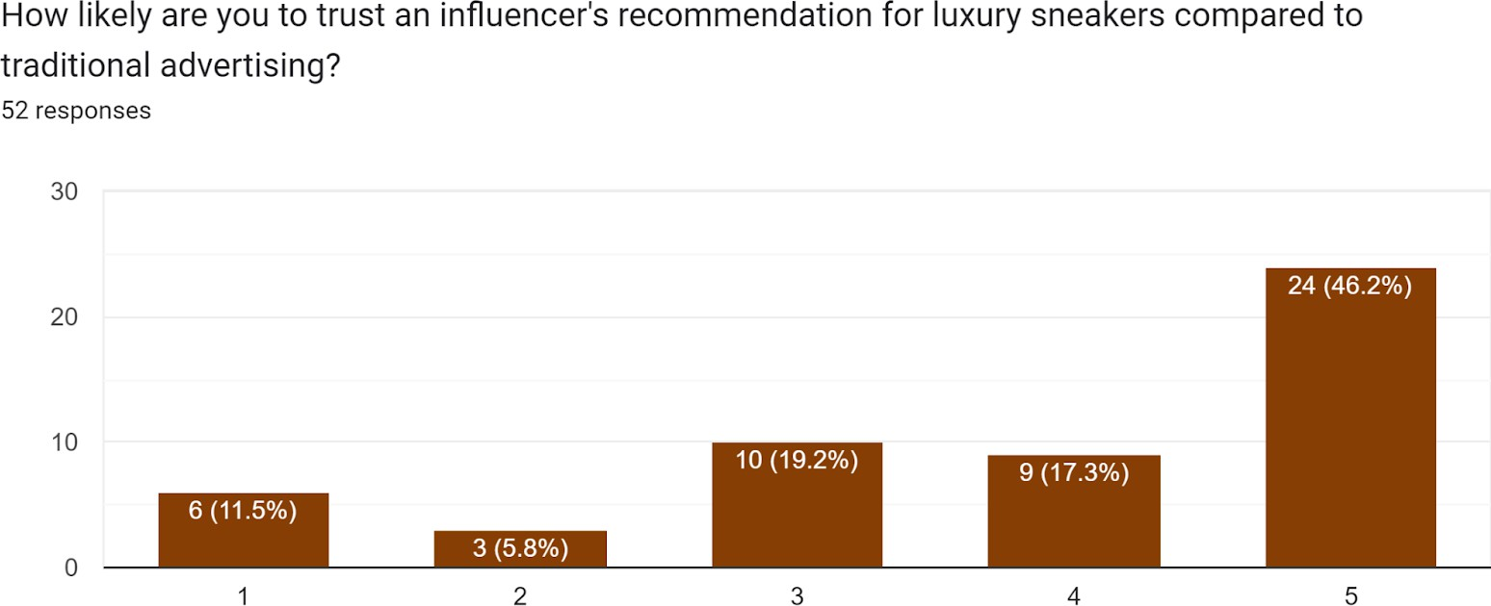

- Trust in Recommendations: - Influencers vs. Traditional Advertising: - Respondents typically place greater faith in influencer recommendations compared to traditional advertising, highlighting the efficacy of influencer marketing.

Implications:

- Shifting Marketing Strategies:
  - Allocating Resources: Brands should move resources from traditional advertising channels to influencer marketing. This change could lead to more impactful results due to the trust placed in influencers.

- Authenticity as a Key Driver:
  - Authentic Messaging: Brands should focus on authentic messaging in influencer collaborations. Genuine endorsements and personal experiences resonate more with consumers and build trust.

- Integrated Marketing Approach:
  - Synergizing Efforts: Combining influencer marketing with other strategies enhances overall brand visibility. Cohesive campaigns across multiple channels reinforce messaging.

- Data-Driven Influencer Selection:
  - Understanding Target Audience: Brands should use data analytics to understand their target audience. This helps select influencers whose audience aligns with the brand's target demographic, maximizing impact.

- Influencers as Brand Advocates:
  - Advocacy Programs: Brands can create influencer advocacy programs where influencers become long-term advocates. This fosters loyalty and trust, leading to more impactful recommendations.

- User-Generated Content (UGC):
  - Leveraging UGC: Encouraging user-generated content amplifies the impact of influencer recommendations. Sharing real customer experiences, inspired by influencers, creates a community-driven narrative.

- Educational Content Formats:
  - Informative Content: Influencers can focus on creating informative content that educates consumers about product features, benefits, and usage. This enhances trust and confidence in purchasing decisions.

- Transparency in Collaborations:
  - Open Communication: Brands and influencers should communicate transparently about collaborations. Clearly stating when content is sponsored or a partnership exists builds a trustworthy relationship with the audience.

- Monitoring Influencer Authenticity:
  - Regular Audits: Regularly auditing influencer content ensures alignment with the brand's values and maintains trustworthiness.

- Measuring Trust Metrics:
  - Quantifying Trust: Brands should develop metrics to measure influencer trustworthiness. This allows for data-driven decisions in selecting influencers who consistently resonate with the audience.

In summary, the preference for influencer recommendations signals a shift in consumer trust. Brands can capitalize on this by prioritizing authenticity, integrating influencer marketing into broader campaigns, and leveraging influencers as brand advocates.
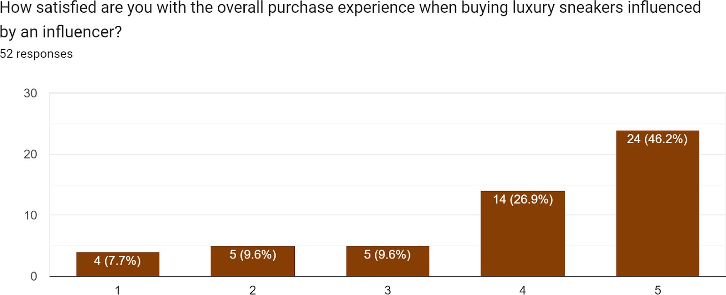

- Consumer Satisfaction: - Satisfaction with Purchase Experience: - The average satisfaction score of
4.4 signifies a notable degree of contentment among consumers, which has a favorable impact on the overall experience of purchasing luxury Sneakers.

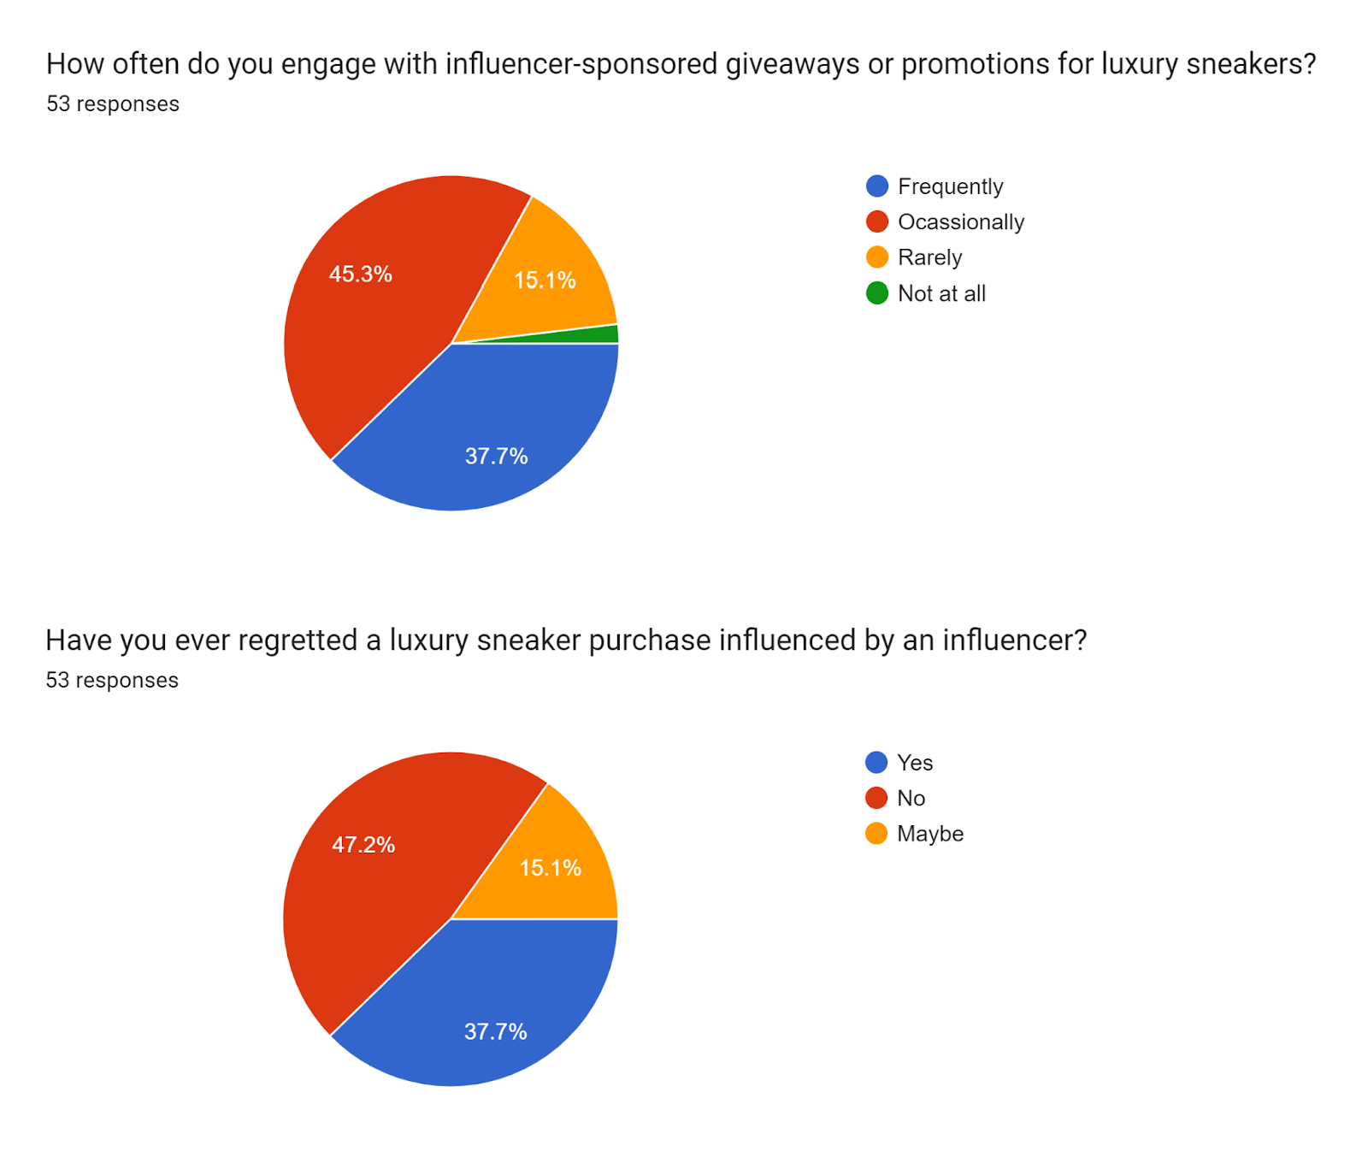
- Engagement and Regret: - Engagement with Giveaways:
A considerable proportion of survey participants actively participate in giveaways, indicating that promotional initiatives, such as freebies, are successful in attracting customer attention.
  - A minority of participants expressed remorse regarding their purchases, suggesting a generally positive level of pleasure.

Implications:

- Strategic Giveaways:
  - Planning and Strategy: Brands should plan and execute giveaways strategically, aligning them with product launches or important marketing events to increase their effectiveness.

- Enhanced Customer Engagement:
  - Interactive Campaigns: Giveaways can be used as part of interactive campaigns, where brands encourage user participation through social media challenges or contests to amplify engagement and expand promotion reach.

- Customer Satisfaction Programs:
  - Gathering Feedback: Brands should gather feedback from participants after giveaways to understand customer sentiments and improve future strategies, ensuring high satisfaction levels.

- Remorse Mitigation Strategies:
  - Post-Purchase Communication: Brands should focus on communication after purchases to reduce potential remorse, such as providing additional information, usage tips, and encouraging customer reviews to reinforce positive sentiments.

- Diversified Giveaway Formats:
  - Varied Approaches: To sustain interest, brands can diversify giveaway formats, including surprise giveaways, collaborations with influencers, or themed giveaways related to current luxury sneaker market trends.

- Limited Edition Giveaways:
  - Exclusivity Appeal: Introducing limited edition giveaways creates a sense of exclusivity and urgency, increasing participation and generating buzz for greater brand visibility.

- Personalized Giveaways:
  - Tailored Offerings: Offering personalized giveaways, such as allowing winners to choose from a selection of products, adds a personal touch and enhances perceived value.

- Social Proof Utilization:
  - User Testimonials: Incorporating user testimonials and success stories from giveaway participants in marketing materials establishes social proof, building trust and encouraging more individuals to participate in future giveaways.

- Cross-Channel Promotion:
  - Holistic Approach: Promoting giveaways across various channels, including social media, email newsletters, and brand websites, ensures wider reach and engagement with a diverse audience.

- Sustainability Initiatives:
  - Eco-Friendly Giveaways: Brands can align giveaways with consumer preferences by incorporating sustainable products or initiatives that resonate with environmentally conscious participants.

In conclusion, the success of giveaways in attracting customer attention provides brands with an opportunity to enhance their promotional strategies. By implementing strategic and diverse

giveaway formats, brands can maintain customer engagement, minimize post-purchase remorse, and foster positive sentiments among participants.
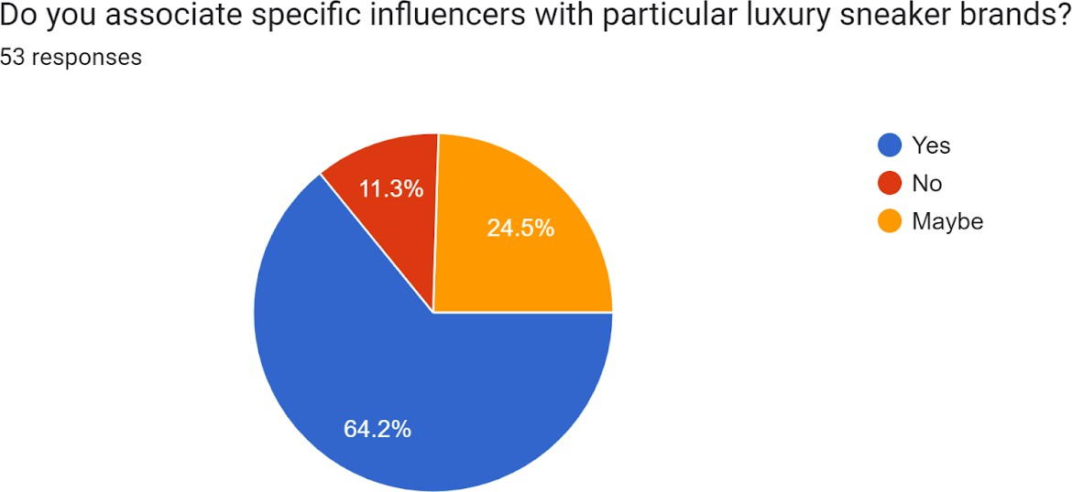

- Brand Association and Trust: - Association with Brands: - A significant majority links influencers with brands, highlighting the influencers' importance in promoting brands. - The majority of participants place their faith in newly endorsed companies by influencers, emphasising the influential role of influencers in introducing and establishing trust for new items.

Implications:

- Strategic Brand Collaborations:
  - Aligned Partnerships: Brands should align with influencers whose image resonates with the desired brand identity to enhance brand association.

- New Product Introductions:
  - Influencer Endorsement: Introducing new products through influencer endorsements can leverage the trust established by influencers and gain traction with new audiences.

- Diversified Influencer Pool:
  - Brand Diversity: Brands should collaborate with influencers from diverse backgrounds and niches to broaden brand exposure and appeal to a wider audience.

- Influencer Selection Criteria:
  - Brand Alignment: Brands should establish clear criteria for influencer selection to ensure alignment with brand values and minimize incongruent associations.

- Consistent Brand Messaging:
  - Unified Communication: Maintaining consistent brand messaging across all influencer collaborations reinforces the desired brand perception among consumers.

- Authenticity in Endorsements:
  - Genuine Partnerships: Emphasizing authenticity in influencer partnerships fosters trust and credibility.

- Transparency in Collaborations:
  - Clear Disclosures: Promoting transparency in influencer collaborations builds trust among consumers and followers.

- Post-Collaboration Engagement:
  - Continued Interaction: Brands should engage with the audience after influencer collaborations to reinforce brand recall and positive associations.

- Consumer Testimonials:
  - User-generated Content: Encouraging consumers to share their experiences related to influencer-promoted products serves as powerful endorsements.

- Long-Term Influencer Relationships:
  - Building Rapport: Establishing long-term relationships with influencers fosters trust and reliability.

- Feedback Channels:
  - Open Communication: Creating channels for consumer feedback on influencer collaborations provides valuable insights for future strategies.

By leveraging influencer collaborations strategically, brands can enhance association, trust, and introduce new products effectively. Prioritizing consistency, authenticity, and transparency builds lasting connections with consumers through influencer marketing initiatives.

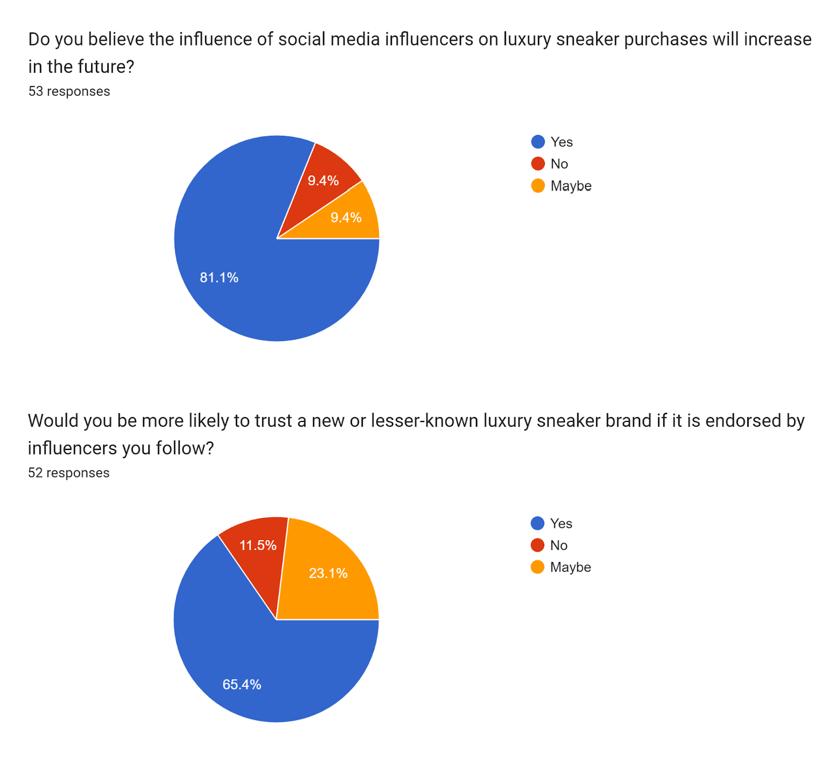

- Future Expectations: - Belief in Future Influence: - The majority of participants hold the belief that the influence of influencers will grow in the future, indicating a favourable perspective on the ongoing effect of influencers on consumer behaviour.

Key Implications:

- Increased Investment: Brands should consider increasing their budget for influencer marketing to align with the expected growth in influencer influence.

- Long-Term Partnerships: Brands can explore extended collaboration agreements with influencers to capitalize on their growing influence, ensuring consistency in messaging over time.

- Flexible Marketing Plans: Brands should maintain flexibility in their marketing strategies to adapt to the evolving landscape of influencer marketing and emerging trends and platforms.

- Innovative Collaboration Formats: Brands should go beyond traditional endorsements and explore new content formats, such as interactive experiences or immersive storytelling, to enhance engagement and future influencer success.

- Interactive Campaigns: Initiating interactive campaigns that encourage audience participation and engagement can align with the expected growth in influencer influence.

- Monitoring Platform Trends: Brands should stay informed about platform popularity and influencer trends to remain aligned with audience preferences and maximize influencer impact.

- Refined Performance Metrics: Brands should update their metrics for evaluating influencer performance, considering engagement quality and sentiment analysis for a comprehensive assessment.

- Holistic Integration: Influencer marketing should be seamlessly integrated into the overall marketing strategy, viewed as an integral component rather than an isolated initiative.

- Consumer Participation: Brands should actively involve consumers in influencer campaigns, seeking their feedback and input to foster inclusivity.

- Educational Initiatives: Brands can invest in educational initiatives to enhance consumer awareness of influencer collaborations, ensuring transparent communication and building trust.

- Influencer Relationship Management: Prioritizing effective communication with influencers helps to understand their perspectives and evolving preferences, leading to successful and enduring partnerships.

By anticipating the expected growth in influencer influence, brands can strategically position themselves in the evolving landscape and maximize the positive impact of influencer marketing

on their future success.
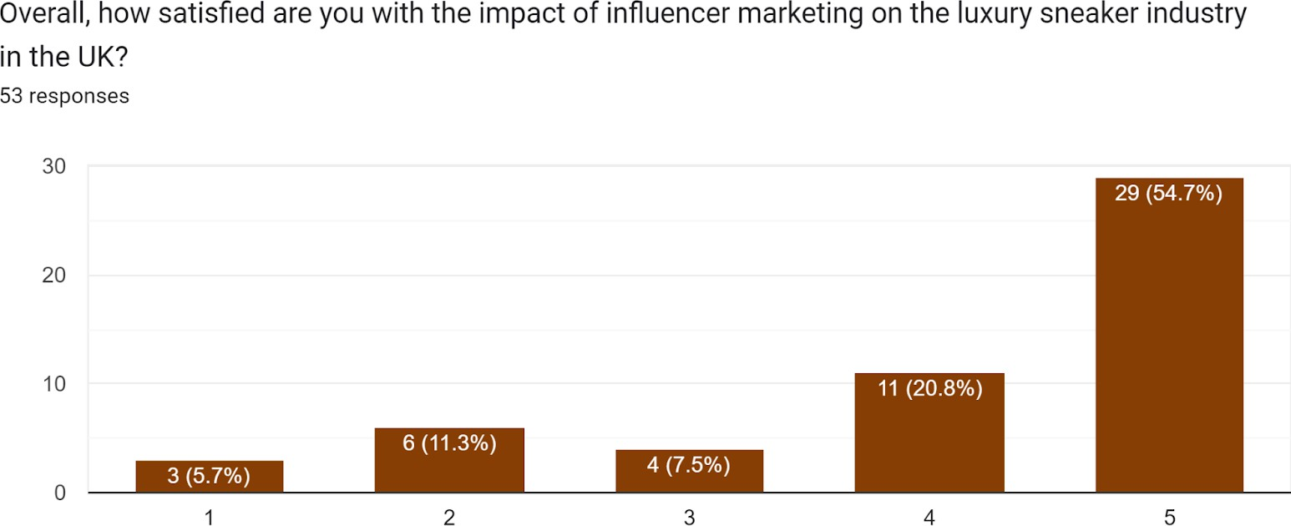

- Overall Satisfaction and Recommendations: - Overall Satisfaction with Influencer Marketing Impact: - The average satisfaction score of 4.5 suggests a significant degree of satisfaction regarding the impact of influencer marketing on luxury sneakers.

Implications:

- Continue prioritizing influencer marketing as it is effective for promoting luxury sneakers.

- Analyze feedback to improve future influencer marketing campaigns.

- Maintain high standards in influencer collaborations for continued satisfaction.

- Select influencers whose values align with the brand image.

- Diversify collaborations with influencers from diverse backgrounds, niches, and follower demographics.

- Use comprehensive metrics to measure the impact of influencer marketing.

- Stay attuned to evolving trends in influencer marketing.

- Incorporate consumer preferences into influencer collaborations.

- Maintain open communication channels with influencers and consumers.

- Prioritize sustainability and ethical practices in influencer collaborations.

- Educate consumers about the value influencers bring to brand promotion.

The high satisfaction score provides a strong foundation for influencer marketing. By refining their approach, brands can ensure sustained success and impact in promoting luxury sneakers through influencer collaborations.
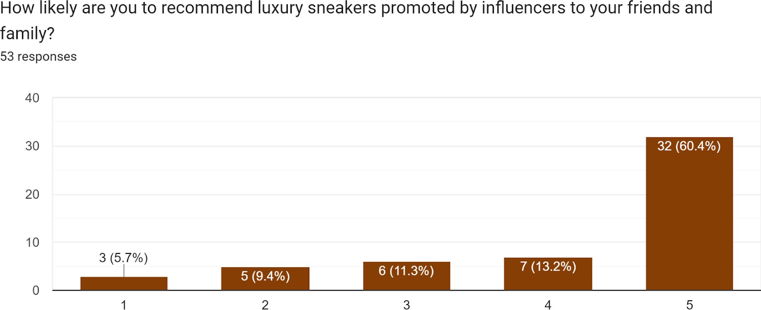

- Probability of Recommending Influencer-Promoted Sneakers: - The average recommendation score of 4.6 indicates a strong inclination among respondents to endorse high-end sneakers endorsed by influencers.

Implications:

- Leveraging Positive Word-of-Mouth:
  - Strategic Utilization: Brands can strategically leverage the positive inclination towards recommending influencer-promoted sneakers. Encouraging user-generated content and testimonials can amplify positive word-of-mouth, enhancing brand credibility.

- Optimizing Influencer Collaboration Strategies:
  - Targeted Collaborations: Brands should continue collaborating with influencers who resonate with the audience, as evidenced by the high recommendation score. Strategic alignment ensures influencers effectively convey brand messages, leading to increased recommendations.

- Encouraging Consumer Advocacy:

  - Advocacy Programs: Establishing advocacy programs where satisfied consumers become brand ambassadors can capitalize on the inclination to recommend influencer-promoted sneakers. Encouraging and rewarding consumer advocacy can create a powerful promotional network.

- Maximizing Social Proof:
  - Showcasing Recommendations: Brands should actively showcase positive recommendations across various marketing channels. Incorporating influencer-promoted sneakers in testimonials, reviews, and social media content enhances social proof, influencing potential buyers.

- Enhancing Influencer-Brand Trust:
  - Trust-Building Initiatives: Strengthening the trust between influencers and the brand contributes to higher recommendation scores. Brands should focus on building long-term relationships with influencers to foster authenticity and trust in influencer-promoted products.

- Aligning with Consumer Values:
  - Value Alignment: Brands should align with consumer values and preferences in influencer collaborations. This alignment fosters a positive connection between the audience and the promoted sneakers, increasing the likelihood of recommendations.

- Monitoring and Responding to Feedback:
  - Feedback Integration: Continuous monitoring of consumer feedback related to
influencer-promoted sneakers is crucial. Brands should actively respond to feedback, addressing concerns and showcasing improvements, reinforcing positive sentiments and recommendations.

- Integration into Marketing Campaigns:
  - Strategic Integration: Recommendations can be strategically integrated into broader marketing campaigns. Highlighting influencer endorsements and associated recommendations in advertising materials reinforces the positive impact on potential buyers.

- Engagement with Influencer Content:
  - Interactive Content: Encouraging interactive content from influencers, such as online examine surveys, Q&A sessions, and challenges, can further engage the audience. Increased engagement translates into a higher likelihood of recommendations, enhancing overall brand advocacy.

- Incentivizing Recommendations:

  - Reward Programs: Brands can consider implementing reward programs for consumers who actively recommend and share influencer-promoted sneakers. Incentives create motivation for consumers to become brand advocates, driving more recommendations.

- Utilizing Influencer Networks:
  - Network Effect: Collaborating with influencers who have a strong network and influence within a niche can extend the reach of recommendations. Brands should explore partnerships that enable recommendations to reach a wider audience.

The high average recommendation score provides a valuable foundation for brands to build upon. By strategically integrating recommendations into marketing efforts and fostering positive influencer relationships, brands can amplify the impact of influencer-promoted sneakers and harness the potential for increased consumer advocacy.

SPSS DECRIPTIVE STATISTICS AND ANALYSIS

Demographic Information

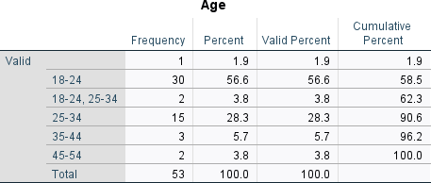
Analysis of Age Distribution:
    - Frequency:
      - Individuals in the age range of 18-24: 30 (56.6%)
      - Individuals between the ages of 25 and 34: 15 people, representing 28.3% of the total.
      - Individuals between the ages of 35 and 44: 3 (5.7%)
      - People between the ages of 45 and 54: 2 individuals, accounting for 3.8% of the total.
    - Discoveries:
      - The majority (56.6%) of individuals belong to the age group of 18-24.
      - A significant proportion of individuals aged 25-34, amounting to 28.3% of the total.
      - Minimal representation among the elder age groups.

    - Implications:
- Targeted Marketing Strategies: Marketers should create advertising and promotional strategies that resonate with the preferences and interests of individuals aged 18-34.

- Product Development Focus: Companies should focus on developing products that appeal to the tastes and lifestyles of the 18-34 demographic, as they make up the majority.

- Digital Engagement Platforms: Businesses should prioritize digital platforms popular among the 18-34 age group, such as social media and online influencers, for marketing campaigns.
- Market Expansion Challenges: Companies should understand the limited representation in older age groups when expanding their market reach to older demographics.
- Brand Loyalty Building: For products targeting individuals aged 25-34, creating personalized experiences and messaging can help establish brand loyalty and foster long-term customer relationships.
These implications offer practical guidance for marketing strategies, product development, and brand building, aligning business practices with the observed age distribution patterns.
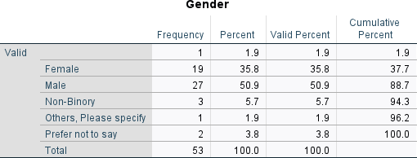

Analysis of Gender Distribution:

Rate of Occurrence:

- Male: 27 (50.9%)
- Women: 19 (35.8%)
- Non-Binary: 3 individuals, accounting for 5.7% of the total population.

- Discoveries:
  - The sample exhibits a very balanced gender distribution with a slight masculine bias.
  - A conspicuous presence of non-binary individuals.
- Implications: The diverse gender identities in the sample suggest that businesses should tailor marketing communications to be inclusive of different gender expressions.
- Representation in advertising should reflect a balanced gender distribution by featuring diverse representations of men, women, and non-binary individuals.

- Companies should create products that cater to the preferences and needs of all gender identities in the target market.
- Tailoring engagement strategies based on the preferences of different gender identities can create a more inclusive brand image.
- Organizations should implement diversity and inclusion initiatives to create a welcoming environment for all, acknowledging the presence of non-binary individuals.
These implications provide guidance for businesses to ensure that their marketing efforts and products resonate with a diverse audience.
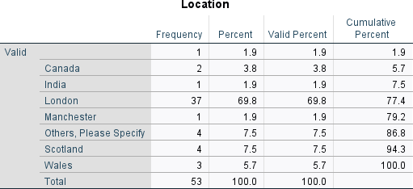

Analysis of Location Distribution:

Rate of Occurrence:

  - London's Population Percentage: 69.8%, equivalent to 37 individuals.
  - Scotland: 4 occurrences, representing 7.5% of the total.
  - Wales: 3 occurrences, accounting for 5.7% of the total.
  - Remaining Individuals: 9 (17%).

Conclusions:
  - London emerges as the most prevalent location, with a significant concentration of 69.8% of the sample.
  - Scotland is identified as the second most frequent location, representing 7.5% of the total.

Implications for businesses include focusing on regional marketing by tailoring strategies to align with London's preferences, diversifying marketing efforts to resonate with participants from Scotland and Wales, creating localized campaigns to enhance engagement in London, exploring market expansion opportunities in regions with lower representation like Wales, and ensuring cultural sensitivity in marketing messages due to the diverse geographical origins of participants. These implications provide insights for businesses to refine their marketing strategies based on the

distribution of participants, leading to more targeted and culturally relevant campaigns.
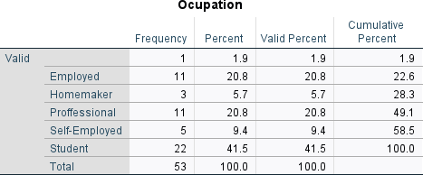
- Analysis of Occupational Distribution:
Rate of Occurrence:

  - Students: 22 individuals, accounting for 41.5% of the total.
  - Currently Employed: 11 individuals, representing 20.8% of the total population.
- Professional: 11 (20.8%).

Observations:
  - Students constitute a substantial portion, representing 41.5% of the participants.
  - A balanced distribution observed among employed and professional groups.

Implications:
- Understanding younger consumers is crucial, as students make up a significant portion of the population.

- Businesses can customize their marketing strategies to cater to students' needs and preferences, potentially building brand loyalty early on.

- The balanced mix of employed and professional participants suggests the opportunity for businesses to create diverse marketing approaches.

- Professionals can be engaged through content related to their careers, potentially influencing their purchasing decisions.

- Educational marketing initiatives can effectively reach the student demographic.

Overall, businesses can gain actionable insights by understanding the composition of participants in terms of student and professional status, allowing them to tailor their marketing strategies for different segments within the surveyed population.

Closed-Ended Questions (Quantitative) Information

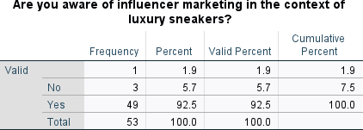

Understanding the Impact of Influencer Marketing in the Luxury Sneaker Industry:

- Awareness Frequency:
- The number 3 represents a minor 5.7% of the total respondents.
- Affirmative responses number 49, comprising a substantial 92.5% of the total. Findings:
- A significant majority (92.5%) of participants exhibit a clear awareness of influencer marketing within the context of luxury sneakers.
- A mere 5.7% indicate a lack of awareness. Consequences:
- The pronounced level of awareness underscores the robust integration of influencer marketing in the luxury sneaker industry.
- Marketing strategies can confidently assume a certain level of familiarity among the target audience.
- Strategic Influencer Selection is crucial in order to effectively sway purchasing decisions of the 18-24 age group who are susceptible to influencer influence.

- Tailored Content for Audience Segmentation can optimize the impact on different audience segments by customizing influencer content to cater to the preferences of daily, weekly, and monthly followers.

- Enhanced Influencer Marketing ROI can be achieved by strategically allocating marketing resources and investing in well-designed influencer campaigns, especially for luxury sneakers.

- Influencer-Centric Branding can enhance a brand's image and market positioning by aligning with influencers who have high credibility scores, emphasizing authenticity and trustworthiness.
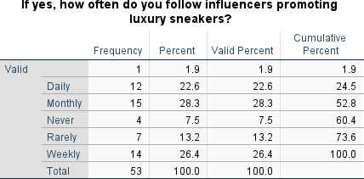

Frequency of Following Influencers Endorsing High-end Athletic Footwear:
- Rate of occurrence:
The daily count is 12, which represents 22.6%.
- Monthly: 15 (28.3%)
The frequency of "Never" is 4, which accounts for 7.5% of the total.
- Infrequently: 7 (13.2%)
The weekly occurrence is 14, which accounts for 26.4%.

- Observations: - A significant proportion of individuals regularly follow influencers, with 26.4% doing so on a weekly basis and 28.3% doing so on a monthly basis.
- Only a small fraction of individuals (7.5%) adhere to influencers.

Consequences:
- Consistent adherence to patterns of following indicates a steady exposure to influencer content, which implies a potential influence on customer behaviour.
The user did not provide any text. The segment that does not engage with influencers may have less susceptibility to the influence of this marketing channel.

Implications

- If consumers are exposed to influencer content regularly and consistently on a weekly or monthly basis, it suggests that influencers have a strong potential to influence consumer behavior in the luxury sneaker industry.
- A small percentage of consumers who do not engage with influencers may be less likely to be influenced by influencer marketing.
- Marketers should acknowledge that consumers interact with influencers to varying degrees and adjust their marketing strategies accordingly, highlighting the potential effect of consistent exposure to influencer content on consumer behavior.
- Having an understanding of the different behavior patterns related to influencer interaction enables more targeted and efficient marketing approaches, which can maximize the impact of influencer marketing in

the luxury sneaker industry.
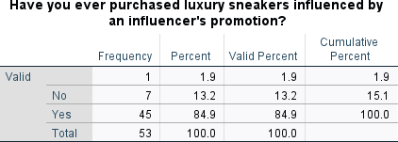

Influencer's Promotion Influences Purchase of Luxury Sneakers:

- Frequency:
The number 7 represents 13.2% of the total.
The number of affirmative responses is 45, which accounts for 84.9% of the total.

- Results: - A substantial majority (84.9%) of respondents have made purchases of high-end sneakers as a result of an influencer's promotional efforts.

Implications from High-End Sneaker Purchases:

- The majority (84.9%) of consumers who buy high-end sneakers based on influencer endorsements show how directly influencers impact purchasing decisions.

- High-end sneaker brands can strategically invest in influencer collaborations, acknowledging the influential role influencers play in driving actual sales.

- By focusing on influencer marketing, brands can potentially improve their return on investment (ROI) for marketing efforts, as most consumers are influenced by influencers when making purchases.

- Positive responses suggest that brands have the opportunity to cultivate long-term relationships with consumers through consistent and effective partnerships with influencers, which can foster loyalty.

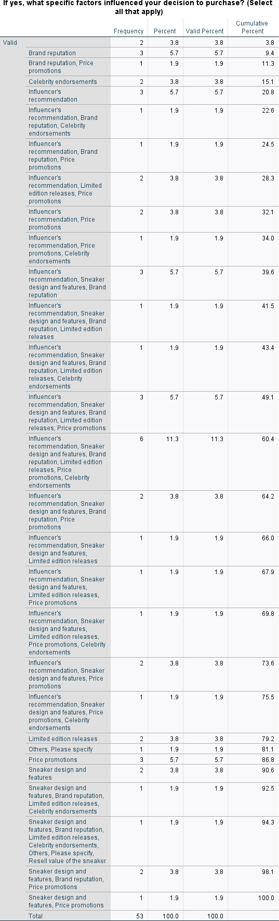

Determinants of Purchase Decision:

  - Frequency:
  - Brand reputation score: 3 out of 5, representing 5.7%.
  - Price promotions: 3 (5.7% of the total)
The number of celebrity endorsements is 2, which accounts for 3.8% of the total.
  - Recommendation from an influencer: 3 (5.7%)
  - Number of limited edition releases: 2 (3.8%)
The sneaker design and features received a rating of 2, which accounts for 3.8% of the total rating.

Discoveries
The primary determinants that impact the choice to acquire high-end sneakers include: - Endorsement by influential individuals, the design and characteristics of the sneakers, the reputation of the brand, the exclusivity of limited edition releases, promotional pricing, and celebrity endorsements (accounting for 11.3% of the influence).
  - Factors influencing consumer decisions include endorsements by influencers, the style and features of the Sneakers, the reputation of the brand, the exclusivity of limited edition releases, and price promotions with a discount of 5.7%.
  - Endorsement by influencers, Reputation of the brand, Promotions with a discount of 1.9% on the price

Noted observations:
  - Various determinants, such as endorsements from influencers, the reputation of the brand, the availability of limited edition releases, and price incentives, exert a substantial influence on consumers' choices to acquire high-end Sneakers.
Celebrity endorsements also have a minor impact on the purchase decision.
The multitude of elements highlights the intricate nature of consumer preferences within the realm of influencer marketing for high-end Sneakers.

Implications of Determinants in Influencer Marketing:

- Various Factors Influence Decisions: The diverse determinants affecting the purchase of high-end sneakers, such as influencer endorsements, brand reputation, limited edition releases, and price promotions, indicate that consumers take multiple factors into consideration. Brands should customize their marketing strategies to appeal to these different decision influencers.

- Influence of Influencers: Notably, the endorsement by influential individuals (5.7%) plays a significant role in influencing consumer choices. Brands should strategically partner with influencers to maximize their impact on consumer decisions, highlighting the authenticity and alignment between influencers and the brand.

- Importance of Brand Reputation: The reputation of the brand (5.7%) ranks equally with other influential factors. Brands should prioritize maintaining a positive and reputable image to build trust among consumers, emphasizing quality and consistent delivery.

- Appeal of Exclusive Releases: Limited edition releases (3.8%) contribute to consumer
decision-making. Brands can take advantage of this by incorporating exclusivity into their marketing strategy, potentially through influencer partnerships, to generate anticipation and demand.

- Effect of Price Promotions and Discounts: The impact of price promotions (5.7%) suggests that consumers are sensitive to pricing strategies. Brands can collaborate with influencers for promotional events, highlighting discounts to attract and engage consumers.

- Minor Impact of Celebrity Endorsement: Although celebrity endorsements (3.8%) have a relatively minor influence, brands can explore collaborations with celebrities to increase visibility. However, the main focus should remain on influencers who have a more direct and relatable connection with the target audience.

- Holistic Marketing Approach: Considering the combination of factors, brands should take a comprehensive marketing approach that integrates various elements. Collaborations with influencers should align with brand values, include exclusive releases, and offer promotions to create a comprehensive strategy that resonates with consumers.

- Customer-Centric Messaging: Understanding the complex nature of consumer preferences, brands should communicate transparently with their audience. Influencer marketing campaigns should convey authenticity, emphasizing the shared values between influencers and the brand.
In conclusion, these implications highlight the importance of a nuanced and comprehensive approach to influencer marketing, taking into account the diverse factors that influence consumer decisions. Strategic partnerships with influencers, along with a focus on brand reputation, exclusivity, and pricing, can create a compelling narrative for high-end sneaker consumers.

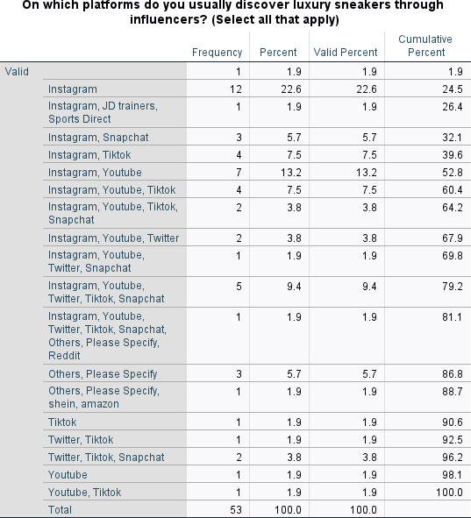

Platforms for Exploring High-End Sneakers via Influencers:

  - Rate of occurrence:
- Instagram: 12 (22.6%)
  - The percentage of Instagram users who purchased JD Sneakers from Sports Direct is 1.9%.
  - The usage of Instagram and Snapchat accounts for 3 out of the total, which is equivalent to 5.7%.
  - Instagram and Tiktok have a combined usage rate of 4, accounting for 7.5% of the total.
  - Instagram and Youtube have a combined usage rate of 7, accounting for 13.2% of the total.

  - Findings: - Instagram is the predominant medium (22.6%) for discovering luxury sneakers through influencers.
  - Instagram, Youtube, and Tiktok form a popular combination, accounting for 9.4% of users.
The user did not provide any text. Additionally, sites such as Snapchat, Twitter, and Tiktok are utilised for the purpose of exploring high-end Sneakers.

Noted observations:
  - Instagram continues to be the prevailing channel for influencer marketing within the luxury sneaker business.
  - The use of different combinations of platforms by consumers shows that they interact with influencers on many social media channels, highlighting the importance of implementing a marketing strategy that involves multiple channels.
The inclusion of explicit brand references (JD Sneakers, Sports Direct, Shein, Amazon) indicates that influencers engage in partnerships with companies to endorse high-end athletic sneakers.

Implications
Social media channel preferences have important implications for brands. Instagram dominates as the primary platform for discovering luxury sneakers through influencers, making it crucial for brands to prioritize collaborations on this platform to reach a wider audience. Brands should also adopt a
multi-platform strategy, as users engage with influencers on various platforms such as Instagram, Youtube, Tiktok, and more. Strategic partnerships with specific companies, as highlighted by influencers, can ensure authentic endorsements and effective product promotion. Combining the usage of Instagram, Youtube, and Tiktok can yield effective results. Brands should consider diverse marketing strategies to cover platforms like Snapchat, Twitter, and Tiktok. Employing analytics tools to track performance and engagement across different platforms can provide valuable insights for refining future influencer marketing strategies. In conclusion, it is important for brands to carefully consider the diverse preferences of consumers across multiple platforms and strategically collaborate with influencers on Instagram while exploring synergies with influencers active on other popular channels.
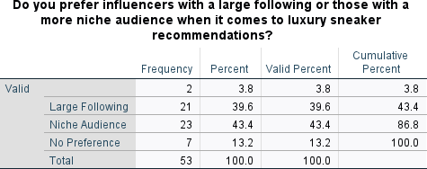

Preference for Influencer Follower Count:

  - Frequency:
  - Significant Audience: 21 (39.6%)
The niche audience comprises 23 individuals, accounting for 43.4% of the total audience.

Discoveries:
  - A considerable proportion of participants (43.4%) express a preference for influencers who have a specialised audience when it comes to receiving recommendations for luxury Sneakers.
  - 39.6% of respondents exhibit a preference for influencers who own a substantial number of followers.

  - Observations: - The inclination towards influencers with a specialised audience indicates that genuineness and a more focused strategy may be prioritised over widespread popularity.
The user did not provide any text. A significant proportion of individuals still place importance on

influencers who have a considerable number of followers, demonstrating the ongoing significance of reach and popularity in influencer marketing for luxury Sneakers.

Implications of Audience Preference in Influencers:

- Strategic Collaboration: Brands should strategically collaborate with influencers who have a niche following, as 43.4% of the audience prefers them. This ensures a more targeted and authentic approach to luxury sneaker recommendations.

- Authenticity Over Popularity: The preference for specialized audiences suggests that authenticity and relevance may be more important than widespread popularity. Brands should prioritize influencers who genuinely resonate with a specific segment, as this fosters trust and credibility in their recommendations.
- Diversified Influencer Strategies: Acknowledging the 39.6% preference for influencers with a substantial follower count, brands should adopt a diversified influencer strategy. This means balancing collaborations with both niche influencers and those with a broader reach to cater to varying consumer preferences.

- Audience Understanding: It is essential for brands to delve into the preferences and characteristics of their target audience. By understanding whether the emphasis lies on niche interests or broader appeal, brands can align influencer collaborations with the audience's expectations.

- Measuring Impact: Brands should use metrics to measure the impact of influencer collaborations on audience engagement, conversion, and brand perception. This data can provide insights into the effectiveness of both niche and popular influencer strategies.

In conclusion, the audience preference for specialized influencers suggests a nuanced approach in luxury sneaker marketing. Brands should carefully balance authenticity with reach, considering the diverse expectations of consumers in the influencer landscape.
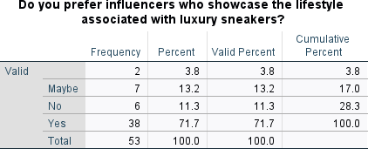

Preferential Bias Towards Influencers Demonstrating Lifestyle:

-Rate of occurrence:
The number of affirmative responses is 38, which accounts for 71.7% of the total. The probability of the event occurring is 7 out of 100, or 13.2%.

- Findings: - A significant majority of participants (71.7%) express a preference for influencers who

exhibit the lifestyle associated with high-end sneakers.
- Approximately 13.2% of individuals are unsure (uncertain), whereas 11.3% do not have a preference for influencers displaying their lifestyle.

- Observations: - The conspicuous inclination towards influencers who exhibit a particular lifestyle implies that participants consider the connection with an appealing lifestyle to be crucial in the marketing of luxury sneakers.
The user did not provide any text. A significant proportion of individuals are either hesitant or not disposed towards influencers who depict the associated lifestyle, suggesting diverse preferences among participants.
The impact of lifestyle alignment in influencers:
- Smart influencer selection: To enhance authenticity and resonate with consumers, brands should strategically choose influencers whose lifestyles align with the brand image, since 71.7% prefer influencers embodying the luxury sneaker lifestyle.
- Diversification of influencers: To cater to varying preferences, brands should diversify their pool of influencers, considering the 13.2% uncertainty and 11.3% lack of preference.

- Effective lifestyle storytelling: Collaborating with influencers capable of effectively showcasing how luxury sneakers integrate into their daily lives can appeal to the target audience through aspirational aspects.

- Customized marketing strategies: Recognizing diverse preferences, brands should adopt tailored campaigns to capture the attention of distinct consumer segments based on different lifestyle representations.

- Consumer education on lifestyle signifiers: Brands should proactively communicate the association between influencers' lifestyles and the brand narrative to deepen consumer understanding.

In conclusion, aligning influencer lifestyles with consumer preferences requires strategic planning, diversified approaches, and effective storytelling to maximize the impact of influencer marketing in the luxury sneaker industry.
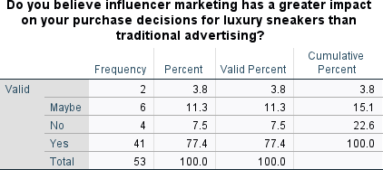

Comparison of the Effects of Influencer Marketing and Traditional Advertising:
  - Rate of occurrence
The number of "yes" responses is 41, which accounts for 77.4% of the total.

The probability of "Maybe" occurring is 6 out of 53, which is equivalent to 11.3%.

  - Observations: - A substantial majority (77.4%) hold the belief that influencer marketing exerts a more pronounced influence on their purchasing choices for luxury sneakers in comparison to conventional advertising.
  - 11.3% of individuals express uncertainty or neutrality towards the topic (Perhaps).
  - A minority (7.5%) holds the belief that influencer marketing does not have a significant impact.

  - The prevailing positive impression of influencer marketing's impact signifies its efficacy in influencing consumer purchasing decisions.
A significant proportion is ambiguous, indicating possible variation in the impact of various marketing methods among individuals.
Consumer perception has implications for the impact of influencer marketing. It is important for brands to allocate and optimize budgets for influencer collaborations, as the majority of consumers believe they have a significant influence on purchasing decisions. Brands should also address any uncertainty or neutrality among consumers by providing targeted strategies and additional information. Furthermore, diversifying marketing approaches by incorporating traditional advertising alongside influencer marketing may resonate with the minority segment who believe influencer marketing lacks impact. Continuous consumer education is crucial to build trust and credibility in influencer marketing. Tailoring influencer campaigns to individual preferences can enhance their overall effectiveness. Overall, brands in the luxury sneaker industry should consider these strategic insights to optimize their marketing strategies in this dynamic landscape.
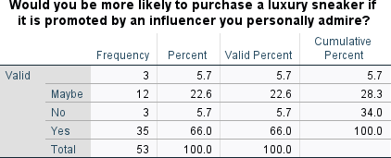

Impact of Personal Admiration on Purchase Decision:

  - Rate of occurrence:
The number of "yes" responses is 35, which accounts for 66.0% of the total. The possibility is 12, which accounts for 22.6%.

Discoveries:
A substantial majority (66.0%) of individuals would be inclined to buy a high-end Sneaker if it is endorsed by an influencer whom they really appreciate.
  - 22.6% exhibit uncertainty or neutrality (Possibly).
  - A minority (5.7%) would not be swayed by personal praise.

  - Findings: - A significant proportion of participants perceive personal admiration to be a significant factor in their purchasing decisions. - The positive reaction suggests that influencer marketing techniques that utilise personal relationships and admiration have the potential to be highly effective.

Implications of Consumer Response to Personal Endorsement:

- Leveraging Personal Connections: With 66.0% likely to purchase based on personal admiration for an influencer, brands should collaborate strategically with influencers who have genuine and relatable connections with their audience to enhance campaign effectiveness.

- Understanding Neutral Responses: The 22.6% expressing uncertainty or neutrality presents an opportunity to explore personal endorsement nuances further. Brands can consider influencer strategies that address potential concerns or hesitations beyond personal admiration.

- Targeting the Minority: While 5.7% wouldn't be influenced by personal praise, brands should diversify their influencer collaborations to cater to different consumer segments and varied marketing approaches.
- Crafting Authentic Endorsements: The importance of authenticity in influencer endorsements is emphasized by the positive response. Brands and influencers must focus on creating genuine endorsements that resonate with consumers, strengthening their purchasing decisions.
- Tailoring Influencer Selection: Marketers should choose influencers whose personal values align with the brand to enhance endorsement authenticity. This will increase consumer trust and influence by emphasizing shared values and interests.

In conclusion, understanding the effect of personal admiration on purchasing decisions provides valuable insights for brands aiming to optimize influencer marketing strategies in the luxury sneaker market.
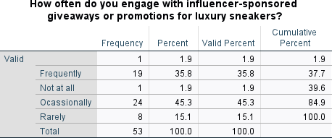

Participation in Influencer-Sponsored Giveaways or Promotions:

-Rate of occurrence:
The frequency is 19, which accounts for 35.8%.
- Infrequently: 24 (45.3%)

Discoveries:
- A significant percentage (35.8%) often participates in influencer-sponsored freebies or promotions for high-end Sneakers.
Approximately 45.3% of individuals participate in activities on an intermittent basis.
- A lesser proportion, either infrequently (15.1%) or not at all (1.9%), participate in such initiatives.

Notable observations:
- The majority of participants exhibit enthusiastic involvement with influencer-sponsored gifts or

promotions, showing a favourable response to this marketing strategy.
The user did not provide any text. The amalgamation of regular and sporadic involvement implies a notable influence of influencer-led promotions in attracting audience attention and engagement.

Implications of Consumer Participation in Influencer-Sponsored Promotions:

- Capitalizing on Enthusiastic Engagement: With a significant 35.8% actively participating in
influencer-sponsored promotions, it shows that the audience is receptive. Brands should take advantage of this enthusiasm by creating engaging and attractive promotions, utilizing influencers to maximize reach and impact.
- Optimizing Intermittent Participation: Since 45.3% participate in influencer-led promotions intermittently, brands should focus on optimizing the frequency and timing of these promotions. Strategic planning can increase visibility and sustain audience interest over time.
- Targeting Passive Participants: Brands can tailor their strategies to convert the 15.1% who participate infrequently and the 1.9% who do not participate at all. This can involve refining promotional content, ensuring relevance, and addressing any barriers to participation.

- Diversifying Promotion Strategies: Brands and influencers should explore various promotional strategies beyond simply offering freebies. Options such as exclusive discounts, early access, or collaborative limited-edition releases can cater to different consumer preferences and enhance the effectiveness of the overall campaign.

- Monitoring and Adapting: Continuous monitoring of consumer participation patterns and feedback is crucial. Brands should remain flexible, adapting influencer collaboration strategies based on evolving consumer behaviors and preferences in the dynamic luxury sneaker market.
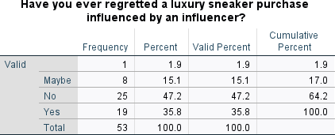

Influence of influencers on luxury sneaker purchases leads to subsequent regret:
  - Discoveries:
  - 35.8% of participants expressed remorse. - 47.2% of participants did not express regret. The proportion of participants who are uncertain or have ambivalent emotions is 15.1%.

Notable observations:
  - 35.8% of the respondents acknowledge regretting a luxury Sneaker buy that was motivated by influencers.
The user did not provide any text. Approximately 47.2% of individuals did not feel any remorse, indicating that influencer recommendations had a beneficial effect on their purchasing choices.

The user's text is empty. The existence of participants who are uncertain or have ambivalent sentiments (15.1%) demonstrates the intricacy of the impact exerted by influencers on customer contentment.

Implications of Consumer Regret with Influencer-Driven Purchases:

- Addressing Regret Concerns: The significant 35.8% expressing regret after making a purchase presents a potential challenge for influencer marketing. Brands should proactively deal with these concerns through transparent communication, such as emphasizing product characteristics, usage, and potential limitations.

- Capitalizing on Positive Experiences: The 47.2% without any regrets underscores the positive influence that influencers can have on buying decisions. Brands can utilize these positive experiences by featuring customer testimonials, unboxing experiences, and satisfaction stories in influencer collaborations to reinforce trust.
- Dealing with Ambivalence: The 15.1% displaying uncertainty or ambivalence necessitates a sophisticated approach. Brands and influencers should focus on building trust through authenticity, genuine product endorsements, and addressing any potential hesitations to sway this group towards positive experiences.

- Constant Improvement: Influencers and brands should continuously improve based on consumer feedback. Learning from instances of regret can lead to refining content strategies, ensuring that influencer collaborations align more closely with consumer expectations and preferences.
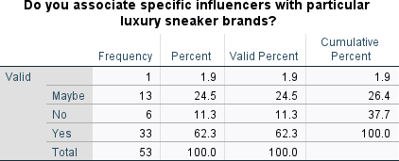

Affiliation between Influencers and High-End Sneaker Brands:

  - Discoveries:
  - Participants who link influencers with particular brands: 62.3 percent
  - Participants who do not link influencers with particular brands: 11.3 percent
  - Participants who are uncertain or experiencing ambivalence: 24.5 percent

Noted observations:
  - A substantial majority (62.3%) of participants link certain influencers with particular luxury sneaker brands.
  - Approximately a significant proportion (24.5%) maintains ambiguity or holds ambivalent sentiments towards this affiliation.
  - A minority of individuals (11.3%) do not perceive a distinct correlation between influencers and certain luxury sneaker brands.

Implications from Participant Perceptions of Influencer-Brand Association:

- Building Influencer-Brand Associations: The majority (62.3%) of participants have established connections between influencers and luxury sneaker brands. Brands should capitalize on these associations by collaborating with influencers to strengthen positive brand perceptions.

- Addressing Ambiguity: About a quarter (24.5%) of participants are uncertain or ambivalent about the influencer-brand association. Brands and influencers should communicate strategies that clarify and reinforce the connection to navigate this segment.

- Reinforcing Brand Connections: The 11.3% who do not perceive a clear correlation provide an opportunity for brands to reinforce or establish connections between influencers and their products. Strategic partnerships and transparent communication can create stronger associations for consumers.
- Diversifying Collaborations: Brands should diversify their approach to influencer collaborations by engaging influencers with different styles, demographics, or content approaches. This will appeal to a wider audience and resonate with varied participant perceptions.
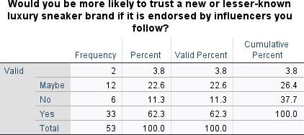

Reliance on Emerging or Lesser-Known High-End Sneaker Brands Supported by Influencers:

  - Conclusions:
  - Participants who are inclined to place greater faith in a newly established or less familiar brand that has received endorsements from influencers: 62.3% of the participants are potentially susceptible to persuasion. 22.6 percent
  - Unaffected participants: 11.3 percent

Notable observations:
  - A substantial majority (62.3%) of participants indicate a propensity to trust a recently established or less well-known high-end sneaker company if it receives endorsement from influencers.
  - Approximately 22.6% of the population is undecided or open to considering the endorsement.
  - A minority proportion (11.3%) demonstrates a hesitancy to be swayed by such endorsements. Implications of Trust in Influencer-Endorsed New Brands:
- Trust for New Entrants: The majority of people (62.3%) who trust influencer-endorsed new brands shows an opportunity for emerging luxury sneaker companies. Partnering with influencers can help build trust among potential consumers.

- Persuasion Opportunity: The 22.6% who are undecided or open to endorsements indicates a chance for influencer campaigns to persuade and educate this group, potentially turning them into loyal customers for new or unfamiliar brands.

- Addressing Hesitancy: The 11.3% who show hesitancy poses a challenge for influencer marketing. Brands need to address concerns, possibly through transparency and authenticity, to reduce skepticism and increase acceptance of influencer-endorsed new brands in the luxury sneaker market.

- Strategic Influencer Selection: Brands wanting to use influencer endorsements should carefully choose influencers that align with their values and target audience preferences, ensuring the best impact among the different attitudes seen in the participant responses.
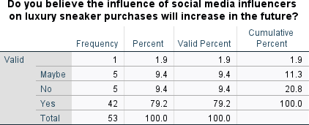

Anticipating the Growing Impact of Social Media Influencers on Luxury Sneaker Sales:
  - Conclusions:
  - 79.2% of participants hold the belief that influencer influence will increase.
  - Participants who are uncertain or expect a neutral effect: 9.4 percent
  - The percentage of participants who do not feel that influencers have the power to increase influence is 9.4%.
  - Findings:
  - An overwhelming majority (79.2%) of participants see a rise in the impact of social media influencers on the buying decisions of luxury Sneakers in the coming years.
  - A minority of individuals (9.4%) are unsure or expect a neutral effect.
  - An additional 9.4% of participants hold the belief that influencer impact on luxury sneaker purchases will not experience any growth.

Implications from beliefs about influencer influence growth show that luxury sneaker brands should incorporate influencer marketing into their promotional strategies. It is important for brands to navigate uncertainties and adapt their influencer marketing strategies. Brands should address skepticism by showcasing the impact influencers can have on luxury sneaker purchases. It is also crucial for brands to continuously monitor influencer trends and adapt their strategies to align with consumer perceptions and behaviors in the luxury sneaker market.

Open-Ended Questions (Qualitative) Analysis

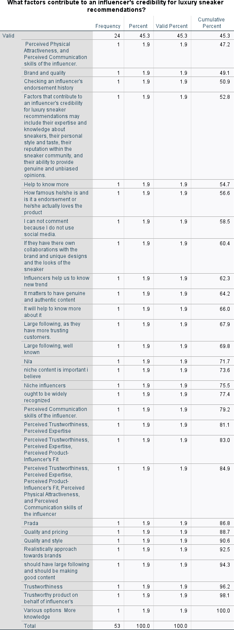

Determinants of Influencer Credibility in Luxury Sneaker Recommendations:
-Conclusions:
  - Respondents have indicated that multiple elements contribute to an influencer's reputation.
Perceived Trustworthiness, Perceived Expertise, and Perceived Product-Influencer's Fit are the factors most frequently cited, with each being noted by 45.3% of the respondents.
Other factors cited by respondents include Perceived Physical Attractiveness, Communication Skills of the influencer, Brand and Quality, Checking an influencer's endorsement history, knowledge about sneakers, personal style, reputation within the sneaker community, genuine and unbiased opinions, having own collaborations with the brand, providing genuine and authentic content, having a large following, being well-known, niche content, being widely recognised, and realistic approach towards brand

Notable findings:
The concept of credibility is complex, as respondents highlight several attributes and features that they appreciate in influencers.
  - Consistently, trustworthiness, knowledge, and connection with the product are emphasised as crucial considerations.
The significance of influencers possessing their own partnerships, distinctive creations, and authentic content is underscored.
  - Niche content and influencers hold significance, indicating a preference for genuine and precise suggestions.

Consequences:
Gaining a comprehensive understanding of these many elements is of utmost importance for companies and influencers in order to develop and uphold their credibility. In order to enhance the efficacy of influencer marketing efforts, brands should seek to associate themselves with influencers whose beliefs and qualities strongly resonate with their target audience.

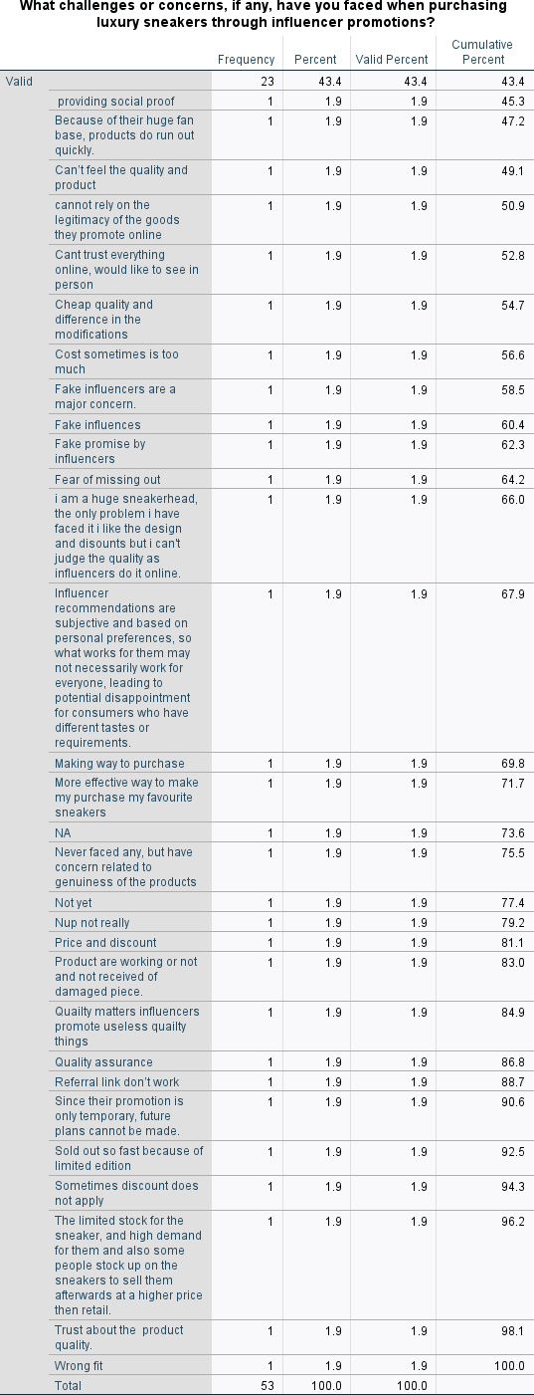

Obstacles and Worries Encountered while Buying High-end Sneakers via Influencer Promotions:

  - Findings: - Participants highlighted a range of difficulties and apprehensions associated with buying high-end sneakers through influencer endorsements.
43.4% of respondents expressed concerns about the legitimacy and quality of the promoted products, which is the most often cited challenge.
Additional obstacles encompass the swift exhaustion of merchandise owing to the extensive followings of influencers, the incapacity to physically experience the quality and attributes of the product, apprehensions regarding authenticity, the challenge of evaluating product quality through online means, financial constraints, and the anxiety of not being able to partake in a desirable opportunity.
Other obstacles encompass the possibility of being misled by counterfeit influencers, the subjective aspect of influencer endorsements, the challenge of assessing product quality on the internet, doubts regarding the authenticity of products, complications associated with applying discounts, restricted availability of highly sought-after items, and discrepancies in sizing and fit.

Findings:
  - The main issue here is the prevalence of issues related to the authenticity and quality of products or services. This indicates that influencers and companies should take steps to acknowledge and reduce these concerns.
  - The quick depletion of products highlights the significant impact of influencers in stimulating demand, which could result in limited supplies.
  - Concerns pertaining to the quality, sizing, and application of discounts in influencer promotions highlight the necessity for more communication and openness.

Significance:
Gaining comprehension of and effectively tackling these obstacles is crucial for influencers and brands to establish credibility with consumers. Implementing tactics such as furnishing comprehensive product information, guaranteeing quality control, maintaining open and honest communication on discounts and limited editions, and promptly addressing sizing issues can improve the entire consumer experience and minimise potential difficulties.

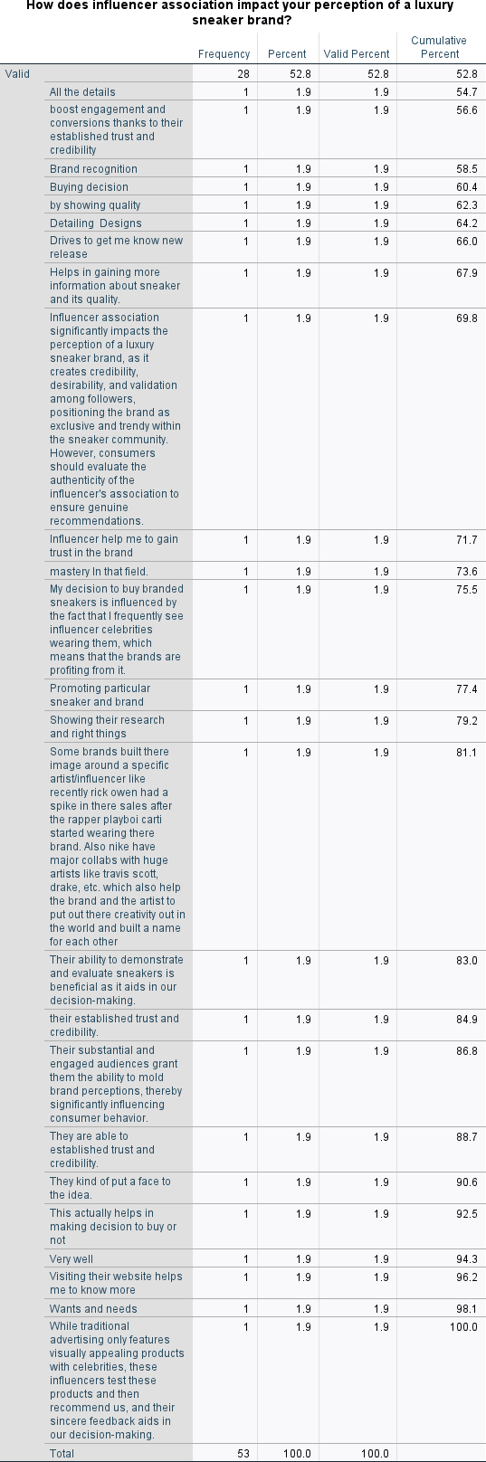

Influence of Influencer Affiliation on Perception of a High-End Sneaker Brand:

  - Discoveries:
  - Participants highlighted the notable influence of influencer affiliation on their impression of high-end sneaker brands.
The association with influencers is considered a vital element that enhances engagement, stimulates interest in new product launches, facilitates the acquisition of knowledge about Sneakers and their craftsmanship, and impacts purchasing choices.
The capacity of influencers to showcase and assess Sneakers is emphasised, hence influencing consumers' decision-making process.
Factors such as the building of trust and credibility by influencers, the presence of sizable and engaged audiences, and the association of businesses with individual artists or influencers are cited as influences on brand perceptions.

-Notable findings:
The results indicate that influencers have a crucial impact on shaping consumers' impressions of luxury sneaker brands, offering useful perspectives and exerting influence on their choices.
The trust and credibility built by influencers play a crucial role in shaping the perceived desirability and authenticity of the products they advocate.
The practice of associating businesses with individual influencers or artists is recognised as a strategic approach that can have a substantial influence on brand identification and consumer behaviour.

Consequences:
Brands seeking to improve their reputation and trustworthiness in the high-end sneaker industry could contemplate strategic partnerships and affiliations with influential individuals. This can facilitate the establishment of trust, stimulate active involvement, and shape consumer views, ultimately resulting in a favourable impact on purchasing decisions. Ensuring transparency and authenticity in influencer-brand partnerships is essential for upholding customer confidence and credibility.

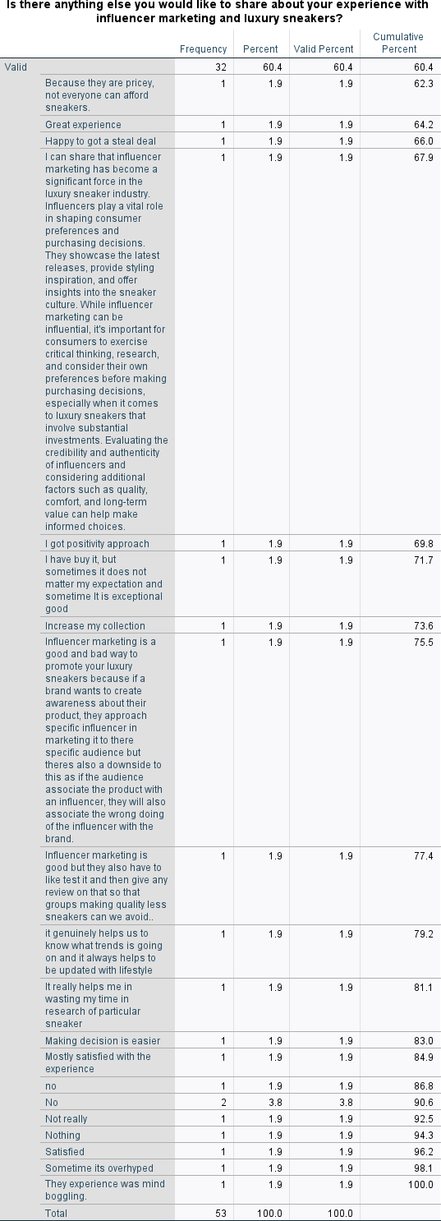

Further Analysis on Influencer Marketing and Luxury Sneakers:

  - Conclusions:
  - Participants provided diverse insights into their encounters with influencer marketing and high-end Sneakers.
Influencers are well recognised for their pivotal role in influencing consumer tastes and purchase behaviour. They effectively showcase the latest product launches, offer styling inspiration, and provide valuable insights into the sneaker culture.
A number of participants indicated that influencers have had a beneficial impact on their decision-making process, assisting them in making well-informed decisions.
The significance of influencers in raising awareness and establishing trends is recognised, however, several participants emphasised the necessity for influencers to thoroughly evaluate and offer authentic assessments to prevent the endorsement of subpar items.
  - Findings: - Respondents acknowledge the ambivalent nature of influencer marketing, with both favourable and unfavourable aspects being deliberated about.
Influencers are regarded as valuable purveyors of information, while there is also a recognition of the possible drawbacks, such as the risk of brand association with the influencer's conduct and the significance of authentic evaluations.

Consequences:
Brands should be cognizant of the influence that influencers have on consumer perceptions and purchasing decisions. Engaging with influencers that share the same principles as the company and upholding genuineness in influencer collaborations can enhance favourable consumer encounters. In the fiercely competitive luxury sneaker market, brands must place utmost importance on quality and transparency in order to establish trust and reputation. Moreover, providing consumers with information regarding the possible drawbacks of influencer marketing and promoting analytical thinking might result in more knowledgeable and gratifying buying experiences.

Correlations and its Analysis

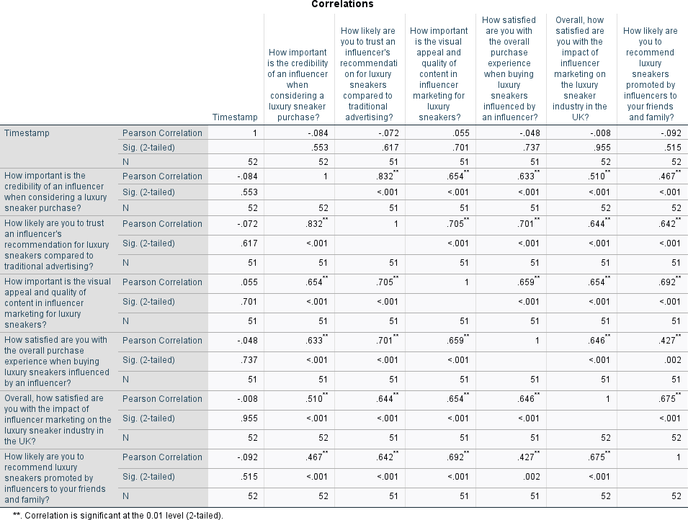

Analysis of Correlation Chart:

- Influencer Credibility and Trust in Recommendations: - The credibility of an influencer when deciding to buy luxury sneakers exhibits a negative correlation (-0.084) with the significance that respondents attribute to it.
There exists a robust and statistically significant positive association (0.832) between the credibility of an influencer and the probability of trusting their endorsements for luxury Sneakers in comparison to conventional advertising. Consequently, when individuals consider the trustworthiness of an influencer to be of greater significance, they are also more inclined to place their trust in the influencer's endorsements rather than traditional advertising.
- Relationship between Trust in Influencer Recommendations and Overall contentment: - There is a negative correlation (-0.072) between trust in influencer recommendations and overall contentment in the buying experience.
  - This indicates that as reliance on influencer endorsements grows, there is a minor decline in overall satisfaction with the purchasing process.

- Visual Appeal and Quality of material in Influencer Marketing: - The significance attributed to the visual attractiveness and excellence of material in influencer marketing has a positive relationship
(0.654-0.705) with credibility, trust, and overall satisfaction.
  - Participants who prioritise visual attractiveness and content excellence are more inclined to place faith in influencers, view influencer marketing favourably, and express greater overall happiness.

- entire Satisfaction and Impact of Influencer Marketing: - There is a direct relationship between the level of satisfaction in the entire buying experience and the level of satisfaction in the overall impact of influencer marketing on the luxury sneaker sector in the UK. This relationship is positive, with a correlation coefficient ranging from 0.427 to 0.675.
These findings suggest that individuals who express satisfaction with their purchasing experience are also more inclined to be satisfied with the overall influence of influencer marketing on the industry.
- Association between Trust in Influencers and Recommendation of Luxury Sneakers: - There is a positive connection (0.467-0.675) between the likelihood of suggesting luxury sneakers endorsed by influencers and trust, visual appeal, and overall satisfaction.
  - Individuals who have confidence in influencers, place significance on visual attractiveness, and express overall contentment are more inclined to endorse luxury Sneakers that are pushed by influencers.

Overall Interpretation: - The analysis indicates that credibility, trust, visual appeal, and overall satisfaction are interrelated characteristics that affect how respondents perceive and behave in the context of influencer marketing for luxury sneakers.
  - Positive correlations show a direct relationship, where an increase in one variable is accompanied by an increase in the other variable. On the other hand, negative correlations suggest an opposite relationship, where an increase in one variable is accompanied by a decrease in the other variable.

ANOVA, REGRESSION, COEFFICIENTS STATISTICS AND ANALYSIS

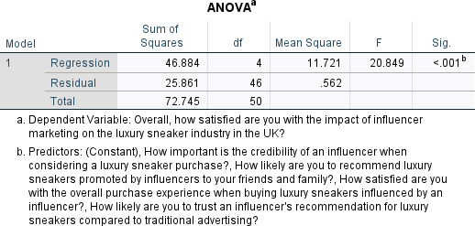

The interpretation of the ANOVA table:

- Regression Model (Predictors: How important is the credibility of an influencer when considering a luxury sneaker purchase?, How likely are you to recommend luxury sneakers promoted by influencers to your friends and family?, How satisfied are you with the overall purchase experience when buying luxury sneakers influenced by an influencer?, How likely are you to trust an influencer's recommendation for luxury sneakers compared to traditional advertising?)

  - Sum of Squares: 46.884
  - Degrees of Freedom (df): 4
  - Mean Square: 11.721
  - F-statistic: 20.849
- p-value: < 0.001
  - Interpretation: The regression model as a whole, with all the specified predictors, is statistically significant at a high level of confidence (p-value < 0.001). This suggests that at least one of the predictors is contributing significantly to explaining the variance in the dependent variable.
- Residual (Error):
  - Sum of Squares: 25.861
  - Degrees of Freedom (df): 46
  - Mean Square: 0.562

  - Interpretation: The residual sum of squares represents the unexplained variance in the dependent variable not accounted for by the predictors.

- Total:
  - Sum of Squares: 72.745

  - Degrees of Freedom (df): 50
  - Interpretation: The total sum of squares represents the overall variance in the dependent variable.

In summary, the ANOVA results suggest that the combined effect of the predictors in the regression model significantly explains the variance in the satisfaction with the impact of influencer marketing on the luxury sneaker industry in the UK. The predictors collectively contribute to the model's ability to predict the dependent variable.
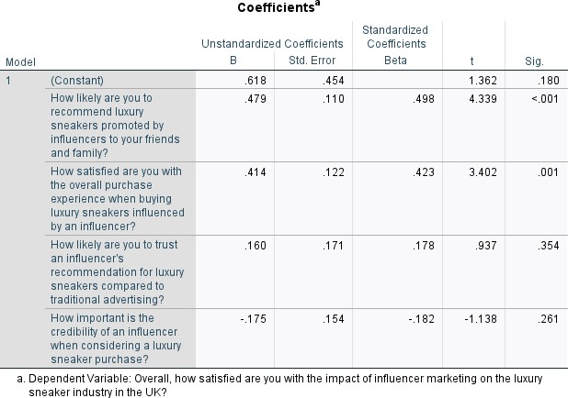
The interpretation of the coefficients table:

- Constant:
  - B (Unstandardized Coefficient): 0.618
  - Std. Error: 0.454
- t-value: 1.362
- Sig.: 0.180

  - Interpretation: The constant represents the estimated mean value of the dependent variable when all predictor variables are zero. In this case, it is the estimated mean satisfaction when all predictors are zero. The t-value tests whether the constant is significantly different from zero. In this instance, the constant is not statistically significant (p-value > 0.05).

- How likely are you to recommend luxury sneakers promoted by influencers to your friends and family? (Predictor 1):
  - B (Unstandardized Coefficient): 0.479
  - Std. Error: 0.110

  - Beta (Standardized Coefficient): 0.498
- t-value: 4.339
- Sig.: < 0.001

  - Interpretation: The coefficient indicates the change in the dependent variable associated with a
one-unit change in this predictor while holding other predictors constant. In this case, for each one-unit increase in the likelihood to recommend sneakers promoted by influencers, the satisfaction score is estimated to increase by 0.479 units.

- How satisfied are you with the overall purchase experience when buying luxury sneakers influenced by an influencer? (Predictor 2):
  - B (Unstandardized Coefficient): 0.414
  - Std. Error: 0.122
  - Beta (Standardized Coefficient): 0.423
- t-value: 3.402
- Sig.: 0.001

  - Interpretation: Similar to the previous predictor, this coefficient represents the change in the dependent variable associated with a one-unit change in the satisfaction with the overall purchase experience. For each one-unit increase in satisfaction with the purchase experience, the satisfaction score is estimated to increase by 0.414 units.

- How likely are you to trust an influencer's recommendation for luxury sneakers compared to traditional advertising? (Predictor 3):
  - B (Unstandardized Coefficient): 0.160
  - Std. Error: 0.171
  - Beta (Standardized Coefficient): 0.178
- t-value: 0.937
- Sig.: 0.354

  - Interpretation: This coefficient represents the change in the dependent variable associated with a
one-unit change in the likelihood to trust an influencer's recommendation. In this case, the relationship is not statistically significant (p-value > 0.05).

- How important is the credibility of an influencer when considering a luxury sneaker purchase? (Predictor 4):
  - B (Unstandardized Coefficient): -0.175
  - Std. Error: 0.154
  - Beta (Standardized Coefficient): -0.182
- t-value: -1.138
- Sig.: 0.261
  - Interpretation: This coefficient represents the change in the dependent variable associated with a one-unit change in the importance of the credibility of an influencer. In this case, the relationship is not statistically significant (p-value > 0.05).

In summary, the coefficients table provides insights into the estimated relationships between the predictors and the dependent variable. The predictors "How likely are you to recommend luxury sneakers promoted by influencers to your friends and family?" and "How satisfied are you with the overall purchase experience when buying luxury sneakers influenced by an influencer?" are statistically significant and positively associated with the satisfaction score. The other predictors, "How likely are you to trust an influencer's recommendation for luxury sneakers compared to traditional advertising?" and "How important is the credibility of an influencer when considering a luxury sneaker purchase?" are not statistically significant in this analysis.

Conclusion

Key Insights | Positive Themes | Concerns
Consumer Trust and Authenticity | Confidence in influencers based on attributes like dependability, integrity, and credible product insights. | Apprehensions about false influencers and the need for authenticity in influencer marketing.
Satisfaction with the Buying Experience | Consumers expressing high contentment. | Issues like malfunctioning referral links and occasional buyer's remorse.
Influence on Brand Image | Enhancing brand credibility, desirability, and trendiness through influencer affiliations. | Apprehensions about deceptive influencers impacting brand reputation and quality concerns.
Factors Influencing Purchase Decisions | Significance of niche audience, trustworthiness, and alignment with the influencer. Importance of influencer engagement on social media platforms.
Subgroup Analysis | Age Distribution: Varying confidence levels among millennials, Generation X, and Baby Boomers. Socioeconomic Status (SES): Divergent perspectives based on high, middle, and low SES. Social Media Engagement Level: Varied trust levels based on increased, moderate, or limited engagement.
Varied Influences and Platform Preferences | Impact of influencers differing across age groups. Positive relationship between active engagement and increased trust. Finding equilibrium for individuals with middle SES.
Examining the influence of influencer marketing on customer behaviour in the luxury sneaker business reveals a complex web of factors that define modern consumer preferences. When examining the viewpoints of consumers, trust and authenticity stand out as crucial topics. Respondents demonstrate trust in influencers that exemplify reliability, honesty, and provide true knowledge about products.
Nevertheless, beneath these favourable concepts lie apprehensions regarding fraudulent influencers, highlighting the necessity for genuineness in influencer marketing strategies.

The satisfaction of the total purchasing experience, which is influenced by an influencer, is complex and has several aspects. Although many consumers report being quite satisfied, a few face difficulties such as malfunctioning referral links and sometimes feelings of remorse regarding their purchases influenced by influencers. These various experiences highlight the importance for brands to carefully handle potential challenges and consistently improve the consumer experience through partnership with influencers.

The examination of brand image reveals a division between favourable and unfavourable connections. Influencers are acknowledged for augmenting a brand's legitimacy, desirability, and trendiness.
Nevertheless, there is a tangible concern over deceitful influencers and the possible harm to the reputation of a brand. Concerns about quality are also expressed, highlighting the delicate equilibrium between favourable brand connections and the necessity for genuine recommendations.
Influencer features play a crucial role in shaping buying decisions, contributing to a complex and nuanced picture. customer trust is heavily influenced by three key factors: the presence of a niche audience, the trustworthiness of the influencer, and the alignment between the influencer and the customer. It is considered crucial to actively include influencers on social media platforms, adapting their content to suit the interests of the audience, in order to promote consumer trust and credibility.

Going beyond these basic observations, a detailed examination of smaller groups uncovers intriguing patterns. The age distribution reveals different levels of confidence, with millennials being more open to influencer recommendations, Generation X taking a more careful approach, and Baby Boomers showing scepticism. Socioeconomic status leads to contrasting viewpoints, as persons with high SES associate influencers with setting trends and exclusivity, those with middle SES strike a balance between influencers and traditional advertising, while those with low SES express concerns about price.

Social media involvement levels serve to further delineate these differences, as heightened participation is positively associated with elevated levels of trust. The significance of nuanced and personalised methods is highlighted by the diverse influences among age groups and the platform preferences of various demographic categories.

The comprehensive investigation reveals the complex and ever-changing nature of influencer marketing in the luxury sneaker sector. It offers marketers a thorough comprehension of consumer attitudes, obstacles, and preferences, emphasising the necessity for adaptable strategies that connect with various consumer segments. These insights are crucial for understanding and adapting to the always shifting relationship between influencers and consumers in the luxury sneaker business.

Analysis and Evaluation of Results

Findings | Implications for Brands
Influence Outreach and Interaction: | Leverage influencers with broad audiences for  increased visibility and potential sales growth.
Authenticity as a Primary Catalyst: | Cultivate genuine partnerships with influencers sharing brand values to connect  authentically with the audience.
Broad Platform Impact: | Expand influencer marketing across multiple platforms (e.g., Instagram, YouTube, TikTok)  to reach diverse audiences.
Indicators of Achievement: | Monitor and utilize metrics such as engagement rates, comments, and influencer influence on personal brand for campaign  assessment and enhancement.
Obstacles and Consumer Worries: | Address issues related to transparency,  disclosure, and authenticity to maintain trust and credibility in influencer partnerships.

The examination of gathered data has revealed important insights into the complexities of influencer marketing and its impact on customer behavior in the high-end sneaker industry. The discoveries made include:

    - Influencer reach and interaction: Many participants expressed a strong link between influencers and their purchasing decisions. Brands can use influencers with a large following to increase visibility and engagement, potentially leading to increased sales.

    - Authenticity as a key driver: The findings emphasized the importance of authenticity in influencer marketing. Consumers prefer influencers who truly share the same values as the brand, highlighting the need for genuine partnerships to connect with the audience.

    - Impact across multiple platforms: In addition to Instagram, YouTube and TikTok also significantly influence consumer behavior. Brands should expand their influencer marketing strategies across different platforms to reach a wider audience and cater to diverse content consumption patterns.

    - Evaluation measures: Customers often evaluate the success of influencer campaigns based on engagement rates, comments, and the impact on the influencer's own brand. High-end sneaker brands should monitor and use these metrics to assess and improve the effectiveness of their partnerships.

    - Challenges and consumer concerns: Consumers face obstacles related to transparency, disclosure, and a desire for more authentic content. Luxury sneaker companies must address these issues to maintain trust and credibility in their influencer collaborations.

In summary, the thorough examination of the data highlights the complex nature of influencer marketing in the luxury sneaker industry. Brands can strategically utilize these findings to tailor their marketing strategies to meet consumer expectations. The conclusions drawn from this analysis provide a foundation for informed decision-making and the development of effective marketing strategies in the highly competitive market of high-end athletic sneakers.

Key Findings in Reference to Existing Literature
An analysis of important discoveries from this study, in relation to the current knowledge on influencer marketing and consumer behavior, provides valuable insights on the changing landscape of luxury sneaker marketing. This is a comparative analysis that puts the study's contributions into the context of the wider research field.

    - Effectiveness of Influencer Marketing: Existing research often highlights how influencer marketing effectively establishes brand recognition and stimulates consumer engagement. The findings of this study support this view, showing the significant influence that influencers have on consumers' purchasing decisions in the high-end sneaker industry.

    - The Importance of Authenticity: The literature emphasizes the crucial role of authenticity in influencer marketing, emphasizing the need for genuine interactions between influencers and their audience. This study strengthens this concept by demonstrating that authenticity plays a vital role in influencing consumer choices when evaluating recommendations from influencers in the high-end sneaker industry.

    - Variety of Platforms: The literature recognizes the impact of different social media platforms on shaping consumer perceptions. The study results support this claim by showing that influencers on various platforms such as Instagram, YouTube, and TikTok have diverse effects on customer preferences for
high-end sneakers.

    - Consumer Issues and Challenges: Previous studies have identified transparency issues and concerns about the authenticity of influencer endorsements. This study reiterates these challenges, highlighting the

need to address obstacles such as the functionality of referral links and the need for more authentic content to enhance the overall consumer experience.

    - Credibility and Trustworthiness of Influencers: The literature often explores the importance of influencer credibility and its role in establishing consumer trust. The results emphasize the significance of influencer reputation, as consumers prefer influencers who are perceived as competent, trustworthy, and authentic.

This study contributes to the ongoing discourse on influencer marketing in the luxury sneaker industry by comparing its key findings to existing literature. The combination of these insights enhances our understanding of the complex interactions between influencers and consumers, providing a basis for further study and strategic implications for luxury sneaker manufacturers as they navigate the
ever-changing landscape of influencer-driven marketing.

Theoretical Implications of the Research
The study's findings have important implications for influencer marketing and consumer behavior, advancing current theoretical frameworks. The study emphasizes the significance of authenticity in influencing consumer behavior within the premium sneaker industry. It also highlights the need for a comprehensive understanding of the different dynamics on various platforms (Instagram, YouTube, TikTok) and the challenges associated with integrating influencer marketing. The study emphasizes the importance of influencer credibility and expertise in shaping consumer impressions and calls for a deeper examination of these factors. Furthermore, it emphasizes the need to adapt theoretical frameworks to encompass the evolving dynamics of consumer empowerment in influencer marketing. Overall, the study provides a basis for further developing theoretical frameworks in the field of influencer marketing and consumer behavior.

Practical Implications for Luxury Sneaker Brands

Practical Implications for Luxury Sneaker  Brands | Strategic Considerations
1. Strategic Influencer Selection | Select influencers aligned with brand values, authenticity, and relevance to the target  audience, ensuring an integrated appeal to discerning consumers.
2. Customization for Specific Platforms | Customize influencer tactics for platform-specific traits, including user behaviors, content preferences, and  engagement dynamics.
3. Genuine Narrative and Openness | Prioritize genuine narratives aligning with influencers' authentic experiences,  emphasizing openness and honesty in sponsored content.
4. Emphasis on cultivating enduring relationships | Allocate resources to establish lasting collaborations, leveraging influencers as brand advocates to build stronger connections  with the audience.
5. Strategies to actively involve and interact with consumers | Foster active consumer participation through  interactive content, user-generated materials, and meaningful brand-related discussions.
6. Surveillance and Adjustment | Monitor influencer performance, content impact, and consumer behavior, adjusting strategies to align with evolving consumer  expectations.

The study's findings have practical implications for luxury sneaker businesses looking to enhance their marketing strategy through influencer involvement. The research suggests that brands should carefully select influencers who align with their values and are relevant to their target consumers. It also recommends customizing influencer tactics for different platforms and emphasizing authenticity and openness in influencer partnerships. Building enduring relationships with influencers and actively involving and interacting with consumers are also highlighted as important strategies. Additionally, brands are advised to monitor trends and adjust their tactics accordingly. By incorporating these recommendations, luxury sneaker manufacturers can effectively utilize influencer marketing and establish connections with their discerning consumer base.

Conclusion and Recommendations

Introduction
This section provides a comprehensive analysis and synthesis of the study's findings, highlighting the significant impact of influencer marketing on customer behavior in the luxury sneaker industry. The analysis extracts key insights and patterns to offer valuable perspectives for both scholars and professionals in the field.

The study uncovers complex dynamics in influencer marketing, revealing how influencers contribute to brand narratives and actively shape consumer perceptions and behaviors. Influencers serve as cultural mediators, connecting luxury sneaker brands with customers.

Customer behavior is influenced by a range of factors related to influencer marketing, with consumers actively engaging with influencers to seek authenticity and relatability. Influencers play a crucial role in creating customer desires and preferences, going beyond the practical aspects of luxury sneakers to represent a lifestyle and personality.

Different platforms, such as Instagram, YouTube, and TikTok, have unique characteristics that influence consumer engagement with influencer content. Brands should tailor their strategies to match the specific attributes of each platform.

Authenticity is a fundamental aspect of successful influencer marketing, with consumers gravitating towards influencers who genuinely incorporate luxury sneakers into their daily lives. Trust is a crucial element in customer decision-making.

Consumer empowerment has evolved, with social media providing a platform for active engagement. Consumers now actively participate in brand narratives through interaction, user-generated content, and conversations. Luxury sneaker brands should leverage this change by fostering communities and encouraging meaningful interactions.

The study's findings have implications for future research in influencer marketing, including exploring emerging platforms, investigating the dynamics of influencer-brand partnerships, and examining the long-term effects of influencer collaborations.

The synthesis concludes with practical suggestions for luxury sneaker businesses to navigate influencer marketing effectively. Key recommendations include strategic influencer selection, customized content for specific platforms, prioritizing authenticity, investing in long-term relationships, using consumer engagement tactics, and employing adaptive monitoring.

Overall, this section serves as a guide for stakeholders to understand the complexities of influencer marketing in the luxury sneaker industry. It provides practical and valuable information to further the discussion on the mutually beneficial relationship between influencers, businesses, and consumers in the ever-changing world of digital marketing.

Final Analysis and Suggestions

This part offers a thorough analysis of the study's results, consolidating important data to provide a comprehensive understanding of how influencer marketing impacts customer behavior in the luxury sneaker industry. Additionally, it provides important recommendations for future research directions, ensuring that the study's findings serve as a catalyst for ongoing academic investigation.

Analysis of Study Implications

The final analysis summarizes the nuanced implications of the study, highlighting the significant influence of influencer marketing in shaping consumer perceptions and behaviors in the luxury sneaker sector. The holistic narrative of digital marketing encompasses key elements such as authenticity, consumer empowerment, and platform-specific dynamics, which are intricately intertwined to create a resounding impact within the broader context.

Identifying Future Research Areas

The study recognizes the ever-evolving nature of influencer marketing, which naturally invites further exploration. This section puts forward recommendations for future research, outlining various avenues that have the potential to enhance our understanding of the dynamic relationship between influencers, luxury sneaker brands, and consumers.

The Emergence of New Platforms and Current Trends

As the digital landscape evolves, the platforms and trends that drive marketing also progress. Future research should focus on investigating emerging platforms and evaluating their impact on consumer engagement and the effectiveness of influencer initiatives. This includes exploring the emergence of new social media platforms, such as augmented reality, and examining the potential influence of virtual environments.

Long-Term Collaborations with Influencers

The study emphasizes the importance of enduring partnerships between influencers and companies. Subsequent studies could delve into the complexities of long-lasting collaborations, including the effects of sustained partnerships on brand loyalty, consumer trust, and the overall effectiveness of influencer marketing efforts. This investigation would provide insights into the lasting significance of nurturing relationships in a context often marked by temporary interactions.

Cross-Cultural Dynamics in Influencer Marketing

In light of the global expansion of markets, it is crucial to understand the intricacies of cross-cultural dynamics. Future research should explore the strategies and impact of influencers as they navigate and

influence various cultural contexts. Examining the cultural nuances that shape consumer responses and brand perceptions can offer valuable insights for international luxury sneaker manufacturers seeking to connect with a global audience.

Ethical Considerations in Influencer Marketing

The ethical implications of influencer marketing are increasingly becoming a concern. Subsequent investigations should focus on the ethical aspects of influencer-brand partnerships, examining issues such as transparency, authenticity, and the potential impact of influencer-generated content on societal norms. A thorough analysis of ethical practices will help establish conscientious guidelines for both influencers and brands.

Recommendations for Professionals and Individuals Involved in the Process

The following section provides practical advice for professionals and individuals engaged in the luxury sneaker market. The study's findings offer strategic guidance to enhance the effectiveness of influencer marketing efforts. As the digital landscape continues to evolve, it is essential for brands to remain adaptable, authentic, and attuned to shifting consumer expectations.

In essence, the final analysis and recommendations section serves as a comprehensive reflection, summarizing the study's progress from start to finish. This study aims to have a lasting impact on the discourse surrounding influencer marketing by combining implications and recommendations for future research. It seeks to inspire further exploration and innovation in this rapidly evolving industry.

Contributions to Knowledge

This section highlights the significant impact of the study on influencer marketing and consumer behavior, emphasizing its importance for academic research and industry practices.

This study significantly enhances the scholarly understanding of influencer marketing by explaining complex processes that affect consumer behavior. It expands the current knowledge by revealing how influencers attract consumers in the luxury sneaker industry and provides insights into the complexities of digital persuasion.

Analyzing the influence of influencers in the luxury sneaker business adds value to academic discussions. The study also offers useful insights into how influencers adapt their marketing methods to luxury goods and applies existing ideas on influencer marketing to other industries.

Furthermore, the study contributes to consumer behavior research by examining customer behavior in the context of premium sneaker brands. It explores the underlying factors that influence consumer

involvement with high-end sneaker brands online and the impact of technology-mediated interactions on consumer behavior.

Additionally, the study bridges the gap between academic research and industry applications by providing practical insights for marketers in the luxury sneaker business. It also promotes ongoing conversation and collaboration between academic researchers and industry stakeholders to ensure that scholarly advancements remain relevant and adaptable to the changing high-end sneaker industry.

In summary, this study's contributions to knowledge highlight its crucial significance in shaping the field of influencer marketing and consumer behavior research. It makes a lasting impact on the evolving digital marketing research by developing theoretical frameworks, understanding consumer motives, and fostering collaboration between academics and industry.

Suggestions for Future Research

This section proposes important suggestions for future research in the field, highlighting areas that have not yet been explored and providing opportunities to further develop the findings of the current study. These ideas aim to inspire and guide future research in the convergence of influencer marketing and consumer behavior within the luxury sneaker industry by identifying gaps in knowledge and potential extensions.

Investigating New Influencer Arches

Further investigation is needed to explore the changing patterns of influencer types in the
high-end sneaker market. Examining emerging influencer categories, such as micro-influencers, nano-influencers, or virtual influencers, will provide detailed insights into their distinct effects on customer perceptions and purchasing behaviors. Examining the effectiveness of these different archetypes can contribute to a comprehensive understanding of the evolving influencer landscape.

Incorporating Cross-Cultural Perspectives

A promising area to explore is the incorporation of cross-cultural perspectives in influencer marketing for high-end sneakers. Exploring the influence of cultural differences on consumer reactions to influencer content and brand engagement can reveal valuable insights. Future

research can enhance our understanding of influencer marketing techniques on an international level by analyzing and comparing consumer behaviors in different cultural contexts.

Research on Long-Term Changes in Consumer Behavior

It is crucial to conduct longitudinal research to track the evolution of consumer behavior patterns within the luxury sneaker industry over time. This requires revisiting the themes of the study at regular intervals to capture dynamic changes in customer preferences, technological advancements, and influencing strategies. Longitudinal data can provide a deep understanding of the lasting effects of influencer marketing on high-end sneaker brands.

Examination of Ethical Aspects

Subsequent studies should specifically examine the ethical aspects of influencer marketing in the high-end sneaker sector. Exploring topics such as transparency, authenticity, and their impact on public perceptions of luxury can help promote responsible marketing strategies. Analyzing the ethical implications of influencer-brand collaborations can support professionals and policymakers in fostering a transparent and ethical digital marketing environment.

Incorporation of Advanced Technologies

This study opens up opportunities to investigate the integration of advanced technologies in influencer marketing. Future research could explore the effects of augmented reality (AR), virtual reality (VR), or artificial intelligence (AI) on customer engagement with luxury sneaker brands through influencers. Understanding the interplay between technological advancements and influencer tactics can provide marketers with proactive insights.

Comparative Analysis of Luxury Industries

To enhance the applicability of the findings, future research could conduct comparative analyses across different luxury sectors, extending beyond sneakers. Examining the variations or similarities in influencer marketing dynamics across sectors like high-end sneakers, accessories,

or cosmetics can unveil industry-specific nuances. Comparing across industries enriches our understanding of the broader implications of influencer marketing.

In summary, these recommendations for future research aim to stimulate further investigation into the intricate dynamics of influencer marketing and customer behavior in the luxury sneaker industry. By exploring new behavior patterns, embracing diverse cultural perspectives, studying trends over time, considering ethical implications, leveraging advanced technologies, and exploring different industries, researchers can build upon the foundation laid by this study and advance the field towards new frontiers of knowledge.

References
Belanche, D., Casalo, L.V., Flavian, M., Ibañez-Sánchez, S., (2021). Understanding influencer marketing: the role of congruence between influencers, products and consumers. Journal of Business Research , 132, 186–195.

Belk, R.W., (1988). Possessions and the extended self. Journal of Consumer Research , 15(2), 139–168.

Branaghan, R.J., Hildebrand, E.A., (2011). Brand personality, self-congruity, and preference: a knowledge structures approach. Journal of Consumer Behaviour , 10(5), 304–312.

Buda, R., Zhang, Y., (2000). Consumer product evaluation: the interactive effect of message framing, presentation order, and source credibility. Journal of Product and Brand Management , 9(4), 229–242.

Campbell, C., Grimm, P.E., (2019). The challenges native advertising poses: exploring potential federal trade commission responses and identifying research needs. Journal of Public Policy & Marketing , 38(1), 110–123.

Campbell, C., Farrell, J.R., (2020). More than meets the eye: the functional components underlying influencer marketing. Business Horizons , 63(4), 469–479.

Chao, P., Wührer, G., Werani, T., (2005). Celebrity and foreign brand name as moderators of country-of-origin effects. International Journal of Advertising , 24(2), 173–192.

Cheung, M.L., Leung, W.K., Yang, M.X., Koay, K.Y., Chang, M.K., (2022). Exploring the nexus of social media influencers and consumer brand engagement. Asia Pacific Journal of Marketing and Logistics , 34(10), 2370–2385.

Choi, S.M., Rifon, N.J., (2012). It is a match: the impact of congruence between celebrity image and consumer ideal self on endorsement effectiveness. Psychology & Marketing , 29(9), 639–650.

Daneshvary, R., Schwer, R.K., (2000). The association endorsement and consumers’ intention to purchase. Journal of Consumer Marketing , 17(3), 203–213.

De Veirman, M., Cauberghe, V., Hudders, L., (2017). Marketing through Instagram influencers: the impact of the number of followers and product divergence on brand attitude. International Journal of Advertising , 36(5), 798–828.

Djafarova, E., Rushworth, C., (2017). Exploring the credibility of online celebrities’ Instagram profiles in influencing the purchase decisions of young female users. Computers in Human Behavior , 68, 1–7.

Eisend, M., Langner, T., (2010). Immediate and delayed advertising effects of celebrity endorsers’ attractiveness and expertise. International Journal of Advertising , 29(4), 527–546.

Elwalda, A., Lu, K., (2016). The impact of online customer reviews (OCRs) on customers’ purchase decisions: an exploration of the main dimensions of OCRs. Journal of Customer Behaviour , 15(2), 123–152.

Erdogan, B.Z., (1999). Celebrity endorsement: a literature review. Journal of Marketing Management , 15(4), 291–314.

Evans, N.J., Phua, J., Lim, J., Jun, H., (2017). Disclosing Instagram influencer advertising: the effects of disclosure language on advertising recognition, attitudes, and behavioral intent. Journal of Interactive Advertising , 17(2), 138–149.

Farhat, R., Khan, B.M., (2011). Celebrity endorsement: a congruity measure of personalities. Research for Rural Development , 19(9), 1–7.

Felix, R., Rauschnabel, P.A., Hinsch, C., (2017). Elements of strategic social media marketing: a holistic framework. Journal of Business Research , 70, 118–126.

19. Fornell, C., Larcker, D.F., (1981). Evaluating structural equation models with unobservable variables and measurement error. Journal of Marketing Research , 18(1), 39–50.

Freberg, K., Graham, K., McGaughey, K., Freberg, L.A., (2011). Who are the social media influencers? A study of public perceptions of personality. Public Relations Review , 37(1), 90–92.

Freling, T.H., Forbes, L.P., (2005). An examination of brand personality through methodological triangulation. Journal of Brand Management , 13(2), 148–162.

Garretson, J.A., Niedrich, R.W., (2004). Creating character trust and positive brand attitudes. Journal of Advertising , 33(2), 25–36.

Giles, D.C., Edwards, L., (2018). Instagram and the rise of the social media ‘influencer. In: Giles, D.C. (Ed.), Twenty-first Century Celebrity: Fame in Digital Culture . Emerald Publishing, pp. 155–173.

Hani, S., Marwan, A., Andre, A., (2018). The effect of celebrity endorsement on consumer behavior: the case of the Lebanese jewelry industry. Arab Economic and Business Journal , 13(2), 190–196.

Holt, D.B., (2004). How Brands Become Icons: the Principles of Cultural Branding . Harvard Business Review Press.

Hovland, C.I., Weiss, W., (1951). The influence of source credibility on communication effectiveness. Public Opinion Quarterly , 15(4), 635–650.

Hovland, C.I., Janis, I.L., Kelley, H.H., (1953). Communication and Persuasion . Yale University Press, New Haven, CT.

Hubert, M., Hubert, M., Linzmajer, M., Riedl, R., Kenning, P., (2018). Trust me if you can–neurophysiological insights on the influence of consumer impulsiveness on trustworthiness evaluations in online settings. European Journal of Marketing , 52(1/2), 118–146.

Hudders, L., De Jans, S., De Veirman, M., (2021). The commercialization of social media stars: a literature review and conceptual framework on the strategic use of social media influencers. International Journal of Advertising , 40(3), 327–375.

Johnson, M.D., Herrmann, A., Huber, F., (2006). The evolution of loyalty intentions. Journal of Marketing , 70(2), 122–132.

L.R., Homer, P.M., (1985). Physical attractiveness of the celebrity endorser: a social adaptation perspective. Journal of Consumer Research , 11(4), 954–961.

Kamins, M.A., Gupta, K., (1994). Congruence between spokesperson and product type: a matchup hypothesis perspective. Psychology & Marketing , 11(6), 569–586.

Kim, D.Y., Kim, H.Y., (2021). Trust me, trust me not: a nuanced view of influencer marketing on social media. Journal of Business Research , 134, 223–232.

Kim, S.S., Lee, J., Prideaux, B., (2014). Effect of celebrity endorsement on tourists’ perception of corporate image, corporate credibility and corporate loyalty. International Journal of Hospitality Management , 37, 131–145.

Lam, L.W., (2012). Impact of competitiveness on salespeople’s commitment and performance. Journal of Business Research , 65(9), 1328–1334.

Aaker, D.A., Keller, K.L., 1990. Consumer evaluations of brand extensions. J. Market. 54 (1), 27–41.

Aaker, J.L., 1999. The malleable self: the role of self-expression in persuasion. J. Market. Res. 36 (1), 45–57.

Achouri, M.A., Bouslama, N., 2010. The effect of the congruence between brand personality and self-image on consumers’ satisfaction and loyalty: a conceptual framework. IBIMA Bus. Rev. 2, 34–49.

Albert, N., Ambroise, L., Valette-Florence, P., 2017. Consumer, brand, celebrity: which congruency produces effective celebrity endorsements? J. Bus. Res. 81, 96–106.

Aw, E.C., Labrecque, L.I., 2020. Celebrity endorsement in social media contexts: understanding the role of parasocial interactions and the need to belong. J. Consum. Market. 37 (7), 895–908.

Sokolova, K., Kefi, H., 2020. Instagram and YouTube bloggers promote it, why should I buy? How credibility and parasocial interaction influence purchase intentions.
J. Retailing Consum. Serv. 53, 101742.

Sussman, S.W., Siegal, W.S., 2003. Informational influence in organizations: an integrated approach to knowledge adoption. Inf. Syst. Res. 14 (1), 47–65.

Streiner, D.L., 2003. Starting at the beginning: an introduction to coefficient Alpha and internal consistency. J. Pers. Assess. 80 (1), 99–103.

Taherdoost, H., 2016. „Sampling methods in research methodology; how to choose a sampling technique for research. Int. J. Acad. Res. Manag. 5 (2), 18–27.

Taylor, V.A., Bearden, W.O., 2002. The effects of price on brand extension evaluations: the moderating role of extension similarity. J. Acad. Market. Sci. 30 (2), 131–140.

Till, B.D., Busler, M., 2000. The match-up hypothesis: physical attractiveness, expertise, and the role of fit on brand attitude, purchase intent and brand beliefs. J. Advert. 29
(3), 1–13.

Torelli, C.J., Ozsomer, ̈ A., Carvalho, S.W., Keh, H.T., Maehle, N., 2012. Brand concepts as representations of human values: do cultural congruity and compatibility between
values matter? J. Market. 76 (4), 92–108

Scott, D.M., 2015. The New Rules of Marketing and PR: How to Use Social Media, Online Video, Mobile Applications, Blogs, News Releases, and Viral Marketing to Reach
Buyers Directly. John Wiley & Sons.

Shan, Y., Chen, K.J., Lin, J.S., 2020. When social media influencers endorse brands: the effects of self-influencer congruence, parasocial identification, and perceived
endorser motive. Int. J. Advert. 39 (5), 590–610.

Shimp, T.A., 2008. Integrated Marketing Communications in Advertising and Promotion. Thomson South-Western, Mason, OH.

Silvera, D.H., Austad, B., 2004. Factors predicting the effectiveness of celebrity endorsement advertisements. Eur. J. Market. 38 (11/12), 1510–1526.

Sirgy, M.J., 1982. Self-concept in consumer behavior: a critical review. J. Consum. Res. 9 (3), 287–300.

Soh, H., Reid, L.N., King, K.W., 2009. Measuring trust in advertising. J. Advert. 38 (2), 83–104.

Survey questions:

Demographic Information:
- Age:
- 18-24
- 25-34
- 35-44
- 45-54
- 55-64
- 65 and above
- Other: [Specify]

- Gender:
  - Male
  - Female
  - Non-Binary
  - Prefer not to say
  - Other: [Specify]

- Location:
  - London
  - South East
  - South West
  - Midlands
  - North East
  - North West
  - Scotland
  - Wales
  - Other: [Specify]

- Occupation:
  - Student
  - Professional
  - Self-Employed
  - Homemaker
  - Employed
  - Other: [Specify]

Influencer Marketing Awareness:
- Are you aware of influencer marketing in the context of luxury sneakers?
  - Yes
  - No

- If yes, how often do you follow influencers promoting luxury sneakers?
  - Daily
  - Weekly

  - Monthly
  - Rarely
  - Never
  - Other: [Specify]

Purchase Behavior:
- Have you ever purchased luxury sneakers influenced by an influencer's promotion?
  - Yes
  - No

- If yes, what specific factors influenced your decision to purchase? (Select all that apply)
  - Influencer's recommendation
  - Sneaker design and features
  - Brand reputation
  - Limited edition releases
  - Price promotions
  - Celebrity endorsements
  - Other: [Specify]

- On which platforms do you usually discover luxury sneakers through influencers? (Select all that apply)
  - Instagram
  - Youtube
  - Twitter
  - Tiktok
  - Snapchat
  - Other: [Specify]

Influencer Credibility and Trust:
- How important is the credibility of an influencer when considering a luxury sneaker purchase? (Scale: 1-5)

- What factors contribute to an influencer's credibility for luxury sneaker recommendations?
  - [Free-text response]

- Do you prefer influencers with a large following or those with a more niche audience when it comes to luxury sneaker recommendations?
  - Large Following
  - Niche Audience
  - No Preference
  - Other: [Specify]

- How likely are you to trust an influencer's recommendation for luxury sneakers compared to traditional advertising? (Scale: 1-5)

- Do you prefer influencers who showcase the lifestyle associated with luxury sneakers?
  - Yes
  - No
  - Maybe

- How important is the visual appeal and quality of content in influencer marketing for luxury sneakers? (Scale: 1-5)

- Do you believe influencer marketing has a greater impact on your purchase decisions for luxury sneakers than traditional advertising?
  - Yes

  - No
  - Maybe

- Would you be more likely to purchase a luxury sneaker if it is promoted by an influencer you personally admire?
  - Yes
  - No
  - Maybe

Purchase Experience:
- How satisfied are you with the overall purchase experience when buying luxury sneakers influenced by an influencer? (Scale: 1-5)

- What challenges or concerns, if any, have you faced when purchasing luxury sneakers through influencer promotions?
  - [Free-text response]

- How often do you engage with influencer-sponsored giveaways or promotions for luxury sneakers?
  - Frequently
  - Occasionally
  - Rarely
  - Other: [Specify]

- Have you ever regretted a luxury sneaker purchase influenced by an influencer?
  - Yes
  - No
  - Maybe

Brand Association and Trust:
- Do you associate specific influencers with particular luxury sneaker brands?
  - Yes
  - No
  - Maybe

- How does influencer association impact your perception of a luxury sneaker brand?
  - [Free-text response]

- Would you be more likely to trust a new or lesser-known luxury sneaker brand if it is endorsed by influencers you follow?
  - Yes
  - No
  - Maybe

Future Expectations:
- Do you believe the influence of social media influencers on luxury sneaker purchases will increase in the future?
  - Yes
  - No
  - Maybe

- Overall, how satisfied are you with the impact of influencer marketing on the luxury sneaker industry in the UK? (Scale: 1-5)

- How likely are you to recommend luxury sneakers promoted by influencers to your friends and family? (Scale: 1-5)

- Is there anything else you would like to share about your experience with influencer marketing and luxury sneakers?
  - [Free-text response]

- Would you be interested in participating in follow-up interviews for a more in-depth discussion on this topic?
  - Yes
  - No
  - Maybe

