Athene Hamilton
2120033
Changemakers: Creativity and Value Creation
BMHP5014
Robert Nartowski
Dementia Awareness

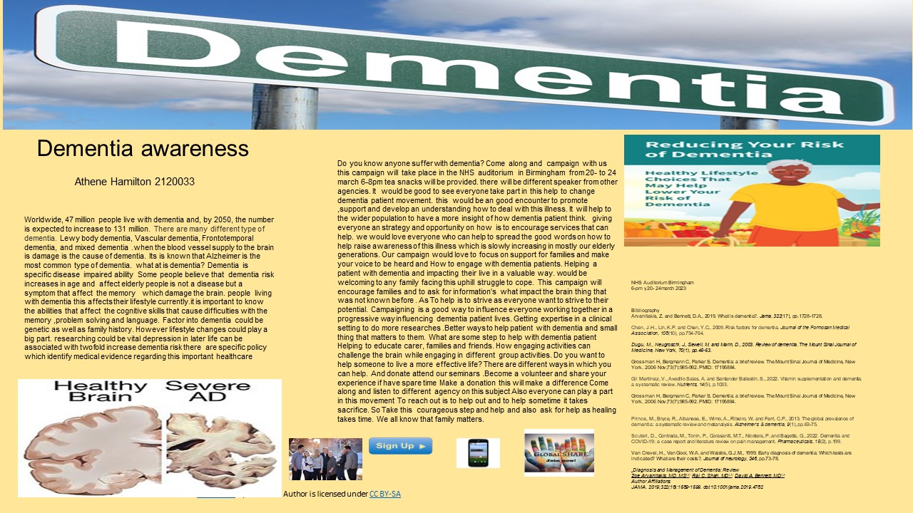
Poster Explanation
My campaign is about raising awareness about this very silent killer which affects mostly elderly populations worldwide, 47 million people live with dementia and, by 2050, the number is expected to increase to 131 million. With some similarity of life depression. working in nursing home settings people some of our customers are associated with this illness. understand how it affect a person is important. Campaigning is important because as it will raise awareness about how these patients who struggling mentally. This campaign will help to support and empower everyone who comes in contact with these patients. Recognising and promoting healthy life style choices, equality and dignity basic human rights, under the Equality Act their legal right to be protected for these patients. This campaign is aimed to have a driving force of different agency to combine different ideas and agree on objectives in order to work together with dementia patient and their families. Raising awareness is vital in a way to understand this illness and how we can help to make lives better for these patients making it effective for them. There should be an organised way of working setting activities in order to maintain and interact with people with the same intentions of changing lives. To reach out is to help out and to help out is to make sacrifices. It is essential to all generations all over the world as this form of disease affect most family life’s we know that all is born to a family may it be adopted or own everyday population is expanding people are living longer. This campaign is aiming for people to recognise how dementia can be challenging for families and the wider society. Aiming to empower family support, options, strategy to empower them knowing what entitlements and services there are. Raising awareness, the central pillar of educating people knowing the stigma. This campaigned, is centred around barriers. campaigning is about awareness and an isolated community of people feeling unloved, help is what we do. this is a silent killer which affect mostly elderly populations Worldwide. This campaign is design to accomplish and reach a good working ethics. Dementia is a problem that affect the Brain slowly it makes the brain deteriorate over time. Living dementia is very hard when someone can’t communicate the way they want. is also very difficult when someone who doesn’t know the patient/service user they are dealing with, so it is essential to have the right training and attitude to work alongside these individuals. support for families and how to engage with dementia patients and those in need of help to support patient, engaging with everyone. Demonstrating basic skills working with other health care professions and the wider society communicating well.

Pitch
Hello everyone, we are the founder of this mind-blowing achievement movement, Dementia. this number 2120033 is unique representing fulfilment and hope which also is our mission statement number to get us on. Doing campaigning in Birmingham. is very mind blowing on what dementia patient and families really would love. This could be an opportunity for all who want to know more about this mission, about what do. There is a society out there who has been stigmatised and need some friendly support to, live with dignity hope and being happy, living life to the fullest This is about help families of all walk of life. This is about ethics and values; this is about linking and independency hands this is not about stereotyping and definitely not about alone and downgraded others. Reaching out in whatever way possible working with compassion, dignity with hope in the wider communities, for the communities Representing families striving to get better help. Goal minded is always important, and with likeminded people that goal can be reached. That is why everyone does these passionate campaigning. Working with great people in different agencies we are design exclusively to help patient and their family throughout all communities that are reachable. consider joining us for this opportunity to help different areas and to establish areas of the country and their communities. this would be very exciting for everyone involved making this movement more successful. By funding, and encourage the growing population influencing other ways to help patient with dementia. What is some step to help with dementia patients Help to educate carer, families and friends How engaging activities can challenge the brain Engaging in different activities in group. Enabling dementia patient to live according to what important for them without been stereotyped, or defeated. treatment, therapy or could be past activities could be fundamental to help these patients. Therefore, strength is power, when each one tells one.

- Pitch Explanation
The need of patient who are facing this battle to cope need, care and support. helping dementia patient to live a more quality life building good relationship with identifying families need for support regardless doing it with compassion and love focus and determine, supporting an individual, respecting their rights, striving to improve needs, upholding equality, diversity and inclusion. there is always ongoing stigma about dementia patient and it is known that stigma is a negative treatment, mood swings is also noted, and changing in pattern of behaviour. Common factor associated to dementia are cognitive skills, such as communication problem thinking difficulties emotional behaviour disorientation.
According to Alzheimer's Association, 2019. 2019 Alzheimer's disease facts and figures. Alzheimer's & dementia, 15(3), pp.321-387.
“Late-life depression is consistently and similarly associated with a twofold increased risk of dementia. The precise risk estimates produced in this study for specific instruments at specified thresholds will assist evidence-based medicine and inform policy on this important population health issue” (Arvanitakis, 2019). Worldwide, 47 million people live with dementia and, by 2050, the number is expected to increase to 131 million. There are many different types of dementia. Lewy body dementia, Vascular dementia, Frontotemporal dementia, and mixed dementia. when the blood vessel supply to the brain is damage is the cause of dementia. It is known that Alzheimer is the most common type of dementia. what at is dementia? Dementia is specific disease impaired ability Some people believe that dementia risk increases in age and affect elderly people but can be develop in younger generations. is not a disease but a symptom that affect the memory which damage the brain. people living with dementia this affects their lifestyle currently. It is important to know the abilities that affect the cognitive skills that cause difficulties with the memory, problem solving and language. Factor into dementia could be genetic as well as family history. However, lifestyle changes could play a big part. researching could be vital depression in later life can be associated with twofold increase dementia risk. There is specific policy which identify medical evidence regarding this important healthcare. Below there is a content of a review that is carried out by neurology. “reviewed notes of cases carried out” 9449 individual patients, of whom 4504 (47.6%) had a dementia diagnosis (Fig. 1, Table 1), other diagnoses being mainly functional psychiatric disorders (such as depression) or cognitive problems falling short of dementia (such as mild cognitive impairment). Patients with DLB comprised 4.6% (95% CI 4.0–5.2%) of all dementia cases. Prevalence in individual services ranged from 2.4 to 5.9%, and was significantly higher among NE services (5.6%; 95% CI 4.8–6.5%; 70% greater) than in EA services (3.3%; 95% CI 2.6–4.2%; χ² = 13.6, p < 0.01). No significant variation in prevalence was observed within each region (NE, χ² = 2.54, p = 0.28; EA, χ² = 4.88, p = 0.28)”. Looking at the write up about this disease it is possible if all understand more by listening with encouragement working hand in hand. As life goes on you get older and older, we all need a shoulder. given the chance to celebrate we all have the same faith. With kind and caring love to everyone that why we are dedicated to help anyone.

Bibliography
Alzheimer's Association, 2019. 2019 Alzheimer's disease facts and figures. Alzheimer's & dementia, 15(3), pp.321-387.
Arvanitakis, Z. and Bennett, D.A., 2019. What is dementia? Jama, 322(17), pp.1728-1728.
Barnato, A.E., Birkmeyer, J.D., Skinner, J.S., O'Malley, A.J. and Birkmeyer, N.J., 2022. Treatment intensity and mortality among COVID‐19 patients with dementia: A retrospective observational study. Journal of the American Geriatrics Society, 70(1), pp.40-48.
Brodaty, H., Green, A. and Koschera, A., 2003. Meta‐analysis of psychosocial interventions for caregivers of people with dementia. Journal of the American Geriatrics Society, 51(5), pp.657-664.
Dugu, M., Neugroschl, J., Sewell, M. and Marin, D., 2003. Review of dementia. The Mount Sinai Journal of Medicine, New York, 70(1), pp.45-53.
Chen, J.H., Lin, K.P. and Chen, Y.C., 2009. Risk factors for dementia. Journal of the Formosan Medical Association, 108(10), pp.754-764.

Cherbuin N, Kim S, Anstey KJ Dementia risk estimates associated with measures of depression: a systematic review and meta-analysis
BMJ Open 2015;5:e008853. doi: 10.1136/bmjopen-2015-008853

Fazio, S., Pace, D., Flinner, J. and Kallmyer, B., 2018. The fundamentals of person-centered care for individuals with dementia. The Gerontologist, 58(suppl_1), pp.S10-S19.
Gil Martínez, V., Avedillo Salas, A. and Santander Ballestín, S., 2022. Vitamin supplementation and dementia: a systematic review. Nutrients, 14(5), p.1033.
Goerdten, J., Čukić, I., Danso, S.O., Carrière, I. and Muniz-Terrera, G., 2019. Statistical methods for dementia risk prediction and recommendations for future work: a systematic review. Alzheimer's & Dementia: Translational Research & Clinical Interventions, 5, pp.563-569.
Grossman H, Bergmann C, Parker S. Dementia: a brief review. The Mount Sinai Journal of Medicine, New York. 2006 Nov;73(7):985-992. PMID: 17195884.

Milne, A., 2023. Book Review: Social work practice with people with dementia by Peter Scourfield.
Prince, M., Bryce, R., Albanese, E., Wimo, A., Ribeiro, W. and Ferri, C.P., 2013. The global prevalence of dementia: a systematic review and metanalysis. Alzheimer's & dementia, 9(1), pp.63-75.
Ritchie, L., Henderson-Bone, S., Gregory, A. and Jenkins, N., 2023. Dementia education in a primary school classroom: A pedagogical perspective. Dementia, p.14713012221149760.
Rousseaux, M., Sève, A., Vallet, M., Pasquier, F. and Mackowiak-Cordoliani, M.A., 2010. An analysis of communication in conversation in patients with dementia. Neuropsychologia, 48(13), pp.3884-3890.

Sakamoto, M., 2023. Understanding young onset dementia: Evaluation, needs and care.
Scuteri, D., Contrada, M., Tonin, P., Corasaniti, M.T., Nicotera, P. and Bagetta, G., 2022. Dementia and COVID-19: a case report and literature review on pain management. Pharmaceuticals, 15(2), p.199.
Diagnosis and Management of Dementia: Review
Tisher, A. and Salardini, A., 2019, April. A comprehensive update on treatment of dementia. In Seminars in neurology (Vol. 39, No. 02, pp. 167-178). Thieme Medical Publishers.
Zoe Arvanitakis, MD, MS^{1,2}; Raj C. Shah, MD^{1,3}; David A. Bennett, MD^{1,2}
Author Affiliations
JAMA. 2019;322(16):1589-1599. doi:10.1001/jama.2019.4782

