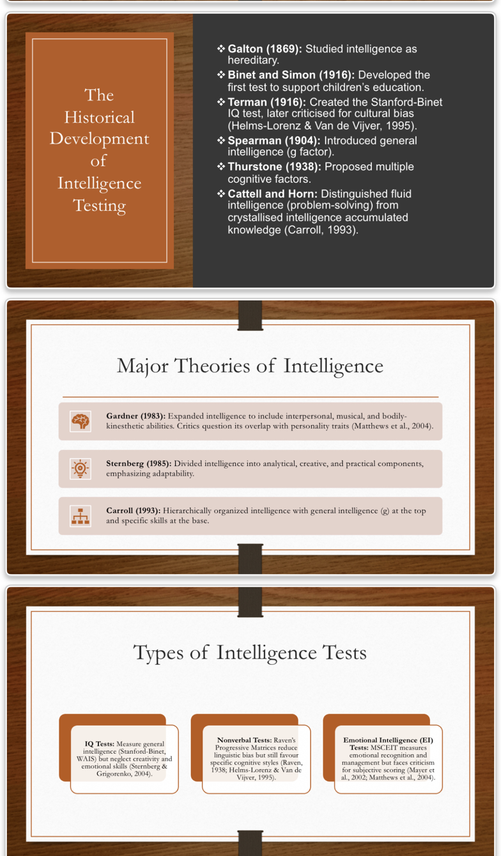
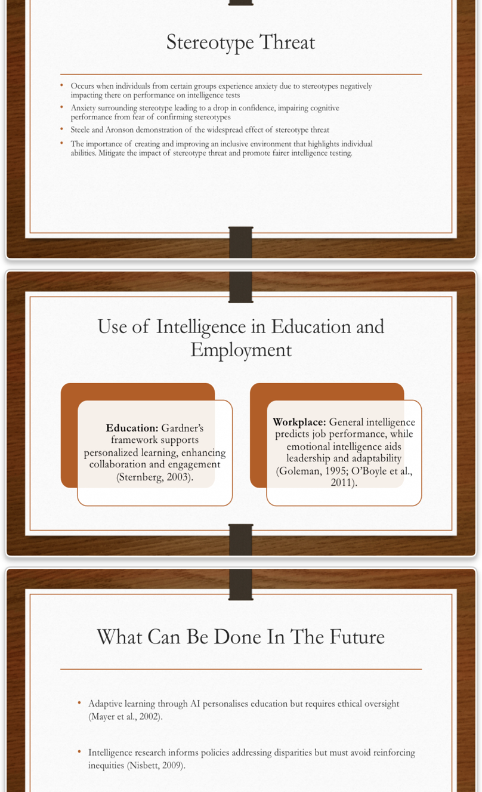
Intelligence Testing Historical roots and contemporary controversies.

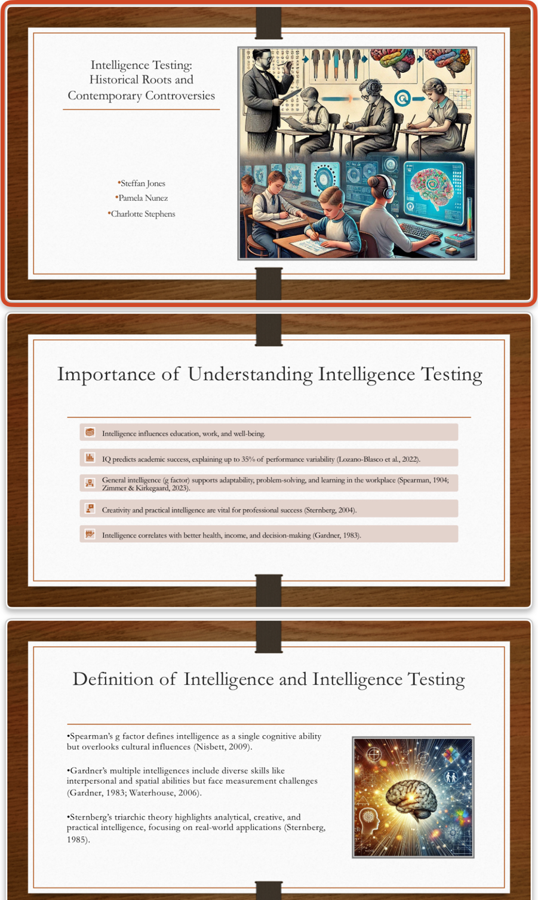
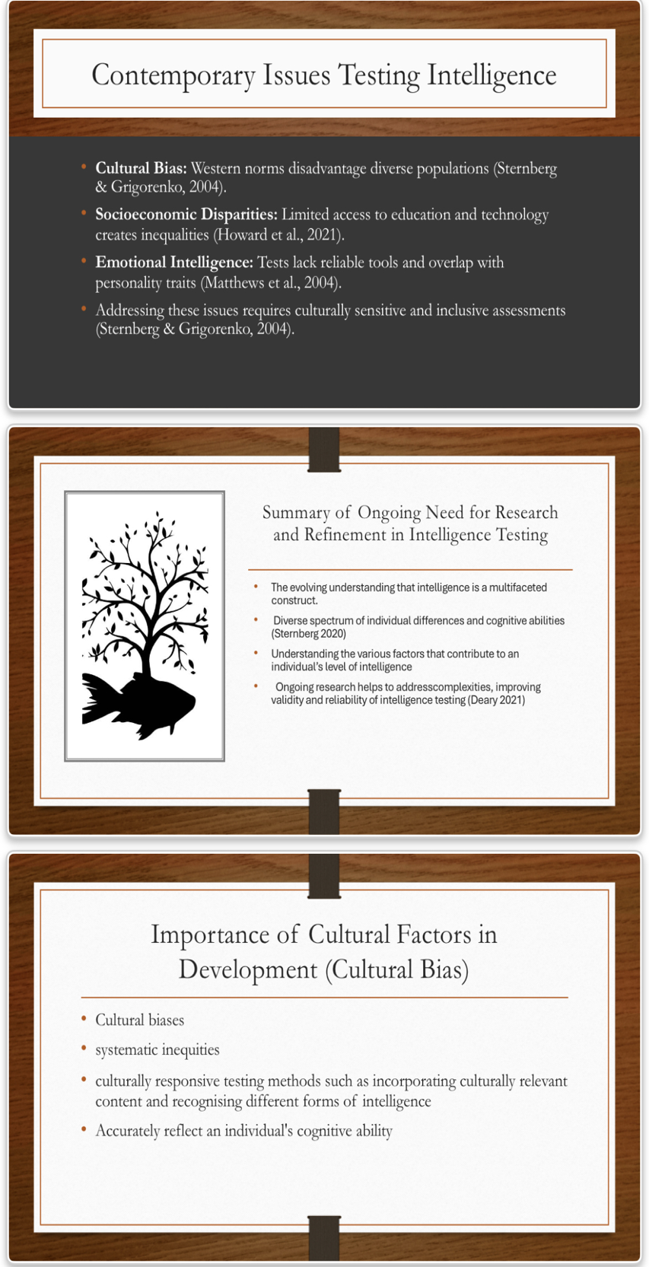

Script for group presentation
Good morning will be covering three topics in today’s presentation. Firstly, a summary of the ongoing need for research and refinement in intelligence testing, secondly the importance of cultural factors in the development of intelligence testing and finally the threat of stereotyping intelligence.
Research on intelligence testing is a field that has evolved significantly over many years, from the beginning of the 20th century where the general conception of intelligence was defined by the result of an IQ test, to now in the modern day where there is a wider acknowledgement and greater understanding that intelligence is so much more than a single test on just one type of intelligence. The ongoing need for research and refinement is crucial due to the evolving understanding that intelligence is a multifaceted construct that often does not account for the diverse spectrum of individual differences, cognitive abilities and cultural diversities which will be discussed in more depth on the next slide (Sternberg 2020). Further, understanding the many factors that contribute to an individual’s level of intelligence such as genetics, environment, mental or physical differences, will lead to more effective methods of supporting individuals in which ever endeavor they wish to pursue or advance in throughout their life (Nisbet et al 2012). Ongoing research helps to address these complexities, improving validity and reliability of intelligence testing (Deary 2021).
Cultural factors play a pivotal role in the development of intelligent testing, as traditional assessments often reflect the values and knowledge of the dominant culture, leading to significant biases. These biases can result in misinterpretations of an individual's cognitive abilities, particularly for those from diverse backgrounds (Helms 2017). For instance, tests that prioritised western knowledge may disadvantage individuals who have diverse cultural experiences and ways of thinking (Sternberg 2020). Move over the reliance on standardise testing can stereotypes and reinforce systematic in equities, as cultural nuances are frequently overlooked (Nisbet et al 2012 to address these issues it is essential to create culturally responsive assessment tools that honour the diverse backgrounds of test takers this includes incorporating culturally relevant content and recognising different forms of intelligence beyond what is typically measured by acknowledging and integrating cultural factors in intelligence testing we can foster a more equitable educational environment that can accurately reflect cognitive capabilities with the individual
Stereotype threat essentially means when an individual is placed or identifies with any type of group and is placed under threat based on a set of stereotypes surrounding that group, and which can lead to anxiety and lack of confidence. The anxiety from this can alter their ability to fulfil their true potential as the pressure imposed can evoke the fear of conforming to a stereotype. Steele and Aronson (1995) found that a group of African American students were amongst those who were seen to be affected by stereotype threat this was studied when prior to taking a standardised tests they were reminded their race, and this directly negatively affected their results of the test. Evidence of this has appeared across various groups and contexts, supporting the significance that stereotype threat has on individuals taking an intelligence test. Stereotype threat could, therefore, contribute to widening the achievement gap and continue the inequality within educational and professional settings. Some of the ways around these problems could include prioritising supporting and understanding the issues and encouraging the self-worth of the individual and allowing students access to multicultural role models may help diminish the effects of stereotype threat (Cohen et al, 2006).

A quote I’d like to include that I have always found very inspiring, and is relevant to this topic, beautifully encompassing intelligence and the importance of continuing in the research and refinement of intelligence is that “Everyone is a genius, but if you judge a fish on its ability to climb a tree it will live its whole life believing it is stupid” – which was believed to have been said by Albert Einstein.

References:
- Sternberg, R. J. (2020). The theory of successful intelligence. Review of General Psychology, 24(1), 1-13.
- Helms, J. E. (2017). Cultural bias in intelligence testing. The Oxford Handbook of Child Psychological Assessment.
- Nisbett, R. E., Aronson, J., Blair, C., Dickens, W., Flynn, J., Halpern, D. F., & Turkheimer, E. (2012). Intelligence: New findings and theoretical developments. American Psychologist, 67(2), 130-159.
- Deary, I. J. (2021). Intelligence: A very short introduction. Oxford University Press.
Jung, R. E., & Haier, R. J. (2007). The Parieto-Frontal Integration Theory (P-FIT) of intelligence: Converging neuroimaging evidence. *Behavioral and Brain Sciences*, 30(2), 135-154.
- Nisbett, R. E., et al. (2012). Intelligence: New findings and theoretical developments. *American Psychologist*, 67(2), 130-139.
- Sternberg, R. J. (2003). The theory of successful intelligence. *Review of General Psychology*, 7(4), 299-315.

