

Circuit Design

  - ACDA 4018 Fundamentals of Electrical and Electronic Systems
  - Level 4 Ordnance, Munitions and Explosive Engineering
  - School of Applied Computing

Elias James

Table of Contents

Table of Figures 2
1. Introduction 3
2. Design Calculations 5
2.1 Proof-of-Concept Calculations 5
3.2 Calculations When R3 and R4 Are 1KΩ 6
3. Proteus Simulation and Results 7
3.1 4.7Ω and 5.1Ω Resistors Proof-of-Concept Proteus Simulation 7
3.2 Oscillator and Graphs of 4.7Ω and 5.1Ω Resistors 7
3.3 1kΩ Resistors Proteus Simulation 9
3.4 Oscillator and Graphs for 1K Ω Resistors 9
4. Breadboard Construction and Results 11
4.1 Breadboard Construction 11
4.1.1 Components and Instruments Used 11
4.1.2 How the Circuit Was Constructed and Tested 11
4.2 Breadboard Circuit Pictures 12
4.3 Breadboard Graph 13
5. Analysis and Conclusions 14
6. References 15
7. Appendix 16
7.1 Breadboard table for Voltage vs Time 16
7.2 R3 1k and R4 1K table for Voltage vs Time 17
7.3 R3 5.1k and R4 4.7K table for Voltage vs Time 22

Table of Figures
Figure 1 A 555 timer [1] 3
Figure 2 Proteus circuit of 4.7K Ω and 5.1K Ω resistors. 6
Figure 3 Oscillator position in Proteus circuit. 6
Figure 4 Signal waves on a Proteus Oscillator of 5.1K Ω and 4.7K Ω resistor circuit. 7
Figure 5 Graph showing voltage output using the 5.1K Ω and 4.7K Ω resistors. 7
Figure 6 Proteus circuit with 1KΩ resistors. 8
Figure 7 Signal waves from a Proteus oscillator for 1KΩ resistors. 8
Figure 8 Graph showing voltage output using 1KΩ resistors. 9
Figure 9 Breadboard construction. 11
Figure 10 Breadboard construction 2 11
Figure 11 Breadboard construction 3. 12
Figure 12 Graph showing the voltage outputs from the breadboard. 12

Introduction
This report investigates the behaviour of a 555 timer integrated circuit configured as an astable multivibrator. The objective of this report is to build, simulate and test a 555 timer in astable mode and observe its timings and voltages by measuring the voltages across the capacitor over time. This report includes simulations using Proteus and hardware testing on a breadboard.
Developed in 1971 by Hans R. Cemenzind and introduced by Signetics, the 555 timer is the most widely used integrated circuit in the electronic world. [1] Its configuration can be changed to operate in many different timing and oscillator modes, and this has many applications such as timing delays, pulse generation, LED flashing, tone generation and oscillators. [1]
The 555-timer has three main modes:
Monostable mode – Which generates a single pulse when it is triggered.
Bistable mode – Known as a flip-flop, which toggles between two stable modes.
Astable mode – Continuously switches between high and low output states, therefore producing a square wave and no stable state
In this report, the 555-timer is in astable mode and therefore means that it constantly toggles between high and low and will create an oscillator. This is commonly used in applications like flashing LEDs and clock signals, and in this application, the LEDs are used. [2] There are three main components that control the timing of an astable 555 timer circuit. These are: two resistors (R3 and R4) and a capacitor (C1). The capacitor will charge through both R3 and R4 resistors but will discharge only through R4. The voltage in the C1 capacitor increases until it reaches 2/3 Vcc, and when achieved the internal discharge transistor activates, and it will discharge until it reaches 1/3 Vcc. The cycle then repeats. [2], [3]

Pin and Name | Function and Astable Use
1 – Ground | Connected to negative terminal of power supply.
2 – Trigger | Starts a timing cycle when voltage drops below 1/3 Vcc. Connected to pin 6.
3 – Output | Provides the square wave signal. Connected to the LEDs.
4 – Reset | Resets the timer when 0V.
5 – Control Voltage | Optional use – Adjusts internal thresholds. Connects to 100nF capacitor usually.
6 – Threshold | Ends timing when voltage across C1 is 2/3 Vcc. Connected to pin 2.
7 - Discharge | Connected to internal transistor that discharges capacitor. Connected in between R3 and R4.
8 – Vcc Power Supply | Connected to positive voltage.
[4]
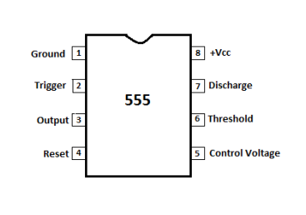
Figure 1 A 555 timer [1]

The circuit construction and component functions within this report are as follows:
- R3 and R4 define the charge and discharge and therefore control the ON and OFF periods.
- C1 stores and releases energy to create the timing delays.
- C2 is a decoupling capacitor, and this stabilises the control voltage on pin 5.
- The LEDs are used to visually observe the output switching.
- Pin 3 is delivering the square wave, which can be observed in the oscillators.
- Pins 2 and 6 are linked together, which allows voltage monitoring across C1 and the trigger threshold.
The expected behaviour in this circuit is that the output will produce a square wave whilst it alternates between a high 9V voltage and a low 0V voltage, and this will be at a constant frequency. What is also expected is a sawtooth waveform which will be observed when voltage is measured across the capacitor due to the increasing charge from 1/3 Vcc to 2/3 Vcc whilst charging and vice versa during discharge.

Design Calculations

Proof-of-Concept Calculations

$$Frequency and period chosen - f = 1Hz T = 1s$$

$$T on = ln⁡(2) × \left(R_{3}+R_{4}\right) × C1$$
$T off = ln⁡(2) × R_{4} × C1$ [5]

$$T = T on +T off$$
$$∴$$
$$T = ln⁡(2) × \left(R_{3}+2R_{4}\right) × C1$$

$$1=0.693 ×\left(R_{3}+2R_{4}\right)×0.0001$$

$$R_{3}+2R_{4} =\frac{1}{0.693 ×0.0001}$$

$$R_{3}+2R_{4} =14430 Ω$$

$$R_{4}=4700 Ω$$
$R_{4}=4.7 KΩ$ (Common resistor)

$$R_{3}+\left(2 ×4700\right) =14430 Ω$$

$$R_{3}=5030 Ω$$
$R_{3}=5.1 KΩ$(Common resistor)

3.2 Calculations When R3 and R4 Are 1KΩ

$$T on = ln⁡(2) × \left(R_{3}+R_{4}\right) × C1$$
$$T off = ln⁡(2) × R_{4} × C1$$

$$T on = ln⁡(2) × \left(1000+1000\right) × 0.0001$$
$$T on =0.693 ×2000 ×0.0001$$
$$T on =0.1386s$$

$$T off = ln⁡(2) × R_{4} × C1$$
$$T off = 0.693× 1000 × 0.0001$$
$$T off =0.0693s$$

$$T = T on +T off$$
$$T=0.1386+0.0693$$
$$T=0.2079s$$

$$f= \frac{1}{T}$$
$$f= \frac{1}{0.2079}$$
$$f= 4.81 Hz$$

Proteus Simulation and Results

4.7Ω and 5.1Ω Resistors Proof-of-Concept Proteus Simulation
Below are images of the Proteus circuit with the 4.7k and 5.1k resistors, which match the proof-of-concept calculations. This is to further confirm the calculations are the same.
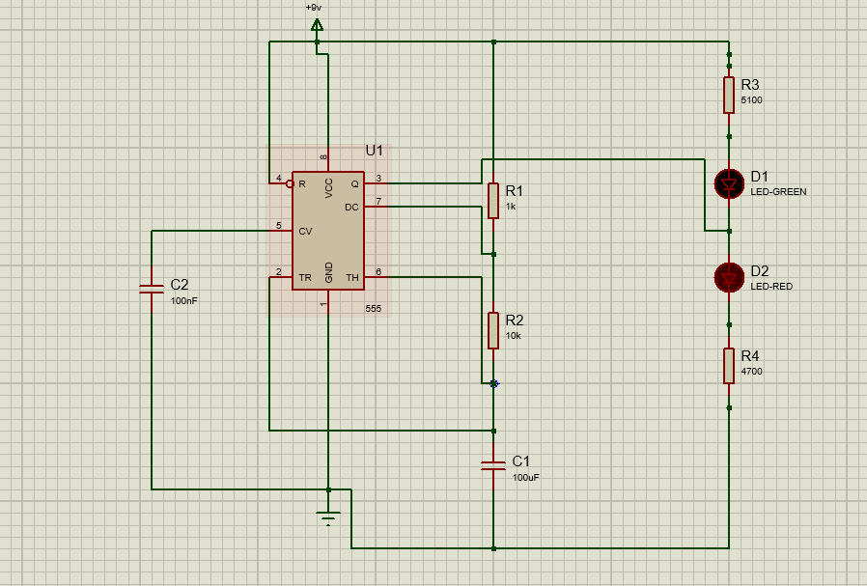
Figure 2 Proteus circuit of 4.7K Ω and 5.1K Ω resistors.

Oscillator and Graphs of 4.7Ω and 5.1Ω Resistors
The images below show the oscillator placement within Proteus for accurate capture of VC1 and Vout. Also included is the produced graph and signal waves.
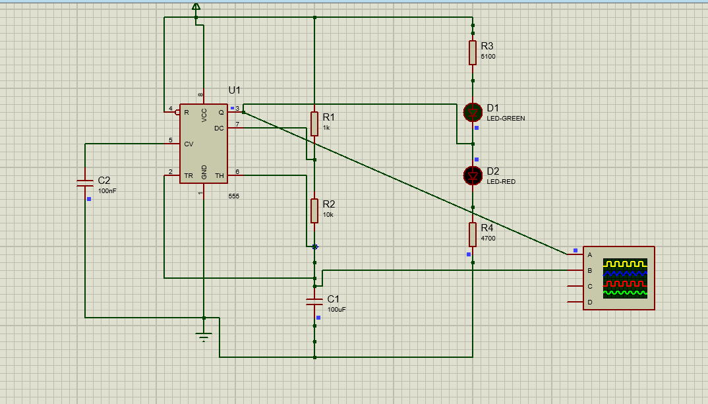
Figure 3 Oscillator position in Proteus circuit.

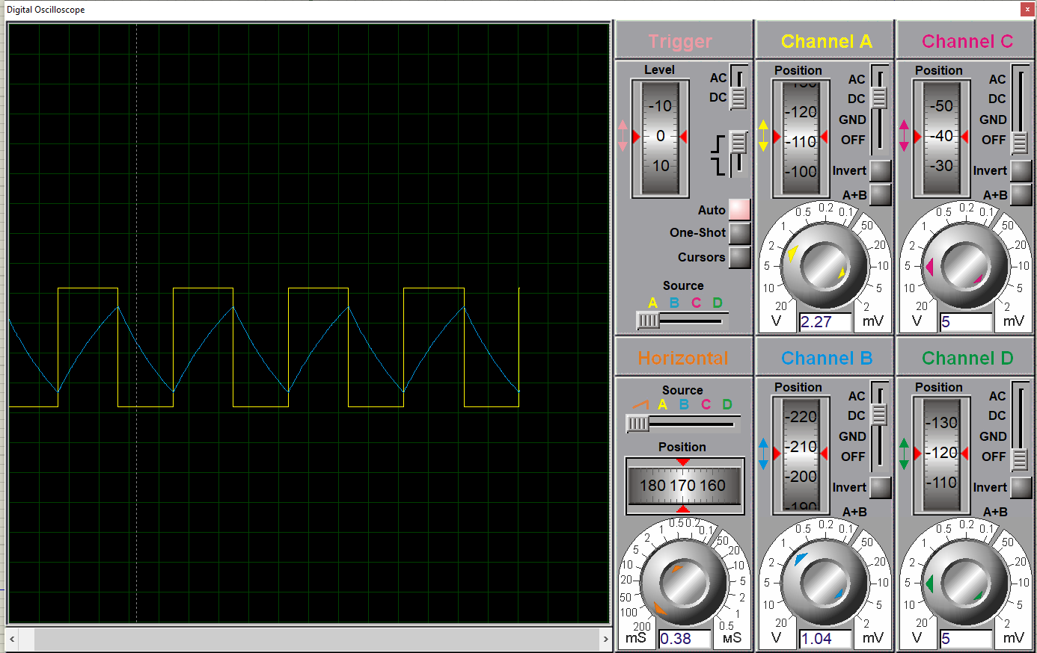
Figure 4 Signal waves on a Proteus Oscillator of 5.1K Ω and 4.7K Ω resistor circuit.

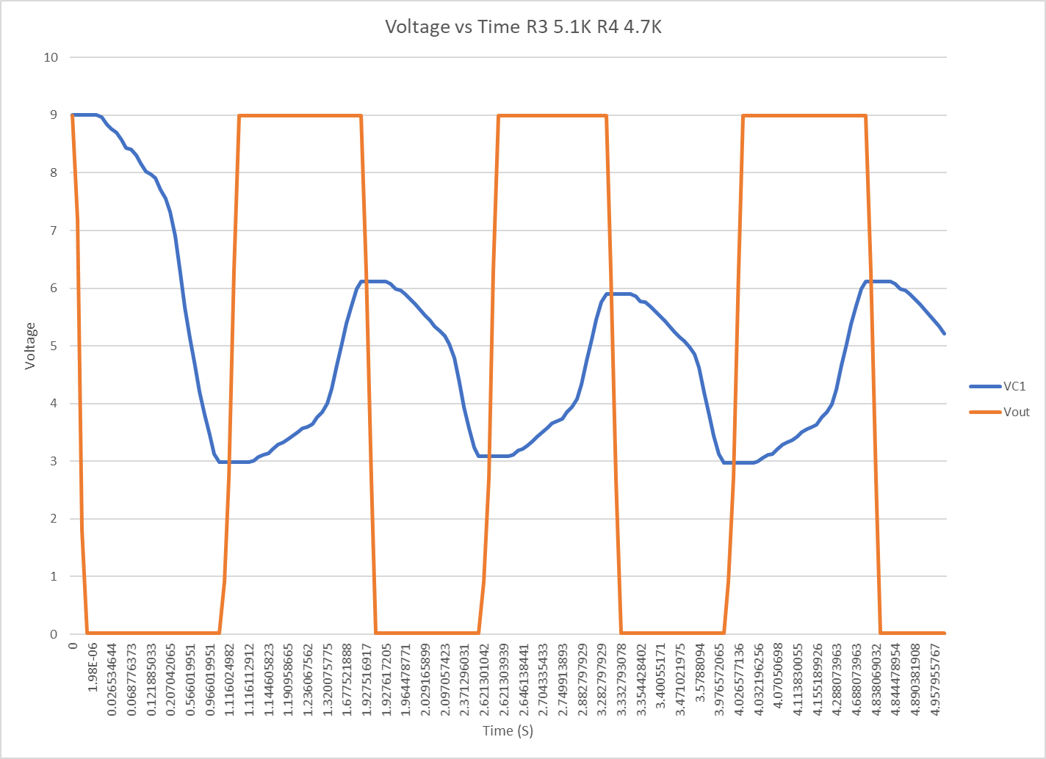
Figure 5 Graph showing voltage output using the 5.1K Ω and 4.7K Ω resistors.

1kΩ Resistors Proteus Simulation
Below are the images of the Proteus circuit where R3 and R4 are 1KΩ, which match the breadboard construction to make a comparison of real-world and simulated results.
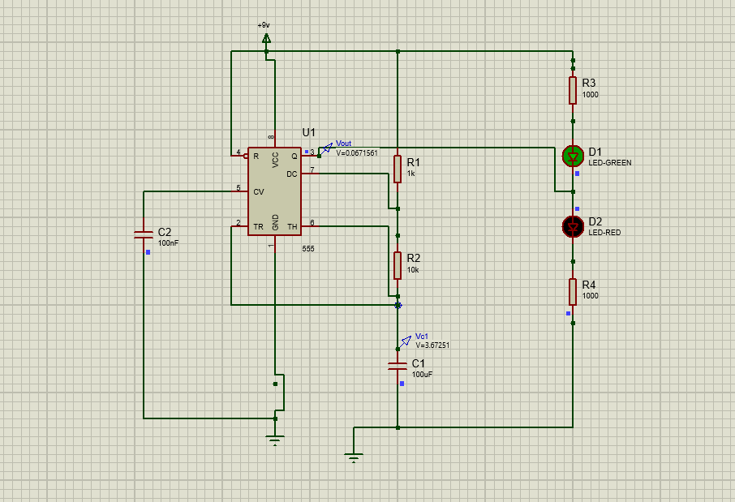
Figure 6 Proteus circuit with 1KΩ resistors.

Oscillator and Graphs for 1K Ω Resistors
The images below are the signal waves from VC1 and Vout and the graph produced from this data
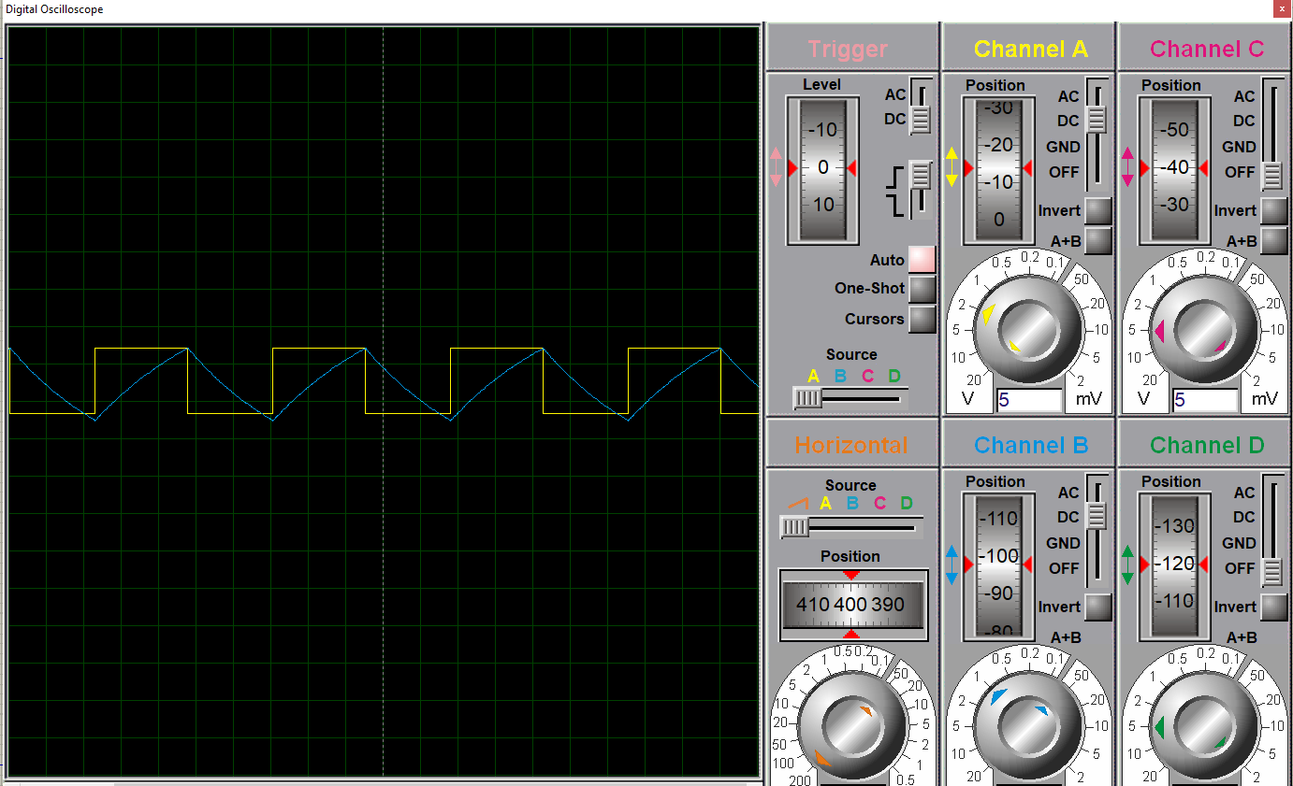
Figure 7 Signal waves from a Proteus oscillator for 1KΩ resistors.

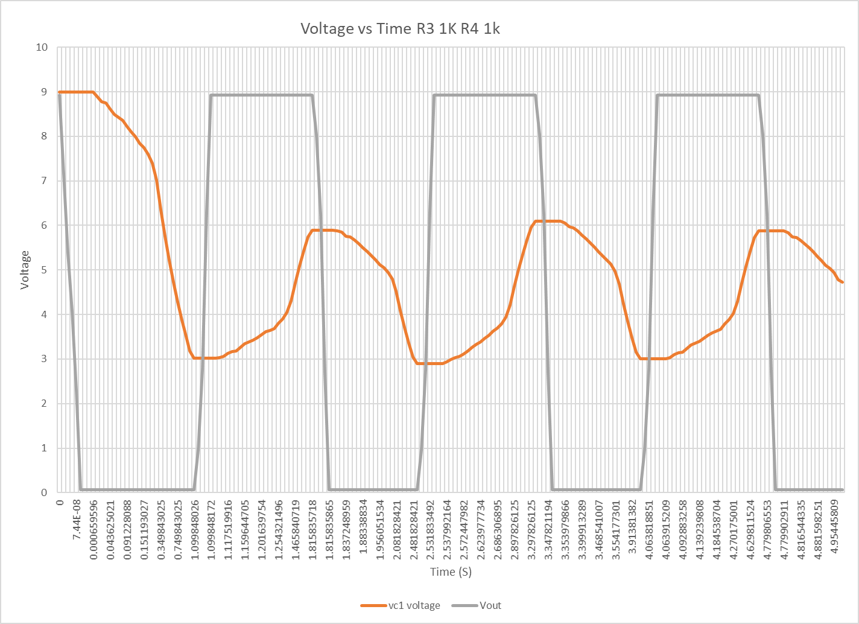
Figure 8 Graph showing voltage output using 1KΩ resistors.

Breadboard Construction and Results

Breadboard Construction

Components and Instruments Used
- 1 x Breadboard
- 1 x Green LED
- 1 x Red LED
- 1 x 100 µF Capacitor (C1)
- 1 x 100 nF Capacitor (C2)
- 1 x 555 Timer
- 3 x 1KΩ Resistors (R1, R3 and R4)
- 1 x 10KΩ Resistors (R2)
- 1 x 9V Power Supply
- 7 x Wires
- Multi-meter

How the Circuit Was Constructed and Tested
This circuit was constructed using a standard solderless breadboard. A 9V DC power supply was connected to the positive and negative rails of the breadboard using 2 wires, and this provided power to the circuit. A 555 timer was placed in the middle of the breadboard. Pin 1 (ground) was connected using a wire to the negative rail, and pin 8 (Vcc) was connected similarly, but to the positive rail on the breadboard. A 100nF capacitor (C2) was connected to Pin 5 (control voltage) and then connected to ground (negative rail). This stabilises the internal voltage divider. A 1k (R1) and 10k (R2) resistor were connected in series, flowing from the positive rail, to pin 6 (threshold), to pin 2 (trigger), where a 100µF capacitor (C1) connected pin 2 to the negative rail. A wire linked together Pin 2 and Pin 7 (discharge). Pin 4 (reset) was connected to the positive rail, which would prevent unintended resets. Pin 3 (output) was connected to the green and red LEDs in series. One LED is connected to the positive rail by a 1K (R3) resistor, and the other is connected to the negative rail by a 1K (R4) resistor. This was to visually show the high and low states of the output. This allowed the capacitor to charge and discharge, and therefore generate a square wave signal. This was then measured using a multi-meter set to volts across the capacitor (VC1) and the output (Vout) for comparison with Proteus.

Breadboard Circuit Pictures
Below are images of the breadboard construction and a demonstration that it functioned by the red LED being illuminated.

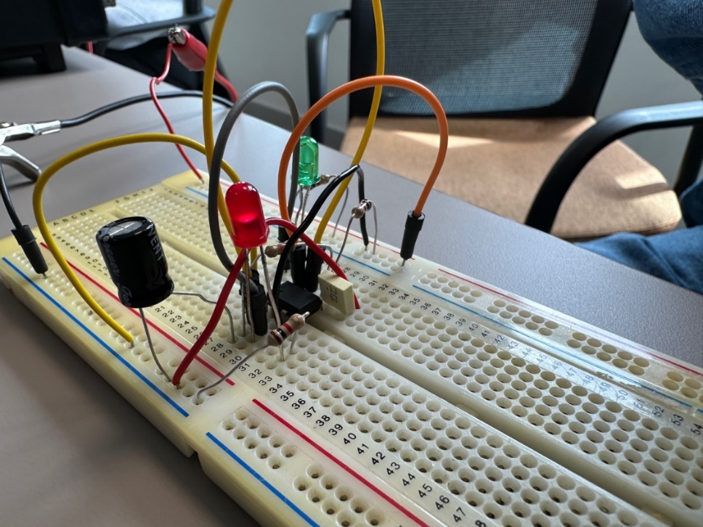
Figure 9 Breadboard construction.

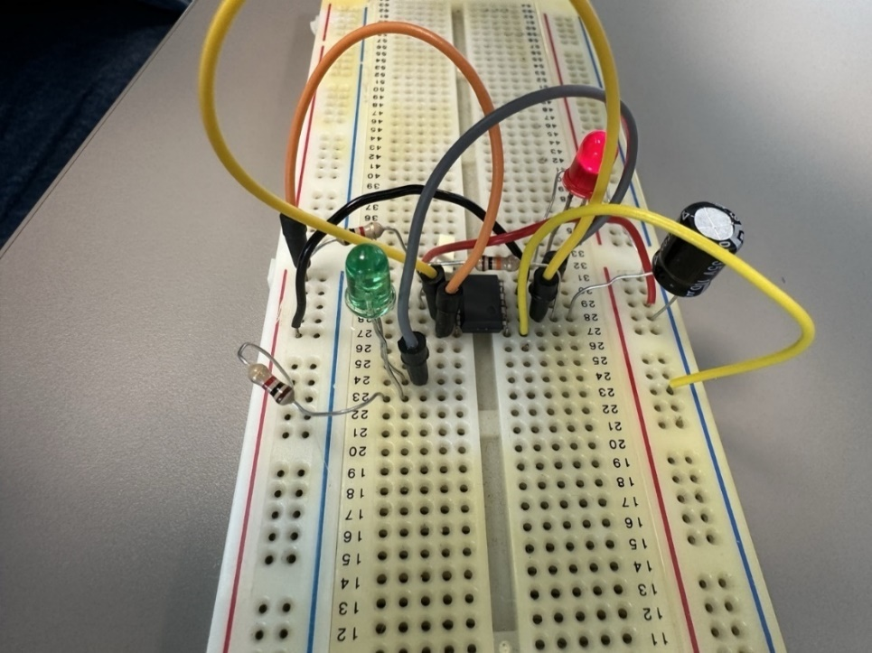
Figure 10 Breadboard construction 2

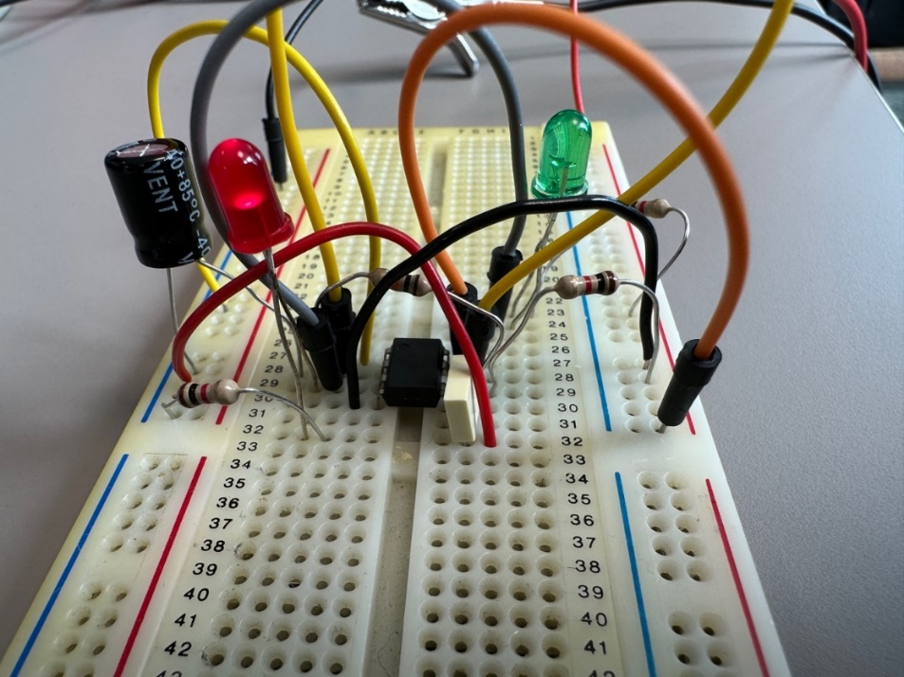
Figure 11 Breadboard construction 3.

Breadboard Graph
Below is a graph produced by measuring the voltage of VC1 and Vout using a multi-meter. Data can be seen in the appendix.

Figure 12 Graph showing the voltage outputs from the breadboard.

Analysis and Conclusions
When comparing the two graphs from the breadboard and the Proteus simulation of the same resistor values (1K) you can determine if the output behaviour is consistent and as expected.
The waveform shape of the Proteus simulation is a classic astable 555 timer behaviour. It has a clean square wave for Vout and a predicted sawtooth shape for VC1, where the capacitor is charging and discharging. In the breadboard graph, you can see that although it isn’t as clean as the Proteus simulation, there is a rough square wave shape for Vout and a more jagged rise and fall pattern for VC1 where the capacitor is charging and discharging. Overall, the waves in both graphs have a similar pattern and are indicative of the behaviour that they should produce. Both graphs' output voltages are within 0-9V, and this therefore matches the 9V supply and is what you would expect from a 555-timer. The breadboard shows a bit more irregularity, and the Proteus waves are significantly cleaner. This is to be expected from real-world measurements, and these differences could be due to noise, tolerances in resistors or capacitors, human error in measuring or loose connections/contact resistances in the breadboard construction.

References

[1] A. Bohare, ‘Department of Physics, K. L. D. A. V. P. G. College Roorkee, Roorkee-247667 [India]’.

[2] Md. M. Abrar, ‘Design and Implementation of Astable Multivibrator using 555 Timer’, IOSR J. Electr. Electron. Eng., vol. 12, no. 01, pp. 22–29, Jan. 2017, doi: 10.9790/1676-1201022229.

[3] H. R. Camenzind, ‘Redesigning the old 555 [timer circuit]’, IEEE Spectr., vol. 34, no. 9, pp. 80–85, Sep. 1997, doi: 10.1109/6.619384.

[4] Ø. N. Dahl, ‘555 Timer Tutorial: How It Works and Useful Example Circuits’, Build Electronic Circuits. Accessed: Jul. 25, 2025. [Online]. Available: https://www.build-electronic-circuits.com/555-timer/

[5] ‘(PDF) Fifty Years of the 555 Timer - A Tribute from a Didactic IC Design Perspective’, in ResearchGate, Accessed: Jul. 25, 2025. [Online]. Available: https://www.researchgate.net/publication/373820294_Fifty_Years_of_the_555_Timer_-_A_Tribute_from_a_Didactic_IC_Design_Perspective

Appendix

Breadboard table for Voltage vs Time

Breadboard | C1 | pin 3
Time | VC1 | Vout
1 | 7.73 | -0.09
2 | 0.07 | -0.19
3 | 0.09 | -0.52
4 | 7.75 | -7.68
5 | 6.32 | -0.08
6 | 8.97 | -0.1
7 | 0.9 | -7
8 | 7.68 | -6.74
9 | 0.09 | -0.2
10 | 0.14 | -0.69
11 | 7.8 | -7.7
12 | 5.5 | -0.03
13 | 0.5 | -4.9
14 | 7.8 | -7.5
15 | 7.58 | -6.25
16 | 0.1 | -0.41
17 | 7.35 | -7.73
18 | 6.84 | -0.18
19 | 4.5 | -0.08
20 | 0.71 | -6.62
21 | 7.7 | -7.05
22 | 0.03 | -0.25
23 | 0.11 | -0.6
24 | 7.85 | -7.73
25 | 6.35 | -0.05
26 | 0.41 | -0.04
27 | 0.81 | -7.4
28 | 7.72 | -6.5
29 | 0.04 | -0.35
30 | 7.48 | -0.69

R3 1k and R4 1K table for Voltage vs Time
1k 1k | c1 | pin 3
TIME | Vc1 | Vout
0 | 8.99991 | 8.93284
1.99E-08 | 8.99991 | 7.15116
3.97E-08 | 8.99991 | 5.3825
5.46E-08 | 8.99991 | 4.05876
7.44E-08 | 8.99991 | 2.29291
1.14E-07 | 8.99991 | 0.067156
4.36E-07 | 8.99991 | 0.067156
8.25E-05 | 8.99917 | 0.067156
0.00066 | 8.99401 | 0.067156
0.01283 | 8.8858 | 0.067156
0.024534 | 8.78317 | 0.067156
0.028275 | 8.75037 | 0.067156
0.043625 | 8.61783 | 0.067156
0.059007 | 8.48703 | 0.067156
0.066755 | 8.42216 | 0.067156
0.074608 | 8.35641 | 0.067156
0.091228 | 8.21948 | 0.067156
0.106126 | 8.09866 | 0.067156
0.119147 | 7.99451 | 0.067156
0.13778 | 7.84783 | 0.067156
0.151193 | 7.74392 | 0.067156
0.169863 | 7.60157 | 0.067156
0.198448 | 7.38871 | 0.067156
0.249843 | 7.0209 | 0.067156
0.349843 | 6.35682 | 0.067156
0.449843 | 5.75596 | 0.067156
0.549843 | 5.2123 | 0.067156
0.649843 | 4.72039 | 0.067156
0.749843 | 4.2753 | 0.067156
0.849843 | 3.87258 | 0.067156
0.949843 | 3.5082 | 0.067156
1.049843 | 3.17851 | 0.067156
1.099848 | 3.02573 | 0.067156
1.099848 | 3.02573 | 0.964853
1.099848 | 3.02573 | 2.75475
1.099848 | 3.02573 | 6.31163
1.099848 | 3.02573 | 8.93284
1.099851 | 3.02572 | 8.93284
1.099944 | 3.02622 | 8.93284
1.106007 | 3.05906 | 8.93284
1.11752 | 3.12091 | 8.93284
1.125164 | 3.16156 | 8.93284
1.128912 | 3.18149 | 8.93284
1.144259 | 3.2621 | 8.93284
1.159645 | 3.3418 | 8.93284
1.167401 | 3.38141 | 8.93284
1.175269 | 3.42159 | 8.93284
1.187604 | 3.4838 | 8.93284
1.20164 | 3.55374 | 8.93284
1.213351 | 3.61141 | 8.93284
1.220568 | 3.64651 | 8.93284
1.229224 | 3.68861 | 8.93284
1.254321 | 3.80842 | 8.93284
1.2745 | 3.90279 | 8.93284
1.306204 | 4.04761 | 8.93284
1.365841 | 4.30901 | 8.93284
1.465841 | 4.71692 | 8.93284
1.565841 | 5.08935 | 8.93284
1.665841 | 5.4294 | 8.93284
1.765841 | 5.73988 | 8.93284
1.815836 | 5.88473 | 8.93284
1.815836 | 5.88473 | 8.03515
1.815836 | 5.88473 | 6.24525
1.815836 | 5.88473 | 2.68837
1.815836 | 5.88473 | 0.067156
1.815839 | 5.88474 | 0.067156
1.815932 | 5.8842 | 0.067156
1.821994 | 5.84892 | 0.067156
1.837249 | 5.76109 | 0.067156
1.841152 | 5.73897 | 0.067156
1.852574 | 5.67421 | 0.067156
1.867928 | 5.58847 | 0.067156
1.883388 | 5.50346 | 0.067156
1.899366 | 5.41698 | 0.067156
1.917627 | 5.31982 | 0.067156
1.936556 | 5.22096 | 0.067156
1.956052 | 5.12107 | 0.067156
1.970309 | 5.04924 | 0.067156
1.990487 | 4.94932 | 0.067156
2.022192 | 4.79632 | 0.067156
2.081828 | 4.52129 | 0.067156
2.181828 | 4.09516 | 0.067156
2.281828 | 3.70959 | 0.067156
2.381828 | 3.36073 | 0.067156
2.481828 | 3.04507 | 0.067156
2.531833 | 2.8988 | 0.067156
2.531833 | 2.8988 | 0.964853
2.531833 | 2.8988 | 2.75475
2.531833 | 2.8988 | 6.31163
2.531834 | 2.8988 | 8.93284
2.531837 | 2.89879 | 8.93284
2.53193 | 2.89931 | 8.93284
2.537992 | 2.93284 | 8.93284
2.549505 | 2.99601 | 8.93284
2.557149 | 3.03751 | 8.93284
2.560898 | 3.05787 | 8.93284
2.572448 | 3.11993 | 8.93284
2.583926 | 3.18097 | 8.93284
2.599386 | 3.26218 | 8.93284
2.611275 | 3.32386 | 8.93284
2.623978 | 3.38903 | 8.93284
2.639133 | 3.4658 | 8.93284
2.652553 | 3.53291 | 8.93284
2.672049 | 3.62895 | 8.93284
2.686307 | 3.69812 | 8.93284
2.706485 | 3.79449 | 8.93284
2.73819 | 3.94239 | 8.93284
2.797826 | 4.20935 | 8.93284
2.897826 | 4.62592 | 8.93284
2.997826 | 5.00627 | 8.93284
3.097826 | 5.35354 | 8.93284
3.197826 | 5.67062 | 8.93284
3.297826 | 5.96012 | 8.93284
3.347821 | 6.09518 | 8.93284
3.347821 | 6.09518 | 8.03515
3.347821 | 6.09518 | 6.24525
3.347821 | 6.09518 | 2.68837
3.347821 | 6.09518 | 0.067156
3.347824 | 6.09519 | 0.067156
3.347918 | 6.09463 | 0.067156
3.35398 | 6.05808 | 0.067156
3.369234 | 5.96709 | 0.067156
3.373137 | 5.94416 | 0.067156
3.384559 | 5.87707 | 0.067156
3.399913 | 5.78825 | 0.067156
3.415374 | 5.70018 | 0.067156
3.431351 | 5.61058 | 0.067156
3.449613 | 5.50991 | 0.067156
3.468541 | 5.40749 | 0.067156
3.488037 | 5.304 | 0.067156
3.502295 | 5.22958 | 0.067156
3.522473 | 5.12606 | 0.067156
3.554177 | 4.96755 | 0.067156
3.613814 | 4.68261 | 0.067156
3.713814 | 4.24112 | 0.067156
3.813814 | 3.84166 | 0.067156
3.913814 | 3.48022 | 0.067156
4.013814 | 3.15319 | 0.067156
4.063819 | 3.00165 | 0.067156
4.063819 | 3.00165 | 0.964853
4.063819 | 3.00165 | 2.75475
4.063819 | 3.00165 | 6.31163
4.063819 | 3.00165 | 8.93284
4.063822 | 3.00164 | 8.93284
4.063915 | 3.00214 | 8.93284
4.069978 | 3.03511 | 8.93284
4.081491 | 3.09722 | 8.93284
4.089135 | 3.13802 | 8.93284
4.092883 | 3.15803 | 8.93284
4.10823 | 3.23897 | 8.93284
4.123616 | 3.31899 | 8.93284
4.131371 | 3.35876 | 8.93284
4.13924 | 3.39911 | 8.93284
4.151574 | 3.46156 | 8.93284
4.165611 | 3.53178 | 8.93284
4.177322 | 3.58969 | 8.93284
4.184539 | 3.62493 | 8.93284
4.193195 | 3.6672 | 8.93284
4.218292 | 3.78749 | 8.93284
4.23847 | 3.88224 | 8.93284
4.270175 | 4.02765 | 8.93284
4.329812 | 4.29011 | 8.93284
4.429812 | 4.69965 | 8.93284
4.529812 | 5.07359 | 8.93284
4.629812 | 5.41501 | 8.93284
4.729812 | 5.72674 | 8.93284
4.779807 | 5.87217 | 8.93284
4.779807 | 5.87217 | 8.03515
4.779807 | 5.87217 | 6.24525
4.779807 | 5.87217 | 2.68837
4.779807 | 5.87217 | 0.067156
4.77981 | 5.87218 | 0.067156
4.779903 | 5.87164 | 0.067156
4.785965 | 5.83644 | 0.067156
4.80122 | 5.7488 | 0.067156
4.805123 | 5.72672 | 0.067156
4.816544 | 5.6621 | 0.067156
4.831899 | 5.57655 | 0.067156
4.847359 | 5.49173 | 0.067156
4.863337 | 5.40543 | 0.067156
4.881598 | 5.30847 | 0.067156
4.900526 | 5.20983 | 0.067156
4.920022 | 5.11015 | 0.067156
4.93428 | 5.03848 | 0.067156
4.954458 | 4.93877 | 0.067156
4.986163 | 4.78611 | 0.067156
5 | 4.72098 | 0.067156

R3 5.1k and R4 4.7K table for Voltage vs Time

4.7 5.1 | c1 | pin 3
TIME | Vc1 | Vout
0 | 8.99991 | 8.98554
2.00E-08 | 8.99991 | 7.18973
7.99E-08 | 8.99991 | 1.80944
1.60E-07 | 8.99991 | 0.013334
1.98E-06 | 8.99989 | 0.013334
0.000118 | 8.99886 | 0.013334
0.003772 | 8.96621 | 0.013334
0.018862 | 8.83266 | 0.013334
0.026535 | 8.76578 | 0.013334
0.034178 | 8.69916 | 0.013334
0.0495 | 8.56763 | 0.013334
0.064902 | 8.43743 | 0.013334
0.068776 | 8.40519 | 0.013334
0.080661 | 8.30627 | 0.013334
0.098005 | 8.16429 | 0.013334
0.114686 | 8.03004 | 0.013334
0.121885 | 7.97303 | 0.013334
0.130517 | 7.90468 | 0.013334
0.155513 | 7.71075 | 0.013334
0.175575 | 7.55855 | 0.013334
0.207042 | 7.32589 | 0.013334
0.26602 | 6.90897 | 0.013334
0.36602 | 6.25555 | 0.013334
0.46602 | 5.66432 | 0.013334
0.56602 | 5.12938 | 0.013334
0.66602 | 4.64536 | 0.013334
0.76602 | 4.20742 | 0.013334
0.86602 | 3.81117 | 0.013334
0.96602 | 3.45263 | 0.013334
1.06602 | 3.12823 | 0.013334
1.116025 | 2.9779 | 0.013334
1.116025 | 2.9779 | 0.9128
1.116025 | 2.9779 | 2.71064
1.116025 | 2.9779 | 6.3019
1.116025 | 2.9779 | 8.98554
1.116028 | 2.97789 | 8.98554
1.116113 | 2.97835 | 8.98554
1.121644 | 3.00856 | 8.98554
1.133233 | 3.07134 | 8.98554
1.140862 | 3.11225 | 8.98554
1.144606 | 3.13233 | 8.98554
1.159955 | 3.21363 | 8.98554
1.17534 | 3.294 | 8.98554
1.183094 | 3.33394 | 8.98554
1.190959 | 3.37444 | 8.98554
1.203278 | 3.43709 | 8.98554
1.217268 | 3.5074 | 8.98554
1.228909 | 3.56522 | 8.98554
1.236068 | 3.60033 | 8.98554
1.244638 | 3.64237 | 8.98554
1.269389 | 3.76158 | 8.98554
1.289182 | 3.85499 | 8.98554
1.320076 | 3.99749 | 8.98554
1.377522 | 4.25209 | 8.98554
1.477522 | 4.66494 | 8.98554
1.577522 | 5.0419 | 8.98554
1.677522 | 5.38607 | 8.98554
1.777522 | 5.70032 | 8.98554
1.877522 | 5.98724 | 8.98554
1.927517 | 6.12109 | 8.98554
1.927517 | 6.12109 | 6.28825
1.927517 | 6.12109 | 2.69654
1.927517 | 6.12109 | 0.013334
1.92752 | 6.1211 | 0.013334
1.927617 | 6.12052 | 0.013334
1.933927 | 6.08232 | 0.013334
1.949152 | 5.99113 | 0.013334
1.953056 | 5.96811 | 0.013334
1.964479 | 5.90074 | 0.013334
1.97983 | 5.81157 | 0.013334
1.995276 | 5.72323 | 0.013334
2.011187 | 5.63364 | 0.013334
2.029166 | 5.5341 | 0.013334
2.047404 | 5.43494 | 0.013334
2.065746 | 5.33702 | 0.013334
2.07888 | 5.268 | 0.013334
2.097057 | 5.17396 | 0.013334
2.124652 | 5.03442 | 0.013334
2.173533 | 4.79645 | 0.013334
2.271296 | 4.35377 | 0.013334
2.371296 | 3.94359 | 0.013334
2.471296 | 3.57245 | 0.013334
2.571296 | 3.23664 | 0.013334
2.621301 | 3.08102 | 0.013334
2.621301 | 3.08102 | 0.9128
2.621301 | 3.08102 | 2.71064
2.621301 | 3.08102 | 6.3019
2.621301 | 3.08102 | 8.98554
2.621304 | 3.08101 | 8.98554
2.621389 | 3.08147 | 8.98554
2.62692 | 3.11116 | 8.98554
2.642239 | 3.1926 | 8.98554
2.646138 | 3.21304 | 8.98554
2.657558 | 3.27291 | 8.98554
2.672912 | 3.35229 | 8.98554
2.68837 | 3.4311 | 8.98554
2.704335 | 3.51134 | 8.98554
2.717569 | 3.57698 | 8.98554
2.734185 | 3.65828 | 8.98554
2.741344 | 3.6928 | 8.98554
2.749914 | 3.73412 | 8.98554
2.774665 | 3.85128 | 8.98554
2.794458 | 3.9431 | 8.98554
2.825352 | 4.08315 | 8.98554
2.882798 | 4.33339 | 8.98554
2.982798 | 4.73917 | 8.98554
3.082798 | 5.10967 | 8.98554
3.182798 | 5.44796 | 8.98554
3.282798 | 5.75682 | 8.98554
3.332793 | 5.90092 | 8.98554
3.332793 | 5.90092 | 6.28825
3.332793 | 5.90092 | 2.69654
3.332793 | 5.90092 | 0.013334
3.332796 | 5.90093 | 0.013334
3.332893 | 5.90036 | 0.013334
3.339203 | 5.86355 | 0.013334
3.354428 | 5.77567 | 0.013334
3.358332 | 5.75347 | 0.013334
3.369755 | 5.68854 | 0.013334
3.385106 | 5.60261 | 0.013334
3.400552 | 5.51747 | 0.013334
3.416463 | 5.43112 | 0.013334
3.434442 | 5.33519 | 0.013334
3.45268 | 5.23963 | 0.013334
3.471022 | 5.14526 | 0.013334
3.484156 | 5.07874 | 0.013334
3.502333 | 4.9881 | 0.013334
3.529928 | 4.85362 | 0.013334
3.578809 | 4.62427 | 0.013334
3.676572 | 4.19764 | 0.013334
3.776572 | 3.80231 | 0.013334
3.876572 | 3.44462 | 0.013334
3.976572 | 3.12098 | 0.013334
4.026577 | 2.971 | 0.013334
4.026577 | 2.971 | 0.9128
4.026577 | 2.971 | 2.71064
4.026577 | 2.971 | 6.3019
4.026577 | 2.971 | 8.98554
4.02658 | 2.97099 | 8.98554
4.026665 | 2.97146 | 8.98554
4.032196 | 3.0017 | 8.98554
4.043785 | 3.06456 | 8.98554
4.051414 | 3.10551 | 8.98554
4.055158 | 3.12561 | 8.98554
4.070507 | 3.20701 | 8.98554
4.085892 | 3.28747 | 8.98554
4.093646 | 3.32745 | 8.98554
4.101511 | 3.368 | 8.98554
4.11383 | 3.43072 | 8.98554
4.12782 | 3.50111 | 8.98554
4.139461 | 3.55899 | 8.98554
4.14662 | 3.59415 | 8.98554
4.15519 | 3.63624 | 8.98554
4.179941 | 3.75558 | 8.98554
4.199734 | 3.8491 | 8.98554
4.230628 | 3.99176 | 8.98554
4.288074 | 4.24665 | 8.98554
4.388074 | 4.65998 | 8.98554
4.488074 | 5.03736 | 8.98554
4.588074 | 5.38193 | 8.98554
4.688074 | 5.69654 | 8.98554
4.788074 | 5.98379 | 8.98554
4.838069 | 6.1178 | 8.98554
4.838069 | 6.1178 | 6.28825
4.838069 | 6.1178 | 2.69654
4.838069 | 6.1178 | 0.013334
4.838072 | 6.11781 | 0.013334
4.838169 | 6.11722 | 0.013334
4.844479 | 6.07904 | 0.013334
4.859704 | 5.98791 | 0.013334
4.863609 | 5.96489 | 0.013334
4.875031 | 5.89756 | 0.013334
4.890382 | 5.80844 | 0.013334
4.905828 | 5.72015 | 0.013334
4.921739 | 5.6306 | 0.013334
4.939718 | 5.53112 | 0.013334
4.957956 | 5.43202 | 0.013334
4.976298 | 5.33415 | 0.013334
5 | 5.21032 | 0.013334

