Physiologic AssessmentPhysiologic Assessment

Student name: Akinwande Otegbeye
Student ID: 2422050

Module name: Introduction to Physiology
Module code: BMHP5023
Lecturer name: Shaila Hussain
Assessment: 1

Introduction
Diabetes mellitus is a chronic metabolic disorder in which the body fails to respond to insulin, leading to continuous insulin resistance (NHS, 2023). Type 1 diabetes is an autoimmune disease in which the pancreas produces little or no insulin, and Type 2 diabetes is the most prevalent type in which the body is unable to use insulin or the pancreas does not produce enough insulin (Diabetes UK, 2022). Obesity, inactivity, poor diet conditions and smoking are all strongly responsible for Type 2 diabetes and non-modifiable factors such as age, ethnicity and family history (WHO, 2023).
Diabetes is characterised by damage to the pancreatic islets, which include the beta cells responsible for insulin production and for releasing glucose into the blood (NICE, 2022). As the practice nurse in a GP surgery, I am seeing more individuals who have developed Type 2 diabetes and do not understand it. This report aims to help educate people about the benefits of treatment. It will outline blood glucose and oxygen use for cellular metabolism, the importance of checking blood sugar levels (and therefore diabetes management), and lifestyle management.
Figure 1, Alpha and beta cells per endocrine pancreas (Tortora & Derrickson, 2021).
STRUCTURE OF THE PANCREATIC ISLET
----------------------------------

[ Surrounding Exocrine Tissue ]
--------------------------------
| |
| ○ ○ ○ ○ ○ ○ ○ ○ |
| |
| ISLET OF LANGERHANS |
| ------------------------- |
| | β β β β β | |
| | (Beta cells – insulin) | |
| ------------------------- |
| | α α α α | |
| | (Alpha cells – glucagon) | |
| --------------------------- |
| |
--------------------------------

Key:
- **β-cells (beta cells)** → secrete **insulin** (lower blood glucose)
- **α-cells (alpha cells)** → secrete **glucagon** (raise blood glucose)
- Islets are scattered throughout the pancreas and make up ~1% of its mass

2. Blood Sugar Regulation
Diabetes-induced blood glucose regulation is an integral part of a healthy life, with blood glucose controlled by the hormones insulin and glucagon, which are released by the pancreas. After eating, the components are broken down into glucose, stimulating glucagon production and thus increasing blood glucose levels. In response, beta cells in the pancreas release insulin to promote glucose binding to cells (especially muscle and adipose tissue), store excess glucose as glycogen, and release glucagon (Hall & Guyton 2020). When blood glucose levels drop between meals or during exercise, beta cells release glucagon, causing the liver to break down glycogen into glucose, which it releases into the blood (NICE 2022). This keeps blood glucose levels in check while the whole body functions in a safe, stable range between 4 and 7 mmol/L (NICE 2022). To treat type 2 diabetes, this regulatory system deteriorates. Insulin resistance means cells don't respond well to insulin, leading to low blood glucose levels. Over time, the pancreas may become depleted and produce less insulin, which is contributing to a worse risk of hyperglycaemia (WHO, 2023).
Figure 2: The negative feedback loop in blood glucose regulation that occurs through time (Marieb & Hoehn, 2019).

NEGATIVE FEEDBACK LOOP OVER TIME
---------------------------------

BLOOD GLUCOSE LEVEL (mmol/L)
↑
| After Eating (Glucose Rises)
| |
| |
| Pancreas detects rise
| |
| β-cells release INSULIN
| |
| -----------------------------------------------------
| | |
| Body Cells Liver Cells
| (↑ glucose uptake) (↑ glycogen formation/storage)
| | |
| -----------------------------------------------------
| |
| Blood Glucose Falls
| |
|---------------------------|-----------------------------------------
| |
| Fasting/Exercise (Glucose Falls)
| |
| Pancreas detects fall
| |
| α-cells release GLUCAGON
| |
| Liver
| (↑ glycogen breakdown → glucose release)
| |
| Blood Glucose Rises
|
--------------------------------------------------------------------→ Time

Cellular Metabolism
Cells depend on energy to do growth, repair and movement. This is produced by cellular respiration, the process by which an organism takes in glucose and oxygen to produce adenosine triphosphate (ATP), the body's main energy source. Stages of cellular respiration: 1. Glycolysis. It occurs in the cytoplasm. Glucose (protein/materials) is broken down into pyruvate, producing a small amount of ATP.
2. Krebs Cycle (Citric Acid Cycle). Takes place in the mitochondria. Pyruvate is further broken down and released during electron production. The electron transport chain involves proteins in the mitochondrial membrane and produces a large amount of ATP in the presence of oxygen. The overall equation for aerobic respiration is
In diabetes, if glucose is not reaching cells properly due to a lack of insulin/insulin resistance, it may be broken down into fatty acids for energy. That results in ketones, which at high levels can lead to diabetic ketoacidosis (DKA), which in many cases is very life-threatening (NHS, 2023).
Diagram placeholder: In brief, 3: Cellular respiration mechanisms (from Tortora & Derrickson, 2021).
Figure 3
CELLULAR RESPIRATION OVERVIEW
--------------------------------

GLUCOSE (C6H12O6)
|
|
[ Glycolysis ]
(Occurs in cytoplasm)
|
▼
2 × Pyruvate molecules
|
▼
[ Pyruvate Oxidation ]
(Mitochondrial matrix)
|
▼
Acetyl-CoA
|
▼
[ Krebs Cycle / Citric Acid Cycle ]
(Mitochondrial matrix)
|
▼
High-energy electron carriers produced (NADH, FADH2)
|
▼
[ Electron Transport Chain (ETC) ]
(Inner mitochondrial membrane)
|
▼
Oxygen (O2) acts as the final electron acceptor
|
▼
ATP Production (≈ 30–32 ATP)
|
▼
CO2 + H2O + ENERGY (ATP)
Cellular respiration takes place with three main stages: Glycolysis (Cytoplasm) • glucose is broken down into two pyruvate molecules. produces a little ATP. • Does not need oxygen.
Krebs Cycle (Mitochondrial Matrix). • • Pyruvate is converted into Acetyl-CoA and enters the cycle. • • Carbon dioxide (CO 2) and high-energy electron carriers (NADH and FADH2) are produced.
In- Mitochondrial Membrane (Electron Transport Chain). • • Donate electrons from NADH/FADH 2. • • Oxygen is necessary because it is the final electron acceptor. • • This allows the chain to continue functioning. • produces the most ATP (about 30-32 molecules)
Overall reaction
Why this matters for diabetes. If insulin production is low or cells are insulin-resistant (for instance, not very glucose-sensitive in diabetic cells), glucose can't enter the cells. That means less glucose is available for ATP production– the body might break down the fat, instead. • This can lead to ketone production and may cause diabetic ketoacidosis (DKA) in severe diabetes cases.
Tortora et al. (2021). Principles of Anatomy and Physiology. 16th ed. Hoboken: Wiley, pp. 820-830.

3. Recording and tracking blood sugar levels for type 2 diabetes
Type 2 diabetes. Blood sugar levels should always be tracked. Tracking of blood sugar levels is a cornerstone of diabetes self-management through regular monitoring. Tracking helps us learn how our bodies process food and medication, respond to stress, and respond to exercise. Why track everything: • Keeps our blood sugar levels from falling dangerously (or staying low). Hyperglycaemia, in other words, can result in long-term complications, whereas hypoglycaemia may result in immediate danger such as confusion, fainting and seizures (NICE, 2022). • Allows for medication changes. Information from health practitioners indicates that insulin levels (or oral diabetes medication) should be adjusted. • Lower complications risk. Regular monitoring reduces the risk of neuropathy, retinopathy, and cardiovascular disease (Diabetes UK, 2022). Poor glycaemic control. • Higher risk of hospitalisation. • Delays could increase long-term complications, as well. • Disrupted Physiologic AssessmentPhysiologic Assessmentself-managing ability or lower levels of symptom detection. • Presence of unreported hypoglycaemia or hyperglycaemia. Tracking can be done through finger-prick tests, continuous glucose monitors (CGMs), and digital apps that store data for patients with diabetes.

5. Recommendations
The evidence-based strategies for the treatment of Type 2 disease. Lifestyle changes are considered the best way to combat Type 2 diabetes. Smaller lifestyle changes lead to better glycaemic control and optimal health for individuals. A balanced diet is also recommended to help control blood sugar and weight. A higher percentage of vegetables, whole foods, and protein, with no meat, is better. Cut refined sugars and junk • The foods have low GI. • Cut saturated fats and cut the cardiovascular risk as much as possible to reduce fat. As part of an overall Mediterranean diet, it is good for glycaemic control (NHS 2023). When active, they increase the penetration of glucose from the blood into the body. Exercise increases glucose's sensitivity to insulin, thereby affecting glycaemic responses to insulin in muscle and skin (NHS 2022). • Do 150 minutes of moderate activity a week (NICE, 2022). • Get strength training twice a week. • And to motivate walking, swimming, cycling, doing things that gain some weight for you daily, and so on. Smoking promotes cardiovascular diseases (both of which are already endemic to people with diabetes) and the referral to smoking cessation services. • Offer nicotine replacement as much as possible with approval. Weight Control. Losing 5-10 per cent of body weight is associated with increased insulin sensitivity (WHO, 2023). Alcohol Regulation. Excess alcohol can exacerbate hypoglycaemia and also help with weight gain. Education and health promotion. • Offer good, organised diabetes education programs (like DESMOND). • Be self-driven. • Perform frequent toe examinations, have eye tests and check medication adherence. Support at social and psychological levels. In other words, diabetes can lead to mental health risks, so send out information about counselling or support groups. • Encourage family action in the living and home domain.

6. Conclusion
Disease management is on the path (from a very early age, developing into life). Type 2 diabetes is a complex, long-term condition for which lifestyle choices determine individual health outcomes, blood sugar levels, energy levels, cellular function, and so on. This report shows that patient education, ongoing monitoring by those in charge, and lifestyle changes for diabetes can all be improved and made less difficult, at best, through proper diabetes management to help people get better. Another big thread throughout the year is that we must understand the endocrine system, especially the pancreas and its hormones (insulin and glucagon). When we know that these hormones are involved in maintaining homeostasis, it makes sense that understanding them takes work, and that's why certain interventions are needed. This simple knowledge offers great benefits, fosters more interactions, and gives people the confidence to make informed choices about the care they receive from our health care system. Knowledge of the basic physiology of diabetes makes it easier for people to self‑manage it. Talking about cellular metabolism can help you feel better and avoid blood sugar spikes. Glucose and oxygen enable ATP, the energy required to run all bodily functions. Glucose cannot enter cells because insulin resistance prevents it from crossing cell membranes, so symptoms may include fatigue or thirst. Recognising this process would help them understand why blood glucose remains at a constant level and enable them to examine how symptoms are linked to underlying metabolic changes. Blood glucose monitoring is an important part of managing diabetes and is done from time to time to ensure levels stay within a healthy range. The need for regular surveillance allows people to identify patterns, learn which foods and exercises work, and recognise early signs of hypo- or hyperglycaemia. Healthy people without such input would not know when things are going drastically wrong, so more serious complications would occur. Tracking can also provide healthcare workers with helpful information, enabling them to make effective changes to treatment and, as a team, to better inform treatment decisions. From a patient-centred care perspective, we know that lifestyle changes are effective for glycaemic control and for reducing the risk of complications. Studies show that lifestyle changes in diet, physical activity, smoking cessation and weight management can dramatically improve outcomes, especially for patients with Type 2 diabetes. Educational, structured programs that support people in making longer-term changes are as important as the psychological side of health promotion. Control of Type 2 diabetes should be achieved by providing accurate information and helping people understand how it relates to them, so that long-term care is important to them.

References
American Diabetes Association (2022) ‘Standards of medical care in diabetes’, Diabetes Care, 45(S1), pp. S1–S264.
Buse, J.B., Wexler, D.J., Tsapas, A., Rossing, P., Mingrone, G. and Mathieu, C. (2020) ‘Primary care management of Type 2 diabetes’, The Lancet, 395(10229), pp. 2005–2018.
Diabetes UK (2022). 2 Diabetes: Type Overview. London: Diabetes UK.
Hall, J.E. and Guyton, A.C. (2020) Textbook of Medical Physiology. 14th edn. Philadelphia: Elsevier.
Marieb, E.N. and Hoehn, K. (2019) Human Anatomy & Physiology. 11th edn. Harlow: Pearson.
NHS (2023) Diabetes: Overview. Available at: https://www.nhs.uk/conditions/diabetes/ (Accessed: 21 March 2026).
NICE (2022) Type 2 Diabetes in Adults: Management (NG28). London: National Institute for Health and Care Excellence.
Public Health England (2021) Health Matters: Preventing Type 2 Diabetes. London: PHE.
Tortora, G.J. and Derrickson, B. (2021) Principles of Anatomy and Physiology. 16th edn. Hoboken: Wiley.
World Health Organisation (2023) Diabetes Fact Sheet. Geneva: WHO.

Figure 1, Alpha and beta cells per endocrine pancreas (copilot_image_1774344898806 (1)
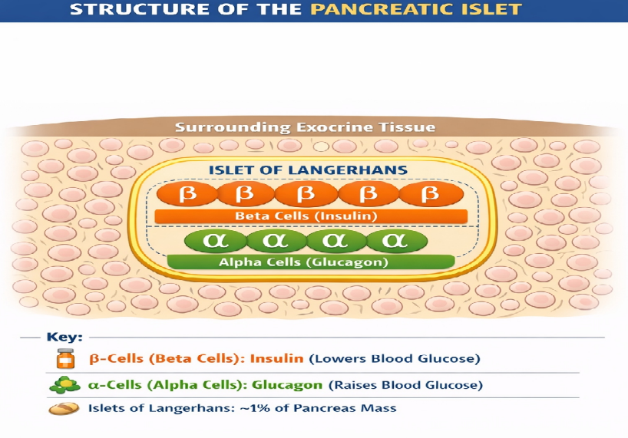

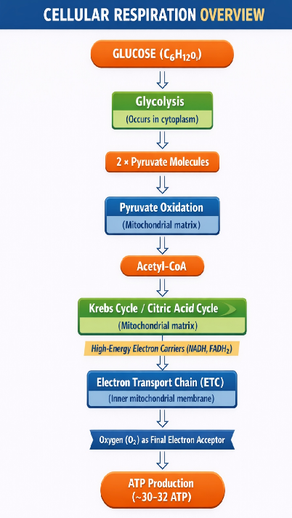
Figure 3

Figure 2: The negative feedback loop in blood glucose regulation that occurs through time copilot_image_


