

Student name: Luz Karina Barba Oliveira
Student ID: 2416438

Module name: Introduction to Physiology
Module code: BMHP5023
Lecturer name: Shaila Hussain

Assessment: Assessment 1 – Case Study Report: Type 2 Diabetes

Table of content:

- introduction………………………………………………….3
Diabetes definition………………………………………………………….3
Risk Factors…………………………………………………………………4
Visual Representation Type 2 Diabetes………………………………..4-5
Endocrine System…………………………………………………………5-6
- Blood sugar Regulation…………………………………..6-7
- Cellular Metabolism……………………………………8-9-10
- Recording and tracking blood sugar levels for type 2 diabetes………………………………………………….10-11
- Recommendations………………………………………11-12
- Conclusion…………………………………………………..12
- References……………………………………………13-14-15

1. Introduction

This case study focuses on the management of patients with diabetes in general practice (GP) setting. Nurses play a crucial role in guiding patients through lifestyle modifications and preventive strategies that can help manage type 2 diabetes more effectively. The report will examine the different forms of diabetes, identify key risk factors, explore monitoring methods for blood glucose, and discuss recommended treatment and care approaches. Additionally, it considers how tailored patient education can improve long-term outcomes and daily wellbeing.

Diabetes Definition:
Diabetes is a chronic condition in which the body struggles to maintain normal blood glucose levels. In affected individuals, either the pancreas fails to produce sufficient insulin, or the body’s cells do not respond properly to the hormone (WHO, 2024). Insulin is responsible for helping cells take up glucose from the bloodstream to generate energy. When insulin is lacking or ineffective, blood glucose accumulates, which can gradually damage organs, nerves, and blood vessels if left unmanaged (NHS, 2025). Understanding these mechanisms is essential for nurses to provide effective care and guidance.

Diabetes is broadly classified into two main types. Type 1 diabetes arises when the body’s immune system mistakenly attacks the pancreas, leading to little or no insulin production (NHS, 2025). In contrast, type 2 diabetes, which is more prevalent, occurs when the body’s cells become resistant to insulin or the pancreas produces insufficient amounts. Unlike type 1, type 2 diabetes can often be prevented or delayed through lifestyle interventions, including diet, exercise, and, when necessary, medication (NICE, 2025).

Risk Factors:
Type 2 diabetes can develop at any age, including in childhood, although the risk tends to increase with age (NIDDK, 2025). Several factors make an individual more likely to develop this condition. Being overweight or having obesity significantly raises the risk, as excess body fat can lead to insulin resistance. A family history of diabetes also increases susceptibility, highlighting a genetic component. Additionally, having prediabetes or a history of gestational diabetes, or having given birth to a baby weighing nine pounds or more, are important risk factors (NIDDK, 2025).

Individuals of Asian, African, or Afro-Caribbean descent, as well as those with a history of gestational diabetes or long-term corticosteroid use, are considered higher risk (NICE, 2025). With the increasing prevalence of type 2 diabetes, understanding the underlying physiological mechanisms is essential.

Visual Representation Type 2 Diabetes:

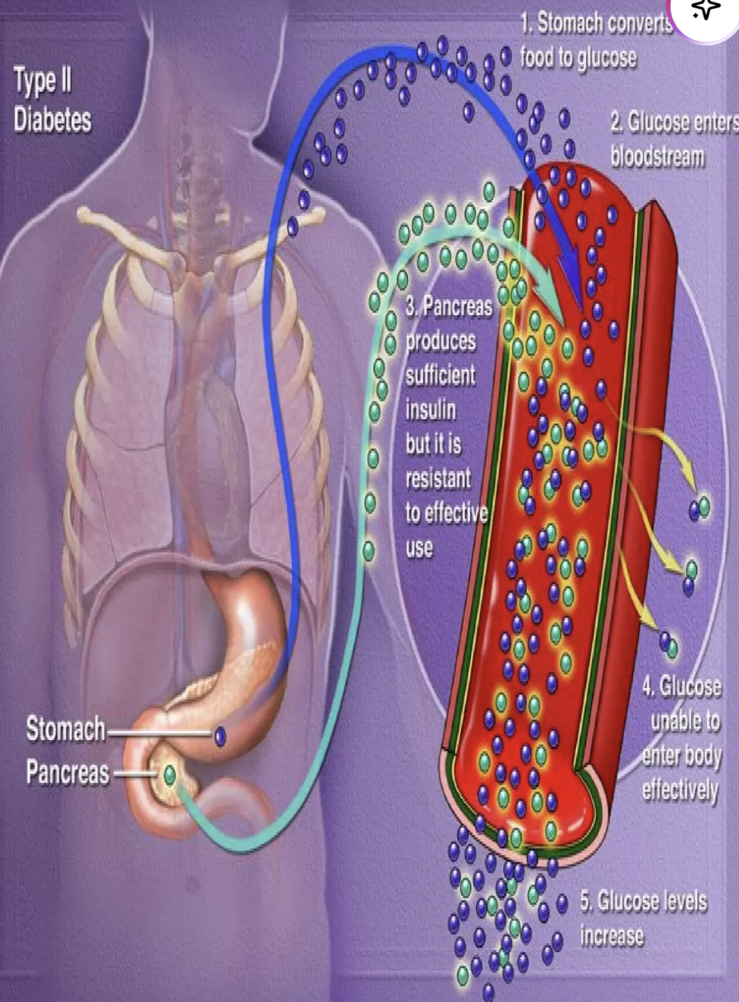
Image 1 (SlideShare, n.d.)
Image 1 visually demonstrates how glucose from digested food enters the bloodstream and how insulin facilitates its uptake by the body’s cells (SlideShare, n.d.; WHO, 2024). The diagram shows glucose moving from the stomach into the blood after digestion (blue arrow), while insulin, secreted by the pancreas (green arrow), allows cells to absorb glucose efficiently (NHS, 2025).

In type 2 diabetes, the pancreas still produces insulin, but the body’s cells exhibit reduced responsiveness, a phenomenon called insulin resistance (NHS, 2025). As a result, glucose builds up in the blood (represented by the increasing number of blue dots), leading to elevated blood sugar levels over time. This accumulation, if persistent, can contribute to long-term complications such as nerve, kidney, and cardiovascular damage, highlighting the importance of early detection and effective management.

Endocrine System:
Image 2 provides a detailed overview of how the endocrine system interacts with multiple organs and its critical role in regulating blood glucose, especially in relation to diabetes. The endocrine system sends hormonal signals throughout the body, coordinating various physiological processes to maintain homeostasis and ensure the body functions efficiently (Ashwell, 2022).

At the center of this system is the hypothalamus, a small but essential brain structure that acts as the body’s control hub. It links the nervous system with hormonal regulation and directs other endocrine glands to release specific hormones that influence growth, metabolism, and energy balance. The thyroid gland, located in the neck, produces hormones that regulate metabolism, affecting how effectively the body utilizes glucose and generates energy (Khatri, 2021).

The pancreas, situated in the abdomen, plays a pivotal role in controlling blood sugar by releasing insulin and glucagon, which help the body maintain glucose levels within a healthy range (Leeds NHS, 2024).
Dysfunction in any of these organs, for example, reduced insulin production, thyroid imbalances, or impaired hypothalamic signalling, can disrupt glucose regulation, increasing the risk of type 2 diabetes. For nurses, understanding these interconnections is crucial, as it informs holistic patient assessment, and enables the identification of early warning signs of endocrine disorders. This knowledge supports patient education, lifestyle advice, and timely interventions that promote metabolic stability and reduce long-term complications.

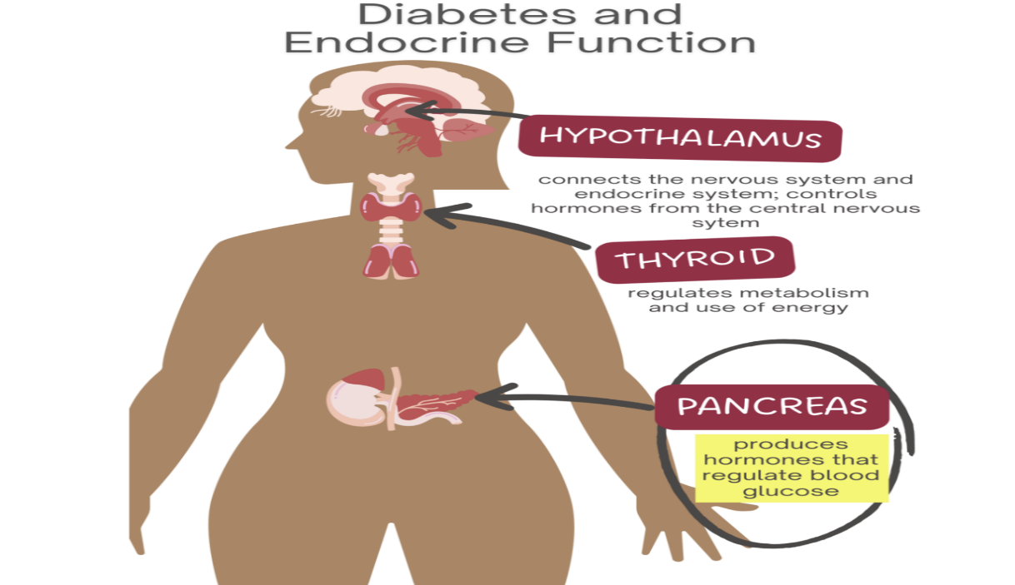
Image 2 (Nursing Central, n.d.)

2. Blood Sugar Regulation

Blood sugar regulation is a vital process that allows the body to maintain stable glucose levels, which is especially important in preventing and managing type 2 diabetes. Image 3 demonstrates how the pancreas regulates blood glucose through two key hormones: insulin and glucagon (Let’s Talk Science, 2021).
When blood sugar rises, such as after a meal, the pancreas releases insulin. This hormone enables glucose to enter body cells, where it can be used for energy or stored as glycogen in the liver and muscles. Without insulin, glucose would accumulate in the bloodstream, leading to hyperglycemia and long-term complications (Callahan, 2020).

Conversely, when blood glucose falls, for example during fasting or exercise, the pancreas releases glucagon. Glucagon signals the liver to break down stored glycogen into glucose and release it into the bloodstream, preventing dangerous drops in blood sugar (Callahan, 2020; Let’s Talk Science, 2021). The image uses pink arrows to show insulin release and blue arrows to show glucagon release, highlighting this continuous balance.

Understanding this system is essential for nurses in primary care. For instance, after a carbohydrate-rich meal, a patient may experience a spike in glucose, whereas skipping a meal or engaging in physical activity may lower levels. Nurses can teach patients how lifestyle factors, medications, and diet influence glucose patterns, helping them make informed decisions about meals, exercise, and insulin administration if required (Callahan, 2020; Diabetes UK, 2025).

Image 3 - Process of the blood sugar regulation (Let’s talk science, 2021)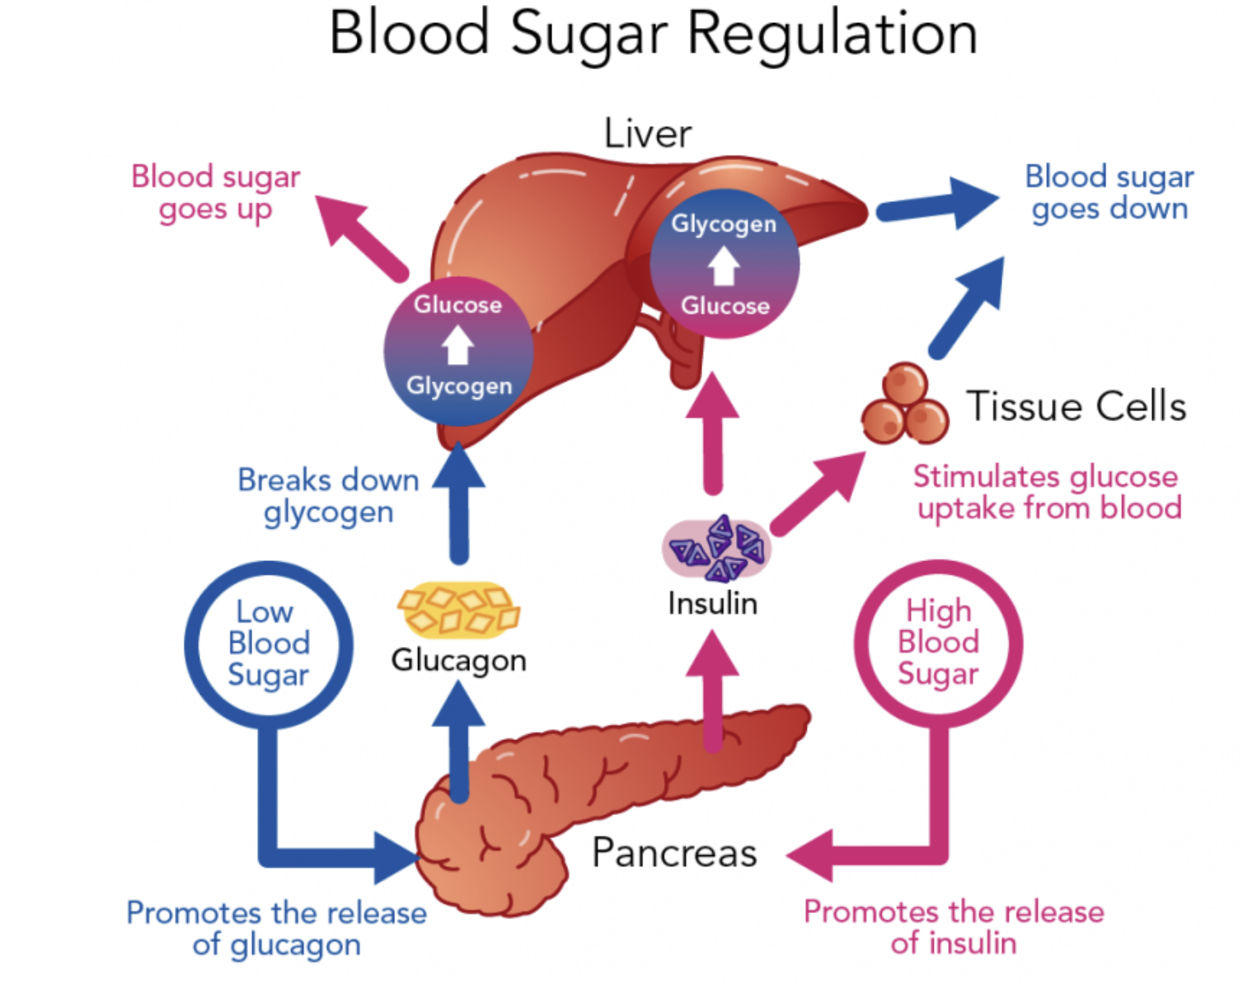

3. Cellular Metabolism

In a GP clinic, nurses assess how a patient’s lifestyle influences cellular metabolism and overall health. Cellular metabolism refers to the chemical reactions within cells that generate energy, maintain essential functions, and support overall wellbeing (Judge, 2020). Several lifestyle factors, including diet, physical activity, sleep, stress, and alcohol consumption, affect these processes, and poor habits can increase the risk of type 2 diabetes and related complications. This understanding allows nurses to support patients in ways that make sense for their routines and challenges.

Regular physical activity enhances glucose uptake by muscles, improves insulin sensitivity, and supports energy production within cells (Małkowska, 2024; Bizimana, 2024). Inactive patients may experience slower metabolism, fatigue, weight gain, and increased insulin resistance.
Nurses play a crucial role by guiding patients to set realistic and achievable activity goals, such as walking for 30 minutes daily, participating in resistance training twice a week, or incorporating light stretching routines. These small but small consistent changes can significantly improve metabolic flexibility and overall health.

Diet is another key factor in managing type 2 diabetes. Diets that emphasize whole grains, fruits, vegetables, lean proteins, and healthy fats, while limiting refined sugars and processed foods, help maintain stable blood glucose and promote weight control (Bizimana, 2024; NICE, 2025).

For example, a balanced breakfast could include oats with berries and low-fat yogurt, while lunch could feature grilled chicken with a variety of vegetables. Nurses assess weight, body composition using BMI or waist-to-height ratio, and eating patterns to provide sensitive, practical guidance, often referring patients to dietitians for tailored plans (Smith, 2025). These approach helps nurses give guidance that patients can realistically follow in their daily lives.

Social and emotional wellbeing also affects metabolism. Chronic stress disrupts cortisol regulation, which can impair insulin function and increase blood glucose levels (Dolan, 2024). Nurses can support patients by promoting stress-reduction strategies, such as mindfulness practices, social support networks, or participation in community activities, which can improve both mental health and metabolic control.

Sleep quality is another essential contributor. Poor or insufficient sleep can impair glucose regulation and increase the risk of insulin resistance (Diabetes UK, 2023; Metabolic News, 2025). Nurses can encourage consistent sleep routines, limiting screen time before bed, and educating patients on creating restful sleep environments.
Excessive alcohol consumption further disrupts metabolism by affecting insulin function and liver glucose regulation (WHO, 2024; Lee, 2025). Nurses provide guidance on safe alcohol intake, highlighting how moderation can support glucose control and reduce long-term health risks.

Finally, existing health conditions, such as obesity, hypertension, or chronic stress, can worsen metabolic efficiency. By assessing all these factors together, nurses help patients optimize energy balance, improve glycaemic control, and prevent complications. The holistic approach enables tailored education, ongoing support, and targeted interventions to empower patients to make sustainable lifestyle changes and maintain long-term metabolic health (Diabetes UK, 2023; Royal College of Nursing, 2017).

4. Recording and tracking blood sugar levels for type 2 diabetes

Monitoring blood sugar is a central part of managing type 2 diabetes and plays a key role in preventing complications. Patients can measure their glucose using finger-prick tests, which provide immediate snapshots of blood sugar at specific times, such as before meals, after eating, or at bedtime.

Alternatively, continuous glucose monitors (CGMs) offer real-time readings throughout the day and night, allowing patients to observe trends and identify patterns in response to meals, exercise, stress, or medications (Diabetes UK, 2025). For example, a patient may notice a sharp rise in glucose after consuming a high-carbohydrate breakfast or a drop in glucose levels after physical activity, highlighting areas where lifestyle adjustments are needed.
Regular monitoring enables patients to recognise when their blood sugar is too low (hypoglycemia) or too high (hyperglycemia) (Diabetes UK, 2025), and take appropriate action, such as consuming carbohydrates for a low reading or adjusting meal portions or activity levels for a high reading.

For self-management to be effective, patients require clear guidance and support from healthcare professionals. Health literacy is critical, as it allows individuals to interpret and act on health information accurately (NHS England, 2022).
I
n a GP setting, nurses can demonstrate how to use monitoring devices correctly, explain results in simple, understandable language, and help patients interpret trends. It is important for nurses in primary care to understand how this system works. For example, a patient might notice their blood sugar rise after a car-heavy meal, while skipping a meal or being active can make it drop.

5. Recommendations

Supporting someone with type 2 diabetes requires combining effective healthcare guidance with practical healthcare guidance. Structured diabetes education is essential, helping patients understand their condition, set blood glucose targets, and see how daily behaviours affects glycaemic control. Programs such as DESMOND or similar initiatives improve self-management skills and long-term outcomes (Watts, 2019).

Dietary modification is central part of management. A balanced, nutrient-rich diet, such as a Mediterranean or high-fibre eating pattern, can support weight control, improve insulin sensitivity, and stabilize blood glucose levels. Limiting refined sugars, processed foods, and large portions helps prevent glucose spikes (Bizimana, 2024). Referral to a dietitian can provide a personalised plans and practical guidance to help patients stay on track.
Regular physical activity is also recommended. Exercise improves glucose uptake in muscles, enhances insulin function, and supports cardiovascular health. Both aerobic and resistance training have been shown to improve glycaemic control and related complications (Bassin, 2023).
Nurses in primary care play a vital role by guiding patients, supporting lifestyle changes, tracking blood sugar, and reinforcing education. Applying these recommendations helps patients manage their condition more effectively, maintain overall health, and improve daily wellbeing.

6. Conclusion

Through patient education, nurses empower individuals to engage in self-management, interpret blood sugar readings, and make informed decisions regarding diet, exercise, and medication (NHS England, 2022; Watts, 2019). Structured programs, such as DESMOND, combined with personalized guidance, support patients in achieving realistic health goals, improving glycaemic control, and reducing the risk of complications.

Nurses also provide ongoing monitoring and emotional support, helping patients navigate challenges such as stress, disrupted sleep, or comorbid conditions that can affect metabolic efficiency (Royal College of Nursing, 2017; Bassin, 2023). By integrating education, practical guidance, and lifestyle interventions, nurses facilitate sustainable behaviour change, promote long-term metabolic stability, and enhance overall wellbeing.

In conclusion, a nurse-led, patient-centred approach is fundamental in managing type 2 diabetes effectively. By combining clinical knowledge, empathetic guidance, and structured support, nurses enable patients to maintain optimal blood sugar control, prevent complications, and improve their quality of life (NICE, 2025; Diabetes UK, 2023).

References

Ashwell, E. (2022). British Journal of Nursing - The endocrine system and associated disorders. [online] British Journal of Nursing. Available at: https://www.britishjournalofnursing.com/content/clinical-pathophysiology/the-endocrine-system-and-associated-disorders [Accessed 3 Dec. 2025].
Bassin, S. (2023). The Impact of Physical Activity in Patients with Type 2 Diabetes. American Journal of Lifestyle Medicine, 19(1), p.155982762311805-155982762311805. doi: https://doi.org/10.1177/15598276231180541.
Bizimana, R.T. (2024). The Impact of Lifestyle Modifications on Type 2 Diabetes Prevention and Management. IDOSR JOURNAL OF BIOCHEMISTRY, BIOTECHNOLOGY AND ALLIED FIELDS, 9(3), pp.18–24. doi: https://doi.org/10.59298/idosr/jbbaf/24/93.1824000.
Callahan, A. (2020). 4.5: Glucose Regulation and Utilization in the Body. [online] Medicine LibreTexts. Available at: https://med.libretexts.org/Bookshelves/Nutrition/Nutrition_Science_and_Everyday_Application_(Callahan_Leonard_and_Powell)/04%3A_Carbohydrates/4.05%3A_Glucose_Regulation_and_Utilization_in_the_Body [Accessed 4 Dec. 2025].
Diabetes UK (2023). Sleep and Diabetes. [online] Diabetes UK. Available at: https://www.diabetes.org.uk/guide-to-diabetes/life-with-diabetes/sleep-and-diabetes [Accessed 5 Dec. 2025].
Dolan, E.W. (2024). Partner’s positive mood linked to reduced cortisol levels in older couples. [online] PsyPost - Psychology News. Available at: https://www.psypost.org/partners-positive-mood-linked-to-reduced-cortisol-levels-in-older-couples/ [Accessed 4 Dec. 2025].
Judge, A. (2020). Metabolism. Essays in Biochemistry, [online] 64(4), pp.607–647. doi: https://doi.org/10.1042/ebc20190041.
Khatri, M. (2021). What Does Your Thyroid Do? [online] WebMD. Available at: https://www.webmd.com/a-to-z-guides/what-does-thyroid-do [Accessed 3 Dec. 2025].
Lee, J. (2025). Excessive alcohol consumption: a driver of metabolic dysfunction and inflammation. Frontiers in Toxicology, 7. doi: https://doi.org/10.3389/ftox.2025.1670769.
Małkowska, P. (2024). Positive Effects of Physical Activity on Insulin Signaling. Current Issues in Molecular Biology, 46(6), pp.5467–5487. doi: https://doi.org/10.3390/cimb46060327.
MetabolicNews (2025). How Does Lack of Sleep Affect Insulin? [online] MetabolicNews. Available at: https://metabolicnews.net/how-does-lack-of-sleep-affect-insulin/ [Accessed 4 Dec. 2025].
NHS (2024). What is the pancreas? [online] Leeds Teaching Hospitals NHS Trust. Available at: https://www.leedsth.nhs.uk/services/pancreas-unit/what-is-the-pancreas/ [Accessed 4 Dec. 2025].
NHS (2025). What is type 2 diabetes? [online] NHS. Available at: https://www.nhs.uk/conditions/type-2-diabetes/what-is-type-2-diabetes/ [Accessed 17 Nov. 2025].
NHS England (2022). Enabling people to make informed health decisions. [online] NHS England. Available at: https://www.england.nhs.uk/personalisedcare/health-literacy/ [Accessed 5 Dec. 2025].
NICE (2025). Diabetes - type 2. [online] NICE. Available at: https://cks.nice.org.uk/topics/diabetes-type-2/ [Accessed 17 Nov. 2025].
NICE (2025). Overweight and Obesity Management. [online] Nice.org.uk. Available at: https://www.nice.org.uk/guidance/ng246 [Accessed 5 Dec. 2025].
NIDDK (2022). Risk factors for Type 2 Diabetes. [online] National Institute of Diabetes and Digestive and Kidney Diseases. Available at: https://www.niddk.nih.gov/health-information/diabetes/overview/risk-factors-type-2-diabetes [Accessed 5 Dec. 2025].
Office for Health Improvement & Disparities (2025). Diabetes profile: Statistical commentary, March 2025. [online] GOV.UK. Available at: https://www.gov.uk/government/statistics/diabetes-profile-update-march-2025/diabetes-profile-statistical-commentary-march-2025 [Accessed 17 Nov. 2025].
Royal College of Nursing (2017). The Role of Nurses in Alcohol and Drug Treatment Services a Resource for commissioners, Providers and Clinicians. [online] Public Health. Available at: https://assets.publishing.service.gov.uk/media/5a81e43a40f0b62305b915dc/Role_of_nurses_in_alcohol_and_drug_services.pdf [Accessed 5 Dec. 2025].
Smith, W. (2025). How nurses can support patients with obesity in primary care. [online] Nursing in Practice. Available at: https://www.nursinginpractice.com/clinical/diabetes-and-endocrinology/how-nurses-can-support-patients-with-obesity-in-primary-care/ [Accessed 5 Dec. 2025].
Watts, M. (2019). DESMOND - Diabetes Education and Self Management for Ongoing and Newly Diagnosed. [online] Diabetes.co.uk. Available at: https://www.diabetes.co.uk/education/desmond.html [Accessed 5 Dec. 2025].
World Health Organization (2024). Diabetes. [online] WHO. Available at: https://www.who.int/news-room/fact-sheets/detail/diabetes [Accessed 17 Nov. 2025].
World Health Organization (2024). Global status report on alcohol and health and treatment of substance use disorders. [online] Google Books. Available at: https://books.google.co.uk/books?hl=en&lr=&id=pI4REQAAQBAJ&oi=fnd&pg=PP1&dq=World+Health+Organization+ [Accessed 4 Dec. 2025].

