Enquiring Teacher Programme
Lesson Study Action Research

Does listening to music improve pupil engagement in
lessons?

Candidate number: P144302
Word Count: 6,372

Aims, purpose and research context
The location for the study is an 11-16 mixed comprehensive school in a suburban setting in south Wales. In this school, there exists a no phone policy from the first to the last bell of the day inclusive of break and lunch times. However, the home environment of a typical teenager is one of almost constant background noise due to increasing use of technology and the internet, including social media, music streaming and film/television programme downloads. This raised an interesting issue for the researcher; traditionally, educators still expect learners to work in near silence when on independent tasks in the school environment, yet empirical evidence suggests that at home, the learning environment is often far busier and full of background noise. There is existing research that there is the presence of a positive learning curve in instances where subjects’ mood was positively altered through exposure to music whilst working (Lesiuk. T, 2005). However, contrasting evidence revealed performance to be poorer when subjects are exposed to any type of music during study, whether it be lyrical or purely instrumental (Perham. N, Vizard. J 2010). There is clearly debate as to whether background noise and/or listening to music whilst studying has a positive effect on learning. This leads to the question that forms that basis for this action research, which is ‘Does listening to music improve pupil engagement in lessons?’
To answer this, the researcher will conduct a Lesson Study (LS) cycle with the aim of observing the behaviour of pupils in two conditions. The researcher will be the teacher in the classroom and 2 colleagues will observe the engagement of 3 lower ability pupils in each of the two conditions. In the first lesson of the LS, pupils will be working on an independent task with no music under quiet conditions. Following this, a second lesson will take place, during which the independent task continues but this time pupils are allowed to listen to music on their devices through headphones. The aim is to determine whether being able to listen to music improves the pupils’ approach to and engagement in their learning and therefore ultimately their attainment.

Literature review
Children experience things in many different environments under many different conditions; classrooms are not the only space where pupils learn. Furthermore, the factors that influence these learning environments are also changing. Pollard et al state that ‘Television, new media, mobile technologies and specific ‘virtual learning environments’ now often play a significant role in supporting learning’ (Pollard, et al., 2014, p. 204). If this is the case then the classroom environment should be looking towards moving with these changing learning environments. Bronfenbrenner’s Ecological Theory supports this idea as he proposes that a child’s development is influenced by so many more environments than just the one that they experience in the classroom, as outlined in the diagram below:
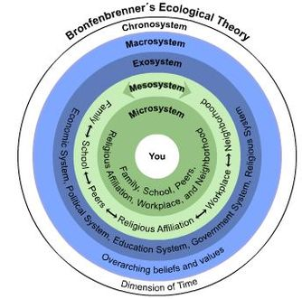
(Bronfenbrenner, 1992).
His research indicates that we cannot consider what the best conditions are for children to learn inside the classroom without also considering the conditions in which they learn outside the classroom. All the layers in the diagram make up a child’s learning environment and if, as Pollard et al (2014) states, media now plays such an influential role in a child’s learning, then the introduction of music in to the classroom learning environment should be looked at very closely.

However, when reading around the topic of listening to music and its impact on pupil focus and engagement, it became clear that there are contrasting views as to whether the former has a positive impact on the latter. As previously mentioned, there is existing research that suggests there is the presence of a positive learning curve in instances where subjects’ mood was positively altered through the exposure to music whilst working, with the quality of work being highest when subjects were listening to music compared with when they were not (Lesiuk, 2005). Findings from research in the field of neuroscience also suggest that cognition and emotion are so closely connected that children will learn best in environments where their emotional state is more positive. The diagram below is a graphical representation of the neurological relationship between cognition and emotion:
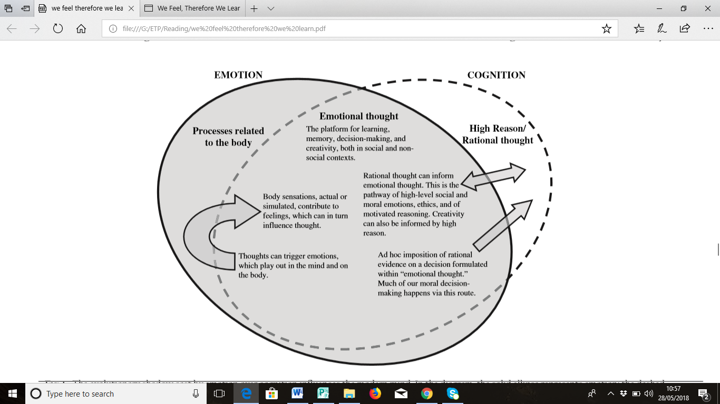
(Immordino-Yang & Damasio, 2007)
The overlap between emotion and cognition is known as ‘Emotional Thought’ and it is suggested that this is the best platform for learning, memory, decision making and higher level reasoning leading to higher levels of creativity (Immordino-Yang & Damasio, 2007). If pupils were able to select songs to listen to on personal devices whilst working in the classroom, this would trigger within them a range of positive emotions which, according to this research would then lead to higher levels of cognition as they would be operating in the zone of Emotional Thought. Pollard et al (2014) lends further support to this idea, as their research suggests that the emotions a pupil experiences are strongly influenced by the classroom environment, stating that ‘attention, memory, decision-making and other cognitive capabilities are strongly influenced by affective disposition and feelings; the latter respond to characteristics of the learning environment’ (Pollard, et al., 2014, p. 35). It is also reported that using music as a form of sensory enrichment could improve pupils performance (Fogarty, 2009).
However, contrasting evidence revealed performance to be poorer when subjects are exposed to any type of music during study, whether it be lyrical or purely instrumental (Perham & Vizard, 2011). Perham & Vizard attribute this poor performance to the ‘Irrelevant Sound Effect’. This idea is derived from the Irrelevant Speech Effect, whereby a person’s visual recall of information is disrupted because of ongoing irrelevant background noise in the form of speech; a similar effect can be observed when irrelevant non-speech sound is present, namely music (Felicia, 2011). Furthermore, findings from a study by South Bank University and the Institute of Education in London found quantifiably that children’s exam results were cut by as much as a third if classroom conditions were noisy or there was a lot of background noise (Paton, 2011).
There is also the issue of how children are perceived by their peers as a result of their music choice or taste. It is reported by Tarrant, North & Hargreaves (2000) that children listen to music for 3 main reasons: "selfactualisation", to "fulfil emotional needs", and to "fulfil social needs", the last of which being linked to judgement by their peers for their musical taste. As Tarrant, North and Hargreaves (2000) state that one of the main reasons adolescents listen to music is to ‘fulfil social needs’, it has been observed that teenagers may select certain music in order to portray a certain social image to others (North, Hargreaves, & Susan, 2010) and so the positive effect of music on mood and therefore engagement may be negated.
In summary, there appears to be no clear decision as to whether listening to music would have a positive effect on pupil engagement in lessons or not and this is what led to the development of the research question for this study; does listening to music improve pupil engagement in lessons?

Lesson Study (LS) design
The primary method of data collection will be LS. LS is defined by Dudley (2008:3) as:

‘A process whereby two or more teachers, work together, developing practice in the classroom, focusing on the needs and learning of real pupils and trying to solve a teaching- or learning-based problem which is affecting pupils’ progress’.

In the case of this LS, 3 teachers from the same school are involved in the LS cycle.
According to Dudley (2008:3), the LS cycle involves the following steps:
- Agree a focus for pupils’ learning and progress.
- Identify three case pupils.
- While keeping in mind the three case pupils, teach and jointly observe the study lesson focusing on the case pupils’ learning and progress.
- Hold a post-lesson discussion analysing how the case pupils responded to the technique.
- Repeat the lesson observation following evaluation of the first.
- Interview the case pupils to gain their insights into the study lesson.
- Evaluate the progress made by the case pupils and what can be learned about the application of the technique.
LS has been chosen as a research method in this case for several reasons. Firstly, it appears to be a highly successful, now globally implemented strategy with 140 year history that brings together all the features of professional learning that most improve learning and teaching:
- The professional learning takes place over time – and is not a one-off event.
- It happens in real classrooms with real pupils.
- It involves an element of collaborative enquiry or experiment between teachers rather than individual teachers acting alone. (Cordingley et al., 2004 cited in Dudley, 2014:3).
Evidence from the use of LS by hundreds of leading teachers working with ‘coasting schools’ who used LS as a coaching approach to improve pupil progress in writing and mathematics at age 11 showed considerable impact year on year (Dudley, 2014). This strategy has also been independently reviewed, by Hadfield et al. (2011 cited in Dudley, 2014:4) who found it to have a positive effect on pupil learning but also teacher pedagogy. Support for this strategy from independent research adds rigour, ensuring the basis for the research method is more reliable. A large scale study in the US also suggests LS has a significant impact on pupil learning as a result of teacher learning (Dudley, 2012) and Peter Dudley’s pilot project demonstrated a positive impact on pupil learning which was directly linked with related teacher learning in a later study (Dudley, 2013). Therefore the LS approach also provides excellent opportunity for staff Continuing Professional Learning and Development (CPLD) as teachers so rarely get the chance to observe and share good practice due to time and budget constraints.

The class that has been selected is a mixed ability KS4 class of pupils aged 15-16 years. Whilst all pupils in the class will be asked to voluntarily adhere to the observational parameters in each observation-quiet working and then working whilst listening to music- only 3 lower ability pupils will be selected as the focus for observer comments and follow up interviews. Lower ability pupils have been selected as empirical evidence suggests they are the ones whom often have the most trouble remaining focused for longer periods of time and so will be the easiest to observe any changes with. A larger sample of 10 focus pupils will have been asked for their assent (parental consent will also have been sought as case pupils will be under 18) to allow for voluntary withdrawal and pupils absence on the day of the LS observations.

Qualitative data will be collected in the form of observer comments on the engagement levels of the selected case pupils in one lesson with no music and then the second lesson where pupils do have the option to listen to music through their headphones if they choose. The observers will be asked to comment on things such as the level of engagement, effort and confidence in tackling independent tasks being displayed by the case pupil in each of the two lessons. The comments made by the observers will then be analysed by the researcher to attempt to identify if there is any change in pupil engagement linked to whether they are listening to music or not. Analysis in this case will simply involve the review of the comments as there is no quantifiable data to present or graph. The case pupils will also be interviewed after each lesson observation in the LS cycle to give their views, feelings and opinions on the lesson. Their responses will then be analysed by the researcher in an attempt to identify if they feel there has been any change in their own level of engagement between the two lessons.
Qualitative data collection is most appropriate in this case as it enables us to things in their natural context and we can see things that may escape conscious awareness. As professional observers, we can also learn about things pupils may be unwilling to talk about in person in their interviews. It is also inconspicuous and part of normal classroom routine, especially in the selected study school, so it can be the least intrusive of all methods, helping to reduce bias and increase the reliability of the findings. It also allows information to be gathered in a short space of time and its results have a high degree of generalisability (Flick, 1956).
The group interview technique does raise the issue of validity, as pupils may want to make themselves appear more competent than they actually are, or may amend their answers to fall in line with that of their peers (Arthur, Waring, Coe, & Hedges, 2012). An attempt to avoid this will be made with the style of the interview questions and the atmosphere within which the interviews are conducted. The researcher has taught these case pupils since year 7, so pupil-staff relationships and trust will help to improve the validity of the answers given in interview. Some element of reliability is ensured with the use of a replicable set of questions in the group interviews, although if interesting elements arise in the course of the interview, for example there are contrasting opinions amongst the case pupils then the researcher may pursue this avenue to gain more depth of information.

Reflective notes will be kept for reference throughout the duration of the research. Reflection is important to ensure that we go beyond just the collection of data, that we use it to inform our practice and become continually improving teaching professionals. To ensure that reflection is meaningful during the LS sequence, strategies related to Brookfield’s Lenses will be employed within the realms of the 4 Lenses: (1) the autobiographical (self), (2) the students' eyes (student), (3) our colleagues' experiences (peers), and (4) theoretical literature (scholarship). (Brookfield, S.1995).

Ethical considerations
BERA (2011:5) states that:

‘Educational researchers should operate within an ethic of respect for any persons involved in the research they are undertaking. Individuals should be treated fairly, sensitively, with dignity, and within an ethic of respect and freedom from prejudice regardless of age, gender, sexuality, race, ethnicity, class, nationality, cultural identity, partnership status, faith, disability, political belief or any other significant difference’.
(BERA, 2011, p. 5)

To ensure that this ethic of respect is upheld and that there are no adverse outcomes for the participants, researcher, observer or the University of Wales Trinity Saint David (UWTSD), this research project will adhere to guidelines set out by BERA (2011), the Education Workforce Council (EWC, 2018) the UWTSD (2017) that include the following:
- Gaining voluntary informed consent from participants and their parents (appendix A and B respectively).
- Openness and transparency.
- No use of deception.
- The participants are clear that they have the right to withdraw at any stage and that they will not be treated differently in any way as a result.
- That there is no detriment to the participant arising from the research.
- That the identity of the school where the research will take place and that identity of the participants will remain confidential.
- Research procedures will be rigorous and in line with agreed protocol and appropriate methodology.
- All data will be stored securely and used only by the researcher, being then destroyed at the conclusion of this research project.
- All staff involved in the research are Disclosure and Barring Service (DBS) checked.
- Personal relationships with the pupils may give rise to pupils feeling as though they have to take part as the researcher is also their teacher and therefore in a position of power. Careful planning of the consent/assent form question styles and reassurance that the pupils are under no obligation to participate will minimise this risk as much as possible.
- The researcher and observers will not be on their own at any time with a pupil/class.
- Usual school safeguarding procedures will be adhered to.
- During LS sessions and pupil interviews the door will be open at all times.
Anonymity of participants is not possible in this case as the LS format means the participants are known to the researcher. Complete confidentiality will be achieved by ensuring that the name of the school and the names of all participants are replaced with alternative names or numbers. All data and the write up of the findings will be kept on electronic devices with passcodes.

Lesson Study 1 and Analysis

Pupils are working on a project about the 2011 Japanese earthquake and tsunami. They have been working on it for a couple of weeks and so are clear on what they need to do to continue. The objective each lesson is to complete a whole chapter, if they are working on one of the smaller chapters (Where and When or Causes) or half a chapter if they are working on one of the larger chapters (Effects and Response). The task involves a high level of independence, with pupils using guidance notes on the board that outline what should be included in each chapter of the project, coupled with a resource booklet full of newspaper articles and images containing all the information they need. There are adapted information booklets and writing frames for lower ability and a separate extension task for higher ability. This high level of pupil autonomy made this the perfect sequence of lessons in which to conduct the LS. Usefully, the three focus group pupils are all on the ‘Causes’ chapter this lesson and, so their objective is to complete this chapter by the end of the lesson.
Notes from the observers (appendix C) indicate that the level of engagement shown by all 3 focus group pupils is erratic across the one hour lesson. At the start of the lesson, all 3 pupils are fully engaged in the teacher explanation, with pupils 1 and 2 beginning to chat and move off task within a few minutes after the explanation. Pupil 3 resists a little longer, but is soon drawn in to pupil 1 and 2’s discussion.
The teacher, having circulated the class returns to the pupils and refocuses them. This re engagement continues for some 5-6 minutes, though it is noted that all 3 are relying heavily on the writing frames. They are lower ability pupils, but it is commented by one observer that they seemed to be more just going through the motions using the writing frame as a crutch to lean on rather than it being a genuine need for support. This indicates low levels of effort even when they appear to be on task.
Approximately 15 minutes in to the lesson pupil 3 has made the most progress but is observed to be ‘daydreaming’ now and pupils 1 and 2 are chatting again. The teacher comes back around and asks them how they are getting on and offers support. Within 7 minutes of this intervention, 1 and 2 are talking again and remain off task for some time. Pupil 3 remains on task a minute or so longer but again in drawn in to their conversation. It could be argued that perhaps the pupils are supporting each other, discussing the task at hand. However, the observer comments that the topic of the pupils’ discussion each time was not work related; they are overheard discussing the latest computer game and what happened at lunch time.
This pattern continues for the duration of the lesson; teacher instruction/intervention followed by a short period of engagement with the task before all 3 pupils to varying degrees end up talking until the teacher intervenes again. The pupils did not meet the objective of the lesson. In fact, to quantify, pupil 1 wrote 12 lines, pupil 2 wrote 7 lines and cut out and stuck in a map and pupil 3 wrote approximately 1/3 of a page which equates to around half the chapter of ‘Causes’. The proforma used by the observer to collect comments worked well (appendix C) as it allowed for in-depth qualitative comments on pupil progress and levels of engagement. It will therefore be kept the same for the second lesson in the LS. To ensure continuity, the focus group pupils will also remain in the same seats and be continuing with the task from this lesson in the second LS.
During the focus group interview following the first lesson, it was found that the pupils appeared quite apathetic about the lesson (appendix D). When asked what they enjoyed most about the lesson, pupil 3 commented that they liked finding out about the tsunami in Japan and pupils 1 and 2 talked about drawing diagrams and sticking photos in; no real in depth comments were made and their tone was quite passive. All pupils also commented that they used the writing frame a lot and found it really helpful, though if they get stuck they ask the teacher, rather than trying to work out for themselves what needs to be done. Pupils 1 and 2 also commented that they ask pupil 3 for help sometimes too, which can be distracting for pupil 3.
When asked to describe their level of concentration in the lesson, pupil 1 was quite self-reflective, admitting that they had not done much in the lesson, commenting that they ‘found it hard to write a lot’ and that they ‘didn’t do much today’. Pupil 2 was a little misguided in terms of the quality and quantity of work that they had produced in the lesson, commenting that they thought they ‘did okay’ and that they ‘just needed to add the diagram’ when in fact, they had a lot more than this remaining to meet their objective for the lesson. Pupil 3 was quite accurate in their self-evaluation, saying that they ‘just need to draw the diagram’ then they would be done, which was true.
In summary, this first lesson observation shows that the focus group pupils were quite passive in their learning rather than being actively engaged in the task at hand. They would focus for short periods of time following teacher intervention but this did not last and as a result the quality and quantity of work produced was not sufficient in meeting the learning objectives.

Lesson Study 2 and Analysis
In this lesson, the focus group pupils were expected to continue with the task from last lesson, with their objective being to complete the ‘Causes’ chapter and move on to the ‘Effects’ chapter, though in this second LS they could listen to music on their personal devices through headphones if they wish.
In the observation notes (appendix E), the first comment remarks that as soon as pupils 1 and 3 put their headphones on they were immediately engaged. Pupil 2 had forgotten to bring headphones, but was immediately very focused, most likely because he could not talk to pupils 1 and 3. It is also observed that when the pupils did talk, it was at a whisper and for much shorter periods of time than in the first LS. This classroom was almost silent as almost all pupils had headphones on and so this perhaps deterred the focus group pupils from chatting as loudly and for as long as they did in the first observation. Pupil 2 and 3 did talk a bit at one point, but it was about the task, with pupil 2 offering advice to pupil 3. When pupil 2 asked pupil 1 a question, as soon as they had answered pupil 1 replaced them immediately and carried on working; pupil 1 produced more work in 5 minutes of listening to music than they did in the whole of the first lesson observation.
These pupils can struggle to maintain focus whilst working independently. When listening to music however, they demonstrated sustained concentration for a far greater period of time and produced work in greater quantity and to a higher quality. It could be argued that this was down to several factors:
- They were able to tune out any distractions from other pupils around them as they cannot hear them.
- They were feeling a greater sense of ownership over the task, as they created their own mood for working in by selecting certain songs or artists.
- This mimics the conditions across other learning environments in their lives, as previously mentioned in the Ecological Theory (Bronfenbrenner, 1992).
- It allows them to better access and work in the realms of Emotional Thought (Immordino-Yang & Damasio, 2007).
However, it could of course be argued that this may be a short term novelty effect, that over time the personal devices, in this case their mobile phone, will prove too great a temptation with regards to checking social media platforms, creating a distraction and ultimately becoming more of a hindrance than a help. This did start to become an issue in the second LS, when at some points the personal devices, in this case mobile phones, did cause a bit of a distraction, with all 3 pupils at one stage drawn in to a conversation about the make and model of pupil 1’s phone. Pupils 1 and 3 did manage to get back on task but pupil 2 struggled to refocus, trying to draw pupil 1 back in to conversation, perhaps because he did not have his own headphones he was beginning to feel isolated and finding it harder to focus on the task at hand. It is also suggested that the positive effect of music on pupil engagement may only be short term in itself as studies have found that children exhibit only a temporary improvement in pupil test scores whilst listening to music (Geake, 2009).
The observer concludes that all pupils remained engaged in their work for a significant proportion of the lesson and made more progress than in the previous lesson observation. Conversations were more infrequent and often were focused on the work when they did occur. The observer comments that the overall impact on the class was ‘very striking’ with almost all pupils engaged in silence for the majority of the lesson. However, the effect did appear to taper off as time went on. The level of engagement did not remain as high as when the pupils put their headphones on initially, with some, including focus group pupil 2 beginning to move off task. Perhaps the novelty had worn off or maybe it was just a case of different pupil having different attention spans and those with shorter attention spans were beginning to lose focus naturally irrespective of whether they were listening to music or not. Also, interestingly pupil 1 admitted to the observer that he did not actually have any music on his phone but that he still found it helpful to put the headphones on as it blocked out some of the noise from the class and stopped people from talking to him.
In the focus group interview following the second lesson, the consensus from all the boys seemed to be that they preferred working with music and that they thought they had worked harder under these conditions (appendix F). When asked what they enjoyed about the lesson and to describe their levels of concentration, pupil 3 said they found it much easier to reach the lesson objectives, stating that they were ‘nearly done on Effects’ and that they always listen to music at home when they’re working too. Interestingly, pupil 3 also said that listening to music helped him feel more relaxed in the classroom. Pupil 1 also stated that they had done a lot more work than last lesson, even though they actually had no music playing through the headphones. They attributed this effect to the fact that it blocked out background noise in the classroom, allowing them to concentrate better, saying they ‘did a lot more this lesson than last lesson’. Pupil 2 also observed that they had worked much harder because, even though they did not have headphones, they could not talk to pupils 1 and 3 as easily as they had headphones on which left them no choice but to engage with their own work.
When asked what they did when they came across a section of the task they found difficult, none of the pupils mentioned asking the teacher this time, or referring the writing frame. Instead, they commented that they had asked each other, perhaps indicating a greater feeling of confidence and ownership over the task as a result of being more engaged in it.
In conclusion, it appears that the effect of listening to music on levels of engagement is a positive one for three reasons:
- It helps the pupils to relax and create a more personal learning environment.
- It enables them to tune out background distractions.
- Dissuading pupils from engaging each other in conversation as the classroom is already close to silent.

Research findings in relation to relevant literature and research
Lesson 1 of the LS found that the focus group pupils were quite passive in their learning rather than being actively engaged in the task at hand. They would focus for short periods of time following teacher intervention but this did not last and as a result the quality and quantity of work produced was not sufficient in meeting the learning objectives. This is directly at odds with some other research findings. As previously mentioned, an article in the Telegraph stated that ‘A study almost a decade ago by South Bank University and the Institute of Education in London found that children’s exam results were cut by as much as a third if they taught in noisy classrooms’ (Paton, 2011). In addition, there is research to suggest that learning in quiet conditions is better for pupil cognition. Findings by Perham & Vizard (2011) indicated that participant recall and focus was better under quiet conditions than when they were listening to music. It is also stated in recent research by Lees (2012) that silence has a positive effect on pupil attainment and that it most definitely has a place in the classroom:

‘In areas of better learning outcomes, better interpersonal relationships, better self-esteem and wellbeing measures, silence in a person’s life and an individual’s education is shown throughout the relevant research literature to be a benefit.’
(Lees, 2012, p. 176).
However, Lees (2012) does make a distinction between ‘weak’ silence and ‘strong’ silence, the former being one of punishment and the latter being one of coercion saying that the former is not a condition to be advocated in the classroom. However, when she describes ‘strong’ silence in more detail, Lees says that this is a condition that entails ‘dominant teacher talk and the avoidance of controversial issues’. This clarification actually makes conditions of ‘strong’ silence sound just as negative as those in ‘weak’ silence, suggesting that silence in any form is oppressive and not conducive to learning. Educators should be encouraging pupils to lead their own discussions and discuss controversial issues to reduce prejudice, not ‘avoid controversial issues’. It could therefore be argued that if these are the conditions that underpin Lees’ argument for silent classrooms then perhaps they are not conditions that should be being promoted in education at all.

The findings from the second lesson in the LS add to and are supported by existing research that suggests listening to music does have a positive impact on levels of focus and effort. Research by Vizard & Perham suggest that listening to background music prior to task performance increases cognitive processes, such as attention and memory, through the mechanism of increasing arousal and positive mood (Perham & Vizard, 2011). It was found in the second lesson that the effect of listening to music on levels of engagement is a positive one and could be attributed to three main reasons:
- It helps the pupils to relax and create a more personal learning environment.
- It enables them to tune out background distractions.
- Dissuading pupils from engaging each other in conversation as the classroom is already close to silent.
Expanding on the first bullet point, pupil 3 also commented that ‘listening to music helped him feel more relaxed in the classroom’ which is in direct contradiction to the findings of Smith & Morris (1976) that it increases levels of anxiety and emotionality, leading to the conclusion that perhaps that research is now rather outdated. Children are exposed to increasing levels of multimedia in all facets of life now and therefore are more likely to associate it with pleasure than it giving rise to feelings of anxiety. The comments of pupil 3, that they felt more relaxed when listening to music, could be attributed to the concept of classical conditioning; a learning process that repeatedly pairs two stimuli until a response which is at first elicited by the second stimulus (in this case, the pupil’s choice of music) is eventually elicited by the first stimulus alone (in this case, the task in the classroom). Consequently, the feeling of positive emotion associated with the music comes to also be associated with the work and thus increases the level of pupil engagement. This appears at first to be a strong argument for the positive effect of music on engagement. However, more there is some research suggests that conditioning in humans is a result of much higher, more advanced mental processes rather than an unconscious association between two stimuli (Brewer, 1974). This would mean it could be argued that whilst a positive effect of music on engagement does exist, it is not as a result of mood or emotion at all, casting doubt on the concept of the zone of Emotional Thought (Immordino-Yang & Damasio, 2007) as well. However, research by Pollard et al (2014) supports the findings of the second lesson, as they suggest that the emotions a pupil experiences are strongly influenced by the classroom environment, stating that ‘attention, memory, decision-making and other cognitive capabilities are strongly influenced by affective disposition and feelings; the latter respond to characteristics of the learning environment’ (Pollard, et al., 2014, p. 35).
To expand on bullet points two and three, perhaps the benefit of headphones is more to do with being able to eliminate distractions in the environment around them than the impact of the music itself. Recent research carried out with office workers states that ‘In the now dominant open plan workplace, office workers listen to music via headphones, not just because they want to, but because, in order to maintain their personal space and their sanity, they have to’ (Newman, 2016). It could be argued that the classroom is a similar environment to an open plan office space, with all the distractions that come with it. The study by Newman (2016) states that questions like “Is listening to music at work good for workers in terms of increased or improved productivity?” are really questions about how much privacy, autonomy and control are possessed by modern-day workers. Perhaps this is the reason for increased engagement in the second lesson; pupils felt a greater sense of autonomy over the task at hand and were able to tune out other distractions. As pupil 1 said, they didn’t even have music playing, but the headphones enabled them to ignore other noise distractions.

Conclusion and evaluation
The findings from this lesson study show that levels of engagement are improved when pupils listen to music whilst they work. However, it is difficult to attribute this effect to one particular factor; was it the music of was it the ability to tune out background noise, or a combination of both? It also transpired that only one of the 3 pupils was actually listening to music, with the others either just wearing headphones but with no music or having forgotten headphones all together. Interestingly though, levels of engagement did increase in all 3 pupils.
The small sample size may mean that the results may not be able to be generalised to all pupils in all contexts and may mean the results are not replicable. It is also difficult to quantify levels of engagement. In this LS, the data collected was qualitative. The researcher does, however, feel that the data that was collected was insightful as it enabled observation of pupils in their natural context so that we may observe behaviours that we otherwise may not be aware of. It is also a non-intrusive method; pupils in the study school are used to having observers in as part of regular practice, so it is less likely that they may be modifying their behaviour in light of another member of staff being present, making the observations more reliable. There is the issue of pupils trying to anticipate what the research outcomes may be. For instance, some were asking the observer if this study was about changing the school rules so they would be allowed to use headphones in all lessons and have their phones out in school. This may have created bias as pupils would work harder under the listening to music condition, believing that it would have these changes on school policy and created issues of validity in the answers given in the focus group interviews.

Recommendations
Going forward, the findings do show that listening to music has a positive effect on pupil engagement in lessons. The methodology is sound, meaning that the findings are valid in terms of finding the answer to the research question. However, to improve reliability the focus group sample needs to be larger and across a wider ability range to make it possible to generalise the findings. If the LS were to be repeated, the process should be conducted in a class in each year group, with 3 focus groups in each; higher, middle and lower ability and if possible across more than one school. In terms of informing the practice of the researcher, the use of headphones definitely helps pupils who are usually less productive to better meet their lesson objectives. It will now also be trialled with a KS3 class that has a high concentration of ALN pupils and pupils with challenging behaviours to see if it not only helps their levels of engagement but also reduces negative behaviour. An anticipated knock on effect also being that if the more disruptive pupils are now better engaged, the more able pupils are able to focus and progress better, ultimately leading to improved attainment for the whole class.

Bibliography
Arthur, J., Waring, M., Coe, R., & Hedges, L. V. (2012). Research Methods and Methodologies in Education. SAGE Publications Ltd.
BERA. (2011). Ethical Guidlines for Educational Research. British Educational Research Association.
Brewer, W. (1974). There is no convincing evidence for operant or classical conditioning in adult humans. In W. B. Weimer & D. S. Palermo (Eds.), Cognition and the symbolic processes. Oxford: Lawrence Erlbaum.
Bronfenbrenner, U. (1992). Ecological Systems Theory. London, England: Jessica Kingsley Publishers.
EWC. (2018, June 20). Code of Professional Conduct and Practice for Registrants with the Education Workforce Council. Retrieved from EWC Wales: https://www.ewc.wales/site/index.php/en/fitness-to-practise/code-of-professional-conduct-and-practice-pdf/file.html
Felicia, P. (2011). Handbook of Research on Improving Learning and Motivation through Educational Games: Multidisciplinary Approach. Waterford Institue of Technology, Ireland.
Flick, U. (1956). Introducing research rethodology: a beginner's guide to doing a research project. Los Angeles: SAGE.
Fogarty, R. (2009). Brain Compatible Classrooms 3rd Edition. Corwin.
Geake, J. (2009). The Brain At School: Educational Neuroscience In The Classroom. McGraw-Hill Education.
Immordino-Yang, M. H., & Damasio, A. (2007). We feel therefore we learn; the relevence of affective and social neuroscience to education. Mind, Brain and Education, 3-10.
Lees, H. E. (2012). Silence in Schools. Stoke on Trent: Trentham books.
Lesiuk, T. (2005). The effect of music listening on work performance. Psychology of Music, 173-191.
Newman, K. M. (2016). Headphones are the New Walls: Music in the Workplace in the Digital Age. In: Purcell R., Randall R. (eds) 21st Century Perspectives on Music, Technology, and Culture. Pop Music, Culture and Identity. London: Palgrave Macmillan.
North, A. C., Hargreaves, D. J., & Susan, O. A. (2010). The importance of Music to Adolescents. British Journal of Educational Psychology, 255-272.
Paton, G. (2011, October 21st). Silence is golden how keeping quiet in the classroom can boost results. Retrieved May 31st, 2018, from The Telegraph, Eduaction: https://www.telegraph.co.uk/education/educationnews/8841649/Silence-is-golden-how-keeping-quiet-in-the-classroom-can-boost-results.html
Perham, N., & Vizard, J. (2011). Can preference for background music mediate the irrelevant sound effect? Applied Cognitive Pychology, 625-631.
Pollard, A., Black-Hawkins, K., Cliff Hodges, G., Dudley, P., James, M., Linklater, H., et al. (2014). Reflective Teaching in Schools (Vol. 4). Continuum Publishing Corporation.
Smith, C. A., & Morris, L. W. (1976). Effects of Stimulative and Sedative Music on Cognitive and Emotional Components of Anxiety. Psychological Reports, 1187-1193.
Tarrant, M., North, A. C., & Hargreaves, D. J. (2000). English and American Adolescents Reasons for Listening to Music. Psychology of Music, 166-173.

Appendix A
January 2018

Dear Pupil,
Your class has been selected to participate in some university research aimed at improving teaching practice and pupil wellbeing and performance. Your lives have changed greatly from those of your teachers and parents when we were in school; you have instant access via personal devices to music, films and all manner of media through your phones and laptops. Historically, it is believed that pupils work best in silent or at least quiet conditions. However, easy access to media often means that you would choose to have music or even the television on in the background whilst studying. Therefore, this research project will focus on the question ‘does listening to music improve pupil engagement in lessons’.
You will first be in a lesson where you are required to work on an independent task under usual, quiet classroom conditions. Then, in a second lesson, you will be again required to work on an independent task, but this time whilst listening to music through headphones, if you so choose. A teacher will be present in the class, as well as the usual classroom teacher, to observe and compare your levels of engagement in each condition. Some of you will also be interviewed afterwards about what you think about how listening to music affects your focus in lessons.
Your participation is in no way compulsory and even if you give assent now, you can withdraw your assent at any time. The design of the study is such that it will in no way impact on your grades or progress in the short term or long term, nor the high esteem in which you are held by the teachers involved in the study and by the school itself. The outcome will also not have an effect on the school’s mobile phone policy.
Action research such as this is becoming more and more common place in the classroom as a way of improving teaching and learning. Feedback following the research can be given on request, though individual pupils cannot be discussed for confidentiality purposes.
Please complete the consent form overleaf and return directly to Miss. Gleeson as soon as possible.
If you have any questions, please just ask me.

Yours faithfully
Teacher ‘X’

Appendix B
January 2018

Dear Parent/Guardian,
Your child’s class has been selected to participate in some university research aimed at improving teaching practice and pupil wellbeing and performance. Our children’s lives have changed greatly from our own during our time in education; they have instant access via personal devices to music, films and all manner of media through their phones and laptops. Historically, it is believed that pupils work best in silent or at least quiet conditions. However, easy access to media often means that they would choose to have music or even the television on in the background whilst studying. Therefore, this research project will focus on the question ‘does listening to music improve pupil engagement in lessons’.
Your child will first be in a lesson where they are required to work on an independent task under usual, quiet classroom conditions. They will then, in a second lesson, be again required to work on an independent task, but this time whilst listening to music through headphones, if they so choose. A teacher will be present in the class, as well as the usual classroom teacher, to observe and compare their levels of engagement in each condition. Some of the pupils will also be interviewed afterwards about what they think about how listening to music affects their focus in lessons.
Your child’s participation is in no way compulsory and even if you give consent now you can withdraw your consent at any time. Your child will also be asked to agree to voluntary participation in the study and they will not participate if we have not gained both their assent and your consent.
The design of the study is such that it will in no way impact on your child’s grades or progress in the short term or long term, nor the high esteem in which they are held by the teachers involved in the study and by the school itself. The outcome will also not have an effect on the school’s mobile phone policy.
Action research such as this is becoming more and more common place in the classroom as a way of improving teaching and learning.
Please complete the parental consent form overleaf and return directly to Miss. Gleeson as soon as possible. Feedback following the research can be given on request, though individual pupils cannot be discussed for confidentiality purposes.
If you have any questions, please contact me at the school.
Yours faithfully
Teacher ‘X’


Appendix C
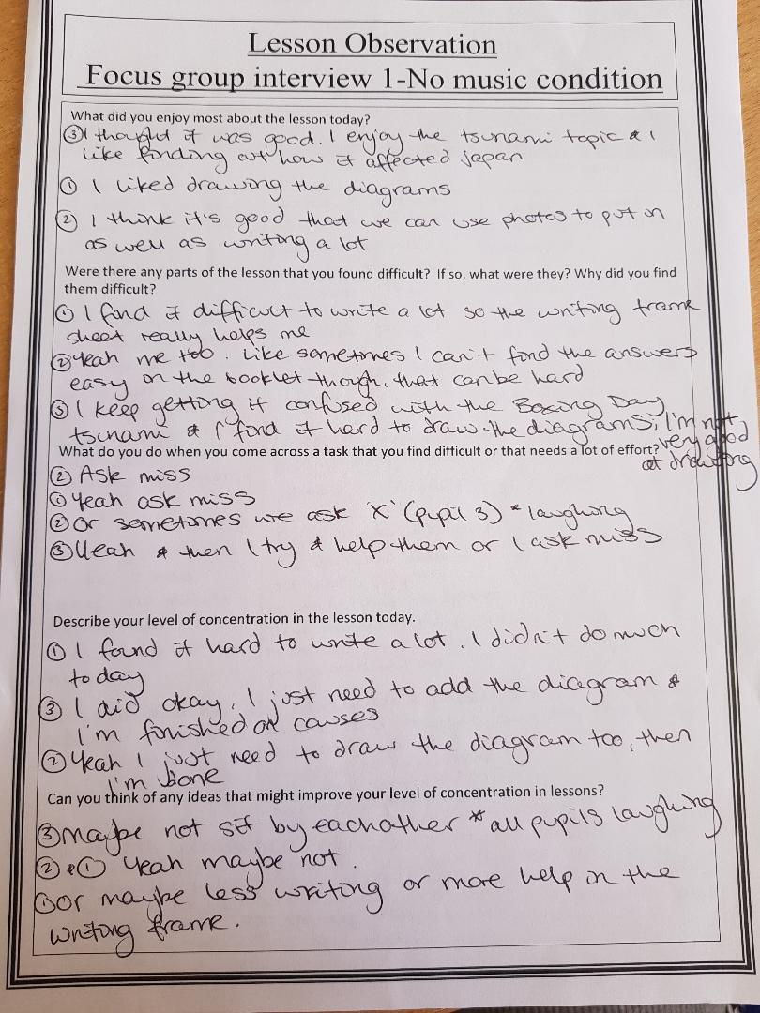
Appendix D
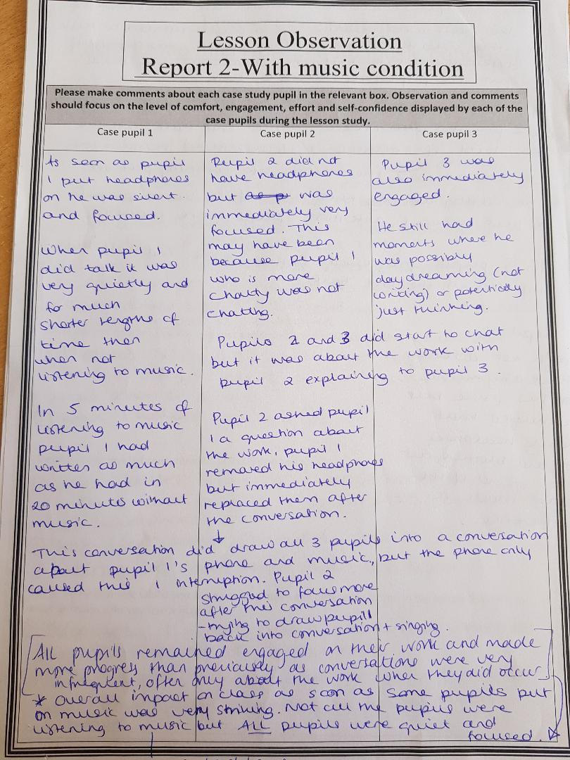
Appendix E
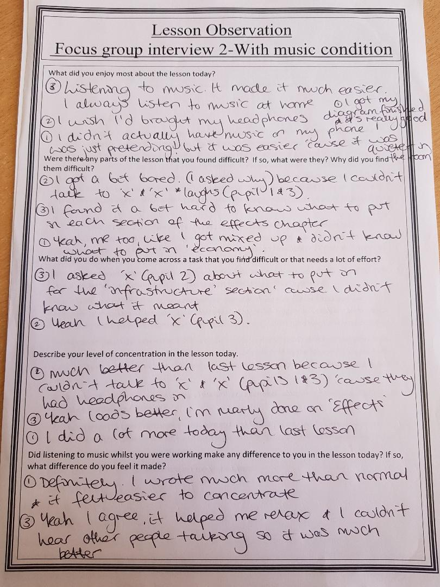
Appendix F

