GLOBAL BUSINESS ENVIRONMENT
MODULE CODE: LCBB4005
ASSESMENT 1
Lecturer: Nadeem Mirza
Student name: Alina Munteanu
Student code: 1920430

Table of Contents
1.0 Introduction 3
2.0 Major forces shaping the business environment of the car manufacturing industry 3
2.1 Pestle analysis 3
Political: 3
Economic: 4
Social: 4
Technological: 4
Environmental: 5
Legal: 5
2.2 Porter's five forces 5
Threat from new market players: 5
Threat from substitute products: 5
The threat of consumers: 6
The threat of suppliers: 6
Threat from rivals: 6
2.3 Evaluation of how the industry has changed over the years 6
3.0 Assessment of the opportunities and challenges and resilience strategies 7
3.1 Evaluation of opportunities and threats 7
Threats: 7
Opportunities: 8
3.2 Positioning strategies to gain competitive advantage 8
3.2.1 Product life cycle strategies 8
3.2.2 Porter's value chain 9
4.0 Conclusion 10
References 11

1.0 Introduction
In this assignment, the major forces that shape the business environment of the car manufacturing industry will be discussed in conjunction with different analyses to identify the threats and opportunities prevalent for the car manufacturing company through Porter's five forces. Traditionally the opportunities and challenges of the forces will be critically evaluated through the product life cycle, and Porter's value chain methods. Lastly, identification of the position of industries that would be most suitable to gain competitive advantages will be discussed.

2.0 Major forces shaping the business environment of the car manufacturing industry
The major forces that shape the contemporary and future of the global business environment are tech innovation, green revolution, shifting of human geographies, and transformation of money. All these forces somehow shape the business environment internationally as well as adapt to their changing environment.

2.1 Pestle analysis

Political:
The United Kingdom government had undertaken several policies to reduce the impact of carbon footprints for the transportation systems that are considered as one of the major sources of emissions due to which the government targets at finishing the petrol and diesel cars by the year 2030 (Reducing carbon emissions in the UK, 2020). Moreover, the Brexit impact has widely affected the automobile manufacturing industries in the United Kingdom due to being out of the European markets frameworks.

Economic:
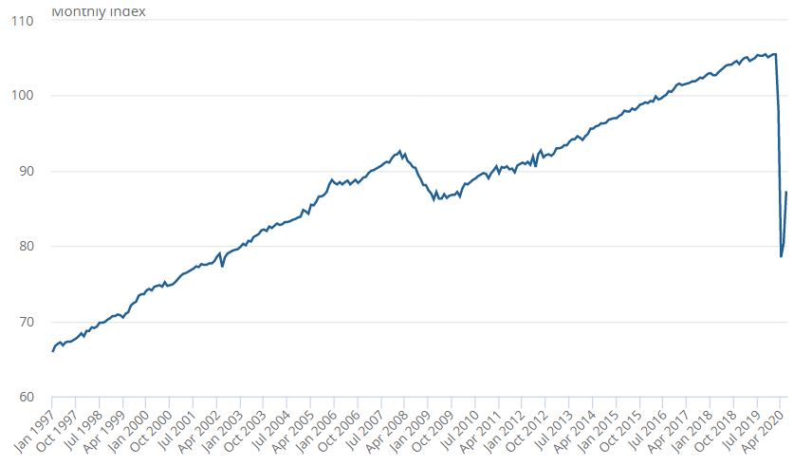
Fig 1: GDP growth rate
Source: Ons.gov.uk. 2020
Due to the strike of the covid-19 pandemic, the United Kingdom government has experienced a fall in the GDP in the first semi-annual year due to which the purchasing power of the consumers in the economy has reduced drastically. Even though in June, the GDP has shown favourable trends by the growth of 8.7%, its level stayed lower than February (Ons.gov.uk. 2020).

Social:
Cars being one of the major sources of toxic emissions and noise pollution, they affect the entire society. The toxic emissions can have an impact on the public and create diseases related to breathing and skin. Further, automobiles are one of the major reasons for road accidents due to which society gets affected on a big scale. Therefore, the car manufacturing industries are required to prioritize the minimization of toxic emissions and enhancing the safety features without which society can have a great impact on them.

Technological: due to frequent evolving of the market forms and consumer demands the car manufacturing companies need to indulge in the process of upgrading the necessities of technology at frequent levels. Technology upgrades can, overall increase the expenditure of companies that will further diminish the profit margins.

Environmental: pollution is one of the most challenging issues faced by car manufacturers that can affect them due to their necessity to reduce the carbon footprint levels and be more environment-friendly and sustainable.

Legal: the car manufacturers of the United Kingdom are required to abide by the laws and regulations enforced by the government regarding emissions laws, safety laws, and vehicle regulatory laws.

2.2 Porter's five forces
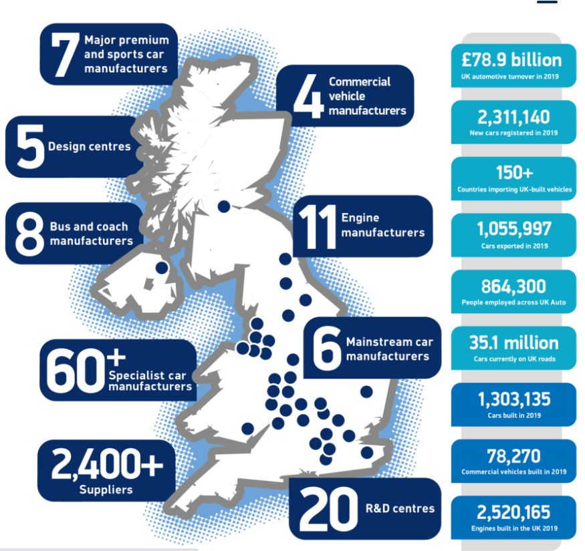
Fig 2: Facts about the UK car manufacturing industry
Source: SMMT. 2020

Threat from new market players:
The threat of new market players: due to easy entry in the market, the alternate brands have hiked in recent years due to which the popular brands face additional threats.

Threat from substitute products:
Overall, there were approximately 1.3 million cars built in 2019 by car manufacturers in the United Kingdom who provide cost-efficient vehicles to the consumers that can impact the luxury sectors and abrupt their operations to target potential consumers (SMMT. 2020). This reflects the existence of high threats from substitute products.

The threat of consumers:
Because of the availability of alternate substitute products, the consumers can switch from branch to brands that offer the most efficient vehicles and their opinions can, however, impact the car manufacturers in the United Kingdom.

The threat of suppliers:
Due to the increasing cost of taxes by the government, the suppliers before supplying can impose additional charges due to which the car manufacturing companies will potentially experience increased costs of materials. There are over 2400 suppliers in the industry (SMMT. 2020). Steel remains one of the crucial inputs of the UK car industry along with other equipment for which the suppliers play an integral role (Rawlinson and Wells, 2016).

Threat from rivals:
There are around 980 businesses in the UK car manufacturing industry that depict intense competition (Ibisworld.com. 2020). Due to the availability of alternate brands of vehicles providing cost-efficient and fuel-efficient vehicles, the luxury and middle segment cars can face immense competition while capturing the market.

2.3 Evaluation of how the industry has changed over the years
Car manufacturing since prior times has been a major aspect for the development of the countries due to the increasing population and income levels of the consumers. Automobiles are utilized by the people for travelling purposes, going for trips, travelling to work.
Cars have been developed immensely over the last few years as, in the prior time cars were much more fuel consuming, unsustainable in nature, and nature harming while at present the manufacturers provide a lot of opportunities for the consumers to enjoy inclusive of Hi-Tech specifications, increased power, refined engines, additional safety features, fuel-efficient, as well as battery cars have been forwarded. The car manufacturing industries in the United Kingdom play an important role in contributing to the economy as the manufacturing companies are worth 78 million pounds that further generates more than 15 billion pounds for the economy. In a recent article, it was highlighted that the growth rate of 0.1% in the manufacturing production increased the annual rate of expansion by 3.9% due to which the manufacturing industries in the United Kingdom have been identified as one of the major contributors to the United Kingdom economy (The Guardian, 2017).
The car manufacturing companies, however, following the rules and regulations forwarded by the United Kingdom government abide by and focus on creating less nature harming automobiles in a sustainable manner that has been critically appreciated by the market consumers. Hence the development of the car manufacturing companies over the past years has shown immense growth and feature-loaded opportunities due to which it contributes a major portion of wealth in the UK economy that further helps in development.

3.0 Assessment of the opportunities and challenges and resilience strategies

3.1 Evaluation of opportunities and threats
From the car manufacturing industry viewpoint, the threats and opportunities identification have a crucial role in positioning the companies in proper market forms to target the major consumers and generate additional revenue levels for future growth and expansion.

Threats:
The entry of new industries proposes an immense threat to the existing ones as they can target several consumer segments and exploit the performance of the existing companies.
Additional threats are offered to the industries by the government policies that enforce a much sustainable and carbon footprint reducing the necessity for not harming nature immensely. To follow these manifests, the industries require to undertake technological upgrades that require an additional flow of resources that reduces the profit margins.
Due to the present situation, several companies to be nature efficient are adopting electric vehicles that are operated either by solar panels or batteries due to the increasing fuel prices in the economy.
Closing of production due to the Covid-19 pandemic that reduces output. (Ibisworld.com, 2020).

Opportunities:
Due to the present prevalent covid-19 pandemic and lockdowns enforced by the government, the people of the United Kingdom opt for purchasing vehicles for continuing their work activities and travel with safety.
The increasing population further creates development opportunities shortly.
The rise of electric cars that are much efficient and less nature harming has created the expectations of the consumers to rise immensely and provide new facilities in the upcoming situations.

3.2 Positioning strategies to gain competitive advantage
3.2.1 Product life cycle strategies

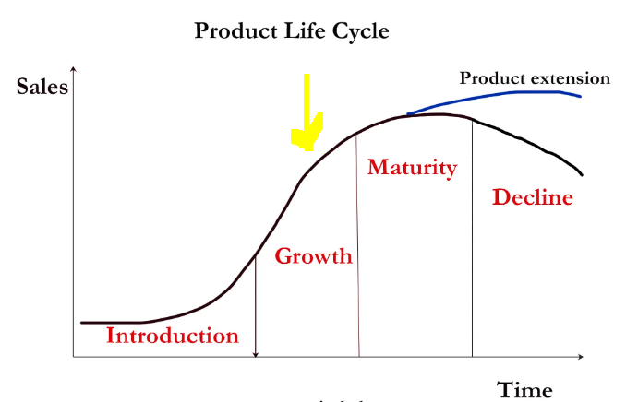
Fig 3: Product life cycle
Source: (Pettinger, 2020)

From the previous discussions, it can be identified that the car manufacturing industries in the UK are in the growth phase of the product life cycle. It is considered so as the industries at present are creating and supplying several innovative conceptual automobiles inclusive of electric vehicles, fuel-efficient cars, and additional safety, ensuring prospects within the automobiles. The innovative phase has continued over the past few decades, and the industries prioritize their activities to be carried out more sustainably and efficiently. As per a recent article, it has been identified that converting fuelled vehicles into electric ones in addition to the facility of self-driving cars possesses the ability to lead future changes (The future of Britain’s automotive industry, 2019). In the growth phase, the industries are at present offering reduced-priced vehicles for every consumer segment necessity inclusive of cheap vehicles to luxurious ones to enhance their experience. As further highlighted in a recent article, the concepts and introduction of electric cars are much cheaper to run than the fuel consuming ones and the purely electric vehicles have been available in the UK for over four years that has comparatively reduced taxes, costs of fuels, and subsidies on purchasing price making it much simple yet efficient purchase (Carrington, 2019).

3.2.2 Porter's value chain
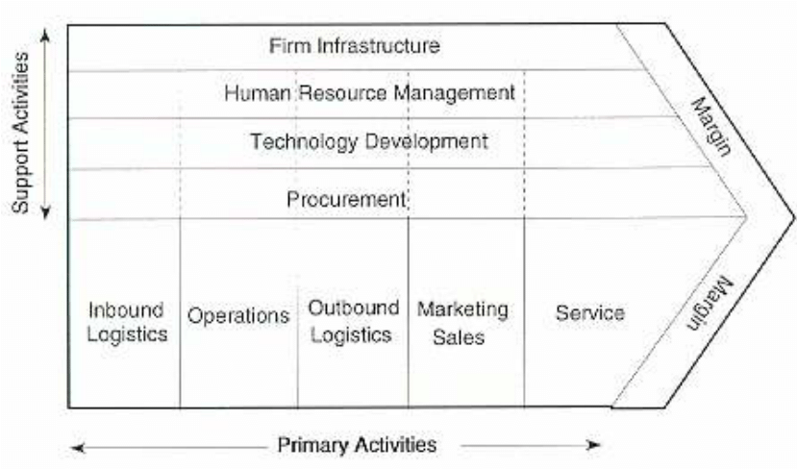
Fig 4: Porter’s Value Chain model
Source: Simons, 2011
Not focusing just on the department or on the accounting Porter' Value Chain focuses on systems and how inputs can be changed into outputs. Porter's Value chain model is divided into two kinds of activities which are support and primary. Under support exist four aspects and under primary activities there are five aspects. UK car manufacturing can use this model and look out for ways by which they can improve in these aspects and gain a competitive advantage in the market and gain more customers. The companies which belong from the car industry of the UK can develop a productive and efficient organizational structure, plan and then manage all their strategies by which they will be able to develop the whole infrastructure of the firm. In case of human resource management, the organizations must ensure that they are providing all their HRs with the right lessons and training by which they will be able to recruit potential talents in the firm (Ruan, 2020). In the case of technology development, they need to look for new and innovative equipment which will benefit them to execute their whole process of manufacturing more effectively. Obtaining good services will help the car manufacturing companies to make effective and cost-efficient decisions while purchasing goods and resources from their suppliers. In case of inbound logistics, all the companies need to deal with suppliers who have their factory nearby as it will help them to reduce their transportation costs and thus, they will be able to offer their cars to their customers at a very much lower price than the existing one. The car companies must ensure that they are opting the best manufacturing process by which they will be able to create the best cars in the market. In case of marketing and sales, all the brands need to promote their cars in the right way and need to make sure that their advertisements are reaching out to a lot of people and this way they will be able to serve a lot of audiences (Naru and Jain, 2020). In the case of service, all the major and minor car companies in the UK need to offer them after purchasing services to their customers. This will help them in the future to build a strong customer base in the market.

4.0 Conclusion
From the above discussion, it can be understood the car manufacturing companies in the United Kingdom have transformed immensely from the previous times due to which it possesses the ability to satisfy the needs and necessities of the consumers in the economy and have a huge scope of growth and expansion in the future. As per the conducted analysis, the industries have been identified to have several growth opportunities through which they can increase their competitiveness.

References
Carrington, D., 2019. Electric Cars Are Already Cheaper To Own And Run, Says Study. [online] the Guardian. Available at: <https://www.theguardian.com/environment/2019/feb/12/electric-cars-already-cheaper-own-run-study [Accessed 19 December 2020].
Ibisworld.com, 2020. Ibisworld - Industry Market Research, Reports, And Statistics. [online] Ibisworld.com. Available at: <https://www.ibisworld.com/united-kingdom/market-research-reports/motor-vehicle-manufacturing-industry/ [Accessed 19 December 2020].
Ibisworld.com. 2020. Ibisworld - Industry Market Research, Reports, And Statistics. [online] Available at: <https://www.ibisworld.com/united-kingdom/market-research-reports/motor-vehicle-manufacturing-industry/ [Accessed 19 December 2020].
Naru, R. and Jain, A.K., 2020. THE ROLE OF CUSTOMER RELATIONSHIP MANAGEMENT IN AUTO CAR INDUSTRY IN BUILDING CUSTOMER RELATIONSHIP IN AFTER SALES DEPARTMENT. Journal of Critical Reviews, 7(11), pp.3826-3834. Available at: https://www.researchgate.net/profile/Rakesh_Naru2/publication/343254325_THE_ROLE_OF_CUSTOMER_RELATIONSHIP_MANAGEMENT_IN_AUTO_CAR_INDUSTRY_IN_BUILDING_CUSTOMER_RELATIONSHIP_IN_AFTER_SALES_DEPARTMENT/links/5f1fc217a6fdcc9626b9ec2d/THE-ROLE-OF-CUSTOMER-RELATIONSHIP-MANAGEMENT-IN-AUTO-CAR-INDUSTRY-IN-BUILDING-CUSTOMER-RELATIONSHIP-IN-AFTER-SALES-DEPARTMENT.pdf
Ons.gov.uk. 2020. GDP Monthly Estimate, UK - Office For National Statistics. [online] Available at: <https://www.ons.gov.uk/economy/grossdomesticproductgdp/bulletins/gdpmonthlyestimateuk/june2020 [Accessed 19 December 2020].
Pettinger, T., 2020. Product Life-Cycle - Economics Help. [online] Economics Help. Available at: <https://www.economicshelp.org/blog/140934/business/product-life-cycle/ [Accessed 19 December 2020].
Rawlinson, M. and Wells, P., 2016. The new European automobile industry. Springer. https://books.google.com/books?hl=en&lr=&id=1AW_DAAAQBAJ&oi=fnd&pg=PR8&dq=porters+five+force+uk+car+industry&ots=JXEWFXN2VW&sig=mV0HU1QL72RMvVPL4tEXr_Cjb7A
Reducing carbon emissions in the UK, 2020. Reducing Carbon Emissions In The UK. [online] WWF. Available at: <https://www.wwf.org.uk/what-we-do/projects/reducing-carbon-emissions-uk [Accessed 19 December 2020].
Ruan, S., 2020, April. Research on Strategic Cost Management of Enterprises Based on Porter’s Value Chain Model. In Journal of Physics: Conference Series (Vol. 1533, No. 2, p. 022056). IOP Publishing. Available at: https://iopscience.iop.org/article/10.1088/1742-6596/1533/2/022056/pdf
SMMT. 2020. UK Automotive Industry - SMMT. [online] Available at: <https://www.smmt.co.uk/industry-topics/uk-automotive/#:~:text=The%20UK%20automotive%20industry%20is,value%20to%20the%20UK%20economy.&text=Over%201.3%20million%20cars%20%2C%2078%2C270,in%20the%20UK%20in%202019. [Accessed 19 December 2020].
The future of Britain’s automotive industry, 2019. The Future Of Britain’S Automotive Industry - Prospect Magazine. [online] Prospect Magazine. Available at: <https://www.prospectmagazine.co.uk/sponsored/the-future-of-britains-automotive-industry [Accessed 19 December 2020].
the Guardian, 2017. Car Makers Drive Longest Period Of Manufacturing Growth In UK Since 1994. [online] the Guardian. Available at: <https://www.theguardian.com/business/2017/dec/08/car-makers-longest-period-uk-industrial-growth [Accessed 19 December 2020].
Simons, R., 2011. Mobile Technology and the Value Chain: Participants, Activities and Value Creation. In Operations Management (pp. 222-248). Apple Academic Press. Available at: https://www.researchgate.net/publication/26518923_Mobile_technology_and_the_value_chain_Participants_activities_and_value_creation/link/0deec51d45bf0502c3000000/download

