  Component One: Student Journal (learning log) 750 words +/- 10%  Contribution to Overall Module Assessment: 25% | Student No: | 2235127
 | Module Title: | Operating Hotel Facilities
 | Module Code: | BMIH4006
 | Lecturer: | Daniel Payne
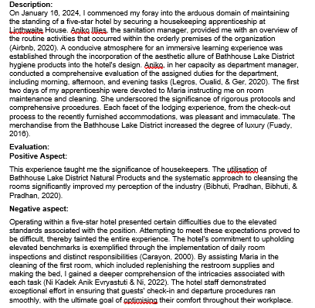
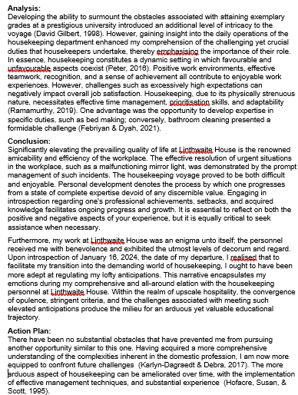

Component Two: Health and Safety Guide
Contribution to Overall Module Assessment: 25%
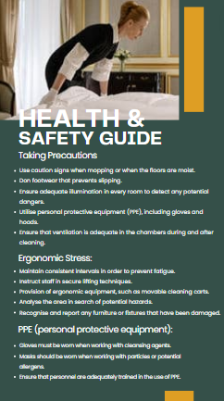
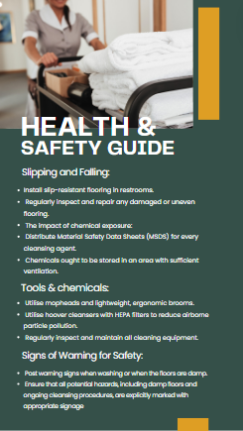

Reference List


