E-Portfolio
Learning in the Digital Era-BMPS4009
Star Gleeson
2203541

Table of contents

- Task 1-Written summary
- Task2-Mind Map
- Task 3-Video Presentation
- Task 4-Reflection
- References

Task1-Written summary
As a student you will need an ideal way to create a perfect study environment for yourself. This means a safe environment in which you can be productive to the best of your ability as well as being comfortable. This means a space to tackle and overcome any negative behaviors such as procrastination or perfectionism. A way to tackle all this is by choosing a time and place when you know there will be less distractions. More so, establishing a time in which you know yourself to be most productive. Further, it is good to find time for yourself to relax so you are not overwhelmed as spending too much time on a task at once can potentially decrease your performance and take a toll on your physical and mental wellbeing.
There are key elements that you as a student will learn to make improvements. Time management is crucial as a student to academic success as well as one of your biggest struggles as a student says (Moore et al, 2010). (Cottrell, 2019) suggests you handle organizing and managing your time as a student independently as well as managing any other commitments that you have such as a job, a social life, hobbies. By learning to manage and priorities your work it will help you build good habits which are sustainable for the long term.
You should always fail to plan and plan to fail. Meaning that the ability to plan is essential. You should always estimate a realistic time for yourself, effort, and resources. Poor planning can result in falling behind or failing. Thus, it often leads to missed deadlines and poor research. Learning to priorities work can help you decide which tasks are more important than the others. (Moore et al, 2010) states you work better without pressure.

Task2-Mind map

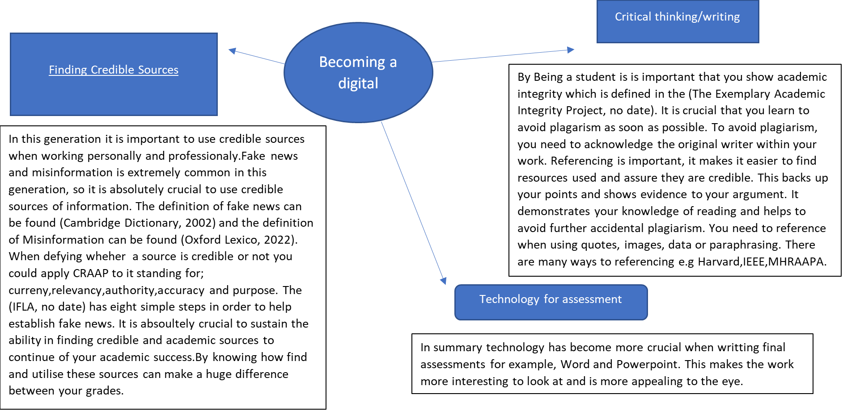

Task3-Video presentation

https://uowtsd-my.sharepoint.com/:p:/g/personal/2203541_student_uwtsd_ac_uk/EZJnDIJRxSVCqZcDG3sWgPgB51ydReedFT8yPFdYvS0zVA?e=Es3yXq

Task4-Reflection

As I look back and reflect Throughout my beginning experience of university, I searched up ‘how to make a work schedule’ and (Kojic, 2022) made me realise that it really is crucial to create a schedule to keep on track. Whereas when I was in sixth form it was not so much of a worry. This to me has been an incredibly helpful resource as it helps me figure out my time management which I used to struggle with. (SCA, no date) helped me understand Eisenhower's’ time management principle and how to separate tasks from urgent too important to unimportant.
I realise just how important it is to be creating a safe space and environment to tackling negative traits. I at the beginning of university used to always procrastinate whether I was understanding what the task was saying and believed all my work needed to be perfect. Whilst learning this module and going through my research it has taught me that not everything, I do will be perfect and that is okay. It also taught me that by procrastinating I am putting myself under unnecessary pressure further reducing my abilities.
When I began university, I had some form of understanding of referencing but not much. I have found that (Cite them right, 2022) has taught me the correct way I should be referencing my university work. This sight is extremely useful.

References list

- Cambridge dictionary (2002) Fake news.
Available at: https://dictionary.cambridge.org/dictionary/english/fake-news
(Accessed at:10 November 2022)

- Cite them right (2022) Electronic books(ebooks)(Harvard)
Available at: https://www-citethemrightonline-com.ezproxy.uwtsd.ac.uk/sourcetype?docid=b-9781350927964&tocid=b-9781350927964-6
(Accessed at: 10 November 2022)

- Cottrell (2019-pp.91-95) The Study Skills Handbook
Available at: https://www.studocu.com/en-gb/document/australian-college-of-business-and-accounting/strategic-management/the-study-skills-handbook/27614685
(Accessed at:10 November 2022)

- Marja Kojic (2022) How to make a work schedule (+ work schedule templates).
Available at: https://clockify.me/blog/business/schedule-employee-time/
(Accessed:10 November 2022)

- IFLA (no date) How to Spot Fake News – COVID-19 Edition.
Available at: https://www.ifla.org/skills-for-a-digital-world/how-to-spot-fake-news-covid-19-edition/
(Accessed at:10 November 2022)

- Moore et al (2010) Nature of Auditory Processing Disorder in Children.
Available at:https://www.researchgate.net/publication/258242146_Moore_et_al_2010_Pediatrics_suppl
(Accessed at:10 November 2022)

- Oxford lexico (2022) Misinformation
Available at: https://www.oxfordlearnersdictionaries.com/definition/english/misinformation?q=misinformation
(Accessed at: 10 November)

- SCA (no date) Time management: understanding the Eisenhower principle
Available at: https://sca.online/blog/time-management/
(Accessed at:10 November)

- The Exemplary academic integrity project (no date) The Academic Integrity Project
Available at: https://www.academicintegrityproject.org/
(Accessed at:10 November 2022)

