ACADEMIC STUDY SKILLS – ECGE4002P
|
1804188
Kelly-Marie Hodson
Contents
Portfolio Task 1 Developing your skills: vision of success as a student teacher 1
What success looks like for me as a student teacher 1
Current Skills Audit 2
Digital Mind Map 3
Portfolio Task 2 – Developing Critical Thinking 4
Developing Critical Thinking 4
A Summary of Stella Cottrell’s Critical Thinking Skills 4
References 5
Portfolio Task 3 – Developing Critical Writing 6
What I think about Education in Wales 6
References 7

Portfolio Task 1 Developing your skills: vision of success as a student teacher

What success looks like for me as a student teacher

My vision is to be a successful teacher in a local Swansea school. I want to be able to inspire and motivate children in my local area to achieve their dreams and to show them that they can make a difference. I see success as showing the children how interesting the area around their school is and getting involved in the local community projects. This could even include tasks as ensuring we take monthly trips to the local library. Success to me would be pupils looking back at primary school and remembering enjoying being in my class. To achieve this, I will need to graduate from university. This means making the most of every opportunity I’m given throughout the three years and ensuring I push myself to take risks and learn from the mistakes that I make. I will need to take advantage of the university library reading current and relevant journals, articles as well as researching books and eBooks as well. Listening to university peers’ experiences as well as their differences of opinion will broaden my own mind and challenge my views. Lecturers are a wealth of information, getting involved in group discussions as well as listening to the information they give in lectures will help me to become a successful teacher. I know that I will need to work on my own creativity and innovation skills in order to achieve my vision and this is something I will work on throughout the three years. I need to ensure I manage my time effectively to complete university tasks to the highest of my ability whilst maintaining a happy family life.

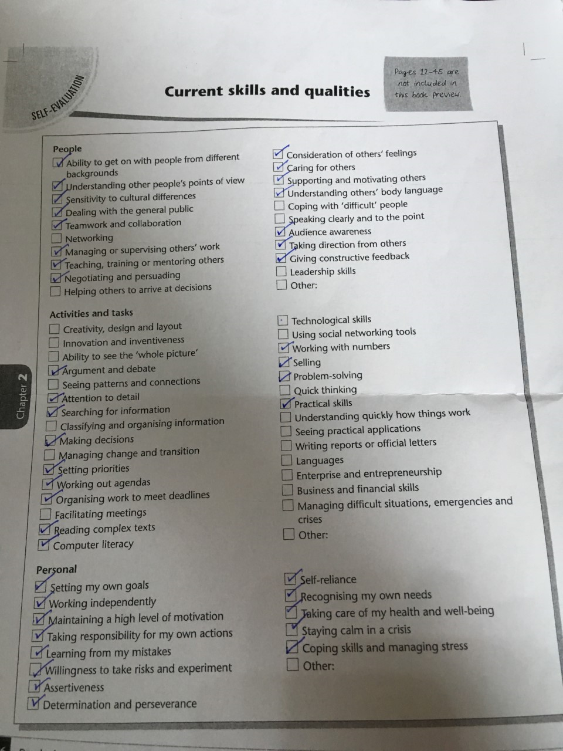
Current Skills Audit

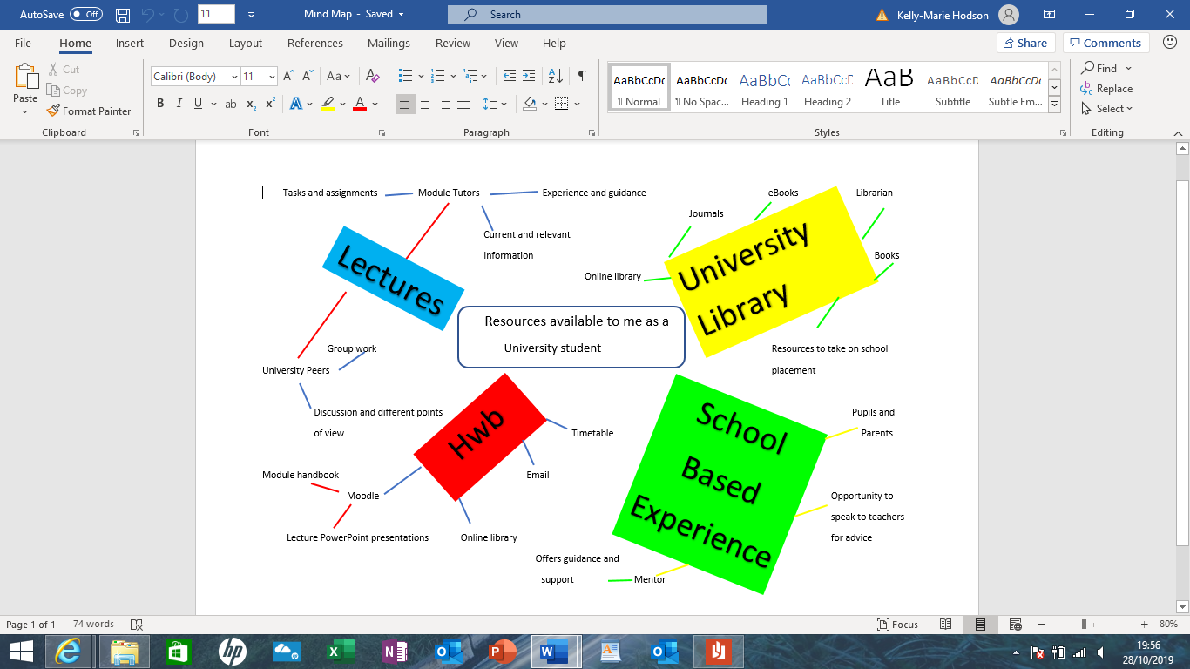

Digital Mind Map

Portfolio Task 2 – Developing Critical Thinking

Developing Critical Thinking

A Summary of Stella Cottrell’s Critical Thinking Skills

In Stella Cottrell’s Critical Thinking Skills (2005) Chapter One she explains to the reader what critical thinking is. The chapter recognises some benefits and personal qualities that are associated with critical thinking. It also recognises barriers that can hinder the development of critical thinking skills and lets the reader assess their own understanding of critical thinking and can identify priorities for improvement.
Cottrell begins by explaining that critical thinking is the ability to reflect and to think in a reasoned way. She expands on how critical thinking is a process and the skills and attitudes you need to adopt. She goes onto explain how reasoning is an important part and how we must know our own reasons and be able to critically analyse other people’s.
The benefits of critical thinking skills are discussed and how they can benefit every day and professional life by giving you improved attention and attention, more focused reading and improved ability to identify key points in text. Critical thinking involves dedication to accuracy, precision and perseverance. Cottrell goes onto explain how good critical thinking skills can help you to make more accurate choices and how you need to be able to question your own point of view even argue an alternative point of view which you may perceive to be wrong. Strategies for critical thinking skills are mentioned with the key points being identified as:
- An analytical strategy for the material
- Understanding of the wider context
- An evaluative and selective approach
- Being self-critical about your own work
Stella Cottrell speaks directly to students in explaining how critical thinking skills can benefit academic work. She tells students how critical thinking means finding the best evidence, evaluating an arguments strength, coming to a conclusion, constructing a line of reasoning, using the best examples and providing evidence to support your argument.
Barriers to critical thinking is discussed in depth with Cottrell and she offers support of how to get around these. Such as not seeing criticism as making negative comments and how critical evaluation means using both negative and positive aspects. How common barriers are a lack of method, strategy or practice and a reluctance to critique experts. Affective reasons can also be a barrier. Cottrell explains how you must use your own beliefs but also consider evidence that best supports your argument even if it is not your own personal belief. Students can mistake information for understanding and prefer facts rather than learning skills to help them achieve well rounded judgements independently. The final barrier Cottrell discusses is insufficient focus and attention to detail. Telling us that we need to be precise and accurate and have a good attention to detail, we need to stray from having a too general overview and focus on the exact task. From undertaking Cottrell’s tasks in the chapter I have found that my own barriers are a lack of practice, insufficient focus and attention to detail and I have found the relevant chapters to read to help.

References
Cottrell, S. (2005). Critical Thinking Skills. Palgrave Macmillan Ltd.

Portfolio Task 3 – Developing Critical Writing

What I think about Education in Wales

Education in Wales is undergoing a major change with the introduction of the new curriculum ‘Successful Futures’ by 2022. The change has come about after a review into the current curriculum by Professor Graham Donaldson. The current curriculum was found to be outdated and limiting for schools. His report highlighted that the current curriculum needed to undergo a major change and to ensure the students of Wales are well equipped for life. Professor Donaldson’s vision for education in Wales has four main purposes. Which are to ‘create ambitious, capable learners. Enterprising, creative contributors. Ethical, informed citizens. Healthy, confident, individuals. Ready to lead fulfilling lives as valued members of society.’ (Donaldson, Successful Futures, 2015)
The new curriculum will be a positive change for both the students and teachers of Wales. ‘Teachers will have more freedom to teach in ways they feel will have the best outcomes for their learners. They have the flexibility to deliver in creative ways that best suit the learner’. (Government, 2019) For students the new curriculum means ‘it will build their ability to learn new skills and apply their subject knowledge more positively and creatively. As the world changes, they will be more able to adapt positively. They will also get a deep understanding of how to thrive in an increasingly digital world’ (Government, 2019). ‘Successful futures’ is about making learning more experience based and giving teachers more freedom to be flexible in their teaching styles to best equip the learners for the future.
Donaldson recommends in his report that ‘the school curriculum in Wales should be defined as including all of the learning experiences and assessment activities planned in pursuit of agreed purposes of education’ (Donaldson, Successful Futures, 2015). This is an important point as it means all schools will be working towards these purposes in a manner that suits their individual learners. Unlike the current curriculum whereby its seen to be inflexible and narrow for the learners. ‘Successful futures stresses the need to be very clear about the purposes of school education’ (Donaldson, A systematic approach to curriculum reform in Wales, 2017).
However, there will be some challenges when rolling out the new curriculum. There is seen to be ‘issues associated with apparently less prominent role of subjects, the move away from key stages or the place of religious education’ (Donaldson, A systematic approach to curriculum reform in Wales, 2017). The introduction of a new curriculum is always going to be a big change as your changing something many people will believe is relevant and reliable it will be about educating parents/carers etc so that they can see for themselves what the new curriculum entails and how it will affect their child.
In conclusion, I think education in Wales needs updating to be current and relevant for students. The four main purposes set out a guideline that all schools can work towards without having to teach it in a set way. Students will also be taught life skills that will help them to become well rounded individuals. It enables teachers to have more freedom in the way they teach and learners to be taught in a way that’s best for them.

References
Donaldson, P. G. (2015). Successful Futures. Independent Review of Curriculum and Assessment Arrangments in Wales.
Donaldson, P. G. (2017). A systematic approach to curriculum reform in Wales. Wales Journal of Education, 7-20.
Government, W. (2019, 10 30). New school curriculum: overview. Retrieved from Welsh Government: www.gov.wales/new-school-curriculum-overview

