Name: Fan Wenjun
Student No: 2106312
Module code: BMMB7012
Module name: Marketing Management
Report title: SHEIN needs to reduce negative public opinion and increase brand reputation in future marketing

Executive Summary
SHEIN reaches $10 billion in revenue in 2020. In the first quarter of 2022, SHEIN surpassed Amazon in terms of global downloads.This report will reveal the secret behind SHEIN's successful marketing and the future marketing direction.

From a marketing perspective, taking SHEIN as the research object, this paper uses the PESTLE model to understand SHEIN's macro market environment and the Boston Matrix, SWOT model to analyse SHEIN's micro market environment in detail.

The subsequent segmentation of SHEIN is positioned as mainly female workers aged 20-35 who are fashion conscious and value for money. The target market is positioned in terms of younger users, geographical globalisation, habitual social media and casual interests. And the corresponding product market positioning is proposed.

The marketing mix (7P's) is used to analyse SHEIN's marketing strategy from a more customer service oriented perspective.SHEIN has a fast response and cheap supply chain, and uses big data precision marketing and KOL& KOC content marketing. This is followed by an analysis of SHEIN's marketing media channels, including self-publishing and social media.

The SHEIN marketing campaign has been very successful from a quantitative and qualitative point of view, but there is negative public opinion about fast fashion industry and the internet industry itself.

SHEIN should reduce negative public opinion and increase brand reputation. This can be done from the perspective of reducing negative public opinion on design plagiarism, neglect of human rights, ecological damage, poor product quality and policy risk content.

Contents

Executive Summary 2
1.0 - Introduction 4
2.0 - Main Findings 4
2.1 - The Marketing Concept 4
2.2- The Macro & Microenvironments 4
2.2.1 - The Macro Environment 4
2.2.2 - The Microenvironment 6
2.3 - The Target Market 7
2.3.1 - Segmentation 7
2.3.2 - Targeting 7
2.3.3 - Positioning 8
2.4 - The Marketing Mix 8
2.5 - Marketing Media 9
2.6 - Measuring Success 10
3.0 - Conclusion 10
4.0 - Recommendations 10
4.1Reducing negative public opinion of design plagiarism 11
4.2 Reducing negative public opinion that ignores human rights 11
4.3 Reducing negative public opinion that destroys the environment 11
4.4 Reducing negative public opinion about poor product quality 12
4.5 Reducing negative public opinion with policy risks 12
References 14
Appendix 16
PESTLE 16
Boston matrix 16
SWOT 17

1.0 - Introduction
This report takes a look at the future of marketing and uses SHEIN, a fast fashion internet company, as the subject of the study, examining why SHEIN has overtaken Amazon as the number one downloaded app in the world and why SHEIN's revenue is set to reach $10 billion by 2020. The study also looks at why SHEIN is expected to reach $10 billion in revenue by 2020.

While SHEIN is developing at a high speed, it also shows its existing disadvantages at the marketing level, and a large number of negative public opinions are also spreading. SHEIN was accused of design plagiarism, human rights neglect, ecological damage, poor product quality, and policy risks. SHEIN has formed the stereotype of low-end products, and the brand reputation has been greatly affected.

2.0 - Main Findings

2.1 - The Marketing Concept
The value orientation of marketing is emphasised by Philip Kotler's (2013) definition of marketing “as a social and managerial process whereby individuals and collectives obtain what they want by creating products and values and freely exchanging them with others. The ultimate goal of marketing is to satisfy needs and wants.”

The American Marketing Association (2013) sees marketing as a series of organisations and business owners maximising the creation, communication, delivery and exchange of products of value to consumers, customers, partners and society.

Marketing requires marketers to be responsible for overall marketing activities, especially in areas where product differentiation is small and a large number of marketing talents are needed to explore differentiated markets, and talents are an important part of marketing. Marketing, as a consuming activity, will invest a lot of money and manpower to carry out, and its financial support is very important. The current development of digital media has also pushed the digital marketing business forward, and marketers can rely on big data and algorithmic mechanisms to achieve user profile insights, integrated promotion of online channels, and more accurate marketing operations.

2.2- The Macro & Microenvironments

2.2.1 - The Macro Environment
PESTEL is an effective tool for analyzing the macro environment. It can not only analyze the external environment, but also identify all the forces that have an impact on the organization. It can be divided into six factors: political, economic, social, technological, environmental and legal.The report will use PESTLE model to analyze SHEIN's macro market environment, reveal how macro market environment factors affect SHEIN's marketing strategy, and put forward his own marketing suggestions based on this.

Political factors
SHEIN is in the midst of a trade war between the US and China and the Chinese government no longer requires online retailers to issue invoices, which effectively eliminates up to 7.5% of China-specific tariffs. Its parent company is registered in Hong Kong and the Hong Kong government does not tax income received from elsewhere. The US tax exemption on imports of $800 exempts them from 16.5% import duties. This means SHEIN is able to capture the market by undercutting competitors by 24%. (Bloomberg, 2020)

SHEIN keeps an eye on government policy developments in marketing, makes reasonable use of policies and regulations, maintains a good partnership with the government and obtains convenient opportunities for policy promotion in the market.

Economical factors
SHEIN is part of the fast fashion industry, which is expected to be worth $244,846.1 million globally by the end of 2026, with a large market space. The global emerging apparel e-commerce market size is expected to grow at a size of $90 billion over the next 10 years. (Wind, 2020)
With the huge and growing market space, SHEIN will spend more on marketing, building its brand and increasing sales.

Social factors
SHEIN satisfies the high demand for fashion and price sensitivity of the Z-era, as well as the demand of some lower and middle class consumers for good quality and inexpensive clothing. It also satisfies the modern demand for multiple styles of clothes, where dressing and matching will become a playful process.

As a result, high fashion elements, low prices and fast updates have become the core selling points of SHEIN.

Technical factors
SHEIN has built up a comprehensive big data system to accurately track current trends and manage the supply chain.

Empowered with marketing new product promotion, the stability and perfection of the upstream and downstream will lead to a higher level of product and experience.

Legal factors
The risk of infringement of intellectual property rights is a legal one, as SHEIN's products are suspected of being copied from the work of well-known designers and other brands, such as Dr. Martens. In the marketing process, promotional material should be firmly protected against copyright risks.

Ecology factors
SHEIN is part of the fast fashion industry, which is often criticised for the negative impact of mass production on the ecological environment. Marketing should avoid this and reflect the harmony between product and nature.

2.2.2 - The Microenvironment
The report will use the Boston matrix model to position SHEIN from the micro market environment. After that, the SWOT model is used to analyze the micro market environment of SHEIN to gain insight into how the micro market environment affects SHEIN's marketing strategy.

Boston matrix takes the market growth rate as the ordinate and the relative market share as the abscissa. It divides the whole matrix into four quadrants and divides the products into four categories, including stars, cash cow, question marks and dogs. SHEIN has maintained a high market growth rate and a high relative market share, and is a star product in its growth phase. The marketing level should aim at long-term benefits, continue to increase its market share and strengthen its irreplaceable competitiveness.

SWOT is to analyze the internal strengths and weaknesses of the enterprise, including external threats and opportunities, which can help the establishment of the company's marketing competitive strategy.

Strength
SHEIN has low prices, fast turnaround (as little as 7 days) and high quality and fashionable products. Using celebrity marketing and the existing big data system, it can achieve precise marketing and word-of-mouth communication. Its SEM & SEO search traffic is effective. The community of online products do share social content precipitation.

Weakness
Competition is now more intense in cross-border e-commerce. SHEIN has problems with ecological damage and plagiarism of clothing designs. The localisation of cross-border e-commerce is a problem. The nationality of the founder is also unclear.

Oppotunity
Online spending habits of users brought about by the epidemic. The market size of cross-border e-commerce continues to grow. Provide commission support for more KOCs and coupon discounts for their fans to sink channels. Leverage on the policy tariff reductions brought about by the current trade war between the US and China. Continue to develop markets in other countries around the world. Continue to leverage the social media resources accumulated.

Threat
Labour-intensive production can breed rumours of neglect of human rights The price of Netflix traffic is going through the roof. There is a risk of uncertainty about future cross-border trade policies.

Therefore, SHEIN will maintain its investment in SEM & SEO in its marketing strategy, maintain a good and sustainable partnership with KOL & KOC to avoid negative public opinion on ecology, human rights and localization, social content to achieve user emotional precipitation and repurchase, cooperate with independent designers to avoid plagiarism, and continue to improve the existing user data and big data technology system to achieve accurate marketing.

2.3 - The Target Market

2.3.1 - Segmentation
SHEIN's users are mainly fashion-conscious, value-for-money female workers between the ages of 20-35. The main users are geographically based in North America and Europe, with the US accounting for over 50%, Italy 10%, France 10%, Spain 5% and Canada 4%. More than 70% of users are women.

This group is more fashion conscious, more value for money and personalised design, keen and proficient in using mainstream social media platforms, with high recognition of online marketing, high penetration of online shopping, focus on leisure, like to travel and party et cetera. (HUGO, 2021)

2.3.2 - Targeting
SHEIN shelves different styles of products for different countries and regions of users, as well as adapting to the culture and policies of different countries. For example, the promotion of more sophisticated and sexy products in the USA, adhering to the open culture and multi-ethnic elements and import policies of the USA.

SHEIN focuses on promoting women's clothing for women and capturing the needs of its core users. We are also exploring the potential needs of female users, with products such as accessories, bags and baby products.

SHEIN targets the younger and more value-for-money female audience, promoting young and inexpensive fashion items. The playful nature of the products on the shelves is more in line with the needs of deeper users who like interesting things.

SHEIN's marketing channels are geared towards social media and online celebrity marketing, and its content is more casual, with elements such as lawns, sunshine and bouquets of flowers being used to promote the brand.

2.3.3 - Positioning
Market positioning was put forward by American scholar al rice in the 1970s. Market positioning is that an enterprise creates a strong and distinctive personality for its products according to the competition status of similar products in the target market and the importance of customers on some characteristics or attributes of such products, and vividly transmits it to customers to obtain customer recognition。

Analyze the market location map of SHEIN. Unlike traditional fast fashion brands such as Zara, HM and UNIQLO, SHEIN is a pure online sales model and has a faster and cheaper supply chain. Unlike traditional e-commerce, SHEIN is more focused on sinking the market, and its products are more affordable and fashionable.

Therefore, SHEIN's market positioning is a fast fashion e-commerce with high quality and low price, fast update and full of fashion sense, which gives consumers a brand image of cheap and easy to wear.

2.4 - The Marketing Mix

Product
SHEIN's main products are good value, fashionable women's fashion and other related derivative women's products that can satisfy the beauty-loving, price-sensitive female consumer. A small number of products are available for men.

Place
SHEIN only has an online channel to complete sales, which includes its own website, app and social media shops. SHEIN uses social media for marketing and has official online shops on all its social media channels.

Price
SHEIN focuses on inexpensive products. In addition to the low pricing itself, coupons are issued on official channels and exclusive coupons are issued for KOLs and KOCs.

Promotion
SHEIN's promotional traffic is divided into three parts. The highest proportion of traffic (40%) comes from SEO & SEM search traffic, while the second highest proportion (37%) comes from direct traffic, mainly through brand awareness and subsequent product repeat collection accumulated through previous event marketing, event marketing and topic marketing. The rest of the traffic is mainly through KOL & KOC's subsequent downstream promotion.（HUGO，2021）

People
In addition to the usual celebrities (Katy Perry, etc.), customer service, marketing planners, art designers, marketing strategists, etc., SHEIN's promoters play a more powerful promotional role as KOLs & KOCs with influence and trust.

Physical Evidence
SHEIN gives its physical products and packaging a stylish and functional brand identity.

Process
SHEIN's overall delivery process consists of the user actively searching or passively accepting, thus clicking through to the shop, the user selecting and adding products to the shopping cart, then continuing with the payment process, waiting for delivery and reviewing the products. The entire process can be tracked and controlled, including post-purchase consumption records, post-purchase logistics records and post-purchase customer service.

2.5 - Marketing Media
Self-media
SHEIN has 25.51 million followers on Facebook, 25.14 million followers on Ins, 2 million followers on TIKTOK, 470,000 followers on Twitter and 180,000 followers on Youtube.（SHEIN，2022）

By leveraging its early fan operation in social media, it has accumulated a large flow of loyal, fashion-loving fans, which will be accurately diverted into the shops to realise sales.

Social media
On social media, various offers, celebrity campaigns and social issue campaigns are launched to attract traffic and achieve brand reputation enhancement and sales channel sinking. For example, the hashtag #SHEIN was launched on TIKTOK and has already had 10 billion plays. The user-initiated #SHEIN haul trending topic has already had 3 billion plays. Launched the SHEIN TOGETHER charity show on ins, featuring big names including Katy Perry, Doja Cat, Lil Nsa X and more. Donated clothing to women worldwide and supported causes including BLM against black discrimination, women's rights and homeless communities. KOCs with social media accounts are eligible for promotion and commission share.

2.6 - Measuring Success
These marketing campaigns were very successful, but there was a certain amount of negative marketing opinion carried by the limitations of the product itself.

Quantitative effect
SHEIN's full-year revenue reaches nearly $10 billion in 2020, up 250% year-on-year. In the US, SHEIN's market share in the fast fashion segment jumps from 7% in January 2020 to nearly 30% in June 2021. 13.8 million downloads of SHEIN's app from January to April 2022, compared to 13.3 million downloads from Amazon, surpassing Amazon in quarterly downloads for the first time.（SHEIN，2022）

Qualitative results
SHEIN has maximised its brand awareness through a series of marketing campaigns that have resulted in the number one download in the world. Through a series of branding campaigns, SHEIN attracted a group of highly loyal users and achieved high revenues with a thin profit margin business model. However, there is a negative public opinion about the general quality of fast fashion industry products, the neglect of human rights and the destruction of the environment.

3.0 - Conclusion
Thanks to the China vs US trade war, SHEIN has been granted tariff relief. Its industrial output is growing and is sought after by the Z era, which loves social media. Its supply chain is fast and cheap, but there is a legal risk of design plagiarism and negative public opinion that pollutes the environment. SHEIN focuses on its own field and continuously improves its marketing competitiveness. The negative public opinion of the founder and cross-border trade have policy risks. A large number of kol&amp;koc resources have been accumulated in marketing, and the ability of seo&amp;sem is very strong. A powerful big data system has been built to achieve precision marketing.

SHEIN has positioned itself as a fast fashion brand with high quality and low price, rapid renewal and full of fashion, which can be realized by using a variety of marketing strategies. This report will be analyzed through STP theory and marketing 7p theory.

These marketing campaigns have been a huge success.SHEIN become the number one downloaded app in the world and generating $10 billion in revenue.

4.0 - Recommendations
Based on the above analysis. SHEIN has a large number of public opinions on design plagiarism, neglect of human rights, damage to the environment，poor product quality and negative public opinion on policy risks.

In 1991, David Aaker refined the "five-star" model of brand equity on the basis of previous research results, and believed that brand equity is composed of "brand awareness, perceived brand quality, brand association, brand loyalty and other brand proprietary assets". In order to enhance the brand's "five star", SHEIN should reduce negative public opinion communication, increase positive public opinion guidance. Increasing brand reputation and reshaping users' minds are the marketing strategies that SHEIN needs to make continuous efforts and pay a lot in future marketing.

4.1Reducing negative public opinion of design plagiarism

Reducing negative public opinion of design plagiarism and collaborating with original designs. Avoid using promotional content that carries the risk of plagiarised designs. SHEIN is developing collaborations with original designers, promoting original designer collaborations and creating a brand image for consumers that SHEIN focuses on original design. Subsequently, SHEIN can explore more original designer resources to achieve a win-win situation in terms of fame and revenue with designers, or even, SHEIN can co-brand with some of the big original design brands to increase its own brand endorsement.

SHEIN can also make bold assumptions in the marketing field, hold original design competitions, attract more independent designers with original design ability, promote the concept of original design, and win the topic heat for its own brand. SHEIN can also change from an original replicator role to an original trend setter.

4.2 Reducing negative public opinion that ignores human rights

SHEIN can try to carry out corporate employee welfare activities, pay attention to the spiritual and material needs of employees, and publicise them in self-media channels to create a corporate image of enthusiastic employees. SHEIN provides help to the victims of the epidemic and the underprivileged, promoting SHEIN's focus on social responsibility and increasing The brand's social reputation.

The good company image satisfied by employees is one of the key points of SHEIN's follow-up marketing. Enterprises with high employee satisfaction will be more favored and recognized by consumers. SHEIN can post quality content about employee benefits and work experience. Similarly, SHEIN can plan and launch a workplace internship variety show, so that guests can personally feel SHEIN's people-oriented corporate philosophy, and continue to increase brand popularity and goodwill through event marketing.

4.3 Reducing negative public opinion that destroys the environment

SHEIN can reduce negative public opinion on ecological damage by initiating and participating in environmental protection activities, by promoting the environmental friendliness of the production process from the point of view of the production of goods, thus reducing negative public opinion on ecological damage. It can also initiate fashionable environmental topics and activities from the perspective of the cultural concept of environmental protection, such as environmental concept clothing design competitions. It is also possible to participate in global environmental public interest activities to increase environmental publicity and current affairs heat, such as the environmental programme to protect the Amazon rainforest.

In the field of ecological environmental protection, SHEIN will not only be the protector of the concept of environmental protection, but also become an important practitioner of the concept of environmental protection. It will use the power of action to eliminate the negative public opinion of consumers that SHEIN destroys the ecological environment. SHEIN can use live broadcast or documentary to show us its future plans for ecological protection, such as planting trees in the desert, salvaging underwater garbage and reducing carbon emissions, and guide consumers' public opinion with public welfare content.

4.4 Reducing negative public opinion about poor product quality

SHEIN can use the persuasive communication of KOLs to reverse the perception of poor product quality and increase brand reputation by sending KOCs samples and a share of sales commissions, allowing KOCs to spread word-of-mouth and private domain communication about the good quality of their products. The good quality of the product, continued down-channeling and the release of KOC benefit campaigns to fracture the spread.

When the marketing funds are sufficient, SHEIN uses the combined fist of KOLs and KOCs to reverse the reputation of poor product quality. When the marketing funds are small, SHEIN can attract more sinking KOCs through Commission sharing and sample sending. While sinking the channel to continuously accumulate public praise, it also brings more loyal consumers who think the product quality is good.

4.5 Reducing negative public opinion with policy risks

SHEIN needs to be alert to the dissemination of policy risk content and maintain good cooperative relations with governments of various countries through public relations publicity. The founder of SHEIN is Chinese, and there is negative public opinion that his nationality is Singaporean. The production base is mainly in Guangzhou, China, and must maintain a close public relations cooperation image with the Chinese government to ensure the stability of the industrial production end. However, as a Chinese enterprise, SHEIN is affected by the China VS US trade war, and will be questioned by American investors and American government regulators. SHEIN also needs to maintain its public relations cooperation image with the American government. SHEIN will also enter more national markets in the future, such as the South American market represented by Brazil and the European fashion represented by Germany. Public relations cooperation with other countries also needs to be paid. SHEIN should establish a political public relations image supporting economic globalization and the trend of globalization to ensure that it can lay a good foundation for cooperation with governments of all countries.

References
- Brooks, G., Drenten, J. and Piskorski, M.J. (2021) ‘Influencer Celebrification: How Social Media Influencers Acquire Celebrity Capital’, Journal of advertising, 50(5), pp. 528–547. doi:10.1080/00913367.2021.1977737.
- Chenyuqian, Sunhong &amp; gewangrong (2021). The research of clothing brand marketing strategy under digital economy Operation and management (11), 51-55
- Chenjiangtao &amp; wuyanqing (2020). From product output to value output -- sheen brand building Economic Research Guide (34), 56-57+63Chen Qing (2021) The cross-border e-commerce with fast fashion export is gaining momentum China business daily, 007
- Caienze (2021). SHEIN: a dark horse of cross-border e-commerce with "shallow singing and low singing" Board of directors (06), 74-75
- Dengyilong (2022). Xiyin creates a fast fashion cross-border e-commerce brand Enterprise management (02), 80-84
- Fahy, J., and Jobber, D., (2015), Foundations of Marketing, 5th edition, London: McGraw-Hill
- Hines, T. and Bruce, M. (2007) Fashion marketing : contemporary issues. 2nd ed. Amsterdam ;: Butterworth-Heinemann.
- Kotler, P. (2003) A framework for marketing management. 2nd ed., [International ed.]. Upper Saddle River, N.J: Prentice Hall.
- Kotler, P. (2003) Marketing insights from A to Z : 80 concepts every manager needs to know. Hoboken, NJ: J. Wiley & Sons.
- Kotler, P. and Lee, N. (2005) Corporate social responsibility : doing the most good for your company and your cause. Hoboken N.J. ;: Wiley.
- Kotler, P. and Lee, N. (2006) Marketing in the public sector : a roadmap to improved performance. Philadelphia, Pa: Wharton Schoo
- Kotler P and Chernev, A. (2014), Strategic Marketing Management, 8th edition, Cerebellum Press
- Kim, D.Y. and Kim, H.-Y. (2021) ‘Influencer advertising on social media: The multiple inference model on influencer-product congruence and sponsorship disclosure’, Journal of business research, 130, pp. 405–415. doi:10.1016/j.jbusres.2020.02.020.
- Lane, C. and Probert, J. (2009) National capitalisms, global production networks fashioning the value chain in the UK, USA, and Germany. Oxford: Oxford University Press.
- Laura Jones & Cao Jie (2021). SHEIN: why mysterious Chinese brands cause a boom among young people in the West International Public Relations (12), 5
- Lopez y Royo, A. (2019) Contemporary Indonesian fashion : through the looking glass. 1st edition. London: Bloomsbury Publishing. doi:10.5040/9781350061330.
- Liyonghua (2021). Behind the rapid rise of cross-border e-commerce is the competitiveness of China's flexible manufacturing China Economic Weekly (10), 74-75
- Man and God work together (2021). From Metersbonwe to Shein, where is the strength of Chinese manufacturing Sales and marketing (Management) (11), 84-88
- Jobber, D., and Ellis-Chadwick, F., (2016), Principles and Practice of Marketing 7th revised edition, Berkshire: McGraw-Hill
- Lynch, R., (2015), Strategic Marketing 7th edition, Harlow: Pearson
- Pride, W.M., and Ferrell, O.C. (2016), Marketing: Concepts and Strategies, 7th ed, Houghton Mifflin
[22]Qin Yi (2021). AB surface of flexible SHEIN 21st Century Business Review (07), 34-37
[23]Shuping (2021). SHEIN, a fast fashion brand, should catch up with zara Shanghai quality (07), 47
[24]Wu Qing (2022) The Unicorn Shein's crazy growth path China business daily, d04
Wu Qing ( 2022) Behind the extraordinary rise of Shein China business daily, d04
[25]Janssen, L., Schouten, A.P. and Croes, E.A.J. (2022) ‘Influencer advertising on Instagram: product-influencer fit and number of followers affect advertising outcomes and influencer evaluations via credibility and identification’, International journal of advertising, 41(1), pp. 101–127. doi:10.1080/02650487.2021.1994205.
[26]Schouten, A.P., Janssen, L. and Verspaget, M. (2020) ‘Celebrity vs. Influencer endorsements in advertising: the role of identification, credibility, and Product-Endorser fit’, International journal of advertising, 39(2), pp. 258–281. doi:10.1080/02650487.2019.1634898.
[27]Xueyunchun &amp; Xiang Yongsheng (2022). Research on cross-border e-commerce c2m business model -- Taking sheen as an example Mall modernization (07), 24-26
[28]Ye Dan & chenyuqing (2022) Who is SHEIN Nanfang Daily, b04
[29]Yanjiehua (2022). Digital intelligence transformation, looking for certainty in uncertainty Entrepreneur (05), 55-57
[30]Zhou, S. et al. (2021) ‘How social media influencers’ narrative strategies benefit cultivating influencer marketing: Tackling issues of cultural barriers, commercialised content, and sponsorship disclosure’, Journal of business research, 134, pp. 122–142. doi:10.1016/j.jbusres.2021.05.011.

Appendix

PESTLE
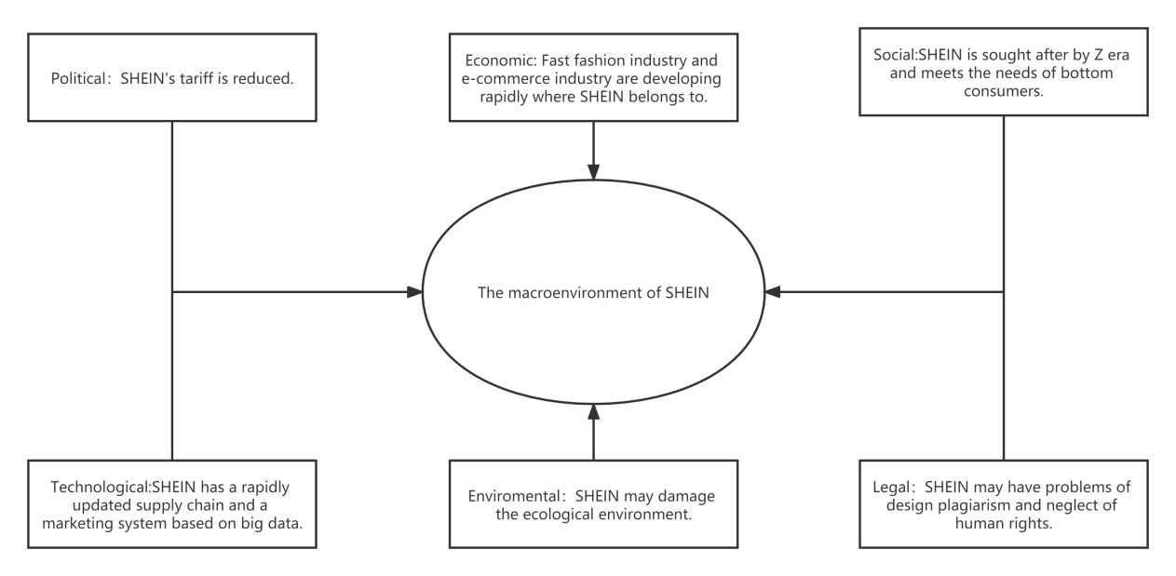

Boston matrix
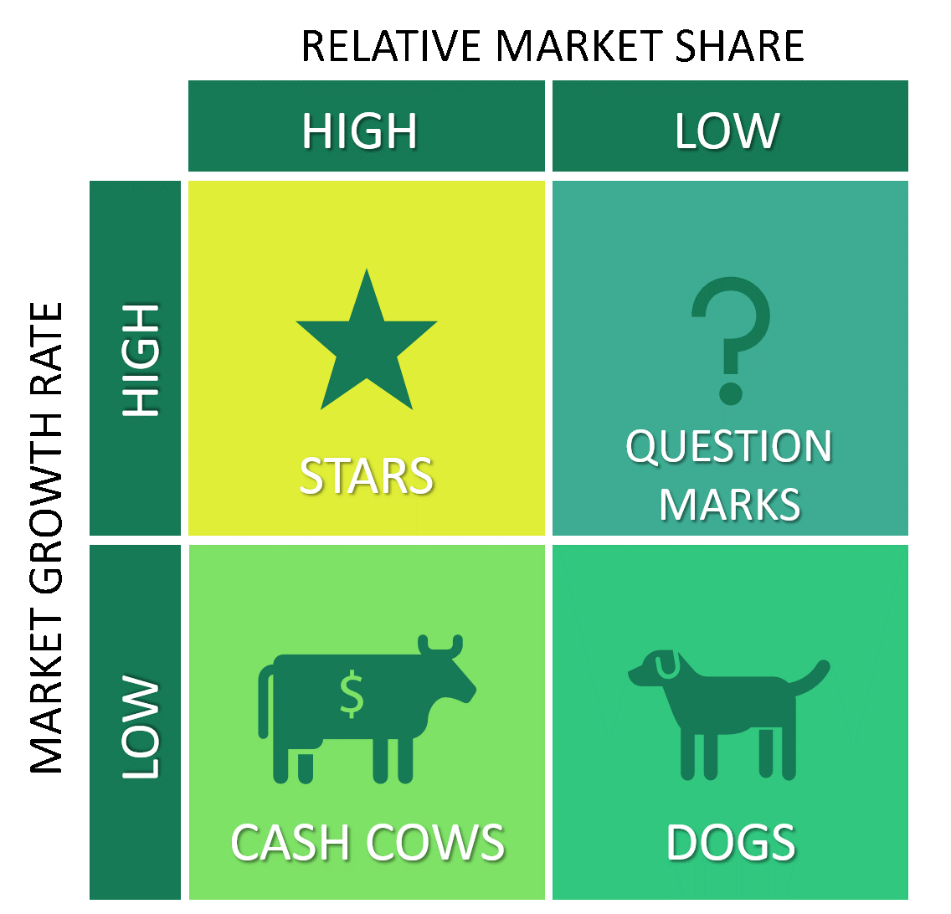
SHEIN

SWOT
Strength  Have a fast and high-quality supply chain  Powerful sem&seo  High social media traffic  Marketing system of big data | Weakness  Dividend reduction of cross-border E-commerce  Design plagiarism  Broken talk ecology  Negative opinion of Founder
Oppotunity  Users' online consumption caused by the epidemic  Koc's sinking channel  Tariff relief from trade war | Threat  Neglect of human rights  Price rise of online traffic  Policy risks of future cross-border trade

