Cover Page

Title of assessment
Component 1: E-Portfolio Study Skills

Contents page
Table of Contents
Cover Page 1
Contents page 2
Journal 3
Infographic 4
Essay Plan 5
Library Search Screenshot 6
Summary of sources 7
References 8

Task one

Journal
Title of chosen journal article
- Written summary (300 words)
- APA Reference of the journal article you have summarised

The article talks about how music makes people feel. The writer talks about how it can affect people positively and influence their thoughts and feelings. Within the article, it talks about the theories, the evolution and applying music.
The writer talks about the theories of music. They state that there are individual differences when it comes to our responses to music. Some people become attached to songs due to memories that may remind them of the song and therefore makes them feel better. The enjoyment of music has shown to reward areas of the brain such as chills and the writer says that chills are highly pleasurable for the brain.
The article also talks about the evolution of music. The writer states that there is research on how music and emotions are connected. For example, those higher in neuroticism are more likely to have nostalgia when listening to certain types of music. Other factors such as social context may affect your emotions when listening to music. The listeners emotional state also affects the way they listen to music and how they respond. The writer states that these days, there are apps such as Apple music, and Spotify that create playlists for people’s personal preferences. Listening to music like this may impact the way we feel towards the artists.
The article writer also talks about applying music. It is shown that the connection between emotional responses and music is linked to music therapy, the writer states that music in major key is more successful at relieving stress than music in a minor key. Music’s ability to change behaviours means that this is used in music therapy.
Overall, from the article, we can conclude that music is an effective in a way of therapy to treat behaviours. (Nendick, 2022)

Task two

Infographic
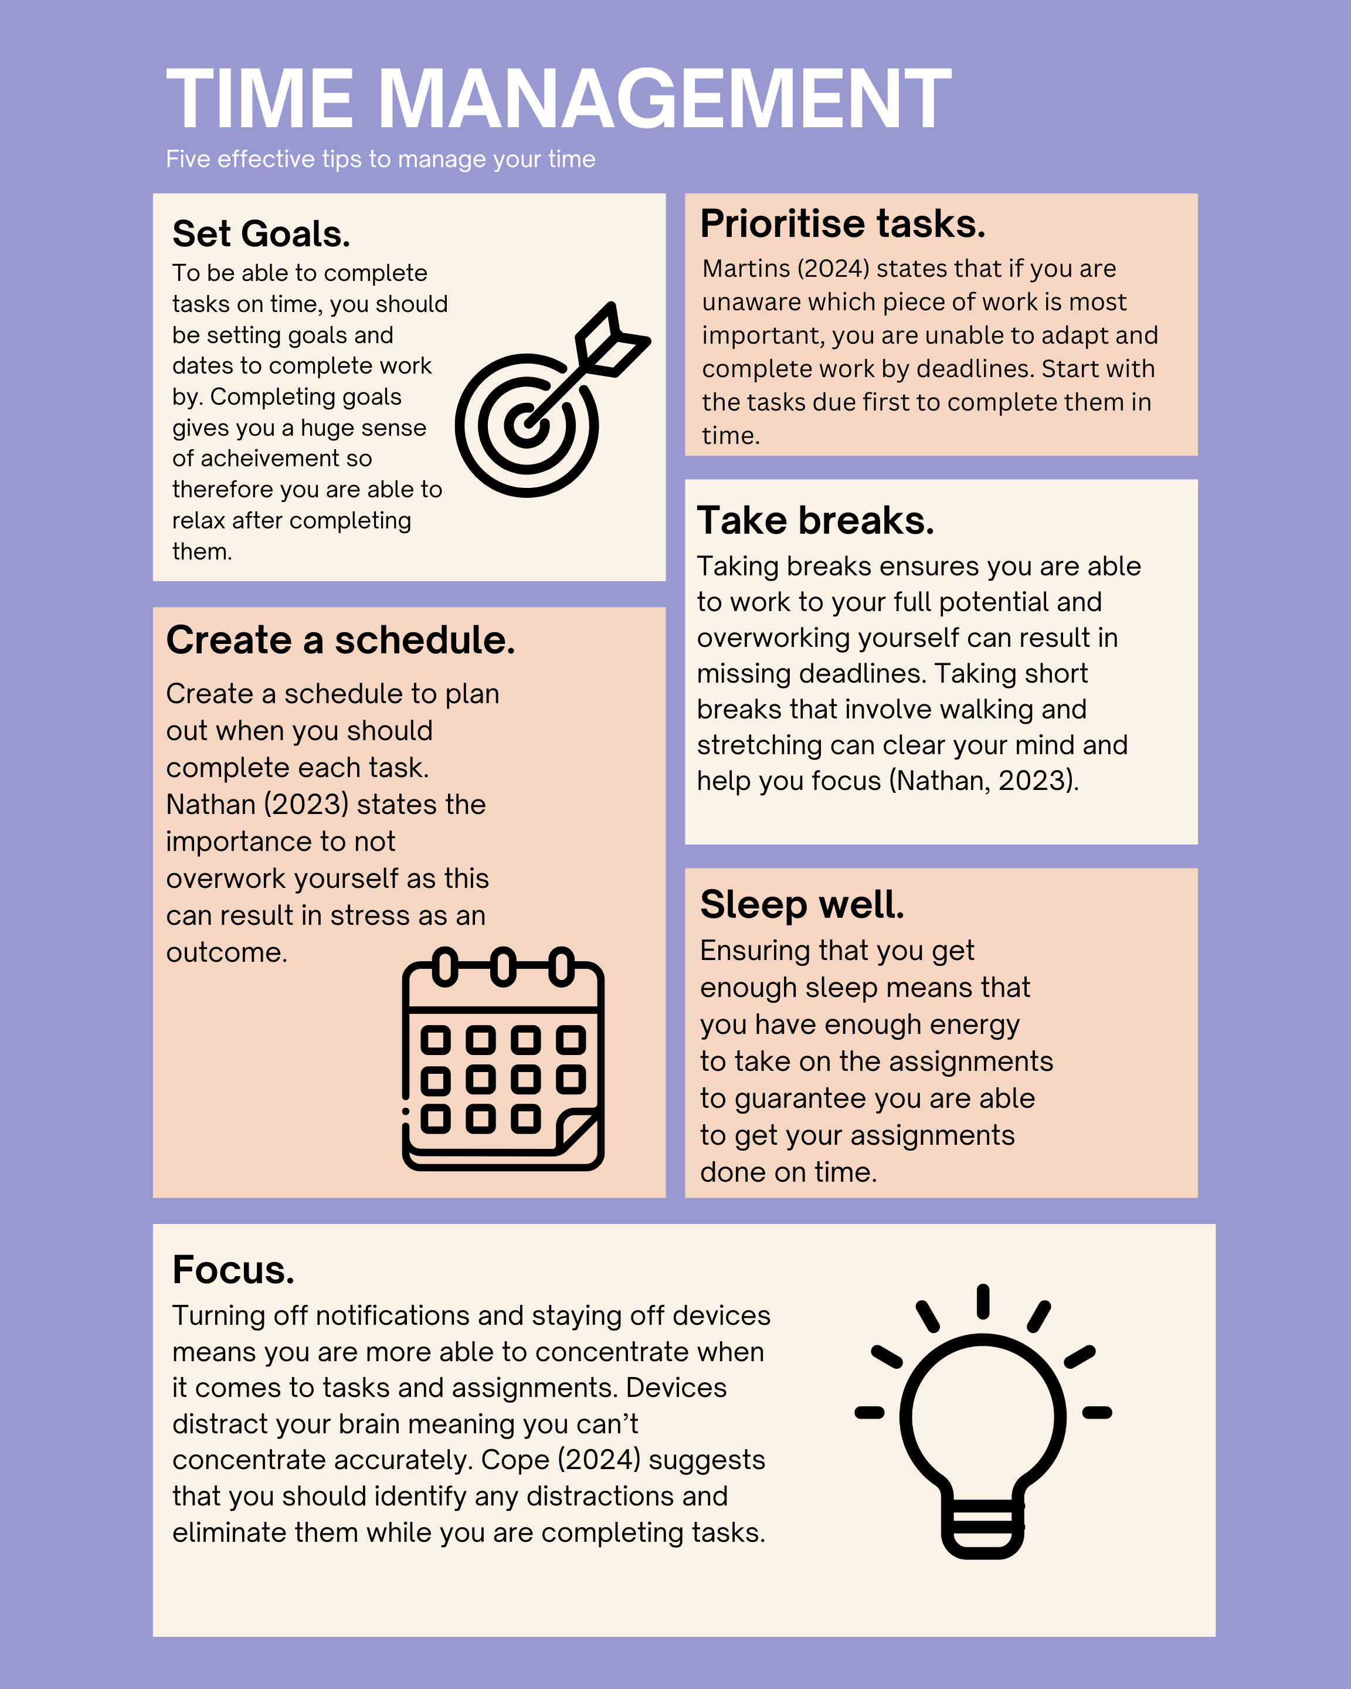

Task three

Essay Plan
Essay plan (outline, image, template etc)
Describe and discuss the psychological, social and physical benefits of owning a pet.

Owning a pet can have many benefits psychologically, socially and physically. Many people feel and understand the benefits that their pets may have on them and therefore feel more positive. In this essay plan I will be stating the benefits of owning a pet and give the supporting evidence.

Having a pet can lead to improvement in cardiovascular outcomes. There are studies to show that owning a pet can result in the better health of children and adults, “pet ownership, particularly dog ownership, may reduce cardiovascular disease risk” (Cherniack, 2015). The presence of animals has shown to lower owner’s blood pressure compared to those who don’t own a pet (Heeckeren, 2021). This means you are at lower risk of developing a heart condition. Animals have shown to calm their owners and relieve them from stress and strain on the heart.

Owning a pet can also increase physical activity. “Studies have shown that adults who own a pet exercise more and participate in more leisure-time physical activity” (Cherniack 2015). Owners are left with the job of making sure their animals needs are met and by having a pet this means you can leave the house more for a walk and to explore. Going out for just 5 minutes a day can improve your physical well-being and health.

Pet ownership has shown to improve mental health issues such as autism and developmental disorders. “Dogs enhanced communication skills in 40 children with developmental delay beyond that in the presence of toys, and the children showed greater environmental awareness” (Cherniack 2015). Pets recognise when their owner is feeling down and therefore comfort them and are therefore great as a therapeutic strategy. Pets are also used for people with mental health issues in care hospitals and homes as it has shown to improve their confidence and health.

Pet ownership is also important for the development of children. The development of children is a key part of growing up as this shapes the child’s personality as they grow older. “Without the ability to make positive relationships with others, children can develop mental health difficulties” (Holttum 2018). Parents have found that if their children had developed a bond with their pet, they were more likely to develop better social skills (Holttum 2018). Having a pet that gets along with a child means the child is able to form better relationships and make them more confident as they grow older. This is essential for a child as this will help them with their future careers.
To conclude having a pet can benefit you in many ways such as reducing cardiovascular issues, increasing physical activity, improving mental health and helping child development. There has shown to be little negative effects of owning a pet.

Library Search Screenshot
(around 2 searches)
Books used
Justification (Chosen these books...)

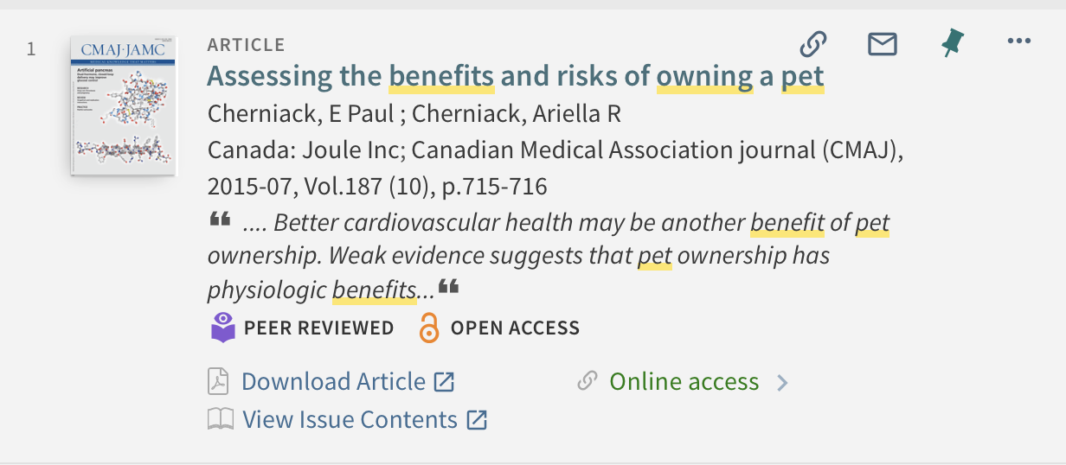

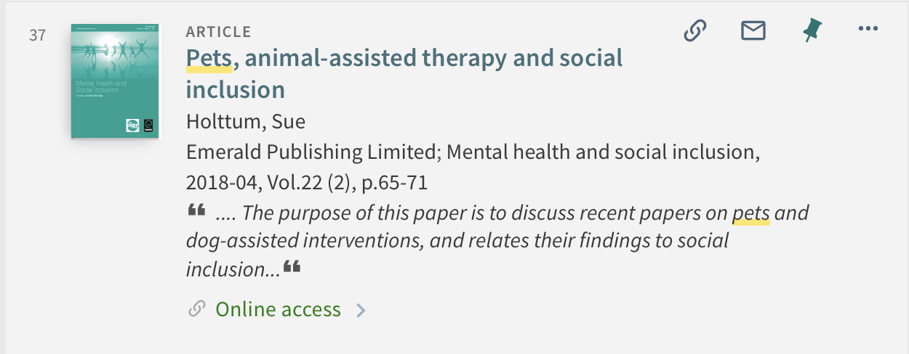

I have chosen these books as they contained relevant information to complete my essay plan. They went into a lot of detail about the topic and had the information I needed to complete the task. The first article was peer assessed meaning that it is reliable.

Summary of sources
- How will you decide which sources to use?
I will decide what sources to use by basing it off how reliable and how relevant the information is. I will ensure the sources are as recent as possible to try and prevent any outdated evidence.
I have not used AI in my research.

References
(All references for each task)

Heeckeren, A. (2021, February 23). 10 Mental & Physical Health Benefits of Having Pets. https://www.onehealth.org/blog/10-mental-physical-health-benefits-of-having-pets

Holttum, S. (2018). Pets, animal-assisted therapy and social inclusion - ProQuest. https://www.proquest.com/docview/2023407447?accountid=130472&sourcetype=Scholarly%20Journals

Martins, J. (2022, December 16). 18 Time Management Tips to Boost Productivity. https://asana.com/resources/time-management-tips

Nathan, D. (2023b, September). 7 time management tips for students. https://www.prospects.ac.uk/applying-for-university/university-life/7-time-management-tips-for-students

Nendick, Z. (2022, September 12). How does music make you feel? https://www.bps.org.uk/psychologist/how-does-music-make-you-feel

Cherniack, P. (2015b, July 14). Assessing the benefits and risks of owning a pet. https://www.proquest.com/docview/1697189386?accountid=130472&parentSessionId=qzBMgGaELq%2Bn7lpYTSSASW3zmozUYa7Ex2GF0eGwdQI%3D&pq-origsite=primo&sourcetype=Scholarly%20Journals

Cope, S. (2021, April 1). 18 Effective Time Management Strategies & Techniques. https://www.upwork.com/resources/time-management-strategies

