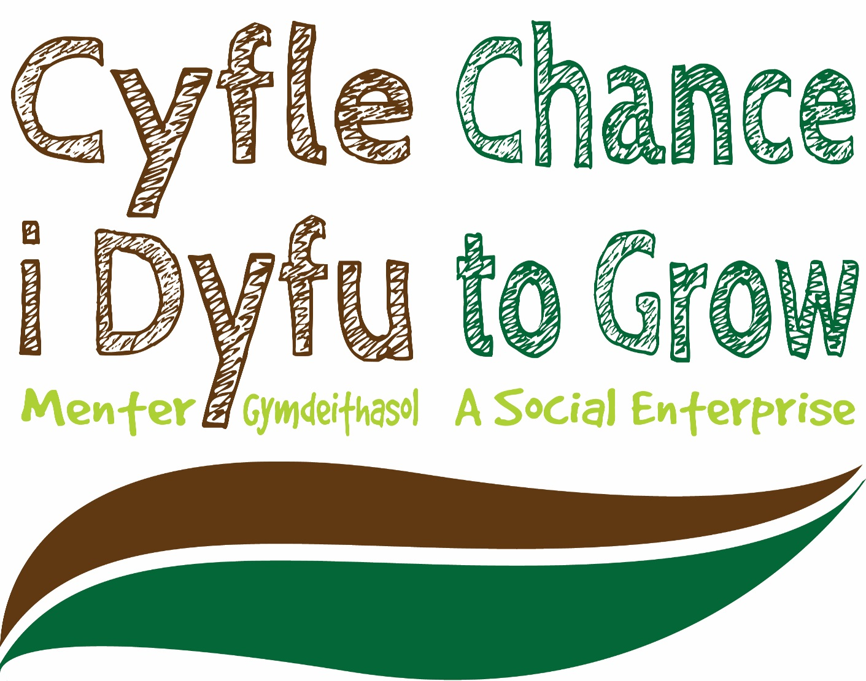

OCTOBER 2017

MODULE NAME: ACADEMIC SKILLS (M4X01434)
Project Name: CYFLE I DYFu
Name: JACKY, JOY, CAMERON, SIYA, NASIR
Student Number: 1704545, 1701536,1702706,151841,150345

Contents
1 EXECUTIVE SUMMARY 1
2 INTRODUCTION 2
2.1 Report Remit 2
2.2 Background of the organisation 2
2.3 Aim and Objectives 3
2.4 Project Team 3
2.5 Project implementation 4
2.6 Conclusion 5
3 References 6

EXECUTIVE SUMMARY

Cyfle I dyfe is a business located in Swansea which is a social enterprise offering support, work and volunteering opportunities to marginalised people including those with a history of substance misuse. Cyfle I Dyfe manufacture wooden furniture as well as crafts from the finest pieces of wood with a long lasting life time

The market was a huge success from the start which has been attracting all kind of shoppers and with a long waiting list of potential traders. The market is supported by local shops as well as cafes, all contributing to a real feel to the local area.

Our programme focuses on building practical skills that help people develop more positive routines, and sustain their development. Cyfle I Dyfe provide real-life workplace experiences. Service users also have the chance to complete learn basic carpentry skills which are helpful for later on in life. In addition to this, employment opportunities are supported.For those who find it bit difficult one to one emotional support is also available during which they can discuss any problems on their own or barriers which may prevent future access to employment.

INTRODUCTION

Report Remit
The group will be interacting with cyfle I dyfu by volunteering marketing promoting and fundraising for the organisation. The main objective of this report is to outline the aims and objectives of how the group will proceed.
The organisation is mainly known to help ex-offenders, however, as a team the aim is to highlight other people that they are involved with. These include people with history with substance abuse and learning difficulties as well as providing work experience and gaining an OCN qualification; we want to promote that in our leaflets, on our blogs as well as our Facebook pages. They also currently have no Instagram page which the group wish to set up and share pictures of the workshop.

Background of the organisation
Cyfle I dyfy is a social enterprise this means all their profits go straight back into the business to give people a chance to grow. The organisation is run by a gentleman named Andrew who has been running the business since 2010. currently, the organisation has 9 members including Andrew, the director, and the key workers.
Andrew the founder of the organisation previously worked for a business that helped adults with learning difficulties get back into the workplace. He found that it was more business based than a personal factor, he explained that the business he was previously working for seemed more interested in the numbers and financial side of getting individuals back into the workplace rather than listening to their needs and getting to know the individuals and working with them on a day to day basis, therefore he started his own project helping more vulnerable people and making it a more personal interest. Andrew himself suffers mental health issues and feels he can relate to individuals in that situation.
“Our programme focuses on building practical skills that help people develop more positive routines, and sustain their development and/or recovery. We provide real-life workplace experience, structure, routine, and social interaction & integration. “ (CYFLE I DYFU WEBSITE, 2010)
The business is a carpentry business that builds all sorts of woodwork e.g. benches, bespoke signages, wooden tables and anything wood based. At the start of the business set up, Andrew managed to fund the business himself through his retirement package, this lasted for 2 years. This was when he started seeking financial help from other sources. financially, it cost the business £9000 per month to run, and their funding is currently being funded by a company called Aviva community fund. They are seeking more funding through the lottery foundation. Currently cyfle I dyfy have 20 faithful clients who continuously support their work. They have a local shop in Swansea where they advertise and market their ideas. They also sell their products in various markets throughout Carmarthenshire and Cardiff.

Aim and Objectives
Working with cyfle I dyfu, the group will aim to increase the awareness of the organisation and what they do. One of the important aspects they will want to cover is that they also hope to raise funds by selling some of the furniture. The group will volunteer in one of their stores to increase an understanding of what cyfle I dyfu do. Our group has spoken to the leader of the organisation and he has asked for leaflets to be made which Cameron has offered to do. The charity has its own Facebook as well as a Twitter page, the group will be using Facebook to try to get their contacts on the social media sites to generate more traffic to cyfle i dyfu’s Facebook page by “inviting” their contacts to their page, as well as regular sharing their page on the groups, Facebook pages. The organisation sells a lot of bespoke furniture meaning the team can devise a plan to target specific people depending on their needs.
“More than 30,000 people leaving prison each year will be referred to a specialist employment adviser,” (Winnett, 2012)

Project Team
JACKY ROBSON – TEAM LEADER
Jacky’s responsibilities are to keep everyone updated on various information. Jacky also has to keep in regular contact with Andrew from the project organisation and to gain more contacts for the project. Her previous experience in sales and management are key aspects to help promote more of the business.
cameron borkett – team WORKER AND IT
Cameron is the project team worker; his responsibilities are to complete tasks handed to him and to help the team with it related issues. Cameron has had many years’ experience working with computers as he took a summer course in computing and continued it in sixth form.
SIYA - MARKETING/PROMOTING
In this project, the marketing part of the group will be responsible for promoting the organisation (cyfle I dyfu) utilising social media sites such as Facebook, Instagram and such. The marketing team is experienced in organising events as well as using social media as means of publication
NAS - TEAM WORKER
In this project Nasir is responsible for the marketing side of things which include handing out leaflets as well as managing the social media side of things such as posting pictures on Instagram and Facebook to show people the products and services as well as causing awareness about the business itself
JOY- TEAM WORKER
Joys role as a team worker is to contribute to the team positively towards the motivation and focus of the project. Joy also finds responsibility helping to maintain the teams communication and coordination. Hands on, his main contribution will be to help in all aspects of the project especially research and promotion.

Project implementation
This part of the report will show how the group is going to complete their aims and objectives. The first step would be to spread awareness by liking and sharing the cyfle I dyfu Facebook page as in this day and age where according to statsita.com
“At the beginning of 2017, the total number of social media users in the UK had reached over 39 million users, with estimates going up to 42 million users.” (statstia, 2017)
Meaning that using social media to get a message across is a good idea this is also suggested as
“social media marketing is constantly evolving with technology. “
(DUNKLIN, I.S.& LOFTUS, MATTHEW) 2016
Key milestones for this project will include creating an Instagram page which Siya will be running and creating a leaflet which Cameron will be having a hand in and will be getting assisted by a contact he has who does graphic design. As a group it will be discussed with the owner as the team what can be done in unit 19 to promote cyfle I dyfu.
That is all that the group can do as of yet due to the amount of information they have.

Conclusion

As a conclusion the group are waiting for feedback from Andrew regarding start dates for volunteering, fundraising and marketing. Andrew is in contact with a lady from Swansea University regarding masculinity research on the team he works with. Once Andrew has spoken and agreed dates with Kate Spiller then the group will be able to get more involved. Whilst this is happening the group will keep in touch with future correspondents.

References

www.statista.com. (2017). Social media usage in the UK. [online] Available at: https://www.statista.com/topics/3236/social-media-usage-in-the-uk/ [Accessed 26 Oct. 2017].

Dunklin, I. and Loftus, M. (2017). Social Media Marketing. [online] Ssrn.com. Available at: https://ssrn.com/abstract=2974753 [Accessed 26 Oct. 2017].

Cyfle-i-dyfu.co.uk. (2017). About Us -. [online] Available at: http://cyfle-i-dyfu.co.uk/about- us [Accessed 26 Oct. 2017].

Winnett, R. (2017). Companies will get £6,000 if they find a job for ex-prisoner. [online] Telegraph.co.uk.Available at:http://www.telegraph.co.uk/news/politics/9125046/Companies-will-get-6000-if-they-find-job-for-ex-prisoner.html [Accessed 29 Oct. 2017].

