

PROJECT PHOENIX
Ryanair Customer Experience Transformation Programme
Project Management Plan

Prepared for | Executive Board, Ryanair Holdings plc
Prepared by | Anamaria Fermesanu
Student ID | 1907760
Module | Project Management
Module code | LCBB6006
Lecturer | Dr Said Usman
Assignment Title | Component 1: Coursework Essay
Project Duration | 24 Months
Project Budget | €198.5 Million
Methodology | PMBOK® 7 | PRINCE2® 7 | Kotter's 8-Step Model
Status | Proposed — January 2027

Table of Contents
Executive Summary 3
1. Introduction 3
2. Business Case 4
2.1 Current Performance 4
2.2 Strategic Challenges 4
2.3 Budget Allocation 4
3. Project Scope and Work Breakdown Structure 6
3.1 Scope Definition 6
3.2 Work Breakdown Structure 6
4. Project Schedule and Critical Path 7
4.1 Phased Timeline 7
4.2 Critical Path 8
5. Risk Management 8
5.1 Risk Strategy 8
5.2 Risk Assessment Matrix 8
5.3 Project Risk Register 8
6. Stakeholder and Communication Management 9
6.1 Stakeholder Strategy 9
6.2 Communication Schedule 10
7. Quality Management 11
7.1 Quality Framework 11
7.2 Quality Objectives and Acceptance Criteria 11
8. Cost Management and Financial Controls 12
8.1 Cost Baseline 12
8.2 Expected Financial Benefits 12
9. Benefits Realisation and Success Measurement 13
9.1 Benefits Realisation Strategy 13
9.2 Customer Key Performance Indicators 13
9.3 Project Success Criteria 14
10. Conclusion and Recommendations 14
10.1 Conclusion 14
10.2 Recommendations 15
References 16

Executive Summary
Project Phoenix is a 24-month transformation programme commissioned by Ryanair’s Executive Board to close a gap that has followed the airline for years: the business performs exceptionally well as an operation, yet its passengers remain among the least satisfied in Europe. Ryanair carried over 200 million passengers in the 2024/25 financial year and generated revenues of €13.95 billion with a net profit of €1.61 billion (Ryanair Holdings plc, 2025). Even so, independent consumer research keeps returning to the same complaints, namely poor service quality, unclear pricing and slow complaint handling (Which? 2025).
This plan sets out how the airline intends to respond. It brings together digital transformation, workforce development, customer experience redesign and organisational change under one governance structure, and it draws on PMBOK® 7 (PMI, 2021), PRINCE2® 7 (AXELOS, 2023) and Kotter’s 8-Step Change Model (Kotter, 1996) so that governance, delivery and benefits realisation are handled in a disciplined and consistent way.
The investment required is €198.5 million, which includes a contingency reserve. Against that, the programme is expected to generate around €253 million in annual benefits once fully embedded, giving a payback period of roughly four years and an estimated five-year return on investment of 145%. Progress will be tracked through a set of Key Performance Indicators covering customer satisfaction, complaint resolution, employee engagement, digital adoption, repeat bookings and overall financial performance.

1. Introduction
Ryanair was founded in 1984 and has since become the clearest example in Europe of what a low-cost carrier can achieve. The model rests on tight operational efficiency, high aircraft utilisation and ancillary revenue, and it has allowed the airline to undercut competitors on price year after year while still delivering strong returns to shareholders. By March 2025 the fleet had grown beyond 600 aircraft serving 230 airports across 37 countries, with more than 200 million passengers carried and net profits above €1.6 billion (Ryanair Holdings plc, 2025).
Price leadership on its own, however, no longer guarantees a lasting competitive advantage. Passenger expectations have moved on. Transparent pricing, a reliable app and customer support that is actually reachable are now treated as basic requirements rather than extras. Ryanair continues to sit near the bottom of independent satisfaction surveys, below other low-cost carriers, and although this has not yet damaged the financial results, it carries a genuine risk to long-term loyalty and to the brand itself (Which?, 2025).
It is worth being clear about what Project Phoenix is not. The programme does not attempt to turn Ryanair into a full-service airline; doing so would throw away the cost advantage that four decades of operational discipline have created. The aim is narrower than that: to fix the specific points in the customer journey where dissatisfaction is actually generated, without loosening the cost control that defines the business. From a project management standpoint, this demands structured governance, careful stakeholder management, tight financial control and deliberate change leadership, and these themes run through the rest of the plan.

2. Business Case

2.1 Current Performance
Table 2.1 summarises Ryanair’s current operational and financial position. These figures form the baseline against which the benefits of the programme will later be measured.

Table 2.1: Ryanair Current Business Performance (2024/25)
Performance Indicator | Current Position
Annual Passengers | 200.2 million
Annual Revenue | €13.95 billion
Net Profit | €1.61 billion
Fleet Size | 613 Aircraft
Airports Served | 230+
Countries Served | 37
Customer Satisfaction Ranking (Which?, 2025) | Bottom quartile among European airlines
Average Trustpilot Rating | 1.3 / 5.0
Source: Ryanair Holdings plc (2025); Which? (2025)

The contrast between these financial results and the satisfaction scores sitting alongside them is the central problem this project exists to solve. Porter (1985) identifies customer loyalty as one of the most durable sources of competitive advantage. At present Ryanair holds on to its passengers mainly through price, but in a market where several competitors can match those fares, service quality becomes the deciding factor.

2.2 Strategic Challenges
Analysis of Ryanair’s operating environment identified six pressure points, each of which has shaped the scope of Project Phoenix:
- Persistent dissatisfaction with ancillary pricing and transparency
- Inconsistent service standards across European operations
- Lengthy complaint resolution processes averaging 7+ days
- Mobile application experience rated poorly relative to competitors
- Growing regulatory scrutiny on consumer rights and transparency obligations
- Increasing competition from carriers offering similar fares with stronger service reputations

2.3 Budget Allocation
The €198.5 million budget was built using benchmarking data from comparable digital transformation and change programmes delivered by other large European organisations. Table 2.2 shows how the investment is spread across the workstreams, and Figure 2.1 presents the same breakdown visually. Just under half of the total is committed to technology in one form or another, which reflects where the customer experience problems actually sit; by contrast, only 6% goes to external consultancy, keeping ownership of the transformation inside the business. The €10 million contingency reserve is held centrally and can only be released with Steering Committee approval.

Table 2.2: Project Budget Allocation
Investment Area | Budget (€ million) | % of Total
Digital Transformation Programme | 48.0 | 24%
Marketing & Brand Relaunch | 26.0 | 13%
Employee Training & Development | 22.0 | 11%
Website & Mobile Redevelopment | 24.5 | 12%
Customer Relationship Management System | 18.0 | 9%
PMO & Programme Governance | 15.0 | 8%
Loyalty Programme Development | 15.0 | 8%
External Consultancy | 12.0 | 6%
Pilot Implementation | 8.0 | 4%
Contingency Reserve | 10.0 | 5%
TOTAL | 198.5 | 100%
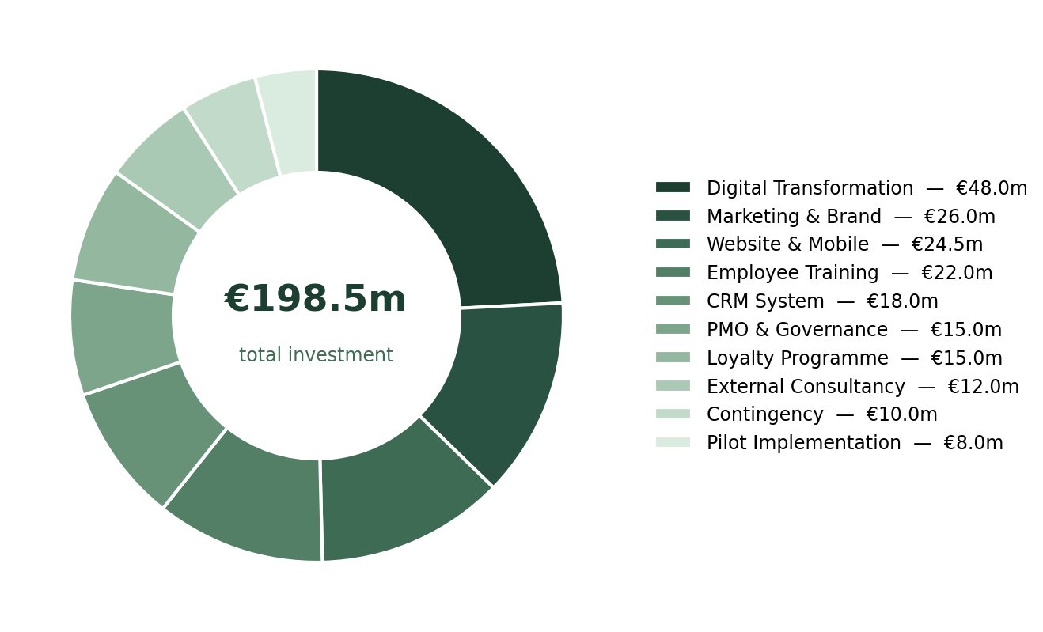
Figure 2.1: Distribution of the €198.5m Investment by Workstream

3. Project Scope and Work Breakdown Structure

3.1 Scope Definition
A well-defined scope boundary is one of the strongest controls a project manager has. Kerzner (2022) points to poor scope definition as the single most common cause of overruns in complex transformation programmes, which is why the inclusions and exclusions for Project Phoenix were agreed before implementation begins.
The programme covers digital platforms, employee capability, customer communication and organisational culture. Anything unrelated to customer experience sits outside the boundary; fleet expansion, route development and changes to the core pricing strategy are all explicitly excluded.

3.2 Work Breakdown Structure
The work has been broken down into eight phased packages that follow the project lifecycle. Table 3.1 sets out the WBS Dictionary, listing the main activities, their durations and the deliverable each one produces.

Table 3.1: WBS Dictionary — Project Phoenix
Ref | Activity | Duration | Deliverable
1.1 | Project Charter | 2 Weeks | Approved Charter
1.2 | Appoint Project Team | 2 Weeks | Project Team Established
1.3 | Stakeholder Identification | 2 Weeks | Stakeholder Register
2.1 | Customer Research | 4 Weeks | Customer Analysis Report
2.2 | Competitor Benchmarking | 3 Weeks | Benchmark Report
2.3 | Current Process Review | 3 Weeks | Process Mapping Document
3.1 | Customer Journey Redesign | 6 Weeks | Future Customer Journey Map
3.2 | Pricing Transparency Review | 4 Weeks | Pricing Communications Framework
3.3 | Customer Service Standards | 5 Weeks | Service Standards Manual
4.1 | Website Redevelopment | 20 Weeks | Rebuilt Customer Website
4.2 | Mobile App Redevelopment | 22 Weeks | Redesigned Ryanair App
4.3 | CRM Implementation | 16 Weeks | Salesforce CRM Platform
5.1 | Training Materials | 6 Weeks | Certified Training Package
5.2 | Leadership Development | 8 Weeks | Leadership Programme
5.3 | Employee Training (12,000 staff) | 12 Weeks | Training Completion Report
6.1 | Pilot — Dublin Airport | 6 Weeks | Pilot Performance Report
6.2 | Pilot — London Stansted | 6 Weeks | Comparative Analysis
6.3 | Pilot Evaluation | 4 Weeks | Rollout Approval
7.1 | European Network Rollout | 20 Weeks | Programme Delivered Across Network
7.2 | Marketing Campaign Launch | 12 Weeks | Public-Facing Brand Campaign
8.1 | Benefits Realisation Review | 4 Weeks | Benefits Report
8.2 | Project Closure | 2 Weeks | Final Project Report & Handover

4. Project Schedule and Critical Path

4.1 Phased Timeline
The 24-month schedule introduces change gradually. This limits disruption to daily operations, which cannot simply pause for a transformation programme, and allows enough time for system development, testing and for the new ways of working to bed in. Table 4.1 summarises the eight delivery phases, and Figure 4.1 shows how they overlap across the two years.

Table 4.1: Project Timeline — Phase Overview
Phase | Duration | Start | Finish | %
1. Initiation | 1 Month | Jan 2027 | Jan 2027 | 4%
2. Research & Analysis | 2 Months | Feb 2027 | Mar 2027 | 8%
3. Customer Experience Design | 3 Months | Apr 2027 | Jun 2027 | 13%
4. Digital Development | 6 Months | Jul 2027 | Dec 2027 | 25%
5. Employee Training | 4 Months | Oct 2027 | Jan 2028 | 17%
6. Pilot Programme | 2 Months | Feb 2028 | Mar 2028 | 8%
7. European Rollout | 8 Months | Apr 2028 | Nov 2028 | 21%
8. Project Closure | 1 Month | Dec 2028 | Dec 2028 | 4%
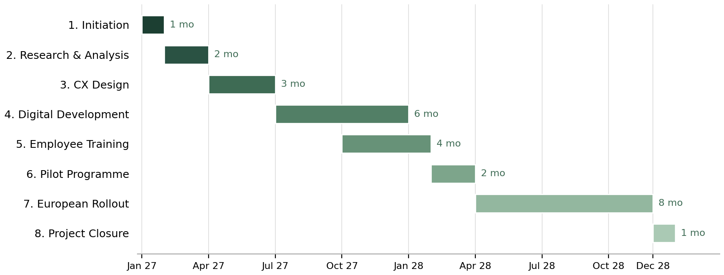
Figure 4.1: Project Phoenix Delivery Timeline, January 2027 – December 2028

4.2 Critical Path
The critical path was established through Critical Path Method (CPM) analysis. A delay to any activity in the sequence below would push back the completion date of the whole programme:
Project Approval → Customer Research → Customer Experience Design → Website & App Development → CRM Integration → Employee Training → Pilot Programme → European Rollout → Project Closure
Website redevelopment (20 weeks) and the European rollout (20 weeks) are the two longest activities on the critical path, so both will be watched more closely than the rest. The PMO will run weekly schedule reviews to catch slippage as early as possible.

5. Risk Management

5.1 Risk Strategy
On a programme of this scale, risk management cannot be treated as an administrative exercise; delivery depends on it. The framework follows PMI (2021) guidance: risks are identified continuously, scored on a 5×5 Probability-Impact Matrix, assigned a planned response, and reviewed monthly through the RAID log.

5.2 Risk Assessment Matrix
Each risk is scored by multiplying its probability by its impact, with both rated on the five-point scale shown in Table 5.1. The resulting score, somewhere between 1 and 25, determines how closely a risk is watched and who owns the response. Anything scoring above 15 is escalated to the Steering Committee rather than being managed within the project team.
Table 5.1: Risk Scoring Methodology
Score | Probability | Impact | Risk Level
1 | Very Low | Negligible | Low Risk (1–5)
2 | Low | Minor | Low Risk (1–5)
3 | Medium | Moderate | Medium Risk (6–10)
4 | High | Major | High Risk (11–15)
5 | Very High | Critical | Critical Risk (16–25)

5.3 Project Risk Register
Table 5.2 presents the ten most significant risks identified during planning, each with a named owner and a specific mitigation. It is worth noting that the two highest-scoring risks are organisational rather than technical: employee resistance and scope creep. That finding shaped the design of the programme itself, and it is the reason Kotter’s (1996) change model and a formal Change Control Board sit at the centre of the delivery approach rather than being treated as afterthoughts.
Table 5.2: Risk Register — Project Phoenix
ID | Risk | Prob. | Impact | Score | Owner | Mitigation
R1 | Employee resistance to change | 4 | 5 | 20 | HR Director | Engagement programme, leadership workshops, structured two-way communication channels throughout implementation
R2 | Scope creep | 4 | 4 | 16 | Project Manager | Formal Change Control Board; all scope changes require Steering Committee approval above €2m or 4 weeks impact
R3 | Website development delay | 3 | 5 | 15 | CIO | Agile sprint delivery, fortnightly reviews, pre-contracted contingency development resources
R4 | Budget overrun | 3 | 5 | 15 | Project Manager | Monthly EVM reporting; contingency reserve of €10m; automatic Steering Committee review if CPI falls below 0.90
R5 | Customer dissatisfaction during pilot | 3 | 4 | 12 | CX Manager | Limited pilot scope, real-time feedback monitoring, rapid corrective action protocol within 48 hours
R6 | Supplier delivery delays | 3 | 4 | 12 | Procurement | SLA-backed contracts with financial penalties; alternative supplier framework pre-qualified
R7 | CRM integration failure | 2 | 5 | 10 | CIO | Phased integration, system testing plan, vendor-supported deployment
R8 | Cybersecurity incident | 2 | 5 | 10 | CIO | Penetration testing, MFA, ISO 27001-aligned security protocols, 24/7 monitoring
R9 | Low training completion | 2 | 4 | 8 | HR Director | Regional phased delivery to avoid operational disruption; mandatory completion linked to performance review
R10 | Regulatory change | 2 | 4 | 8 | Legal | Quarterly regulatory monitoring; external legal counsel retained throughout programme
Note: Scores above 15 are classified as Critical and will receive priority Steering Committee attention at each monthly review cycle.

6. Stakeholder and Communication Management

6.1 Stakeholder Strategy
Freeman (1984) established the principle that organisations perform sustainably only when they recognise and respond to everyone with a legitimate stake in their activities. On this programme that principle is applied in practice through Mendelow’s (1991) Power–Interest Matrix, which lets the project team prioritise engagement according to how much influence each group holds over the outcome.
Engagement across the programme is directed at five objectives: keeping the Executive Board committed, securing timely governance decisions, limiting employee resistance, holding suppliers to their performance obligations, and protecting customer confidence while the changes are underway.

Table 6.1: Stakeholder Power–Interest Analysis
Stakeholder | Interest | Influence | Key Expectation | Strategy
Executive Sponsor (CEO) | High | High | On-budget, on-time delivery | Manage Closely
Project Steering Committee | High | High | Programme governance | Manage Closely
Regulatory Authorities | High | High | Compliance | Manage Closely
Investors / Shareholders | Medium | High | Return on investment | Keep Satisfied
Airport Partners | Medium | Medium | Operational continuity | Keep Satisfied
Employees (all functions) | High | Medium | Training, communication, job security | Keep Informed
Customers | High | Medium | Better service | Keep Informed
IT Suppliers | Medium | Medium | Timely, within-scope delivery | Manage Closely
Media | Medium | Medium | Accurate, timely information | Monitor
Marketing Agencies | Medium | Low | Campaign delivery | Monitor

6.2 Communication Schedule
Communication on this programme follows a fixed rhythm rather than an ad hoc approach. Table 6.2 sets out who receives what, how often and through which channel, and each stakeholder group identified in Table 6.1 is covered by at least one of these routes. Governance audiences receive formal monthly reporting, the delivery teams work to a weekly cycle, and employees and customers are kept informed through regular, plain-language updates so that no group learns about changes second-hand.
Table 6.2: Communication Management Plan
Communication | Audience | Frequency | Owner | Method
Executive Board Report | CEO & Board | Monthly | Project Manager | Board Meeting
Steering Committee Meeting | Steering Committee | Monthly | Project Manager | Face-to-face
PMO Progress Report | PMO | Weekly | PMO Manager | Power BI Dashboard
Project Team Meeting | Workstream Managers | Weekly | Project Manager | Microsoft Teams
Risk & RAID Review | PMO & Steering | Monthly | Risk Manager | Workshop
Supplier Performance Review | All Suppliers | Monthly | Procurement Mgr | Online Meeting
Employee Newsletter | All Staff | Monthly | HR Manager | Intranet & Email
Customer Updates | Customers | Quarterly | Marketing Mgr | Website & App

7. Quality Management

7.1 Quality Framework
Quality is managed through the three-stage process described in PMBOK® 7 (PMI, 2021): planning, assurance and control. Planning sets the standard each deliverable must reach before it can be approved; assurance builds compliance checks into execution itself; control validates finished deliverables before sign-off. The intention throughout is to prevent rework rather than discover failures once the work is already done.
Every major deliverable also passes through a formal Stage Gate Review before the project moves to the next phase. The gate criteria are set in advance and agreed with the Project Steering Committee.

7.2 Quality Objectives and Acceptance Criteria
Table 7.1 translates the quality framework into measurable targets. Each objective is deliberately paired with a named approval authority, so a deliverable is only accepted once the person accountable for that standard has signed it off, rather than the project team marking its own work. The targets are demanding, particularly on platform availability, but they are grounded in industry norms for systems operating at this scale.
Table 7.1: Quality Objectives and Targets
Quality Objective | Target | Approval Authority
Website availability post-launch | ≥ 99.9% uptime | CIO
Mobile application crash rate | < 1% of sessions | CIO
Customer complaint resolution time | < 48 hours | CX Manager
Employee training completion rate | 100% of customer-facing staff | HR Director
Customer satisfaction improvement | +20% vs baseline | CEO
Budget variance tolerance | Maximum ±5% | Project Manager
Deliverables accepted first submission | ≥ 95% | PMO
Pilot customer satisfaction score | ≥ 80% positive | Steering Committee

8. Cost Management and Financial Controls

8.1 Cost Baseline
The approved cost baseline is €198.5 million. Spend will be tracked monthly through Earned Value Management (EVM), giving the Steering Committee a live view of cost and schedule performance against that baseline. The monthly report will cover Planned Value (PV), Earned Value (EV), Actual Cost (AC), Cost Variance (CV), Schedule Variance (SV), the Cost Performance Index (CPI) and the Schedule Performance Index (SPI).
Any CPI or SPI falling below 0.90 will trigger a formal corrective action review with the Steering Committee within five working days.

8.2 Expected Financial Benefits
Table 8.1 breaks the projected annual benefit of €253 million into its five contributing streams. The two largest, repeat bookings and ancillary revenue, depend directly on customers choosing to fly with Ryanair again, which is why the customer KPIs in Section 9 are monitored so closely; the remaining streams are cost savings generated by digital self-service and faster complaint handling. These figures are estimates built on benchmarking rather than guarantees, and each stream will be re-validated at the stage gates as real data becomes available. Figure 8.1 illustrates how heavily the case rests on the first two streams, and Table 8.2 then summarises the overall financial position of the programme.
Table 8.1: Projected Financial Benefits — Annual Steady State
Benefit Stream | Target | Estimated Annual Value
Repeat Customer Booking Growth | +10% | €120 million
Increased Ancillary Revenue | +3% | €95 million
Digital Self-Service Savings | +40% adoption | €18 million
Reduced Call Centre Operating Costs | -20% | €12 million
Complaint Handling Cost Reduction | -25% | €8 million
TOTAL ANNUAL BENEFIT | — | €253 million
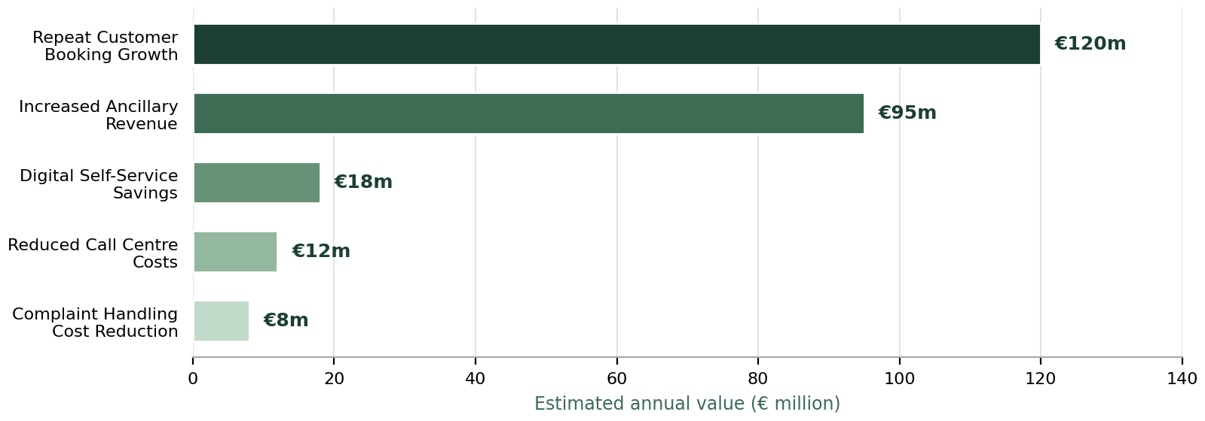
Figure 8.1: Projected Annual Benefit by Stream (€253m Total)

Table 8.2: Financial Summary — Return on Investment
Indicator | Value
Total Programme Investment | €198.5 million
Contingency Reserve | €10 million (5%)
Projected Annual Benefit (Steady State) | €253 million
Estimated Payback Period | Approximately 4 years
Estimated 5-Year ROI | 145%

9. Benefits Realisation and Success Measurement

9.1 Benefits Realisation Strategy
The programme uses a Benefits Realisation Management (BRM) framework in line with Serra and Kunc (2015), who found that organisations applying BRM are significantly more likely to achieve both project success and their wider business strategy. Benefits will continue to be tracked for 24 months after formal closure, so the investment keeps generating value once responsibility passes back to business-as-usual teams.
Benefits fall into four categories: financial, customer, operational and strategic. The first two can be measured directly. Operational and strategic outcomes take longer to show themselves, so these will be assessed through qualitative review alongside the quantitative indicators.

9.2 Customer Key Performance Indicators
Table 9.1 lists the customer-facing indicators the programme will be judged against. Baselines will be confirmed during the research phase so that improvement is measured from a verified starting point rather than an assumed one. The review frequency of each KPI reflects how quickly it can realistically move: complaint resolution time responds within weeks and is therefore reviewed weekly, while retention shifts slowly and is assessed quarterly.
Table 9.1: Customer Experience KPIs
KPI | Baseline | Target (24 Months) | Review Frequency
Customer Satisfaction Score | Current baseline | +20% | Monthly
Net Promoter Score (NPS) | Current baseline | +18 points | Quarterly
Trustpilot Rating | 1.3 / 5.0 | ≥ 3.5 / 5.0 | Monthly
Mobile App Store Rating | Current rating | ≥ 4.5 / 5.0 | Monthly
Complaint Resolution Time | ≈ 7 days | < 48 hours | Weekly
Customer Retention Rate | Current baseline | +10% | Quarterly
Digital Self-Service Rate | Current baseline | +40% | Monthly

9.3 Project Success Criteria
Success will not be judged on delivery alone. Table 9.2 deliberately combines the traditional measures of budget, schedule and milestone completion with outcome measures such as customer satisfaction and benefits realised after closure, reflecting the argument made by Atkinson (1999) that the Iron Triangle tells only part of the story. Each criterion has a named review authority, so accountability for confirming success sits with a specific role rather than with the project team marking its own work.
Table 9.2: Programme Success Criteria
Success Measure | Target | Review Authority
Delivered within approved budget | ±5% variance | Steering Committee
Delivered within approved schedule | ±5% variance | Steering Committee
All major milestones achieved | 100% | PMO
Customer satisfaction improvement | +20% | CEO
Employee training completion | 100% of target population | HR Director
Digital platform availability | ≥ 99.9% uptime | CIO
Customer complaint volume reduction | -30% | CX Manager
Stakeholder satisfaction survey | > 90% positive | Project Manager
Benefits realised within 24 months post-closure | ≥ 85% of planned benefits | Executive Sponsor

10. Conclusion and Recommendations

10.1 Conclusion
Project Phoenix is an investment in Ryanair’s long-term competitive position. The analysis in this plan describes a business whose commercial foundations are remarkably strong; 200 million passengers, revenues approaching €14 billion and net profits of €1.61 billion in a single year speak for themselves. Yet those same foundations are exposed in a market where a price advantage is no longer enough to hold on to customers who have repeatedly experienced poor service (Porter, 1985; Which?, 2025).
As Project Manager, I have designed a phased programme that targets the specific weaknesses in the customer experience without touching the operational discipline the business is built on. Digital technology, employee capability, customer communication and organisational change are brought together under a single governance framework, so the Executive Board can see progress, performance and risk at every stage of implementation.
An investment of €198.5 million is a serious commitment, but the projected annual benefit of €253 million, with payback expected within four years of completion, justifies it on financial grounds alone. The strategic benefits arguably matter even more. Stronger customer trust, a better reputation and a more engaged workforce compound over time in ways that competitors cannot copy simply by matching fares. Atkinson (1999) argues that project success should be judged not only against the Iron Triangle of cost, time and scope but also against the longer-term strategic and stakeholder outcomes a project delivers. On both measures, Project Phoenix is well placed to create real value for Ryanair’s shareholders, its employees and its 200 million passengers.

10.2 Recommendations
The following seven recommendations are proposed for approval by the Executive Board:
- Recommendation 1 – Approve Project Phoenix and authorise a budget of €198.5 million commencing January 2027
- Recommendation 2 – Establish a dedicated Programme Management Office (PMO) before project initiation to lead governance, reporting and financial control
- Recommendation 3 – Implement a phased pilot rollout across five airports before European-wide deployment to de-risk implementation and capture early learning
- Recommendation 4 – Treat employee engagement as a strategic priority, delivering structured communication and training programmes before operational changes are introduced
- Recommendation 5 – Prioritise digital investment, with the redesigned website, mobile application and Salesforce CRM platform forming the critical technology backbone of the transformation
- Recommendation 6 – Extend Benefits Realisation Management for a minimum of 24 months beyond project closure, measured against the KPIs defined in Section 9
- Recommendation 7 – Implement an annual Customer Experience Review beyond programme completion to sustain improvements in response to evolving customer expectations

On the strength of the business case, financial appraisal, risk assessment and delivery framework set out in this plan, Project Phoenix is recommended for immediate approval. The programme is affordable, realistic to deliver, and necessary if Ryanair is to secure its position as Europe’s most trusted value airline in the years ahead.

References
Association for Project Management (2019) APM Body of Knowledge. 7th edn. Princes Risborough: Association for Project Management.
Atkinson, R. (1999) 'Project management: Cost, time and quality, two best guesses and a phenomenon, it's time to accept other success criteria', International Journal of Project Management, 17(6), pp. 337–342.
AXELOS (2023) Managing Successful Projects with PRINCE2®. 7th edn. London: TSO.
Bourne, L. (2015) Stakeholder Relationship Management: A Maturity Model for Organisational Implementation. Farnham: Gower Publishing.
Freeman, R.E. (1984) Strategic Management: A Stakeholder Approach. Boston: Pitman.
Kerzner, H. (2022) Project Management: A Systems Approach to Planning, Scheduling, and Controlling. 13th edn. Hoboken, NJ: John Wiley & Sons.
Kotter, J.P. (1996) Leading Change. Boston, MA: Harvard Business School Press.
Mendelow, A.L. (1991) 'Stakeholder Mapping', Proceedings of the 2nd International Conference on Information Systems. Cambridge, MA.
Meredith, J.R., Shafer, S.M. and Mantel, S.J. (2021) Project Management: A Strategic Managerial Approach. 10th edn. Hoboken, NJ: John Wiley & Sons.
Porter, M.E. (1985) Competitive Advantage: Creating and Sustaining Superior Performance. New York: Free Press.
Project Management Institute (2021) A Guide to the Project Management Body of Knowledge (PMBOK® Guide). 7th edn. Newtown Square, PA: Project Management Institute.
Ryanair Holdings plc (2025) Annual Report 2025. Dublin: Ryanair Holdings plc.
Serra, C.E.M. and Kunc, M. (2015) 'Benefits realisation management and its influence on project success and on the execution of business strategies', International Journal of Project Management, 33(1), pp. 53–66.
Which? (2025) Best and Worst Airlines Survey. London: Which?.

