
University of Wales Trinity Saint David Birmingham

Module: Digital Skills and Research Methods
Module Code: LCHS4003
Task 1
Community Mental Health Services
Task 2
Dentistry Services
Submitted by
Name of the student: Nylah Hussain
ID number: 2505426

Submitted to
Name of the lecturer: Mumtaz Goolam

Submitted on
Date: 22 February 2026

Contents
Task 1 Community Mental Health Services… 3
Task 2 Dentistry Services 4
References 6

Task 1 Community Mental Health Services…

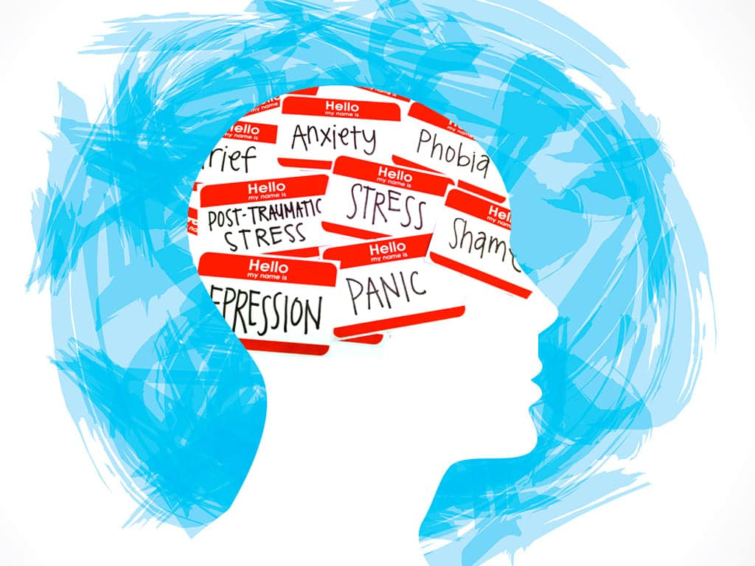
Mental health plays a very crucial role in delivering specialist care in homes and hospitals in an around the UK. Demand for mental health services has increased over the years.
3.8 million people were in contact with the NHS mental health services over the last year that’s up two times more than before the pandemic.

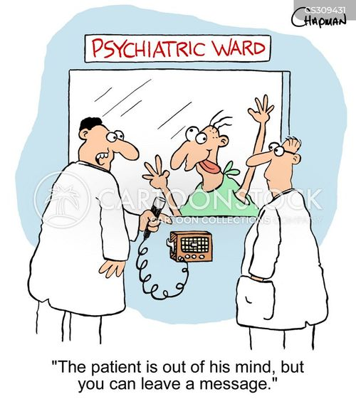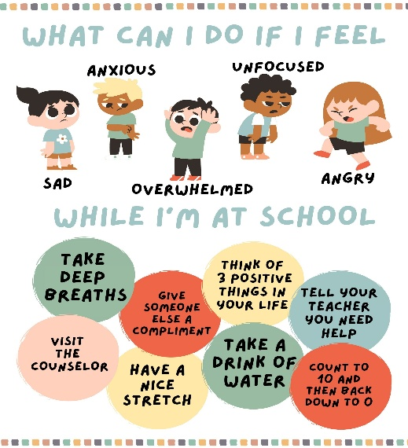
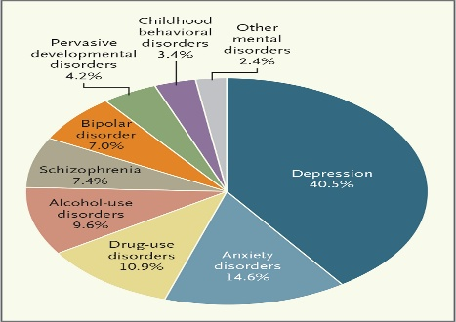
SPEAK TO SOMEONE! You will get the help you need from early on if you speak to someone…
Mental healthcare was provided in more than 100 asylums in and around the countryside and suburbs in 1948.
Mental health consists of a person’s emotional, social and psychological wellbeing. Mental health had started getting recognised in the UK in the early 20th Century 1908.


Task 2 Dentistry Services

Dentistry is one of the most ancient practises we use today, this service has developed and been developing since 7000BC (Before Christ). It has been mentioned that archaeologists have found drilled molars in the Indus River which can be traced back to the Indus River civilisation, whereas written records can be traced to 5000BC from evidence we know that humans have always had concern for their oral health hygiene. (By Beyond Dental Alex Ogden 26th April 2023)
One of the first dentists to record notes was named Hesy-Re, he was a practitioner in Egypt in 2600BC, his tomb reads that he was a doctor who mostly dealt with teeth. (Ogden 2023)
Romans and Greeks also had concern for oral care as they wrote about tooth decay and how to preform dental practises, there was a roman writer Celsus whom wrote about how to manage tooth pain. With this information we can see that oral care and hygiene is something that has evolved over the years in humans. (Ogden 2023)
Tools used to get rid of decay in teeth was a bow drill and flint top, these would be placed into the patients mouth on the tooth and drilled to make a hole or make the existing hole bigger to fill the tooth with bitumen which is now known as tar, this was used to fill and seal cavities. (History of Dental Technology part7 15th April 2019)
‘’The Father Of Modern Dentistry’’ Pierre Fauchard, introduced a change in dentistry that bought patients comfort, patients used to get treated on the floor, however Fauchard proposed the armchair for a more comfortable approach. Fauchard described that he had made tools such as special forceps and drills that became pioneers of contemporary dental services, he was also an advocate for cleaning teeth to prevent decay and gum disease. (Aksoy U Aksoy S, Kirmizi D et al, 16th September2014)
anaesthesia is something that is used in todays dental world and was first invented by William T.G Morton, while other practitioners such as Horace Wells experimented with Nitrous Oxide now known as laughing gas. Other substances used by different practitioners were chloroform, opium, mandrake and alcohol for pain relief. Today we use local anesthesia, this is known to numb a specific area, general anesthesia is to make the patient unconscious we also use laughing gas in some cases. (Robinson DH, Toledo AH. Historical development of modern anaesthesia. J Invest Surg. 25th June 2012).
The dentistry industry we know in today’s world is known for using Xray’s to see beyond the mouth and have a clearer picture of what is going on under the teeth, bones and gums. We now use the many different tools as the world has come far from using a bow drill and flint top, in today’s modern world we use high and low speed hand pieces which are used to drill holes and polish teeth, among other things such as a suction device used to suck up saliva, blood and debris from tooth drilling. Another comfort that has evolved is the armchair that was proposed by Fauchard in the early 1700s, it is now electrical and can be adjusted to the comfort of the patient, this also has a light above the patient so that the dentist can see what they are doing. Something else we us in today’s dental world are impression trays and moulds, these are used to create a mould of your teeth, if you ever needed a moth guard, a tooth bridge or a tooth crown. (Spielman, AI. Place and means of practice. In: Illustrated Encyclopedia of the History of Dentistry. 2023. https://historyofdentistryandmedicine.com/)

Benefits of regularly visiting the dentist are ensuring that your teeth and gums are healthy, however with technology today screenings can be done to detect oral cancer early or gum disease. A dentist can detect a problem in your mouth before it eats through the tooth enamel. Dentists can teach you how to brush your teeth and floss properly which can help less problems for you in the future. Bad breath, is something a dentist could help with as it could be a root problem stemming from tooth decay or gum disease, overall a dentist helps improve your smile, to give you confidence that you need in every day life, to help boost your self-esteem. Dental visits are required at least twice a year, even if you have no problem with your teeth, it is better for the dentist to have a look give your teeth a good polish leave you feeling beautiful, with a radiant smile. (Dr Rez Dental 5th February 2026)

References

"He's out of his mind, but you can leave a message." - CartoonStock Len Chapman 05-10-2025 acessed 19-02-2026
Child Mental Health Digital Downloads Handouts Posters Classroom - Etsy UK Melanie Wiltshire 01-04-2024 accessed 19-02-2026
Transforming Lives, Enhancing Communities — Innovations in Global Mental Health | New England Journal of Medicine 15 January 2014 accessed 19-02-2026
Top tips for looking after your mental health – StreetDoctors 2021- accessed 19-02-2026
Happy Birthday, NHS | Mental Health Foundation 5th July 2013 accessed 19-02-2026
The roots of the concept of mental health - PMC
Bertolote J. 2008- accessed 19-02-2026
NHS England » England’s NHS mental health services treat record 3.8 million people last year 10-10-2024 accessed 19-02-26
Behavioral Health vs. Mental Health: What's the Difference? - AllDayMedicalCenter accessed 19-02-2026
The Fascinating History Of Dentistry | Beyond Dental Alex Ogden 26th April 2023 Accessed 22-02-2026
History of Dental Technology - part 7 - Drills and Handpieces - Pearl Dental Software 15th April 2019 accessed 22-02-2026
Pierre Fauchard (1678-1761): Pioneering Dental Surgeon of the Enlightenment Age | Cureus (Aksoy U Aksoy S, Kirmizi D et al, 16th September2014)
Historical development of modern anesthesia - PubMed (Robinson DH, Toledo AH. Historical development of modern anaesthesia. J Invest Surg. 25th June 2012). Accessed 22-02-2026
Place and means of practice - History of Dentistry And Medicine | The Illustrated Encyclopedia of the History of Dentistry Andrew Spielman 2023 Accessed 22-02-2026
Our Blog | Dr Rez Dental | The Top Benefits of Regular General Dentistry Visits Dr Rez Dental 5th February 2026 accessed 22-02-2026

