Materials and Manufacturing Report – Polymer Moulded Bottle
M4X01163

Alex Collier (1707158)
BEng Material Science
11/30/18

Executive Summary
This report provides analysis and evaluates the material and processes used in the manufacturing of PET polymer moulded bottles. The first area looked at is the material of choice for the bottle, investigating the properties and attributes required for consideration. The second area looked at are the manufacturing processes which can take place to achieve a good product. This has been broken down into 4 stages for ease of reading. Environmental and ethical issues are also documented, along with volumes which are required annually. There is a section dedicated to the future development of polymer bottle manufacturing, this highlights the importance of advancement in the field of material science and engineering.

Table of Contents
Executive Summary 1
Introduction 3
Polymer moulded bottle assembly 4
History 4
Materials 4
Manufacturing 5
Volumes 7
Environmental 8
Future Developments 9
Conclusion 11
References 12
Appendix 14

Introduction
Plastic surrounds us. A plastic bottle is a container with a neck that is narrower than its body with an opening at the top. Plastic bottles are typically used to store liquids such as water and soft drinks. The world population consumes increasing amounts of polyethylene terephthalate (PET) bottles each year. This is mainly down to the durability of PET bottles. They are used on a daily basis by the majority of people. PET has unique properties and is becoming the packaging material of choice for manufacturers. It is very strong compared to its weight and is approved for safe contact with food and beverages. Being an inert material, if it is not recycled it will not degrade at landfill.

Polymer moulded bottle assembly
Important aspects of polymer moulded bottle assembly are below. It follows the process of polymer manufacture, through to recycling and environmental factors.

History

PET Polyester was first developed for fibres by British Calico Printers in 1941. The PET bottle was patented in 1973 by chemist Nathaniel Wyeth. Wyeth’s crucial discovery was a way to improve blow moulding techniques which had been used with glass for thousands of years. In the year 1973, the technique for stretch blow moulding bi-axially orientated PET became commercially viable. This process is the same that is used in modern techniques yielding a strong, clear, lightweight, flexible bottle (Tietz, 2016).

Materials

Polyethylene terephthalate (PET) is the most commonly used thermoplastic polymer in the world. PET is a resin consisting of repeated chains of organic molecules. PET is derived from petroleum hydrocarbons. It is created by a reaction between terephthalic acid (C ₈ H ₆ 0 ₄ ) and ethylene glycol (C ₂ H ₆ 0 ₂ ) (madehow, 2018).The resulting spaghetti-like strands of PET are extruded, quickly cooled, and cut into small pellets. The resin pellets are then heated to a molten liquid that can be easily extruded or moulded into products of practically any shape (PETRA, 2018).
Polyethylene terephthalate is used for its superior clarity and mechanical properties. It is given the recycling code 1, this can usually be found at the bottom of bottles (Appendix 1).
Only around 30% of PET produced is used for bottle manufacturing. The other 60% is used for synthetic fibres (CPME, 2011).
Property | Value
Technical name | Polyethylene terephthalate (PET or PETE)
Chemical formula | (C₁₀H₈O₄)n
Molecular Weight (repeating unit) | 192g/mol⁻¹
Density | 1.41g/mol⁻³
Tensile Strength (Youngs Modulus) | 1700 MPa
Melt temperature | 265°C
Glass transition temperature | 69°C - 115 °C
Specific Gravity | 1.56
Properties of PET (Awaja. F, 2005)

Manufacturing

Before the production of bottles, the PET must first be manufactured as described in the previous section. The PET pellets absorb moisture from the atmosphere, this must be removed from the pellets by dehumidifying drying before the process can take place. Many simulations also take place pre-moulding. When polyethylene terephthalate is stretched, it exhibits strain hardening properties. The properties differ dependant on the temperature and strain-rate of the material. A visco-hyperealistic model is used to describe the stretching behaviour of a polymer. A biaxial characterisation method has been developed, using a non-linear curve fitting programme. This model provides satisfactory data for the stretching behaviour of PET. (X.-T. Pham, 2004).
Stretch blow moulding, otherwise known orientation blow moulding or injection blow moulding, is a manufacturing process which can be used in the production of PET bottles. The process can be broken down into stages.
Stage 1: The stretch blow moulding machine is based on an extruder barrel and screw assemble which melts the polymer. The melted polymer is then injected through nozzles into a mould, where it assumes the shape of a long thin tube. This is called a parison. The parison may be stored or transferred to another factory for bottle production.
Stage2: The parison is the transferred into a second mould in the shape of the final product. A steel rod called a mandrel is the slid into the parison, where it fills with pressurised air, heat and pressure. The combination of these causes the parison to stretch both radially and axially. Some manufacturers then weld a separate bottom piece to the bottle during this process, whilst other produce the bottom from the mould. (Appendix 2)
Stage 3: The mould is then cooled relatively quickly. This process can be done directly or indirectly. Water may flow through pipes around the mould, or highly pressurized air may be shot directly into the mould. This can also be done using liquid CO₂ or liquid Nitrogen. This process is done quickly to reduce the chance of creep.
Stage 4: As this is usually done as part of a continuous manufacturing process, the bottle/ bottles must be removed from the mould, separated and trimmed. If any polymer has leaked through gaps in the mould, this will also require extra trimming (THOMASNET, 2018) .
The table below compares the pre and post blow moulded part for standard bottle production.

Component | Length (mm) | Middle radius (mm)
Parison | 77 | 23
Mould | 151 | 60

Parison and mould geometries. (Bagherzadeh. S, 2010)
A manufacturing process named single stage injection blow moulding may also be used in for bottle production. This will remove the need for the parison to be produced, stored and reheated. In this variant of the process, the preform (parison) is produced shortly before final shaping. The material is melted into a core, it is then cooled in the mould at a temperature above the crystallization temperature and is then blown (Biglione, 2015). This process is advantageous as a greater production rate can be achieved with a continuous process.

Volumes

Approximately 6.4 billion litres of carbonated soft drinks were produced in the UK in 2010. This figure is thought to have grown by 4.6% per year. Of this amount, 57%, 26% and 3 % were packaged in PET, cans and glass, respectively, while the remaining 14 % were consumed from dispensers and in other (unspecified) packaging format (Amienyo, 2013)(Appendix 3). That equates to 3,648,000,000 PET bottles being used in just this industry per year.
Although PET is widely used in the bottling industry, the packaging of beer and wine has remained largely in glass bottles. The oxygen barrier properties of PET currently does not ensure complete protection against deterioration in taste quality (WRAP, 2008). Beer bottles at some festivals and events are now packaged in PET bottles. This is bottled specifically for events and consumed on the premises, leaving no time for oxidation and deterioration of the beer (Creative Machanisms, 2016)

Environmental

The manufacture of plastic resins accounts for the highest percentage of a plastic bottle’s carbon footprint. Whilst processing, large hydrocarbon molecules from petroleum and natural gas are broken down into smaller hydrocarbon molecules using extremely high temperatures.
Polyethylene terephthalate is a highly recyclable material. In 2016, more than 1.7 million tonnes of PET bottles and containers were recycled in Europe alone (PETCORE, 2017). This equates to approximately 59% of all polyethylene terephthalate produced. There are two methods for recycling PET. For chemical recycling of PET to be recycled back to resin it must be washed, re melted then chemically broken down in to terephthalic acid and ethylene glycol. For mechanical recycling, the PET will be washed, cut or chipped, this material will then be pelletized for re-use. Once PET has been recycled, it is no longer suitable for food grade packaging (Dickinson, 2018)
Polyethylene terephthalate is an inert polymer therefore if it is sent to a land fill site it, will not poison the environment or biologically de-grade.
Although the raw materials for PET come from oil and natural gas, it is still energy efficient compared to the likes of glass and aluminium (PETRA, 2018).
In Norway, up to 97% of plastic bottles are recycled. There is an industry-led scheme advised by the government, to reduce plastic waste in the environment. The government decided the best way of tackling this issue, was to put a tax of between the equivalent of 10p-25p, dependant on bottle size. Once the bottle is returned to a machine, the consumer receives a coupon for the original value of the deposit paid. (Harrabin, 2018)
Being lightweight, PET reduces the carbon footprint of transporting products significantly. The same volume can be held in each of the bottles stated below. (WRAP, 2008). See also (Appendix 4).
Bottle type | Bottles per load (empty) | Bottles per load (full) | Load weight of empty bottles (t) | Load weight of full bottles (t) | CO₂ per bottle (g) | CO2 saving per bottle: Transport (g) | %CO2 saving per bottle: Transport
496g glass | 37,530 | 20,160 | 19.46 | 26.51 | 49 | 0 | 0%
365g glass | 46,800 | 21,840 | 18.54 | 25.86 | 41 | 8 | 16.80%
54g PET | 67,500 | 21,840 | 5.33 | 19.09 | 16 | 33 | 67.90%
 |  |  |  |  | Emissions are compared to 496g bottle

It can be seen from the table above that PET is a lot less energy intensive during transport. Another advantage during transport is that PET is shatter proof, so accidental breakage during transport is not an issue, as with glass.

Future Developments

Coca-Cola, Ford Motor Co, HJ Heinz, Nike, and Procter & Gamble have formed a consortium to promote research for developing polyethylene terephthalate (PET) that is 100% derived from renewable raw materials, a move that executives say will extend demand for bio-based PET from resins into the polyester fibres market (Sissell, 2012). By 2020, Coca-Cola claim that 30% of all containers that it produces will be made from renewables.
There is a polyester called polyethylene naphthalate (PEN) has recently been combined with PET to create a new range of ‘alloys’. They are used as specialist packaging due to polyethylene naphthalate’s heat tolerance and barrier properties. (KENPLAS, 2018).
A new recycling technique designed for PET bottles has been developed at a pilot scale. The process takes different coloured PET waste and breaks it down to molecular level. This then separates out the colour and other contaminants. Once this is complete, it can then be converted back to virgin grade raw material for food packaging (Dickinson, 2018).

Conclusion
Polyethylene terephthalate is the material of choice for many bottle manufacturers. This is due to its glass like transparency, chemical inertness and how environmentally friendly it is in comparison to other products. As it is also break resistant, the total amount of product received by a supplier will be higher. As developments emerge in both the manufacture and recycling of PET, it is expected more products will become available and demand for recycled PET will also rise.
While plastic has been recycled since the 1970’s, the quantities that are recycled vary geographically (Hopwell. J, 2009). If recycling is to be increased worldwide, a high quality of education will need to be delivered for people to understand the seriousness of the problem.

References
Amienyo, D. e. (2013). Life Cycle environmental impacts of carbonated soft drinks. The International Journal of Life Cycle Assesment, 77-92.
Awaja. F, P. D. (2005, November 21). Recycling of PET. European Polymer Journal, 1453-1477.
Bagherzadeh. S, e. a. (2010). Numerical Study of Stretch-blow Molding of PET Bottles. Proceedings of the World Congress on Engineering.
Biglione, J. e. (2015). Injection Blow Moulding Single Stage Process – Approach of thematerial behaviour in process conditions and Numerical Simulation. Key Engineering Materials, 805-811.
CPME. (2011, 08 16). Plastics to overtake glass containers. Retrieved from https://www.cpme-pet.org: https://www.cpme-pet.org/content/plastics-overtake-glass-containers
Creative Machanisms. (2016, June 20). Everything you Need to Know About The World's Most Useful Plastic (PET and Polyester). Retrieved from https://www.creativemechanisms.com: https://www.creativemechanisms.com/blog/everything-about-polyethylene-terephthalate-pet-polyester
Dickinson, K. (2018, April 4). Inilever trials circular technique for PET recycling. Retrieved from https://resource.co: https://resource.co/article/unilever-trials-circular-technique-pet-plastic-recycling-12579
Harrabin, R. (2018, February 7). bbc. Retrieved from bbc: https://www.bbc.co.uk/news/science-environment-42953038
Hopwell. J, D. R. (2009). Plastics recycling: challenges and opportunities. Philosophical transactons, The royal society London, 2115-2126.
KENPLAS. (2018, November 18). kenplas.com. Retrieved from Kenplas: http://www.kenplas.com/project/pet
madehow. (2018, November 21). Soda bottle. Retrieved from http://www.madehow.com: http://www.madehow.com/Volume-1/Soda-Bottle.html
PETCORE. (2017, December 18). Press release. Brussels, Belgium.
PETRA. (2018, November 16). An introduction to PET. New York, New York.
Sissell, K. (2012). Coke Joins with Multinationals in push for biobased PET. Chemical week, 174(16),15.
THOMASNET. (2018, November 18). Plastic bottle manufacturing. Retrieved from thomasnet.com: https://www.thomasnet.com/articles/materials-handling/plastic-bottle-manufacturing
Tietz, T. (2016, October 24). schi blog. Retrieved from schi.org: http://scihi.org/nathaniel-wyeth-and-the-pet-bottle/
WRAP. (2008). The carbon impact of bottling Australia wine in the UK: PET and glass bottles. Oxon: WRAP.
X.-T. Pham, F. T.-T. (2004). MODELING AND SIMULATION OF STRETCH BLOW MOLDING OF POLYETHYLENE TEREPHTHALATE . Polymer Engineering and Science , 1460 - 1472.

Appendix

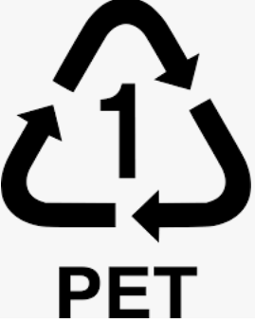
(Appendix 1)

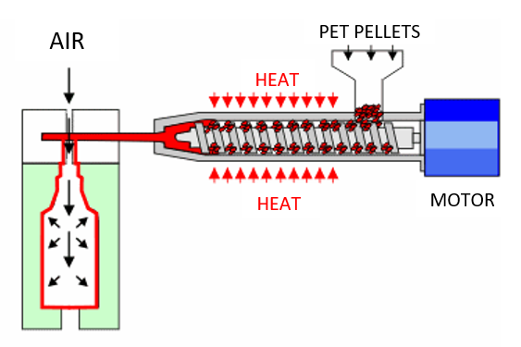
(Appendix 2)

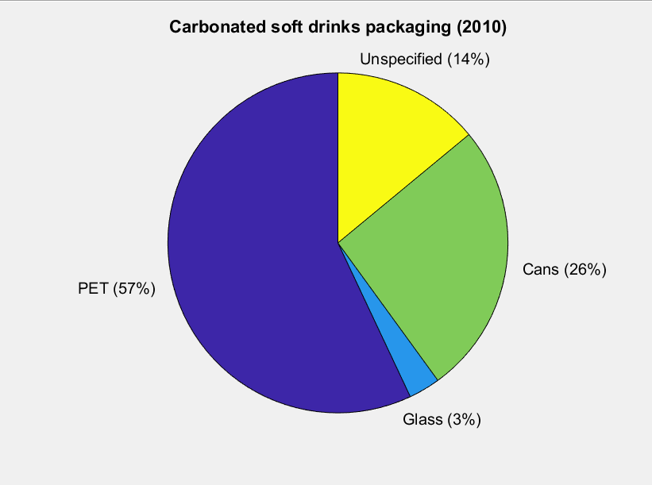(Appendix 3)
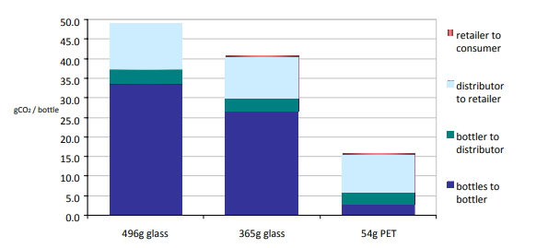(Appendix 4)

