

Owain Plant
1910280

Investigation into land recovery method for Uncrewed Aerial Targets

University of Wales Trinity Saint David
Academic Year: 2023 - 2024

Supervisor: Dr. Mark Broadhead
15/03/2024

This thesis was submitted in partial fulfilment of the requirements for the BEng degree of Ordinance, Munitions and Explosives- Safety Pathway

Academic integrity declaration
I declare that:
- The thesis submitted has been written by me alone.
- The thesis submitted has not been previously submitted to this university or any other.
- That all content, including primary and/or secondary data, was true to the best of my knowledge.
- That all quotations and references have been duly acknowledged according to the requirements of academic research.
I understand that to knowingly submit work in violation of the above statement will be considered by examiners as academic misconduct.

Acknowledgements
The author would like to give acknowledgement to Mark Broadhead, Edwin Muirhead, and Marc Jones.

Abstract
This project investigates three different aerial target systems and looks for a new method for recovering them to a geographically challenging land area. This new method was to be applied specifically to MOD (Ministry of Defence) Aberporth Range. It attempts to find a solution by conducting research into possible solutions that could be used, then creating a unique solution for the unique problem requirements. The solution that was found for system one and two was, firstly to use the manufacturers information and tailor it for lower altitudes. Then look at the wind direction and the varying land heights for the Range. Using this information gained limitations for recovery were created to maximise the possibility of land recovery. System three required a unique method be created due to the lower altitude recovery heights than usual and gaps in manufacturers information. This was done by extrapolating the manufacturers information and applying trigonometry to confirm the theoretical calculations. These theoretical results for each of the three systems were tested to confirm their accuracy, ten test flights and recoveries for each system were carried out. The results showed that the theoretical calculations were greater than the test flight results, this means the theoretical results and created safety trace was suitable. The potential fitted OME (Ordinance, Munitions and Explosives) when conducting recovery was also investigated. This showed that given varying situations upon recovery that worst case scenario for the OME was deflagration. It was however decided due to environmental reasons that all OME should be used prior to attempting land recovery.

Table of Contents
Academic integrity declaration i
Acknowledgements i
Abstract ii
List of Figures iv
List of Tables v
List of Equations vi
1 Introduction 7
2 Background 8
2.1 Uncrewed Aerial Vehicles (UAVs) 8
2.1.1 Applications 8
2.1.2 Ethical issues 8
2.1.3 Governance 9
2.2 Aerial targets 10
2.2.1 History 10
2.2.2 Recovery method 12
2.2.3 The three systems 13
2.2.4 Problem at hand 14
2.2.5 Gap in the literature 14
2.2.6 Reasoning for new method 16
2.3 Research Question 20
2.4 Requirements 21
2.5 Aim and objectives. 21
2.6 Method 22
3 Drift distance methodologies 23
3.1 System one & two 23
3.2 System three 26
4 Results and discussion 31
5 Conclusion 36
5.1 Future work 37
5.2 Reflection 37
6 References 38
7 Appendix- Ethical approval letter 41

List of Figures
Figure 2-1- World War 1 original aerial target [15] 10
Figure 2-2- Mid 1900 aerial target system (Jindivik) [17] 11
Figure 2-3- Image of US Air Force F86 sabre [19] 12
Figure 2-4- Current aerial target systems [20] 12
Figure 2-5-image of UAT falling on parachute. [21] 13
Figure 2-6- Image of boundary and direction of flight from google earth. 14
Figure 2-7- Graph of the TDD on land vs wind speed 18
Figure 2-8- current method illustration. 19
Figure 2-9- Graph of altitude vs drift distance at 15 knot wind speed. 20
Figure 3-1- graph of hybrid map system 1 & 2. 25
Figure 3-2- illustration of hybrid area map system 1 &2. 25
Figure 3-3- Graph of altitude vs drift distance at 30 knot wind speed. 26
Figure 3-4- 10,000 feet drift distance triangle. 28
Figure 3-5- 10,000 feet drift distance triangle with 300 feet cut out. 28
Figure 3-6- Graph illustration of drift distance system 3. 29
Figure 3-7- Illustration of drift distance system 3. 30
Figure 4-1- Graph of Height against time of test results for system 1. 31
Figure 4-2- Graph of Height against time for test results for system 2. 32
Figure 4-3- Graph of Height against time of test results for system 3. 33
Figure 4-4- Graph of Height against time for the three systems test results. 34
Figure 4-5- Road closures for safety trace. 35
Figure 7-1 - Ethical approval letter. 47

List of Tables
Table 2-1- drift distance at sea level 17
Table 2-2- Drift distance on land 18
Table 3-1- Recalculation for difference in land height 24
Table 3-2- Table of Range bearings max wind speeds system 1 & 2 24
Table 3-3- Comparison of constant results and manufacturer values 27
Table 3-4- wind speed constants 27
Table 3-5- Hybrid area map bearing and max wind speed system 3 29
Table 4-1- Theoretical and test results comparisson table 34

List of Equations
Equation 2-1- Equation for still air termination distance 16
Equation 2-2- System 1 & 2 SATD calculation 16
Equation 2-3- System 1 & 2 TDD at sea level 16
Equation 2-4- System 1 & 2 TDD on land 17
Equation 2-5- TDD on land 19
Equation 3-1- calculation taking inot account land height 23
Equation 3-2- Total drift distance on land formula 27
Equation 3-3- Total drift distance at 30m/s for system 3 28
Equation 3-4- Trigonometry system 3 10,000 ft. 28
Equation 3-5- Trigonometry system 3 300 ft. 28
Equation 3-6- Trigonometry system 3 300 ft. rearranged. 28
Equation 4-1- Decent deceleration system 1 calculation 31
Equation 4-2- Time for system 1 to decelerate. 32
Equation 4-3- System 1 drift distance 32
Equation 4-4- Decent deceleration system 2 calculation 32
Equation 4-5- Time for system 2 to decelerate. 32
Equation 4-6- System 2 drift distance 32
Equation 4-7- Decent deceleration system 3 calculation for 400 meters 33
Equation 4-8- Time for system 3 to decelerate for 400 meters. 33
Equation 4-9- System 3 drift distance for 400 meters 33
Equation 4-10- Decent deceleration system 3 calculation for 200 meters 33
Equation 4-11- Time for system 3 to decelerate for 200 meters. 33
Equation 4-12- System 3 drift distance for 200 meters 33

Introduction
This report will look at land recovery methods for three different UAT (Uncrewed Aerial Target) systems at MOD (Ministry of Defence) Aberporth. It was required that the availability of the land recovery option for different UAT systems at Aberporth be increased while the risk rating remain unchanged. An investigation was carried out into a means of maximizing the amount of wind that can be tolerated for land recovery, whilst containing the recovery area to the Range boundary and avoiding the ammunition storage facility (magazine) as well as occupied buildings. To do this firstly, research was carried out into UAT existing recovery methods to see if any existed and could be used. Due to the gap in the literature, work was carried out to explore a new method looking at the tolerable levels of wind for land recovery, whilst considering the geographical area. Theoretical work was carried out into the possible options to maximise wind for the three systems at Aberporth. Once this had been completed, agreed and approved the theoretical calculations underwent recovery test flights at other Ranges. This was to see whether the target falls within the calculated area, with the findings of the theoretical and test results being compared and discussed, before concluding.

Background

Uncrewed Aerial Vehicles (UAVs)

Applications
In recent years, the popularity and abundance of drones has increased dramatically, this is due to the cost of the systems decreasing as well as an increase in their capability and ease of use. Drones are now being utilized in a wide variety of different industries for varying tasks as well as being used and readily available for hobbyists. [1] Examples of some of the industries that are utilizing these systems are the agriculture industry, civil engineering, defence, videography and photography. A future application that a great deal of research is going into is the use of drones for delivery of packages and products, with testing and certification for use currently ongoing by a variety of companies. [2]
Firstly, looking at the agricultural industry they are using these systems to manage animal stock and checking vast areas in a short amount of time. There are also other technologies being incorporated into these systems such as using machine learning to conduct agricultural soil sensing. [3] As previously stated, they are used in civil engineering to aid with construction, maintenance and architecture. These systems can be fitted with a wide range of sensors and cameras to carry out a variety of different tasks. [4]
As can be seen on the news drones are widely used for varying military applications, examples of where these systems have been utilised in recent conflicts include Iraq, Afghanistan, Syria and now in Ukraine. These systems are used for multiple reasons including surveillance, reconnaissance, EOD (Explosive Ordnance Disposal), providing aerial support to ground troops, logistics, precisely targeting enemy positions, training, testing, direct offensive, search and rescue. [5]

Ethical issues
There is a great deal of distinction on the ethical issues associated with the use of drones for military applications. The main ethical issue with using these uncrewed systems is their use for direct offensive attacks, especially with the readily available off the shelf systems being easily convertible to an instrument that can be used in armed conflict. The other main issue is the lack of regulation and governance that surrounds these systems and how their export controls are conducted. [6] This is due to the ever-evolving technology, the rapid pace that modern warfare is changing and the struggle of policy to keep up with these changes. These systems are very much a controversial method of delivering lethal force due to the dissociation of the system controller with the end effects. [7]
In contradiction to the previous statements, there are however benefits to these systems due to them removing personnel from dangerous situations. They are also able to be used to gather critical information to aid in reducing mission risks as well as support and give aid to troops. Examples of this have been shown across social media and news platform with medical supplies being delivered to injured personnel. [8] [9]Another example is British Aerospace development of an evacuation drone which can carry an injured person to safety. [10]

Governance
Aviation regulation falls under two broad categories: civil aviation and military aviation. Whilst not directly driven by the health, safety and environmental protection legal requirements, both civil and military aviation safety in the UK (United Kingdom) is closely related. Many aspects of aviation operations remain subject to the Health and Safety at Work Act. Aviation safety generally follows the principles and conventions established by the ICAO (International Civil Aviation Organisation) and the supporting Air Navigation Commission, which establishes various standards, recommended practices and procedures for air navigation services for adoption worldwide. Most countries around the world, including the UK, therefore regulate aviation in a manner that both recognises and complies with ICAO principles, conventions and procedures. [11]
The UK are now in the process of improving the governance and control of uncrewed aerial systems by developing their regulations. Any UAV operations in the UK under the Civil Aviation Act and Air Navigation Order Article 265, states they must be compliant with the provisions of UK Regulation EU (European Union) 2019/947 as retained and amended in UK domestic law under the EU Withdrawal Act 2018. The guiding principles, based on those established by EU UAV regulations, is that the level of oversight and the associated regulatory controls are proportionate to the level of risk associated with the distinct categories of UAV operation. Lower risk operations involving smaller, low mass drones operated far away from people therefore attract the least onerous requirements for safe operation. Other systems might require that a SORA (Specific Operational Risk Assessment) process developed by JARUS (Joint Authorities for Rulemaking on Unmanned Systems) be followed. This focuses on Specific category UAV operations and containment of the operation within a defined and assessed operating volume as a method to manage ground and air risk. SORA is also recognised within MAA RA 1600, the regulation governing Remotely Piloted Air Systems [12] and the MAA RPAS Manual [13].

Aerial targets
One area of UAVs that are used by the military frequently are UATs (Uncrewed Aerial Targets), these systems are used for trials, training, test and evaluation. Aerial target systems offer an opportunity to test many distinct types of weapon systems utilizing one affordable and reusable system. They fly a wide variety of speeds and have excellent manoeuvrability profiles, which offers a high degree of versatility. They are used to meet a wide variety of engagement training requirements such as end-to-end weapons-release training roles, including surface-to-air and air-to-air dog fighting. They can also be used for specific weapon system requirements, they do this by utilizing different payloads and augmentation techniques. They can carry both internal and external payloads some examples of these are chaff, flares, electronic countermeasures, infrared augmentation, passive and active radio frequency augmentation as well as vector and scalar proximity scoring. [14] Although many people believe that drones and this technology is new it has been around for over one hundred years.

History
The original aerial targets did not have all the features described above and were considerably more basic in design, one of the first target drones was developed in 1917 during the First World War. The image below in Figure 2-1 depicts an example of one of the first aerial targets developed during this period. As can be seen in the image this system was extremely basic, it took off and was recovered by using the skids on the bottom of the aircraft on a runway. [15]
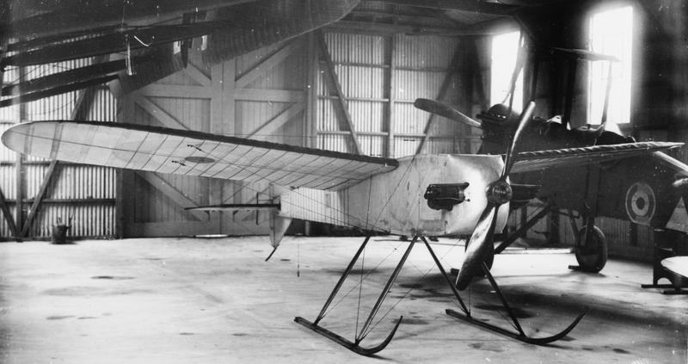
Figure 2-1- World War 1 original aerial target [15]
As conflict progressed and aerial fighting became more commonplace, there was an increase in demand for not only innovative technology but for new and novel solutions. This change gave birth to the Jindivik aerial target system, these systems were first developed and used in Australia, with the first flight for the system being in 1952. The name Jindivik originates from an Australian Aboriginal word which means the hunted one. [16]These systems were adopted into the United Kingdom by the MOD and were frequently flown from Llanbedr in North Wales. The system was radio controlled, launched from a runway and recovered to a runway by skid landing on deployable skis, this system is shown below in figure 2-2. [17]
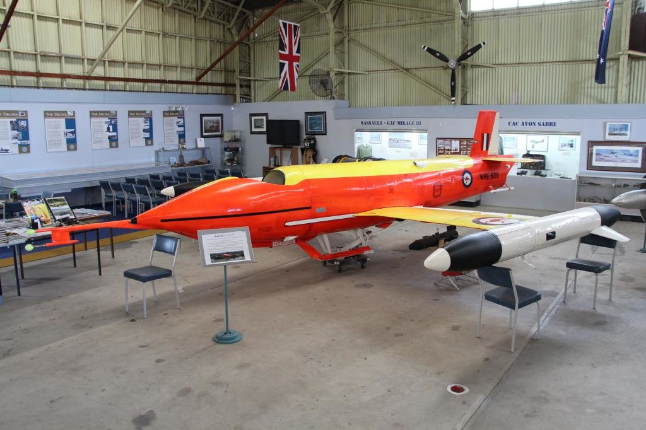
Figure 2-2- Mid 1900 aerial target system (Jindivik) [17]
Other countries have also got their own solutions in varying forms with new systems constantly under development. One example of a unique solution was the United States of America using an old F86 Sabre and retrofitting a remote piloting capability to it. This was due to these systems being no longer of use with new systems developed for use making them obsolete. Rather than scrap them they were used as target practice for training as well as testing new weapon system capabilities. [18] Figure 2-3 below depicts an image of a US Air Force F86 sabre.
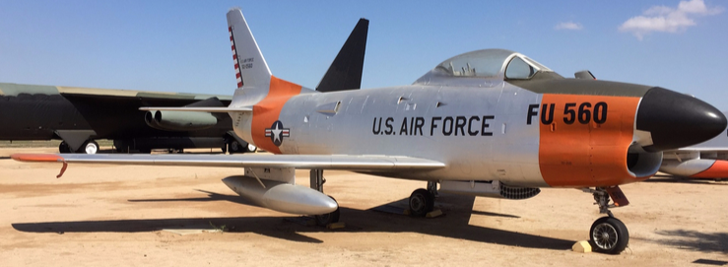
Figure 2-3- Image of US Air Force F86 sabre [19]
This then gave the way for the modern aerial targets that are now commonly used and are a vast improvement on their predecessors. They are launched from a launcher meaning that a runway is not required as well as being smaller in size and smaller teams needed to run the systems. An image is shown below depicting the current aerial targets being launched in figure 2-4.
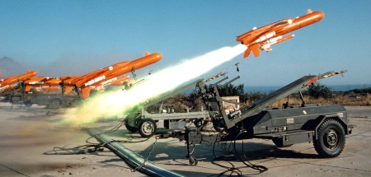
Figure 2-4- Current aerial target systems [20]

Recovery method
The new systems as depicted in figure 2-3 previously are recovered differently to their predecessors due to their simplicity as well as being much smaller. These systems are recovered by parachute either in a big open space with nothing around or to an open area in the sea. These parachutes are deployed by two options, the first is a command sent by the remote pilot, the other is if the signal from the remote pilot is lost for a fixed time, then it deploys. The parachute is deployed by a high integrity electronic system which either sets of a small gas charge, mechanical spring or explosive charge. This firstly deploys the drogue shoot, which is a small parachute that when it catches the air flow pulls the lines and main shoot out in a controlled manor whilst slowing the aircrafts speed. This is because if the main shoot were instantly deployed the forces of the aircraft travelling forward against the force of the open parachute would rip the parachute apart. Once the drogue shoot has slowed the aircraft and opens the main shoot the system will then make a controlled decent on the main shoot for recovery. The image shown below in figure 2-5 is an example of one of these uncrewed aerial targets being recovered on its parachute.
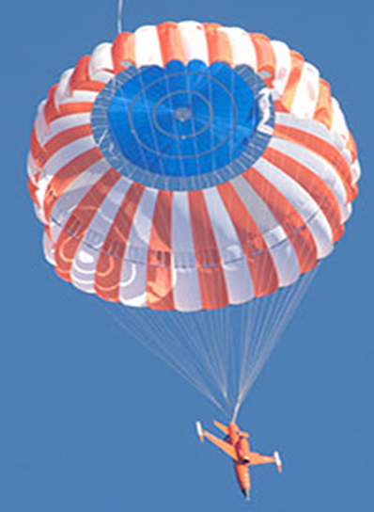
Figure 2-5-image of UAT falling on parachute. [21]

The three systems
The three systems have not been named in this project, this is due to the systems information being proprietary, therefore there should be a distinction between each system and its information. For this reason, the systems have been named system one, two and three. System one and two have a similar airframe shape, parachute deployment method and weight, the difference between system one and two is one is powered by a propeller with the other being propelled by a jet engine. System three has a different airframe, deployment method and parachute to the first two systems and is propelled by a jet engine, meaning it will be treated separately to the first two.

Problem at hand
The reason for this investigation is when the system is recovered at sea it is a costly process which has a long turnaround time, requires many hours worked, requires replacement of components due to contamination, and requires a vessel with personnel aboard to be used to recover it. There are two primary areas of investigation for this project these are the OME issues and the topography of the Range. The OME investigation will look at scenarios the system could encounter when land recovering and what the effect on the OME would be. An investigation will also be carried out to look at the effect of what would happen to the stored OME if the system were to hit the magazine compound. Depicted below for reference in figure 2-6 is an image from Google Earth of Aberporth Range boundary and the magazine boundary. These are the areas that are required to be avoided on recovery, it also depicts a red arrow illustrating the direction of flight when heading for land recovery.
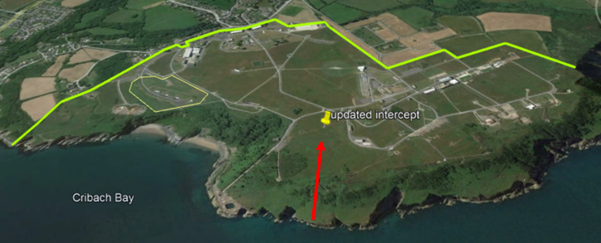
Figure 2-6- Image of boundary and direction of flight from google earth.

Gap in the literature
A literature review was carried out into recovery, the first area where research was carried out was into the manufacturer information. The information from the manufacturer for the three systems is for sea recovery from set altitudes which was not suitable for use, these sources of information have not been referenced due to their sensitivity. The reason they are not suitable is because the aim is to recover these systems to land and from altitudes much lower than that stated in the manufacturers information. Some of the information gathered from the manufacturers information however will be used to aid in the development of a new recovery method.
Two Methodologies were found for land recovery of these systems, one being the Manorbier methodology and the other being Hebrides methodology. [22] [23] These methodologies in their current form are not suited to be used either, due to the land recovery area being much larger for the two Ranges where the methods are created for. They are also not formalized reports and are only rough workings out which have not undergone scrutiny, technical assurance or in-depth peer review. This meant an investigation would also be required into the validity and providence of these methods if they were to be used. Due to this limitation as well as the limitation they would impose because of the smaller Range area, it would make land recovery impossible to achieve.
Research was carried out for other sources of information which were pertinent to the UAV field, this found two papers ‘Parachute deployment system for safe recovery of a drone’ [24] and ‘An overview on the parachute recovery systems with additive manufacturing for UAV safe landing’ [25]. These papers however were also found to be inapplicable due to them being more associated with smaller readily available off the shelf UAVs, rather than larger UAT systems. These systems were also more of a last resort if all systems fail and the system was falling from the sky, that a parachute would deploy to slow its decent rather than using it as an actual recovery method.
Due to this gap that was found and the lack of further verified sources within the UAT information for this given problem similar industries were researched. This found that similar work was carried out in the space sector, this was for first stage rocket motors returning to earth on parachutes. This information was unable to be used due to them recovering these systems to the sea and deploying the parachutes from high altitudes. Other methods of recovery for the first stage motors are Space X Falcon 9 recovering vertically onto remote sea platforms. [27] This was not applicable to these systems either, as the systems themselves would not be able to achieve this functionality. Another example found was a report on the Mars Precision Landing Using Guided Parachutes by John McKinney and Charles Lowry. [26] This method used propulsion of the payload to aid in guiding the parachute to the desired landing location meaning that this was also inapplicable. This means these solutions would sit outside the scope of this work but could lead to some potential future work where new systems with this functionality are investigated.
One other unique method of recovery was found within the space sector where Rocket Lab attempted to recover a booster using a helicopter. [28] The attempts to date have been unsuccessful as well as coming with a great cost associated with it meaning it was discounted as a feasible option. As these systems are constantly evolving and undergoing development with research currently being carried out in this area, there could be new solutions in the future. Currently however there is no applicable solution that was found. Due to the novel problem at hand and lack of literature that was applicable in the field a new method for recovery was required to be created and tested.

Reasoning for new method
As explained previously there is a gap in the literature due to the applicability of previous work carried out in the area. This section will discuss the reasoning that the ‘’Manorbier methodology’’ [23] was not applicable for use but how the methodology works and can be adapted for Aberporth Range. This methodology was read and taken back to first principals to ensure the logic that was used was correct. This method was only applicable to system one and two due to the similarities previously discussed. This means that the calculations used for these two systems are the same. The information and principals in this methodology have been combined with manufacturers information so that the drift distances of these two systems could be calculated, this was done so that lower altitudes than stated in the manufacturers information can be calculated.
The first thing that was required to be calculated was how far the system will fly before the parachute has fully deployed onto the main chute, this is called the ‘’still air termination distance’’. This calculation only considers three factors: the max wind speed of the aircraft, aircraft speed and the system delay. This equation is shown below in 2-1.
$$SATD=\left(\left(MWS+ACS\right)*SD\right)$$
Equation 2-1- Equation for still air termination distance
Where:
SATD= Still Air Termination Distance
MWS= Max Wind Speed m/s
ACS= Aircraft Speed
SD= System Delay
The system when heading in for land recovery will be flying at a speed of 55m/s with a system delay of 3 s and a maximum wind speed of 15.5 m/s, this information was as per manufacturer instructions. The calculation for the still air termination for these systems is shown below in equations 2-2. This considers the worst-case scenario where the wind is directly behind the system coming into land.
$SATD=\left(\left(15.5+55\right)*3\right)$= 211.5 meters
Equation 2-2- System 1 & 2 SATD calculation
The next thing to be calculated was how far the system will drift when at sea level, this was to give a base line before considering the height the recovery location is on land. The equation for this total drift distance at sea level is shown below in equation 2-3.
$$TDD@ SL=SATD+(\left(0.2*WS\right)*A)$$
Equation 2-3- System 1 & 2 TDD at sea level
Where:
TDD@ SL= Total Drift Distance at Sea Level
SATD= Still Air Termination Distance
0.2= System 1 & 2 manufacturers table calculation constant
WS= Wind Speed
A= Altitude
Table 2-1 below uses the equation above to show the total drift distance at sea level for system 1 and 2 at varying wind speeds, given an altitude of two hundred meters. This shows the drastic difference that varying wind speed has on the drift distance of the system.
Wind speed (m/s) | SATD (m) | Altitude (m) | TDD @ SL (m)
2.5 | 211.5 | 200 | 311.5
5 | 211.5 | 200 | 411.5
7.5 | 211.5 | 200 | 511.5
10 | 211.5 | 200 | 611.5
12.5 | 211.5 | 200 | 711.5
15 | 211.5 | 200 | 811.5
Table 2-1- drift distance at sea level
Now that the drift distance at sea has been calculated and methodology for this created it was used to calculate higher altitudes, this is to compare with the ones that are listed in the manufacturer tables. It was found that the drift distance at sea calculations using this method at these altitudes matched what was in the manufacturer tables. This meant that the methodology was correct and could now be manipulated to consider the height above sea level where the system would be landing. The equation below in equation 2-4 gives the total drift distance on land taking the height above sea level into consideration.
$$TDD on land=\left(\left(0.2*WS\right)*(A-HAL)\right)+SATD$$
Equation 2-4- System 1 & 2 TDD on land
Where:
TDD = Total Drift Distance
0.2= System 1 & 2 manufacturers table calculation constant
WS= Wind Speed
A= Altitude
HAL= Height Above Land
SATD= Still Air Termination Distance
Table 2-2 below shows a table of the drift distances on land where land was taken to be eighty meters above sea level. Eighty meters was chosen from survey data of Aberporth Range which cannot be referenced due to its sensitivity. This height however was the lowest point on the Range which means that it considers the worst-case scenario for the maximum drift of the system.
Wind speed (m/s) | TDD @ SL (m) | HAL (m) | TDD on land (m)
2.5 | 311.5 | 80 | 271.5
5 | 411.5 | 80 | 331.5
7.5 | 511.5 | 80 | 391.5
10 | 611.5 | 80 | 451.5
12.5 | 711.5 | 80 | 511.5
15 | 811.5 | 80 | 571.5
17.5 | 911.5 | 80 | 631.5
20 | 1011.5 | 80 | 691.5
Table 2-2- Drift distance on land
Figure 2-7 below shows a graphical representation of the correlation between the effect that an increase in wind speed has on the drift distance on land from the results that were gained and shown above. As can be seen from the graph the relationship is linear meaning as the wind speed increases so does the drift distance. This means that they are directly proportional to one another, hence where the 0.2 constant in the manufacturer information comes from.

Figure 2-7- Graph of the TDD on land vs wind speed
Figure 2-8 below shows a map of the area for potential drift for varying wind speeds from 2.5 m/s to 20 m/s. The central ring depicts the lowest wind speed and lowest total drift distance, the area then increases for the drift distance as the wind speed increases. This image depicts the problem and why this method cannot be used because occupied buildings and the magazine are within the boundary when the wind speed are above 5 m/s. This means that land recovery could only be conducted if the wind speeds are 5 m/s or below which is highly unlikely.
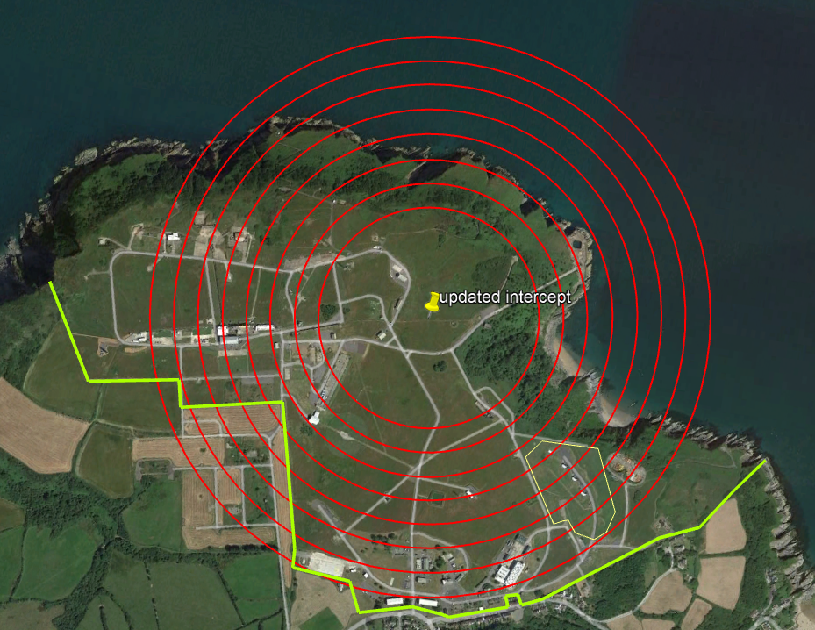
2.5 m/s
5 m/s
20 m/s
7.5 m/s
10 m/s
12.5 m/s
15 m/s
17.5m/s
Figure 2-8- current method illustration.
The third system is different to the first two because although it uses a jet like the second system it is a different shape and uses a different parachute, meaning that it requires its own calculations be carried out. The equation that was previously used cannot be used in its current form due to the information supplied by the manufacturer not giving a table of information that is usable at lower altitudes. This was the 0.2 constant that was previously stated and is in red below, as well as where it sits in the equation can be seen below in equation 2-5.
$$TDD on land=\left(\left(0.2*WS\right)*(A-HAL)\right)+((15.5+ACS)*3)$$
Equation 2-5- TDD on land
Where:
TDD = Total Drift Distance
0.2= System 1 & 2 manufacturers table calculation constant
WS= Wind Speed
A= Altitude
HAL= Height Above Land
15.5= Max wind speed m/s
ACS= Aircraft Speed
3= System delay
The graph below in figure 2-9 shows the relationship between drift distance and altitude for a 15-knot wind speed as supplied by the manufacturer of the asset. As can be seen on the graph the relationship between parachute drift distance and altitude is not linear as it was previously so a constant figure cannot be taken as before.

Figure 2-9- Graph of altitude vs drift distance at 15 knot wind speed.

Research Question
The research question for this project is, can uncrewed aerial targets be recovered safely to land in a contained area enabling redeployment? This means a methodology needs to be created in accordance with the requirements in the next section.

Requirements
This project work package is being complete for QinetiQ and specifically looks at land recovery for MOD Aberporth Range. The client required that an investigation be conducted into if it is possible for each of the three aerial target systems be land recovered to the Range. As part of this it was required by the Range that:
- It be contained within the Range boundary.
- Avoid occupied buildings.
- Avoid the magazines area.
- Ensure the residual risk level does not change.
This required that theoretical work initially be carried out which would then be required to be backed up by real world test results. To be able to conduct the required work there was a need to:
- Be assigned time to carry out the work.
- Have access to the manufacturer information.
- Be provided with test flight information for each system.
This was required to make the use of aerial targets on the Range a more cost effective and efficient service to the customers.

Aim and objectives.
To successfully meet the requirements above there was a key aim and some objectives that have been identified. The aim of the project is:
- To theoretically calculate then prove under test that all three UAT systems can be contained within the desired areas of the Range for safe recovery to land.
The aim of the project has associated objectives to ensure that it can be successfully delivered, these are listed below:
- Look at the feasibility of land recovery for the three systems.
- Refine the calculations.
- Plot drift distance area.
- Investigate hazards associated with OME carried when conducting land recovery.
- Test the theory.
- Compare the test and theoretical results.

Method
A method and plan were required to ensure the aims and objectives above are met, these are listed below:
- Research and gain understanding of the current drift distances calculations for sea recovery and its methodology for calculation.
- Conduct checks on the current methodologies validity and see if there was any way to expand upon it.
- Use various computer software systems, mathematical calculations and carry out modelling for potential options.
- Assess if the parachute drift distance and the free fall distance for the different systems fit within the Range boundaries.
- Have the information gained peer reviewed with any changes required being carried out.
- Read the insensitive munitions reports and any supporting documentation about the fitted OME.
- Assess what the effect of different scenarios would have on the fitted OME and ensure the worst-case scenario is no more than deflagration.
- Look at if it would be tolerable to land in magazine compound.
- The methodology will need to be tested completing a minimum of five recoveries per system in varying conditions to gain the required results and prove the methodologies validity.
- The tests will consist of a land recovery on parachute where the information from the flight log will be gathered, looking at the recovery height against time and calculating its drift distance.
- An average of each of the systems results will be taken and compared with the theoretical results.
- The method will then be a standard method ensuring that certain stipulations and restraints are in place and clear.
- Share the knowledge that has been gained with others.

Drift distance methodologies
As previously explained a hybrid model was required for systems one and two due to the current method being an omnidirectional safety trace. This previous trace does not consider wind from different directions or the different height above land on the Range. As could be seen from the map previously shown above, the higher wind speeds encompass an area where there are habited buildings, the magazine area and leave the Range boundary. The other problem was there was currently no method for calculating the drift distance for system three at low altitudes as previously explained.

System one & two
It was required that a hybrid drift area map be created which will take the direction of the wind into account as well as the different heights on the Range. The problem with taking one height above sea level for the whole of Aberporths Range was that the topography level varies from approximately 80 to 120 meters. The data used for calculating the land height has come from surveyed information supplied by Terrestrial Surveillance Development and Analysis. The difference in topographical heights means the drift area in some Range locations will be smaller than the one that was previously calculated. This is slightly counter intuitive to what first might be thought, the reason for this is due to the distance and time the system falls for being reduced. The area where the boundary fence is which cannot take winds above 5 m/s, is higher than that of the rest of the Range. The drift distance for this area will be re calculated to consider the specific height above sea level for this point, this in turn will affect the drift distance and area plotted. The formula used for this can be seen below in equation 3-1.
$$TDD on land=\left(\left(0.2*WS\right)*(A-HAL)\right)+((15.5+ACS)*3)$$
Equation 3-1- calculation taking inot account land height
Where:
TDD= Total Drift Distance
0.2= System 1 & 2 manufacturers table calculation constant
WS= Wind Speed
A= Altitude
HAL= Height Above Land
15.5= Max wind speed
ACS= Aircraft Speed
3= System delay
The chosen height above land was selected to be 110 meters from the survey data, this number was selected due to the lowest point on the fence line being 113 metres. Table 3-1 below shows the new drift distances for the new height above sea level at varying wind speeds.
Wind speed (m/s) | TDD @ SL (m) | HAL (m) | TDD on land (m)
2.5 | 311.5 | 110 | 256.5
5 | 411.5 | 110 | 301.5
7.5 | 511.5 | 110 | 346.5
10 | 611.5 | 110 | 391.5
12.5 | 711.5 | 110 | 436.5
15 | 811.5 | 110 | 481.5
Table 3-1- Recalculation for difference in land height
The next adjustment to be completed was done by looking at the areas where the higher winds had the greatest effect, which were the fence line and magazine area. These areas maximum wind that could be tolerated were calculated as well as the amount of wind that could be tolerated across the rest of the Range. Considering the limiting wind speed in certain directions and the height above land varying new restrictions can be put in place. These are to limit the max wind speed when blowing between 300-322 degrees to 5 m/s and 7.5 m/s max when blowing between 027- 080, for the rest of the Range the max was 15 m/s. The angles for the magazines and fence line have an added tolerance of two degrees either side as a factor of safety. Table 3-2 below shows what wind limitations are in place depending on which direction the wind is blowing in. It shows what the Ranges maximum total drift for certain areas that can be tolerated is, from these numbers it clearly shows the total calculated drift sits within the required boundaries.
Description | Bearings (degrees) | Wind speed max (m/s) | TDD on land (m) | Range MTDD (m)
Magazines | 120-142 | 5 | 331.5 | 335.00 m
Fence line | 208-261 | 7.5 | 346.5 | 390.00
Rest of Range | 0-119, 143-207, 262-360 | 15 | 571.5 | 575.00
Table 3-2- Table of Range bearings max wind speeds system 1 & 2
The graph below in figure 3-1 shows the drift distance safety trace for the varying angles ensuring that the system will not leave the boundry or enter the magazine, due to the limitations in place. The image below in figure 3-2 shows the new hybrid area safety trace applied onto the Range area at Aberporth. The green area depicted is the outer edge of the safety trace with the lines showing the angles whereby the wind speed was limited. The outer two red lines show how limiting the wind speed has kept the drift distance within the Range boundary and out of the magazine area.

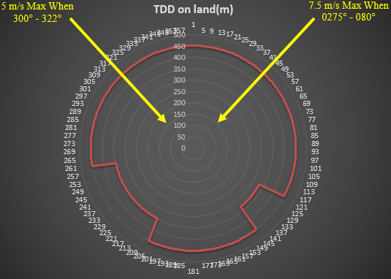
Figure 3-1- graph of hybrid map system 1 & 2.
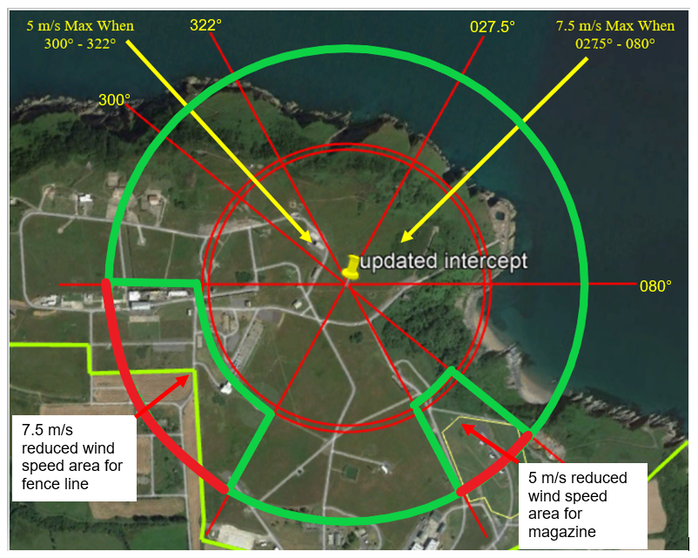
Figure 3-2- illustration of hybrid area map system 1 &2.

System three
Now that it was understood a new method was required, investigation into the best way to do this was conducted using the manufacturers’ information on drift distance. The graph shown below in figure 3-3 shows the correlation between parachute drift distance and altitude. The manufacturers information is depicted in blue which shows the gap for lower altitudes where it connects to zero. If a linear line was taken as previous the drift distance becomes negative meaning it cannot be used. This is shown in the graph below as the black line for the linear relationship of the manufacturer information. If a line is instead taken from the 10,000 feet altitude point down to zero, it remains above the drift distance from the manufacturer meaning it is on the safe side as well as giving positive numbers. This is shown in the graph below as the green line noted as theoretical constant drift distance calculation.

Figure 3-3- Graph of altitude vs drift distance at 30 knot wind speed.
Table 3-3 below shows a comparison in data between that given by the manufacturer and the one gained using the drift distance constant derived that was shown in the graph above. This shows that the constant figures are always above that of the manufacturers meaning a bigger area is given.
Altitude | Manufacturers information distance (m) | Derived constant distance (m)
0 | 0 | 0
1600 | 1700 | 3120
1800 | 2150 | 3510
2000 | 2600 | 3900
2200 | 3000 | 4290
2400 | 3450 | 4680
3000 | 4800 | 5850
4000 | 7000 | 7800
5000 | 9150 | 9750
6000 | 11300 | 11700
7000 | 13400 | 13650
8000 | 15450 | 15600
9000 | 17500 | 17550
10000 | 19500 | 19500
Table 3-3- Comparison of constant results and manufacturer values
This information meant that a drift distance constant for each of the different wind speeds could now be calculated. Table 3-4 below shows the constants that were gained by calculating the slop of the graph for each wind speed as previously shown.
WS (knot) | Constant
5 | 0.32
10 | 0.645
15 | 0.97
20 | 1.3
25 | 1.625
30 | 1.95
Table 3-4- wind speed constants
Using the above constants and the previous method for systems one and two the total drift distance can now be calculated using the formula shown below.
$$TDD on land=\left(\left(DDC\right)*(A-HASL)\right)+((WS+ACS)*3)$$
Equation 3-2- Total drift distance on land formula
Where:
TDD= Total Drift Distance
DDC= Drift Distance Constant
WS= Wind Speed
A= Altitude
HASL= Height Above Sea Level (80 meters for Range & 110 meters for fence line)
ACS= Aircraft Speed
3= System delay
Using the altitude and drift distance constant previously calculated above the total drift distance at sea for a 30 m/s wind speed at 300ft or 91.5 meters is shown below in equation 3-3.
$$TDD on land=\left(1.95*91.5\right)=178.425 meters$$
Equation 3-3- Total drift distance at 30m/s for system 3
Below in figure 3-4 is a check logic that was carried out to ensure that the given answers were correct using Pythagoras theorem. [29] Starting with an altitude of 10,000 feet or 3047.85 meters.
θ
10,000 feet or 3047.85 meters
Figure 3-4- 10,000 feet drift distance triangle.
The drift distance from the manufacturer information is 19,500 feet or 5943.31 meters, by take the bottom corner angle as θ it can be calculated as shown below in equation 3-4:
Tan θ = 3047.85/ 5943.31
Equation 3-4- Trigonometry system 3 10,000 ft.
θ = 0.473851166 radians
So, if the altitude is 300 feet or 91.5 meters instead of the 10,000 feet above cutting the drift distance cone at this height will give the drift distance at that altitude, this is depicted below in figure 3-5.
300 feet or 91.5 meters
10,000 feet or 3047.85 meters
Figure 3-5- 10,000 feet drift distance triangle with 300 feet cut out.
The drift distance at 300 feet can now be calculated, this is shown below in equation 3-5 and 3-6:
Tan (0.754623374) =91.5/Y
Equation 3-5- Trigonometry system 3 300 ft.
Y = 91.5/ TAN (0.754623374)
Equation 3-6- Trigonometry system 3 300 ft. rearranged.
Y= 178.4251 meters
As can be seen the derived constant calculation and the trigonometry calculation give the same answer and confirm the logic used. As previously completed with system one and two the different heights above land as well as directional wind can be used to create a safety trace using this new method. The wind direction limitational angles and maximum wind speed are shown in Table 3-5 below as well as the calculated total drift distance for each area. It also states what the Ranges maximum total drift that can be tolerated is, from these numbers it clearly shows the total calculated drift sits within the required boundaries.
Description | Bearings (degrees) | WS max (knots) | TDD (m) | Range MTDD (m)
Magazines | 120-142 | 20 | 316.43 | 335.00
Fence line | 208-261 | 10 | 272.49 | 390.00
Rest of Range | 0-119, 143-207, 262-360 | 30 | 507.28 | 575.00
Table 3-5- Hybrid area map bearing and max wind speed system 3
Images in figures 3-6 and 3-7 below show a graph and image of the safety trace gained taking the wind direction as well as the height above land into consideration.

Figure 3-6- Graph illustration of drift distance system 3.
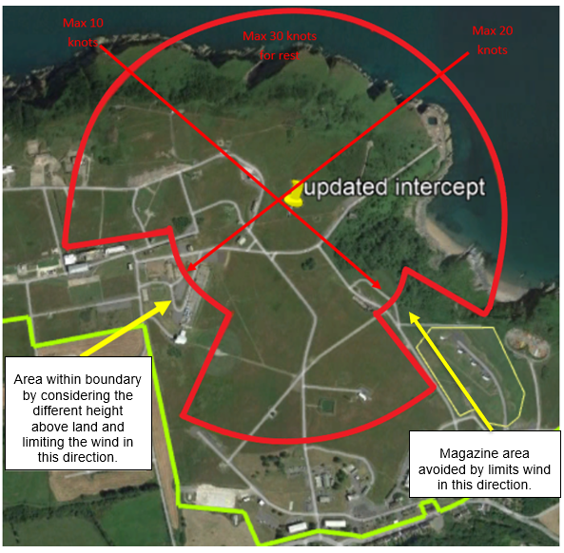
Figure 3-7- Illustration of drift distance system 3.

Results and discussion
There were a series of flights undertaken to prove the theoretical work carried out, unfortunately these flights could not be completed at Aberporth without further information firstly being gathered. This was due to further confidence in the recovery method being required before attempting the recovery at Aberporth because of the potential of it leaving the Range boundary. This meant that the test flights were conducted on two other Ranges, MOD Hebrides Range and MOD Manorbier Range to prove the theory first.
A series of ten flight log data files were extracted from each of the three systems and used to gain the test information. This data was extracted direct from the flight log and was proprietary information so it has been formatted into graphs. The required information was filtered to look only at the recovery element of the flight as well as specifically looking at the height and time information. The information required was the initial height and time the system was at when the command to deploy the parachute was carried out, until the system had landed. Once this information was gained an average of this data was taken for the ten test flights that were conducted for each of the systems. The graph depicted below in figure 4-1 shows the height against time for system one average test results.

Figure 4-1- Graph of Height against time of test results for system 1.
The calculation below in equation 4-1 looks at how long it took the system to land versus the height the system was at when parachute deploy command was sent.
$$\frac{200}{19.2}=10.4 m/s$$
Equation 4-1- Decent deceleration system 1 calculation

Equation 4-2 below shows the decent rate in meters against the speed the system was travelling at.
$$\frac{55}{10.4}=5.28 seconds$$
Equation 4-2- Time for system 1 to decelerate.
The equation below shows the forward drift distance the system has.
$$5.28*55=290.4 meters$$
Equation 4-3- System 1 drift distance
The graph below in figure 4-2 shows the average of the ten test flights results for height against time for system two.

Figure 4-2- Graph of Height against time for test results for system 2.
The equations shown below were used to calculate the drift distance of the system at two hundred meters for system two.
$$\frac{200}{18.6}=10.8 m/s$$
Equation 4-4- Decent deceleration system 2 calculation
$$\frac{55}{10.8}=5.115 seconds$$
Equation 4-5- Time for system 2 to decelerate.
$$5.115*55=281.325 meters$$
Equation 4-6- System 2 drift distance
The graph below in figure 4-3 shows the average of the ten test flights results for height against time for system three. This altitude was higher than the others due to the asset owner being unwilling to go below four hundred meters because the potential damage it could cause to the system from a hard landing.

Figure 4-3- Graph of Height against time of test results for system 3.
The equations shown below were used to calculate the drift distance of the system at four hundred meters’ altitude.
$$\frac{400}{13.6}=29.4 m/s$$
Equation 4-7- Decent deceleration system 3 calculation for 400 meters
$$\frac{61.7}{29.4}=2.0978 seconds$$
Equation 4-8- Time for system 3 to decelerate for 400 meters.
$$2.0978*61.7=129.43426 meters$$
Equation 4-9- System 3 drift distance for 400 meters
The equations below use the same data as before however they only consider the first two hundred meters of altitude.
$$\frac{200}{4.2}=47.61905 m/s$$
Equation 4-10- Decent deceleration system 3 calculation for 200 meters
$$\frac{61.7}{47.61905}=1.2957 seconds$$
Equation 4-11- Time for system 3 to decelerate for 200 meters.
$$1.2957*61.7=79.94469 meters$$
Equation 4-12- System 3 drift distance for 200 meters

The graph below in Figure 4-4 shows a comparison of each systems test results for time against height.

Figure 4-4- Graph of Height against time for the three systems test results.
Table 4-1 below shows the theoretical results that were calculated for each system against the test results that were gained. The theory results that are shown below are the minimum distance that the Range can tolerate with this distance being within the magazine area boundary.
System | Theory Results | Test results
1 | 331.5 meters | 290.4 meters
2 | 331.5 meters | 281.325 meters
3 | 272.49 meters | 79.94469 meters
Table 4-1- Theoretical and test results comparisson table
The results above show that all the test results are a smaller distance than the ones that were theoretically calculated. This means that any test flights that would have been conducted at the Range would have landed within the previously drawn safety trace.
To ensure the safety of the personnel on the Range, road closures will need to be put in place these are shown in the image below. This was done to stop personnel and vehicles accessing the danger area during recover.
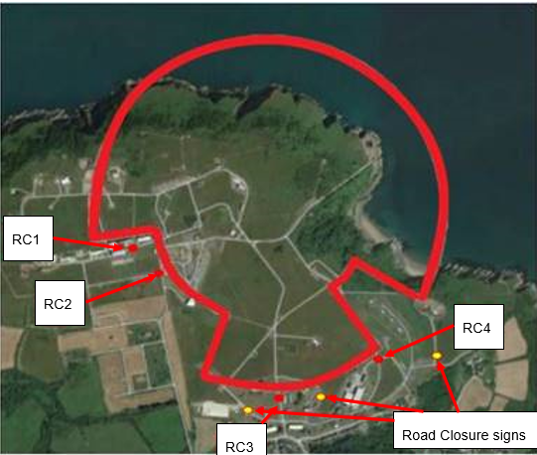
Figure 4-5- Road closures for safety trace.
While conducting research into the fitted OME for these systems a great deal of information was found which was subsequently reviewed. This information showed that given a variety of situation such as impact or fuel fire the worst-case scenario for all the fitted OME was deflagration. This meant that there was no safety issue with recovering with OME fitted, it was however deemed that there was environmental issue. This was that in the summertime the grass is often a fire hazard due to it being dry so any source that could start a fire should be avoided. It was deemed that if the OME was not used during its flight that before it comes in to recover it would be used. It was also assessed if it was tolerable to land in magazine compound and was found that there was no credible risk from this. This was due to the entrance to each storage building being facing away from the recovery direction, it was however decided that this risk would be avoided due to legislative issues so the method still has wind restrictions for magazine area in place.

Conclusion
The research question for this project was, can uncrewed aerial targets be recovered safely to land in a contained area enabling redeployment? This work has made it possible to maximize the amount of wind that can be tolerated for land recovery at Aberporth, therefore increasing the option for land recovery of the three systems. This will save a great deal of money for the company as well as reduce the burden and risk associated with recovery at sea. Another benefit is the time saving where these systems can be refuelled, serviced and made fit to fly in a short turnaround time increasing capability. This project work has also been shared with other Ranges and they are now looking at how they can improve their operations and current safety argument around land recovery.
This new method has enabled the possibility for land recovery at Aberporth, however there are limitations that are associated with this new method for land recovery. The first one is that additional information was found post the test flights, this was the system delay believed to be 3 seconds was actually 3.8 seconds due to manufacturers’ parts quality. This difference was due to the electronic components had added more delay to the system than first anticipated due to lack of component consistency. It was agreed that higher quality parts with higher integrity would be used when recovering to Aberporth, so that the system delay would remain at 3 seconds. Another limitation was the availability of land recovery was limited by wind speed blowing in certain direction for each system. There was also a requirement to have accurate and up to date weather information provided by the onsite Met Office when planning to recover, due to the wind limitations. The methods that have been used here would not be applicable to a new system, meaning more work would need to be done if new systems were to be introduced.
This piece of work has now been accepted by the range for system one and two with the safety traces shown being uploaded to the trials control system. This new recovery method was planned to be used for a trial at Aberporth, however unfortunately the navy wildcat lynx helicopter had a successful kill of the system meaning land recovery was not required. This means that the new method for system one and two has yet to be tested at Aberporth range. The project managed to theoretically calculate and prove with test results that all three systems could be recovered to Aberporth range. System three has not yet been accepted for use by the Range due to a concern around the potential for hard landing. Although the system would fall within the safety trace at the lower altitude, it goes against the manufacturers instruction. This creates a business risk to the system rather than a safety risk due to the potential to damage the system with the force of landing. This approval for use will require further work outside of the scope of this project.

Future work
There is future work that could be conducted in the area, the work conducted during this investigation can be used as a base to expand on for this future work. The first piece of future work would be to look at the landing forces involved with lower than recommended altitudes for system three. As part of this work, it would look to gain the approvals required and carry out any changes needed to make land recovery for this system possible.
Other future work would be to apply this method at different sites and apply it to new potentially different systems currently being produced. There could also be an investigation into the tolerability of including occupied buildings and the magazine area within the trace if the Range were to deem the risk acceptable. There is also the potential to look at landing beyond the fence line in the fields behind which are owned by the MOD but leased to farmers.
An area as previously discussed where future work could be carried out is into modifying these systems or designing a new system with new functionality. This could include the ability to be recovered vertically onto remote sea platform like the Space X Falcon 9. [27] or land back to a helicopter landing site on the Range.

Reflection
The project went well and the objectives previously outlined were met by improving the availability of land recovery at Aberporth Range as can be seen and discussed above. While conducting the background research a great deal was learnt about different systems, their use, history, novel solutions as well as the varying work being carried out in this field and adjacent fields. This work gave a great insight into these systems and other similar systems as well as new emerging technologies that are being developed. The skills, experience and knowledge that have been gained during this project work will be applied in the future. These will be applied to both academic studies as well as in my current role in the workplace. This work has also given me the opportunity to learn more about academic writing, academic processes, the OME industry and company corporate procedures.
This project work has been challenging as well as enjoyable to complete, the main challenge was to ensure that the spelling, punctuation and grammar throughout the report was correct. This challenge highlighted the importance of having work peer reviewed and to conduct multiple personal reviews. Another challenge was to write in such a way that it was not too technical that it could be easily understood but still have the required technical detail. This challenge however has also been enjoyable and interesting, giving the opportunity to grow professionally and personally.

References

[1] | J. B. Rico Merkert, “Managing the drone revolution: A systematic literature review into the current use of airborne drones and future strategic directions for their effective control,” Journal of Air Transport Management, vol. 89, October 2020.
[2] | J. E. D. G. M. T. C. A. O. M. G. Angela Smith, “Public acceptance of the use of drones for logistics: The state of play and moving towards more informed debate,” Technology in Society, vol. 68, February 2022.
[3] | O. B. A. C. A. T. Z. Payton Goodrich, “Placement and drone flight path mapping of agricultural soil sensors using machine learning,” Computers and Electronics in Agriculture, vol. 205, 2023.
[4] | Y. Y. A. P. C. H.-l. C. Janet Mayowa Nwaogu, “Application of drones in the architecture, engineering, and construction (AEC) industry,” Automation in Construction, vol. 150, June 2023.
[5] | L. Friese and N. J.-J. &. M. Smallwood, “Emerging unmanned threats: The use of commercially-available UAV's by armed non-state actors,” Armament Research Services Pty. Ltd., Perth, 2016.
[6] | T. B. Anna Konert, “Military autonomous drones (UAVs) - from fantasy to reality. Legal and Ethical implications.,” Transportation Research Procedia, vol. 59, pp. 292- 299, December 2021.
[7] | E. F. K. V. john Borrie, “Increasing Transparency, oversight and accountability of armed unmanned aerial vehicles,” UNIDIR resources, Geneva , 2017.
[8] | J. &. S. C. Scott, “Drone Delivery Models for Healthcare,” Proceedings of the 50th Hawaii International Conference on System Sciences, p. 8, 2017.
[9] | R. N. G. M. P. D. J. P. Stephan F, “Human drone interaction in delivery of medical supplies: A scoping review of experimental studies,” 2022.
[10] | British Aerospace systems , “T-650 Heavy Lift Electric UAS Concept Vehicle,” BAE systems, [Online]. Available: https://www.baesystems.com/en-uk/product/t-650-heavy-lift-electric-uas-concept-vehicle. [Accessed 28 January 2024].
[11] | UK civil aviatin authority , “The International Civil Aviation Organisation (ICAO) requires the UK to put a State Safety Programme in place,” The UK aviation system, [Online]. Available: https://www.caa.co.uk/safety-initiatives-and-resources/how-we-regulate/state-safety-programme/safety-policy-objectives-and-resources/the-uk-aviation-system/#:~:text=The%20CAA%20are%20also%20responsible,regulates%20and%20oversees%20military%20operations.. [Accessed 26 January 2024].
[12] | MOD, “RA 1600- Remotly piloted system manual,” MAA, no. issue 9.
[13] | MOD, “Remotly piloted air system manual- regulatory process, catogorization, and compliance,” MAA, no. initial issue.
[14] | QinetiQ, “Uncrewed aerial targets- designed to ensure operational readiness and defence against the most advanced Aerial Threats,” QinetiQ, [Online]. Available: https://www.qinetiq.com/en/what-we-do/target-systems/aerial-targets. [Accessed 24 JAnuary 2024].
[15] | Imperial War Museums, “A Brief History of Drones,” Imperial War Museums, [Online]. Available: https://www.iwm.org.uk/history/a-brief-history-of-drones#:~:text=The%20Aerial%20Target%2C%20a%20British,was%20tested%20in%20March%201917.. [Accessed 26 January 2024].
[16] | Fleet Air Arm Association of Australia, “GAF JINDIVIK PILOTLESS TARGET AIRCRAFT,” Fleet Air Arm Association of Australia, [Online]. Available: https://www.faaaa.asn.au/heritage/our-heritage-pilotless-target-aircraft/our-heritage-unmanned-target-aircraft/. [Accessed 12 November 2023].
[17] | S. S. Englund, “GAF Jindivik Mk 303A,” imodeler.com, [Online]. Available: https://imodeler.com/2017/04/gaf-jindivik-mk-303a/. [Accessed 26 November 2023].
[18] | D. D. Sloggett, Drone Warfare- The development of unmanned aerial conflict, Barnsley : Pen and sword aviation , 2014.
[19] | March field air museum , “https://www.marchfield.org/aircraft/fighter/f-86h-sabre-north-american/,” March field air museum , 2023. [Online]. Available: https://www.marchfield.org/aircraft/fighter/f-86h-sabre-north-american/. [Accessed 26 January 2024].
[20] | G. Molinelli, “UK armed forces commentry,” Combined Aerial Target Service (CATS)- Mirach 100/5 , [Online]. Available: https://ukarmedforcescommentary.blogspot.com/p/combined-aerial-target-service-cats.html. [Accessed 20 November 2023].
[21] | Kratos , “Recovery Systems,” Kratos , [Online]. Available: https://www.kratosdefense.com/systems-and-platforms/unmanned-systems/aerial/aerial-targets. [Accessed 18 November 2023].
[22] | J. Sutherland, “Hebrides methodology- Construction of recovery trace in support of CATS operations,” QinetiQ, 2017.
[23] | E. Muirhead, “Manorbier Methodology- Launch, Recovery and general flying trip wires,” QinetiQ, 2020.
[24] | e. a. Ramesh Kumar, “Parachute deployment system for safe recovery of a drone,” Materials Today: Proceedings, April 2023.
[25] | L. P. Preema Paul, “An overview on the parachute recovery systems with additive manufacturing for UAV safe landing,” Materials Today: Proceedings, vol. 72, no. 6, pp. 3158-3162, January 2023.
[26] | Space X, “Falcon 9- First orbital class rocket capable of reflight,” Space X, [Online]. Available: https://www.spacex.com/vehicles/falcon-9/. [Accessed 26 January 2024].
[27] | J. Mckinney and C. Lowry, “Mars Precision Landing Using Guided Parachutes,” American institute of aeronautics and astronautics, 2012.
[28] | Rocket Lab, “Rocket Lab to Attempt First Mid-Air Helicopter Capture of the Electron Rocket During Next Mission,” Rocket LAb, [Online]. Available: https://www.rocketlabusa.com/updates/rocket-lab-to-attempt-first-mid-air-helicopter-capture-of-the-electron-rocket-during-next-mission/. [Accessed 024 January 2024].
[29] | R. p. Agarwal, “Pythagorean theorem before and after Pythagoras,” Advanced Studies in Contemporary Mathematics, vol. 30, no. 3, pp. 357- 389, 24 June 2020.

Appendix- Ethical approval letter
Shown below in figure 2 was the OME ethical approval letter.
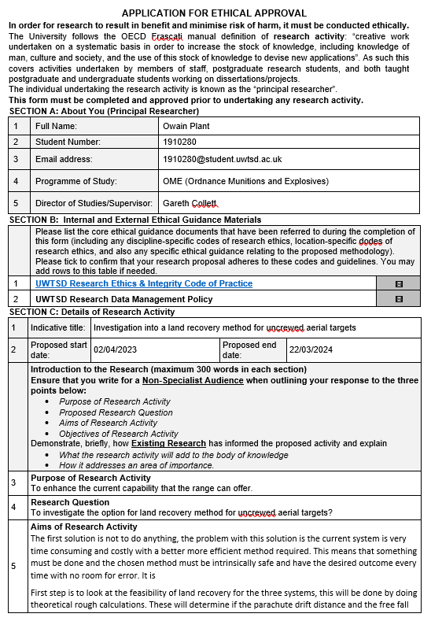
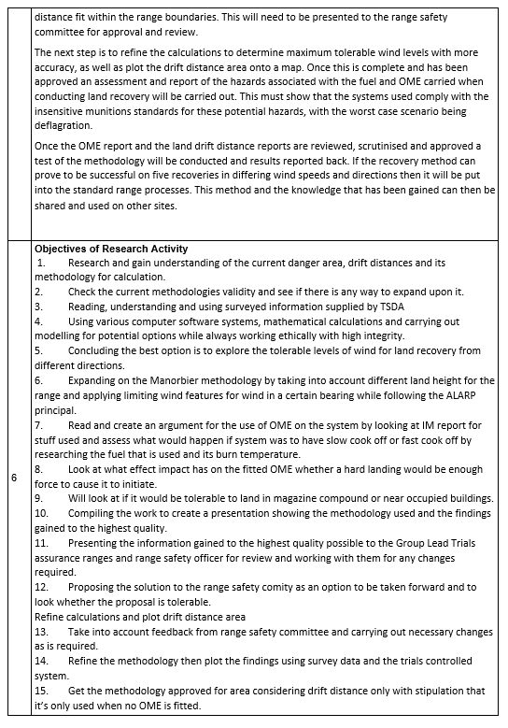
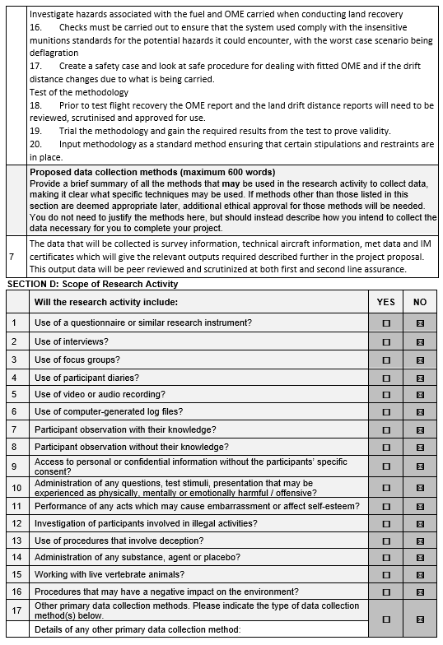

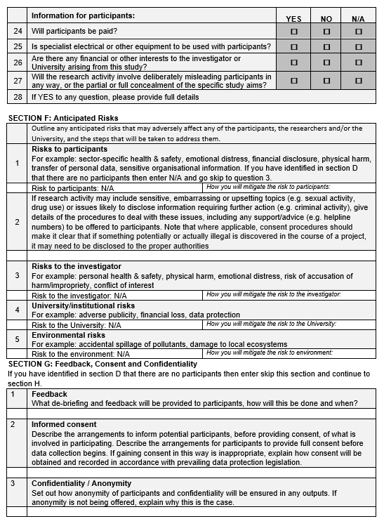

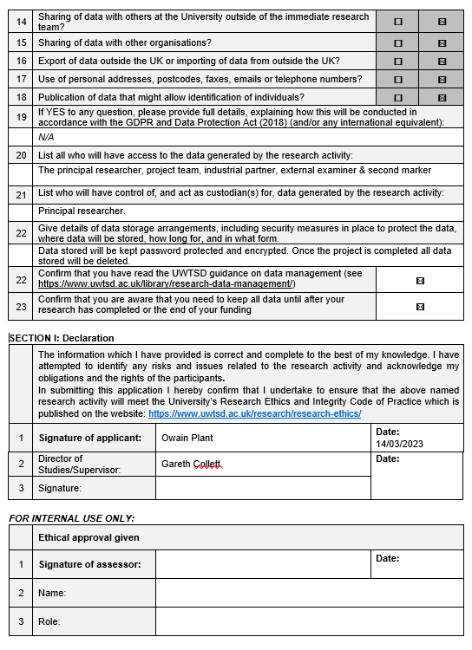
Figure 7-1 - Ethical approval letter.

