Report for Data Handling and Business Intelligence Assignment 2 2019 – Evaluating the Strengths of using Excel for Data Handling, alongside WEKA as a Tool for Data Mining



MAY 2019

MODULE NAME: data handling and business intelligence (M5X00842)
Project Name: MICROsoft Excel and WEKA
Name: Sam thomas
Student Number: 1706610

Table of Contents

1. eXECUTIVE sUMMARY 1
2. Introduction 2
2.1 Report Remit 2
2.2 Strengths and weaknesses of excel ………………………………………………….…………….2
2.3 Data Mining using WEKA 7
2.4 Prediction 10
2.5 Association 10
2.6 Clustering 11
2.7 Conclusion…………………………………………………………………………………………………………………11
3. References 13

List of Figures

LIST OF TABLES

APPENDICES

eXECUTIVE sUMMARY

During this report, the main aim I want to accomplish is to help Sarn Helen Office Supplies. I will look at all of the pros and cons of using Microsoft Excel and try to give the pros and cons as well as my opinion as to whether or not the programme would bring success and help resolve the profitability issue.
Once I have evaluated this programme, I will talk about WEKA, also touching upon the positives and negatives of the programme, including the price of installation, the detailed data mining tools and the potential difficulty with integrating it.
I will also include screenshots showing usage on both WEKA and Microsoft Excel with a brief description on what is happening in each photo.
After this, I will discuss the three main areas of WEKA, which are Prediction, Association and Clustering. I will talk about the benefit this would bring to the company and how they could utilise the tools.
To conclude the report, I will then give my own personal opinion on how I believe Microsoft Excel and WEKA can benefit a business such as Sarn Helen, after assessing all pros and cons I will determine whether I believe it to be of worth to a company to implement the programme. Determining risk vs reward I will then conclude by talking about the impact on overall profitability.

Introduction

For this assignment, I have been tasked as a data analytics assistant who is responsible for looking at large quantities of data and assessing how to use the information. As a data analysist, many tools are used such as WEKA and Microsoft Excel, both these programmes come with positives and negatives that I will look at.

REPOrt remit
I have been approached by Sarn Helen Office Supplies who are concerned over a reduction in profits since 2017. With little understanding as to why, they have asked us to analyse the data, using both Microsoft Excel and WEKA. I will also look to give the company recommendations as how to better engage with the company’s data in the future, giving both pros and cons of implementing the strategies. I will also take in to account the cost of using a software like WEKA on such a large scale and whether it is worth paying for it.

STRENGTHS AND WEAKNESSES OF EXCEL
One of the main tools used in organising and analysing data is Microsoft Excel. “Microsoft Excel is a spreadsheet developed by Microsoft for Windows, macOS, Android and iOS. It features calculation, graphing tools, pivot tables, and a macro programming language called Visual Basic for Applications.” It was first released in 1987 but has had multiple updates and new versions up until present day. It is one of the most commonly used tools for basic data analysis, due to its basic features. Despite this, Excel does also have more complicated tools for complex data sets. Excel is a part of a package developed by Microsoft which includes other software’s such as Publisher, Word and PowerPoint. There are many strengths regarding Excel that make it a good tool for analysing and pre-processing data as well as visualising it. One way in which Excel increases efficiency is by the ease of comparisons that can be made from spreadsheet to spreadsheet. “With the powerful analytical tools included within Microsoft Excel you have the ability to analyse large amounts of data to discover trends and patterns that will influence decisions. Microsoft Excel’s graphing capabilities allows you to summarize your data enhancing your ability to organize and structure your data.” This would allow businesses such as Sarn Helen Office Supplies to quickly and efficiently look at data that is related to their business, allowing them to spend less time looking at large quantities of data as Excel organises it for ease. They could then compare this data such as profit and expenditure, against previous years dating back to the decrease in profits in 2017 in order to see if there has been a change. It can also allow them to breakdown the data more finely to see exactly what is setting their profits back. Another benefit of Excel is that the ‘Excel Web App’ allows the spreadsheets to be shared across the company online from employee to employee. This allows employees who have access to the spreadsheets to formulate ideas better in brainstorming format across the whole company. This would be likely to improve output as one employee may have an idea that somebody alone may not have been able to come up with. Another key advantage of Microsoft Excel is the list of simple enough formulas which can simplify very complex sets of data. “It performs all mathematical and logical functions like addition, subtraction, multiplication, division, average, etc. It provides many formulas that help you to solve both simple and complex calculations.”- NIDHI HURIA, M.C.A Computer Science, Gurukul Kangri University (2013). Simplifying the data in this way makes it attractive to companies to adopt as it will be relatively simple to train their staff to use regularly. Finally, Microsoft Excel files can be saved with individual passwords in order to protect what may be important company data, especially that which involves financial data.
However, despite all of the clear benefits that Excel brings, there are also negatives that have to be considered when deciding on whether it is beneficial to the company. Firstly, some businesses have experienced problems with the programme in terms of its speed, especially when dealing with large sets of data. “When a data file is too large, it can make the Excel program run very slowly, especially if all the data is in one file. Trying to break the data down into smaller files can lead to some of it being lost or misplaced”. This is not good or a business such as Sarn Helen who are trying to improve profits, as it could reduce efficiency within the company and lead to an even greater dip in profits. Excel is also criticised for the fact it is a standalone programme and has no links to any other business programmes, so data is not able to be easily transferred for the company’s ease. Another key weakness of Excel is that it is very susceptible to human error. “On average, a spreadsheet will contain 1 error for every 20 cells that have data.” Although it may seem trivial over a few small errors, a tiny mistake at any point in the spreadsheet could decrease accuracy across the whole piece of work. For a spreadsheet that is concerned with the profit and loss of a company such as Sarn Helen, it is a big risk to gamble on human errors such as this as a small change in a figure could lead to a huge difference to an end sum such as expected profit or loss for a time period. This misinformation could lead to Sarn Helen making an ill-informed business decision. For example, if the spreadsheet falsely shows that profits are going up, they may invest heavier in to stock, which would lead to a long term loss of money and too much unsold stock that could very badly affect the financial state of the company. Also, another disadvantage is that gaining a deeper learning of Excel could be seen as very complicated. Although on the other side, it could be seen as an advantage that Excel has a wide variety of features, in the short term it may be hard to train staff on how to use it. “Advanced features like error checking, cell formatting, macros and workbook sharing take time to master.” In the long term, understanding these techniques would greatly help a business such as Sarn Helen. However, it is then a case of whether the company has the resources in terms of time to train the staff until they are completely integrated in to the system. They would also need to be prepared for staff to make errors in the short term when inputting data. The final main drawback of using Microsoft Excel is the cost. “The latest version of Microsoft Excel costs around $109 or $229 from Microsoft, depending on whether you buy an upgrade for a previous version, which is the cheaper option, or the full latest version.” For a large scale business, that is not an extreme amount, especially given that Excel can also be bought as a package with other Microsoft programmes. Microsoft Excel may also be bought at a discounted rate in bulk for business use on multiple devices. Despite this, at an average cost of $150 per subscription, this cost could be a problem for a business such as Sarn Helen, especially with a range of free or cheaper alternatives. Three key features of Excel are the ‘IF’ function, Pivot Tables and Look Up. Below are examples of the three.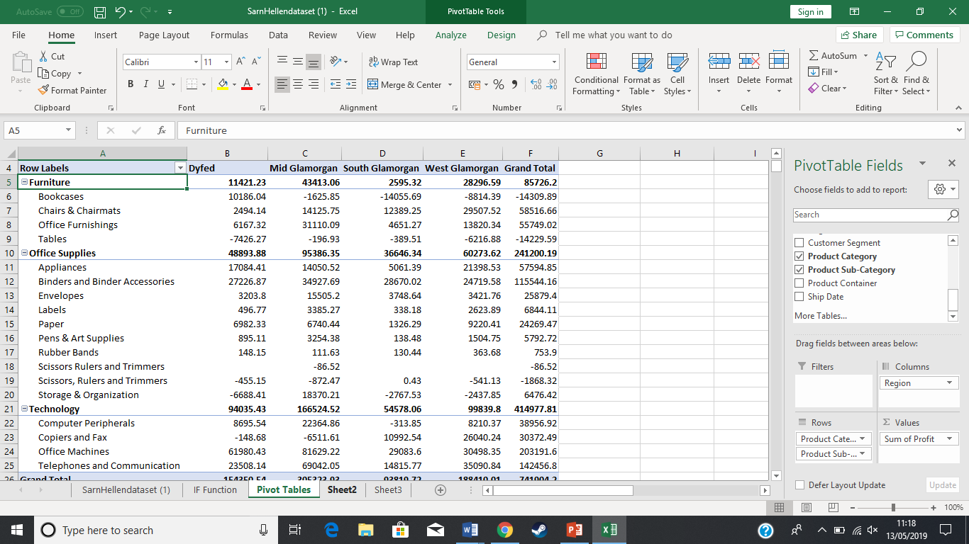Picture 1= Pivot Table showing Profit, Region, Category and Sub Category.
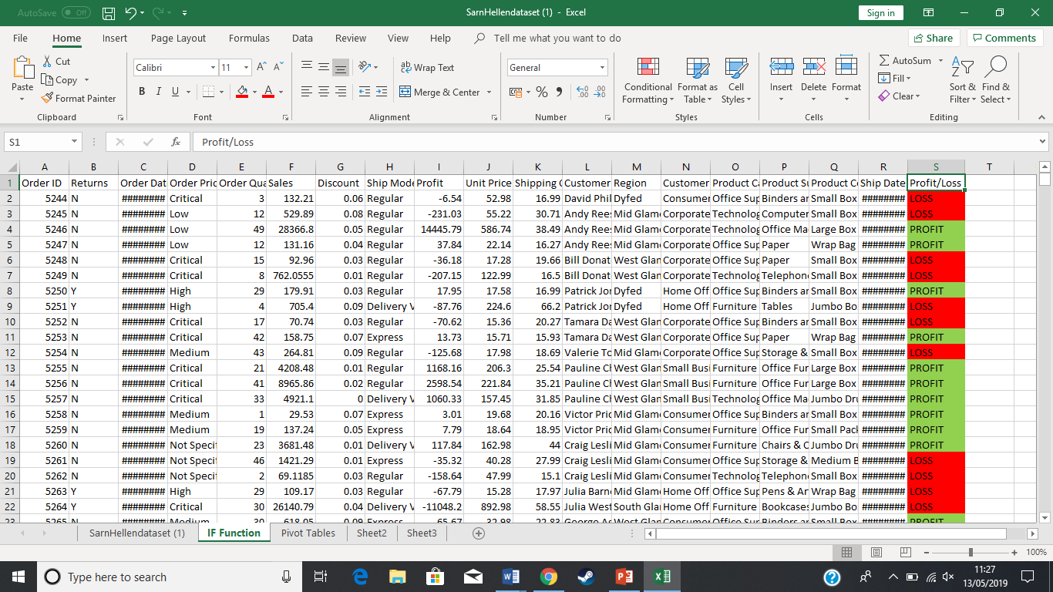The second photo shows how Profit and Loss can be worked out using the IF Function.

DATA MINING USING WEKA
Another tool that is used for data mining in a more sophisticated way is a programme called WEKA. “Waikato Environment for Knowledge Analysis (Weka) is a suite of machine learning software written in Java, developed at the University of Waikato, New Zealand. It is free software licensed under the GNU General Public License.” WEKA is another programme that is widely used by businesses for analysing data. It has three main features of how the data is handled, under the names Prediction, Association and Clustering which will be discussed later. “Weka contains a collection of visualization tools and algorithms for data analysis and predictive modelling, together with graphical user interfaces for easy access to these functions”. Although it is widely acclaimed for its usefulness in business, it also does have its drawbacks.
One positive of WEKA is the price. In fact, the lack of price, WEKA is completely free to download and install on any device for business and personal use. It is ideal for businesses as it gives very detailed information for handling data, meaning many businesses would consider it essential as it organises all of your data without having to pay a fee. Another advantage of WEKA is that it can reduce the likelihood of human error. “may assist company entrepreneurs improve their earnings and steer clear of generating company mistakes down the line.” In relation to the drawbacks surrounding Microsoft Excel, one of the main problems was human error when inputting data to the spreadsheets. By using WEKA, this could decrease the likelihood of error, as all of the pre-processing data would be run through the programme and any errors would likely be cut out. Finally, the sophisticated software could help to improve business performance once the system is fully integrated.
However, this software also comes with negatives. One of the main drawbacks of WEKA is that it is a very complex system that takes time and a lot of practice to figure out. Although beneficial long term, it could be said that trying to implement it could negatively effect staff as it is very hard to work with. Below are some images of WEKA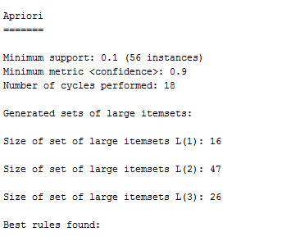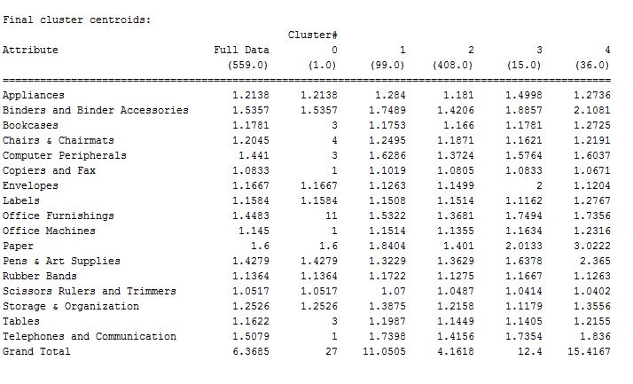
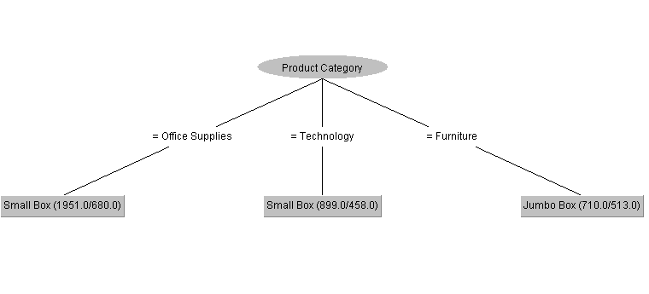
Although what is shown above can be very useful to companies, it takes a lot of time and effort to get to that stage, especially for new users who are trying to get to grips with the software. With little support provided by WEKA themselves on how to use the functions, it could be considered too strenuous to implement across the whole of a company, especially if people working for that company do not react well to change or are not open to learn.

PREDiction
As spoken about previously, there are three main ways in which data is handled within WEKA, the first of which being prediction. Prediction, also known as classification, is a very useful tool from WEKA. A strict business definition is as follows; “The act of predicting business activity for a future period of time. Typically, it is a projection based upon specific assumptions, such as targeted prospects or a defined sales strategy. For example, a sales pro forma in a business plan is considered a forecast.” This relates to prediction in WEKA, however in WEKA it relates to learning from past data in order to classify new data. Two common ways in which classification takes place is decision tree analysis and statistical analysis. This feature takes the guesswork out of business planning, as although the numbers won’t be certain, you get a far clearer and detailed look at the likely figures you can expect in the next financial term. Prediction or classification is one of the most commonly used features when talking about Data Mining.

Association
The second feature is association. Association is another well used feature for Data Mining and can be very useful to businesses. It is also known as ‘Market Basket Analysis’ and is used to find relationships between two or more common variables. This Is shown on WEKA and can help companies to see clearly what relationships are apparent in their business, for example two variables they may think have no correlation could turn out to be having either a positive or a negative affect on overall profit. By using this in Weka, it allows businesses to either stop the relationship, or take greater advantage of it to increase business performance. Association also comes with rules. “Association rule learners find associations between attributes. Between any attributes: there’s no particular class attribute. Rules can predict any attribute, or indeed any combination of attributes.” By getting to grips on how to effectively use this technique, it could benefit a business in the long term.

clustering
The final feature is called clustering. Clustering is used to automatically identify group items together. For example, it uses past data in order to assign groups for new data that is going to be used, this can also be called segmentation. It can segment groups in to things such as geographical location, age and more. Doing it like this can reduce the complexity of the data and make it easier to work along side other methods of data mining.

Conclusion
In conclusion, I would recommend that Sarn Helen Data Supplies implement both WEKA and Microsoft Excel to their company, as despite the drawbacks, the long term benefits will bring greater efficiency to the company when handling data alongside a greater knowledge of modern business practice. This will all inevitably lead to a greater profitability in the long term.

References
- “Microsoft Excel is a spreadsheet developed by Microsoft for Windows, macOS, Android and iOS. It features calculation, graphing tools, pivot tables, and a macro programming language called Visual Basic for Applications.” Available from: https://en.wikipedia.org/wiki/Microsoft_Excel (Accessed on 7th May 2019)
- “With the powerful analytical tools included within Microsoft Excel you have the ability to analyse large amounts of data to discover trends and patterns that will influence decisions. Microsoft Excel’s graphing capabilities allows you to summarize your data enhancing your ability to organize and structure your data.”-TurboFuture. Available from: https://turbofuture.com/computers/Advantages-of-Microsoft-Excel (Accessed on 7th May 2019)
- “It performs all mathematical and logical functions like addition, subtraction, multiplication, division, average, etc. It provides many formulas that help you to solve both simple and complex calculations.”- NIDHI HURIA, M.C.A Computer Science, Gurukul Kangri University (2013). Available from: https://www.quora.com/What-are-the-advantages-of-Microsoft-Excel (Accessed on 7th May 2019).
- “When a data file is too large, it can make the Excel program run very slowly, especially if all the data is in one file. Trying to break the data down into smaller files can lead to some of it being lost or misplaced”. Available from: https://blog.blackcurve.com/11-disadvantages-of-using-excel-to-manage-your-pricing (Accessed on 8th May 2019).
- “On average, a spreadsheet will contain 1 error for every 20 cells that have data.” Available from: https://blog.blackcurve.com/11-disadvantages-of-using-excel-to-manage-your-pricing (Accessed on 8th May 2019).
- “Advanced features like error checking, cell formatting, macros and workbook sharing take time to master.” Available from: https://www.techwalla.com/articles/disadvantages-of-using-microsoft-excel (Accessed on 8th May 2019).
- “The latest version of Microsoft Excel costs around $109 or $229 from Microsoft, depending on whether you buy an upgrade for a previous version, which is the cheaper option, or the full latest version.” Available from: https://www.techwalla.com/articles/disadvantages-of-using-microsoft-excel (Accessed on 8th May 2019).
- “Waikato Environment for Knowledge Analysis (Weka) is a suite of machine learning software written in Java, developed at the University of Waikato, New Zealand. It is free software licensed under the GNU General Public License.”-Wikipedia. Available from: https://en.wikipedia.org/wiki/Weka_(machine_learning) (Accessed on 8th May 2019).
- “Weka contains a collection of visualization tools and algorithms for data analysis and predictive modelling, together with graphical user interfaces for easy access to these functions”. Available from: Ian H. Witten; Eibe Frank; Mark A. Hall (2011). "Data Mining: Practical machine learning tools and techniques, 3rd Edition". Morgan Kaufmann, San Francisco. Retrieved 2011-01-19. (Accessed on 8th May 2019).
- “may assist company entrepreneurs improve their earnings and steer clear of generating company mistakes down the line.” Available from: http://www.emanio.com/data-mining/Weka-Data-Mining.html (Accessed on 8th May 2019).
- “The act of predicting business activity for a future period of time. Typically, it is a projection based upon specific assumptions, such as targeted prospects or a defined sales strategy. For example, a sales pro forma in a business plan is considered a forecast.”-Business Dictionary. Available from: http://www.businessdictionary.com/definition/forecast.html (Accessed on 9th May 2019).
- Data Handling and Business Intelligence PowerPoint.

“Microsoft Excel is a spreadsheet developed by Microsoft for Windows, macOS, Android and iOS. It features calculation, graphing tools, pivot tables, and a macro programming language called Visual Basic for Applications.” Available from: https://en.wikipedia.org/wiki/Microsoft_Excel (Accessed on 7th May 2019)
“With the powerful analytical tools included within Microsoft Excel you have the ability to analyse large amounts of data to discover trends and patterns that will influence decisions. Microsoft Excel’s graphing capabilities allows you to summarize your data enhancing your ability to organize and structure your data.”-TurboFuture. Available from: https://turbofuture.com/computers/Advantages-of-Microsoft-Excel (Accessed on 7th May 2019)
“It performs all mathematical and logical functions like addition, subtraction, multiplication, division, average, etc. It provides many formulas that help you to solve both simple and complex calculations.”- NIDHI HURIA, M.C.A Computer Science, Gurukul Kangri University (2013). Available from: https://www.quora.com/What-are-the-advantages-of-Microsoft-Excel (Accessed on 7th May 2019).
“When a data file is too large, it can make the Excel program run very slowly, especially if all the data is in one file. Trying to break the data down into smaller files can lead to some of it being lost or misplaced”. Available from: https://blog.blackcurve.com/11-disadvantages-of-using-excel-to-manage-your-pricing (Accessed on 8th May 2019).
“On average, a spreadsheet will contain 1 error for every 20 cells that have data.” Available from: https://blog.blackcurve.com/11-disadvantages-of-using-excel-to-manage-your-pricing (Accessed on 8th May 2019).
“Advanced features like error checking, cell formatting, macros and workbook sharing take time to master.” Available from: https://www.techwalla.com/articles/disadvantages-of-using-microsoft-excel (Accessed on 8th May 2019).
“The latest version of Microsoft Excel costs around $109 or $229 from Microsoft, depending on whether you buy an upgrade for a previous version, which is the cheaper option, or the full latest version.” Available from: https://www.techwalla.com/articles/disadvantages-of-using-microsoft-excel (Accessed on 8th May 2019).
“Waikato Environment for Knowledge Analysis (Weka) is a suite of machine learning software written in Java, developed at the University of Waikato, New Zealand. It is free software licensed under the GNU General Public License.”-Wikipedia. Available from: https://en.wikipedia.org/wiki/Weka_(machine_learning) (Accessed on 8th May 2019).
“Weka contains a collection of visualization tools and algorithms for data analysis and predictive modelling, together with graphical user interfaces for easy access to these functions”. Available from: Ian H. Witten; Eibe Frank; Mark A. Hall (2011). "Data Mining: Practical machine learning tools and techniques, 3rd Edition". Morgan Kaufmann, San Francisco. Retrieved 2011-01-19. (Accessed on 8th May 2019).
“may assist company entrepreneurs improve their earnings and steer clear of generating company mistakes down the line.” Available from: http://www.emanio.com/data-mining/Weka-Data-Mining.html (Accessed on 8th May 2019).
“The act of predicting business activity for a future period of time. Typically, it is a projection based upon specific assumptions, such as targeted prospects or a defined sales strategy. For example, a sales pro forma in a business plan is considered a forecast.”-Business Dictionary. Available from: http://www.businessdictionary.com/definition/forecast.html (Accessed on 9th May 2019).

