NAME: Prasanna Dhakal
STUDENT NUMBER:2131567
MODULE: LCMB7003
LECTURER: Charles Oham
COURSE: Master’s in business administration
SUBMISSION DATE:13/01/2023
TITLE: Strategic management on Netflix

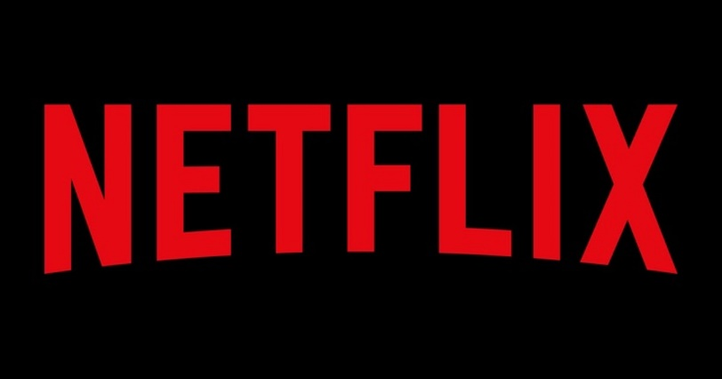
TABLE OF CONTENTS

1) Executive summary 5
2) Introduction 7
2.1) Objectives of study 7
2.2) Strategic Management Framework for Netflix 8
2.3) Netflix business model & design 8
2.4) Netflix's Generic Competitive Strategy 9
2.5) Netflix's Intensive Growth Strategy 9
3) SWOT analysis on Netflix 10
3.1) Netflix's strengths -Internal strategic factor 11
3.2) Netflix's Weakness-Internal strategic factor 12
3.3) Netflix's Opportunities-External strategic factor 14
3.4) Netflix's Threat-External strategic factor 15
4) Pestle analysis of Netflix 17
4.1) Political factors 17
4.2) Economic factors 18
4.3) Social factors 18
4.4) Technological factors 19
4.5) Legal factors 19
4.6) Environmental factor 20
5) Netflix Porter's five forces analysis 21
5.1) Competition in the Industry 22
5.2) The threat of new entrants 22
5.3) The bargaining power of suppliers 23
5.4) The bargaining power of customers 24
5.5) Threat of substitute products or services 25
6) Framework diagram of Netflix 26
7) Recommendation 27
8) Conclusion 27
9) References 29

Executive Summary
The American media and entertainment corporation Netflix specializes in and offers online streaming media, video-on-demand, and the distribution of DVDs. When Netflix announced a price increase for subscriptions a few years ago, customers were furious. Netflix has implemented a price increase of sixty percent for their DVD rental and streaming plan. Customers will be required to pay an additional $6 per month to continue receiving the same level of service they have previously. They went from a plan that cost $8 per month and included an add-on that cost $2 per month for unlimited DVD rentals to $16 per month and did not include any add-ons. The viewers of Netflix have a lot of criticism for the firm because of this decision. The degree to which individuals are dissatisfied with the price increase is illustrated by tweets such as "Dear Netflix, you made a poor business decision to increase the prices." Customers have threatened to terminate their memberships and stop making payments if action is not taken to resolve the issue. When a business finds out that a decision has upset some of its most devoted clients, the first thing it will do is nearly always issue a statement or an apology. In the end, Netflix decided not to forward with this. They did not apologize for the significant price increase; instead, they issued a statement detailing the financial benefits they were achieving as a result of raising their rates. It was reported that the corporation was able to boost pricing and gain more income due to demand higher than projected for DVDs and plans that only included DVDs. It would have been best for Netflix to take advantage of this chance to win back some of the viewers who were previously unhappy with the service. Readers were already angry, and their accusation did nothing but inflame the situation further. As a result of an error made by Netflix, more than 800,000 users had their memberships terminated without being prompted. A corporation should decide on a pricing target before settling on a new pricing strategy, then analyze demand, estimate expenses, compare those estimates to those of competitors, choose a pricing model, and lastly, decide on a price. If the corporation was going to significantly raise prices without providing prior warning, it needed to offer more value for the product it was selling. In this report, swot analysis, pestle analysis and porter five analysis is critically discussed. Conclusively, it is determined in this study that many other companies look to Netflix as an inspiration and model. Everything from the product to the business strategy to the branding to the website itself is top-notch. Those with an interest in marketing, whether as a hobby or a career, analyzing a lot from Netflix's strategy.
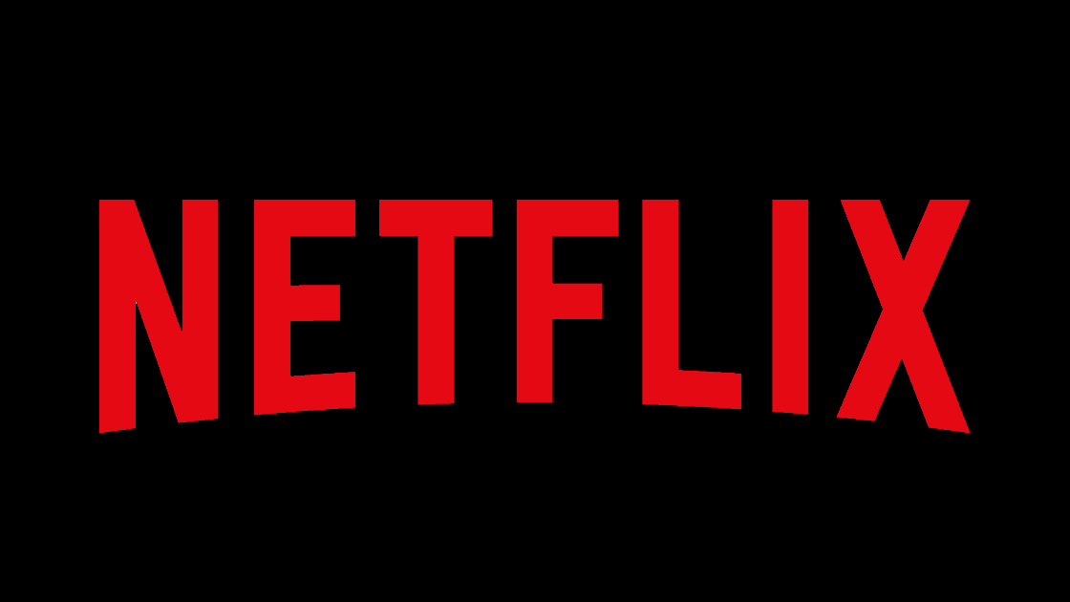
https://images.app.goo.gl/2jGXSvdkfyBEw1qb6

Introduction

2.1) Objectives of study:
The objective of developing a marketing plan of Netflix is to map out the steps that need to be taken in order to boost consumer acquisition, brand awareness, sales, and repeat business. The corporate world uses Netflix as both a model and a paradigm to look up to and model themselves after. They have done an excellent job in terms of the product, the business strategy, the branding, and the overall content. The manner in which Netflix approaches marketing is one from which students of marketing and marketing fans may gain a great deal of insight. Netflix has created a marketing strategy that is a model of integration with their approach. It is successful as a result of being unified, flexible, and user-centered all at the same time. If you want to have a relaxing experience with Netflix, you'll quickly realize that the company prioritizes their customers above everything else. Utilizing the integrated marketing features of your platform is highly recommended if you want to get the most out of the targeting capabilities of your platform as well as the use of content marketing for data analytics. Netflix places a high value on developing a trustworthy relationship with its users by offering individualized suggestions and other features that are uniquely tailored to each user. They additionally implement innovative advertising techniques in order to entice new viewers (González et al., 2020).
Combined viewing enjoyment requires an up-to-date presentation that is maintained consistently across a variety of platforms and devices. Data analytics is an essential tool for innovative marketers, as they allow them to develop solutions that customers would adore (Lobato and Lotz, 2020). Netflix is able to utilize data analytics to recommend episodes and movies to its subscribers because it maintains a large database of information on the watching habits of its customers. To give you an example, Netflix will recommend more sports documentaries to users who enjoy Rocky. If you want to be a great business manager, you need to incorporate data analytics into your marketing plans as well as the strategies you use to optimize your website (Kumar et al., 2020).
Netflix, Inc. is a creative organization and beyond ludicrous real-time features that capabilities in light of a participation plan of action. The organization is settled in Los Gatos, California. Netflix, laid out in 1997 in Scotts Valley, California, by Reed Hastings and Marc Randolph, furnishes clients with a library of motion pictures and network shows accessible through dispersion arrangements, notwithstanding the organization's works, which are alluded to as Netflix Firsts. Netflix has 222 million individuals all around the world as of September 2022. You will not have the option to get it in the central area of China, Syria, North Korea, or Russia, yet you can get it wherever else. Netflix is a functioning individual from the Movie Affiliation and has been a significant player in the appropriation of autonomous movies (MPA). Gadgets that can get to Netflix incorporate brilliant televisions and set-top boxes. Shrewd televisions likewise include TVs that are furnished with a web network. Web programs and downloadable application programming make Netflix available on the previously mentioned electronic gadgets (Pérez, 2020).
2.2) Strategic Management Framework for Netflix
2.3) Netflix’s Business Model & Design
Netflix's business model combines several different ideas. The company's operations involve both on-demand video distribution and the creation of new series, movies, and other media. According to Netflix's generic competitive advantage approach, these business models analyze Netflix's value chain and competitive advantages using the VRIN/VRIO framework. The organization exemplifies how online business modelling supports large-scale, low-cost, and efficient operations (González et al., 2020). It includes:
- Media pipeline and platform (entertainment content production, etc.)
- Innovative concepts
- A business model without middlemen (production to distribution)
Unlimited subscription model (revenue model for unlimited online access)
2.4) Netflix’s Generic Competitive Strategy
The entire strategy of Netflix, which makes use of the company's significant competitive advantages, contributes to the sustainability of the business model used by Netflix. The company's business model and its location in the competitive landscape help to reduce the adverse effects of external factors such as Walmart, Amazon, Google, Apple, and Disney. Despite the existence of these competitors, Netflix is nevertheless able to achieve success thanks to its ambitious expansion ambitions. When these expansion plans are aligned with the overall strategy and business model, it ensures that operational efficiency will be maximized and that the organization will reap the benefits of its competitive advantages (Pérez, 2020). It includes:
- Cost Leadership
- Differentiation

2.5) Netflix’s Intensive Growth Strategies
It's how Netflix grows its business and market share. The Ansoff Matrix suggests expanding the Internet provider's streaming offering in its current markets to grow its business. Netflix's ability to retain and recruit users in existing markets is key to its growth plan, which strives to increase revenues and market share. External and internal strategic settings influence the internet company model, which implements generic and intensive growth plans. Netflix Inc. uses the "4Ps" marketing mix to grow its user base. This aggressive expansion also helps the corporation enter the extremely competitive digital content streaming industry. Netflix Inc. completed a SWOT analysis to effectively compete in the market (Fernández Gómez and Martín Quevedo, 2018). It includes:
- Market Penetration
- Market Development
- Product Development

SWOT Analysis of Netflix
The growth of Netflix over the years has been spectacular, and the firm now serves 222 million subscribers in 190 countries worldwide. There are paying members for this online entertainment service in over 190 countries, making it one of the most popular services of its kind. An estimated seventy percent of Netflix users will watch a whole season of a show all at once. This includes both television shows and movies, documentaries, and full-length features, all of which may be found in various genres and can be spoken in a few different languages. Reed Hastings and Marc Randolph launched Netflix in 1997 and are the company's founders. After delivering DVD rentals and sales by mail order for one year, the business transitioned to an online-only strategy. Netflix began offering customers the option to view movies and television series online in 2007, eliminating the need for customers to wait for DVDs to come in the mail before watching their favorite shows and movies. In 2010, it may become possible to stream material online across international boundaries for the first time. The increase in revenue that Netflix has seen so far this year may be mainly ascribed to the fact that the firm is increasing its presence worldwide (Fernández Gómez and Martín Quevedo, 2018).
The SWOT analysis
3.1) Netflix’s Strengths – Internal Strategic Factors
1.Exponential Growth- Netflix has arisen as a dominant power on the lookout for online video web-based during the decade in the US and the rest of the world.
2. Brand Reputation – Regardless of how it has been around for an exceptionally brief time frame, Netflix has proactively turned into a commonly recognized name. As per Interbrand, Netflix will have a brand worth $15 billion in 2021, putting it in position.
3. Global Customer Base – Netflix has clients in more than 190 nations, and the organization assists those clients. Since it has over 167 million clients, Netflix conveys a lot of weight in converses with Hollywood studios for the privilege of creating its unique substance.
4. Originality – Netflix's ability to consistently produce original material of the highest quality over its existence is another of the company's numerous strengths. Tiger King and Stranger are only two of the many shows it broadcasts on its channel (Mier and Kohli, 2021).
5. Adaptability – Netflix quickly adapted to changing consumer preferences by making its content available for streaming on all internet-enabled devices, including computers, tablets, smartphones, and even televisions. This included making its content available for streaming on all of Netflix's original programming. As a result, they were able to watch their company experience phenomenal growth over time.
6. Customer–Centric Service – Users of Netflix, have been looking for quite some time for an offline viewing option that they can utilize if they are traveling (on an airplane or in the metro) or if they have a shaky data connection. In retaliation, Netflix introduced the capability to download shows in advance (for offline viewing) (Fernández Gómez and Martín Quevedo, 2018).
7. Affordable Pricing – Netflix's pricing policy has reduced the pace of the competition. The various plan options that Netflix provides provide excellent value for the money. Customers can view as many movies as they like each month for a minimal fee of $8.99, which allows them to stream movies online or watch movies on DVD. It offers a more excellent range of films at more affordable pricing than cable television and movie theatres combined. Streaming in Ultra HD (4K+HDR) is also accessible to subscribers on premium plans for an extra $15.99 per month.
3.2) Netflix’s Weaknesses – Internal Strategic Factors
1. Limited Copyrights – A risk for the corporation is posed by the fact that Netflix does not own the content it distributes. The licenses obtained from various other production businesses will, in due time, expire, and the content will then be available on many other websites (González et al., 2020).
2. Increasing Debt – Most countries worldwide now have access to Netflix's extensive library of high-priced content. Netflix is constantly accruing additional debt to finance the production of new programming. A significant problem is a fact that the debt keeps growing from year to year.
3. Lack of Green Initiatives – Neither a business plan to promote environmental sustainability nor an initiative to increase the company's use of renewable energy has been put into action by Netflix as of yet. The four largest internet companies have publicly intended to run their businesses entirely on green energy. The fact that Netflix does not use renewable energy is detrimental to the company's reputation.
4. Rigid Pricing – The market is begging for more individualized price structures and a broader range of product options. Regrettably, Netflix only offers three tiers of service, Basic, Standard, and Premium, for its customers to choose from when it comes to cost. It has been hypothesized that the absence of appealing alternatives is the cause of the reduction in new members, and this view has some support (Pérez, 2020).
5. Over-dependence on North America Market – Despite having a presence in several countries worldwide, Netflix's primary concentration is on the North American market. The United States and Canada contributed revenue equal to over ten billion dollars ($10.05 billion) to Netflix's total revenue of $20.15 billion for the company's fiscal year 2019. This represents a significant setback because the market in North America is about to become highly competitive.
6. Support Shortages – Netflix had a spike in the number of members and hacked accounts during the first half of the year 2020 due to people remaining inside due to the Pandemic. Netflix cut back on its assistance hours as the issues it was experiencing persisted. Because there was a shortage of customer service, users who had the security of their accounts breached by hackers had to wait longer to receive aid (Kumar et al., 2020).
7. Raising Prices – Netflix has increased its fees at a time when competing for video streaming services such as Apple TV+ have recently entered the market.
8. Growing Operational Costs – Netflix has an advantage over its rivals due to its continued content expansion, but this advantage comes at an increasing expense. In 2019, a total of $14.61 billion was spent on steaming, representing a significant increase from the $12.04 billion spent in 2018.

3.3) Netflix’s Opportunities – External Strategic Factors
1. Low–Price Mobile Streaming Option – By offering a more affordable alternative, Netflix may be able to win new consumers in international locations and keep existing ones. By extending this more affordable service to additional countries, it will be able to compete with services like Disney+, Apple+, and Peacock (Lad et al., 2020).
2. Exploit Ad-Based Model – Advertising revenue is significant to the businesses of many different service providers, like Google, Amazon, and Facebook. A method for doing business that is dependent on advertising could be beneficial to Netflix's bottom line.
3. Expand Global Customer Base – Netflix is in an excellent position to extend its operations and attract new customers in a range of international regions due to the extensive subscriber base it now possesses. They can turn their attention to nations where it is still not readily available. However, people in Syria, North Korea, Crimea, and China cannot access it now.
4. Refresh Content library – It must strengthen its ties with other movie distributors to increase the amount of licensed content. Now that it is producing its original programming, Netflix needs to update its collection of series and movies.
5. Introduce Cheaper Annual Subscription – Users typically sign up for a month of Netflix service soon upon the debut of new or updated content on the platform, after which they binge-watch all their favorite episodes. The business has the potential to enhance its profitability by introducing a yearly membership plan and offering discounts or other inducements to clients who now pay monthly fees (Kumar et al., 2020) .

3.4) Netflix’s Threats – External Strategic Factors
- Competitive Pressure
In addition to Netflix, other companies offer the service of digital streaming. Its primary rival is making significantly more headway each year in the market. Netflix is up against persistent competition from streaming services. These services all provide customers regular access to the new and original material.
- Government Regulations
In many nations, a significant danger lurks in the form of the stringent restrictions and controls that the government imposes on service providers like Netflix. It is doubtful that Netflix will ever launch in China, given the strict regulations the Chinese government has placed on importing and exporting foreign media (Ramasoota and Kitikamdhorn, 2021).
- Piracy
Because of the high cost of subscriptions, thousands of people all over the world continue to download media in illegal ways. This is because they are unable to afford legal alternatives. An extra significant threat that Netflix is forced to contend with.
- Market Saturation
Netflix fell short of its objective of 600,000 new subscribers in the United States during the last three months of 2019, gaining a total of 420,000 new customers instead. Although 218,000 Canadian clients were intended to be acquired, just 125,000 were actually brought on board. As the market gets closer to being saturated, there has been a slowdown in the increase of subscribers in North America for the past three consecutive quarters. As a result of the increased level of competition in the market, it will be more difficult for Netflix to acquire new members in the coming years (Maddodi, 2019).
- Account Hacking
As the number of Netflix subscribers grew between the first and second quarters of 2020, the frequency with which accounts were compromised increased drastically. Angry Netflix users may defect in numbers if account hacking persists for the foreseeable future.
- Carbon Emission
A recent report by the Shift Project found that digital technology has a larger carbon footprint than the airline industry. About one percent of global emissions are attributable to online video streaming. Now more than ever, when countries worldwide are threatened by climate change, excessive carbon emissions constitute a severe threat. They can control how much Netflix you can watch(Kumar et al., 2020).
- Government Pressure due to Capacity Issues
This rapid growth in Netflix subscribers is putting a strain on existing facilities and services. For the next 30 days, European customers of Netflix will be asked to watch their videos in standard definition rather than a high definition to reduce the service's overall data consumption.
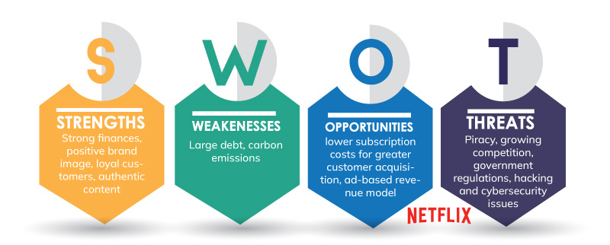
https://images.app.goo.gl/Wh3KZeW8exth7NEV9

Pestle Analysis of Netflix
The PESTLE framework is used to analyze the business strategy employed by Netflix. Netflix does a PESTLE Analysis to understand better the factors in its operating environment that could either make or destroy its business. The PESTLE Analysis sheds light on the various extraneous elements that affect the company's bottom line. It would be unwise for firms like Netflix, dependent on ongoing expansion, to not use the PESTLE framework. Another name, the PESTEL analysis, also refers to the PESTLE analysis. Its primary term is PEST analysis (Iordache, 2022).
4.1) Political Factors:
The following political factors are included in the PESTLE analysis of Netflix, and they are as follows: Regrettably, Netflix is not available in all territories at this time. Netflix cannot operate in China, which has the most excellent economy in the world, because of limitations imposed by the United States. There are many unexplored markets because Netflix restricts its service to particular geographical locations. In addition, the transmission of certain shows on Netflix is prohibited in several countries due to censorship restrictions.
4.2) Economic Factors:
An overview of the economic elements considered in Netflix's PESTLE study is as follows: Since the pandemic began two years ago, over a hundred OTT platforms have formed, with Netflix holding 29% of the market in terms of income. Netflix is currently experiencing a period of fast expansion. According to the data, a higher GDP is associated with an increase in the number of people subscribing to Netflix. Netflix's capacity for expansion is influenced by a wide range of macroeconomic issues, including unemployment, wage growth, taxation, inflation, and interest rates, amongst others. Netflix must produce more original content to compete as additional over-the-top (OTT) service providers enter the market. In addition, in countries such as India, where competing platforms offer the same services at lower prices, the media need to maintain their costs as low as possible and offer more deals to survive. If a company wants to be successful, it must control the expenses connected with marketing and domestic streaming (Iordache, 2022).
4.3) Social Factors:
The following social elements can be seen to have an impact on the PESTLE analysis of Netflix: Netflix needs to consider several important factors, including shifting demographics, gender roles, equal rights, and social mores. By analyzing its customers' online shopping and spending patterns, Netflix can gain a sense of the societal trend affecting its audience. Because of the significant weight that is carried by the company's purchasing power. On the flip side, the culture at Netflix attracts people to work there and motivates them to produce excellent videos. If Netflix does market research among various demographic groups to find out what people in those groups desire, it may generate content that is appealing to the people in those categories, which would result in Netflix increasing its market share (Martín-Quevedo et al., 2019).
4.4) Technological Factors:
Because it is an internet business, Netflix is highly dependent on several forms of technology. Netflix is conscious of the legal safeguards to protect intellectual property, including copyrights, trademarks, and patents. For them to be able to transmit their content, they must be kept abreast of any changes that may occur to the intellectual property rights of third parties. Companies with clients in countries like India must ensure that their websites are operational at all times; otherwise, those customers would discover unauthorized ways to download television shows and movies on the internet. Because there is a possibility of theft at any stage in making a payment, they are further required to ensure cyber security.
Netflix's future will significantly alter when faster 5G networks become available. Because technological advances allow for the creation of ever-more-exciting new content, it is possible that it will be made available frequently (Rahe et al., 2021).
4.5) Legal Factors:
Governing policies that may affect the company should be carefully considered before expanding into a new market. The need to secure personal information has become necessary as technology has advanced. The country's consumer protection law, intellectual property regulations, and security standards must all be upheld. Users commonly exchange login credentials. Hence multi-device streaming needs to be investigated further (Martín-Quevedo et al., 2019).
4.6) Environmental Factors:
Netflix, using its PESTLE research, has identified the following external factors as having an impact on its business: As a result of increased awareness of environmental and sustainability concerns, the term "environment" is now included as one of the main factors in PESTEL analysis. Netflix is dedicated to preserving the environment, and the fact that its business is conducted entirely online means that it leaves no physical trace. Netflix relies on renewable technology to ensure its business model is sustainable and minimize its environmental impact. To meet the energy demands of cloud storage while simultaneously reducing its overall carbon footprint, Netflix has invested in wind energy. This is because a recent study discovered that each streaming service was responsible for increasing the carbon footprint of the entire planet by 1%. This is the reason why this is the case. Reducing the company's adverse effects on the surrounding environment is one of its top priorities.
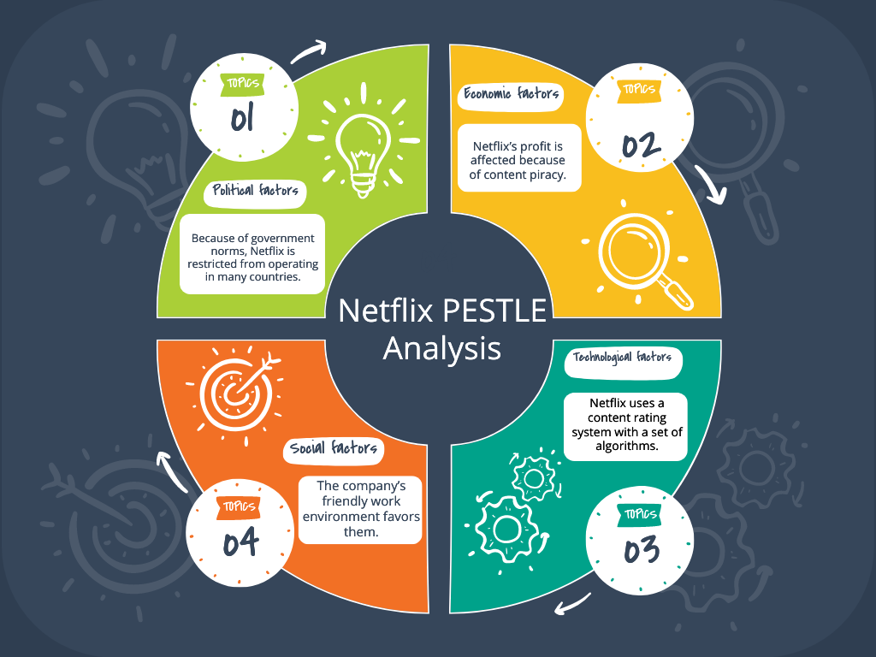
https://images.app.goo.gl/UYsMXYxybWLdJR3t6

Netflix Porter's Five Forces Analysis
Micheal E Doorman introduced Watchman's Five Powers Model to dissect the degree of rivalry for a business in the business. It assists organizations with grasping the contender's assets and the cutthroat climate in the industry.
With the complete number of video web-based memberships on the ascent, in the UK alone, memberships rose from 15.6m in 2018 to 19.1m in 2019 (BBC News, 2019), and the number of administrations accessible expanding, we utilize Doorman's five powers model to dissect the key variables affecting the exhibition of Netflix (Becattini, 2018).
- Background of Netflix
Netflix Inc. began as a DVD rental and selling administration in 1997. Be that as it may, Netflix came to the spotlight in 2010 when they upgraded their action plan and wandered into Video on Request Web-based. With this new activity, they extended dramatically in more than 190 nations and were recorded at New York Stock Trade (NYSE) with a market cap of 65.41B USD (Nafees et al., 2021).
- Netflix Porter's Five Forces
Netflix is producing original programming and enjoying record-breaking business success. So, we'll look at these five factors to determine what kind of business climate Netflix operates in and how that can affect the company's bottom line. Netflix has been so successful thus far because it continuously uses many strategies. Many valuable lessons may be learned, and the model of Porter's five forces is applied in many different contexts from Netflix.
- Risk of alternate products or services
- Intense rivalry or competition (Strong Force)
- Risk of alternate products or services
- Intense rivalry or competition (Strong Force)
5.1) Competition in the industry (Strong force)
The analysis of the most significant competitor of Netflix demonstrates how fierce the battle may be in the media business. Because of the high costs and the limited potential for profit, new competitors face significant challenges when trying to enter the market. Established companies like Amazon and HBO may have an easier time putting this business model into action, even though new entrants like them may find it challenging to do so. As a result, a significant risk is posed by competitors who provide a higher number of supplemental services and have greater control over the content. Eight out of the top ten most-watched subscription streaming shows in the United Kingdom as of December 2018 were only available on Netflix. The bulk of participants were folks you are already familiar with (BBC News, 2018).
Netflix and its competitors engage in fierce competition with one another. Because competitors like Amazon can provide more services in exchange for customers' subscription fees, other companies are taking the most popular video content that Netflix offers and showing it on their platforms. (Martínez-Sánchez et al., 2021)

5.2) The threat of new entrants (vital force)
There are a lot of hurdles to jump through to enter the consumer food market. Because of the amount of time required to understand customer demand, not many new businesses are successful in this industry. In addition, contemporary competitors are aware of the value of customer loyalty and have found ways to capitalize on it. Netflix 2000 is in a position where it faces little competition from new entrants in the market because of its extensive international distribution network and reputable brand. Apple, Disney, HBO, and Britbox (a joint venture between the BBC and ITV) are just some of the significant digital giants that are either launching or have already launched their very own standalone streaming services.
Due to the highly high costs associated with developing original content or licencing content from established firms, new entrants who do not already produce their own video content face significant hurdles to entry. These difficulties include the inability to produce their own video content. Existing entertainment firms have a reduced barrier to entry since they are able to populate the service with their material more quickly, and they may already have a loyal fan base for their brand or a certain show. This makes it easier for them to compete with new entertainment companies (Martínez-Sánchez et al., 2021).

5.3) The bargaining power of suppliers (strong force)
Due to the high production costs of Netflix's programming, the streaming service only works with a select group of content providers. They have virtually little competition, which has allowed them to completely dominate the market. It is easy to understand why content must be branded with the name of the provider before being made available on consumer or VOD platforms. The shift may be seen in the fact that Netflix has chosen to no longer stream Friends in favour of HBO. Traditional movie theatres have generally preferred to hold onto their films for at least three months before making them available to be rented or purchased on demand. Netflix, on the other hand, has enforced a maximum period of 45 days in order to compete with the large theatre chains. The Irishman, the most recent collaboration between Martin Scorsese and streaming service Netflix, debuted in select theatres before making its way to the streaming service. As Netflix's reputation grows, Hollywood will continue to lose ground to the streaming service. This is not the first time that Netflix has attempted something of this nature; in 2018, they distributed Roma by Alfonso Cuarón with only a 21-day theatrical run at independent and small-chain theatres before its streaming launch. People continue to appreciate re watching Netflix oldies such as Friends and The Office US, despite the fact that Netflix's original shows are garnering more views overall (Becattini, 2018).
5.4) The bargaining power of customers (Strong force)
Because there is typically only a marginal price difference between different service providers, customers are free to switch between them with relative ease. As a result, the price is not nearly as significant as the importance of the content's quality. Netflix's five forces model provides no basis for yearlong commitments from its customers because the company bills its subscribers on a monthly basis. The bargaining power of customers is increased as a result of all of these factors, according to Porter's five forces analysis of Netflix. As more and more streaming options become readily available, there will be an increase in the power of the audience. It would appear that the market is not very concerned with prices. If customers do not perceive a big difference in pricing between different services, they will evaluate the offerings based on the quality of the content instead. In the new year, there will be a price rise of one dollar for each of the following streaming services: Netflix ($12.99), Amazon Prime ($8.99), Hulu ($5.99), and Disney+ ($6.99). It was noted before that as content moves to new providers, it is only logical to assume that viewers will follow suit and begin viewing it from a new location as the material moves to these new providers (Rahe et al., 2021).

5.5) Threat of substitute products or services (moderate force)
There are not a lot of options available to replace the chemical in the market. The research conducted by Porter indicates that the level of competitive pressure exerted by new entrants is rather low. There are other companies that produce DVDs and streaming content that is comparable to Netflix's offerings. But the threat posed by alternative types of entertainment should not be underestimated. In 2019, the typical amount of time spent watching streaming video from providers such as Netflix is seven minutes longer than it was a year earlier in 2017. It shouldn't come as a surprise that YouTube accounts for 12% of all time spent watching videos online because it is a platform that allows users to share videos with one another and also stores them for subsequent viewing. Netflix has been left with minimal competition as a result of the collapse of broadcast television, particularly among young adults who are flocking to subscription video services.
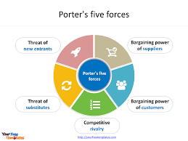
https://images.app.goo.gl/3QidYDt4AWVXrNg87

- FRAME WORK DIAGRAM OF NETFLIX
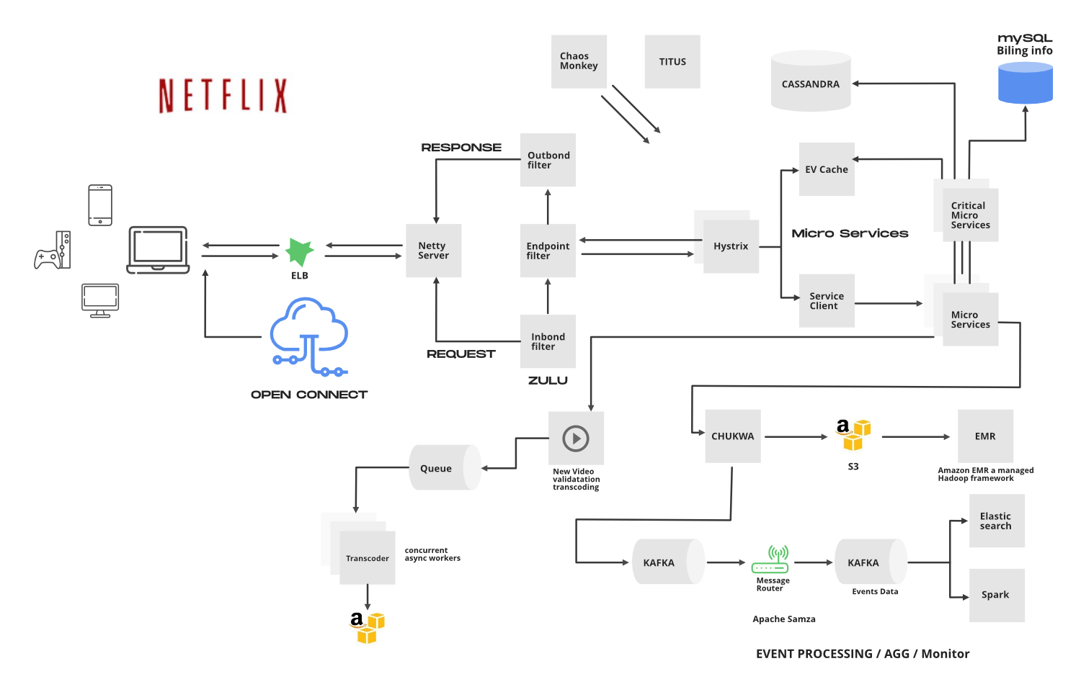

https://images.app.goo.gl/2UyFFX7mMJkX1r4T7

Conclusion

Netflix is a movie rental business that was first introduced in 1997 and currently has a database of approximately 1,000 different titles. Soon after that, in the year 2000, Netflix developed an algorithm for personalized movie selection and transitioned to a subscription business model. In 2005, when Netflix had more than 4.2 million subscribers, the company started developing an algorithm for recommending videos. 2007 was the year when Netflix, at long last, launched its streaming services and started producing its own original content. Netflix is still a big participant in the video-on-demand sector all over the world, despite the fact that it had more than 50 million customers in 2016. There is not a shred of doubt that the method of promotion that Netflix does is unquestionably raising the standard to an exceptionally high level for all digital marketers globally. It is enlightening to gain insight into the factors that contribute to the success of this digital media streaming organization. As a result, Netflix serves as a primary source of motivation and a model for a great deal of other businesses. They have done an amazing job with the product, the business plan, the branding, and the content of their website. Students and professionals alike who are interested in marketing have a lot to gain from studying Netflix's approach.
- Recommendations
Free previews encourage users to pay for full access. They provide all the information you need to use a service. Everyone can find something to watch on Netflix. A notification appears on the Details page and at the top of the screen when initially playing a title if it will leave Netflix in the next month. You won't know about new episodes or trailers if you haven't opened Netflix yet. Netflix should display a title's expiration date when watched and elsewhere on the service. Netflix push notifications and email reminders can help procrastinators. Not ideal, but better than losing a TV show mid-episode. Netflix has some of the decade's best programming. Disney aims to cash in by selling products, which has proven successful. Netflix has developed unique content for years, so it must quickly dominate this industry to catch up to Disney. Netflix should be judicious about how it promotes its shows through retail. Best case scenario: These brands become part of consumers' everyday routines and homes, consolidating their position in their minds. If Netflix succeeds, it will improve content marketing and brand recognition. This function may not be useful as is. Netflix's question to keep you watching may be better. If you don't like a show or movie on a specific platform, it may be more useful to propose something different rather than having you leave. Finding and watching more enjoyable content will boost your online time, and you may urge your friends and social media followers to do the same. Netflix, bravo. How often do you wish you could share a movie or TV show on Facebook, Twitter, or WhatsApp? This is one of Netflix's most-requested features. A share button is a simple yet useful aspect of any website or app. Netflix may get new subscribers by allowing viewers to share material with their online groups. If a trustworthy individual suggests a Netflix show, a viewer may consider subscribing to watch it. Netflix's popularity and subscriber base have expanded significantly, making it the leading streaming provider. It can't rely solely on its popular name to expand in a constantly altering market due to global events and corporate issues. Netflix can increase market share and subscribers with a few modifications. Even with 200 million members, there are still many potential buyers.

References

- Becattini, E. 2018. When we were young: Netflix and the teen audience. Comun. Soc. 2018:207–217.
- Fernández Gómez, E. and J. Martín Quevedo. 2018. Connecting with audiences in new markets: Netflix´ s Twitter strategy in Spain. J. Media Bus. Stud. 15:127–146.
- González, C., M. Membiela-Pollán and M. Cuns. 2020. Relationship marketing and brand community: the case of Netflix. Redmarka. Rev. Mark. Apl. 24:251–274.
- Iordache, C. 2022. Netflix in Europe: Four markets, four platforms? A comparative analysis of audio-visual offerings and investment strategies in four EU states. Telev. New Media. 23:721–742.
- Kumar, J., A. Gupta and S. Dixit. 2020. Netflix: SVoD entertainment of next gen. Emerald Emerg. Mark. Case Stud. 10:1–36.
- Lad, A., S. Butala and P. Bide. 2020. A comparative analysis of over-the-top platforms: Amazon Prime Video and Netflix. In: International Conference on Communication and Intelligent Systems, Springer, 283–299.
- Lobato, R. and A.D. Lotz. 2020. Imagining global video: The challenge of Netflix. JCMS J. Cine. Media Stud. 59:132–136.
- Maddodi, S. 2019. NETFLIX bigdata analytics-the emergence of data driven recommendation. Srivatsa Maddodi, Krishna Prasad, K.(2019). Netflix Bigdata Anal. Emerg. Data Driven Recomm. Int. J. Case Stud. Business, IT, Educ. 3:41–51.
- Martín-Quevedo, J., E. Fernández-Gómez and F. Segado-Boj. 2019. How to engage with younger users on Instagram: A comparative analysis of HBO and Netflix in the Spanish and US markets. Int. J. Media Manag. 21:67–87.
- Martínez-Sánchez, M.E., R. Nicolas-Sans and J.B. Díaz. 2021. Analysis of the social media strategy of audio-visual OTTs in Spain: The case study of Netflix, HBO and Amazon Prime during the implementation of Disney+. Technol. Forecast. Soc. Change. 173:121178.
- Mier, J. and A.K. Kohli. 2021. Netflix: reinvention across multiple time periods, reflections and directions for future research. AMS Rev. 11:194–205.
- Nafees, L., M. Mehdi, R. Gupta, S. Kalia, S. Banerjee and S. Kapoor. 2021. Netflix in India: expanding to success. Emerald Emerg. Mark. Case Stud. 11:1–31.
- Pérez, E.P. 2020. NEXT EPISODE, NEXT MARKET: SOCIAL MEDIA MARKETING FOR SVOD: THE CASE OF NETFLIX. In: GLOBAL, 8.
- Rahe, V., C. Buschow and D. Schlütz. 2021. How users approach novel media products: Brand perception of Netflix and Amazon Prime video as signposts within the German subscription-based video-on-demand market. J. Media Bus. Stud. 18:45–58.
- Ramasoota, P. and A. Kitikamdhorn. 2021. “The Netflix effect” in Thailand: Industry and regulatory implications. Telecomm. Policy. 45:102156.

