Name: Ross Van Den Eeckhaute-Jones
Student P Number: P151366
Module Title: Network Security
Module Code: M7X01701
Assignment Title: Research on current security technologies and Penetration testing on a live website
Module Lecturer: Dr Carlene Campbell
Date: 11/05/2020
Research on current and future network security technologies and penetration testing on a live website

Ross Van Den Eeckhaute-Jones
University of Wales Trinity St. David
Swansea, Wales
Rvandeneeckhaute-jones.151366@student.uwtsd.ac.uk

Abstract— There are many steps to be undertaken in order to maintain good security practices in the workplace. As well as employee training, there must be procedures in place to deal with any perceived threat. This document covers the wide range of techniques both current and future trends in maintaining network security. The process of penetration testing a website has also been documented including steps to prevent future attacks.
Keywords—Network Security, Penetration testing, cybersecurity, IoT, UWTSD

Introduction

Businesses around the world rely heavily on network infrastructure. There are many business operations that require a network connection of some kind including but not limited to:
- Internal/External communications
- Onsite/offsite backups
- Server hosting
- IoT systems
- Mobile device usage

All of these services require the use of network infrastructure. In order for the business to safely use these services, it is crucial that all possible steps are taken to secure the businesses network infrastructure.
The risks to a business stemming from a lack of adequate network security can be devastating. Aside from the reputational damage caused by a security breech, the businesses operations can be severely affected or even destroyed. Important files can be encrypted or deleted, or even leaked/sold. Confidential data of clients/employees can be exposed. [1]
It is important that network security specialists consider all aspects of a network in order to ensure the maximum is being done to maintain network integrity. While a business may have taken all the necessary steps to ensure network security such as appropriate authorization, network policies, access control and appropriate antivirus, it is still important that contingency policies are put in place to recover should any of these strategies fail. No system is “unbreachable” and it is important to always have plans in place to react to different types of breeches. [1,2]
There is a wide range of methods of protecting a businesses network and its data which will be explored further in this document.
An easily implementable method of protecting data is backing up files. Backing up important files can be a method to allow recovery from certain cyberattacks such as ransomware or any attacks/viruses that encrypt or delete data. While this method allows recovery of data, there is no recourse for theft of confidential information as the damage has already been done. [3]
Backups of computer images can also allow restoration of infected devices quicker than manually rebuilding a machine and its required services. This restores normal usage capabilities quickly and can reduce downtimes within a business. [3]
While there are a range of damaging effects that can be caused by different attacks, certain businesses are harder hit by different types of attacks depending on how the business operates. For example, a company that houses many low level employees who are sending and receiving emails frequently throughout the day will benefit from email filtering and well configured firewalls/filters more than a small business of highly skilled network specialists who would be more wise to certain email attack attempts such as phishing. [3]
A highly skilled network security professional would be expected to have a strong idea of what methods would be essential to a certain type of business as well as the recovery methods that would be best implemented to ensure minimal downtime during recovery. [3]
Section | Page Number
Introduction | 2
Research – Internet of Things | 3-4
Research – Cybersecurity Future Trends | 5-6
Penetration Testing | 7-10
References | 11

Literature review
This section will contain research conducted around the network security issues faced by Internet of Things and smart city, as well as the future trends in cybersecurity.

Internet of Things and Smart City security issues

Internet of things and smart city as a concept has taken off massively over the last decade, with capabilities and features increasing year on year.

IoT involves the use of multiple sensors connected to a network which can read various metrics such as temperature, physical activity in an area, light levels and many more. These metrics are then sent to a control room which may be automated to some level, which then further controls those aspects by sending signals back to those areas and performs actions that affect those rooms or areas that the sensors reside. [4]

For example, the control room sets the ambient temperature of each room in a school or university to 25 degrees. 10 sensors feed temperature information to the control room ranging from 20 to 30 degrees. From there, the control room sends information back to those rooms to the heating or aircon controllers to adjust the temperature back to the desired level. [4]

While this kind of temperature controlling system seems simple, the security issues that may be faced can vary. A malicious hacker that may be able to spoof sensor metrics and/or controller signals to unintended levels. This can cause a range of unintended actions. For example, when the university is unattended the hacker may cause heating to be active for hours on end causing unwanted costs to the university. Rooms that require certain cooled temperatures (such as server rooms, kitchen appliances or science storage rooms) may be sabotaged by increasing the temperature to levels which can affect server performance, or ruin/spoil ingredients and supplies. [4]

While this seems arbitrary to the hackers’ motive and intentions, it may be possible for the hacker to extort or hold ransom the services that have been attacked. The university may be forced to pay the hacker to allow normal activity of the IoT system, or spend time and money trying to resolve the intrusions as well as prevent future attacks. [4]

Due to the nature of an IoT system using 10s potentially 100s of devices all communicating mostly through wireless connections, all it takes is 1 slip up from the network manager for a breech to occur.

As mentioned above where sensor data may be spoofed in an attempt to extort or aggravate IoT system users, this is just one avenue of attack that may be launched. Breeches of an IoT system can lead to deeper penetration of the network and its data/services. [5]
Spoofing is just one security issue faced by IoT systems. Below is a list of potential attacks:

Spoofing

Spoofing is where a device or data sent from a device is intercepted and replaced with tampered data, resulting in increased costs and/or energy usage for a business. Spoofing IoT data can also result in sabotaged production material, for example if a product is produced at twice the expected temperature and is ruined. [5-7]

Eavesdropping

Eavesdropping is the act of observing transmitted data across an IoT network. This can include personal confidential information, as well as important business information/data. [5-7]

Authorization/access issues

The majority of IoT devices utilize remote control capabilities. This opens up a range of attacks that target wireless devices and can lead to deeper access into he targeted network. [5-7]

Privacy issues

Production businesses may use IoT to control production values such as times, temps, weight and other important metrics throughout the production process. These values may be trade secrets which would devalue the business should they get released or sold. [5-7]

Hijacking/injection

Due to IoT systems being mass produced with some businesses offering cheaper and cheaper options, it is an unfortunate side effect that some cheap systems will not be as secure as the well-designed systems. The use of unsecure devices in IoT systems opens up the user to potential hijacking of devices allowing injection of malicious code that can propagate through the targeted network with a wide range of devastating consequences. [5-7]

Denial of Service

A business that relies on IoT systems to control aspects of there business operations would suffer massively from a DoS attack. A DoS attack can bring an IoT device or whole IoT system offline, resulting in huge downtime, or ruined/wasted production materials. This inevitable costs a business money and time spent getting the system back online again. [5-7]

When implementing an IoT system, there is a range of security challenges that have to be considered:

Scalability

A business may require an IoT system to operate over anywhere from a small single room or building, all the way up to a huge multi-site business. Scalability with security in mind becomes harder to prepare for as business size increases. The smaller sized business should be expected to be easier to maintain security wise as there are less users and devices to secure. [5-7]

Maneuverability

With wireless devices being key in the IoT system, it is important to be mindful of how portable or flexible the devices that are being used can be. Money can be saved by reutilizing no longer needed devices in other areas if/when required. It is also important to ensure devices are not easily accessible to being tampered, but also in functional spots to allow good performance within the IoT system. [5-7]

Deployment

During installation and rollout of an IoT system, attention must be given to aspects such as positioning, access, and potentially weather protection. If possible, sensors can be installed in ways that make physical tampering impossible or easily detectable. Reducing the opportunities for physical tampering increases security massively. [5-7]

Compatibility

Some IoT systems may have compatibility issues when communicating with non-same manufacturer devices. This can result in a reliance upon third party software to facilitate the communication between devices. The need for additional software to bridge compatibility gaps adds another target for malicious attackers and can weaken the overall security of the IoT system. [5-7]

In some circumstances where new IoT systems must work alongside older systems this may not be helped, but due diligence must be taken to reduce any possible risks by selecting hardware that works best with the current systems. [5-7]

Latency

Care must be taken to ensure devices are installed in spots that do not degrade performance of devices and between devices. Slow communication speeds can result in slow detection times of tampering or interference, as well as inaccurate or corrupted data being transferred across the IoT system. [5-7]

Below are the main security considerations for implementing an IoT system:

Authentication

Authentication is the ability to accurately identify and validate the credentials of a device/user on the IoT network. Authentication leads into manageable device and user activity through access control. [7]

Access control

Access control utilizes authentication to modify the levels of access that users and devices on the IoT network have. Restricting the access of a device to only the required services and permissions can reduce the potential damage a compromised device can cause. [7]

Data Integrity

Data integrity ensures that data sent/received from IoT devices is valid and not tampered with. Data integrity is essential in businesses that deal with user accounts such as energy companies, where user consumption meters are key in identifying and billing users for services. [7]

Confidentiality

Confidentiality is ensuring that data created or transmitted across the IoT system is only accessible by required users with the required credentials. [7]

Privacy

Privacy is the guarantee that user data is only used for the intended purposes, is not viewed/used by any unauthorized users, and is not used for any nefarious means. [7]

In conclusion of the security issues of IoT, it is clear that the technology has grown and will continue to grow and be a big part of business operations and home networks around the world. It is important that the security risks are known and accounted for. [5-7]

It is all too common these days for unaware home users to want to buy the newest technology and use it in their homes, but some users simply don’t understand the potential risks of unsecured technology and may not understand how to properly set up good security measures for their devices. It is important that home users are made aware of the consequences of unsecure systems being brought into their home. [5-7]

Overall IoT has a huge part to play in allowing businesses to grow and reach efficient operating levels previously unseen without utilizing such technology. But as technology grows and improves, so do the opportunities for said technology being attacked by malicious hackers.; It is on the security teams to ensure that they keep up to date with advances and ensure that threats are detected and dealt with before any damage is received from such attacks. [5-7]

Future trends in cybersecurity

Cybersecurity as a whole has a constant need to keep up with current and future threats. In the same vein that antivirus software has to constantly update to defend from new and evolving attacks, network security engineers have to be ready to deal with new and unseen attack methods.

While businesses can appropriately defend from the majority of current attacks if the steps have been taken to secure a business network, malicious hackers understand this and have to work outside the box to find vulnerabilities that are unknown.

Year | Keys per second (1000s)
2000 | 834
2010 | 8918
2015 | 11344
2020 | 17042
When new technology arrives on the shelf (such as IoT, or machine learning network security), malicious hackers see this as a goldmine of opportunities. This is due to the limited amount of testing that can possibly have been done on the product compared to the years of testing and assessments that have been performed on products that have been around for decades. [3,4]

Strictly speaking, business users would be expected to understand the risks of implementing new technology by employing network security specialists to evaluate the risks of such technology, and the posed threats to implementing such a system. [3,4]

Home users who may not be as educated in the security risks around new technology may decide to buy and implement a home IoT system and hope it works off the shelf, without any specialized knowledge. While there are systems available that can achieve this, there are always extra steps that can be taken to secure a system even further. [3,4]

A home user who purchases and installs a home IoT system may be happy that it works, but the home user may not understand the potential damage a malicious hacker could cause to an unsecure system. Bank details may be intercepted while accessing the bank no devices connected to the IoT system. Personal conversations may be eavesdropped, leading to blackmailing. Confidential phone calls or work emails sent from home may be stolen or tampered with resulting in stolen intellectual property which the employee is responsible for. There is always a huge wave of consumers who will jump on the newest technology as soon as it comes out without realizing the risks. [3,4]

It is also to the detriment of new technology that any new and fascinating capabilities of software/hardware may be used for malicious activities as well as to better improve business or entertainment activities. A simple example would be hardware improvements, whenever a faster CPU or GPU comes out, business productivity goes up. But at the same time malicious hackers utilizing the upgraded hardware can now brute force passwords faster than ever before. [3,4]

For example, the below table compared password brute force times across different years using different lengths and complexities: [8]

Password | 2000 | 2010 | 2015 | 2020
abc | 4ms | 0.36ms | 0.29ms | 0.19ms
abc123 | 43 mins | 4 mins | 3 mins | 2 mins
Computer | 2 years | 2 months | 7 weeks | 5 weeks
P@ssw0rd | 13 yr | 1 yr 3 mth | 1 yr | 8 mth

These results are rough estimates using available hardware during each year using a password brute force estimating program. The program works by estimating the potential keys per second using the hardware available in each year. [8]

These results show how fast hardware has improved over the last 2 decades in terms of brute forcing passwords. The results do exhibit an amount of diminishing returns, where keys per second have increased by almost 100% in the last 10 years, whereas in the 10 years starting from 2000-2010 the speed increased by almost 1000%.

In todays cybersecurity climate, businesses are having to adapt to cyber threats in almost real time conditions. Detecting intrusions as fast as possible allows minimal damage and potential blocking of attacks getting further into the network. [9-10]

Since the introduction of GDPR, businesses around the world are having to implement new policies and amend network practices to comply with the data handling procedures. While the GDPR concerns data of EU users, it affects business operations of any country in the world that handles data from EU users. [12]

The requirement of worldwide businesses to follow GDPR regulations also adds additional pressure to increase security in order to not face huge backlash and fines in the event of a breech concerning EU data. [12]

With the slow release of 5G network capability around the world comes more cyberattack potential threats. 5G hopes to improve on 4G to allow lower latency and less demanding energy consumption. This can potentially revolutionize the IoT industry allowing more efficient devices to perform at higher standards than previously achieved. [13]

5G can be susceptible to all the similar attacks that are currently a threat to wireless networks such as eavesdropping, Man in the middle attack, DoS attack and jamming. All these attacks will have to be considered when utilizing 5G. New defenses will have to be employed to keep up with the capabilities and vulnerabilities that come with the use of 5G. [13]

As modern cars are being fitted with self-driving capabilities and are usually now connected to a vehicular network, the advances made with 5G offers great benefits to vehicular networks providing the low latency low resource usage stands true. [13]

Modern cars are relying heavily on moving to electrical functionality as opposed to mechanical for example an electronic accelerator and brakes (controlled by an ECU rather than cabled pedals) Electronic accelerators and brakes allow less moving parts, utilizing sensors to detect brake pressure and accelerator speed. The end result is more accurate results and effectively less wear and tear on parts.

However, with this new technology comes new potential threats. With functions of a vehicle being incorporated with the cars electrical computerized system comes the potential for devastating consequences should any of these systems be breeched. Its not hard to imagine a scenario in the near future where a malicious hacker gains full control of an automated car, where the hacker can now lock doors, select destinations, increase speed or slam on breaks for potentially fatal results.

The way modern electric cars receive version updates of in car systems is through file updates. Its not impossible for a man in the middle attack to intercept an update and relay a tampered version to allow back doors or tweak performance metrics. [13]

It is important that any business that decides to utilize 5G realizes the security implications. A lot of thought and a strong team of networks security specialists must be onboard to even think about implementing 5G into a business due to 5G being relatively new technology and fairly untested grounds. [13]

While the world proceeds through the teething period of implementing 5G, more insight into the reliability and robustness of the service. Businesses may prefer to wait out this period and not put themselves at unnecessary risks while they observe the situation and reassess later down the line if their business could benefit from implementing 5G. [13]

Machine learning is an interesting topic in the cybersecurity sector. While AI is being used to detect and prevent cyberattacks, it is also being used to create and launch cyberattacks. Essentially AI fighting against AI. [14,15]

Intrusion detection using machine learning can be trained alongside live systems, with successful defense time providing valuable data that anomalies can be held against. The longer a system is “trained” against the more accurate a full machine learning system can be. [15]

Cloud computing is becoming more and more of a desirable business solution for businesses of all sizes and needs. While a lot of businesses are already utilizing cloud computing technology, it still remains a relatively new emerging technology. [16]

Along with the growing use of cloud computing comes increasing security threats. With 100s potentially thousands of users/businesses being situated on a cloud computing server farm. The consequences of a breech can be devastating, as experienced with the Heartbleed exploit where malicious hackers were able to read the memory of affected systems, which could house confidential data of businesses. [16-17]

One threat to cloud computing which affects emerging cloud computing technology platform as a service, software as a service and infrastructure as a service. These services utilize software such as Docker and Kubernetes to facilitate rapid deployment and maintenance of lightweight container services. Should a hacker gain access to these services, tampered OS versions may be installed to the containers from which the business conducts operations. This would result in confidential business info and/or potentially sensitive customer info being exposed. [16]

The influence that social media and media in general can have on cybersecurity issues such as social engineering and phishing can allow additional avenues of attack to malicious hackers. Blackmail and extortion have become rife over the last few years due to more frequent “data leaks” as seen in the iCloud breeches. Even the level of fake news and fake media contributes to the potential social engineering attacks. [11]

In conclusion of the future trends of cybersecurity, it is clear that maintaining the security of a network against current and future attacks is no easy task. As advances in technology are made, so open new avenues of attack for malicious hackers.

There is a constant struggle and essentially an arms race between network security specialists and malicious hackers. Machine learning can be an aid but the fact that both sides have access to machine learning capabilities

It is essential that new technology is extensively tested before deployment to ensure maximum effort has been given to maintain integrity of the technology.

Penetration testing
To demonstrate the capabilities of malicious attacks, the Damn vulnerable web app will be used. A variety of attacks will be demonstrated using this software. To prepare for the attacks some initial configuration setup has to be completed.
To start off an up to date version of Kali Linux has been installed onto an Oracle VM Virtual Box. Inside Kali Linux DVWA has been downloaded into the /var/www/html directory.
Using the command “chmod -R 777 DVWA/” while in the /var/www/html directory will give the required permissions to function as expected. By entering the config file with the commands “cd DVWA/config/” and “cp config.inc.php.dist config.inc.php” a copy of the default configuration values can be modified to suit the needs of the experiment. In this case the username and password is created as “user” and “pass” to keep it consistent throughout the experiments.

The next step is to initiate the database setup. Using the commands “service mysql start” and “mysql -u root -p” a user is able to be created for the database. In this case “‘user’@’127.0.0.1’ identified by ‘pass’;” uses the login details from the previous configurations steps to incorporate the DVWA user details. To grant this user the required privileges to work alongside DVWA the command “grant all privileges on dvwa.* to ‘user’@’127.0.01’ identified by ‘pass’;”. This concludes the database configuration.

To host the DVWA to allow penetration testing, apache2 will be used. To initiate the apache2 server, the command “cd /etc/php/7.3/apache2/” is used. Using “gedit php.ini” allows modification to the configuration file of the apache server. DVWA requires that allow_url_fopen is set to “on”, and also that allow_url_include is set to “on”. Both these values can be set to “off” by default. To bring up the server, “service apache2 start” is used
Pre-Configuration is now complete and penetration testing is ready to be carried out

Brute force
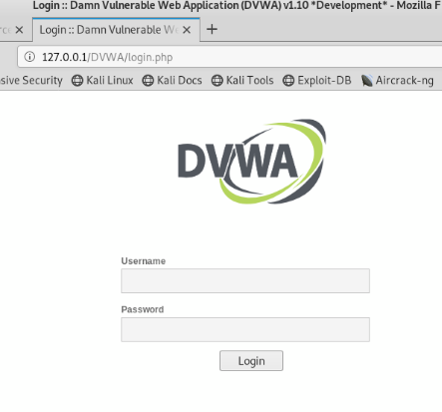
Here is the target of the brute force password attack using DVWA. THC Hydra will be used to perform the brute force attack.
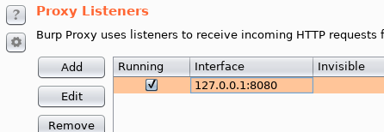
Using burp suite as a proxy will allow interception of http requests.
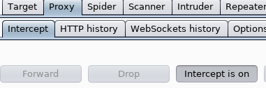

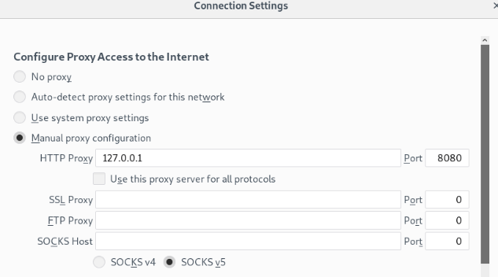
Configuring burp suite allows interception of html session data.
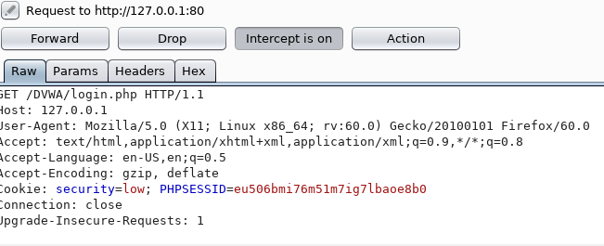
This is the command used to launch the brute force attack: “hydra 127.0.0.1 -l admin -P /usr/share/set/src/fasttrack/wordlist.txt http-get-form "/DVWA/vulnerabilities/brute/:username=^USER^&password=^PASS^&Login=Login:F=Username and/or password incorrect.:H=Cookie: PHPSESSID=eu506bmi76m51m7ig7lbaoe8b0; security=low"
The command the session data captured through burp suite and a wordlist included in Kali Linux to attempt a brute forced password attempt. Below you can see that the attempt was successful providing a correct password to allow successful logging in to DVWA.

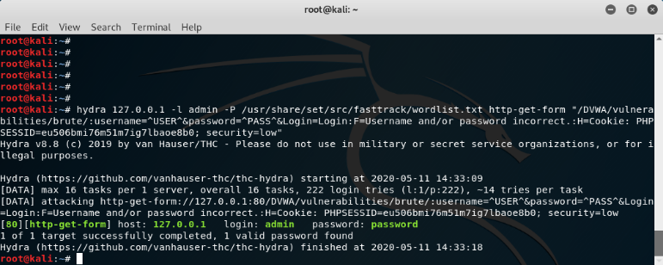
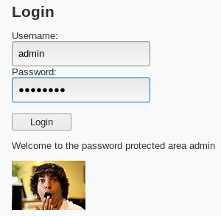
A strong defense to brute force attacks is to use long passwords with a mixture of numerals letters and symbols. As mentioned in part 1 of this document, adding a couple of characters to the end of your password can increase cracking times by potentially weeks or months.
SQL injection
SQL injection uses text input boxes to force out information using queries. By entering “99’ or 1=1;#” it forces the database to give out data
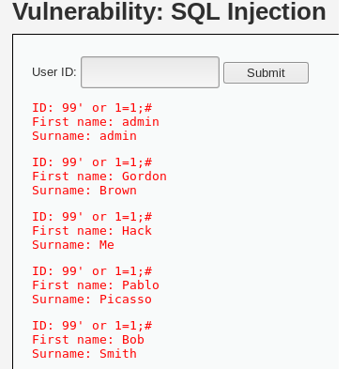
﻿
99' or '1' = '1' UNION select 1,version()# Exposing the database version can lead to malicious hackers discovering database vulnerabilities to further exploit.
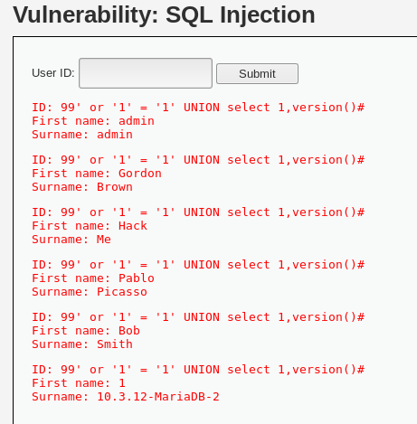

Exploring further using commands such as “﻿
99' or '1' = '1' UNION select 1,user()#“ can reveal further information
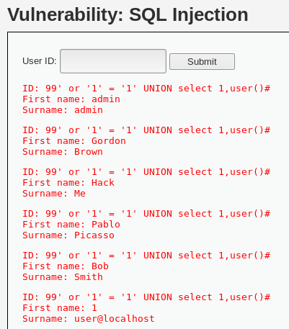

File inclusion
Here you can see the low security level with no input validation or filtering, compared to the high security configurations.


Below you can see the inclusion of google using the address http://127.0.0.1/DVWA/vulnerabilities/fi/?page=https://google.com. This means that any malicious php file can be included and loaded onto the targeted website resulting in potential atack vectors being exploited.
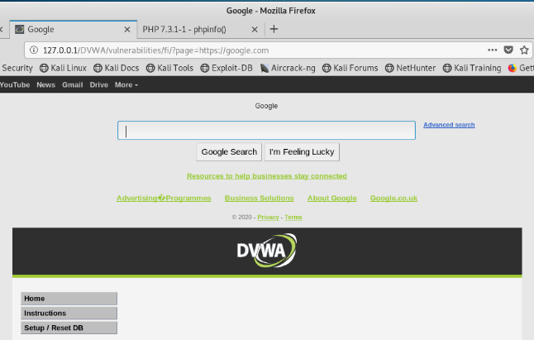
If you were to attempt the same attack on a website with adequate input validation and filters configured, you would find this message and a failure to load the file.
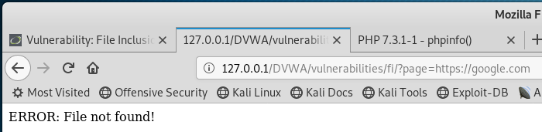

Even with weak input validation for example on medium setting, it is possible to use the same attack with methods to get around the input validation.

As you can see, the medium security features include filters for “http” and “https”. By using differing capital letters in the address, you can bypass the weak string filters present on the medium setting while still including the malicious file.
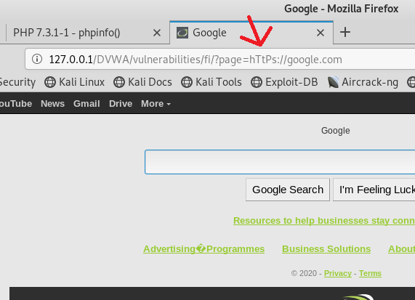

A strong defense to file inclusion is to employ strong filter parameters that cannot be easily bypassed. A stronger defense is to maintain a vetted list of whitelisted filenames rather than try to create filters to stop unwanted files

Command injection
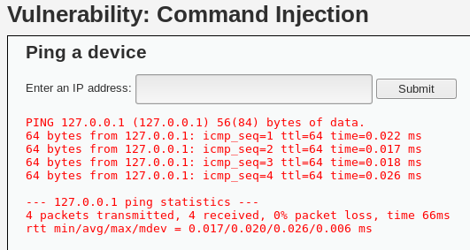
Unsecure input boxes can lead to unintended actions being performed. On the DVWA website, there is a ping function to allow users to receive ping response times.

Due to the low security parameters involving this text input, using Linux command line inputs it is possible to retrieve unintended information. This stems from the capability of executing multiple commands from a single line input on Linux using a ; between commands.

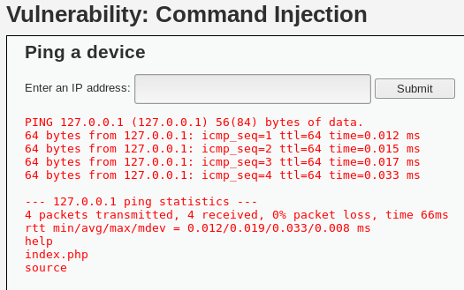

This can result in confidential data being exposed to malicious hackers. Hackers can fish around for important info until they gather enough information to launch a further attack using higher level authentication details.

Below is a data output providing user details from using the command “127.0.0.1;cat /etc/passwd”

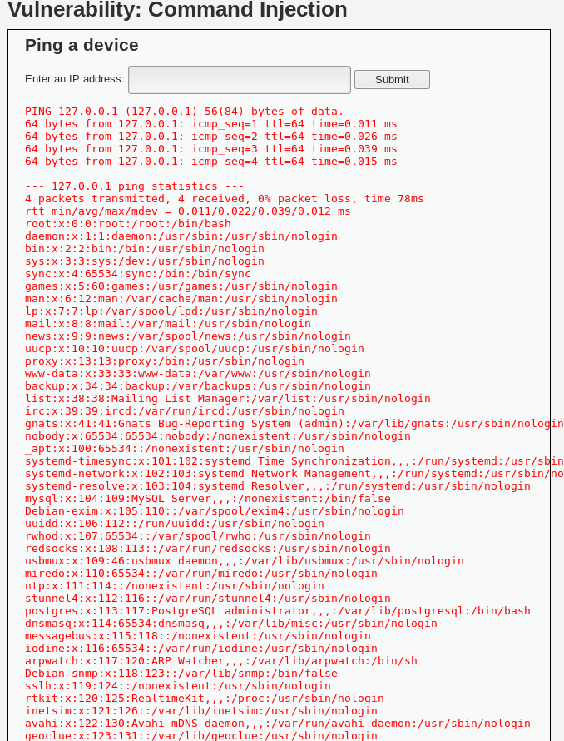

Using the command 127.0.0.1;whoami it is possible to see what user is connected. www-data is the user.

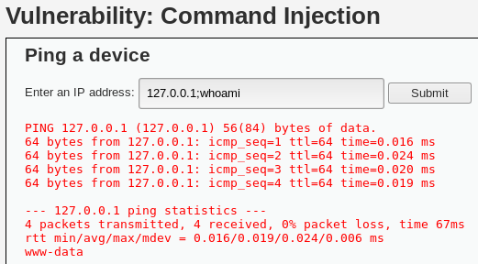

Using command line injection, it is possible to execute commands from a backdoor in a system.

To defend from command injection is to stay away from customer facing command line inputs altogether. APIs allow data to be read from certain servers without the risks of command line execution and should be used wherever possible.

Where not possible, restrict possible inputs that can have malicious consequences, and be sure to end commands properly and safely Performing regular code reviews can reveal weaknesses in systems as well as offer room for improvement.

References

[1] M. V. Pawar and J. Anuradha, “Network security and types of attacks in network,” in Procedia Computer Science, 2015, vol. 48, no. C, pp. 503–506.
[2] A. S. Li, X. C. Li, Y. C. Pan, and W. Zhang, “Strategies for network security,” Sci. China Inf. Sci., vol. 58, no. 1, pp. 1–14, 2014.
[3] V. K. Gunjan, A. Kumar, and A. A. Rao, “Present and Future Paradigms of Cyber Crime and Security Majors-Growth and Rising Trends,” in Proceedings - 2014 4th International Conference on Artificial Intelligence with Applications in Engineering and Technology, ICAIET 2014, 2015, vol. 45, no. 2, pp. 89–94.
[4] C. D. G. Brayan Sánchez-Torres, Jesús Alberto Rodríguez-Rodríguez, Dewar Willmer Rico-Bautista, “Smart Campus: Trends in cybersecurity and future development,” Foreign Affairs, vol. 91, no. 5. p. 287, 2012.
[5] F. Azam, R. Munir, M. Ahmed, M. Ayub, A. Sajid, and Z. Abbasi, “5 INTERNET OF THINGS (IOT), SECURITY ISSUES AND ITS SOLUTIONS,” Sci. Herit. J., vol. 3, no. 2, pp. 18–21, 2019.
[6] Aqeel-ur-Rehman, S. U. Rehman, I. U. Khan, M. Moiz, and S. Hasan, “6 Security and privacy issues in IoT,” Int. J. Commun. Networks Inf. Secur., vol. 8, no. 3, pp. 147–157, 2016.
[7] C. Bekara, “Security issues and challenges for the IoT-based smart grid,” in Procedia Computer Science, 2014, vol. 34, pp. 532–537.
[8] “Estimating Password Cracking Times.” [Online]. Available: https://www.betterbuys.com/estimating-password-cracking-times/. [Accessed: 1-May-2020].
[9] Y. Zou, J. Zhu, X. Wang, and L. Hanzo, “A Survey on Wireless Security: Technical Challenges, Recent Advances, and Future Trends,” Proceedings of the IEEE, vol. 104, no. 9. pp. 1727–1765, 2016.
[10] K. Cabaj, Z. Kotulski, B. Księżopolski, and W. Mazurczyk, “Cybersecurity: trends, issues, and challenges,” Eurasip Journal on Information Security, vol. 2018, no. 1. 2018.
[11] R. Piggin, “Cyber security trends: What should keep CEOs awake at night,” International Journal of Critical Infrastructure Protection, vol. 13. pp. 36–38, 2016.
[12] A. Chiappetta and A. Battaglia, “The impact of privacy and cybersecurity on e-record: The PNR Directive Adoption and the impact of GDPR,” J. Sustain. Dev. Transp. Logist., vol. 3, no. 3, pp. 77–87, 2018.
[13] D. Fang, Y. Qian, and R. Q. Hu, “13 Security for 5G Mobile Wireless Networks,” IEEE Access, vol. 6, no. 2, pp. 4850–4874, 2017.
[13] D. Fang, Y. Qian, and R. Q. Hu, “13 Security for 5G Mobile Wireless Networks,” IEEE Access, vol. 6, no. 2, pp. 4850–4874, 2017.
[14] S. O. Hwang, T. Kwon, W. Yau, and D. Nyang, “14 Special Issue on Cyber Security and AI,” ETRI J., vol. 41, no. 5, pp. 557–559, Oct. 2019.
[15] M. Komar, V. Golovko, A. Sachenko, and S. Bezobrazov, “Intelligent system for detection of networking intrusion,” in Proceedings of the 6th IEEE International Conference on Intelligent Data Acquisition and Advanced Computing Systems: Technology and Applications, IDAACS’2011, 2011, vol. 1, no. 2, pp. 374–377.
[16] N. Khan and A. Al-Yasiri, “Identifying Cloud Security Threats to Strengthen Cloud Computing Adoption Framework,” in Procedia Computer Science, 2016, vol. 94, pp. 485–490.
[17] J. A. Lewis, “Heartbleed and the State of Cybersecurity,” Am. Foreign Policy Interes., vol. 36, no. 5, pp. 294–299, Sep. 2014.

marking criteria and Student FEEDBACK

This section details the assessment criteria. The extent to which these are demonstrated by you determines your mark. The marks available for each criterion are shown. Lecturers will use the space provided to comment on the achievement of the task(s), including those areas in which you have performed well and areas that would benefit from development/improvement.

Common Assessment Criteria Applied (Assignment 1) | Marks available | Marks  awarded
1. Engagement with Literature Skills
Extent of research and/or own reading, selection of credible sources, application of appropriate referencing conventions.
You have covered the key concepts within your research aspect such as security measures and flaws. You have utilised diverse sources and applied the appropriate referencing convention. (Grade mark: 84.44%) | 45 | 38
2. Knowledge and Understanding Skills
Extent of knowledge and understanding of concepts and underlying principles associated with the discipline.
3. Cognitive and Intellectual Skills
Analysis, evaluation and synthesis; logic, argument and judgement; analytical reflection; organisation of ideas and evidence
You have done a very good introduction. Some topics explained but could be more critically appraised. You have done no conclusion for this section. (Grade mark: 66.67%) | 45 | 30
4. Practical Application Skills
Deployment of methods, materials, tools and techniques; application of concepts; formulation of innovative and creative solutions to solve problems.
5. Transferable Skills for Life and Professional Practice
Attributes in professional practice: individual and collaborative working; deployment of appropriate media; presentation and organisation.
Your work is presentable and flow well. (Grade mark: 80.00%) | 10 | 8

Assignment Mark (Assessment marks are subject to ratification at the Exam Board. These comments and marks are to give feedback on module work and are for guidance only until they are confirmed. ) | Late Submission Penalties (tick if appropriate) |  | 76%
 | Up to four weeks late |  | 76%
 | First Attempt? |  | 76%

marking criteria and Student FEEDBACK

This section details the assessment criteria. The extent to which these are demonstrated by you determines your mark. The marks available for each criterion are shown. Lecturers will use the space provided to comment on the achievement of the task(s), including those areas in which you have performed well and areas that would benefit from development/improvement.

Common Assessment Criteria Applied (Assignment 2) | Marks available | Marks  awarded
1. Engagement with Literature Skills
Extent of research and/or own reading, selection of credible sources, application of appropriate referencing conventions.
2. Knowledge and Understanding Skills
Extent of knowledge and understanding of concepts and underlying principles associated with the discipline.
You have demonstrated understanding of the penetration testing and explained the methods and tools for using the Damn software but not for the live website penetration testing. (Grade mark: 65.00%) | 20 | 13
3. Cognitive and Intellectual Skills
Analysis, evaluation and synthesis; logic, argument and judgement; analytical reflection; organisation of ideas and evidence
You have done no conclusion for this section. You have discussed the relevancy within the parameters of the software tools used. The configuration changes that could be made to the site and defence strategy, not done. You have not done any cost solutions and timetable for the execution of solutions. These would not be possible as your discussion was not on the live website but from the pentest tools. (Grade mark: 65.00%) | 20 | 13
4. Practical Application Skills
Deployment of methods, materials, tools and techniques; application of concepts; formulation of innovative and creative solutions to solve problems.
The Damn tool was used to demonstrate Pentest; SQL injection, password (brute force attack). Documentation tests were done. No evaluation analysis of these were done to draw a conclusion of how they could be related to the live website pentest. Pity you have waited last minute when no access to the live website was no longer permitted. (Grade mark: 53.33%) | 60 | 32
5. Transferable Skills for Life and Professional Practice
Attributes in professional practice: individual and collaborative working; deployment of appropriate media; presentation and organisation.

Assignment Mark (Assessment marks are subject to ratification at the Exam Board. These comments and marks are to give feedback on module work and are for guidance only until they are confirmed. ) | Late Submission Penalties (tick if appropriate) |  | 58%
 | Up to four weeks late |  | 58%
 | First Attempt? |  | 58%

