Automation of Workforces Now and in the Future
Introduction
In this report I will be discussing automation in the business landscape of our society, the topics on discussion here will be the causes that drive people to use automation, the problems and solutions that can come from it, the ways that it affects people and the jobs that may be lessened or rendered completely obsolete from the automation of a sector. We will also discuss the potential solutions that have been suggested to mitigate the affects of automation on people, this report will end in a summary of the points discovered and discussed during my appropriate research
Definition of Automation
Computer manufacturer IBM splits this topic into four types of automation:²
- Basic Automation: Swapping basic physical tools for digital interconnected counterparts, this is the equivalent of swapping notes on paper for a messaging system or writing processes on a whiteboard for process mapping software using BPM (Business Process Management) methodology. This can also include RPA³ (Robotic Process Automation) methods which involve the handing off of very simple tasks to a software bot, such as replying to customers with a set message or sending an alert when a threshold is breached, rather than a human performing the task or monitoring.
- Process Automation:⁴ This expands on Basic Automation with the ability to chain simple tasks together, creating an automated workflow that follows a process from beginning to end, for instance, this could involve the onboarding of a new customer in a support environment, the staff member could input the new company details into the workflow and then at the click of a button it would go and create the required accounts in other software or send pre-defined emails etc, it is to be stressed that this type can only perform very simple tasks.
- Integration Automation:⁵ Expanding on what process automation is capable of, this section deals with robots (not AI) that can be fed data from other software to perform a set of specific tasks, the difference here from AI is that the software or bot cannot think on it’s own to interpret or learn from the data or results, it needs and sticks to set rules defined by the humans that created it and cannot deviate from that.
- AI (Artificial Intelligence) Automation: This is the type of automation able to handle the most complex tasks, it can learn from a combination of the data fed to it, it’s environment and outcomes to give a hopefully optimal outcome. This type is still defined by rules and data given by humans and other software/hardware, but due to it’s ability to “think” and learn, it is not as constrained to these original rules and can improve or change itself if needs be. Google’s Deepmind or Microsoft’s recent Bing AI would be examples here.
In short, Automation is any device (software or hardware) that can take the place of a human manually performing the same task.
Main Causes and Effects of Automation
What drives us to give jobs to machines? What motivation could possibly take a job or task out of the capable hands of a human and give it to a machine or AI? ⁶ The simple business answers are money and capability of output, a piece of software does not need sleep, it does not require a wage high enough to live on, it does not need breaks and will never complain about it’s working conditions.
As cold as this may seem, it’s becoming more normal⁷, in recent years major advances have been seen in the replacement of humans for more than just specific repeatable tasks or complex tasks based on sets of data, we have even seen the creative arts affected⁸ by the emergence of more complex AI systems being written as AI “Artists” and producing work that is comparable in quality to that of a real human artist, in fact to the point where in some cases, it’s hard to tell the difference between a human image and an AI generated image⁹, some believe that this could lead to a culture of AI and human collaborating on art through the use of AI-generated image prompts; in line with the reasoning above for automation in general, this would increase the speed of output for artists instead of drawing or creating from scratch and increase profit as more work could be done in less time.
Worker safety and quality control have also been cited as an issue for creating automation in an industrial setting⁷ machines cannot “make mistakes” when they get tired or bored of monotonous, repetitive tasks (aside from if they have been programmed incorrectly, which would be their manufacturer’s mistake and not the machine’s). This will lead to a higher consistence in quality overall and also reduce workplace accidents as human hands will be less involved in processes themselves. In the case of dangerous jobs, these are also being farmed out to robots to protect human life ¹⁰, everything from bomb disposal to sewerage work is being augmented by robotics as with the use of technology these jobs can be done more safely and accurately, dangerous gasses or chemicals can be detected before they come into contact with any humans for instance without the use of animals for this task, within a great many peoples lifetimes, canary’s were still used in coal mines for instance¹¹, it could be argued the use of robots would be much more ethical for this task.
Conversely for a world that still relies heavily on human labour in countries that are not as affluent as others, this would mean a big reduction in the number of simple labour driven jobs available without knowledge of computers or robotics as part of the job.

The tables below¹² show that there is a negative trend in the human labour industry as robotic use increases in some countries, however either conclusion is relatively weak based on pure statistics.
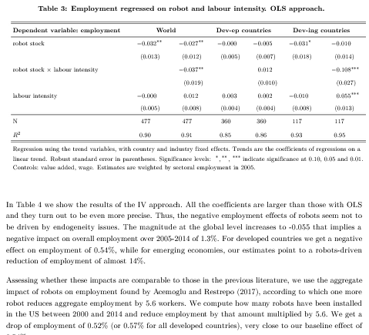
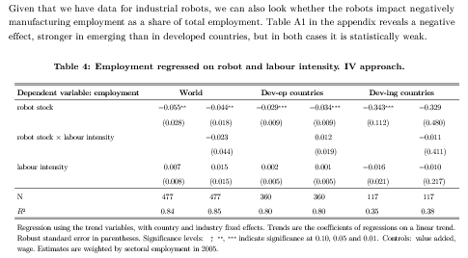

Solutions and Conclusion
In terms of solutions, the obvious solution is to upscale to the future workforce with the skills to build and maintain the machines/robots that are replacing/augmenting jobs in other sectors, coding in various fashions was already making it’s way onto the school and college curriculum as far back as 2014¹⁴ and this should only expand in coming years with complexity of AI and computing applications only increasing.
Other possible ways to help this issue is to introduce more ways for AI and human to collaborate on a job or issue, rather than entirely hand it over to the machine, where I have spoken about AI art earlier in this report is an example of this as the AI can create the prompts for the artist to modify into a finished product.
In this same vein CAD design is also being improved with this use of AI¹³ leading to designers working from suggestions and prompts to improve the efficiency of the model being designed or to automatically check for errors quicker than a human brain and eye could.
In the long run, AI and automation is here to stay and is only going to increase in use in coming years, based on the statistics above, it seems that overall humanity is not being massively impacted at the moment by the “Rise of the machines” and will continue to change and adapt to a world in which robots are completing more and more tasks by themselves. It could eventually lead to humanity as a whole concentrating on the more enjoyable things in life and leaving the graft of hard work to the robots, though this main seem like a dystopian nightmare to some and a pipe dream to others, there are definitely changes to come in the next decade and it seems we have only seen the tip of the iceburg in recent years.

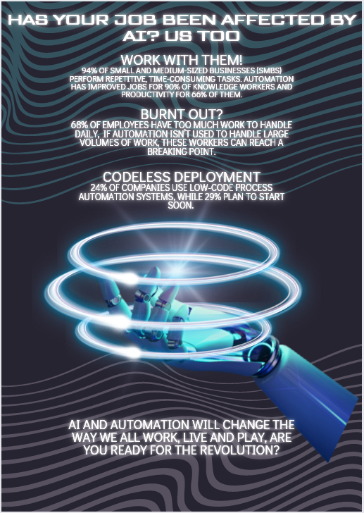

References
- M. Webster, “Automation definition & meaning,” Merriam-Webster. [Online]. Available: https://www.merriam-webster.com/dictionary/automation. [Accessed: 21-Feb-2023].
- “What is automation?,” IBM. [Online]. Available: https://www.ibm.com/uk-en/topics/automation. [Accessed: 23-Feb-2023].
- K. Casey, “How to explain robotic process automation (RPA) in plain english,” The Enterprisers Project, 30-Jul-2020. [Online]. Available: https://enterprisersproject.com/article/2019/5/rpa-robotic-process-automation-how-explain. [Accessed: 23-Feb-2023].
- T. Rausch, “7 steps to successful process automation,” BOC-Group, 26-Jan-2023. [Online]. Available: https://www.boc-group.com/en/7-steps-to-successful-process-automation/. [Accessed: 23-Feb-2023].
- S. Ashraf, “Data Integration Automation – how to do it right?,” Data Integration Blog, 04-Aug-2020. [Online]. Available: https://dataintegrationinfo.com/data-integration-automation/. [Accessed: 23-Feb-2023].
- E. K. Chiou and J. D. Lee, “Trusting automation: Designing for responsivity and resilience,” Trusting Automation: Designing for Responsivity and Resilience, 27-Apr-2021. [Online]. Available: https://journals.sagepub.com/doi/full/10.1177/00187208211009995. [Accessed: 23-Feb-2023].
- A. Munro and E. Rodriguez, “Advantages and disadvantages of automation,” Disintermediation: A Disaster or a Discipline?, 17-May-2016. [Online]. Available: https://www.britannica.com/technology/automation/Advantages-and-disadvantages-of-automation. [Accessed: 23-Feb-2023].
- W. Baker, “Ai in art,” Canterbury AI, 18-Nov-2022. [Online]. Available: https://canterbury.ai/ai-in-art/. [Accessed: 23-Feb-2023].
- Dazed (2021) Most people can't distinguish between AI and human art, says a new study, Dazed. Available at: https://www.dazeddigital.com/art-photography/article/52030/1/people-cant-distinguish-between-ai-artificial-intelligence-human-art-new-study (Accessed: March 1, 2023).
- G. Scott, “Dangerous workplace? robots are here to help! - news,” Dangerous Workplace? Robots are here to help!, 21-Aug-2022. [Online]. Available: https://control.com/news/dangerous-workplace-robots-are-here-to-help/. [Accessed: 02-Mar-2023].
- K. N. Smith, “The canary in the coal mine isn't ancient history,” Forbes, 07-Jan-2020. [Online]. Available: https://www.forbes.com/sites/kionasmith/2019/12/31/the-canary-in-the-coal-mine-isnt-ancient-history/?sh=2ffcffb44393. [Accessed: 02-Mar-2023].
- F. Carbonero and E. Ernst, “Robots worldwide: The impact of automation on Employment and Trade,” Robots worldwide: The impact of automation on employment and trade, Oct-2018. [Online]. Available: https://www.researchgate.net/publication/328571605_Robots_worldwide_The_impact_of_automation_on_employment_and_trade. [Accessed: 02-Mar-2023].
- “Relevance of AI in Computer-Aided Design,” Software Solutions Studio, 25-Feb-2023. [Online]. Available: https://softwaresim.com/blog/relevance-of-ai-in-computer-aided-design/. [Accessed: 02-Mar-2023].
- S. Dredge, “Coding at school: A parent's guide to england's new computing curriculum,” The Guardian, 04-Sep-2014. [Online]. Available: https://www.theguardian.com/technology/2014/sep/04/coding-school-computing-children-programming. [Accessed: 02-Mar-2023].

