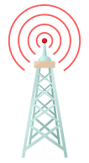  Simulation of Digital Modulation Techniques | Mr George Lincoln Atkins  Digital Signal Processing & Communications

Contents
Introduction 2
Background Information 2
Simulation Models 4
ASK Model 4
PSK Model 5
QPSK Model 6
Results of Simulation 6
ASK Results 6
PSK Results 7
QPSK Results 8
Discussion of Results 9
References 10

Figure 1 Example Noise Signal 3
Figure 2 Examples of Modulation 4
Figure 3 ASK Simulink Model 5
Figure 4 PSK Simulink Model 5
Figure 5 QPSK Simulink Model 6
Figure 7 Graph of ASK Results 7
Figure 8 Graph of PSK Results 8
Figure 9 Graph of QPSK Results 9

Table 1 ASK Results 7
Table 2 PSK Results 8

Introduction
The aim of this assignment is to critically compare the performances of variants of amplitude shift keying (ASK) and phase shift keying (PSK) in the presence of Additive White Gaussian Noise (AWGN).

Simulink shall be used to construct four methods of shift keying. For each method the demodulated data shall be compared with the source data to calculate the Bit Error Rate (BER). A number of simulations for each method shall be performed, firstly with no noise and then with gradually increasing levels of AWGN until system failure occurs. The BER shall be measured and graphs of BER against signal to noise ratio of the channel will be produced, allowing direct comparison between the four methods. [1] The methods which will be used are:
- Amplitude Shift Keying (ASK)
- Phase Shift Keying (PSK)
- Quadrature Phase Shift Keying (QPSK)
- Quadrature Amplitude Modulation (QAM)

Background Information
Data is transmitted in all facets of modern society, whether that is one chip on a circuit board communicating with an adjacent chip, a mobile phone call or even a guidance system on a complex weapon system. This report is concerned with digital signals, Wikipedia defines a digital signal as “a signal that is being used to represent data as a sequence of discrete values; at any given time it can only take on, at most, one of a finite number of values.” [2] It is important that the data which one sends, is what is received, otherwise there isn’t much point in sending it and the outcomes from receiving incorrect data can be catastrophic.

In order to increase the chance of receiving what was sent without corruption, digital modulation is used. In Chapter 7 of High-Performance Communication Networks (Second Edition) Jean Walrand and Pravin Varaiya define digital modulation as “the process of encoding a digital information signal into the amplitude, phase, or frequency of the transmitted signal. The encoding process affects the bandwidth of the transmitted signal and its robustness to channel impairments.” [3]

These channel impairments mentioned in the extract above normally manifest in the real world as what is known as noise. Online learning tool “tutorialspoint” gives the following definition of noise. “Noise is an unwanted signal which interferes with the original message signal and corrupts the parameters of the message signal. This alteration in the communication process, leads to the message getting altered. It is most likely to be entered at the channel or the receiver.”

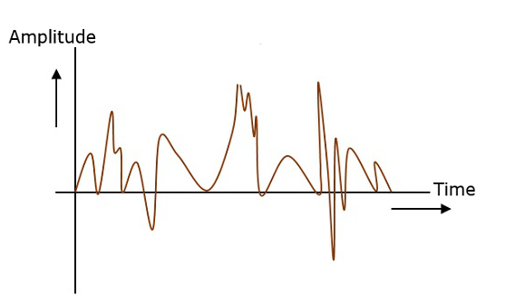
Figure 1 Example Noise Signal

“Noise is some signal which has no pattern and no constant frequency or amplitude. It is quite random and unpredictable. Measures are usually taken to reduce it, though it can’t be completely eliminated.” [4] Essentially, noise muddies the waters of what is trying to be communicated, much like the static experienced when using radios or telephones with patchy signal, as such, it is the aim of the communications engineer to either remove noise, or minimise its impact on the data that is being transmitted.

According to Encyclopedia Britannica there are three methods of digital signal modulation. This report is only concerned with the two previously mentioned. But all shall be included in this section for completeness.

“A digital signal, representing the binary digits 0 and 1 by a series of on and off amplitudes, is impressed onto an analog carrier wave of constant amplitude and frequency. In amplitude-shift keying (ASK), the modulated wave represents the series of bits by shifting abruptly between high and low amplitude. In frequency-shift keying (FSK), the bit stream is represented by shifts between two frequencies. In phase-shift keying (PSK), amplitude and frequency remain constant; the bit stream is represented by shifts in the phase of the modulated signal.” [5]
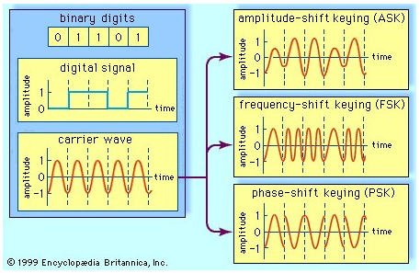
Figure 2 Examples of Modulation

Once the signal has been modulated at the source and transmitted, it needs to be demodulated at the receiving end so that the original signal can be read. Depending on the method of modulation used, obviously the method of demodulation must be changed to suit.

Simulation Models
This section of the report shall give a brief explanation of each modulation technique and an image of them constructed using the Simulink package within MATLAB software.

ASK Model
Encyclopedia Britannica states that “ASK can be considered a digital version of analog amplitude modulation. In its simplest form, a burst of radio frequency is transmitted only when a binary 1 appears and is stopped when a 0 appears. In another variation, the 0 and 1 are represented in the modulated signal by a shift between two preselected amplitudes.” [6] This can be seen in figure 2. When the digital signal is of amplitude 1, the combined carrier wave and digital signal has an amplitude of 1/-1 as well. When the digital signal is of amplitude 0, the combined carrier wave and digital signal has an amplitude of 0.5/-0.5.

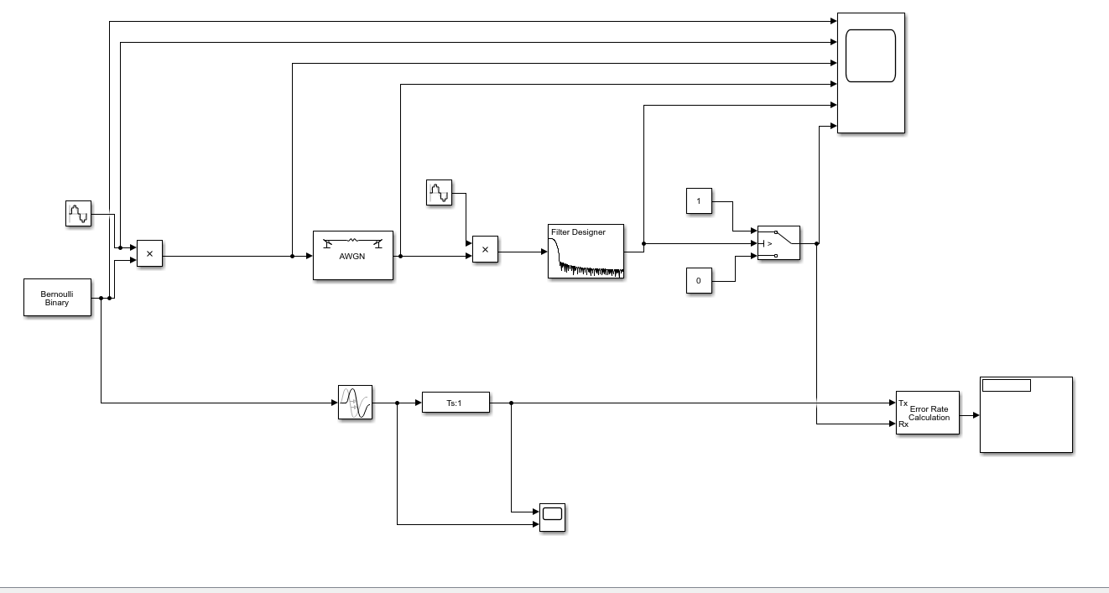
Figure 3 ASK Simulink Model

PSK Model
Encyclopedia Britannica states that “In the simplest form of PSK a single radio frequency carrier is sent with a fixed phase to represent a 0 and with a 180° phase shift—that is, with the opposite polarity—to represent a 1.” [6] This can be seen in figure 2. When the digital signal changes from 0 to 1, the phase of the combined carrier wave and digital signal shifts by 180°, this happens every time the signal switches from a 1 to a 0 and vice-versa.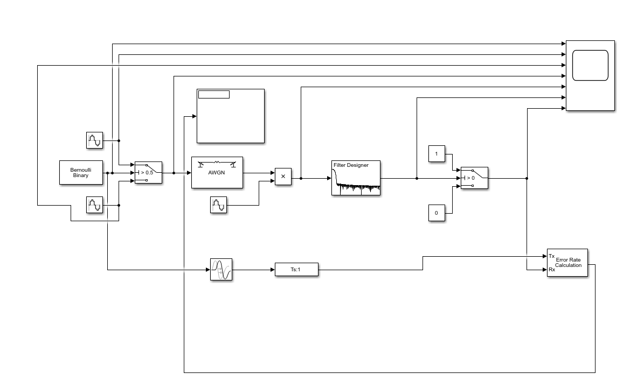
Figure 4 PSK Simulink Model

QPSK Model
Maximum Integrated gives the following definition for QPSK “Quadrature Phase Shift Keying is a form of Phase Shift Keying in which two bits are modulated at once, selecting one of four possible carrier phase shifts (0, 90, 180, or 270 degrees). QPSK allows the signal to carry twice as much information as ordinary PSK using the same bandwidth.” [7]

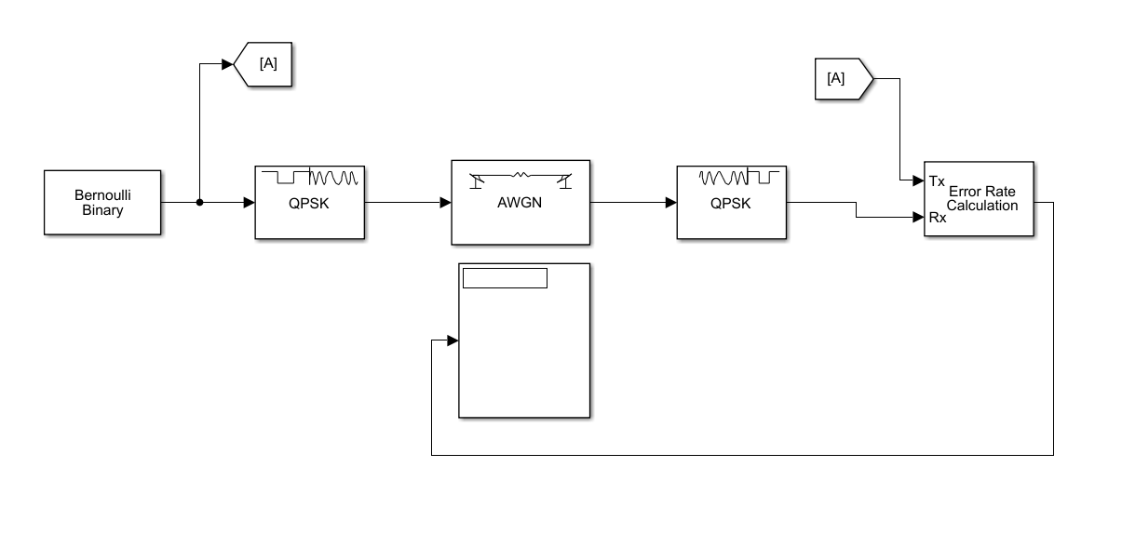
Figure 5 QPSK Simulink Model

Results of Simulation

ASK Results
The results for the ASK modulation technique are shown below in table 1. A graph for these results is produced in figure 7.

Table 1 ASK Results
Signal to Noise Ratio | Test 1 BER | Test 2 BER | Test 3 BER | Mean BER | Standard Deviation
5 | 0.4208 | 0.4222 | 0.4216 | 0.422 | 0.0007
2.5 | 0.4335 | 0.428 | 0.428 | 0.430 | 0.0032
0 | 0.4406 | 0.4398 | 0.4399 | 0.440 | 0.0004
-2.5 | 0.4547 | 0.4543 | 0.4542 | 0.454 | 0.0003
-5 | 0.4821 | 0.4826 | 0.4821 | 0.482 | 0.0003
-7.5 | 0.5085 | 0.5087 | 0.5081 | 0.508 | 0.0003
-10 | 0.5363 | 0.536 | 0.5354 | 0.536 | 0.0005
-12.5 | 0.5612 | 0.5636 | 0.5618 | 0.562 | 0.0012
-15 | 0.5868 | 0.5866 | 0.5863 | 0.587 | 0.0003
-17.5 | 0.6027 | 0.6027 | 0.6058 | 0.604 | 0.0018
-20 | 0.6199 | 0.6195 | 0.6189 | 0.619 | 0.0005
-22.5 | 0.6318 | 0.6305 | 0.6321 | 0.631 | 0.0009
-25 | 0.6399 | 0.6419 | 0.6389 | 0.640 | 0.0015
-30 | 0.6535 | 0.6518 | 0.6517 | 0.652 | 0.0010
-35 | 0.6587 | 0.6598 | 0.6593 | 0.659 | 0.0006
-40 | 0.6632 | 0.6644 | 0.664 | 0.664 | 0.0006

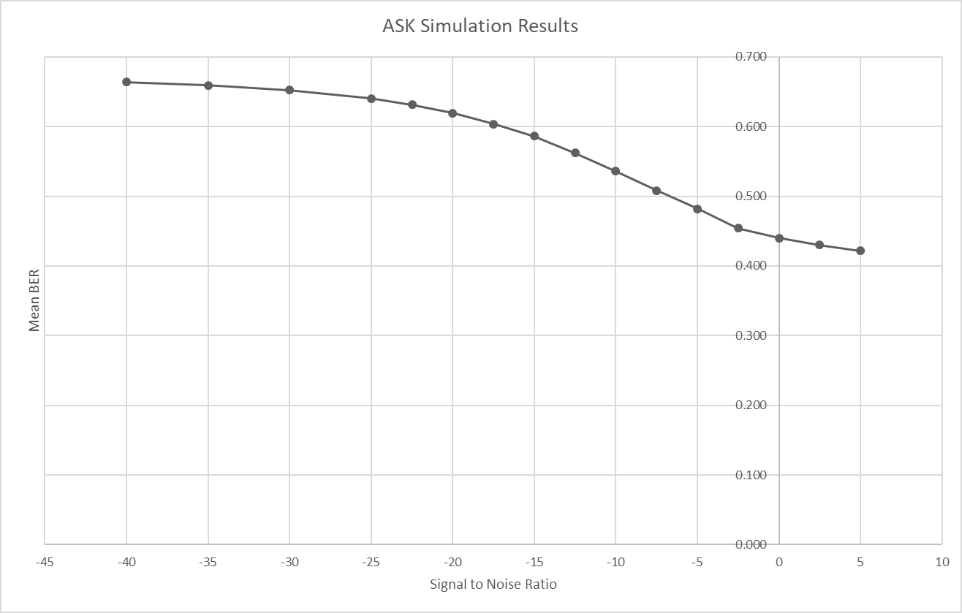
Figure 6 Graph of ASK Results

PSK Results
The results for the PSK modulation technique are shown below in table 2. A graph for these results is produced in figure 8.

Table 2 PSK Results
Signal to Noise Ratio | Test 1 BER | Test 2 BER | Test 3 BER | Mean BER | Standard Deviation
5 | 0.7832 | 0.7815 | 0.7826 | 0.782 | 0.0009
2.5 | 0.7835 | 0.7837 | 0.7851 | 0.784 | 0.0009
0 | 0.7858 | 0.7866 | 0.7869 | 0.786 | 0.0006
-2.5 | 0.792 | 0.7924 | 0.7921 | 0.792 | 0.0002
-5 | 0.8014 | 0.7999 | 0.8013 | 0.801 | 0.0008
-7.5 | 0.8151 | 0.8135 | 0.8141 | 0.814 | 0.0008
-10 | 0.833 | 0.8325 | 0.8324 | 0.833 | 0.0003
-12.5 | 0.857 | 0.8562 | 0.8566 | 0.857 | 0.0004
-15 | 0.8865 | 0.8844 | 0.8865 | 0.886 | 0.0012
-17.5 | 0.9157 | 0.9137 | 0.9147 | 0.915 | 0.0010
-20 | 0.9389 | 0.9396 | 0.9382 | 0.939 | 0.0007
-22.5 | 0.9607 | 0.9595 | 0.9619 | 0.961 | 0.0012
-25 | 0.9789 | 0.9781 | 0.9787 | 0.979 | 0.0004
-30 | 1.002 | 1.0011 | 0.9997 | 1.001 | 0.0012
-35 | 1.0134 | 1.0156 | 1.0148 | 1.015 | 0.0011
-40 | 0.6632 | 0.6644 | 0.664 | 0.664 | 0.0006

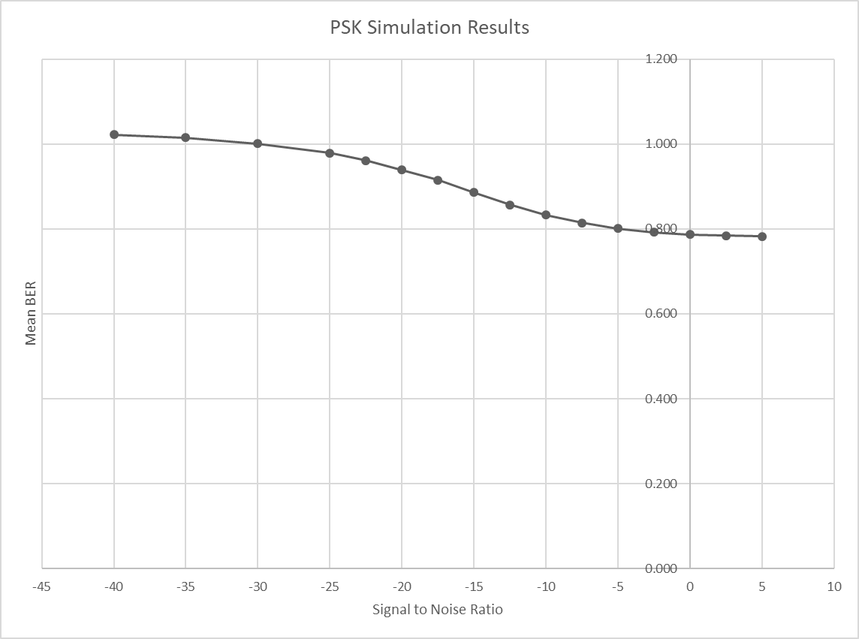
Figure 7 Graph of PSK Results

QPSK Results
The results for the QPSK modulation technique are shown below in table 3. A graph for these results is produced in figure 9.

Table 3 QPSK Results
Signal to Noise Ratio | Test 1 BER | Test 2 BER | Test 3 BER | Mean BER | Standard Deviation
5 | 0.1408 | 0.2788 | 0.2443 | 0.221 | 0.072
2.5 | 0.3133 | 0.211 | 0.2788 | 0.268 | 0.052
0 | 0.3822 | 0.2788 | 0.2788 | 0.313 | 0.060
-2.5 | 0.3822 | 0.3133 | 0.2788 | 0.325 | 0.053
-5 | 0.3133 | 0.3477 | 0.3133 | 0.325 | 0.020
-7.5 | 0.3822 | 0.4512 | 0.2098 | 0.348 | 0.124
-10 | 0.2098 | 0.4167 | 0.2443 | 0.290 | 0.111
-12.5 | 0.3477 | 0.2788 | 0.5202 | 0.382 | 0.124
-15 | 0.2788 | 0.2443 | 0.3822 | 0.302 | 0.072
-17.5 | 0.3822 | 0.3822 | 0.2443 | 0.336 | 0.080
-20 | 0.4167 | 0.4857 | 0.3822 | 0.428 | 0.053
-22.5 | 0.4512 | 0.5202 | 0.5891 | 0.520 | 0.069
-25 | 0.5202 | 0.4167 | 0.4512 | 0.463 | 0.053
-30 | 0.5202 | 0.4512 | 0.5202 | 0.497 | 0.040
-35 | 0.3477 | 0.6236 | 0.4512 | 0.474 | 0.139
-40 | 0.5891 | 0.6236 | 0.5546 | 0.589 | 0.035

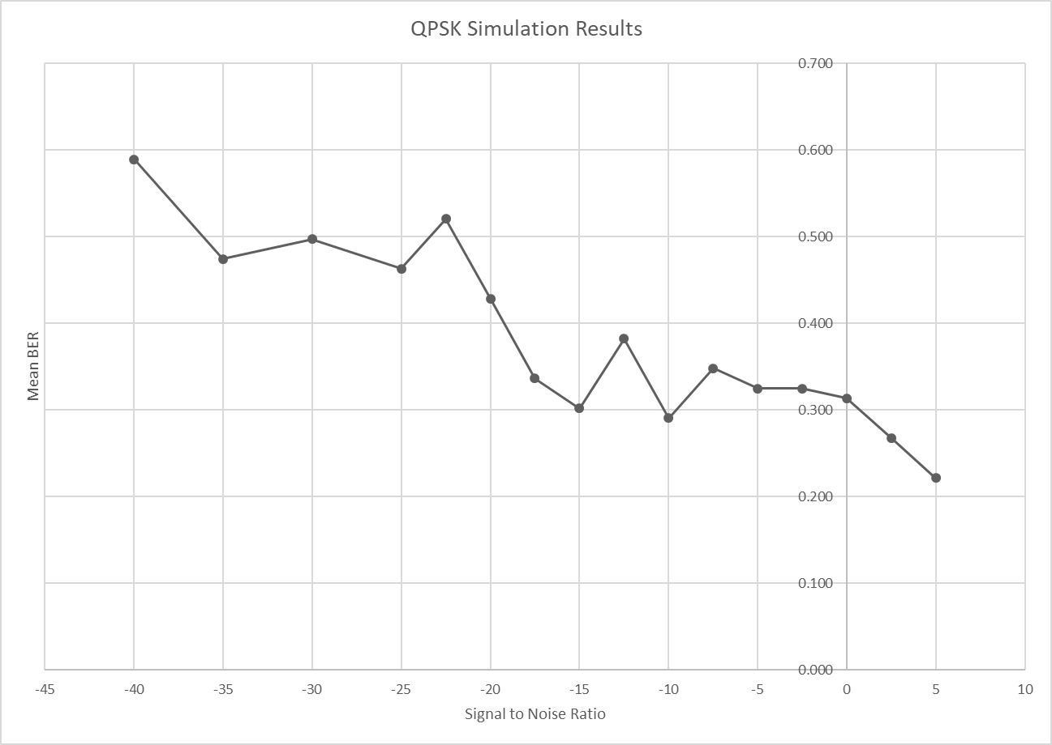
Figure 8 Graph of QPSK Results

Discussion of Results
Figure 9 below shows the results of each of the simulations plotted next to each other on the same axis. ASK in yellow, PSK in red and QPSK in green.

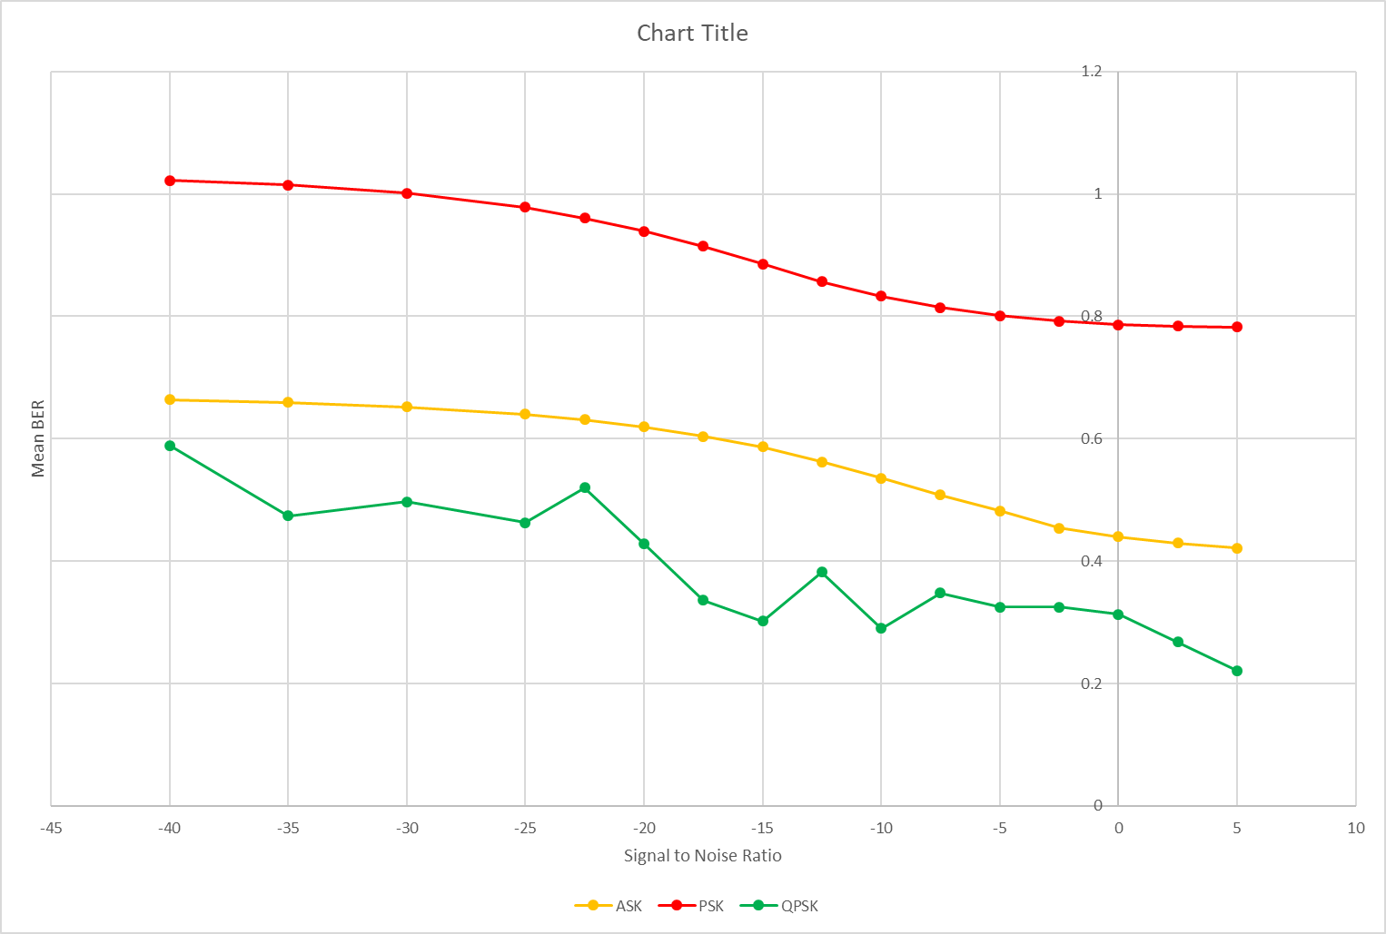
Figure 9 Results Comparison

The simulation of the various methods of modulation and demodulation demonstrate that the PSK had the highest Bit Error Rate through all signal to noise ratios tested. Followed by ASK having the next lowest and QPSK performing the best out of the 3. Therefore, QPSK systems should be used when transmitting important data. The other, simpler systems would be suitable if the data isn’t so important, or an in low noise environments.

References

[1] | S. Mosey, Simulation of Digital Modulation Techniques Assignemnt Specification, Swansea: UWTSD, 2021.
[2] | [Online]. Available: https://en.wikipedia.org/wiki/Digital_signal#:~:text=A%20digital%20signal%20is%20a,a%20finite%20number%20of%20values..
[3] | J. Walrand and P. Varaiya, "Wireless Networks," in High-Performance Communication Networks (Second Edition),, Berkeley, University of California, 2000, pp. 305-306.
[4] | [Online]. Available: https://www.tutorialspoint.com/principles_of_communication/principles_of_communication_noise.htm#:~:text=Noise%20is%20an%20unwanted%20signal,the%20channel%20or%20the%20receiver.&text=Flicker%20in%20television%20receivers%2C%20etc..
[5] | [Online]. Available: https://www.britannica.com/technology/digital-signal-modulation.
[6] | [Online]. Available: https://www.britannica.com/technology/telecommunication/Modulation#ref608218.
[7] | [Online]. Available: https://www.maximintegrated.com/en/glossary/definitions.mvp/term/QPSK/gpk/244#:~:text=Quadrature%20Phase%20Shift%20Keying%20(QPSK,PSK%20using%20the%20same%20bandwidth..

