Advanced Manufacturing Operations / Engineering Management
L4 – Quality & Business Improvements
ACMA4004
Quality Tools & Root Cause analysis
Aroon Kanda- 2020216

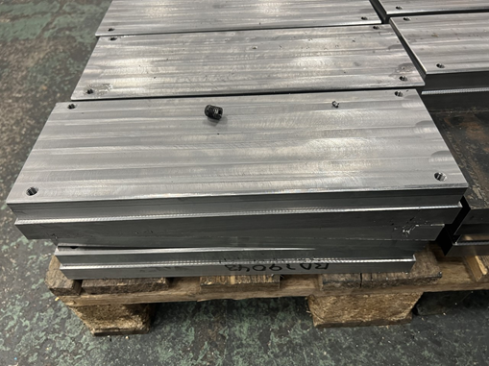
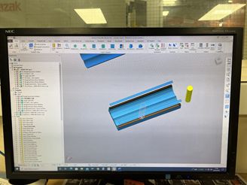

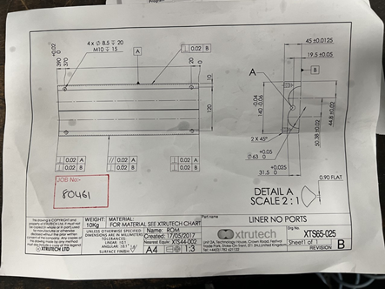
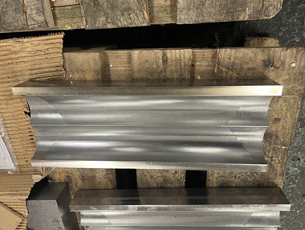

Contents page

Page 1- cover page
Page 2- contents page
Page 3- introduction
Page 4- data collection
Page 5- data analysis
Page 5-7- route cause analysis
Page 8-9- action plan

Introduction
This reason for this report is to create an improvement plan for a selected process, application or operation, the problem needs to have come from our work place. At FSG manufacturing is the most important aspect to the company as its where it makes all of its income from. One of the companies that FSG manufacture for is called Xtrutech and FSG make various parts for them but this report is going to be based on the machining process for the liners that FSG make for them. These parts are running at FSG nonstop and they will continue to be run like this as the customer needs large amounts of them very frequently made from clamax which is a very hard material so it creates a lot of problems with tooling being worn and the time taken to machine it, but the problem with the actual process is how long it’s taking to complete it. The layout of this report will be identification of a problem, data collection (graph and charts), data analysis, and an action plan.

Data collection

This graph shows how many parts were made in the space of 24hrs using the old method and the new method, as you can see it is significantly more with the updated method due to the fact that the time taken to do the process had been decreased and new cutters had been introduced
Tally charts showing the life of the tools for old process and new process
Before
Tool | How many parts it completed before breaking
AJX 32 mm | i
VPX | iii
Moldino 20 mm | iii
Moldino 10 | ii
Ball nose 16 | iii

Tool | How many parts it completed before breaking
AJX 32 mm | iii
VPX | iiiii
Moldino 20 mm | iiii
Moldino 10 | iiii
Ball nose 16 | iii
63 WSX | iiiii

After

Data analysis
the problem that has caused this process to be re evaluated is it was taking too long to machine the parts and the tools were unable to complete multiple parts before being unusable, the reason why this was happening is because the tools were being set on toolpaths that they were not meant to do and taking way too big of a cut at the wrong speeds and feeds this was then resulting in the time the machine was stopped to almost double as the part would need to be checked and multiple tools need to be changed and the re set up in the machine, in the graph you can see that the old process was taking about 2.5 hours to make the part and the time taken to check and load the next part up as well. Then in the new process you can see that the time it takes for the part to be machined is almost halved, obviously the set-up time and time taken to measure the part can’t be reduced but the machining cycles had been changed. One other thing I did collect for my data collection was a how many parts each tool could do before becoming unusable, I made it clear in 2 different tally charts labelled before and after they showed how many parts were made from each tool this then allowed us to see which tools were being over worked and allowed us to alter the CAM program to produce a more efficient way of machining

Root cause analysis
What is a root cause analysis? A root cause analysis is used to identify where problems stared off and that allows us to go to the root of the problem and resolve it. There are some methods that we use to get to these problems and they are the 5 whys? What this means is you keep asking why something happened until you get the original problem and from there you can ensure that the same problems don’t repeat themselves. Another method of doing this is the 5 M’s which involves looking through all the components used which is the machine, method, material, man power, measurement. Both of these will be included into my root cause analysis just so it confirms that both of these methods find the actual root cause of the problem.
5 m’s analysis
Machine-
Cause- of this problem is that the tips on the cutters were wearing down way too quickly which then meant the company had to pay for more tips to be brought in which was then meaning the company was spending large amount of money on tips.
Cause- tools were running on the wrong tool path that was putting the cutter under more pressure which was resulting in the tips being damaged and unable to use them for other parts.
Method-
Cause- the way the parts had been programmed was wrong as it was making cutter designed for face milling cutting do the outside profile of the job which in result was smashing the tips up.
Cause- the reason this programming issue had occurred was the person who had programmed it was used to doing the finishing op when these parts were hardened so when they saw one tool roughing the majority of it they didn’t see it as an issue.
Cause- the speeds and feeds had been set wrong by the programmer as well which resulted in the tips being destroyed and more money being wasted.

Material –
The material in this case wasn’t an issue, bearing in mind it was a very hard material but it did not cause any issues to the process the issue was the speeds and feeds were set wrong which then made the material wear the tips down quicker resulting in the tips being unusable.

Man power-
Cause- the reason that parts were run off in this method is that it was started on an afternoon shift where the machines were set up and just run off, the operators weren’t looking to have it running at peak performance they just wanted to have the machines up and running for the shift and due to this more tips were wasted due to the fact the program was wrong and no one on the shift had the ability to mend it as all the shift managers were on days and the parts were being run on afternoons.

Measurement and medium
For this process there was no problem with the measurement of these parts it was more due to the actual way the part had been machined so this did not come up as an issue that needed to be resolved.
Analysis
This has shown me that the problem all started with the programming error that the programmer made while completing this job as all the issues directly point back to what they did, for example the tips were worn due to the speeds being wrong which is something the programmer should of set same again for the tooling and also the tool paths and depth of cuts.

5 y’s analysis
The problem that I have decided to do this report on is about the machining time and the tool waste produced by making the liners for Xtrutech which is a company that FSG tool and die manufacture parts for. The problem was the parts were taking too long to machine and the tools that were being used were being damaged as one tool had melted and the others all had the tips deemed unusable and when issues like this start happening it starts to get notified because these parts if they continue to be machined like this it would be the company would make less profit from each part due to the fact so much tooling had been used to make each part. The reason that the tools were getting damaged so frequently was due to a programming error that someone had made while doing it and this was inputting the wrong speeds and feeds and using expensive tools to complete tool paths that the tools were not designed to do.
Why did this problem occur?
It occurred because the programmer didn’t use the right tools, the right step-downs, the right speeds and feeds, or taken into account what material they were machining.
Why did they do that?
they did this because they didn’t know what material they were cutting because they had not checked the drawing, they chose the wrong tool because they had not read the tooling handbook that explains exactly what the tool is able to do it also tells you what step-downs you should use for the material that it is machining.
Why did they do this?
They did this because they are an experienced machinist that has had multiple years to work on their skills unfortunately that lead them to program this job inefficiently which lead to tools being damaged and the part time to be extended by an hour.

Action plan
The action plan that we came up with to rectify this process was not a short job it took quite a lot of time and effort from multiple parties such as our tooling expert from Mitsubishi, multiple team leaders and also skilled men on the section, the first step to this process was consulting our team leader saying that the process was not efficient and tips keep breaking, we were then given the opportunity to edit the program to shorten the length of it to do this we consulted our tool expert and he recommended tools that we should swap out that are made to do the processes were asking it to do, we had many trials to see how it cuts, for example we ran one part off just to get the speeds and feeds right, we did another part with just depth of cut but our main improvement was adding a 63 WPX which then relieved one of the cutters that was doing way too much on this process, I took photos of the set ups sheets before and on one tool which was the wrong tool for the process it was doing a 20 minute cut which was basically destroying the tips because again the feeds and speeds were wrong. After multiple trial cuts and different tool paths we were able to change the time from 2 hours to 1 hour which when your doing large batches of parts makes so much different over 40 parts
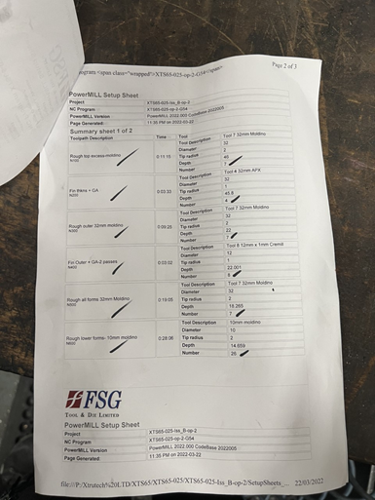
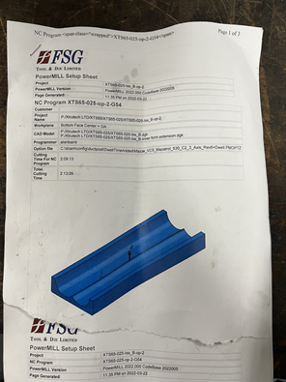
Old set up sheet

As you can see these sheets are showing all of the processes that were on the old program and if you look closely you can see that the 10 moldino is doing a lot of the work which is why the tips were going so quickly so that was another key thing that was needed to be changed.

New set up sheet
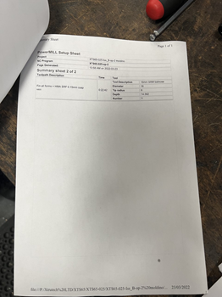
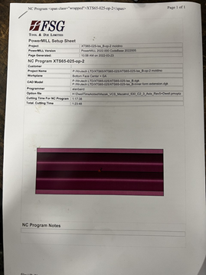
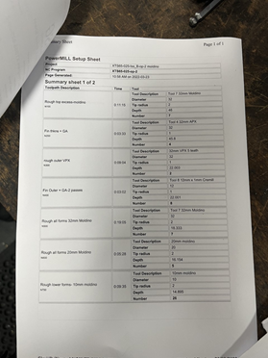

Looking at these set up sheets you can see that the processes look so much more efficient just because there isn’t one that’s doing the biggest roughing process the work is distributed across a selection of tools, just to note the last process is the semi finishing one which is why it is considerably longer than the other one but because the speeds and feeds were altered it gives the tool a longer life.

