

University of Wales Trinity Saint David

School of Engineering

Analysis and Simulation of a Centrifugal Clutch

Kyle Edward Evans

2029909

Mechanical and Manufacturing Engineering

05/11/2023

ACMA5010 – Stress Analysis and Dynamics

Executive Summary
This technical report aims to achieve two tasks; the first will be a descriptive task regarding the development and applications of the centrifugal clutch, while the second is analytical and seeks to solve a series of calculations regarding given clutch specifications. It achieves these tasks by first researching the early history of the centrifugal clutch and its core principles and functionality and comparing it with one of the modern days to identify the similarities. After gaining a better understanding of the topic, a detailed look into the workings of the second task is available in the second half of this report.

While there have been recent developments and research regarding the design and materials of the centrifugal clutch, the core concepts remain intact. However, it is unsuitable for tasks that call for instantaneous engagement and high torque due to its tendency to slip. Instead, applications requiring these qualities use alternative clutches like the toothed electromagnetic clutch. The analytical portion shows that as the coefficient friction of the clutch and shoe face materials increase, so does its ability to transmit torque, as is graphically demonstrated towards the end of this report.

Table of Contents
Executive Summary 1
Task A – Development and Applications of the Centrifugal Clutch 4
Introduction 4
History and Development of the Centrifugal Clutch 4
Material Innovations in Friction Clutch Design 5
Typical Applications and Operating Conditions 6
Applications of the Electromagnetic Clutch 6
Conclusion 7
Task B – Analysis of a Centrifugal Clutch 8
Introduction 8
Calculation Tasks 8
1) What is the Outer Drum Diameter? 8
2) Engagement Speed to the Nearest Whole RPM 8
3) Radial Force Acting on the Clutch Face When the Driving Shaft is Rotating at 550 RPM 9
4) Torque Transmitted to the Driven Shaft When the Driving Shaft is Rotating at 550 RPM 9
5) Transmitted Torque Against Driving Shaft Speed Graph in 25 RPM Increments 10
6) Effects of Friction on Transmitted Torque with Coefficient of Friction at 0.3 and 0.4 10
7) Angular Acceleration with a Drum Mass of 750 g while Transmitting Maximum Torque 11
Bibliography 12

Figure 1 Example of a centrifugal clutch (Author’s own photograph) 4
Figure 2 Patent for a centrifugal clutch (Bartmess, 1916) 5
Figure 3 Conveyor belt using electromagnetic clutches (Miki Pulley, 2023) 7
Figure 4 Graph showing transmitted torque against driving shaft speed (Created by the author) 10
Figure 5 Graph on the effects of friction on transmitted torque (Created by the author) 11

Task A – Development and Applications of the Centrifugal Clutch

Introduction
When mechanical engineers approach a mechanical design project, they may encounter situations where rotary input and output shafts must be able to disengage and re-engage at will or when achieving certain conditions. This statement is especially true when discussing manufacturing machinery and automobiles that call for changing gears and disconnecting wheels when stationary without turning off the engine (Tridgell, 1969; Magik Marks, 2014; Moseman, 2018). As such, this report aims to review the design, development, and applications of a friction clutch that relies on centrifugal forces, ending with a reflection on the uses of electromagnetic clutches in modern manufacturing industries.

History and Development of the Centrifugal Clutch
Historically, the centrifugal clutch has been used in some form since the late 1800s, with Crowdus (1898) discussing using a centrifugally actuated friction clutch in his patent of improvements for motorcycles. Since then, the United States Patent Office has granted several patents seeking to improve the mechanism further, like those of Bartmess (1916), Newton (1937), and Brown and Mitchell (1980). Despite these improvements, the core functionality of the clutch remains the same by leveraging the principle of centrifugal force. Figure 1 features an example of a small centrifugal clutch, likely from a miniature motorbike or small quad bike, labelled using information sourced from Engineering Explained (2015), Skill Lync (2020), and MechStudies (2023). Note that the clutch would typically be keyed to the input shaft and housed within a drum connecting to the output shaft to prevent independent rotation.

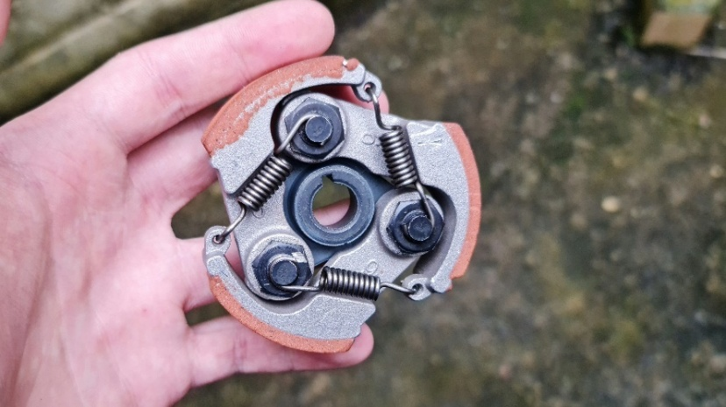
Clutch Shoe
Friction Lining
Extension Spring
Shoulder Screw
Figure 1 Example of a centrifugal clutch (Author’s own photograph)

The shoe clutches are held in place by the shoulder screws, pinning them in place while allowing for rotational movement. For the clutch to transmit torque, the centrifugal force must overcome the spring forces restricting their action for the clutch shoes to expand and apply friction to a drum (Amsbeck, 2023). By varying these elements, along with the number of shoes and size of the unit, the maximum transmittable torque is adjustable to suit the design requirements. These principles have remained mainly unchanged, with earlier patents like that of Crowdus (1989) describing a centrifugally actuated friction clutch that does not actuate before achieving a pre-determined speed.

To better illustrate the similarities between modern clutches and the earlier designs, Figure 2 is an extract from a 1916 patent offering improvements to existing centrifugal clutches of the time (Bartmess, 1916). While there are earlier examples, this one is fascinating in comparison to the motorcycle clutch in the above photograph. The only visible differences are the number of clutch shoes, layout, and assembly method. Functionally, it will likely behave very similarly, where the clutch shoes pivot and engage the outer drum to transmit torque upon exceeding the engagement speed. Meanwhile, the extension springs provide the resisting force to pull the shoes back to rest and allow for adjustability to the engagement speed.

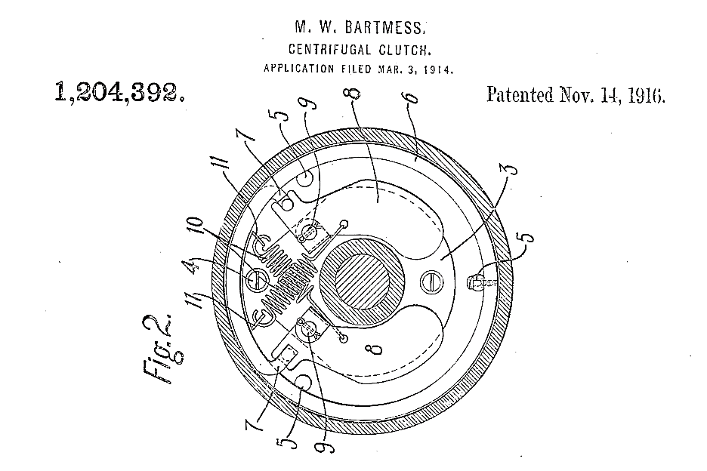
Figure 2 Patent for a centrifugal clutch (Bartmess, 1916)

Material Innovations in Friction Clutch Design
While the fundamental principles of centrifugal clutches are primarily unchanged, recent advancements in manufacturing technologies have spurred designers to experiment with novel designs, benefitting from additive manufacturing and electrical discharge machining. Researchers Crane (1999) and Pon (2023) focus on how compliant mechanisms can reduce part counts by consolidating the hub, shoes, and springs into a single component using flexural hinges. Part consolidation can produce assemblies that are cheaper, less labour-intensive, and lighter, thanks to additive manufacturing (Peels, 2021; Schwaar and Newton, 2022).

Traditionally, centrifugal clutches will utilise materials with a higher coefficient of friction to coat the clutch face and shoes to improve torque transmission. Organic woven clutches are amongst the most popular as they provide a good balance of performance, cost, and durability (Phoenix Friction, 2023). Meanwhile, more exotic materials like ceramic are better in high-temperature environments through repeated engagement, like race events (McGee, 2022). There have been recent developments in this field, with Pon (2023) experimenting with polymers due to their mass-manufacturability and Kholil's (2022) research suggesting sustainable alternatives to clutch materials using coconut fibres and wood powder. However, none of these can match the wear resistance and quality of the original selections.

Typical Applications and Operating Conditions
Since these automatic clutches rely on centrifugal forces for engagement, they enable the use of low-torque motors by disengaging at low rpm and assist the startup by disconnecting the loaded driven shaft from the motor (MechStudies, 2023). Compared to alternative clutches, they require less maintenance due to their simple design, which needs no internal lubrication. For these reasons, manufacturers often install them on lawnmowers, chainsaws, and bikes (Engineering Explained, 2015; Garage 64, 2019). The limiting factors are due to the design relying on friction to drive the system, making it prone to slippage under heavy loads (Crane, 1999). Newton (1937) identifies one serious disadvantage as the core principle itself, that engagement is only achievable by driving the assembly, which carries the centrifugal elements, making them unsuitable for most automotive applications.

Despite these disadvantages, some still chose to install them in their vehicles since they were cheap and could prevent the vehicles from stalling due to drops in speed (Tridgell, 1969; Garage 64, 2019). These advantages have seen the clutch appear in several military applications in cooling towers, ventilation systems, and fighting vehicles (Butterfield, 1965; BLM Automatic Clutch, 2023). Dunstan (2019) describes the Panhard Armoured Car as utilising a novel centrifugal clutch, eliminating the need for a clutch pedal by automatically disengaging when the driver grips the gear lever, but does not discuss the details of its design. It may resemble the clutch patented by Brown and Mitchell (1980) that uses an electromagnetic coil to retract the clutch shoes and disengage the output from the input.

Applications of the Electromagnetic Clutch
Conceptually, electromagnetic clutches vary significantly from their centrifugally actuated counterpart and tend to be much more expensive due to their design complexity (Mechanicalfunda, 2019). The system relies upon an electrically generated magnetic field on the driving input to attract an adjacent flat spring connecting to the driven output (Shapiro, 2009; KEB America, 2015). Like the centrifugal clutch, both faces feature a friction lining to assist in torque transmission. As this does not rely on the clutch reaching a certain speed before engagement (Shapiro, 2019), the motor can run at a lower speed and engage electrically through a controller or the user's will through a control panel.

This clutch type is popular within the manufacturing sector, especially in applications that call for high cycle rates, like packaging and printing machines (JBJ Techniques Limited, 2023). Miki Pulley (2023) highlights its use on conveyor lines, as illustrated in Figure 3. This setup dramatically simplifies the layout as each conveyor operation can be independent from one another while sharing the same input shaft. In addition to the disk-type clutch, toothed clutches exist for high-torque applications like lathes and milling machines (JBJ Techniques Limited, 2023; Modimaz Engineers, 2023). Since some numerically controlled milling machines feature automatic tool changers and carousels, they benefit from being able to quickly disengage and brake before switching tool holders.
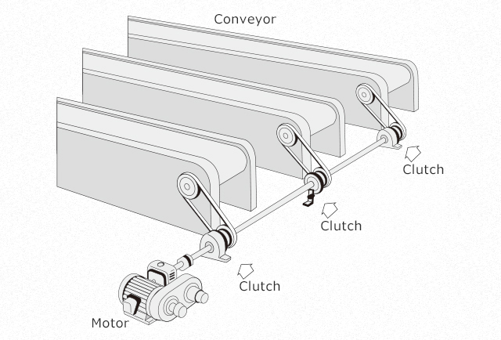
Figure 3 Conveyor belt using electromagnetic clutches (Miki Pulley, 2023)

Conclusion
Mechanical engineers have used the centrifugal clutch since the late 1800s to control rotary shafts and torque transmission in all designs, ranging from lawnmowers to the fighting tanks of Europe. While the core principles have remained unchanged, there have been some who seek more sustainable and mass-producible designs through additive manufacturing. Despite being an excellent option for low-cost applications with no-load startups, they can fall short when high-torques and near instantaneous engagements at low speeds are necessary. Instead, electromagnetic clutches might be more appropriate, but one must expect high initial costs and more frequent maintenance than its predecessor.

Task B – Analysis of a Centrifugal Clutch

Introduction
This section covers the analysis of a centrifugal clutch, as described by Task B of the assignment specification. Unlike the motorcycle clutch previously shown, this features four clutch shoes bound by springs and constrained to linear movements by a spider. The specification supplies the necessary dimensions, weights, and values to reference throughout the analysis. Since the task description does not specify the location of the centre of mass for the shoes, it is assumed to be at the end of the shoe to simplify the calculations. In the real world, mechanical engineers might take the time to find the exact centre of mass for accuracy, which is unnecessary for this task.

Calculation Tasks

1) What is the Outer Drum Diameter?
According to the assignment brief, the centre of mass for each shoe is at a radius of 95mm from the centre while at rest. Additionally, it has a 9mm clearance between the face of the shoe and the outer drum, which has a wall thickness of 4mm. Therefore, the answer will be the sum of these features multiplied by 2 to find the diameter.

$$Outer drum diameter=Outer Drum Radius×2 \\ Outer drum radius=95+9+4=108 mm \\ ∴Outer drum diameter=108×2=216 mm or 0.216 m$$

2) Engagement Speed to the Nearest Whole RPM
The known information allows the engagement speed to be determinable by using the formula for centrifugal force and equating it to the resisting force per the equilibrium conditions (Lee, Barkley, and Kang, 2011; BYJU’s, 2023). Since the engagement speed is when the shoe contacts the drum, the only resisting force to the centrifugal force is the spring linear mechanical spring with a stiffness of 7.5 kN/m. Lastly, the shoe mass is 275 g and is necessary for the following calculations.

$$Centrifugal force=mω^{2}r \\ Spring force=-kx \\ ∴kx=mω^{2}r$$
Now that there is an equation, the engagement speed is determinable by isolating and solving for the angular velocity (ω). The resulting value is in radians per second (rad/s) but can be converted and rounded to the nearest whole value in revolutions per minute (rpm) to satisfy the second task requirements. Since the following tasks assume the clutch transmits torque at 550 rpm, the engagement speed must be less.

$$ω=\sqrt{\frac{k×x}{m×r}} \\ ω=\sqrt{\frac{\left(7.5×{10}^{3}\right)×\left(9×{10}^{-3}\right)}{\left(275×{10}^{-3}\right)×\left(104×{10}^{-3}\right)}}=\sqrt{\frac{7500×0.009}{0.275×0.104}}=48.581 rad/s \\ ω=48.581×\left(\frac{60}{2π}\right)=463.917 rpm \\ ∴Engagement speed=464 rpm$$

3) Radial Force Acting on the Clutch Face When the Driving Shaft is Rotating at 550 RPM
Since the driving shaft rotates beyond the engagement speed, it makes direct contact with the clutch face and transmits torque. While the centrifugal force acts outwards, there must be a force acting in the opposite direction to maintain equilibrium. This force is known as the centripetal force and uses the same equation (Biggs and Lucas, 2022; Kahn Academy, 2023). However, this formula requires the angular velocity in radians per second.

$$ω=2π×\left(\frac{550}{60}\right)=57.596 rad/s$$
$$Centrifugal force=Centripetal force=mω^{2}r$$
$$F_{c}=\left(275×{10}^{-3}\right)×{(57.596)}^{2}×\left(104×{10}^{-3}\right)=0.275×3317.299×0.104=94.875 N$$
At this point, it is essential to realise that the spring force is also present and must be subtracted from the centripetal force to determine the radial forces. Since the centrifugal clutch utilises four independent clutch shoes, the net radial forces acting on the clutch face will equal the radial forces of one shoe multiplied by four.

$$Spring force=-kx=\left(7.5×{10}^{3}\right)×\left(9×{10}^{-3}\right)=7500×0.009=67.5 N \\ Radial force on one shoe=Centripetal force-Spring force \\ Radial force on one shoe=94.875-67.5=27.375 N \\ ∴Net radial forces=27.375×4=109.5 N$$

4) Torque Transmitted to the Driven Shaft When the Driving Shaft is Rotating at 550 RPM
Torque requires two values to be known, that is, the radius and the force. Centrifugal clutches transmit torque via frictional contact between the clutch shoes and drum interior (Lancereal, 2019); therefore, the formula will use the internal radius and frictional forces to find the torque. The frictional force will consist of the coefficient of friction, which is 0.35 and is unitless, and the net radial force of 109.5 N.

$$Frictional force=Coefficient of friction×Net radial forces \\ Frictional force=0.35×109.5=38.325 N \\ Torque=Internal radius×Frictional force \\ ∴Torque=0.104×38.325=3.986 N m$$

5) Transmitted Torque Against Driving Shaft Speed Graph in 25 RPM Increments
For the following two tasks, the graphs are a product of Excel to calculate and plot the data. Firstly, Figure 4 shows the relationship between transmittable torque at a given driving shaft speed. Since the equation for torque relies on frictional force, the expectation is to see a gradual increase in torque as the speed increases, as seen in the graph. Naturally, the torque at 450 rpm is zero, as the centrifugal force cannot overcome the spring forces and will not make contact and transmit torque before exceeding the engagement speed of 464 rpm.

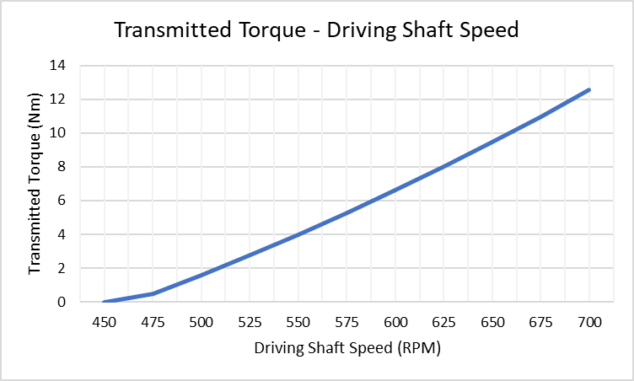
Figure 4 Graph showing transmitted torque against driving shaft speed (Created by the author)

6) Effects of Friction on Transmitted Torque with Coefficient of Friction at 0.3 and 0.4
Figure 5 displays the effects that changing the coefficient of friction will have on the transmittable torque. The results of this task are very similar to the previous one, starting with no torque at 450 rpm and gradually increasing with the driving shaft speed. Plotting the two results on one graph makes the results clear that an increase in the coefficient of friction will also increase the maximum allowable torque transmission.

These relationships are essential to understanding the design of centrifugal clutches. It allows a clutch of the same diameter to run at the same speed but with better torque transmission due to friction lining on the clutch shoes and face. Depending on the lining and application, this can result in a more efficient and cost-conscious assembly. Alternatively, a lower coefficient of friction is helpful in deliberately providing less torque so that the clutch is more likely to slip than damage the system.

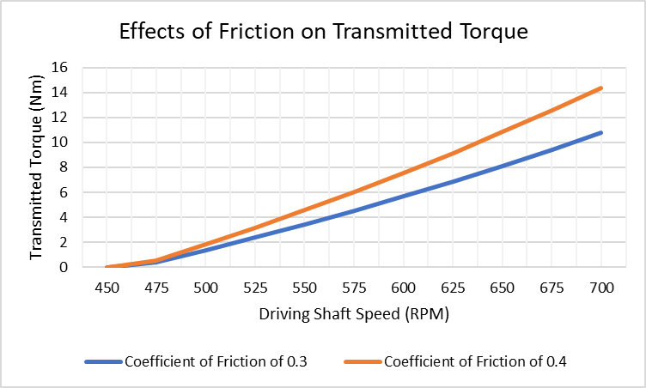
Figure 5 Graph on the effects of friction on transmitted torque (Created by the author)

7) Angular Acceleration with a Drum Mass of 750 g while Transmitting Maximum Torque
Prior graphs show that the maximum possible transmitted torque is 14.341 N m with a coefficient of friction of 0.4 at 700 rpm, as expected when considering the calculations in previous tasks. Angular acceleration equals torque divided by the moment of inertia; the task provides the former, while the latter is determined using the mass and radius of the disk (Unacademy, 2023). In this instance, the radius is the outer drum radius, and the mass is 750 grams.

$$Moment of inertia=\frac{1}{2}×m×r^{2}=\frac{1}{2}×\left(750×{10}^{3}\right)×{\left(108×{10}^{-3}\right)}^{2} \\ ∴Moment of inertia=\frac{1}{2}×7500×{0.108}^{2}=0.00437 kg∙m^{2}$$

Now that the moment of inertia is known. Dividing it by the maximum possible torque will determine the angular acceleration of the drum necessary to maintain the torque. Note that a disk with a more significant moment of inertia will have a smaller angular acceleration, as it is the denominator of the equation. The following concludes the calculation portion of task B, as it satisfies the final requirements for calculation task seven regarding centrifugal clutches.

$$Angular acceleration=\frac{Torque}{Moment of inertia}=\frac{14.341}{0.00437}=3278.69 rad/s^{2}$$

Bibliography
Amsbeck (2023) No load starting with the Centrifugal Clutches. Available at: https://www.amsbeck-mt.de/en/centrifugal-clutches/ (Accessed: 29 October 2023).
Bartmess, M.W. (1916) Centrifugal Clutch. United States Patent Office Patent no. US1204392A. Available at: https://patents.google.com/patent/US1204392 (Accessed: 26 September 2023).
Biggs, B. and Lucas, J. (2022) ‘What are centrifugal and centripetal forces?’, Live Science [blog]. 7 March. Available at: https://www.livescience.com/52488-centrifugal-centripetal-forces.html (Accessed: 30 October 2023).
BLM Automatic Clutch (2023) Centrifugal Clutch for Military & Defence. Available at: https://www.blm-cm.com/centrifugal-clutch-for-military-defense/ (Accessed: 16 September 2023).
Brown, H.M., and Mitchell, R.L. (1980) Centrifugal Clutch Having Electromagnetic Release. United States Patent Office Patent no. US4206837A. Available at: https://patents.google.com/patent/US4206837 (Accessed: 26 September 2023).
Butterfield, T.L.H. (1965) ‘Design and Development of Fighting Tanks’, Proceedings of the Institution of Mechanical Engineers: Automobile Division, 180(1), pp.159-189. DOI: 10.1243/PIME_AUTO_1965_180_017_02
BYJU’S (2023) Conditions of Equilibrium. Available at: https://byjus.com/physics/conditions-of-equilibrium/ (Accessed: 30 October 2023).
Crane, N.B. (1999) Compliant Centrifugal Clutches: Design, Analysis, and Testing. Master’s Thesis. Brigham Young University.
Crowdus, W.A. (1898) Automobile Vehicle. United States Patent Office Patent no. US598314A. Available at: https://patents.google.com/patent/US598314A/en (Accessed: 25 September 2023).
Dunstan, S. (2019) Panhard AML and Eland Enthusiasts' Manual: 1961 Onwards (AML 60, AML 90, and Eland). Somerset: J H Haynes & Co Ltd.
Engineering Explained (2015) Centrifugal Clutch – Explained [video]. Available at: https://youtu.be/D9d4qXreb8Q (Accessed: 19 August 2023).
Garage 64 (2019) DIY Centrifugal Clutch for a Lada [video]. Available at: https://youtu.be/o6AF3LiMIts (Accessed: 12 September 2023).
JBJ Techniques Limited (2023) Electromagnetic Clutches. Available at: https://www.jbj.co.uk/electromagnetic-clutches.html (Accessed: 02 November 2023).
Kahn Academy (2023) What is a centripetal force? Available at: https://www.khanacademy.org/science/physics/centripetal-force-and-gravitation/centripetal-forces/a/what-is-centripetal-force (Accessed: 30 October 2023).
KEB America (2015) Electromagnetic Clutches – How it Works [video]. Available at: https://youtu.be/OztP3uFlUlI (Accessed: 02 November 2023).
Kholil, A. et al. (2022) ‘Natural Fiber Composites from Coconut Fiber, Wood Powder, and Shellfish Shell of Centrifugal Clutch Materials’, Automotive Experiences, 5(2), pp.111-120.
Lancereal (2019) Centrifugal Clutch Explained – An Engineer’s Guide to a Centrifugal Clutch. Available at: https://www.lancereal.com/centrifugal-clutch-explained/ (Accessed: 31 October 2023).
Lee, Y.L., Barkey, M.E., and Kang, H.T. (2011) Material Fatigue Analysis Handbook. Oxford: Butterworth-Heinemann.
Magic Marks (2014) Types of Friction Clutches | Automobile Engineering [video]. Available at: https://youtu.be/8Jr44ybyS7U (Accessed: 1 September 2023).
McCauley, C.J. et al. (2016) Machinery’s Handbook, 30th edn. Norwalk: Industrial Press.
McGee, T. (2022) ‘PRI Education: Race Car Clutch Selection’, Performance Racing Industry [blog]. 1 August. Available at: https://www.performanceracing.com/magazine/columns/08-01-2022/pri-education-race-car-clutch-selection (Accessed: 03 November 2023).
Mechanicalfunda (2019) Advantages and disadvantages of electromagnetic clutch. Available at: https://www.mechanicalfunda.com/2019/08/advantage-disadvantage-electromagnetic-clutch.html (Accessed: 03 November 2023).
MechStudies (2023) ‘Centrifugal Clutches – Definition, Parts, Types, Working, Application’, MechStudies [blog]. Available at: https://www.mechstudies.com/centrifugal-clutches-parts-types-working/ (Accessed: 23 September 2023).
Miki Pulley (2023) What Are Electromagnetic Clutches and Electromagnetic Brakes? Available at: https://www.mikipulley.co.jp/EN/Products/ElectoromagneticClutchesAndBrakes/about.html# (Accessed: 01 November 2023).
Modimaz Engineers (2023) Toothed Clutches. Available at: https://www.modimaz.com/toothed-clutches.htm (Accessed: 05 November 2023).
Moseman, A. (2018) ‘What a Car’s Clutch Actually Does’, Popular Mechanics [blog]. 4 January. Available at: https://www.popularmechanics.com/cars/car-technology/a14745517/how-car-clutch-works/ (Accessed: 25 September 2023).
Newton, N.B. (1937) Centrifugal Clutch. United States Patent Office Patent no. US2239568A. Available at: https://patents.google.com/patent/US2239568A (Accessed: 26 September 2023).
Phoenix Friction (2023) Clutch Friction Materials Explained - Organic, Kevlar, Ceramic, etc. Available at: https://www.phoenixfriction.com/t-clutch-materials-explained.aspx (Accessed: 03 November 2023).
Pon, A. et al. (2023) ‘Optimal shape selection of pseudo-rigid-body model compliant centrifugal clutch manufactured by thermoplastics using TOPSIS approach’, Journal of Thermoplastic Composite Materials. DOI: 10.1177/08927057231158541
Shapiro, J. (2009) ‘The Basics of Electromagnetic Clutches and Brakes’, MachineDesign [blog]. 7 July. Available at: https://www.machinedesign.com/archive/article/21831719/the-basics-of-electromagnetic-clutches-and-brakes (Accessed: 01 November 2023).
Skill Lync (2020) How does a Centrifugal Clutch work? | Skill-Lync [video]. Available at: https://youtu.be/p_BbHxCpJiM (Accessed: 20 August 2023).
Tridgell, C.W. (1969) ‘Paper 3. Centrifugal Clutches for Automotive Use’ (from the Proceedings of the Institution of Mechanical Engineers, 1 Birdcage Walk, Westminster, 24-25th September). Fluid Mechanics and Measurements in Two-phase Flow Systems, 184(9), pp. 60-77.
Unacademy (2023) Moment of Inertia of a Disk Derivation. Available at: https://unacademy.com/content/upsc/study-material/physics/moment-of-inertia-of-a-disk-derivation (Accessed: 03 November 2023).
Wight, R.H. (2004) High-Torque Capacity Compliant Centrifugal Clutches. Master’s Thesis. Brigham Young University.

